TERRAFORM-05
2). Execute the script shown in the video.
Lets create a S3 bucket using terraform script
Need to remember one thing her the bucket name we are giving should be unique.
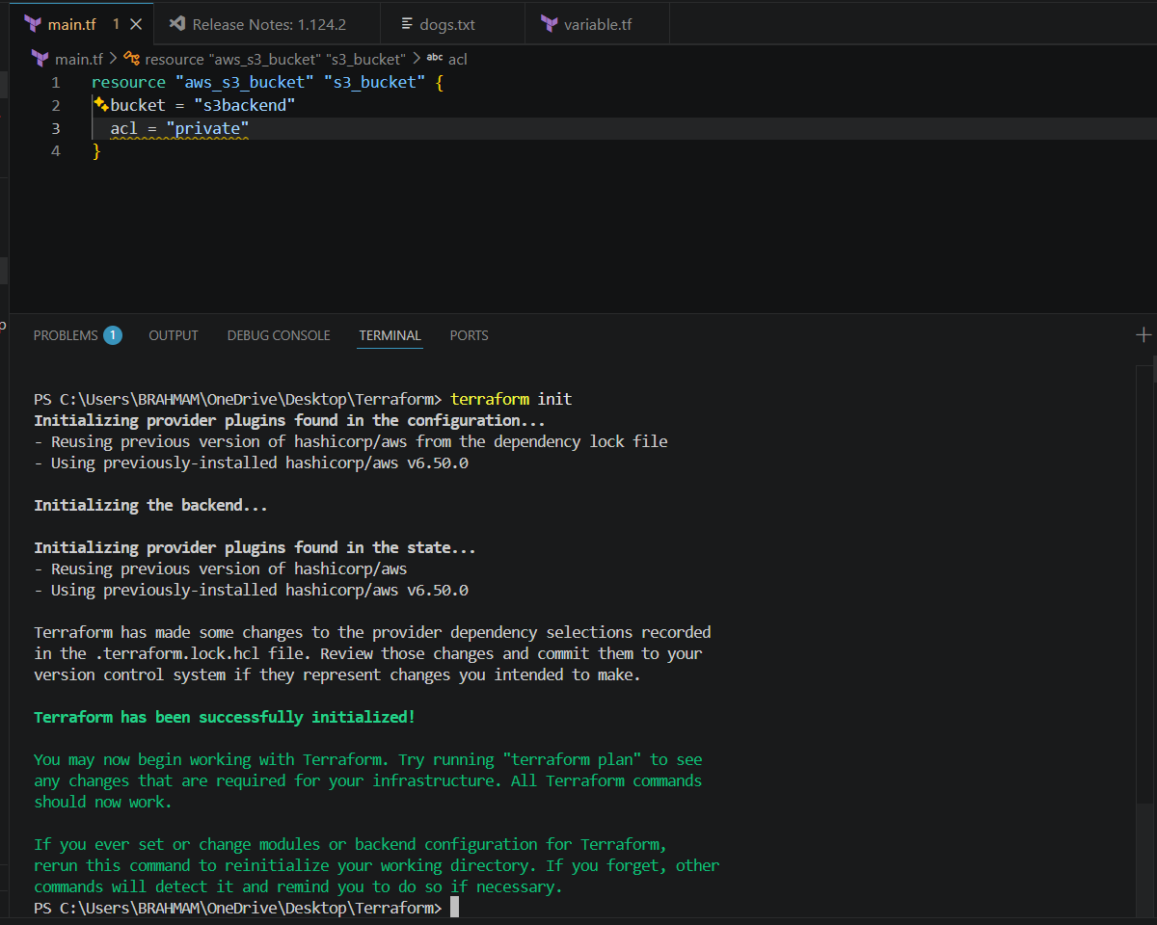
Terraform apply
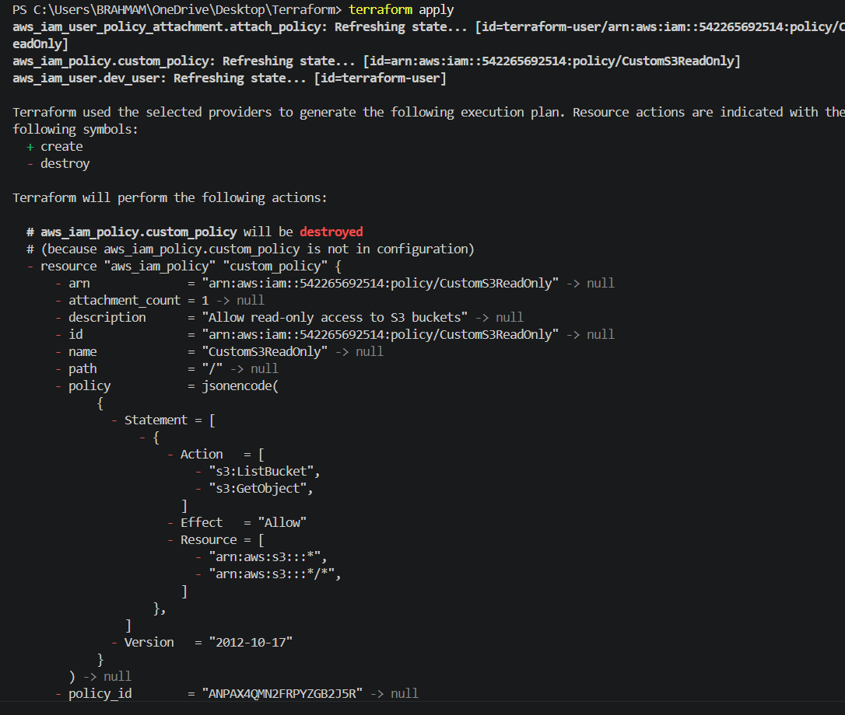
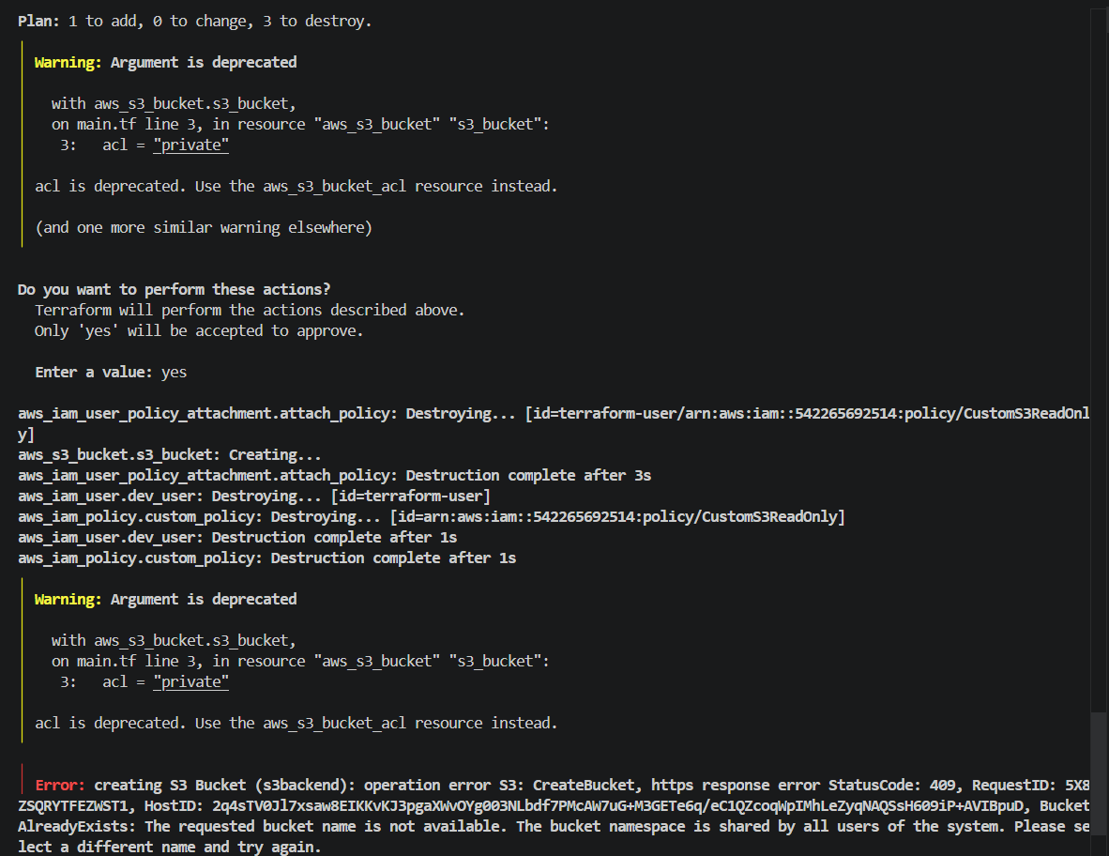
I got error while creating s3 bucket s3 bucket name was not given uniques3backend2terraform apply get success
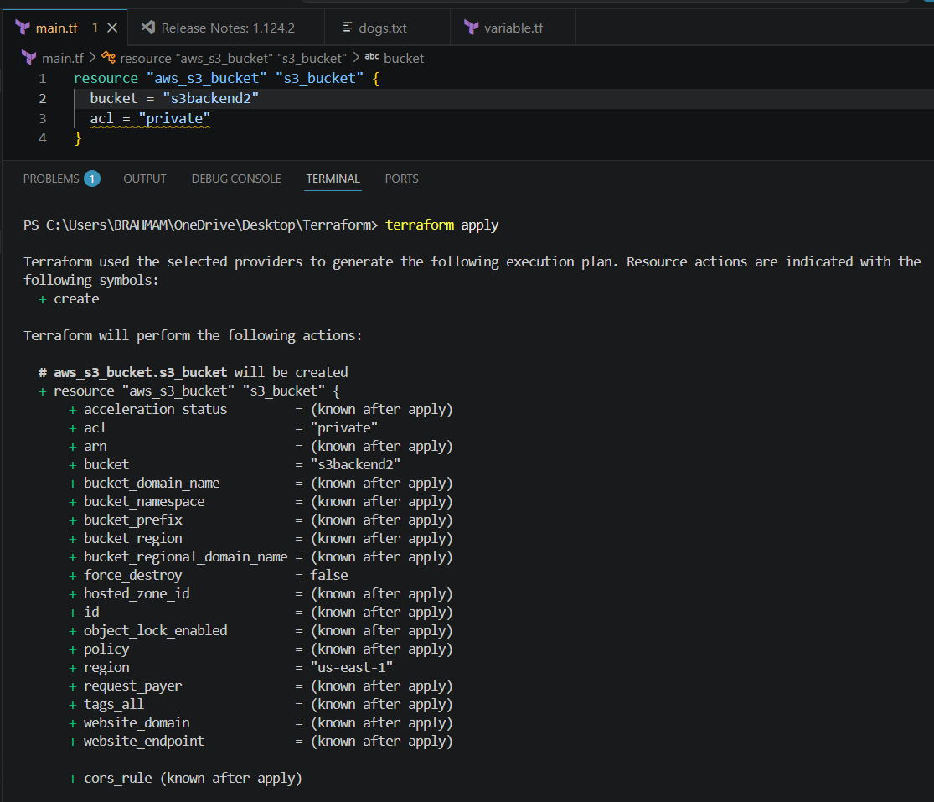
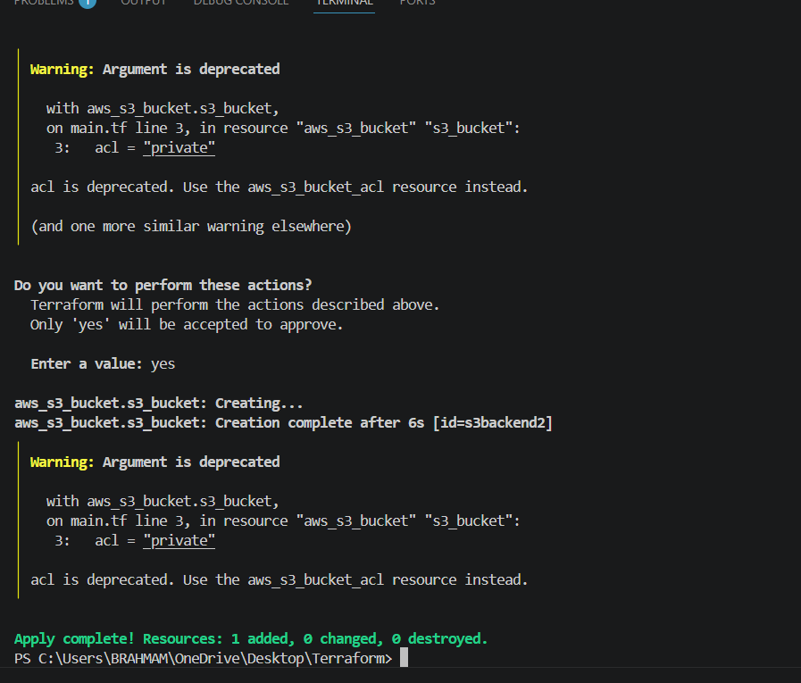
It says a bucket has been created. Lets check in AWS S3 this is the output

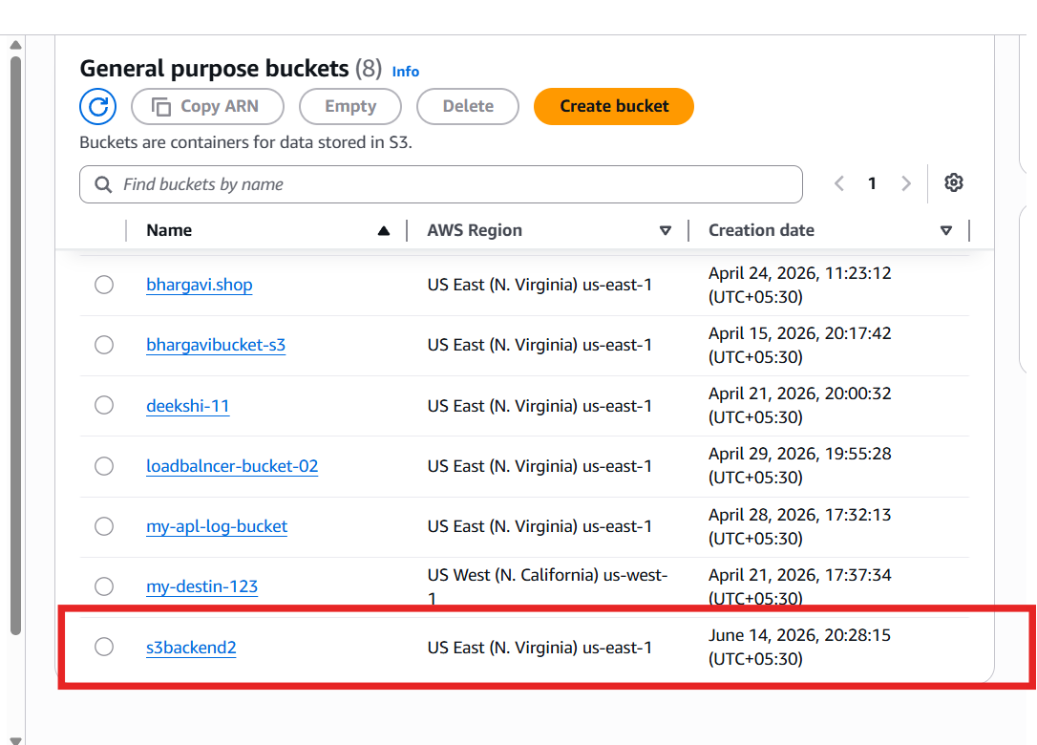
Lets Create Dynamo db using terraform script in the same main.tf file
resource "aws_s3_bucket" "s3_bucket" {
bucket = "s3backend2"
acl = "private"
}

resource "aws_dynamodb_table" "dynamodb-terraform-state-lock" {
name = "terraform-state-lock-dynamo"
hash_key = "LockID"
read_capacity = 20
write_capacity = 20

attribute {
name = "LockID"
type = "S"
}
}
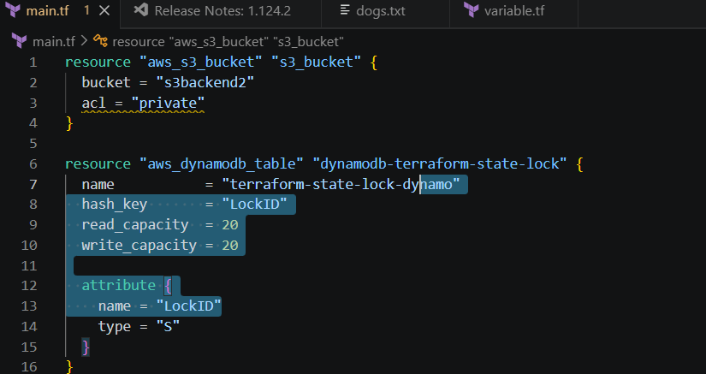
Terraform apply
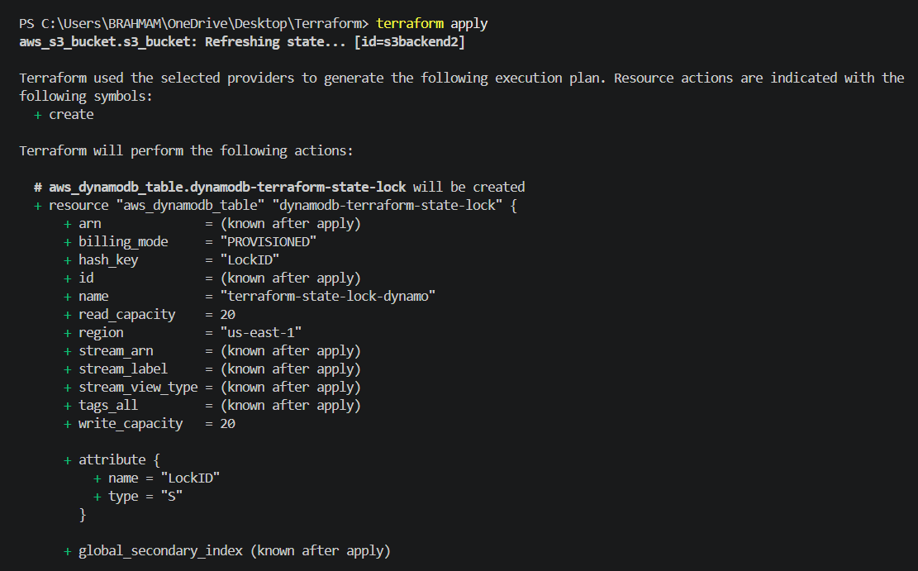
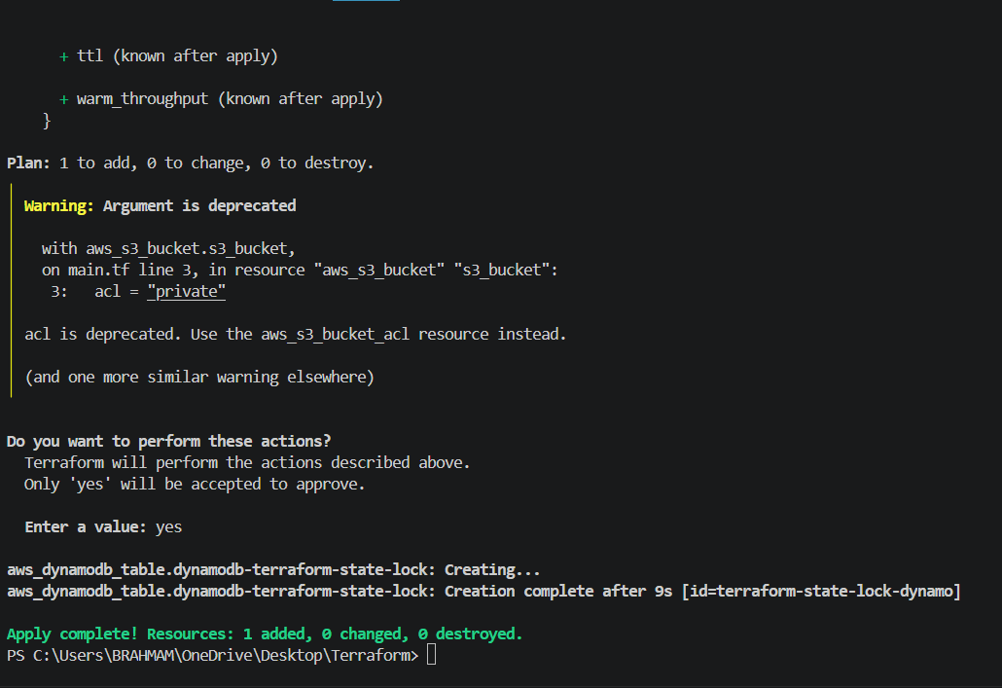
Lets check in AWS Dynamo db
dynamo db table has been created
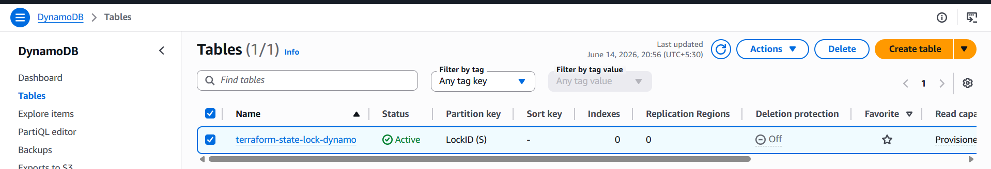
S3 as backend for terraform.tfstate file:
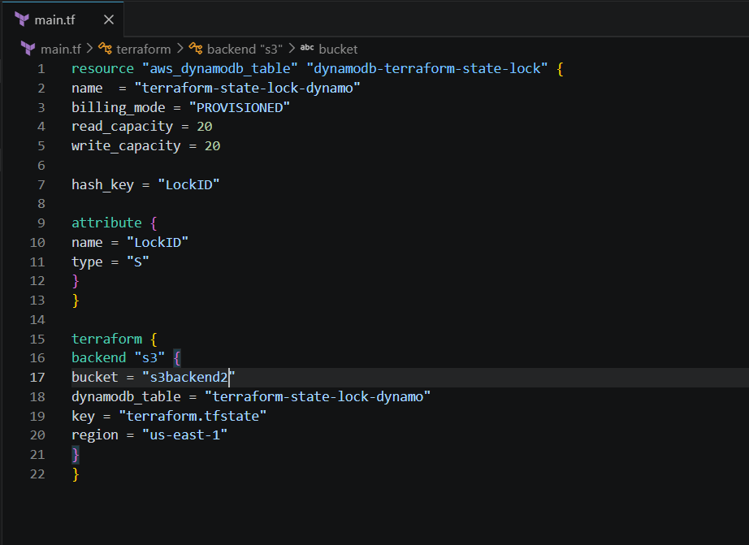
resource "aws_dynamodb_table" "dynamodb-terraform-state-lock" {
name = "terraform-state-lock-dynamo"
billing_mode = "PROVISIONED"
read_capacity = 20
write_capacity = 20

hash_key = "LockID"

attribute {
name = "LockID"
type = "S"
}
}

terraform {
backend "s3" {
bucket = "s3backend2"
dynamodb_table = "terraform-state-lock-dynamo"
key = "terraform.tfstate"
region = "us-east-1"
}
}

Lets execute terraform apply
It will be throwing an error and will ask us to do initializeterraform init
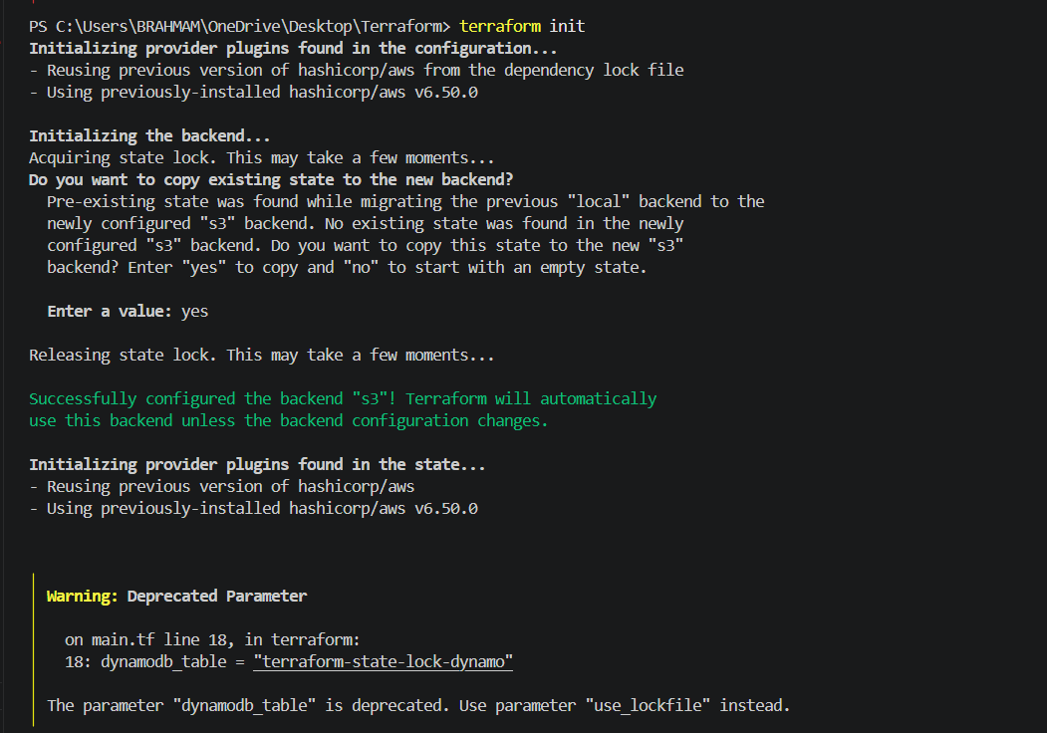
Lets see what happened to terraform.tfstate file
After executing the terraform init all the details in my statefile have been deleted
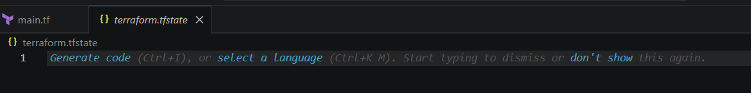
Lets check how previously my statefile looked its seen blueprint how many changes are we doing in seen this file.
Now lets check in S3 the data should be stored.
The file has been moved to S3 - bucket which we have created
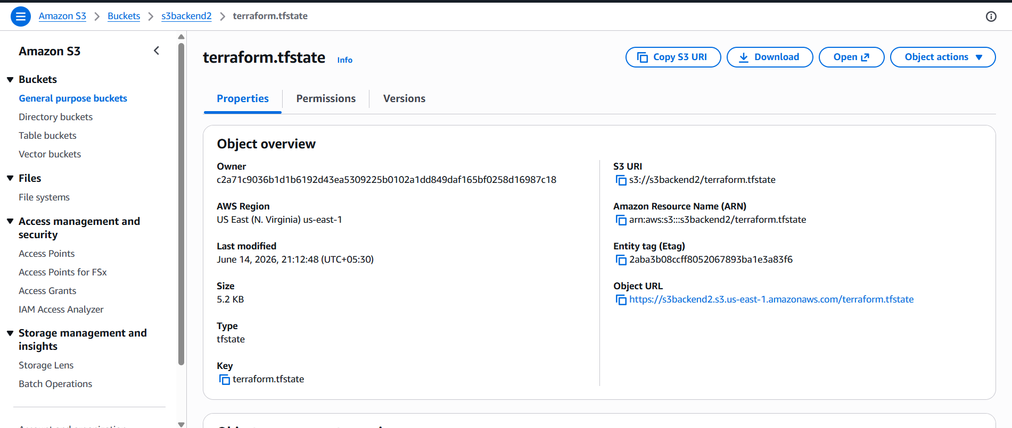
For checking the lock ID
DynamoDB→Tables→file created→explore items→scan→edit item
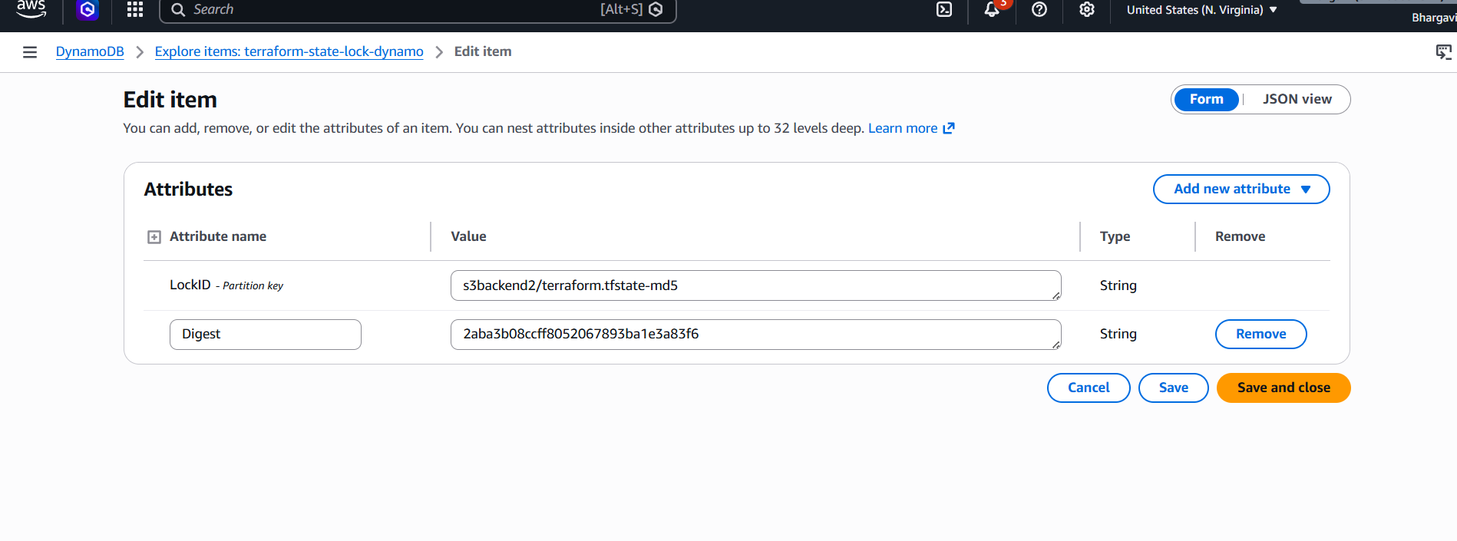
3) Create one EC2 instance with httpd installed using a Terraform script.
provider "aws" {
region = "us-east-1"
}

# Security Group
resource "aws_security_group" "web_sg" {
name = "webserver-sg"
description = "Allow SSH and HTTP access"

ingress {
description = "SSH"
from_port = 22
to_port = 22
protocol = "tcp"
cidr_blocks = ["0.0.0.0/0"]
}

ingress {
description = "HTTP"
from_port = 80
to_port = 80
protocol = "tcp"
cidr_blocks = ["0.0.0.0/0"]
}

egress {
from_port = 0
to_port = 0
protocol = "-1"
cidr_blocks = ["0.0.0.0/0"]
}

tags = {
Name = "webserver-sg"
}
}

# EC2 Instance
resource "aws_instance" "webserver" {
ami = "ami-0521cb2d60cfbb1a6"
instance_type = "t3.micro"
key_name = "deekshi"

subnet_id = "subnet-0210ea06686b6b1b4"
vpc_security_group_ids = [aws_security_group.web_sg.id]

associate_public_ip_address = true

user_data = <<-EOF
#!/bin/bash
yum update -y
yum install -y httpd
systemctl start httpd
systemctl enable httpd
echo "<h1>Apache Installed Using Terraform</h1>" > /var/www/html/index.html
EOF

tags = {
Name = "Terraform-HTTPD-Server"
}
}

output "public_ip" {
value = aws_instance.webserver.public_ip
}

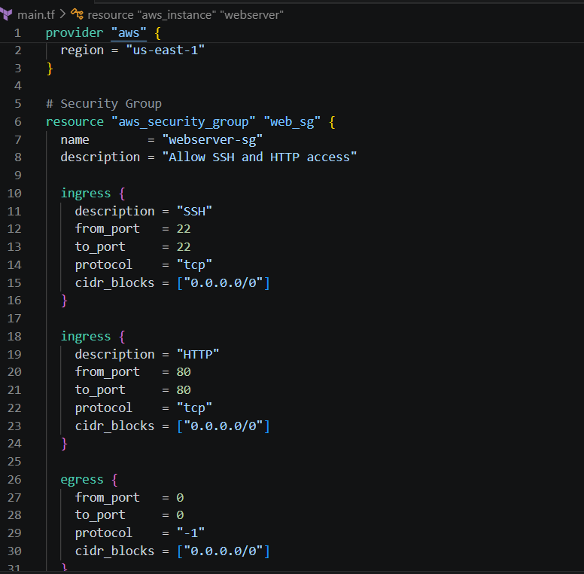
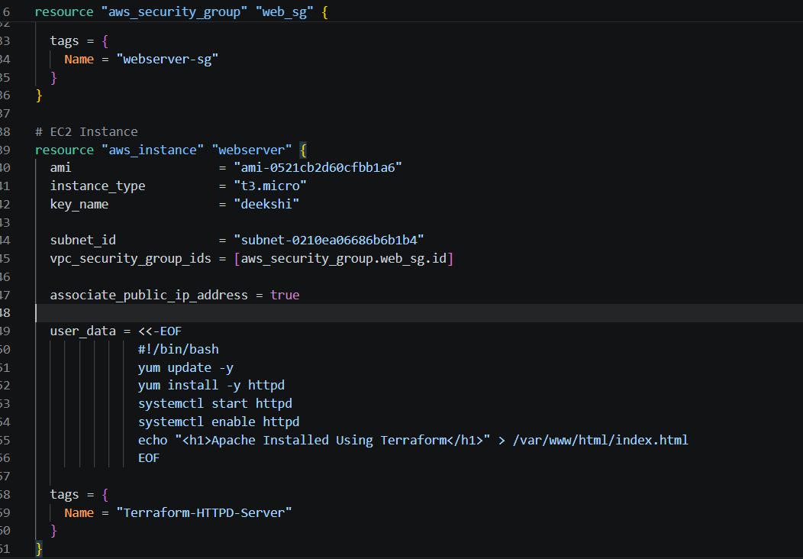
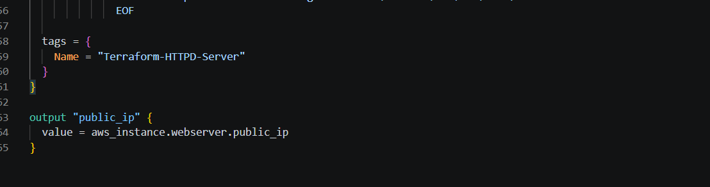
Terraform init
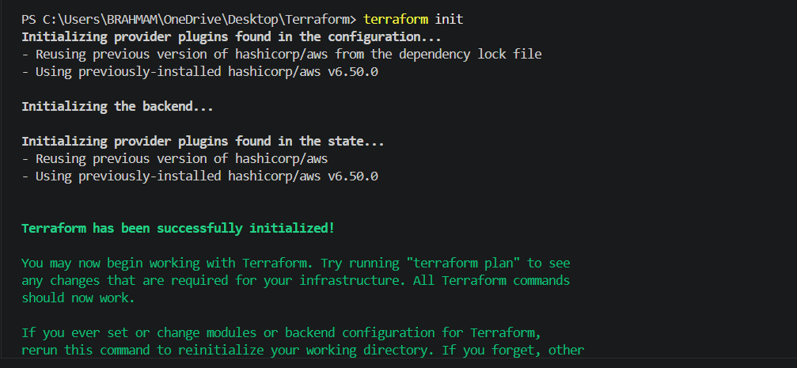
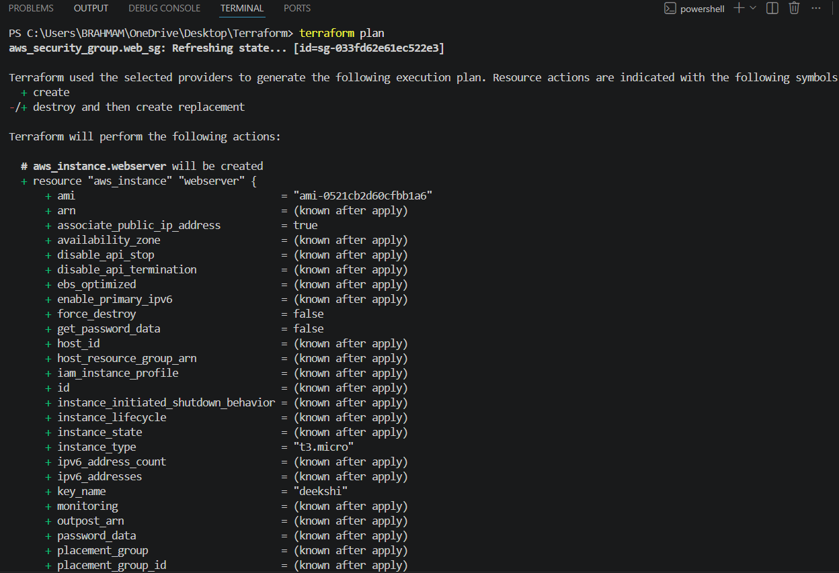
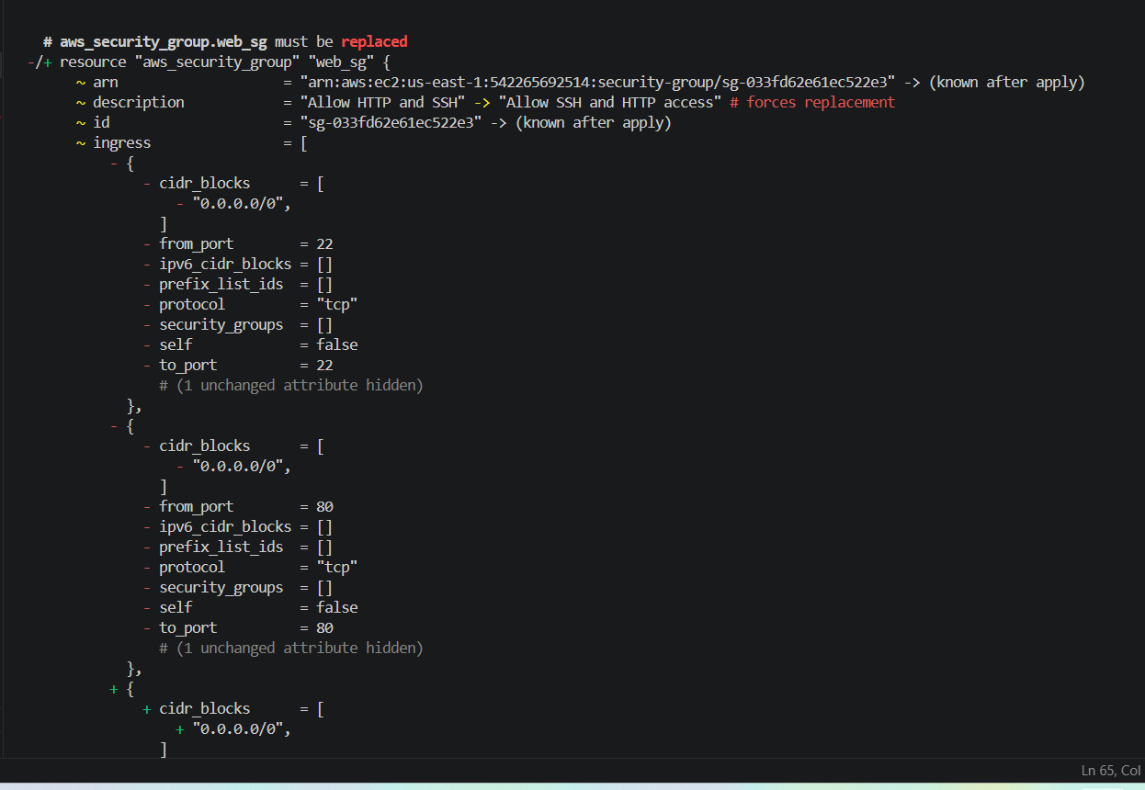
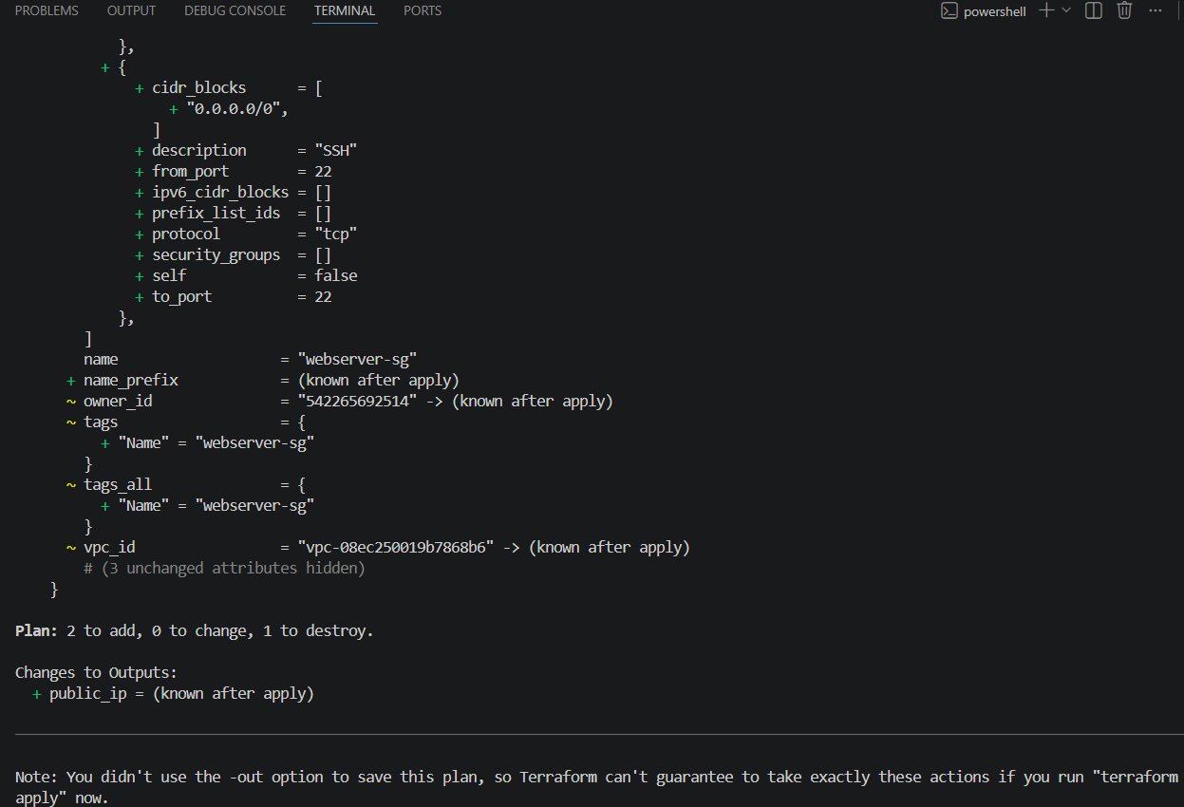
Terraform apply
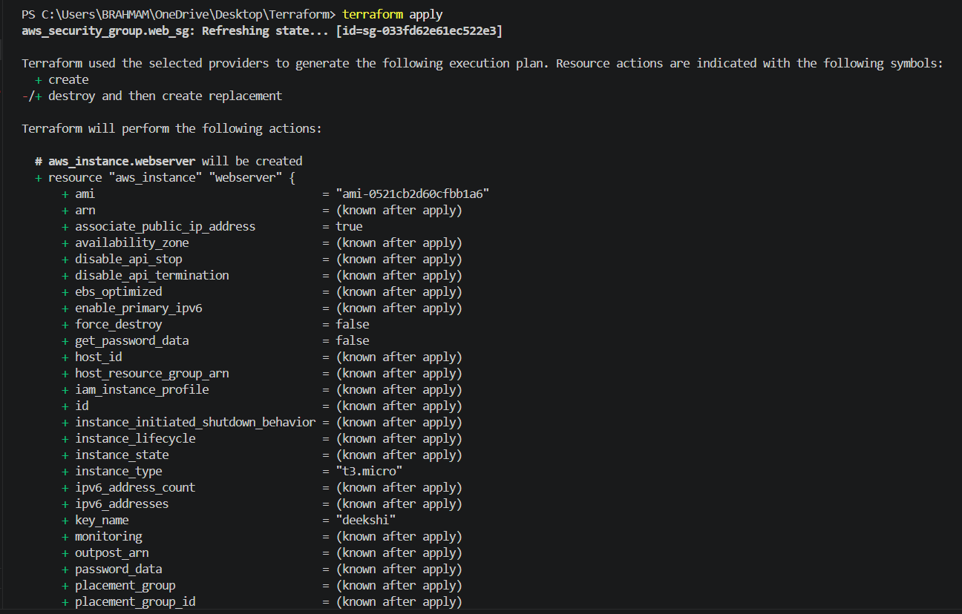
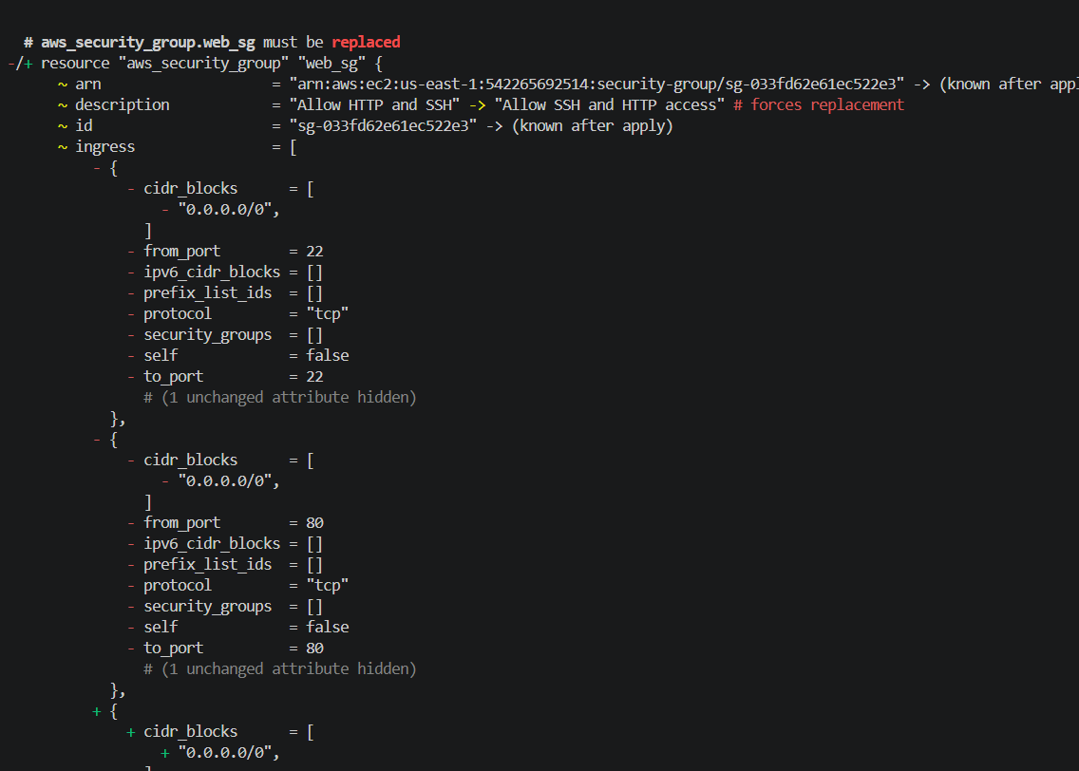
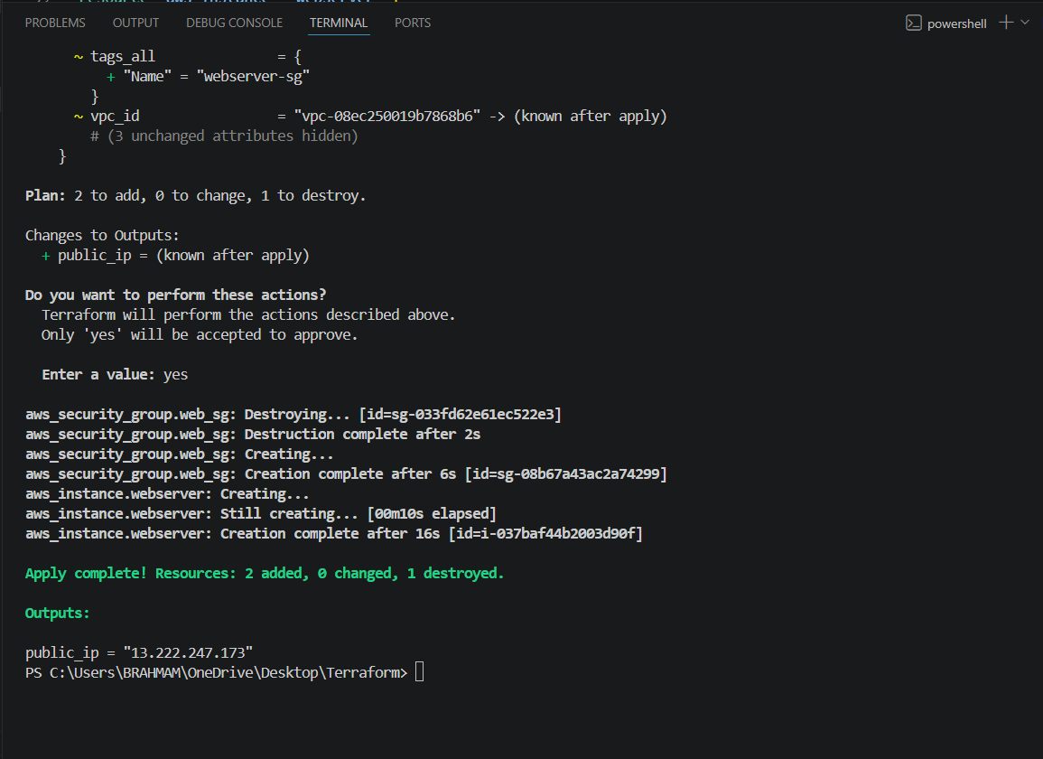
Now check in AWS instance new instance created
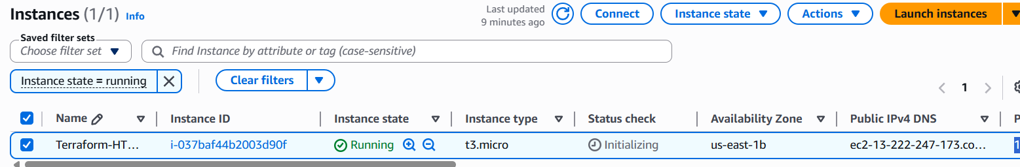
Lets check once in google with the help of public ip of instance
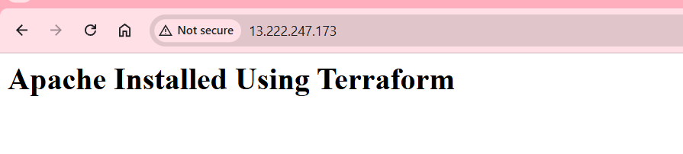

4). Set up S3 as backend for task 3.
Create s3.tf file and write a script
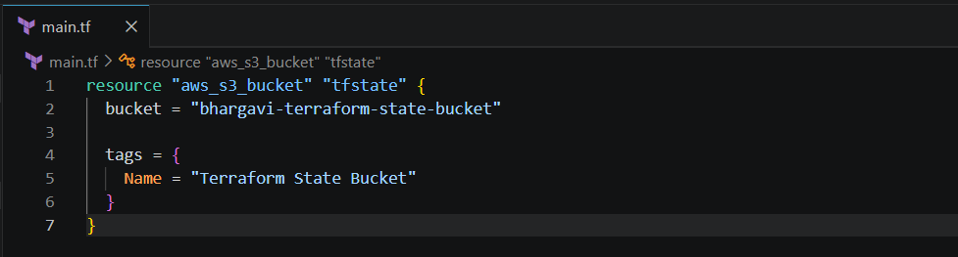
Then do terraform init
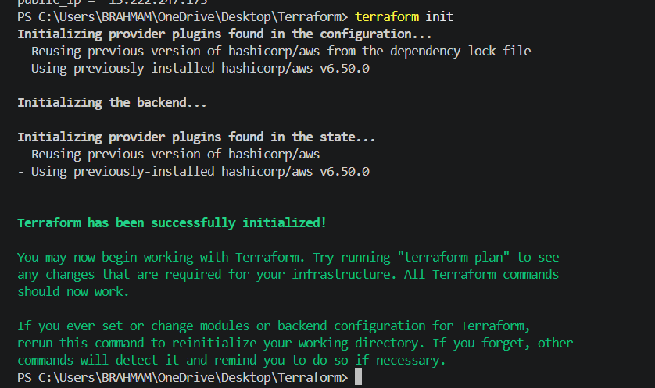
Terraform apply
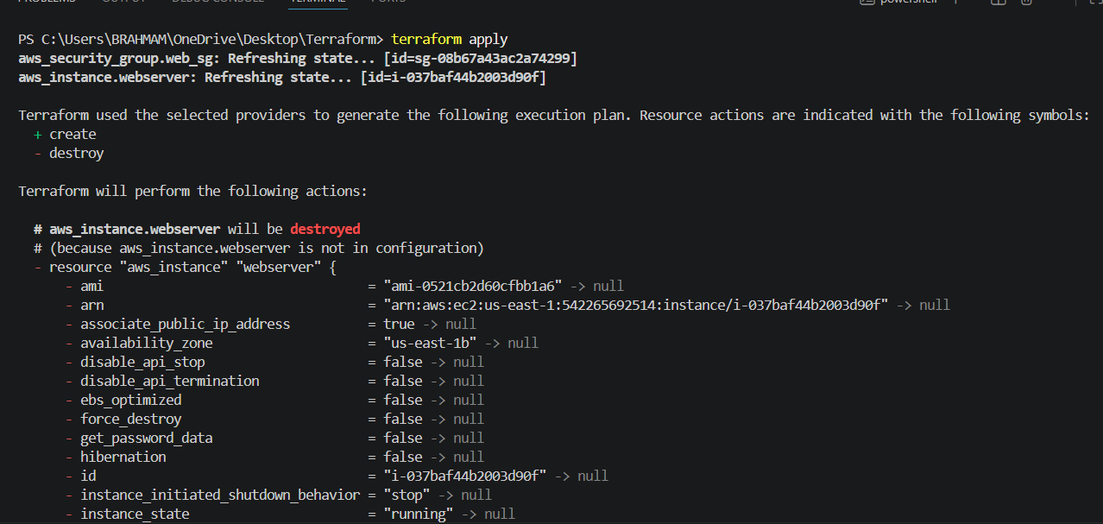
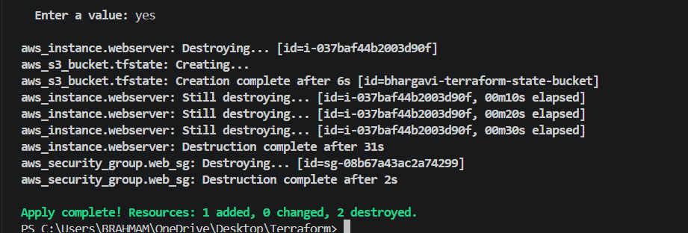
Now check in S3 bucket created or not
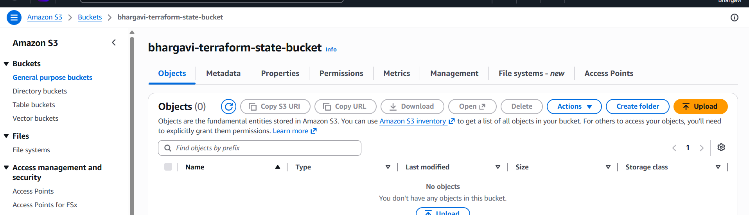
5). Set up DynamoDB locking for task 3.
Create DynamoDB file and written script
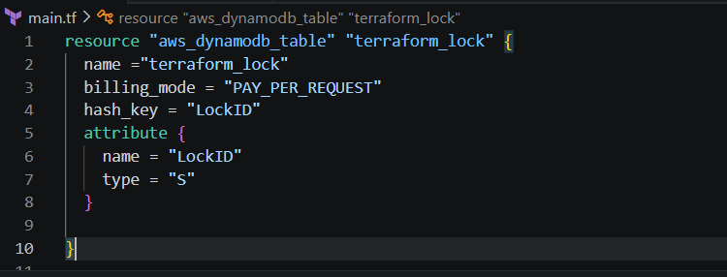
Create one backend fileAnd also written backend.tf file for terraform .tf state
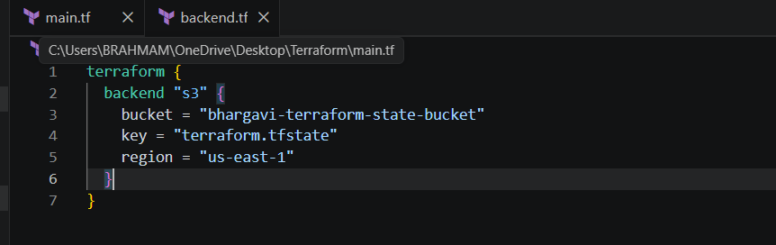
Now do terraform init -reconfigure and check DynamoDB also
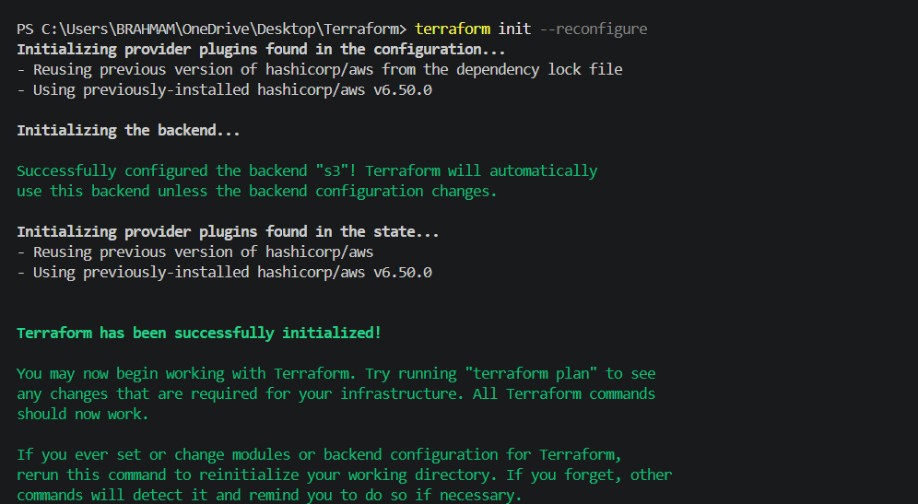
Terraform planterraform apply
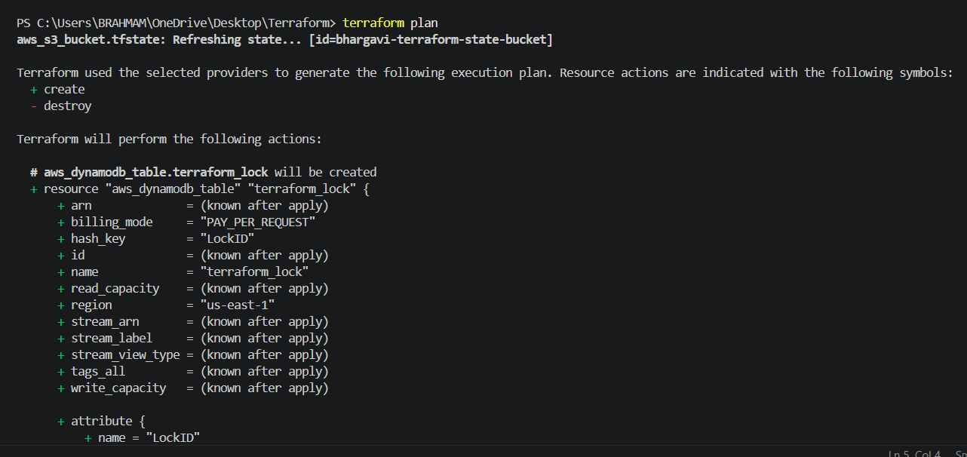
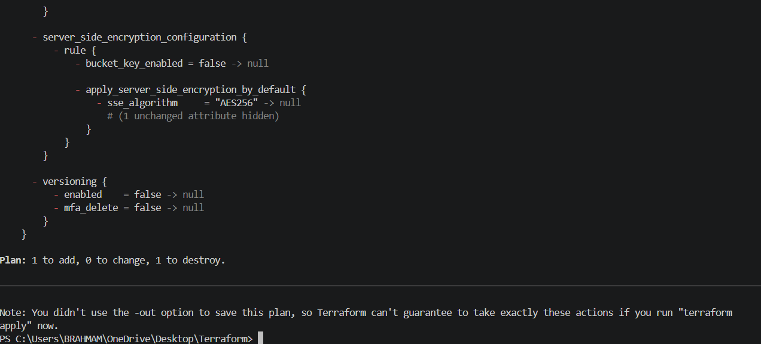
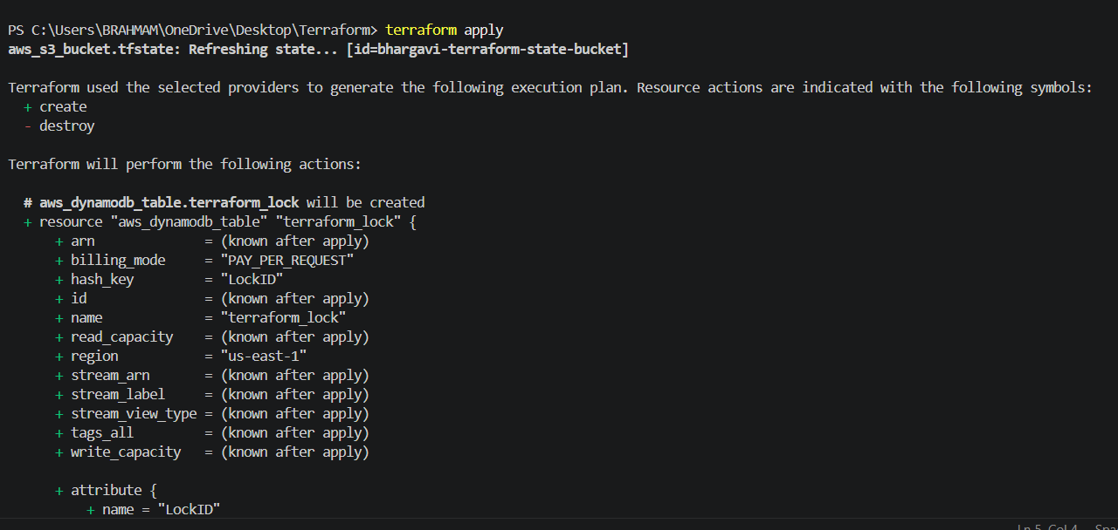
Now check in DynamoDB Table is created