K8s-04
1. Deploy an application using a Deployment with 3 replicas and a rolling update strategy.
Let’s start with YAML file
A Deployment provides declarative management of Pods. It automatically maintains the
desired number of replicas, supports self-healing, rolling updates, rollbacks, and scaling. If a
Pod fails, the Deployment (through its ReplicaSet) creates a replacement automatically."
1st without worker nodes running we can set the
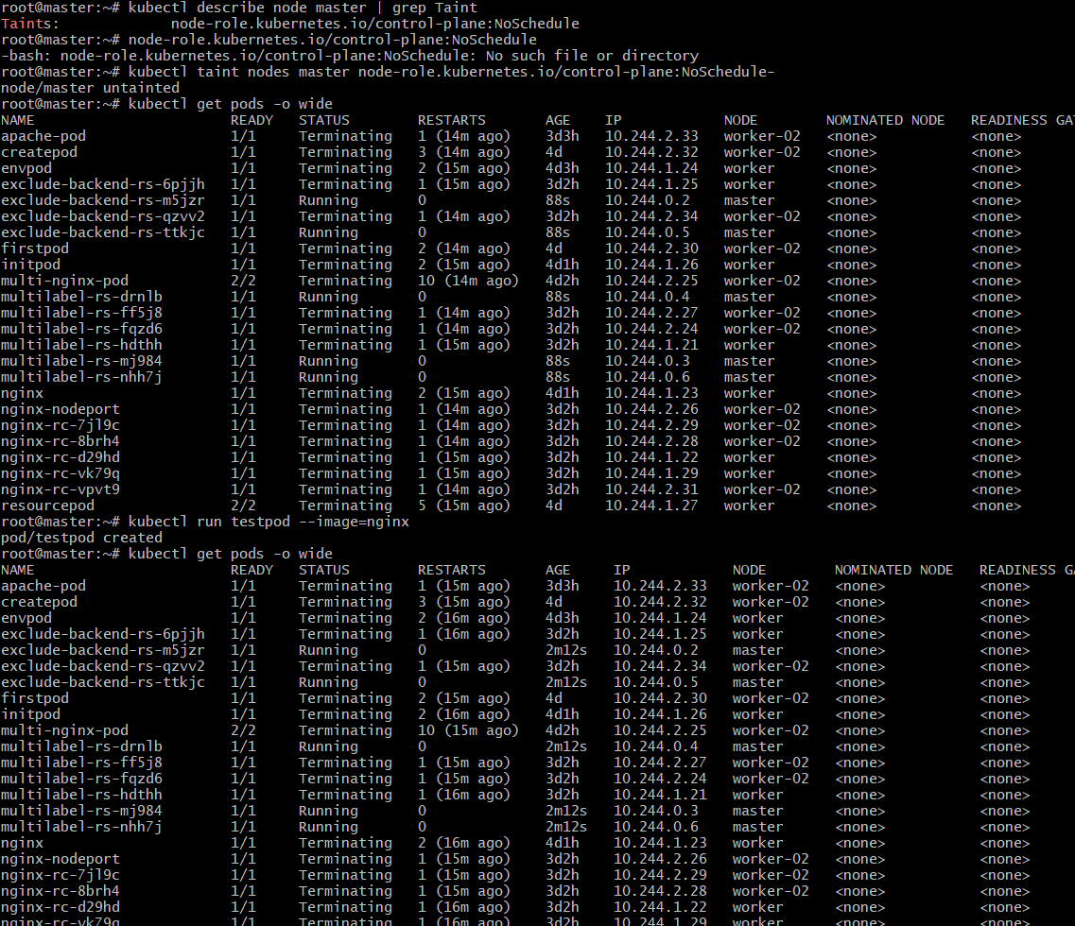
Without work nodes running we can run now in master only…
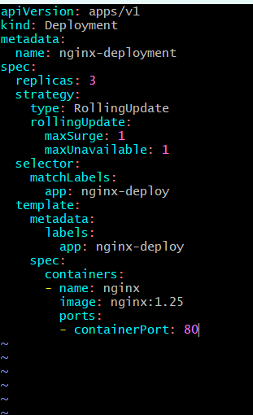
• Apply and Verify Deployment
• Verify ReplicaSet and Pods
• Verify Rolling Update Strategy
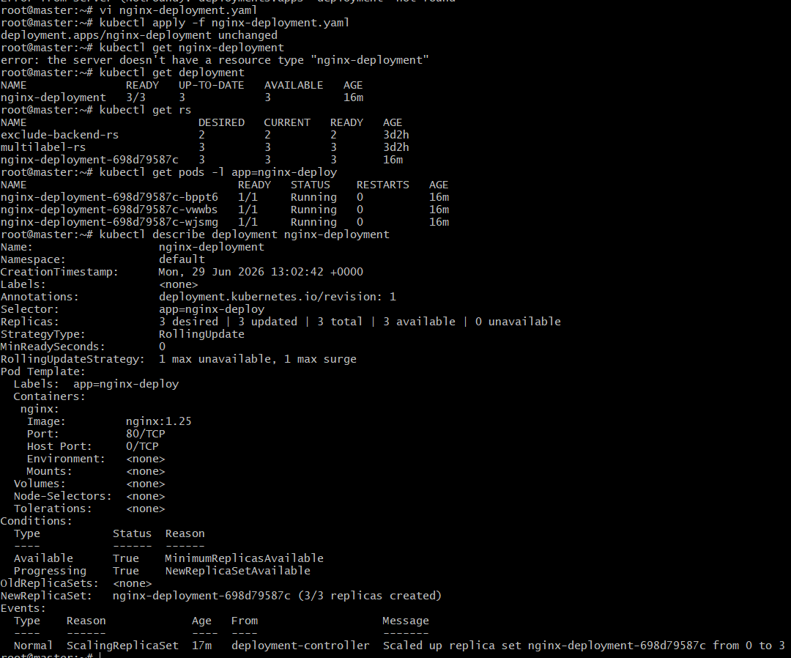
• Rolling update by changing the image from nginx:1.25 to Nginx: latest
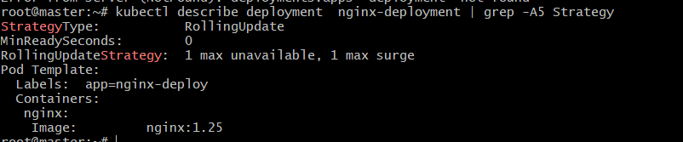
2. Configure a Deployment with a Recreate strategy and observe the downtime.
Create a file recreate-deployment. Yaml
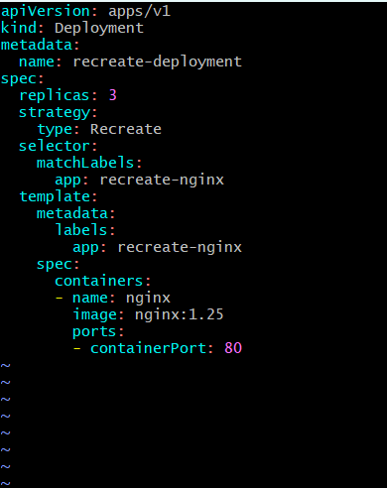
Apply and verify the pods
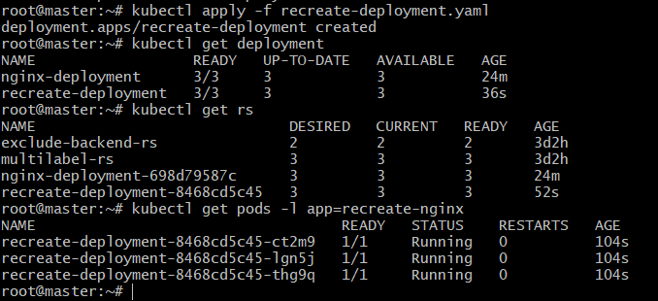
• Update the Deployment and watch pods
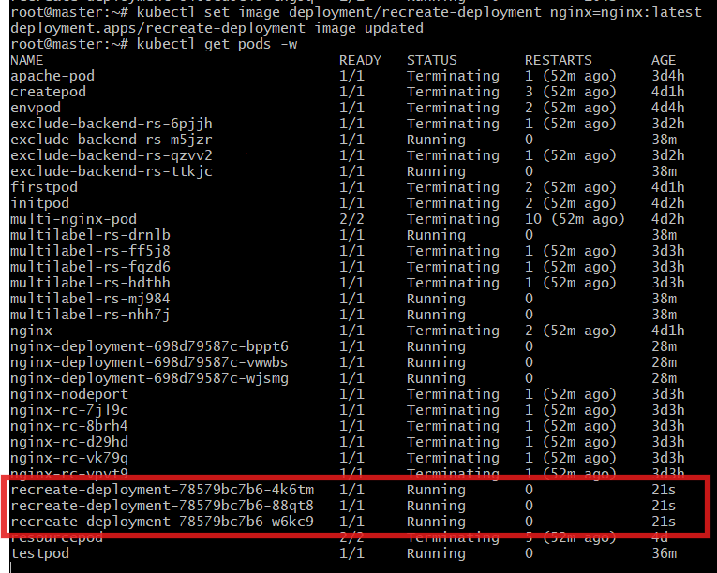
Verify Old ReplicaSet scaled down to 0 and new Replicaset scaled up to 3
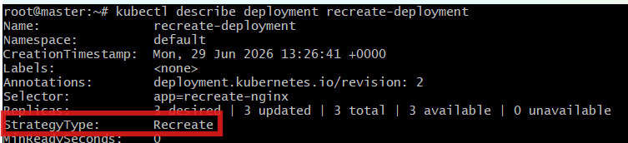
3. Update an existing Deployment and perform a rollback to the previous version.
• Check rollout history
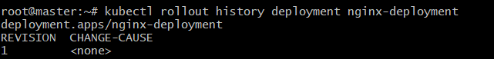
Update the image againVerify the image and Check rollout history again
• Roll back to the previous version
• Verify rollback and rollout history
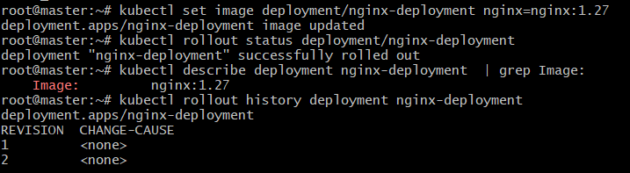
4. Modify a Deployment to add resource requests and limits for CPU and memory.
• Edit the YAML and change yaml script and save it
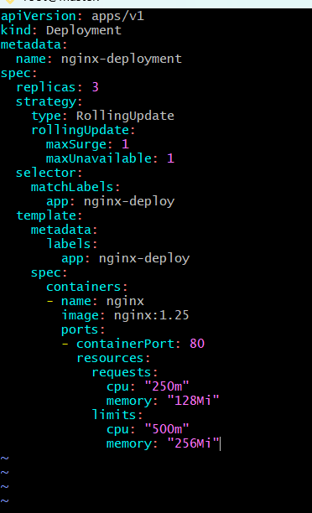
I got this script soo I can again give below script

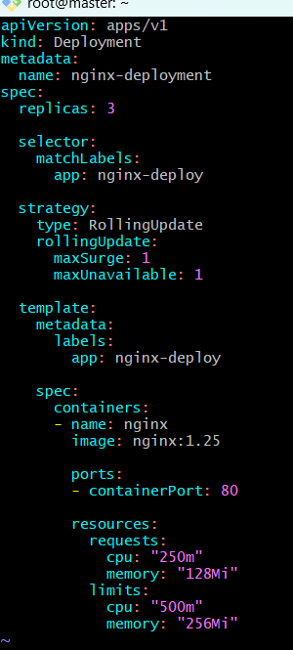
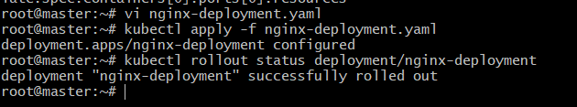
Verify the resources
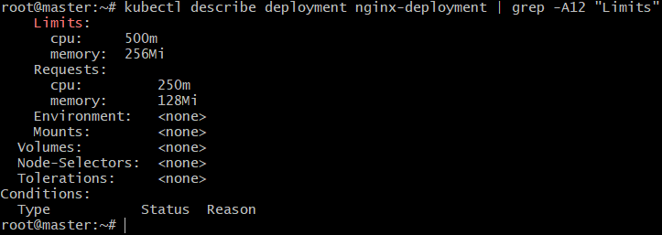
5. Create a Deployment with Max Surge and Max Unavailable configurations.
• Create surge-deployment. Yaml
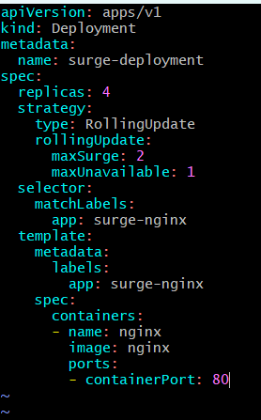
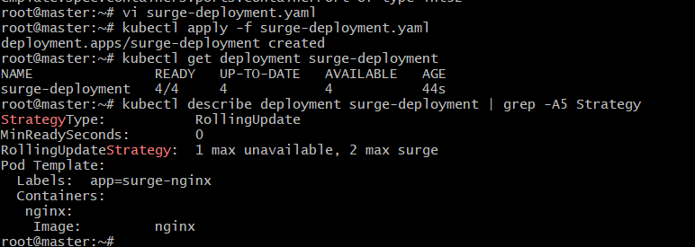
6. Set up a Deployment with a custom revision history limit.
• Edit the same file: and update revision History Limit to 5
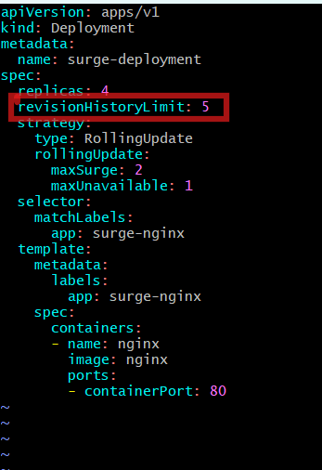
Apply it
• Verify the revision History Limits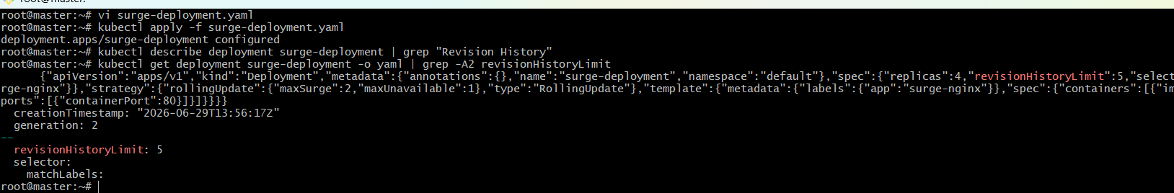
7. Pause a Deployment during an update, and then resume it.
• Paused the deployment and check status
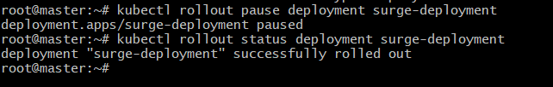
• Update the image while paused and check status
• Resume the deployment and check status
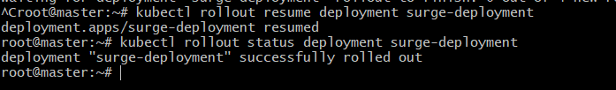
8. Create a pod using resource requests for memory and CPU, and observe how the
scheduler assigns it to a node.
• Create a yaml file
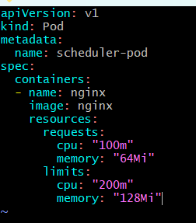
Deleted pod and again created it check status
