DOCKER-02
1.Create a tomcat container on 8080 and deploy sample application in tomcat.
Verified the docker status running or not
First Login to our instance using SSH
- systemctl status docker
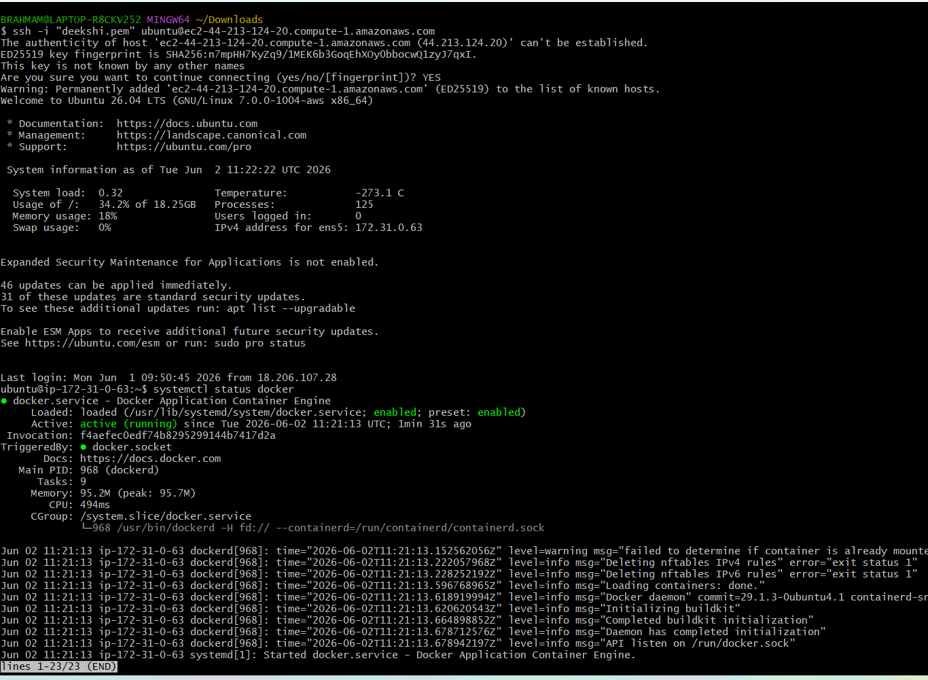
Docker is active
Now lets pull tomcat using docker pull tomcat:latest
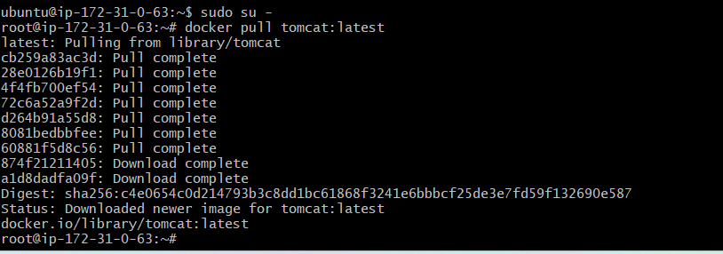
Docker images we can see the images has successfully pulled⇒
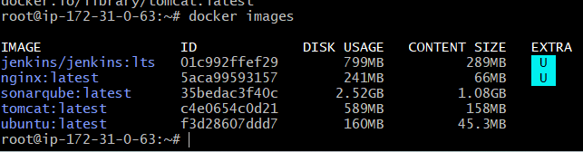
Lets run the image now by using command
docker run -itd -p 8080:8080 tomcat:latest
we lets check using ipaddress:8080
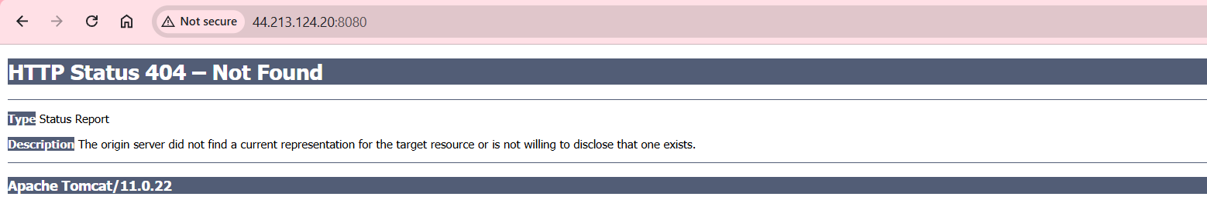
Our tomcat is running, now lets deploy a sample war file
So need to login
Using docker exec -it container_id /bin/bash
To deploy sample war file we need to update the packages and install wget for that we will use
Commandapt updatecd webappsgo to do in webapps

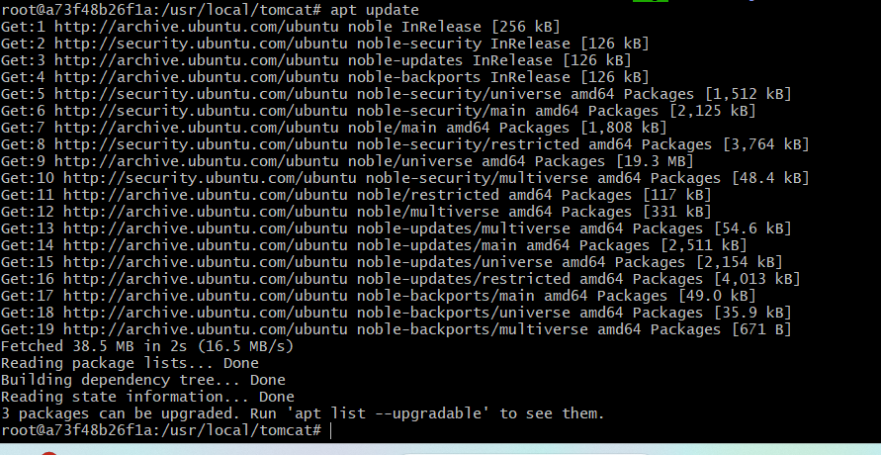
apt-get install wget -y Wget weblink Sample.war has been deployed in webapps Now lets check in browser using ipaddress:8080/sample
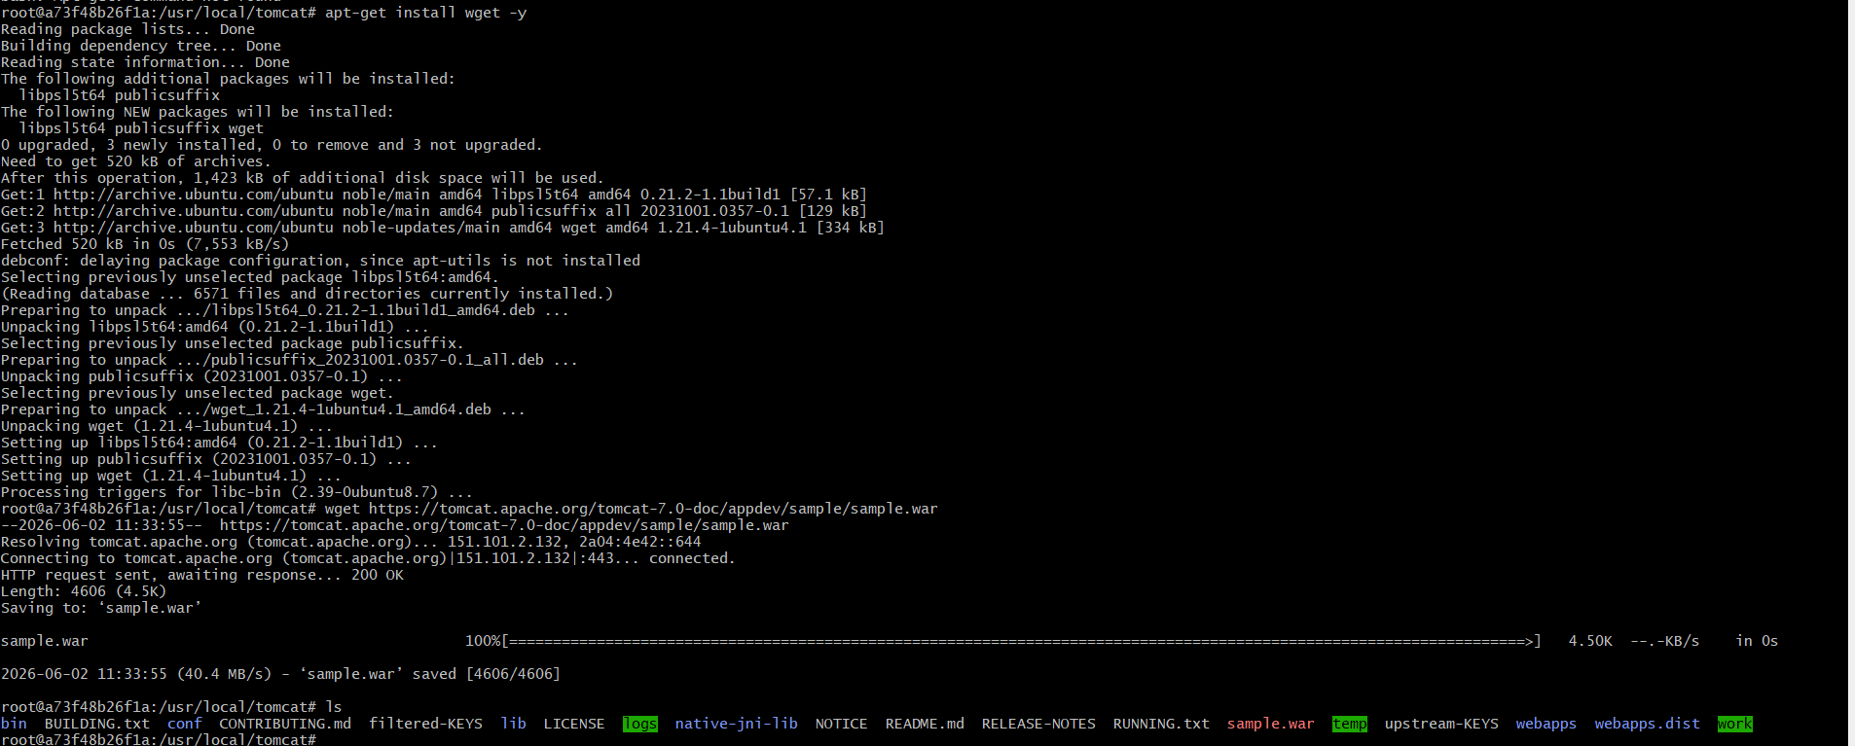
I am not download inside the webapps then I want to move sample.war to webapps
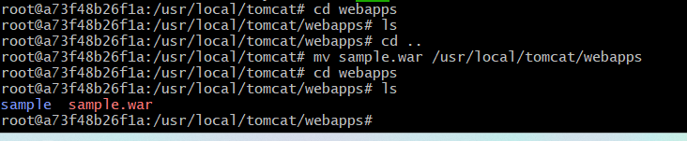
2.Create volume and deploy a tomcat container on port 8081.
Lets create volume by using command
docker volume create deployment
And check if it has been created or not by using docker volume ls
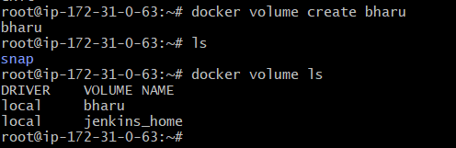
Now lets go to the folder
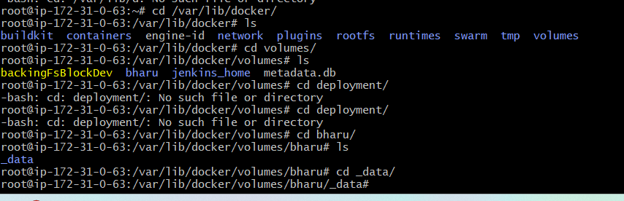
Now lets deploy a sample war file using wget
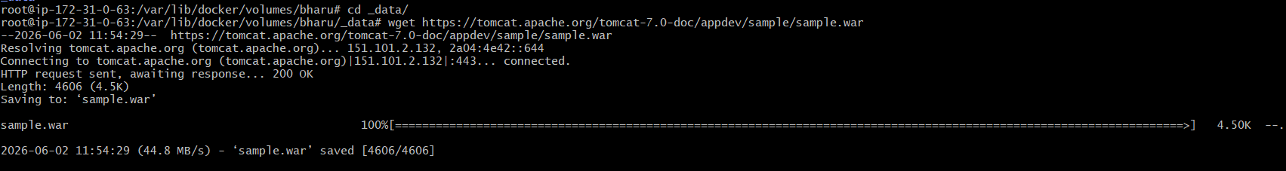
Now lets run the image using command
- docker run -itd -p 8081:8080 -v
/var/lib/docker/volumes/deployment/_data:/usr/local/tomcat/webapps tomcat:latest
docker run -itd -p 8081:8080 -v /var/lib/docker/volumes/bharu/_data/:/usr/local/tomcat/webapps tomcat:latest
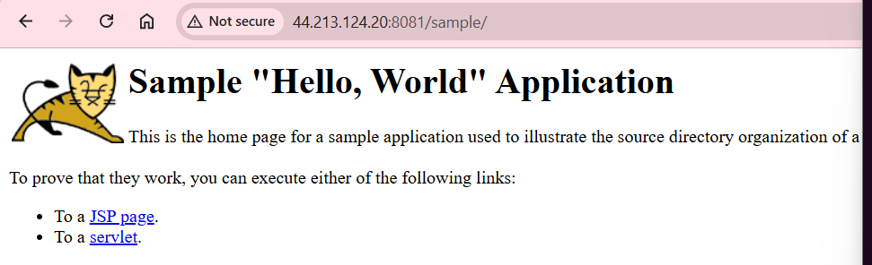
3. Limit the nginx container to 500 MB.
By using command
Docker run -itd -p 80:80 –memory=500m nginx:latest
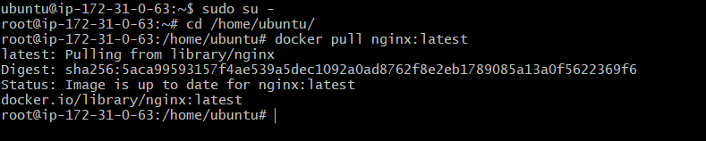
Run Nginx Container with 500 MB Memory Limit
docker run -d → Run in detached mode
--name nginx-500mb → Container name
-p 80:80 → Map host port 80 to container port 80
--memory="500m" → Limit container memory to 500 MB
nginx:latest
Verify Container is Running
docker ps
Verify Memory Limit
docker inspect nginx-500mb
docker stats nginx-500mb
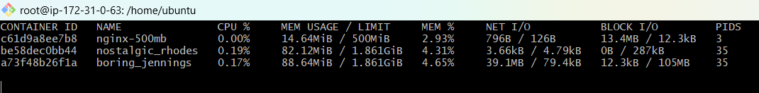
Verify
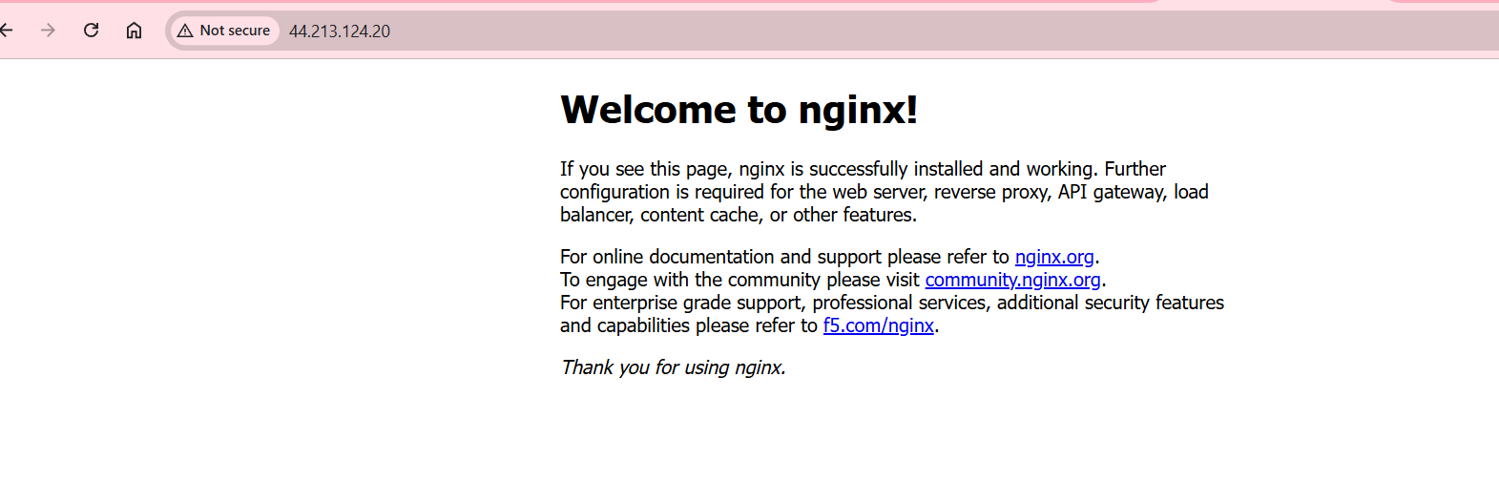
4. Create a sample docker file using below instructions.
a. Base module as amazonlinux:latest
b. Maintainer you name
c. Install nginx
d. COPY one index.html file to image
e. Expose on port 80
f. Command to start the nginx container
create an Index.html file first
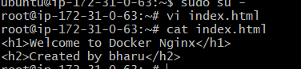
Create a docker file
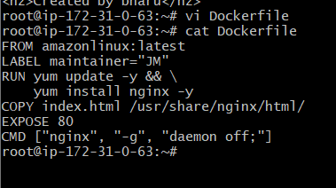
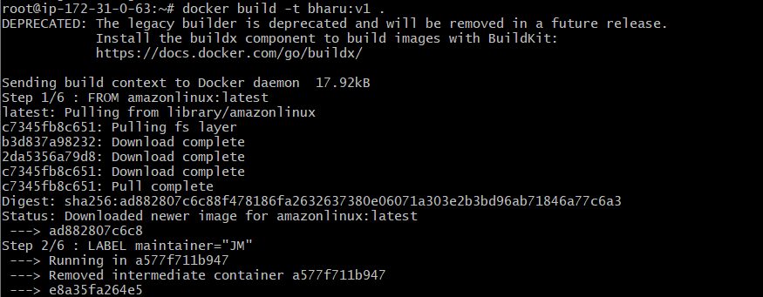
Step 3
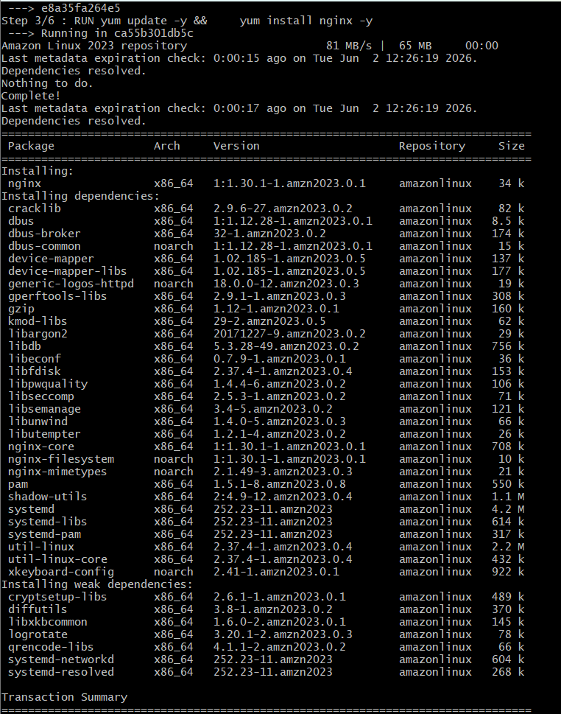
Step 4,5,6
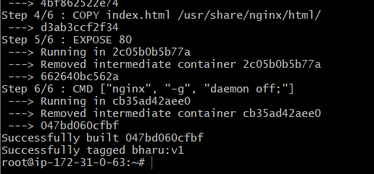
Now Lets run
docker run -d \
--name nginx \
-p 8082:80 \
bharu:v1
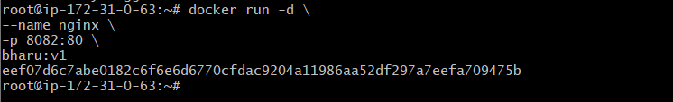
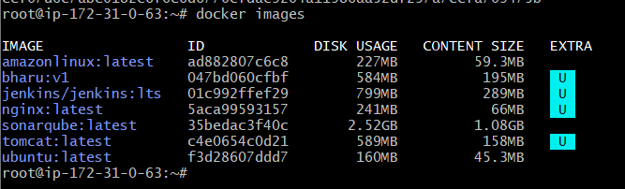
Lets check in browser

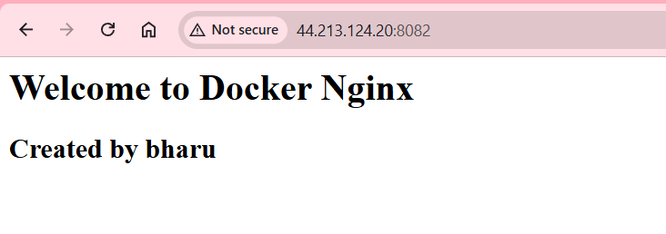
5.Push image to Docker hub
Create a repo in Docker hub


USERNAME:Bharu31
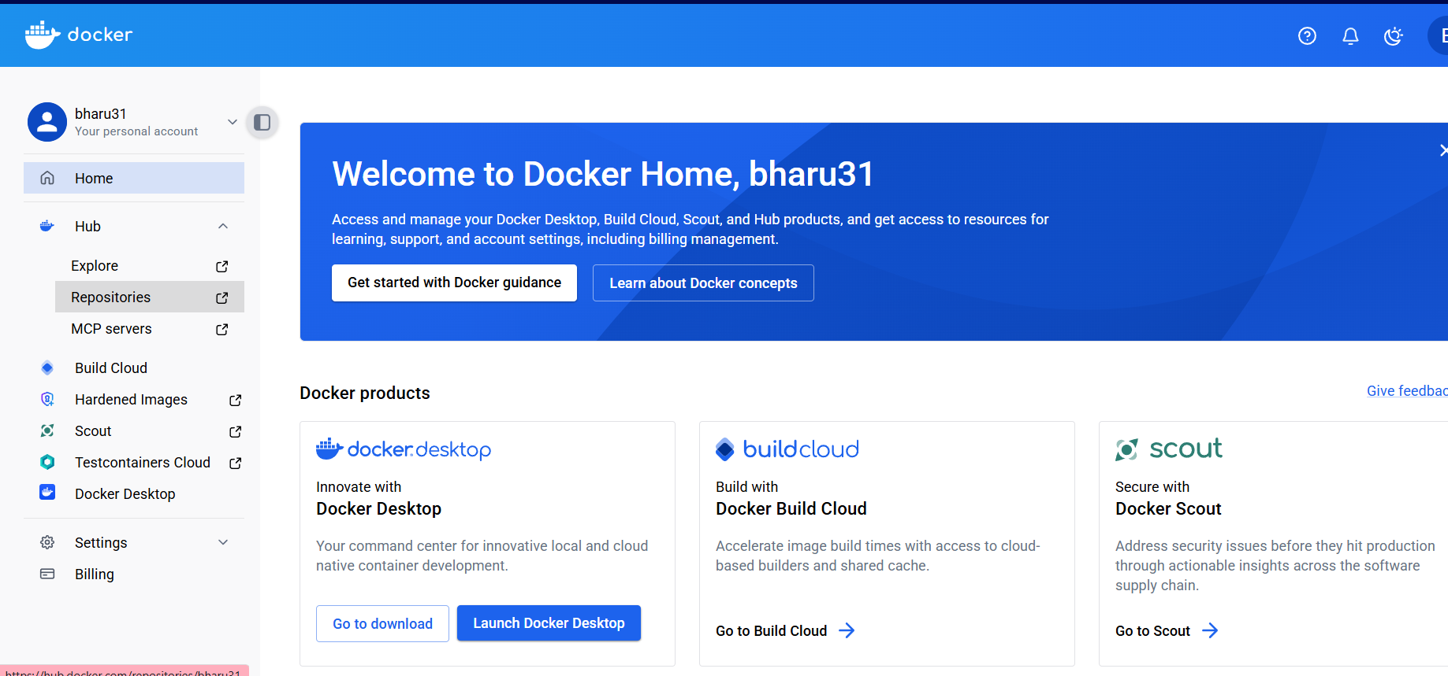
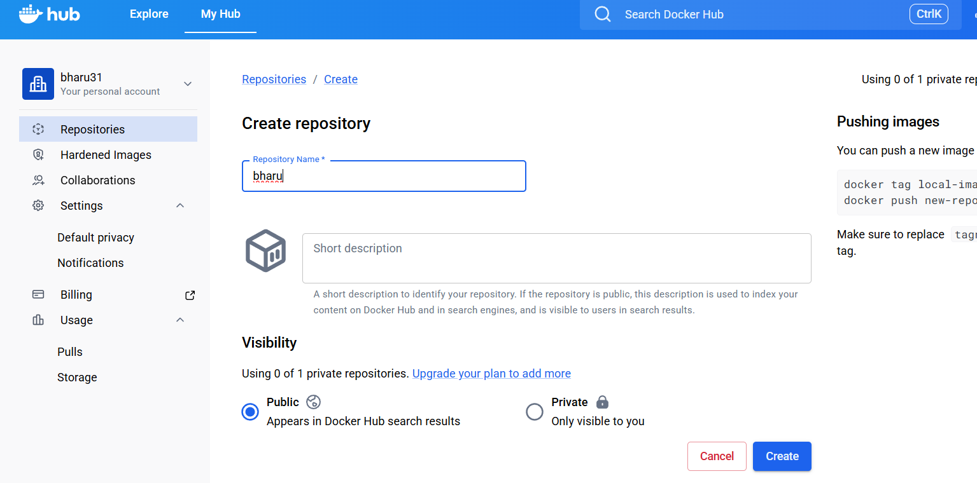
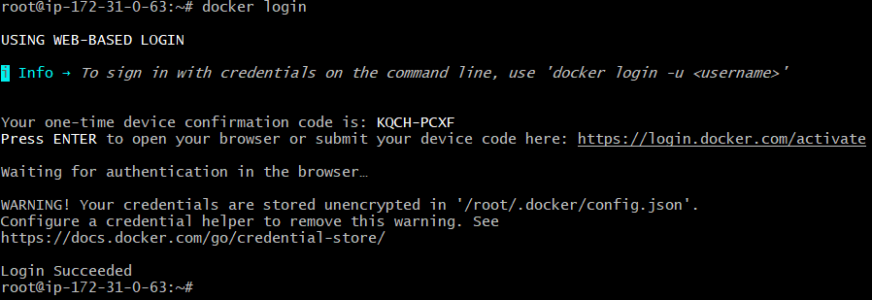
Next click the https://login.docker.com/activate-->open and paste the confirmation codenow all set
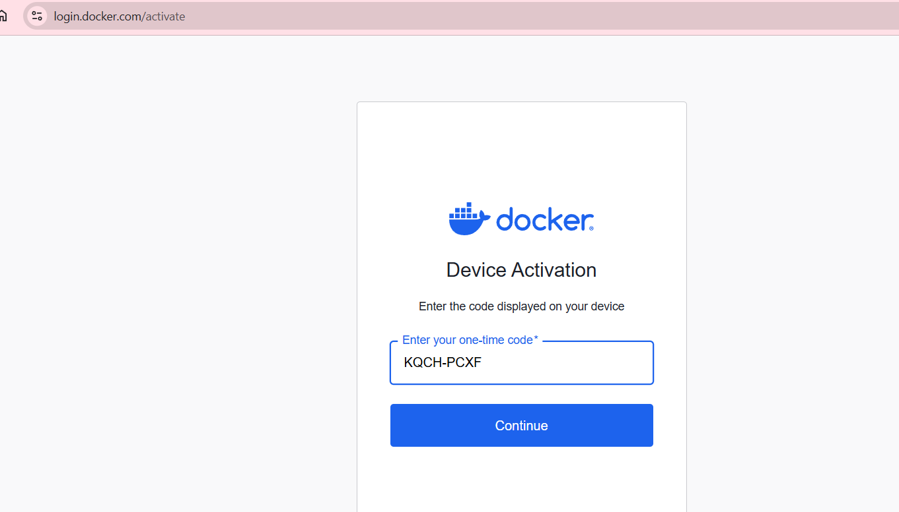

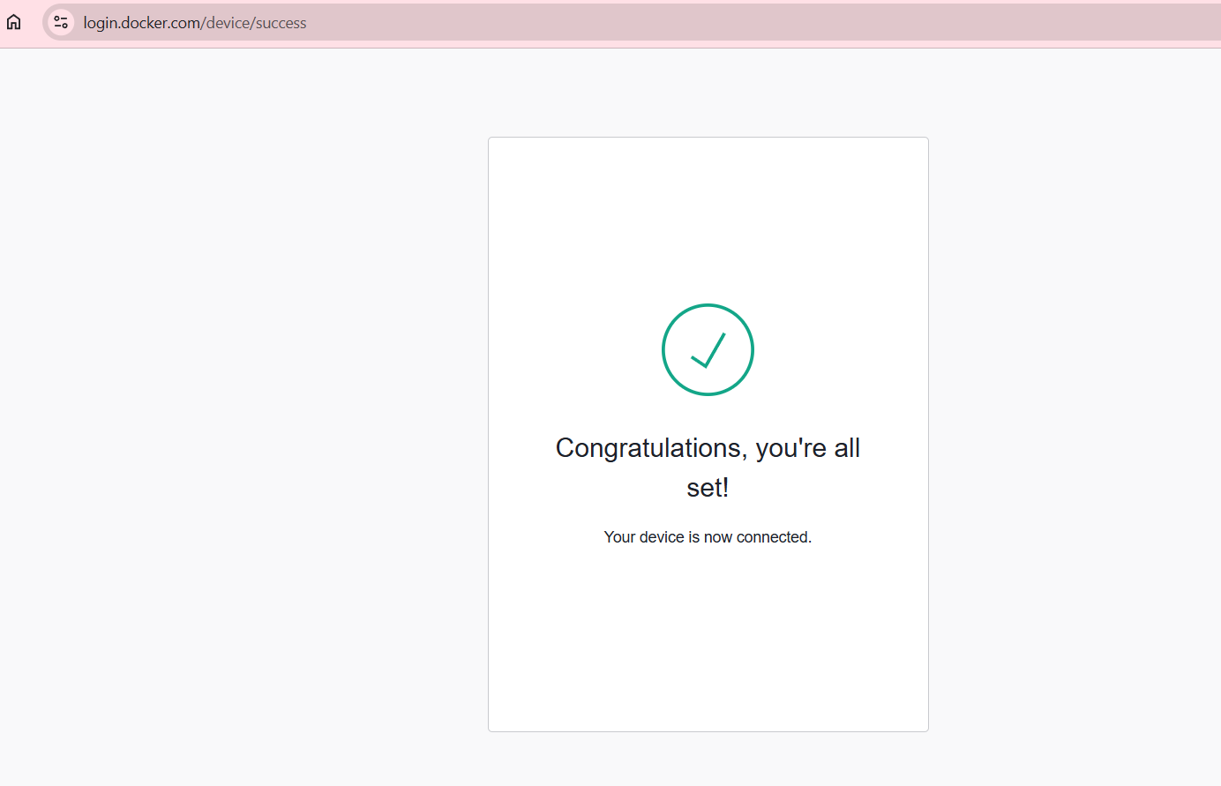
docker tag custom-nginx:v1 monikaroyal19/custom-nginx:v1 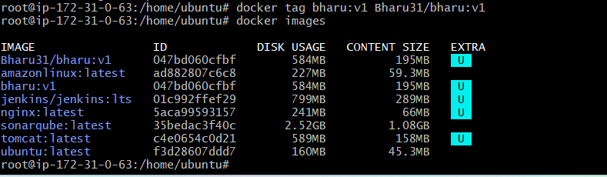 docker push Bharu31/bharu:v1
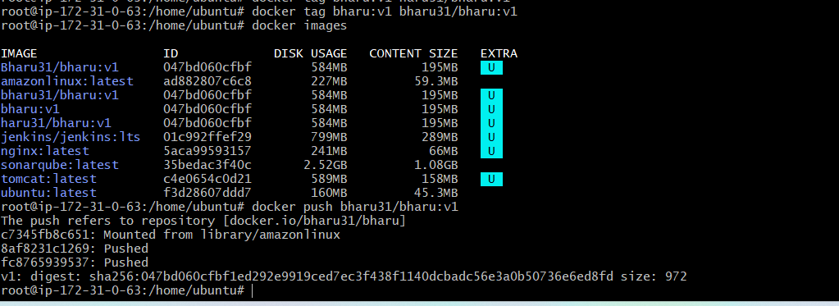
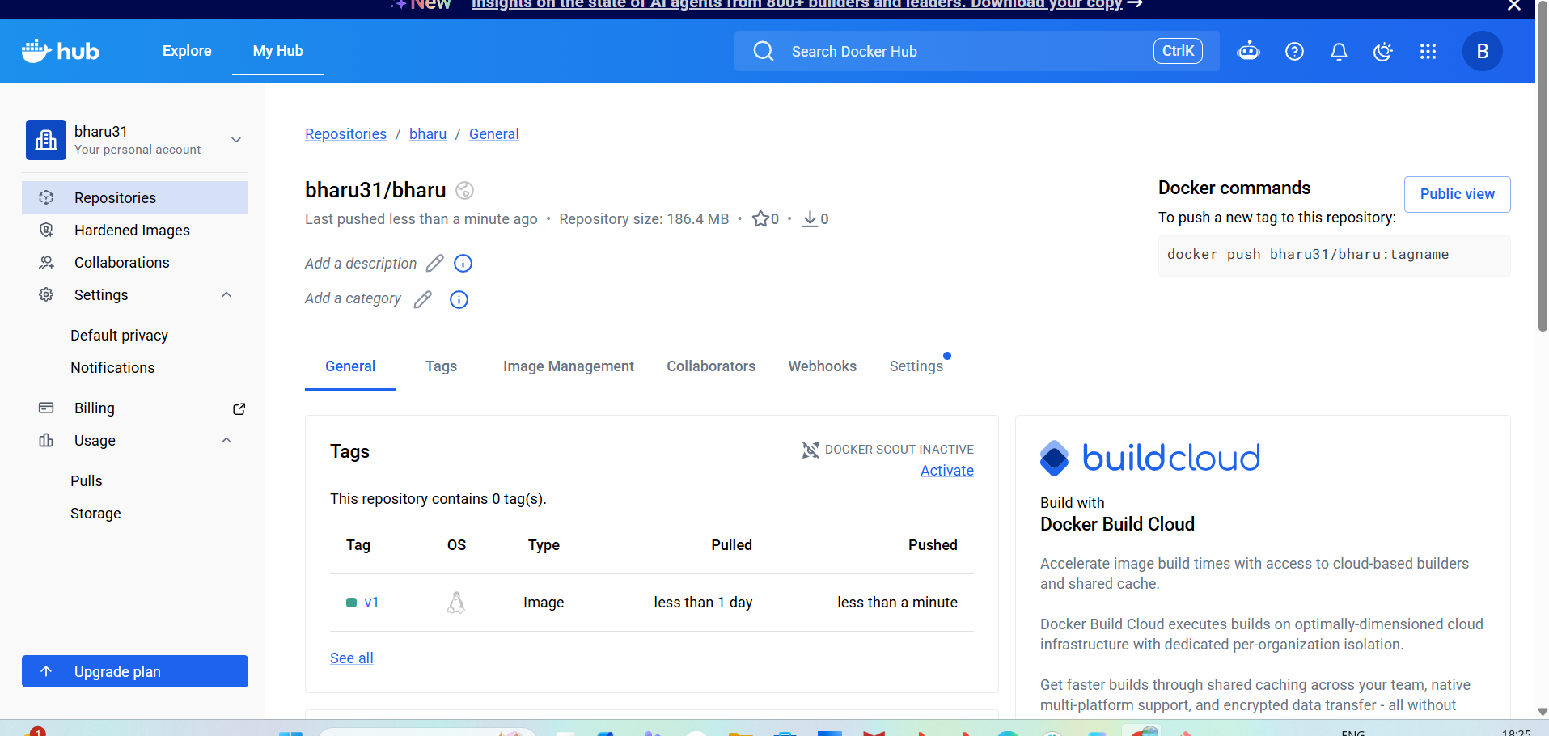
6. push image to AWS ECR
sudo apt updatesudo apt install awscli -y aws –version aws configure and Verify Configuration
aws sts get-caller-identity 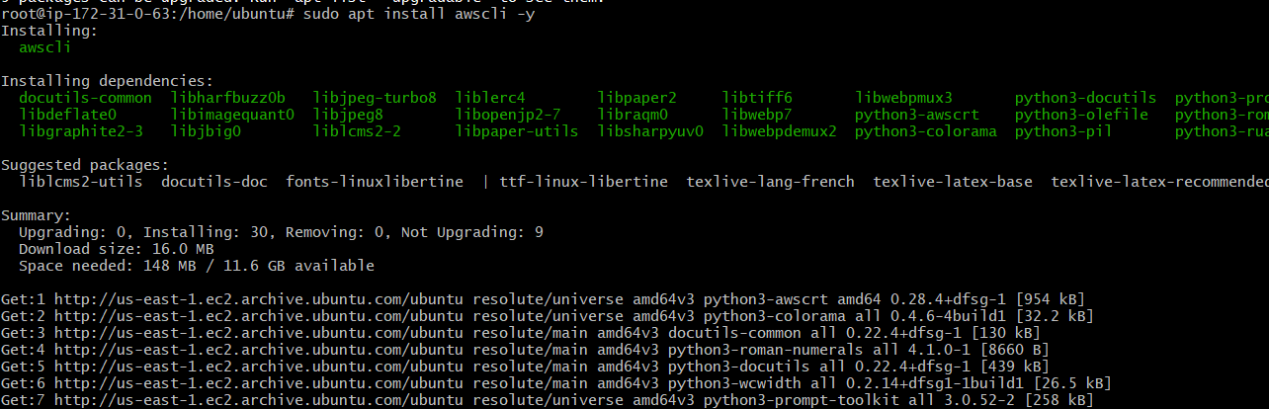
aws ecr get-login-password --region us-east-1 | docker login --username
AWS --password-stdin
- This command goes to create one repository in aws ecr
- 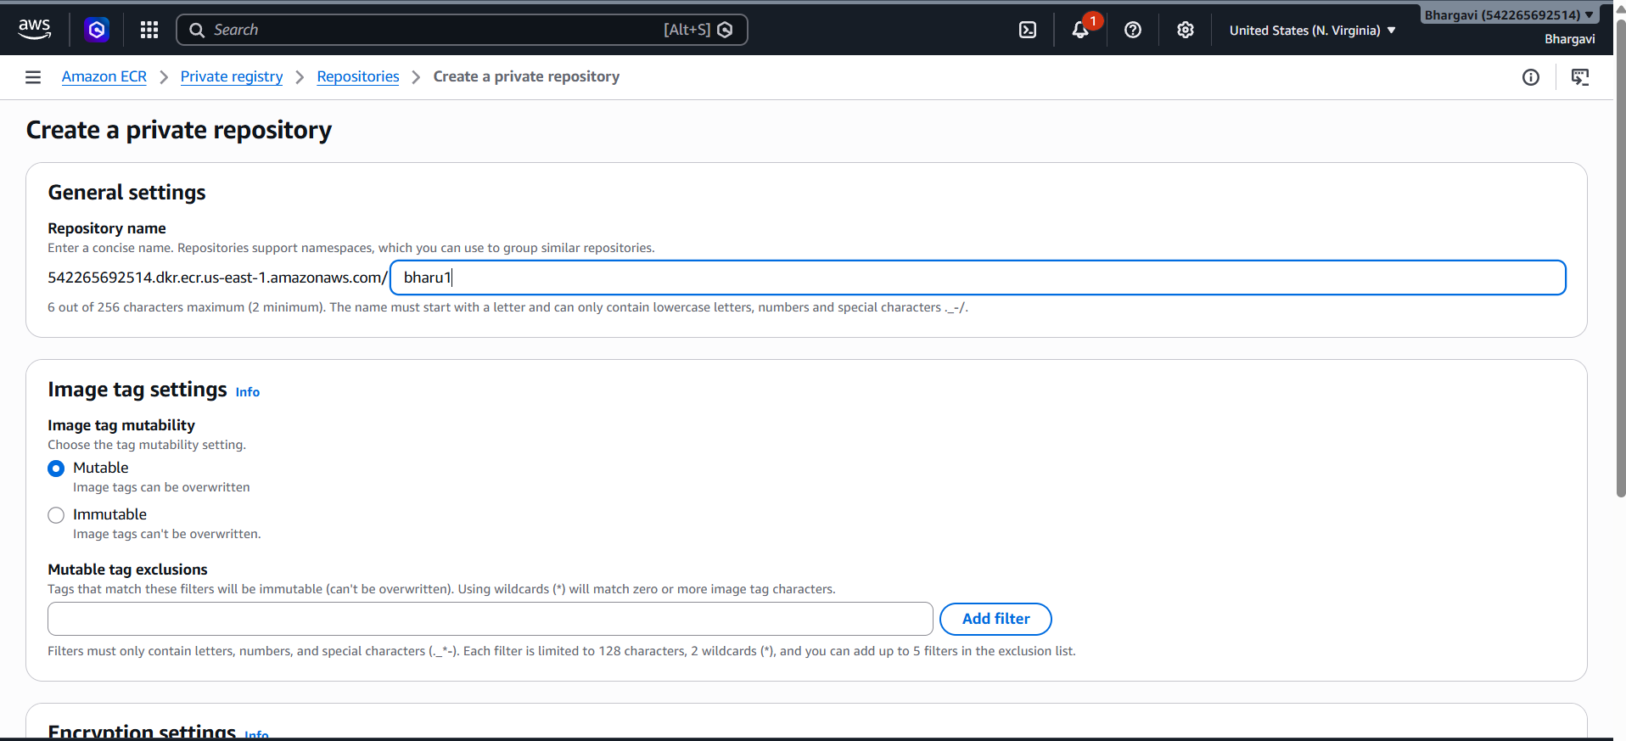
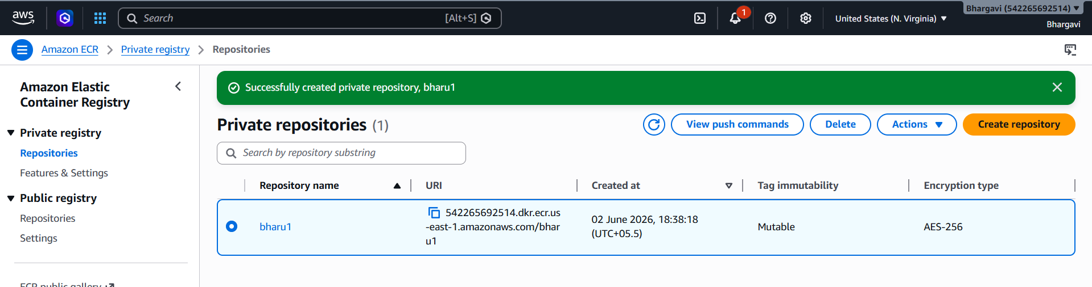
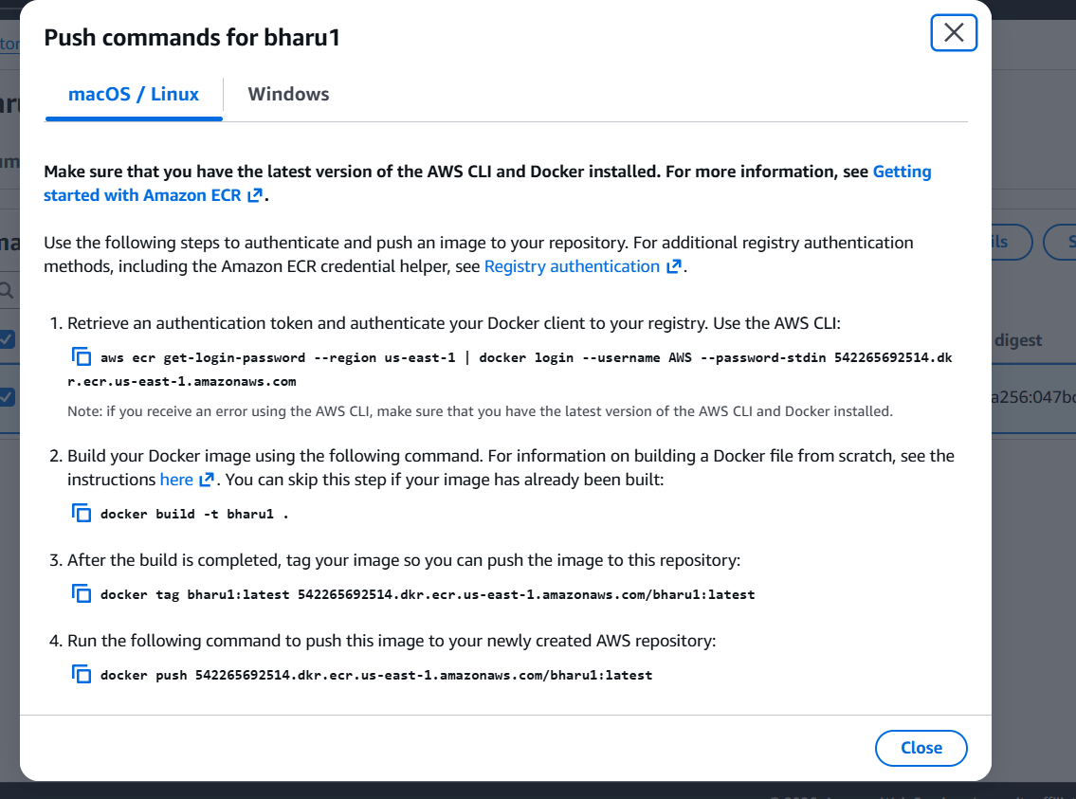

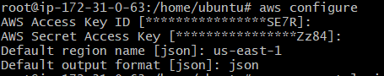
Login using the below command
aws ecr get-login-password --region us-east-1 | docker login --username AWS --password-stdin 542265692514.dkr.ecr.us-east-1.amazonaws.com

url from this
Now lets rename our image to repo name by using command
docker tag bharu:v1 542265692514.dkr.ecr.us-east-1.amazonaws.com/bharu1:v1
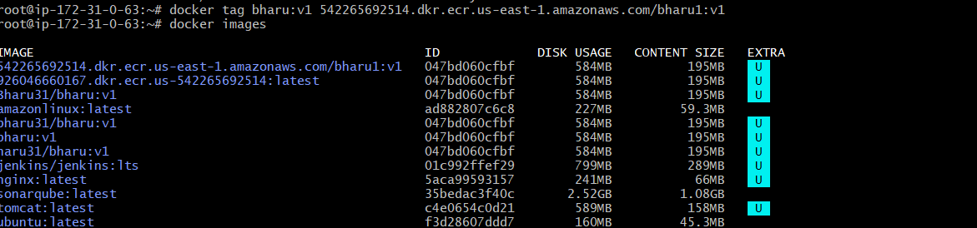
Now lets push to our ECR repo by using command
docker push 542265692514.dkr.ecr.us-east-1.amazonaws.com/bharu1:v1
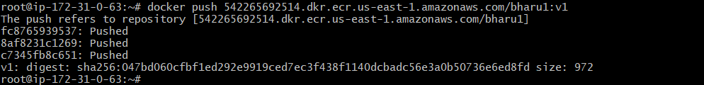
Lets check in the AWS ECR
It has been pushed successfully
