DOCKER-03
1.Create a image from running container.
check if we have any images or not
docker images
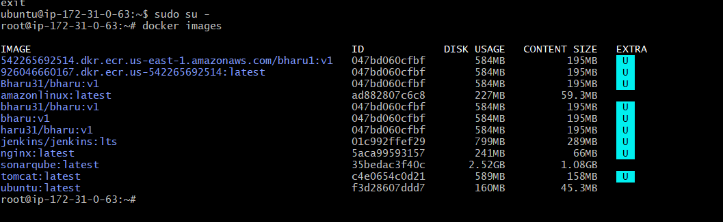
We have running container for that ne need to start an image
create an image using the running container using command
docker commit <container_id> <image_name>:<tag>
and to check if the images has been created or not use command
docker images
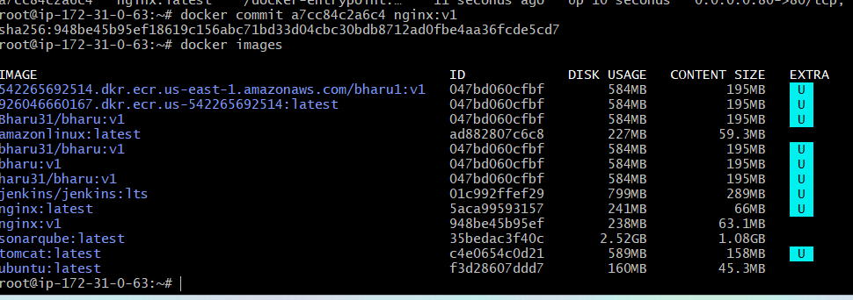
2.Copy image from local machine to docker server and load the image.
For this first Install Docker Desktop in our local machine
Install dockerdesktop from google chrome

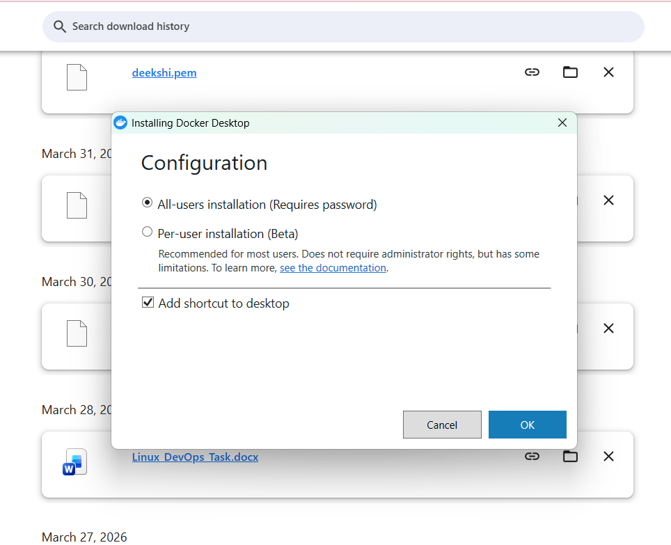
Go to cmd promptwsl –install(windows subsenquence linux)
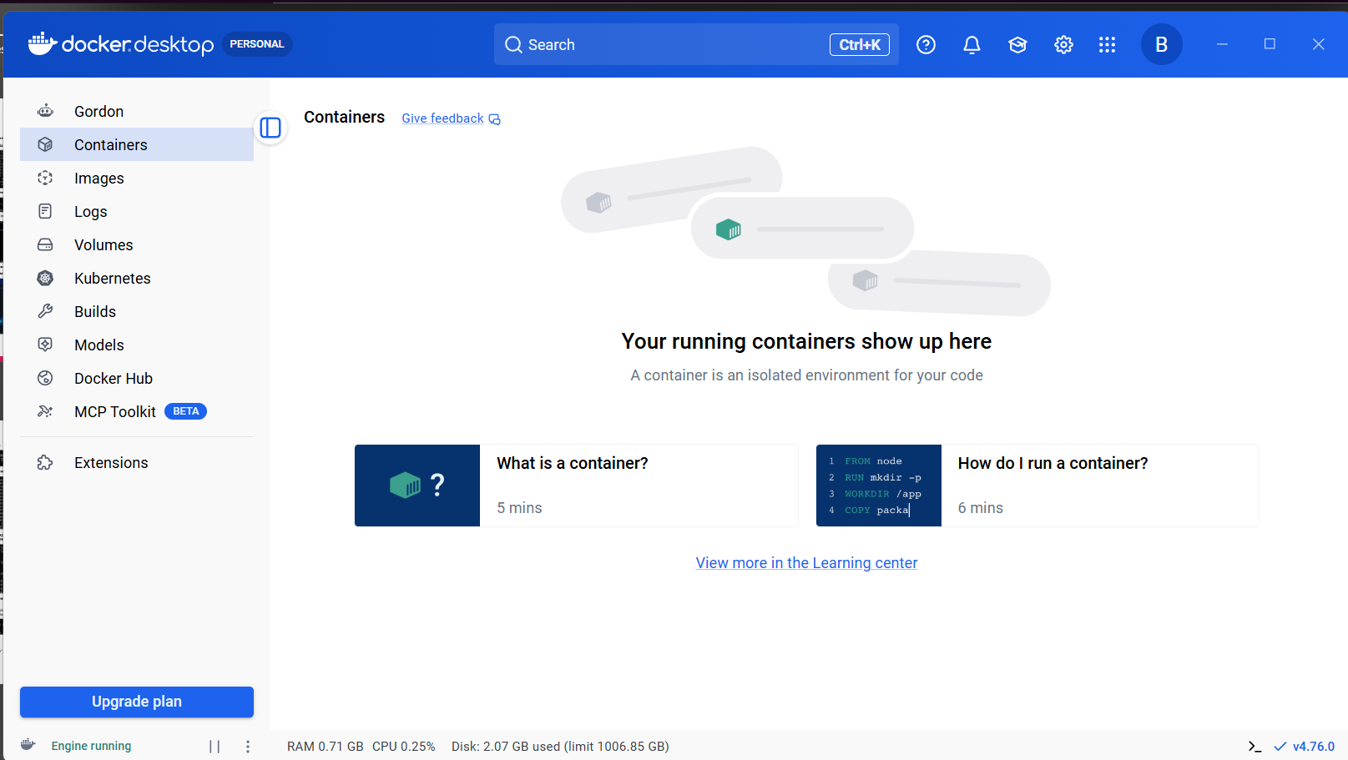
Go to desktopdocker –versiondocker pull tomcatwe have created tomcat succesfully
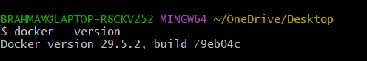

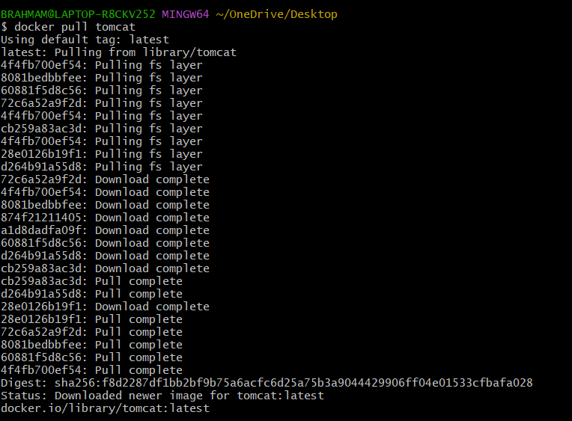
As we cannot copy this image to our server we will be creating a tar file using command
Copied successfully. Now lets check in our server if the file is existing or not
Cd /tmp ⇒checking the tmp folder has we have given this path
Now lets untar the file using command
Docker load -i tomcat.tar
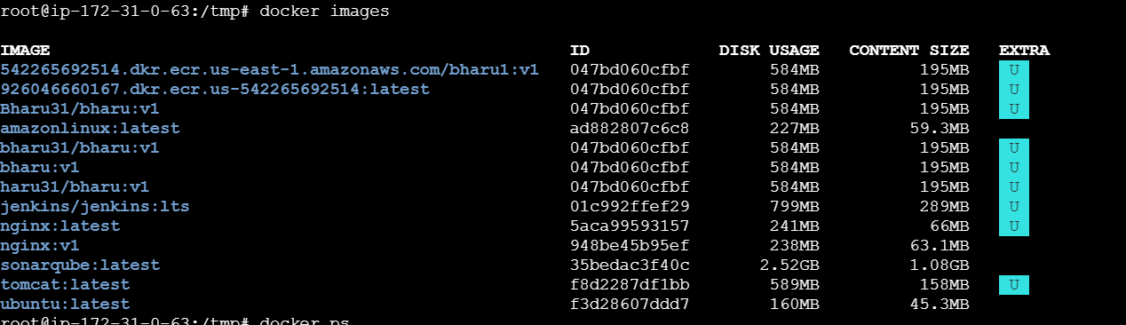
As we can see from above tar file is created now lets move the tar file to our server using command
Scp -i /Users/mohammedimran/Downloads/jenkins.pem tomcat.tar ubuntu@23.20.81.233:/tmp
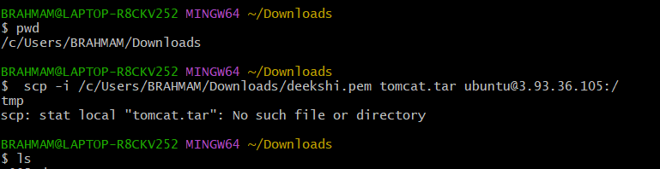
I can go to downloads git bash because of my pem key was in download not in desktop
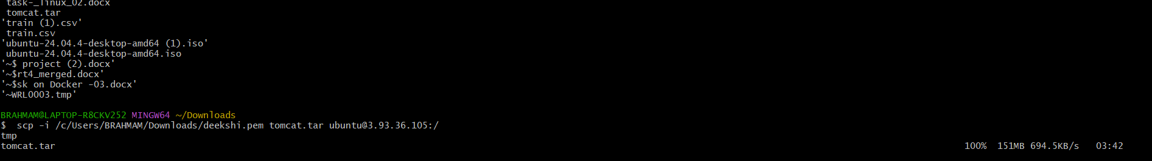
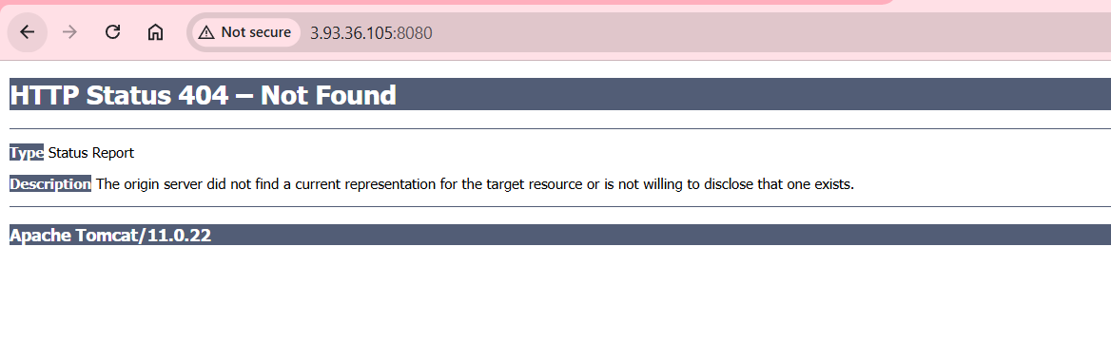3. Create Docker image using alpine and customize with tomcat.
First create a Dockerfile, Using command
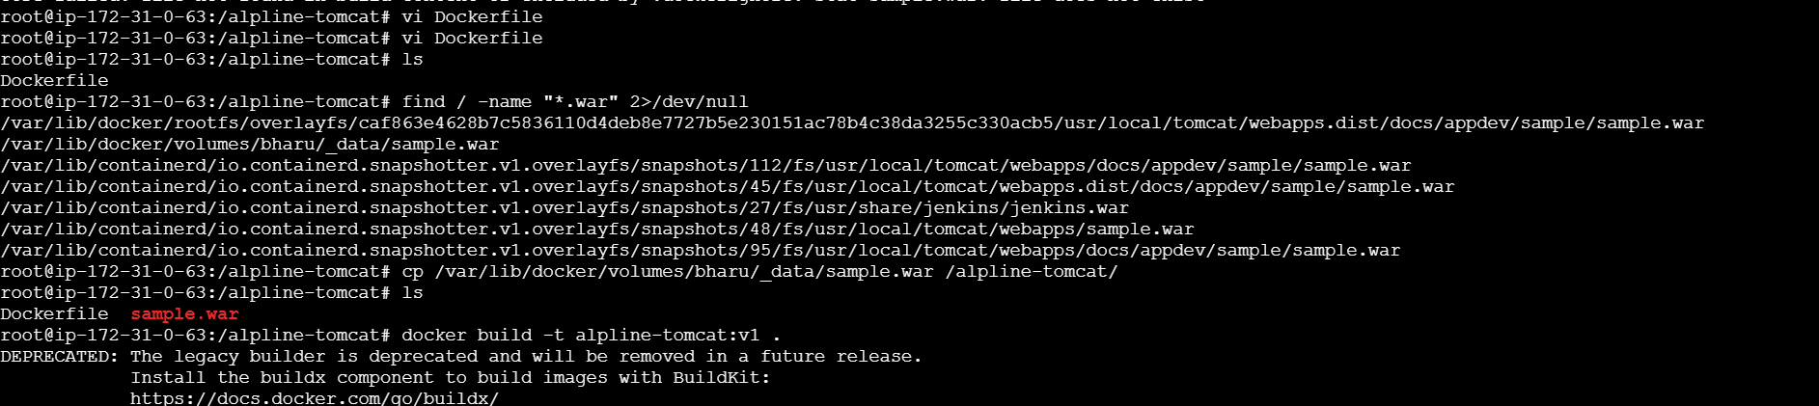
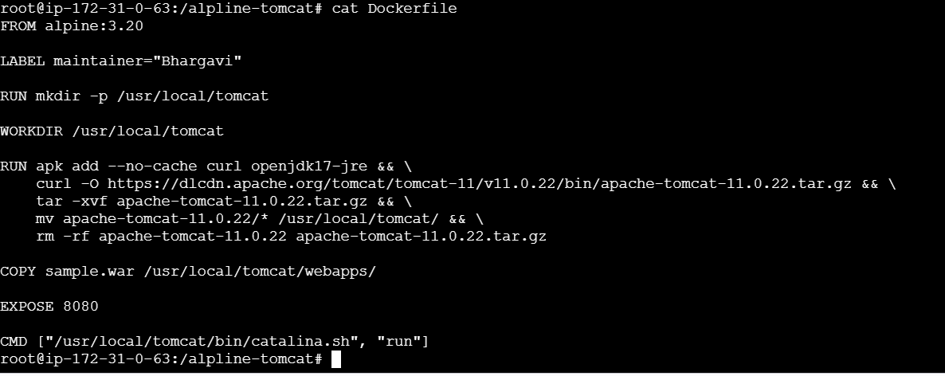

Sample war file is not inside the tomcat then we want to copy to tomcat
Now lets create the image from Docker file
docker build -t tomcat:works .
By using dockerfile a new image has been created
docker images 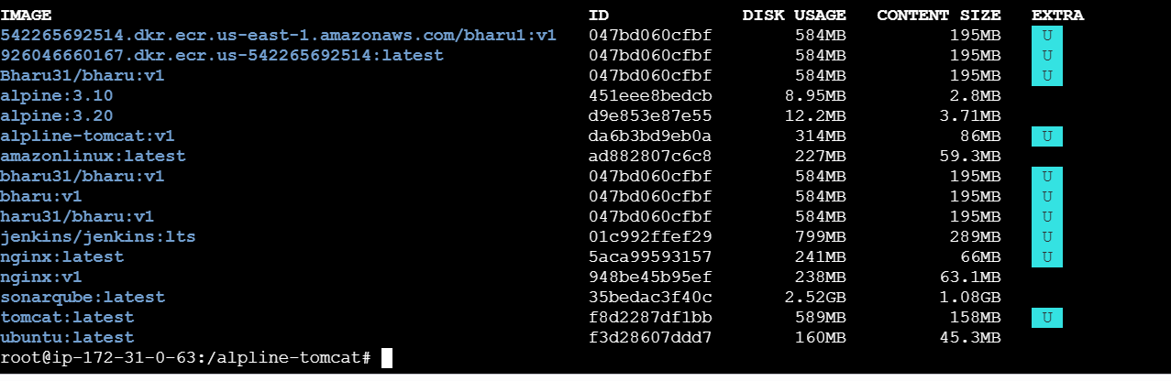
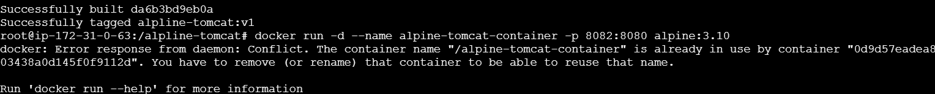
docker run -itd -p -8082:8080 tomcat:works
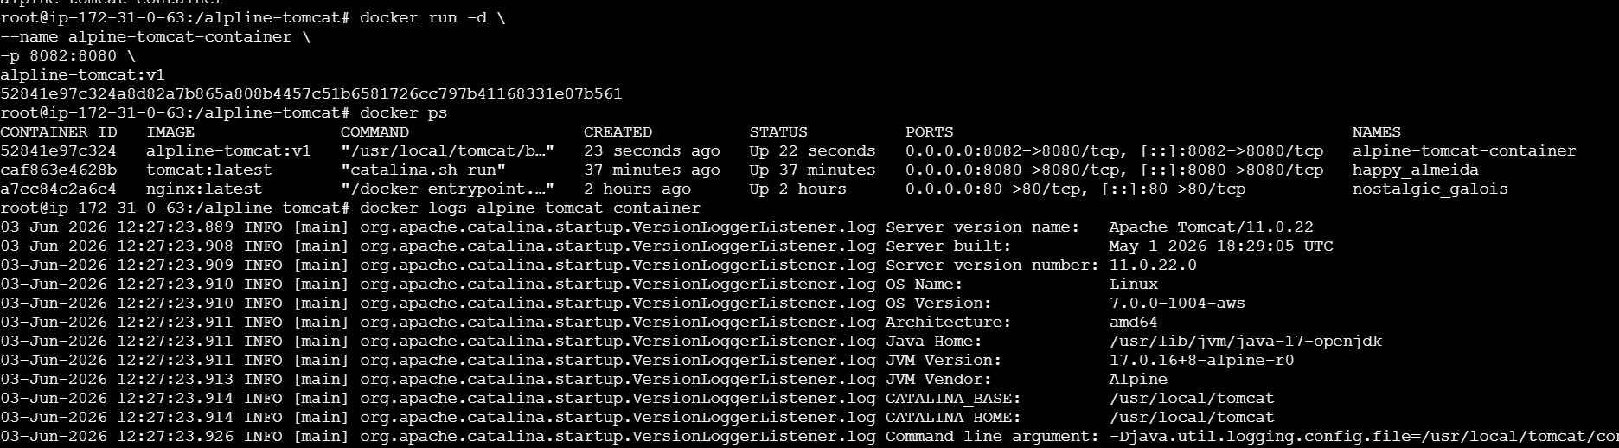
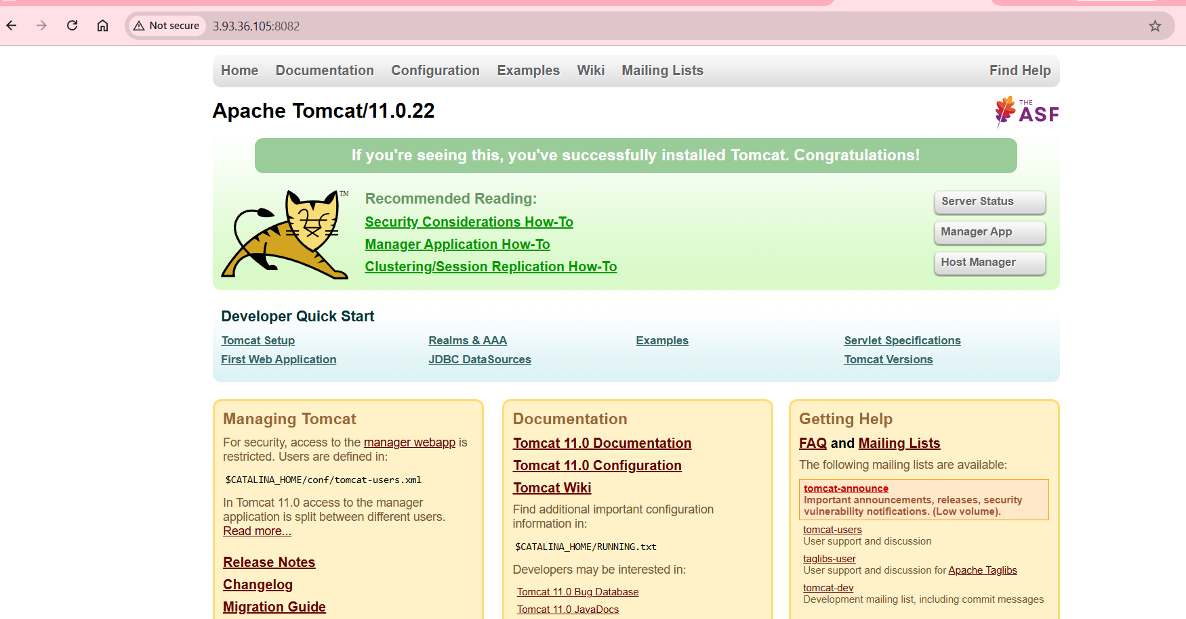
4. Create single stage and multi stage docker file using this source code:
https://github.com/betawins/multi-stage-example.git
Single Stage Docker File:
First lets clone or github repo in our machine
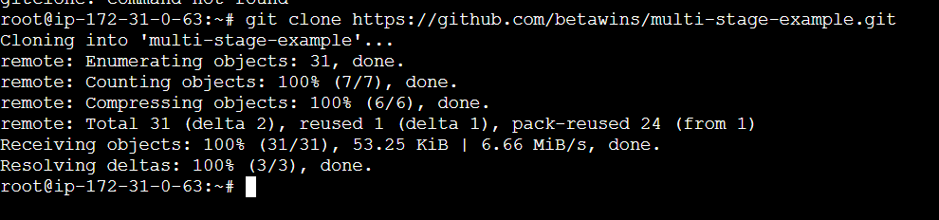
Its cloned do
ls⇒cd multi-stage-example⇒ls⇒vi Dockerfile⇒
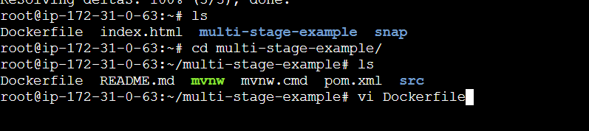
FROM maven:3.8.5-openjdk-11
WORKDIR /app
COPY . .
RUN mvn clean package -DskipTests
EXPOSE 8080
CMD ["sh", "-c", "java -jar target/*.jar"]
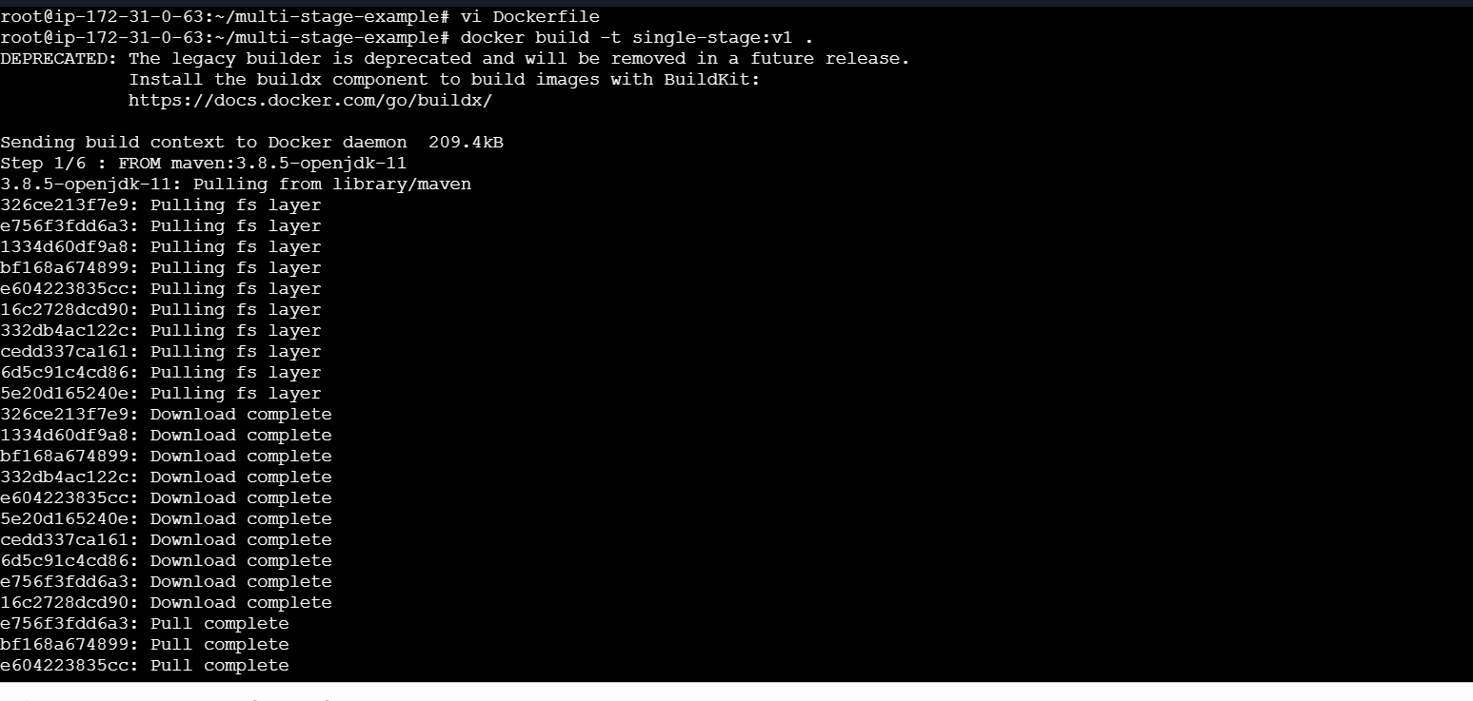
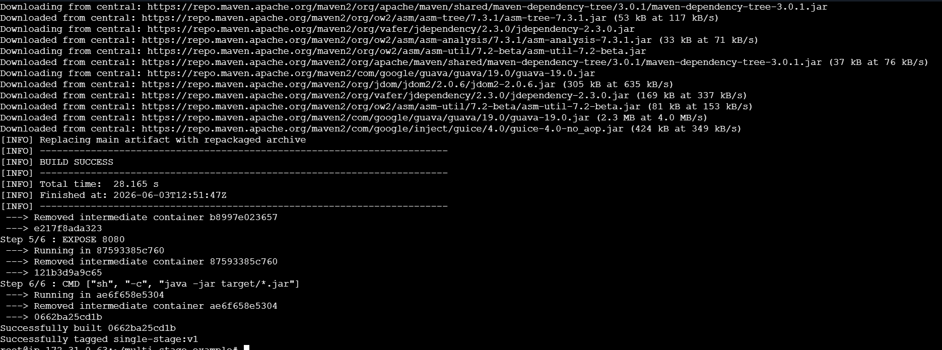
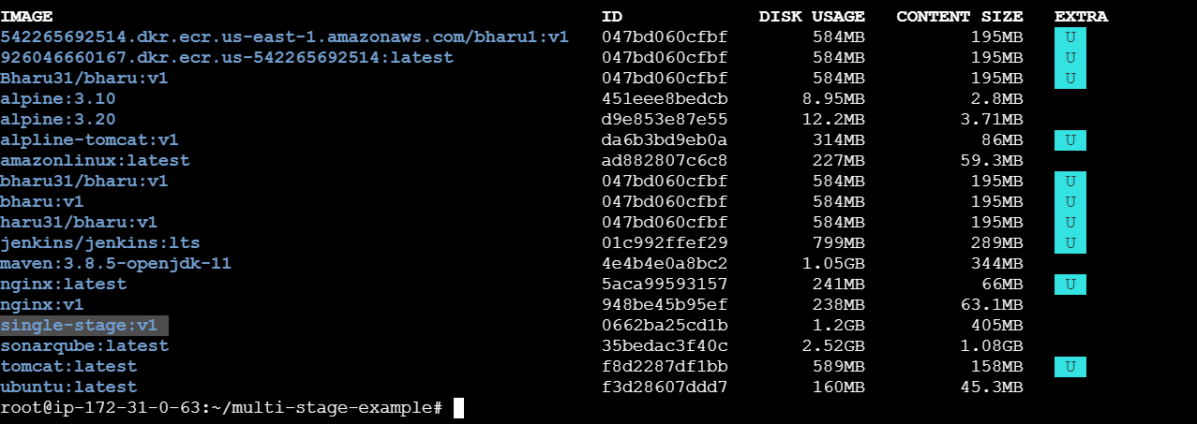
Now lets run the image
docker run -itd -p 8080:8080 –name spring-boot2 single-stage:v1
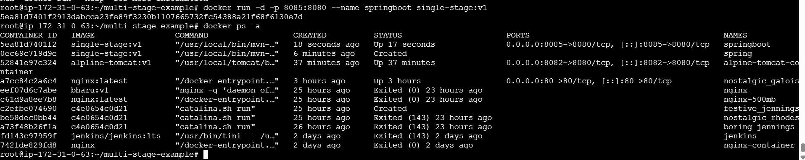
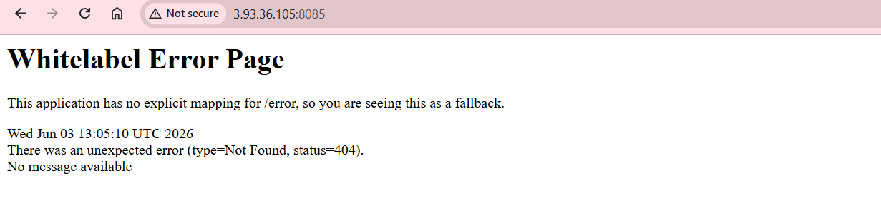
Multi-Stage Dockerfile
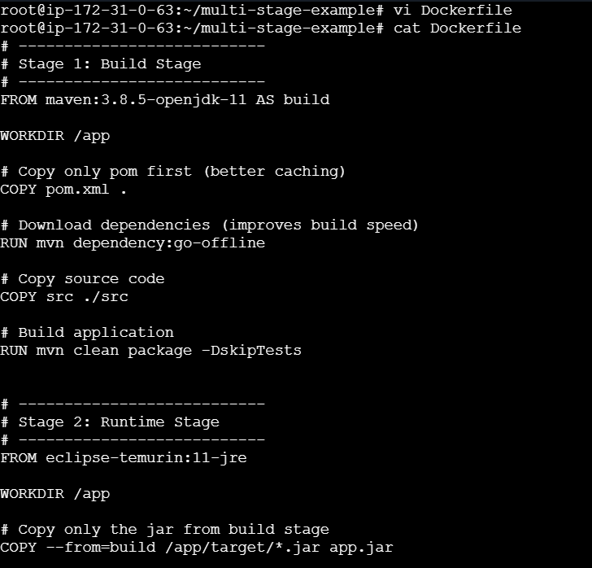
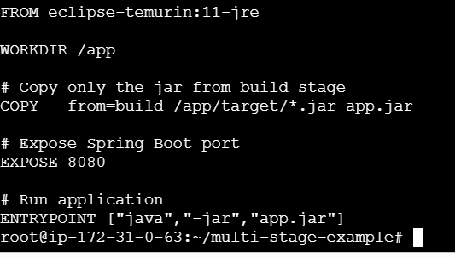
Lets Understand whats happing in the above Docker file:
This Dockerfile is using a multi-stage build to package and run a Java application efficiently. In the first stage (the build stage), it uses a Maven image with OpenJDK 11 to compile the application: it sets a working directory, copies the entire project into the container, and runs mvn clean package to generate a runnable JAR file. In the second stage (the runtime stage), it uses a much smaller Java Runtime Environment (JRE) image to keep the final container lightweight. It sets a working directory, copies only the built JAR file from the first stage into this new image, exposes port 8080 for the application, and finally runs the JAR using java -jar. This approach helps reduce the final image size and improves security by excluding build tools from the runtime environment.
Lets start the image
docker build -t mutistage:v2 .

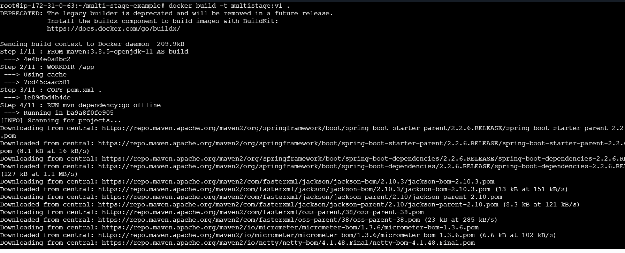
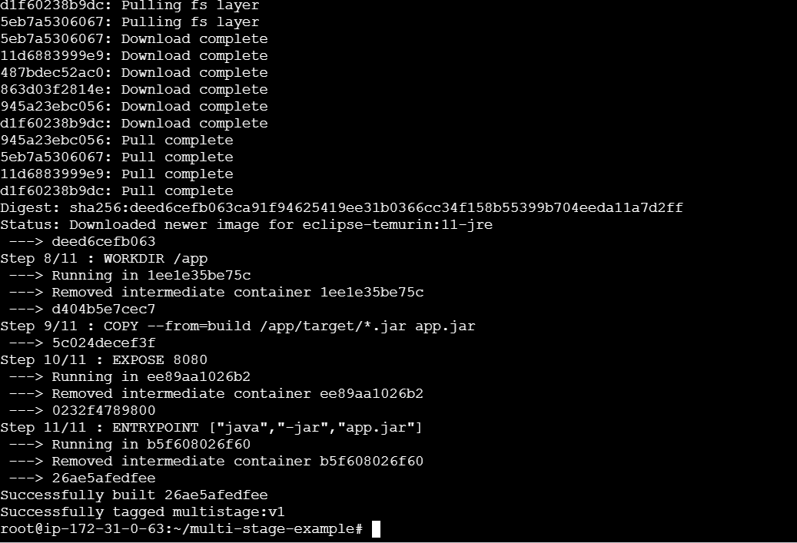
Build is Successfull
Now lets run the container using command
docker run -d -p 8083:8080 –name spring-boot2 mutistage:v1
Docker ps -a to check the running containers
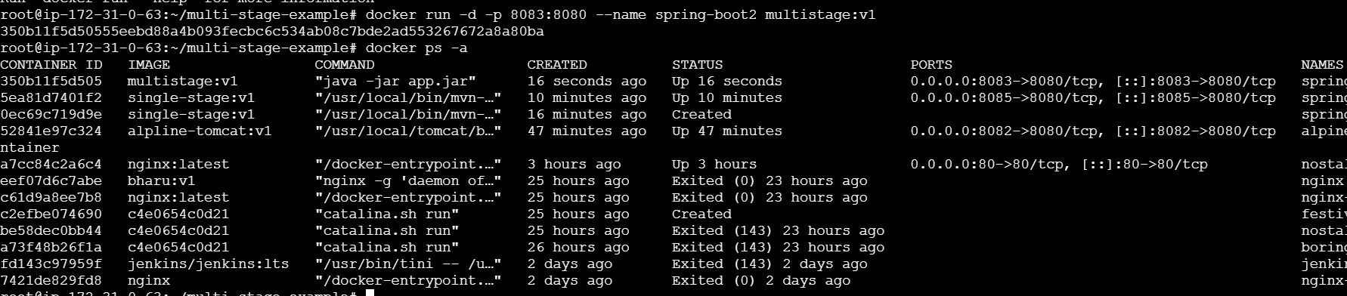
So container is successful created and running
Now lets understand the main difference between single stage and multi stage docker file from the below image
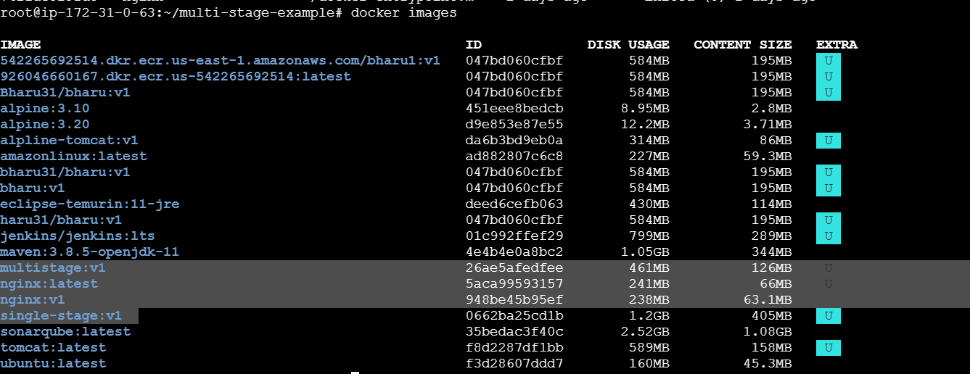
We can see how much size difference there is when we use multistage
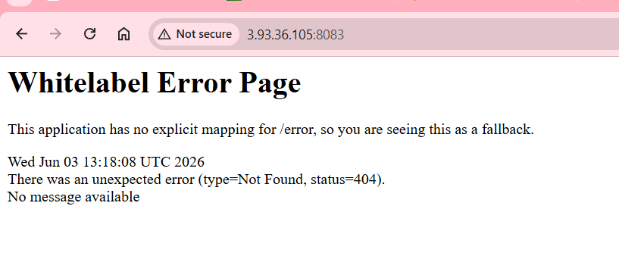
5.Install docker compose and execute sample application
Apt update
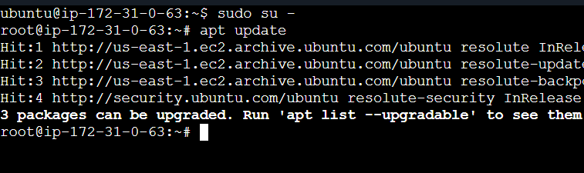
install Docker compose
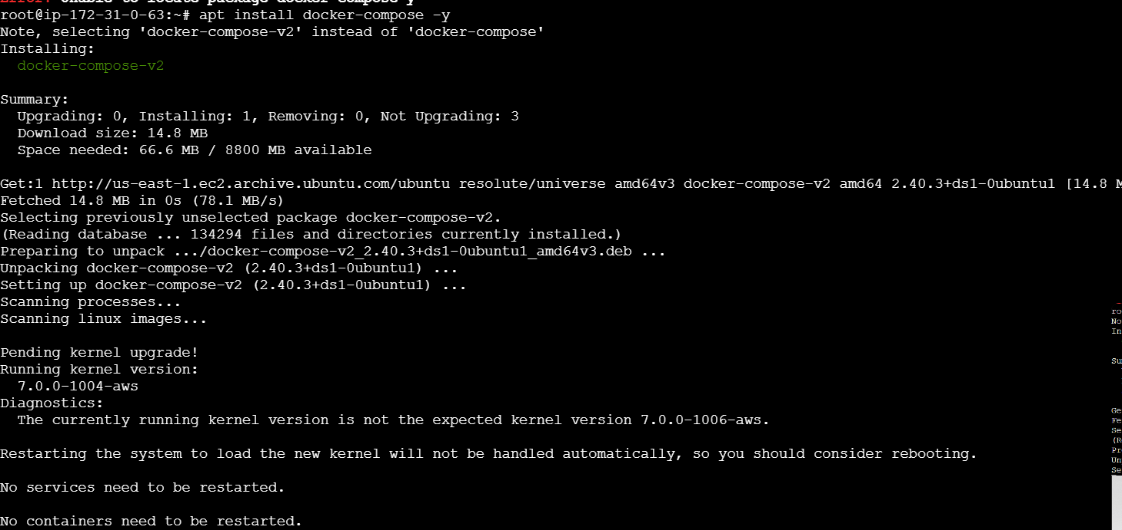
Verify Installation and Create Docker compose project
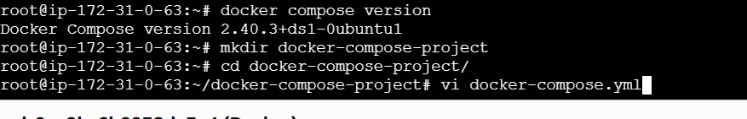
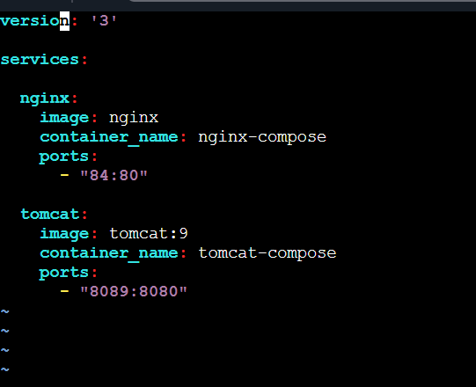
Start Compose
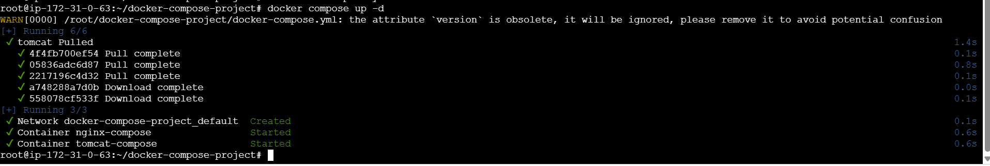
Verify Containers
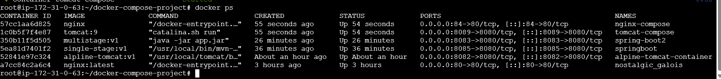
Nginx is run successful and Tomcat also
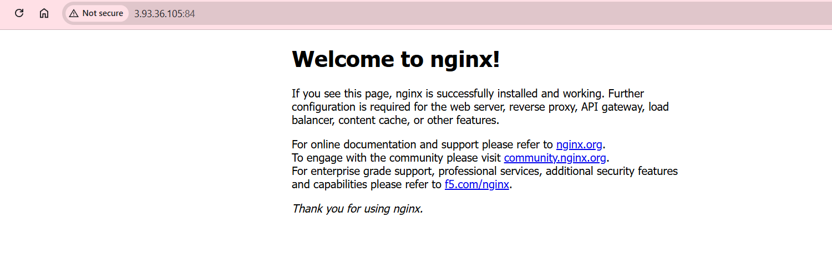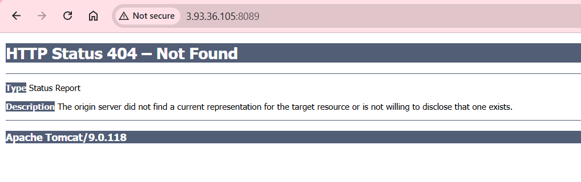
6.Implement a solution to scan images when pushed to the docker registry.
Developer → Docker Build → Push to Registry → Trigger Scan → Report Vulnerabilities → Block/Allow Deployment
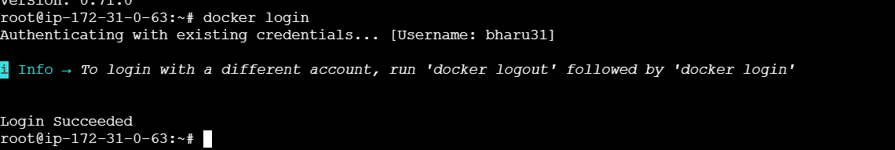
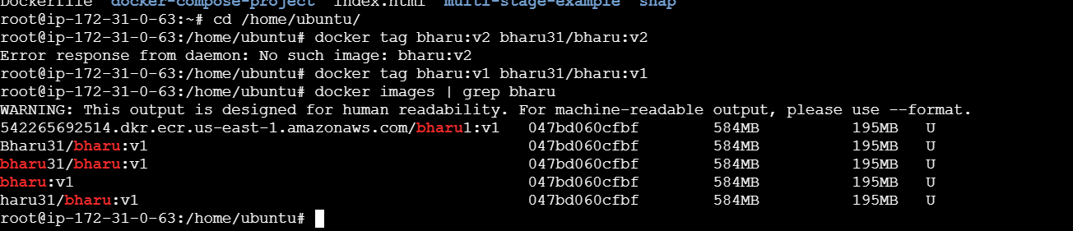
Docker push bharu31/bharu:v1
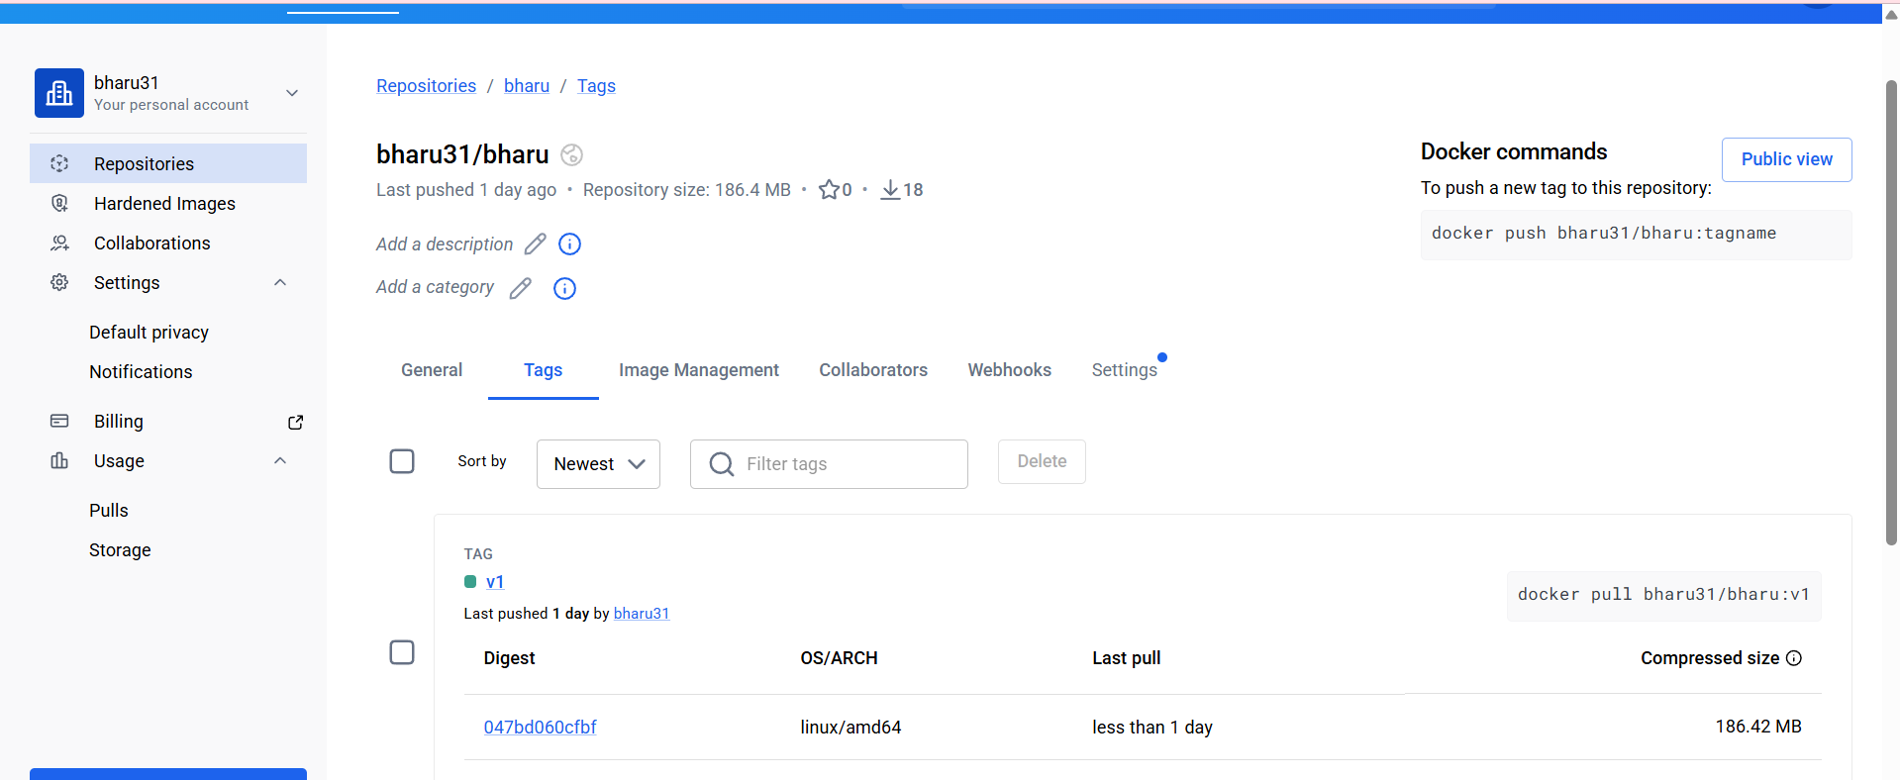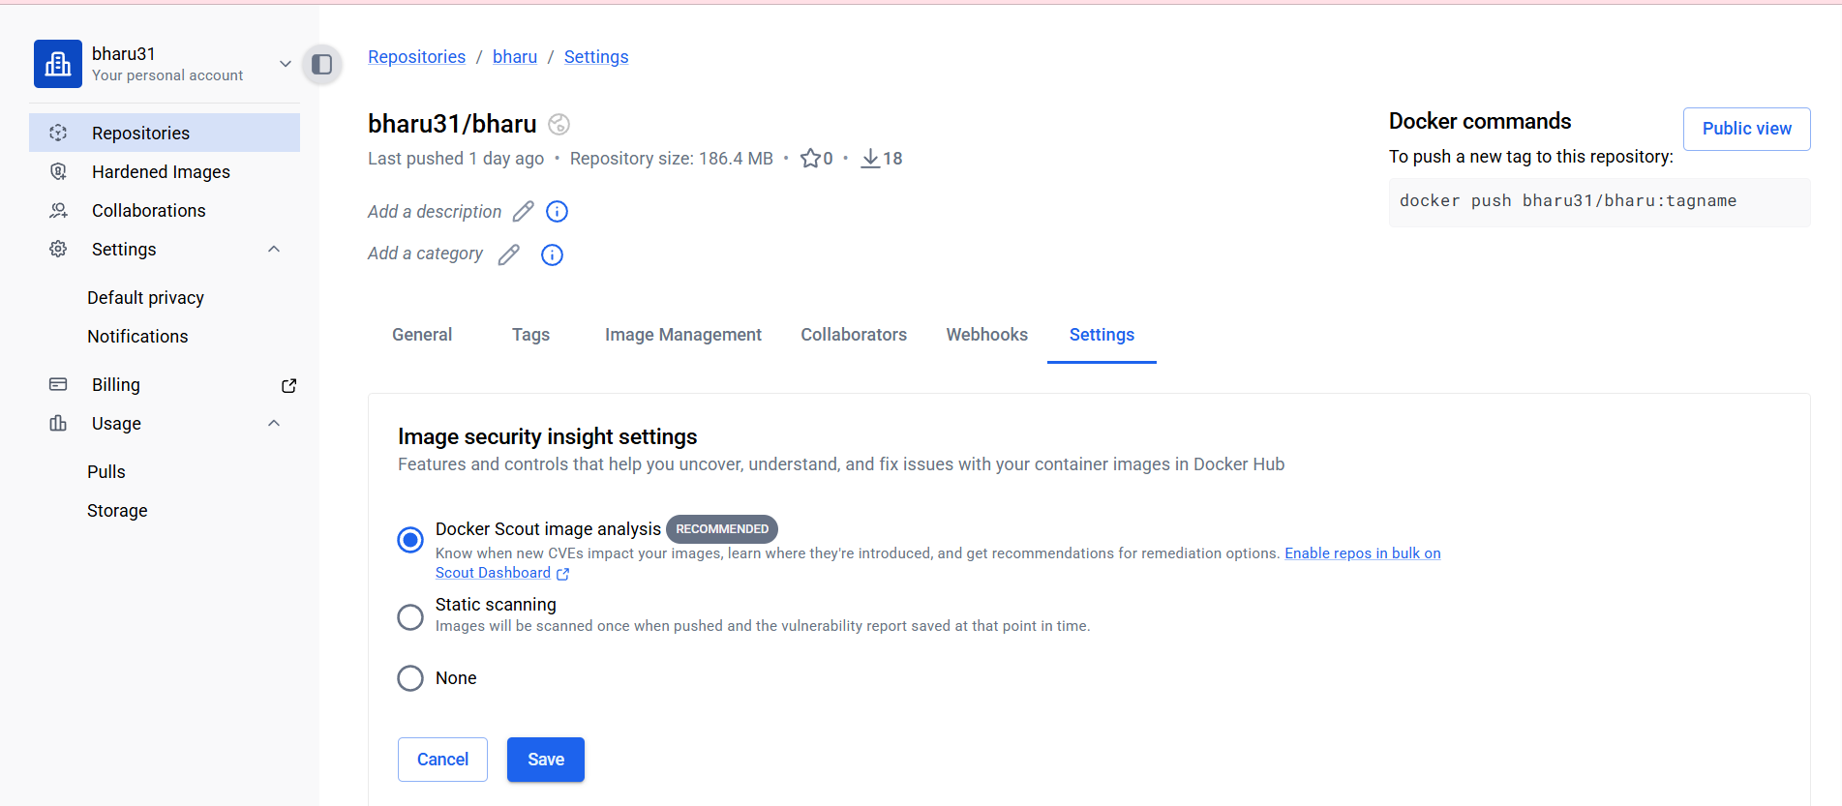
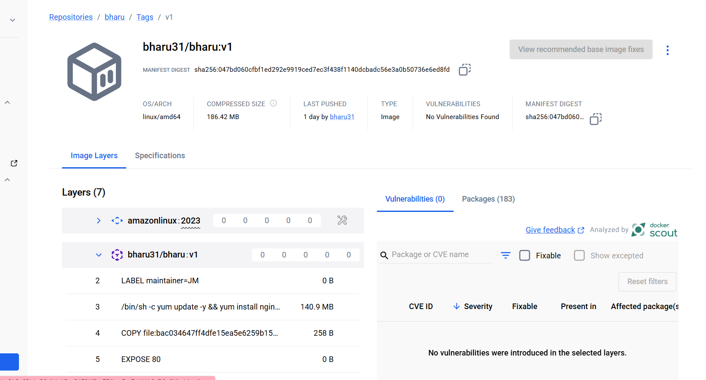
7. Implement soluƟon to scan images when
pushed to AWS ECR.
-Open AWS ECR
-Go to features and setting
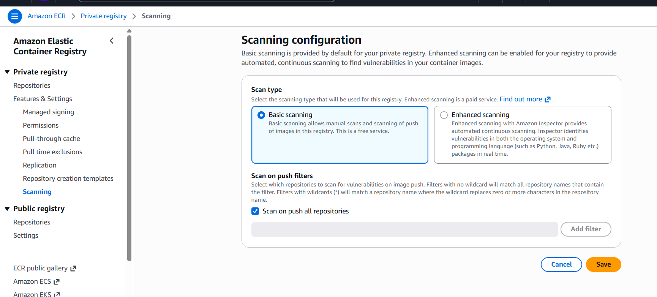
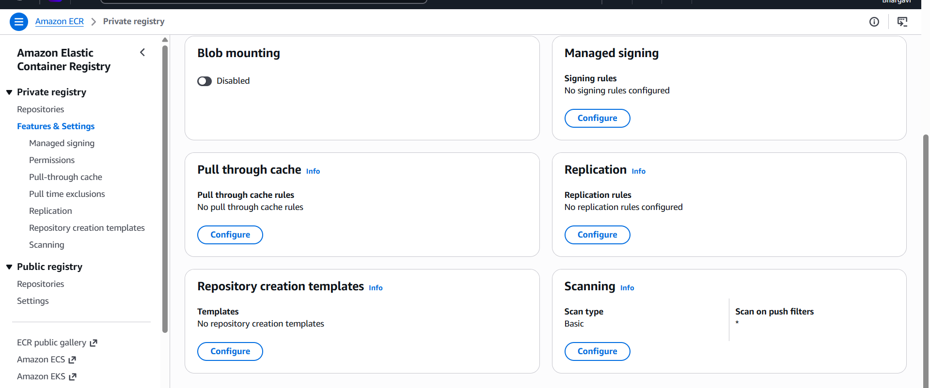
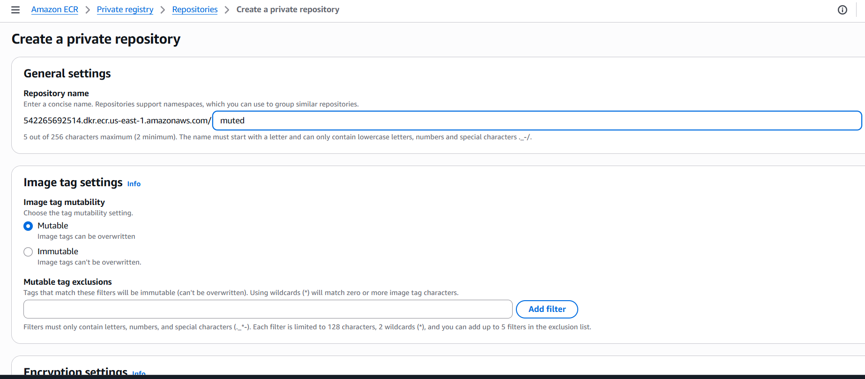
Login to ECR
aws ecr get-login-password --region us-east-1 | docker login --username
AWS --password-stdin 309615786740.dkr.ecr.us-east-1.amazonaws.
com
Tag Image
docker tag nginx-apache:v2 309615786740.dkr.ecr.us-east-1.amazo
naws .com/ nginx-scan:latest
verify: docker images | grep nginx-scan
Push image
docker push 309615786740.dkr.ecr.us-east-1.amazonaws.com/nginx-
scan:latest
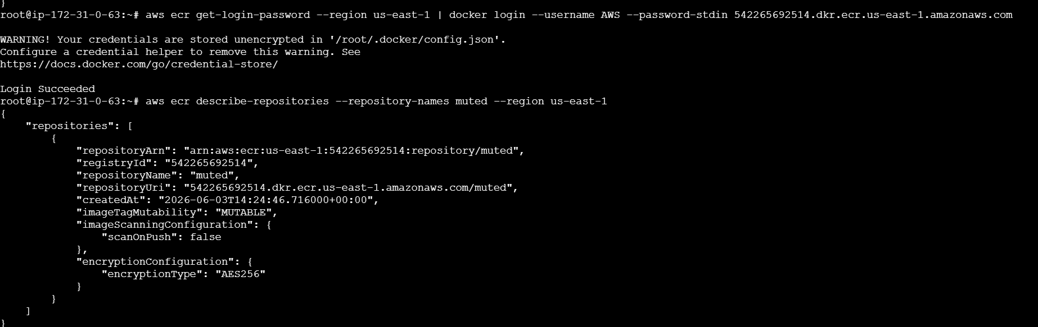
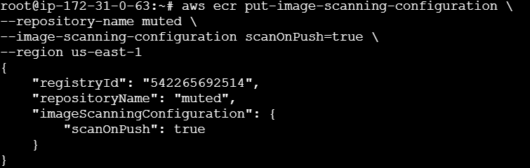
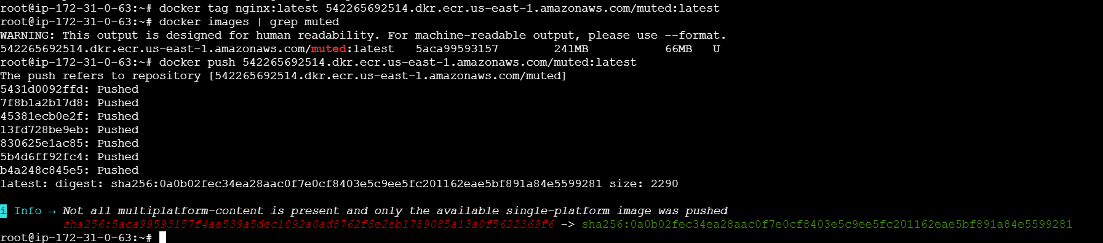
AWS Console → ECR → Repositories → nginx-scan → Images →latest → Scan Findings

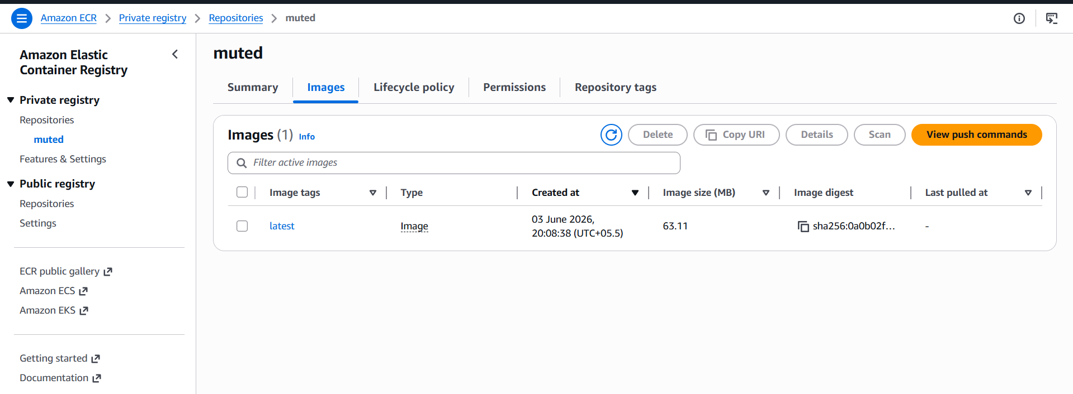
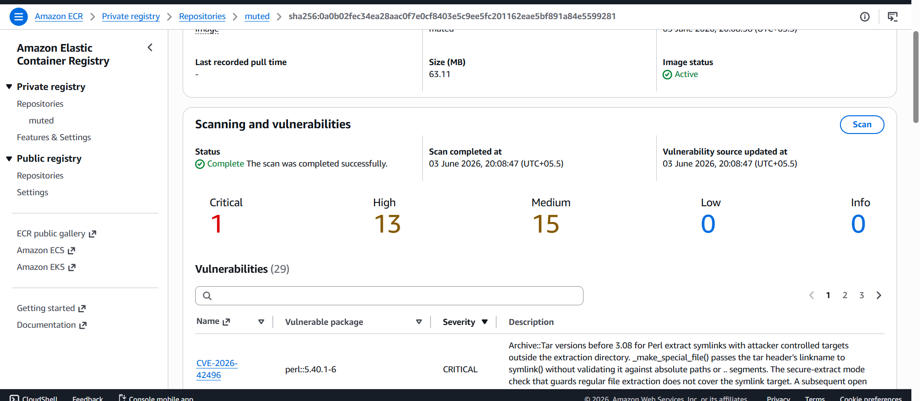
8.Create a Jenkins pipeline to create a docker image and push the
image to Docker hub.
docker run -d \
--name jenkins-server \
--restart unless-stopped \
-p 9090:8080 \
-p 50000:50000 \
-v jenkins_home:/var/jenkins_home \
-v /var/run/docker.sock:/var/run/docker.sock \
-u root \
jenkins/jenkins:lts

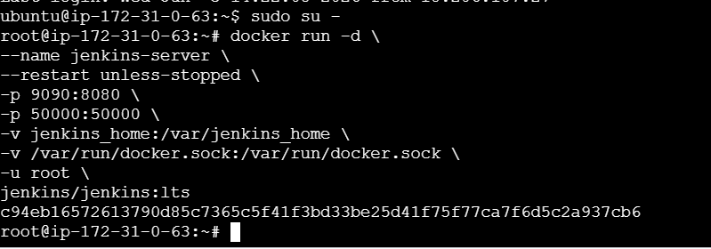
docker start jenkins-server
docker exec -it jenkins-server cat
/var/jenkins_home/secrets/initialAdminPassword
Install both Docker and docker pipeline
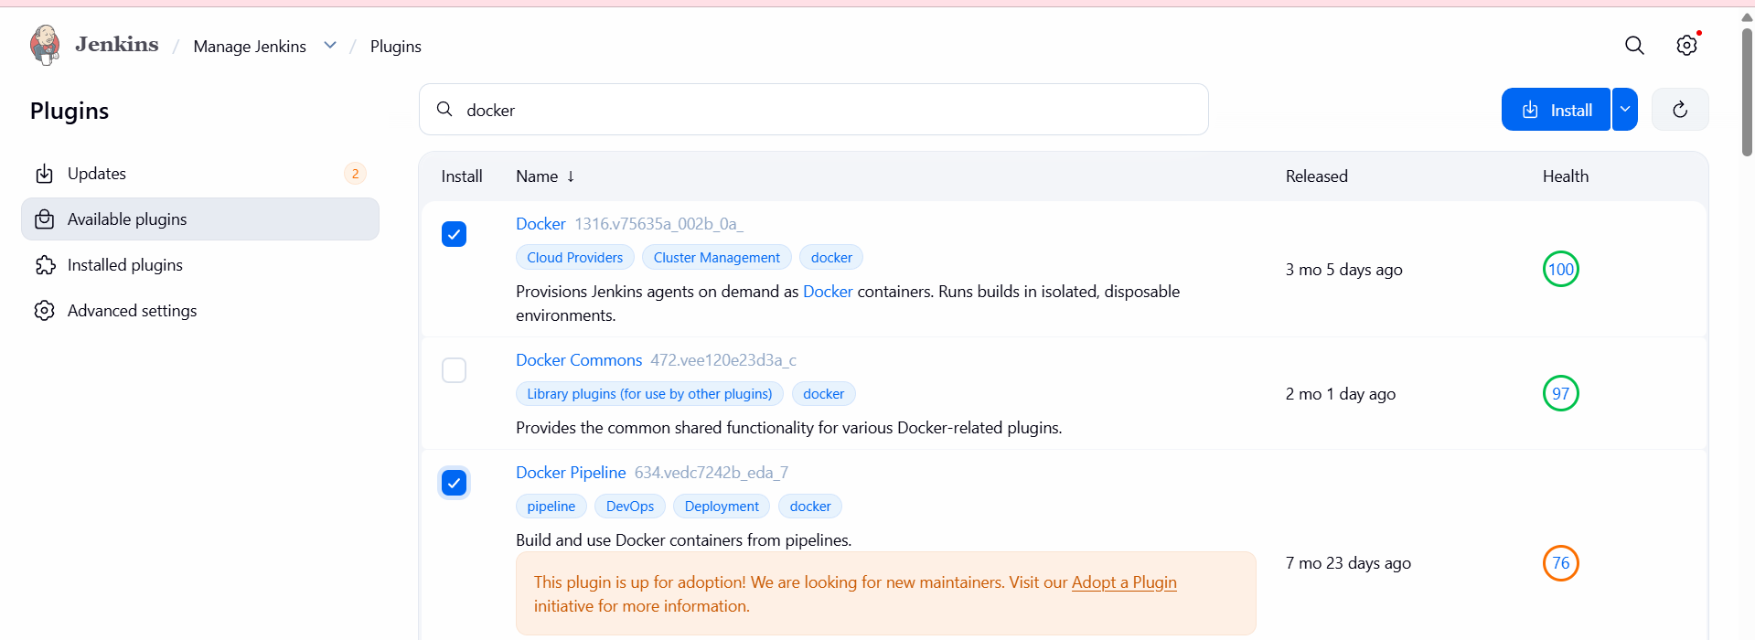
Add Docker Hub Credentials
Manage Jenkins → Credentials → System → Global Credentials → Add
Credentials
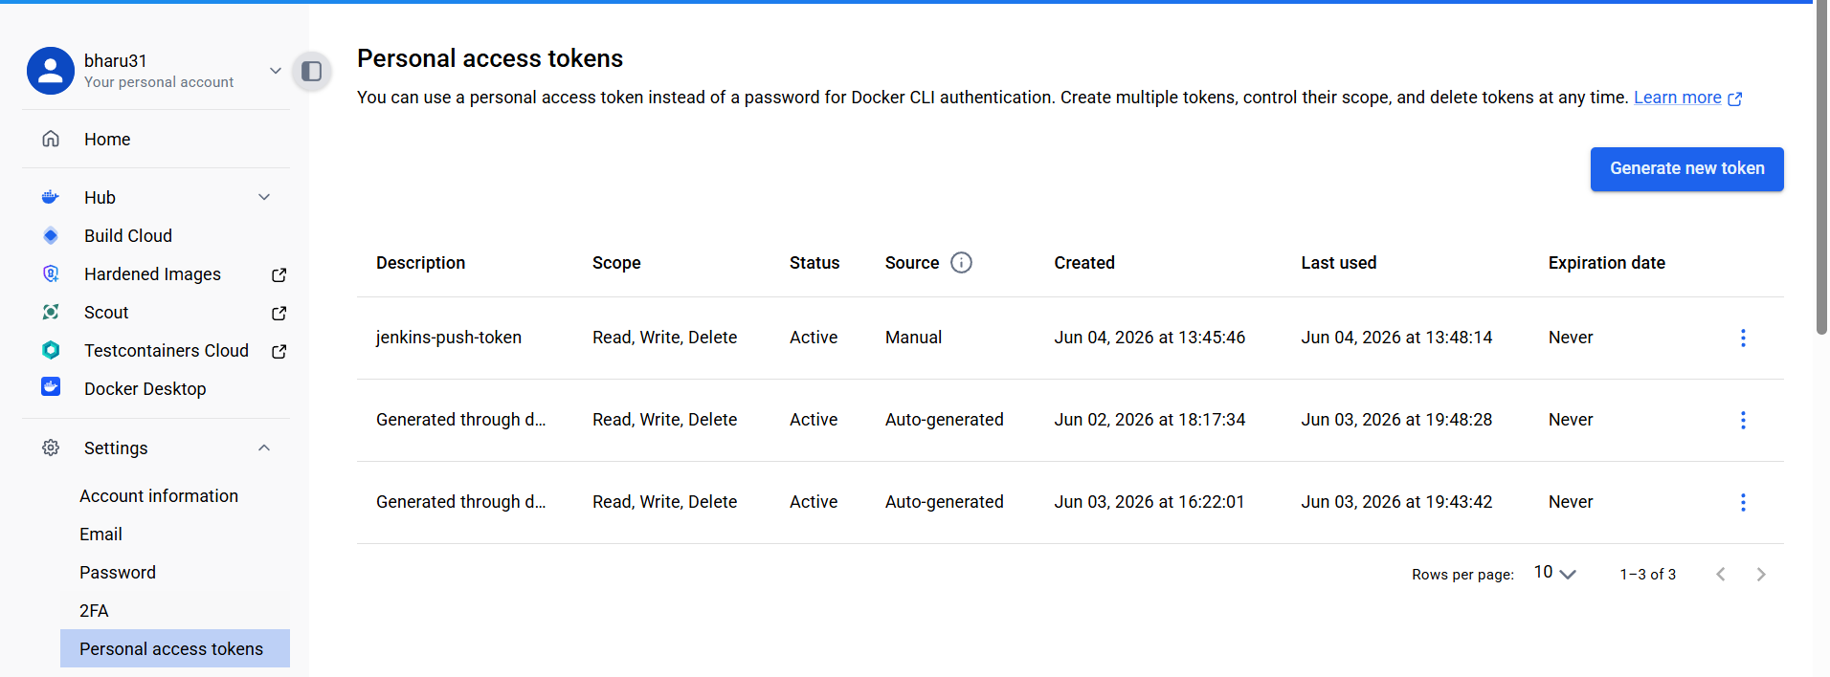
- We have to created in dockerhub personal acces tokens and genearate that token copy that password add that password.
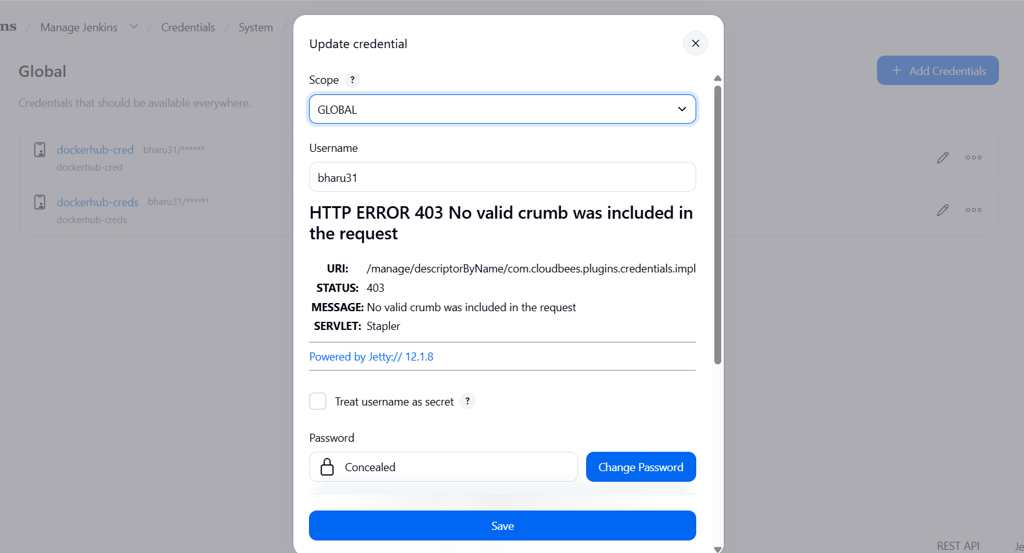
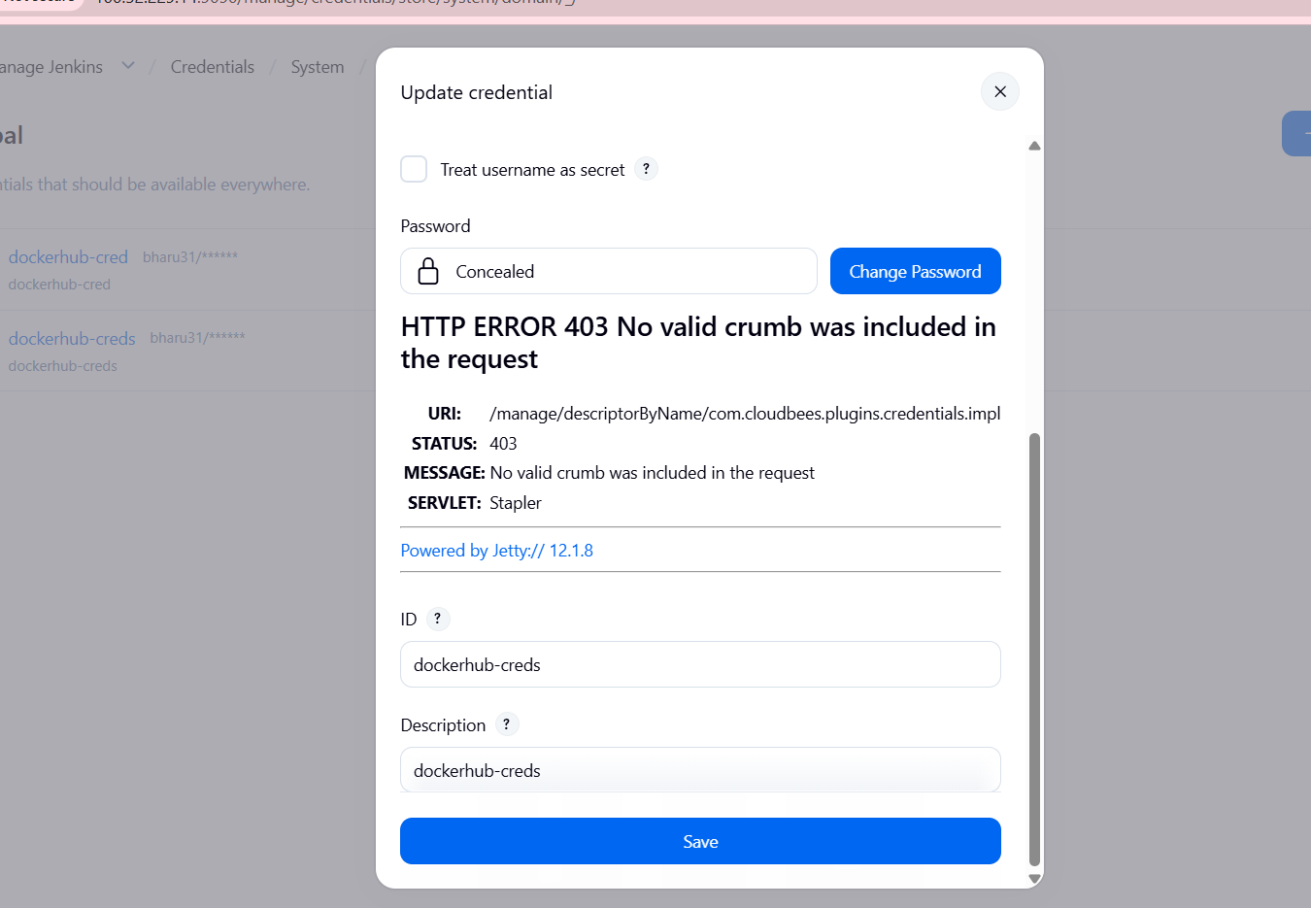
Create Pipeline Job

New Item → Pipeline → Enter Job Name → OK

pipeline {
agent any

environment {
DOCKER_IMAGE = "bharu31/bharu:v3"
}

stages {

stage('Clone Code') {
steps {
git branch: 'master',
url: 'https://github.com/betawins/multi-stage-example.git'
}
}

stage('Create Dockerfile') {
steps {
writeFile file: 'Dockerfile', text: '''
FROM maven:3.8.6-openjdk-8 AS builder
WORKDIR /app
COPY . .
RUN mvn clean package

FROM eclipse-temurin:8-jre
WORKDIR /app
COPY --from=builder /app/target/*.jar app.jar
EXPOSE 8080
ENTRYPOINT ["java","-jar","app.jar"]
'''
}
}

stage('Build Docker Image') {
steps {
sh "docker build -t ${DOCKER_IMAGE} ."
}
}

stage('Docker Hub Login') {
steps {
withCredentials([usernamePassword(
credentialsId: 'dockerhub-creds',
usernameVariable: 'DOCKER_USER',
passwordVariable: 'DOCKER_PASS'
)]) {
sh 'echo $DOCKER_PASS | docker login -u $DOCKER_USER --password-stdin'
}
}
}

stage('Push Docker Image') {
steps {
sh "docker push ${DOCKER_IMAGE}"
}
}
}
}
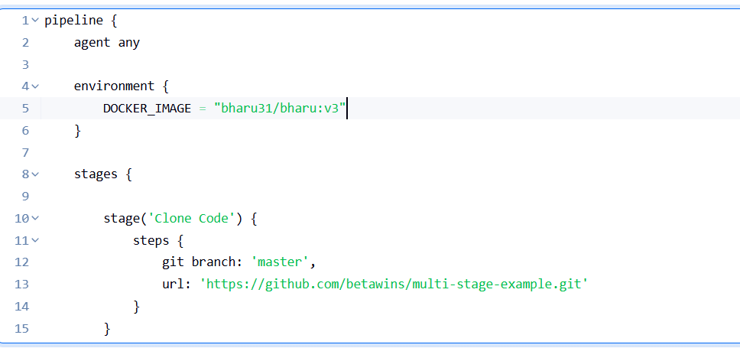
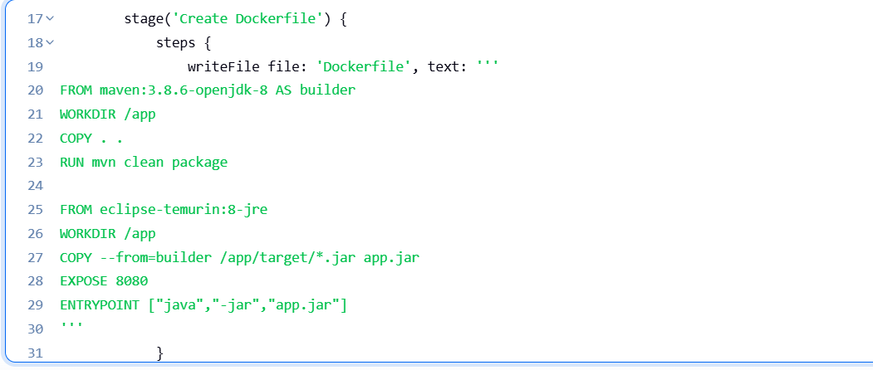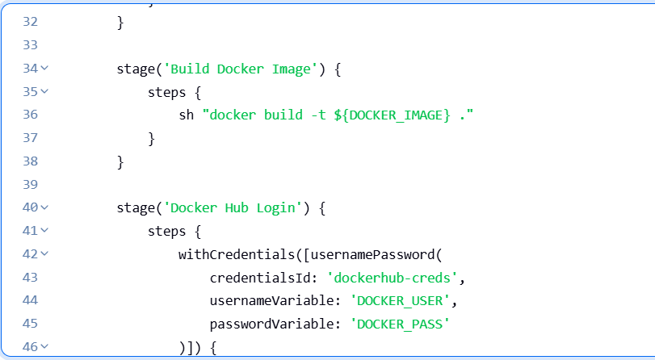
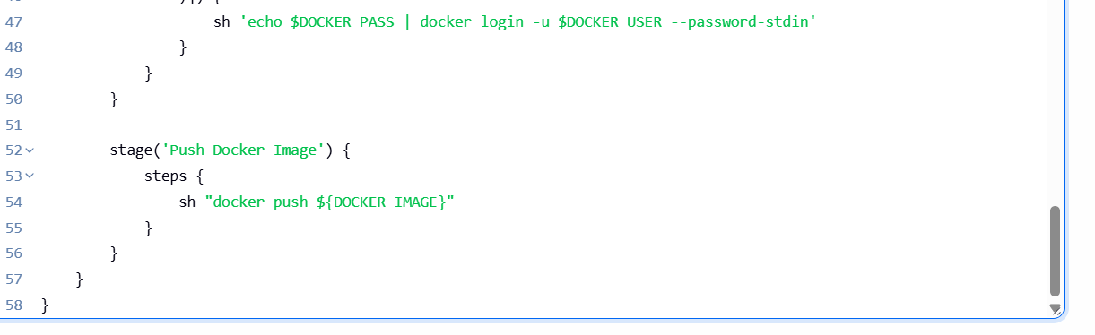
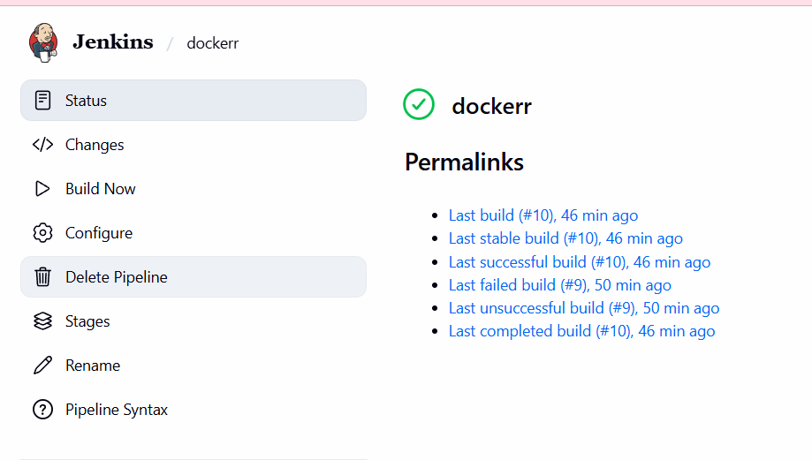

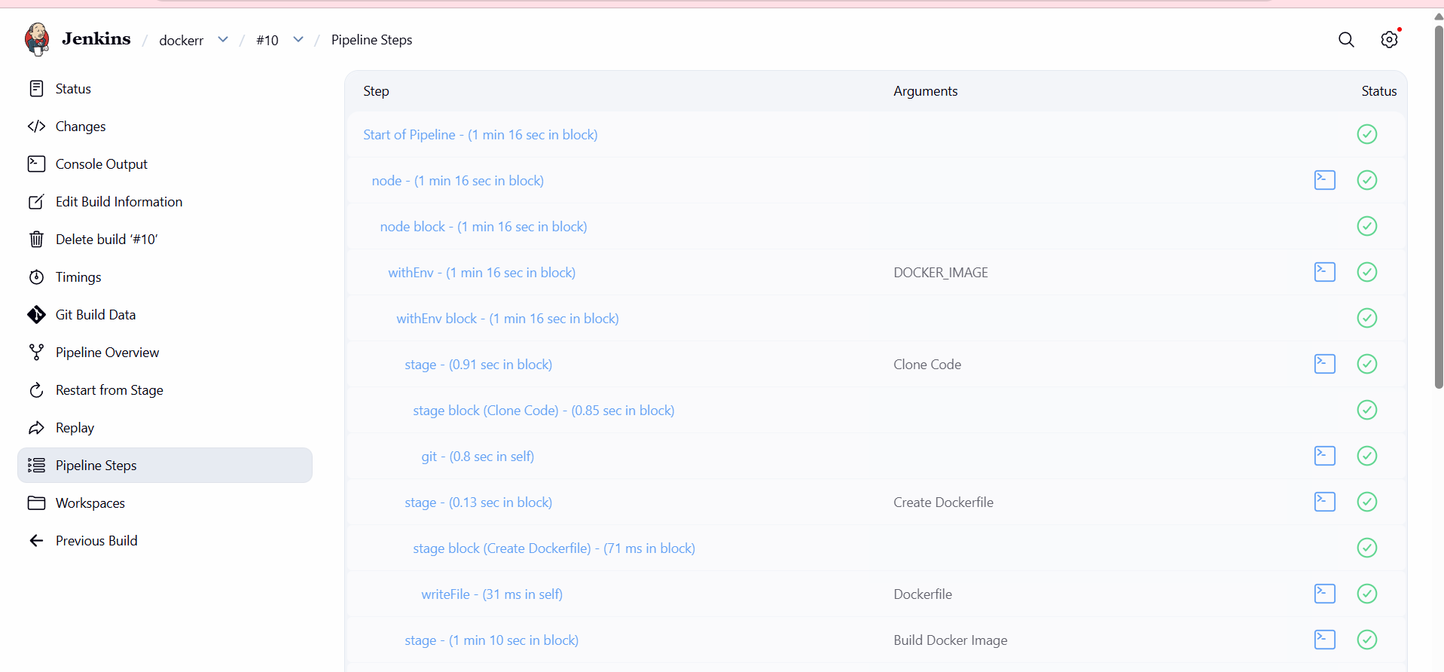
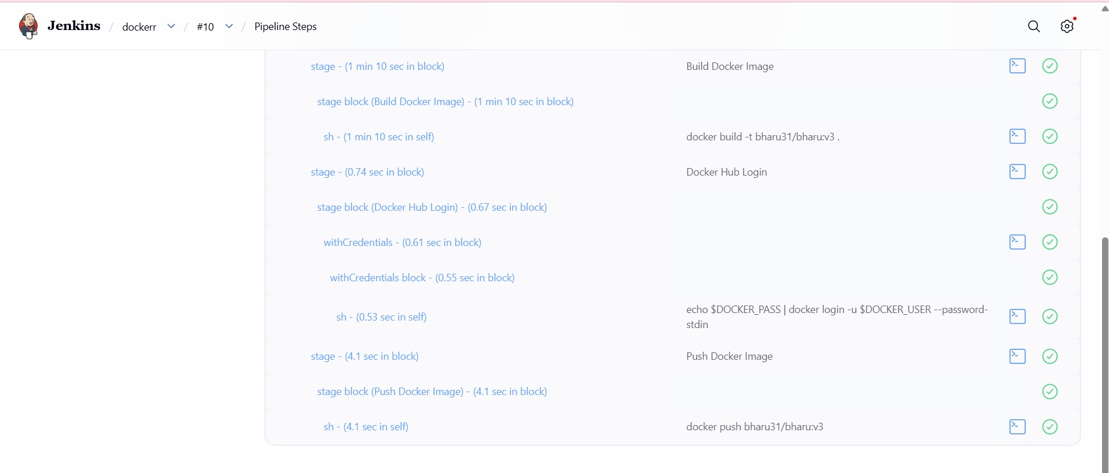
The image was pulled successfully
