K8s-05
1.Create a namespace dev-environment and apply a resource-based quota that restricts the number of pods to 3 and services to 2.
create a namespace dev-environment
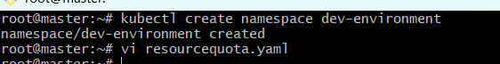
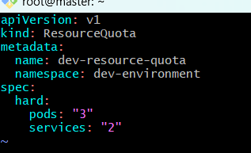
- Apply the ResourceQuotaVerify the ResourceQuota
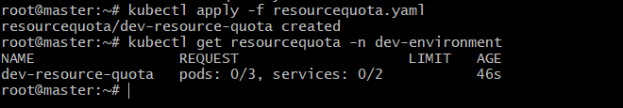
- Resource detailed information
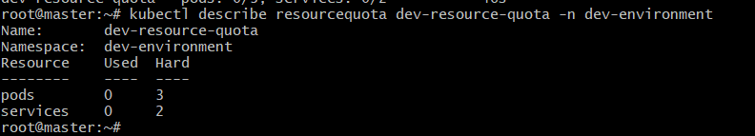
2. Create a pod in the prod-environment namespace with 0.2 CPU and 200Mi memory requests, and 0.5 CPU and 500Mi memory limits.
- Create the namespace
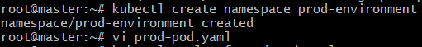
- create the pod prod-pod.yaml
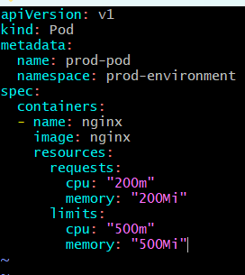
verify the namespaces
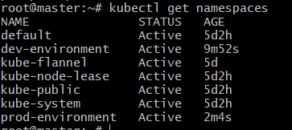
Apply the podverify the poddetails of pod
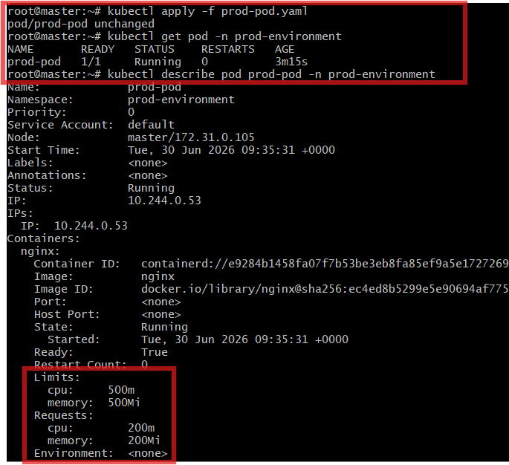
3. In the staging-environment namespace, set a LimitRange that assigns default CPU and memory limits (300m CPU, 600Mi memory) and applies a minimum and maximum CPU.
- Create the namespace staging-environment
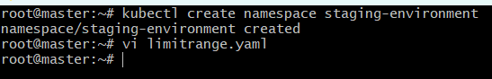
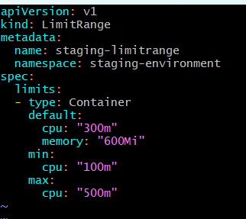
Apply the podverify and describe detailed information
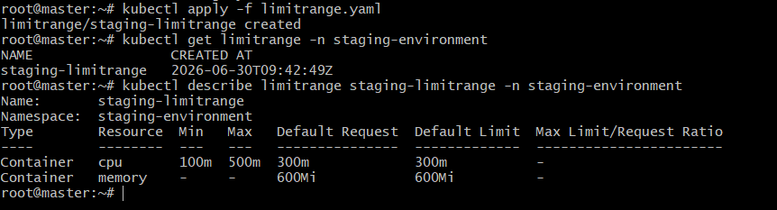
4.Create a pod and a NodePort service in the default namespace, then create another pod in the test namespace and communicate between them using Service DNS.
Create the test namespace
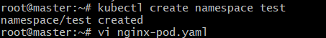
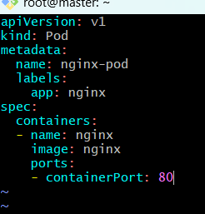
Apply it: 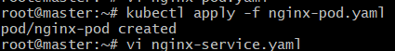
Create nginx-service.yaml
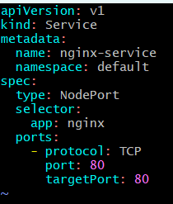
Apply and verify 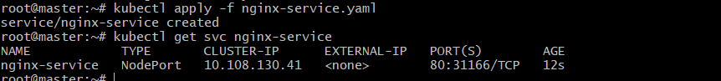
Serach in web browser it is working
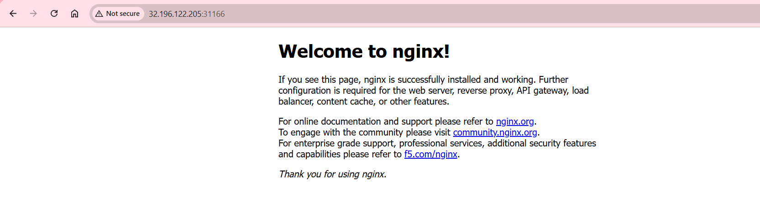
Create test-pod.yaml:
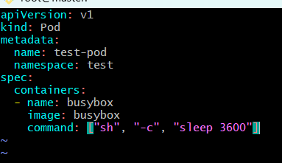
Apply
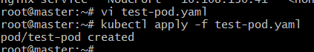
Test communication using Service DNS
Open a shell inside the BusyBox pod:
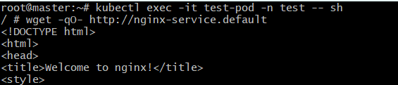
5. Apply a LimitRange with a max limit/request ratio of 2 for memory in the performance-environment namespace, and test by creating a pod with mismatched resource requests and limits.
Create the performance-environment namespace
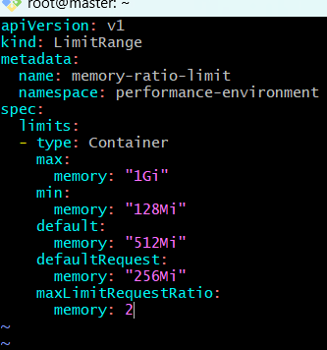
Apply the LimitRange,verify and describe
