K8s-06
1.Create a ConfigMap from a directory containing multiple files and inject the variables into a pod as environment variables.
- Create 1st configuration files.
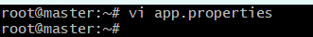
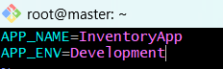
• Create 2nd configuration file
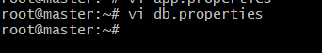
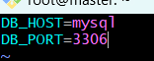
- Verify the files
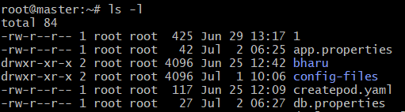
Create a config map from the directory and verify it and describe
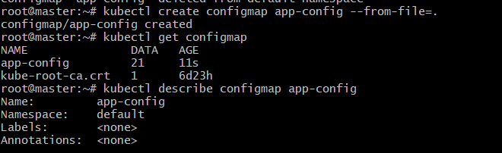
Create a Pod that uses the Config Map as environment variables

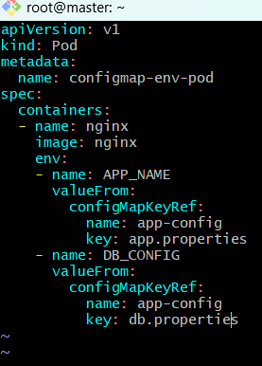
Apply and verify it as Config Map injected as environment variables.
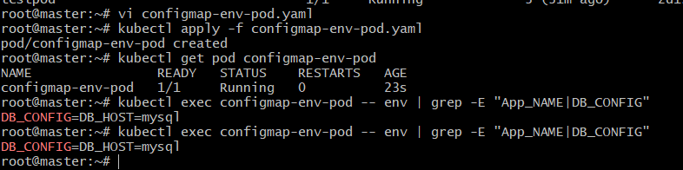
2. Create a Config Map from a file and mount it as a volume inside a pod, ensuring the
configuration data is available as files.
• Create a configuration file
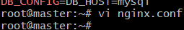
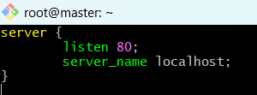
Create a Config Map from the file and verify it
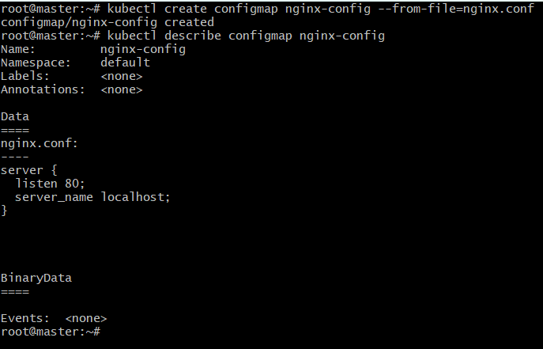
Create the pod
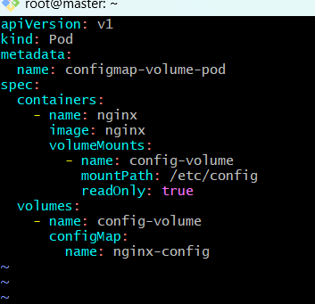
Apply and verify it
• List the mounted files and display the file
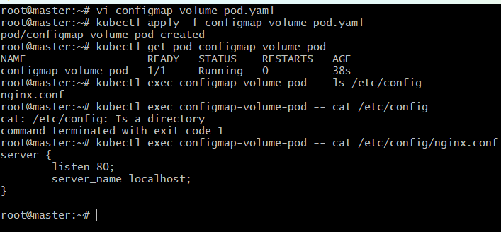
3. Create a Secret with sensitive information (username and password) and inject it
into a pod as environment variables.
• Create the Secret Verify and describe it
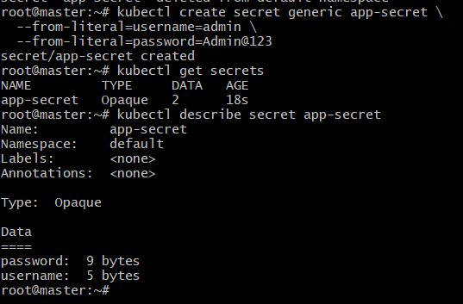
Create secret-env-pod. Yaml
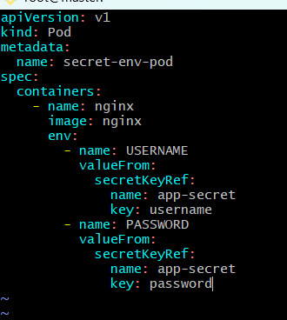
Apply pod and verify the environment variables
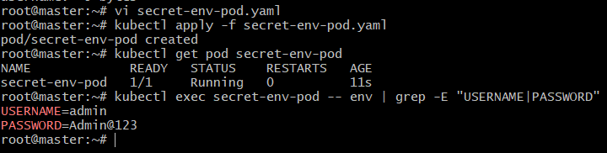
4. Create a Secret using a YAML file, mount it as a volume in a pod, and verify the
specific Secret values are available as files.
• Encode the Secret Values
• Generate Base64 values and password
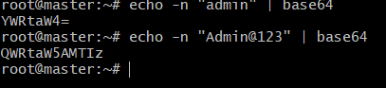
• Create secret.yaml
Vi secret.yaml
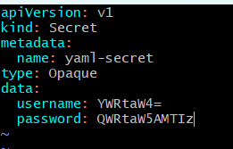
Apply the secret and verify
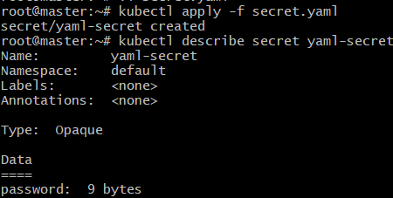
Create the pod
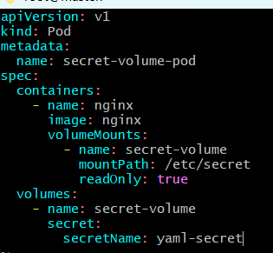
Apply and verify
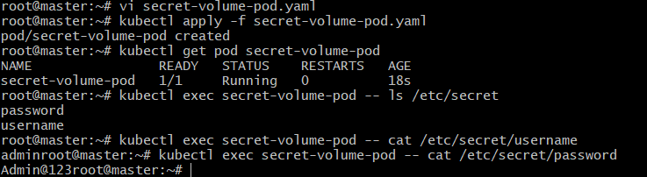
5. Inject a Config Map as environment variables and a Secret as files into the same
pod, ensuring both are accessible within the pod.
• Create combined-pod. Yaml
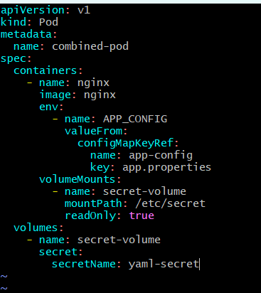
Apply and verify
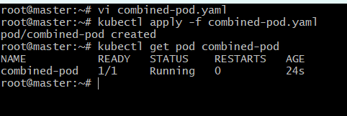
Verify the Config Map Environment Variable
• Verify the Secret Files
