K8s-07
Task1: Execute all yaml files shown in video.
Task 2: Taint a Node and Schedule a Tolerant Pod Taint a node with special=true:NoSchedule. Create a pod with a toleration that matches the taint, allowing it to be scheduled on the tainted node.
• Create first.yaml file and verify it
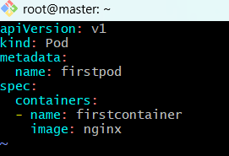
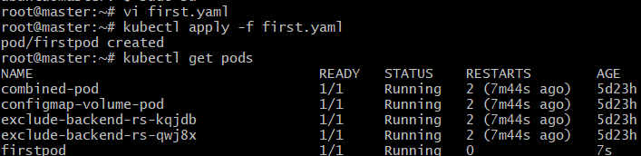
- The pod is created
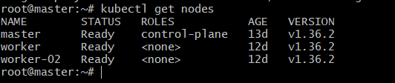
- Lets now taint one node
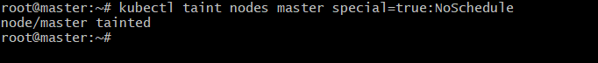
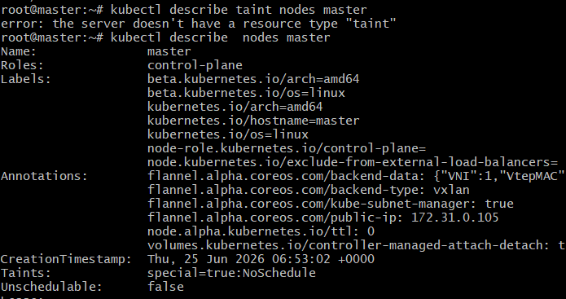
- We can see the taint is added
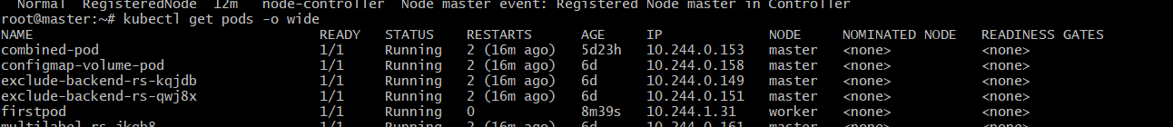
- Lets create yaml file
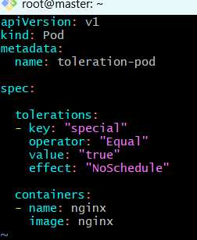
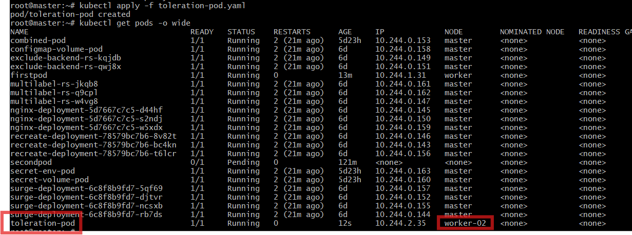
Task 3: Use NodeSelector to Schedule a Pod on a Specific Node Label a node with env=dev. Create a pod with a nodeSelector that schedules it only on the node labeled env=dev.
Now lets create label node
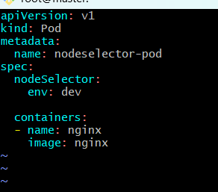
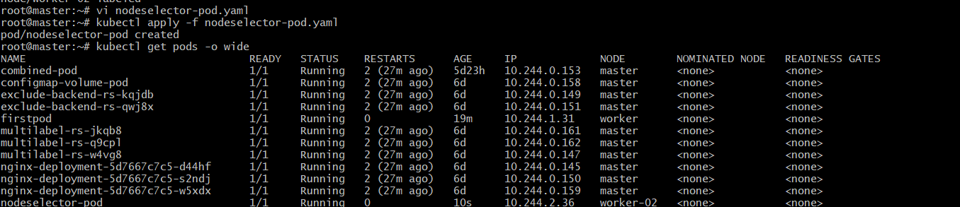
task 4: Use Node Affinity with Soft Scheduling Label a node with env=test. Create a pod with PreferredDuringSchedulingIgnoredDuringExecution node affinity, preferring to schedule it on a node labeled env=test. Remove the label and verify the pod continues to run.

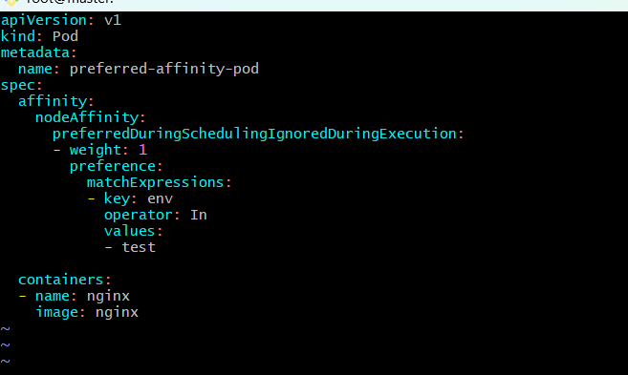
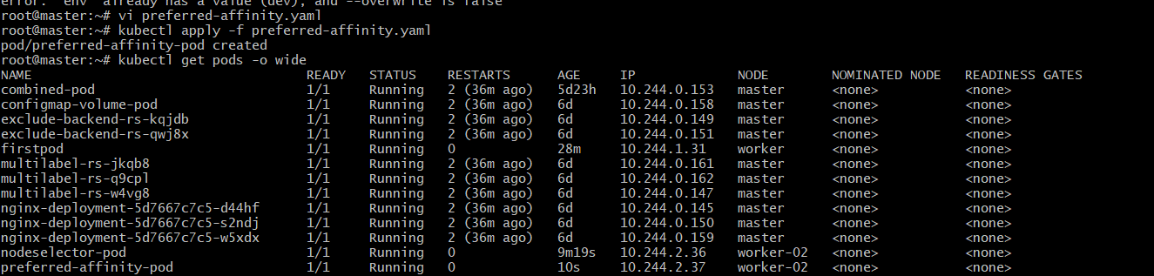
Remove the label
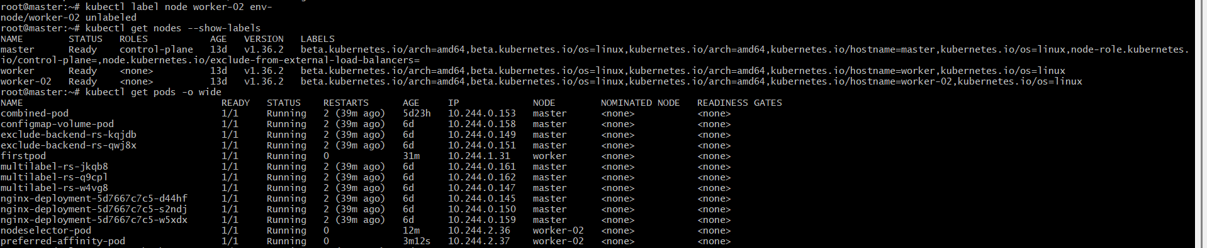
If the Pod is still Running
Then your task is completed.
Reason:
preferredDuringSchedulingIgnoredDuringExecution
means:
- During scheduling → Kubernetes prefers a node with env=test.
- After the Pod is running → Kubernetes ignores label changes.
So removing the label does not stop or move the Pod.

Task 5: Implement Node Affinity with Hard Scheduling Create a pod with RequiredDuringSchedulingIgnoredDuringExecution node affinity, ensuring it will only be scheduled on a node labeled env=prod. Verify the pod cannot be scheduled if no node has the env=prod label.
Step1….Check existing node labels
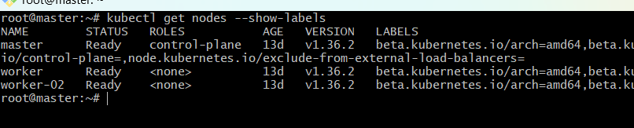
Create the YAML file
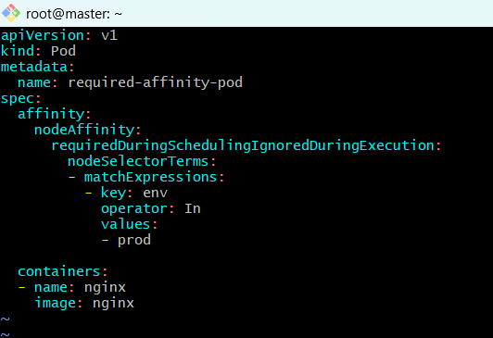
Create the podverify the pod
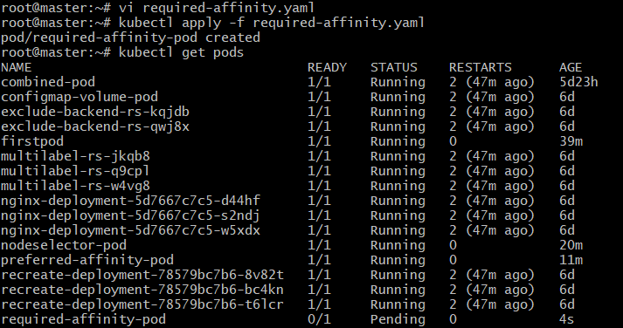
Verify why the Pod is Pending
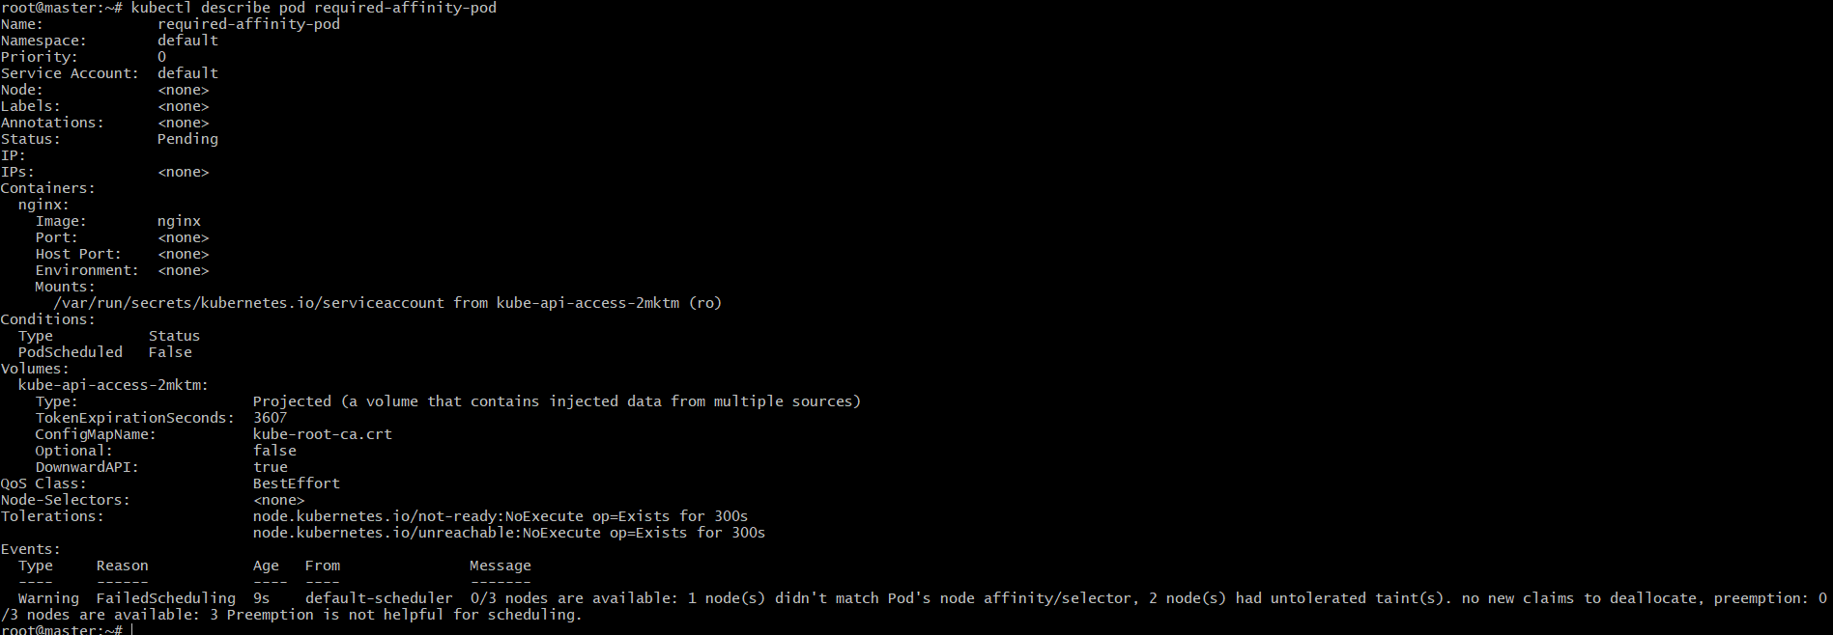
Add the required label
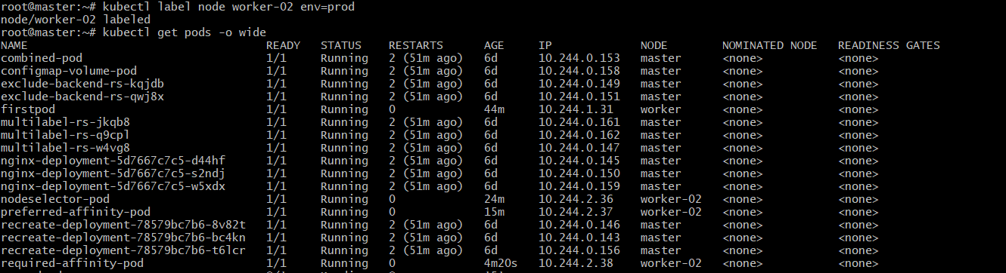Why does this happen?
requiredDuringSchedulingIgnoredDuringExecution
- RequiredDuringScheduling:
  - The matching node label is mandatory.
  - If no node matches, the Pod stays Pending.
- IgnoredDuringExecution:
  - Once the Pod is running, removing the label later does not evict the Pod.
Task 6: Taint a Node and Use NoExecute with Toleration Seconds Taint a node with special=true:NoExecute. Create a pod with a tolerationSeconds field (e.g., 60 seconds) and observe it gets evicted after 60 seconds on the tainted node.
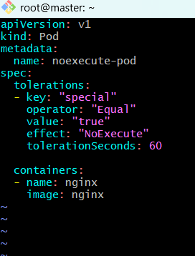
Create the pod and verify the pod
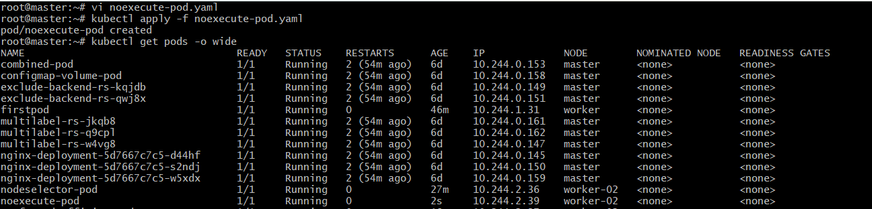
Taint the node where the Pod is running
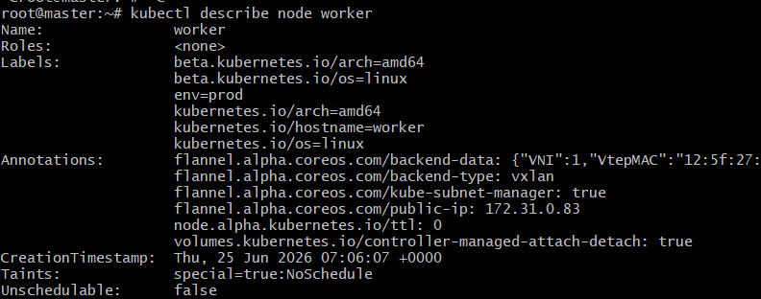
Remove the taint (Cleanup)
