JENKINS-04
- Setup Jenkins CICD pipeline using freestyle job using Docker containers using below code. https://github.com/betawins/hiring-app.git Stages:
stage1:Git Clone
stage 2:SonarQube Integration
stage3:Maven Compilation
stage 4:Nexus Artifactory
stage 5:Slack Notification
stage 6:Deploy On tomcat

Stage1:Git clone

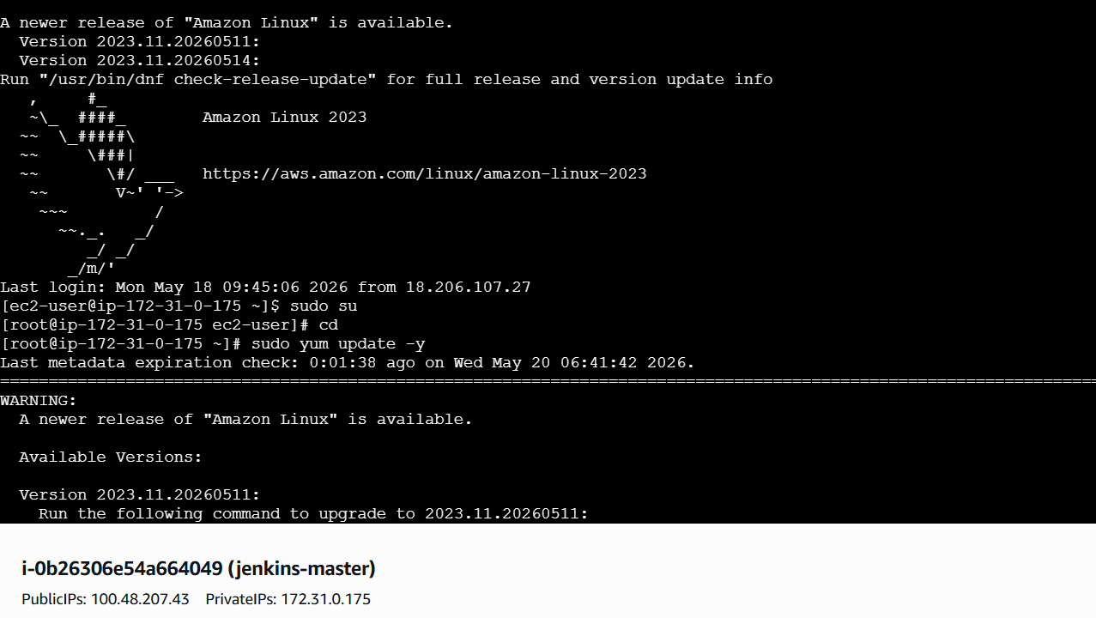
Install docker
- Sudo yum install docker -y
- Systemctl enable docker
- Systemctl start docker
- Systemctl status docker
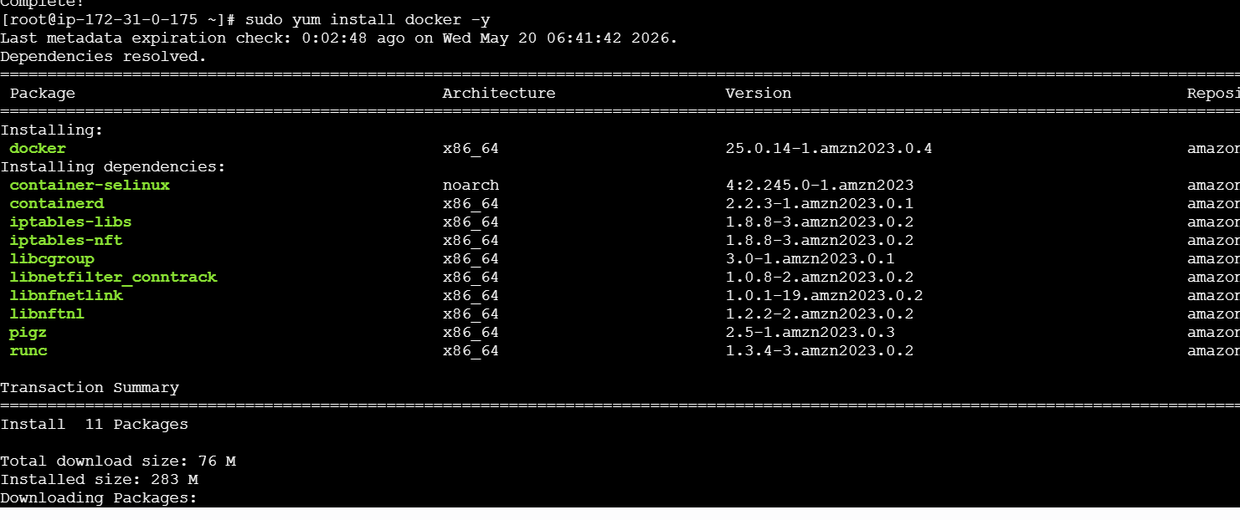
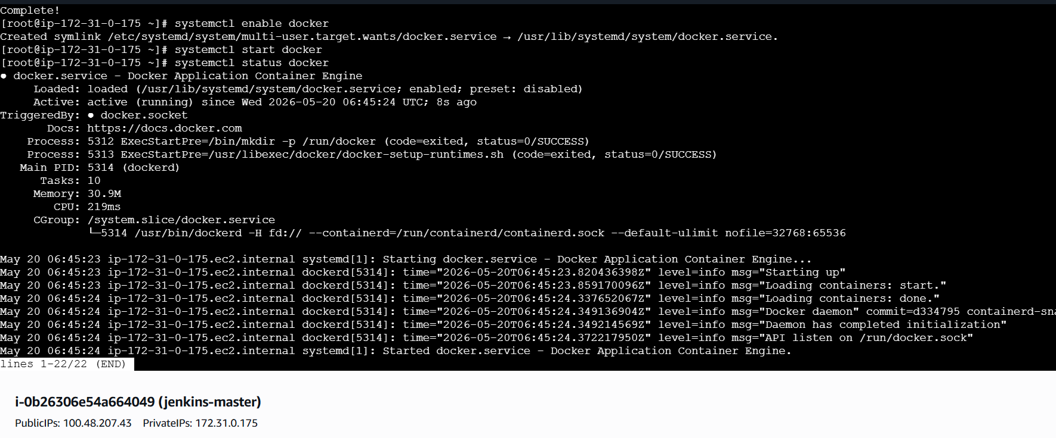
Create directory for docker installation
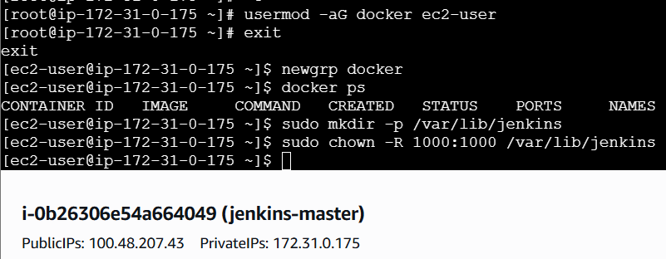
Docker pull
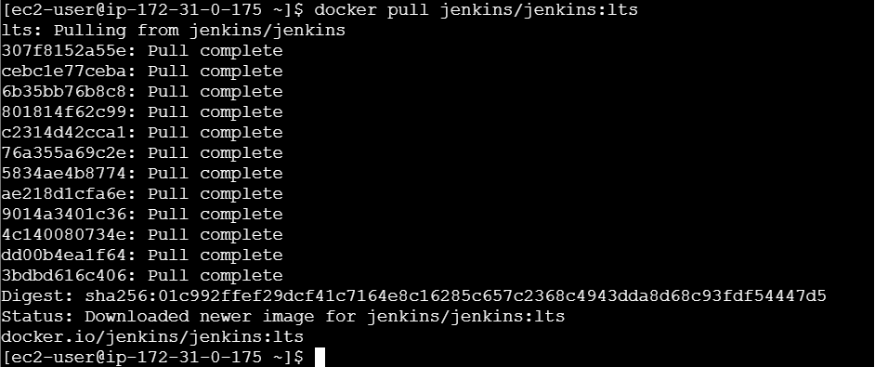
Run Jenkins containerI got error in the same instance already have one Jenkins then I need to
Install new instanceJENKINS-SERVER
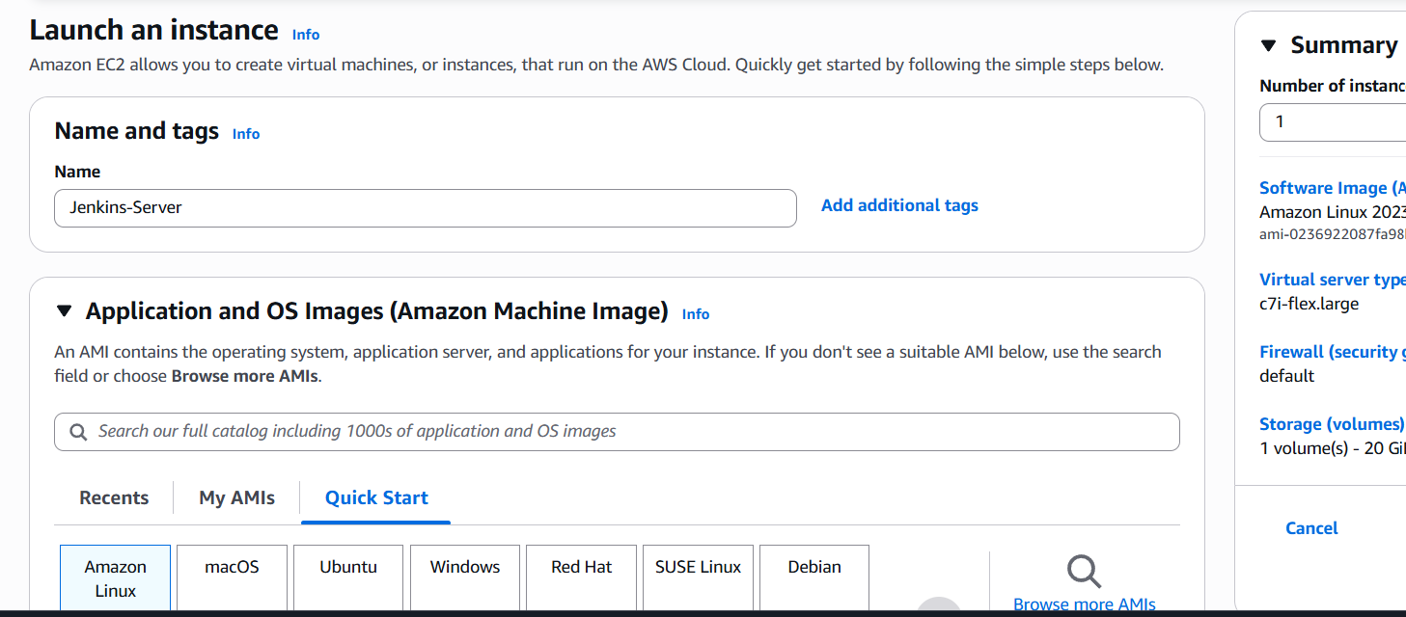
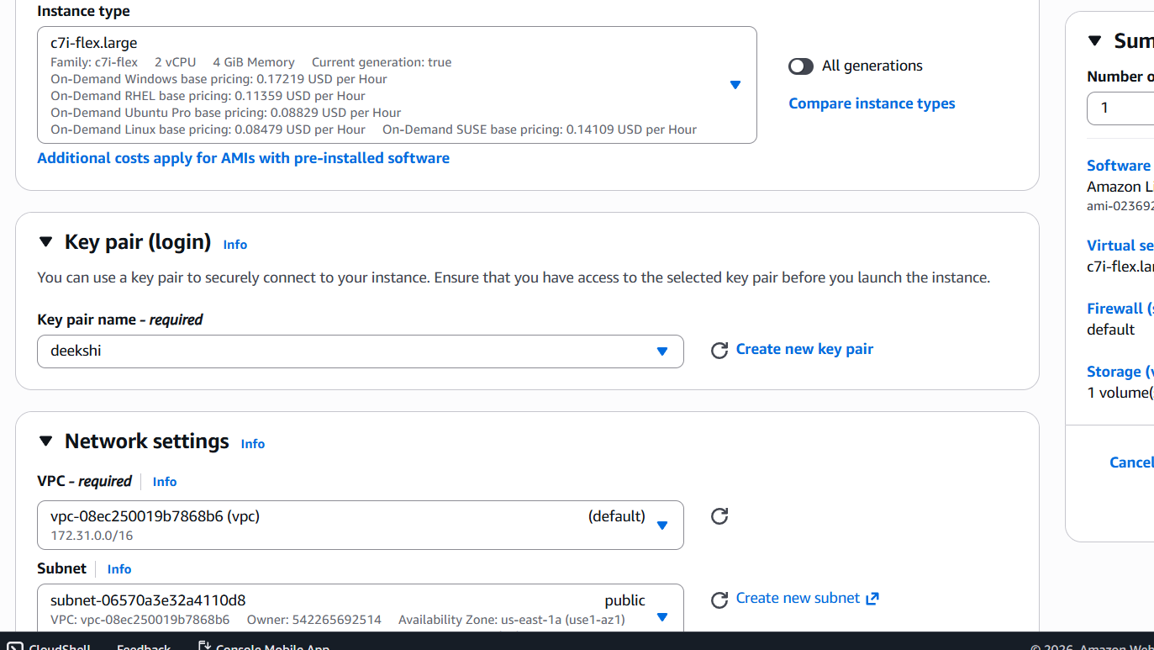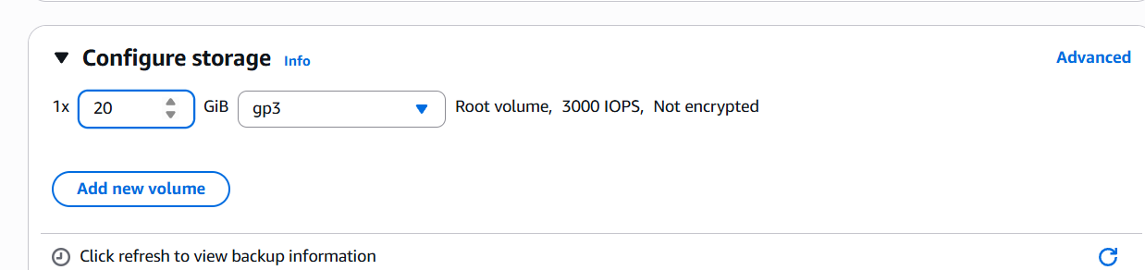
I have to install docker where I can give previous instance all commands exactly
Run Jenkins container using this command
docker run -d \
--name jenkins \
-p 8080:8080 \
-p 50000:50000 \
-v /var/lib/jenkins:/var/jenkins_home \
--restart always \
jenkins/jenkins:lts
Run Jenkins container
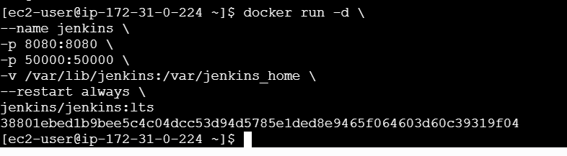
Login in browser
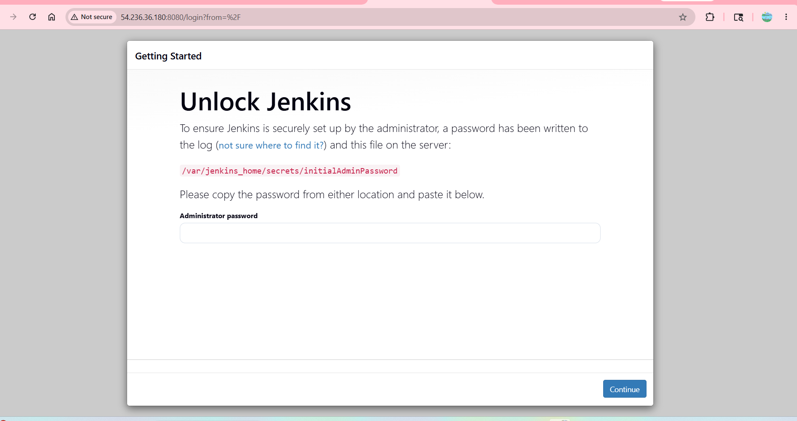
By below command we will be getting default password, before that we can go to root user paste that and login
- docker exec jenkins cat /var/jenkins_home/secrets/initialAdminPassword
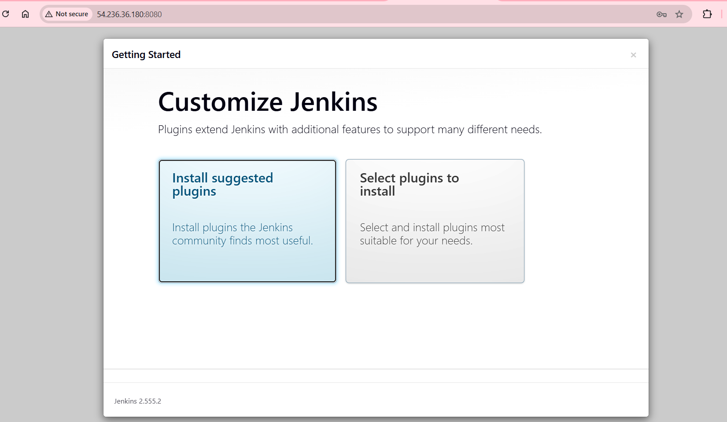
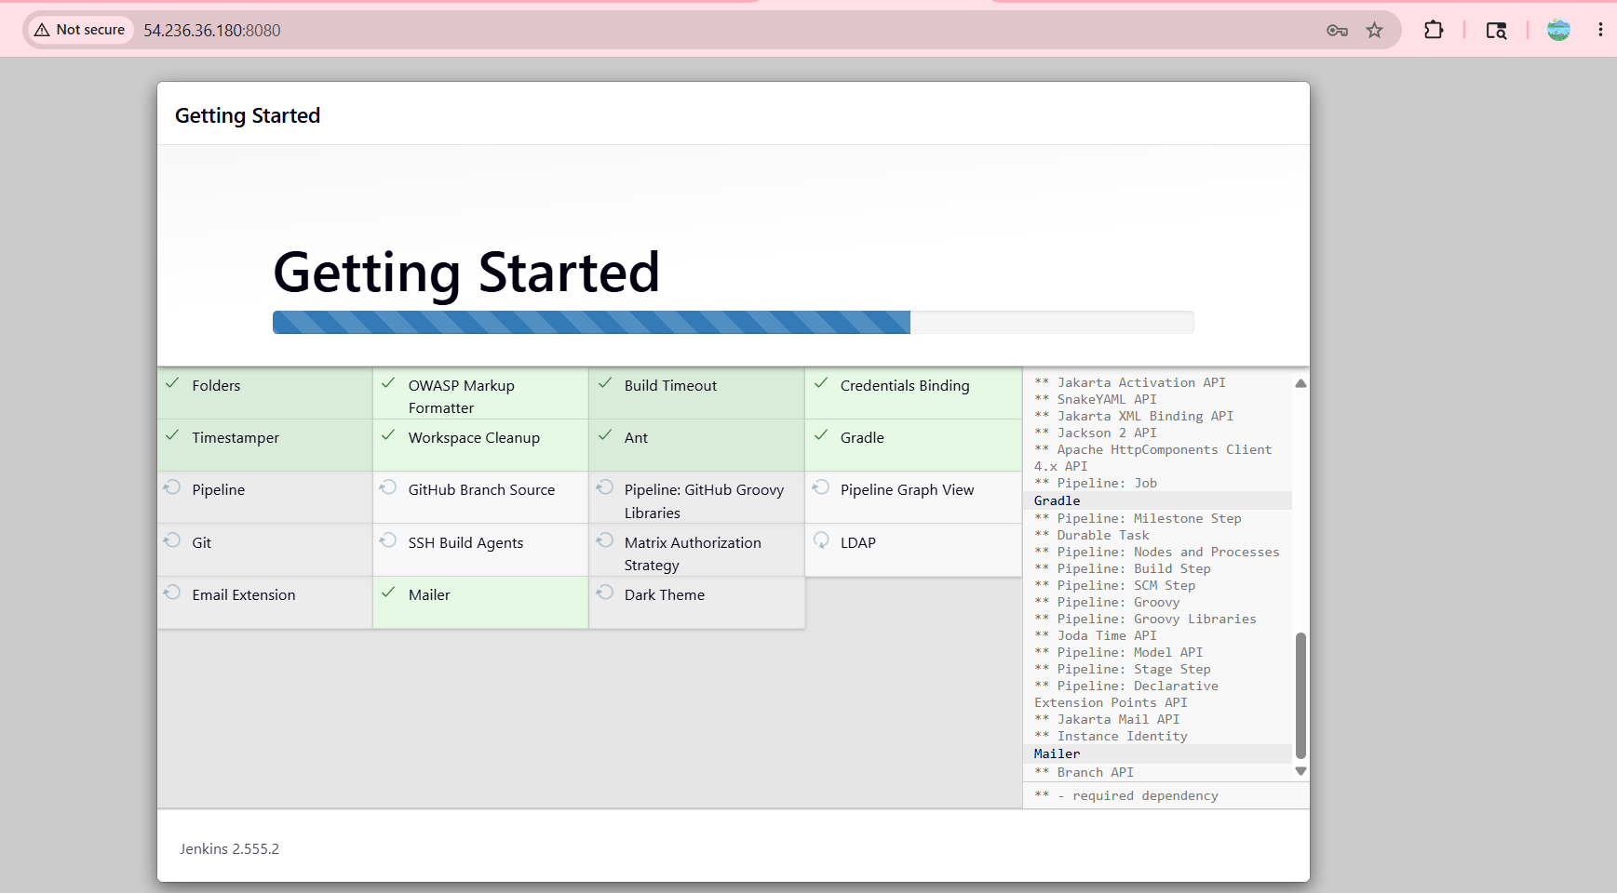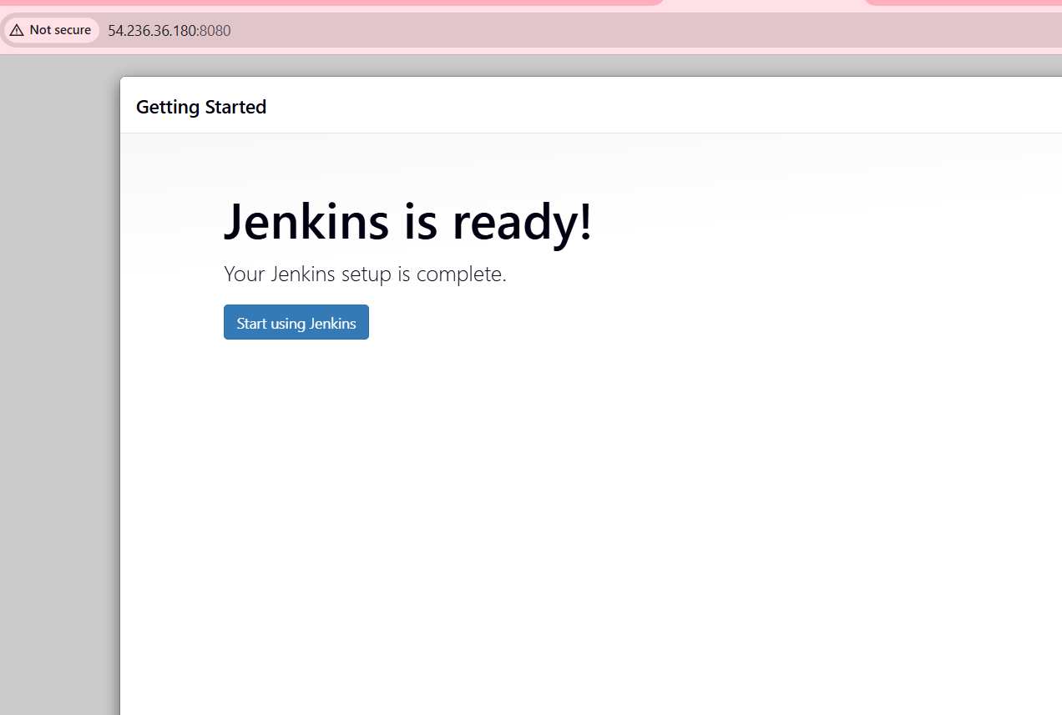
Git clone
Go to Jenkins dashboard -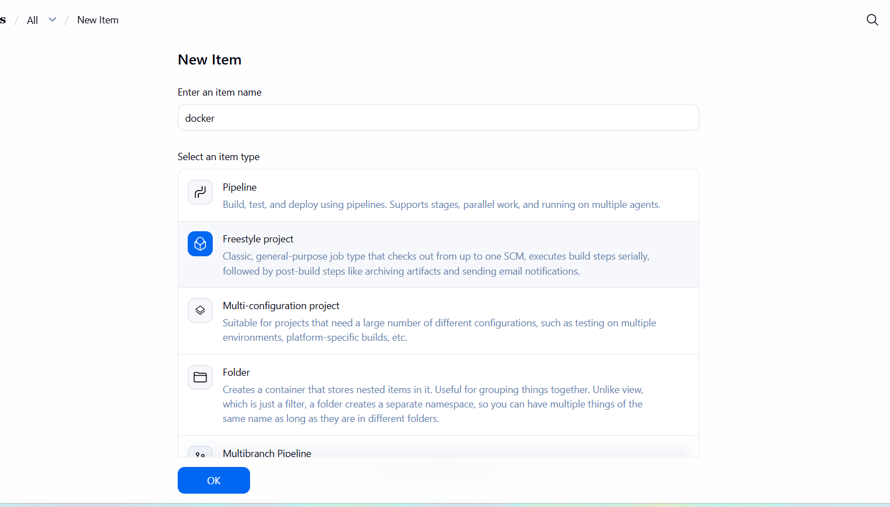click on new item -enter item name -select type :freestyle
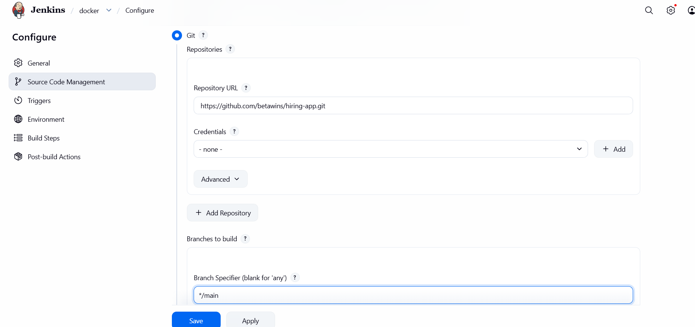
- Select source code management : git paste the repository url Click on build now
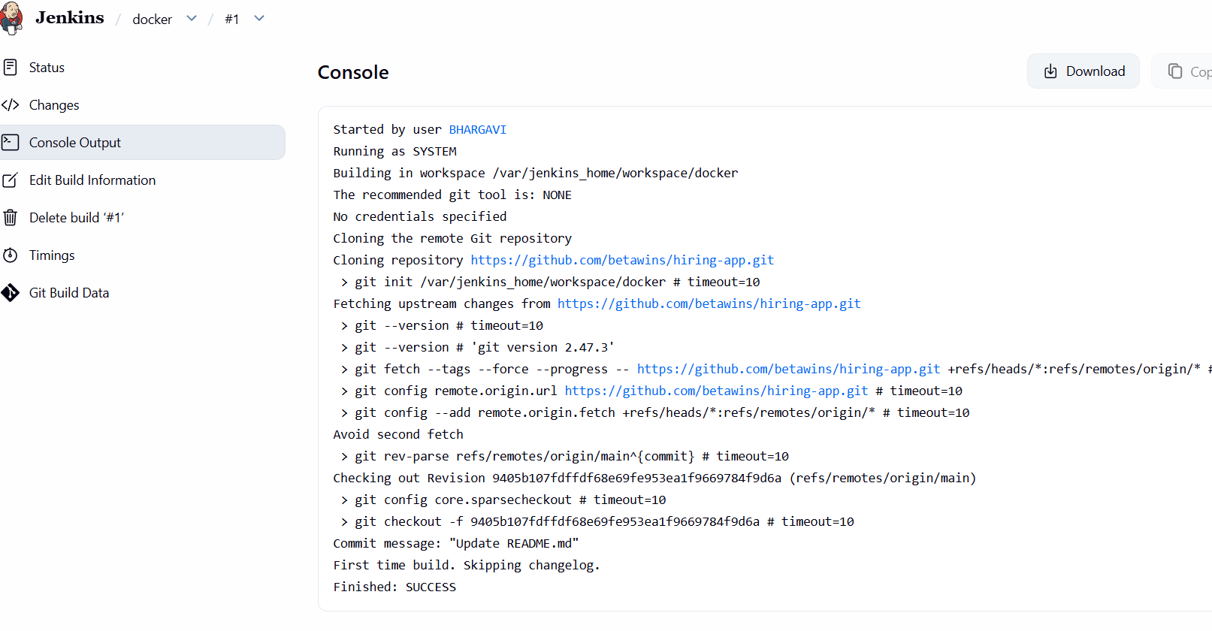
Stage 2:SonarQube Integration
Let’s create new instance with sonarqube installation
- Connect to sonarqube
Sudo Su-
cd
yum -y install docker
systemctl start docker
systemctl status docker
docker pull sonarqube
docker images
docker run -itd --name sonarqube -p 9000:9000 sonarqube
docker ps
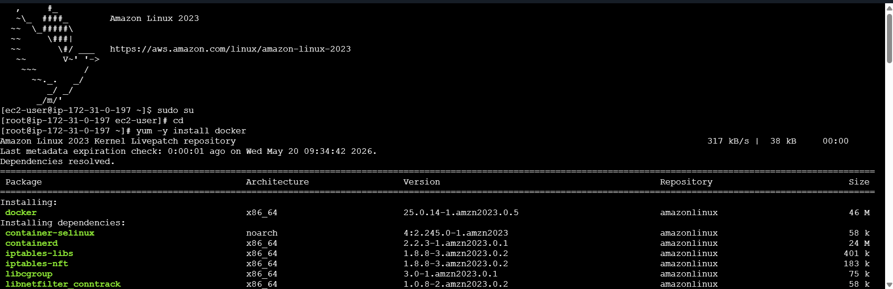
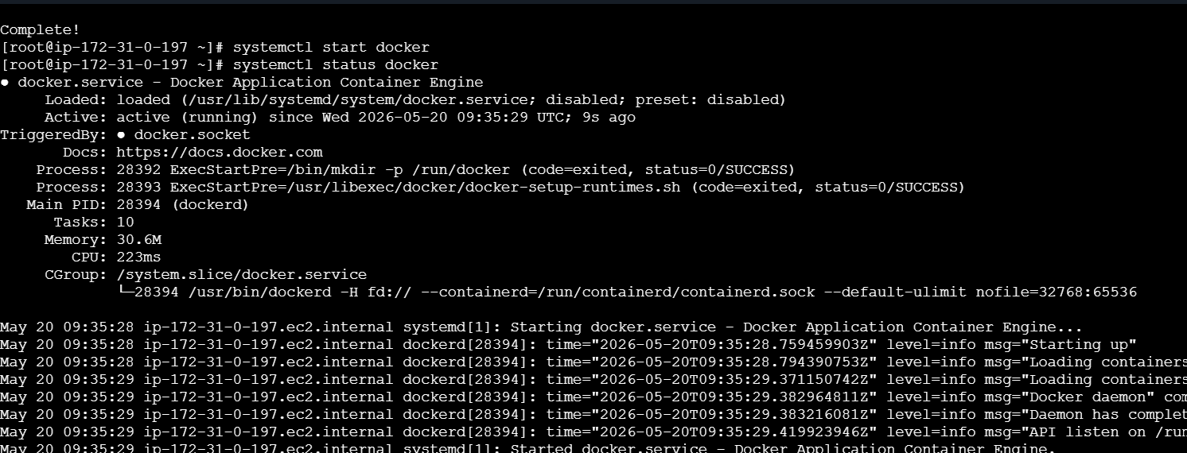
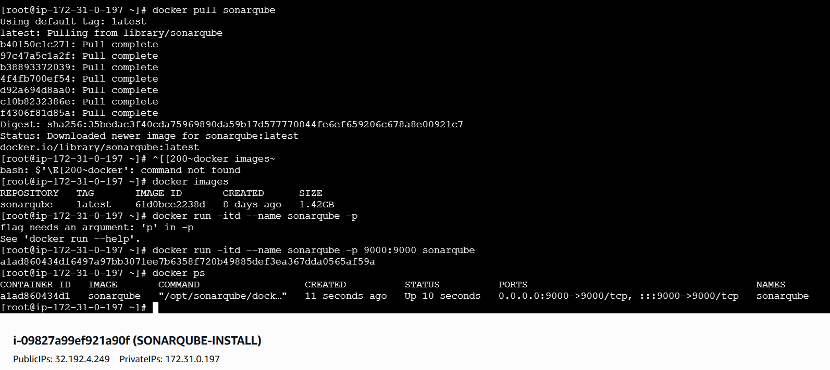
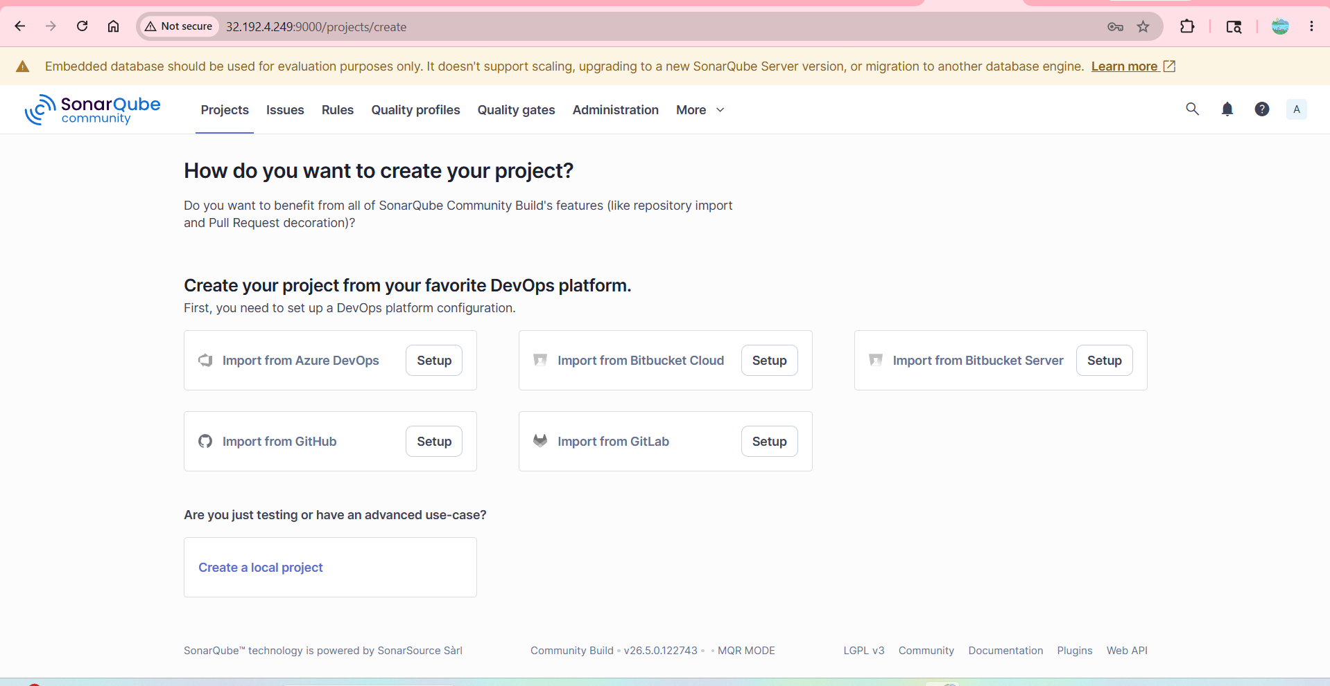
SonarQube Scanner on our JenkinsAdmin@123
Go to Manage Jenkins PluginsSonarcube scanner click on Install
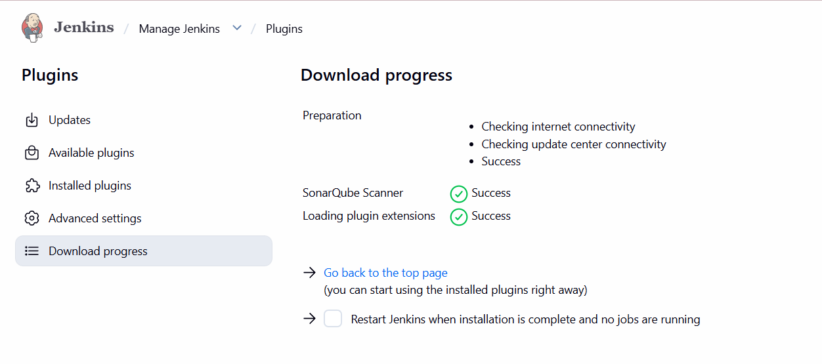
To create credentials
Generate token in sonarqubeManage Jenkinscredentials global secret text paste that copied token in secretgive id save
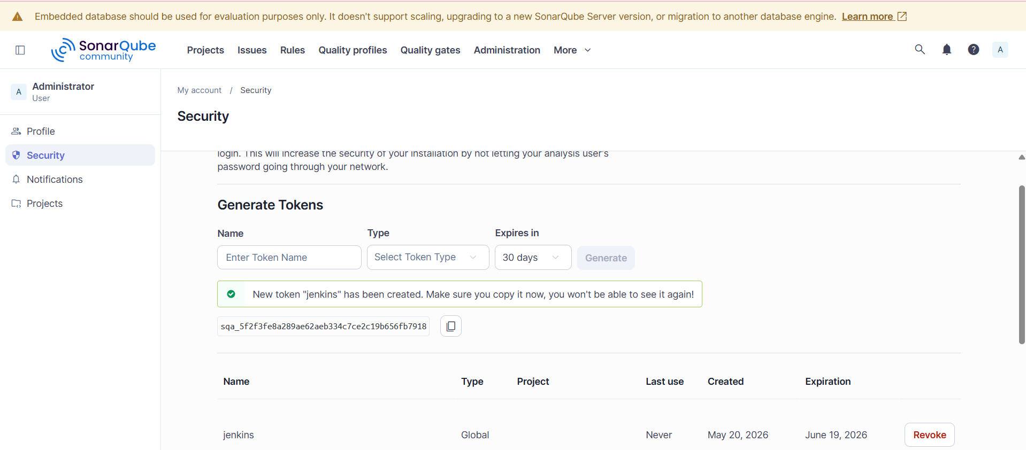
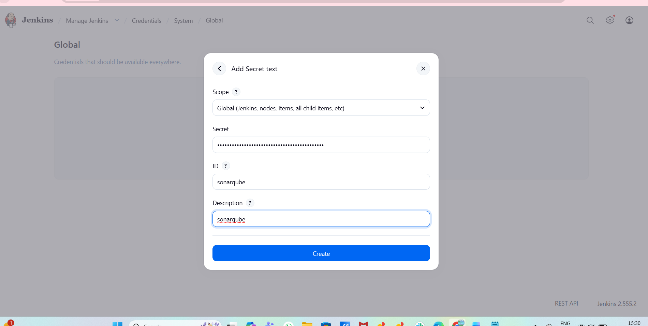
Manage Jenkins click on system SonarQube servergive Name Server URL Credentials.

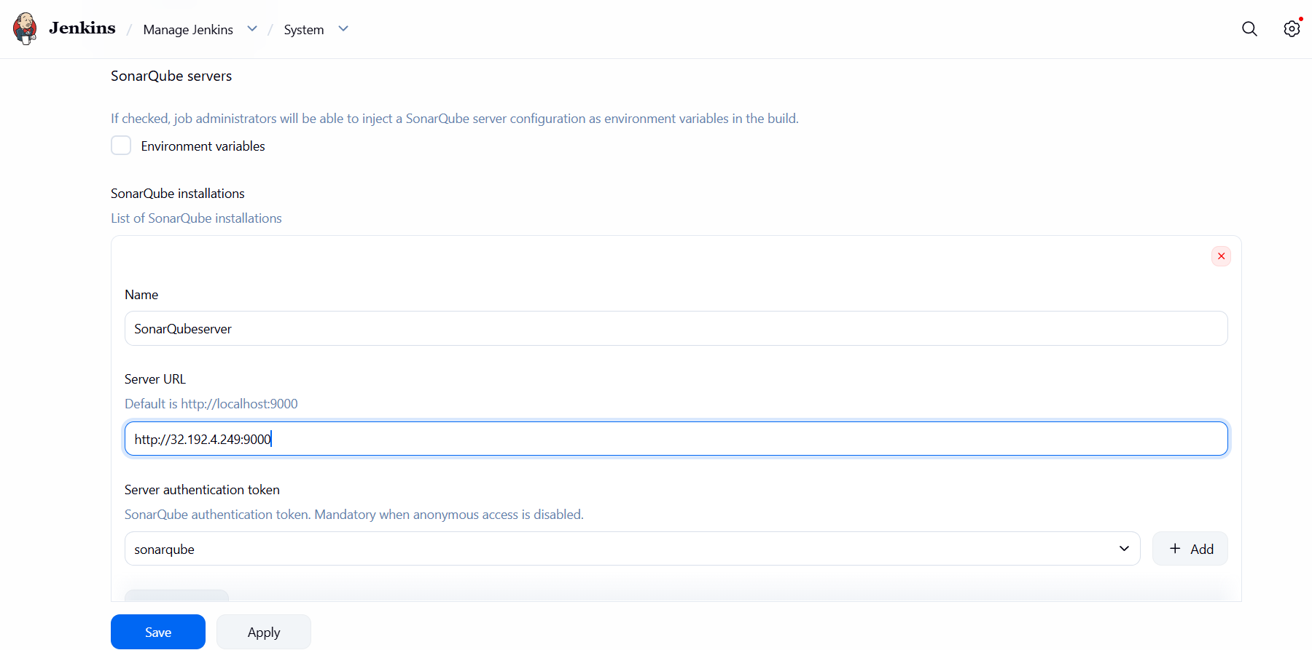
Go to Jenkins-Server docker psdocker exec -it -u root Jenkins bashthen go to our root use rin Jenkins now we need to apt updateapt Install -y wget unzip curl
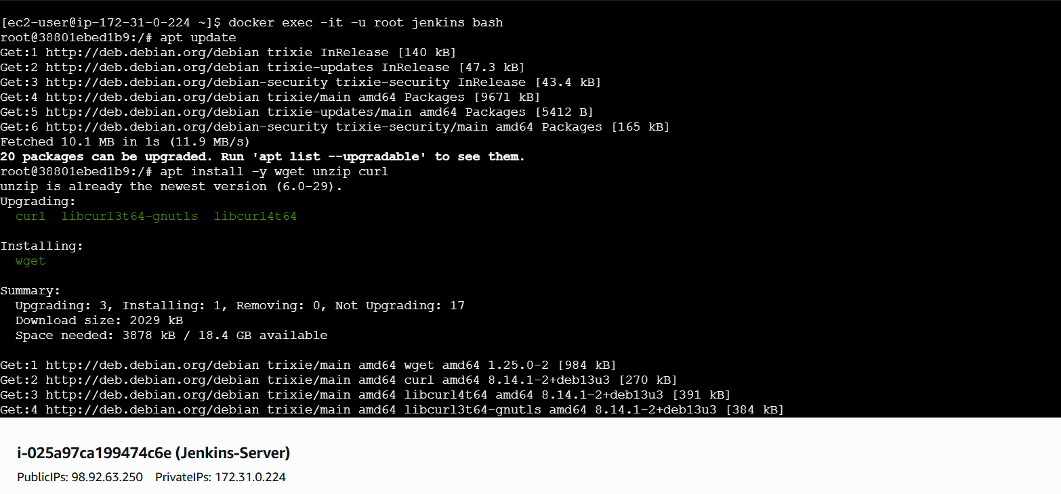
We need to install sonarqube-scanner in Jenkins server
To Download - wget https://binaries.sonarsource.com/Distribution/sonar-scanner-cli/sonar- scanner-cli-3.2.0.1227-linux.zip

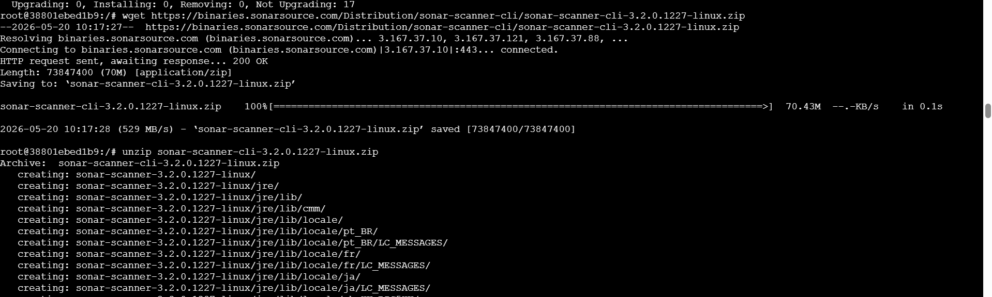 To Unzip - unzip sonar-scanner-cli-3.2.0.1227-linux.zip
To Rename - mv sonar-scanner-3.2.0.1227-linux /opt/sonar_scanner
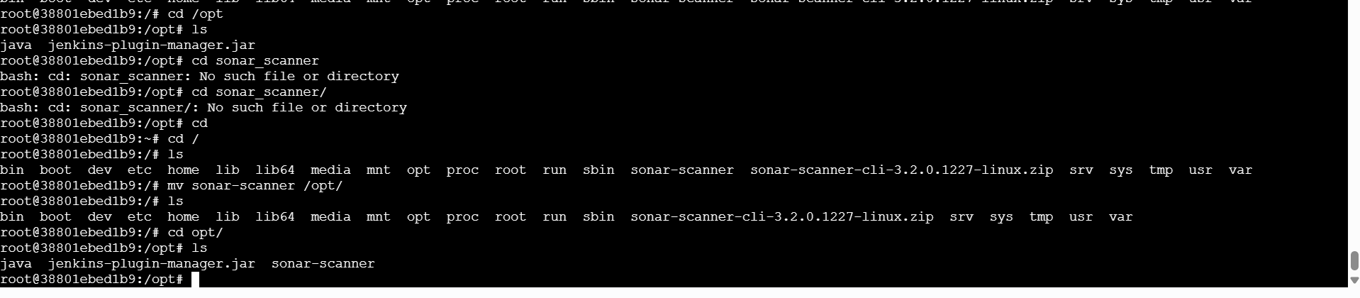
- Add the above sonar-scanner path in the Jenkins
- Go to manage Jenkins – tools-sonarQube Scanner -Name - Path -Save
- /opt/sonar-scanner
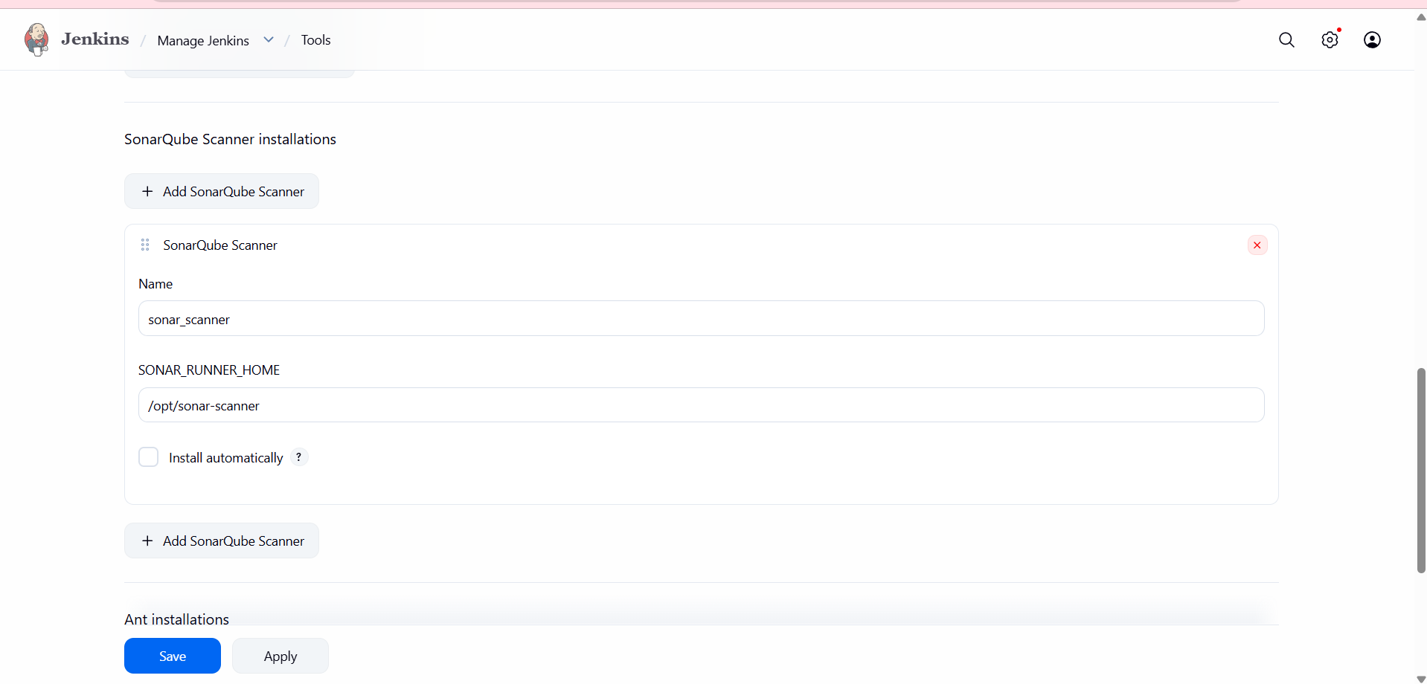
Next We need to give analysis properties of the code to run in the Job we created
Job - Configure - Build Steps -Analysis Properties(we will get it from developers) 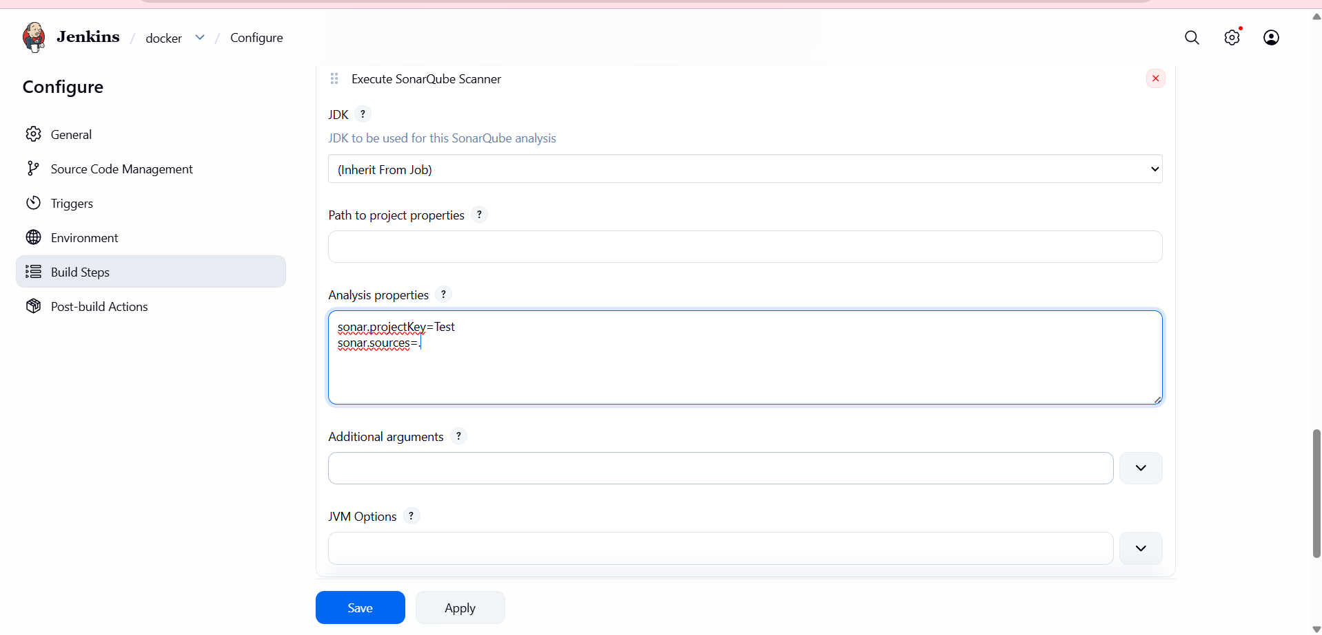
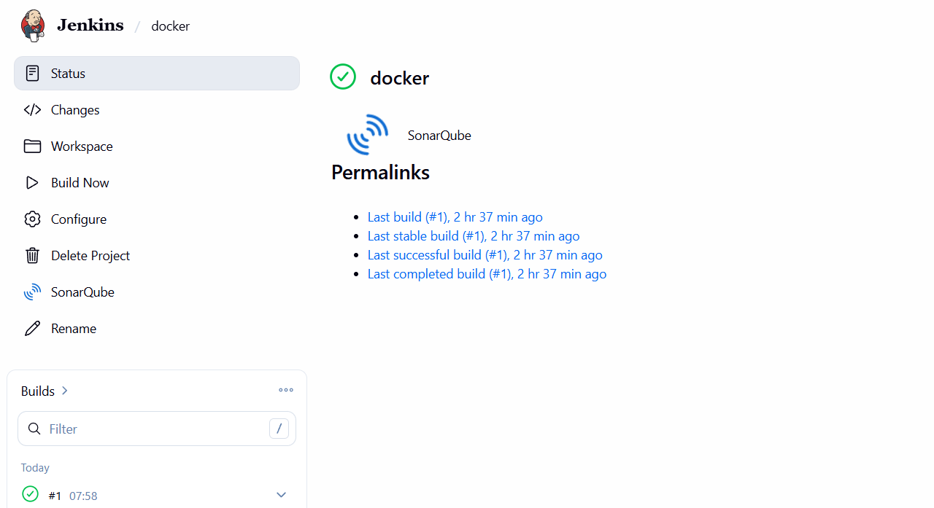
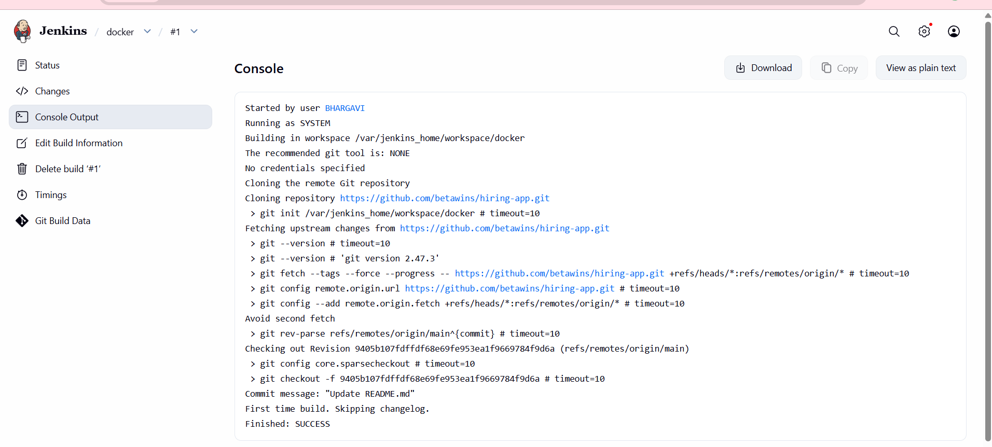
docker run -d \
--name sonarqube \
-p 9000:9000 \
sonarqube:6.6
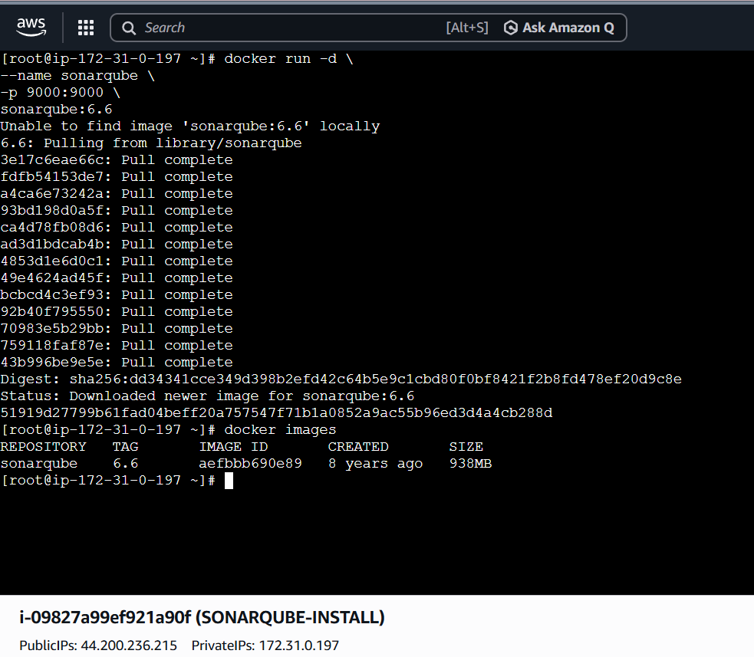
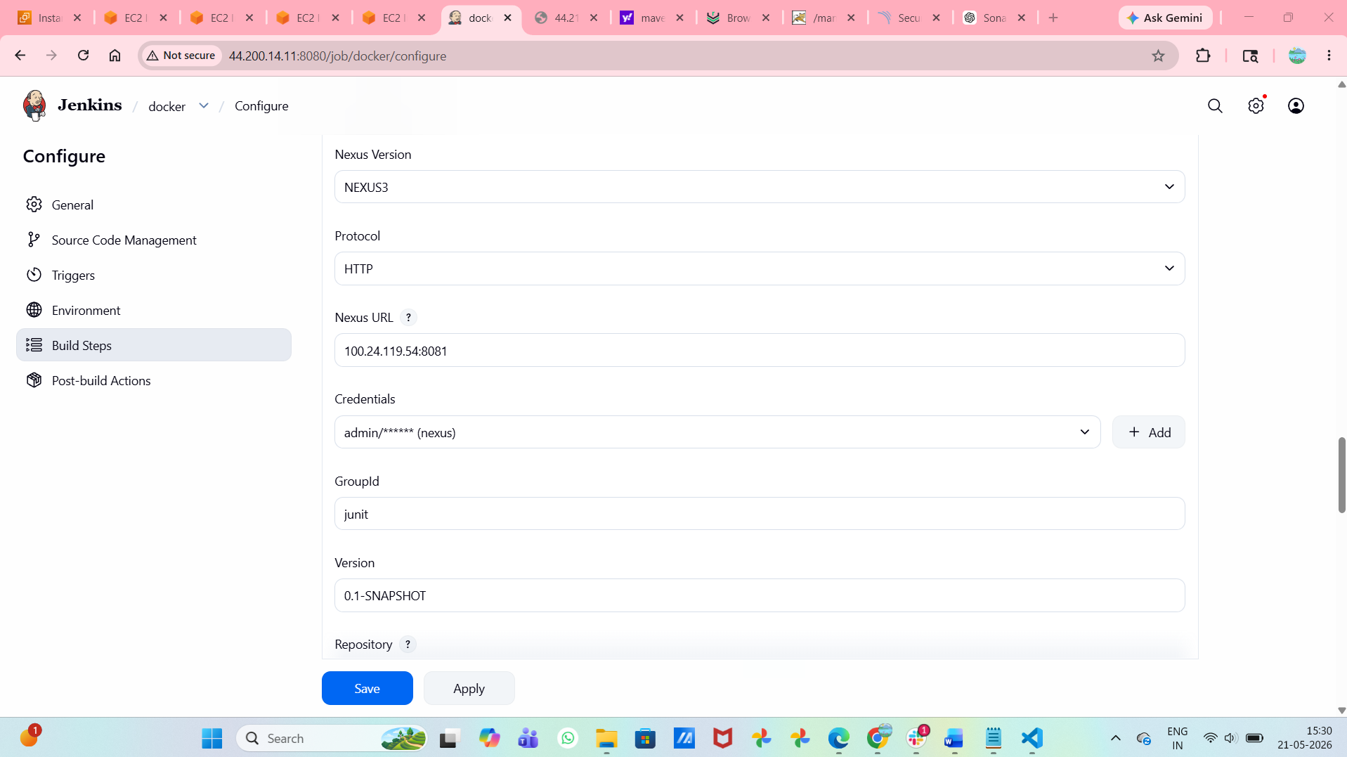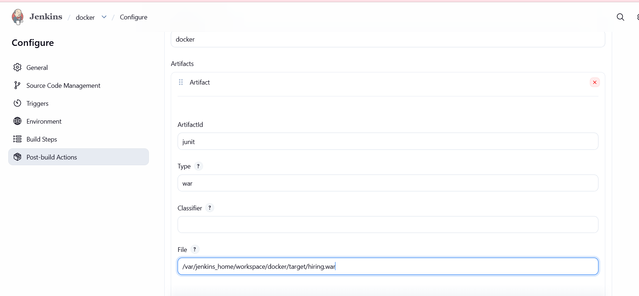
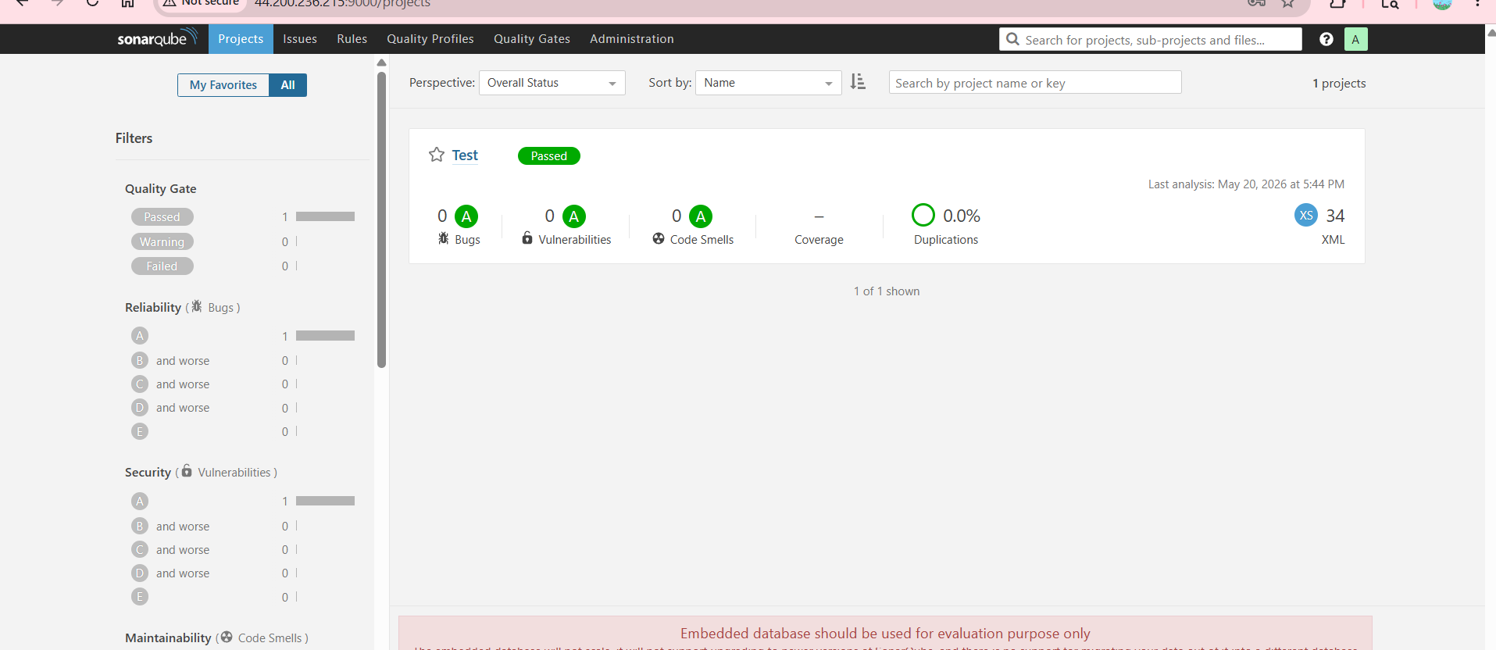
- Maven Compilation:let’s have a instance Jenkins-Server inside we have to install maven 1st we see Jenkins status then we can see Jenkins status inside docker we have to give >>docker ps>>docker exec -u root -it Jenkins bashapt install maven -
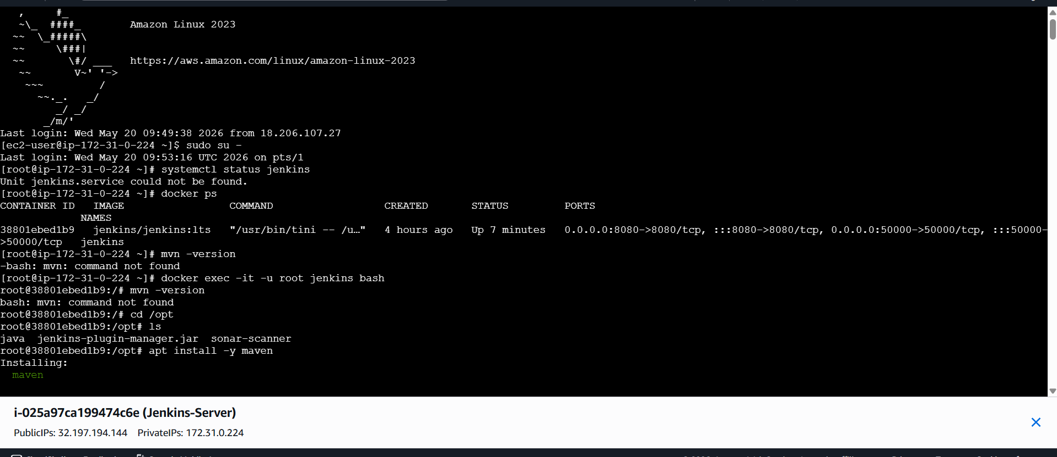
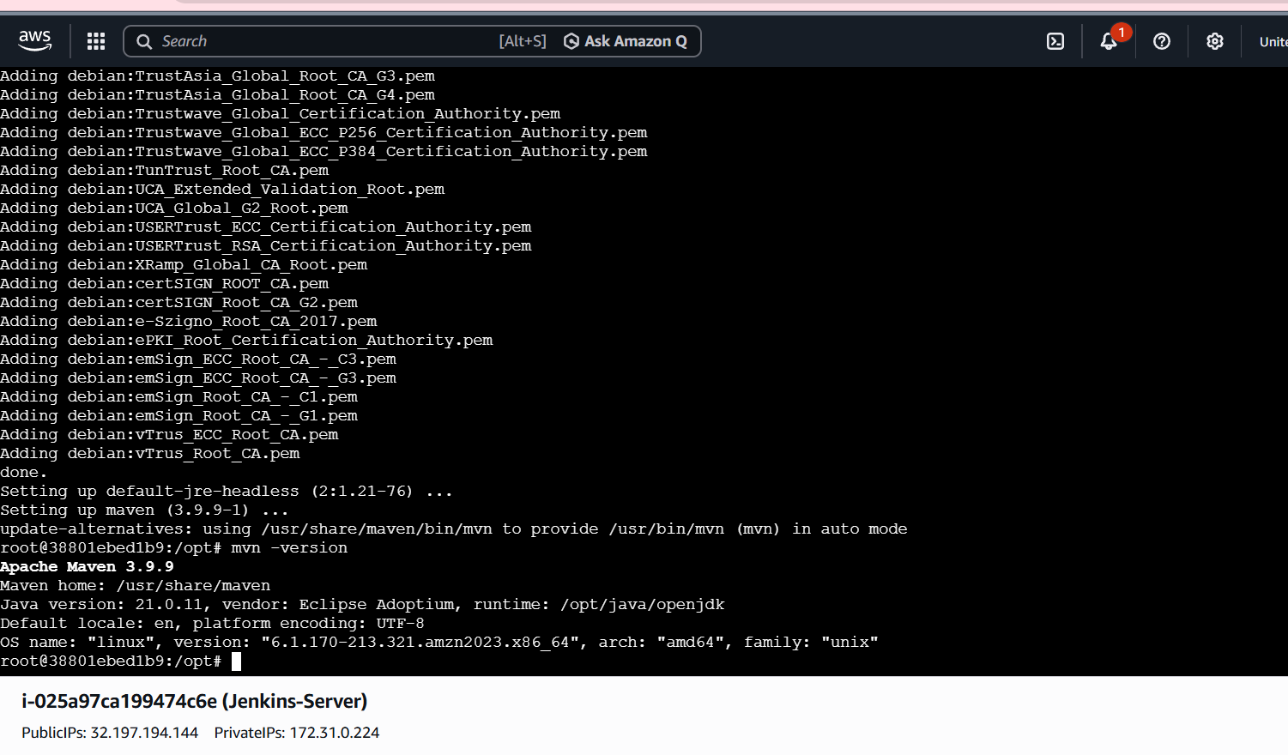
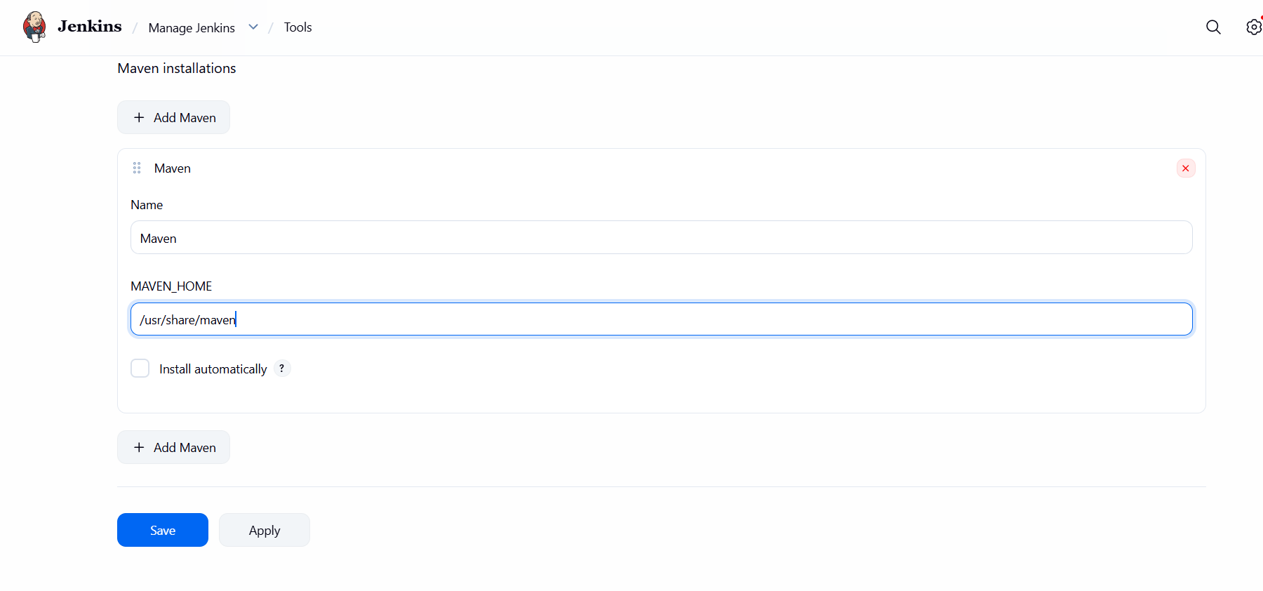
Go to manage Jenkinstoolsnamepath Go to build configure ensure we have done git clone sonarqube installationby
clicking on build steps choose add build steps choose invoke top – level maven
targets --< choose maven version goals : clean install {it will create package and also it
will delete everything} saveclick on build now
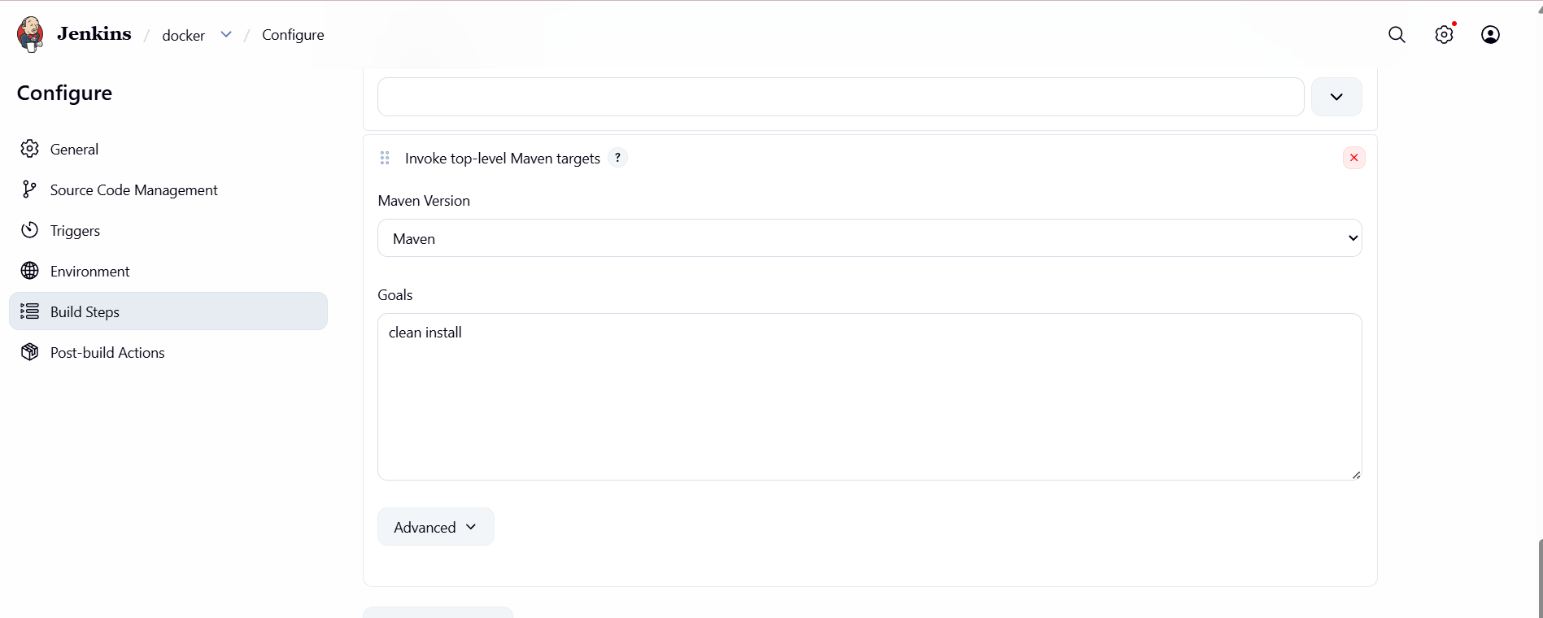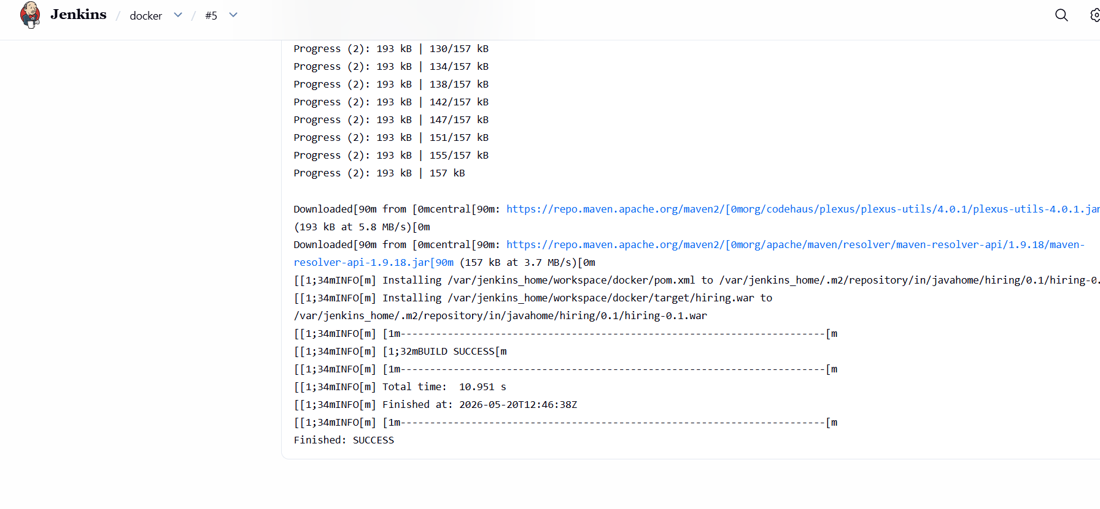
validating to view the target foldercd/var/lscd jenkins_home/lsWe are able to see the target folder

stage :Nexus
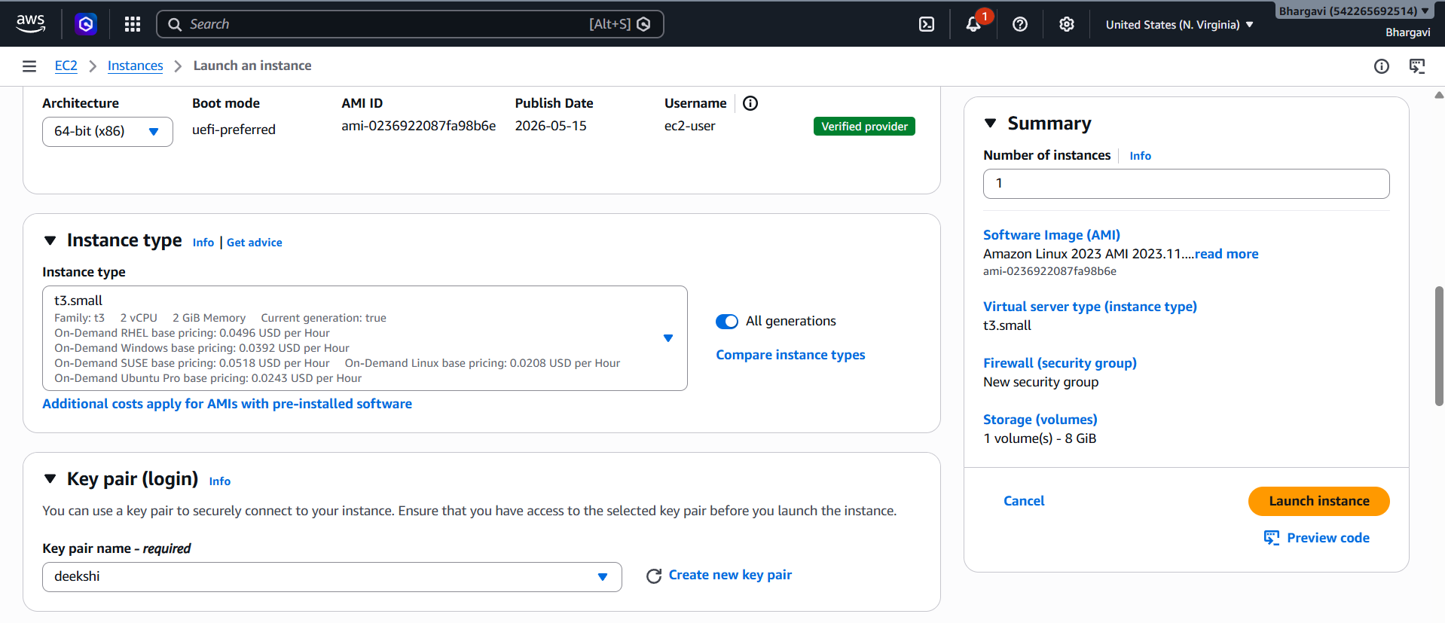
- Lets change the instance type c7.flex.large
- Sudo su - >install java >> sudo dnf java-17-amazon-coretto -y>>java –version>>useradd nexus>> id nexus >>passwd nexus>>Go to cd /opt
- Install nexus wget https://download.sonatype.com/nexus/3/nexus-3.92.2-01-linux-x86_64.tar.gz

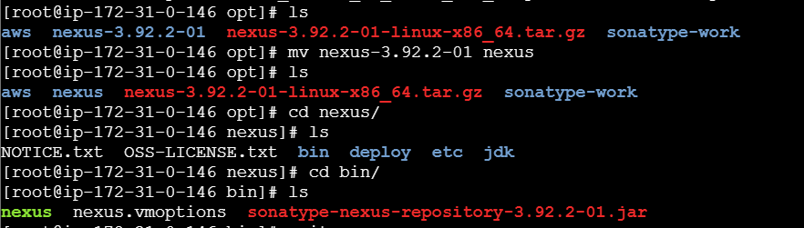
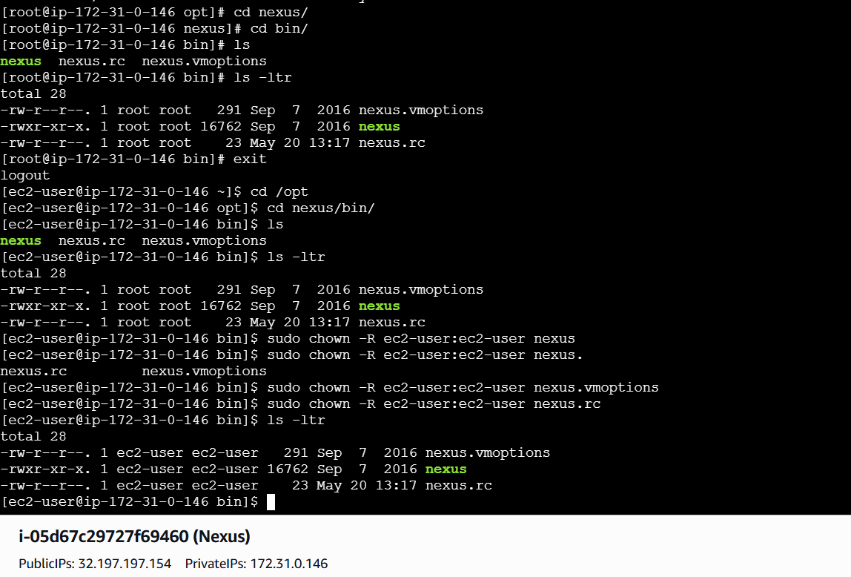
Nexus cannot work in root user
Only work in ec2-user

Using the command
sudo chown -R ec2-user:ec2-user sonatype-work
sudo chown -R ec2-user:ec2-user nexus

Now lets run
Cd /opt/nexus/bin ./ nexus start and ./nexus status as we can see the service is running→
and it's getting excited immediately. The reason is due to the ram consumption so lets
check the ram size and change it accordingly. To change the ram size we need to got the file called
vi nexus.vmoptions
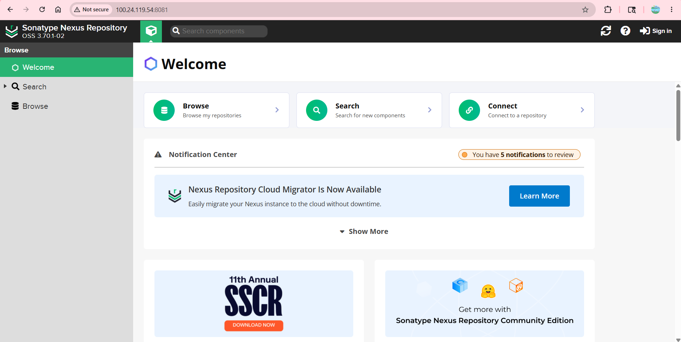

- So now let’s create a new file and give it permissions to run on ec2-user.
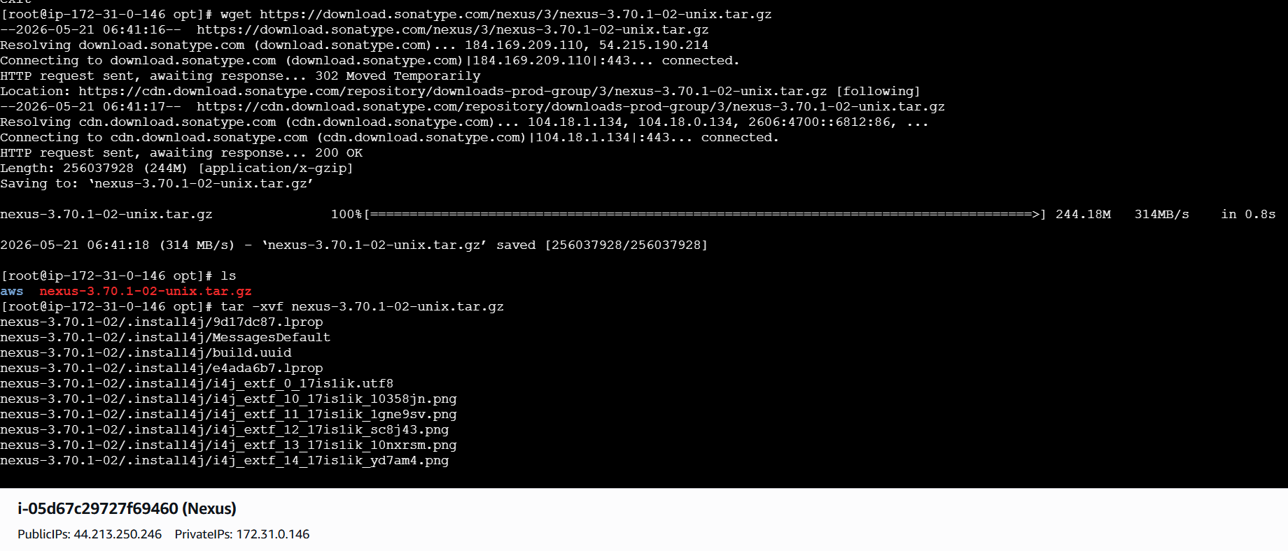
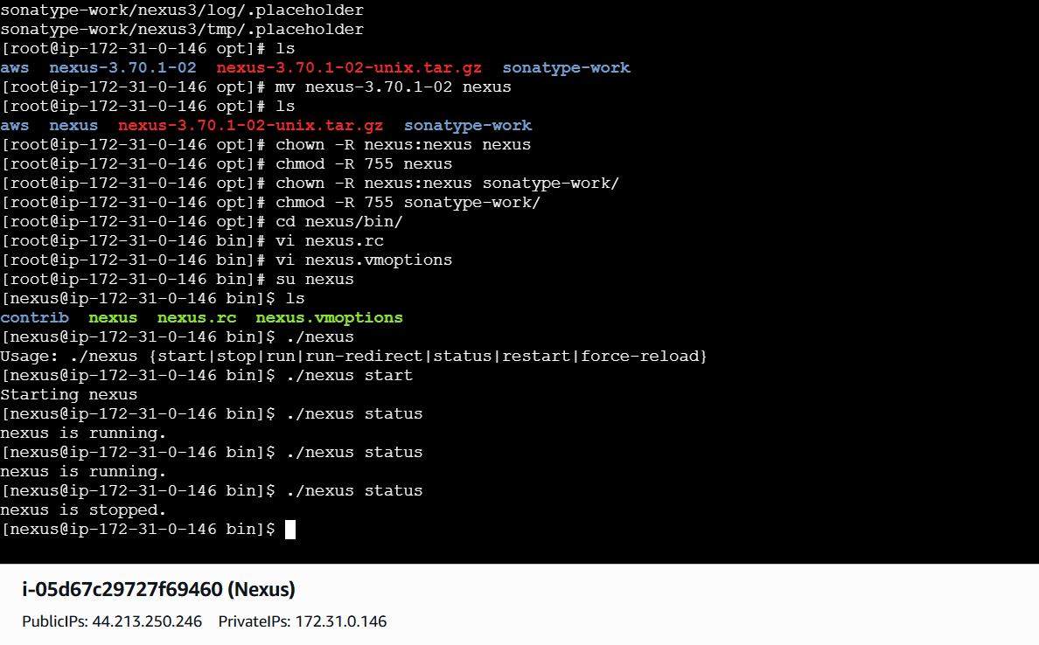

Go to manage Jenkinsplugginsnexus artifactoryinstall
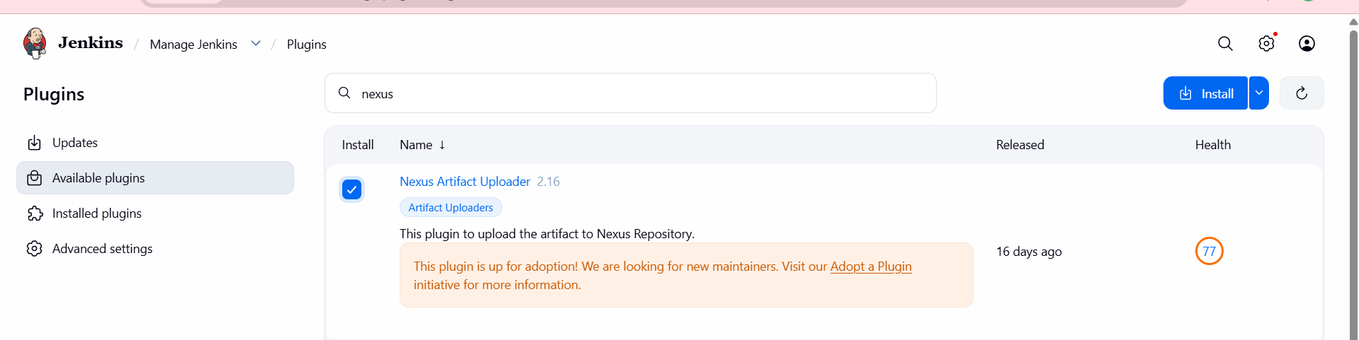
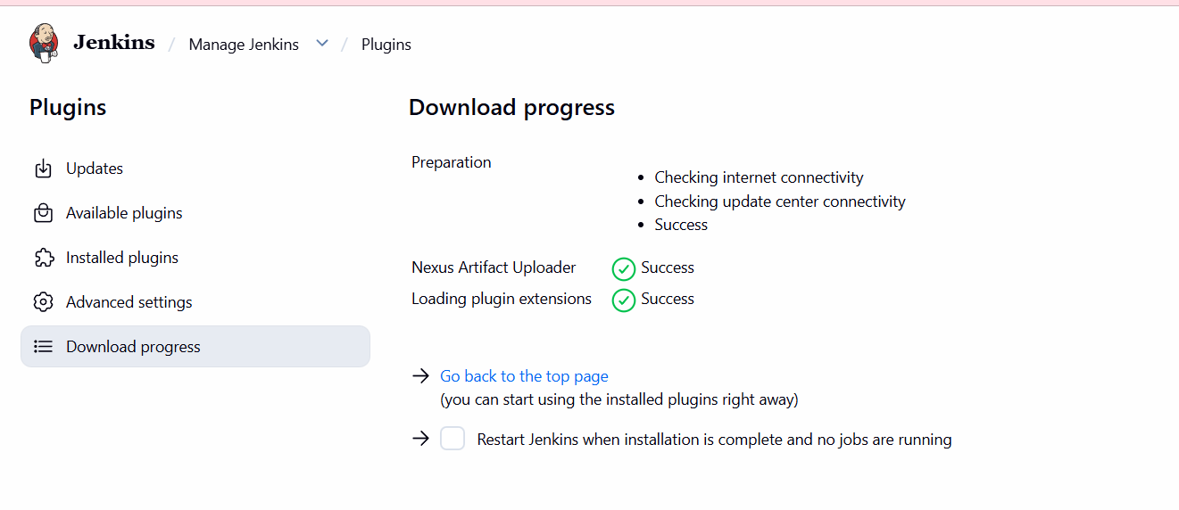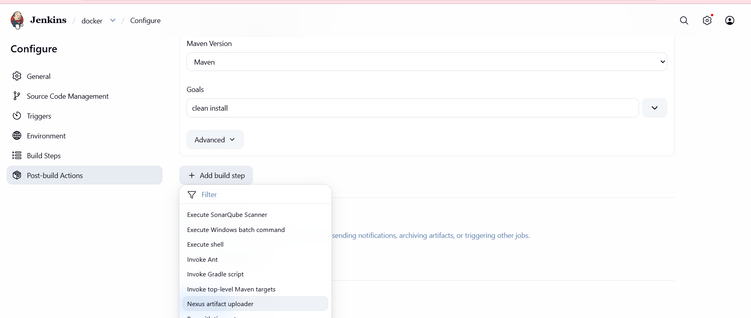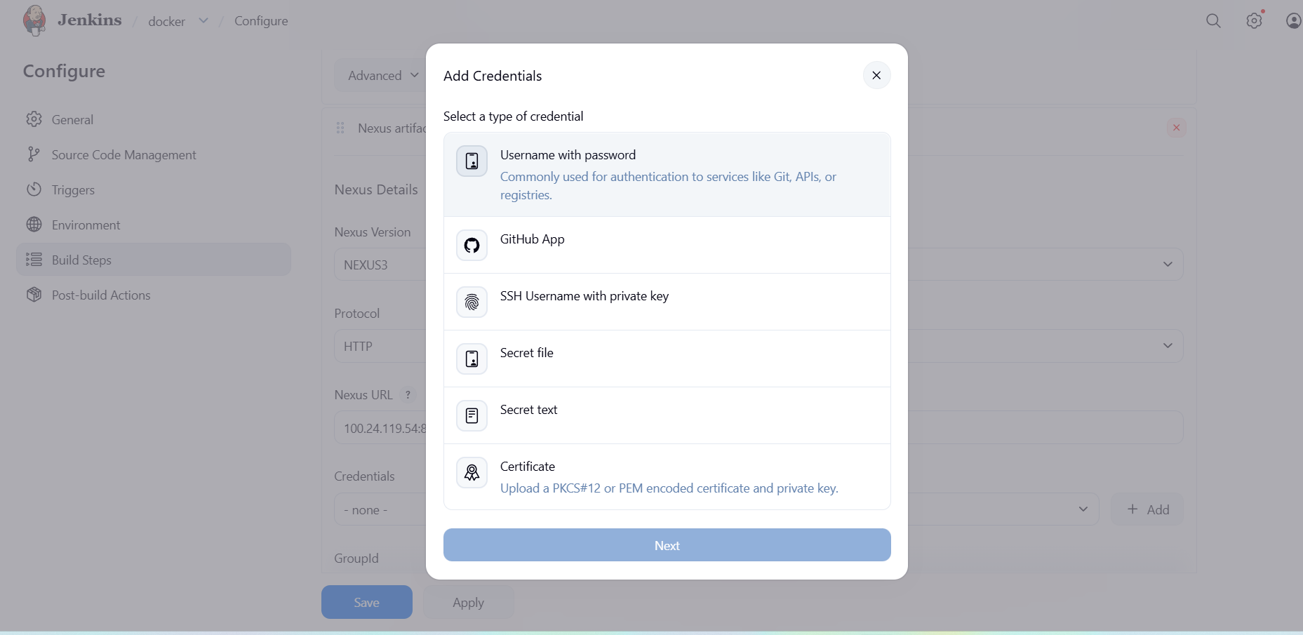
Go to nexus dashboard we open sign in one user and password in this palce we can give new password
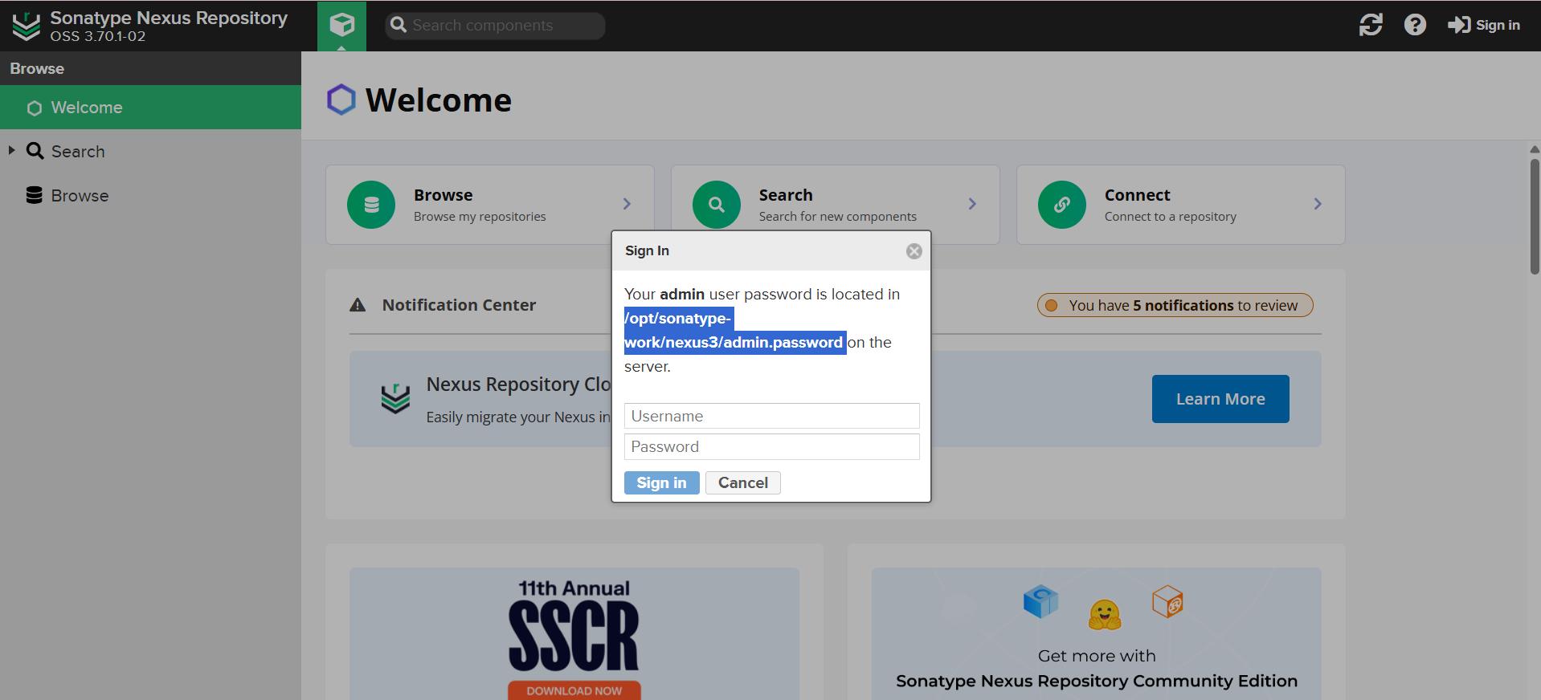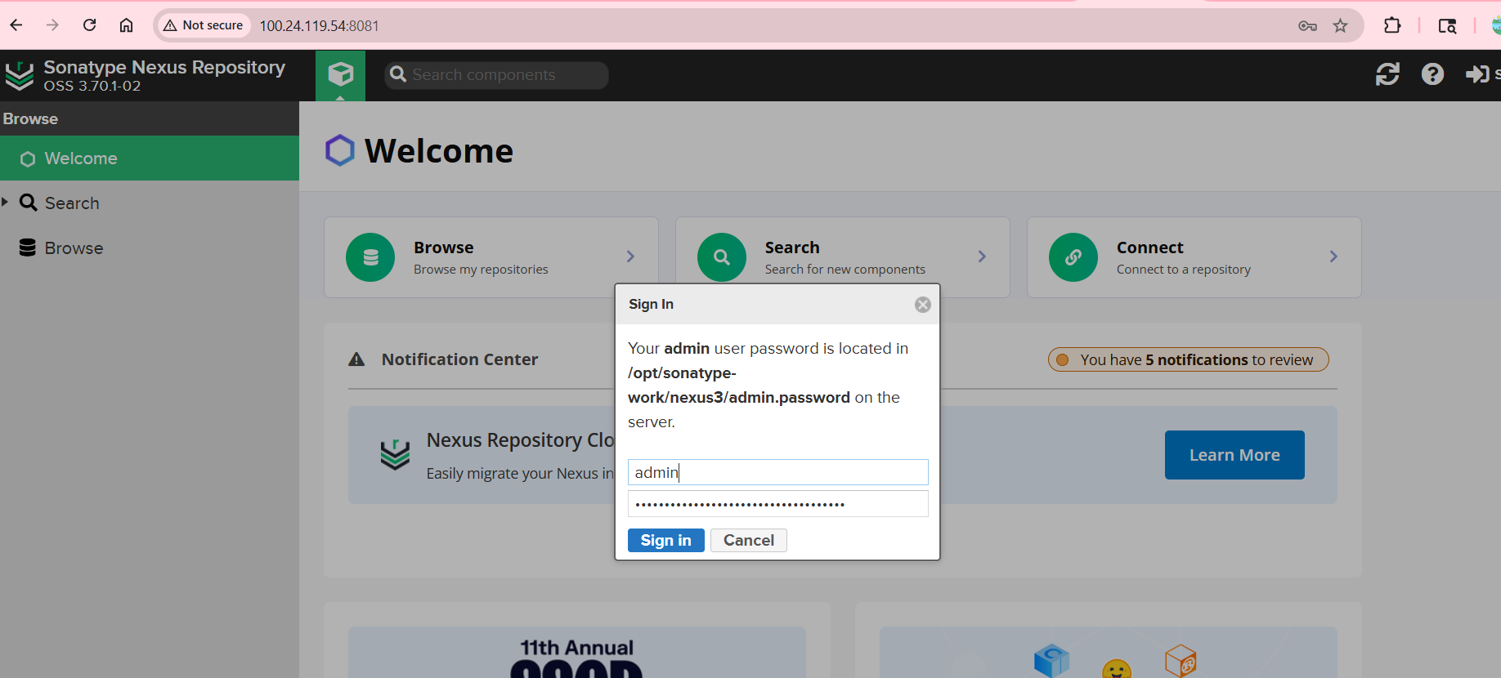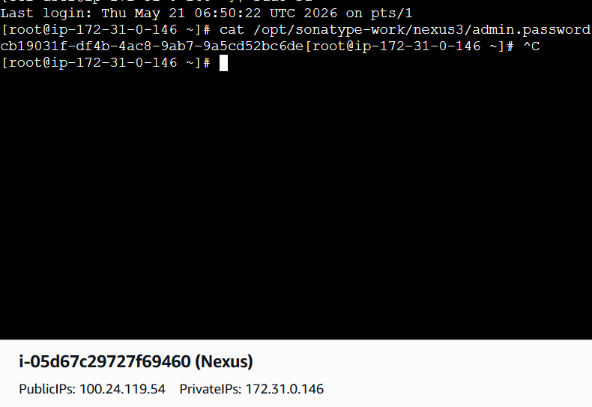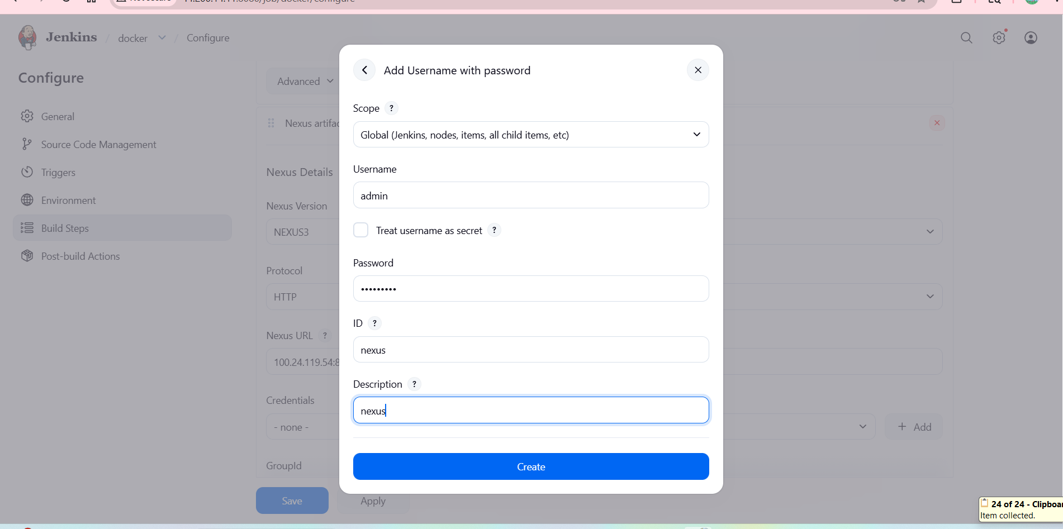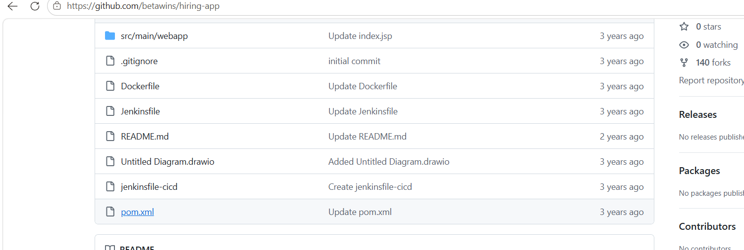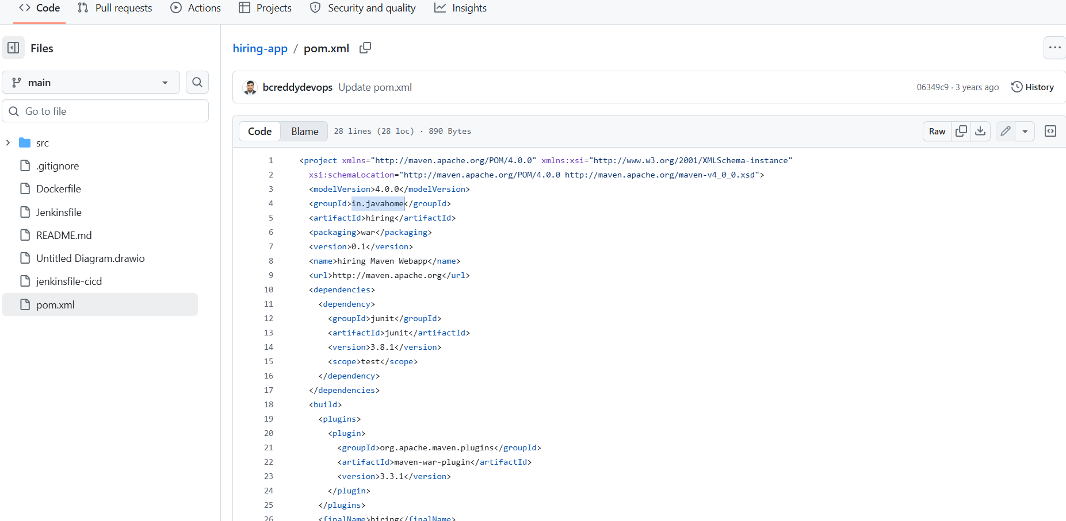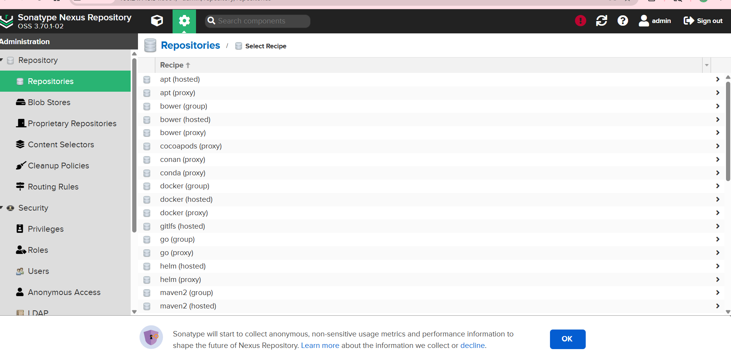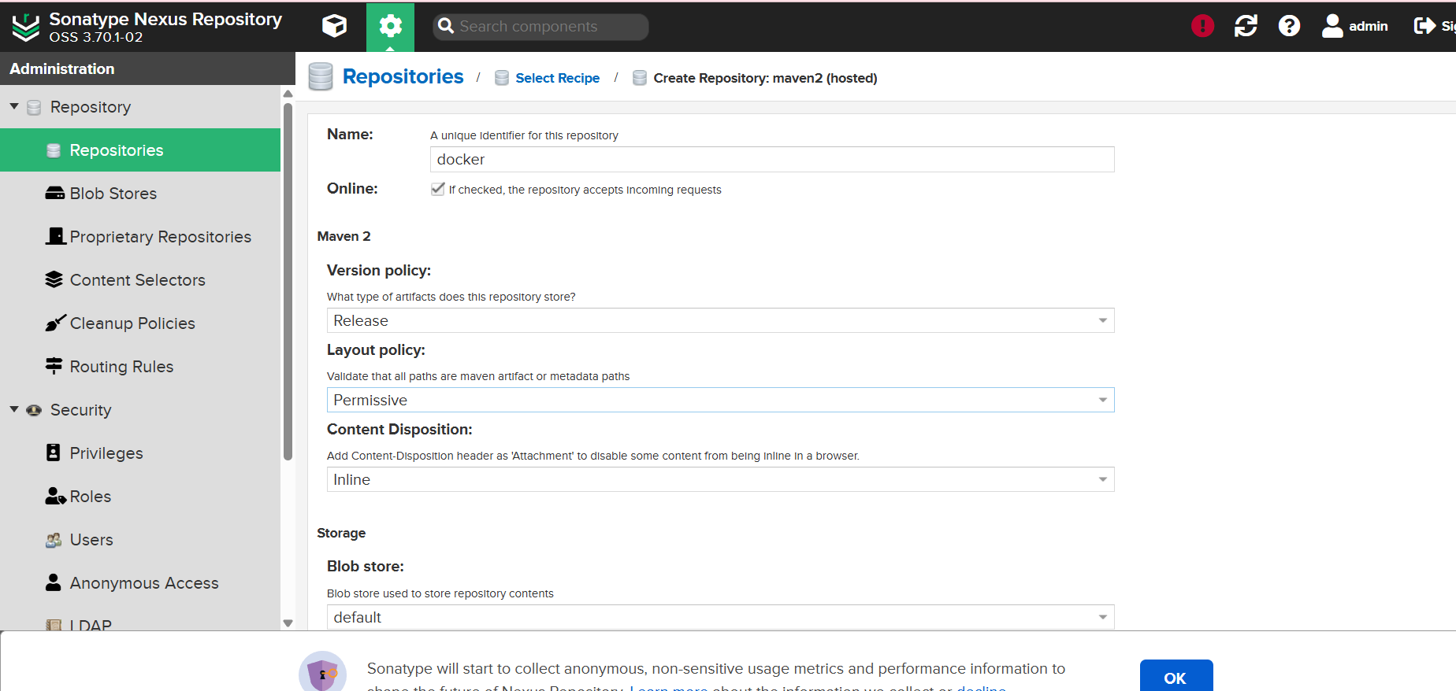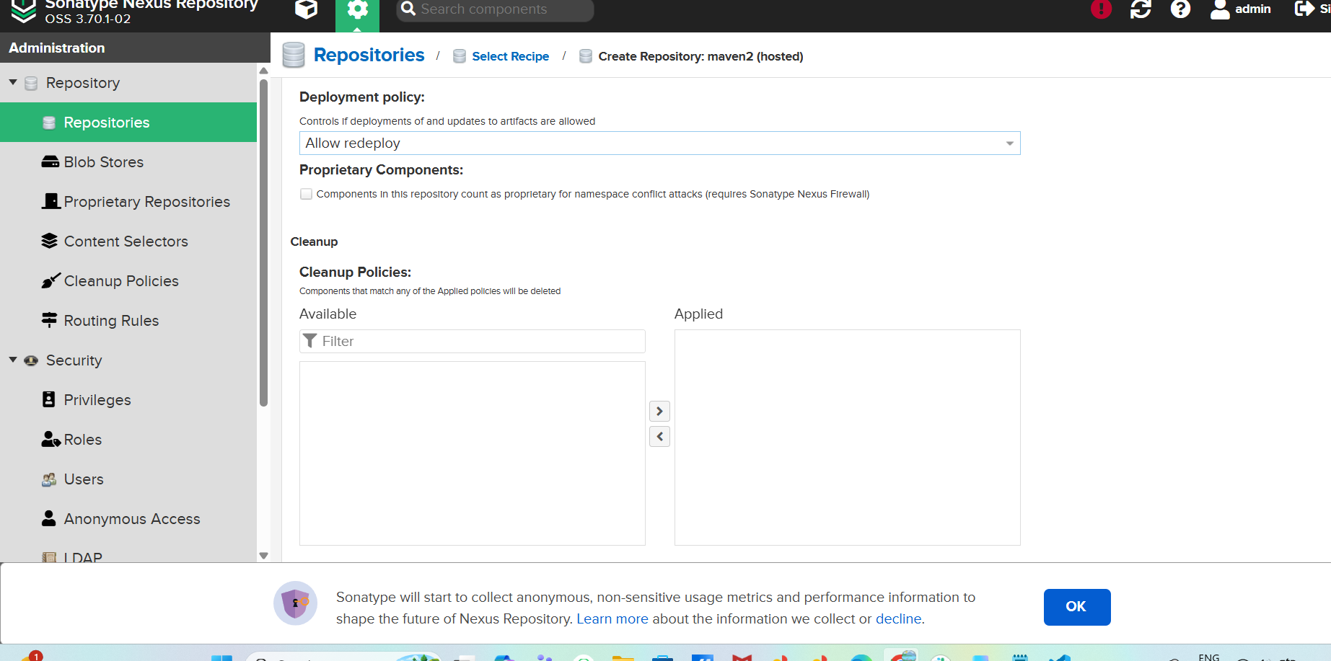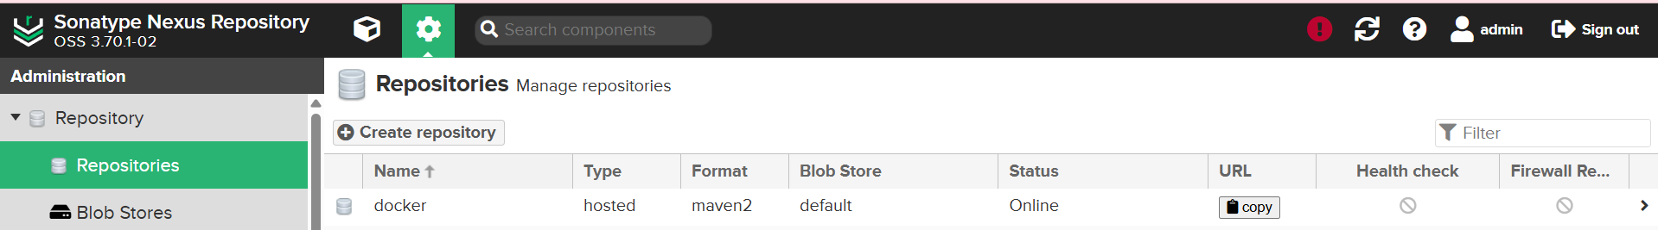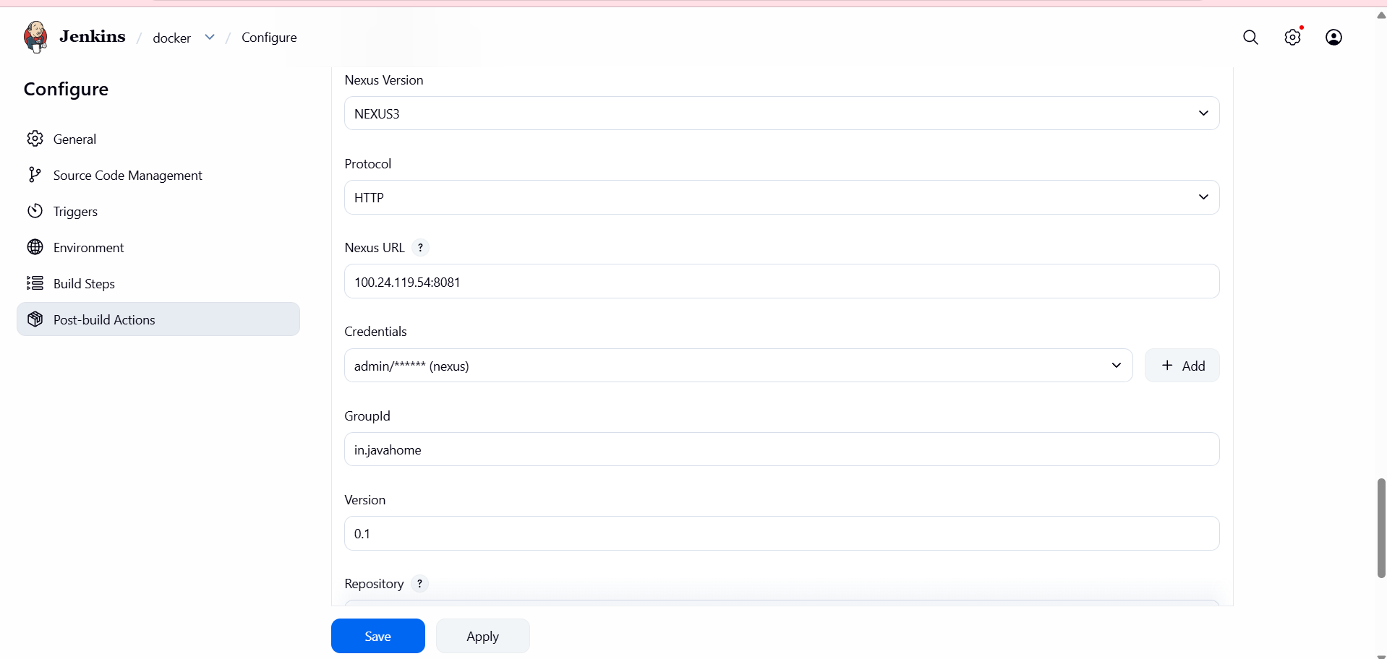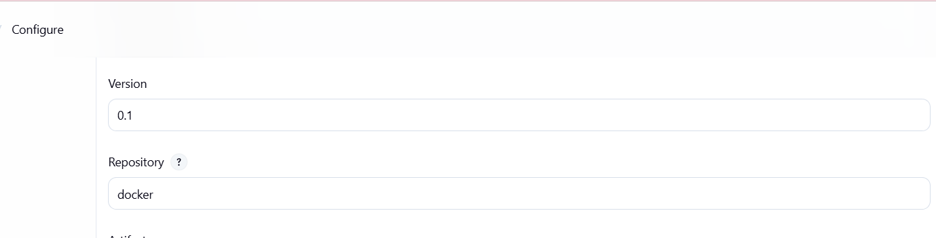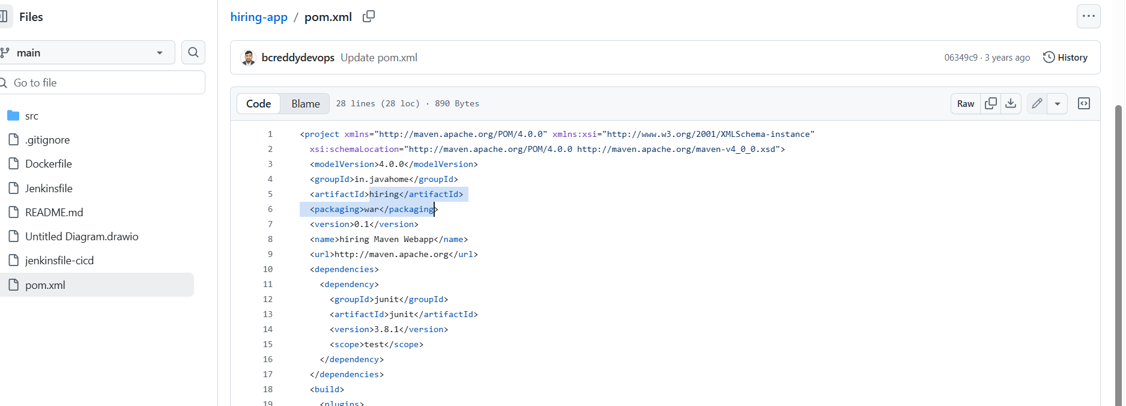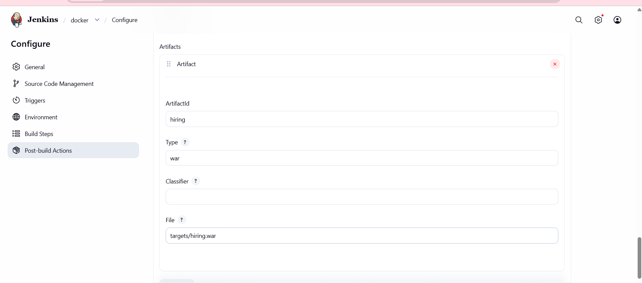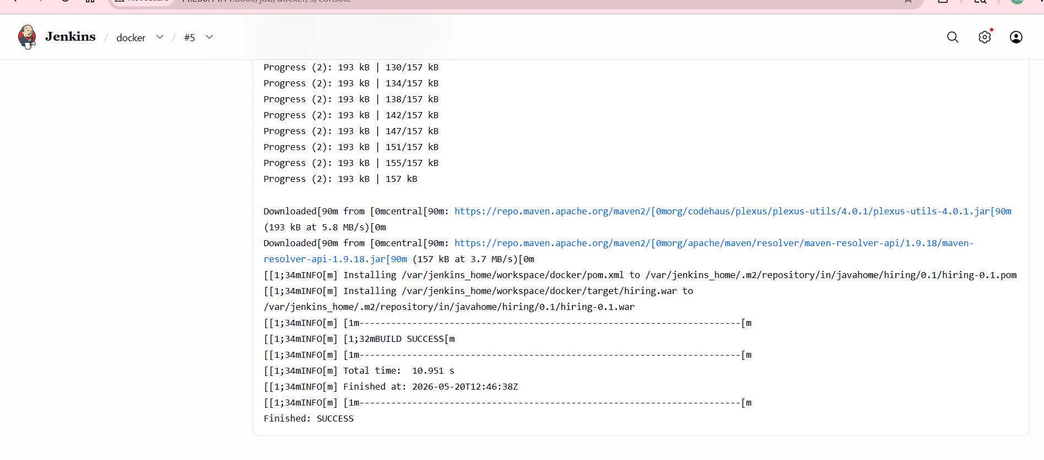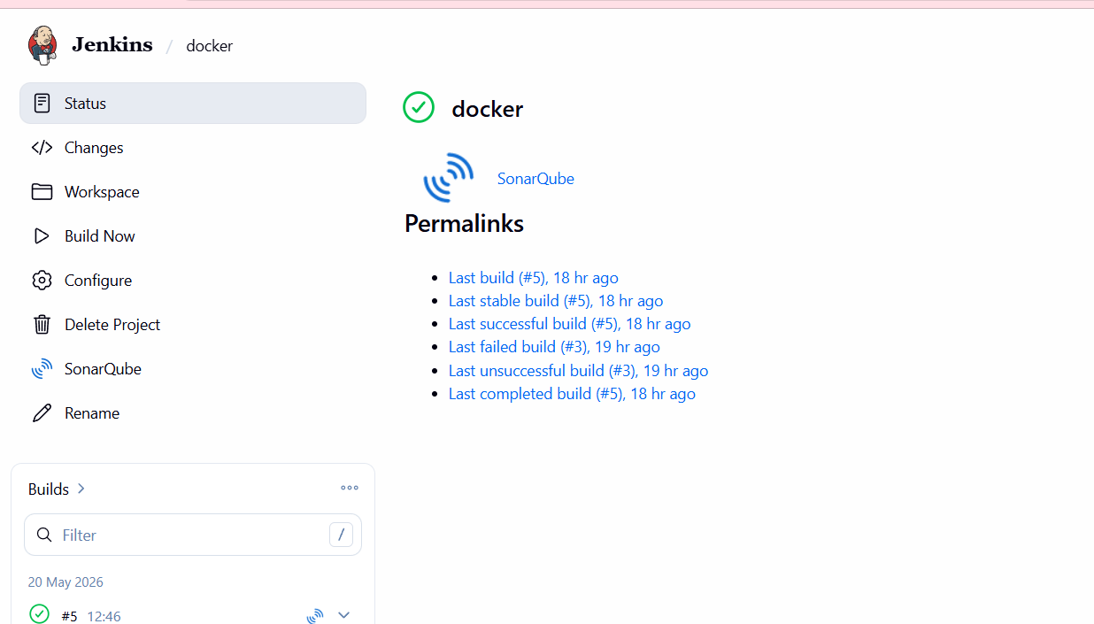
Stage:Deploy the tomcat
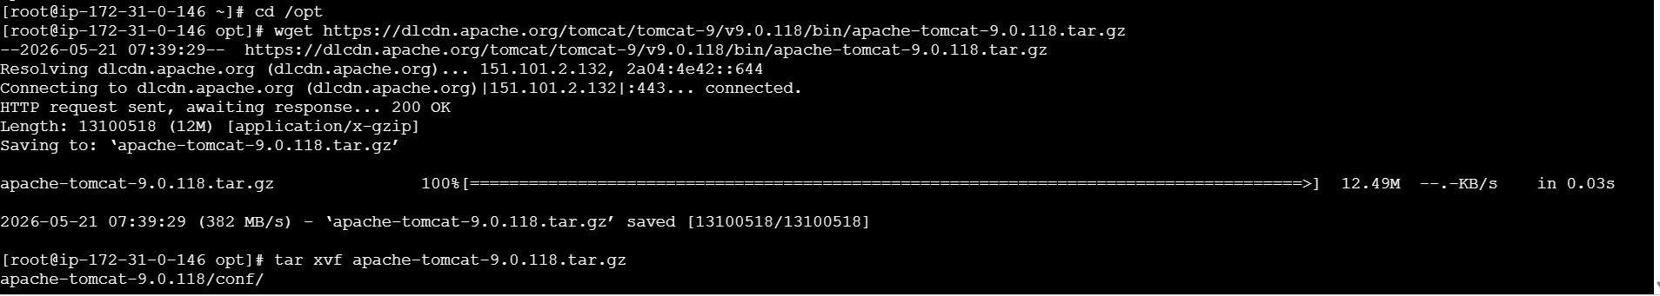
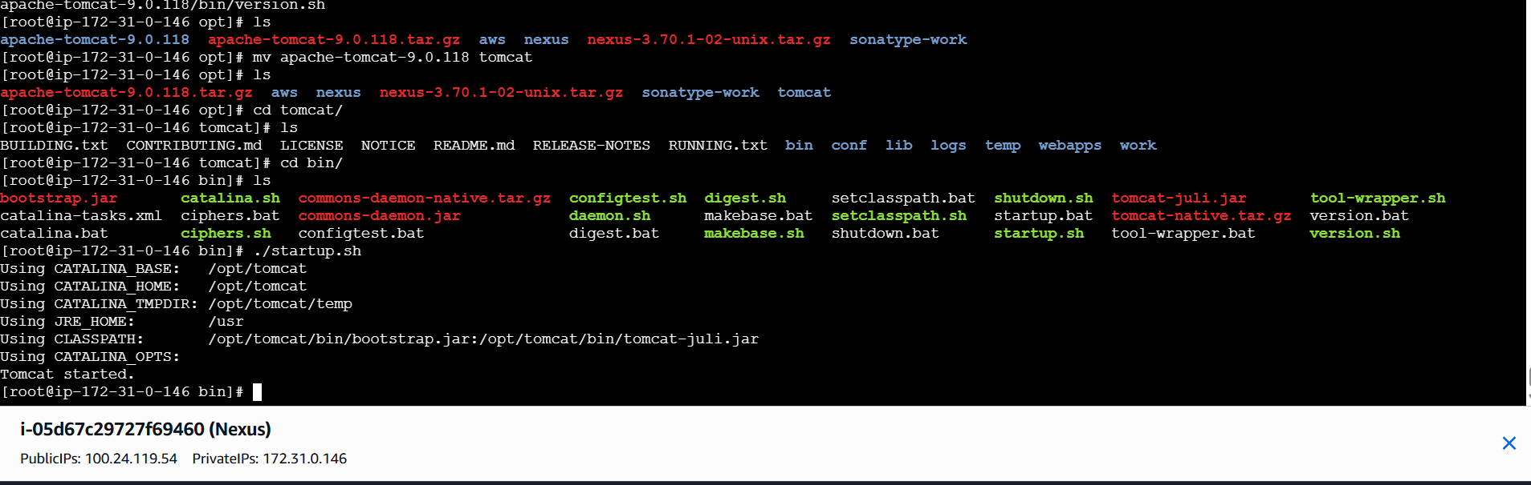
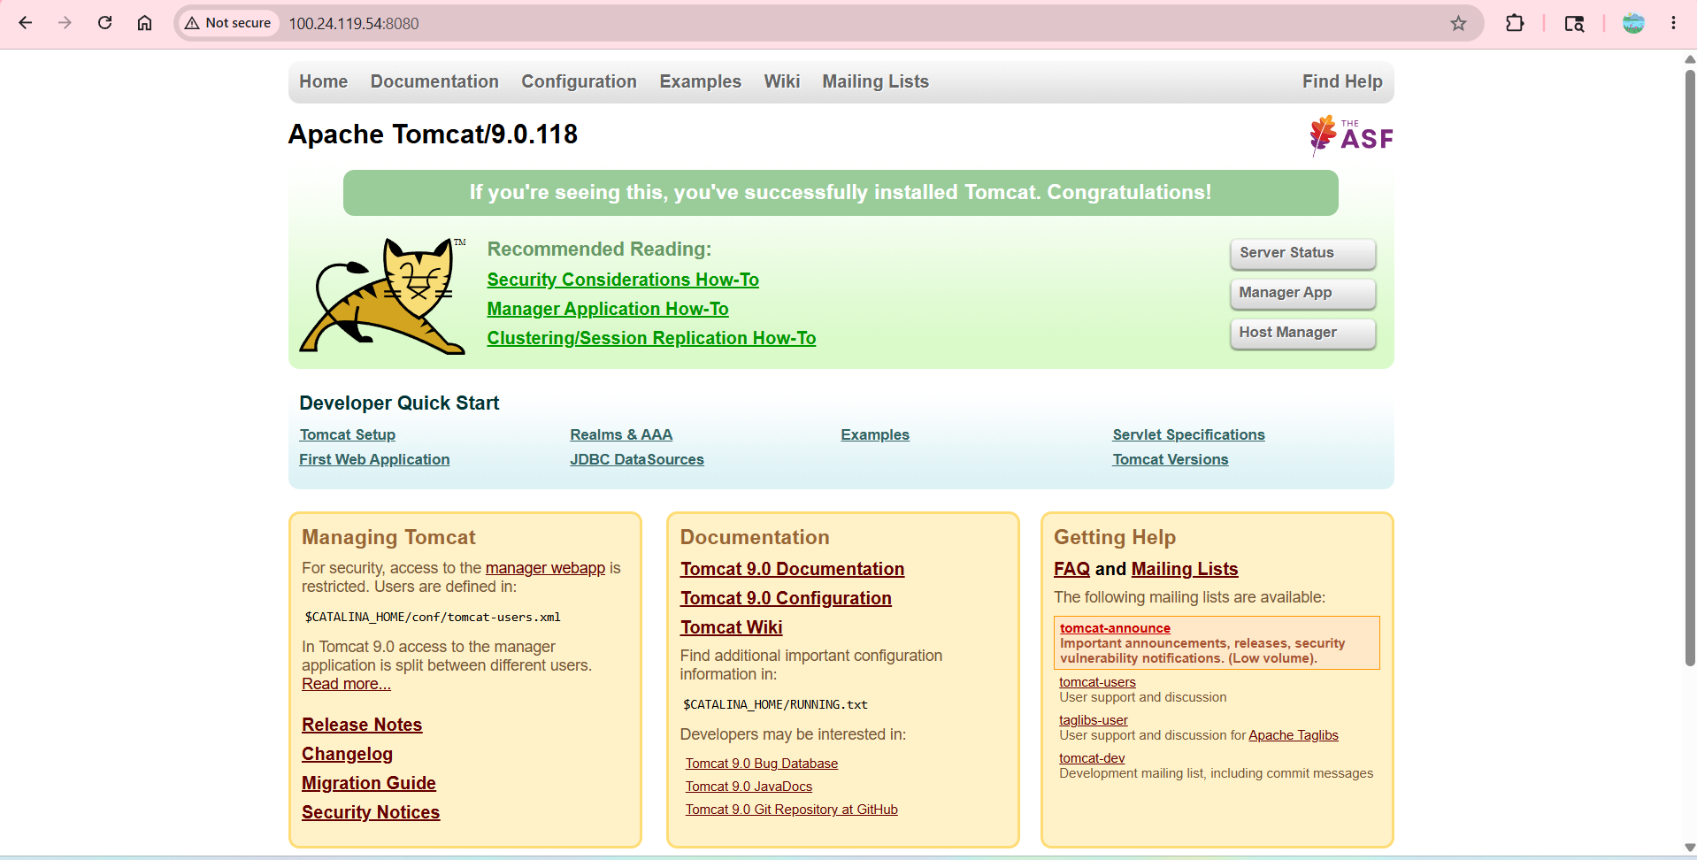
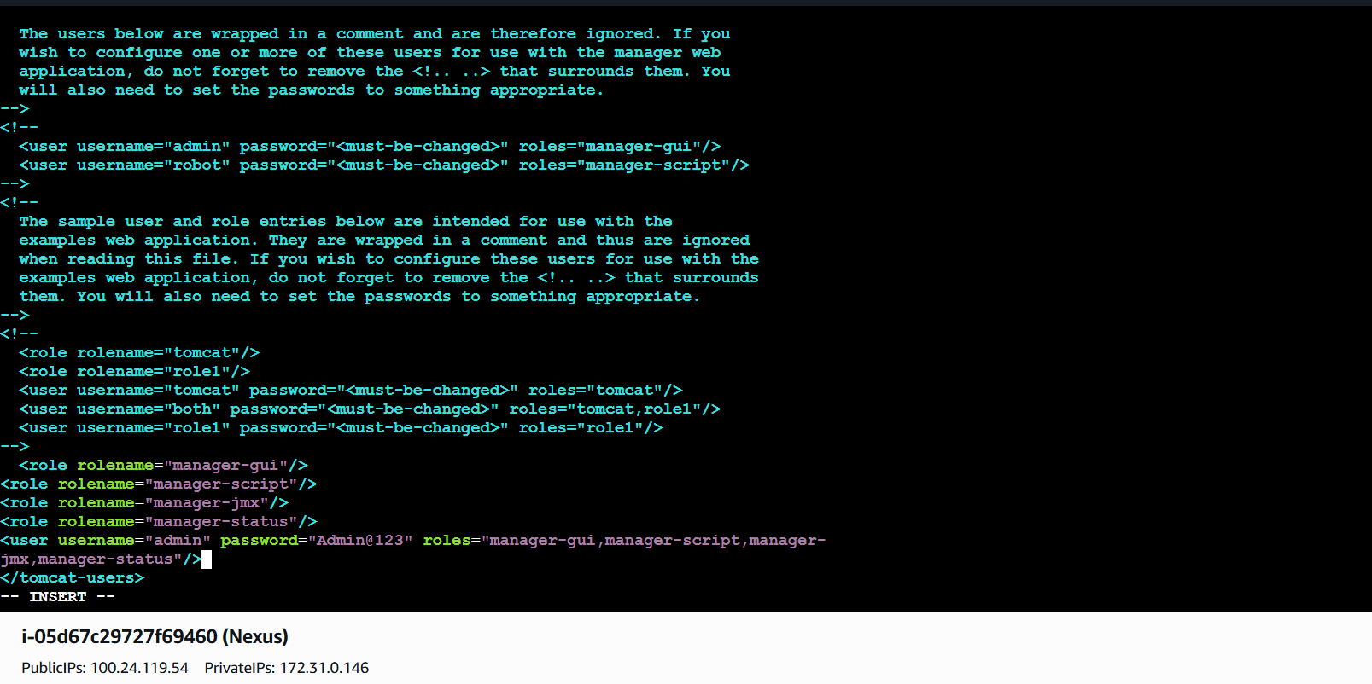

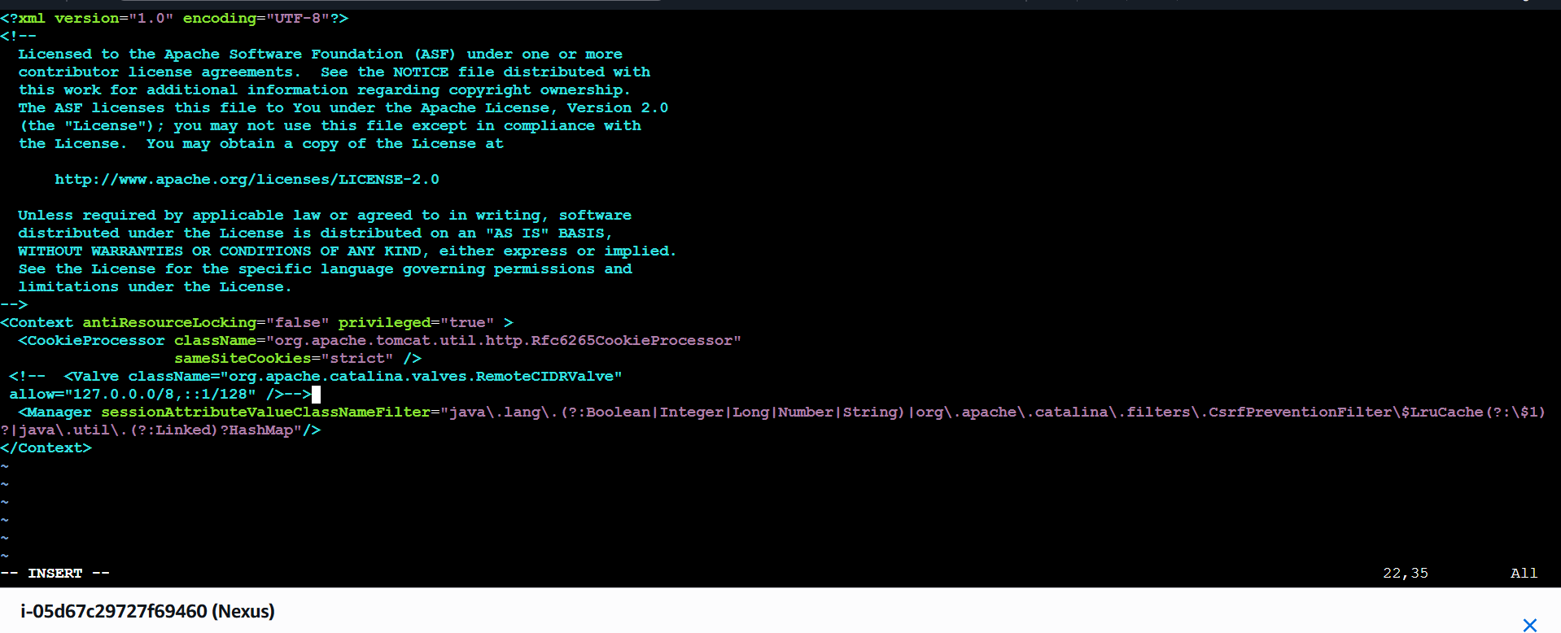
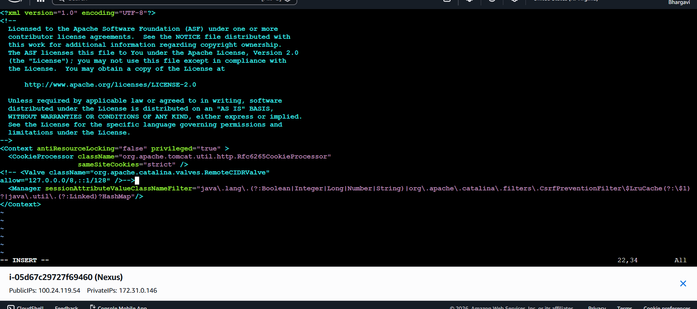
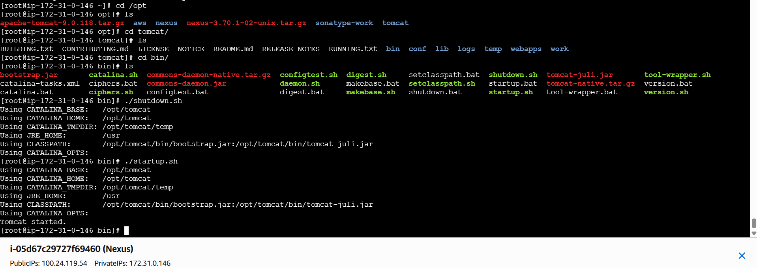go to browsermanage appsusername adminpassword:Admin@123see now browser tomcat in below
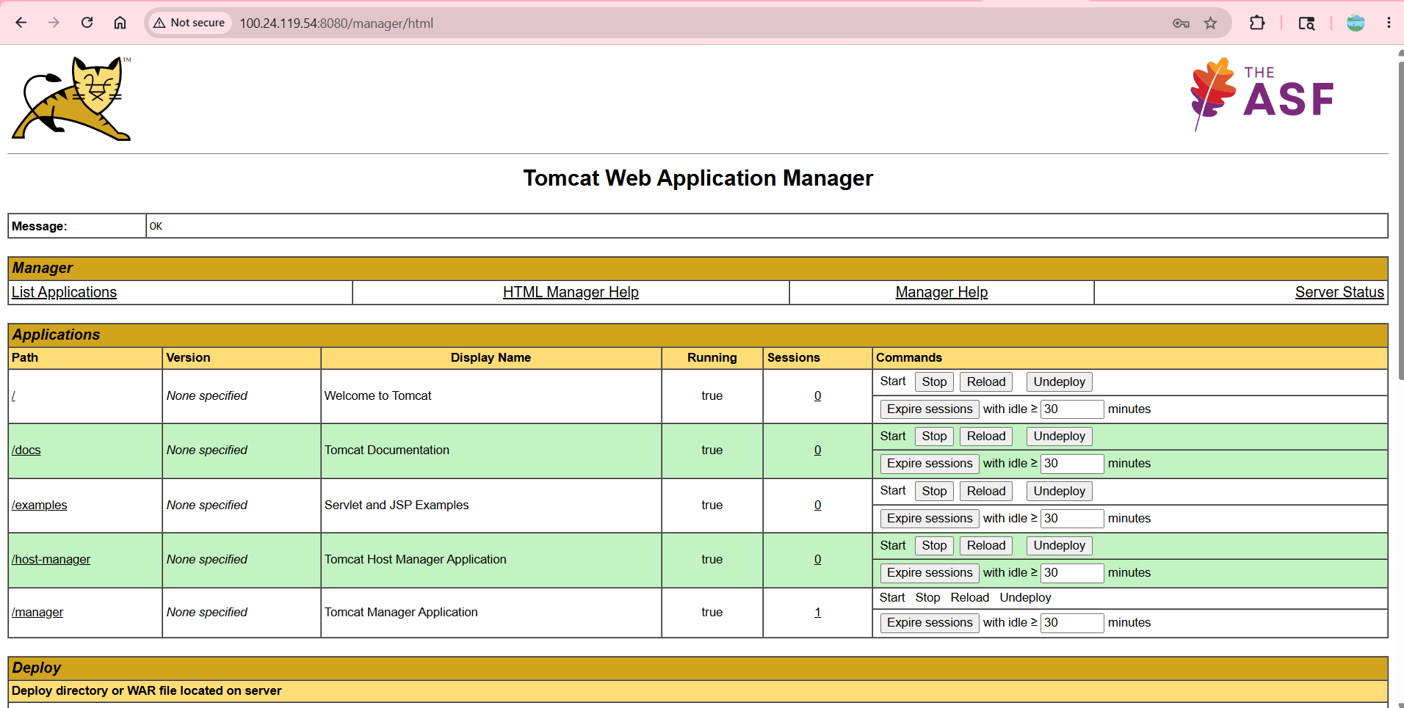
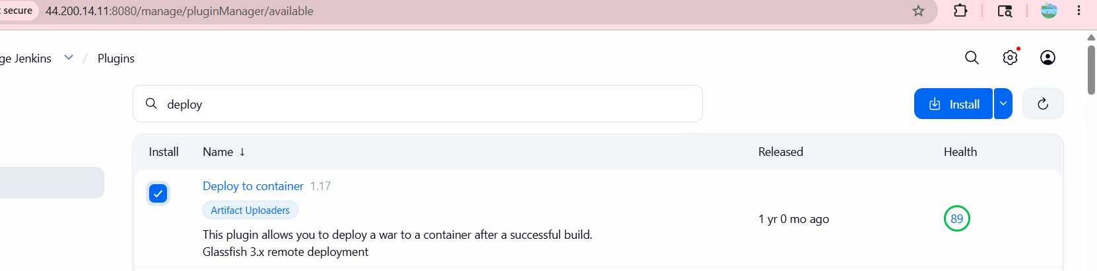
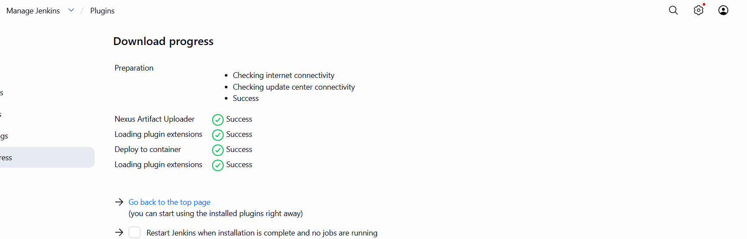
- Click Add → Jenkins
- Select Username with password
- Enter:
  - Username: admin
  - Password: Admin@123
  - ID: tomcat_credentials
  - Description: tomcat_credentials
- Click Add
- Select this credential in container configuration
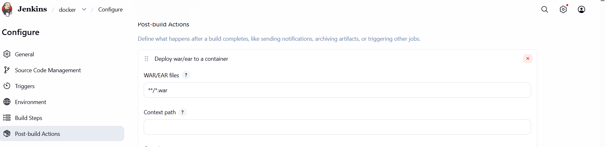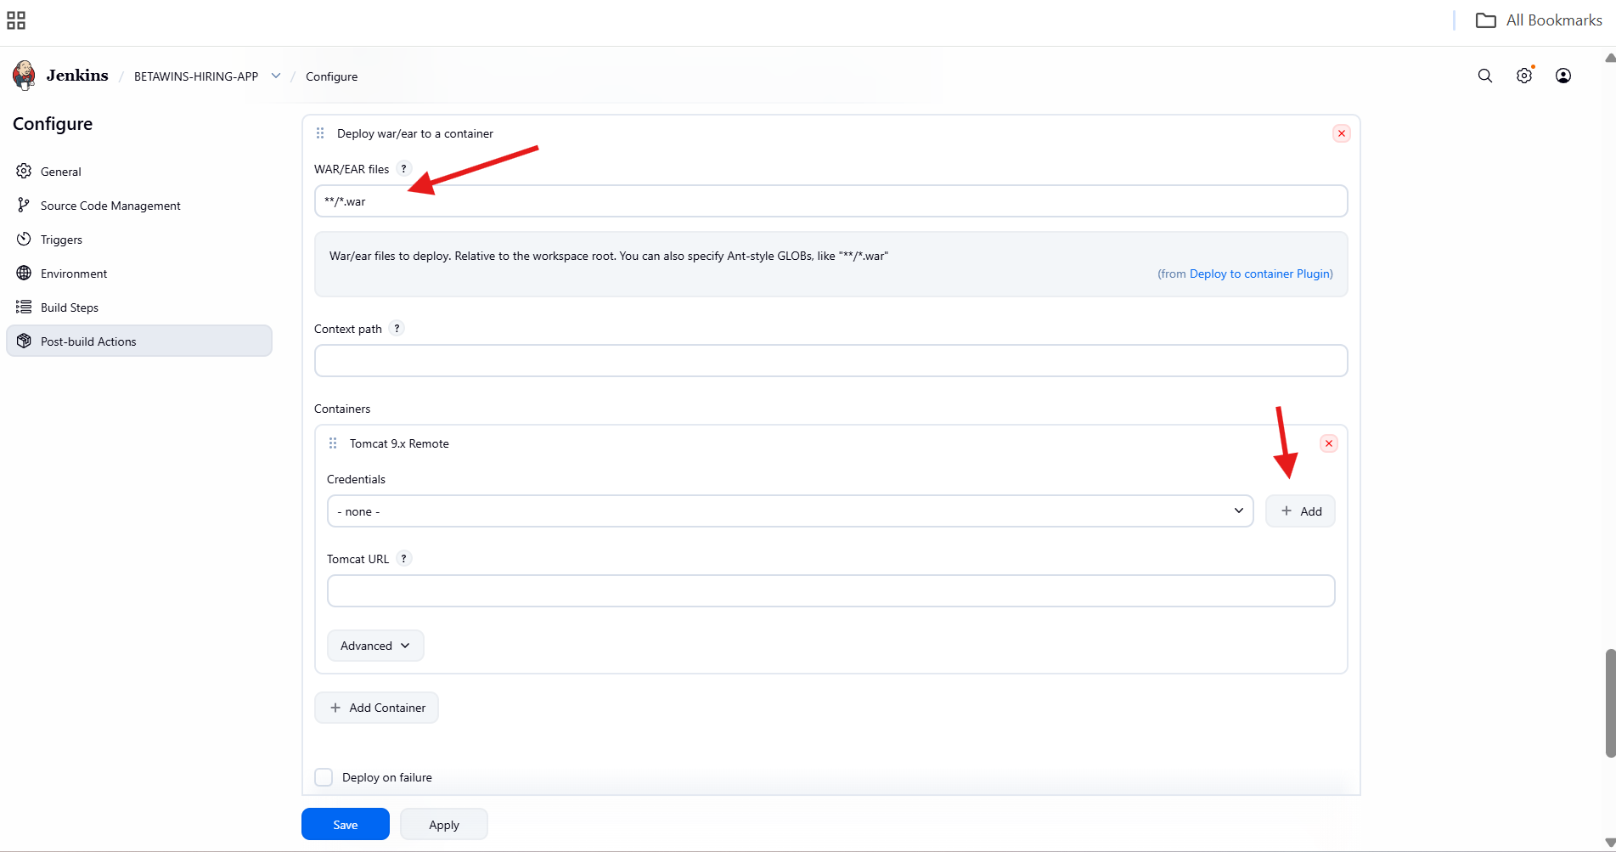
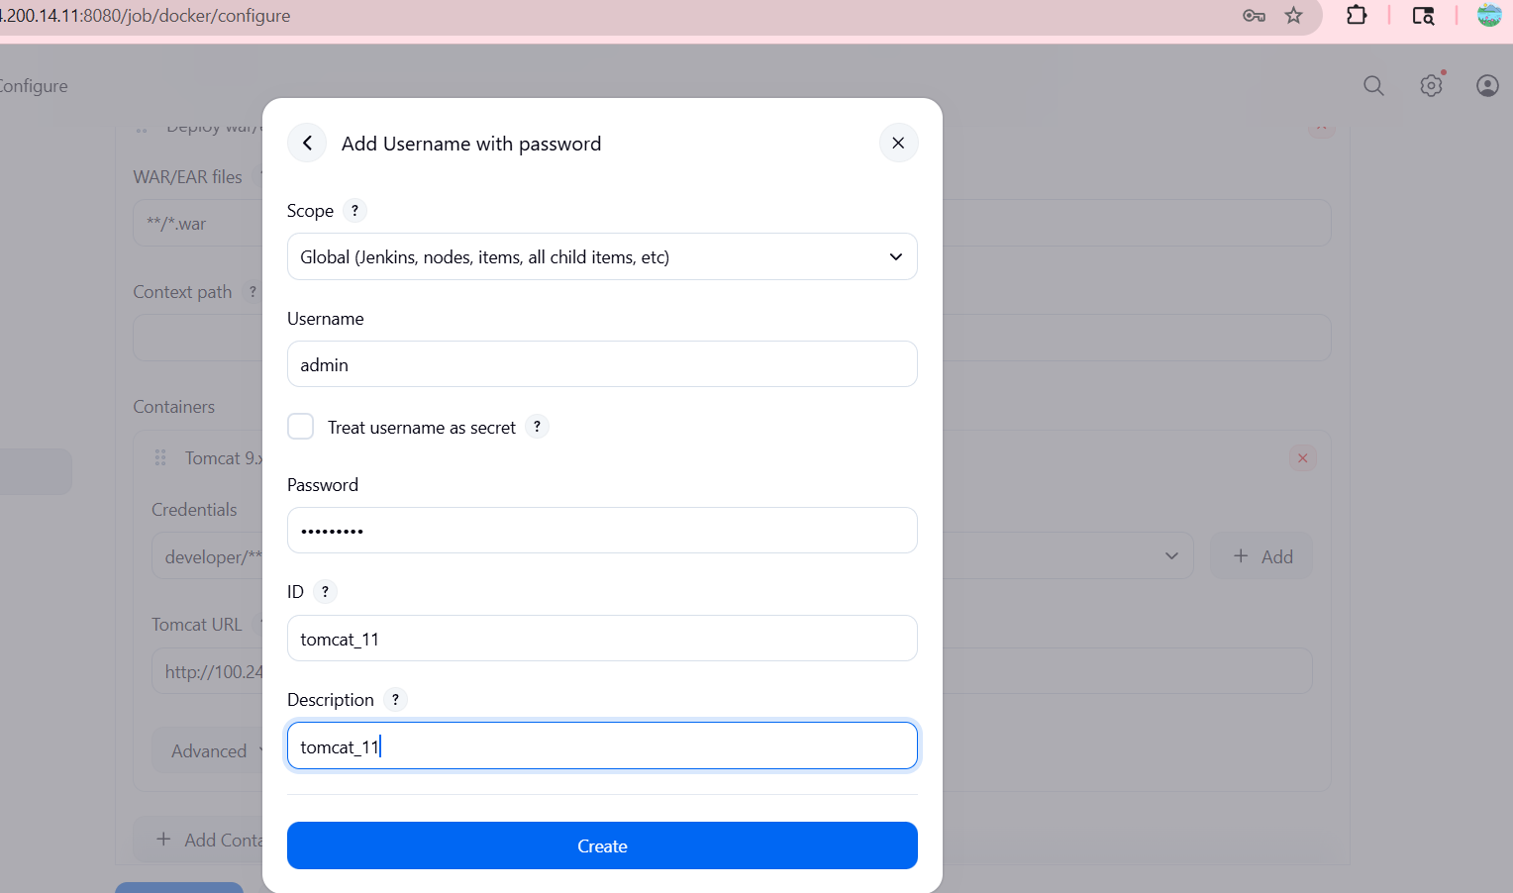
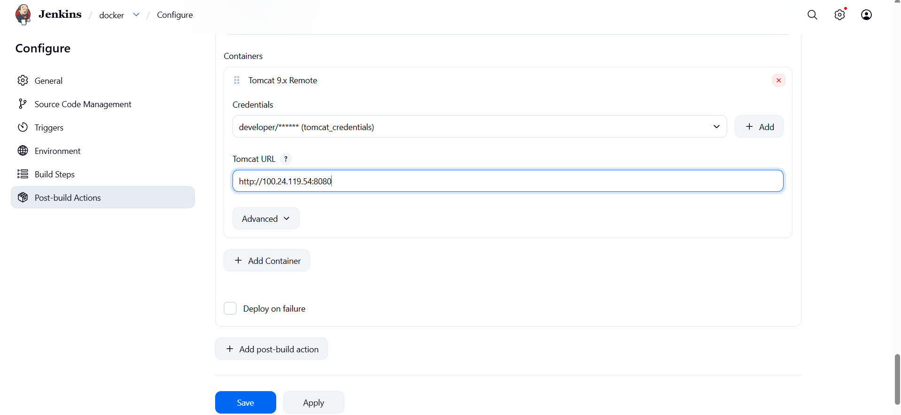
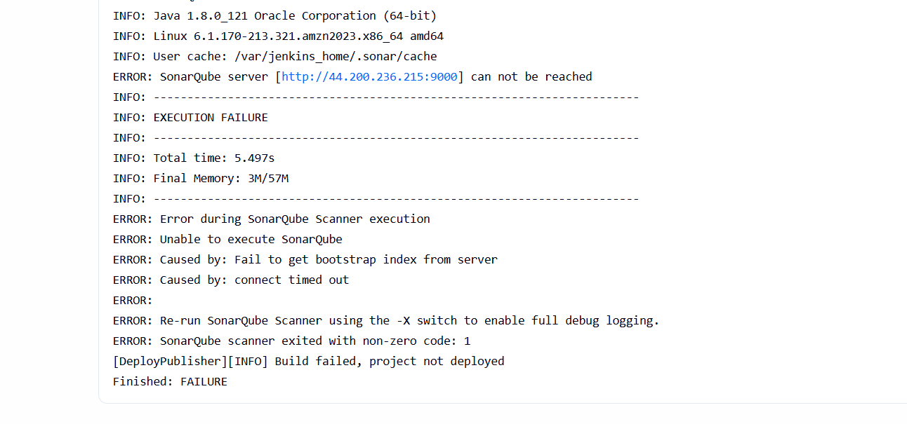
- I got error because of my sonarqube was not running in process thaths why I am restart my sonarqube
- 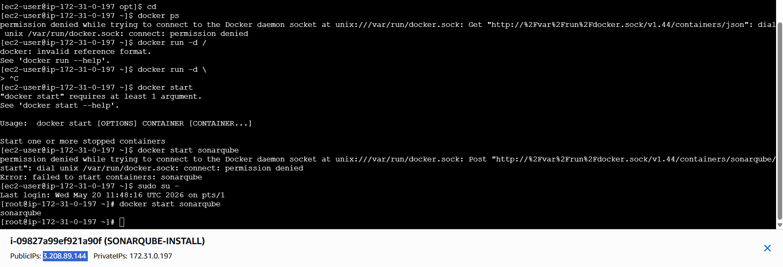
Completed my restart my page
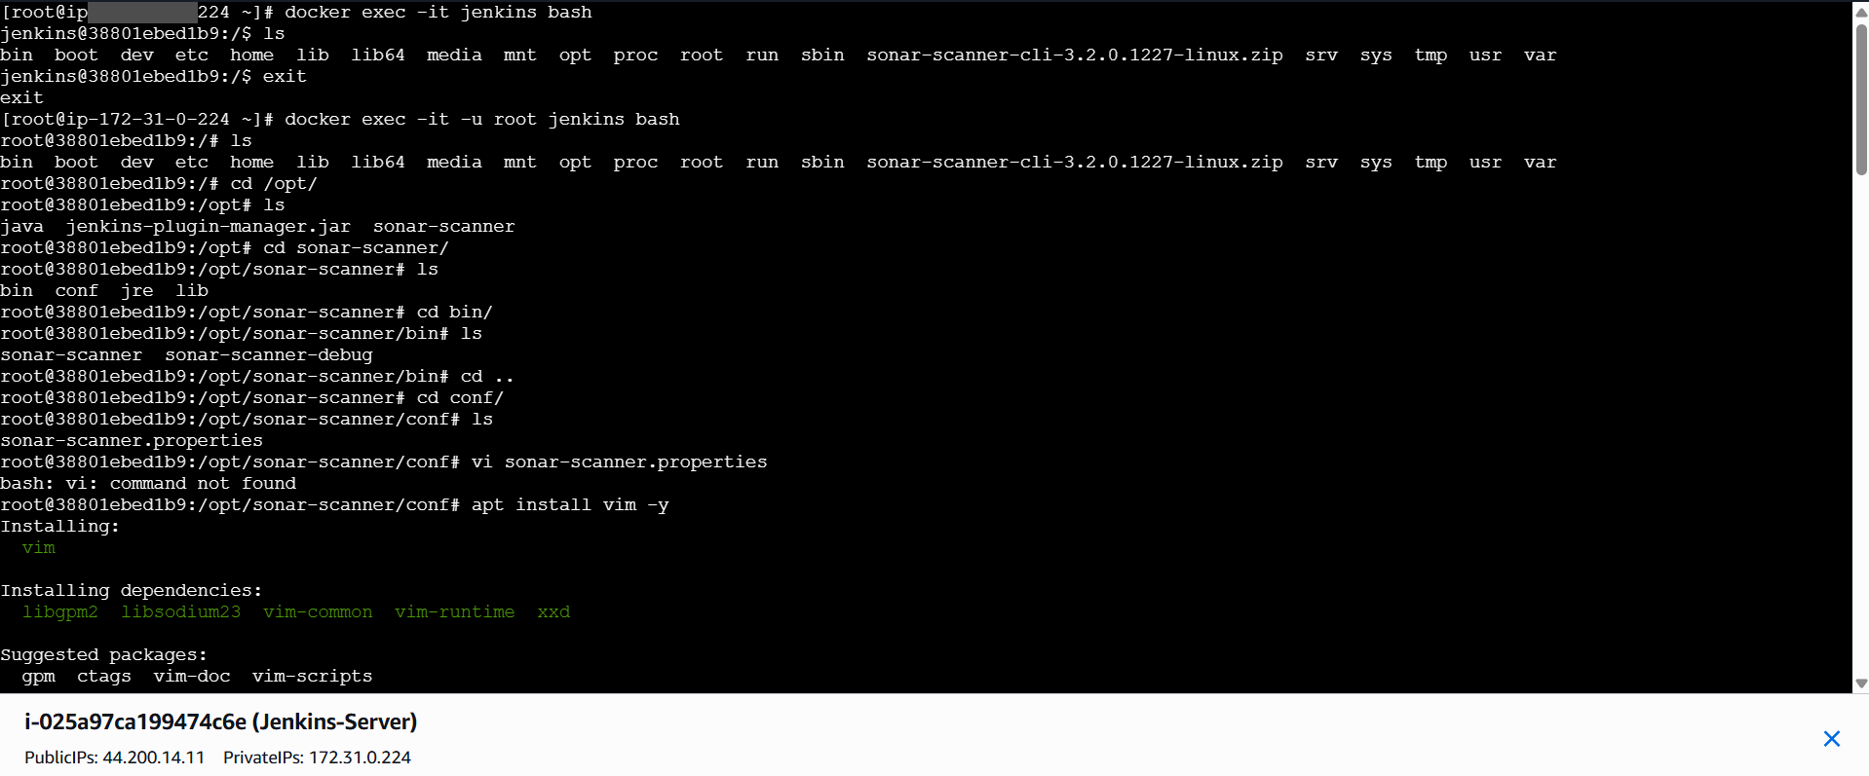
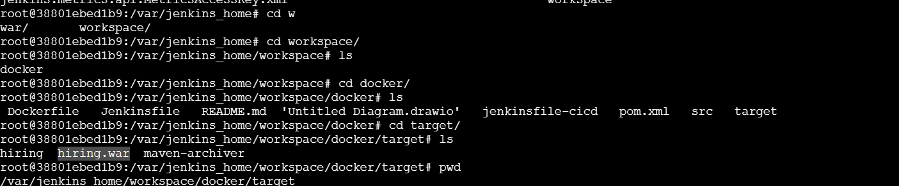
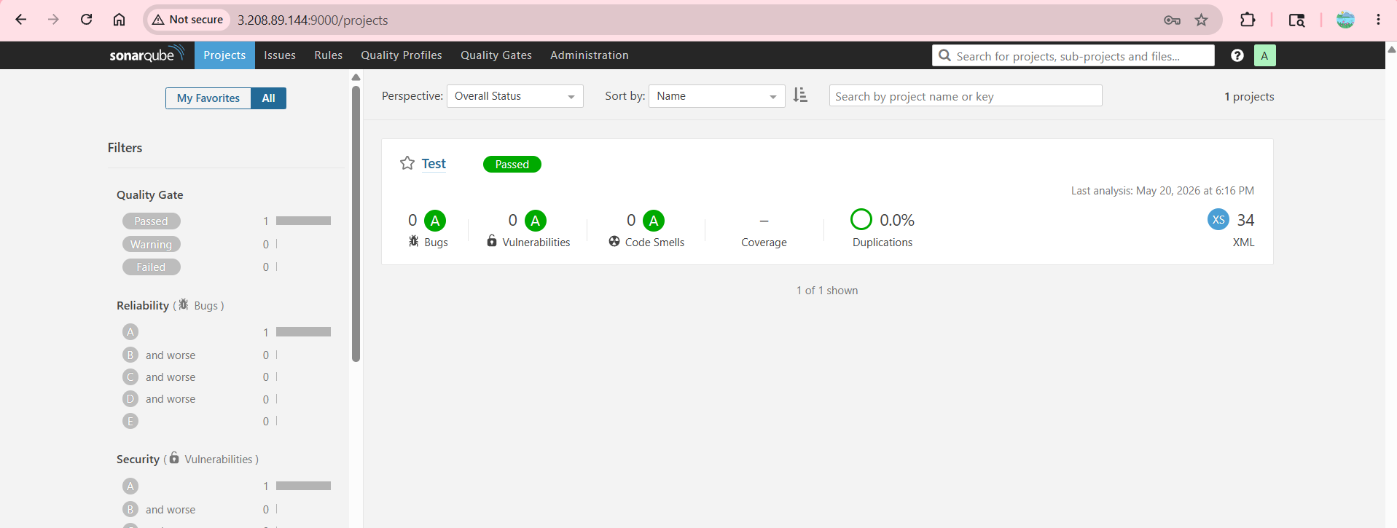
Agiain I get error because credentiasls was changes then again
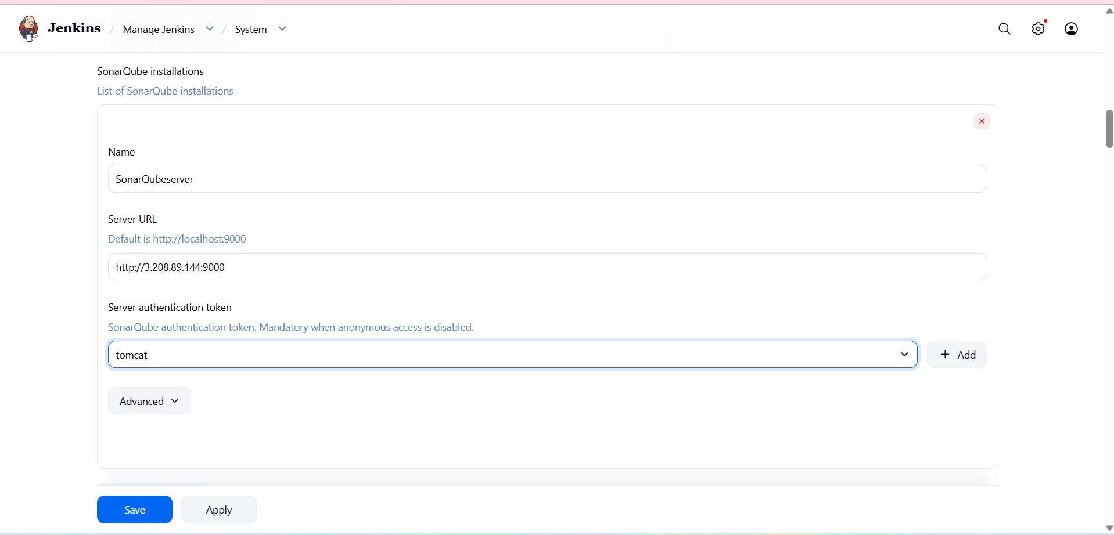
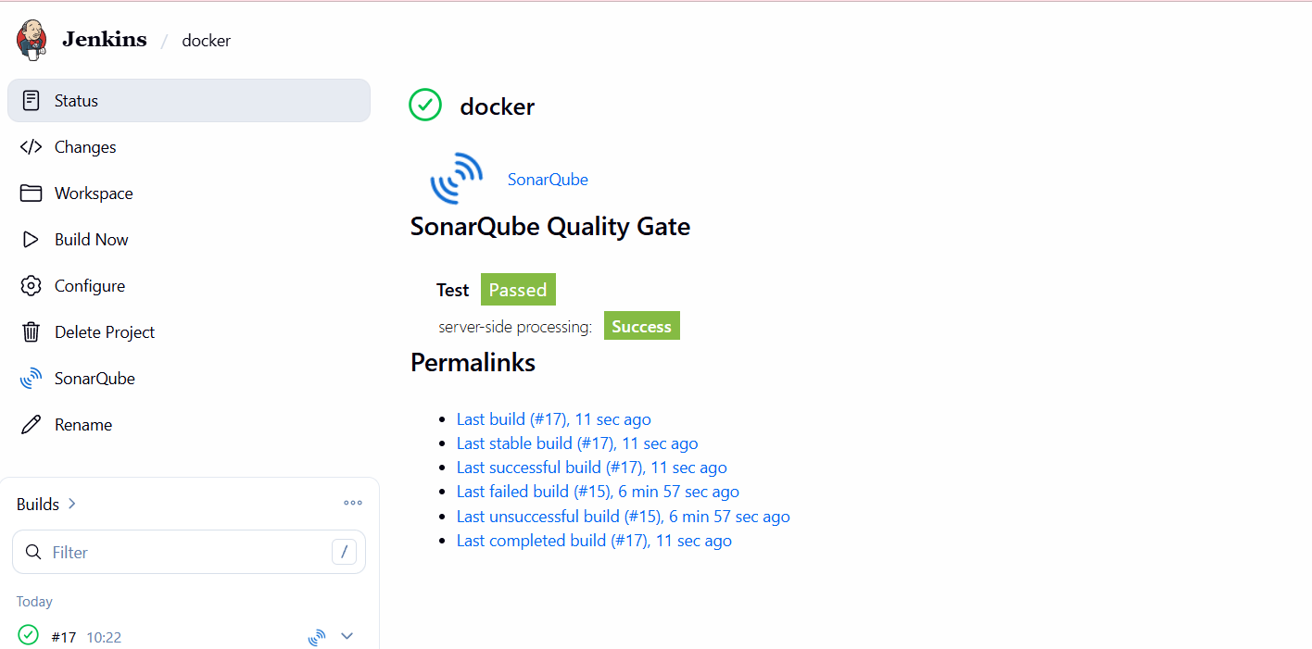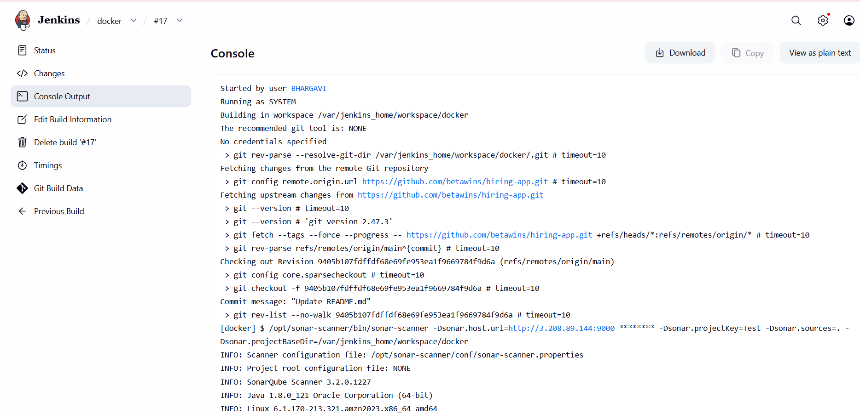
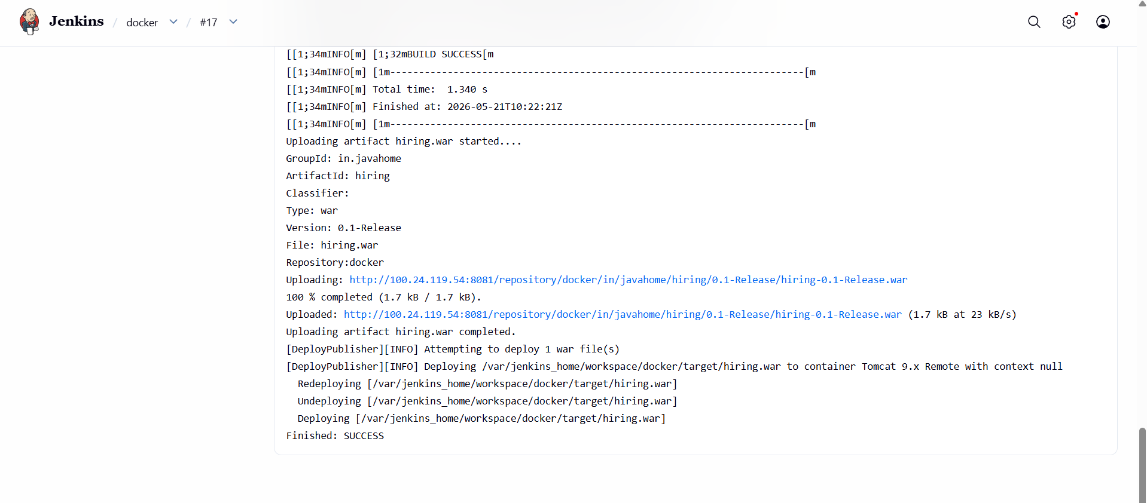
- Console output confirms:
- WAR built successfully
- WAR uploaded
- WAR deployed to Tomcat
Access Deployed Application
- Open browser
http://56.228.33.36:8080/hiring
Verify Application Output
- Page displays:
Welcome to Techie Horizon
- Deployment confirmed successful
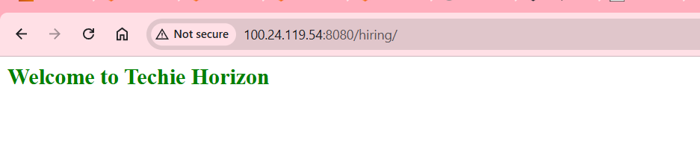
2) Setup a Jenkins CICD pipeline using Declarative pipeline using feature-1.1 branch.
Source Code: https://github.com/betawins/sabear_simplecutomerapp/tree/feature-1.1
stages:
- Git Clone
- SonarQube Integration
- Maven Compilation
- Nexus Artifactory
- Slack Notification
- Deploy On tomcat
For deploy the sonarqube we have to give this command
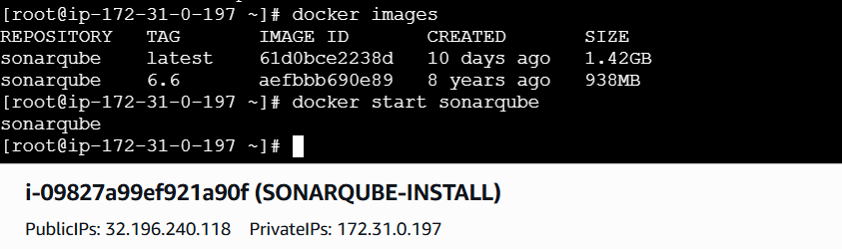
For Jenkins open in docker we have to give this command
For nexus restart the instance I can use this commands and open the server
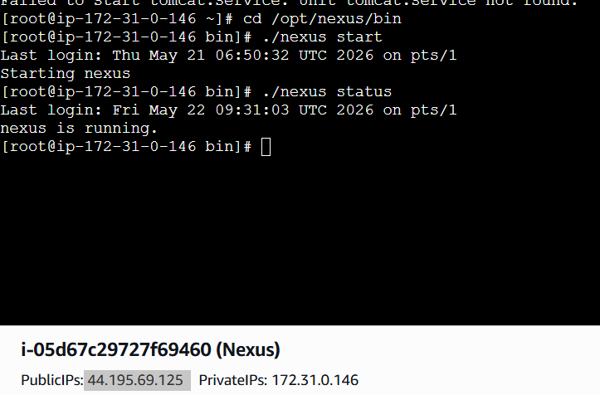

- Opened Jenkins dashboard
- Clicked New Item
- Entered job name: SIMPLECUSTOMERAPP
- Selected Pipeline as the job type
- Clicked OK
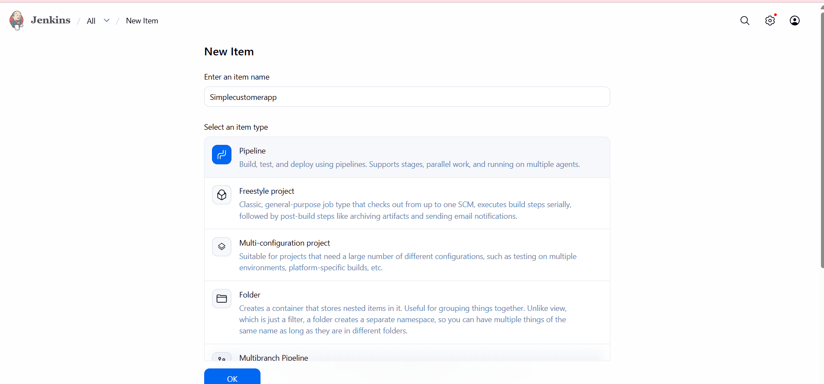
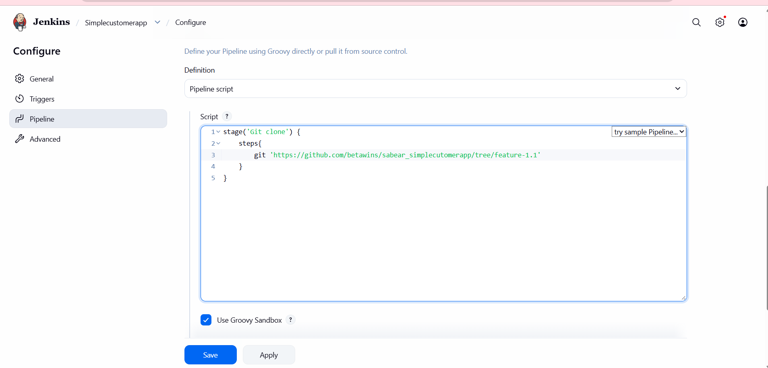
- Clicked Build Now
- Pipeline executed Git Clone stage
- Build failed
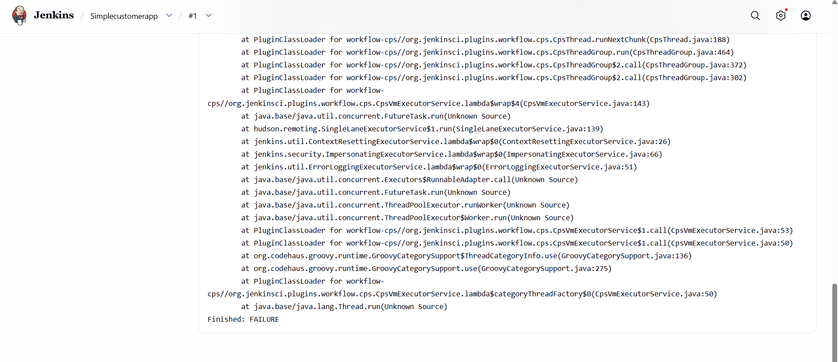
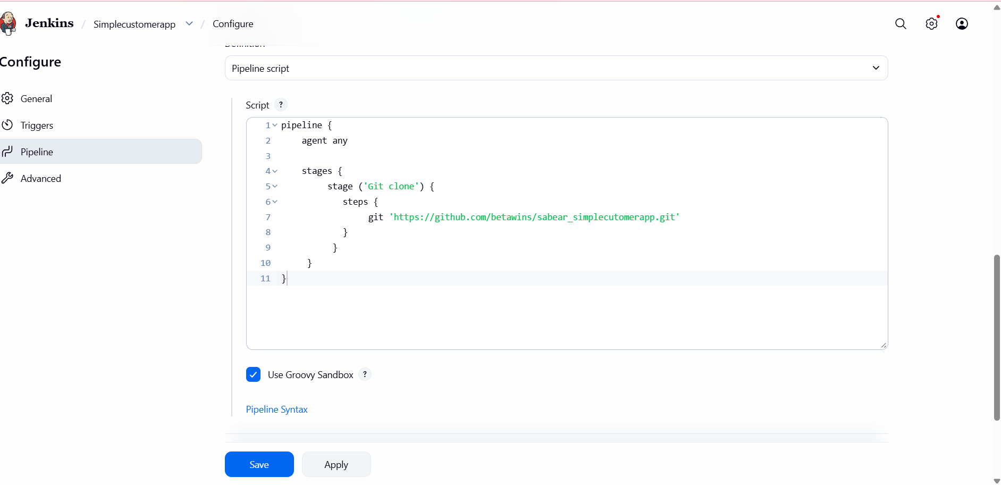
- Triggered Build Now again
- Git Clone stage executed successfully
- 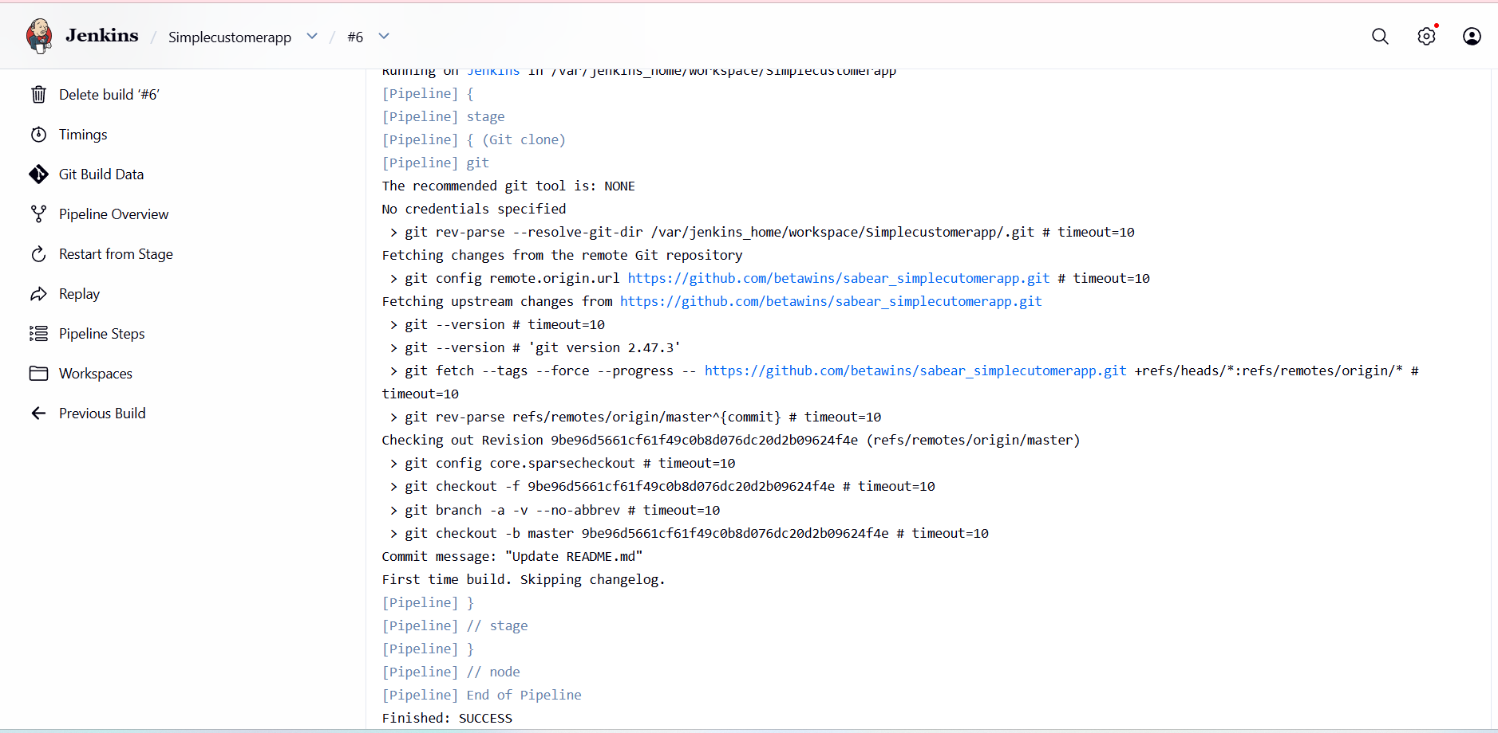

- Updated pipeline to include SonarQube Analysis stage
- Used:
  - withSonarQubeEnv('sonarqube-server')
  - Maven command with Sonar parameters
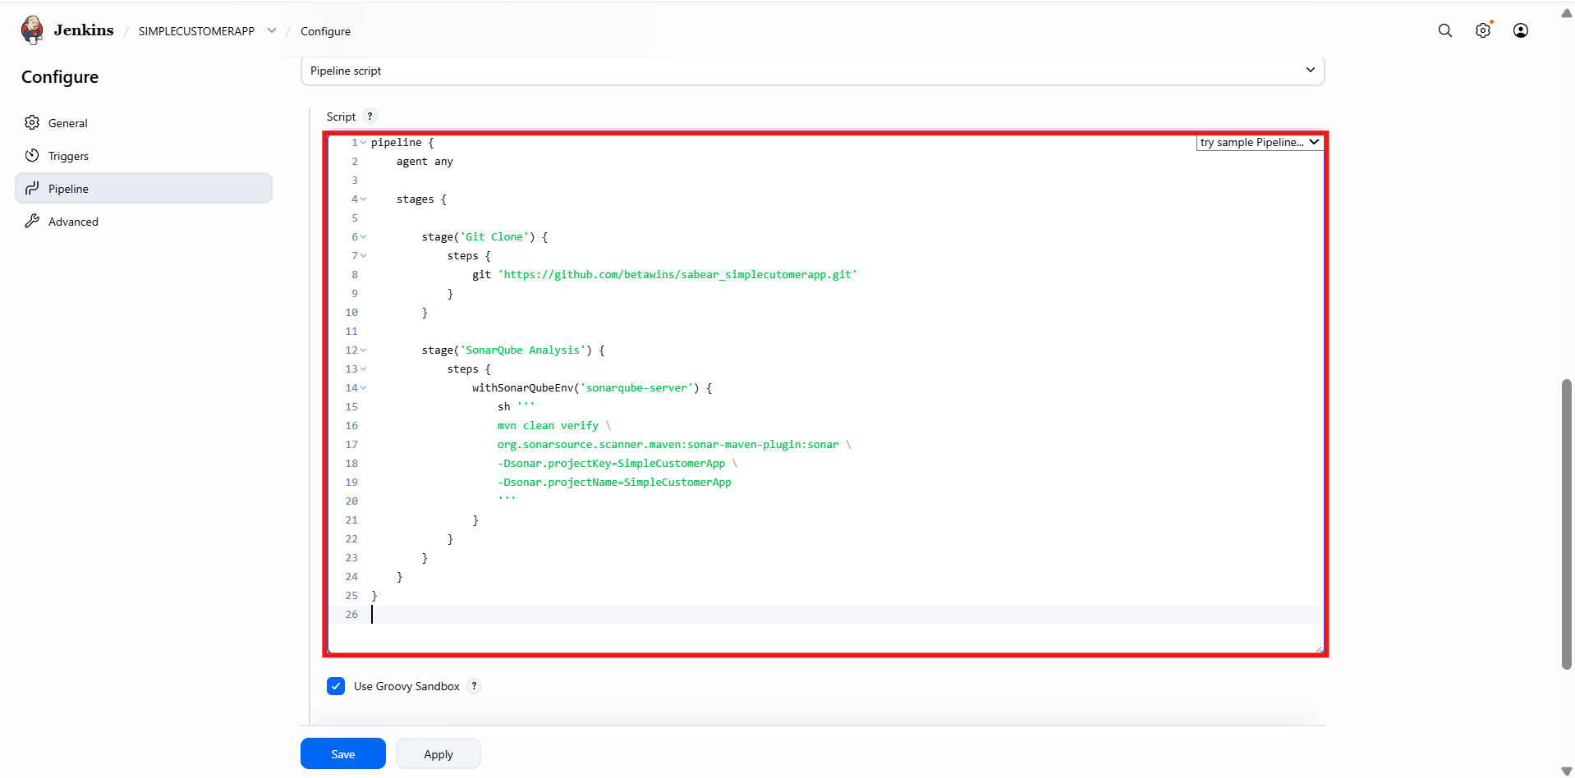
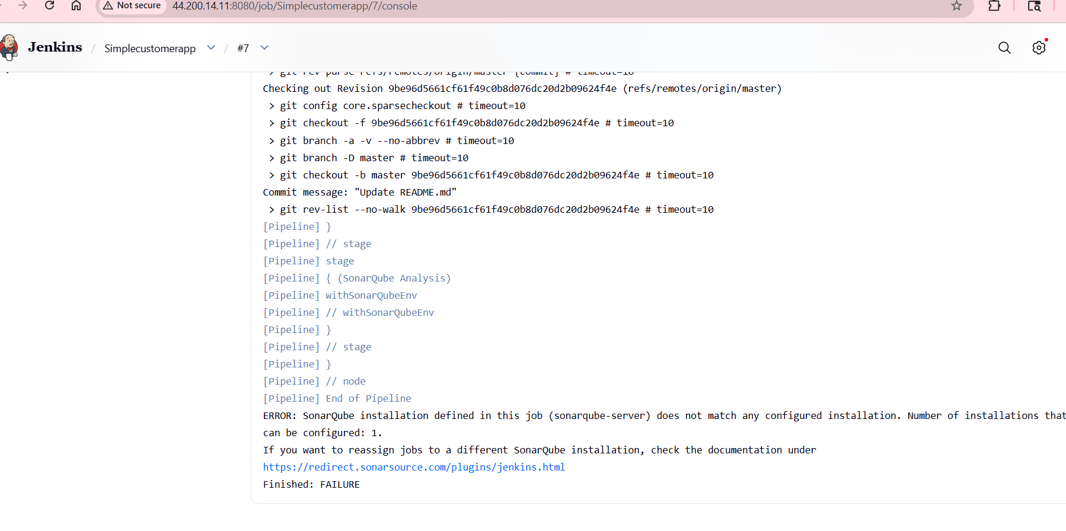
- Pipeline started successfully
- Git Clone stage passed
- SonarQube Analysis stage failed
- Error highlighted in red in stage view
- Added tools section:
  - Maven configured
- Added environment variables
- Ensured:
  - SonarQube server name is correct
  - PATH is properly set
- Saved configuration

Pipeline created we have to gieve nexus details 1st create one repository
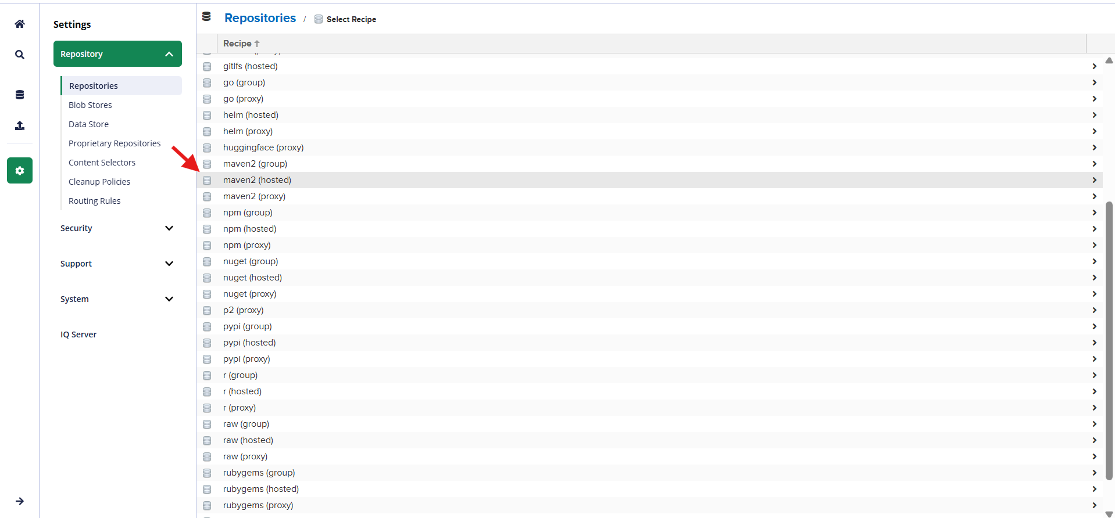
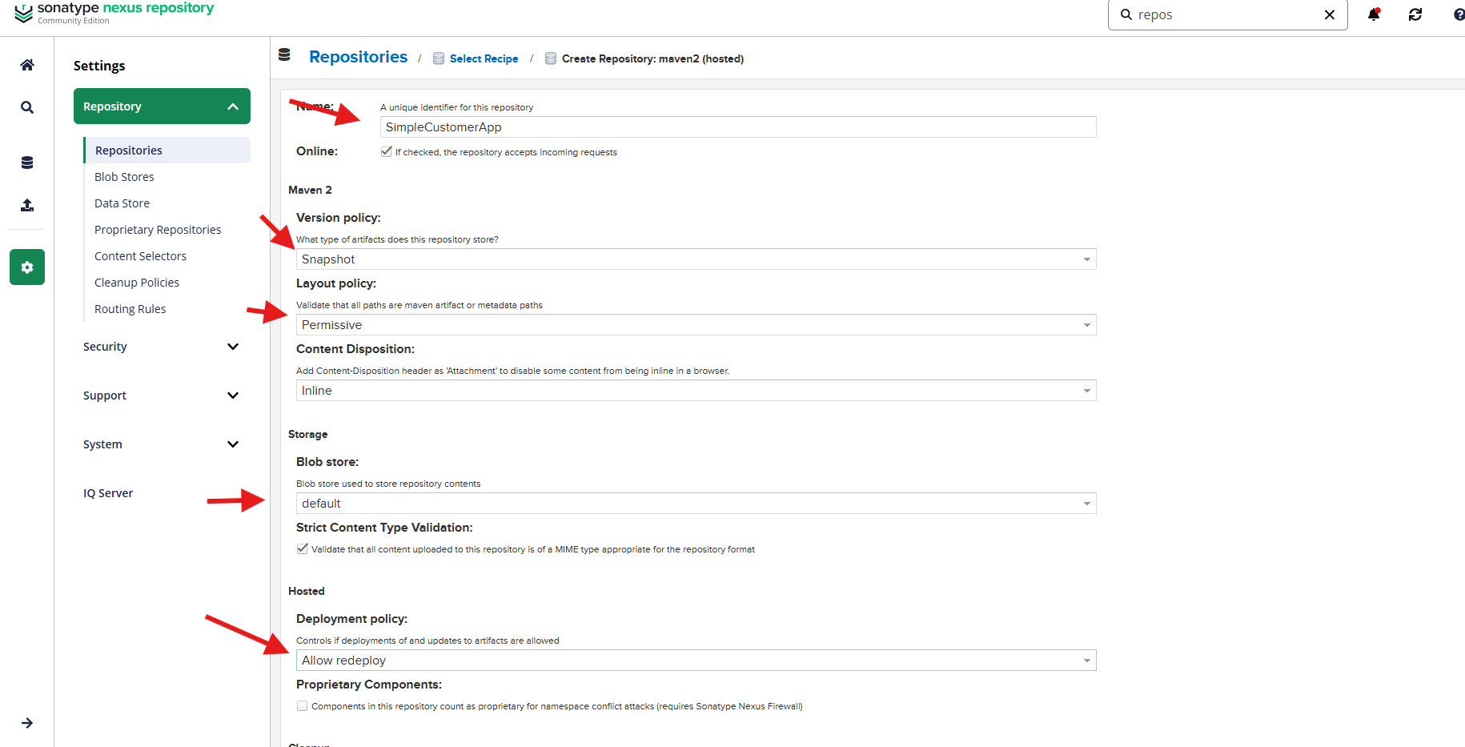
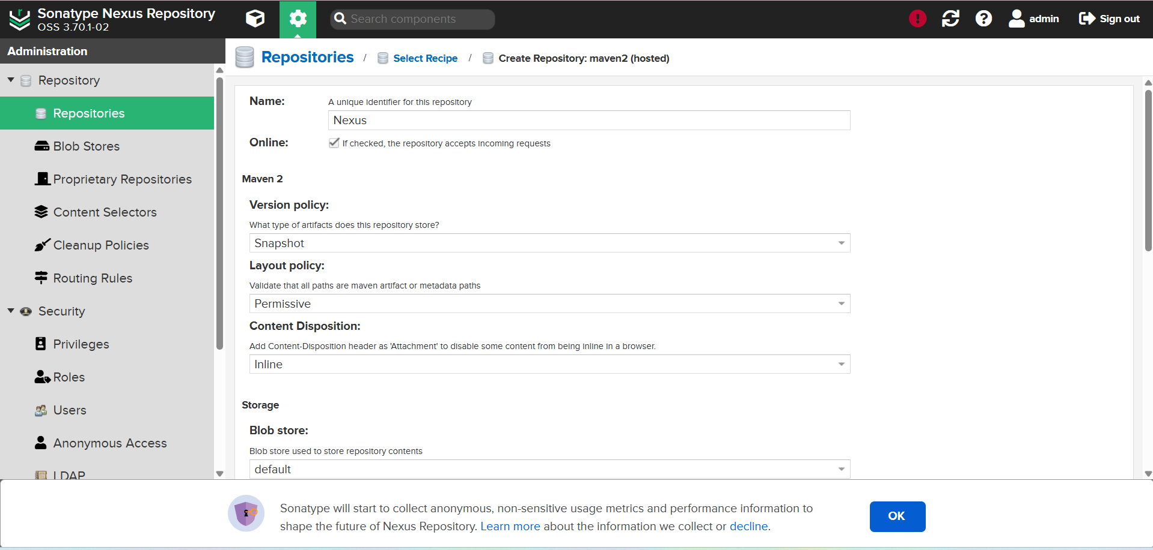
We have to tomcat url and credentials alsocd /opt/tomcat/bin./startup.sh
pipeline {

agent any

tools {
maven 'maven'
}

stages {

stage('Clean Workspace') {
steps {
cleanWs()
}
}

stage('Clone Code') {
steps {
git branch: 'master',
url: 'https://github.com/betawins/sabear_simplecutomerapp.git'
}
}

stage('Build using Maven') {
steps {
sh 'mvn clean install'
}
}

stage('Check Build Files') {
steps {
sh 'ls -ltr target'
}
}

stage('Publish to Nexus') {
steps {
script {

try {

def artifactPath = sh(
script: "ls target/*.war | head -1",
returnStdout: true
).trim()

echo "Uploading Artifact: ${artifactPath}"

nexusArtifactUploader(
nexusVersion: 'nexus3',
protocol: 'http',
nexusUrl: '3.145.186.141:8081',
repository: 'maven-newapp',
groupId: 'com.javatpoint',
version: "${BUILD_NUMBER}-SNAPSHOT",
credentialsId: 'nexus-cred',

artifacts: [
[
artifactId: 'SimpleCustomerApp',
classifier: '',
file: artifactPath,
type: 'war'
]
]
)

} catch (Exception e) {

error "Failed to upload artifact to Nexus: ${e.message}"

}
}
}
}

stage('Deploy On Tomcat') {
steps {
script {

try {

def warFile = sh(
script: "ls target/*.war | head -1",
returnStdout: true
).trim()

echo "Deploying WAR: ${warFile}"

deploy adapters: [
tomcat9(
credentialsId: 'tomcat-creds',
path: '',
url: 'http://3.131.90.248:8080/manager/text'
)
],
contextPath: 'sabaer',
war: warFile

} catch (Exception e) {

error "Deployment to Tomcat failed: ${e.message}"

}
}
}
}
}

post {

success {
echo ":white_check_mark: Pipeline SUCCESS: Job=${env.JOB_NAME} Build=#${env.BUILD_NUMBER}"
}

failure {
echo ":x: Pipeline FAILED: Job=${env.JOB_NAME} Build=#${env.BUILD_NUMBER}"
}
}
}

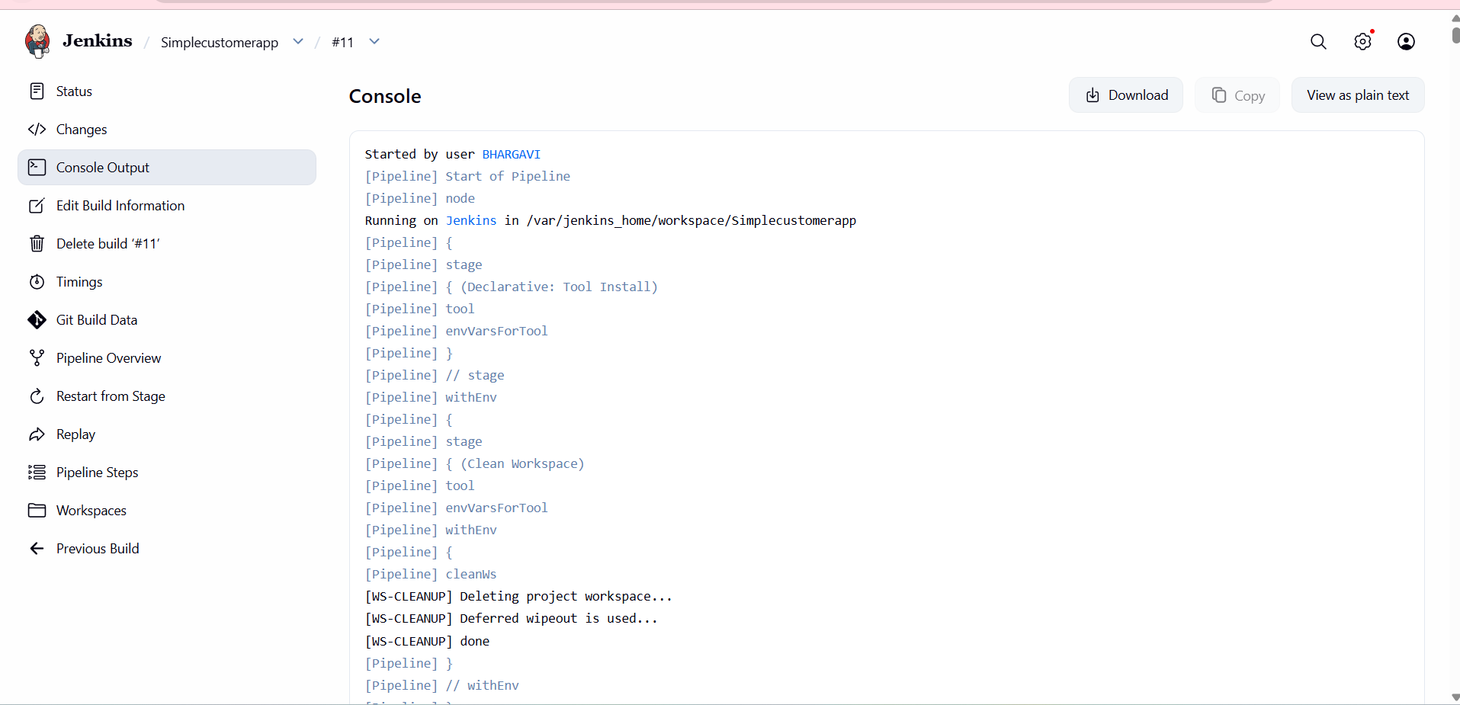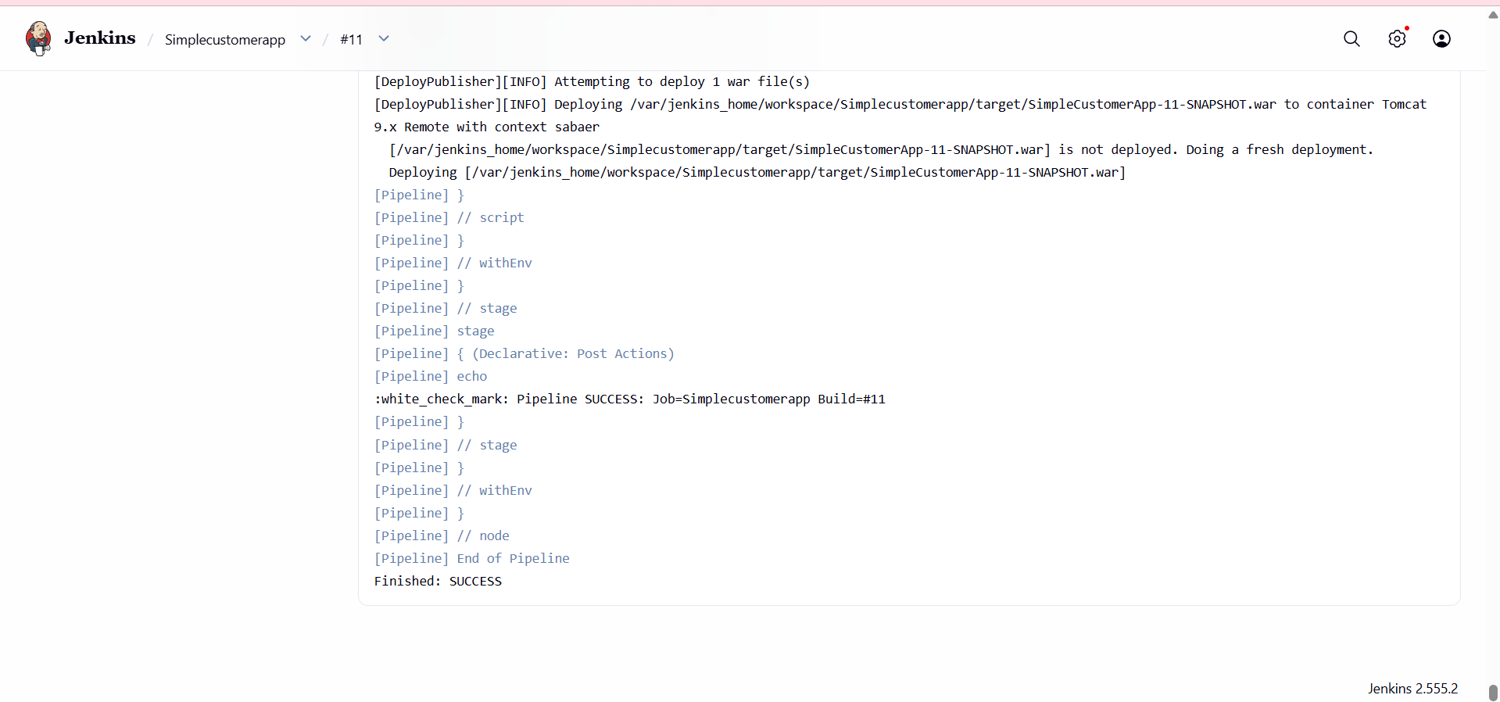
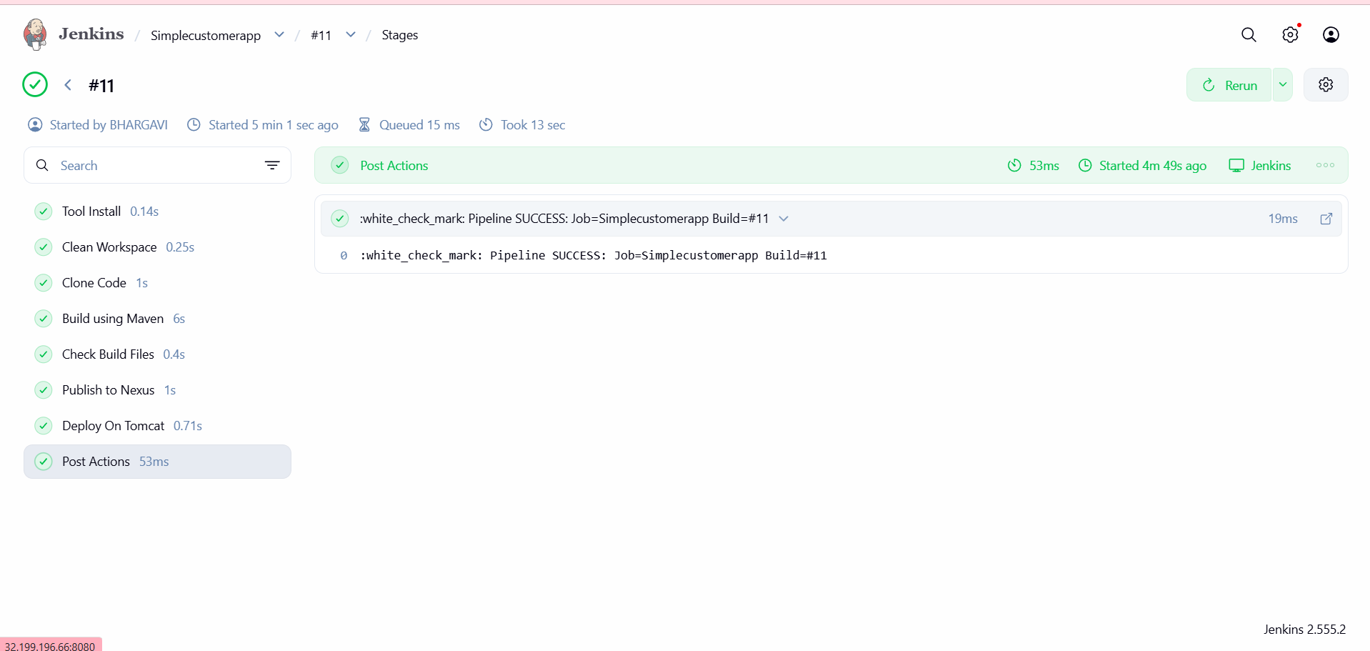
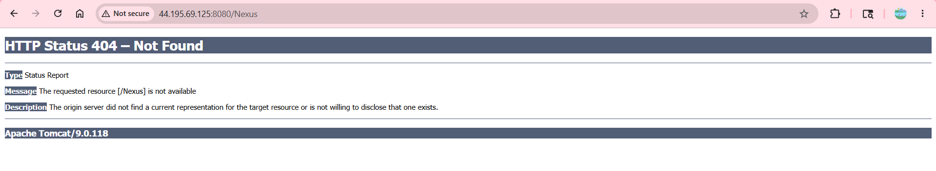
3)Setup a Jenkins CICD pipeline using Scripted pipeline using feature-1.1 branch.
Source Code: https://github.com/betawins/sabear_simplecutomerapp/tree/feature-1.1
stages:
- Git Clone
- SonarQube Integration
- Maven Compilation
- Nexus Artifactory
- Slack Notification
- Deploy On tomcat
Go to manage jenkinkinsgive the name –>pipelinegive the scripted pipelineshown in below
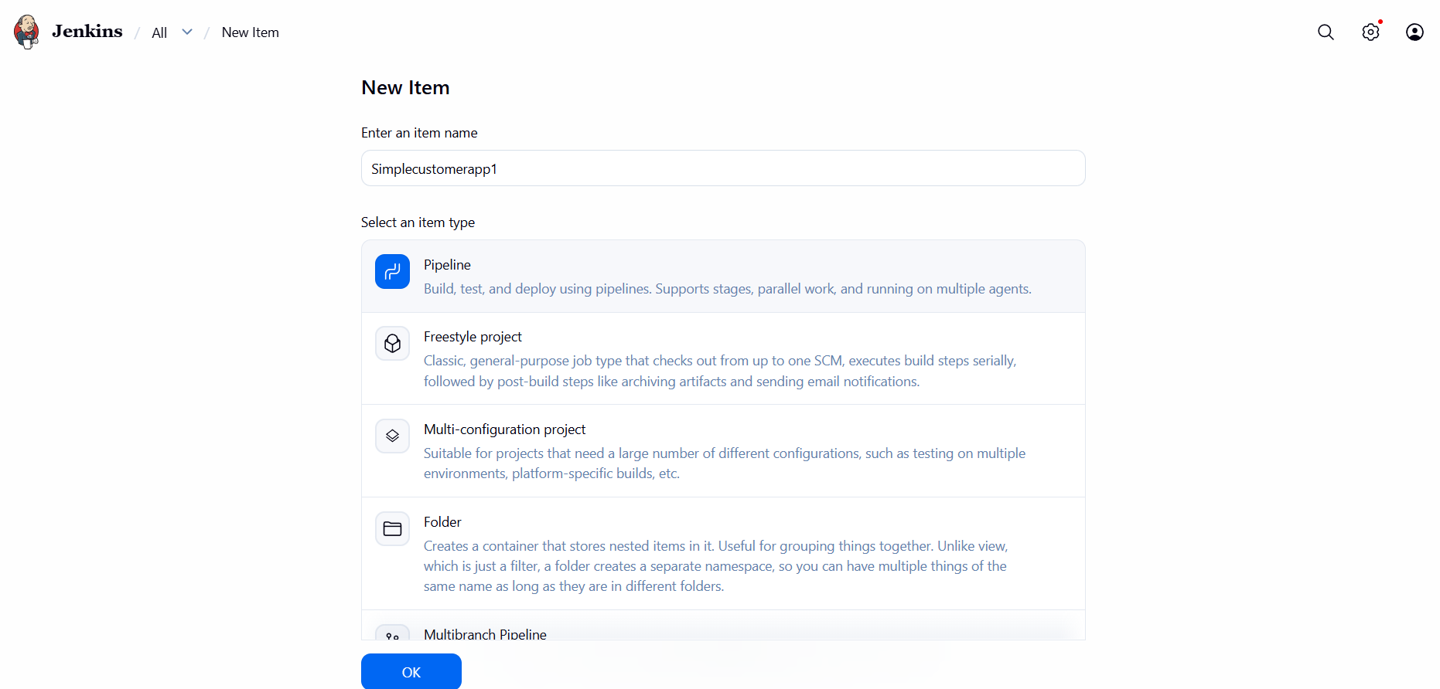
node {

def mvnHome

try {

stage('Tool Configuration') {

mvnHome = tool 'Maven'

}

stage('Clean Workspace') {

cleanWs()

}

stage('Clone Code') {

git branch: 'master',
url: 'https://github.com/betawins/sabear_simplecutomerapp.git'

}

stage('Build using Maven') {

sh "${mvnHome}/bin/mvn clean install"

}

stage('Check Build Files') {

sh 'ls -ltr target'

}

stage('Publish to Nexus') {

def artifactPath = sh(
script: "ls target/*.war | head -1",
returnStdout: true
).trim()

echo "Uploading Artifact: ${artifactPath}"

nexusArtifactUploader(
nexusVersion: 'nexus3',
protocol: 'http',
nexusUrl: '44.195.69.125:8081',
repository: 'Nexus',
groupId: 'com.javatpoint',
version: "${BUILD_NUMBER}-SNAPSHOT",
credentialsId: 'nexus',

artifacts: [
[
artifactId: 'SimpleCustomerApp',
classifier: '',
file: artifactPath,
type: 'war'
]
]
)
}

stage('Deploy On Tomcat') {

def warFile = sh(
script: "ls target/*.war | head -1",
returnStdout: true
).trim()

echo "Deploying WAR: ${warFile}"

deploy adapters: [
tomcat9(
credentialsId: 'tomcat_11',
path: '',
url: 'http://44.195.69.125:8080/manager/text'
)
],
contextPath: 'sabaer',
war: warFile
}

currentBuild.result = 'SUCCESS'

echo ":white_check_mark: Pipeline SUCCESS: Job=${env.JOB_NAME} Build=#${env.BUILD_NUMBER}"

} catch (Exception e) {

currentBuild.result = 'FAILURE'

echo ":x: Pipeline FAILED: ${e.message}"

throw e
}
}
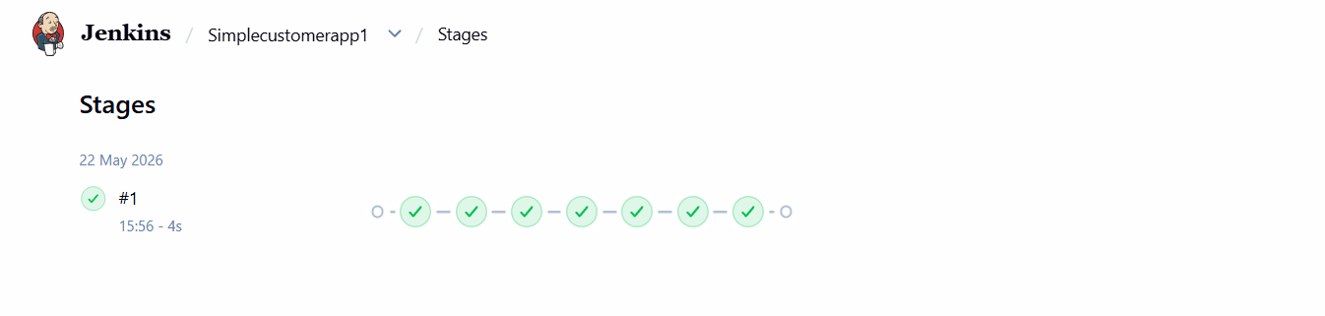
4) Write sample skeleton of pipelines.
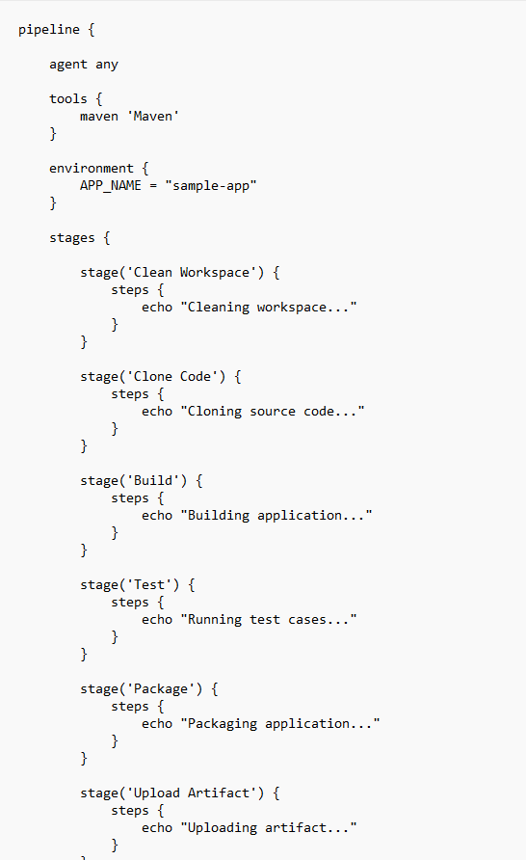
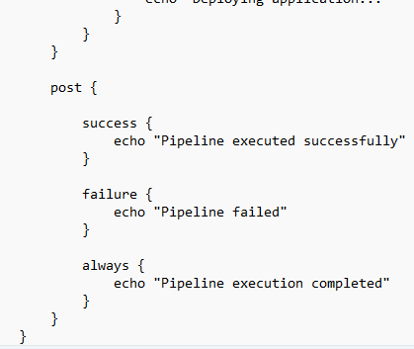
5) Create a parameterized job in Jenkins.
Source Code: https://github.com/betawins/spring3-mvc-maven-xml-hello-world-1.git
- Opened Jenkins → New ItemEntered job name:parameterized-jobSelected Freestyle projectClicked OK

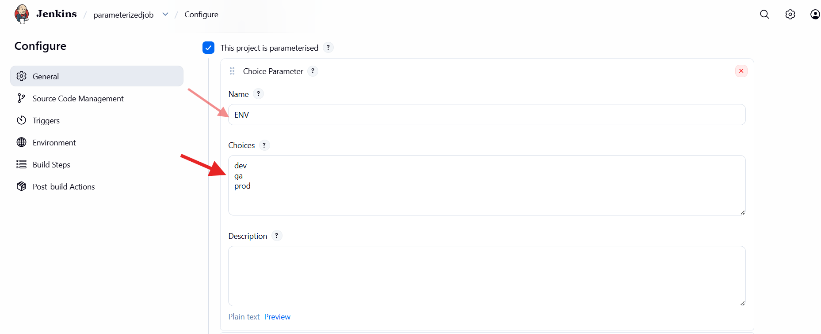
- Opened Configure → General
- Enabled This project is parameterized
- Added Choice Parameter
- Parameter name: ENV
- Choices added:
- dev
- qa
- prod
- Saved parameter configuration

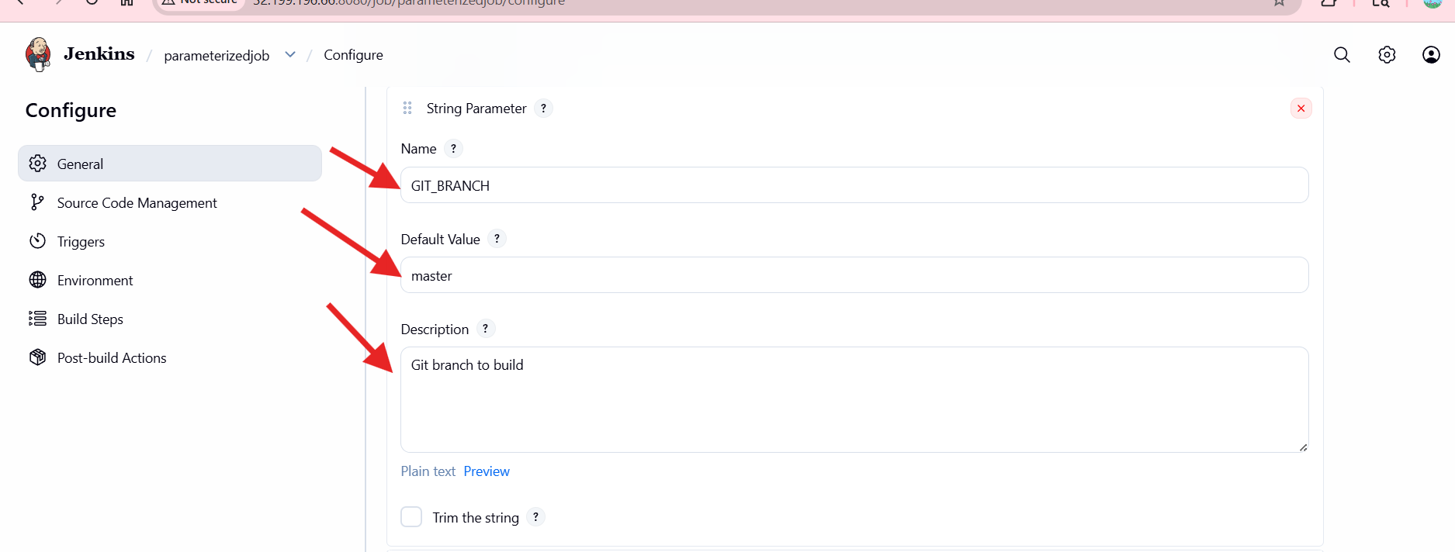

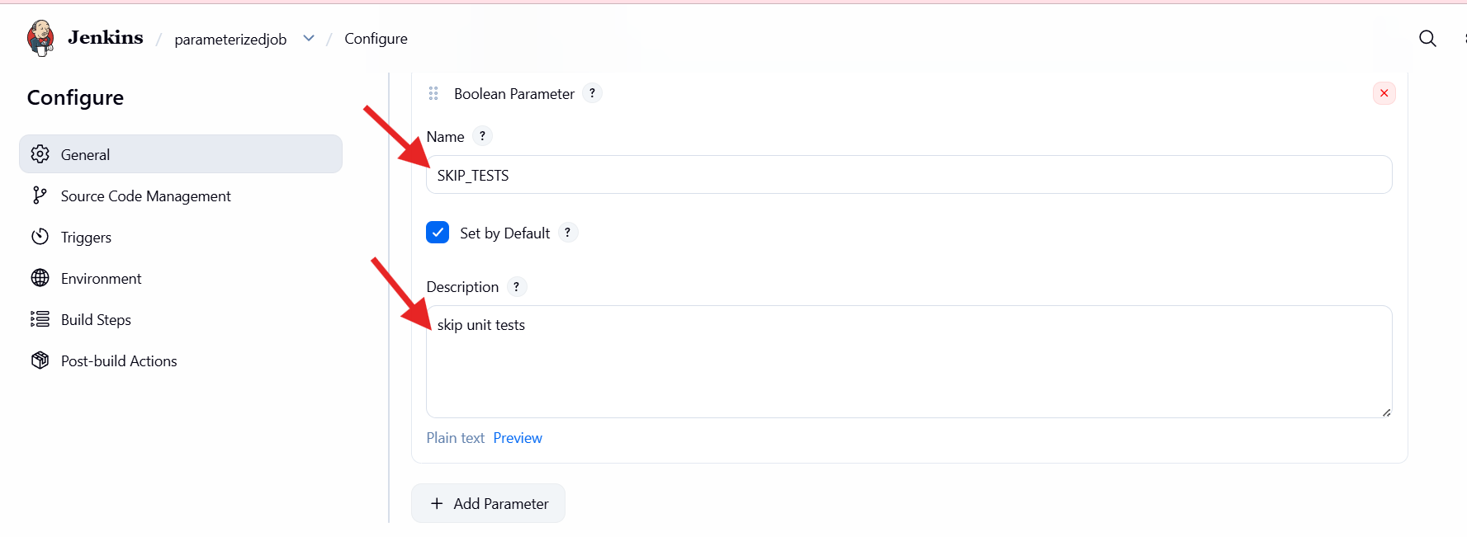
- Added String Parameter
- Parameter name: GIT_BRANCH
- Default value: master
- Description: Git branch to build
- Used to dynamically select Git branch

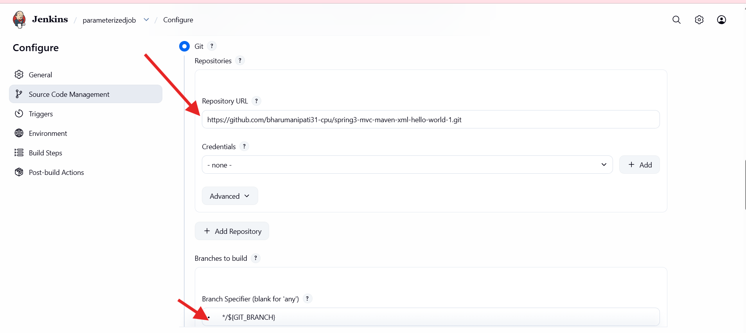
- Added Boolean Parameter
- Parameter name: SKIP_TESTS
- Checked Set by default
- Description: Skip unit tests
- Allows skipping tests during Maven build

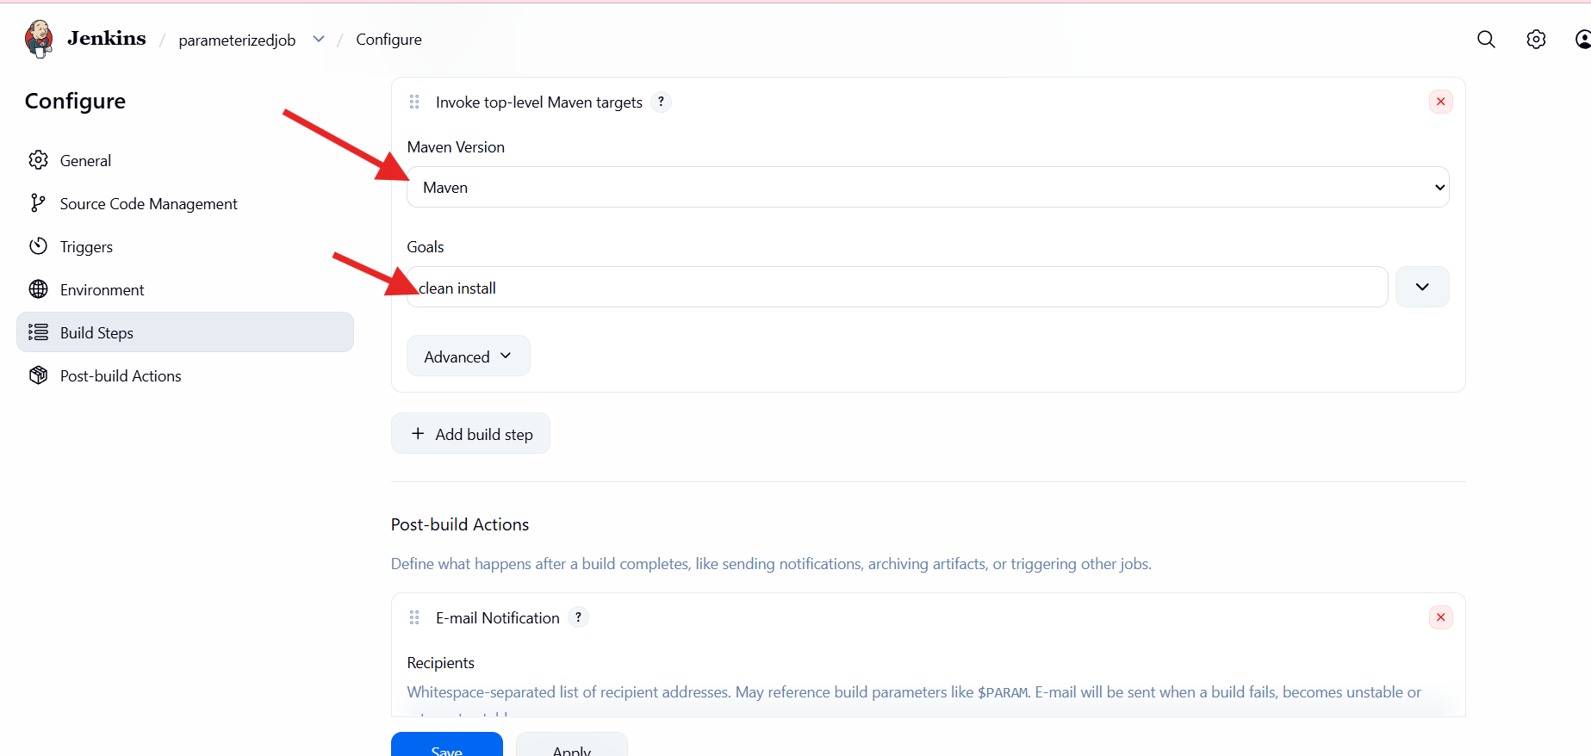
- Opened Source Code Management
- Selected Git
- Added repository URL:
- Spring Maven GitHub repository
- In Branches to build, entered:
- */${GIT_BRANCH}
- Enabled branch selection using parameter

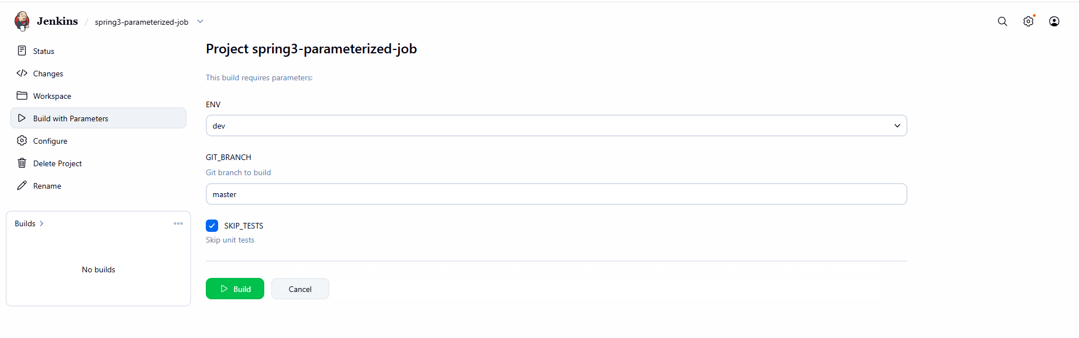
- Opened Build Steps
- Added Invoke top-level Maven targets
- Selected Maven installation: MVN_HOME
- Maven goals configured:
  - clean package -DskipTests=${SKIP_TESTS}
- Build behavior controlled via parameters
- Opened Post-build Actions
- Added Slack Notifications
- Enabled:
  - Notify Build Start
  - Notify Success
- Linked Jenkins job notifications to Slack
- Job created successfully
- Build with Parameters option visible
- No builds executed yet
- Clicked Build with Parameters
- Selected:
- ENV = dev
- GIT_BRANCH = master
- SKIP_TESTS = true
- Clicked Build

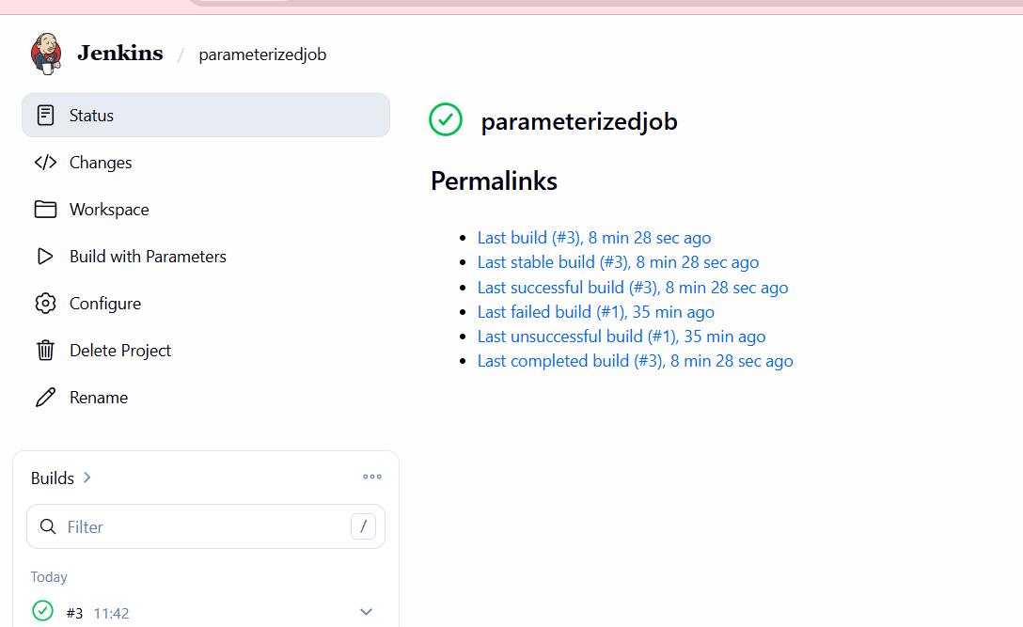
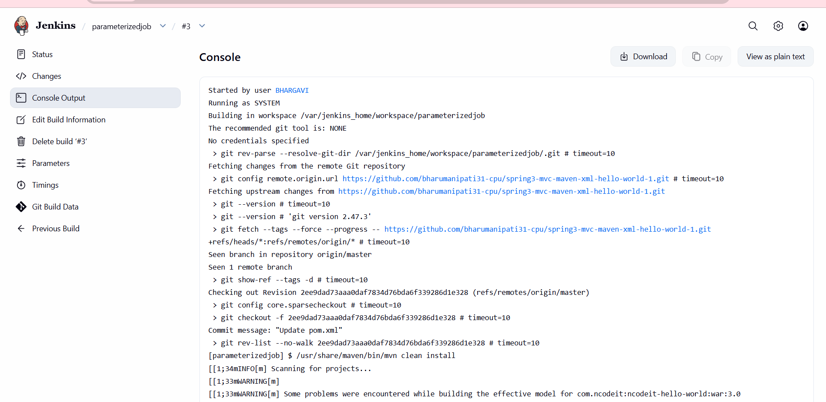
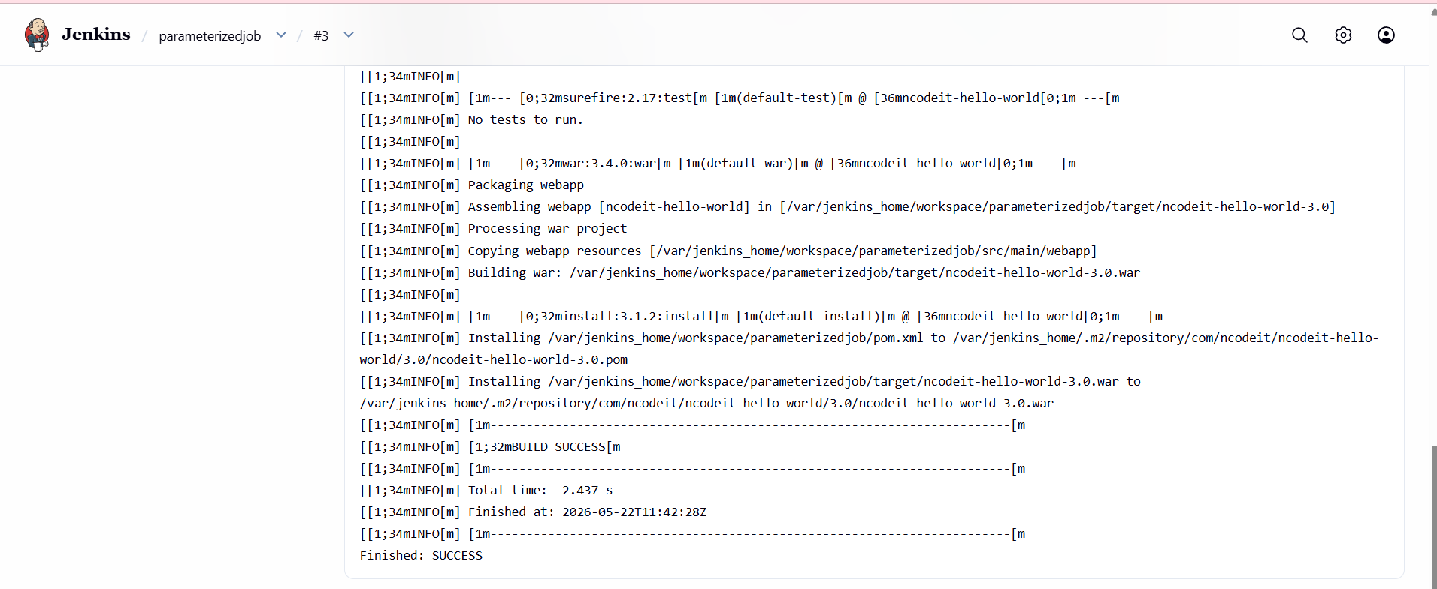

6) Setup one slave machine for Jenkins.
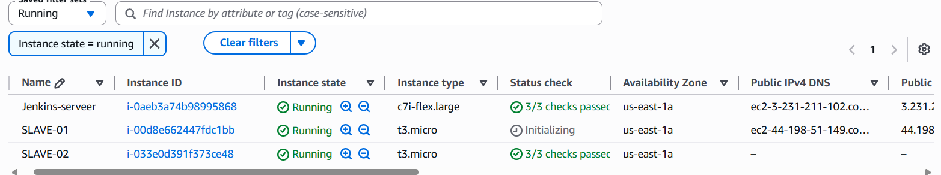
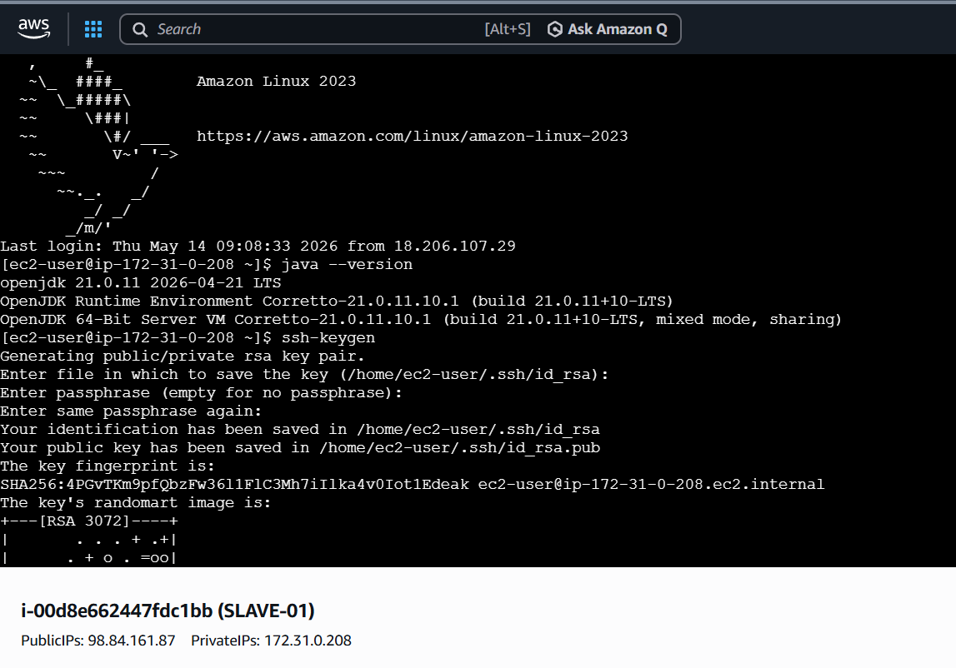
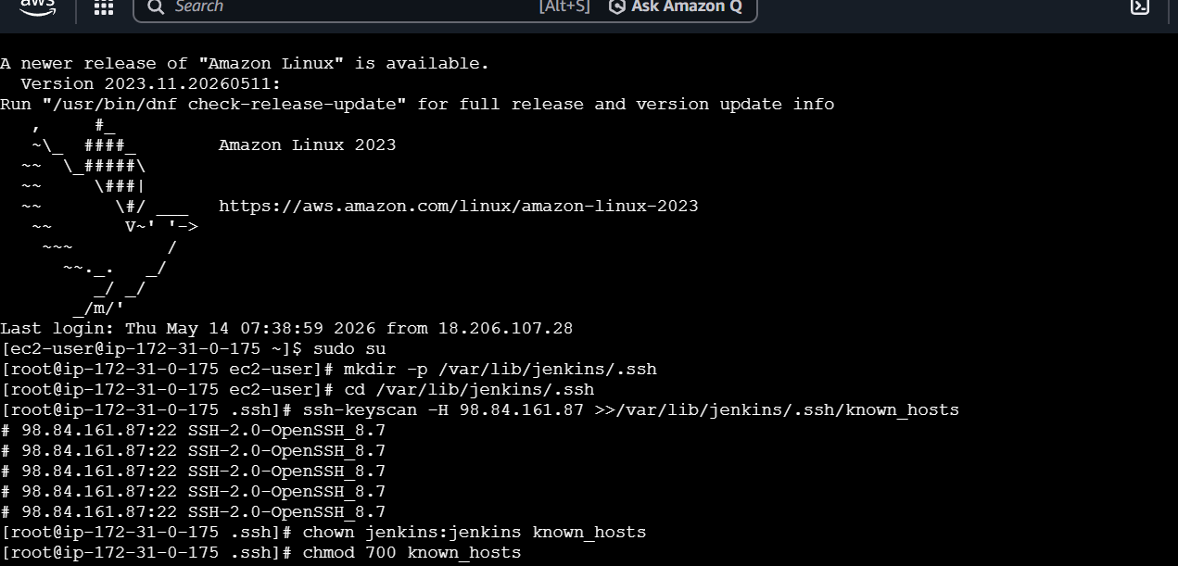
ssh-keyscan -H ip address of slave-01 >>/var/lib/Jenkins/.ssh/know_hosts
This will help to scan from slave1 to master
- Now create one node with slave-01 name
