KUBERNETS-01
- Setup Minikube in your local machine.
To install Minikube on a Mac, the most efficient and recommended approach is using Homebrew alongside Docker Desktop as your container driver.
Hardware Prerequisites
Ensure your Mac meets these minimum resource configurations before proceeding
At least 2 CPUs.
At least 2 GB of RAM.
At least 20 GB of disk space
Step 1: Install a Container Driver
Minikube needs a virtualization or container environment to deploy its cluster. Docker is the most stable and universally compatible choice for both Apple Silicon (M1/M2/M3/M4) and Intel Macs.
- Download and install Docker Desktop.
- Open Docker Desktop and follow the on-screen prompts to complete setup.
- Make sure the Docker engine is completely booted up and running.open powershell and see docker --version
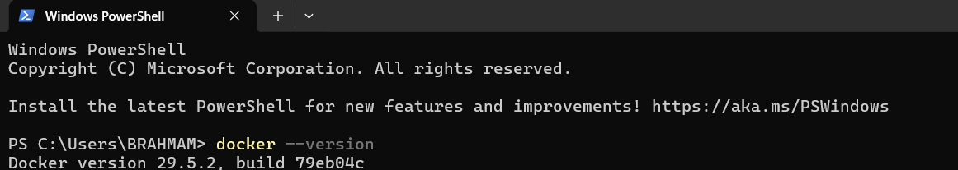
Step 2: Install Minikube and kubectl
https://minikube.sigs.k8s.io/docs/start/
Open Google and search Minikube install and select which Operating System and copy command.
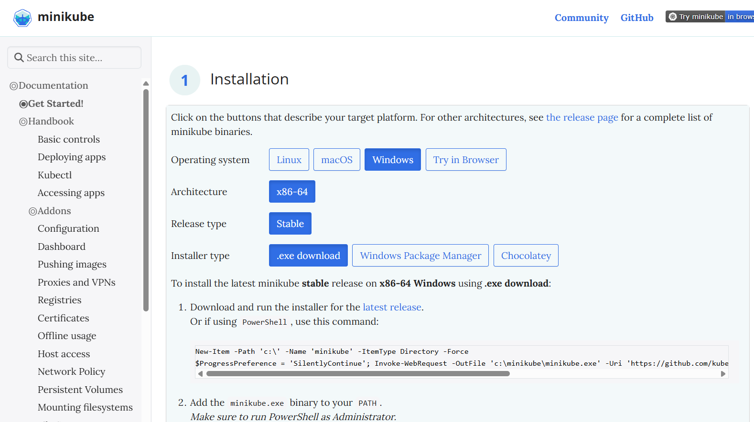
➢ Open PowerShell and paste the command
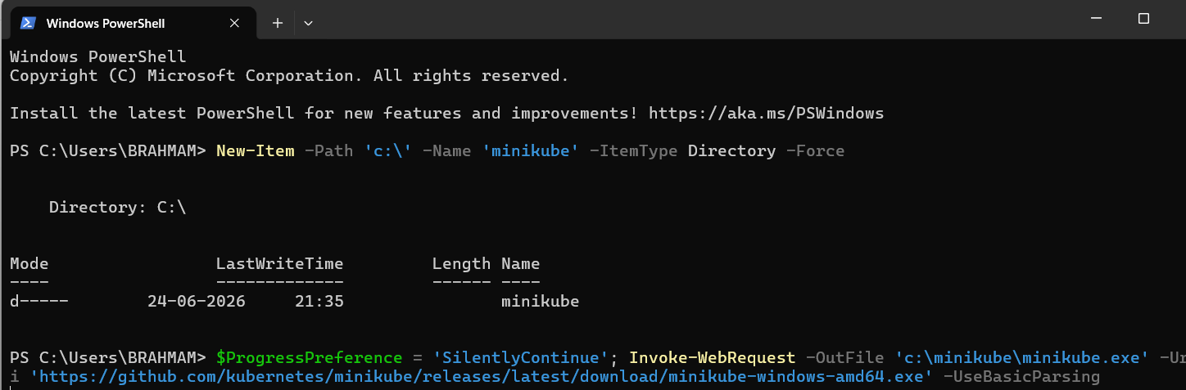
- Now do Environmental variables and check minikube version
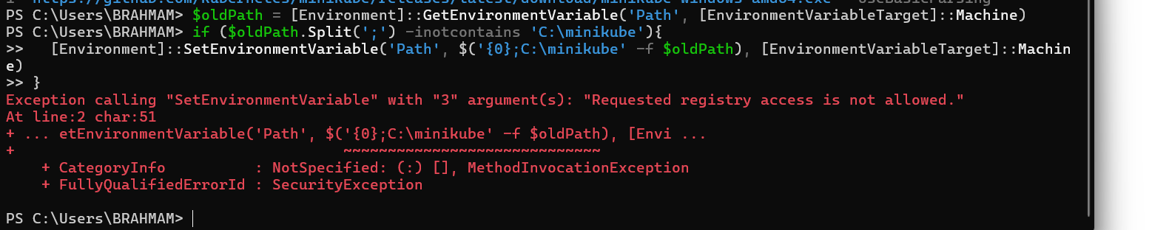
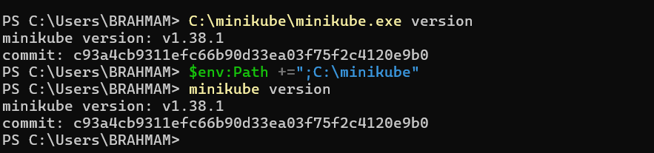
- Open Environmental variables and in variables select path and select edit and copy minikube location path and paste it
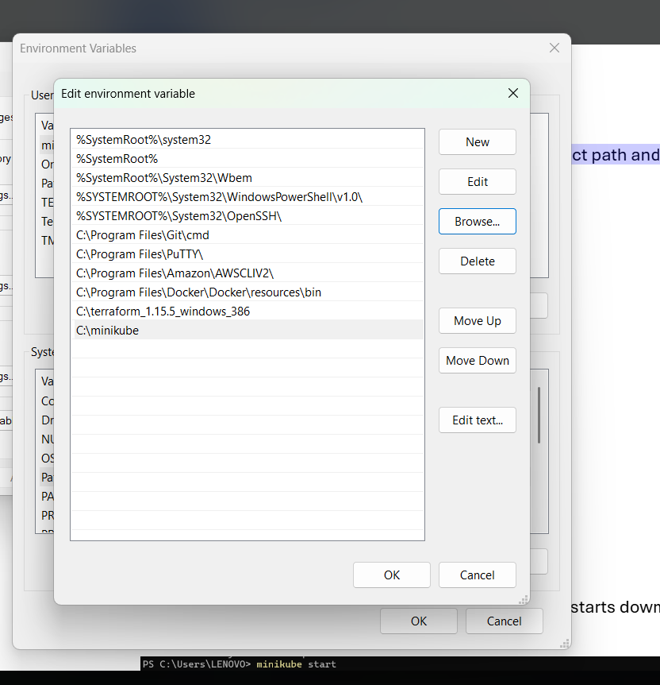
➢ Open terminal use command minikube start and it starts download and check nodes
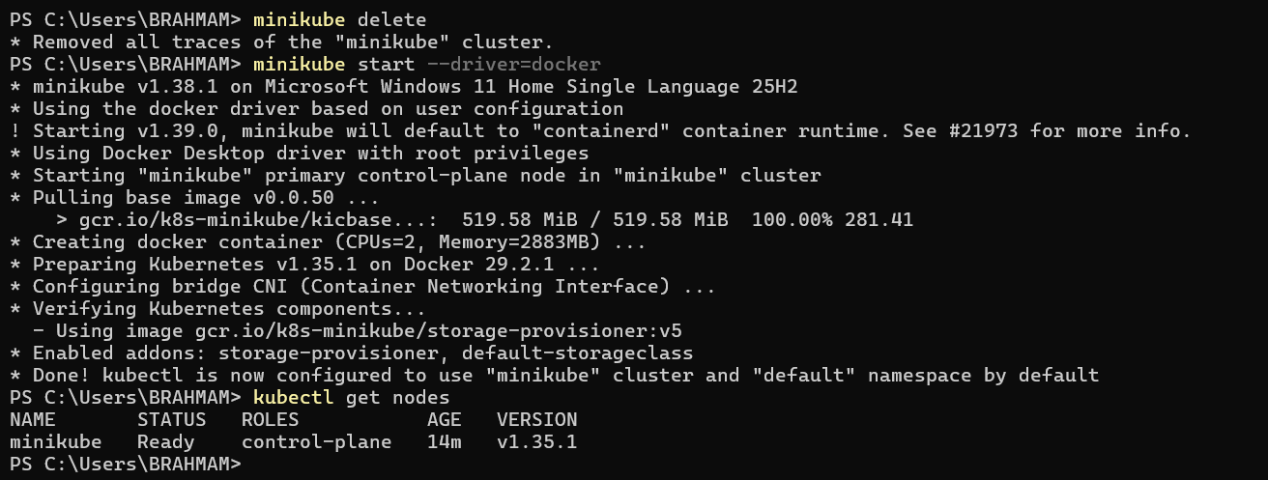
- Setup k8s master and two worker nodes on ubuntu.
- Launch new instance with name K8S Master select image is ubuntu
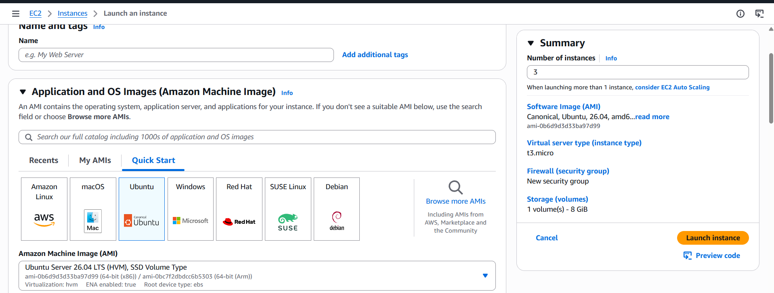
Instance type t2.mediumkey name
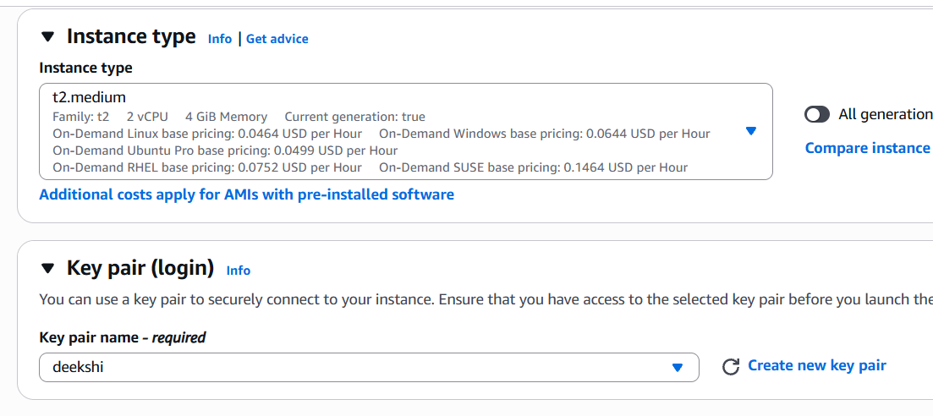
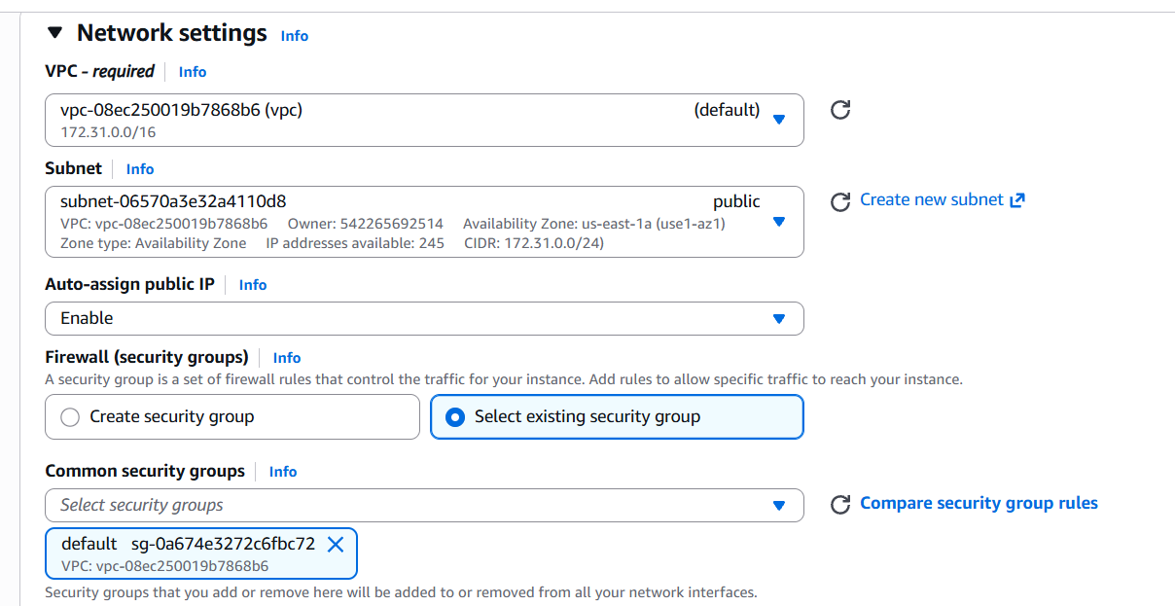
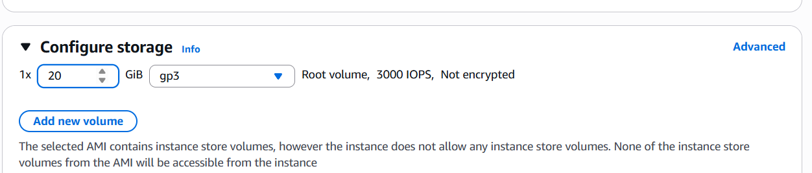
Launch instance created successfully
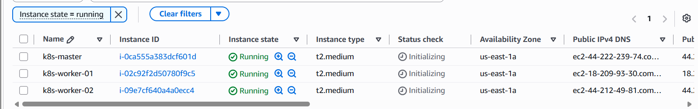
Change hostname for master and workers
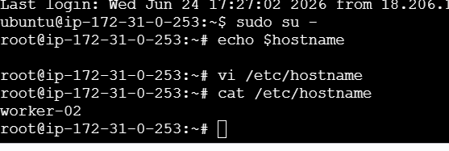
This way I can change my hostname for master,worker nodes
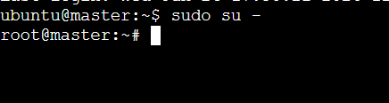
Worker-02
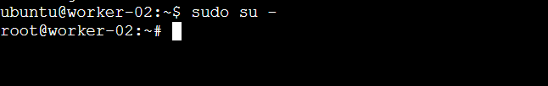
Worker-01
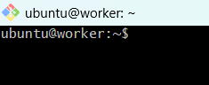
Now install docker in master and same with worknodes also
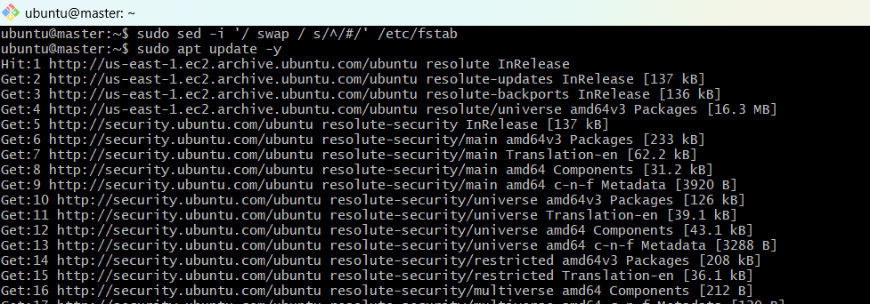
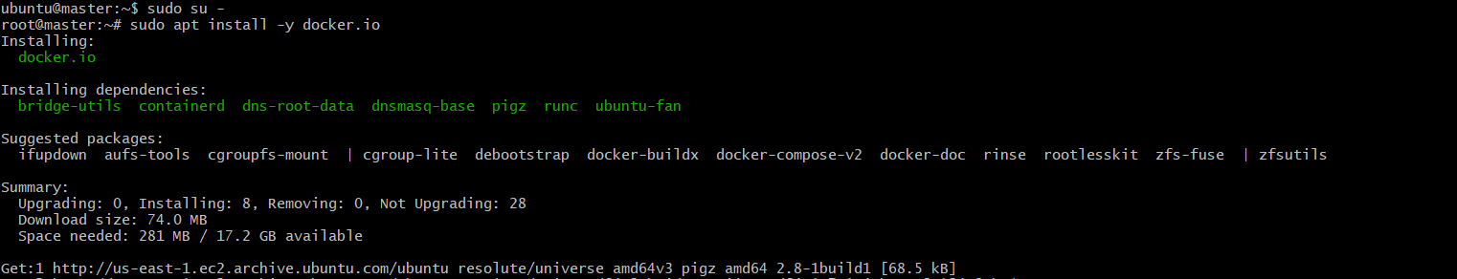
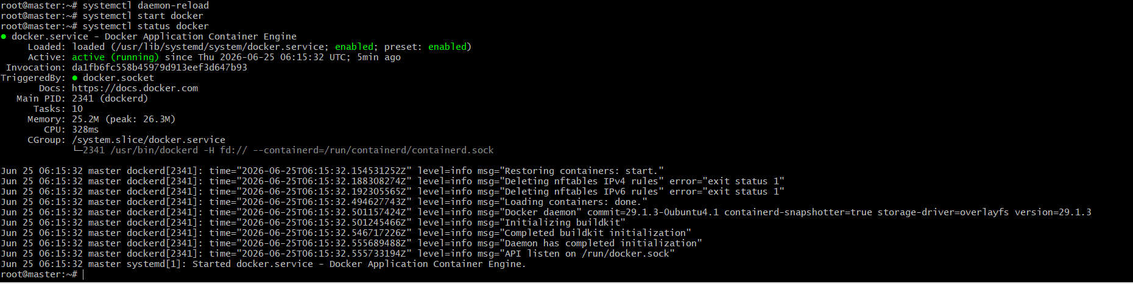
For worker-01
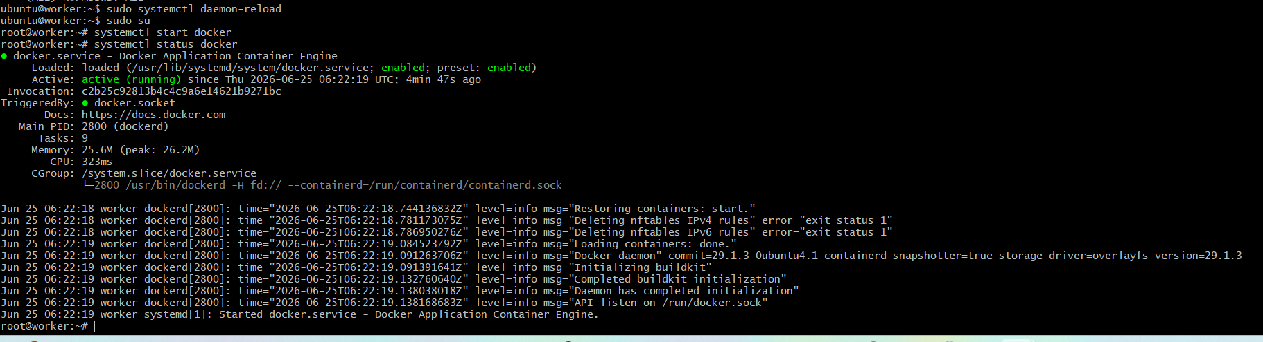
For worker-02
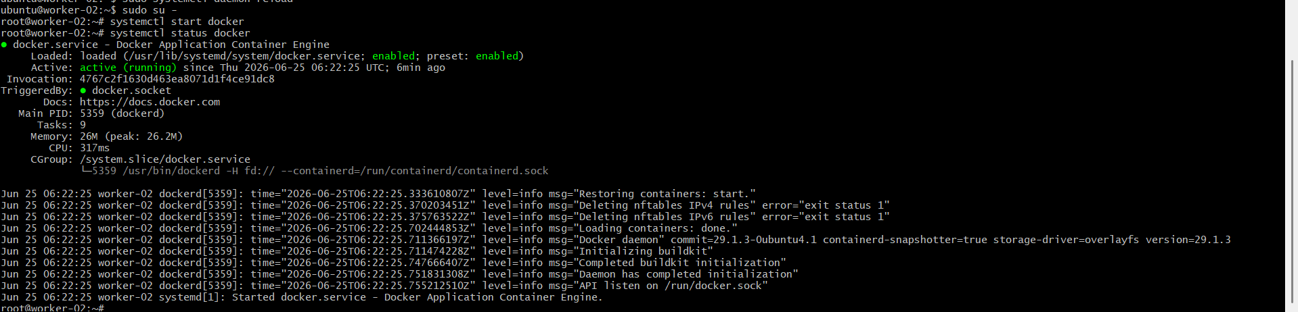
Lets setup k8s cluster
Update the apt package index and install packages needed to use the
Kubernetes apt repository:
sudo apt-get update
# apt-transport-https may be a dummy package; if so, you can skip that package
sudo apt-get install -y apt-transport-https ca-certificates curl gpg
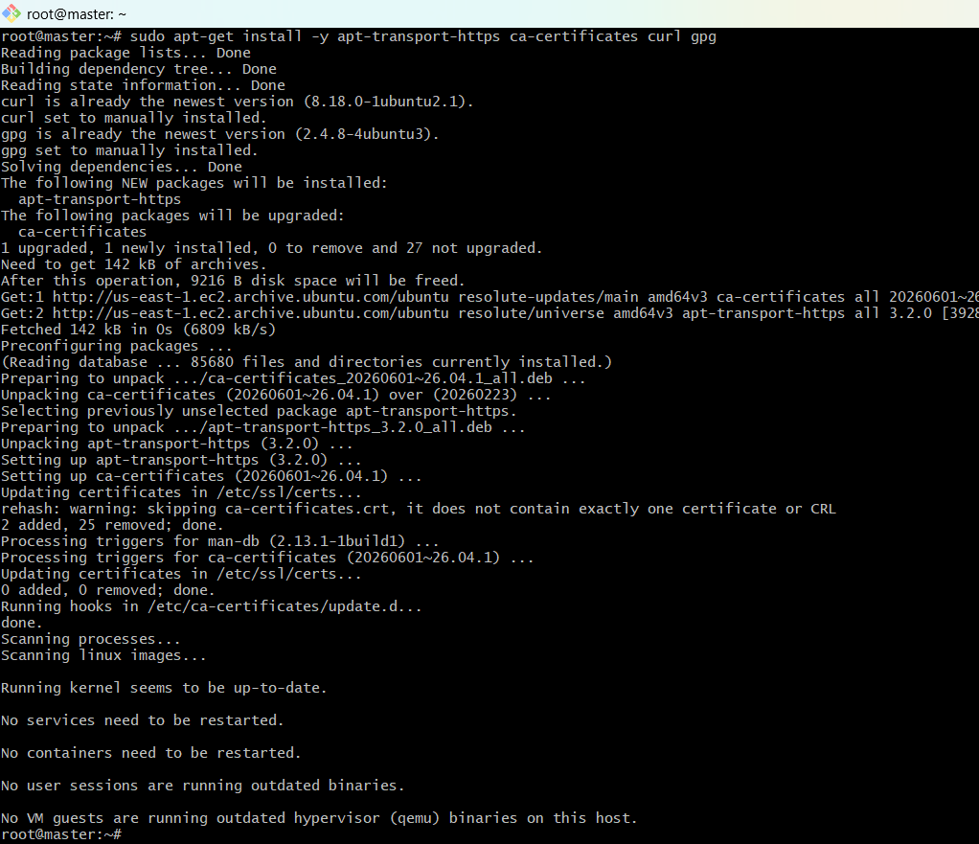
Download the public signing key for the Kubernetes package repositories. The same signing
key is used for all repositories so you can disregard the version in the URL:
# If the directory `/etc/apt/keyrings` does not exist, it should be created before the curl
command, read the note below.
# sudo mkdir -p -m 755 /etc/apt/keyrings
- curl -fsSL https://pkgs.k8s.io/core:/stable:/v1.36/deb/Release.key | sudo gpg --dearmor -o /etc/apt/keyrings/kubernets-apt-keyring.gpg
- echo 'deb [signed-by=/etc/apt/keyrings/kubernetes-apt-keyring.gpg] https://pkgs.k8s.io/core:/stable:/v1.36/deb/ /' | \
sudo tee /etc/apt/sources.list.d/kubernetes.listAdd the appropriate Kubernetes apt repository. Please note that this repository have
packages only for Kubernetes 1.36; for other Kubernetes minor versions, you need to
change the Kubernetes minor version in the URL to match your desired minor version (you
should also check that you are reading the documentation for the version of Kubernetes
that you plan to install).
Update the apt package index, install kubelet, kubeadm and kubectl, and pin their version:
sudo apt-get update
sudo apt-get install -y kubelet kubeadm kubectl
I got error to run because of
While installing Kubernetes components (kubelet, kubeadm, and kubectl) on Ubuntu, the package installation failed because the Kubernetes APT repository was configured incorrectly.
Error Message
403 Forbidden: Failed to fetch packages from the Kubernetes repository.
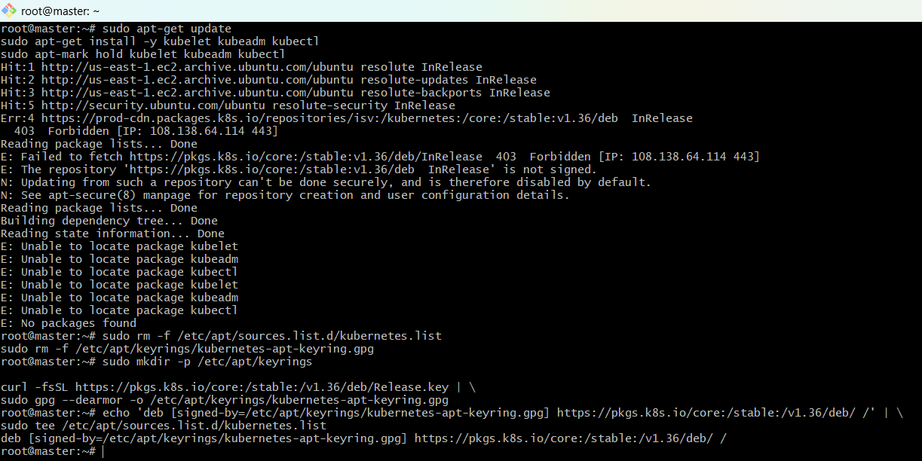
Install Kubernetes packages
sudo apt-get install -y kubelet kubeadm kubectl
sudo apt-mark hold kubelet kubeadm kubectl

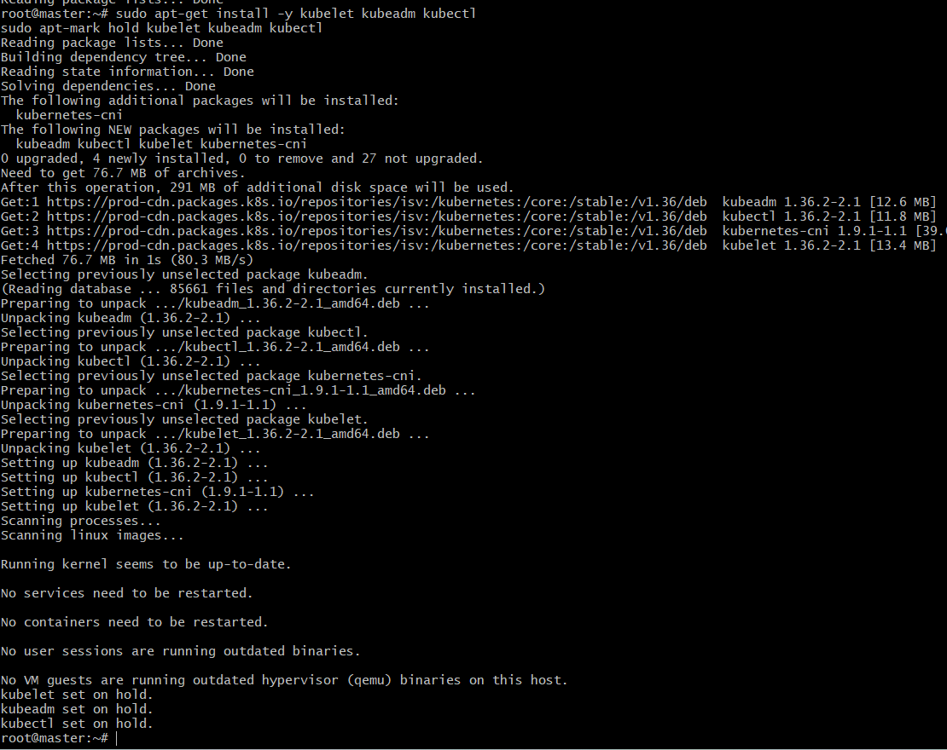
Verify
kubeadm version
kubectl version --client
kubelet --version

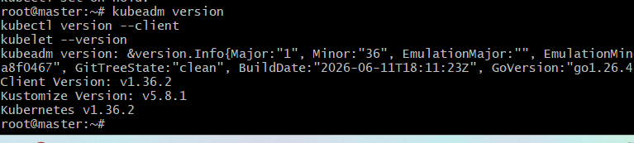
- To configure master we need to initialize with cidr
kubeadm init –pod-network-cidr=10.244.0.0/16
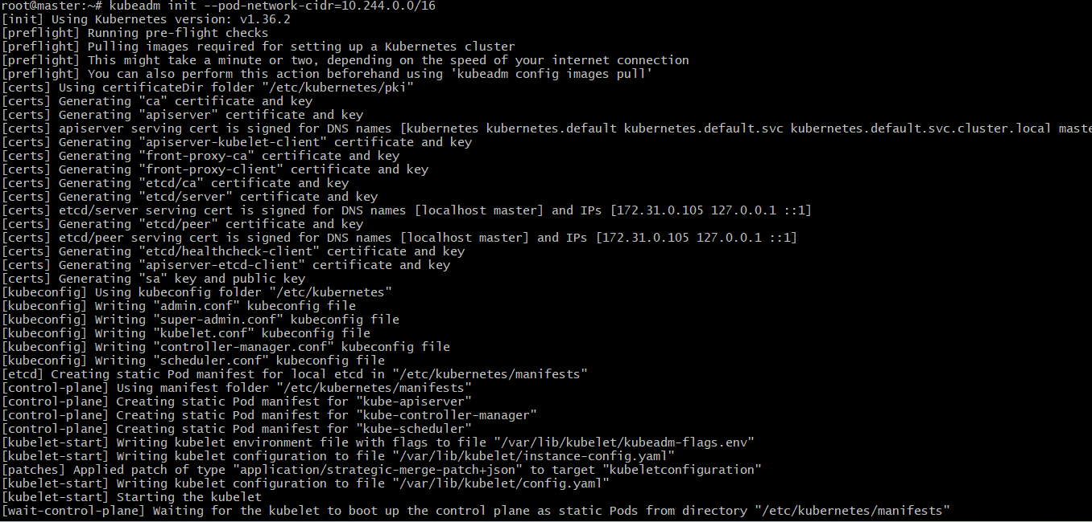
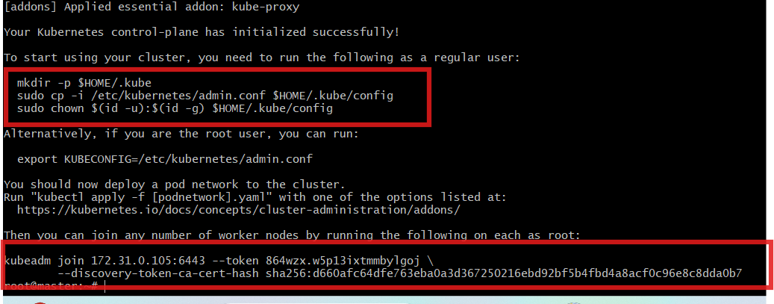
To start using cluster we need to run the following commands
mkdir -p $HOME/.kube
sudo cp -i /etc/kubernetes/admin.conf $HOME/.kube/config
sudo chown $(id -u):$(id -g) $HOME/.kube/config
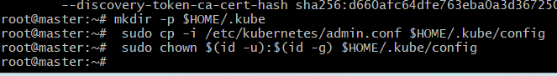
If we execute kubectl get nodes we can see the status as not ready because we haben’t
installed fannel
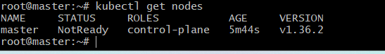
Parallely do the same for both the workers

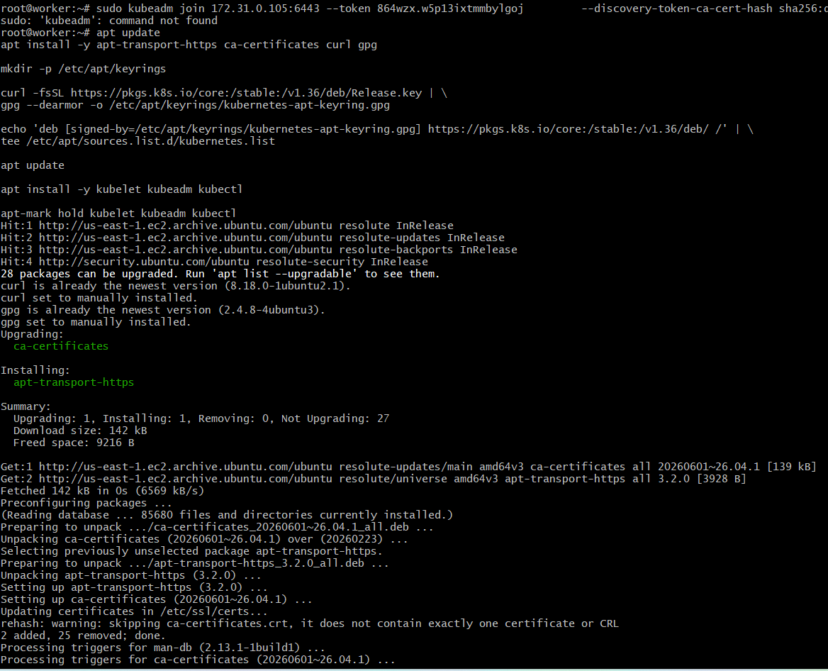
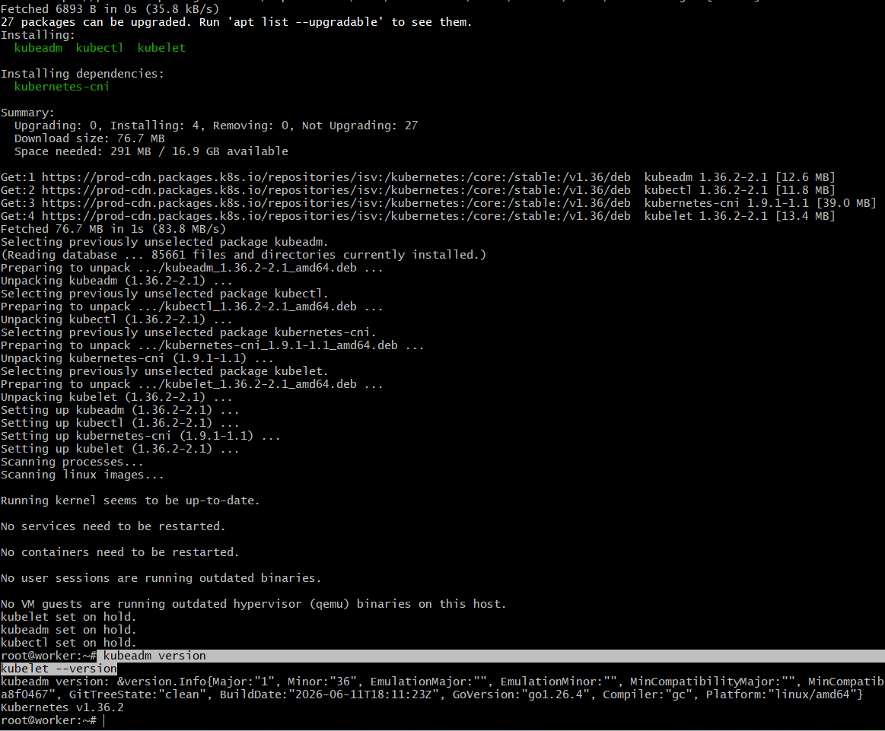
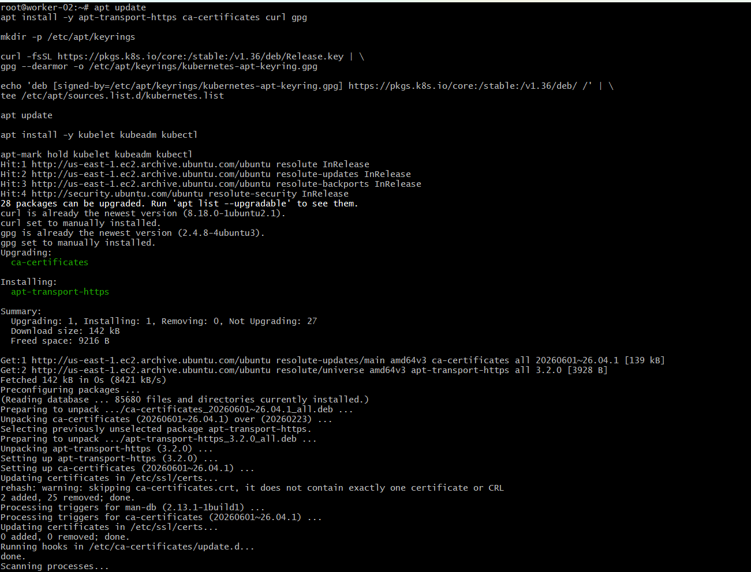
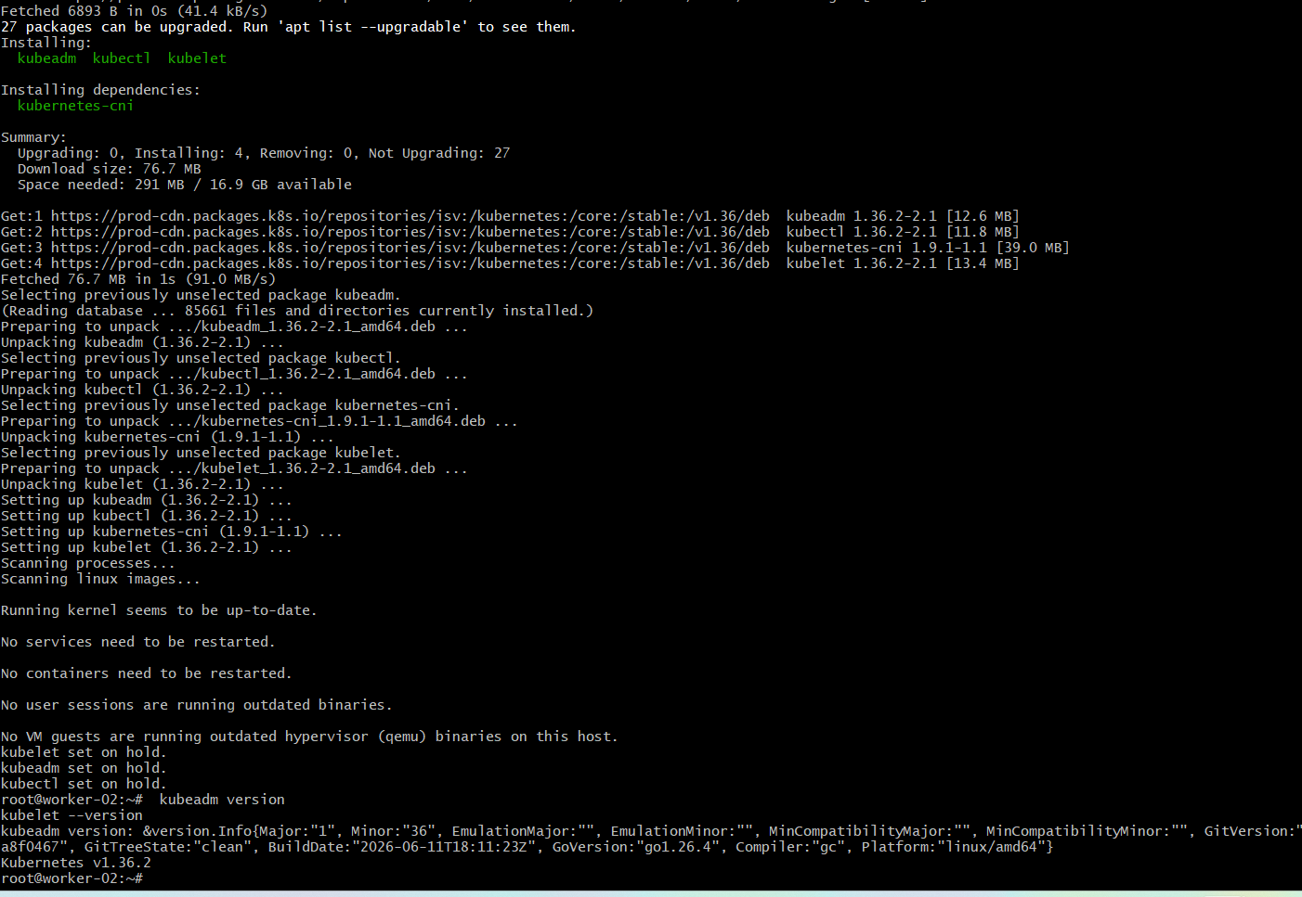
kubeadm join 172.31.0.105:6443 --token 864wzx.w5p13ixtmmbylgoj \
--discovery-token-ca-cert-hash sha256:d660afc64dfe763eba0a3d367250216ebd92bf5b4fbd4a8acf0c96e8c8dda0b7
Run this both workers because of connection between two wrokers
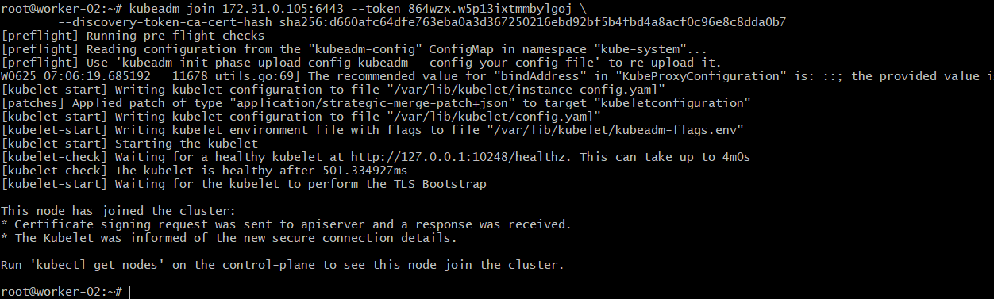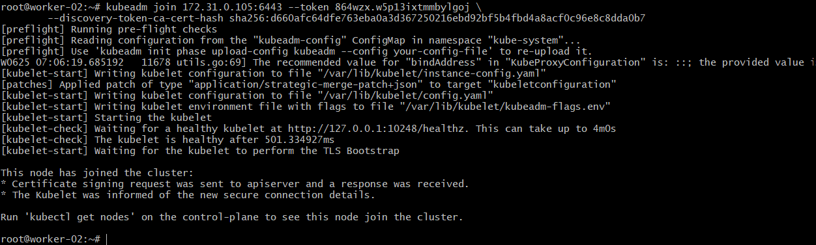
Check the nodes
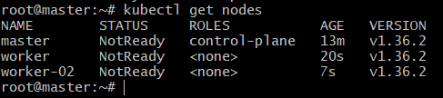
if we execute kubectl get nodes we can see the status as not ready because we haben’t
installed fannel
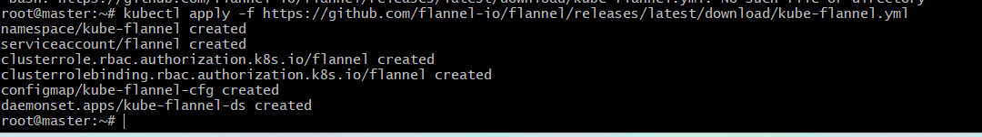
Check nodes now
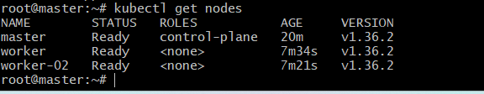

- Run one nginx pod.
To run a pod with name nginx and image nginx
kubectl run nginx –image-nginx
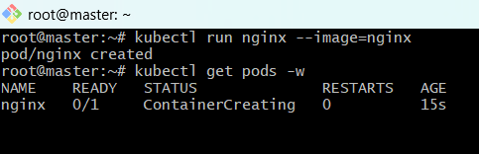
kubectl get pod nginx -o wide it gives the details of whole pod
Also exposed nginx with port 80
kubectl expose pod nginx - -type=NodePort –port=80
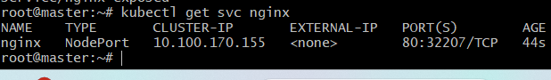
Lets access the browser
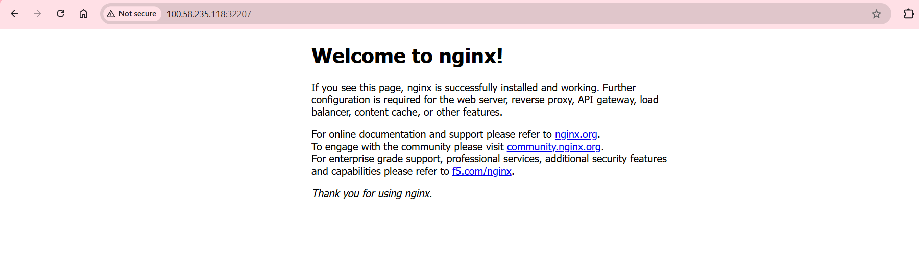

- Mugup Master and slave components on k8s.
Master Components:
1. kube-apiserver
• Entry point of Kubernetes.
• Receives all requests from kubectl.
• Communicates with etcd and other components.
Example:
• kubectl get pods (Request goes to kube-apiserver)
2. etcd
• Key-value database.
• Stores cluster state and configuration.
• Source of truth for Kubernetes.
Example:
• Pod information
• Node information
• Secrets
• ConfigMaps
3. kube-scheduler
• Decides on which node a pod should run.
• Checks CPU, Memory, Labels, Taints, etc.
Example:
• Nginx pod created
• Scheduler places it on a worker node
4. kube-controller-manager
• Runs controllers.
• Maintains desired state.
Examples:
• Node Controller
• Replication Controller
• Endpoint Controller
Worker Node (Slave Node) Components
1. kubelet
• Agent running on every worker node.
• Communicates with API Server.
• Creates and manages pods.
Example:
• API Server says "Run nginx pod"
• kubelet starts the pod.
2. kube-proxy
• Handles networking.
• Maintains Service communication.
• Implements ClusterIP, NodePort, Load Balancer networking.
Example:
• Service routes traffic to nginx pod.
3. Container Runtime
• Runs containers.
Examples:
• containerd
• Docker
• CRI-O
In your Minikube setup, containers are running through the container runtime.
4. Pods
• Smallest deployable unit in Kubernetes.
• Contains one or more containers.
Example:
• kubectl get pods

