Terraform-04
2)Execute the script shown in the video.
Version constraints
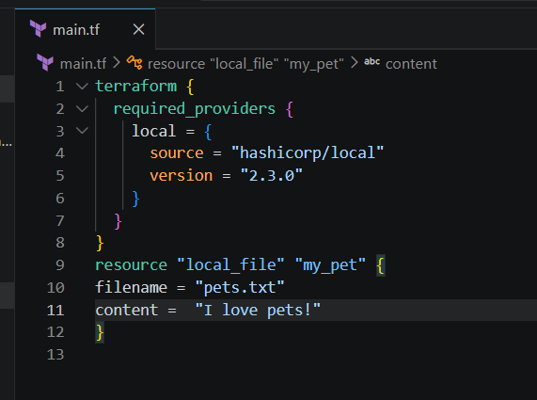
Here we can see that it is downloading the given version from the configuration
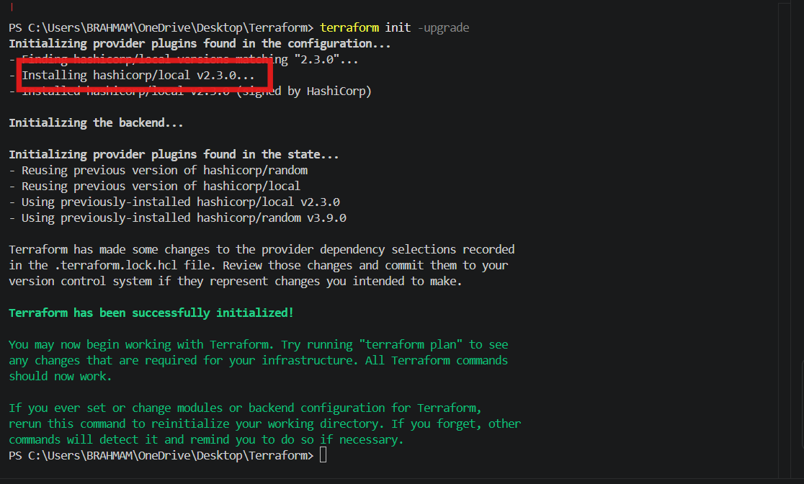
We can see the file has been created
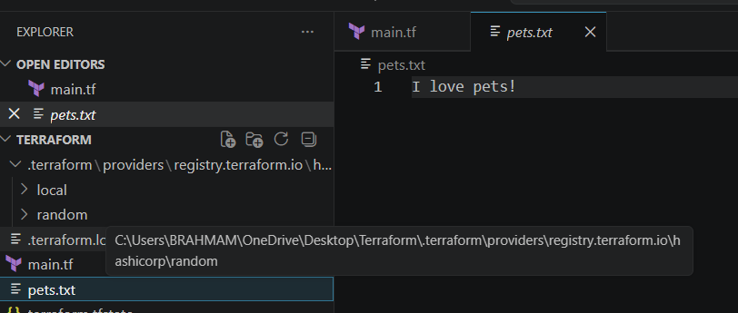
Now lets download different version
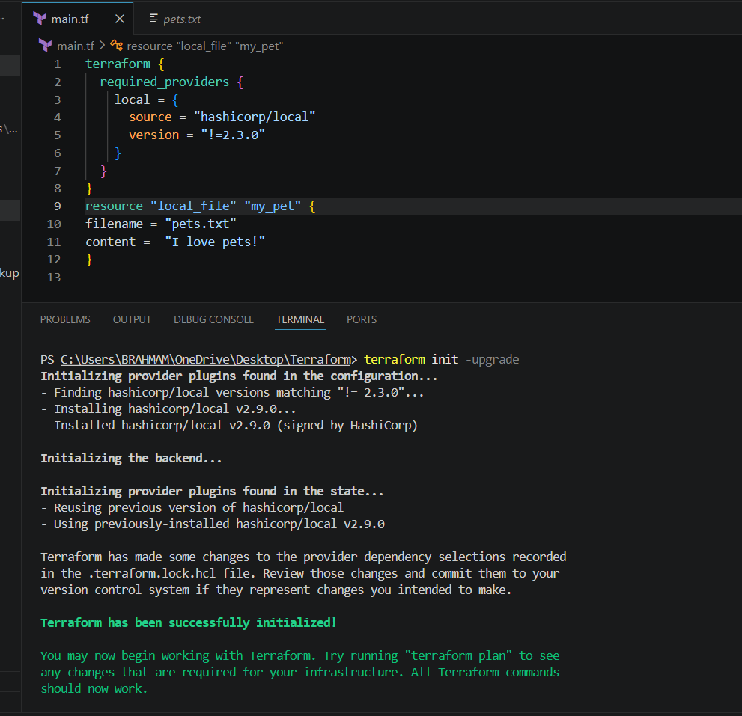
Now lets download for version < 2.3.0
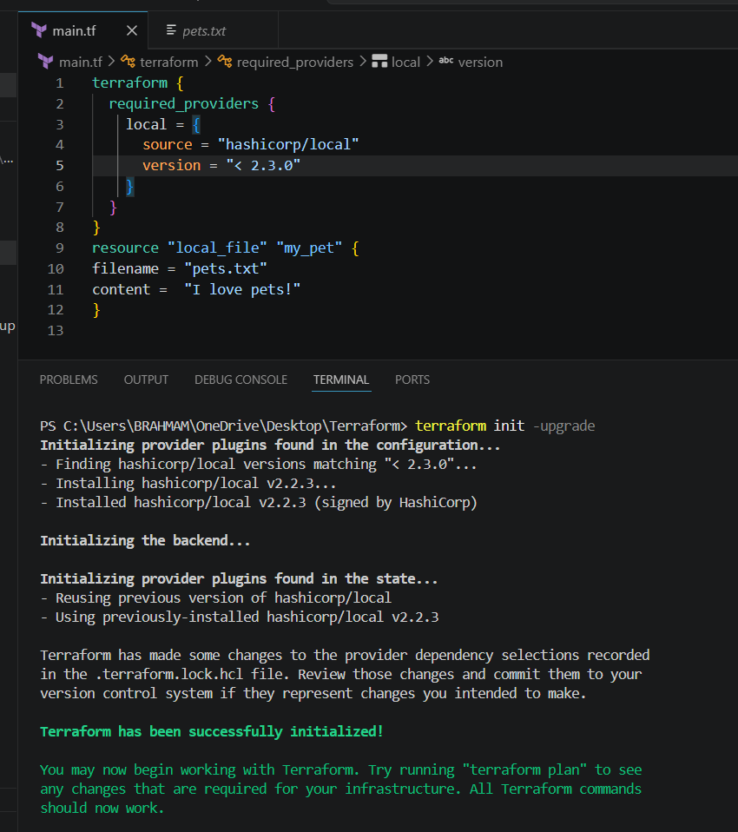
Also lets download the version greater than 2.3.0
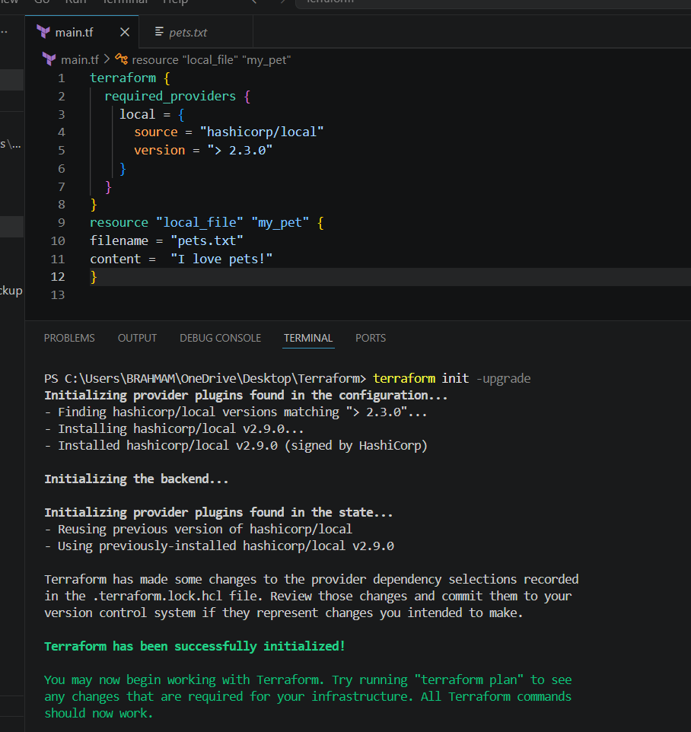
version = "~> 2.3.0" --> specific version or highest version.
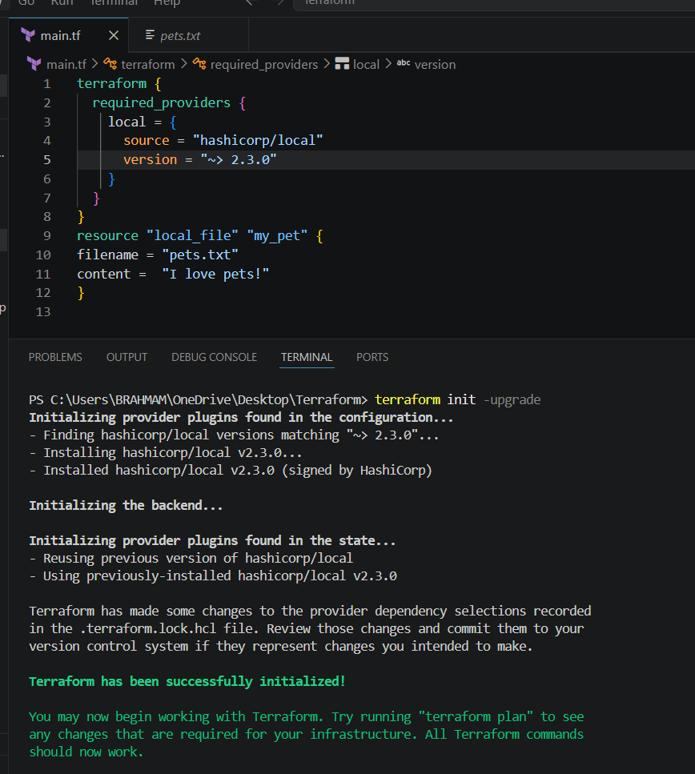
Data source
Data source is used to read the existing infrastructure, it won’t create any files
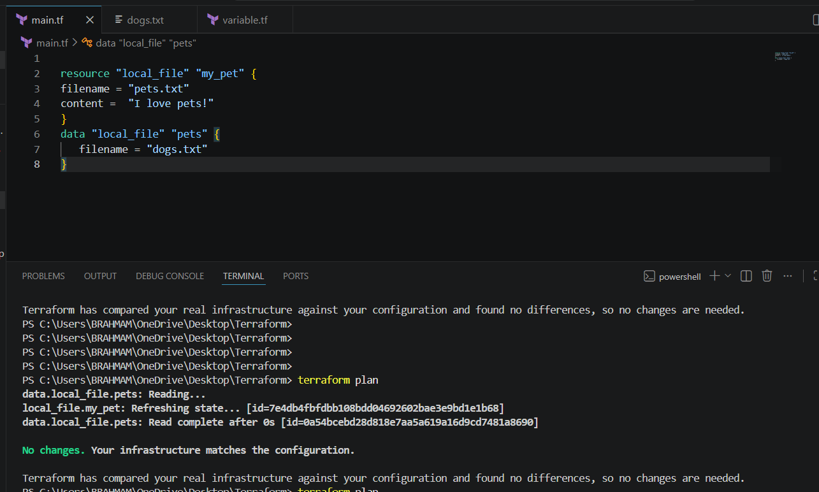
META ARGUMENTS:
Meta arguments are used if we want to create multiple resources.
● Depends on
● Lifecycle rules
1. create_before_destroy
2. prevent_destroy
3. ignore_changes
● Count
● For - each
COUNT⇒ If we want to create multiple files at a time we can use count.
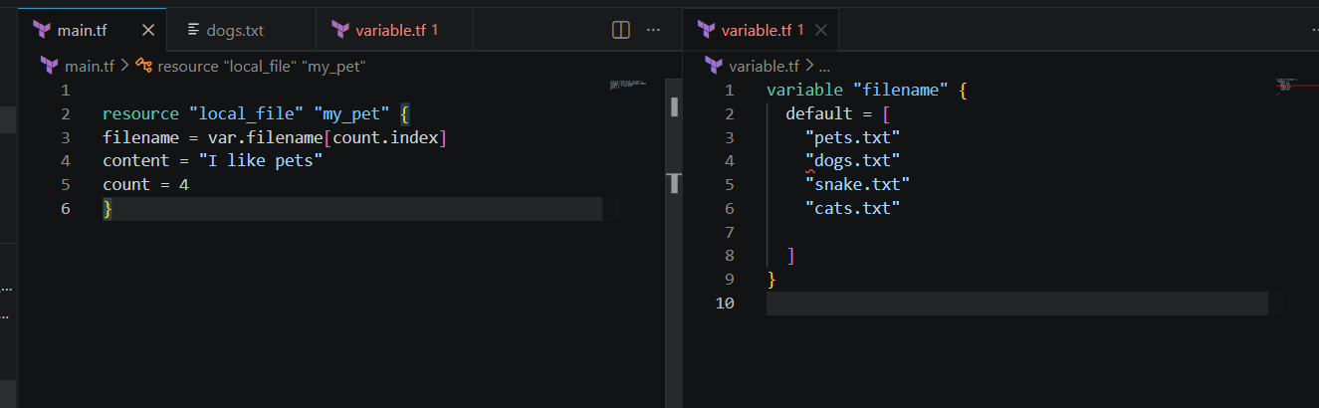
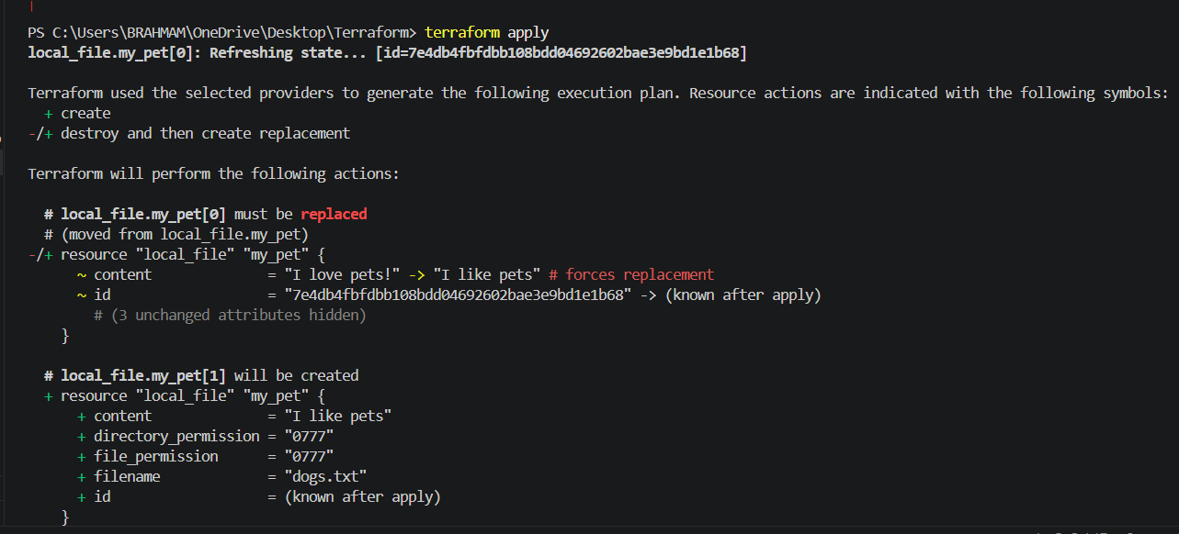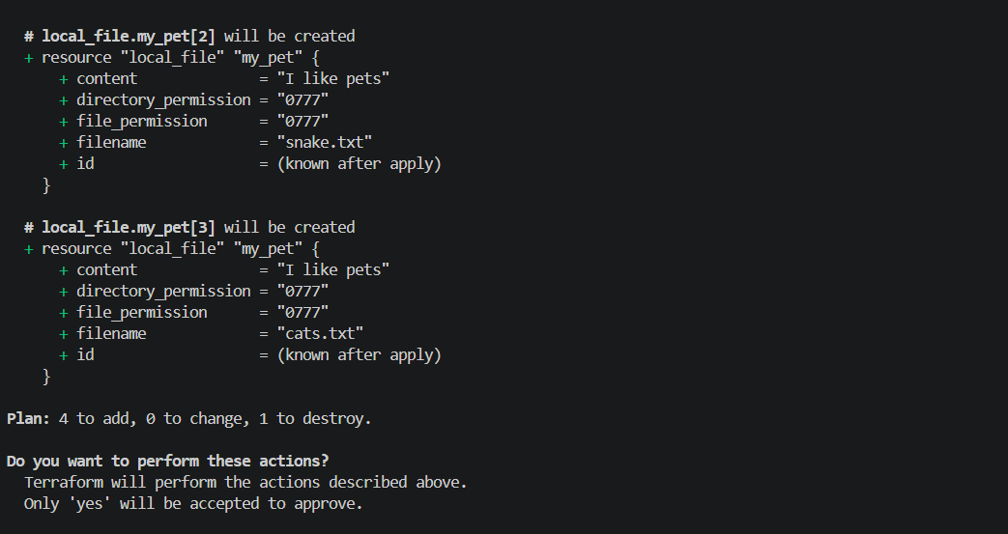
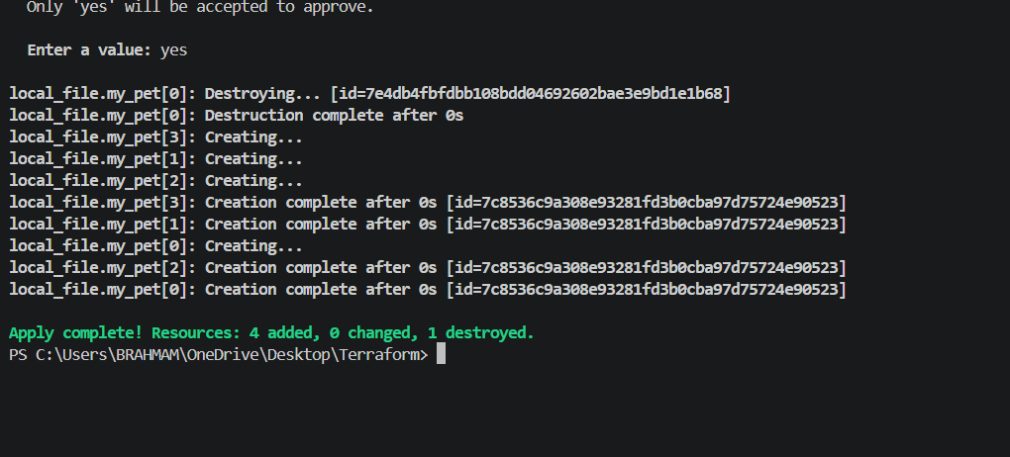
4 files were created
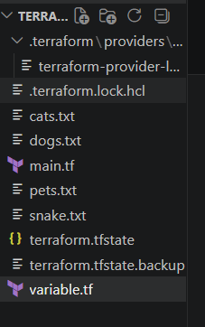
No extra file has been created, the reason is its been overwritten. So for these cases we
need to create a variable file and need to give the count index in the main.tf file then only
multiple files can be generated.
Let's see how it can be done now.
First lets create a variable.tf file and give the details of file names what we want to create
and made the necessary changes in main.tf file too
Now lets destroy two files
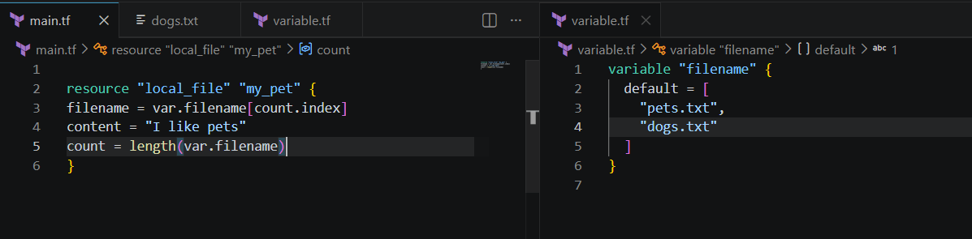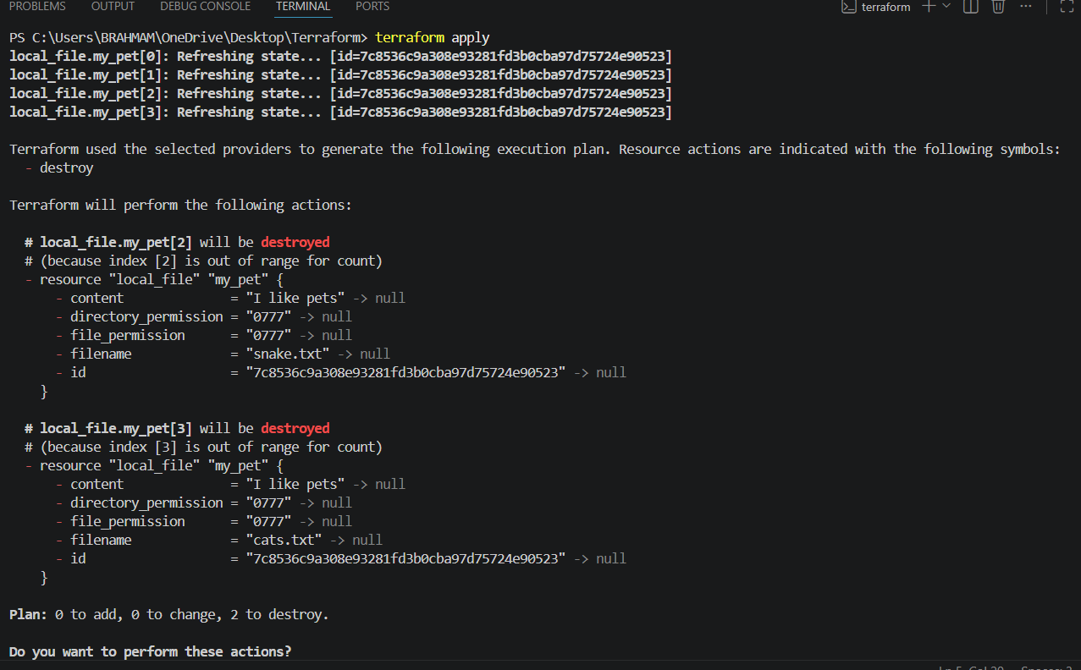
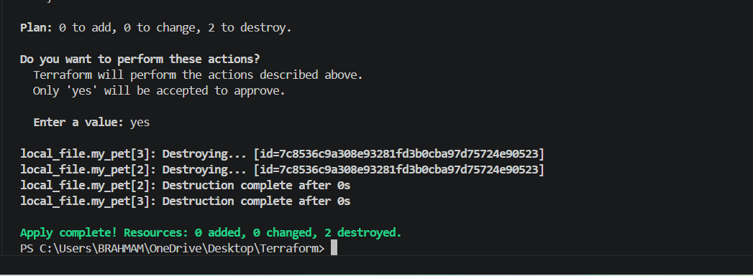
Files deleted successfully
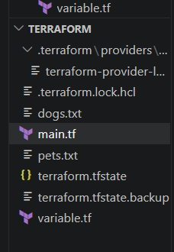
For each
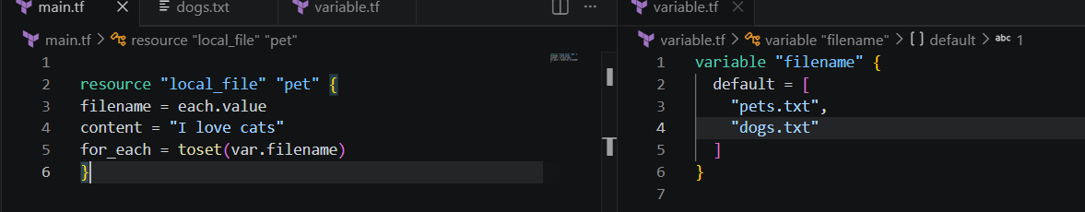
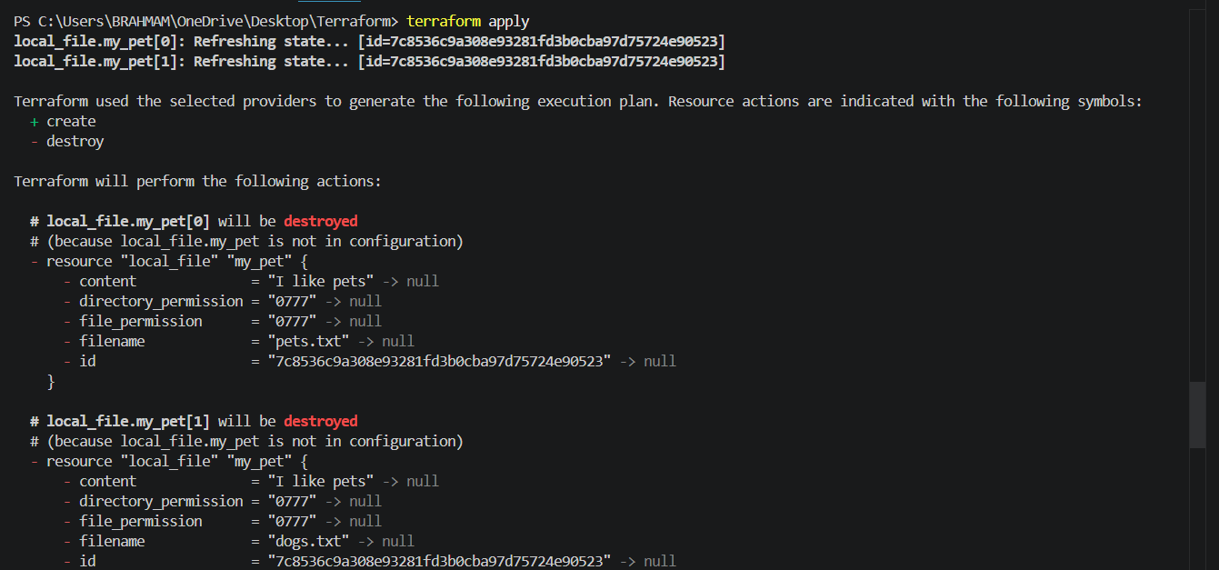
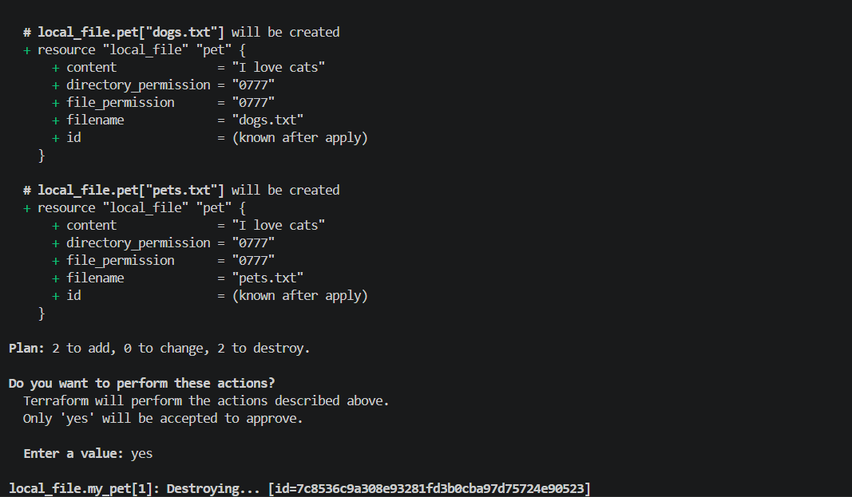
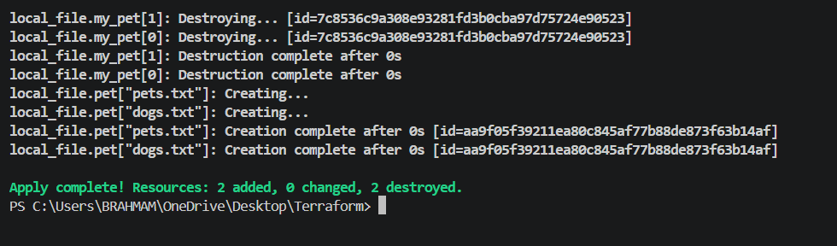If we don’t want to use the inbuilt function we can include type in variable.tf
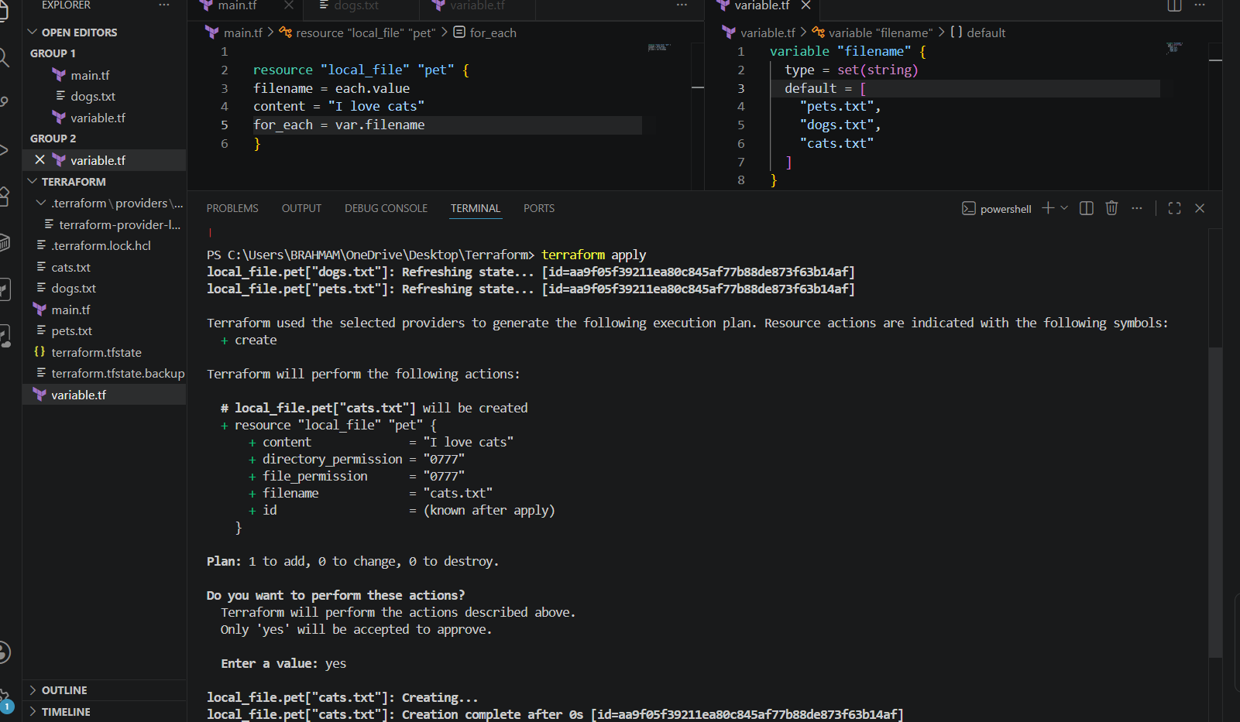
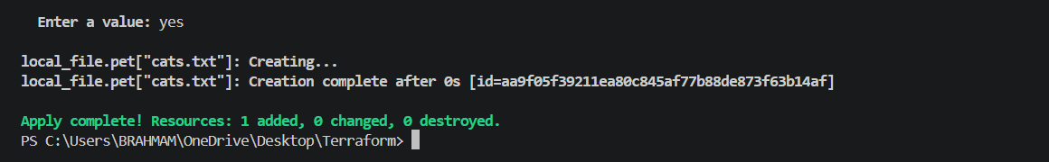
Lets create user and policy

provider "aws" {
region = "us-east-1"
}
# Create IAM User
resource "aws_iam_user" "dev_user" {
name = "terraform-user"
}
# Create Custom IAM Policy
resource "aws_iam_policy" "custom_policy" {
name = "CustomS3ReadOnly"
description = "Allow read-only access to S3 buckets"
policy = jsonencode({
Version = "2012-10-17"
Statement = [
{
Effect = "Allow"
Action = [
"s3:ListBucket",
"s3:GetObject"
]
Resource = [
"arn:aws:s3:::*",
"arn:aws:s3:::*/*"
]
}
]
})
}
# Attach Policy to User
resource "aws_iam_user_policy_attachment" "attach_policy" {
user = aws_iam_user.dev_user.name
policy_arn = aws_iam_policy.custom_policy.arn
}

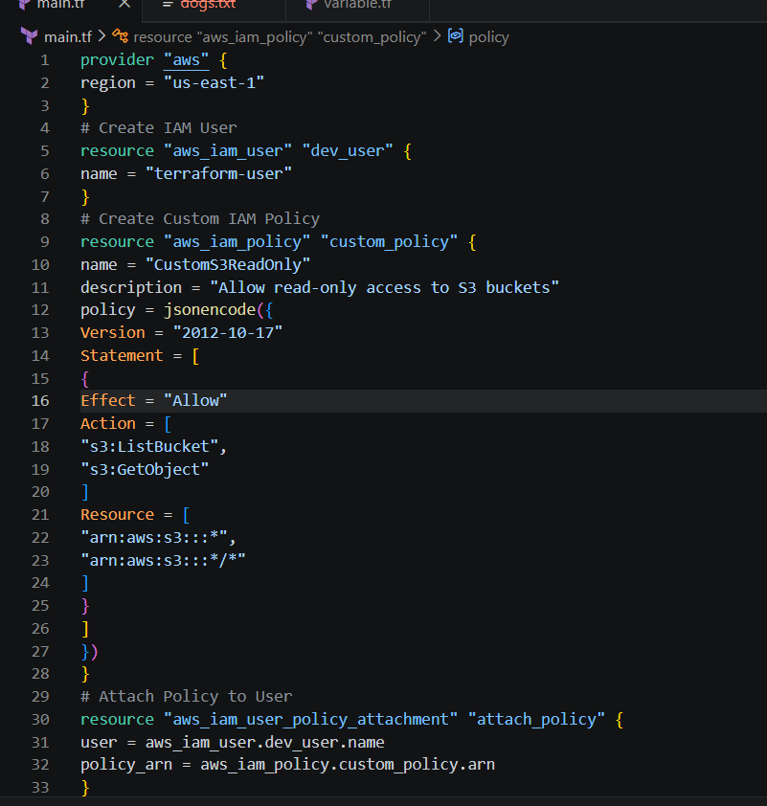
Go to aws accountiam—>create acces key and give that in aws configureterraform initterraform planterraform apply
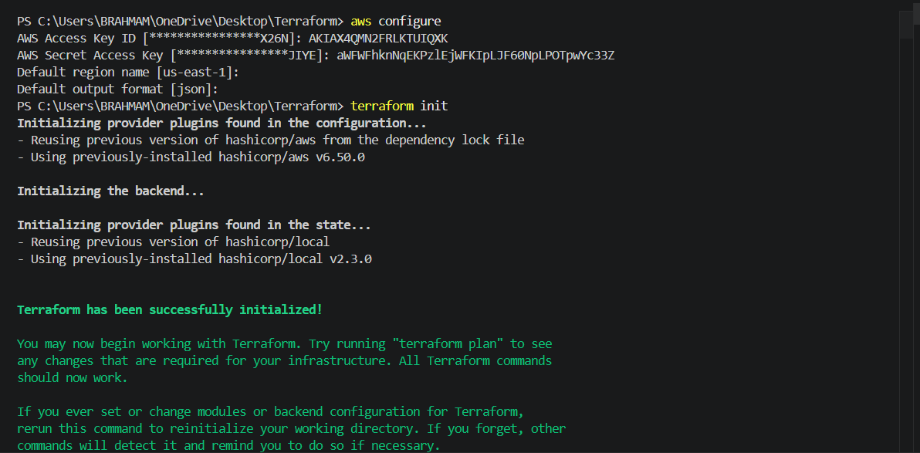
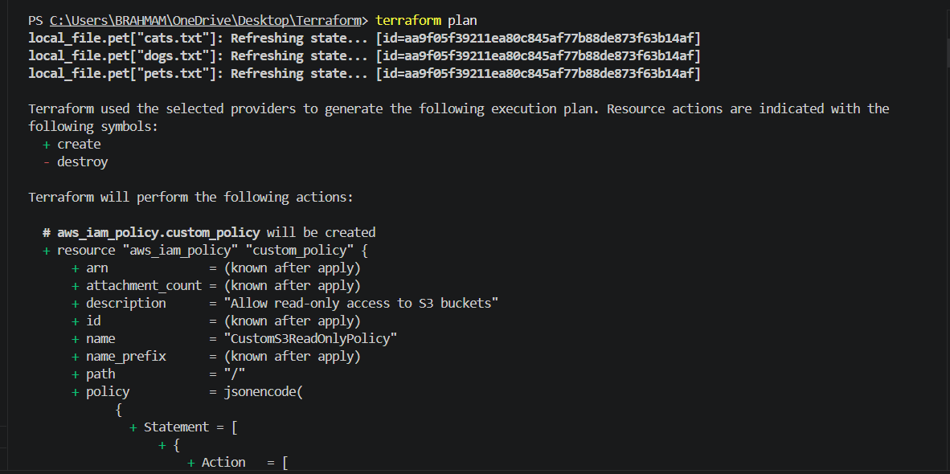
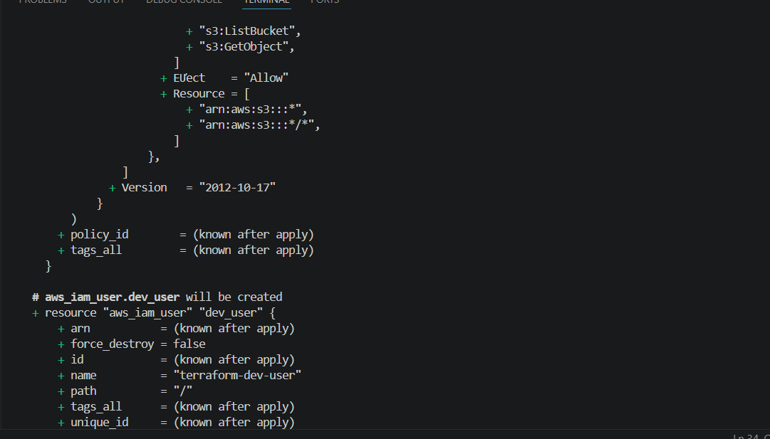
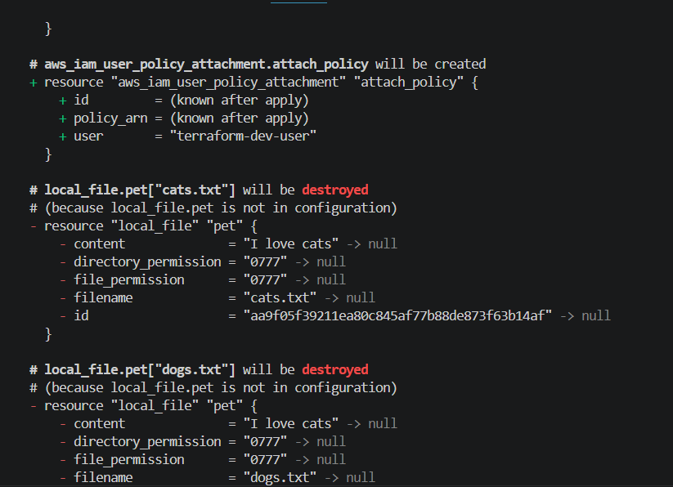
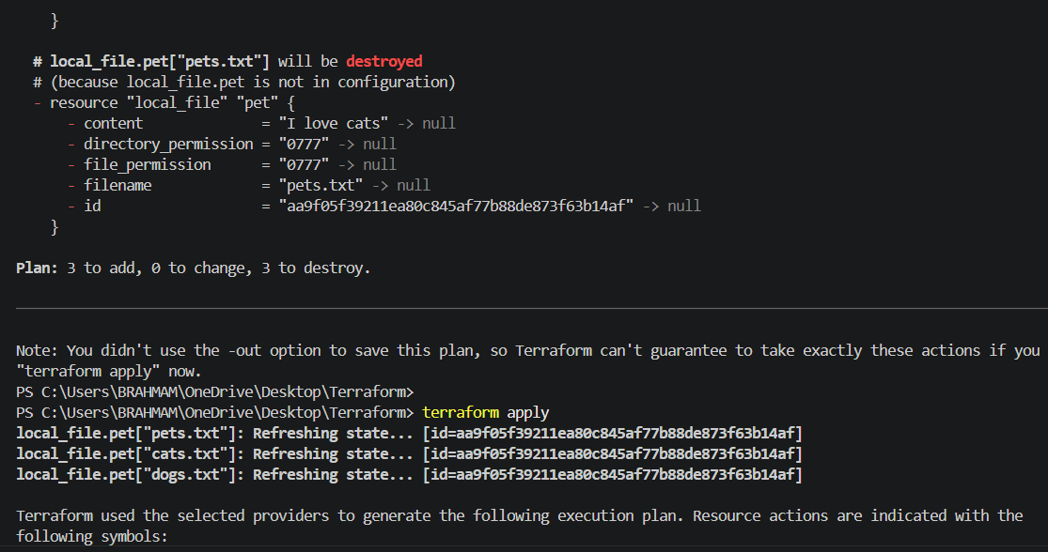
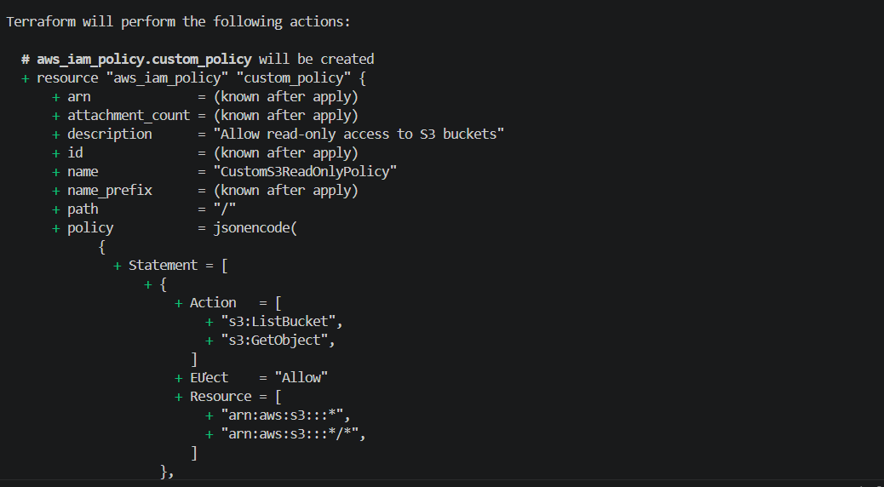
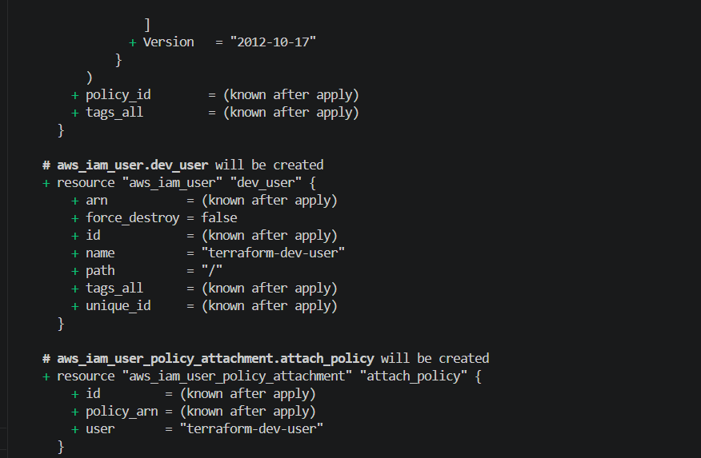
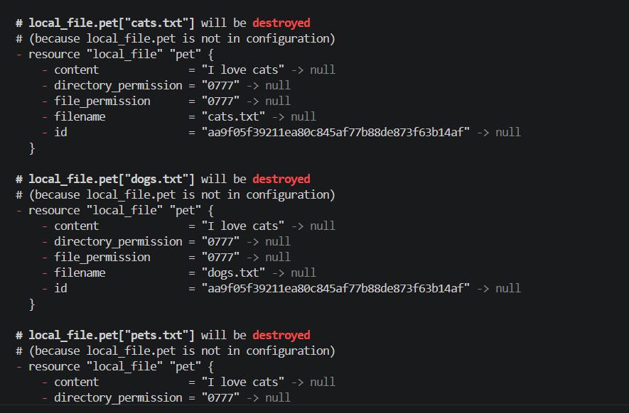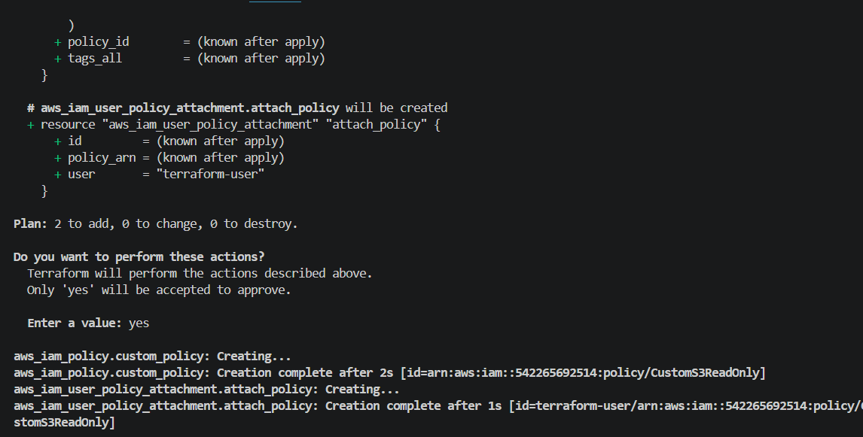

Go to aws accountIAM USERSadded one new userterraform-user
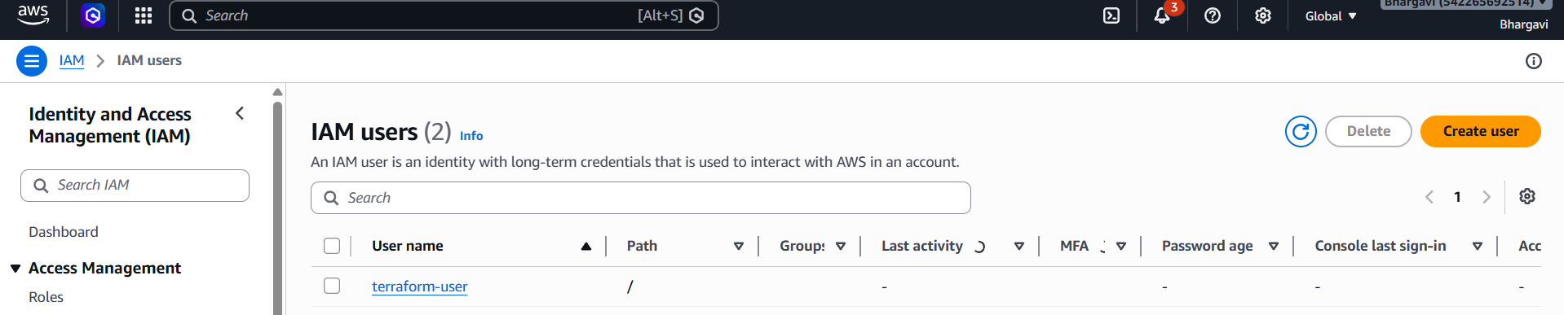
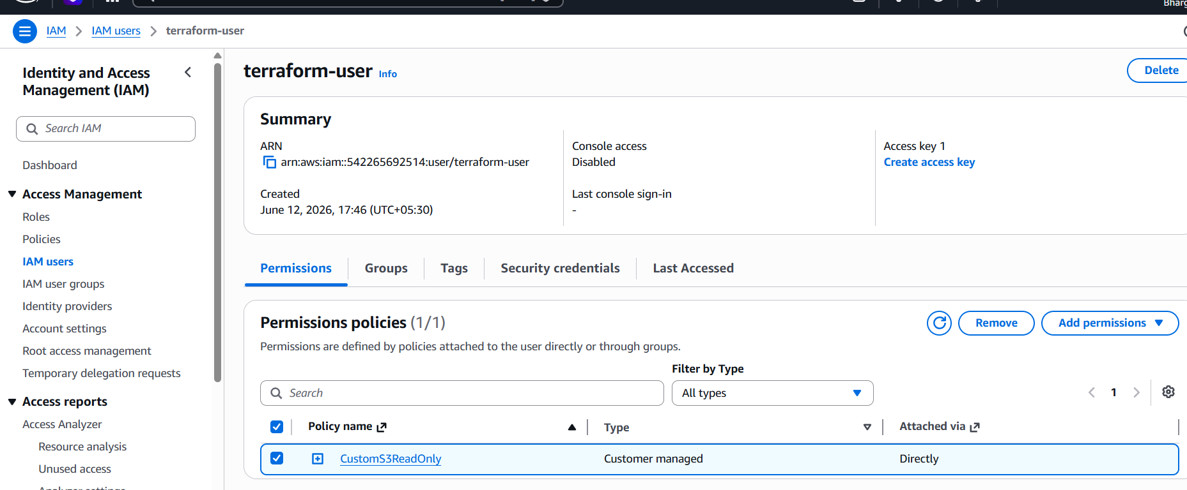
3). Integrate Terraform in Jenkins using the Terraform plugin.
4). Create a CI/CD pipeline for a Nodejs Application: https://github.com/betawins/Trading-UI.git
sudo apt update
curl -fsSL https://deb.nodesource.com/setup_16.x | sudo -E bash –
sudo apt install -y nodejs

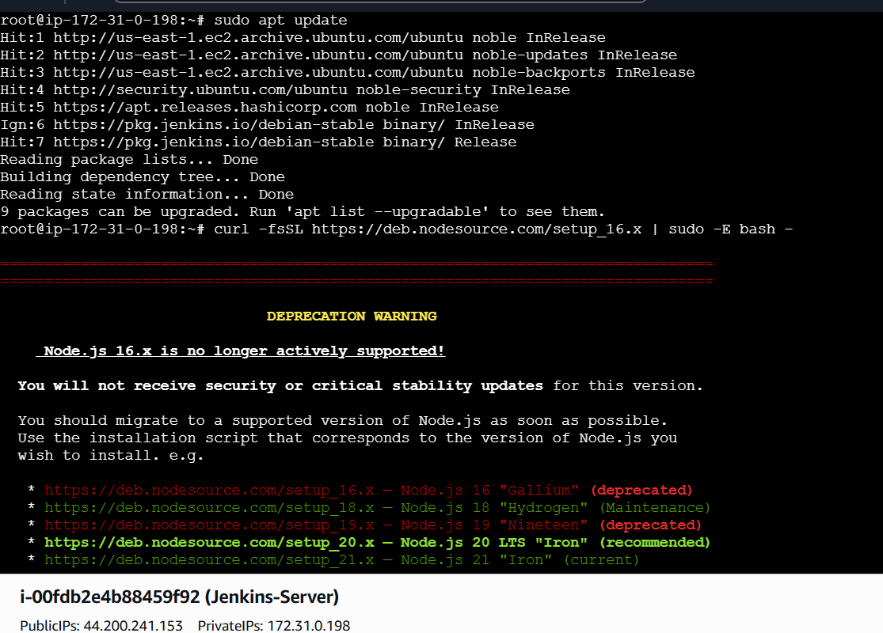
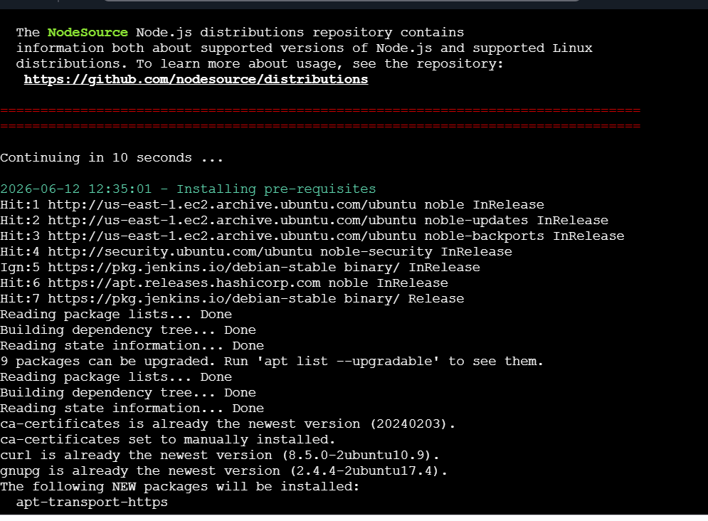
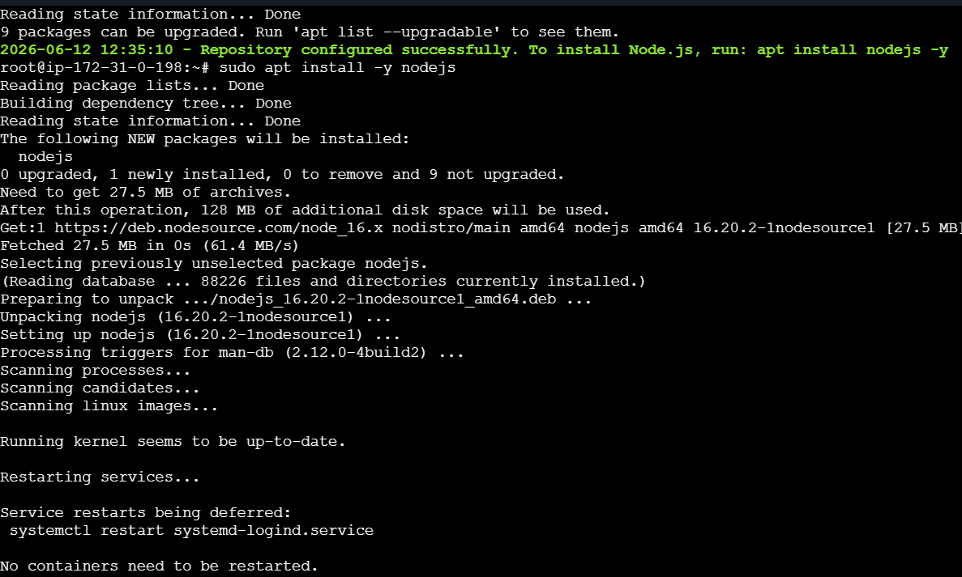
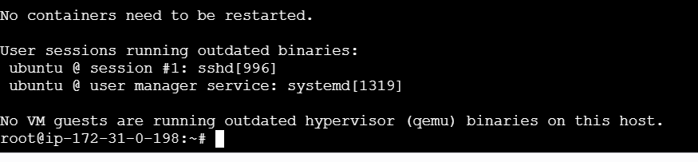
Lets create a pipeline
pipeline {
agent any
environment {
CI = 'false'
}
stages {
stage('Git Clone') {
steps {
git branch: 'master',
url: 'https://github.com/betawins/Trading-UI.git'
}
}
stage('Install Dependencies') {
steps {
sh 'npm install'
}
}
stage('Build NodeJS App') {
steps {
sh 'npm run build'
}
}
}
}
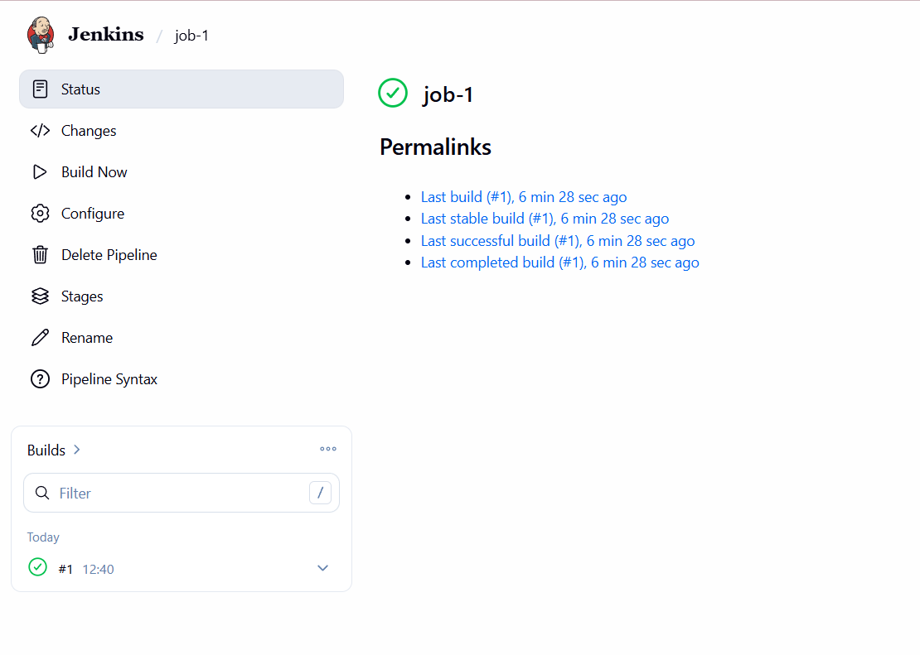
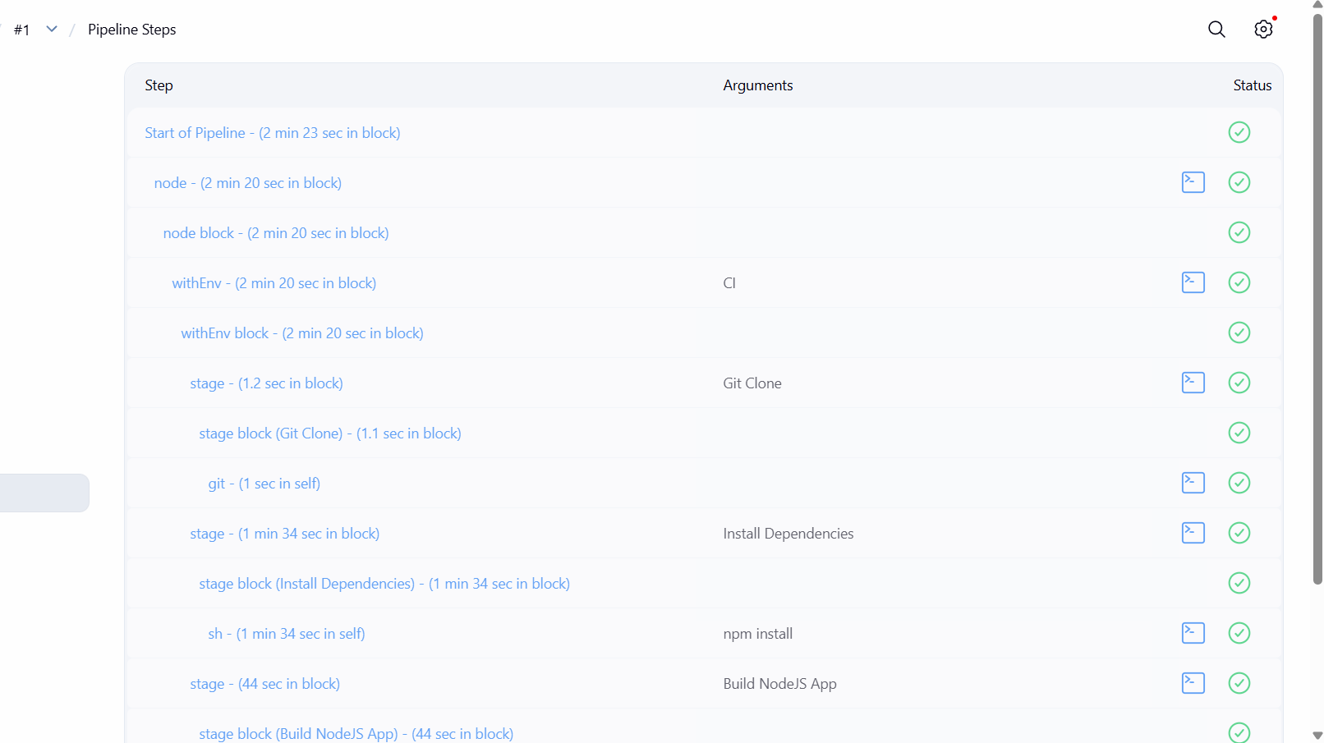
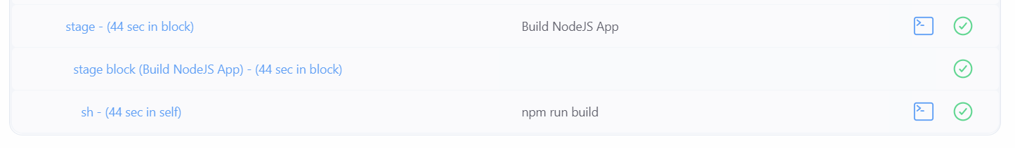
lets verify the package
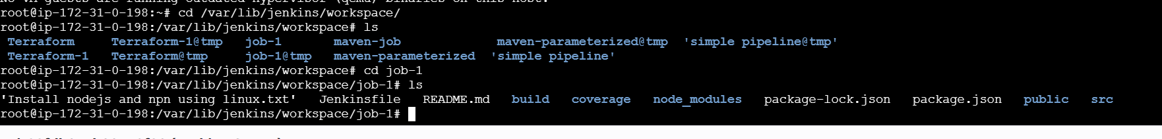
5)Explain 10 Maven commands.
Command Purpose
mvn compile Compiles the source code
mvn test Runs unit test cases
mvn package Creates JAR/WAR package
mvn install Installs package into local Maven repository
mvn deploy Deploys package to remote repository
mvn clean Deletes previous build artifacts
mvn validate Validates project structure and POM
mvn verify Runs checks and integration tests
mvn dependency:tree Displays project dependencies
mvn archetype:generate Creates a new Maven project

