TERRAFORM-01
INTRO_AND BASICS
1)Install Terraform on your PC
Step1:go to browser search for terraform on windows shown in below
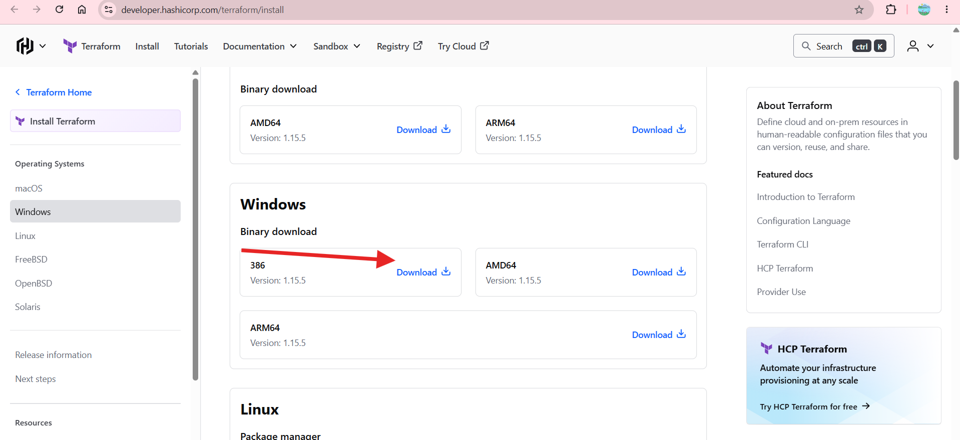
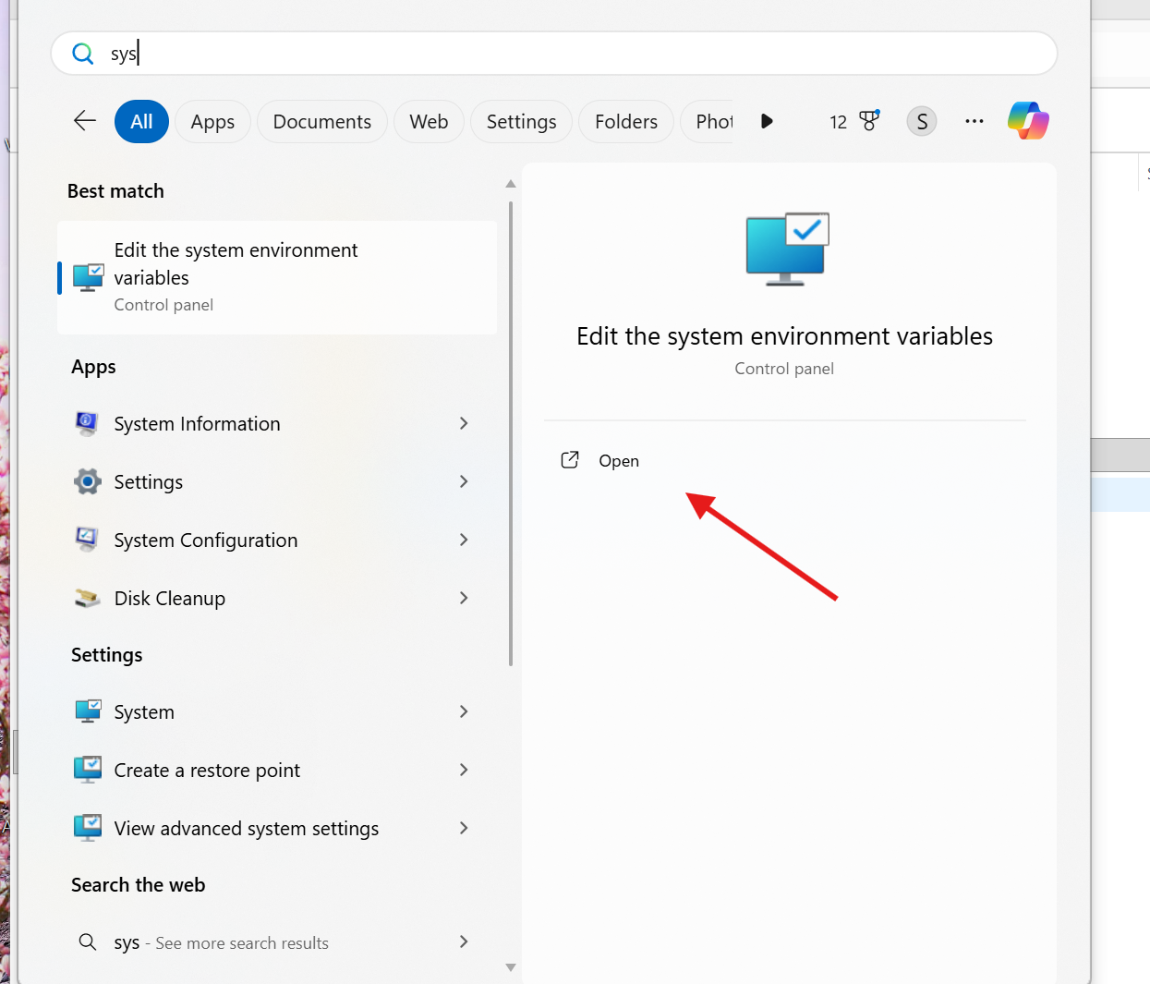
After downloaded we can extract that file in this pccterraform copy to this locationgo to advanced system settingsenvironment variables system variablespath-editcopy the correct path of terraform.-->this is my path
C:\terraform_1.15.5_windows_386\terraform.exe

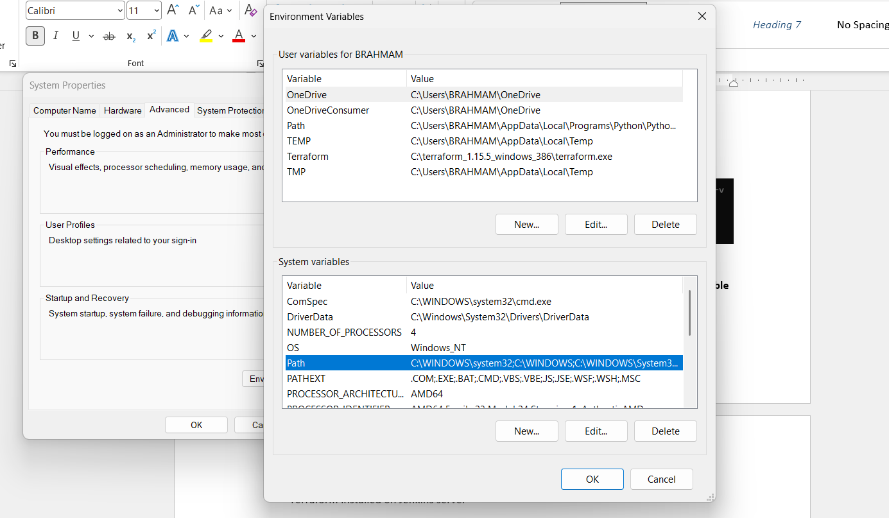
Go to environment variablessystem variablespath editbrowseterraform
Go to teraform version check now
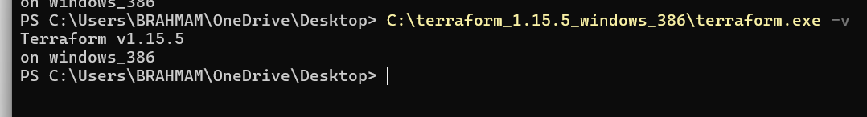

Terraform has been successfully installed and configured on Windows. The executable is available globally through the PATH environment variable and can be accessed from Command Prompt, PowerShell, and Git Bash.
- Terraform installed on Jenkins server
Errors Faced and How They Were Fixed
Error 1: Terraform Command Not Recognized
Cause:
Terraform binary was downloaded but not added to system PATH.
Fix:
Added Terraform installation directory to system environment variables and reopened the terminal.
2). Execute all the templates shown in video.
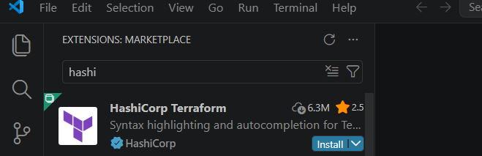
Install the terraform extension in visual studio code
Create file main.tf
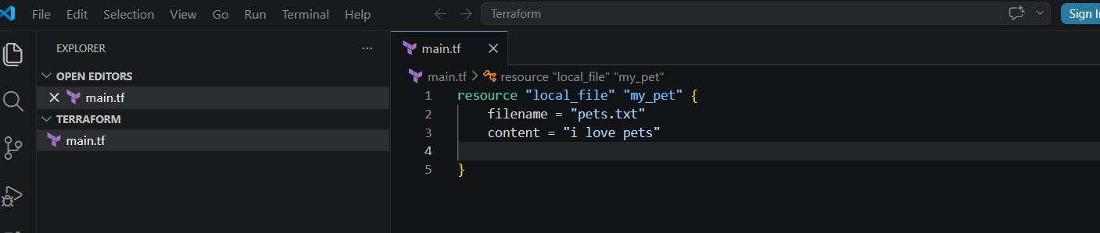
Go to terminalnew terminalterraform init
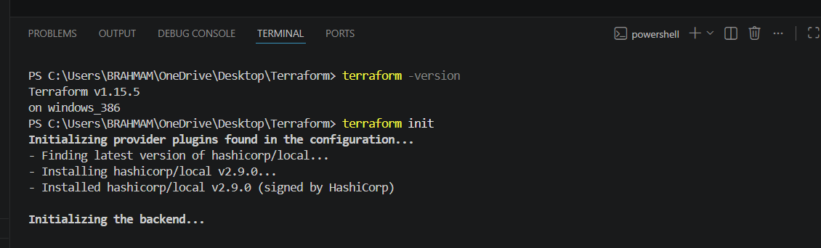
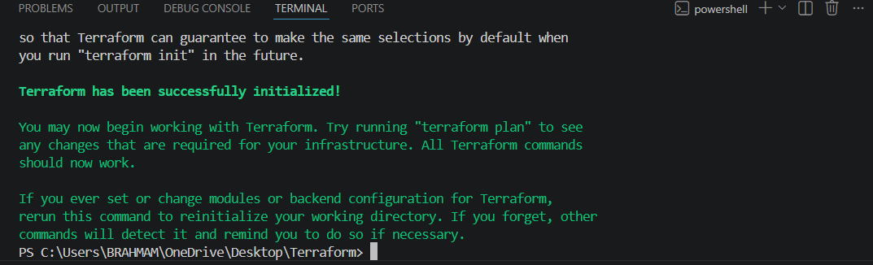
Terraform plan
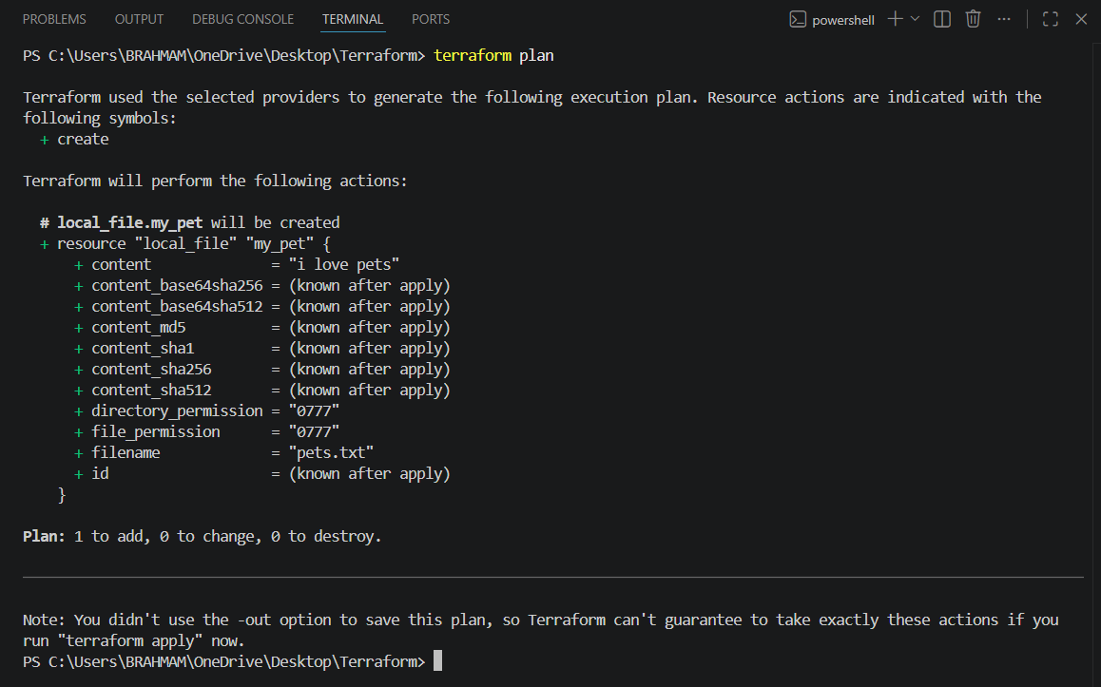
terraform plan shows one thing to add
terraform apply
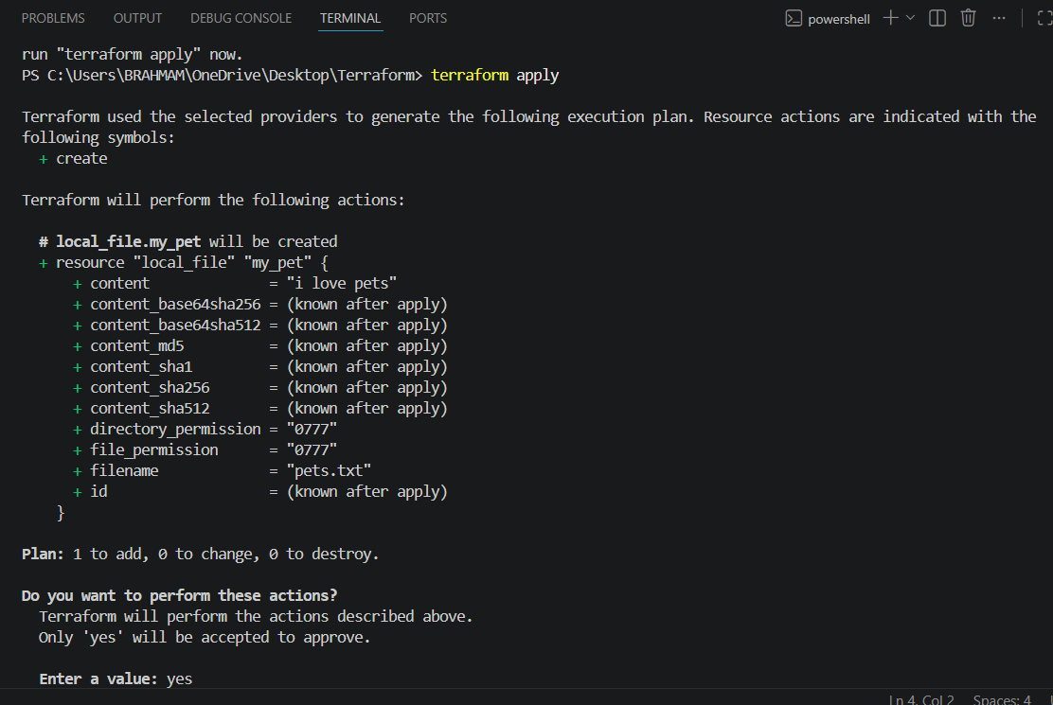
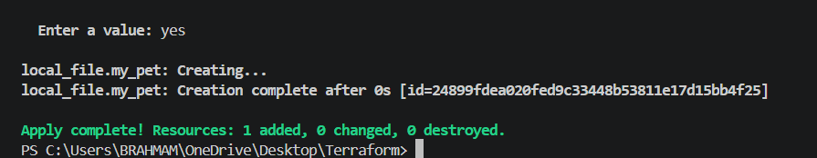

It has created the file
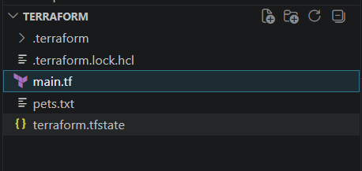
If we run terraform apply again with doing changes in configuration file “I hate pets”(main.tf)
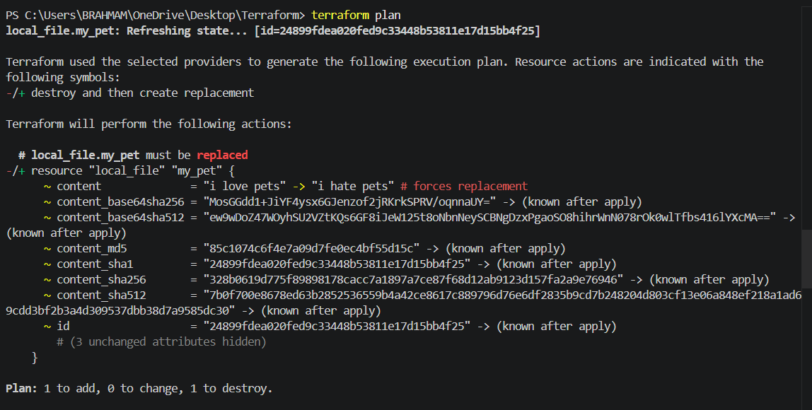
- Again I will do terraform plan and tearraform apply then we can get changes.
- 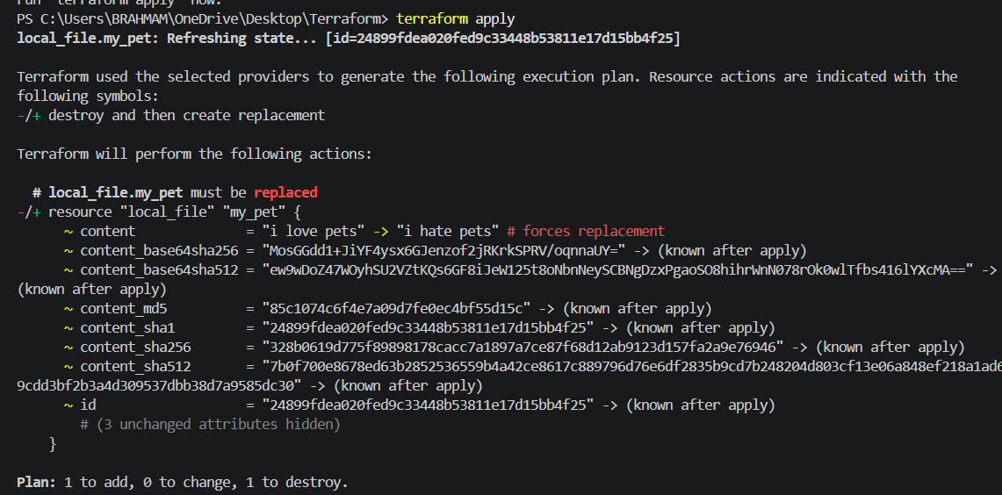
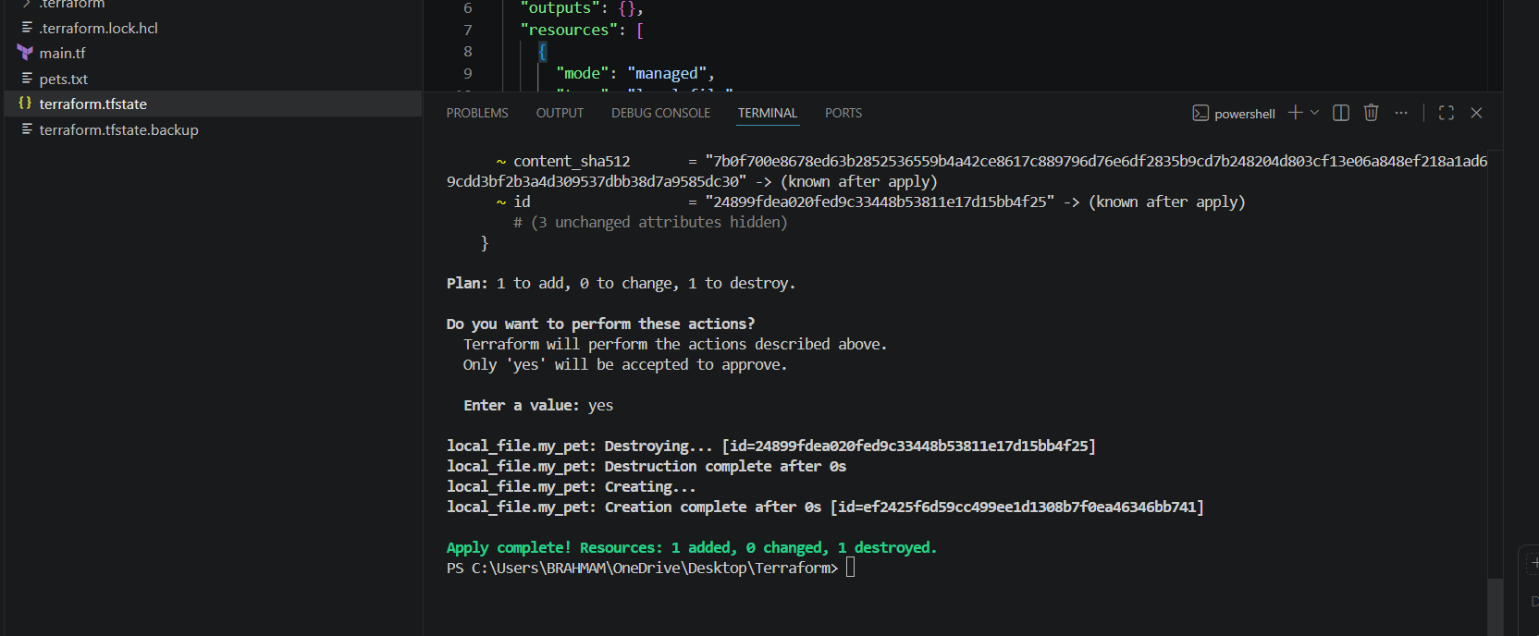
We have to all configurations are in added terraform.tfstate file here.
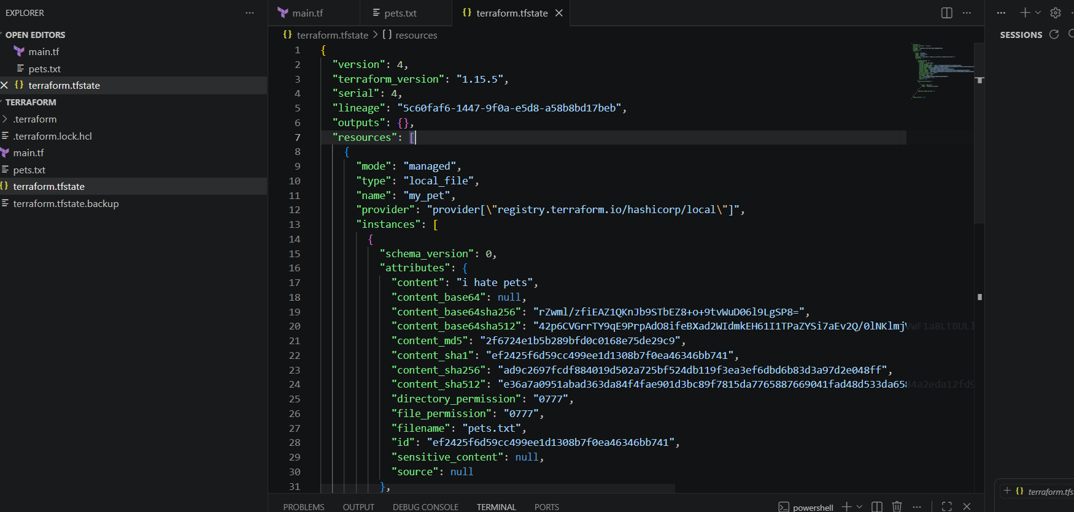

3). Note down below points, Terraform Init Terraform Plan Terraform Apply Terraform Provider.
Terraform init
Purpose:
- Initializes the Terraform working directory.
- Downloads required provider plugins.
- Configures the backend for state storage.
- Downloads referenced modules.
When to Use:
- Before running any Terraform commands in a new project.
- After adding or changing providers/modules.
Terraform plan
Purpose:
- Creates an execution plan.
- Shows what resources will be created, modified, or destroyed.
- Does not make any actual changes.
When to Use:
- Before applying changes to review the impact.
Terraform apply
Purpose:
- Executes the changes defined in the Terraform configuration.
- Creates, updates, or deletes infrastructure resources.
- Updates the Terraform state file.
When to Use:
- After reviewing the execution plan.
Terraform provider : It is a complete package of api calls to communicate with our resources a Acts as the bridge between Terraform and the target infrastructure platform.

4)Integrate a sample Terraform template in Jenkins.
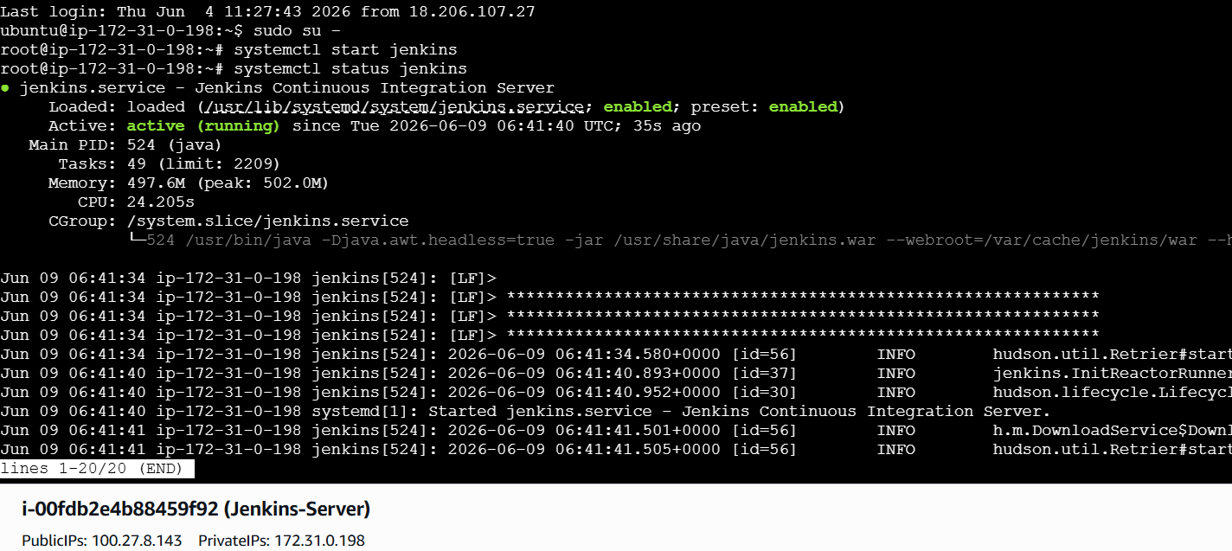
Install Terraform in Jenkins Server
sudo apt update
sudo apt install -y gnupg software-properties-common curl
curl -fsSL https://apt.releases.hashicorp.com/gpg | \
sudo gpg --dearmor -o /usr/share/keyrings/hashicorp-archive-keyring.gpg
echo "deb [signed-by=/usr/share/keyrings/hashicorp-archive-keyring.gpg] https://apt.releases.hashicorp.com $(lsb_release -cs) main" | \
sudo tee /etc/apt/sources.list.d/hashicorp.list
sudo apt update
sudo apt install -y terraform
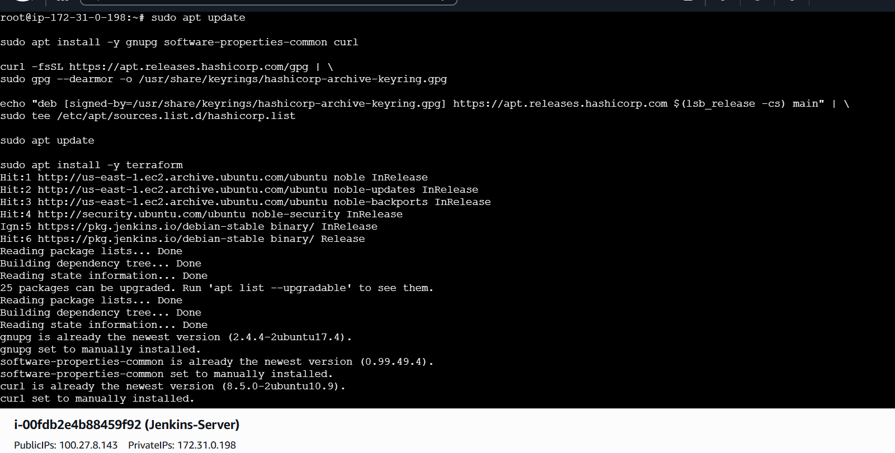
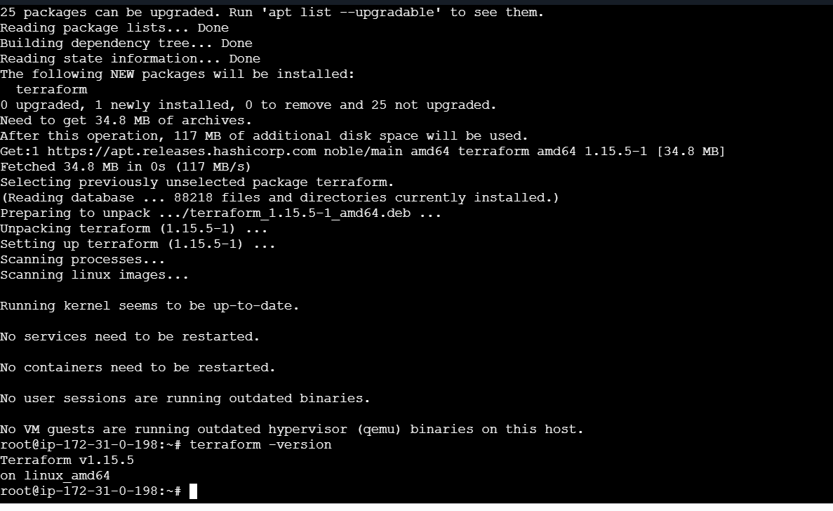
Create vi main.tf for Simple Terraform
Before that I have to login Jenkins page
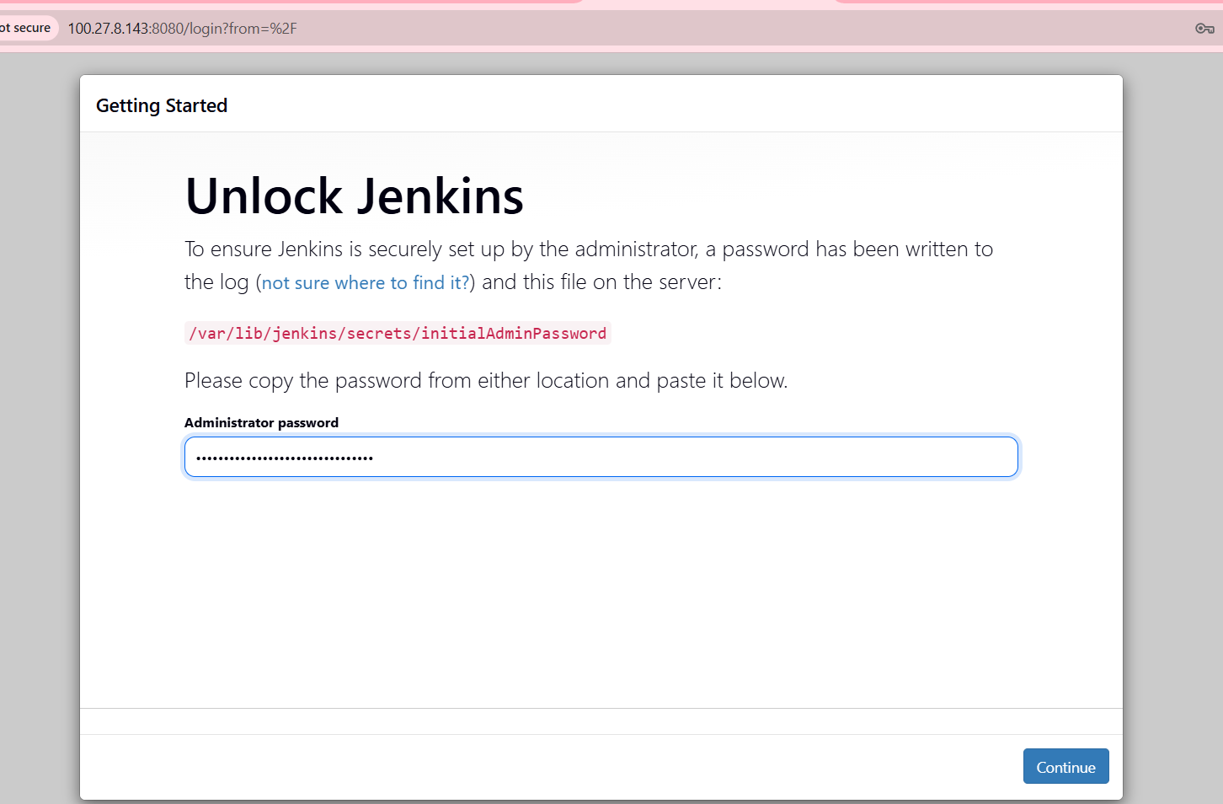
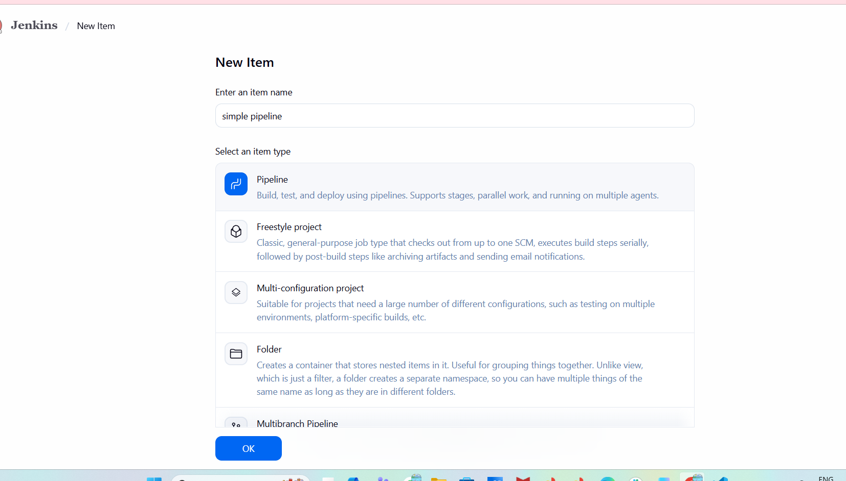
Just create a job and now go to instance
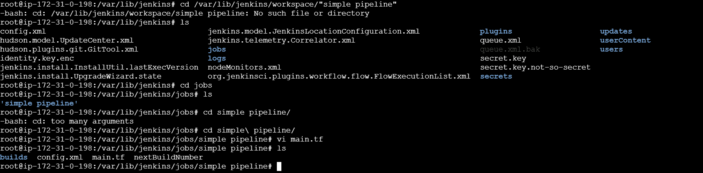
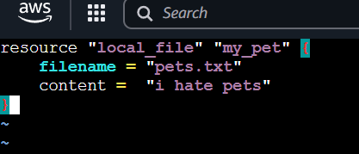
Now go to Jenkinsenter pipeline and now
pipeline {
agent any

stages {

stage('Check Terraform') {
steps {
sh 'terraform version'
}
}

stage('Terraform Init') {
steps {
sh '''
cd "/var/lib/jenkins/jobs/simple pipeline"
terraform init
'''
}
}

stage('Terraform Validate') {
steps {
sh '''
cd "/var/lib/jenkins/jobs/simple pipeline"
terraform validate
'''
}
}

stage('Terraform Plan') {
steps {
sh '''
cd "/var/lib/jenkins/jobs/simple pipeline"
terraform plan
'''
}
}

stage('Terraform Apply') {
steps {
sh '''
cd "/var/lib/jenkins/jobs/simple pipeline"
terraform apply -auto-approve
'''
}
}
}

post {
success {
echo 'Terraform deployment completed successfully.'
}
failure {
echo 'Terraform deployment failed.'
}
}
}

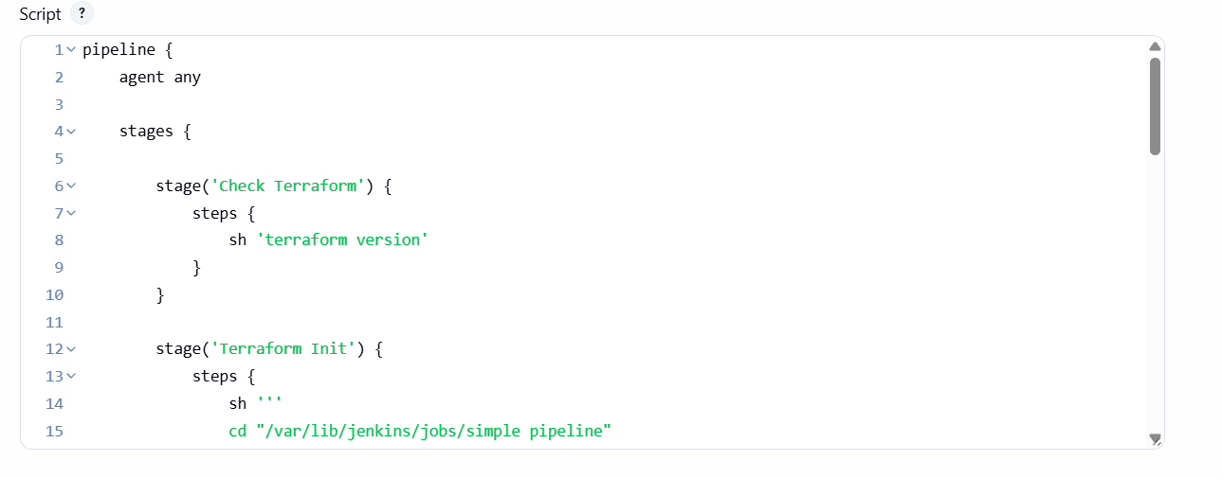
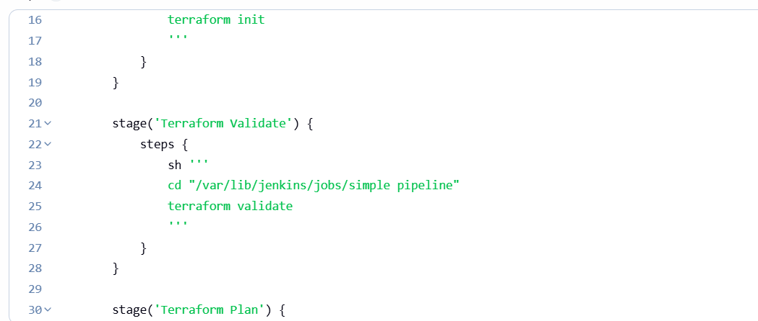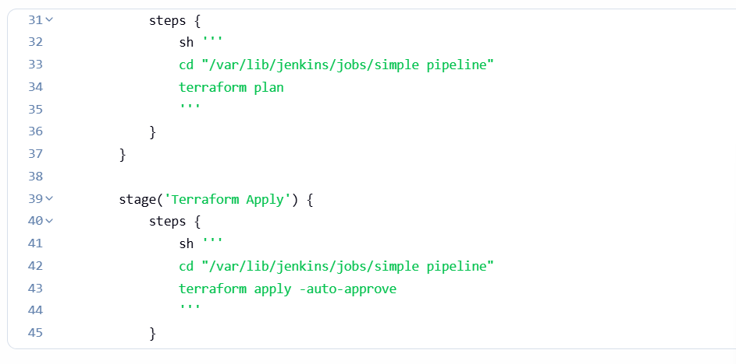
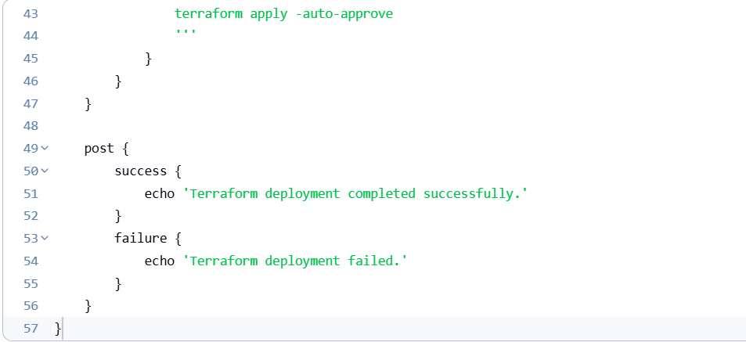

Successfully running pipeline.

