Terraform-03
2.Execute the script shown in the video.
Here we have created both main.tf and variable.tf files
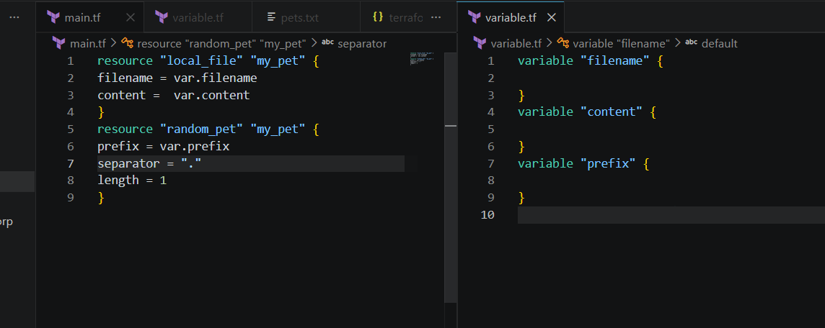
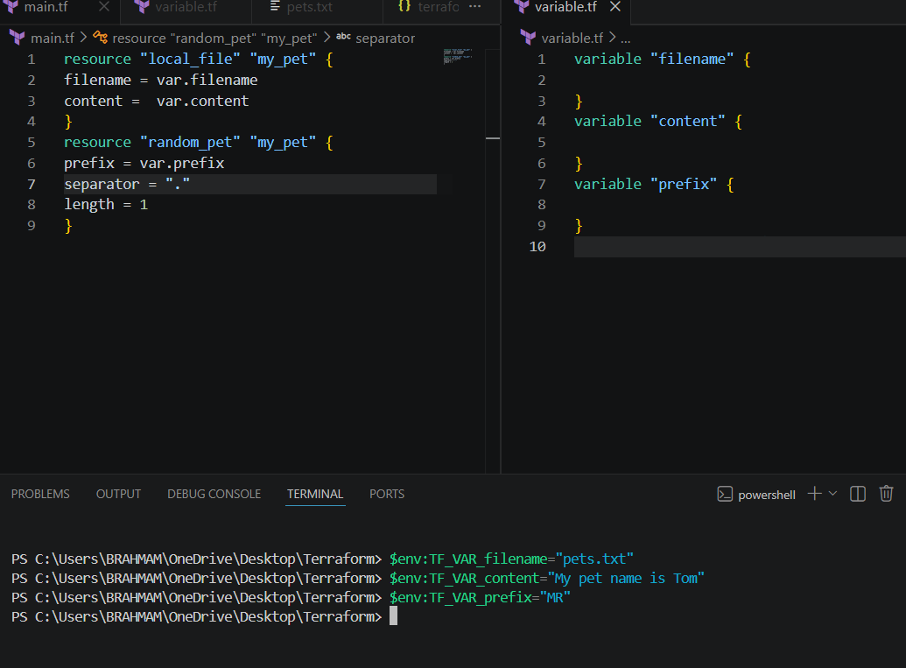
Nows lets apply terraform apply
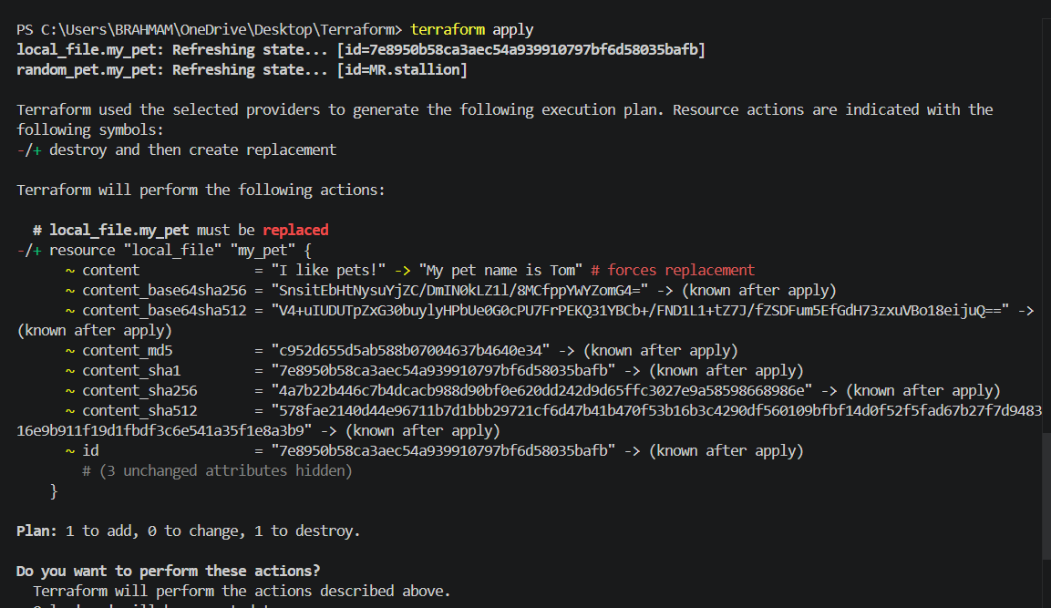
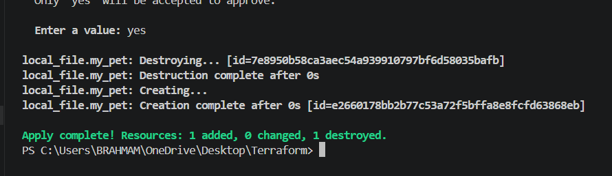
If we verify the file the content has been replaced
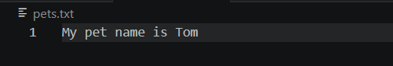
Resource dependency
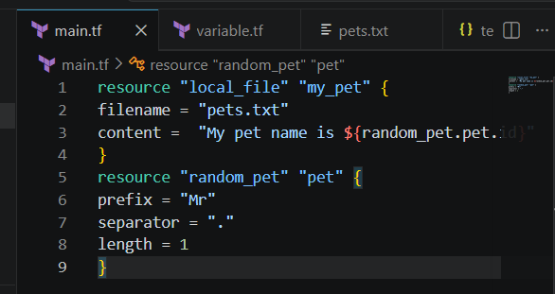
Lets perform terraform apply
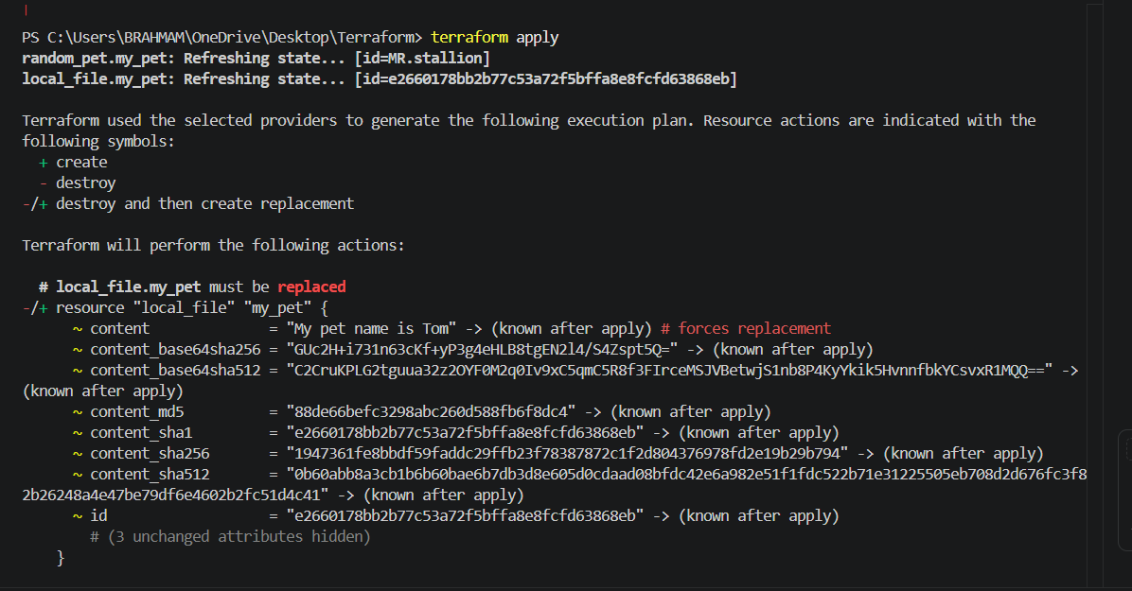
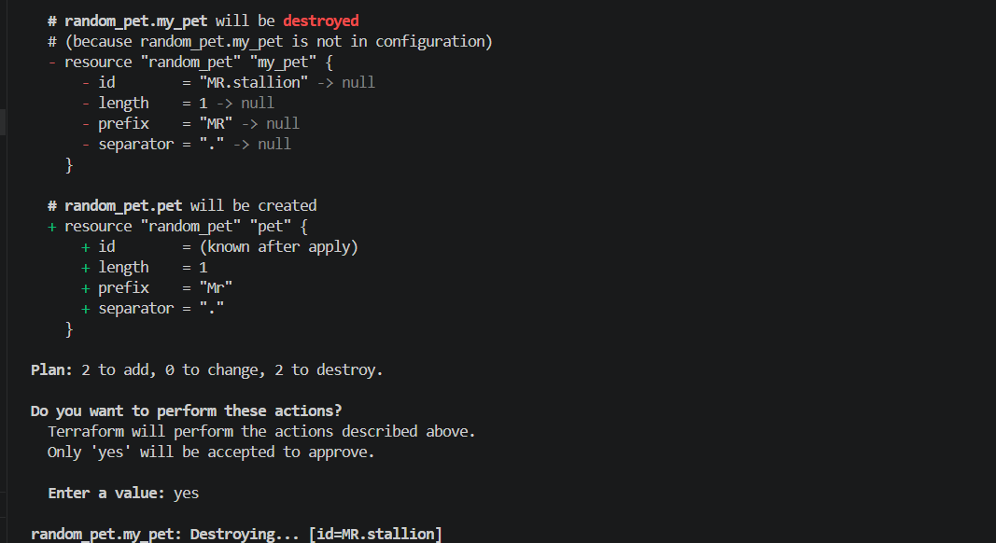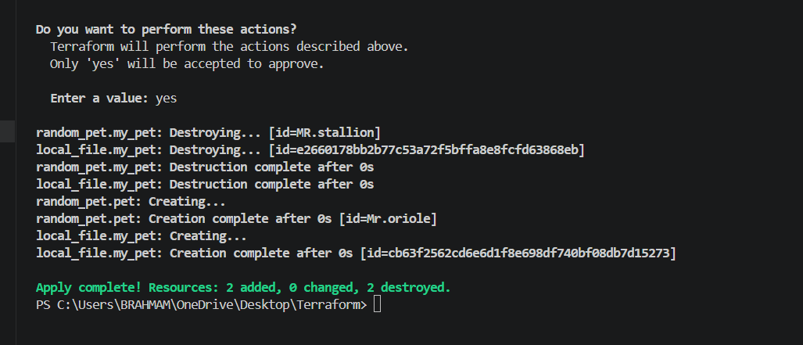
Here the random pet name is created
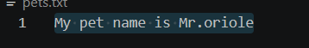
lets use output.tf file
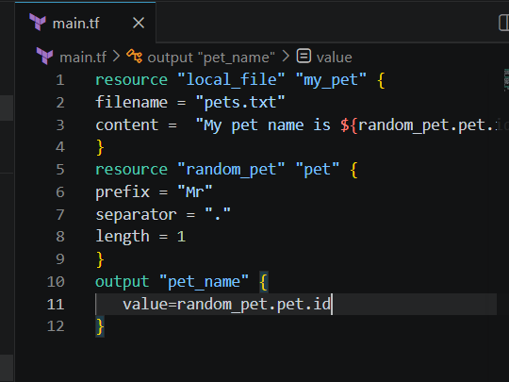
The output is displayed after performing terraform apply
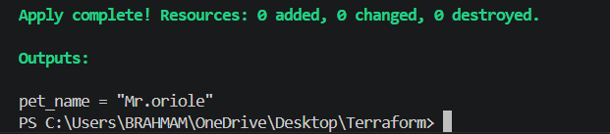
Also by giving terraform output command it will displays the output
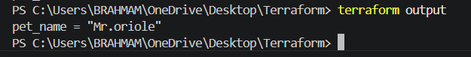
Statefile
By performing terraform show command it will show the statefile
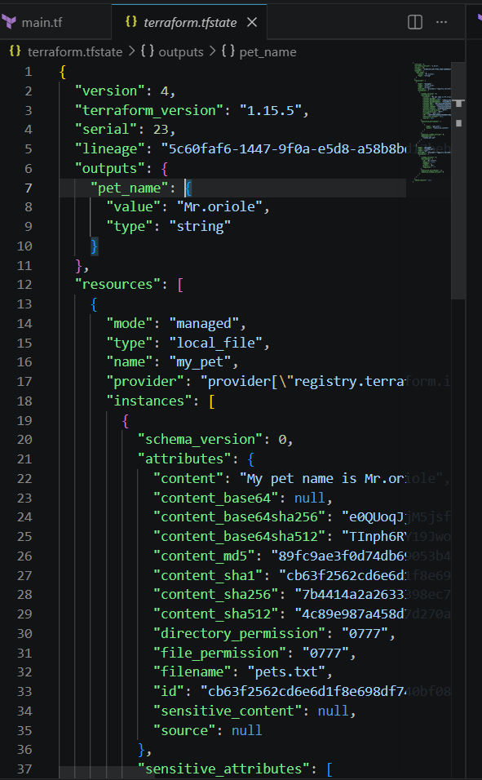
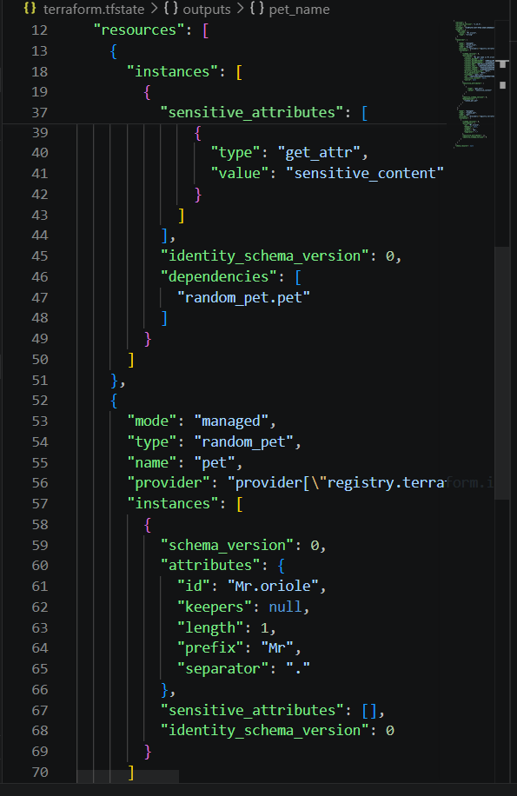
Check once terraform show
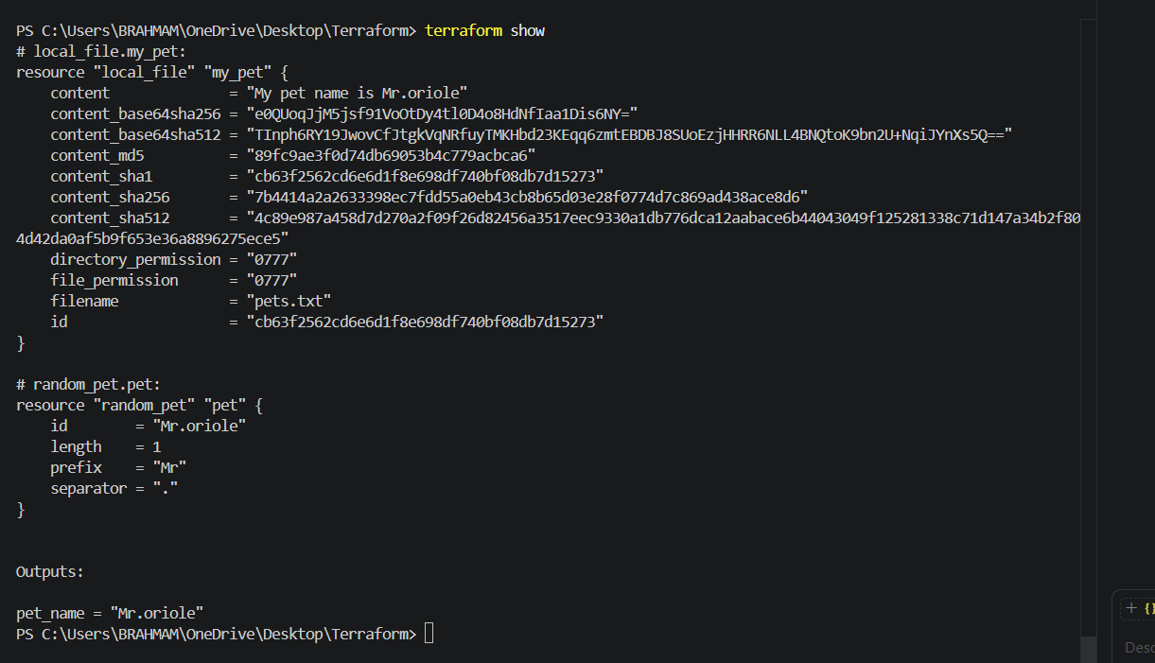
3. Integrate Terraform in Jenkins using the Terraform plugin.
Lets install terraform plugin in JenkinsI am already installed terraform pluginthen now I want to create main.tf file
Create anew itemTeraform
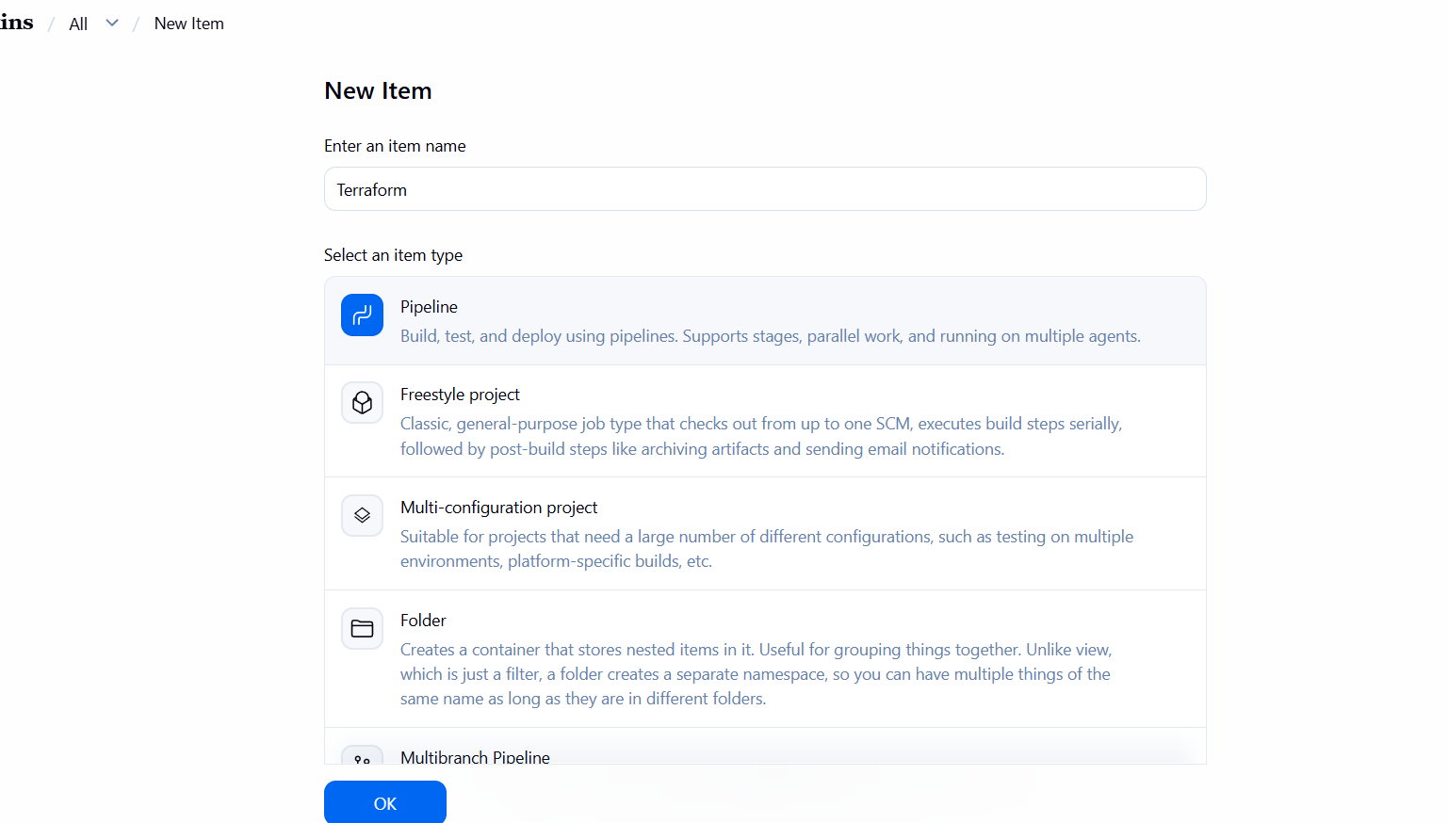
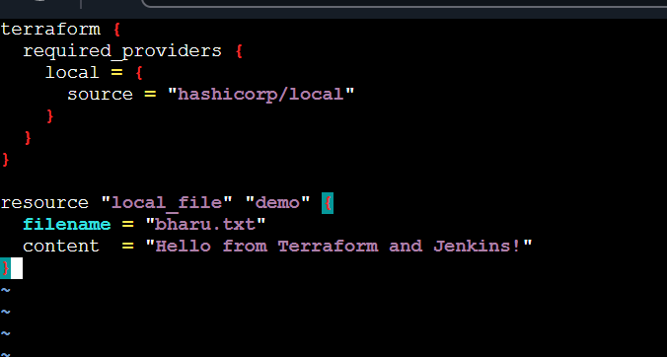
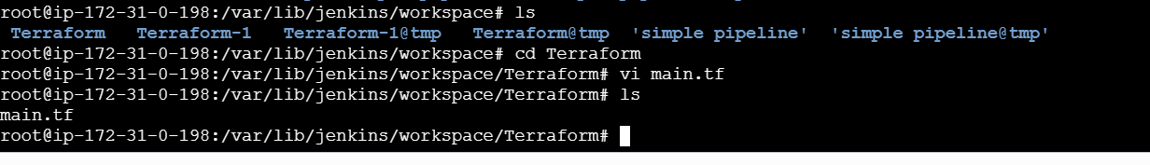
pipeline {
agent any
tools {
terraform 'Terraform'
}
stages {
stage('Terraform Init') {
steps {
sh 'terraform init'
}
}
stage('Terraform Plan') {
steps {
sh 'terraform plan'
}
}
stage('Terraform Apply') {
steps {
sh 'terraform apply -auto-approve'
}
}
}
}
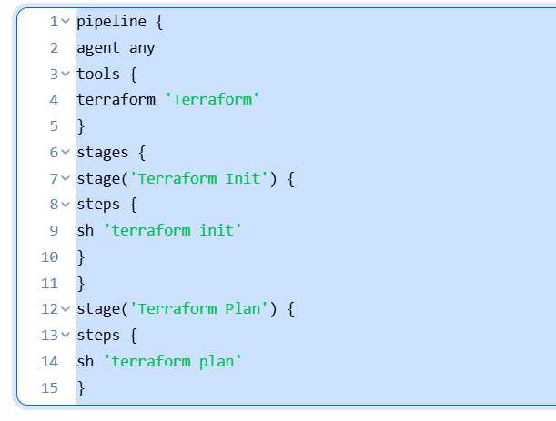
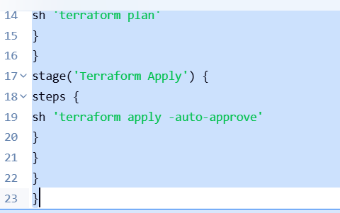
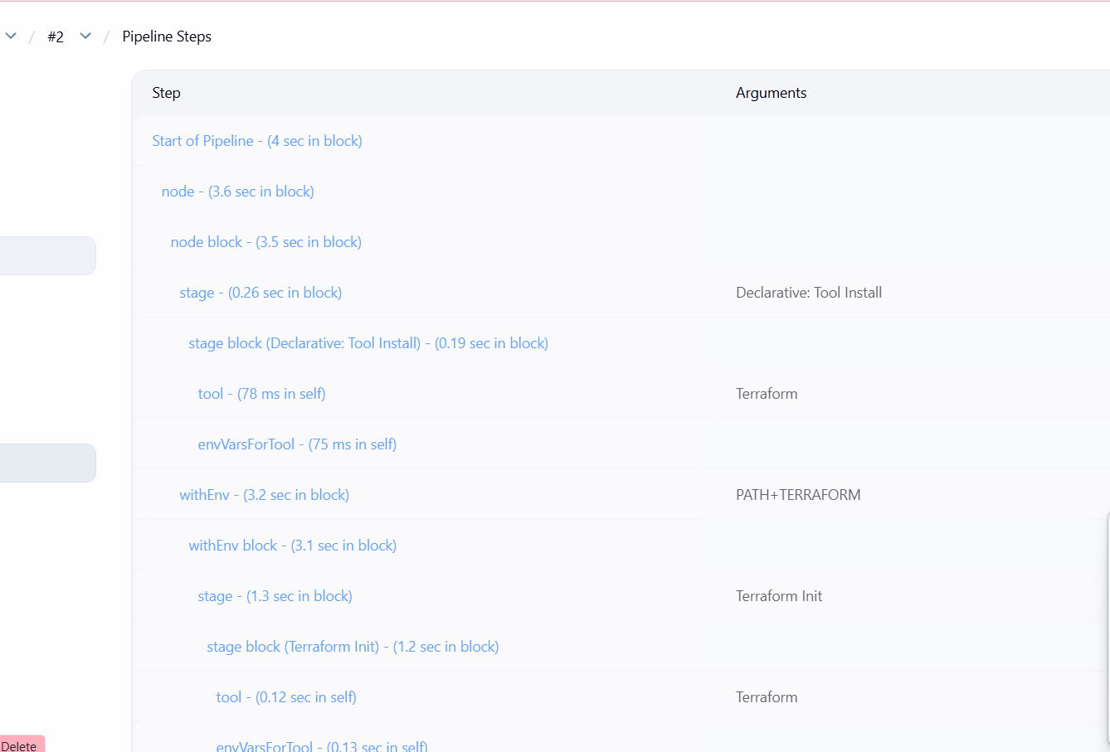
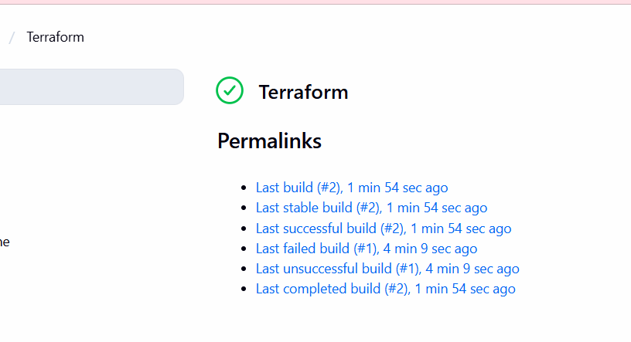
See now file was successfully building checked in gitbash
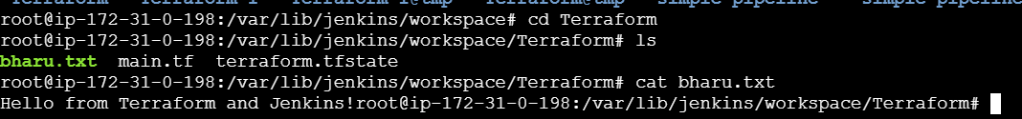

4.Create one Jenkins job using Maven Project for the code below with two stages:
Stage 1:Git clone
Stage 2:Maven CompilationCode:https://github.com/betawins/java-Working-app.git
Lets install maven integration first
Go to manage Jenkins pluginssearch for maven integration click on install
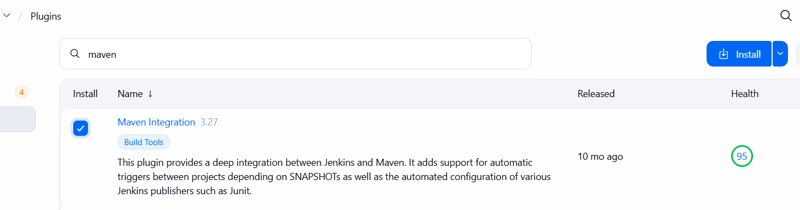
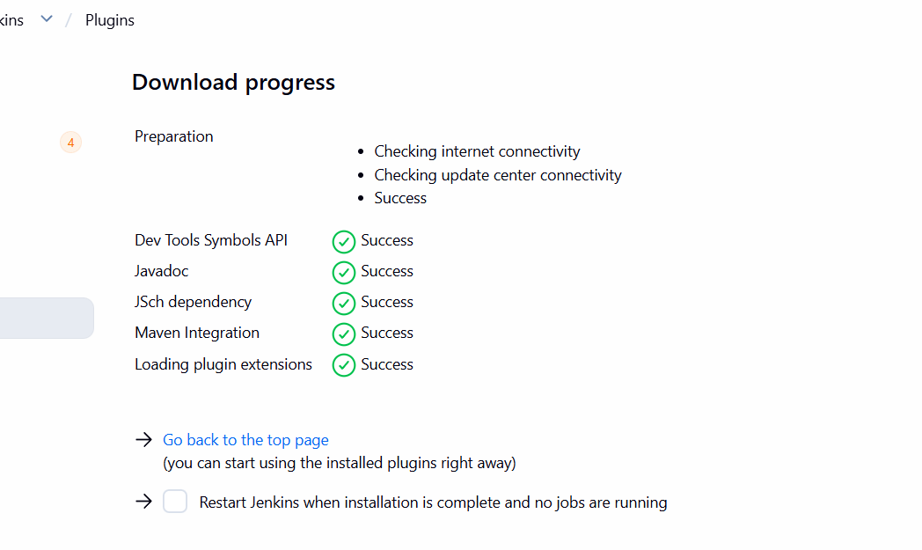
Go to manage Jenkins tools click on add maven give name save
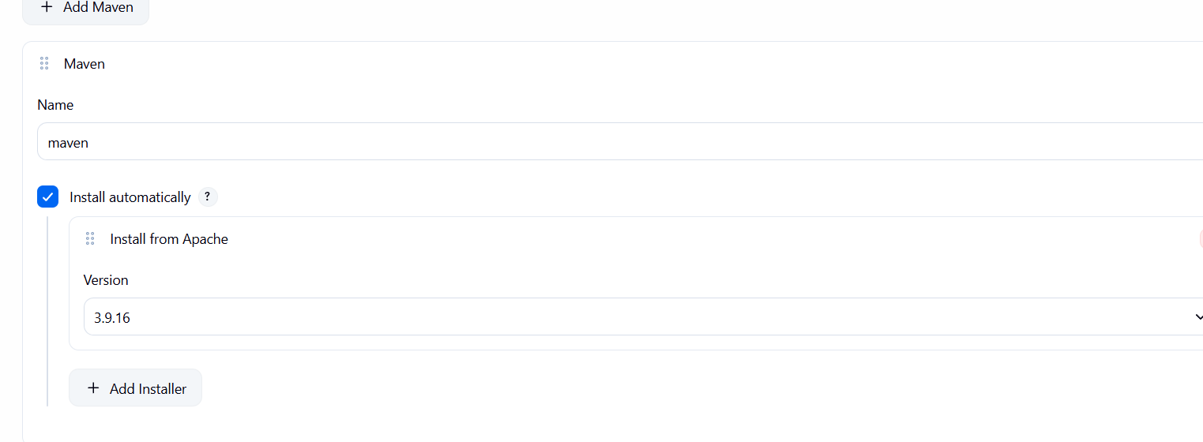
Now lets create a new job
Stage 1 :git clone
Now lets select source management as git and paste the repo url and save it. Then run the job
Create a new job
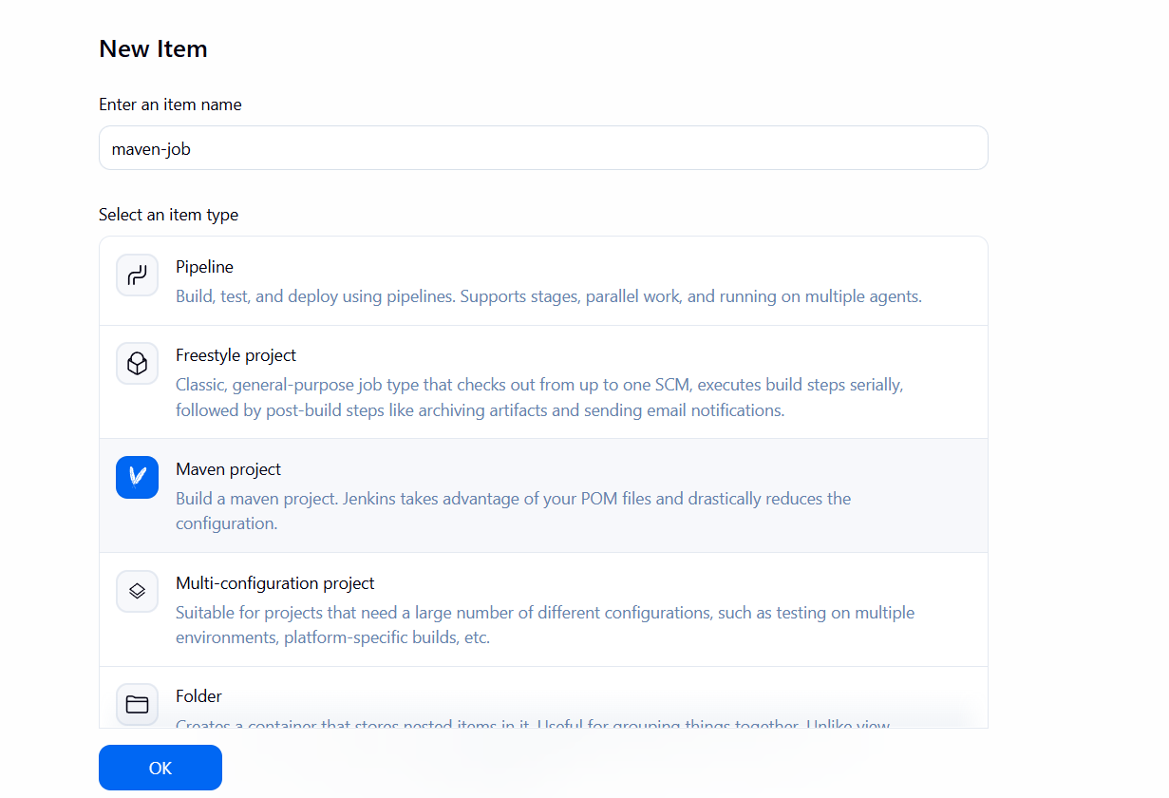
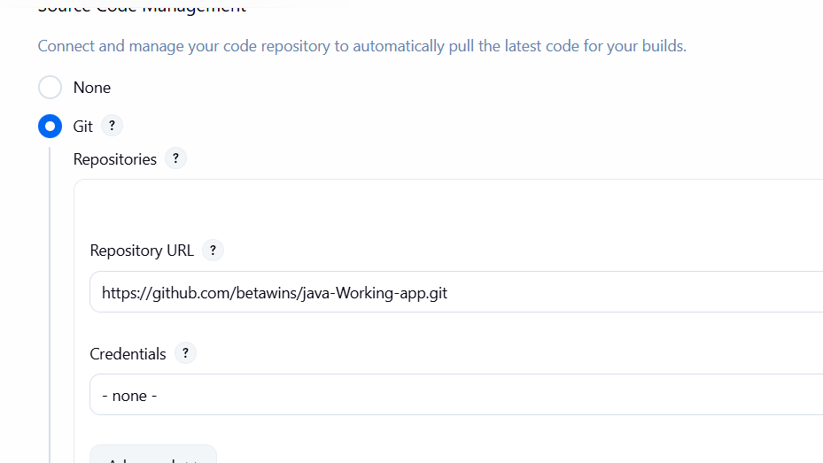
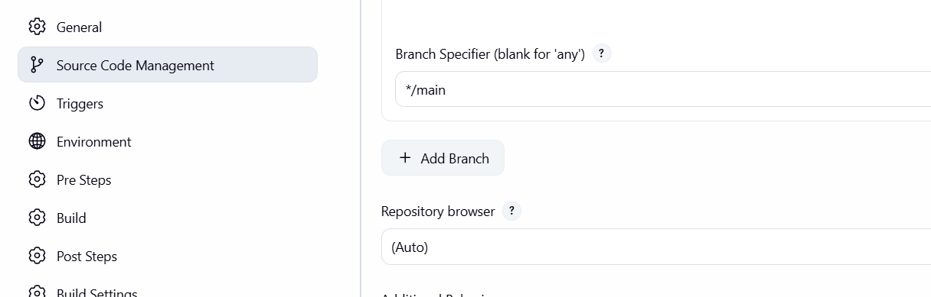

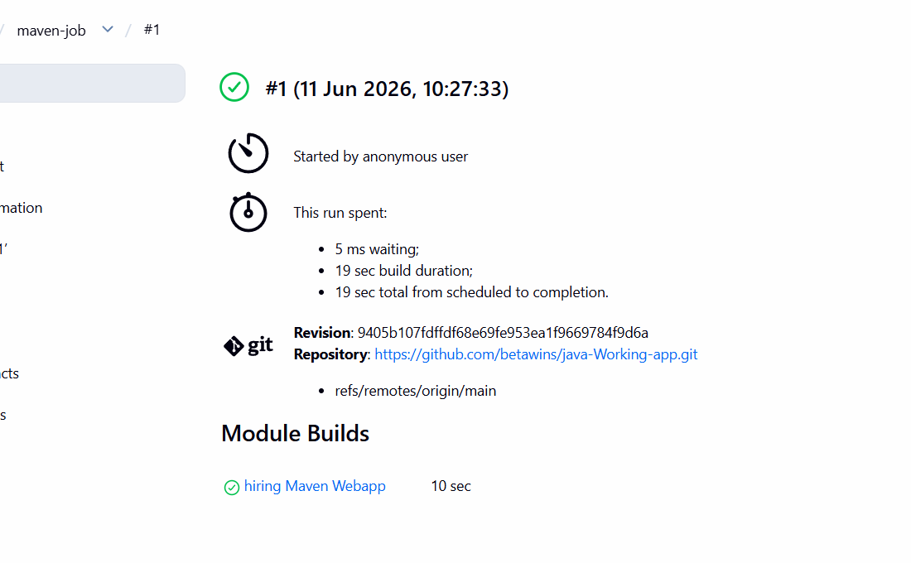
We can see that the Jenkins has successfully built the maven application and generated a war file.
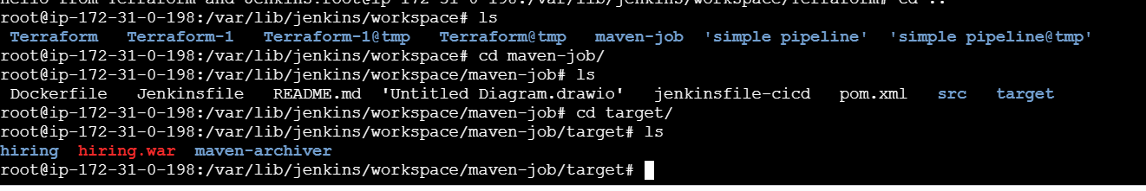

5.Use the same code and create a parameterized job in Jenkins with:
Stage 1:Git clone
Stage 2:Maven CompilationCode:https://github.com/betawins/java-Working-app.git
Lets create a new job
Go to Jenkins click on new item pipeline give name
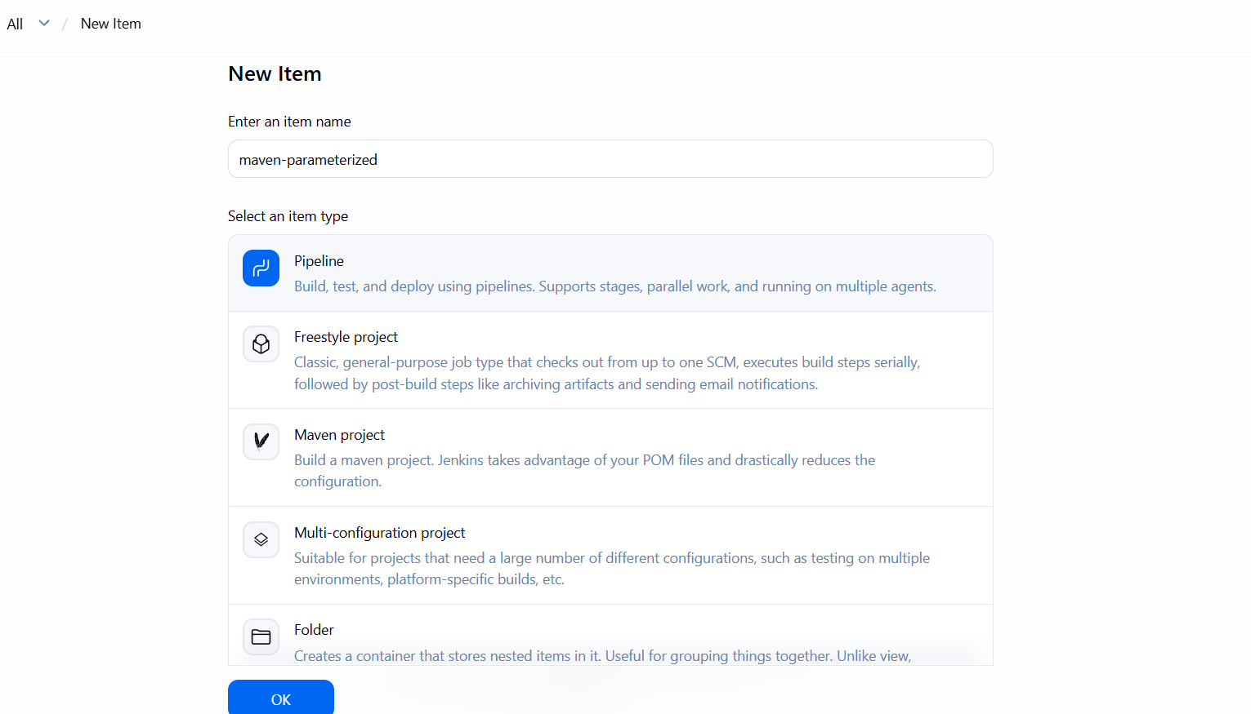
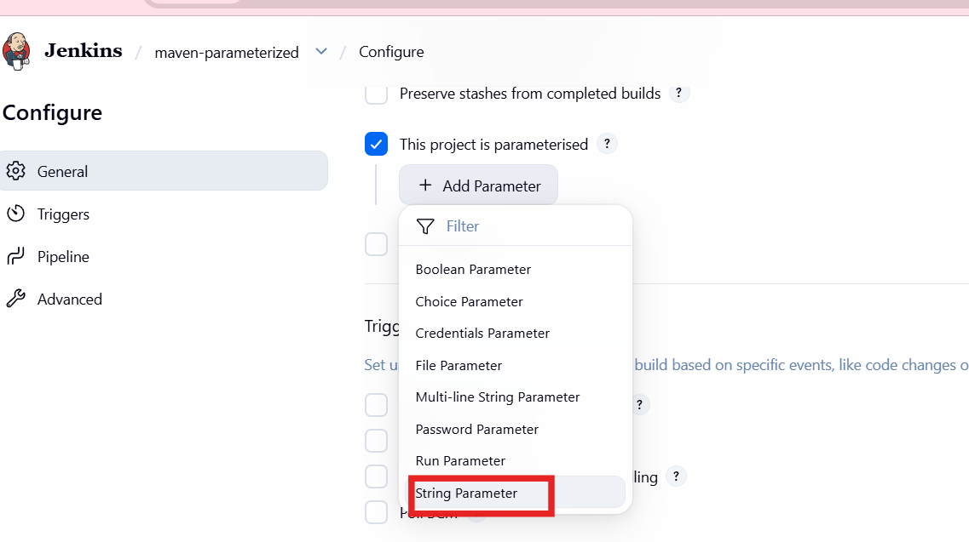
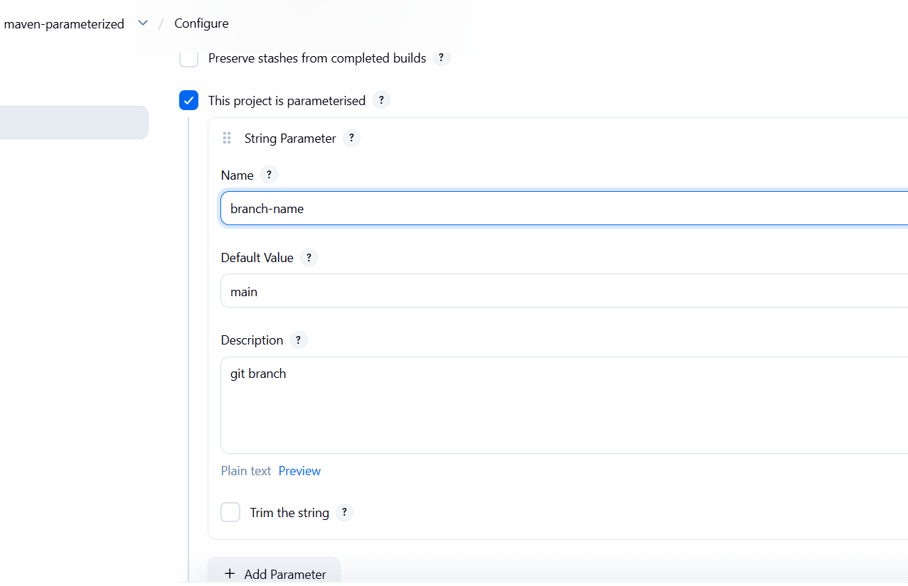
pipeline {
agent any
parameters {
string(
name: 'BRANCH_NAME',
defaultValue: 'main',
description: 'Git Branch Name'
)
}
tools {
maven 'maven'
}
stages {
stage('Git Clone') {
steps {
git branch: "${params.BRANCH_NAME}",
url: 'https://github.com/betawins/java-Working-app.git'
}
}
stage('Maven Compilation') {
steps {
sh 'mvn clean compile'
}
}
}
post {
success {
echo 'Build Successful'
}
failure {
echo 'Build Failed'
}
}
}
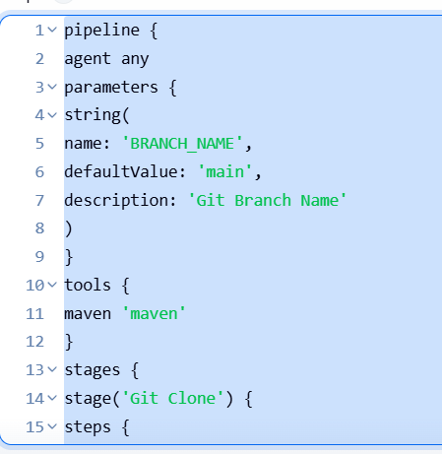
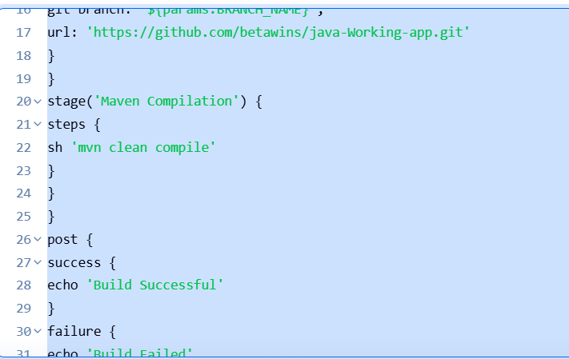

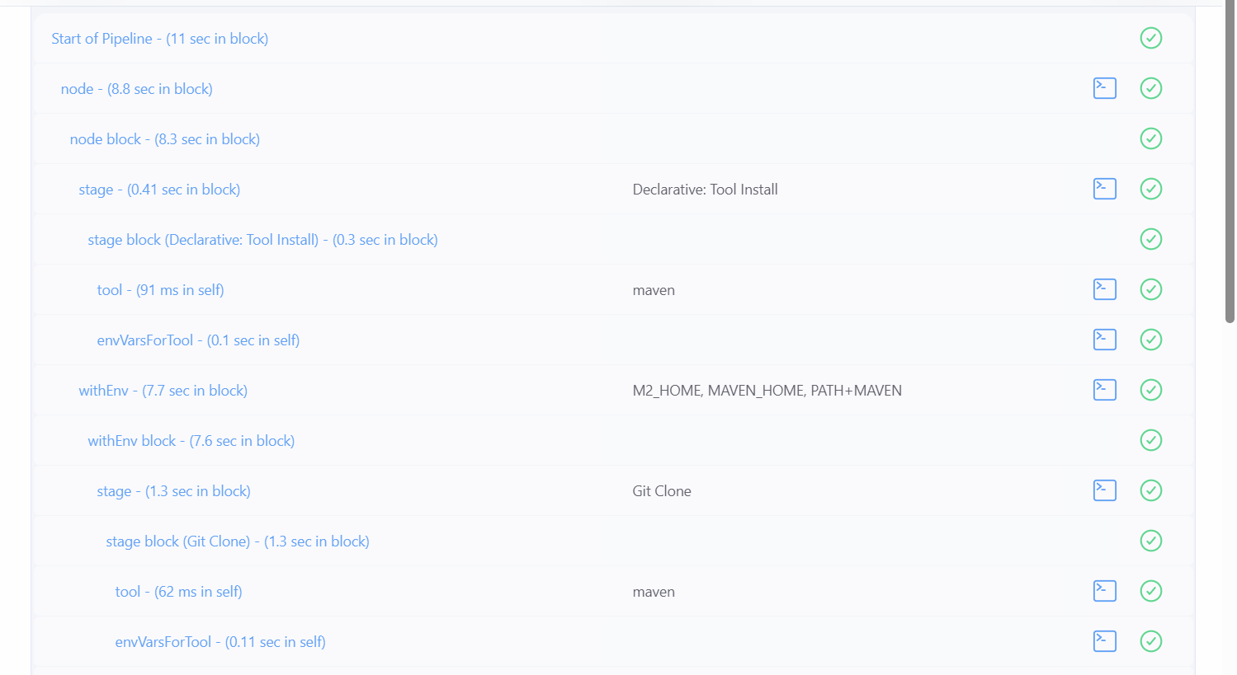
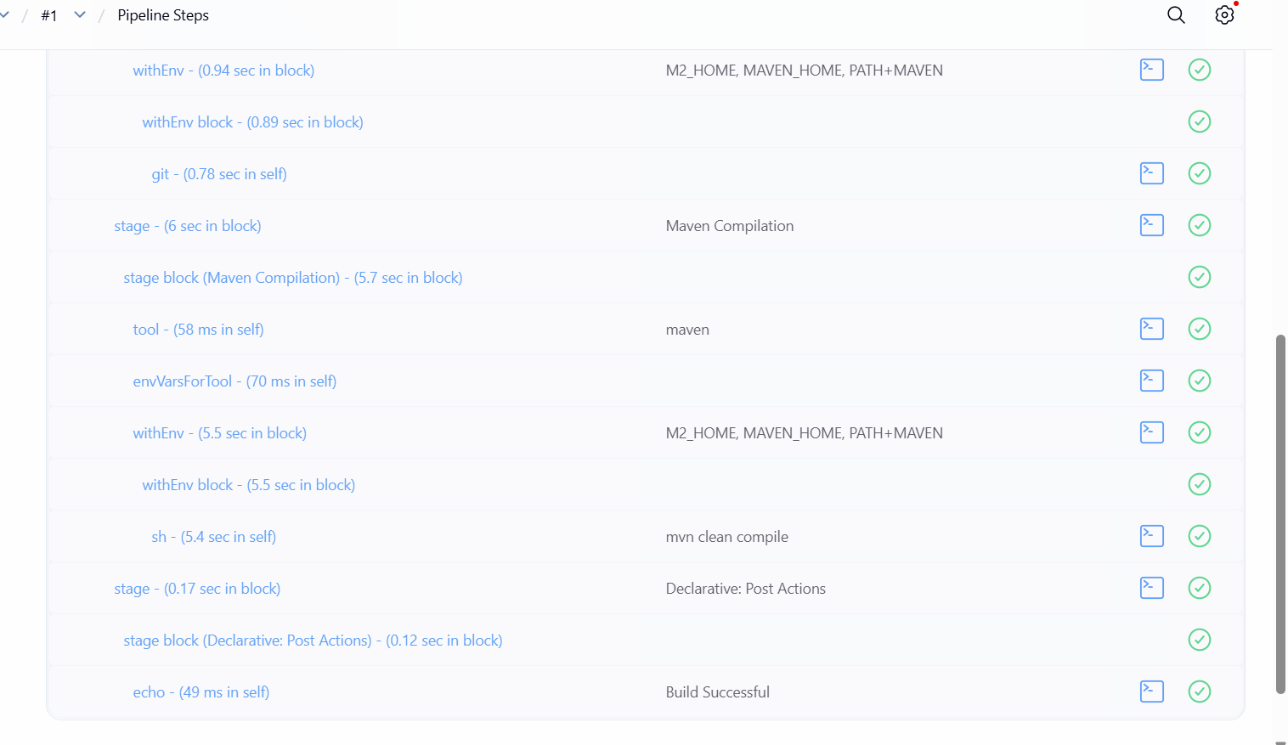
6. What are the global variables in Jenkins?
Global variables in Jenkins are predefined environment variables
accessible
across jobs and pipelines. They provide build-related information
such as
build number, workspace path, job name, Git branch, and Jenkins
home
directory.
Some commonly used global variables include
BUILD_NUMBER, which stores the current build number,
JOB_NAME, which contains the name of the Jenkins job, and
WORKSPACE, which defines the location where Jenkins clones the
source code
and executes builds.
Variables like GIT_COMMIT and GIT_BRANCH help identify the
exact Git
commit and branch used during the build process.
These global variables are useful in automation, scripting, and CI/CD
pipelines
to make Jenkins jobs more dynamic and reusable.

