K8s-02
1. Create a Simple Pod Using YAML Task: Write a YAML file to create a Pod named first
pod with a nginx container. Verify the Pod creation using kubectl get pods and
check the logs of the container using kubectl logs first pod.
• Now open master and create firstpod. Yaml
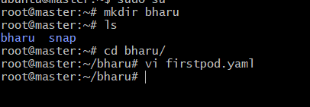
- Now write a script for firstpod
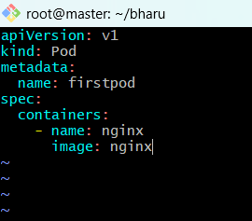
- Pod created and checked status running or not
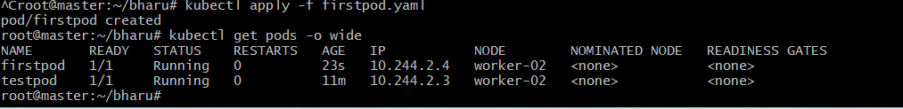
- Check logs firstpod and get pods -o wide
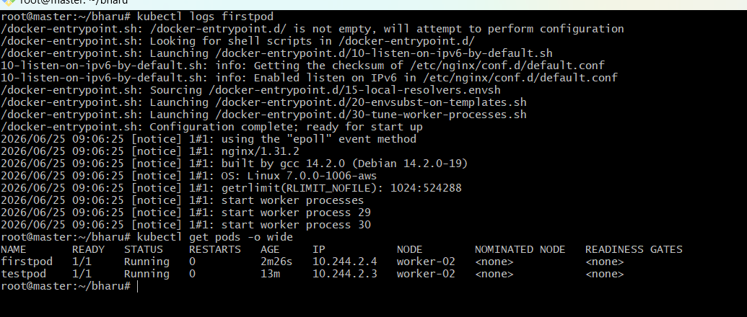
2. Set Environment Variables in a Pod Task: Modify the YAML file to include
environment variables myname: sabair and City: Hyderabad. Deploy the Pod and
use kubectl exec <pod_name> -- env to check if the environment variables are set
properly.
- Create Environmental variables file
- Now write a script for environmental variables
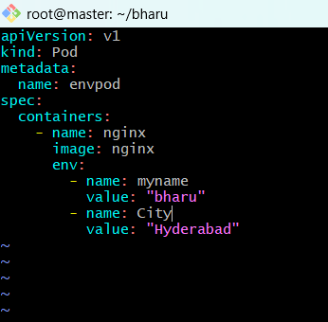
Apply environmental pod and verify pods
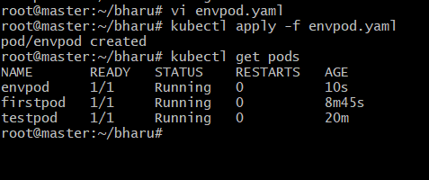
Verify environmental variables
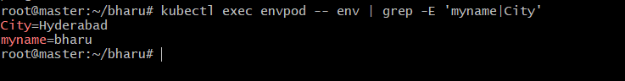
3. Deploy a Pod with Commands (Args) in YAML Task: Modify the YAML file to add args
that instruct the container to sleep for 50 seconds. Deploy the Pod and use kubectl
describe pod to verify the args are correctly passed to the container.
• Create Args file and write a script
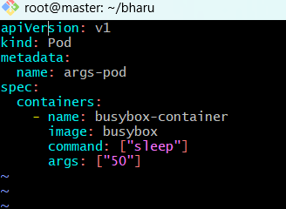
File created and verify pods
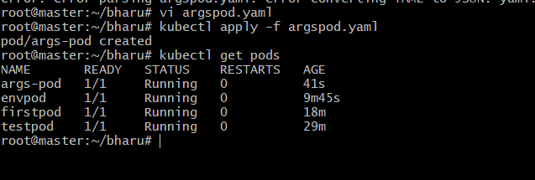
Verify argspod
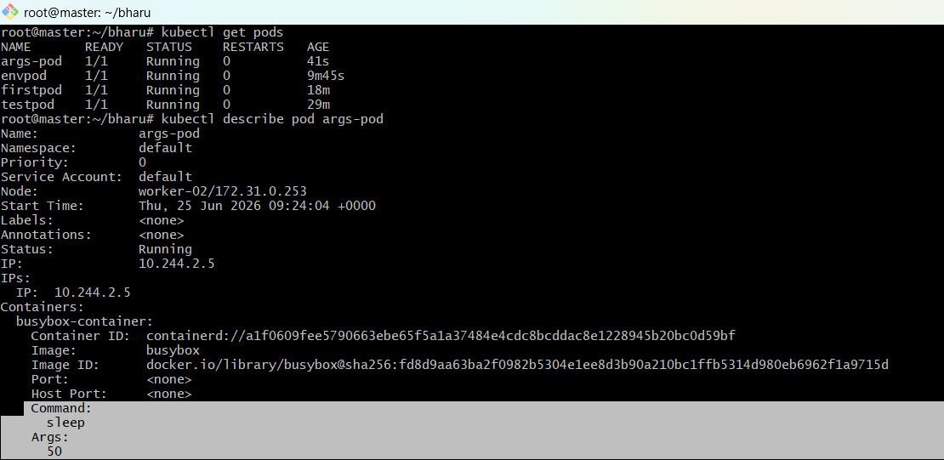4. Create a Pod with Two Containers Task: Create a YAML file to define a Pod with two
nginx containers inside. Use kubectl exec to access both containers and verify that
both containers can communicate through the same network (e.g., using telnet
between them).
Create multi containers file and write script
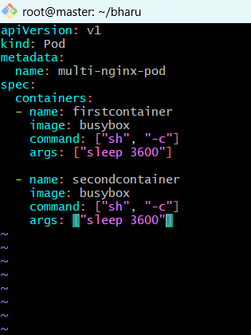
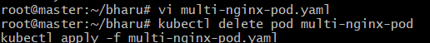
Apply multi container and get pods
two-nginx-pod 1/2 Error
👉 This means:
- 1 container is running
- 1 container is crashing (or failing to start)
So your multi-container Pod is NOT healthy yet.
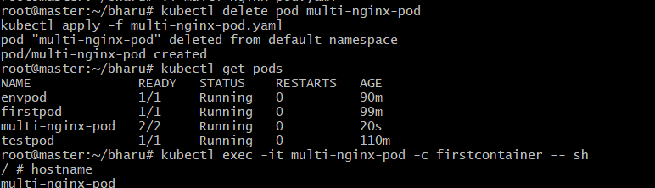
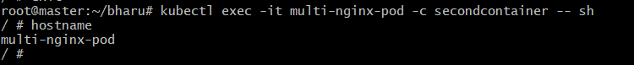
5.Set Up an Init Container in a Pod Task: Modify the YAML to include an init container
that sleeps for 30 seconds before the main containers start. Verify the init
container's execution using kubectl describe pod and check the logs to confirm its
completion.
Goal of this task
You need to:
- Add an Init Container
- Make it sleep for 30 seconds
- Ensure main containers start only after init finishes
- Verify using:
  - kubectl describe pod
  - logs
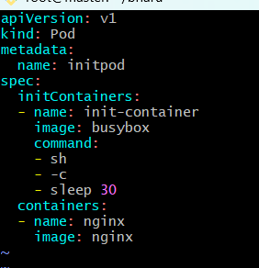

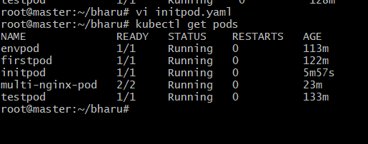
This proves the init container ran first, slept for 30 seconds, completed
successfully, and only then the nginx container started.
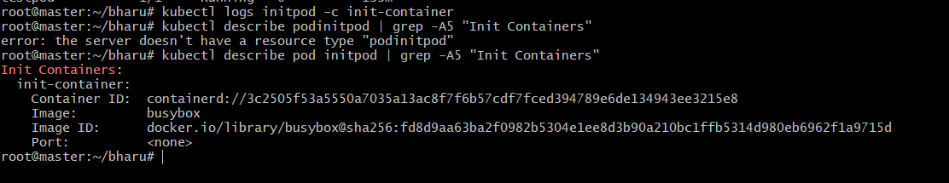
6. Run a Dry Run Command to Generate YAML Task: Use the kubectl run nginx --
image=nginx --dry-run=client -o yaml command to generate a Pod YAML definition.
Modify the generated YAML to suit specific requirements (e.g., labels or
environment variables) and deploy it.
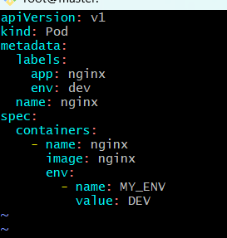
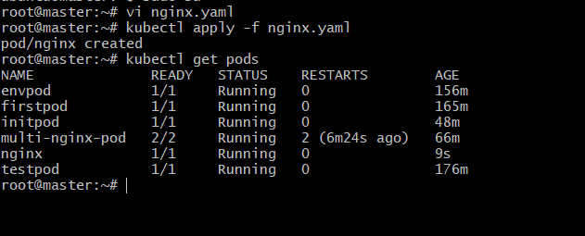
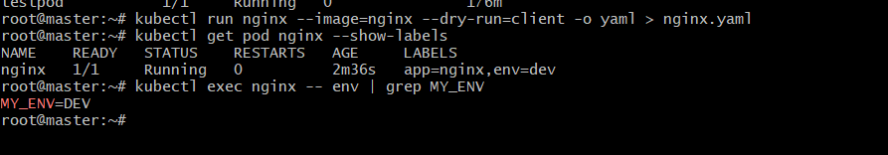
7. Use kubectl apply vs kubectl create Task: Create a YAML file to define a Pod. First,
deploy it using kubectl create -f <file_name>.yml and then modify the YAML (e.g.,
change the image version). Use kubectl apply to redeploy and verify the difference
between both commands.
• Create a new file write a script
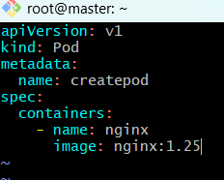
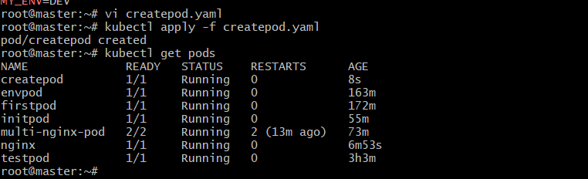
Now modify YAML and change image nginx :1.25 to nginx: latest and save it
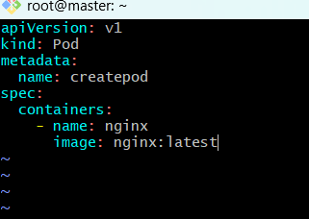
Now Apply Changes we get an error so correct way to do delete old recreate
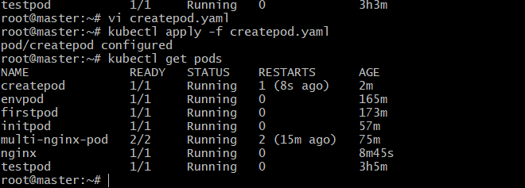
Verify image
8. Edit an Existing Pod Configuration Task: Use kubectl edit pod <pod_name> to
modify the running Pod's environment variables or image. After making the
changes, verify if they took effect by checking the container logs or environment
variables using kubectl exec.
• Open exist pod envpod
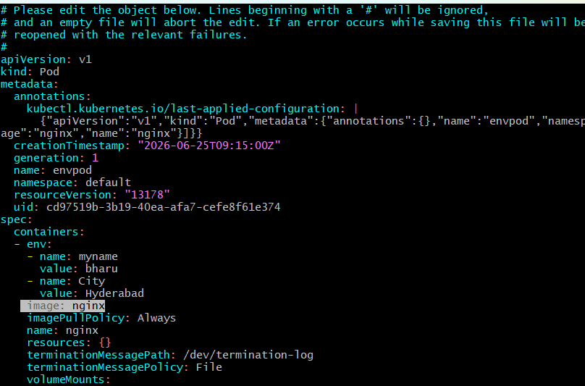
Open and search image: nginx
• Edit image nginx to nginx: latest and save
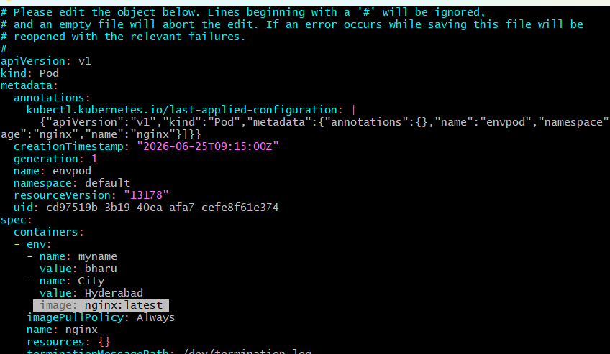
It throws an error not saved
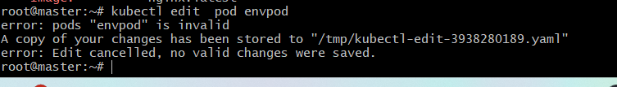
Check image and current env variables
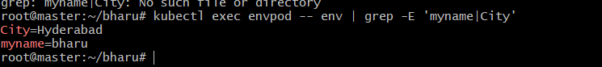

9. Expose a Pod Using a Service Task: Create a YAML file to expose your first pod using
a Service (ClusterIP). Ensure that your service is exposing the Pod on port 80 and
verify it using kubectl get svc.
• Check if firstpod has a label
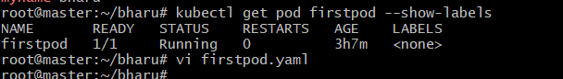
Update firstpod.yaml
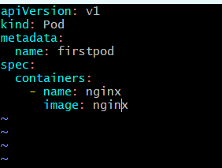
Delete and create pod firstpod
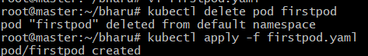
Create the Service YAMLApply the Service
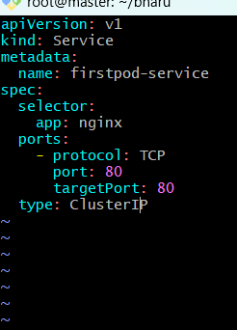
Verify the Service and Endpoints
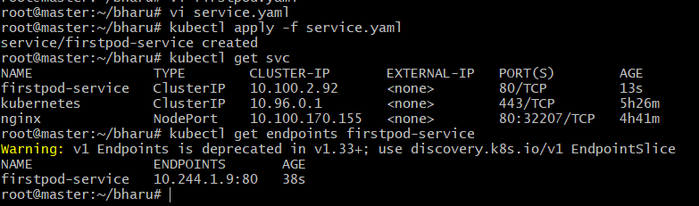
matches every Pod with the label app=nginx check labels
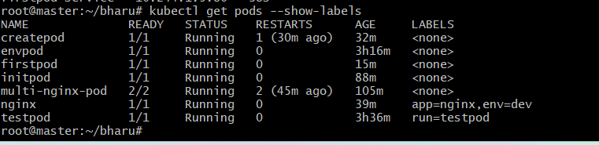
10. Pod with Resource Limits and Requests Task: Add resource requests and limits to
the containers in your YAML file. Specify CPU and memory requests/limits for both
containers and deploy the Pod. Use kubectl describe pod to verify if the resource
configurations are correctly applied
• Create a Pod with Resource file
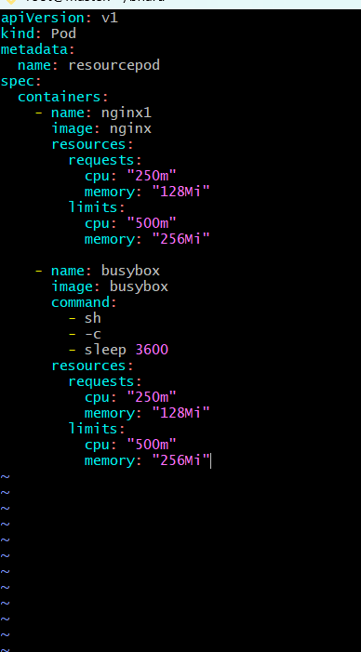
Apply it and check verify pods status
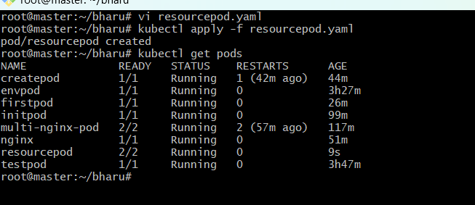
• Check resource configuration
