K8s-03
- Create a ClusterIP service for an Apache web server pod.
• Create Apache pod file
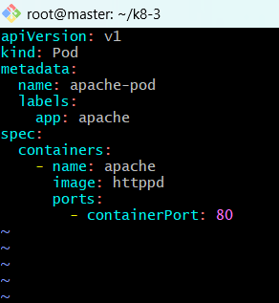
Create pod and check pods status
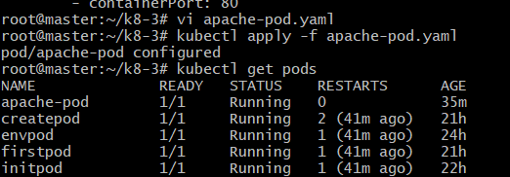
Create apache-service. Yaml
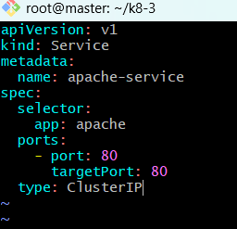
Apply the Service
• Verify Service and Test the Service

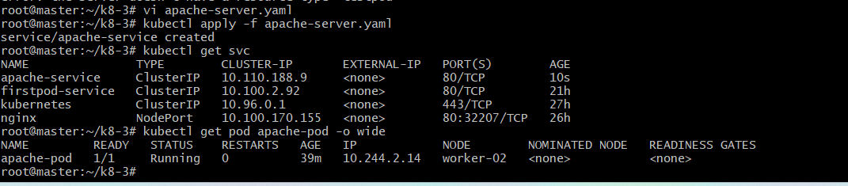
Check endpoints
2. Expose a Nginx pod externally using a NodePort service.
• Create a nginx-nodeport file
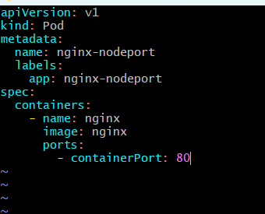
Applysee pods
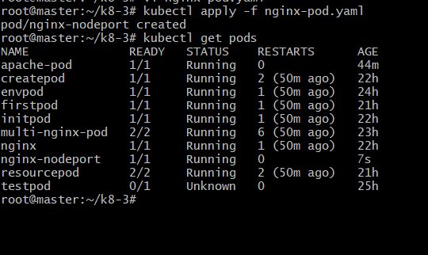
Create nginx-nodeport-service. yaml
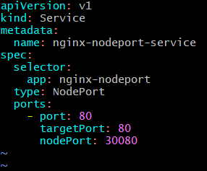
Applyverify svc
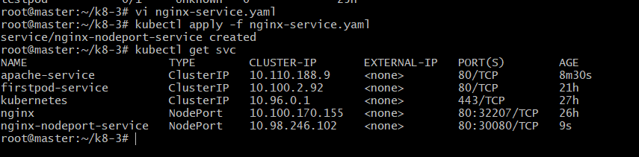
Open in browser with master public Ip and port no 30080
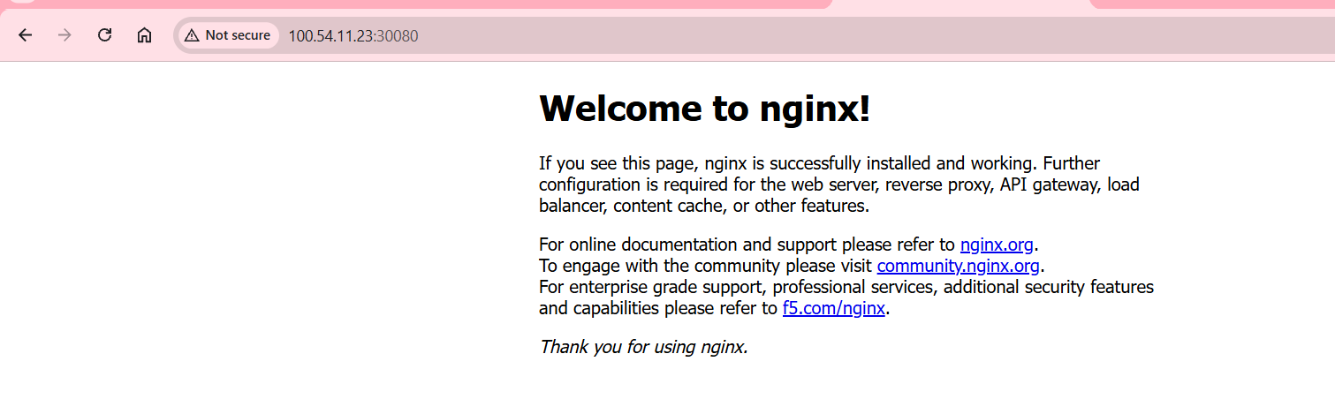
3. Deploy a Replication Controller to maintain 3 replicas of a Nginx pod.
• Create nginx-rc.yaml
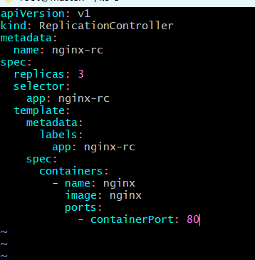
Applyverify the rc
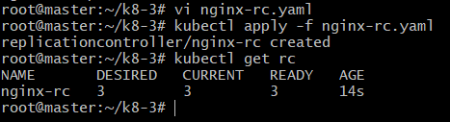
• Verify the Pods
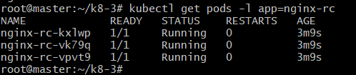
When I tried delete one pod it after that it automatically creates new
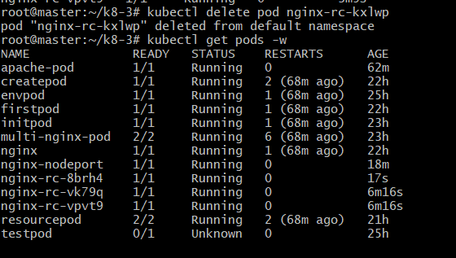
4. Scale the Replication Controller from 3 replicas to 5 replicas
Open RC file and change replica 3 to 5 and applied
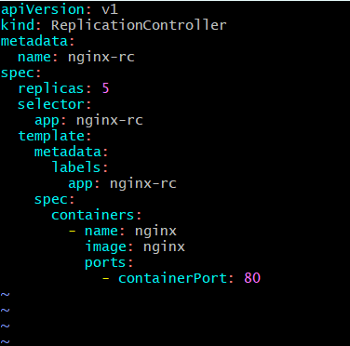
Now apply and verify the pod
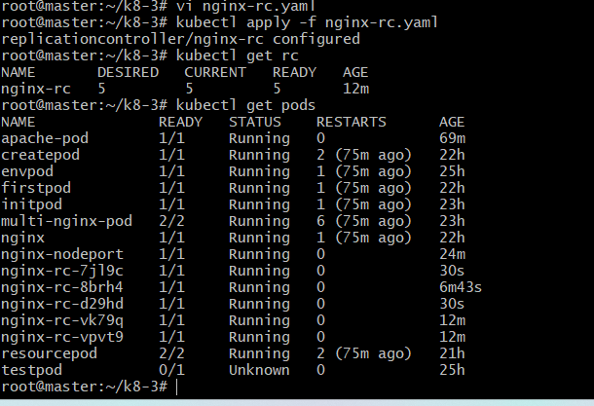
5. Create a ReplicaSet to manage pods based on multiple labels (prod and test).
• Create multilabel-rs. Yaml
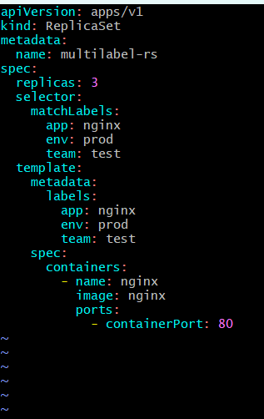
Apply and get rs
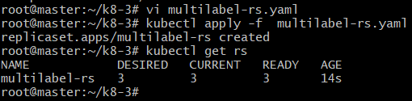
Verify Pods and labels
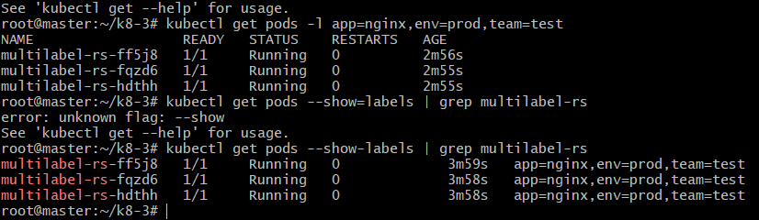6. Deploy a ReplicaSet that excludes pods with the label backend.
• Create exclude-backend-rs. yaml
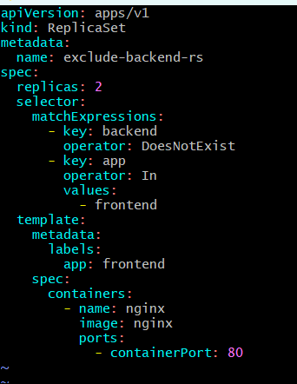
Appl and Verify ReplicaSet
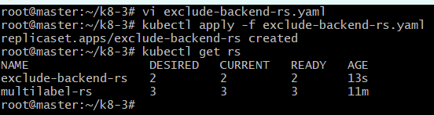’
Verify pods and labels
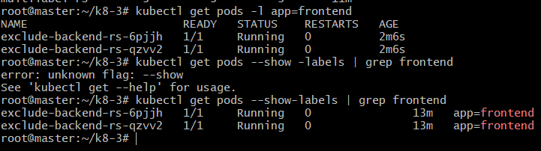
7. Test load balancing across multiple pods using a NodePort service.
• Create rc-nodeport-service. Yaml
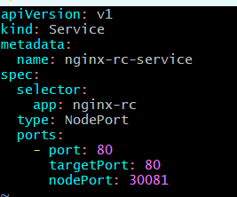
Apply—verify and see endpoints
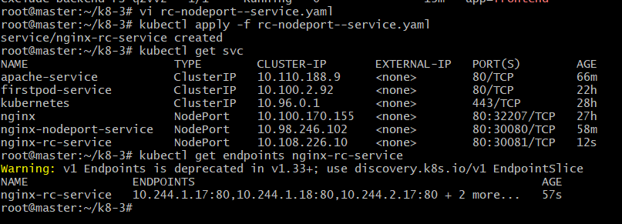
Verify web browser• Open browser check with master IP and port no 30081
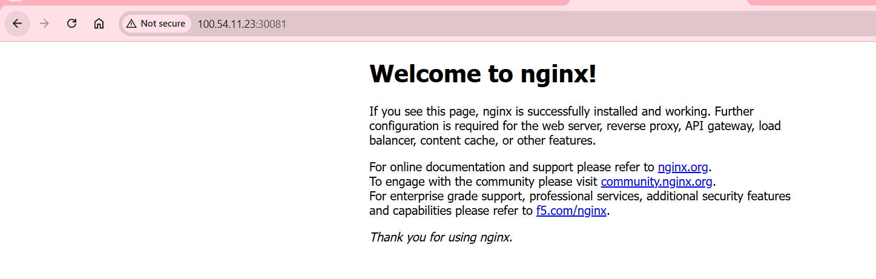
8. Delete a Replication Controller without affecting the running pods.
• Delete RC (Replication Controller deleted)
Now verify RC (Replication Controller no longer exists)
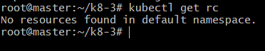
Now verify pods are running or not (Pods are still running)
