DOCKER-01
- Setup a virtual machine using Ubuntu image.
First lets launch new instance Select AMI as ubuntu Choose instance type and key pair
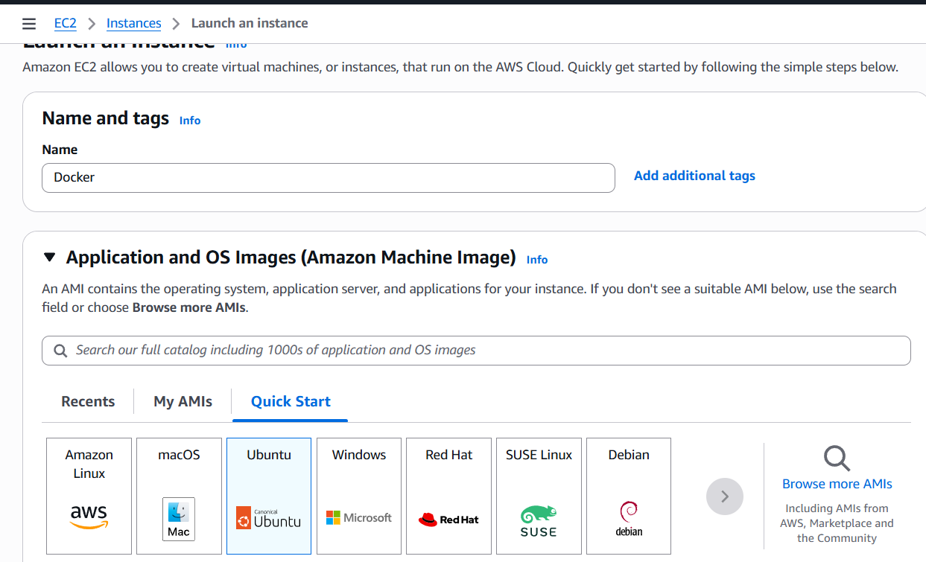
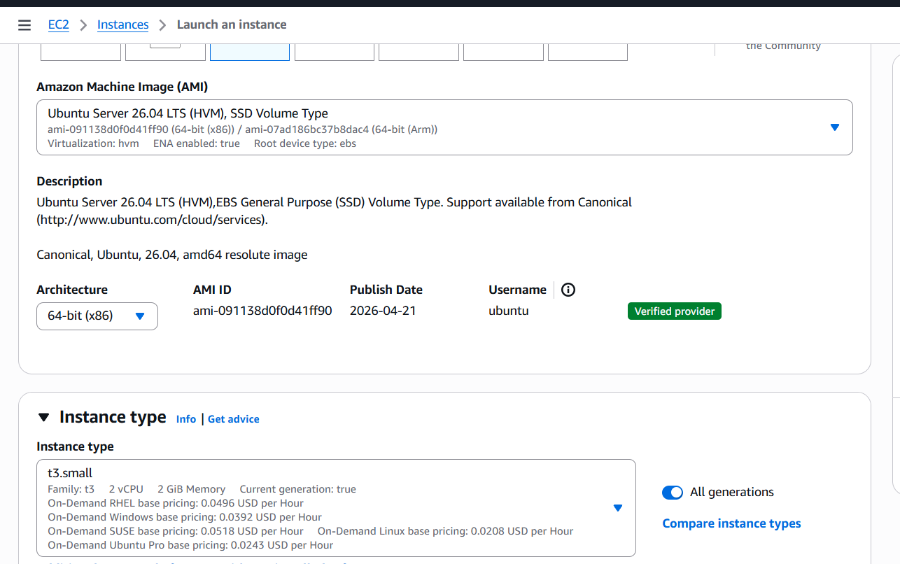
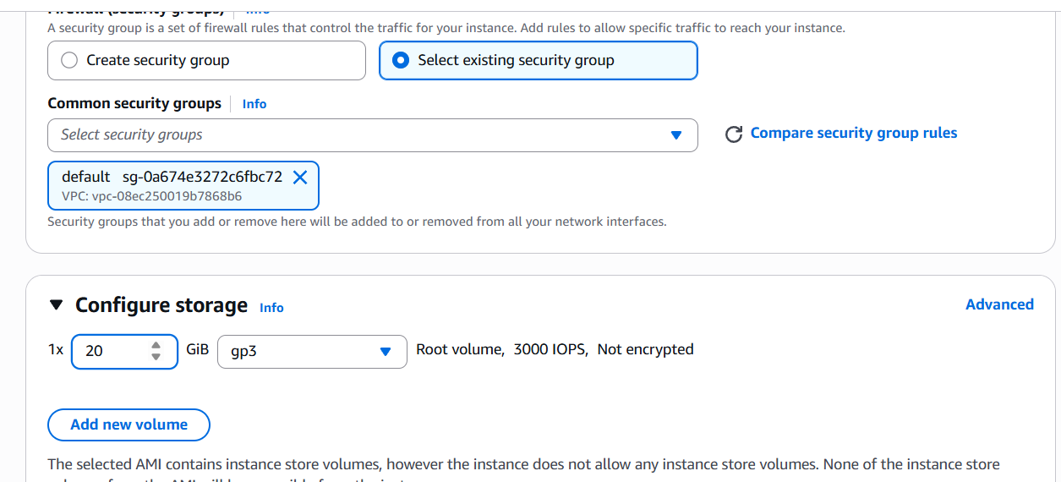
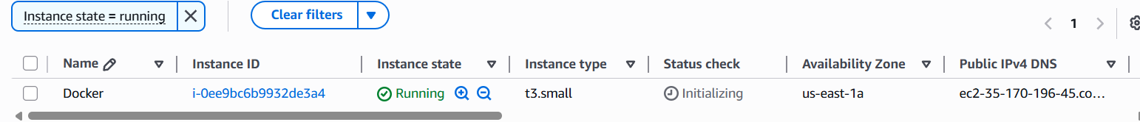
- Install docker on ec2.
Lets Login to our ec2 instance
Instance Connect ec2 connect
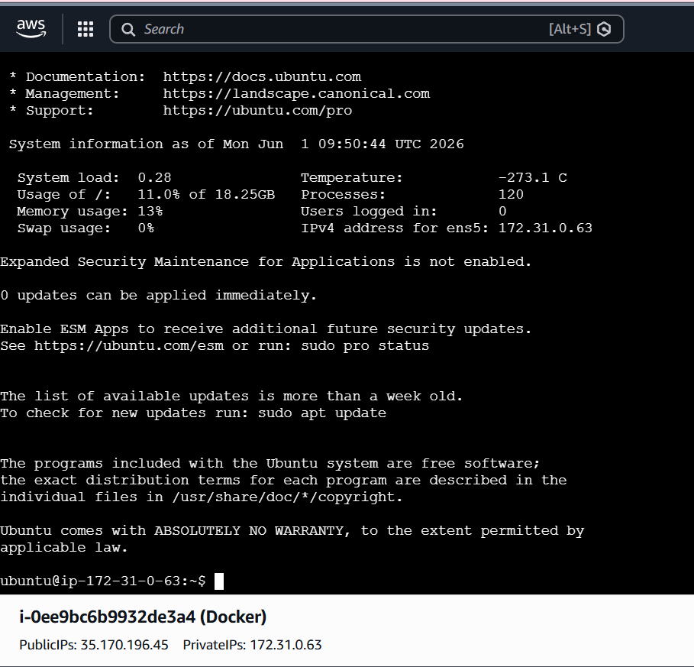
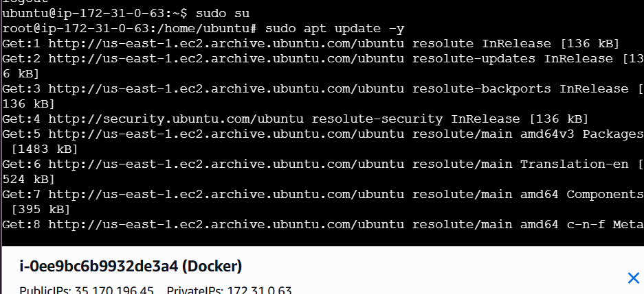
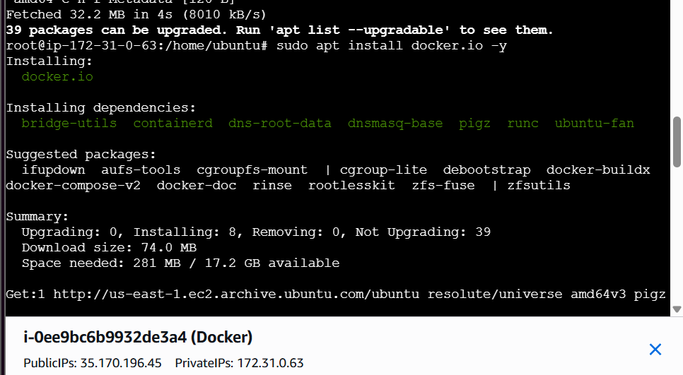
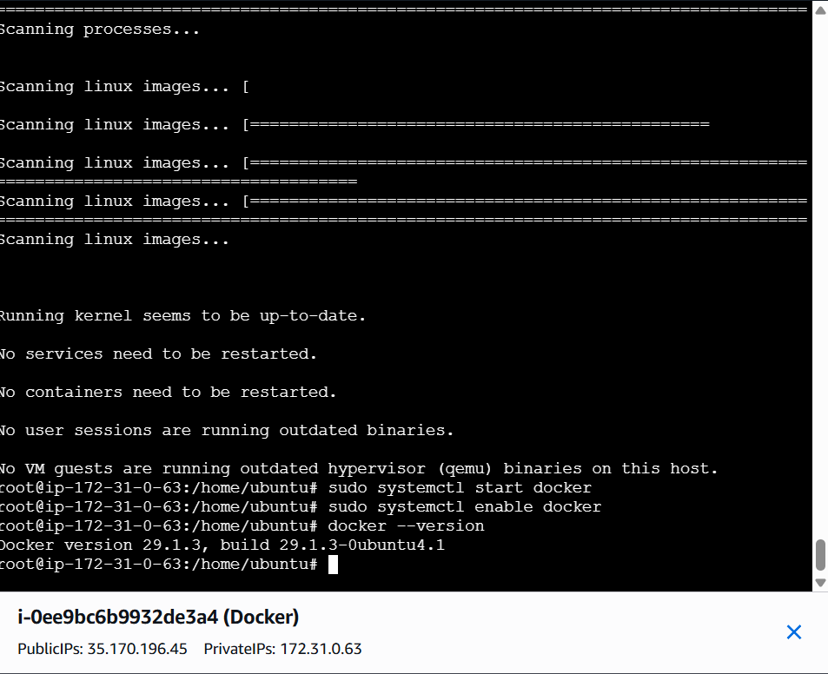
- Pull 5 docker images. (nginx, Apache tomcat, ubuntu, Jenkins, SonarQube)
To pull docker images
For nginx – docker pull nginx
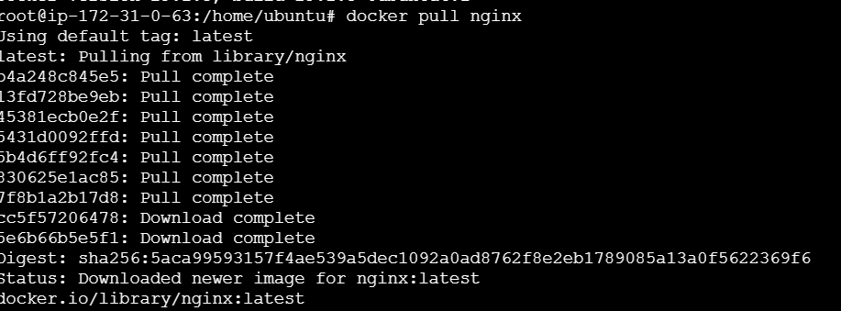
- For tomcat- docker pull tomcat
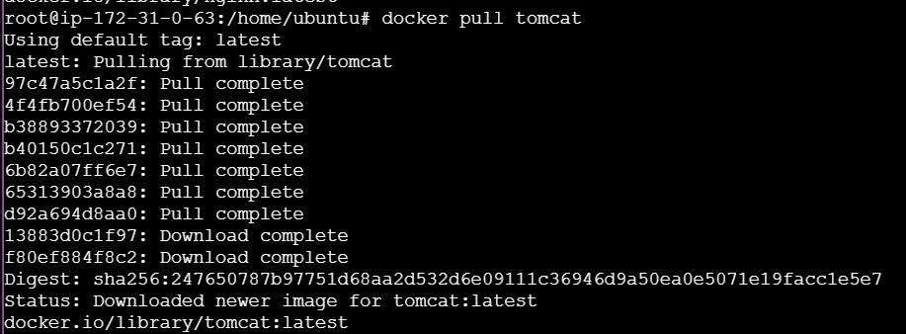
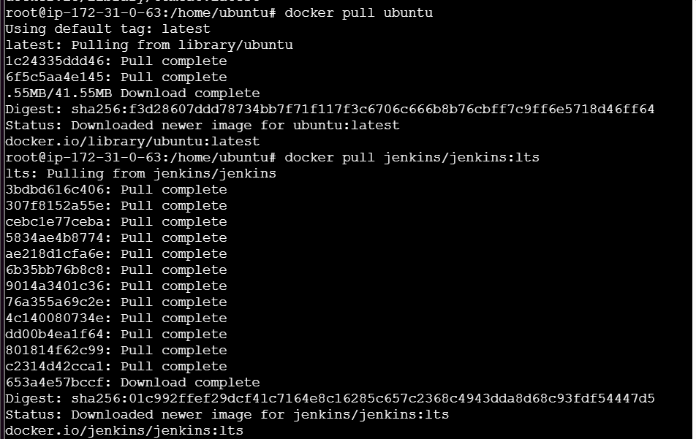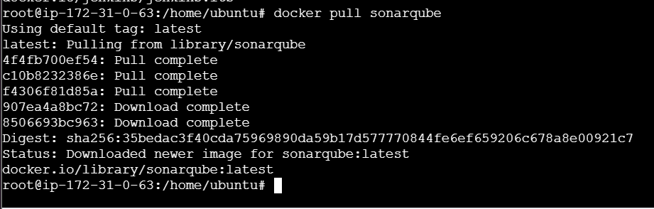
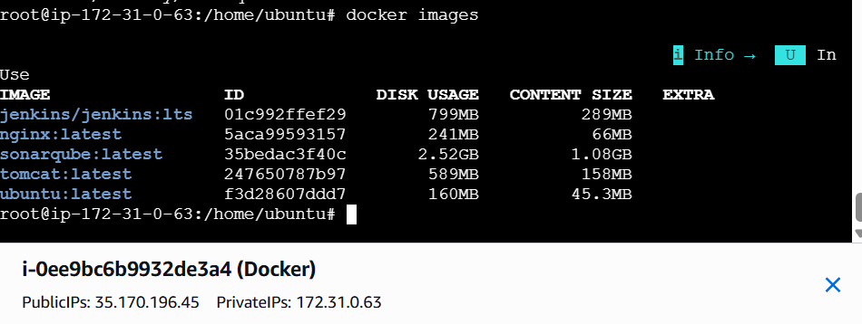
- Run nginx container and expose on port 81.
Now use command
docker run -d --name nginx-container -p 81:80 nginx
By using this command… I’m telling⇒
docker to create and run new container from this image and map the port to 81
docker ps to confirm our mapping has been done properly or not
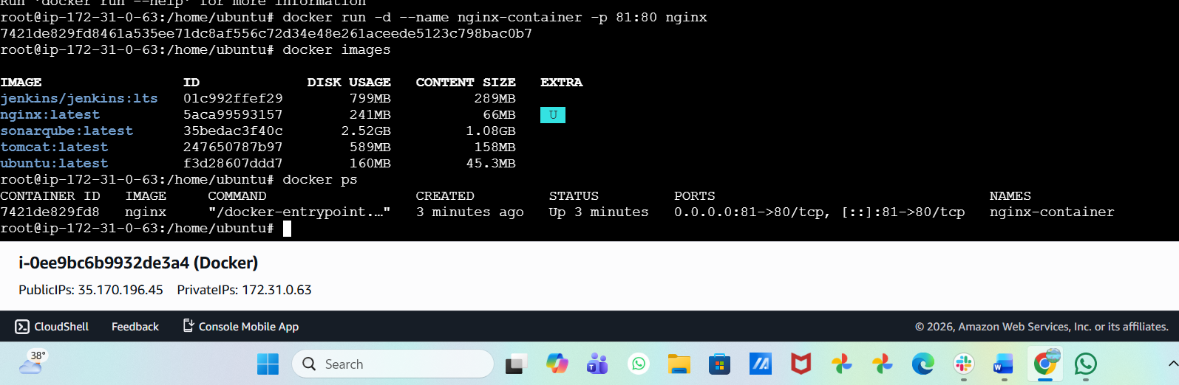
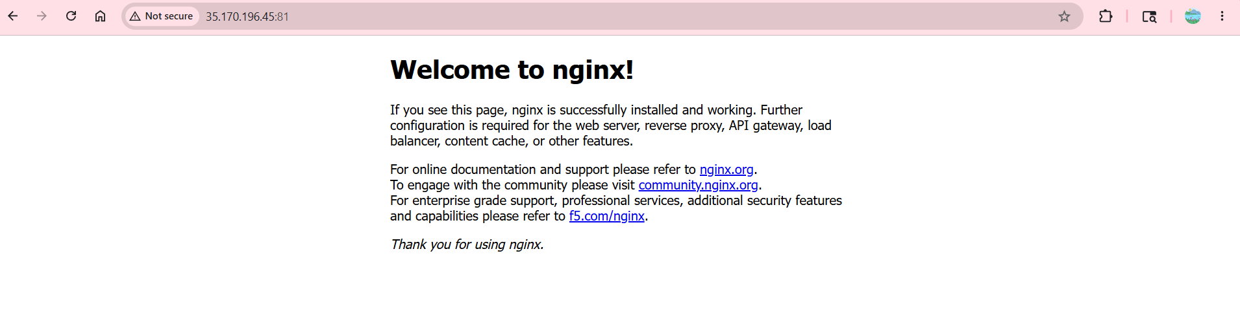
- Delete the Apache tomcat image from local.
To delete the Apache tomcat image from local we can use command
docker rmi tomcat delete the images→
docker images to confirm the image has been deleted
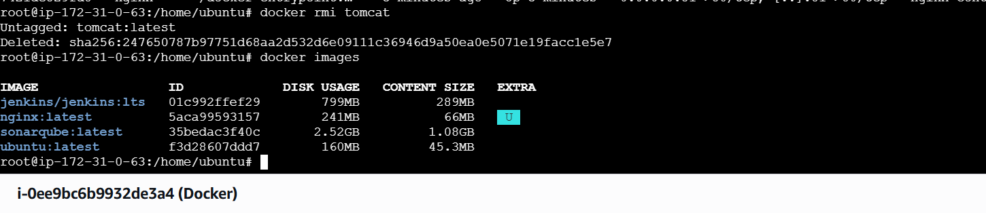
- Inspect the Jenkins image, SonarQube image.
By using docker inspect command we can inspect the images.
Docker Inspect is used to get detailed information about a Docker container, image,⇒
volume, or network in JSON format.
Such as:
● Container ID
● IP address
● Port mappings
● Environment variables
● Mounts/volumes
● Container status
● Network details
● Image details
● Creation time
- Docker inspect jenkins
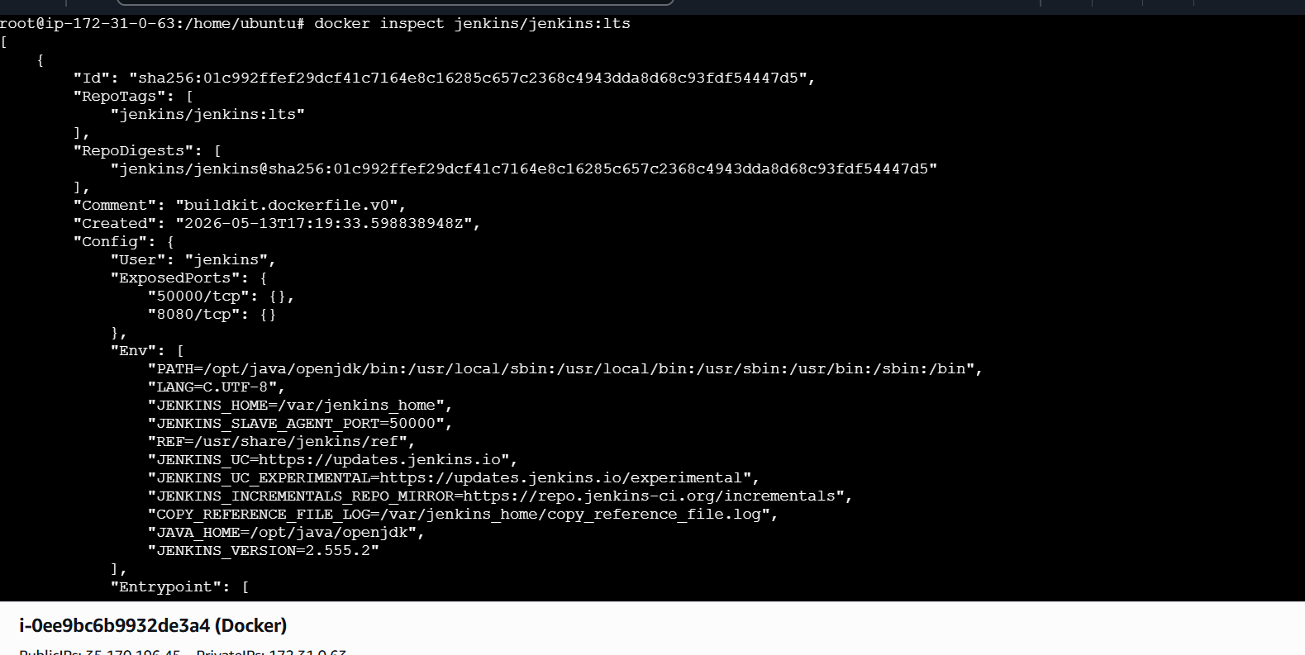
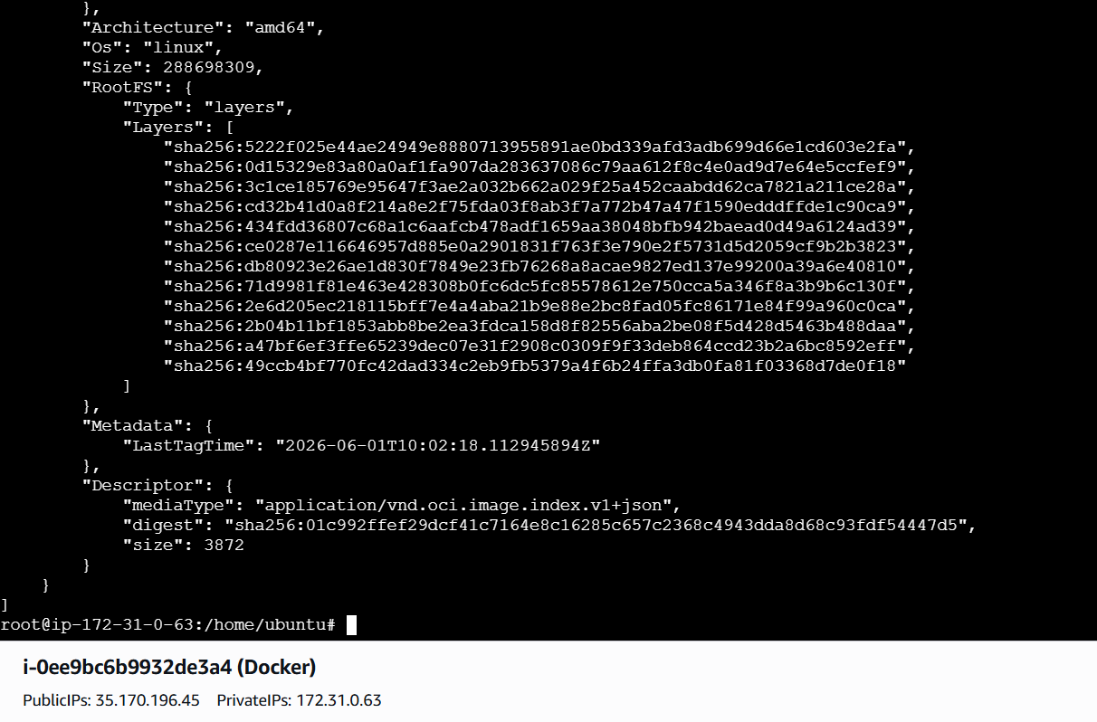
Docker inspect sonarqube
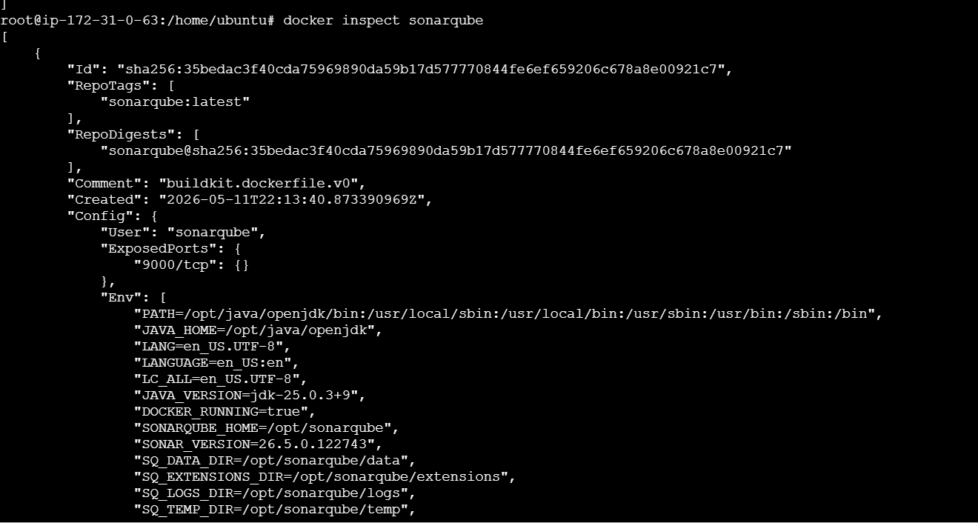
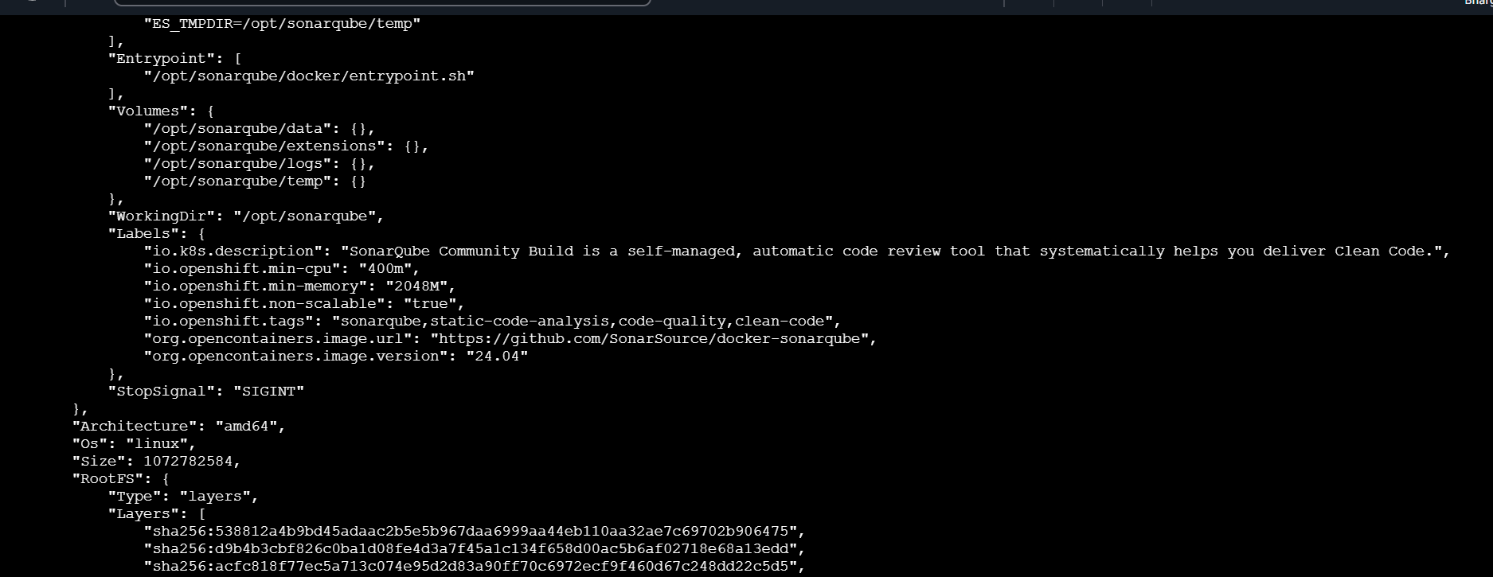
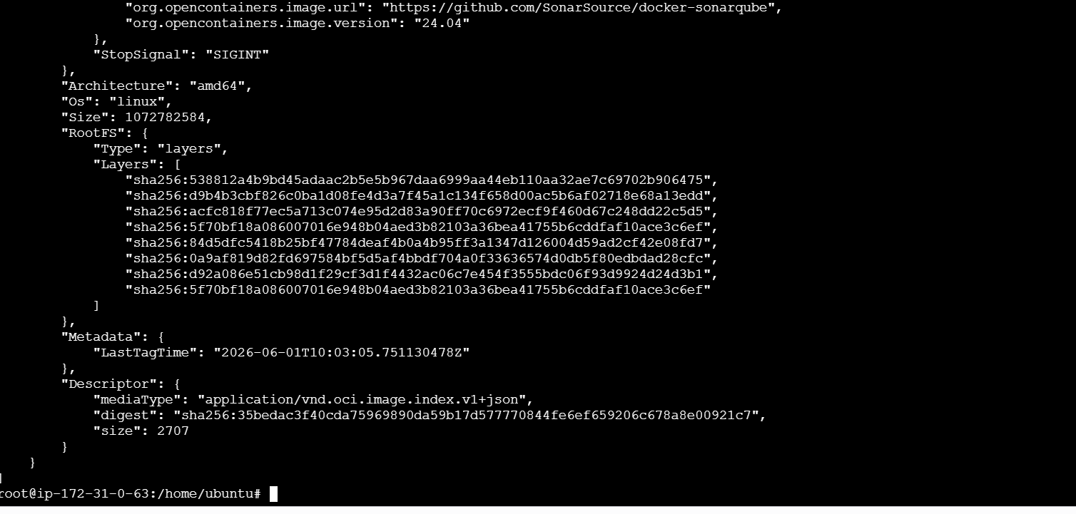

- Run Jenkins container and run one sample job.
By using the below command
docker run -d \
--name jenkins \
-p 8080:8080 \
-p 50000:50000 \
-v jenkins_home:/var/jenkins_home \
jenkins/jenkins:lts
After the be above command now lets use
docker start jenkins
Docker exec -it -u root jenkins bash to change to jenkins root user
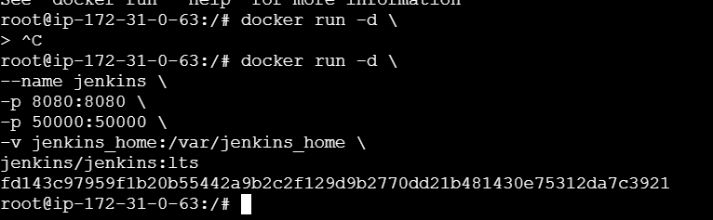
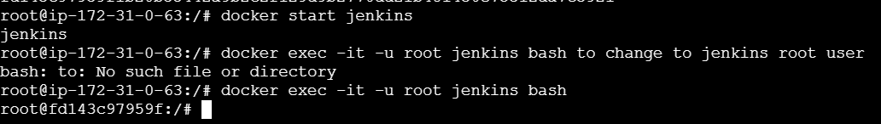
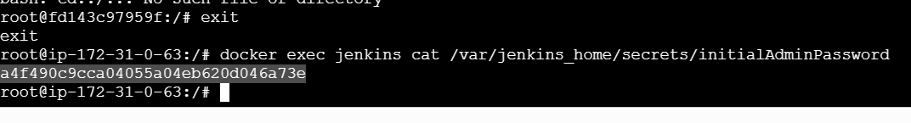
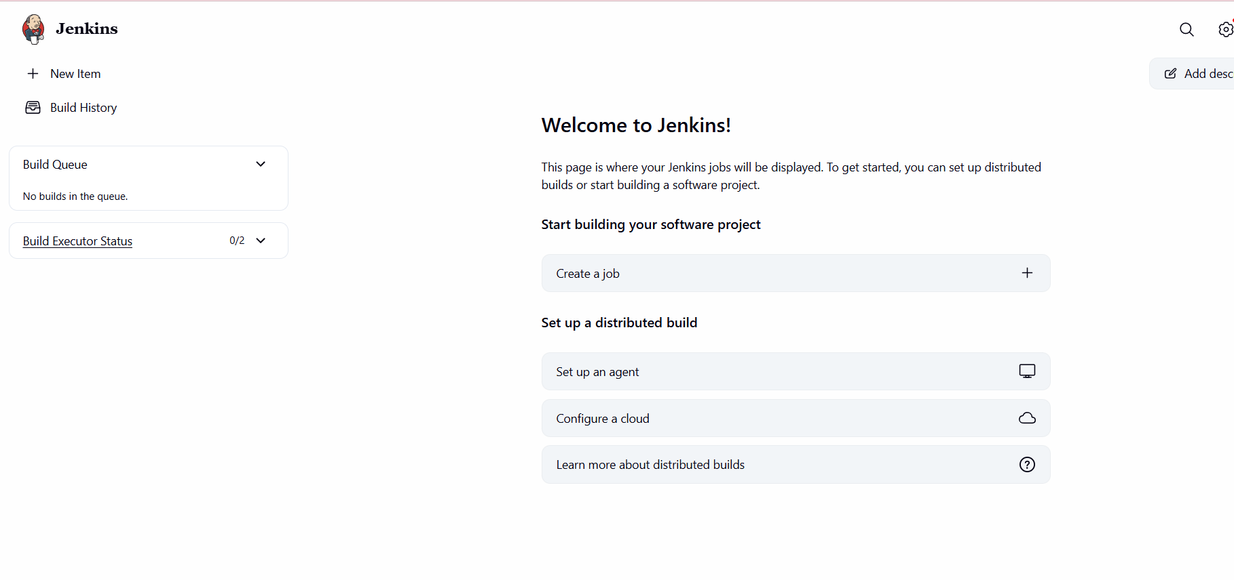
Create a new job
New item freestyle
