JENKINS-01
- Install Jenkins and run Jenkins on port number 8081.
Lets create a new instance with configuration 20gb volume.
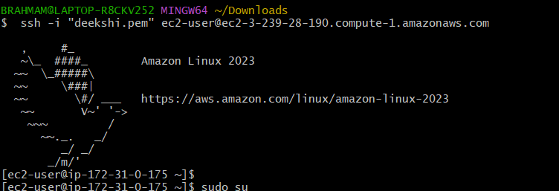
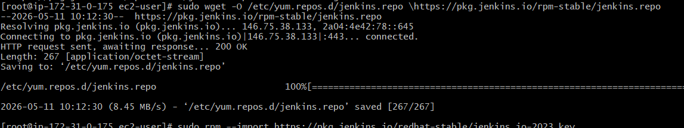
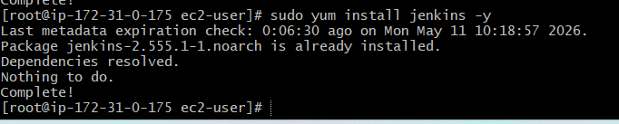
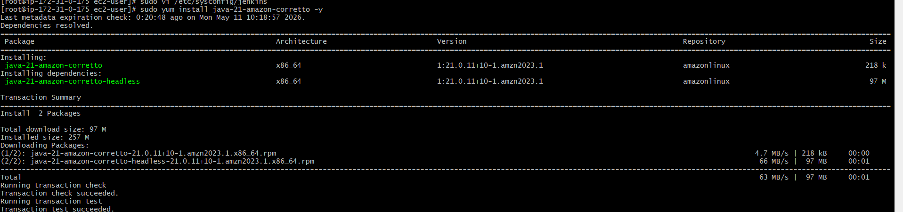
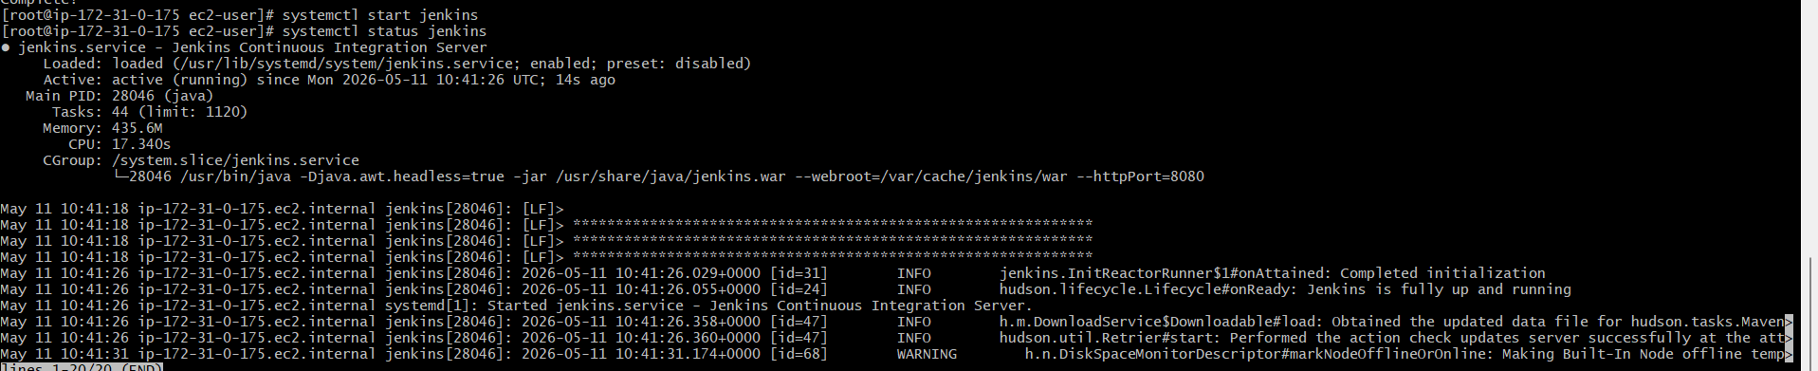
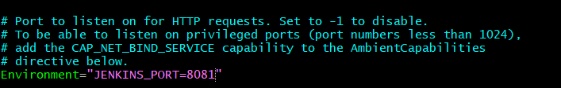
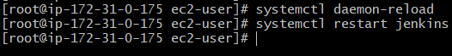
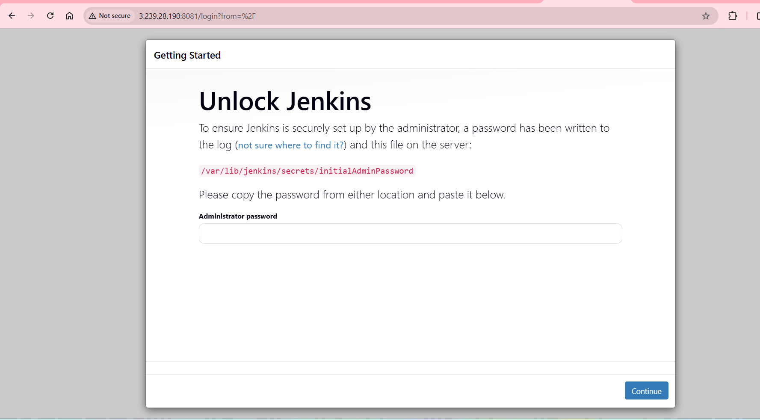

- Secure Jenkins server
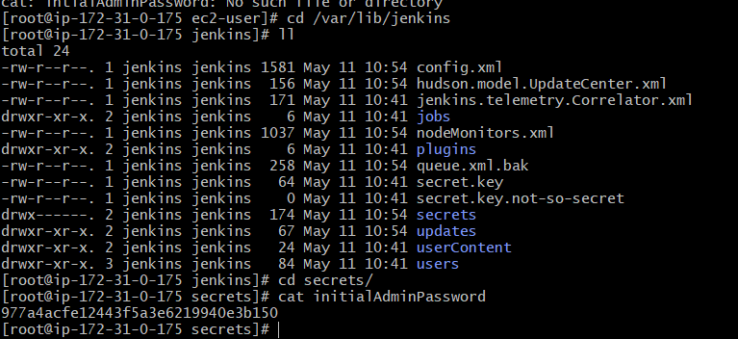

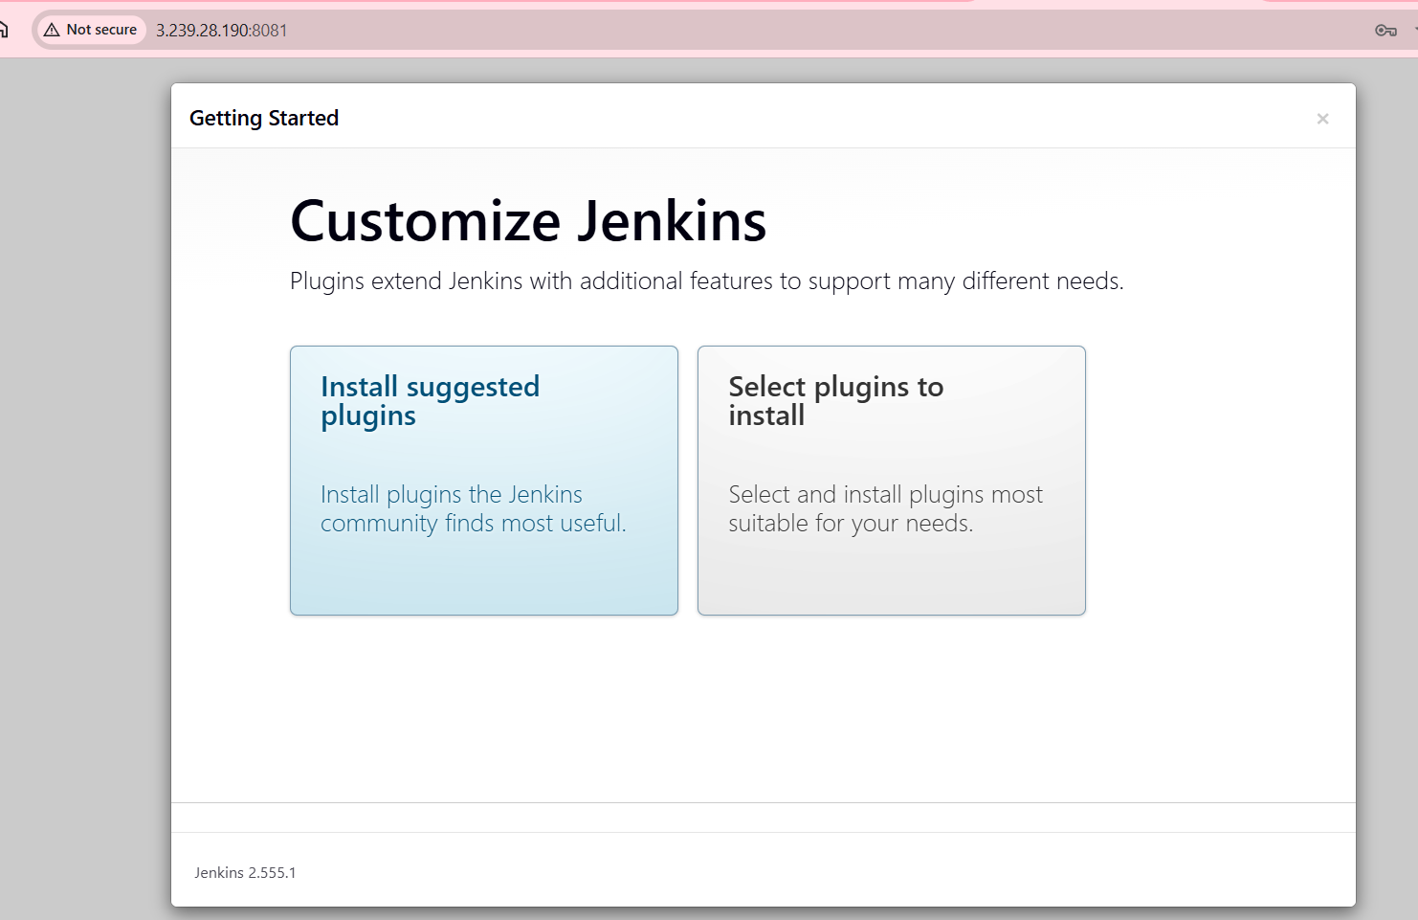
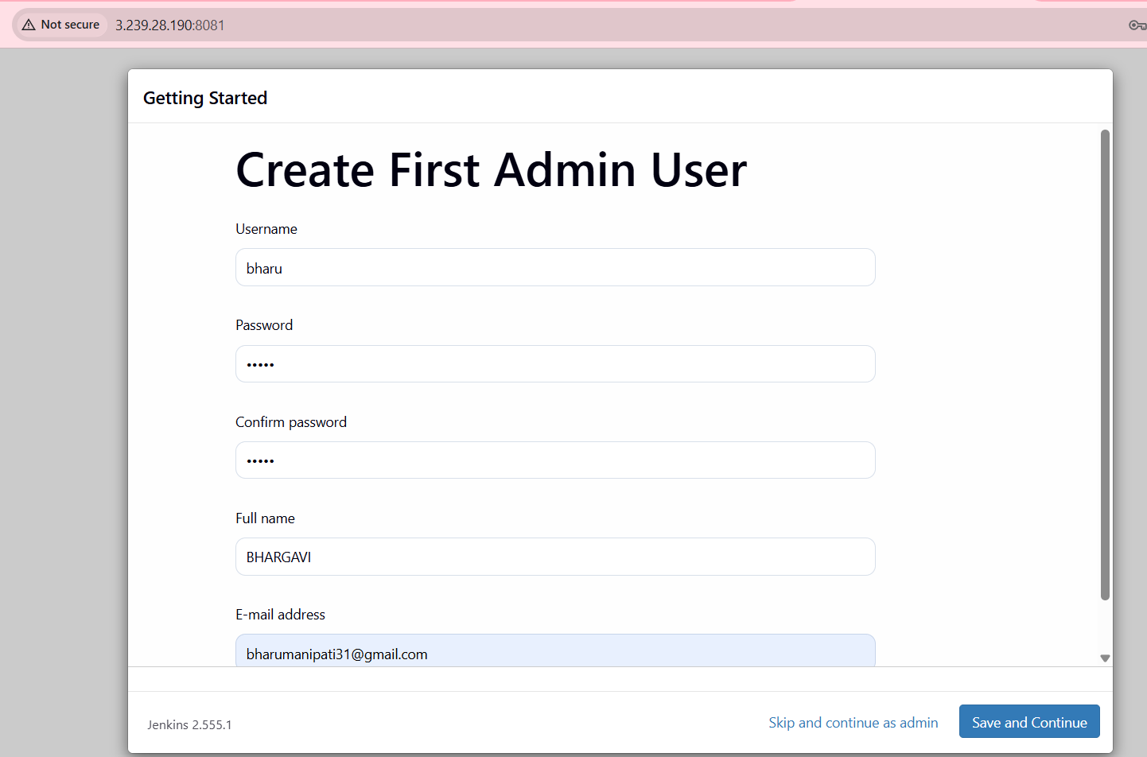
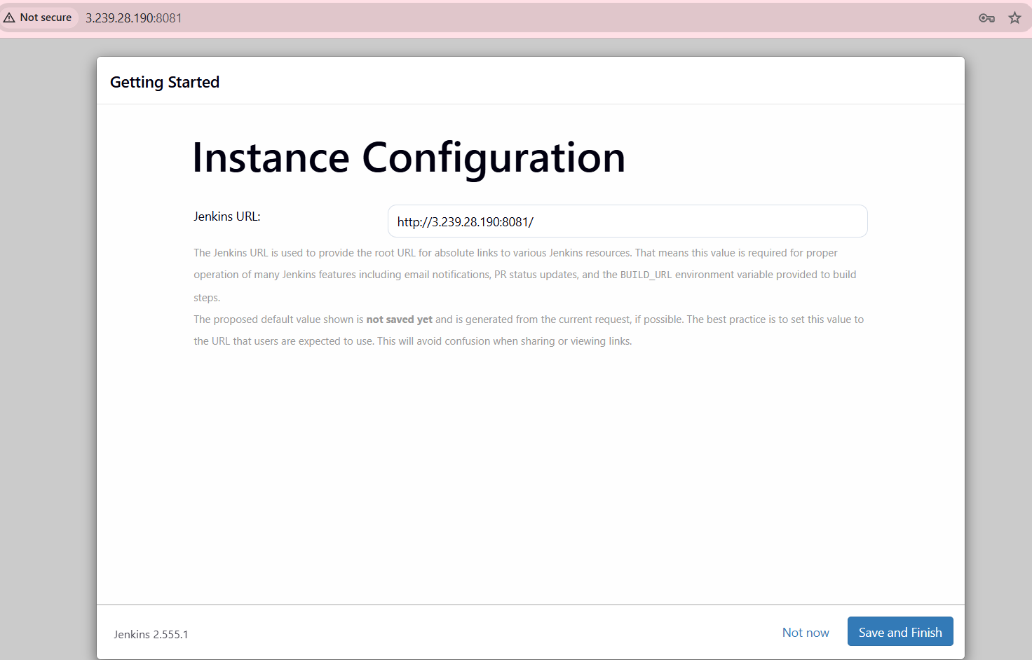
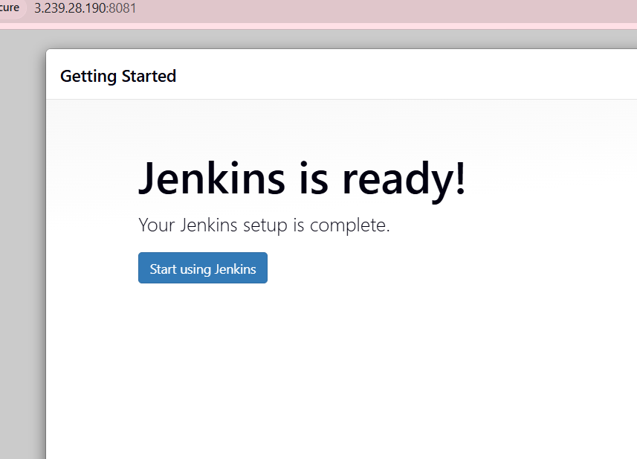
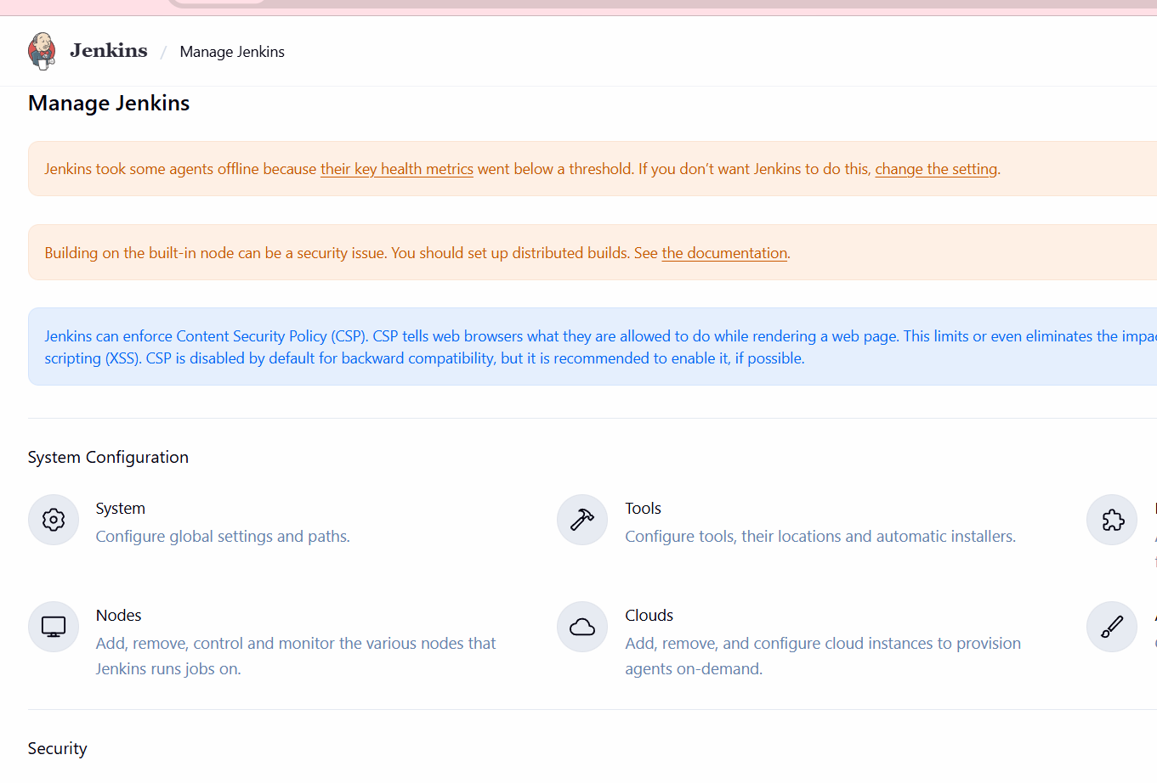
We have to manage Jenkins and find Authentication --Role-Based Strategy select this I don’t have this role then plugins in avalilability plugins role based authorization strategy select and install we have see now in security.
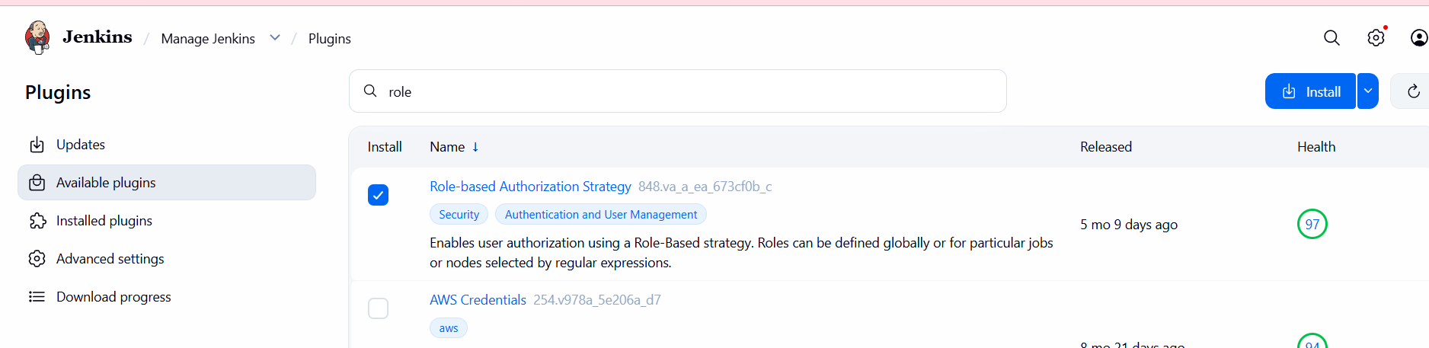
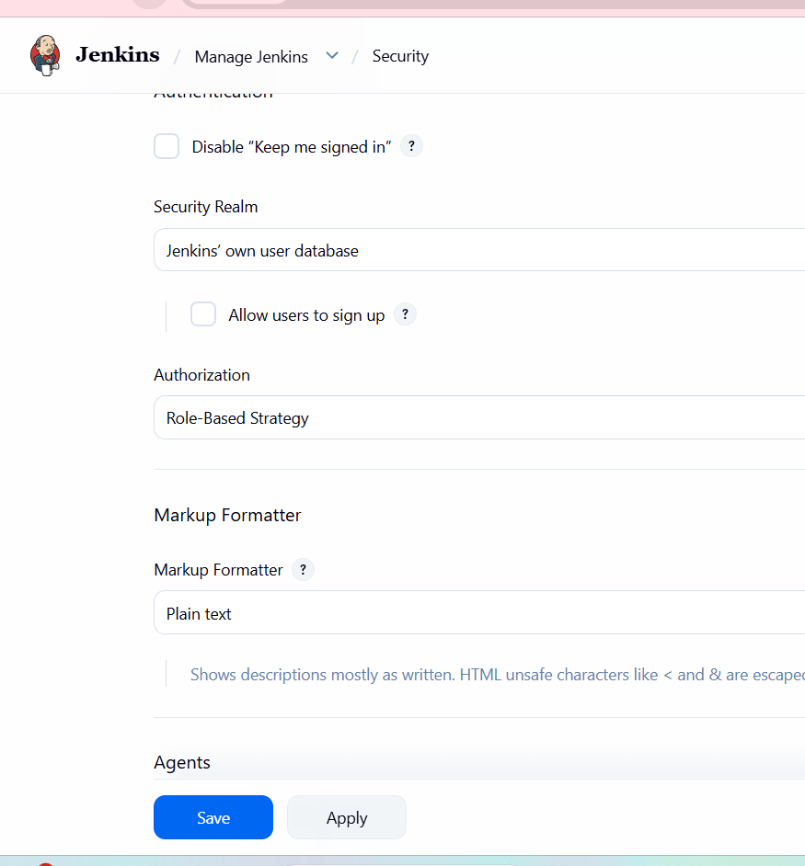

- Create users called DevOps, Testing in Jenkins with Limited access.
Create user
Navigate to the Manage Jenkins page from the Jenkins dashboard Select Users under
the Security sectionTo create a users
On the Users page, select Create User.
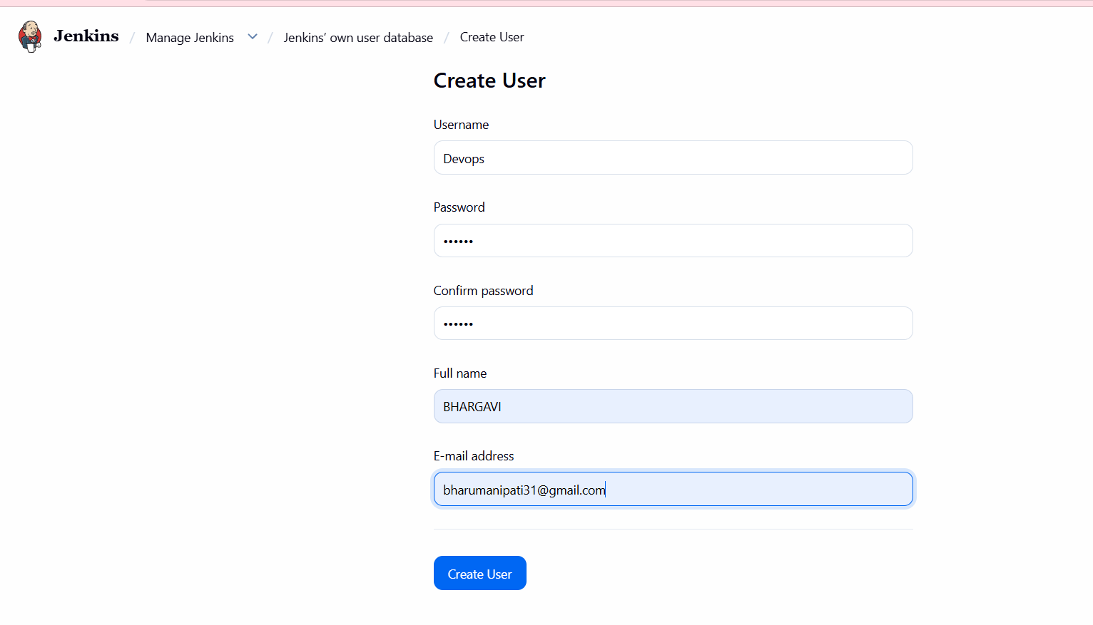
Fill in the required details:
Username: A unique identifier for the user.
Password: A secure password for the user.
Confirm Password: Re-enter the password.
Full Name: The full name of the user.
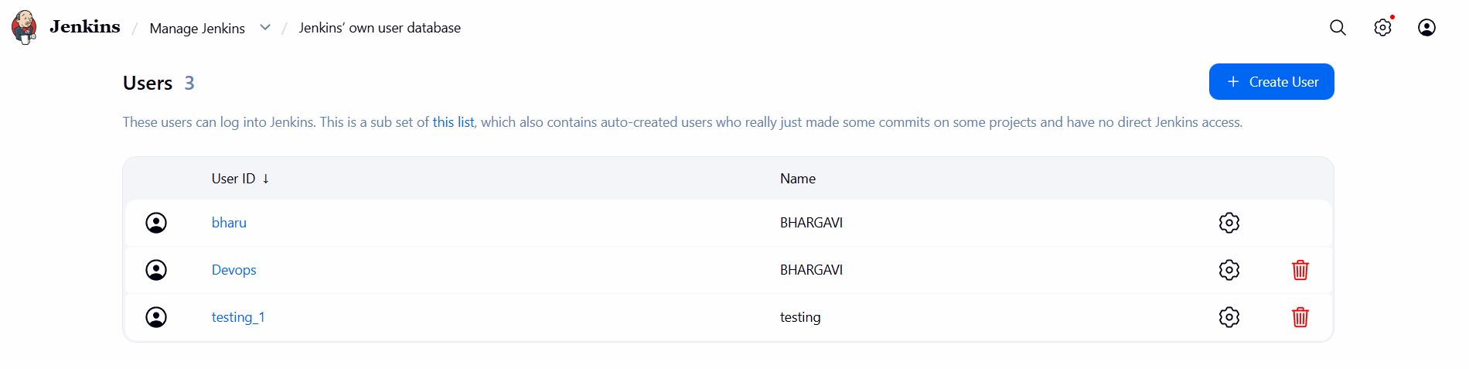
Go to manage Jenkins click on pluginsclick on available pluginssearch Role-based authorization strategy and installEnable project based on JenkinsUnder authorization select project based metrix authorization strategyAssign rolesTried verifying the user
Below for user – Testing I am unable to create as I only have read access
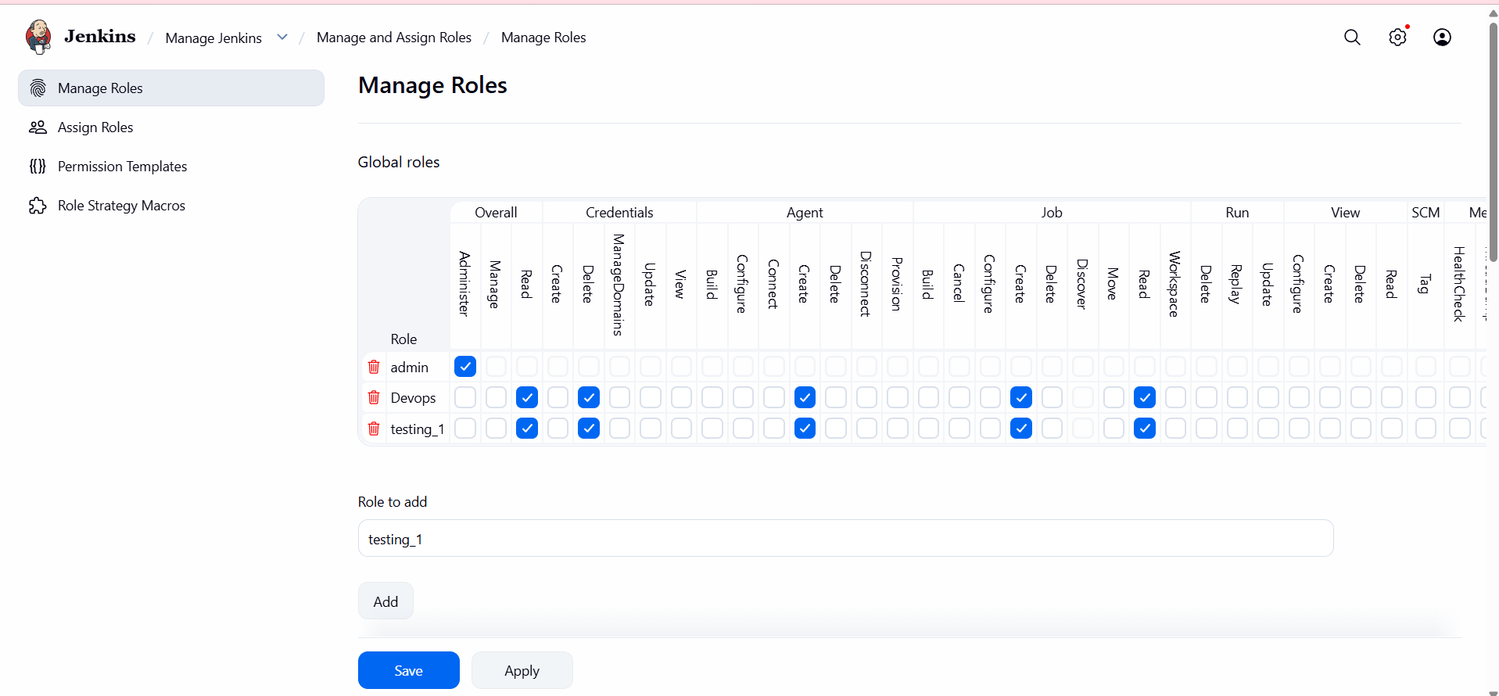

- Configure labels and restrict the jobs to execute based on label only.
Go to manage Jenkins click on nodesClick on built in node
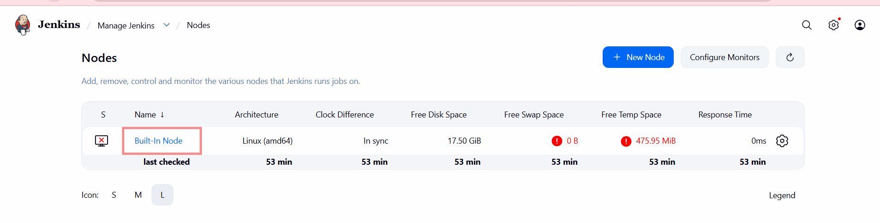
I don’t have temp space then I need to change the instance t2.microc7.large instance type the after I got more free space—see in below
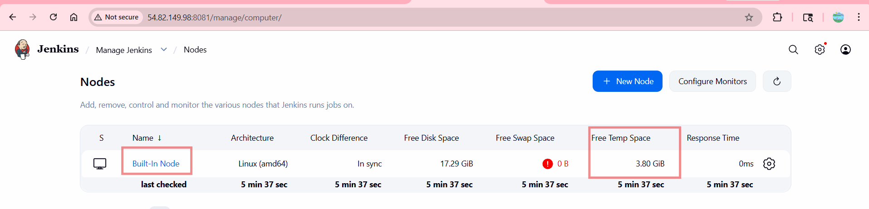
Click on new item give item name choose item type
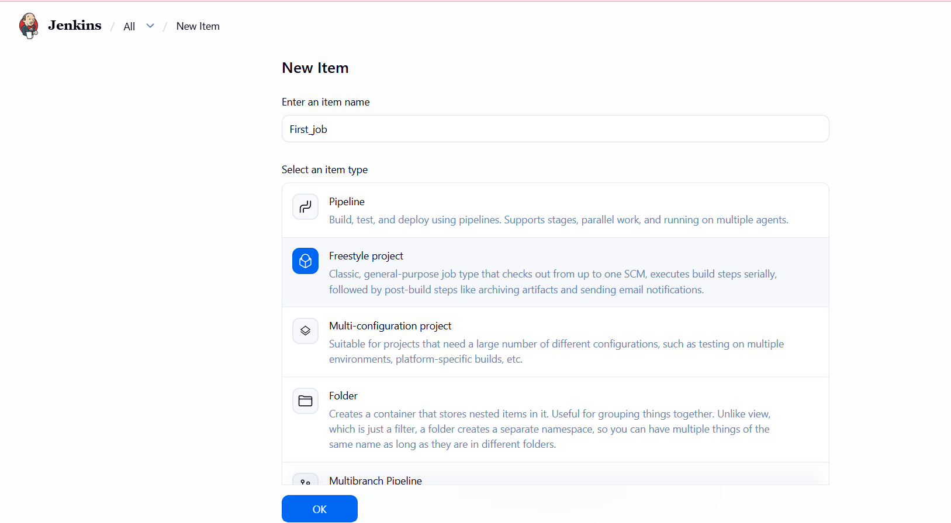

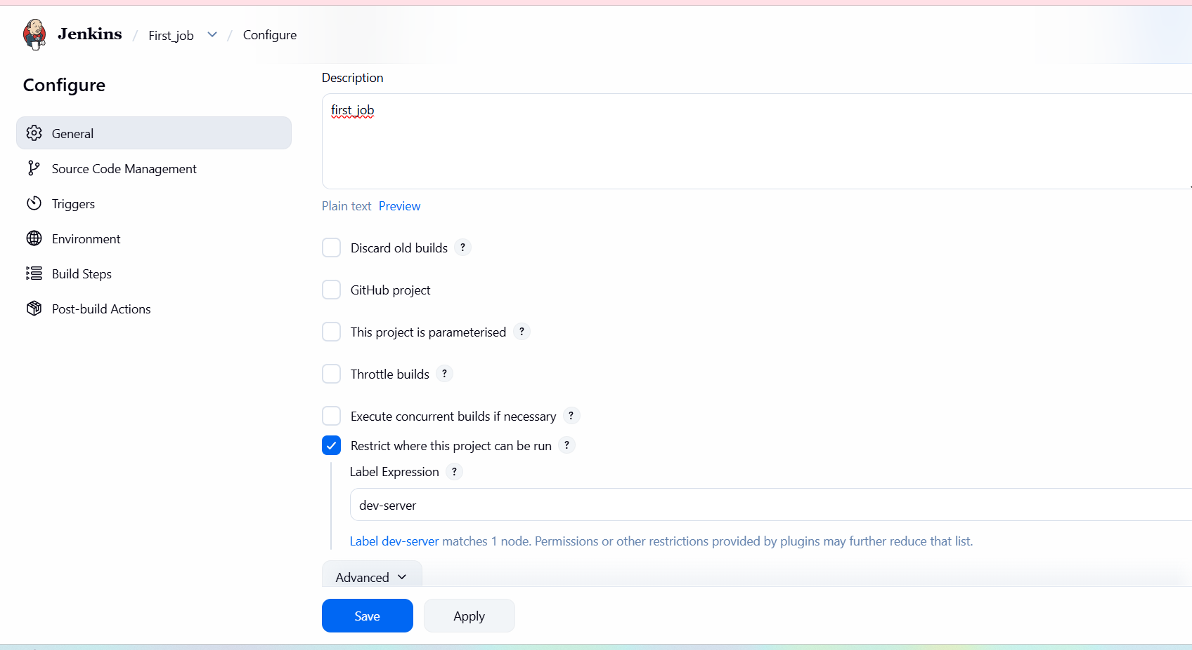
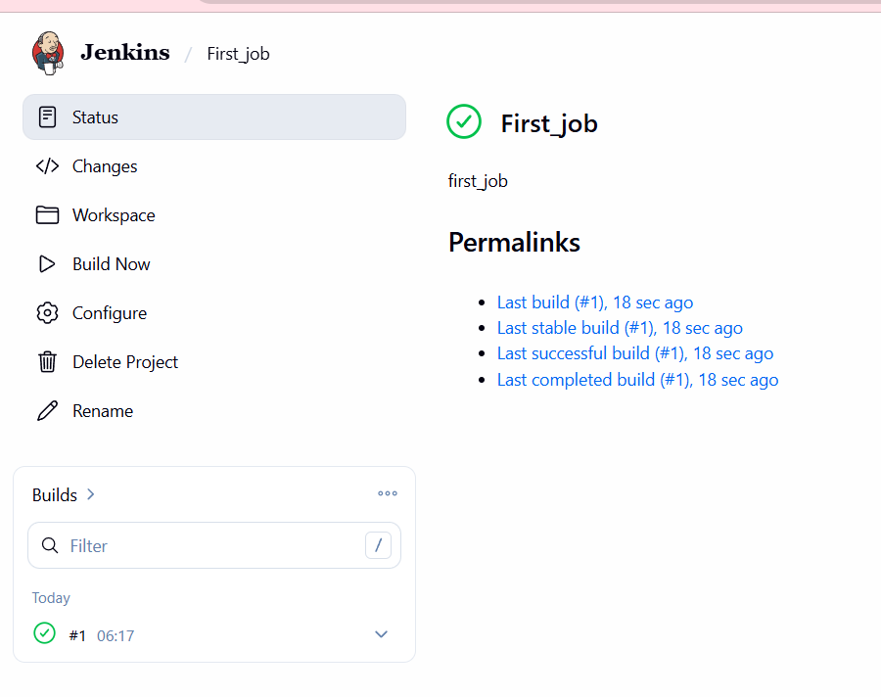
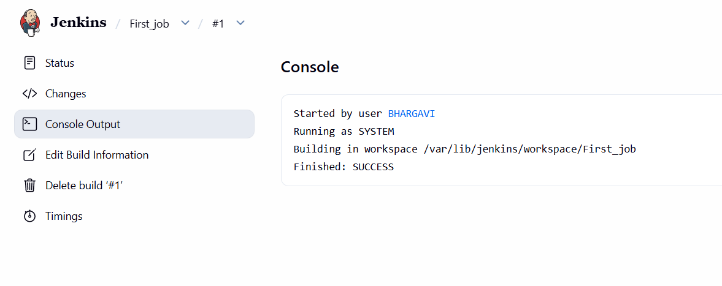

- Create Three sample jobs using the below URL.
  - Source Code:https://github.com/betawins/Techie_horizon_Login_app.git
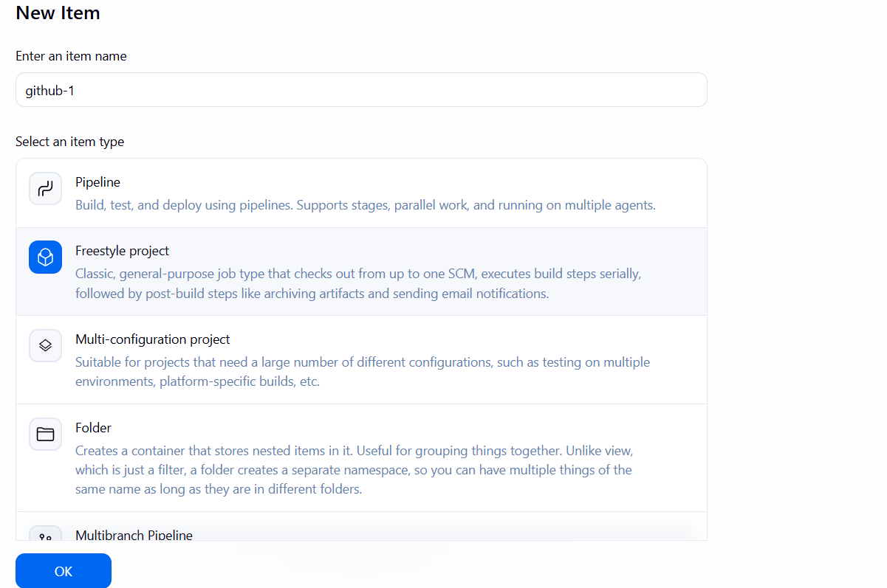
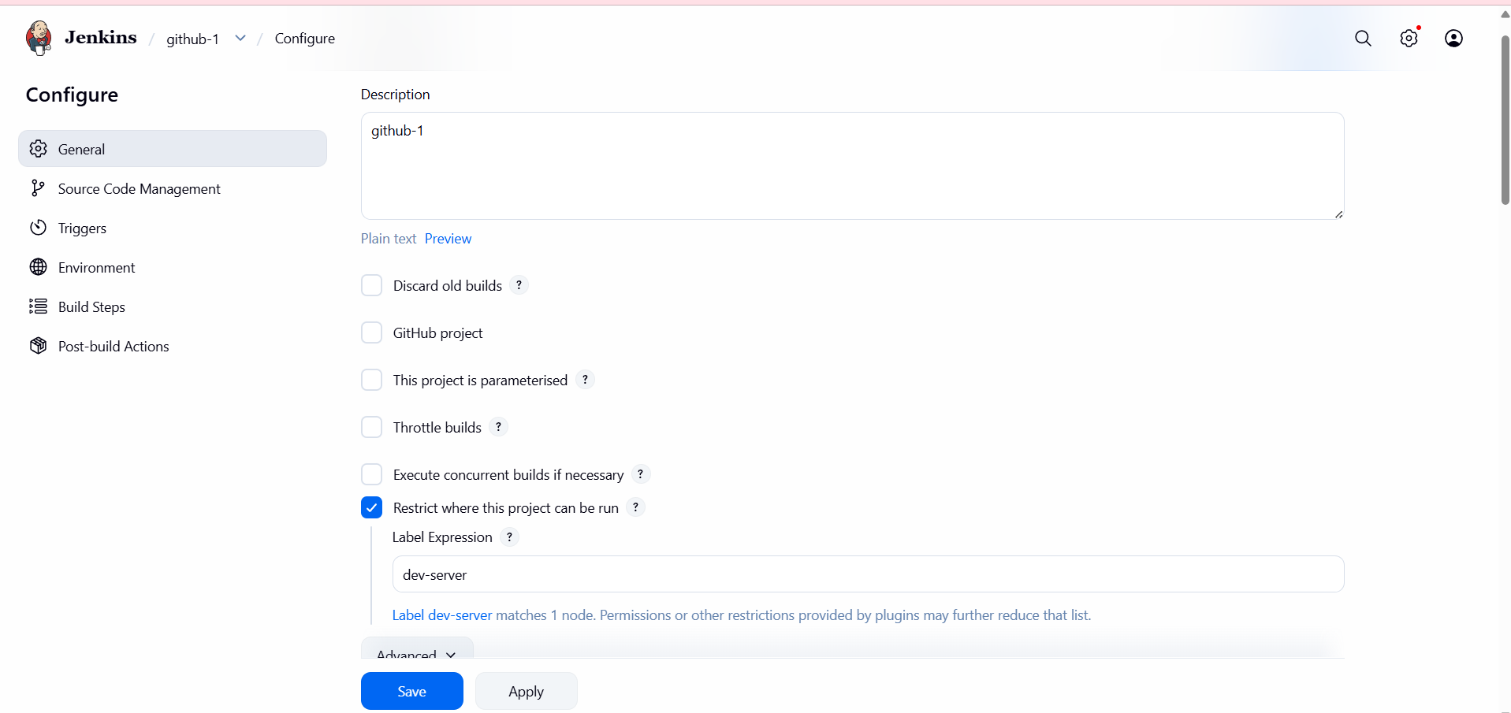
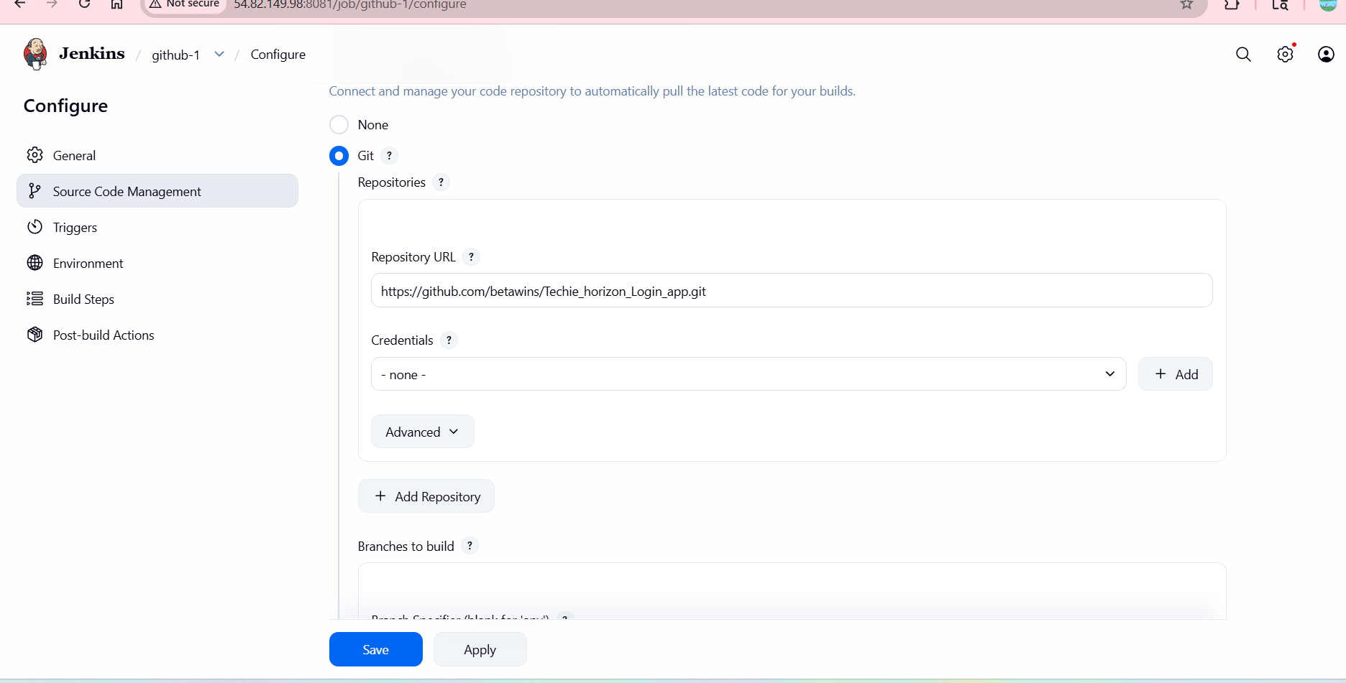
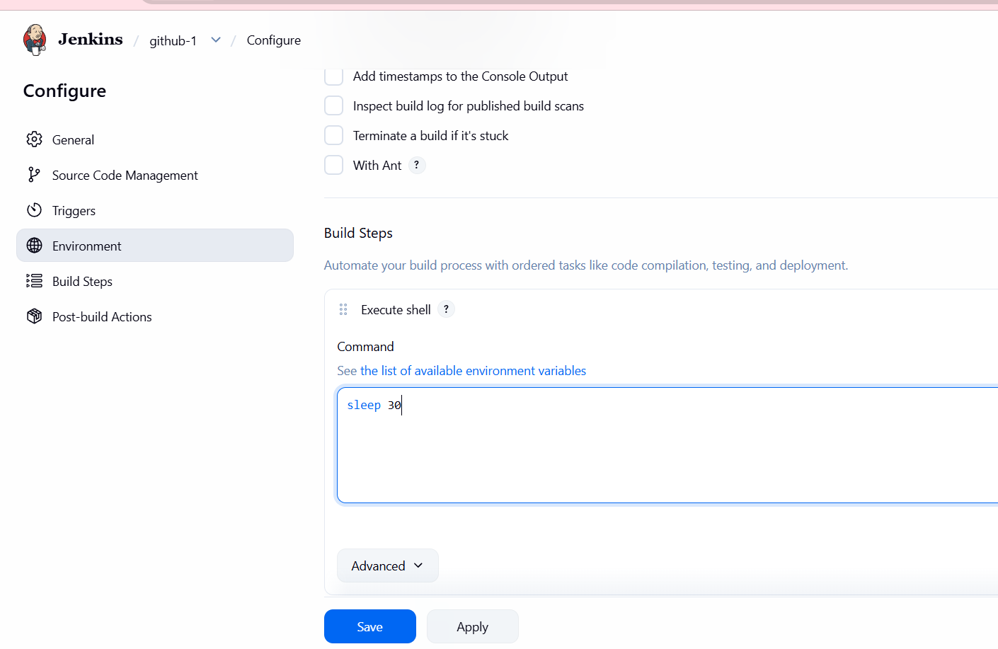
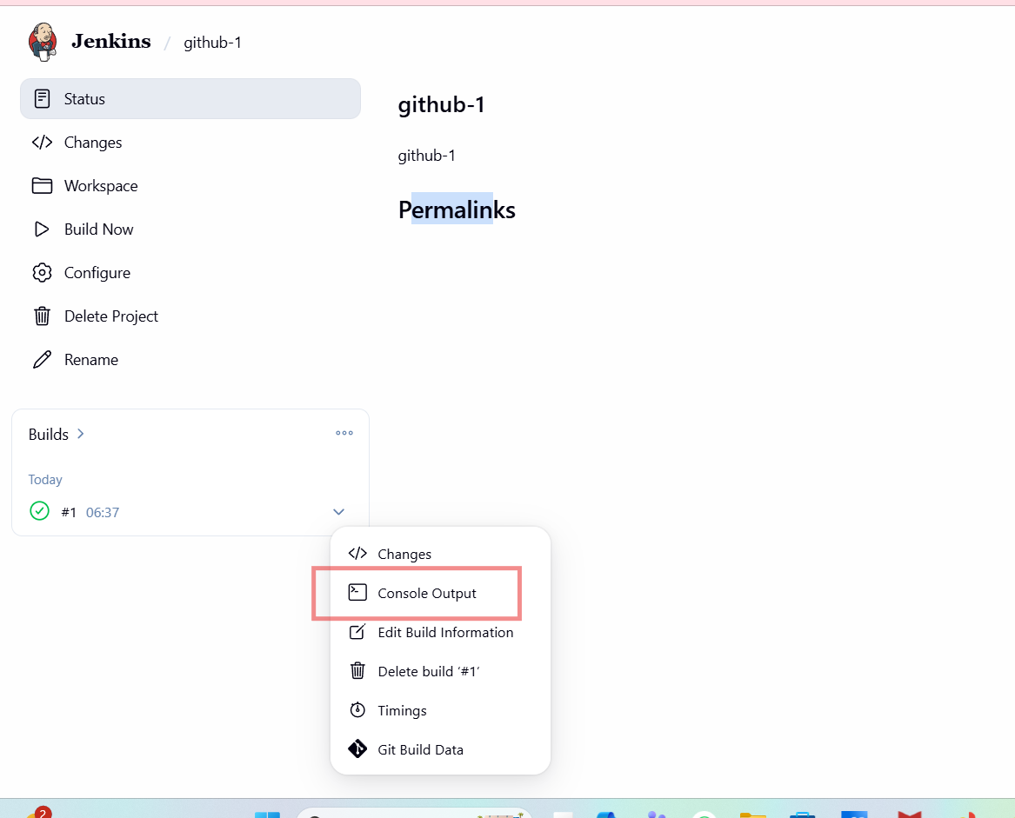
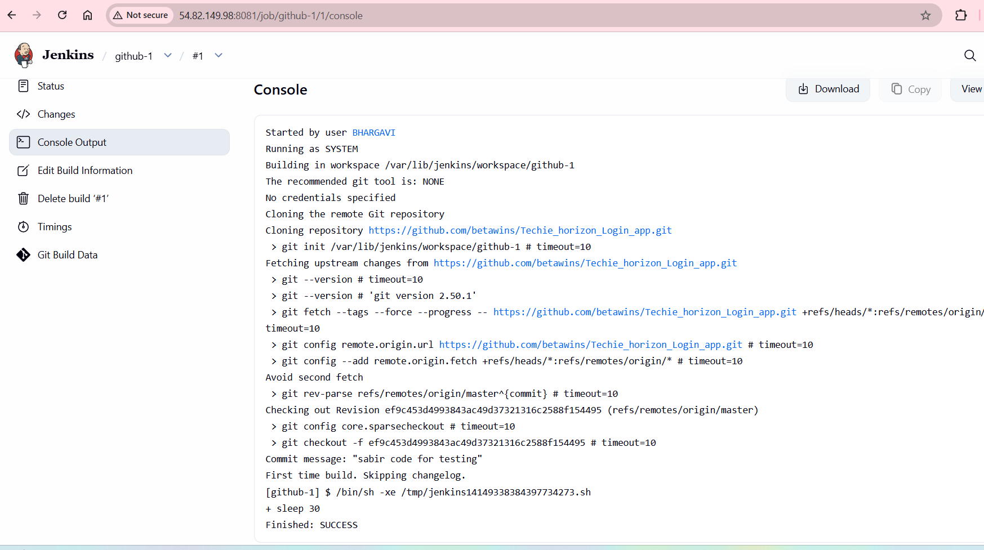
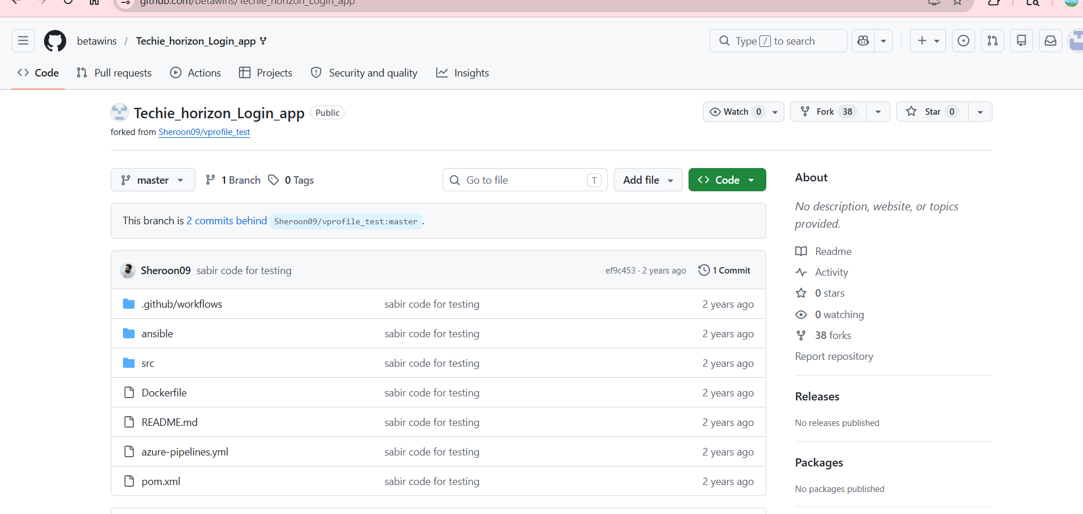
Then check in gitbash it is running or not
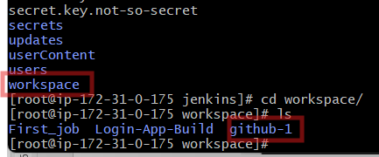
Create 2nd job—github-2
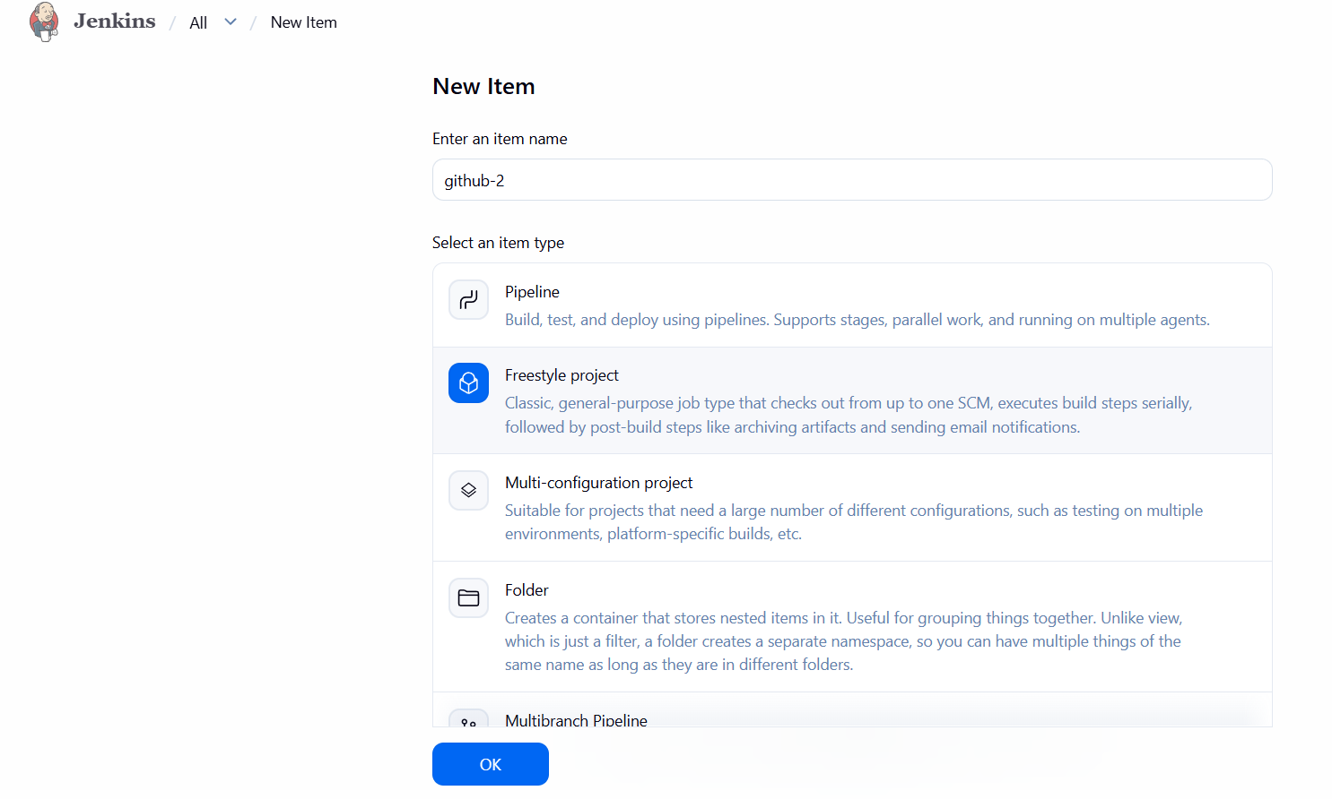
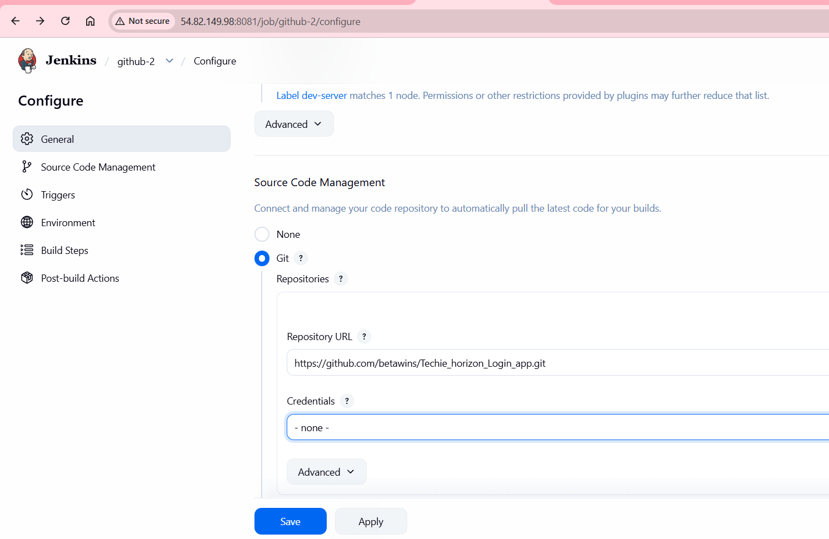
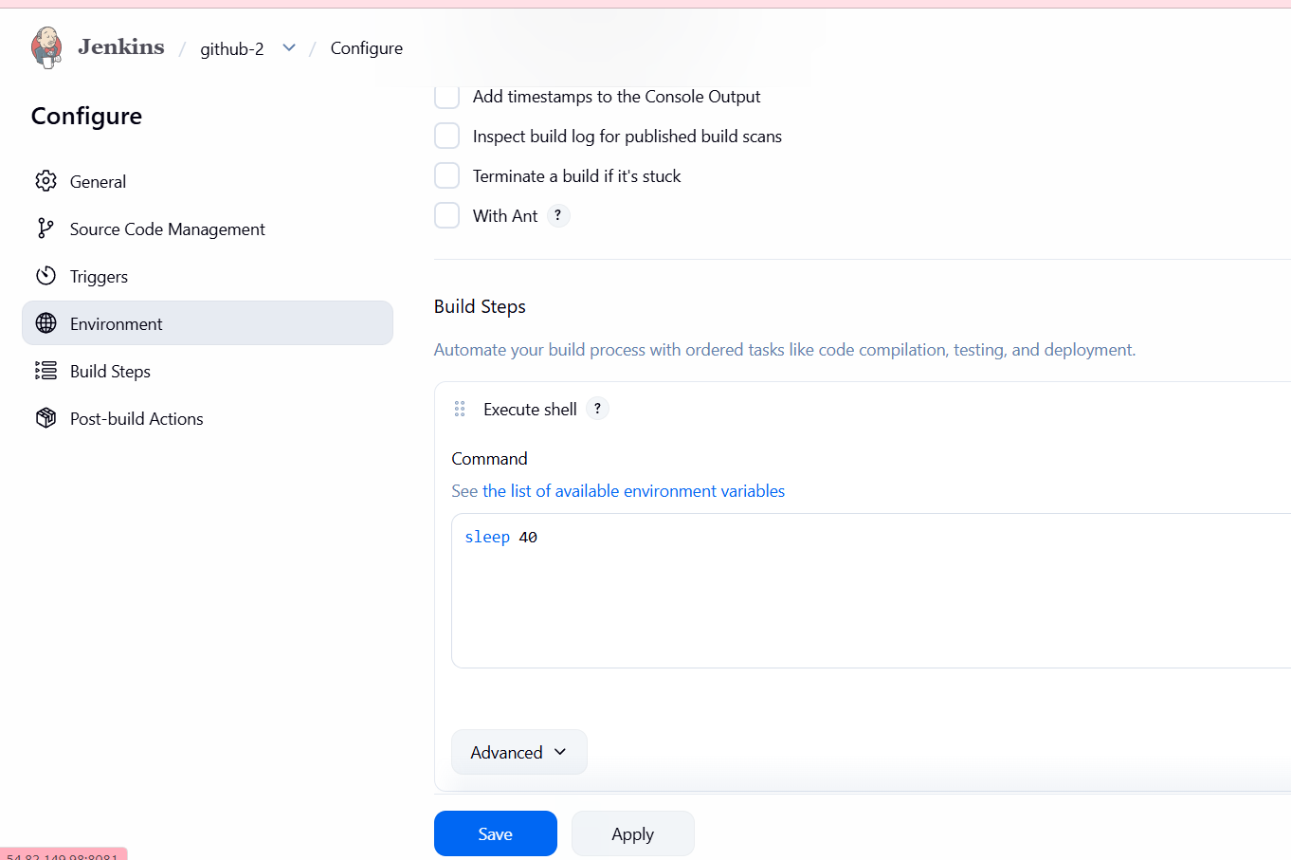
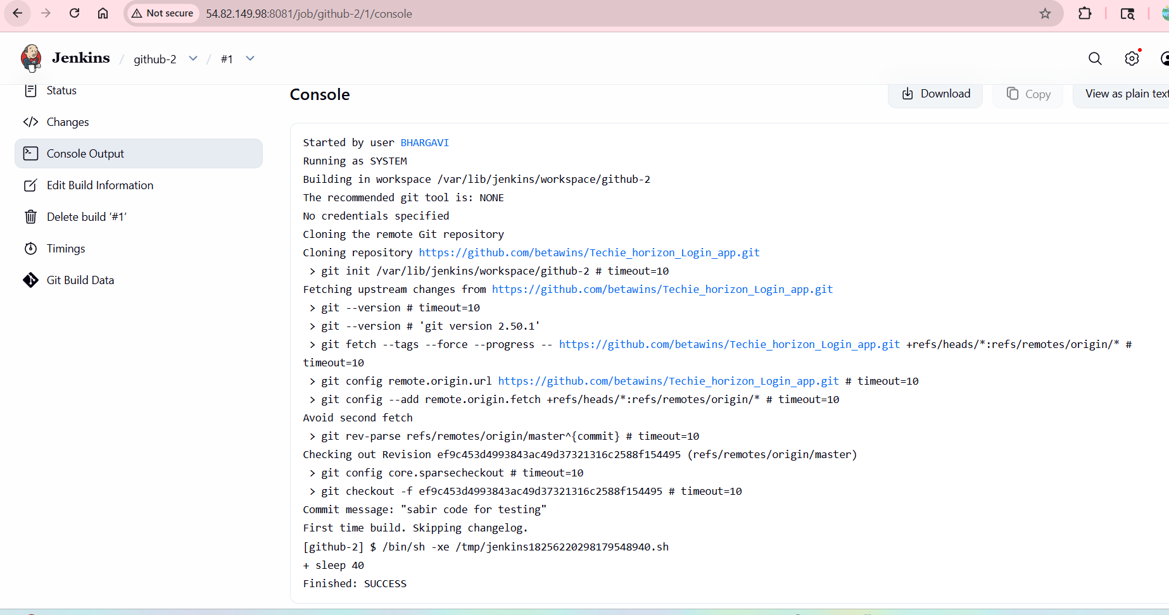
Create job 3 github-3
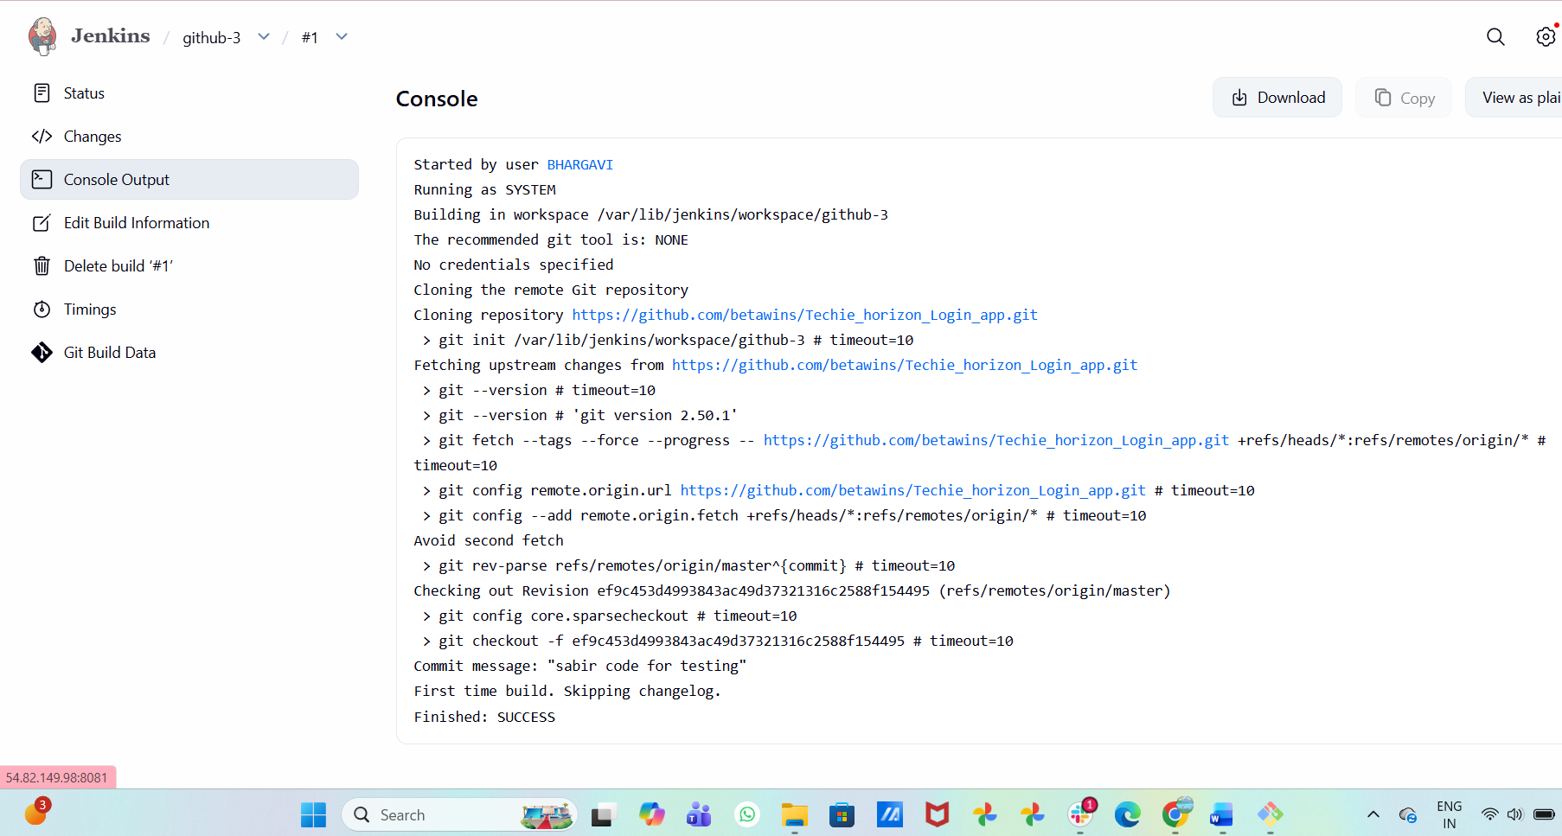

- Create one Jenkins job using GitHub Private repository.
Open GitHub:login—create new repository—private with name-- Create Repository-- uploading an existing file-- Commit changes-- Open:
GitHub Personal Access Token Settings
-- Generate new token--Select:Generate new token (classic)—Note
JenkinsAccess

Expiration | -30 days
-- Select Permissions—repo—generate token-- Copy Token-- Immediately copy token.
-- Open Jenkinns in browser-- Add GitHub Credentials in Jenkins-- Manage Jenkins → Credentials-- Open Global Credentials—system-- Global credentials (unrestricted)-- Add Credentials—Create-- Create Jenkins Job-- New Item-- Private-Repo-Job-- Freestyle Project—ok-- Configure Git Repository-- Source Code Management—Git-- Enter Private Repository URL-- Select Credentials-- github-private-- Add Build Step-- Build Steps-- Add Build Step → Execute Shell-- echo "Private Repository Build Successful"-- Save Job-- Build Job—build now-- Verify BuildClick build number:--#1--Then click:Console Output
Expected output:
Cloning the remote Git repository
using credential github-private
Finished: SUCCESS

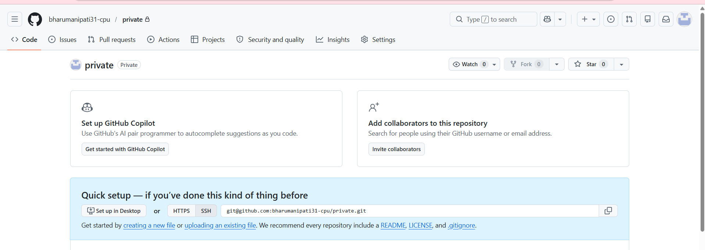
Uploading one file after that open –generate new token
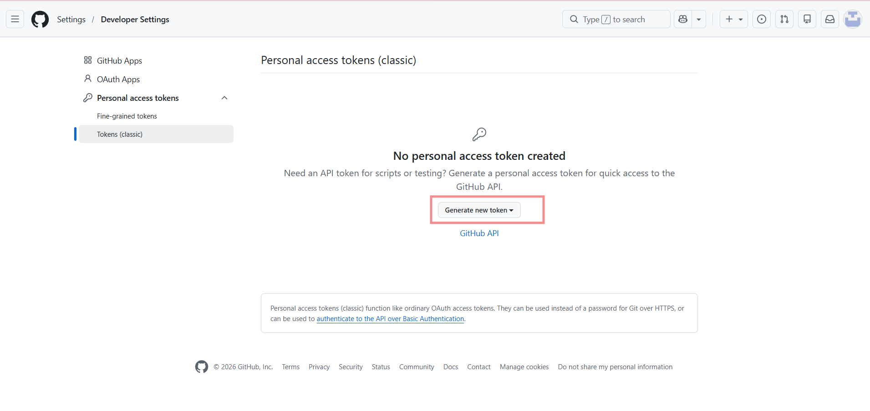
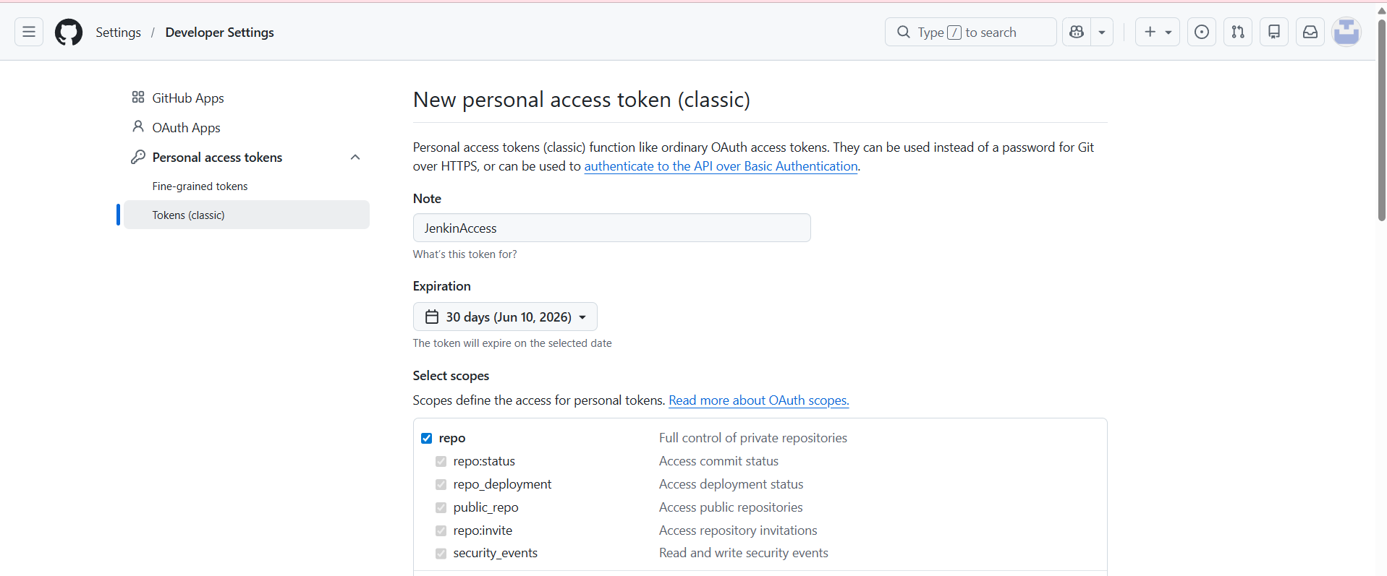
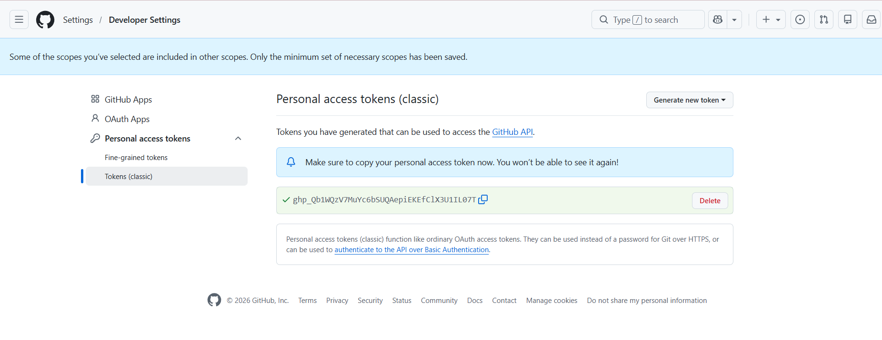
Open Jenkins
