Jenkins-02
- Configure 2 slave machines in the Jenkins master.
EC2 & Initial Setup
Launched three EC2 instances:
  - jenkins-master
  - slave-01
  - slave-02
Logged in to slave-01 as root.-->Installed Java:yum install java-21-amazon-corretto -yVerified Java installation completed.
ssh-keygen Added public key to authorized keys:cat id_rsa.pub >> authorized_keys
Fixed permissions:-chmod 700 authorized_keys
Jenkins Master SSH Trust
Logged in to jenkins-master.
Added slave host key:
ssh-keyscan -H 13.61.10.105 >> /var/lib/jenkins/.ssh/known_hosts
Set correct permissions:
chown jenkins:jenkins /var/lib/jenkins/.ssh/known_hosts
chmod 700 /var/lib/jenkins/.ssh
chmod 600 /var/lib/jenkins/.ssh/known_hosts
Jenkins Node Creation (slave-01)
Opened Jenkins dashboard.
Navigated to Manage Jenkins → Nodes.
Clicked New Node.
Entered node name: slave-01.
Selected Permanent Agent and created the node.
Node Configuration (slave-01)
Set Number of executors to 2.
Initially observed agent offline due to root directory permission issue.
Logged in to slave-01 and created Jenkins workspace:
mkdir -p /home/ec2-user/jenkins
chown -R ec2-user:ec2-user /home/ec2-user/jenkins
Updated Remote root directory in Jenkins to:
/home/ec2-user/jenkins
Added Label:
java
Set Usage to:
Only build jobs with label expressions matching this node
SSH Launch Configuration
Selected Launch agents via SSH.
Entered Host: 13.61.10.105.
Selected SSH credentials (ec2-user).
Chose Known hosts file Verification Strategy.
Saved configuration.
Verified SSH authentication successful in node logs.
Confirmed slave-01 status changed to online.
Job Creation & Execution
Clicked New Item.
Entered job name: first_job.
Selected Freestyle project.
Enabled Restrict where this project can be run.
Entered label:
java
Configured Source Code Management → Git.
Entered repository URL:
https://github.com/betawins/Techie_horizon_Login_app.git
Saved the job configuration.
Ran the job.
Verified build executed remotely on slave-01.
Confirmed Git clone successful.
Build finished with SUCCESS.
Final Node Verification
Navigated to Manage Jenkins → Nodes.
Verified:
  - Built-in node → online
  - slave-01 → online with disk & response metrics visible
Slave-02 Configuration
Repeated the same configuration steps (Java install, SSH setup, workspace creation, Jenkins node setup) for slave-02.
Added slave-02 successfully to Jenkins.
Verified both slave-01 and slave-02 are online and available for builds.
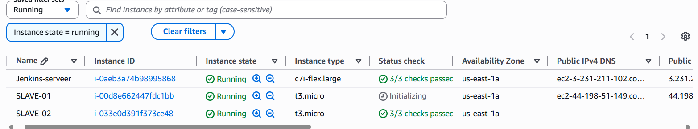
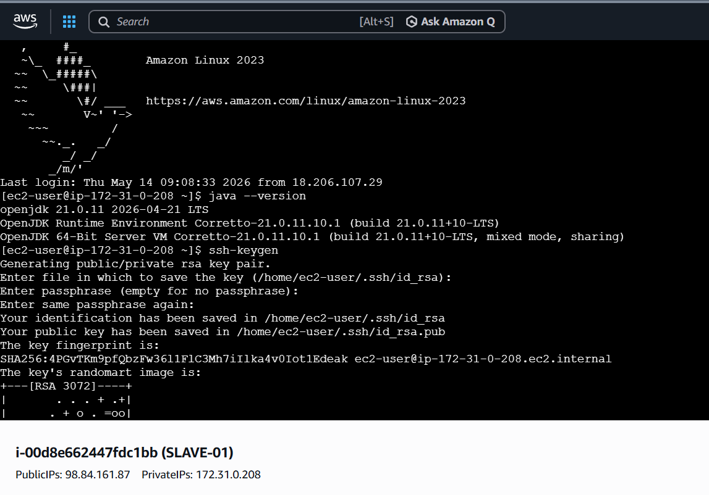
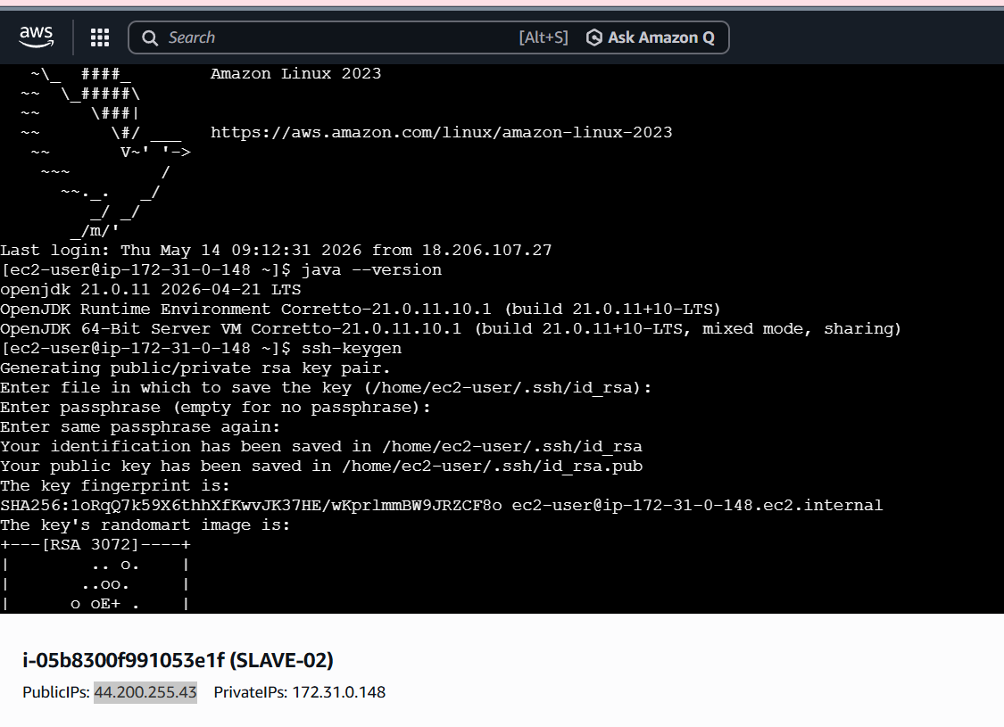
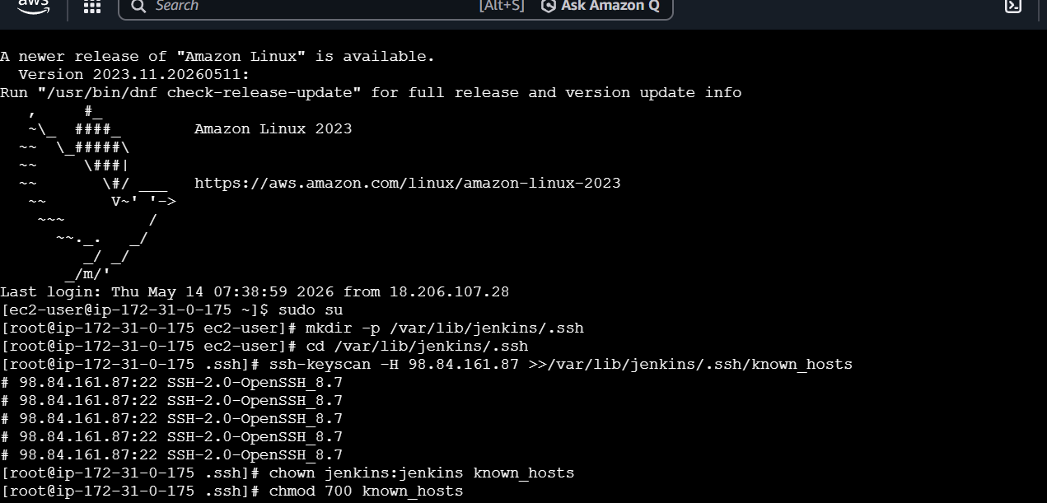
ssh-keyscan -H ip address of slave-01 >>/var/lib/Jenkins/.ssh/know_hosts
This will help to scan from slave1 to master
- Now create one node with slave-01 name
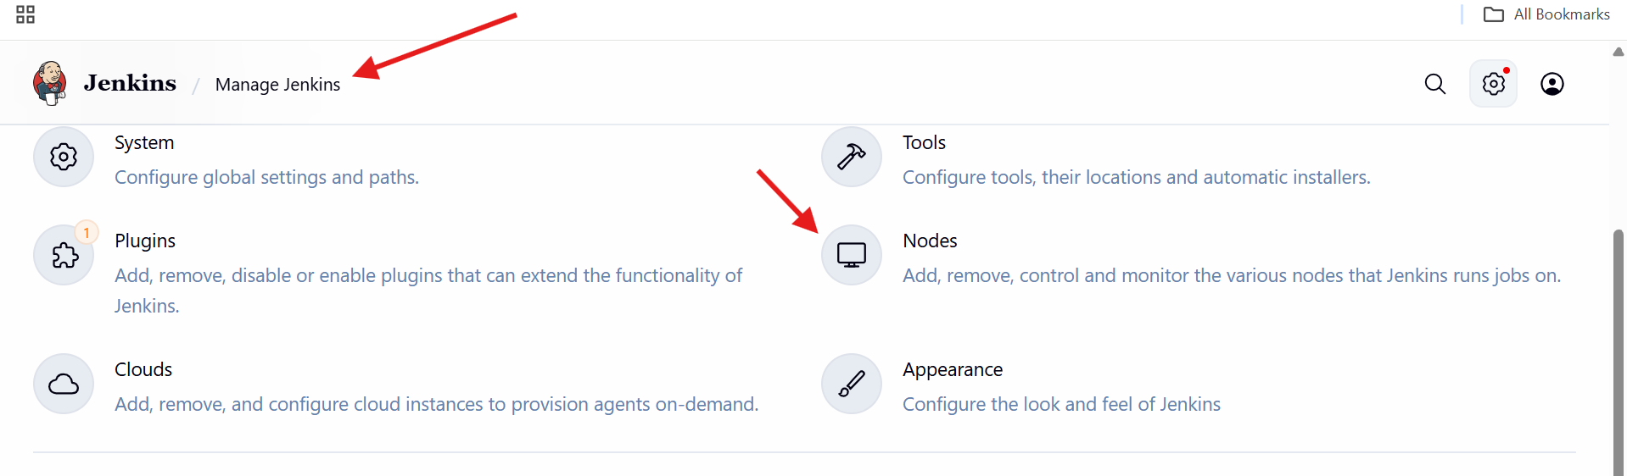
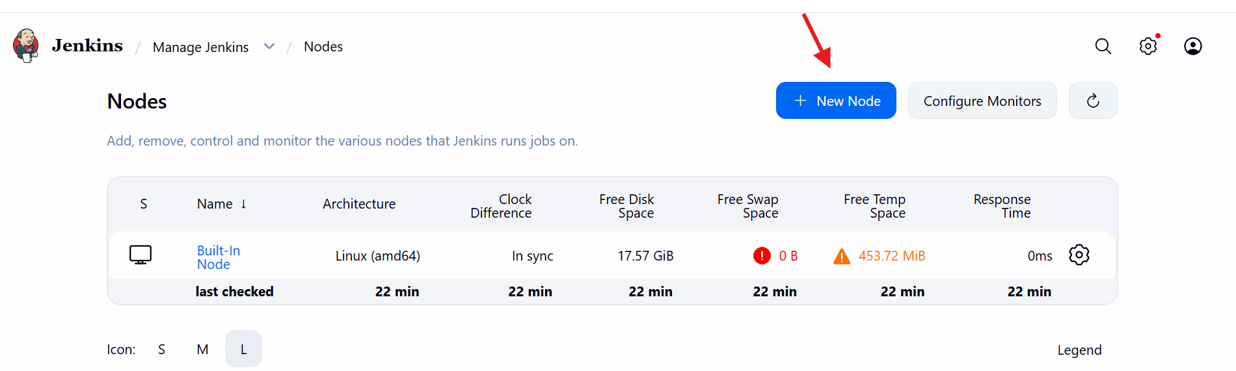
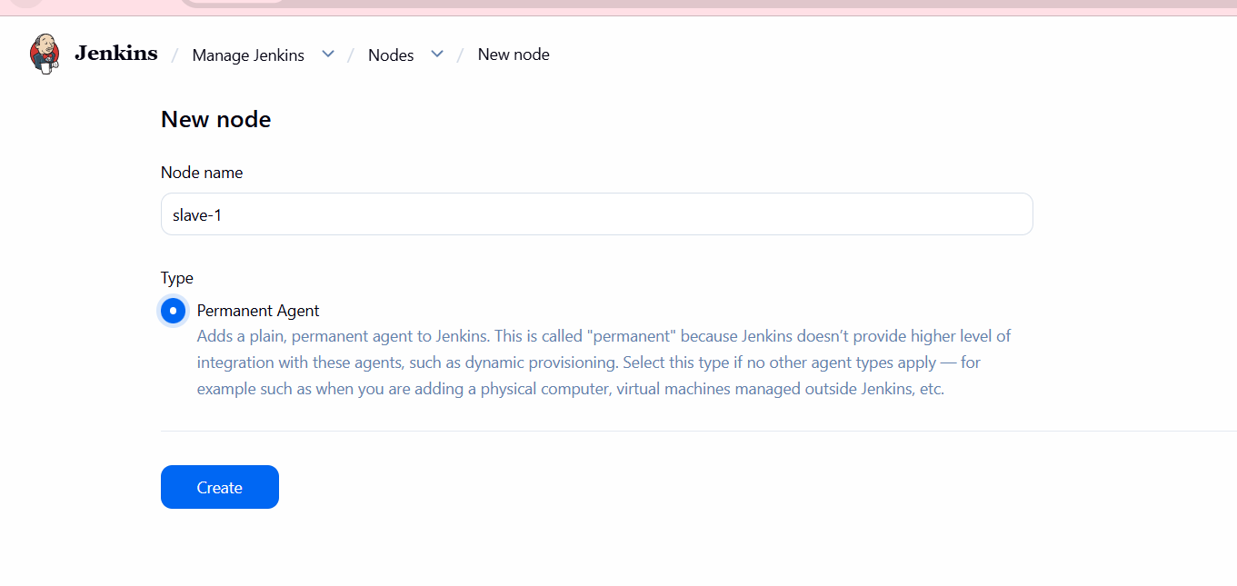
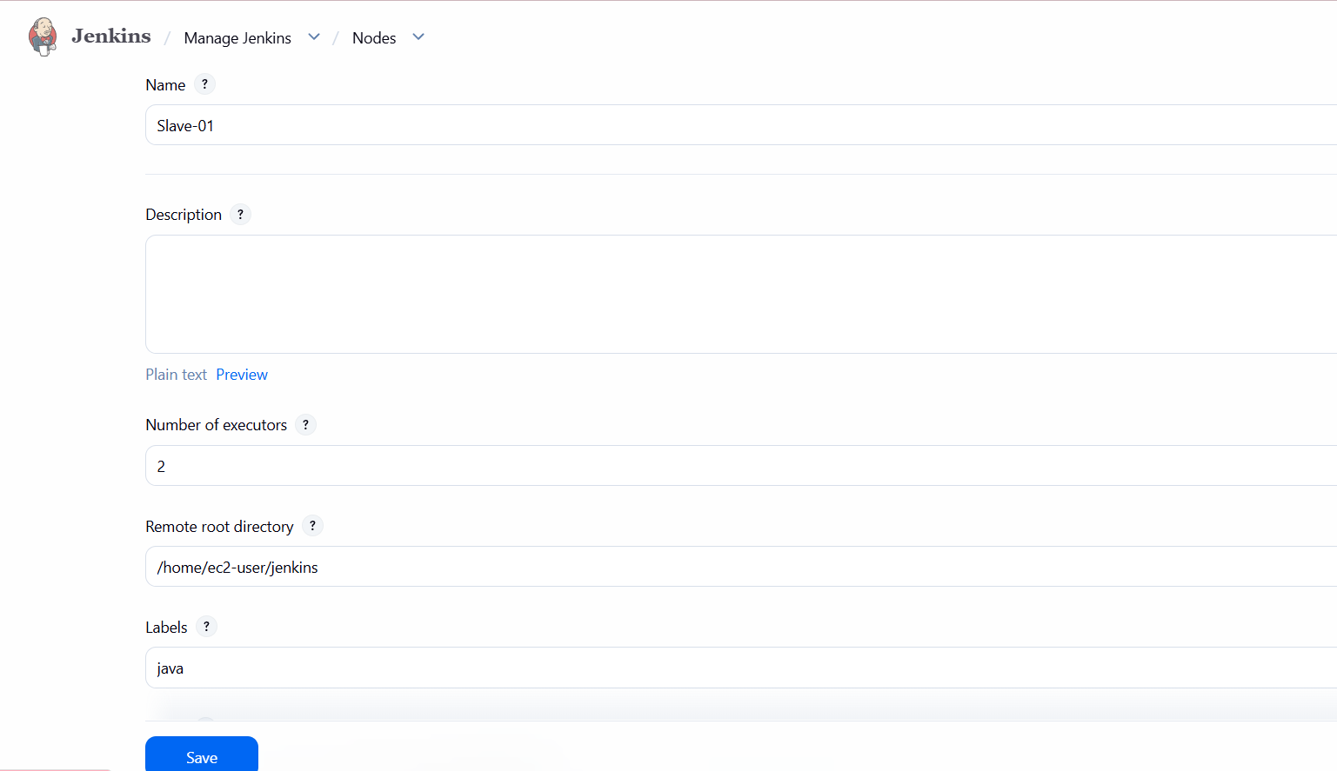

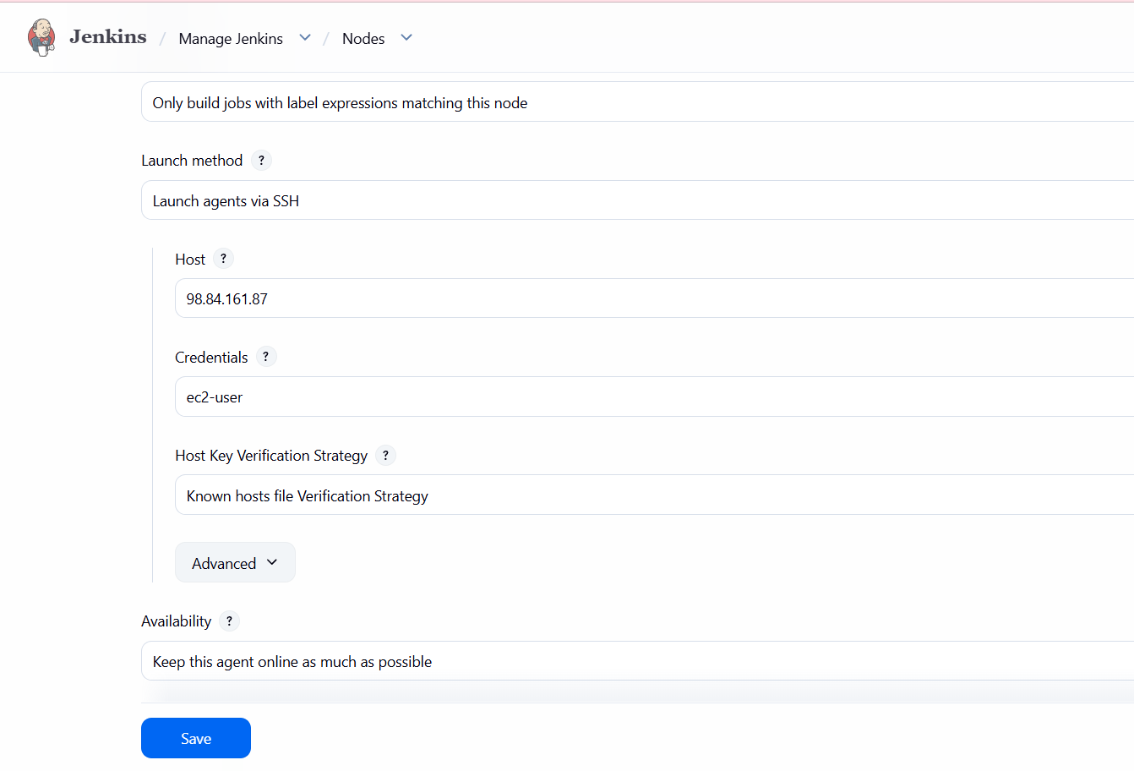
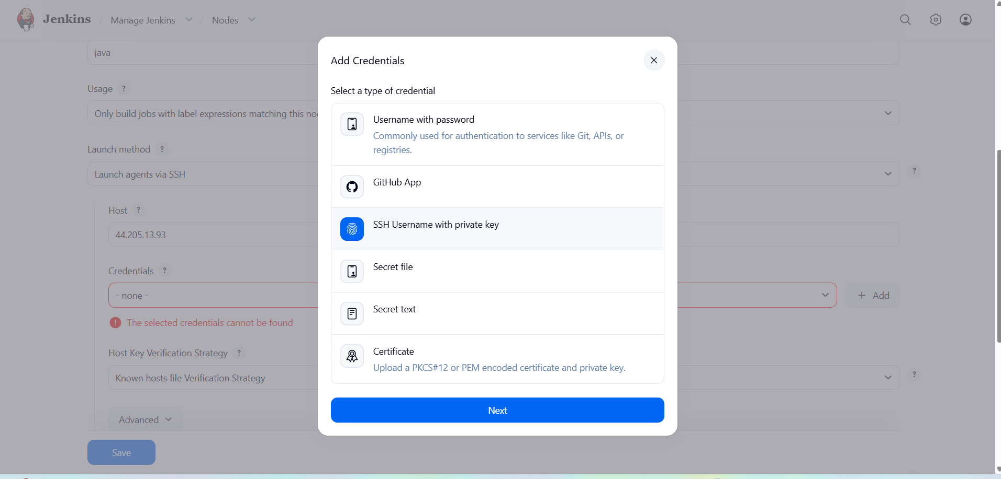
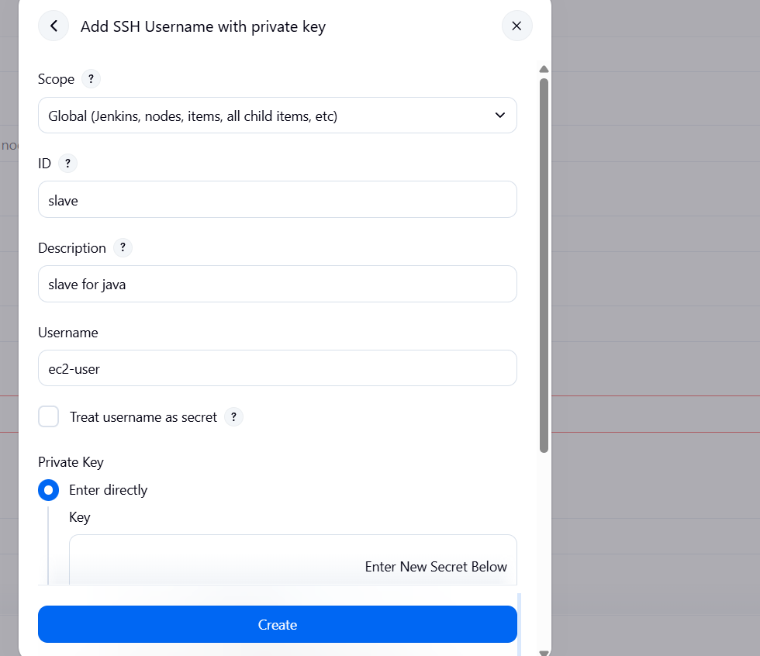
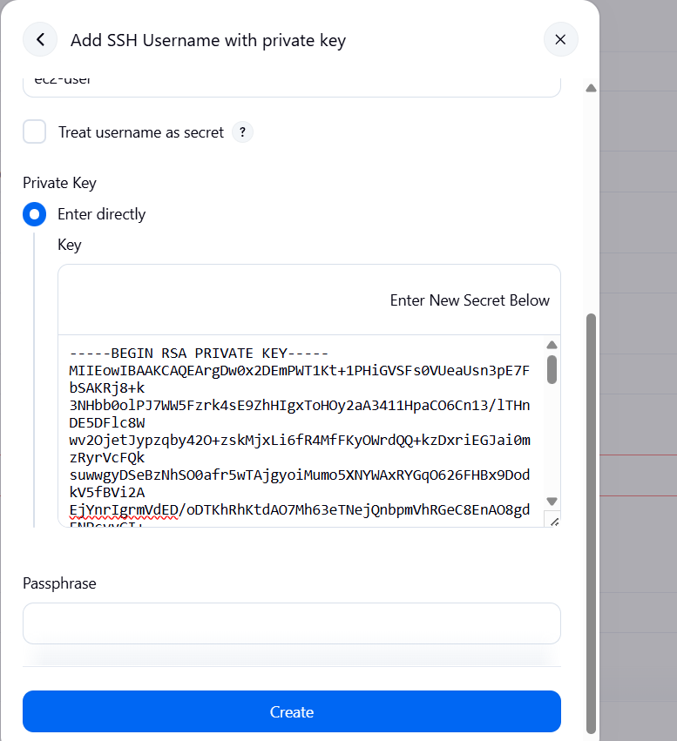
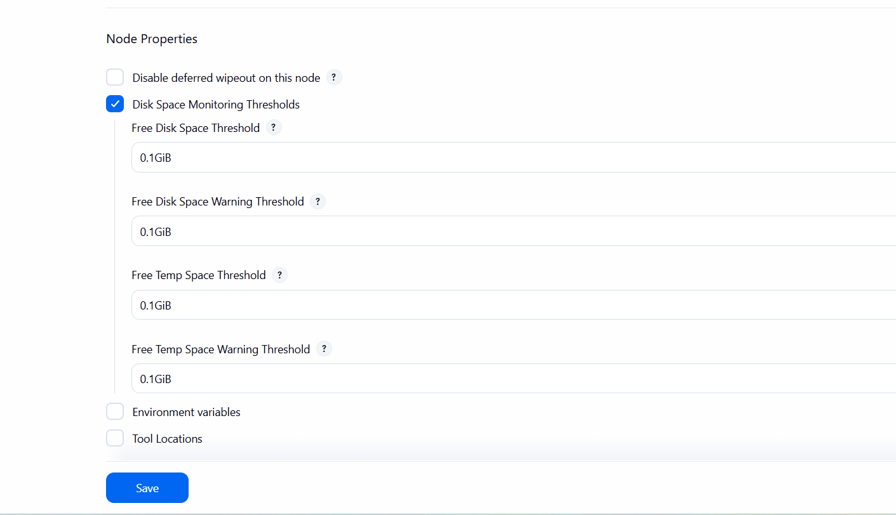
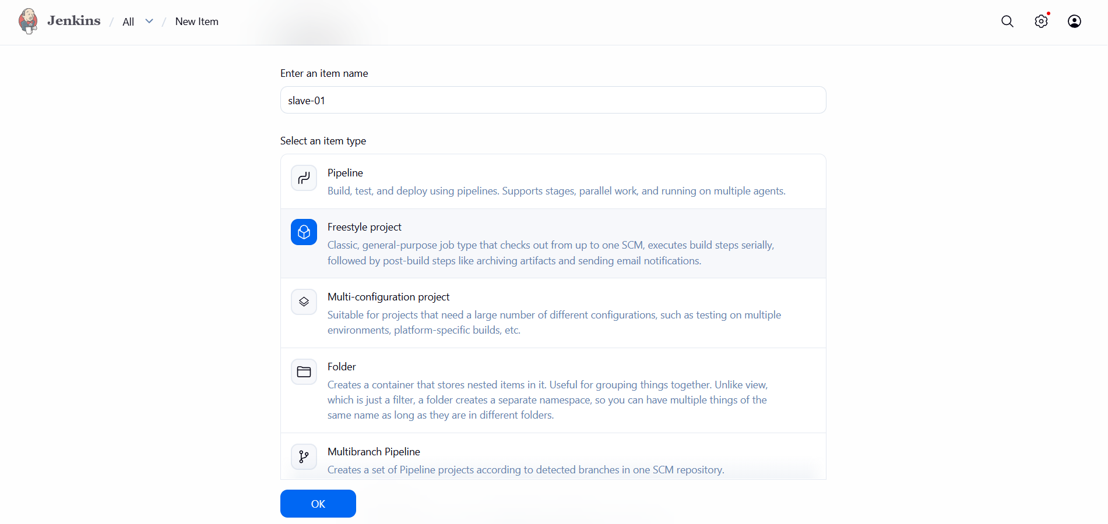
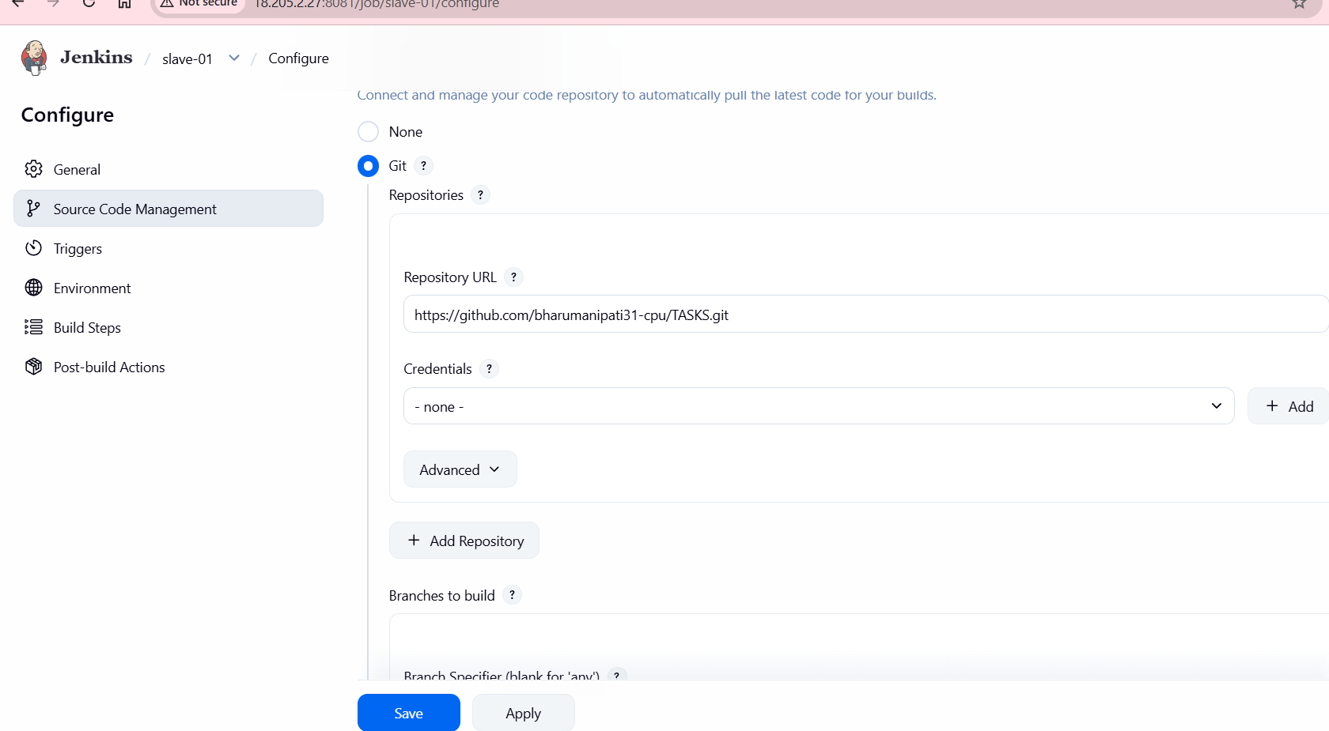
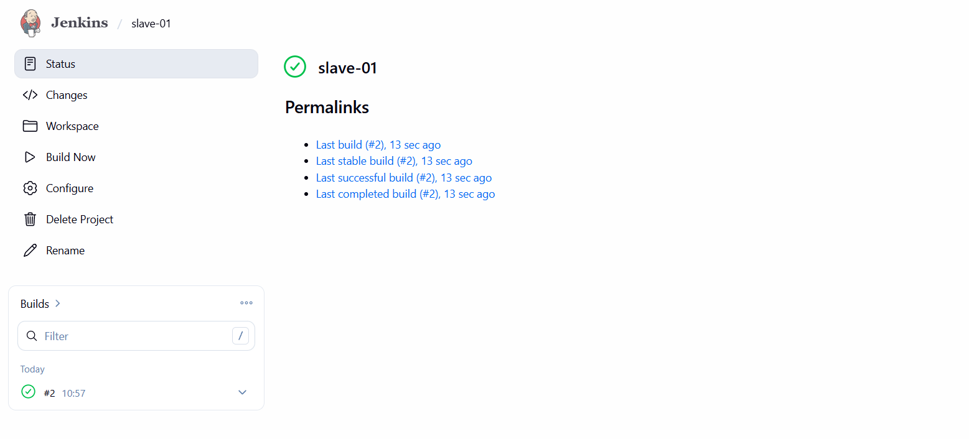
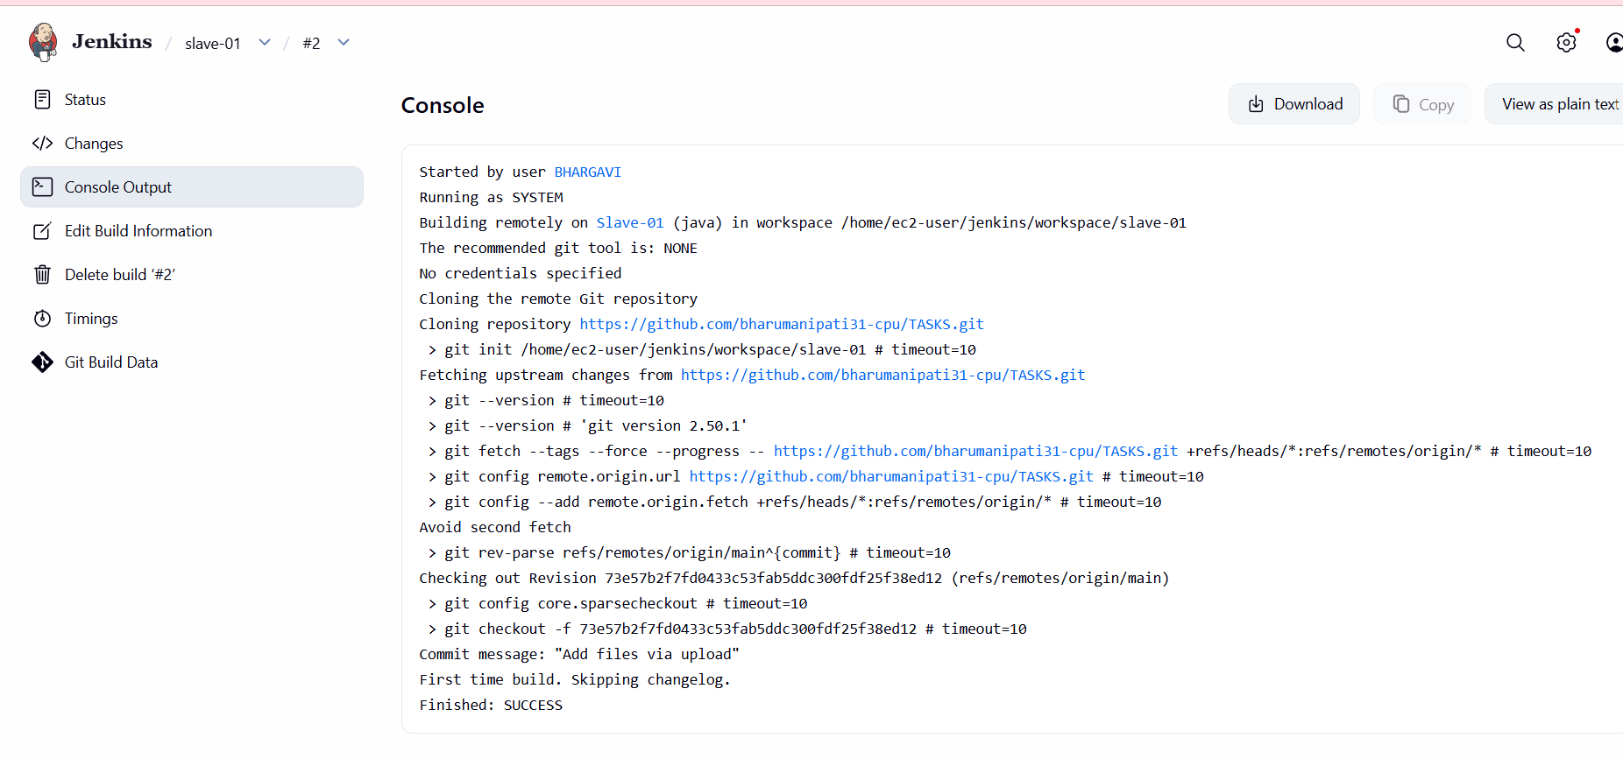
Same process do for slave2 with help of slave-01 copy that existing node

Here we 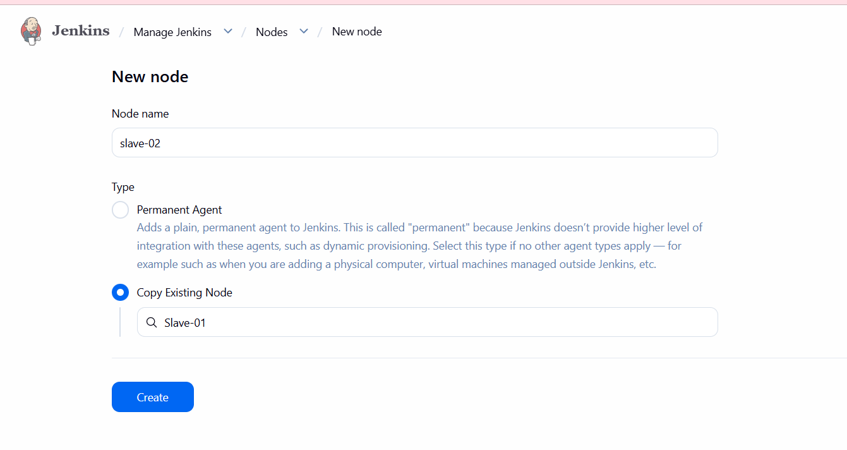
- Can give the slave 2 public ip in the palce of host address—succesfully added master to salve 2
- We can give one command for scan the slave 2
- 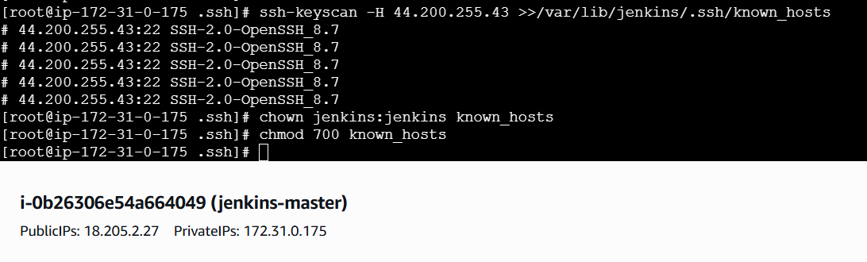

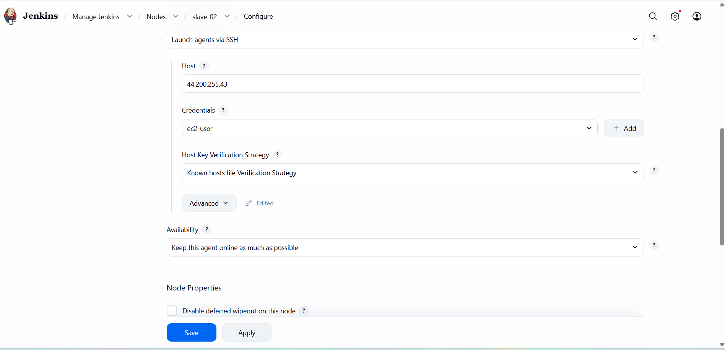

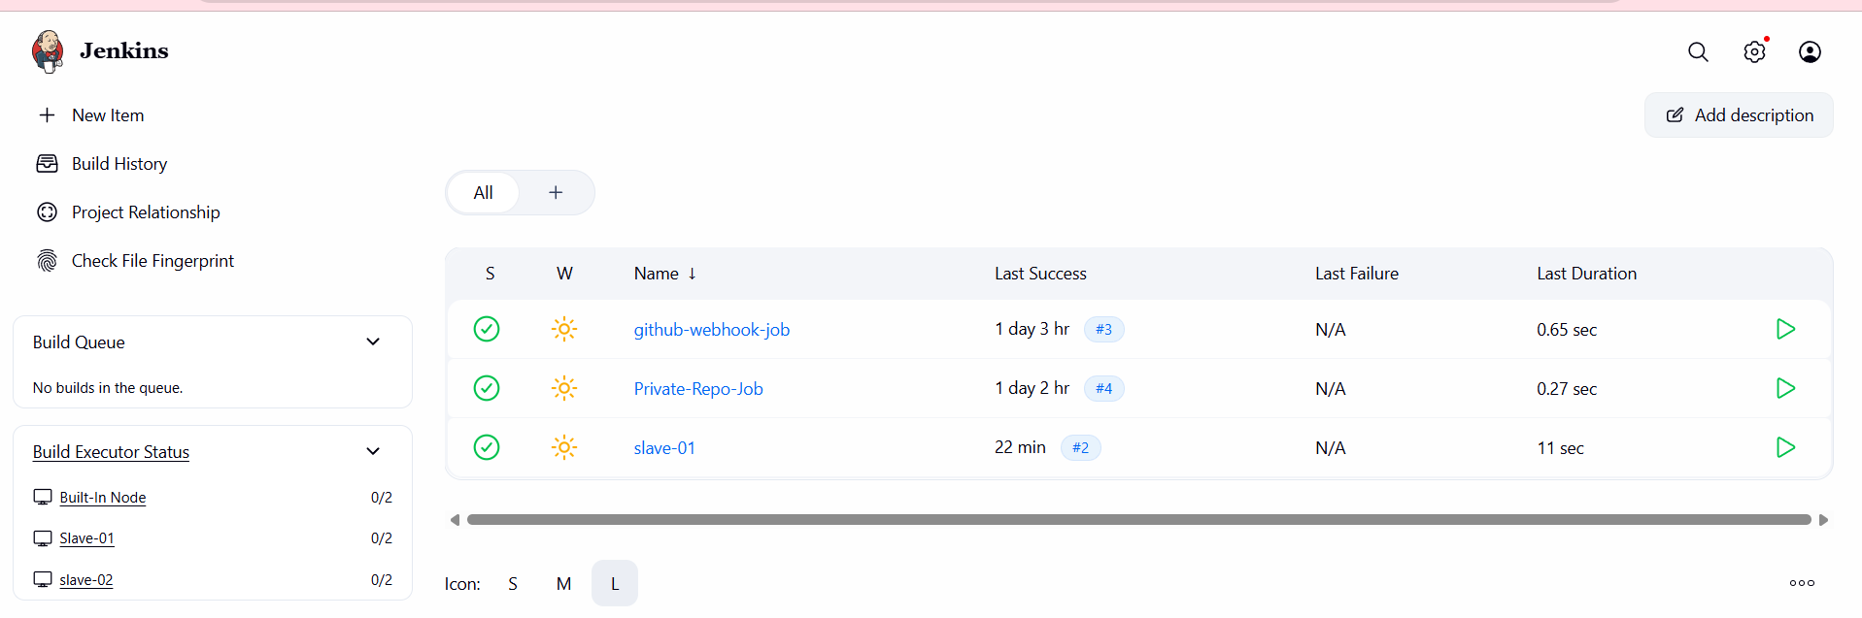
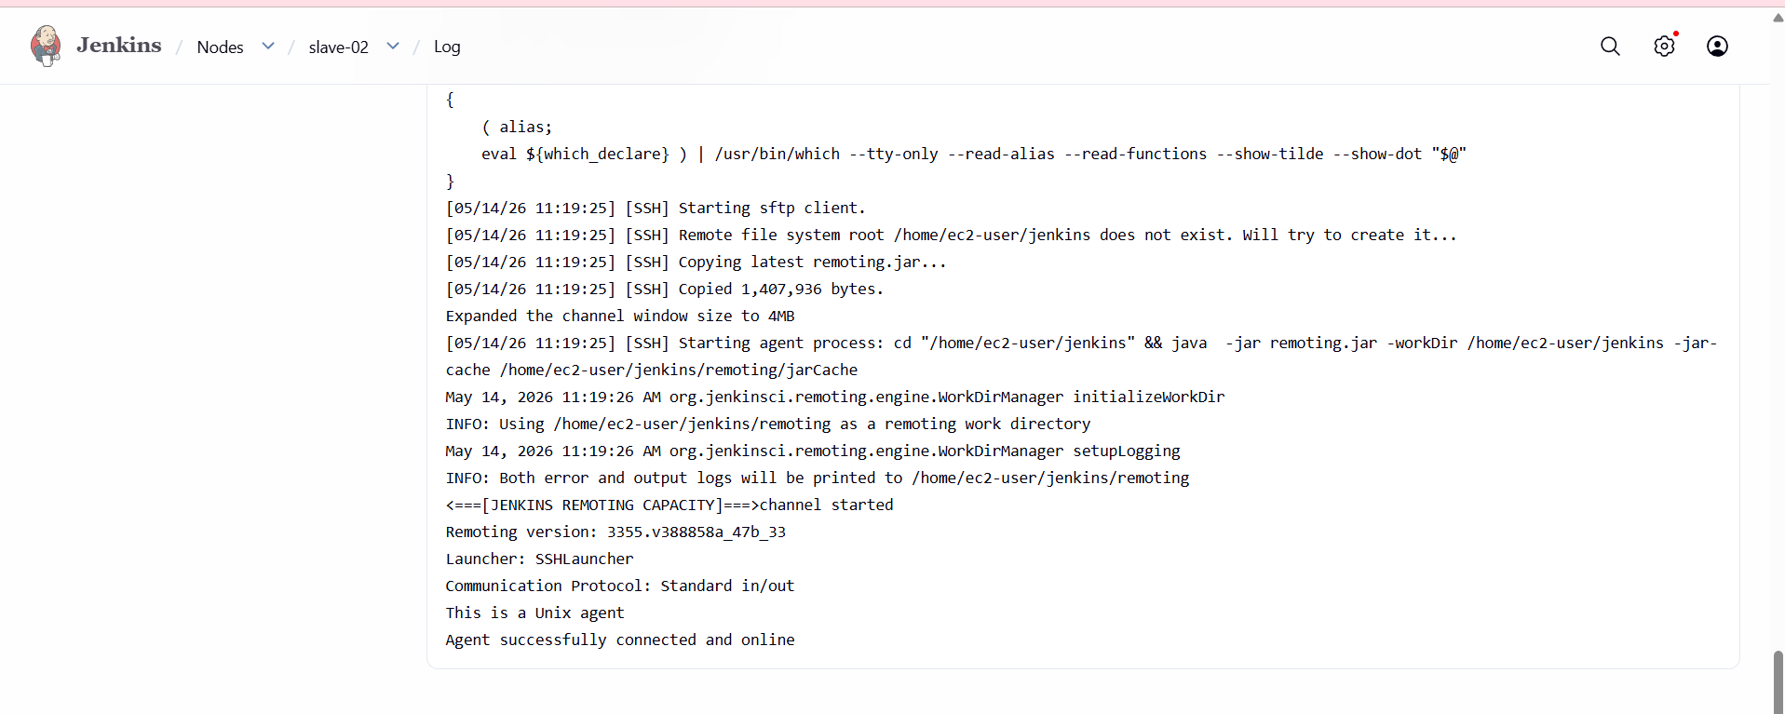

- Configure webhooks to the Jenkins job.
Webhooks are used to automatically trigger Jenkins jobs whenever code is pushed to a GitHub repository
Developer Pushes Code → GitHub Repository → Webhook → Jenkins Job Triggered Automatically
Jenkins Job Configuration
Opened Jenkins and selected the job webhook.
Clicked Configure.
Enabled Restrict where this project can be run.
Entered Label Expression as:
master

Source Code Management Setup
Selected Git under Source Code Management.
Entered Repository URL:
https://github.com/mujahed1716/devops-hub.git
Left Credentials as none (public repository).
Trigger Configuration
Navigated to Triggers section.
Enabled:
GitHub hook trigger for GITScm polling
Build Step Configuration
Scrolled to Build Steps.
Selected Execute shell.
Added command:
sleep 15
Clicked Save.
GitHub Webhook Creation
Opened GitHub repository:
mujahed1716/devops-hub
Navigated to:
Settings → Webhooks → Add webhook
Entered Payload URL:
http://13.53.212.231:8081/github-webhook/
Selected Content type:
application/json
Kept Secret empty.
Selected:
Send me everything
Enabled Active.
Clicked Add webhook.
Verified webhook added successfully.

Repository Change
Opened README.md in the repository.
Edited the file.
Committed changes to the master branch.
Jenkins Build Execution
GitHub webhook triggered Jenkins automatically.
Jenkins job started without manual build.
Build executed on Built-in (master) node.
Jenkins cloned the repository successfully.
Shell command executed.
Console output showed:
job triggered successfully
Build finished with SUCCESS status.

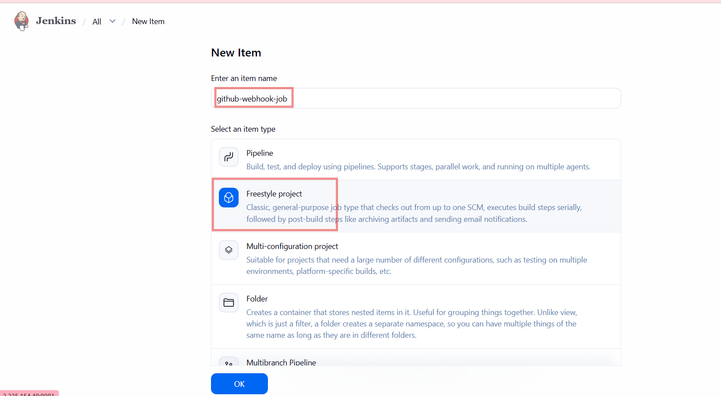
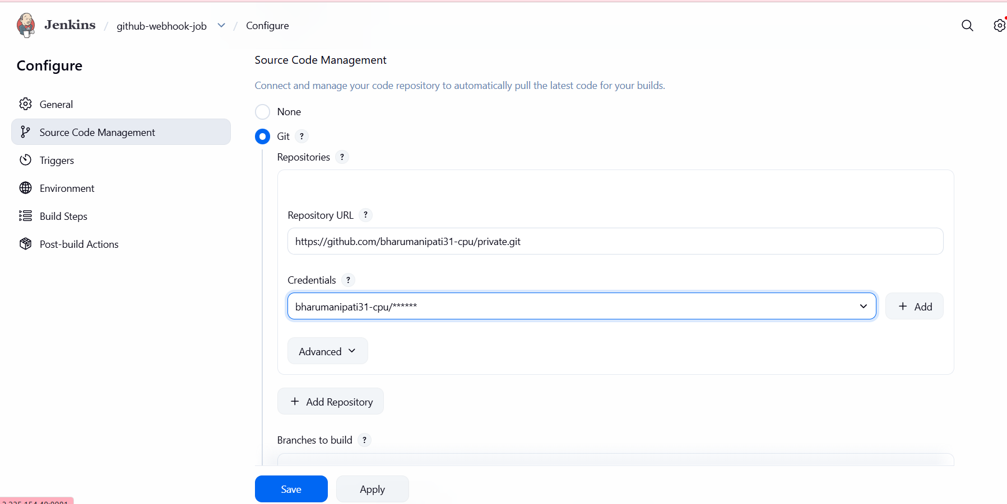
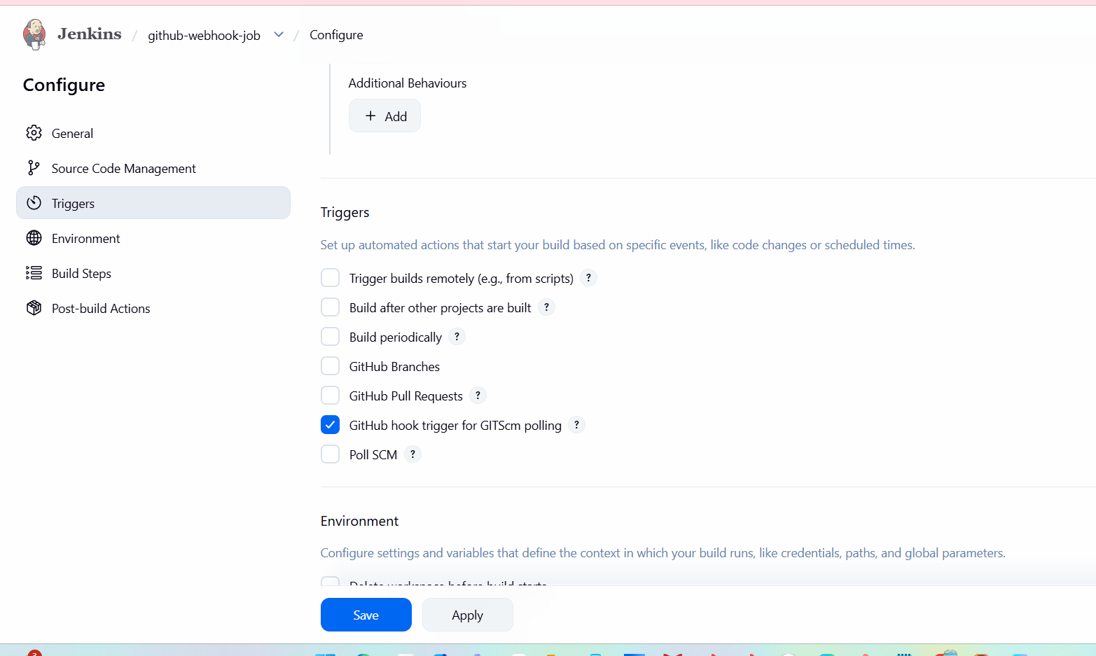
- Open GitHub and open private repo and in that settings open webhooks and add new.

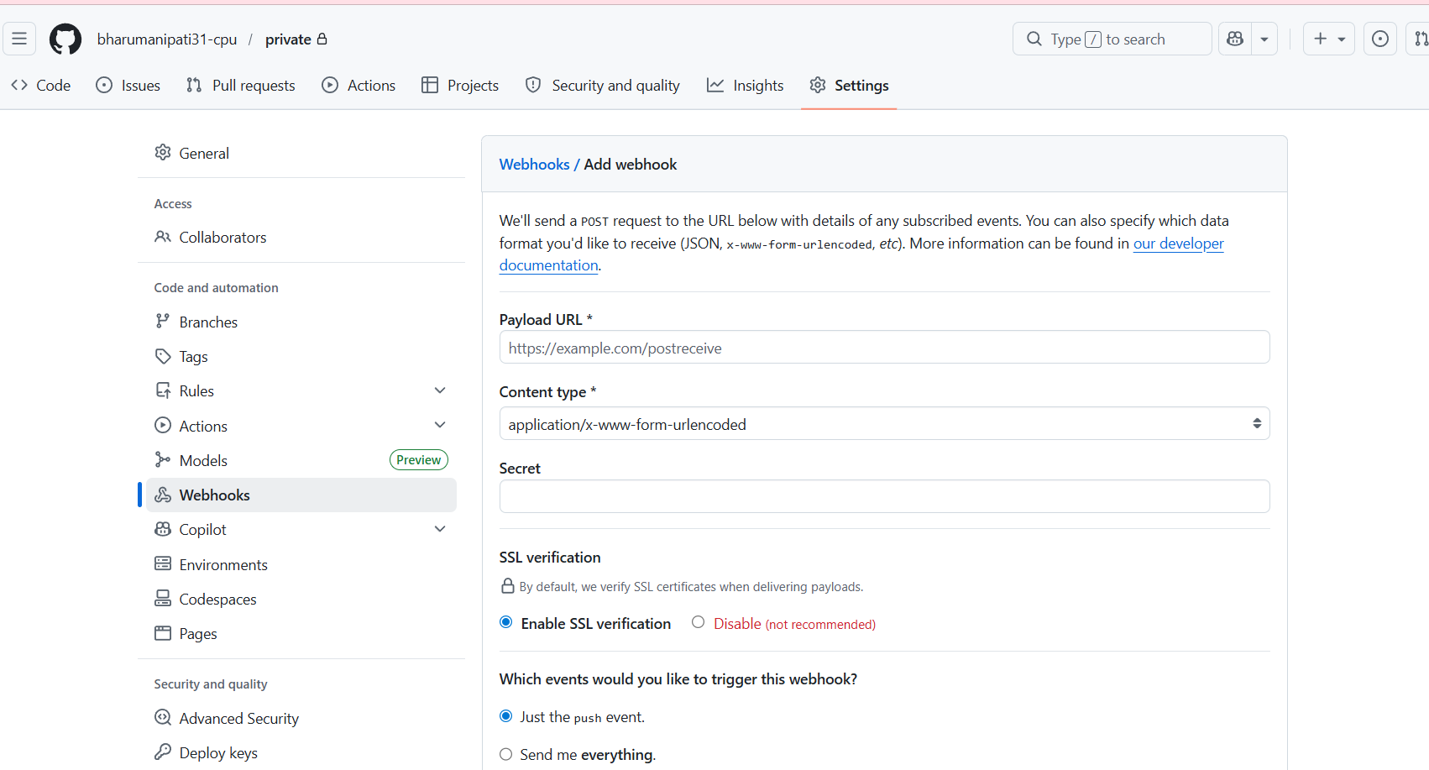
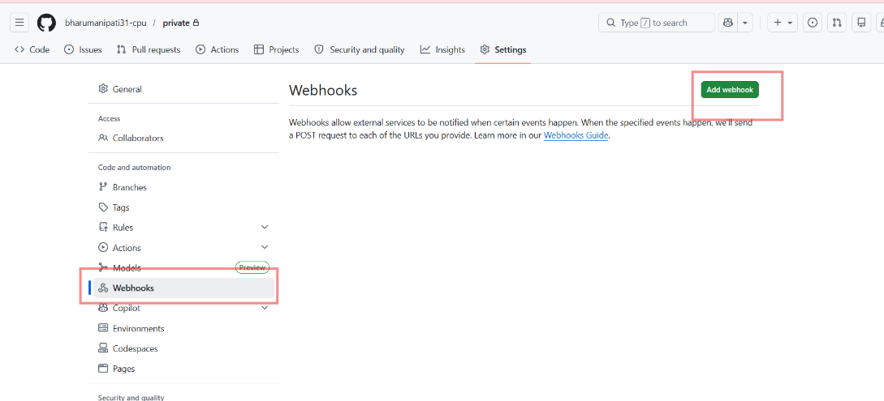

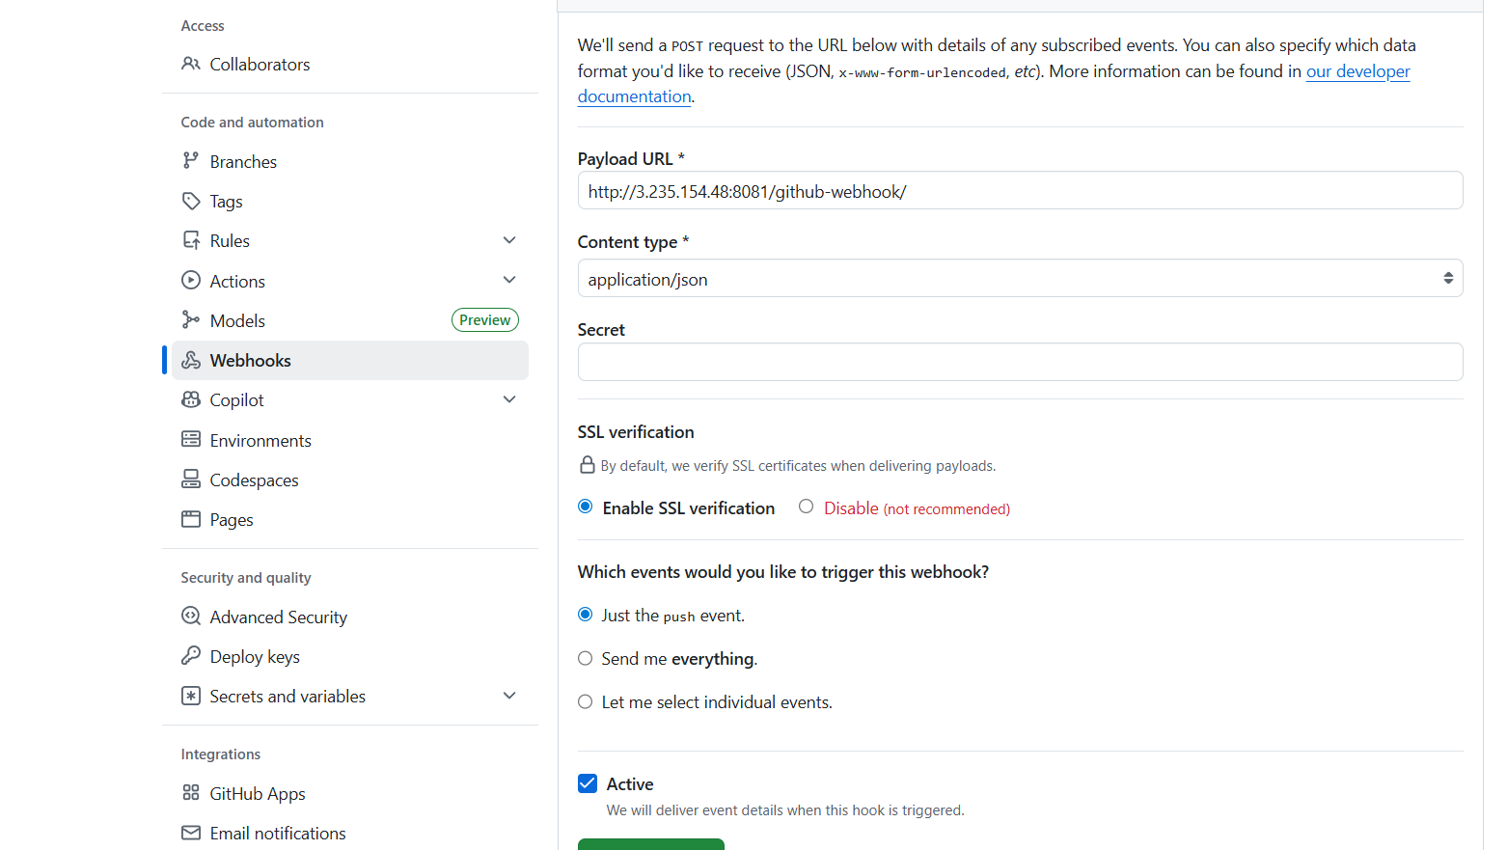
Select here Send me everything
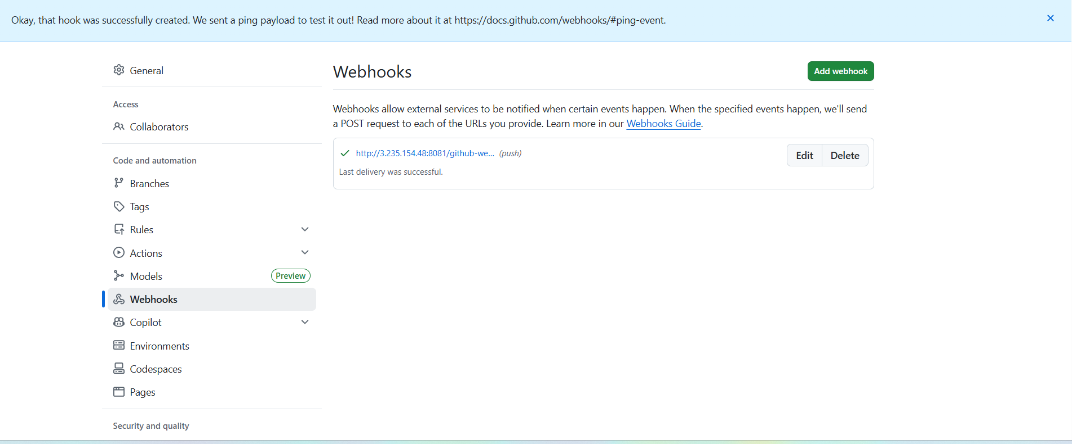
- We can see successfully webhook created
- Make any commits in repository and check in webhooks it shows
- Now we can see automatically build
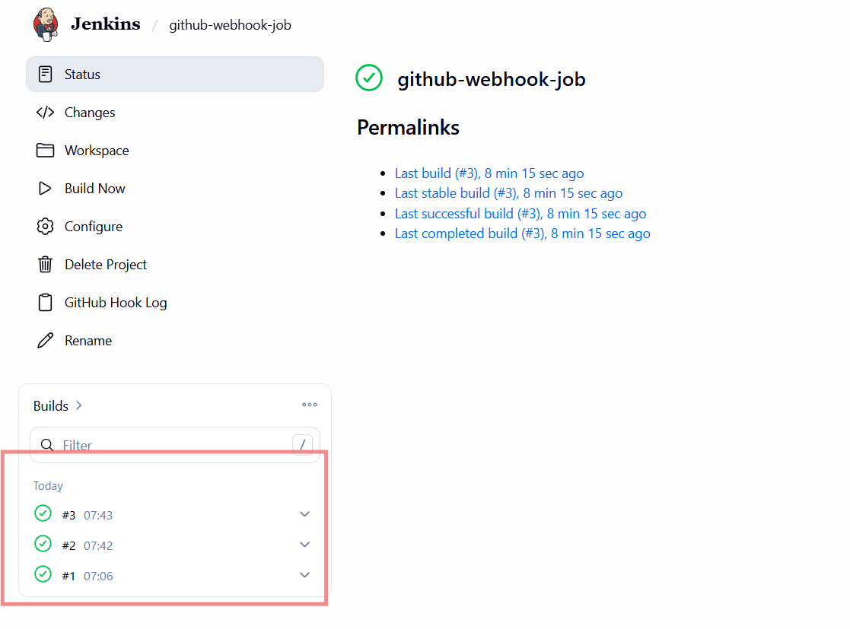
Go to githubprivate repo—>upload new filewe see automatically configure in jenkins
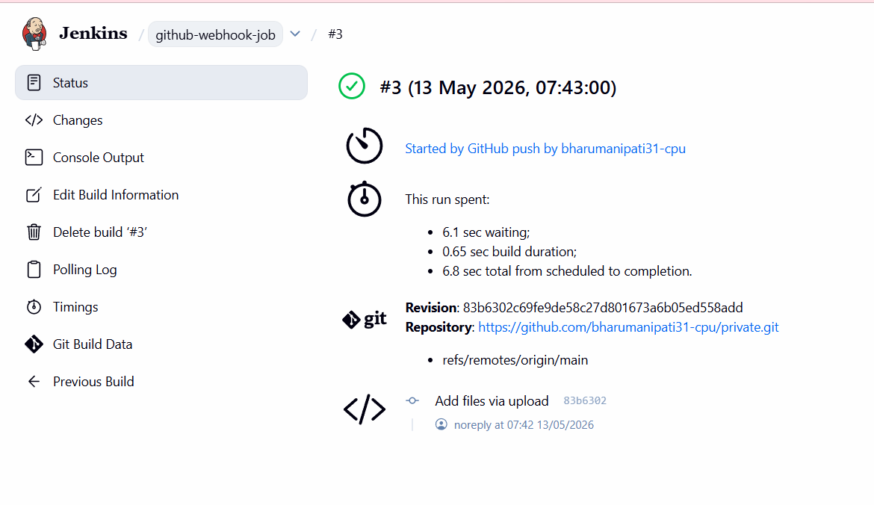

- Configure Poll SCM and Build Periodically options in the Jenkins job.

Steps Performed – Jenkins Periodic Build (first_job)
Job General Configuration
Opened Jenkins and selected first_job.
Clicked Configure.
Added Description:
added build periodically
Enabled Restrict where this project can be run.
Set Label Expression to:
master
Source Code Management
Navigated to Source Code Management.
Selected Git.
Entered Repository URL:
https://github.com/mujahed1716/devops-hub.git
Left Credentials as none.
Set Branch Specifier to:
*/master
Trigger – Build Periodically
Opened Triggers section.
Enabled Build periodically.
Entered schedule:
* * * * *
Saved the job configuration.
Jenkins Built Execution
Jenkins automatically triggered builds based on the schedule.
Multiple builds appeared in Build History.
Selected a build and opened Console Output.
Verified message:
Started by timer
Jenkins fetched the latest code from GitHub.
Build completed with SUCCESS status.
SCM Trigger Verification
Returned to Triggers configuration.
Enabled Poll SCM.
Entered schedule:
* * * * *
Saved configuration.
GitHub Repository Change
Opened GitHub repository devops-hub.
Edited README.md.
Added content to the file.
Committed changes to master branch.
Jenkins SCM-Based Build
Jenkins detected SCM change.
New build appeared with status Started by an SCM change.
Opened Console Output.
Verified Git fetch and checkout steps.
Build completed with SUCCESS.

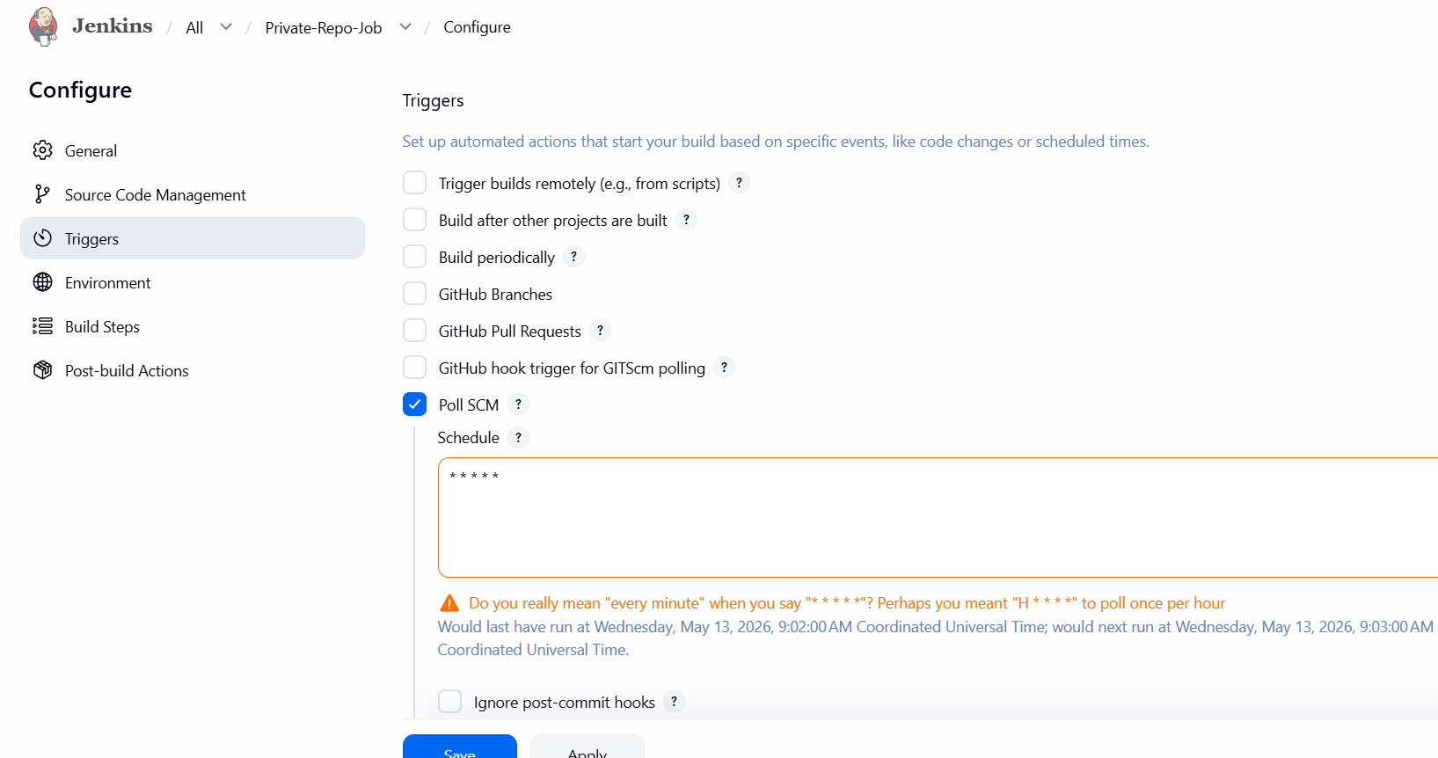
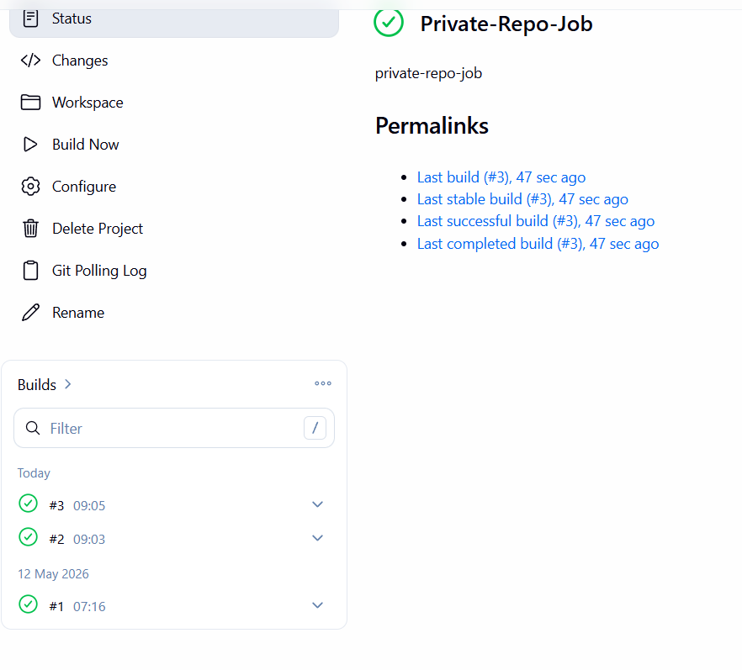
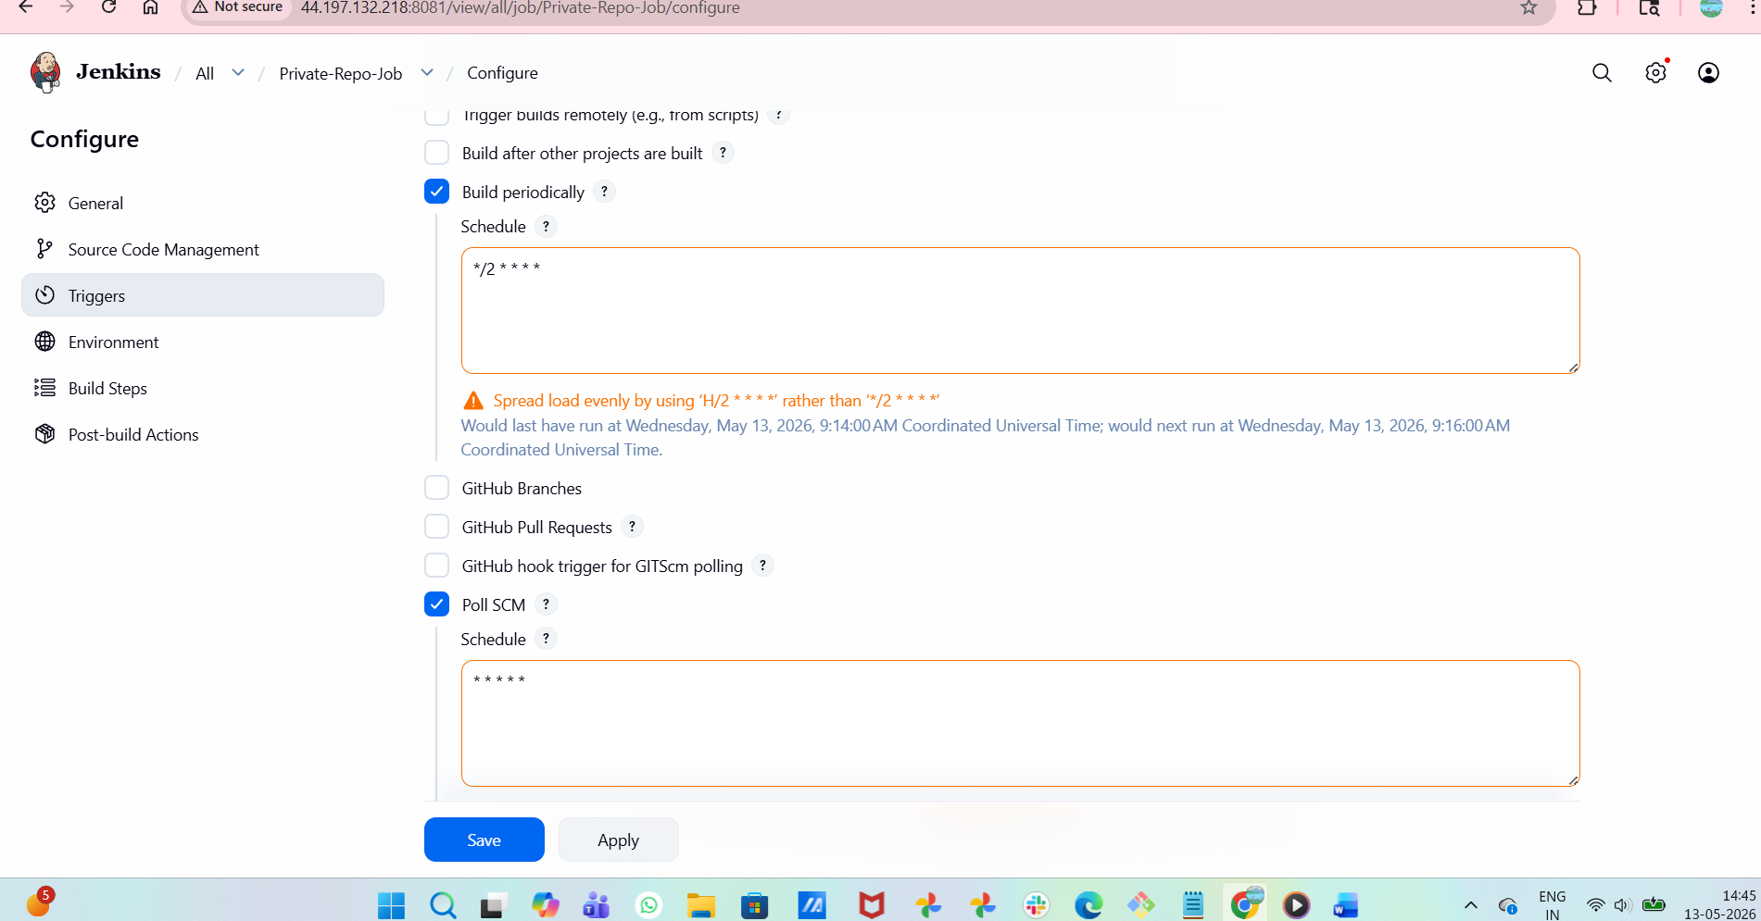
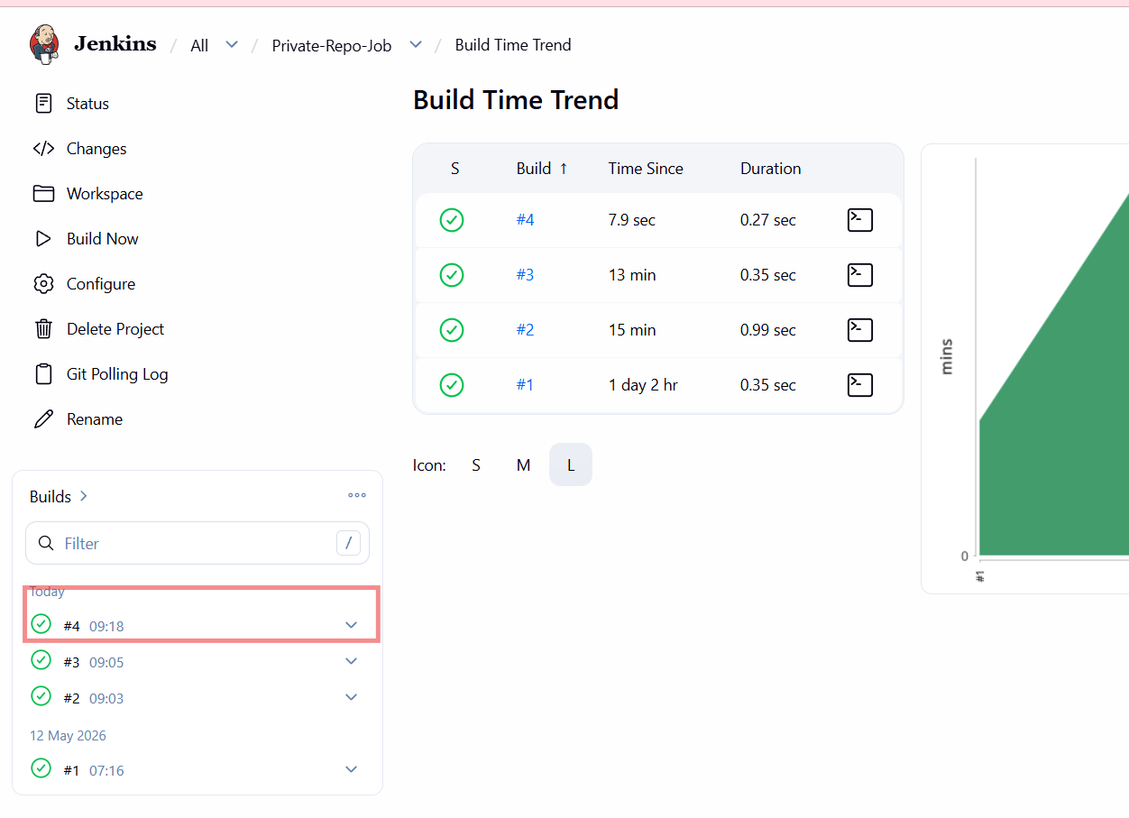
- Take a backup of the Jenkins server using a bash-script.
Steps Performed – Jenkins Backup Script
Logged in to the server as root.
Navigated to /opt directory:
cd /opt
Listed contents of /opt:
ls
Created a directory for scripts:
mkdir /opt/scripts
Moved into the scripts directory:
cd /opt/scripts
Created a backup script file:
vi jenkins_backup.sh
Added Jenkins backup script content defining:
  - Jenkins home directory
  - Backup directory
  - Date variable
  - tar command with exclusions
Saved and exited the script file.
Provided execute permission to the script:
chmod +x jenkins_backup.sh
Executed the backup script:
./jenkins_backup.sh
Verified message displayed:
Online Jenkins backup completed
Backup Verification
Navigated back to /opt:
cd /opt
Listed directories:
ls
Entered Jenkins backup directory:
cd jenkins-backup
Listed backup files:
ls
Confirmed Jenkins backup archive created:
jenkins_backup_2025-12-25_13-57.tar.gz

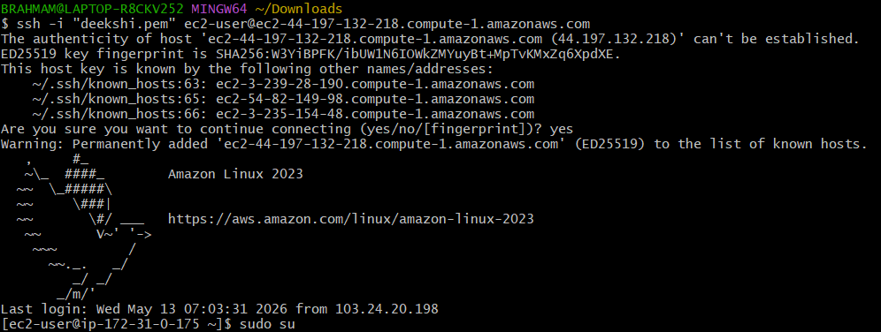
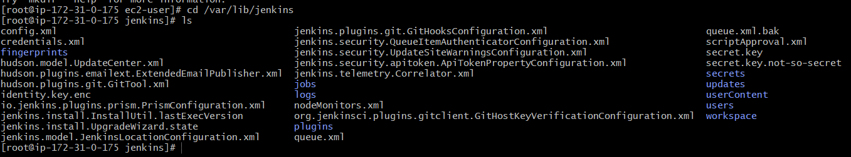
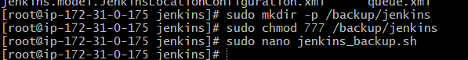
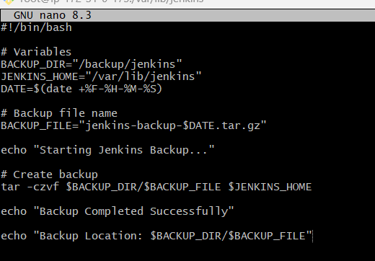
- Now give permissions and run it and then backup Jenkins
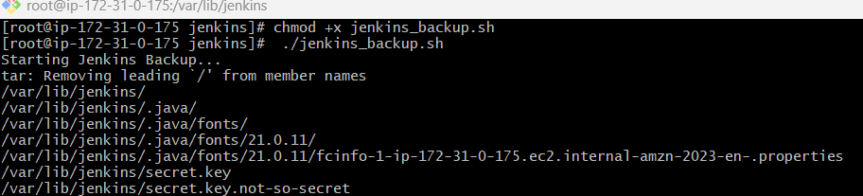
- Backup done successfully now we can verify it by ls -h
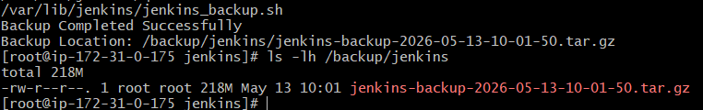

5.Take a backup of Jenkins using the Thin Backup plugin.
Steps Performed – Jenkins ThinBackup Plugin Backup
Install ThinBackup Plugin
Opened Jenkins UI.
Navigated to:
Manage Jenkins → Plugins → Available plugins
Searched for ThinBackup.
Selected the ThinBackup plugin.
Clicked Install.
Plugin Installation Verification
Opened Download progress page.
Verified:
  - Internet connectivity check → Success
  - Update center connectivity → Success
  - ThinBackup plugin → Installed successfully
Clicked Go back to the top page.
Access ThinBackup
Navigated to:
Manage Jenkins → ThinBackup
Confirmed ThinBackup page loaded successfully.
Observed available options:
- Backup now
- Restore
Prepare Backup Directory on Server
Logged in to Jenkins server as root.
Created backup directory:
mkdir -p /opt/jenkins-backup
Changed ownership to Jenkins user:
chown -R jenkins:jenkins /opt/jenkins-backup
Set permissions:
chmod 755 /opt/jenkins-backup
Verify Backup File
Listed contents of backup directory:
ls -ltr /opt/jenkins-backup
Verified backup archive exists:
jenkins_backup_2025-12-25_13-57.tar.gz

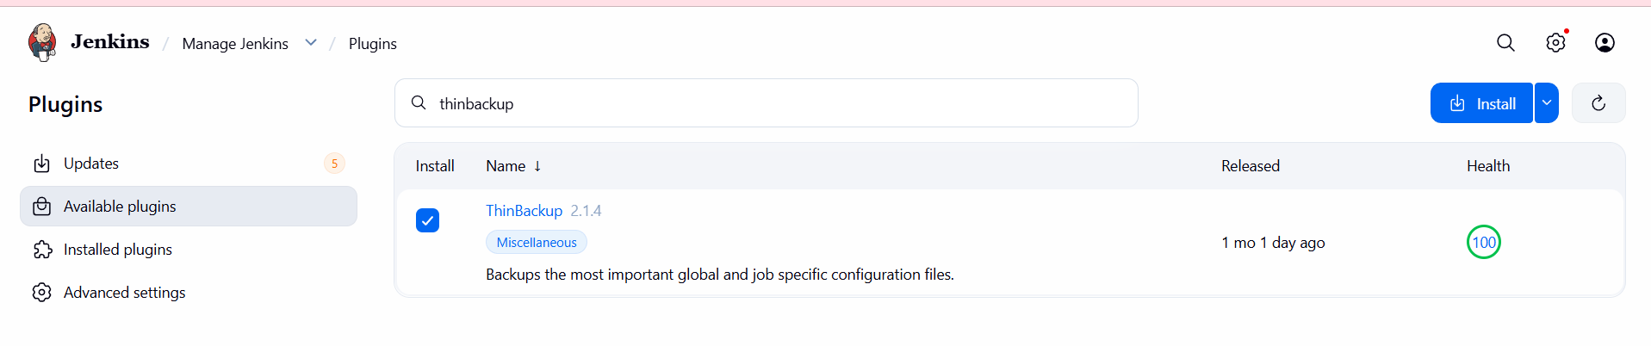
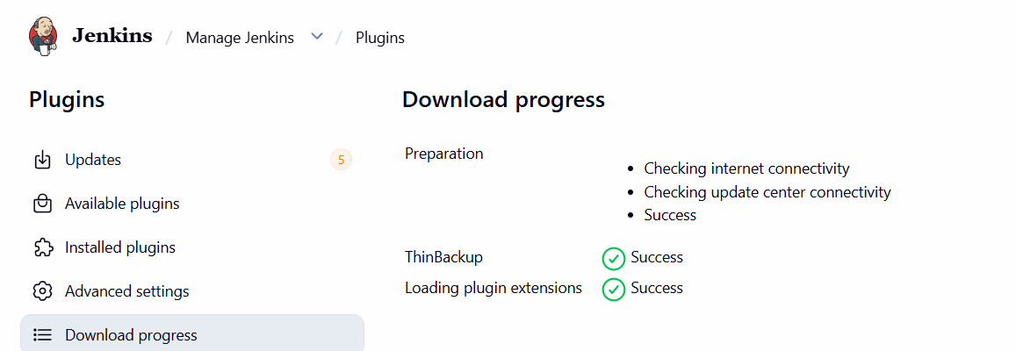
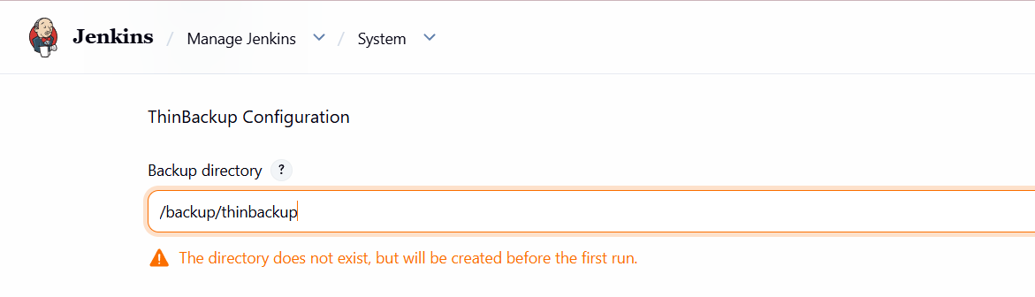
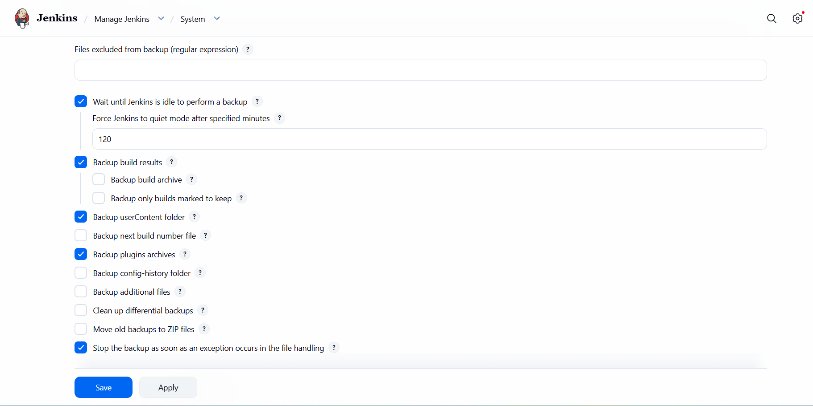

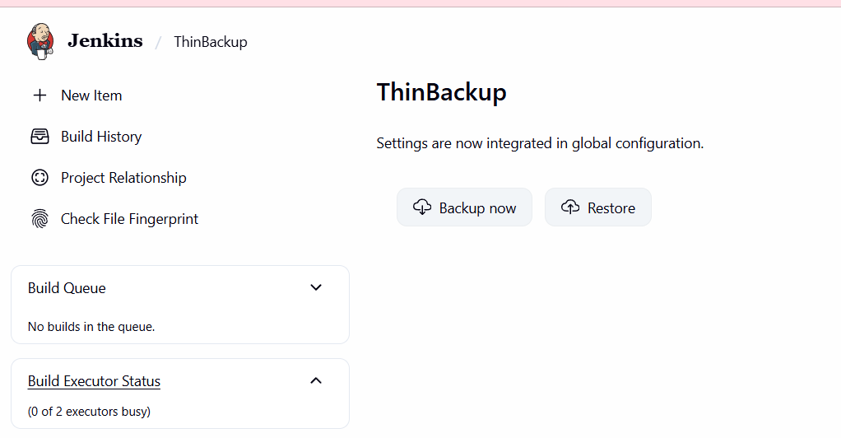
- ls -lh /backup/thinbackup/
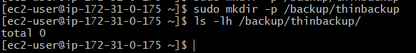

6.Set up a new Jenkins server and restore the backup taken in task 4.
On Jenkins Master (Old Server)
Logged in to jenkins-master EC2 instance.
Navigated to /opt:
cd /opt
Listed directories and verified jenkins-backup exists.
Moved into backup directory:
cd jenkins-backup
Verified Jenkins backup file is present:
jenkins_backup_2025-12-25_13-57.tar.gz
On Backup EC2 Instance (New Server)
Logged in to backup EC2 instance.
Added Jenkins repository:
wget -O /etc/yum.repos.d/jenkins.repo https://pkg.jenkins.io/redhat/jenkins.repo
Imported Jenkins GPG key:
rpm --import https://pkg.jenkins.io/redhat-stable/jenkins.io-2023.key
Installed Java:
yum install java-17-amazon-corretto -y
Installed Jenkins:
yum install jenkins -y
Started Jenkins service:
systemctl start jenkins
Verified Jenkins service status:
systemctl status jenkins
Access Jenkins on Backup Server
Opened browser and accessed Jenkins:
http://56.228.32.222:8080
Confirmed Jenkins UI loaded successfully.
Transfer Backup File to Backup Server
Returned to jenkins-master.
Changed permission on backup file:
Created a file test.pem and copied pem key
chmod 600 test.pem
Copied backup file to backup server:
scp -i test.pem jenkins_backup_2025-12-25_13-57.tar.gz ec2-user@56.228.32.222:/tmp
Accepted SSH host key when prompted.
Verified file transfer completed successfully.
Restore Backup on Backup Server
Logged in to backup EC2 instance.
Navigated to /tmp:
cd /tmp
Verified backup file exists:
jenkins_backup_2025-12-25_13-57.tar.gz
Extracted backup into Jenkins home:
tar -xvf jenkins_backup_2025-12-25_13-57.tar.gz -C /var/lib/jenkins
Verified Jenkins files restored under /var/lib/jenkins.
Restart Jenkins
Restarted Jenkins using browser:
http://56.228.32.222:8080/restart
Jenkins restarted successfully.
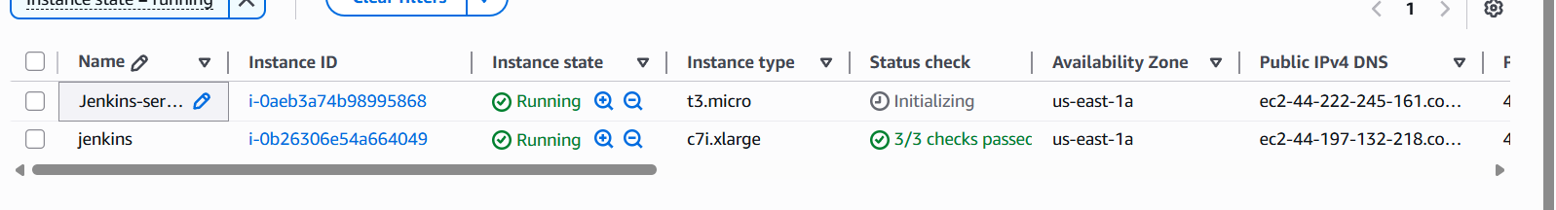
We need to copy the pem key of our new instance on our old instance
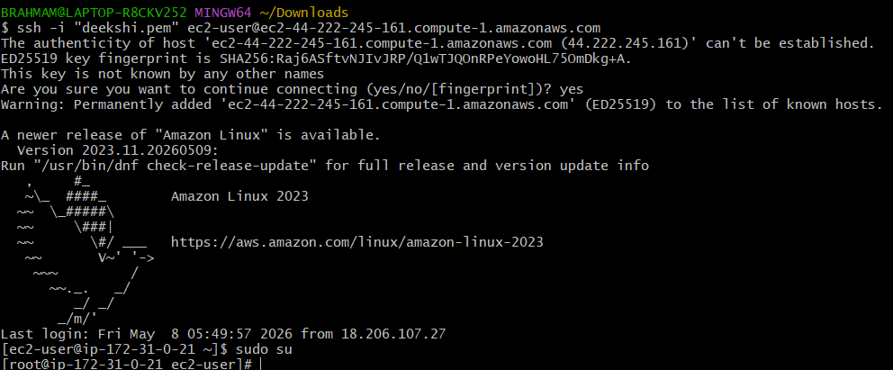
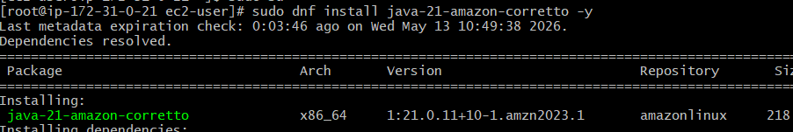
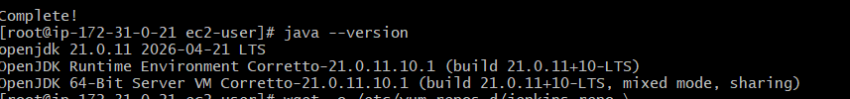
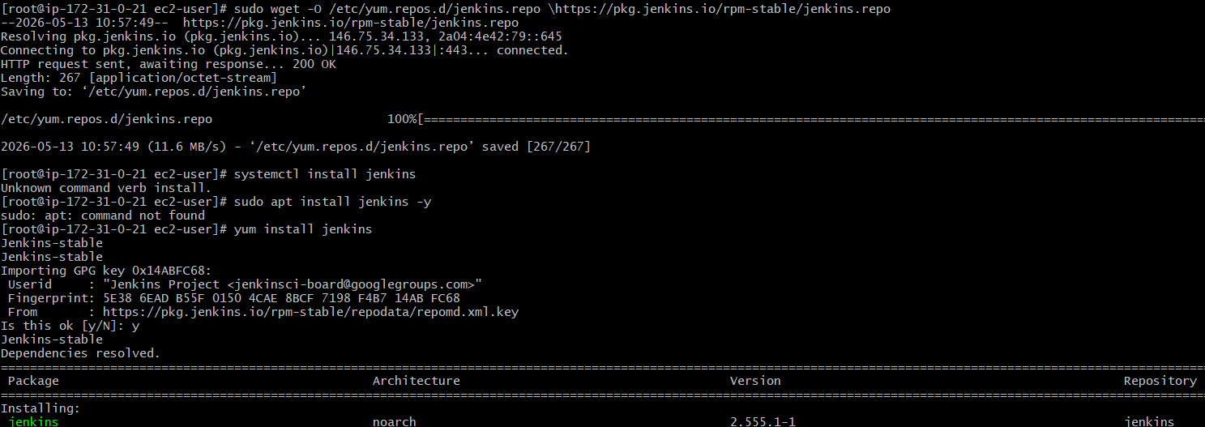
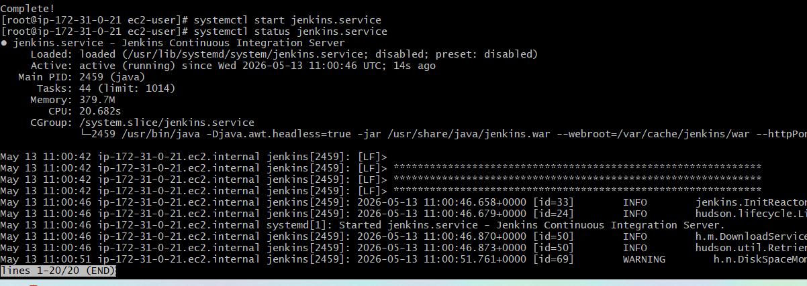
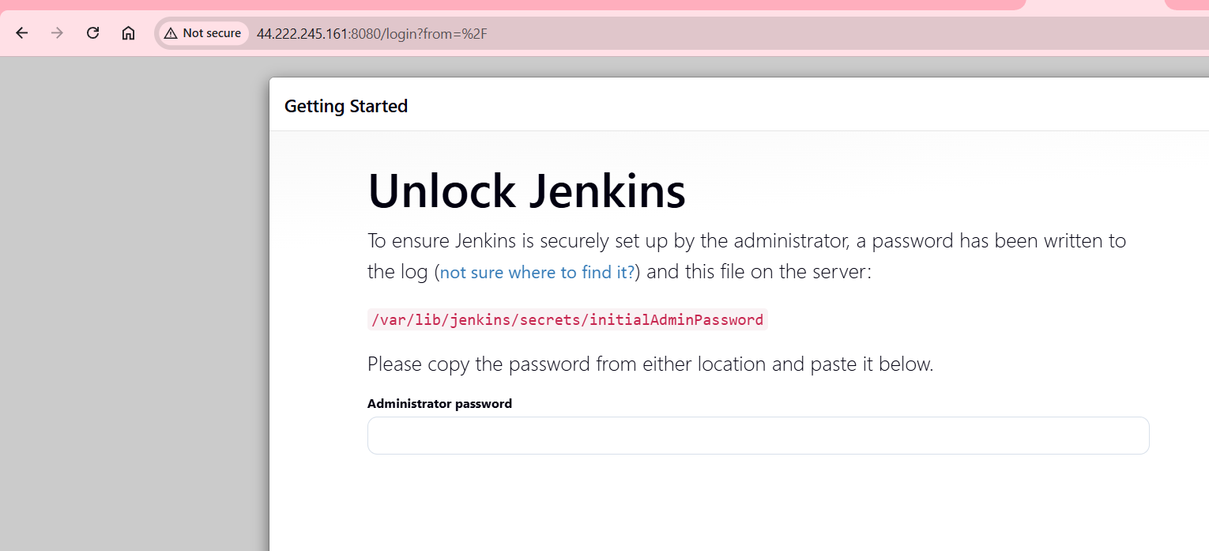

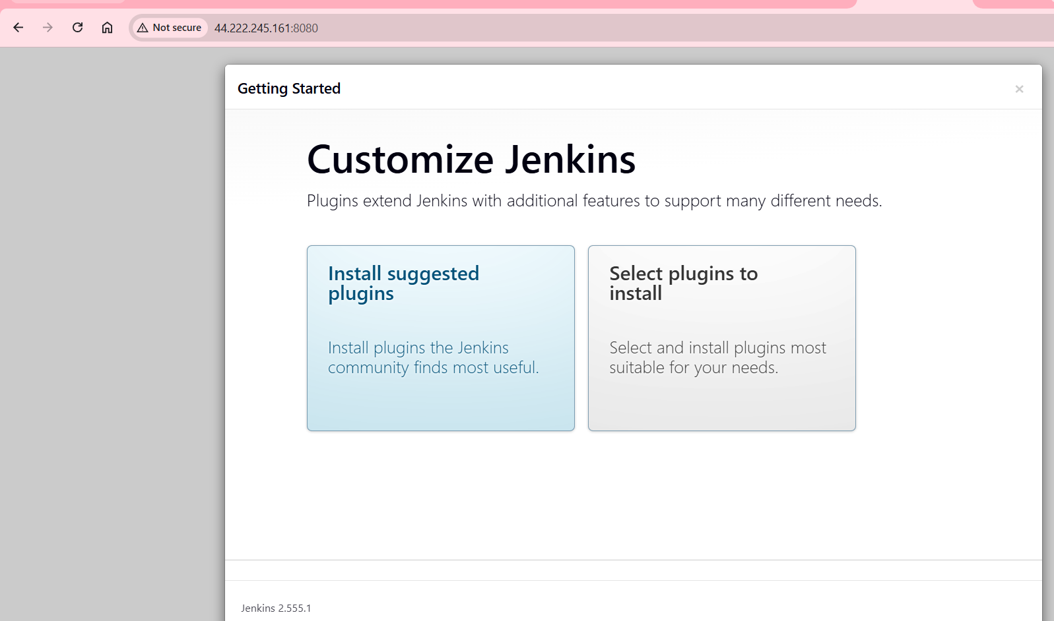
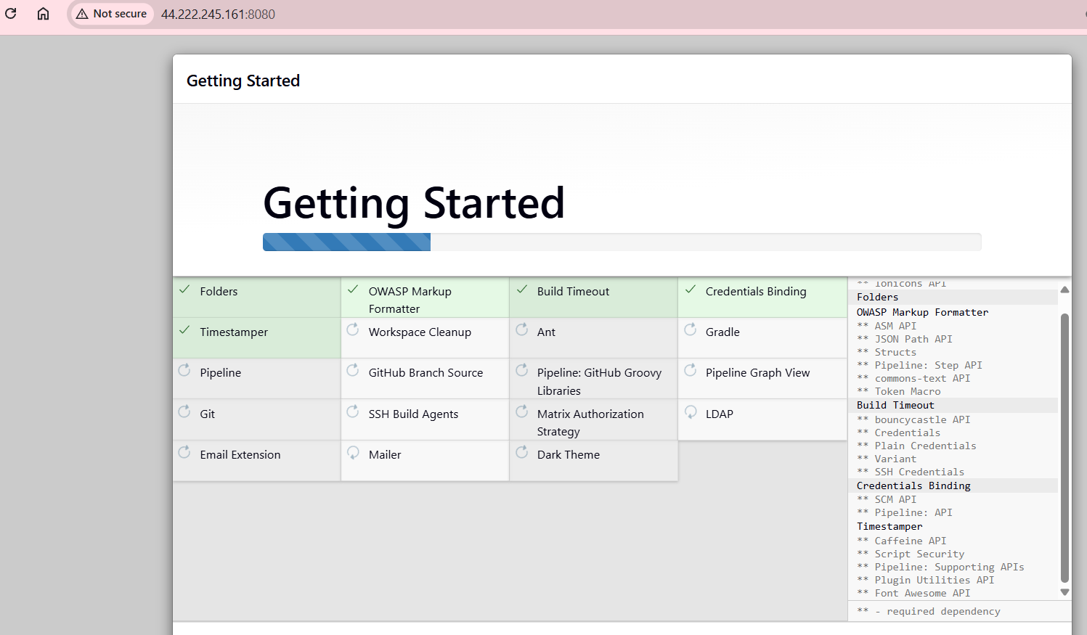

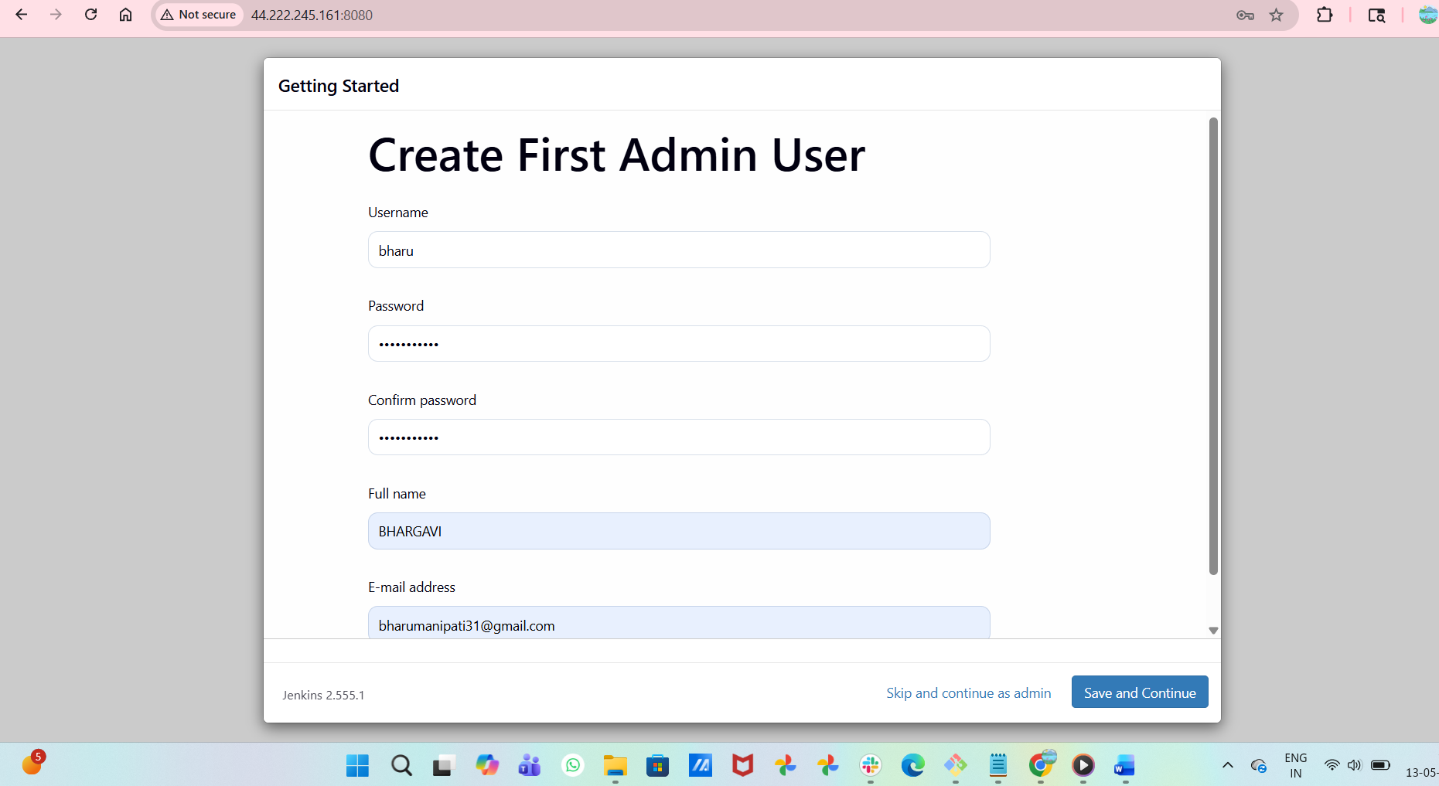
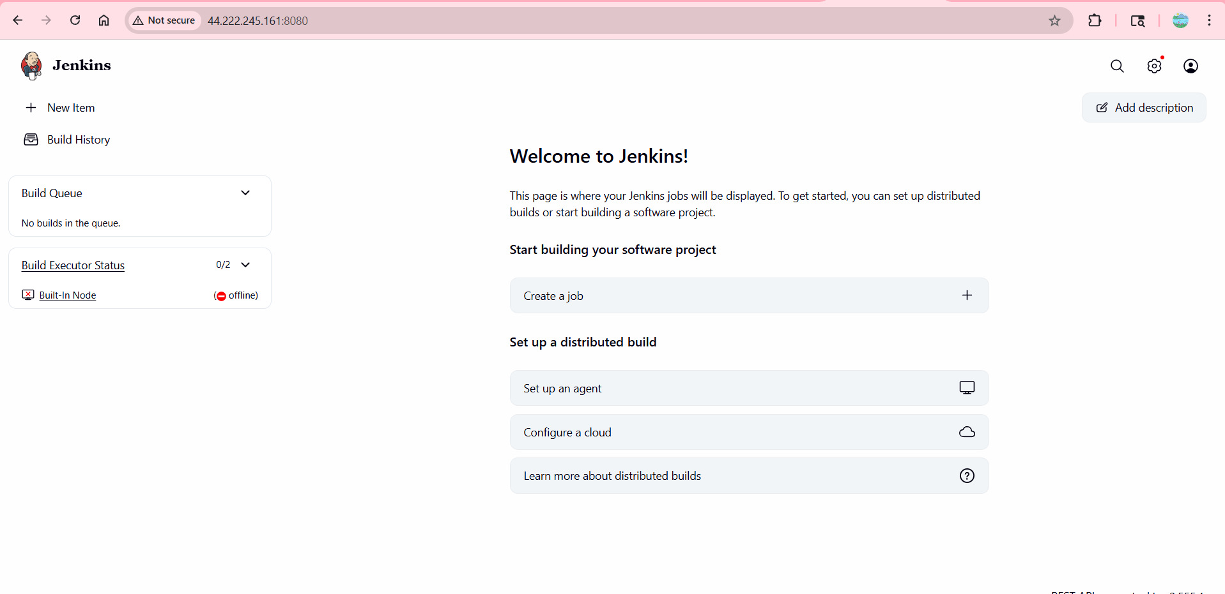
- From our old instance we need to do secure copy our tar file to new instance using command
- scp -i test.pem /backup/jenkins/jenkins-2026-05-13-10-34.tar.gzec2-user@54.224.48.156:/tmp
- Now I can give pem give to old instance that pem key code was copy and paste to the new instancevi test.pem paste in that new instance vi test.pem file
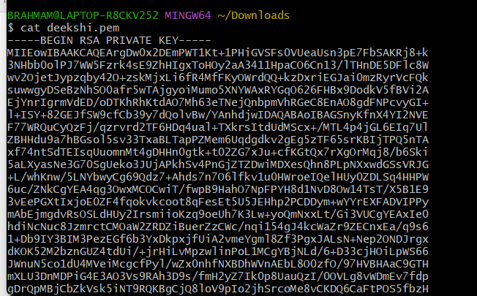

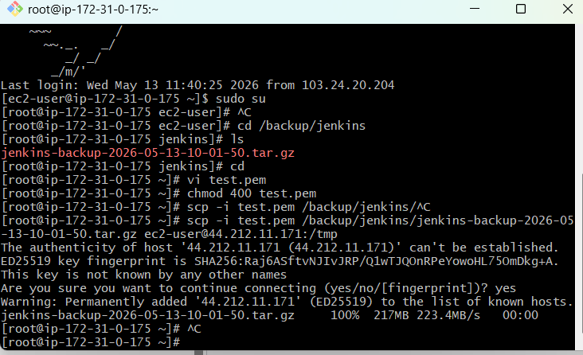

- By using the command we will securely copy the tar file to our new instance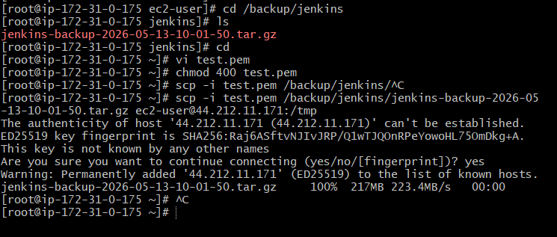
- Now we need to untar the file and can find all the contents have been copied from our old server
