JENKINS-03
1. Create one Jenkins job using the below code and create three stages.
--stage1: Git clone to download the source code.
-- stage2: Sonarqube Integration to check the quality of code.
-- stage3: Slack Integration to send the alerts to slack.
Source Code: https://github.com/betawins/VProfile-1.git
Stage1: Git clone to download the source code.
Go to Jenkins --create a build
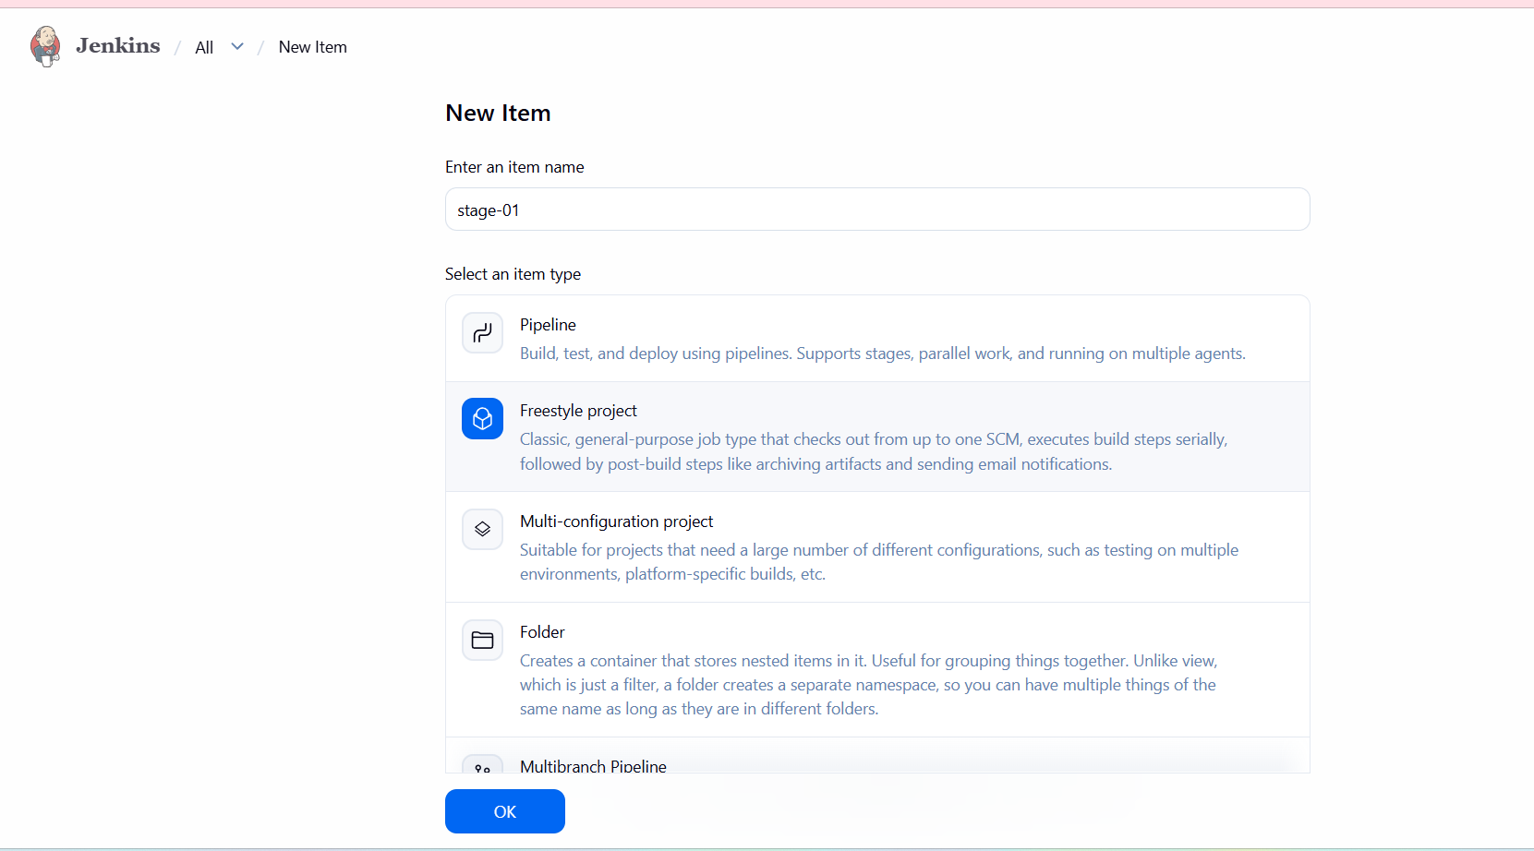
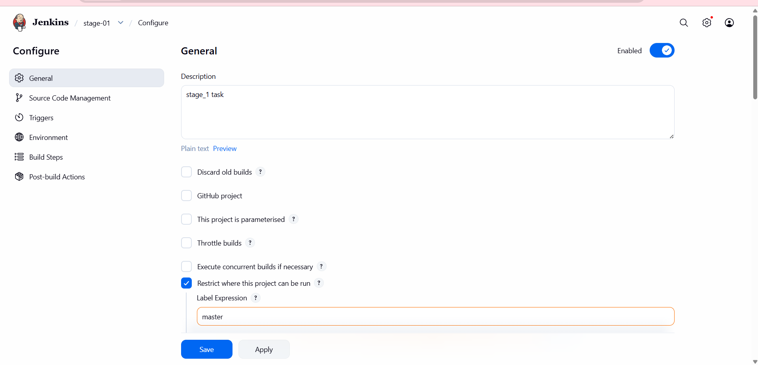
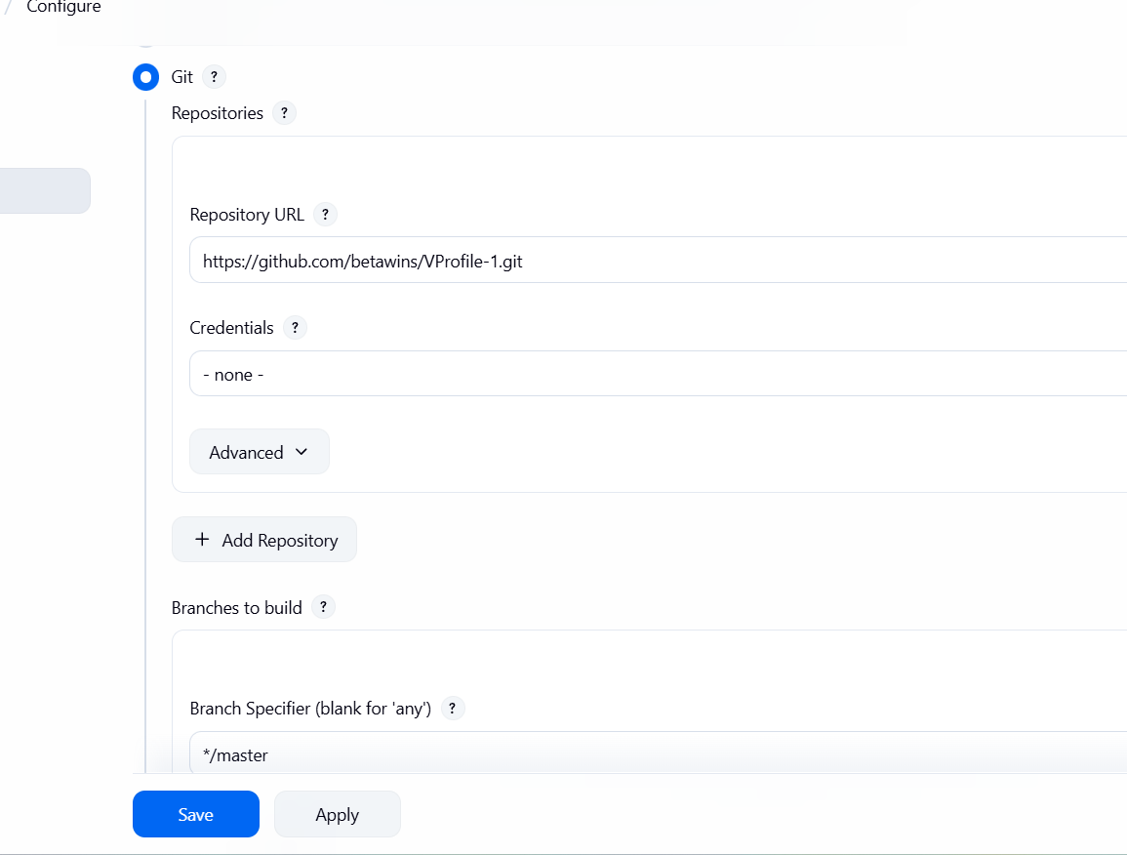
- I can give here master then I faced one issue with master labelgo to manage Jenkins—nodes—executors-2-label name master—save—then I see my output success.

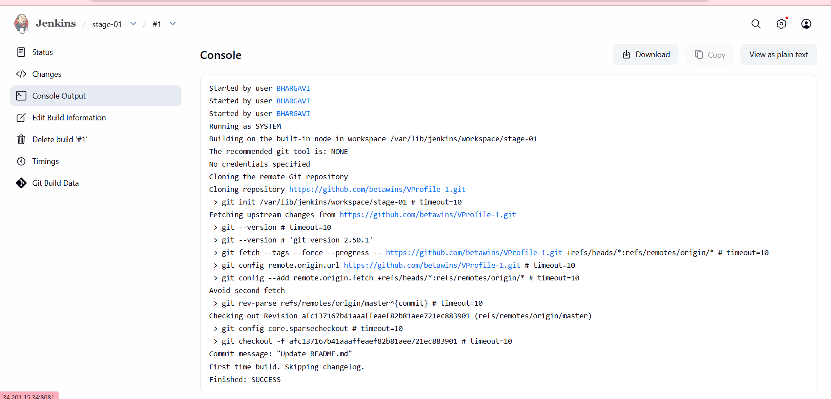
- stage2: Sonarqube Integration to check the quality of code.
EC2 Instance Creation for SonarQube Server
launched an EC2 instance to host SonarQube and PostgreSQL.
Explanation
SonarQube needs a Linux server with enough CPU, memory, and disk. EC2 provides a flexible compute environment.
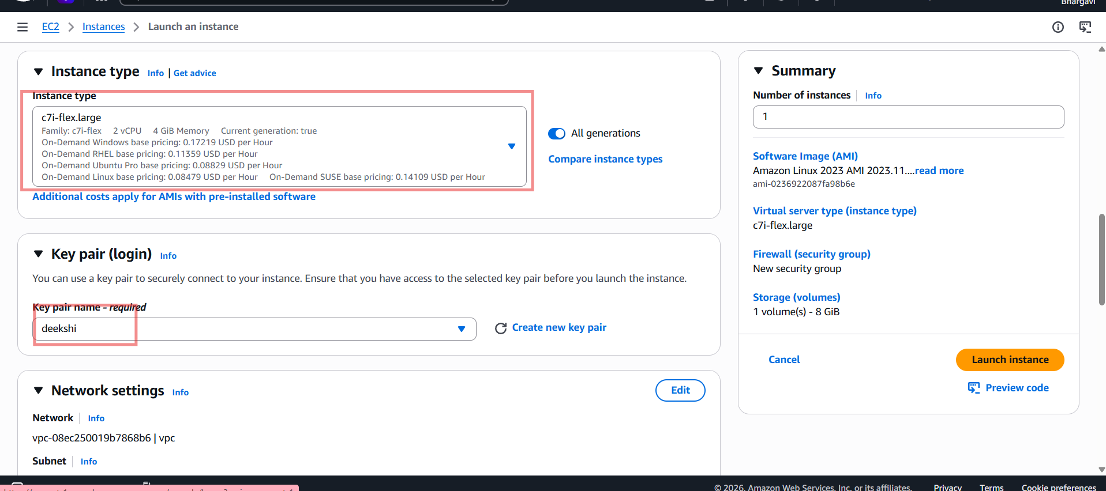
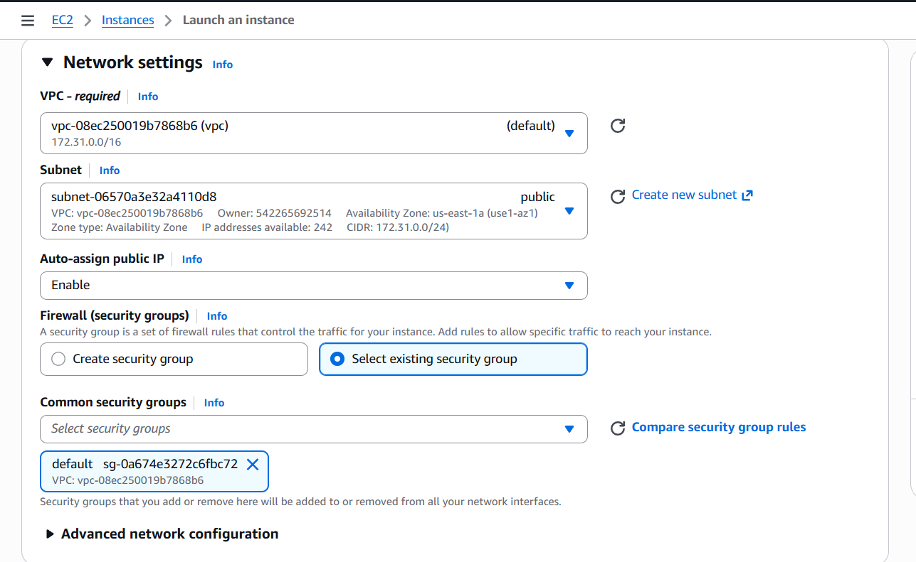
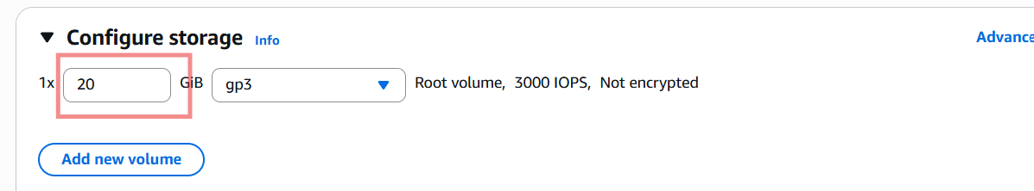

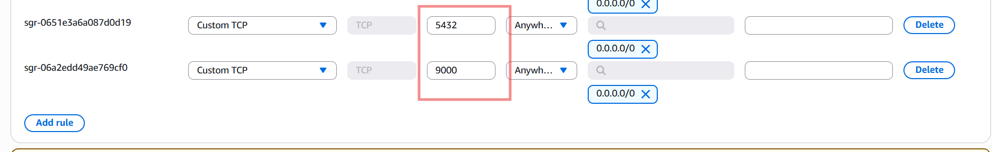
Install java
yum install java-1.8.0-openjdk -y

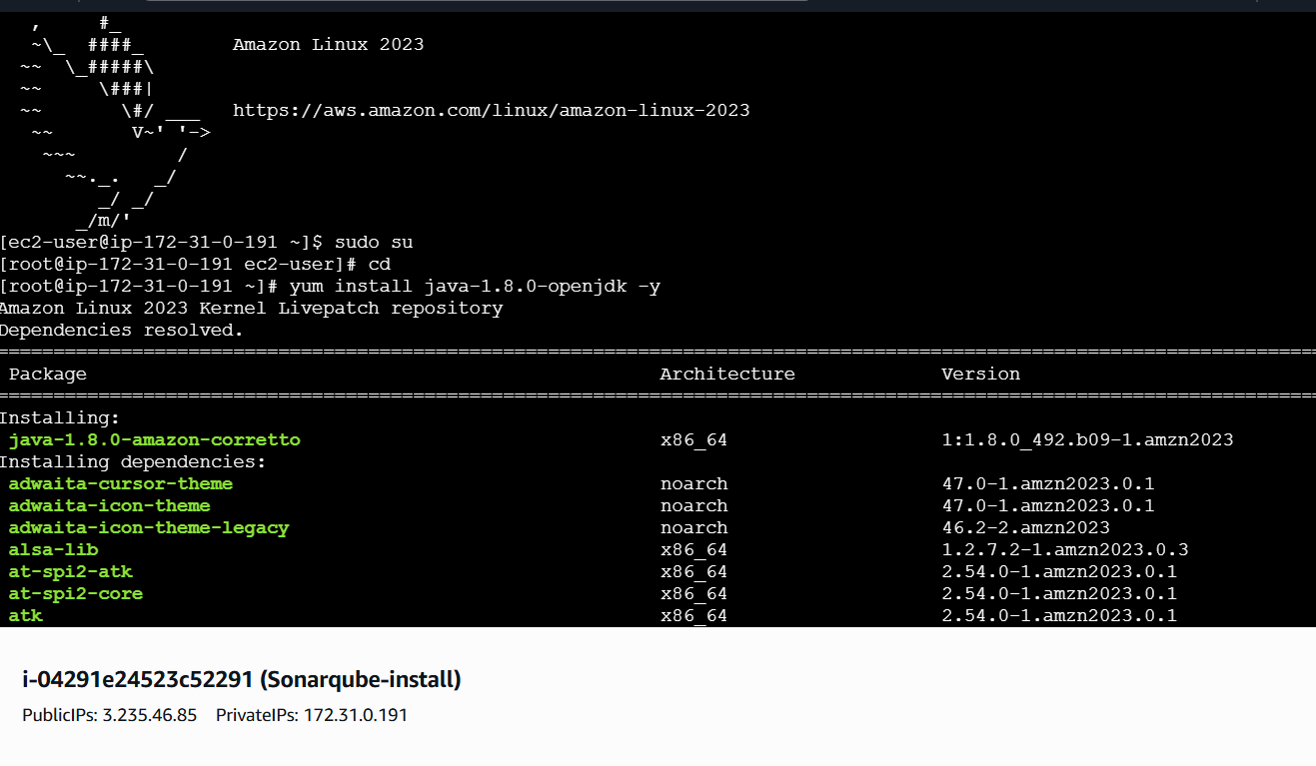
sudo wget https://dev.mysql.com/get/mysql57-community-release-el7-11.noarch.rpm
sudo yum localinstall mysql157-community-release-e17-11.noarch.rpm
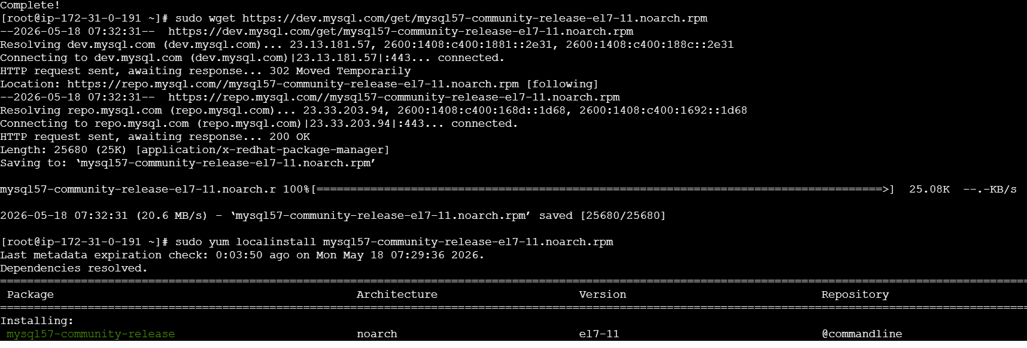
rpm --import https://repo.mysql.com/RPM-GPG-KEY-mysql-2022
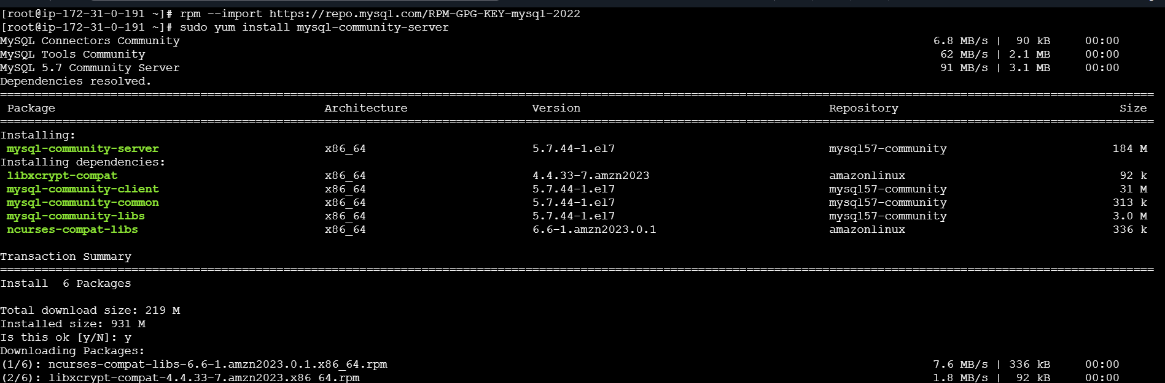
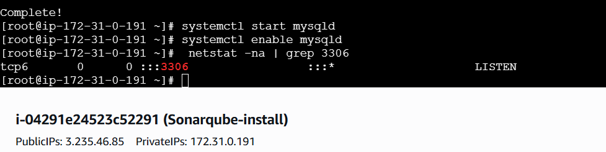
Configure the MySQL Root Password
Retrieve the temporary root password from /var/log/mysqld.log
We can see default MySQL root password -- grep 'temporary' /var/log/mysqld.log
First lets login to mysql using default password
mysql -u root -p

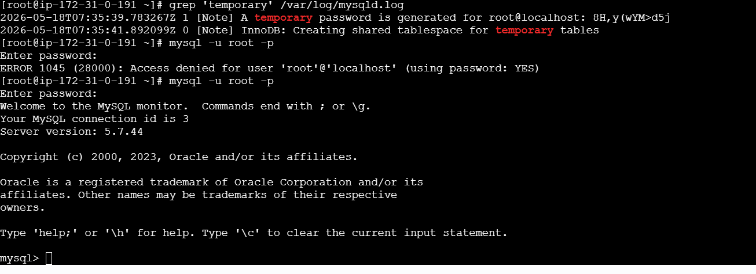
replace the default password with a new and strong password
ALTER USER 'root'@'localhost' IDENTIFIED BY 'Admin@123';
flush privileges;
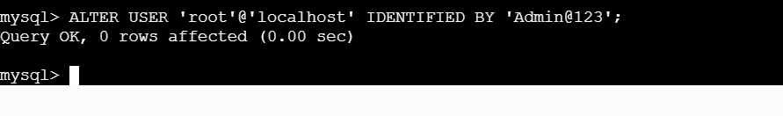
Tried to login to mysql with new password
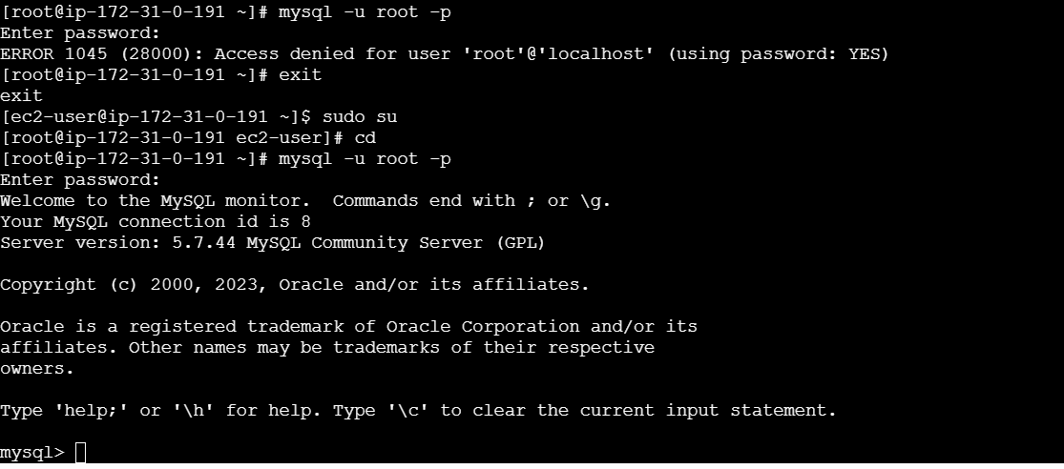
Whwn I give 1st time I can give admin123 then got error
I rectified with password Admin@123
Now stage2- SonarQube Installation
To install sonarqube, goto cd /opt/
To download --wget
https://binaries.sonarsource.com/Distribution/sonarqube/sonarqube-6.6.zip
To Unzip unzip sonarqube-6.6.zip
To Rename mv /opt/sonarqube-6.6 /opt/sonar
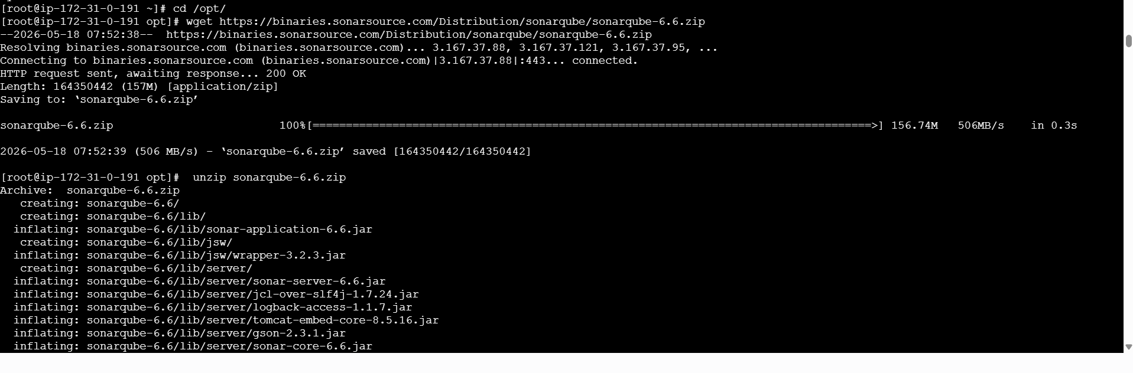
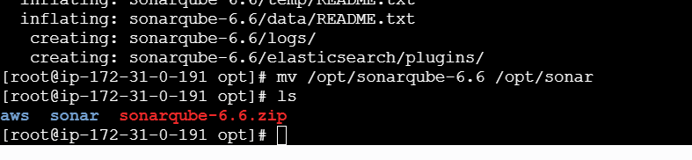
Created Databases and users, Gave the users the permissions and checkied if we did right
or
not.
Steps Involves and commands used
Create a new sonar database
CREATE DATABASE sonar CHARACTER SET utf8 COLLATE utf8_general_ci;
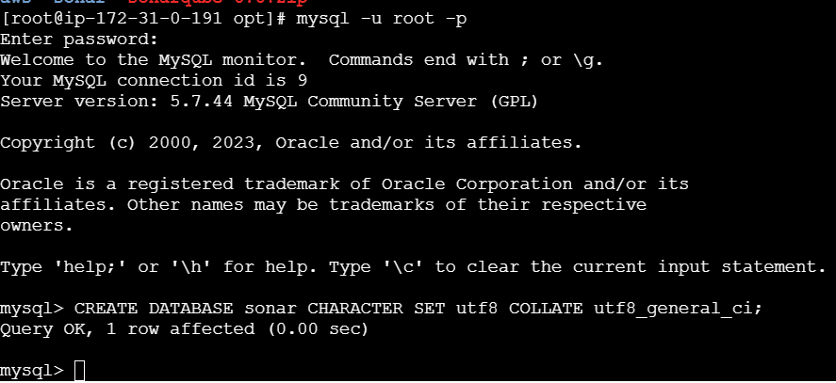
Create a local and a remote user
CREATE USER sonar@localhost IDENTIFIED BY 'Sonar@123';
CREATE USER sonar@'%' IDENTIFIED BY 'Sonar@123';
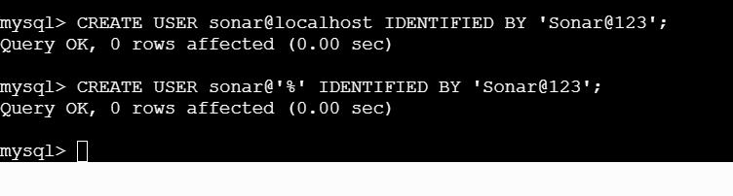
Grant database access permissions to users
GRANT ALL ON sonar.* TO sonar@localhost;
GRANT ALL ON sonar.* TO sonar@'%';
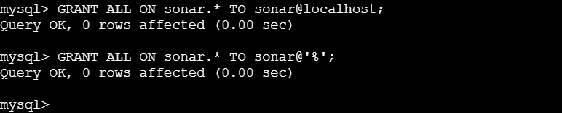
To check databases → show databases;
To check users → SELECT User FROM mysql.user;
FLUSH PRIVILEGES;
QUIT
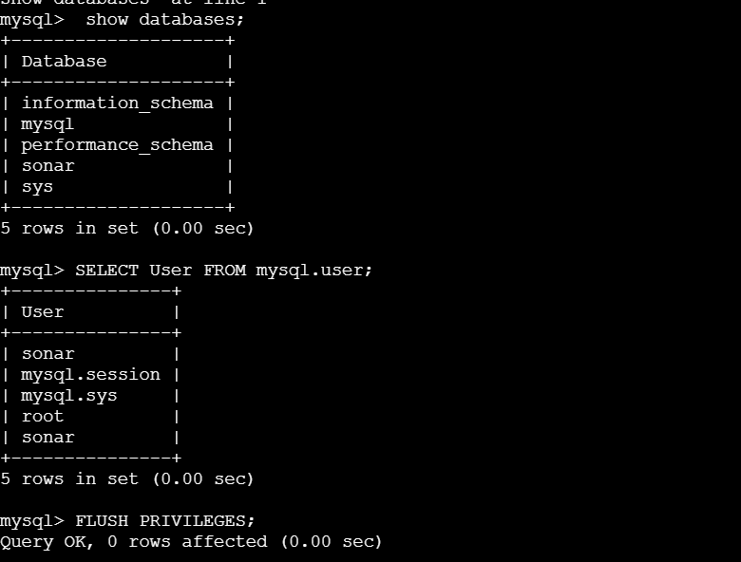
Lets enable SonarQube properties file to connect to the database
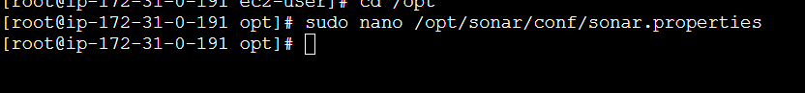
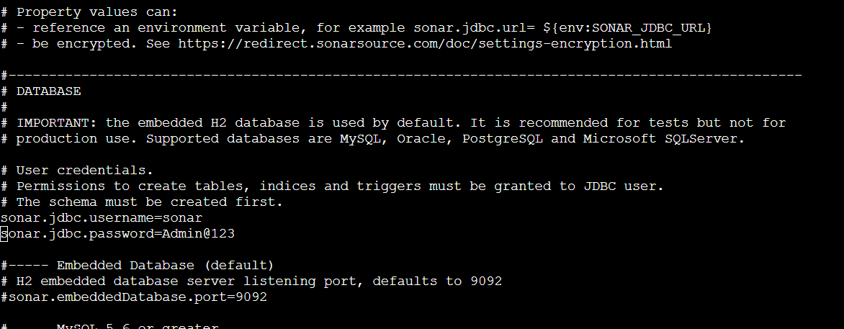
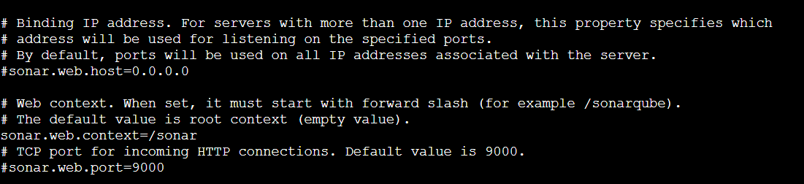
Cd /opt
sudo unzip sonarqube-6.6.zip
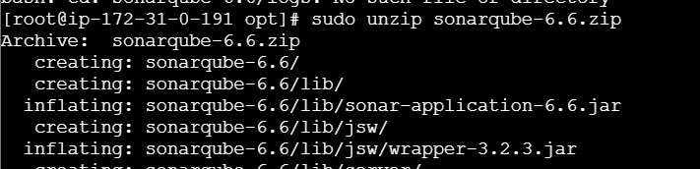
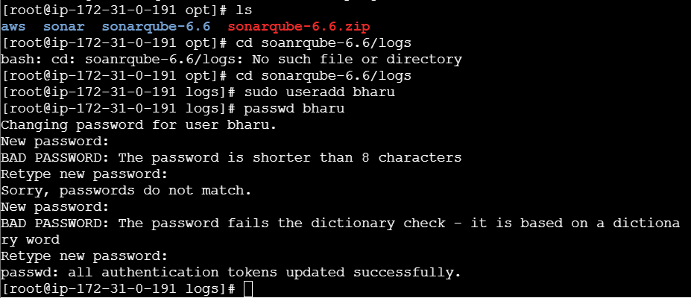
Mypasswd Admin@123
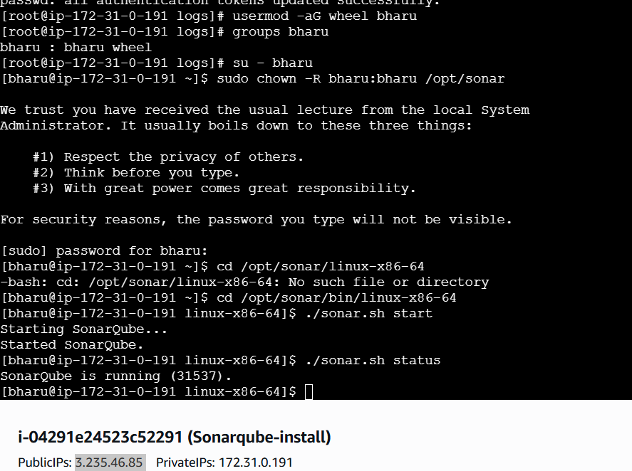
Successfully logged into sonarqube server
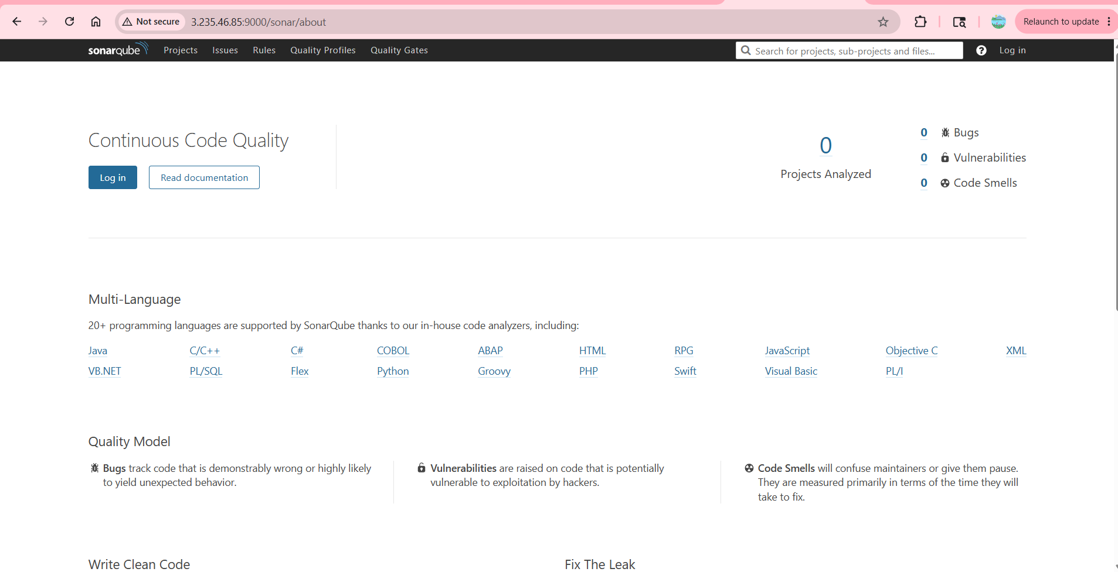
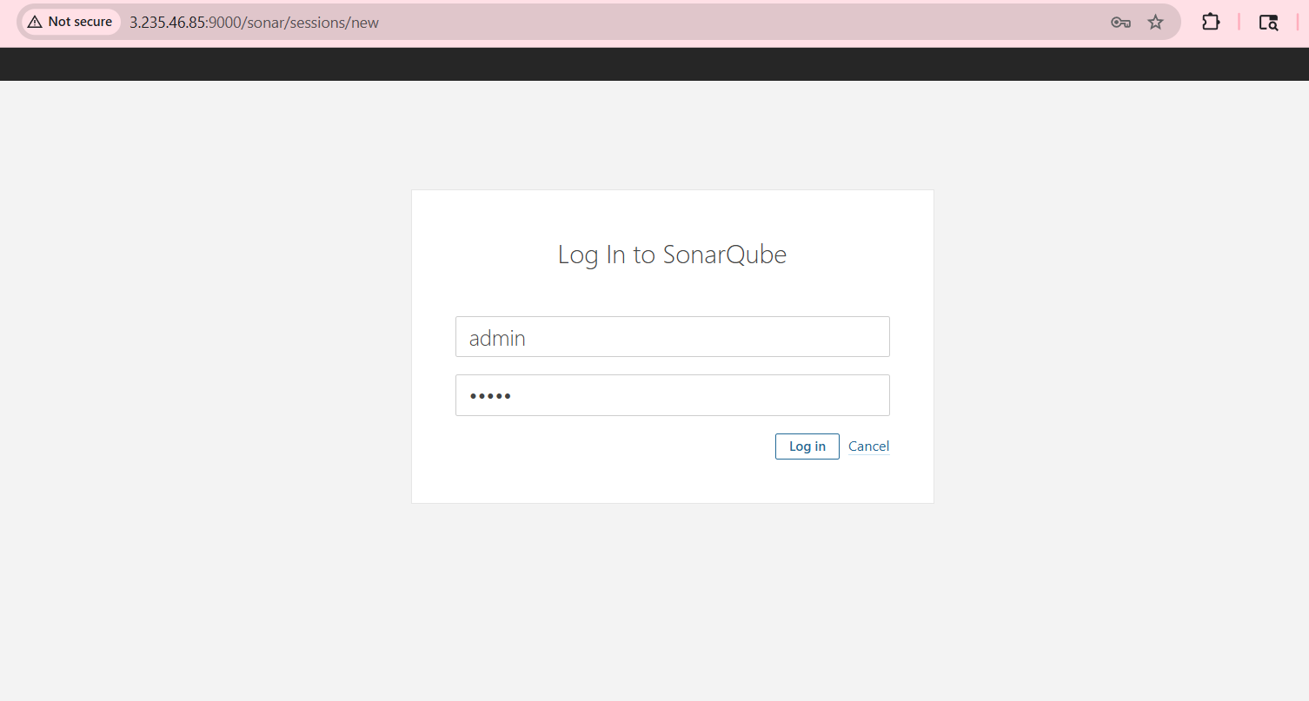
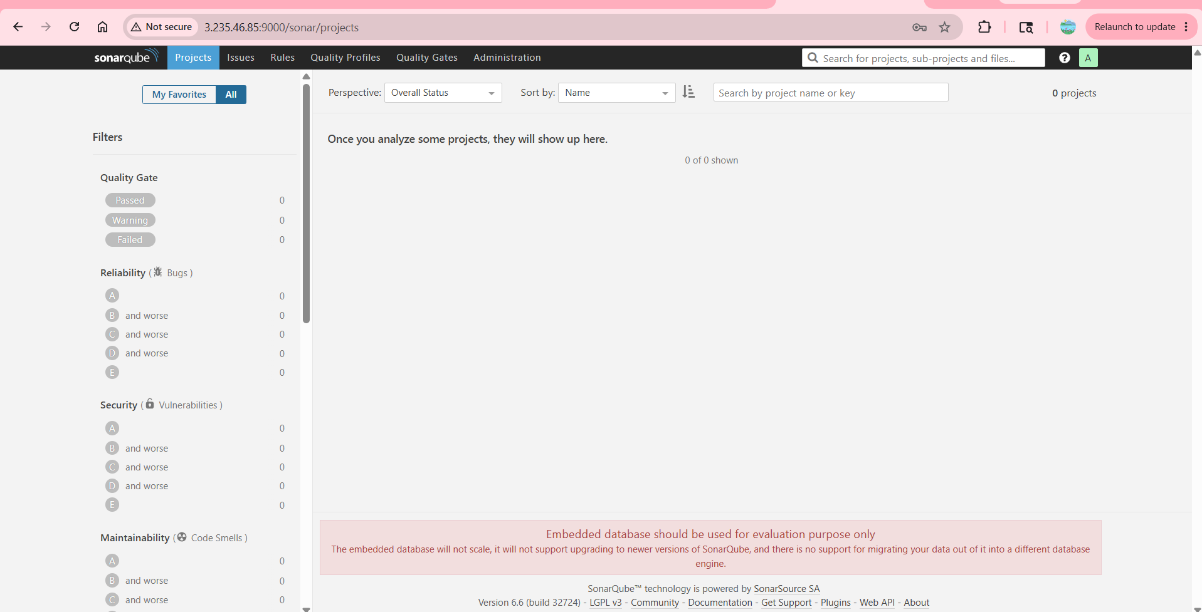
SonarQube Scanner on our Jenkins
Go to Manage Jenkins Plugins Sonarcube scanner click on Install
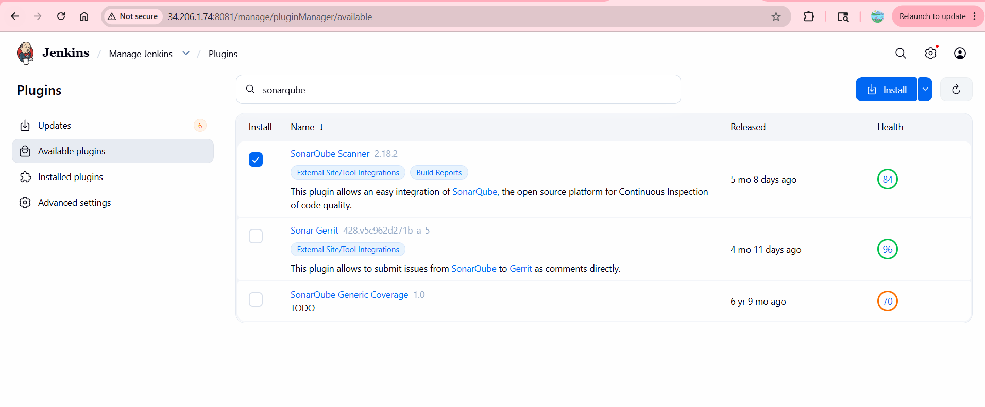
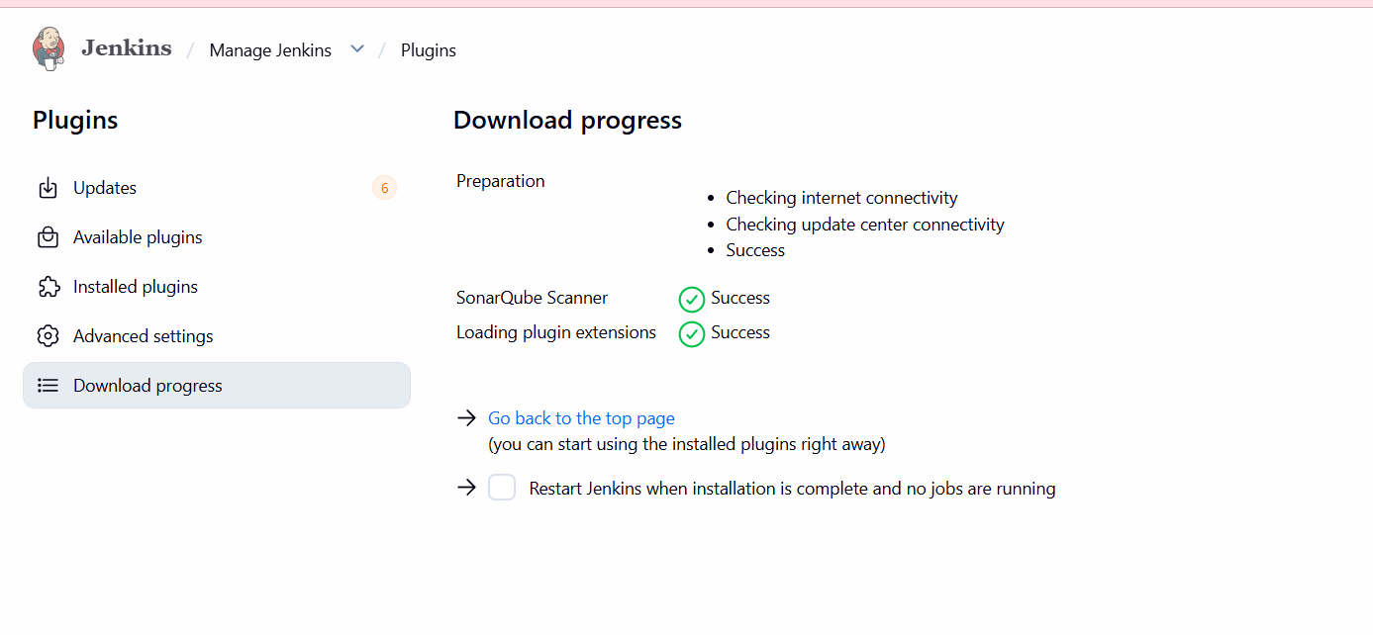
To create
Manage Jenkins - click on system -SonarQube server -give Name - Server URL -
Credentials
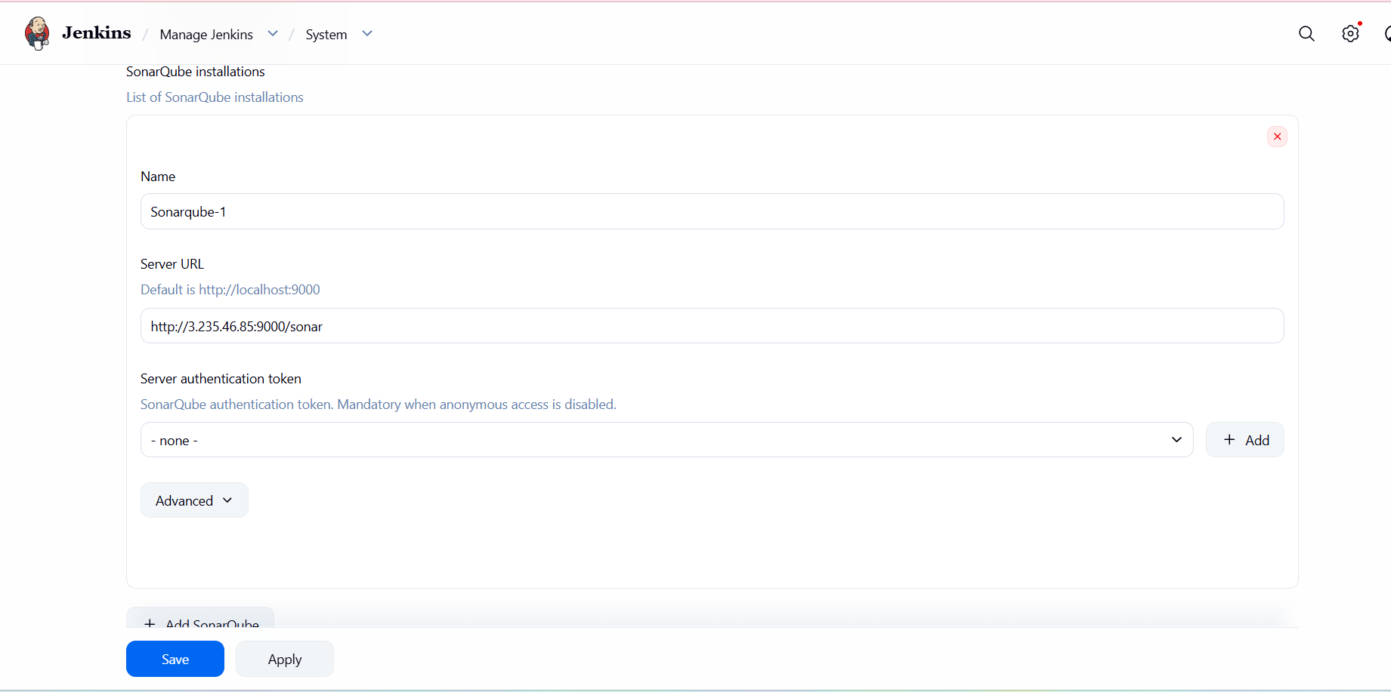
Generate an Authentication Token in SonarQube
- Log into SonarQube → My Account → Security → Generate Tokens
-Copy the generated token.
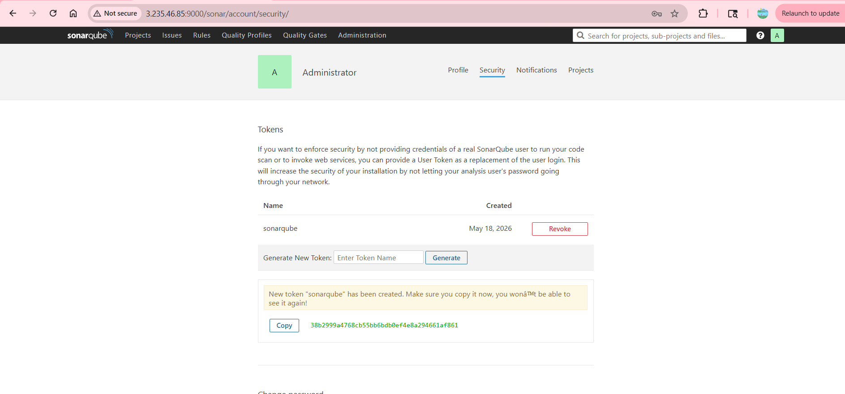
Add it to Jenkins credentials
Go to manage Jenkins click on credentialsClick on global add credentials secret text
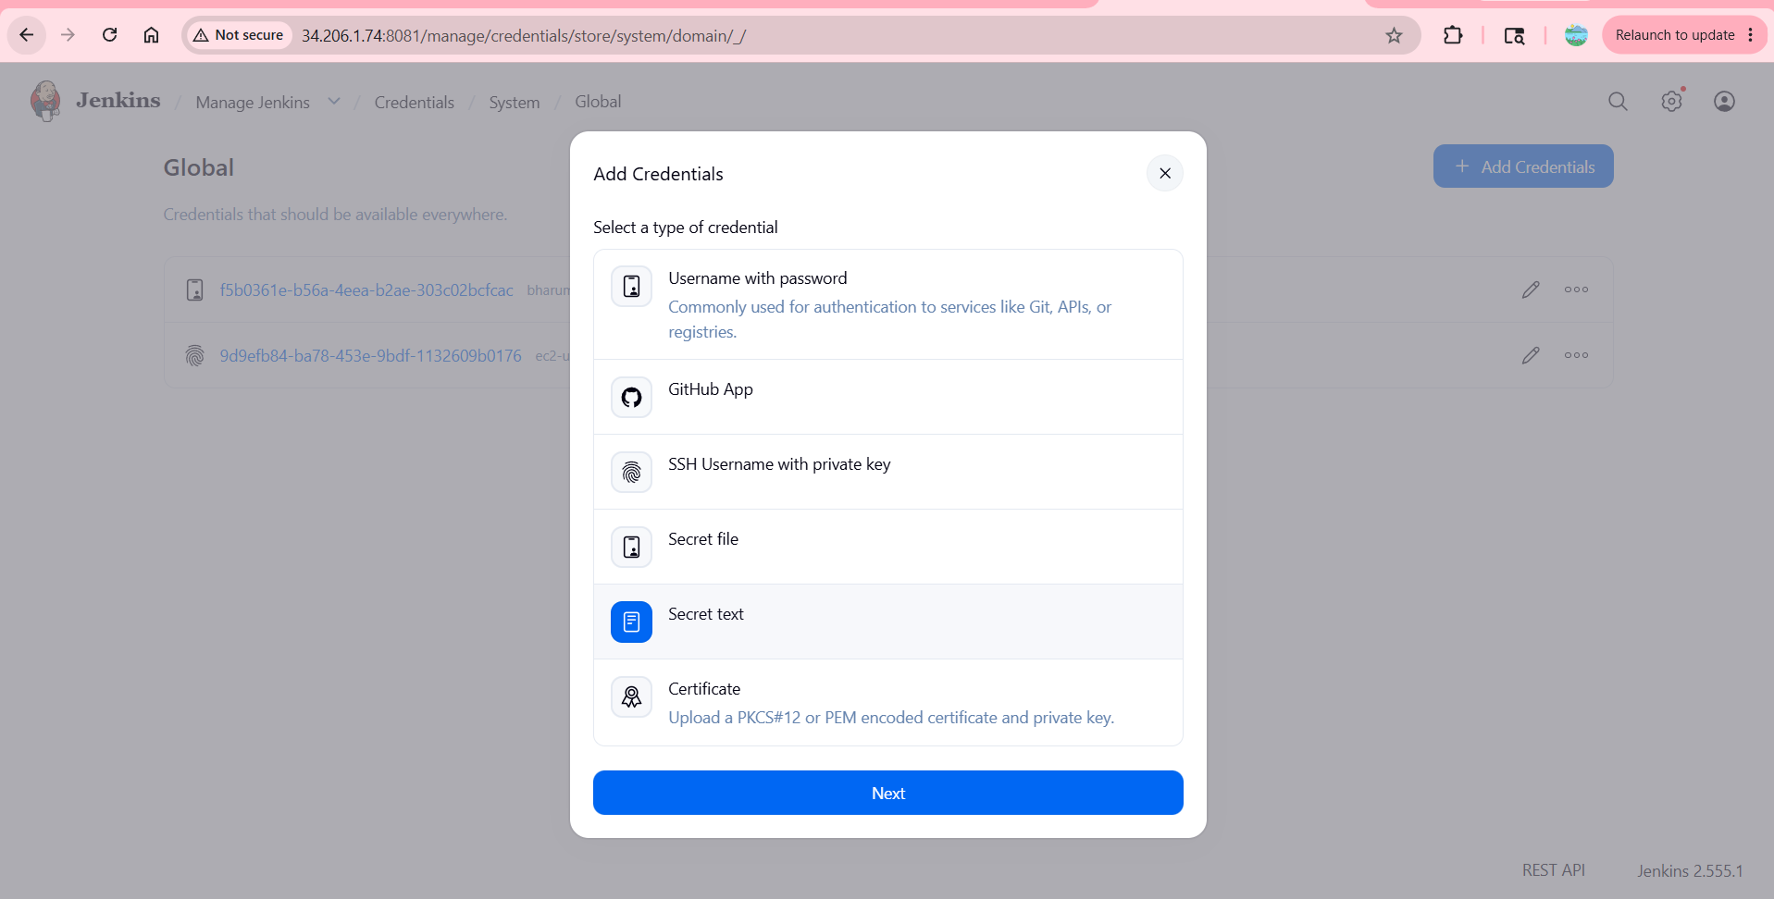
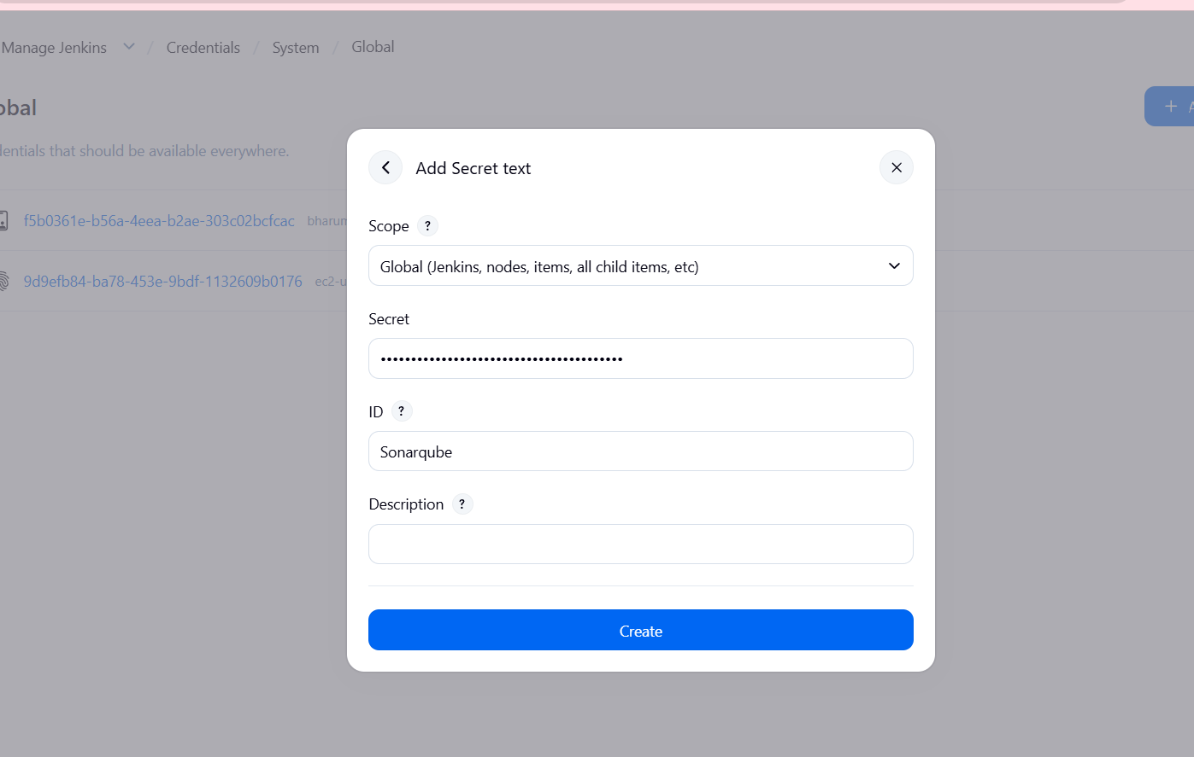
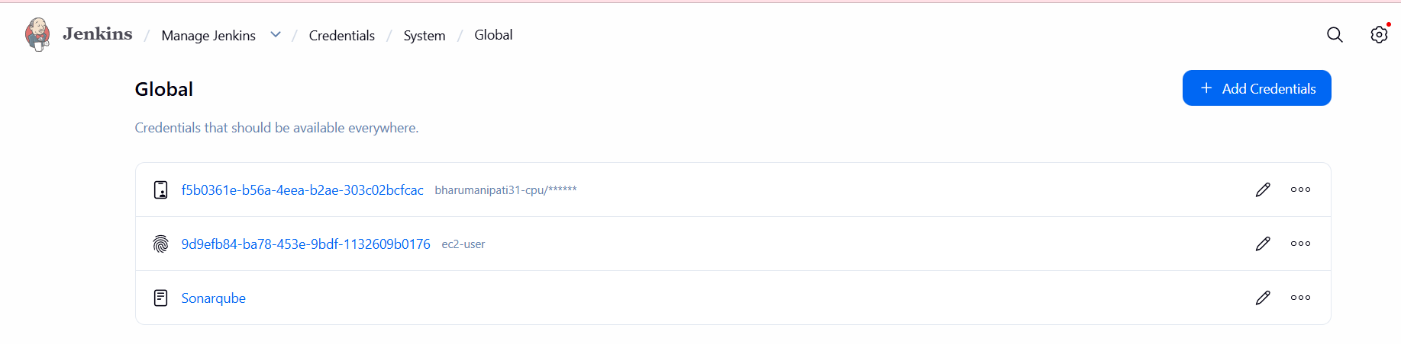
add the credential in the configurations
go to manage Jenkins click on system choose sonarqube server add credential to server
authentication token
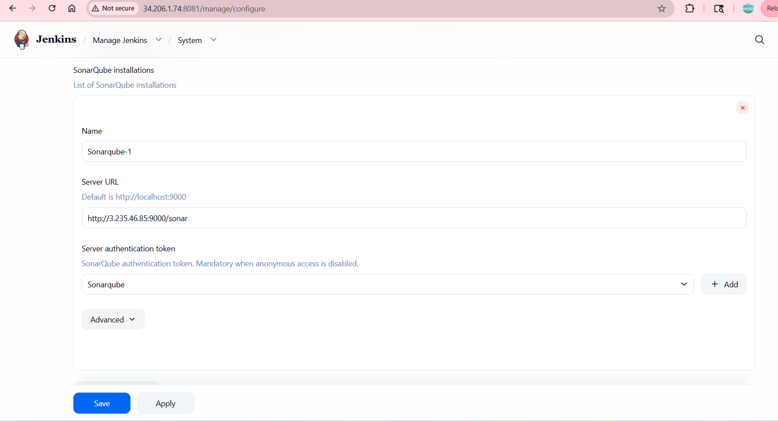
We need to install sonarqube-scanner in Jenkins server
To Download - sudo wget https://binaries.sonarsource.com/Distribution/sonar-scanner-cli/sonar-scanner-cli-3.2.0.1227-linux.zip
- To Unzip - unzip sonar-scanner-cli-3.2.0.1227-linux.zip
- To Rename - mv sonar-scanner-3.2.0.1227-linux /opt/sonar_scanner
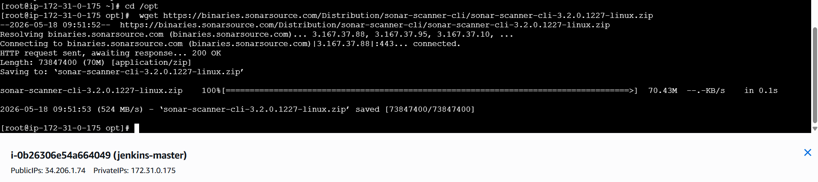
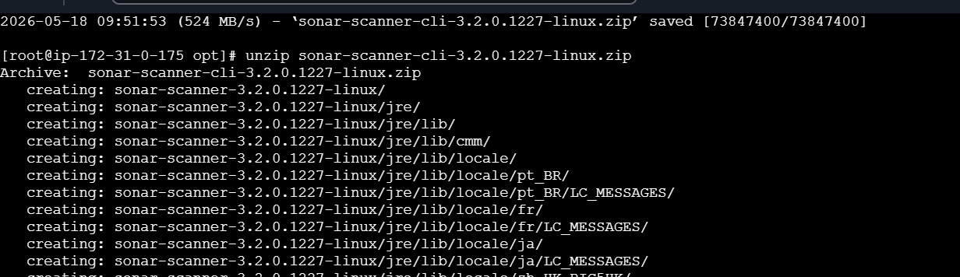
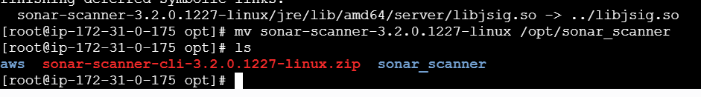
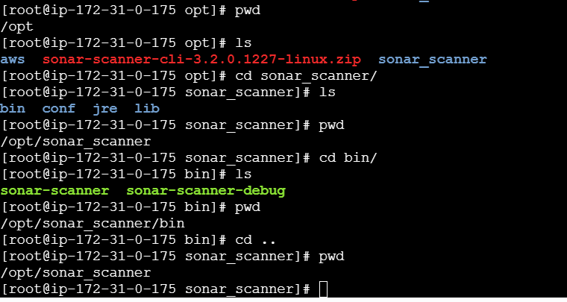
Add the above sonar-scanner path in the Jenkins
Go to manage Jenkinstools sonarQube Scanner Name Path Save
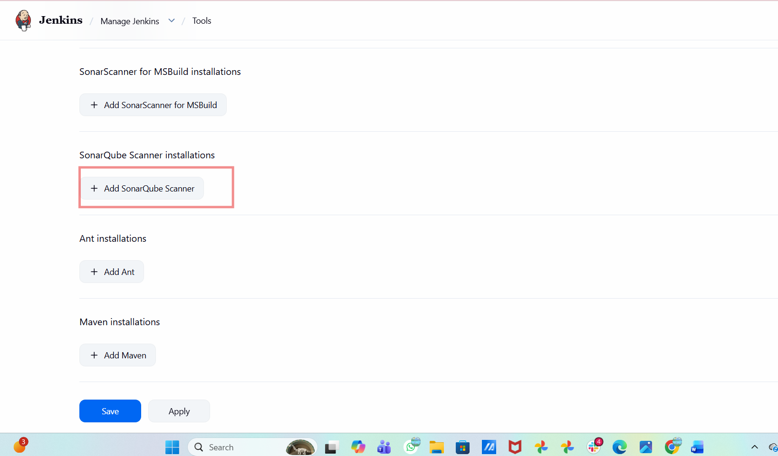
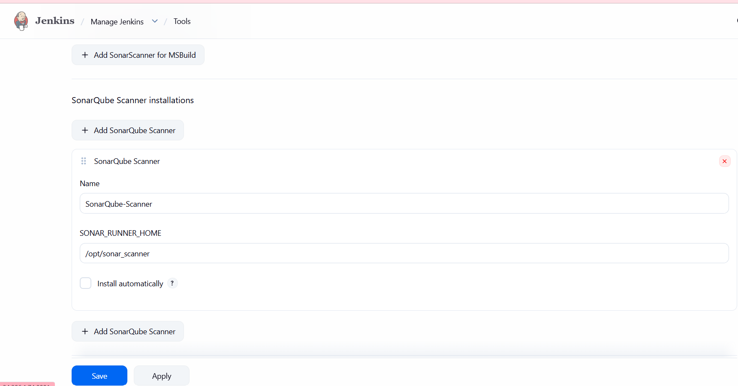
Next We need to give analysis properties of the code to run in the Job we created
Job Configure Build Steps Analysis Properties(we will get it from developers)-Save
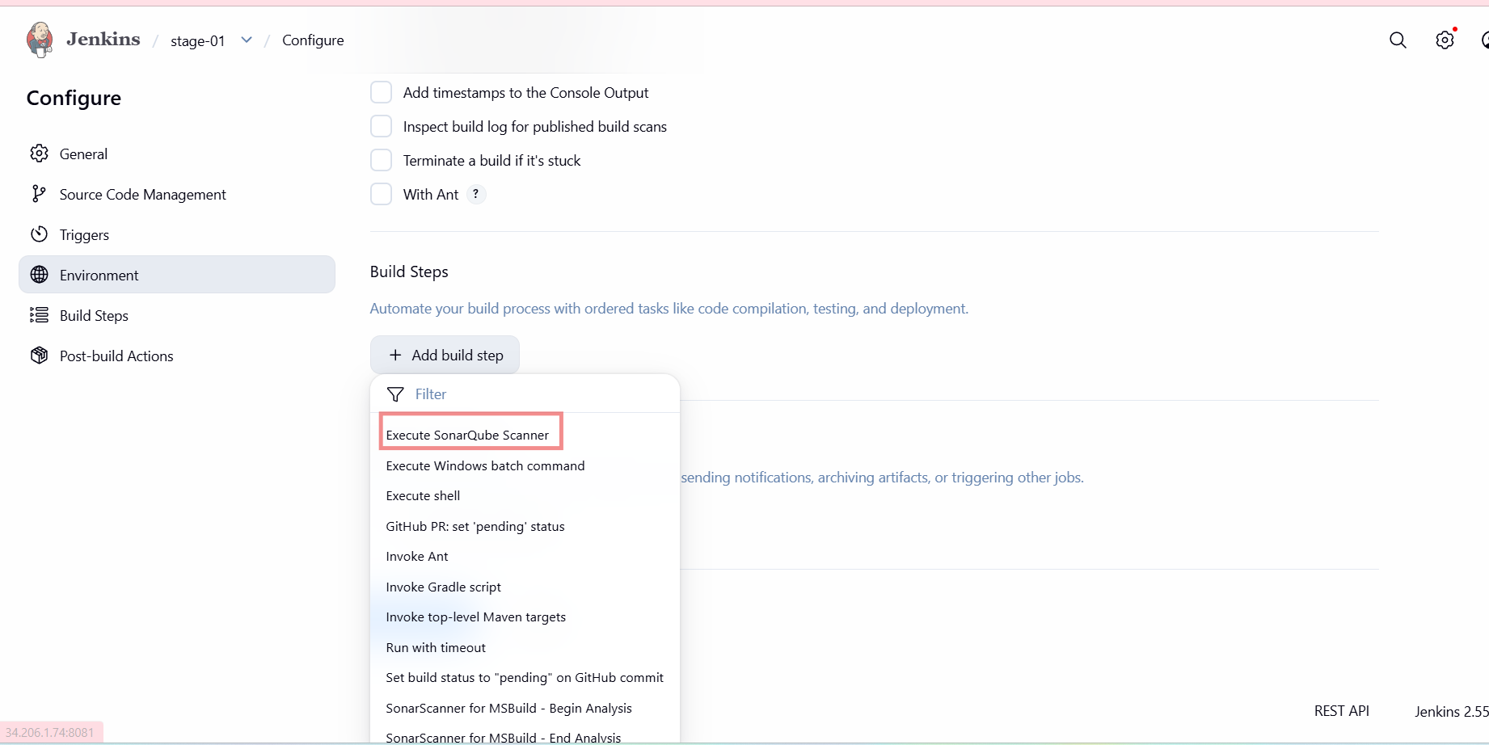
Open the sir given url in chrome go to last line and copy that
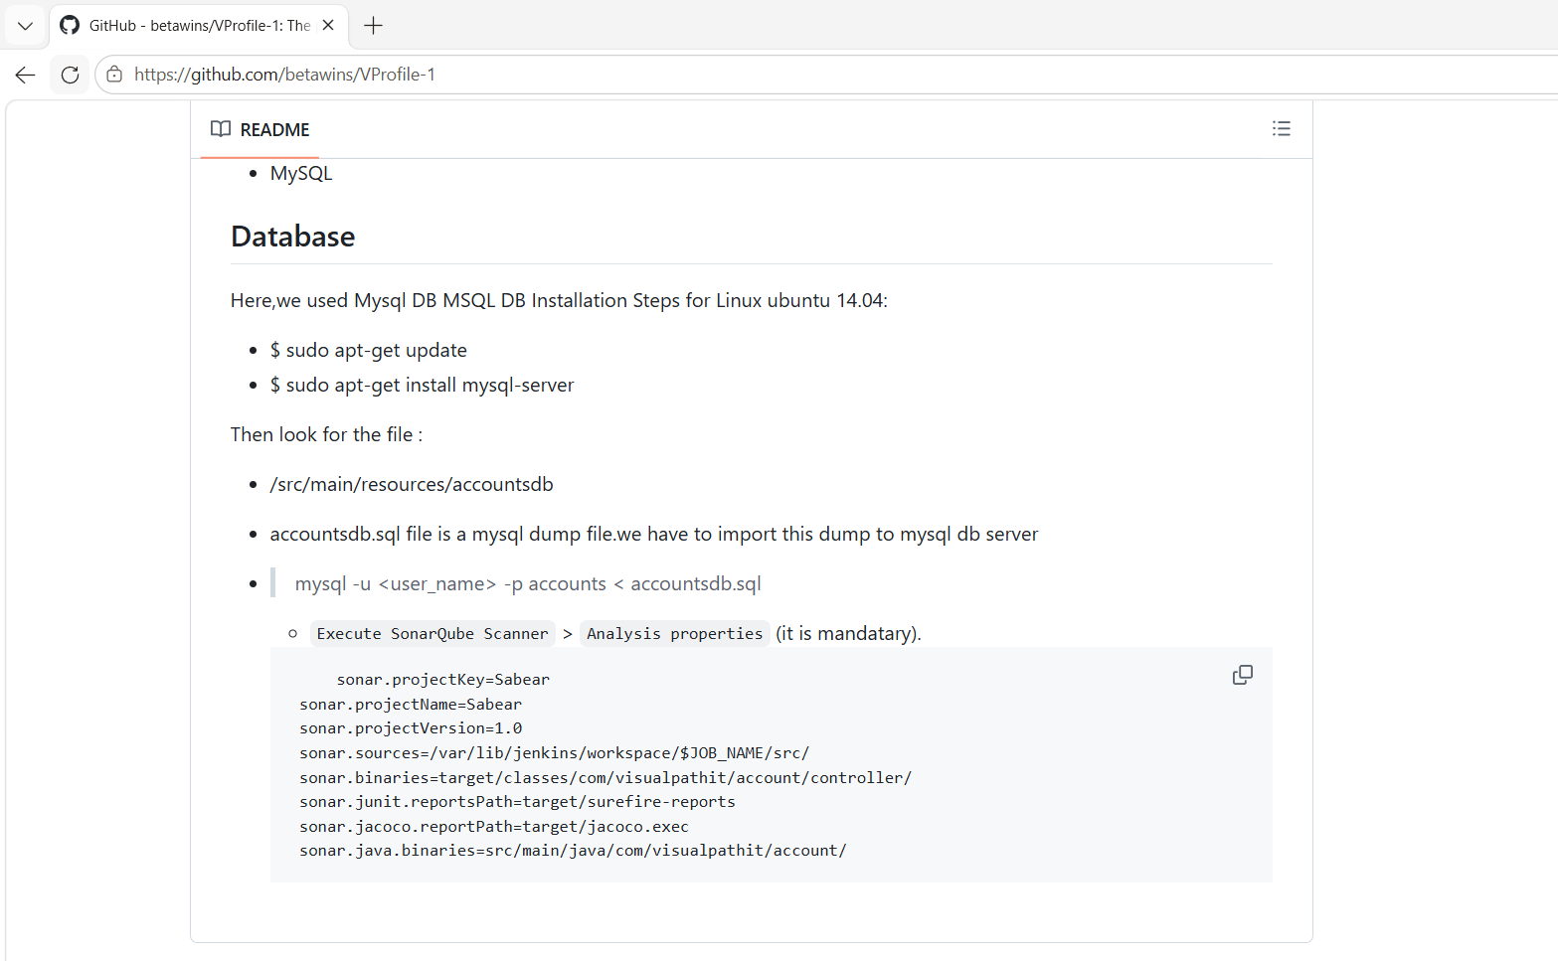
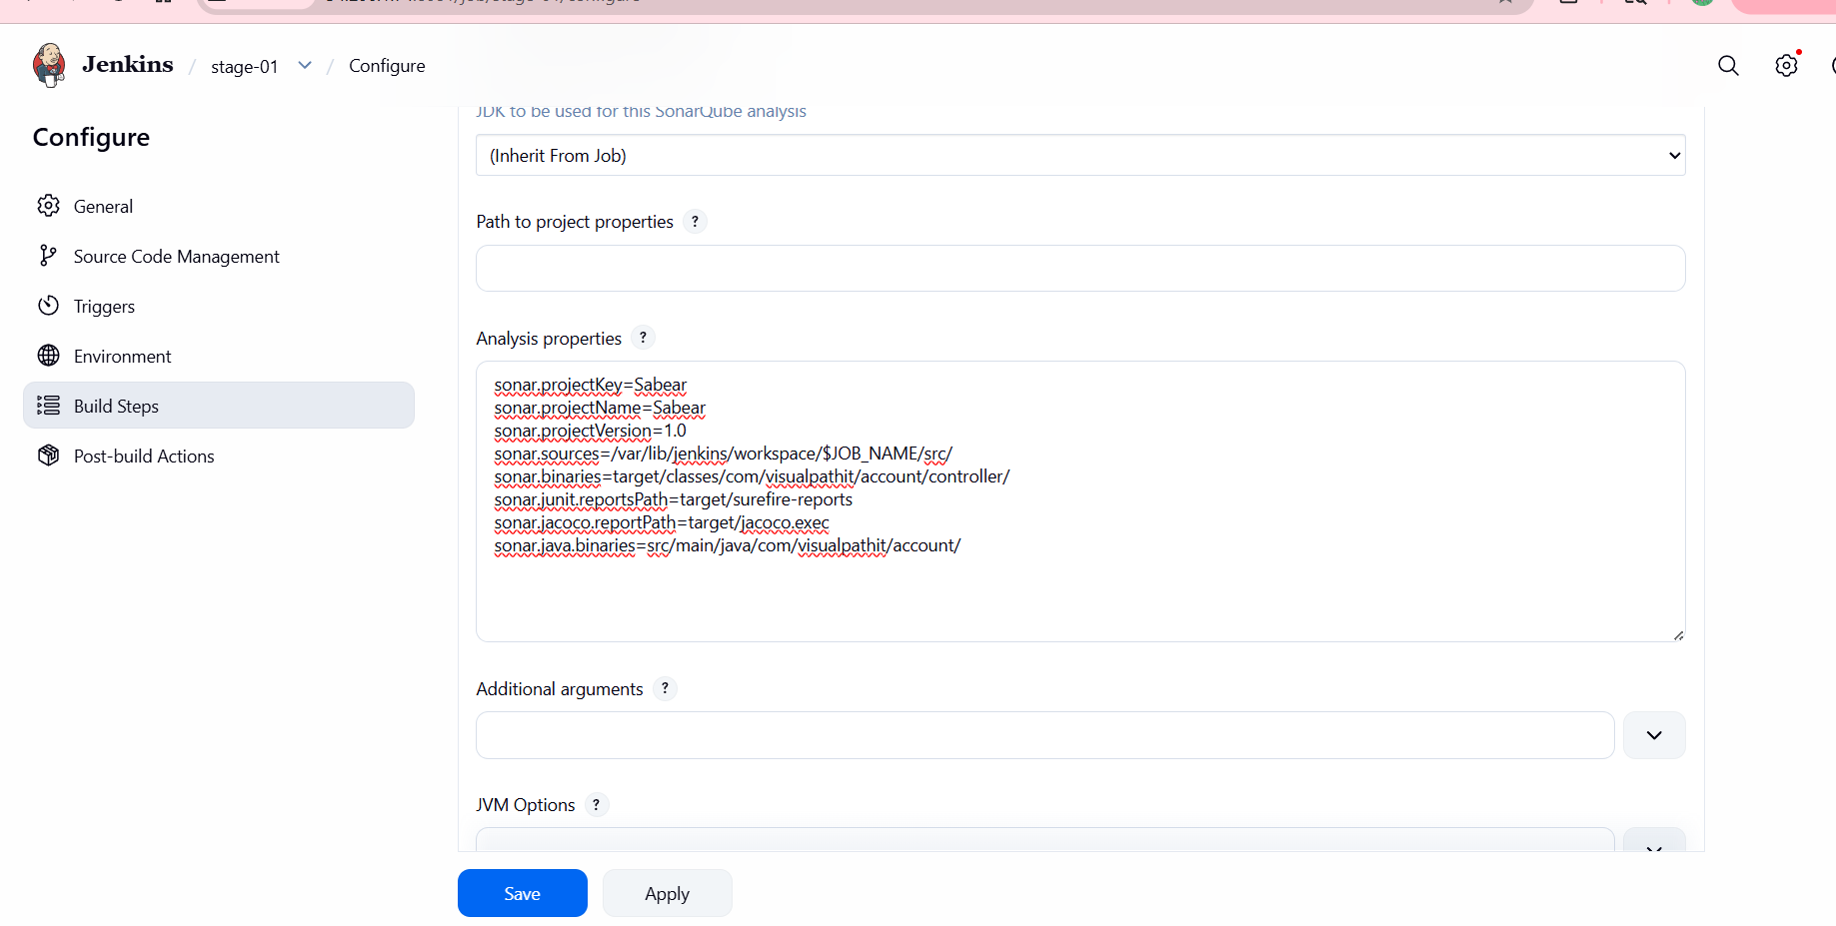

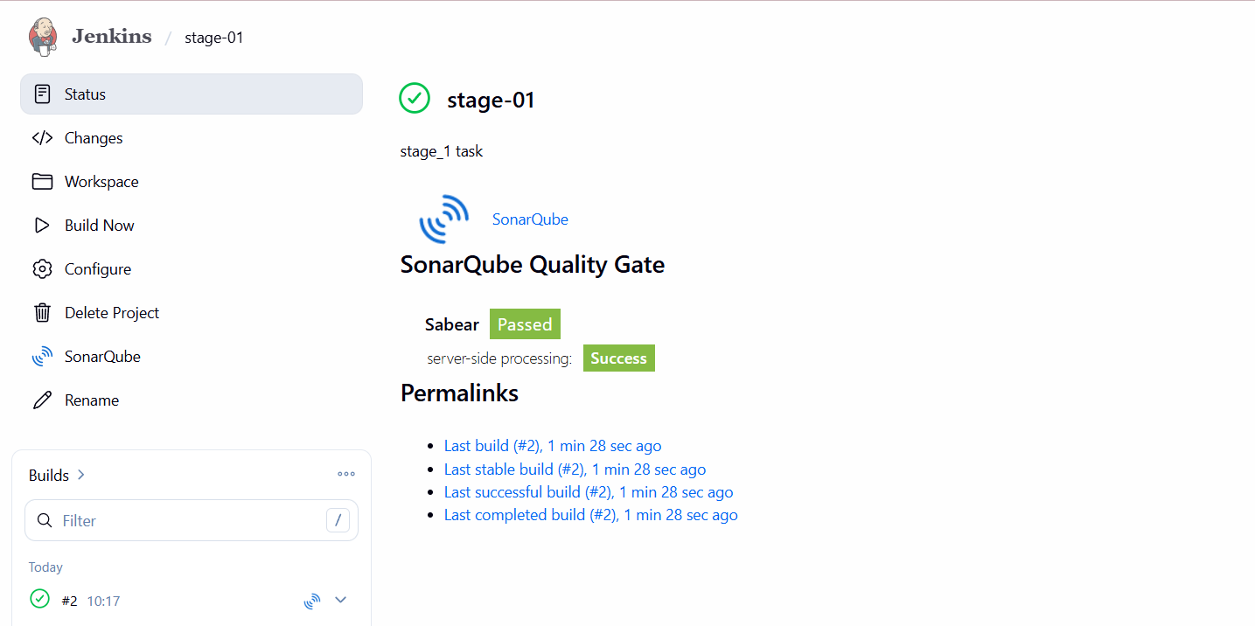
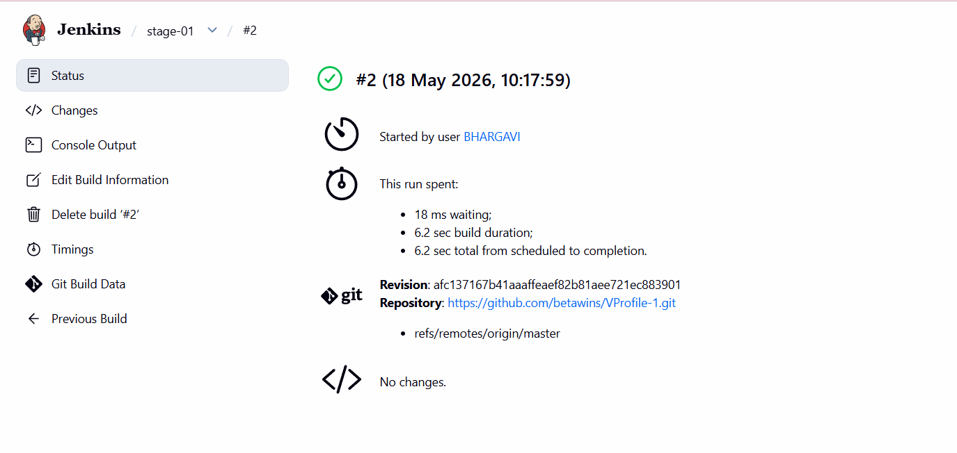
Job ran successfully
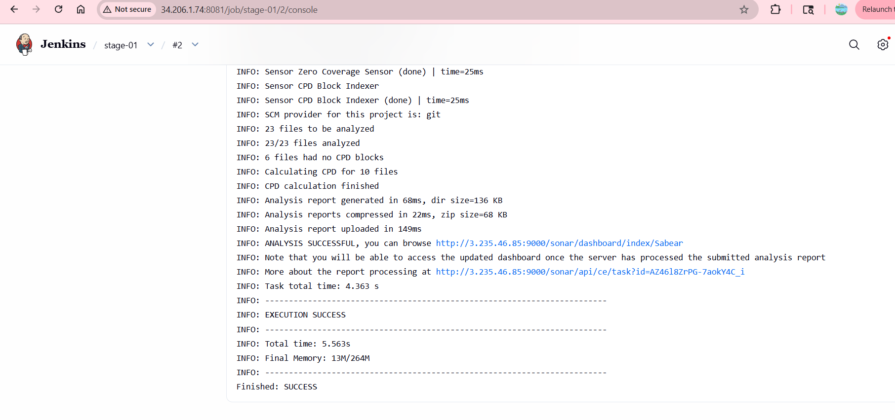
It also passed in sonarqube
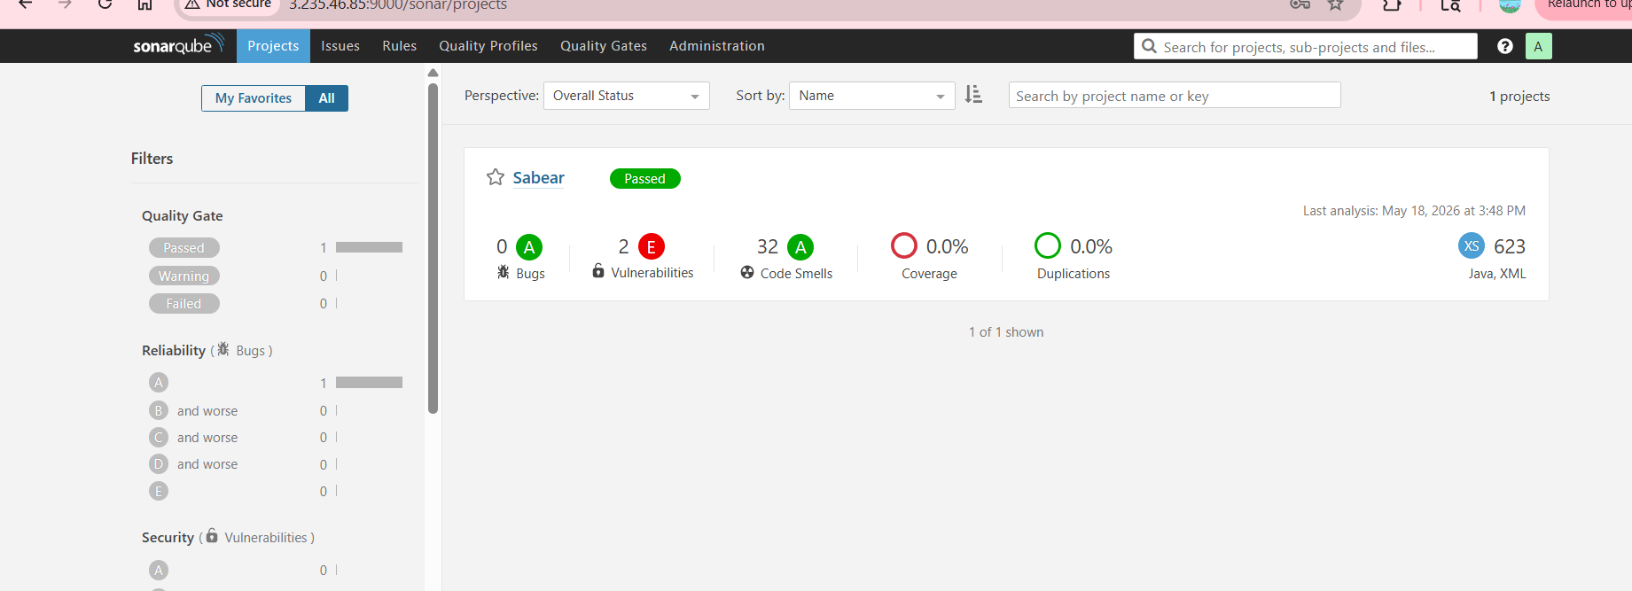
Stage 3 : Slack Integration to send the alerts to slack.
Go to manage Jenkins plugins available plugins - search for slack notification -install
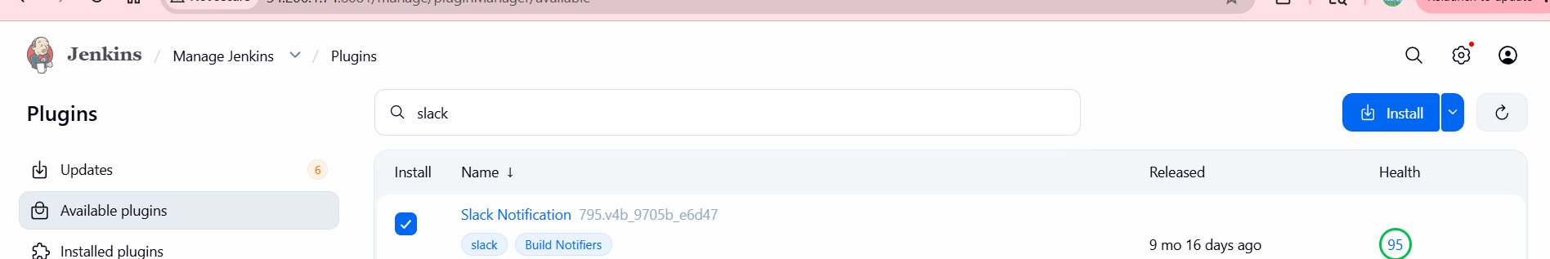
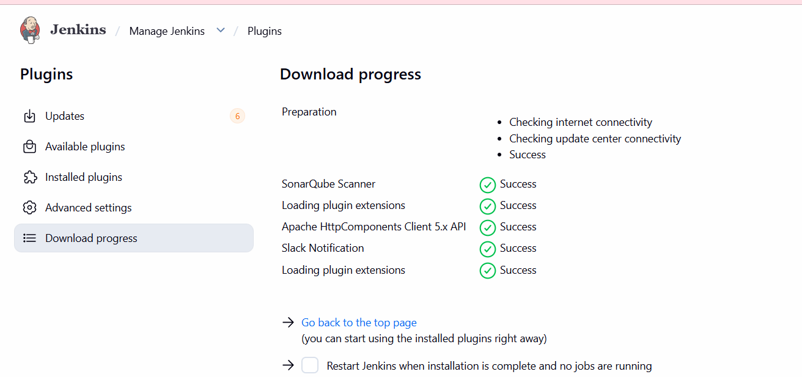
I have created a slack account
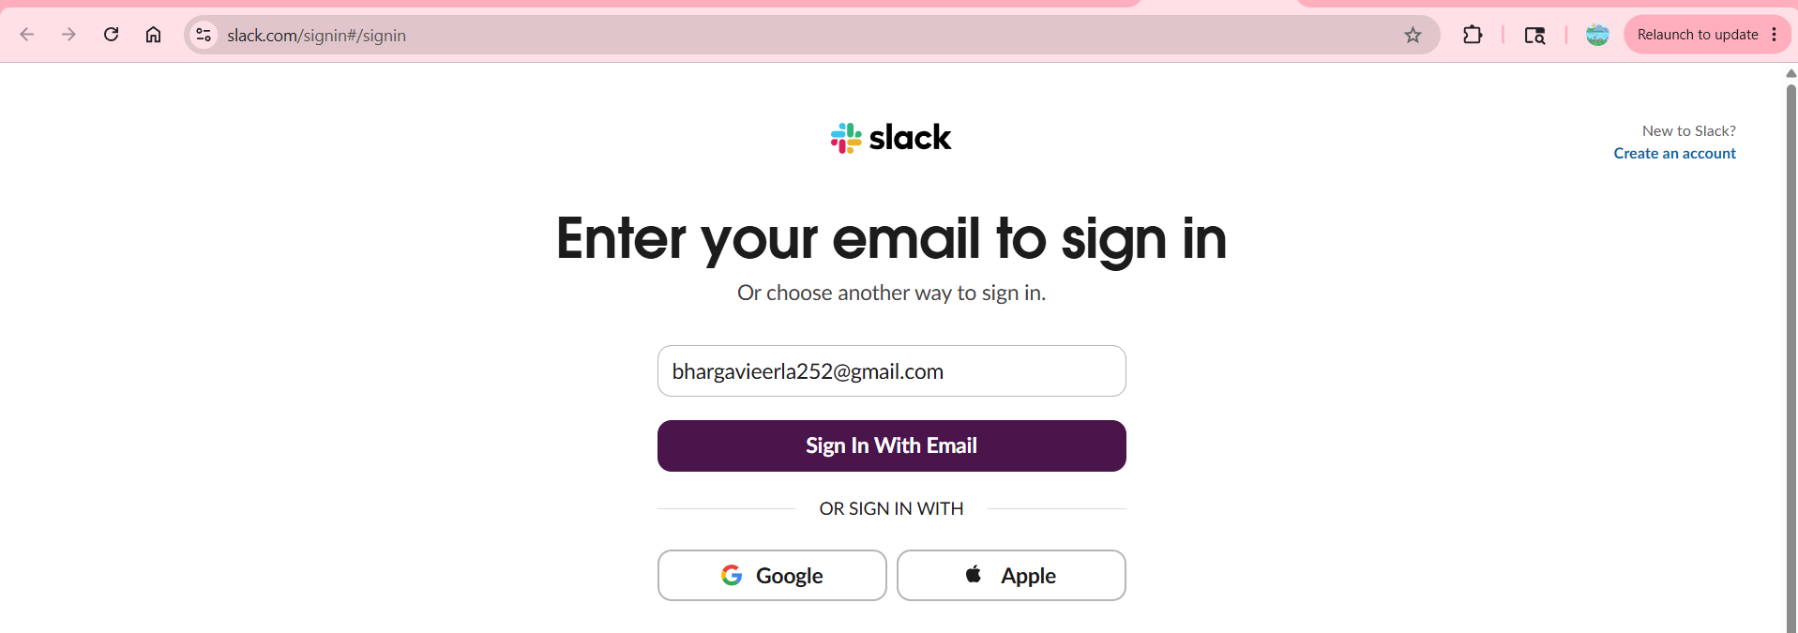
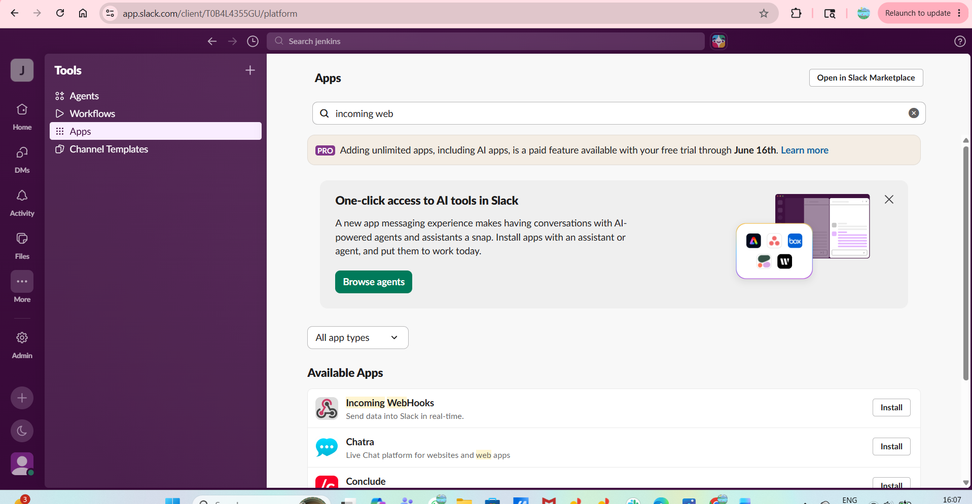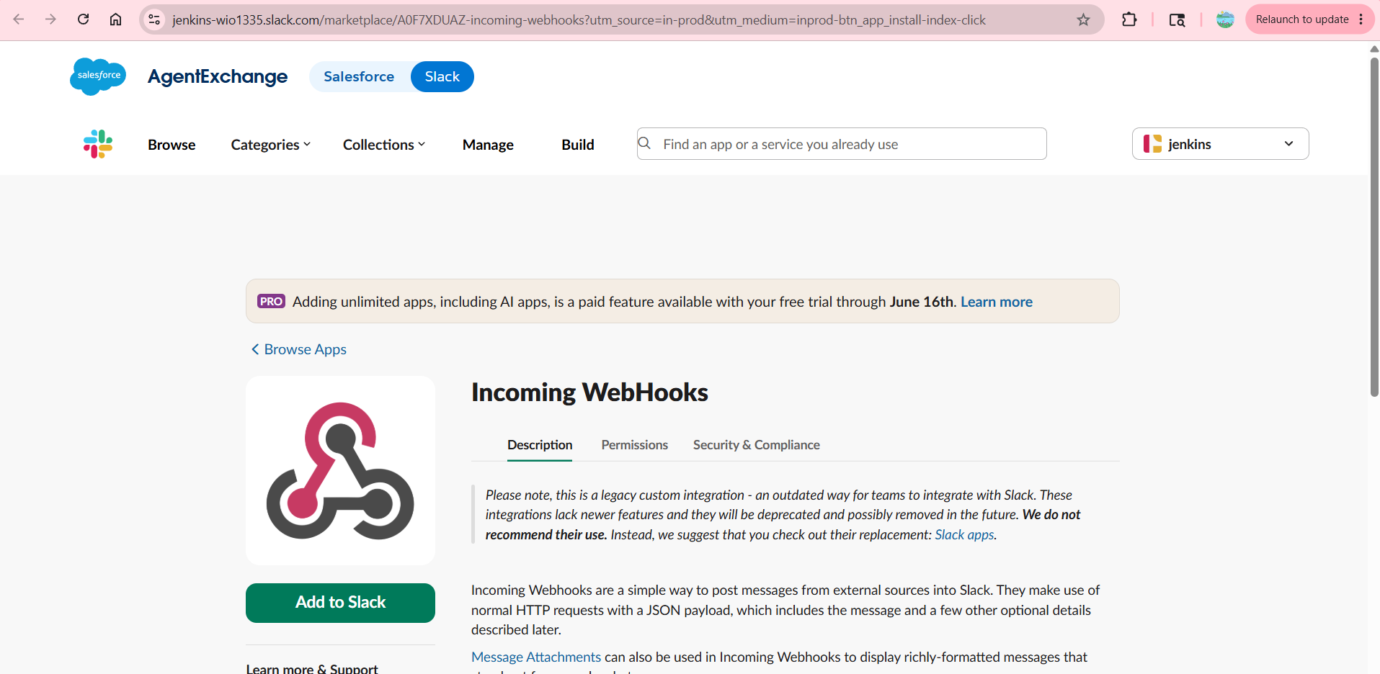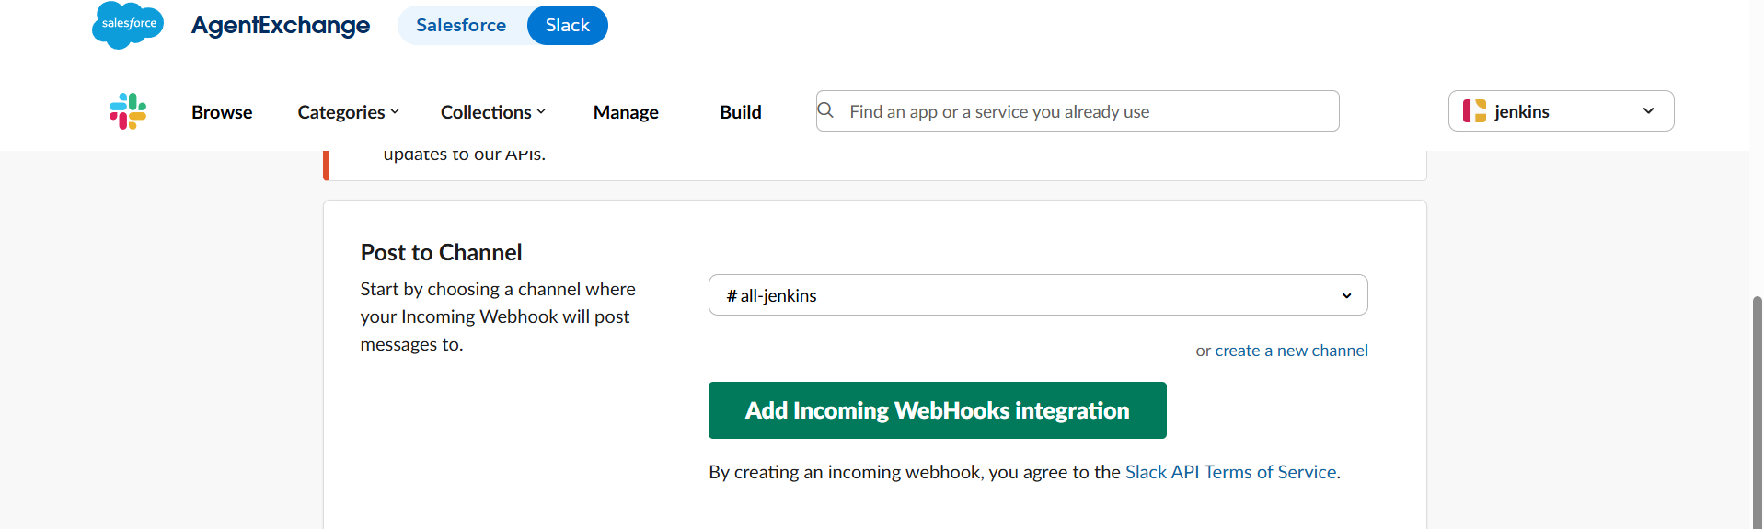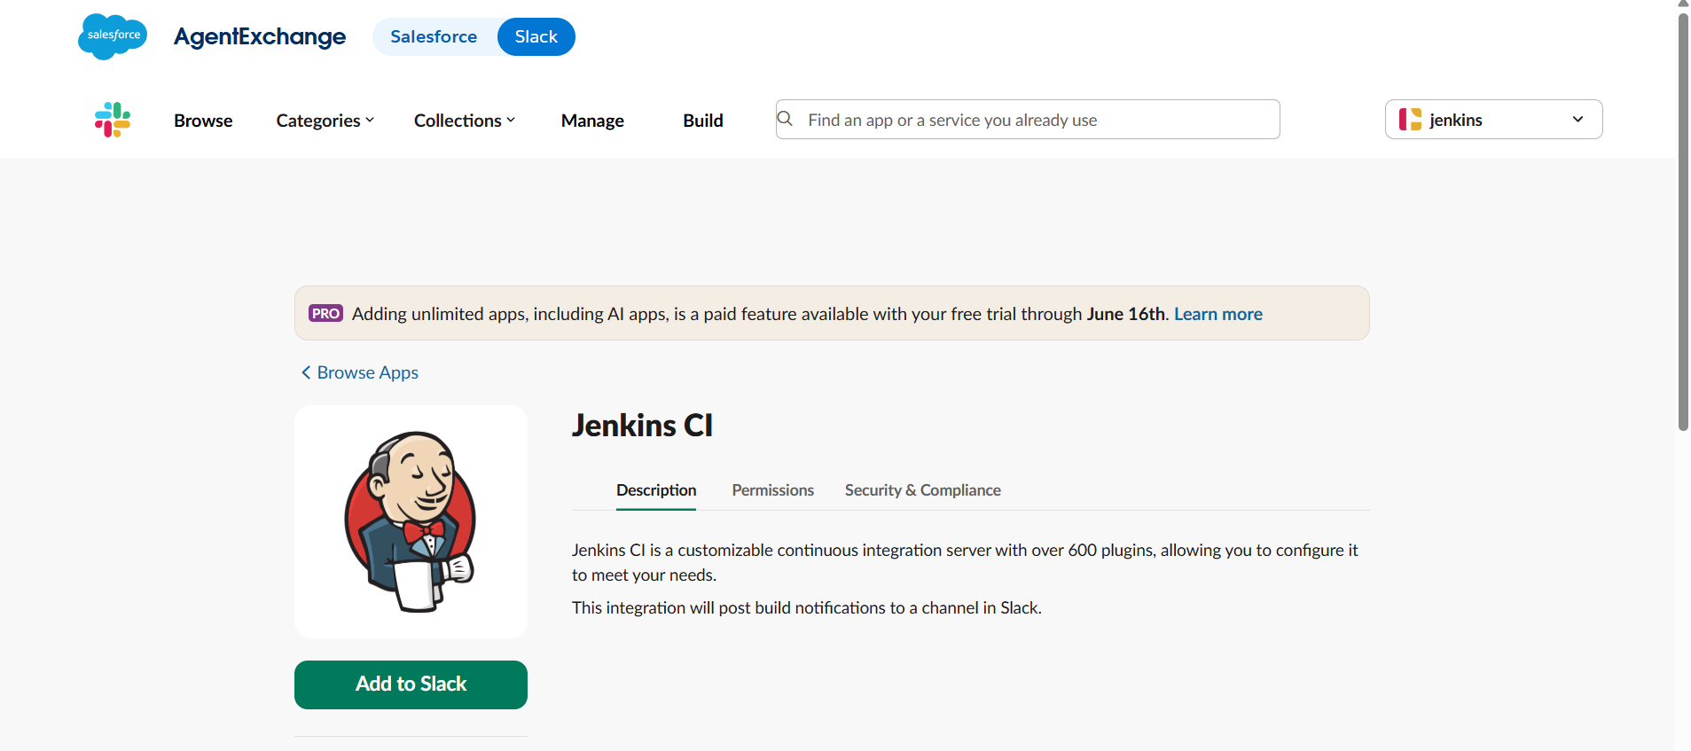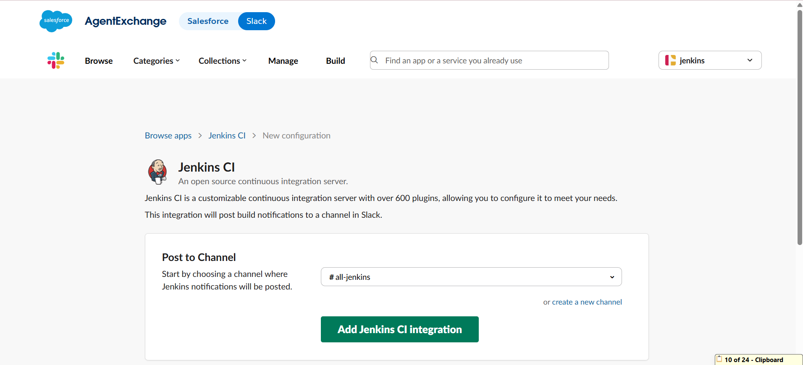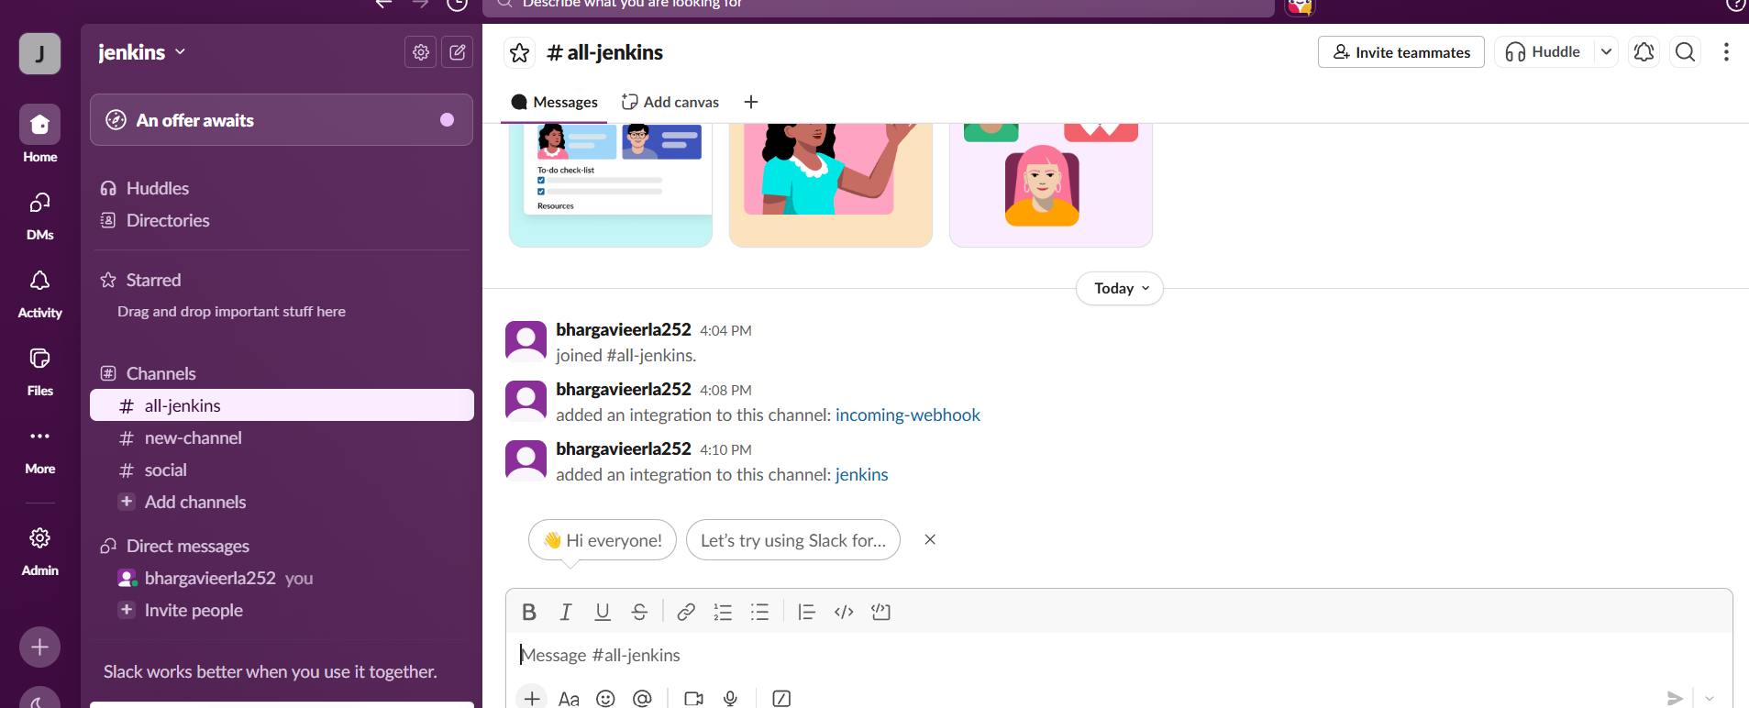
Open Jenkins last go to token copy that
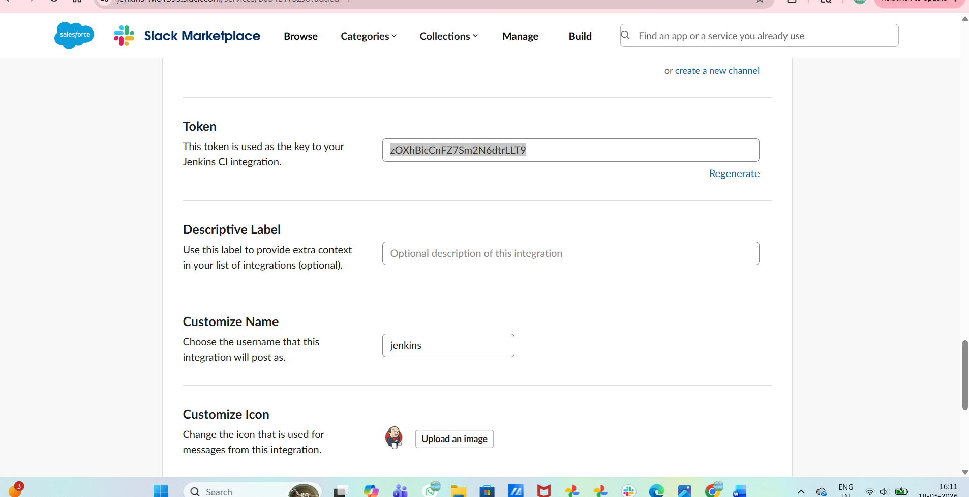
Go to manage Jenkinscredentialsclick on secret textadd the copied token inSecret
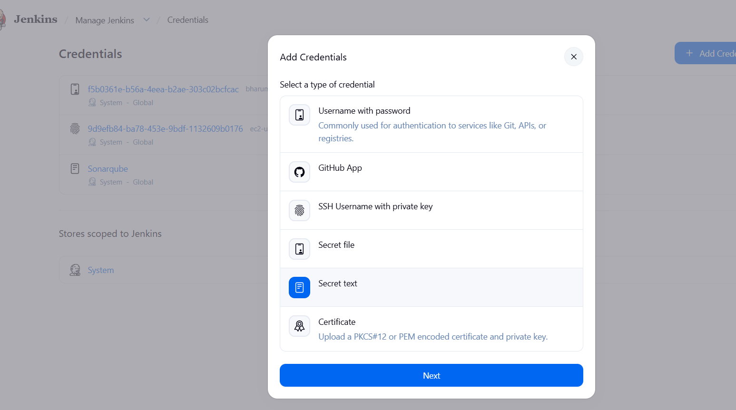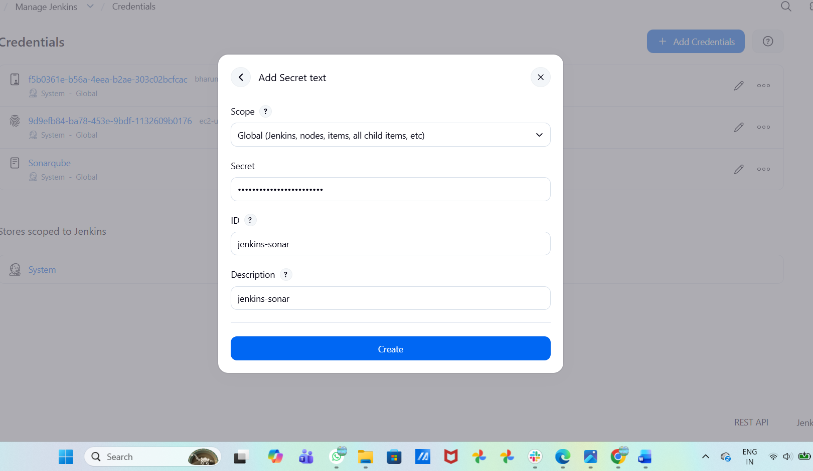
If we open the channel in slack there we will be having channel id, copy that and give in
channel id section
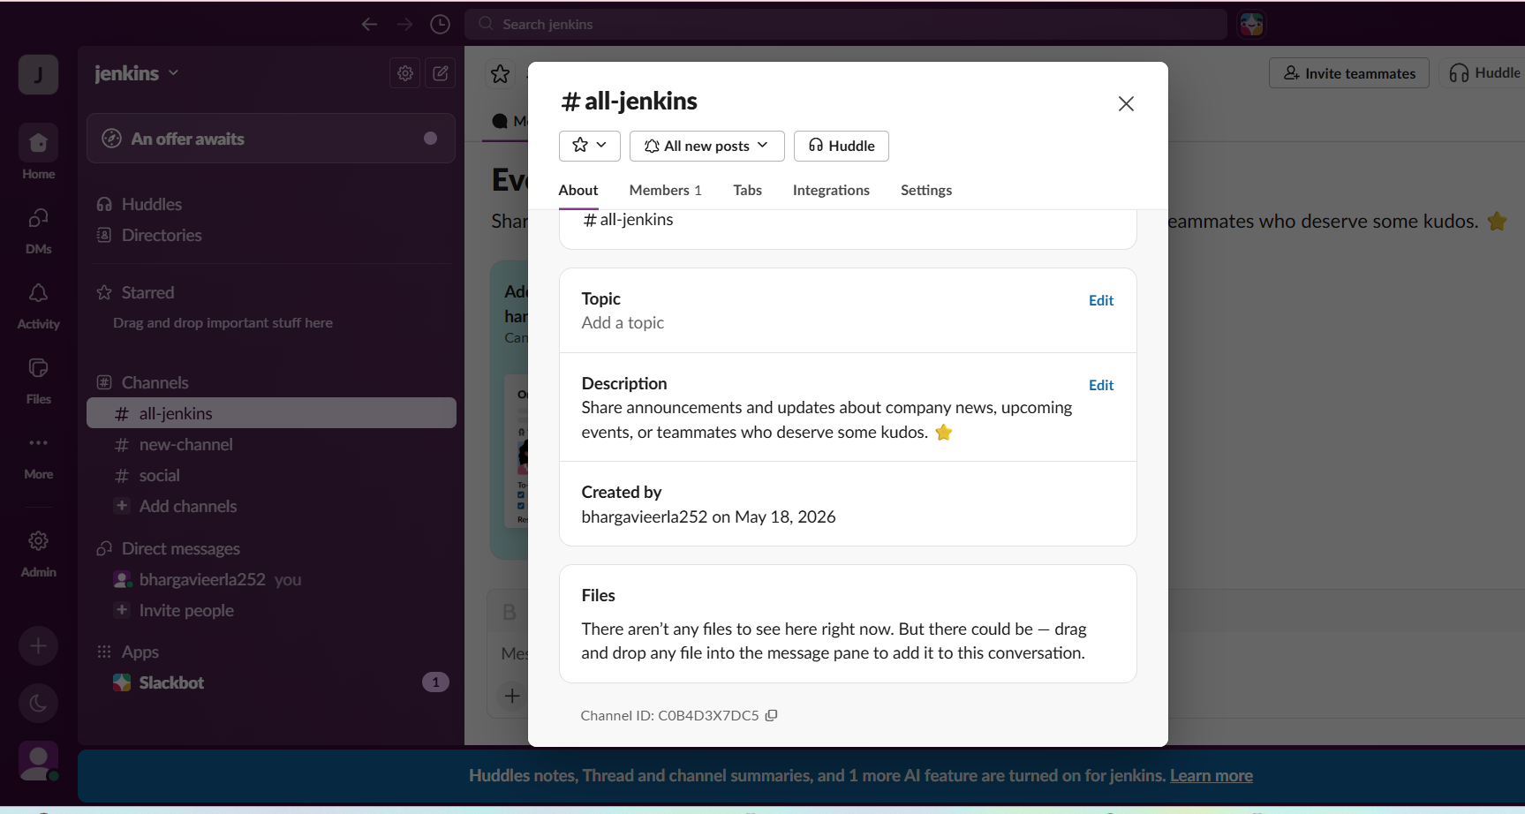
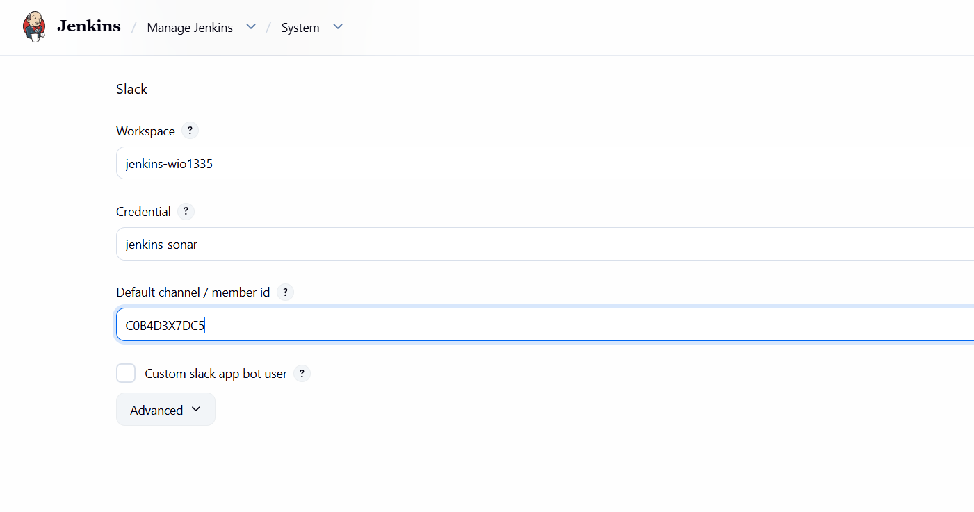
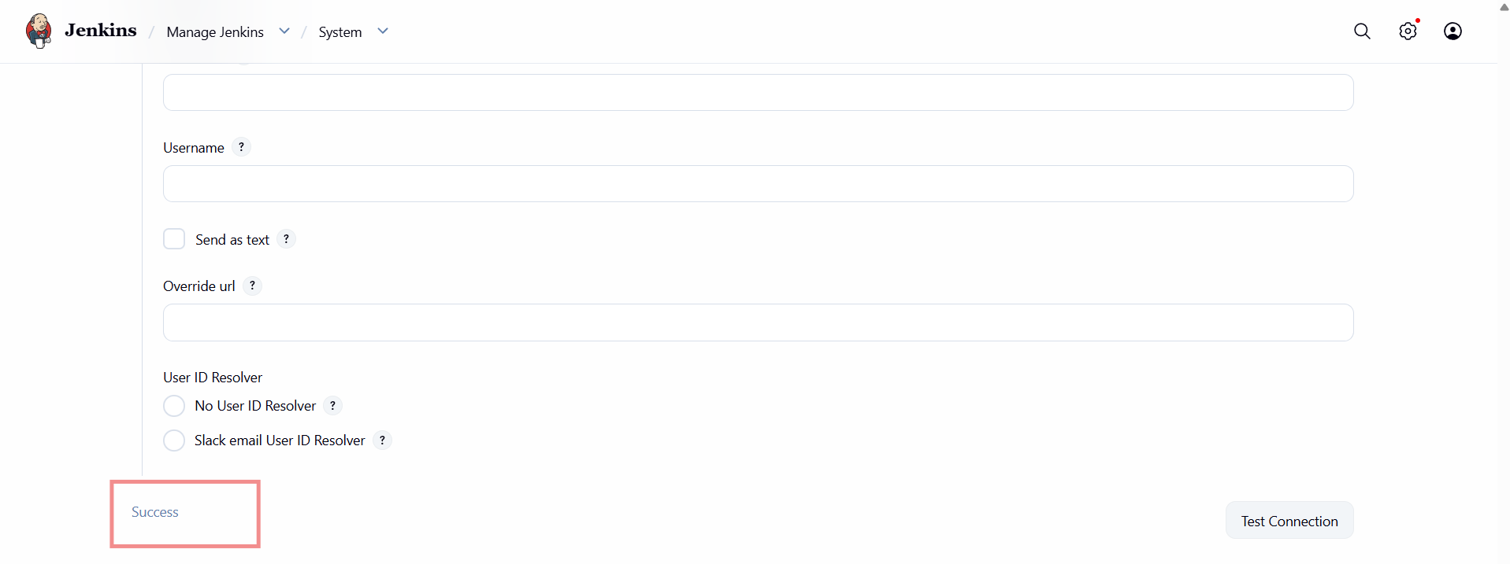
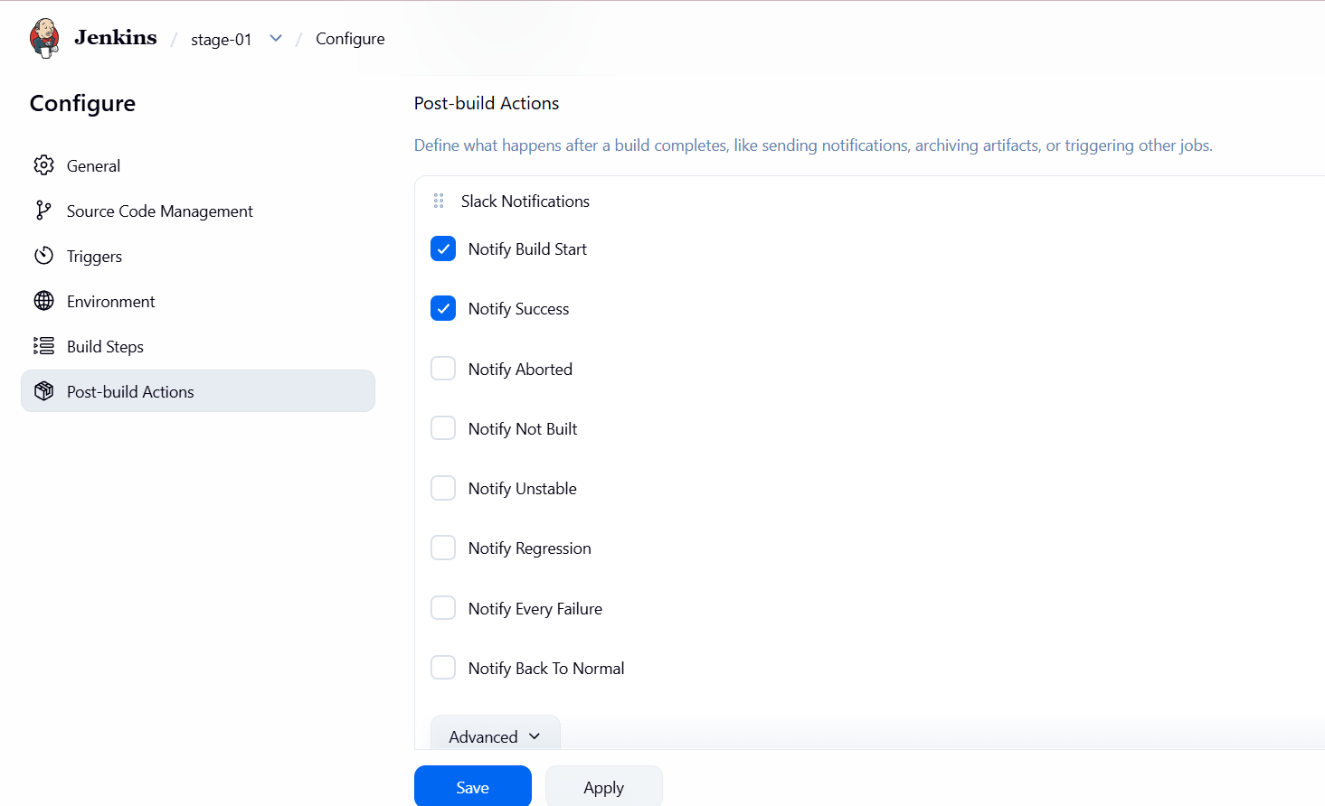
- Here we can see connection is successful
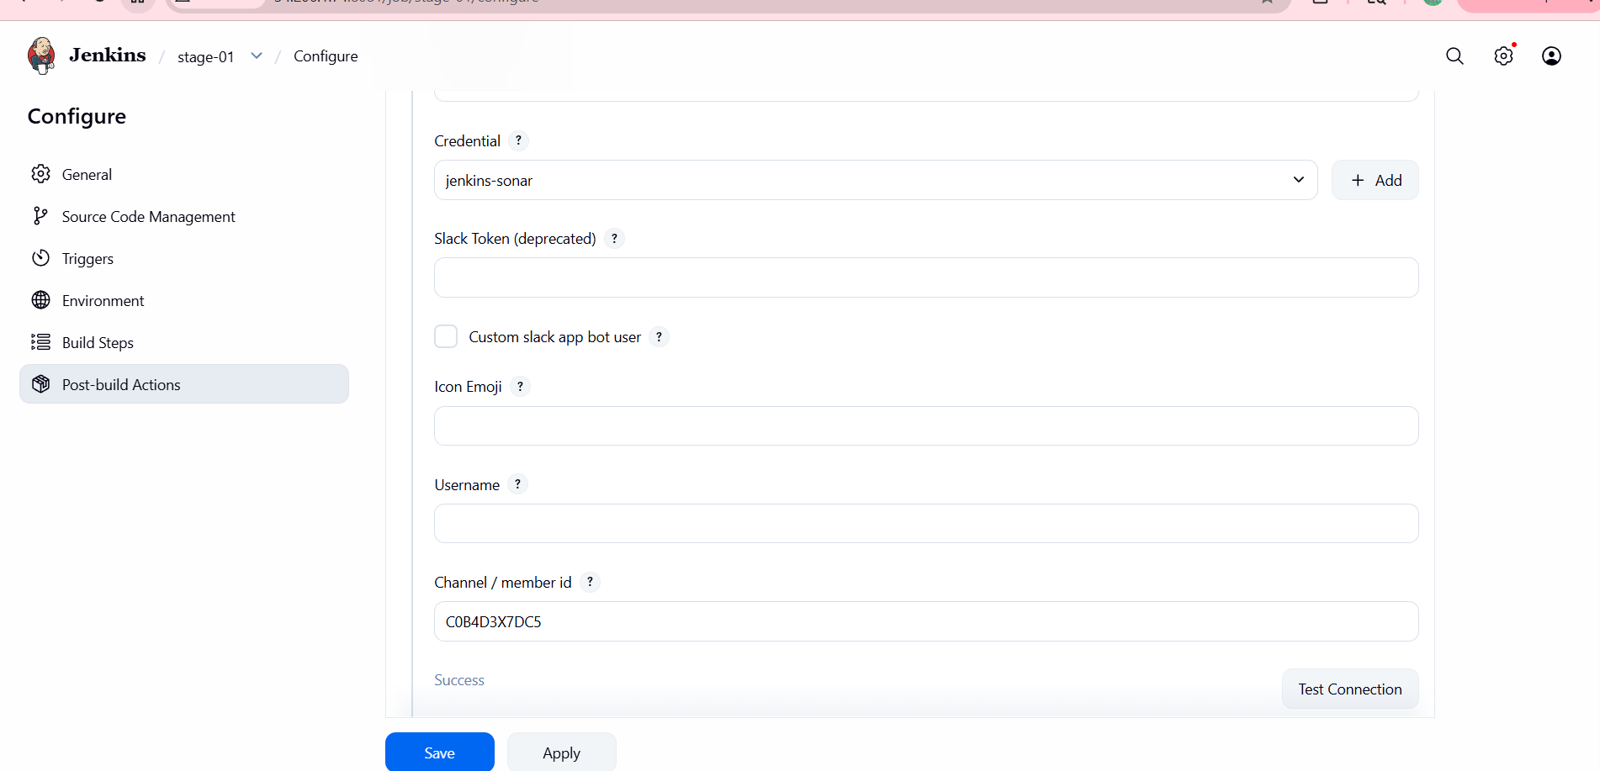
- When we click on build it is successfully ran
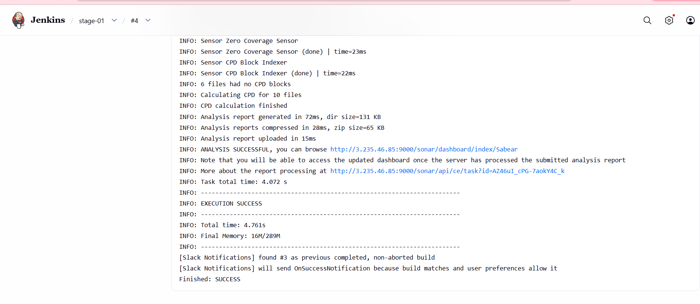
Also we are able to get the alerts in slack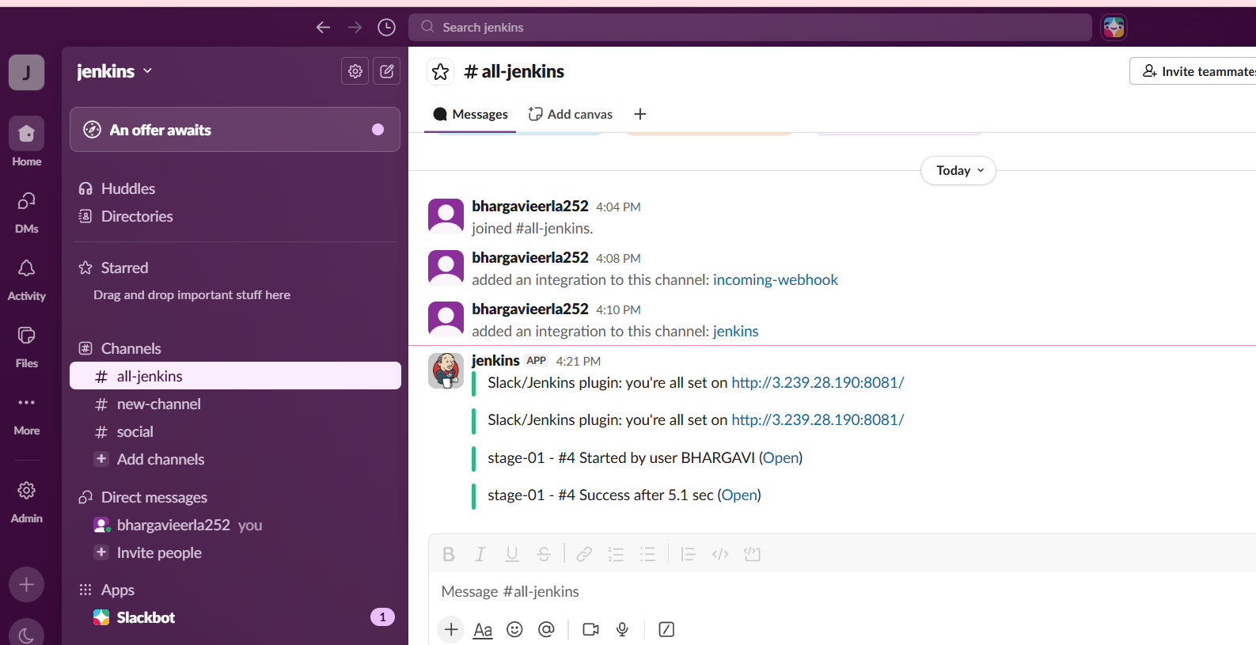
2. Create one Jenkins job using the below code and create three stages.
- stage1: Git clone to download the source code.
- stage2: Sonarqube Integration to check the quality of code.
- stage3: Slack Integration to send the alerts to slack.
Source Code: https://github.com/betawins/hiring-app.git
create a new build
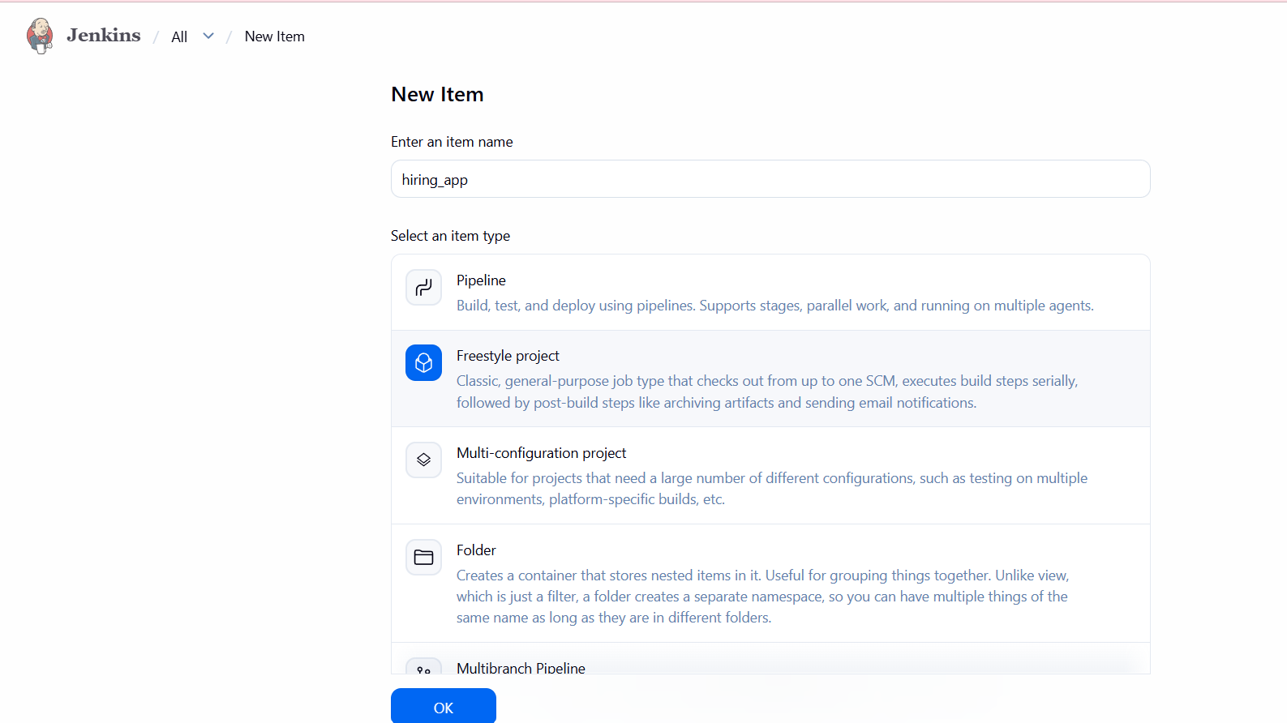
Choose git and provide url
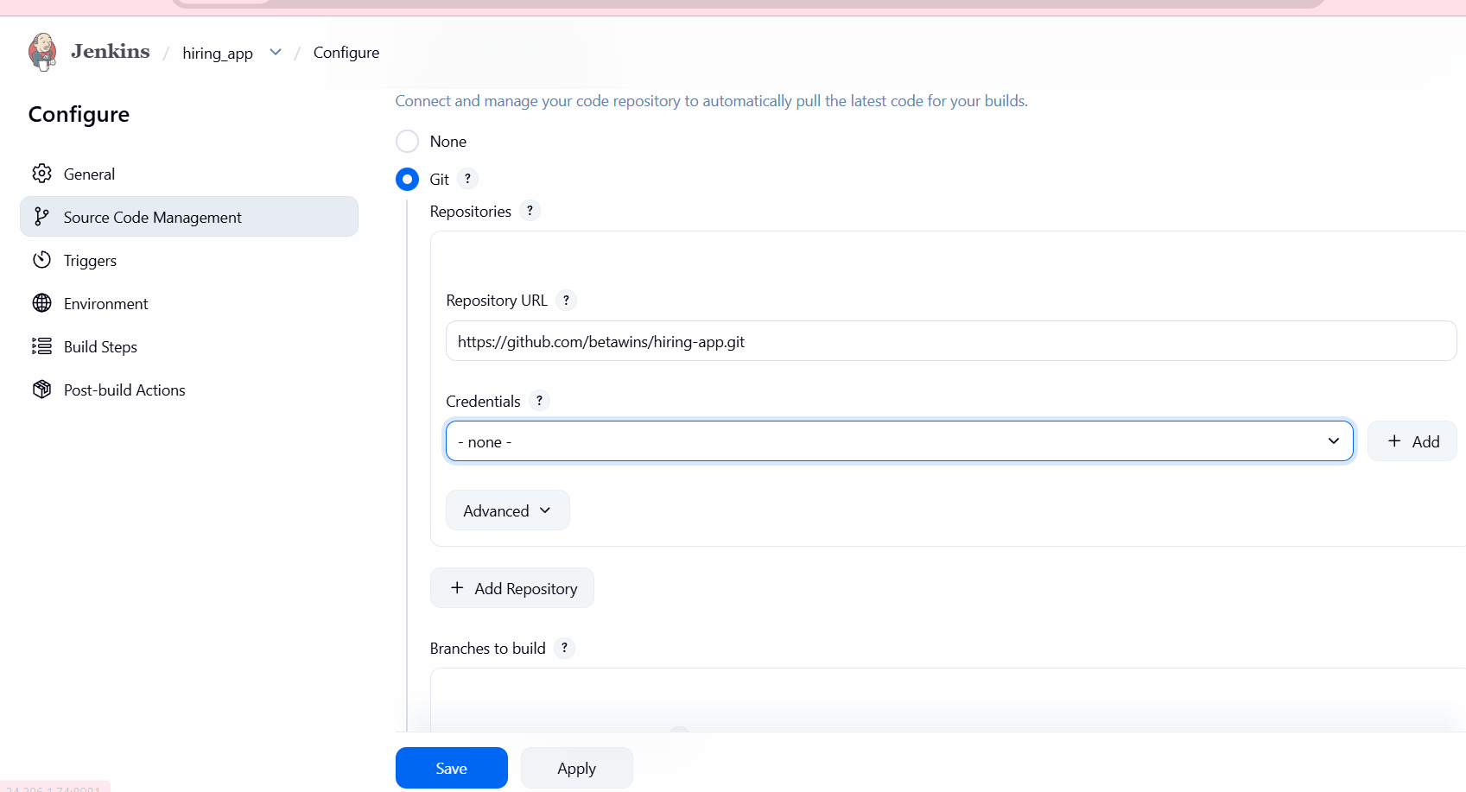
Click on add build step - choose sonarqube scannerAdd code in analysis properties
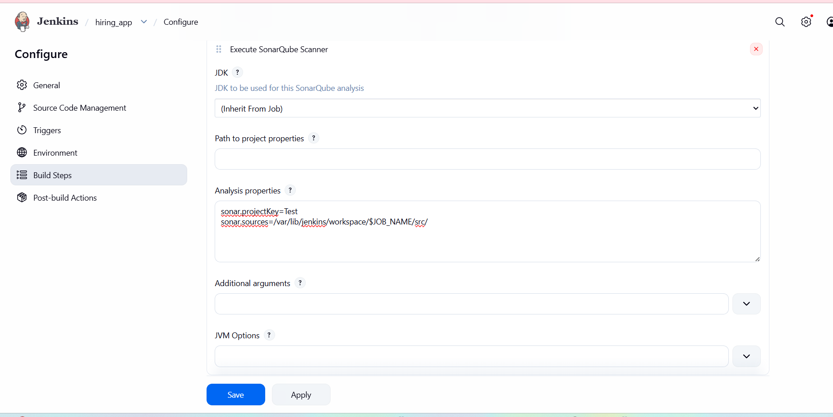
Go to post build actions choose slack notificationselect 2 advanced
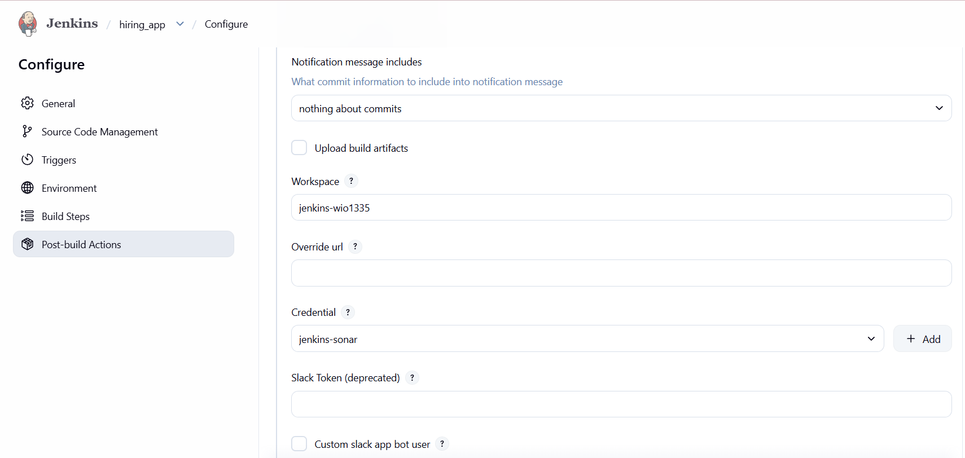
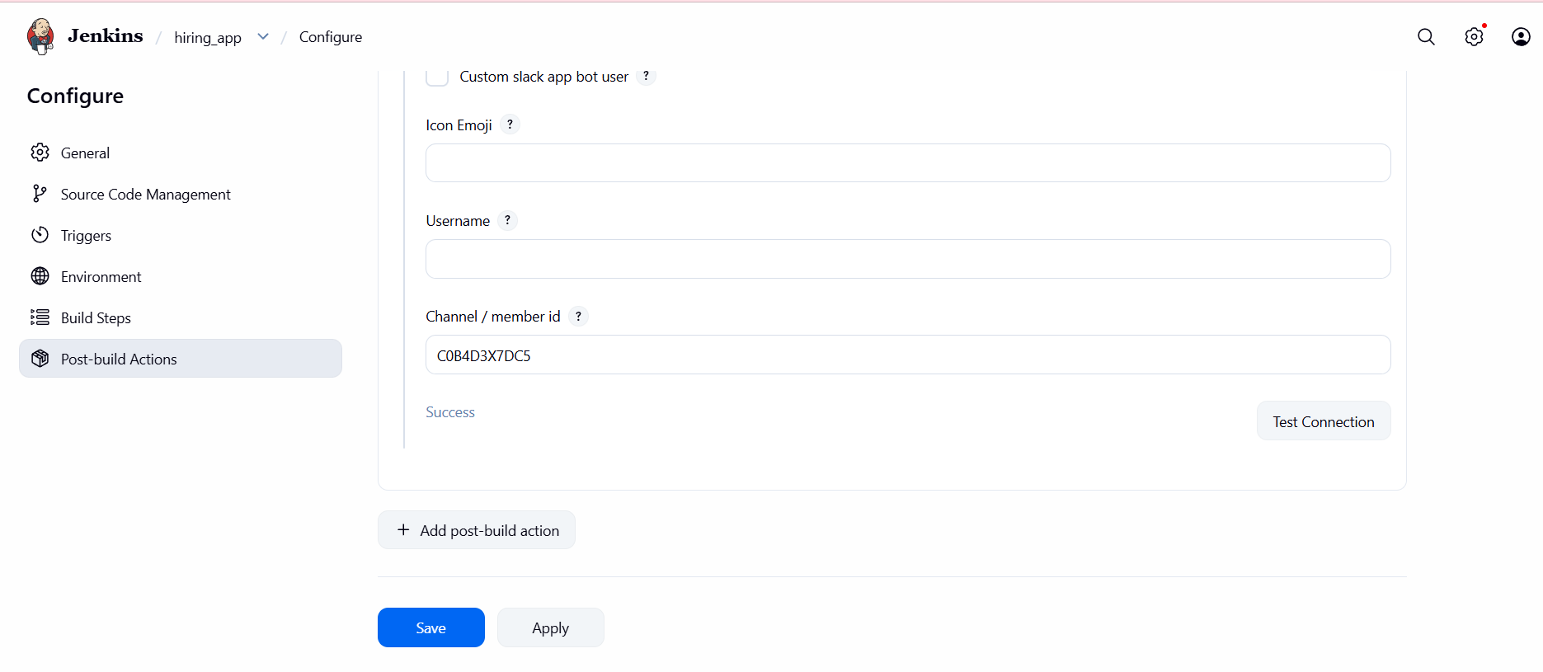
Click on build nowsuccesswe get alerts on slack
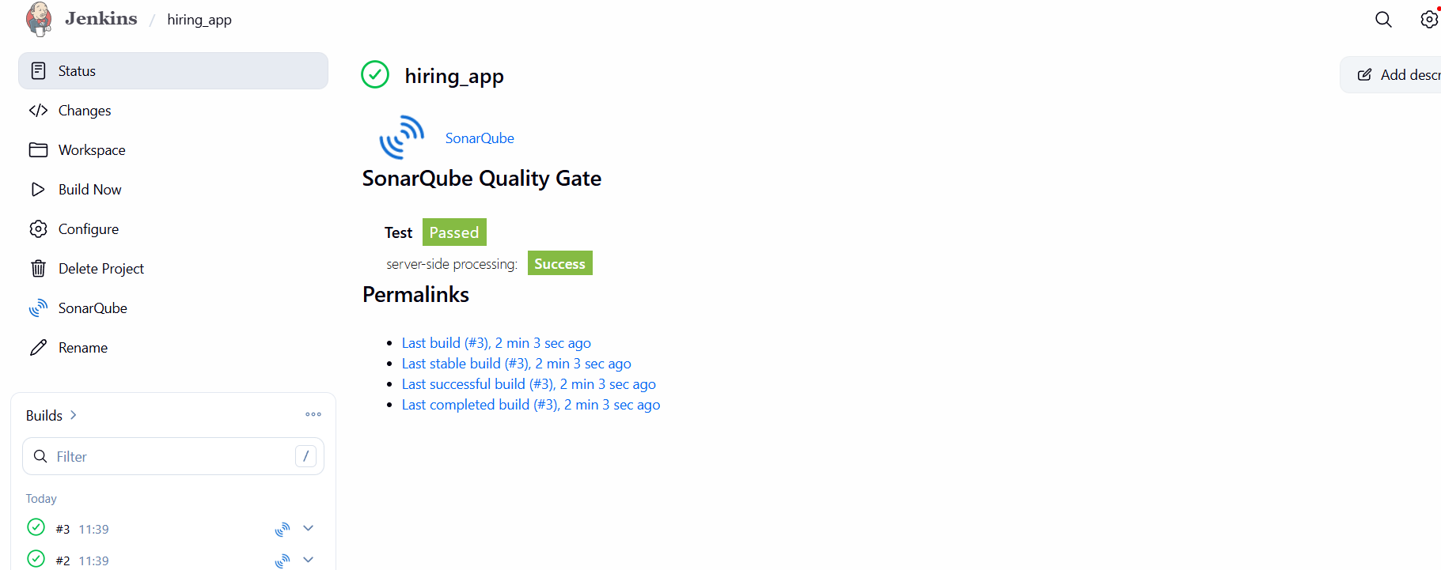
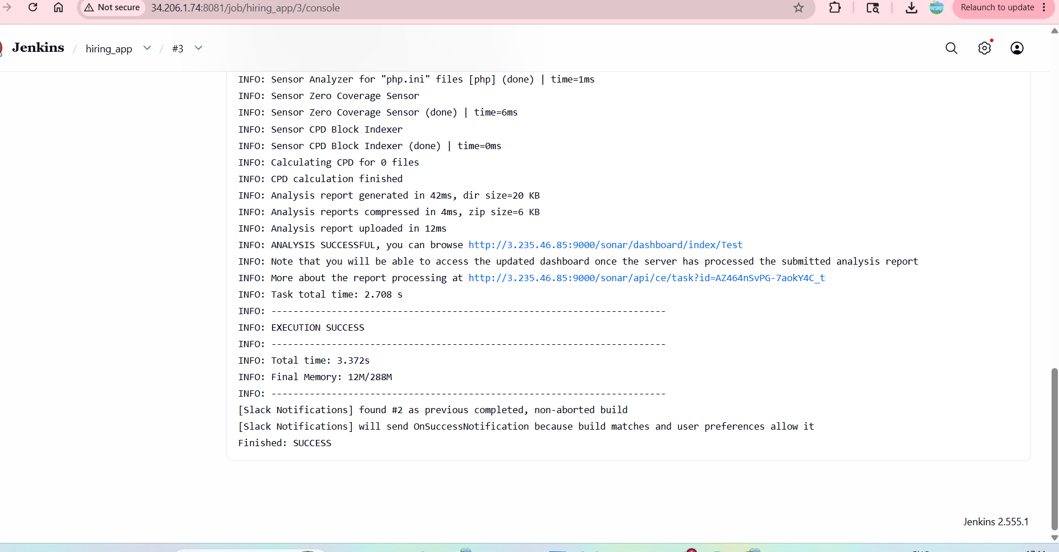
- We get alerts on slack