DMS Automotive

Metric Chrome Socket Inventory

Date:_____________________________________

Volunteer Name(s):__________________________

Inspect sockets to identify missing, damaged or otherwise in need of replacement sockets. This list applies to metric, chrome sockets for DMS automotive. Return this document to automotive leadership when complete.

Helpful Information:
In addition to nominal dimension, these sockets are sorted by drive size (see Figure 1), socket depth (see Figure 2), and point style (see Figure 3).

Notes:

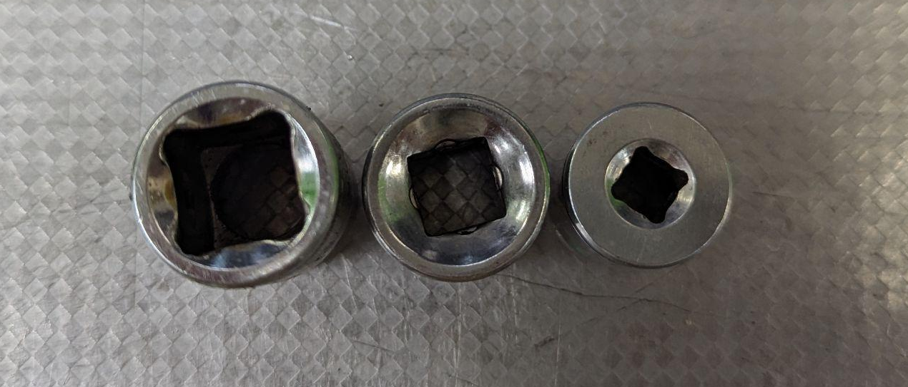
Figure 1: From left to right, ½” Drive, ⅜” Drive and ¼” Drive sockets.

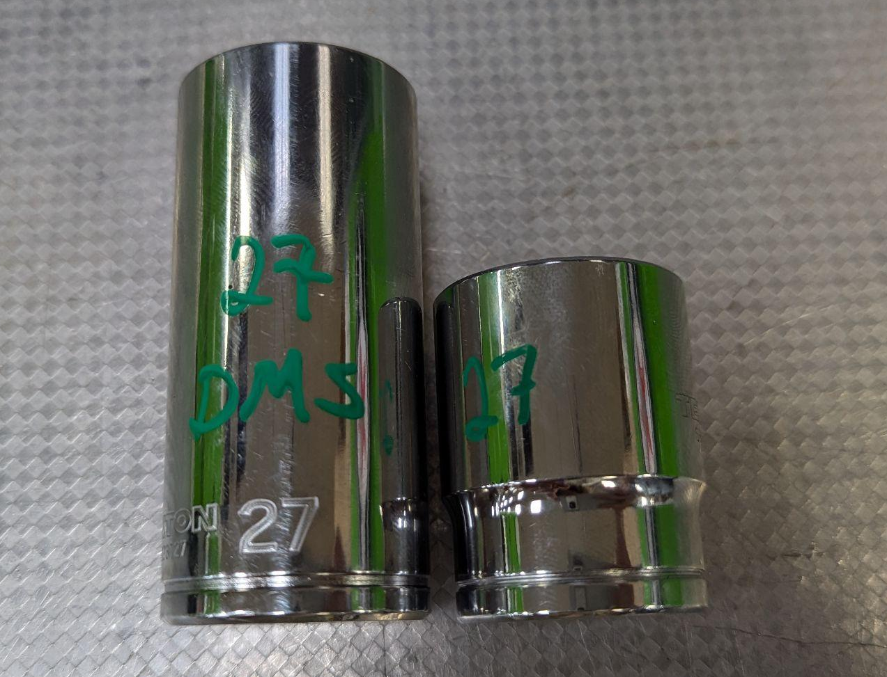
Figure 2: Deep socket (left) and standard socket (right).

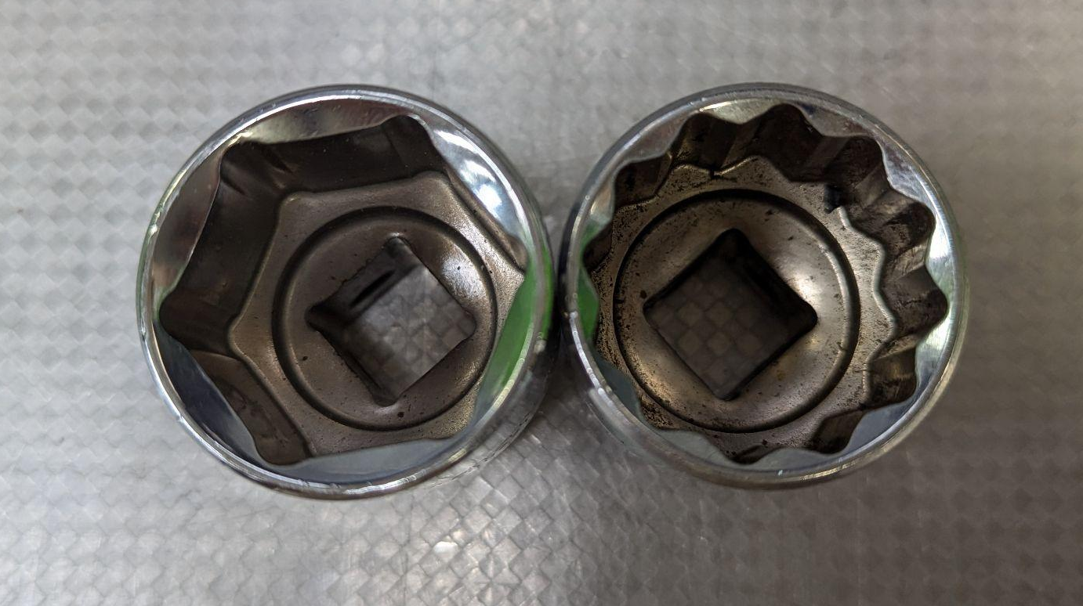
Figure 3: 6-Point socket (left), 12-Point socket (right).

¼” Drive Sockets
 | Standard 6pt. | Deep 6pt. | Standard 12pt. | Deep 12pt.
4
4.5
5
5.5
6
7
8
9
10
11
12
13
14
15

Notes:

⅜” Drive Sockets

 | Standard 6pt. | Deep 6pt. | Standard 12pt. | Deep 12pt.
6
7
8
9
10
11
12
13
14
15
16
17
18
19
20

Notes:

½” Drive Sockets
 | Standard 6pt. | Deep 6pt. | Standard 12pt. | Deep 12pt.
10
11
12
13
14
15
16
17
18
19
20
21
22
23
24
25
26
27
28 | N/A |  | N/A
29 | N/A |  | N/A
30 | N/A |  | N/A
31 | N/A |  | N/A
32 | N/A |  | N/A
33 | N/A |  | N/A
34 | N/A |  | N/A
35 | N/A |  | N/A
36 | N/A |  | N/A
37 | N/A |  | N/A
38 | N/A |  | N/A

Notes:

