What is the INSTA Heat Press?
- A giant iron!
  - Like our current heat press, this is a large heated metal plate.
- Used for:
  - Direct to Film, Dye Sublimation, Heat Transfer Vinyl, White Toner Ink, Fabric Interfacing

What can you make with it?
- Items Benefit DMS’s Function and Appearance
  - Signage and Promotional Items for DMS
    - Coffin Race Shirts
    - Subiefest Shirts
    - Tour Day Sign
    - Tabletop Sig Play Mats
- To press items bigger than 16x20!
  - Arcade Cabinets
  - Cosplay bodysuits
  - Photographs/Art Canvas Prints
  - Fabric
  - Clothing
  - Metal & Wood Signs

Why is it good for DMS?
- Exclusivity/ Excitement/Draw
  - Heat presses are difficult to find at this size.
  - Graphic Designers are excited to have access to a larger tool.
  - Already getting more graphics volunteers due to heat press interest.
- Iteration
  - Makers can easily test materials samples and layouts, this is not cost-effective with a sign shop or fabric shop such as Spoonflower.
- DMS Needs It!
  - Will help us quickly redecorate DMS after/during construction
  - DMS branding, such as Apparel, Decor, Signage.

How did it get to DMS?
- Donor purchased heat press for testing, and offered it to DMS once testing was complete.
- Donor also wishes to tour DMS during the month of October
  - James emailed donor at the time of donation receipt
- Donor stated they may also wish to buy a block of memberships for their employees

How Hot is It?
- Heats to 3-400Degrees F, presses materials flat.
  - Efficient, heat is well contained within the unit.
  - Heat cannot be felt at all outside of Vector
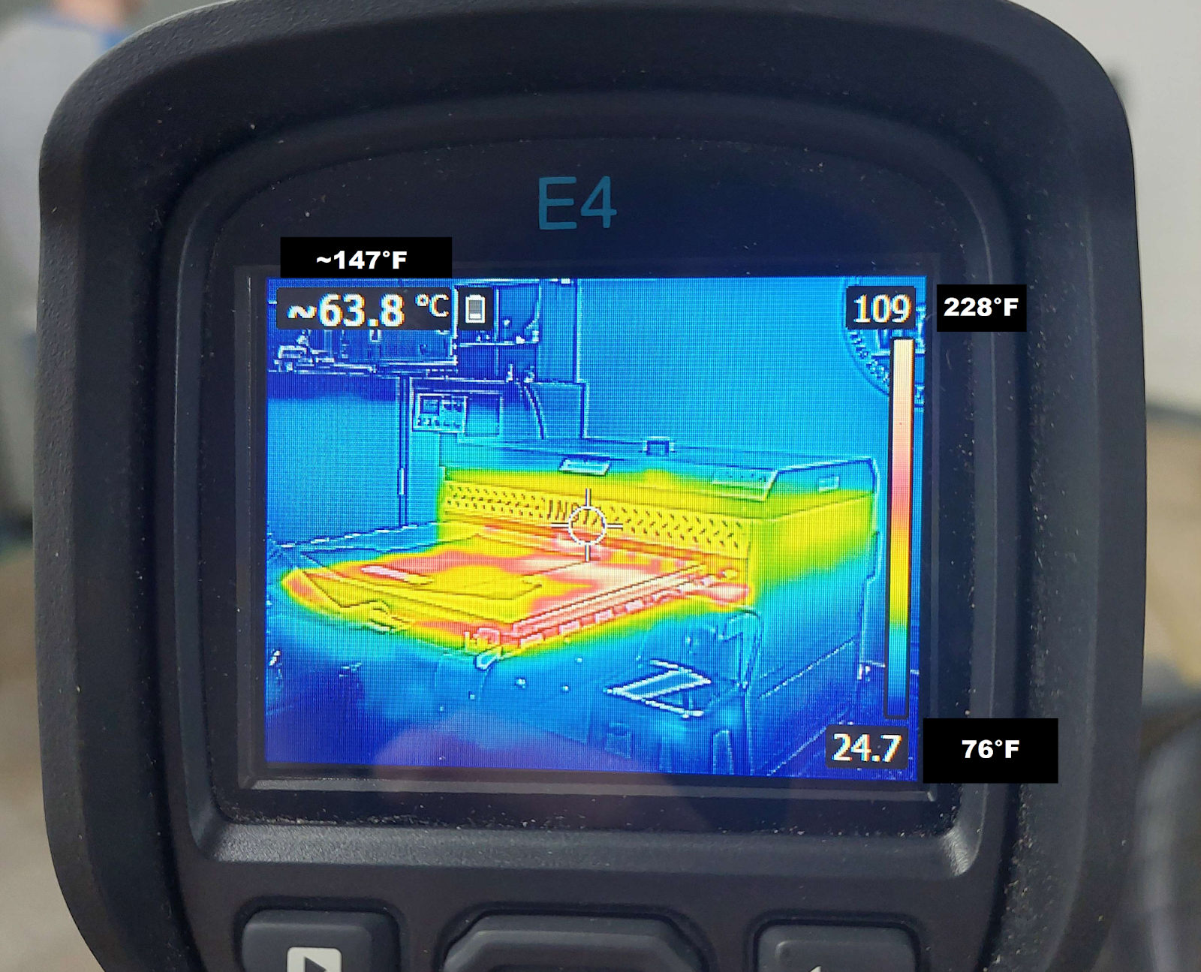

What are the needs of the Heat Press?
- 3 Phase, 208 power- as close to the breaker box as possible. (per Jeff)
- Dust Free Environment- dust and dirt from workshops will ruin prints.
- 20in of space around it.
- Air Pressure
  - Extant- an air hose may be connected from the Machine Shop
  - Ideal- air pressure drop from line in Jewelry
    - Glass Kilns already need an extension of the Jewelry line
    - Most piping is already in DMS storage
    - Cost minimal
- Heat Venting- Optional
  - Optional because heat is not excessive.
  - To maximize cooling efficiency, a heat chimney could be easily added to the Glass Kiln Venting.
    - All venting/ flue parts already gathered.

Why is the INSTA in Vector?
- Vector can use it in arcade cabinets, play decks, and signage for our area
- It allows Vector to benefit DMS
- The location is logical- near other types of Printmaking
- Vector meets the power and cleanliness requirements of the machine.

FAQ:

Does Vector plan more printer purchases?
- Direct to Film No, Never.
  - We already turned down a free Direct To Film Printer from this donor.
Requires fume extraction, is the size of a car, must be kept at 75f, maintenance every 24-48hrs.
- UV Printer: No, Never.
Similar to above, high maintenance, fumes, maintenance.
- Direct to Garment No Purchase, will analyze if offered one for free.
  - Not likely, limited to specific use cases.
  - Analysis Requirements:
    - Low scheduled maintenance cycles, Cost, Maintenance Schedules & costs, Fumes, Use Cases
- Large Format Dye Sublimation Printer.
  - Possible ask, but not in 2024, not likely in 2025.
    - only after deliberation, growth, and cost-benefit analysis.
  - Considerations before an ask:
    - Low maintenance
    - Low Cost. (Currently 5-7k for a new machine)
      - Costs have fallen significantly, if they fall further it may be a reasonable buy or accepted donation in the coming years.
    - Fumes: None
    - Use Cases: Broad.

How will Vector Prevent Abuse/Misuse of the Press?
- Intended use will be taught in class.
  - If a user’s business model is dependent upon DMS tools, this is beyond intended use.
- Speed is set slow, and is slow enough not to be profitable for a business
  - Speed control is difficult to find, and will be covered with a lockbox.
    - Tampering w/ the lockbox will result in immediate and permanent tool ban
- Each press must be triggered manually.
  - Auto button will be covered with lockbox
    - Tampering with lockbox will result in immediate & permanent ban.
- Ideal: RFID interlock will be added to press control box as a cover, and a log of use will be pulled monthly, user numbers that come up frequently will be queried/ video pulled.
- Currently: Manual logging
  - Date/Name/Starting number of presses/ending # of presses (on the control unit)

