Heat Press Class (First Draft)
(dye sub 101 prerequisite)

Intended Use:
- Not for commercial use. If your profit model relies on the UPTIME of DMS Tools, this is unacceptable use.
- If your use is preventing multiple members from using the machine- this is beyond intended use.
- Use will be monitored by camera & log.
- Unlogged use will be banned
  - If you merely forgot, message Vector@dallasmakerspace.org with the day/time/approximate # of presses.
- Do not tamper with 3d Printed box covers. Tampering with box covers will result in permanent tool ban.

What Does it Do?
Large, flat iron. It is the final step in many pint processes.

- Direct to Film (DTF) Pressing
- Dye Sublimation Pressing
- Heat Transfer Vinyl Pressing
- Also used for applique and interfacing heat fusible fabric.

Yes, but what can I make with it?
- T-shirts, hoodies, apparel
- Signs/Banners
- Custom Fabric Designs
- Press-n-cut clothing
- Cosplay Body Suits
- Fine Art Canvas Prints
- Photographs on Metal
- Balloons!

What Materials?
Items under 1/8” thick. MUST BE CLEAN
Examples:
Fabric, T-shirts, thin metals (

Set Up:
- Hook up:
  - Pneumatic
  - Power
- Set Heat
- Set time

Lay Out Material:

Dye Sub/DTF:
- Lay out paper under if any material may get on rubber mats
- Lay out as flat as possible
- Dye sub/DTF film face down
- Cover with paper
- Press both green buttons to start first press
- Repeat when second Platten is done

Fabric Fusing:
- Set temp/time according to interfacing directions.
- Fusing must be smaller than fabric
  - When in doubt, put paper down first
- Place fabric ‘good’ side down
- Place interfacing adhesive (bumpy) side towards fabric.
If double sided interfacing, place second piece of fabric ‘good’ side up.
Cover all with paper.
- Press both Green buttons once to activate press.

Resources:

Dye Sub:
- Print in-house, carefully paste together.
- Alpha Graphics can mail off image.
  - Image must be 300dpi. Print out a small sample on normal printer to be sure it looks good.
  - Be sure to flip image
- WeSubNStuff
  - Process is in the works, local large format (44in) dye sub printer

Heat Transfer Vinyl:
- Must take vinyl cutter class to learn to cut vinyl
  - Apply to surface, press at time/temp

Direct To Film:

DTForder.com
https://dtforder.com/products/gang-sheet-1
  - 22x24 is cheapest per linear foot, use gang sheet builder,
Sheet already has margin, be sure to UNCHECK the margin!
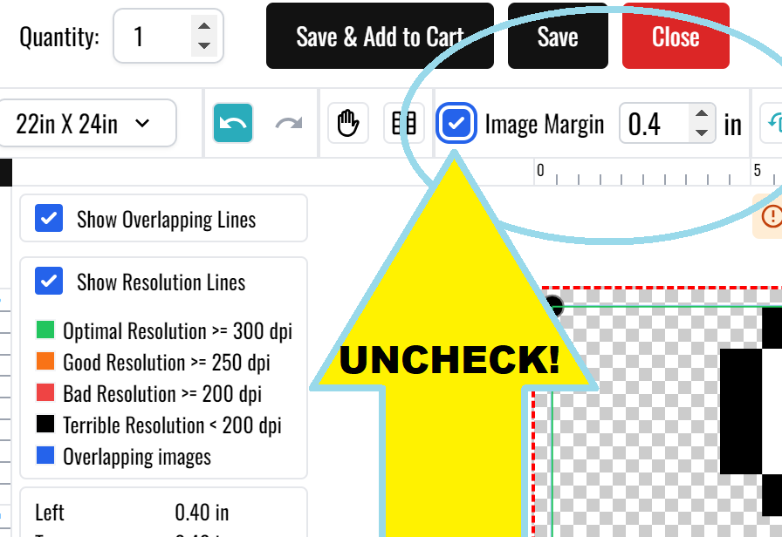
  - Where is it? 10MIN From DMS. No ship, 4hrs to print.
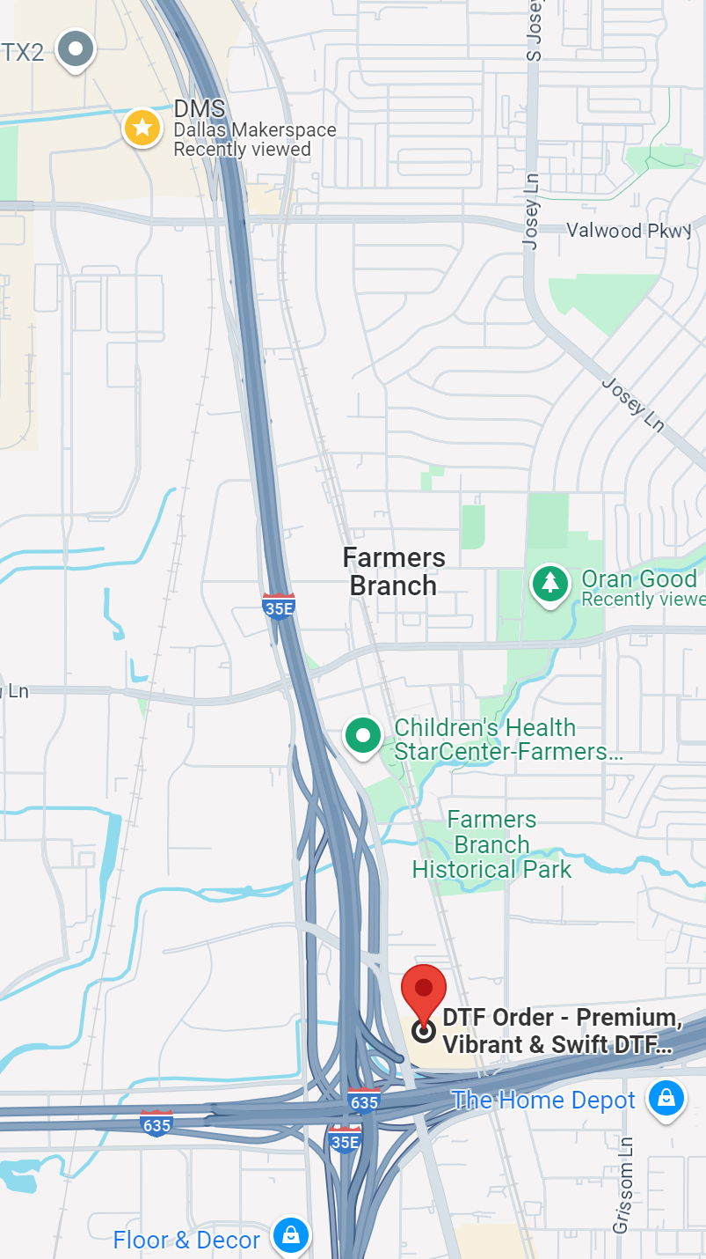

- DTF Dallas
  - Better quality, slightly more expensive
  - https://dtfdallas.com/products/custom-gang-sheet?variant=47278795555104
  - 