# General

This Project is created to book a flight at Php Travels Website using Java Selenium combination. Please check the pom.xml file for all the relevant dependencies.

Below is the general flow of the smoke scripts.

First Script:

1. Go to the website home page.
2. Verify the objects on the page.

Second Script:

1. Go to the website home page
2. Create the Object for Default Page
3. Search for a flight
4. Select the first flight from the list
5. Enter the details for booking
6. verify the booking confirmation

**Note:** Scripts are doing minimum to showcase the framework

# Test Scripts

Two Test Scripts are created to demonstrate the framework. Both of these test scripts refer to the test data provided in the ShoppingData.csv.

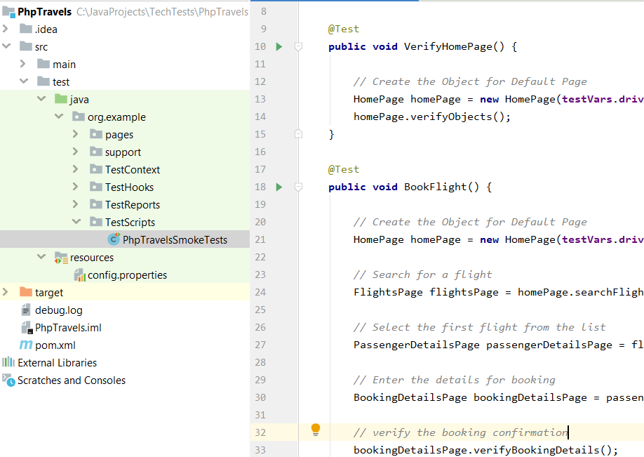

# 1.0 Klov Reporter

This project has implemented Extent Klov Reporting. Please follow the guidelines to setup Mongo DB and Extent reporting.

<https://github.com/anshooarora/extentreports-java>

<https://extentreports.com/docs/versions/4/java/klov-reporter.html>

[*https://www.mongodb.com/download-center/community*](https://www.mongodb.com/download-center/community)

## 1.1 provide Settings as per below

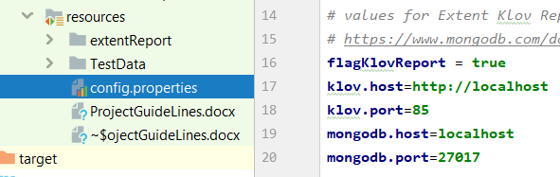

## **1.2 Turn off Extent Reporting**

User can turn off the Extent Klov Reporting by setting the “flagKlovReport” to false.

# 2.0 Execution Environment

Currently Project is set to run locally. For Remote Execution set the ‘runRemotely’ flag to true and provide the valid Hub URL.

