# General

This Project is created to get the weather details using the given API. Please check the pom.xml file for all the relevant dependencies.

Three test scripts are designed using **Karate BDD** approach.

1. get weather When city name is provided
2. get weather When Latitude & Longitude is provided
3. get weather When postal code is provided

**Note:** Scripts are doing minimum to showcase the framework

# Test Scripts

Two Test Scripts are created to demonstrate the framework. Both of these test scripts refer to the test data provided in the ShoppingData.csv.

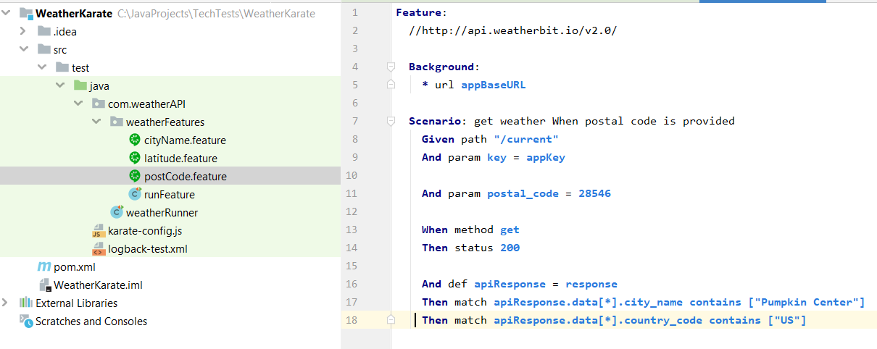

# 1.0 Klov Reporter

This project has implemented Extent Klov Reporting. Please follow the guidelines to setup Mongo DB and Extent reporting.

<https://github.com/anshooarora/extentreports-java>

<https://extentreports.com/docs/versions/4/java/klov-reporter.html>

[*https://www.mongodb.com/download-center/community*](https://www.mongodb.com/download-center/community)

## 1.1 provide Settings as per below

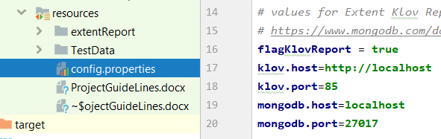

## **1.2 Turn off Extent Reporting**

User can turn off the Extent Klov Reporting by setting the “flagKlovReport” to false.

# 2.0 Execution Environment

Please obtain the valid key from the weather API – and replace it the highlighted area.

