# LEARN EASE

**AN INDUSTRIAL TRAINING PROJECT REPORT**

***Submitted in the partial fulfilment of the requirements for the award of the degree of***

**Bachelor of Computer Applications**

**By**

**Sandeep kumar [22BCA050]**

**Anand mohan singh[22BCA049]**

**Shivam kumar singh[22BCA064]**

**Raushan raj Tiwari[22BCA075]**

**Bhashkar kuamr[22BCA002]**

**Ajeet kumar[22BCA085]**

**Under the Supervision of**

***Ankit Kishore Sen***

***(Sr. IBM AI Expert)***



## FACULTY OF INFORMATION TECHNOLOGY AND ENGINEERING

**GOPAL NARAYAN SINGH UNIVERSITY**

**JAMUHAR, SASARAM, BIHAR, 821305**

**May 2025**

## DECLARATION BY THE STUDENT

*This is to certify that the major project work entitled “****education platform”*** *submitted to Faculty of Information Technology and Engineering, in partial fulfillment of requirements for the completion of project work of* ***BCA*** *program is a record of original work done by my team during the period of study (Feb 2025 – May 2025) in Gopal Narayan Singh University, Jamuhar, Bihar, India.*

*I further declare that the project report does not contain any work or part of any work which has been submitted for the award of any degree either in this University or in any other Institute without proper citation, to the best of my knowledge.*

Roll No. Student Name Student Signature

22BCA050 Sandeep kumar …………………………………….

22BCA0549 Anand Mohan Singh …………………………………….

22BCA064 Shivam kumar Singh ……………………………………

22BCA075 Raushan Raj Tiwari ……………………………………

22BCA002 Bhashkar kumar ……………………………………

22BCA085 Ajeet kumar **………………………………………**

## CERTIFICATE

*This is to certify that this is the bonafide Project Work done by the* ***Sandeep kumar[22BCA050] Anand mohan singh[22BCA49] Shivam Kumar singh[22BCA064] Raushan raj Tiwari[22BCA075]***

***Bhashkar kumar[22BCA002] Ajeet kumar[22BCA085 ]****under the supervision of* ***Ankit Kishore Sen***

***(Sr. IBM AI Expert),*** *in partial fulfillment of the requirements for the completion of the award of* ***BCA*** *degree program.*

*Name and Sig. of Project Guide*

*Date:*

*Submitted for the Viva- Voce Examination held on ___________________*

***Internal Examiner External Examiner***

*Name: ____________________ Name: _______________*

*Signature: _________________ Signature: ____________*

***Dean***

***Faculty of Information Technology and Engineering***

## ACKNOWLEDGEMENT

*We would like to express sincere thanks to our project supervisor, Ankit Kishore Sen, for his/her patience and encouragement throughout these months. He/She always put aside his/her precious time to discuss project topics with us and gave us strength to keep working on this project. We could not have completed this project work without the assistance of our project supervisor, Ankit Kishore Sen,*

*We also want to take this opportunity to thank all the Faculty and Staff of the Faculty of Information Technology for their support and encouragement. Finally, we all would like to thank our family for their encouragement and understanding. Their support enabled us to pursue our graduation from this esteemed University.*

Roll No. Student Name Student Signature

22BCA050 Sandeep Kumar …………………………………………………..

22BCA049 Anand Mohan Singh …………………………………………………..

22BCA064 Shivam Kumar Singh …………………………………………………

22BCA075 Raushan Raj Tiwari …………………………………………………

22BCA002 Bhashkar Kumar ………………………………………………..

22BCA085 Ajeet Kumar ………………………………………………….

**Abstract**

An online **Education platform** is a digital ecosystem designed to facilitate learning through web-based interfaces. It enables students, educators, and institute to connect remotely, offering a wide range of courses, interactive tools, and resources.

The rapid advancement of technology and the increasing demand for accessible education have led to the development of education platforms. This platform provides learners with flexible, personalized, and scalable educational experiences through video lectures, quizzes, assignments, discussion forums, and AI-powered learning assistants. They cater to diverse learning needs, from academic subjects to skill development and professional certifications

**Table of Contents**

|  |  |
| --- | --- |
| **Contents** | **Page No.** |
| DECLARATION BY THE STUDENT …………………………………………………………………………………………….......... i  CERTIFICATE FROM THE SUPERVISOR(s) …………………………………………………………………………………......... ii  STUDENT BONAFIDE CERTIFICATE …………………………………………………………………………………………………. iii  Acknowledgements …………………………………………………………………………………………………....................... iv  Abstract …………………………………………………………………………………………………………………………………………. v  **Chapter 1: Introduction …………………………………………………………………………………..................... 1**   * 1. Problem Statements ………………..…………………………………………………………….…………… 1   1.2 Problem Specifications ……………….…………………………………………………………………….... 2   * 1. Aim and Objectives ……………..……………………….…………………………………………………….. 2   1.4 Plan of the work ……………………………………………………………………………………………….. ..3  1.5 Materials / Tools required ………………………………………………………………………………….. 4  **Chapter 2: Analysis and Design Methodology**  2.1 Requirement Analysis (functional and non-functional requirements) ……………………………5  2.1.2 Functional Requirements………………………………………………………………………………..5  2.1.2 Non-Functional Requirements………………………………………………………………………. 6  2.2 Expected Outcomes……………………………………………………………………………………………………….6  2.3 System Design  • DFD (Data Flow Diagram) ………………………………………………………………………………………………….7  • ERD (Entity Relation Diagram) ……………………………………………………………………………………..……8  **OR**  **(For Object Oriented Analysis and Design)**  • Activity Diagram  • Sequence Diagram  • Class Diagram  • State Chart Diagram  • Use Case Diagram  **OR**  **(For Networking or Hardware related Analysis and Design)**  • System Block Diagram  Logic Diagram  • Pin Diagram/ Pin Configuration Diagram  • Topology Diagram  **Chapter 3: Implementation**  3.1 Implemented Functionality……………………………………………………………………………………………..9  3.2 Implementation Parameters…………………………………………………………………………..……………….9  3.3 Coding Standards……………………………………………………………………………………………………….… 10  3.4 Programming Languages……………………………………………………………………………………………… 10  **Chapter 4: Test and Result Analysis**  4.1 Test Plan and Test Cases……………………………………………………………………………………………….15  4.2 Testing and Verification………………………………………………………………………………………………..16  4.3 Test Report…………………………………………………………………………………………………………………..16  4.4 Result and Discussion……………………………………………………………………………………… ………….17  4.5 Snapshots…………………………………………………………………………………………………………………….19  **Chapter 5: Conclusions and Recommendation**  5.1 Summary of the results……………………………………………………………………………………………………….22  5.2 Advantages of your work/results/methodologies……………………………………………………………….22  5.3 Scope of future work…………………………………………………………………………………………………………..22  5.4 Unique Features of your Innovation/Project……………………………………………………………………….23  **References …………………………………………………………………………………………….. ……………………………………….23**  **Appendix ………………………………………………………………………………………………………………………………………….25**   1. Copy of periodic progress reports submitted by team members with guide comments and signature on it. …………………………………………………………………………………………………………………………26 2. Synopsis | |

**Chapter 1: Introduction**

* 1. **Problem Statements**

In the digital age, education has transcended physical classrooms, giving rise to **education platforms** that provide learners with flexible and accessible learning experiences. These platforms leverage technology to deliver structured courses, interactive learning materials, and personalized education, to students, professionals, and lifelong learners alike.

Education platforms offer a range of subjects, including academic courses, skill development programs, and industry certifications.

**Key features of education platforms include:**

* **Accessibility**: Learners can access content from anywhere with an internet connection.
* **Interactivity**: Engaging tools like live classes, and collaborative projects enhance learning.
* **Multimedia Integration**: Videos, simulations, and interactive assessments enrich understanding.
* **Certifications**: Platforms often provide certificates or degrees, making them valuable for career advancement.

**Objective:**

The primary objective of an education platform is to provide accessible, engaging, and personalized learning experiences for students, professionals, and lifelong learners.

**these platforms aim to:**

* Enhance Accessibility: Offer education anytime, anywhere, overcoming geographical and financial barriers.
* Improve Engagement: Integrate multimedia, and interactive features to boost learner motivation.
* Ensure Credibility & Security: Provide verified certifications, protect user data, and prevent cybersecurity threats.
* Promote Collaborative Learning: Enable global networking, discussion forums, and peer-to-peer interactions

**1.2. Problem Specifications:**

To develop an effective education platform, the system must address key challenges related to **accessibility, engagement, personalization, security, and credibility**. Below are the specific problem areas that require well-defined solutions:

1. **User Accessibility**:
   * Ensure compatibility across devices (mobile, desktop, tablets).
   * Optimize content delivery for low-bandwidth connections.
   * Provide multilingual support for diverse learners.
2. **Engagement & Interaction**:
   * Incorporate quizzes, and interactive sessions.
   * Offer classes, peer discussions, and collaborative projects.
   * Utilize multimedia elements like animations and simulations.
3. **Cybersecurity & Data Privacy**:
   * Implement secure authentication and data encryption.
   * Prevent cyber threats such as hacking, phishing, and data breaches.
   * Ensure compliance with global privacy regulations (GDPR, CCPA, etc.).
4. **Credibility & Certification**:
   * Establish reliable assessment methods to validate learning.
   * Provide industry-recognized certifications and accreditation.
5. **Scalability & Maintenance**:
   * Support increasing user demand without performance degradation.
   * Ensure regular updates and system improvements.
   * Enable seamless integration with external tools and resources.

**1.3. Aim and objective**

**Aim:**

The primary aim of an **education platform** is to provide **accessible, flexible, and interactive learning experiences** that empower individuals to acquire knowledge, enhance skills, and achieve academic or professional growth, irrespective of their location or background.

**Objectives:**

* **Enhance Accessibility** – Ensure learning opportunities for all by overcoming geographical and financial barriers.
* **Engagement & Interactivity** – Integrate multimedia tools, gamification, and live interactions to boost learning effectiveness.
* **Cybersecurity & Data Protection** – Safeguard user data and prevent cyber threats for a secure learning environment.
* **Credibility & Certification** – Provide valid assessments and recognized certifications

support career advancement.

**1.4. Plan of Work:**

To create a robust and effective education platform, the development process follows a structured plan, ensuring **accessibility, engagement, security, and scalability**. Below is a detailed **plan of work**:

**1. Research & Requirement Analysis**

* Identify target users (students, professionals, educators).
* Analyze existing platforms to understand strengths and limitations.
* Define key features, including **security protocols, and interactive learning tools**.

**2. Platform Design & Architecture**

* Design a **user-friendly interface** with seamless navigation.
* Plan scalable **backend architecture**.
* Ensure compatibility across devices (desktop, mobile, tablets).

**3. Content Development & Integration**

* Create structured course modules with **multimedia (videos, quizzes, interactive assessments)**.
* Provide **feedback** to enhance user engagement.

**4. Development & Implementation**

* Code the platform using **secure web technologies** (HTML, CSS, JavaScript, Python, or frameworks like React).
* Establish **authentication and security features** (data encryption, user privacy protection).
* Optimize for **high performance and accessibility** across regions.

**5. Testing & Quality Assurance**

* Conduct extensive **functionality testing**, ensuring bug-free operation.
* Perform **usability testing** to enhance the user experience.
* Validate cybersecurity measures to protect user data.

**6. Deployment & Maintenance**

* Provide continuous updates and **feature enhancements**.
* Look for security threats and implement proactive **cybersecurity defenses**.

**7. User Engagement & Growth Strategy**

* Offer free trials and personalized learning paths to attract users.
* Gather user feedback for **continuous improvement**.

**1.5. Materials/Tools Required To build this project,**

the following tools and technologies were used**:**

1. Languages and Frameworks: HTML/CSS/JavaScript: For designing the user interface and managing interactivity.
2. Development Tools: IDEs like Visual Studio Code.
3. Hosting Platforms: Local browser during development

**Chapter 2: Analysis and Design Methodology**

* 1. **Requirement Analysis**

To develop an effective **education platform**, a thorough requirement analysis is essential. This ensures that the platform meets the needs of learners, educators, and administrators while addressing technical, security, and accessibility concerns.

**2.1.1 Functional Requirements**

* **Course Management:** Structured curriculum with modules, quizzes, assignments, and live sessions.
* **Interactive Features:** discussion forums, virtual classrooms, peer collaboration.
* **Assessment & Certification:** Online exams, grading systems, verified certificates.
* **Accessibility & Cross-Platform Support:** Compatibility across devices with multilingual options

**2.1.2 Non-Functional Requirements**

* **Scalability:** Ability to support increasing users and content without performance loss.
* **Security & Data Privacy:** Encryption, secure authentication, compliance with GDPR/CCPA.
* **Performance Optimization:** Fast loading times, seamless navigation, low-latency interactions.
* **Reliability & Availability:** 24/7 uptime, automated backups

**2.2 Expected Outcome**

A well-designed **education platform** aims to provide an **accessible, engaging, and secure learning environment** that enhances knowledge retention and skill development. The expected outcomes include:

1. **Improved Accessibility & Inclusion** – Learners from diverse backgrounds, including remote areas, can access quality education.
2. **Enhanced Engagement & Interaction** – multimedia content, and discussion forums increase learner participation.
3. **Verified Credentials & Career Advancement** – Industry-recognized certifications support professional growth and credibility.
4. **Strong Cybersecurity Measures** – Secure authentication, encryption, and privacy protection ensure a safe learning environment.
5. **Scalability & Continuous Improvement** – The platform evolves with user feedback, ensuring long-term viability and technological advancements.

Ultimately, an **efficient, engaging, and secure digital learning ecosystem** will empower learners, educators, and institutions to achieve educational goals effectively

**2.3 System Design:**

*Working model of E- learning platform*

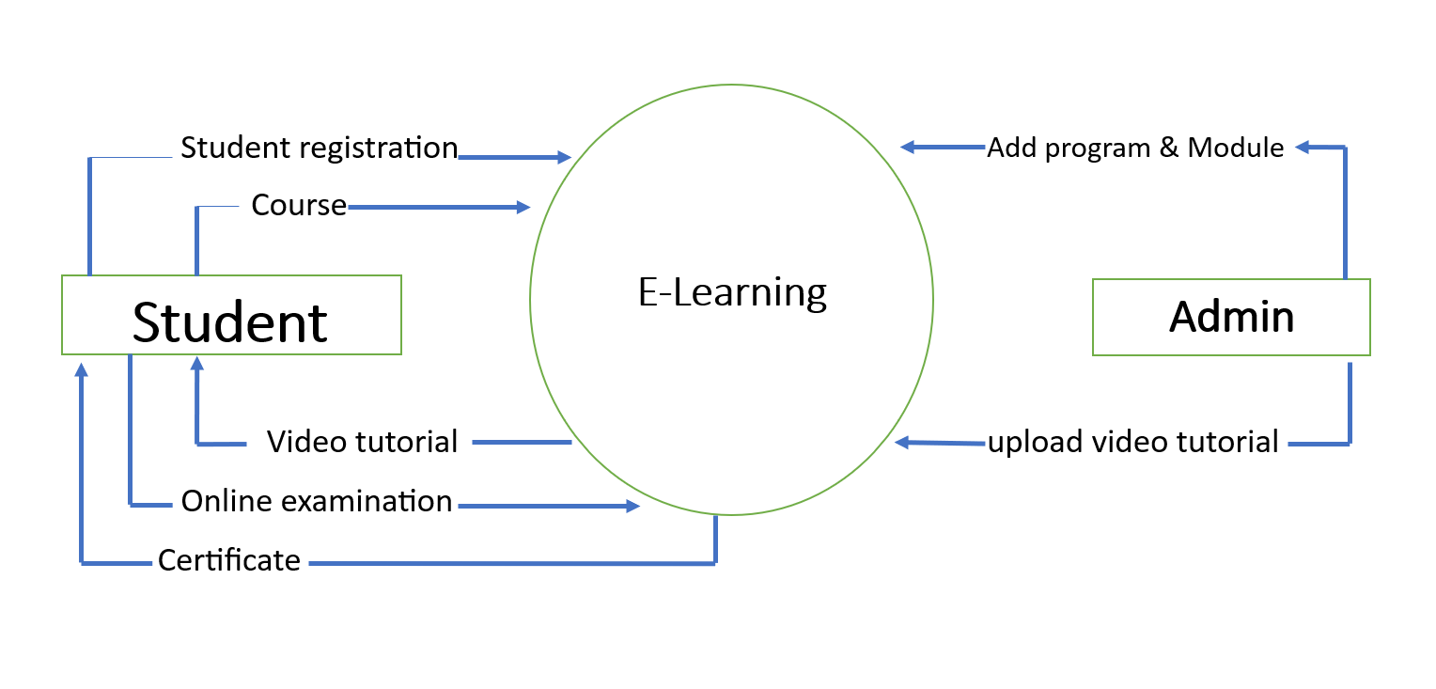

*Enitiy relationship Diagram*

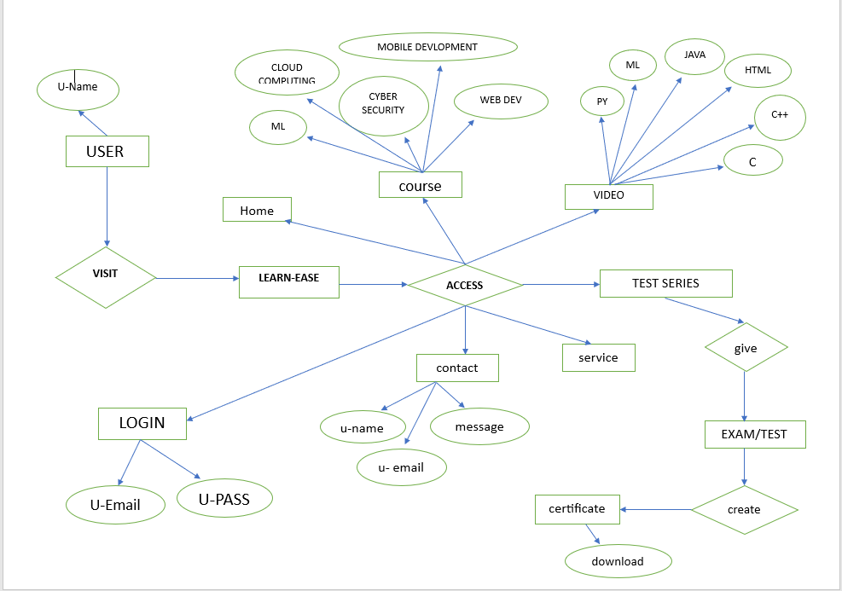

**Chapter 3: implementation**

**3.1 Implemented Functionality**

An e-learning website typically incorporates various functionalities to enhance the learning experience. here’s a breakdown of commonly implemented features:

**Core Functionalities**

1. **User Authentication & Profiles** –

Secure sign-up/login, student profiles.

1. **Course Management** –

Uploading & organizing courses, structured learning paths.

1. **Content Delivery** –

Multimedia support (videos, PDFs, interactive elements).

1. **Quizzes & Assessments** –

Auto-graded tests, interactive exercises, progress tracking.

1. **Certificates & Badges** –

Skill recognition upon completion of courses.

**3.2 Implementation Parameters:**

To ensure the successful deployment and operation of the E-learning website, several key parameters need to be defined and adhered to during the implementation phase. These parameters guide the development, deployment, and maintenance processes, ensuring that the system meets the specified requirements and performs effectively.

**1. System Architecture**

* **Modular Design**: The system should be designed in a modular way, allowing individual components to be developed, tested, and maintained independently.
* **Scalability**: The architecture should support scalability to handle increased data volume and user load as the number of user increase.
* **Integration**: Ensure compatibility with existing hardware, software, and IoT devices

**2. Database Management**

* **Database Schema**: Define a robust and flexible database schema that supports the required functionalities and allows for future expansion.
* **Data Integrity**: Implement mechanisms to ensure data accuracy and consistency, including validation rules and constraints.
* **Backup and Recovery**: Establish regular backup procedures and a disaster recovery plan to prevent data loss.

**3. Security**

* **Authentication and Authorization**: Use secure authentication mechanisms, including multi-factor authentication (MFA), to verify user identities.
* **Data Encryption**: Encrypt sensitive data both in transit and at rest to protect against unauthorized access.

**4. User Interface and Experience**

* **Intuitive Design**: Develop a user-friendly interface that simplifies navigation and interaction for all user types.
* **Responsive Design**: Ensure the system is accessible on various devices, including desktops, tablets, and smartphones.

**5. Performance Metrics**

* **Response Time**: Aim for system response times of under 2 seconds for most user interactions.
* **Availability**: Ensure the system has an uptime of at least 99.9%, minimizing downtime and disruptions.
* **Throughput**: The system should be capable of processing high volumes of data and transactions efficiently.

**6. Testing and Quality Assurance**

* **Unit Testing**: Conduct thorough unit testing for individual components to identify and fix issues early.
* **Integration Testing**: Perform integration testing to ensure that system components work seamlessly together.
* **User Acceptance Testing (UAT)**: Involve real users in the testing process to validate that the system meets their needs and expectations.

**7. Deployment and Maintenance**

* **Deployment Plan**: Develop a detailed deployment plan that includes steps for installation, configuration, and migration of existing data.
* **Monitoring and Support**: Implement monitoring tools to track system performance and provide ongoing technical support.
* **Regular Updates**: Schedule regular updates and maintenance to introduce new features, fix bugs, and improve system performance.

**3.3 Coding Standards:**

Code Organization:

Separated the frontend (HTML, CSS, JavaScript) and backend logic

Used descriptive naming conventions for variables, functions, and file paths.

• Security Considerations:

Used secure filename to prevent malicious file.

Restricted allowed file types to ensure safe conversions.

• Reusability:

Modularized the codebase with reusable functions for conversion logic

• Styling and Readability:

Followed CSS best practices, such as consistent indentation and organized sections with comments. o JavaScript animations follow a readable and event-driven approach

**3.4 Programming Languages:**

* 1. HTML:

Used for structuring the user interface and embedding dynamic Flask template syntax ({{ }}) for linking static files and rendering dynamic content.

* 1. CSS:

Styled the application with modern aesthetics, incorporating gradients, neon colors, and responsive layouts.

* 1. JavaScript:

Added dynamic behavior to the frontend, including scrolling actions and dynamic visibility of sections.

**CODE:-**

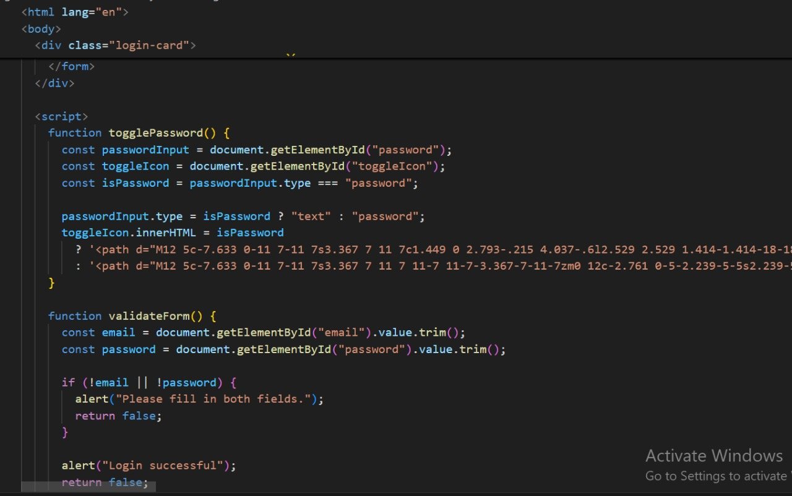

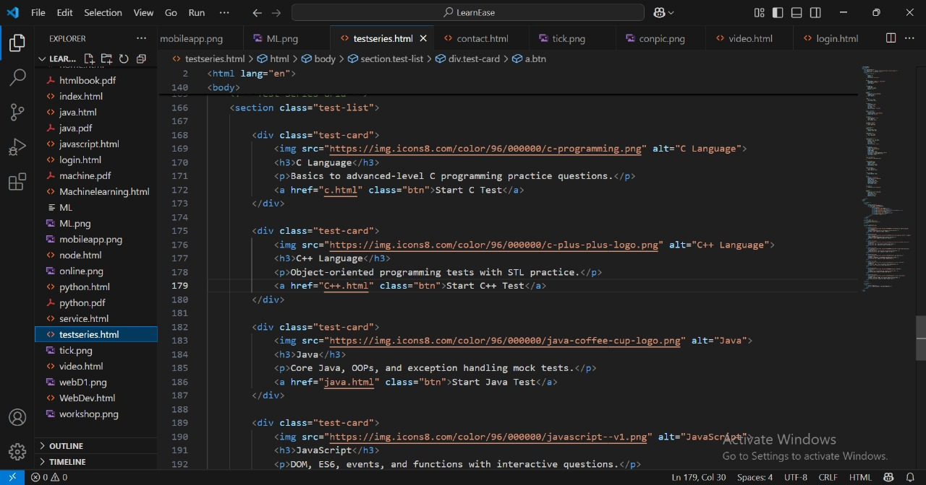

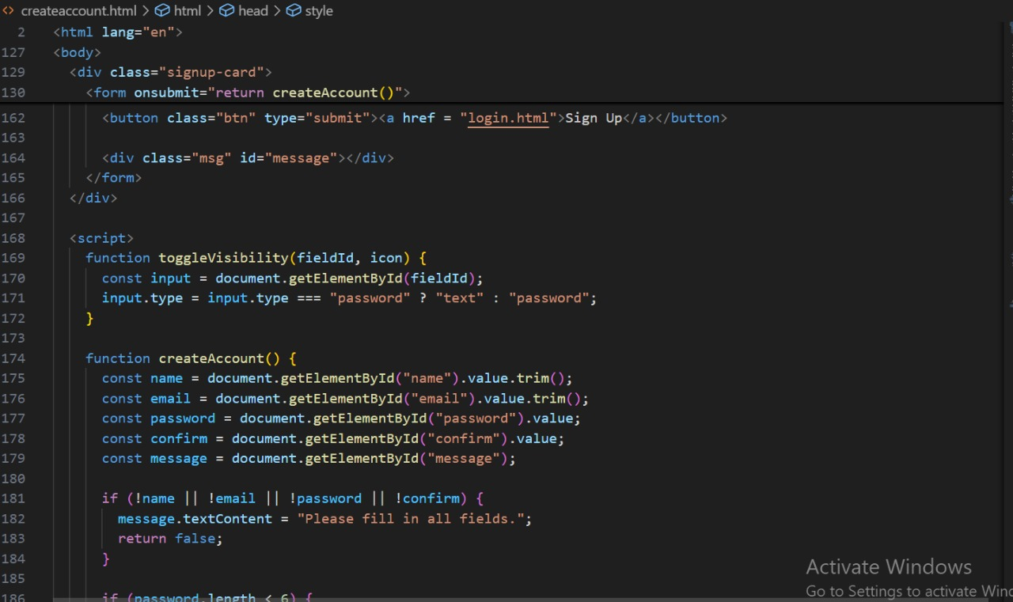

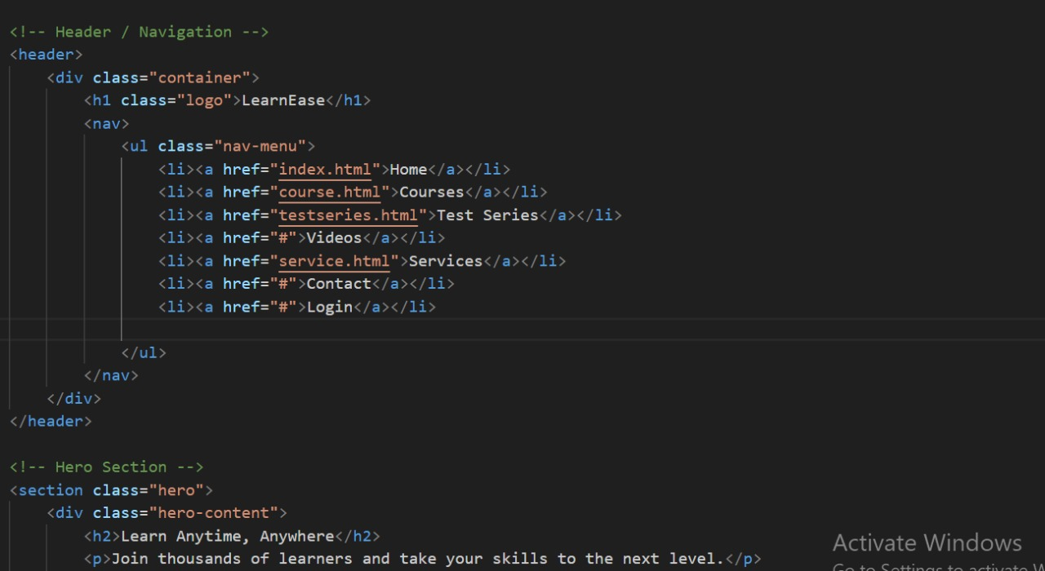

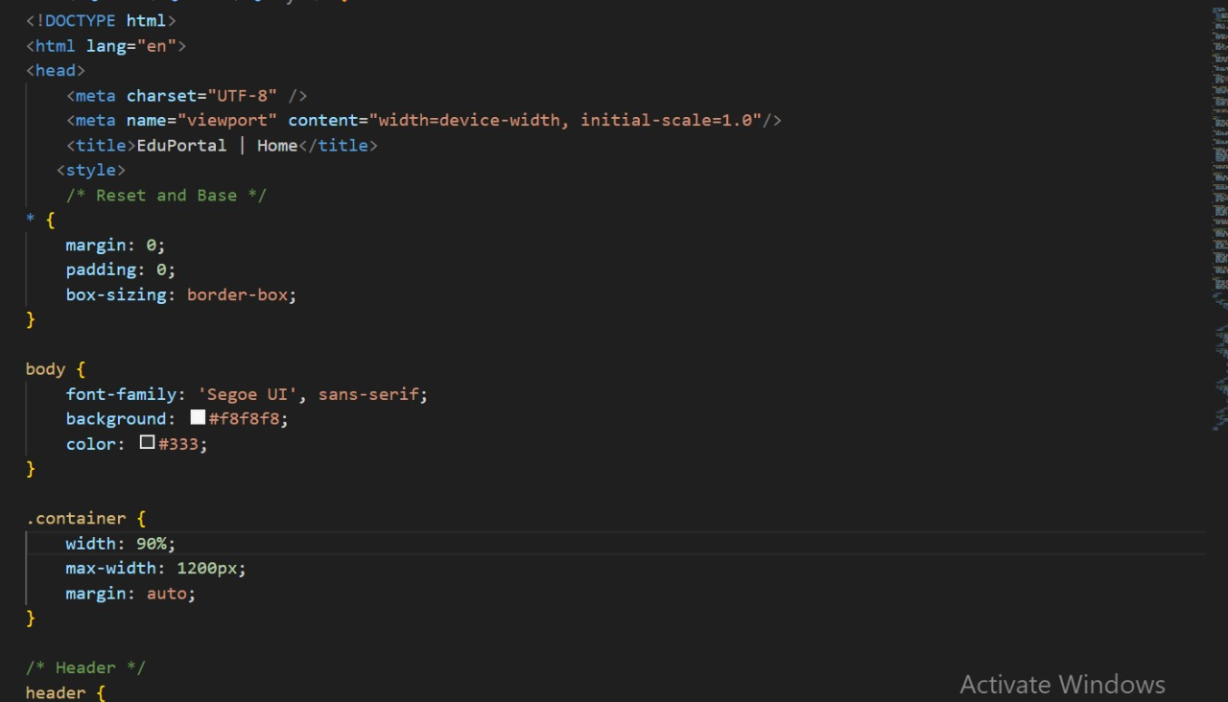

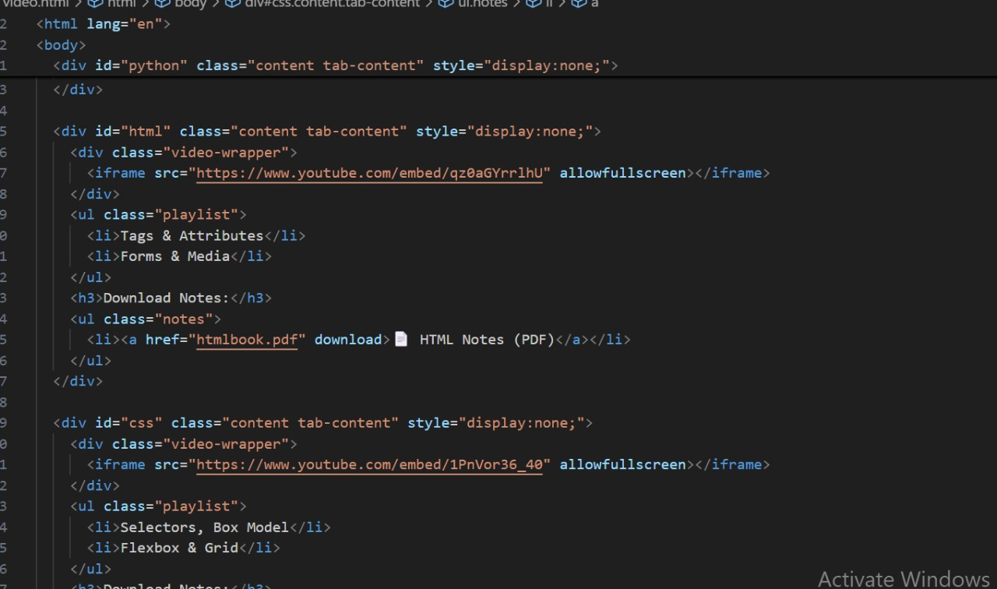



**Chapter 4: Test and Result Analysis**

**4.1 Test Plan:**

The Test Plan for the online education system outlines the approach, objectives, resources, and schedule for testing activities to ensure that the system meets its requirements and functions as expected.

**Test Cases**

**1. Objectives**

* Verify that the education platform meets all specified functional and non-functional requirements.
* Ensure that the system is free of defects and performs reliably under various conditions.
* Validate that the system is user-friendly and meets stakeholder expectations

**Test Case 1: Test Plan for Education platform**

**Objectives**

* Validate core functionalities such as course management, user enrollment, and progress tracking.
* Ensure a seamless user experience for students, educators, and administrators.
* Verify security measures, including user authentication and data protection.
* Test performance and responsiveness under different loads

**Test Case 2: Security Testing**

* **Objective:** Ensure that user authentication, and access controls are secure, preventing unauthorized access and data breaches.
* **Preconditions:**

The system has multiple user roles (Student, Instructor, Admin)

* **Test Steps**:

• Attempt login with incorrect credentials.

**Expected Outcome:** Access denied with an error message and no account information revealed.

* Attempt login with correct credentials.

**Expected Outcome:** Access granted with correct user id and password.

**2. Test Scope**

* **Functional Testing:** Registration, course creation, quizzes, discussions, video streaming.
* **Usability Testing:** User interface design, accessibility compliance, and navigation experience.
* **Security Testing:** Authentication, authorization, data encryption, and vulnerability checks.
* **Compatibility Testing:** Browser, and operating system support.

**4.2 Test Report:**

|  |  |  |  |
| --- | --- | --- | --- |
| Test Case ID | Feature | Test Scenario | Expected output |
| TC01 | User Registration | Register with valid credentials | Successful account creation |
| TC02 | Video Playback | Play course videos on different device | Smooth playback without lag |
| TC03 | Quiz Functionality | Attempt a quiz and submit answers | Correct evaluation and score assignment |
| TC04 | Security Check | Try logging in with incorrect credentials | Access denied with warning |

**4.3 Testing and Verification:**

Testing and verification are critical steps in the software development lifecycle to ensure that the Education platform meets its specified requirements and functions correctly. Here are the key aspects involved:

**1. Testing Process**

1. **Unit Testing**:
   * **Objective**: Verify the functionality of individual components or modules.
   * **Approach**: Each function or method is tested independently to ensure it works correctly.
2. **System Testing**:
   * **Objective**: Validate the entire system's functionality against the requirements.
   * **Approach**: Perform end-to-end testing of the system, including all integrated modules.
3. **Security Testing**:
   * **Objective**: Ensure the system is secure from vulnerabilities.
   * **Approach**: Conduct penetration testing, vulnerability assessments, and code reviews.

**4.4 Results and Discussion:**

**Result**

The comprehensive testing and verification process for the Education platform provided valuable insights into the system's performance and reliability.

**Discussion**

The testing and verification process for the Education platform revealed several important insights, highlighting both the strengths and areas for improvement within the system. Here, we discuss the key findings and their implications:

**Future Improvements:**

To ensure the Education platform continues to evolve and meet the changing needs of dairy farmers, several future improvements can be considered:

**1. AI-Powered Personalization**

* Implement adaptive learning algorithms to tailor course content based on student progress.
* AI-driven recommendation systems suggest relevant courses based on learning patterns.
* Intelligent chatbots assist students in resolving queries instantly

**2. Enhanced User Interface and Experience**

* **Mobile App Development**: Develop a mobile application to allow USER to access the system on-the-go.
* **Voice Commands**: Integrate voice command functionality for hands-free operation.

**3. Enhanced Cybersecurity Measures**

* Zero-trust architecture to prevent unauthorized access.
* Stronger encryption methods for student data protection.
* Multi-factor authentication (MFA) for secure login.
* AI-based fraud detection to monitor cheating in online assessments.

**4. Enhanced Security Features**

* **Advanced Encryption**: Implement stronger encryption algorithms for data protection.
* **Biometric Authentication**: Introduce biometric authentication methods for added security.

**5. Improved Student Engagement & Gamification**

* Interactive learning modules with AR/VR integration for immersive education.
* Gamified progress tracking with badges and rewards.
* Live AI tutors that offer instant explanations for complex topics

.

**6. Scalability and Performance Optimization**

* **Cloud-Based Deployment**: Explore cloud-based solutions for enhanced scalability and data accessibility.
* **Performance Tuning**: Continuously optimize system performance to handle increasing data volumes and user load efficiently.

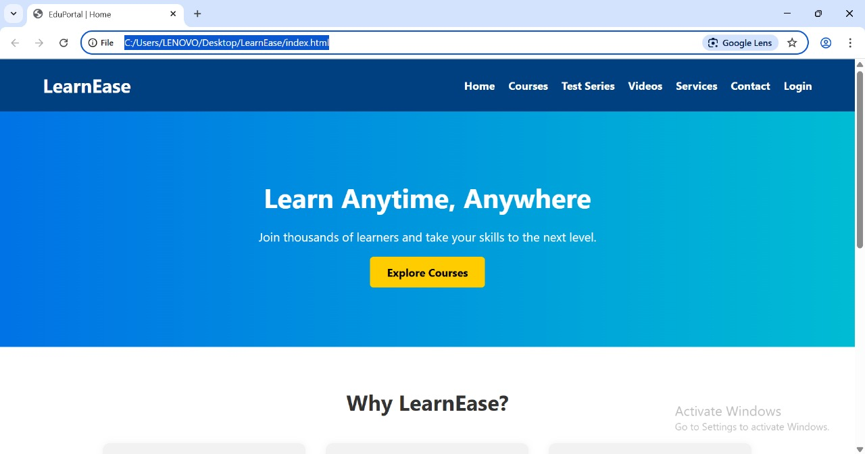**4.5 Snapshot**

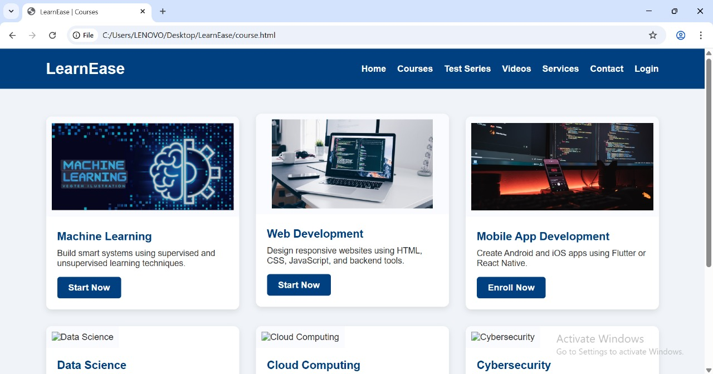

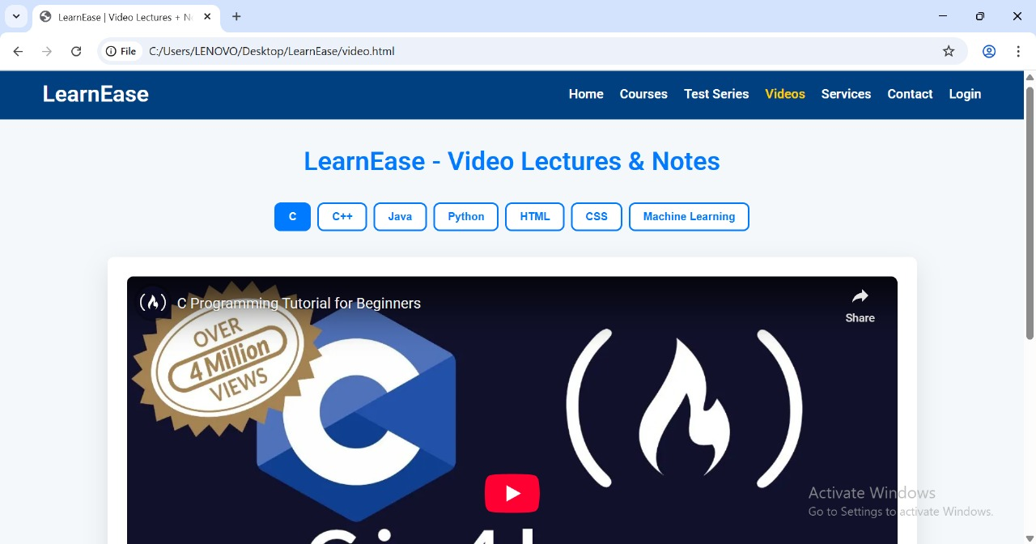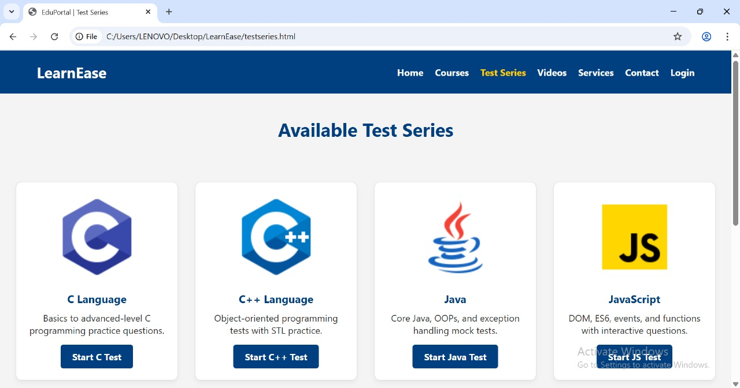

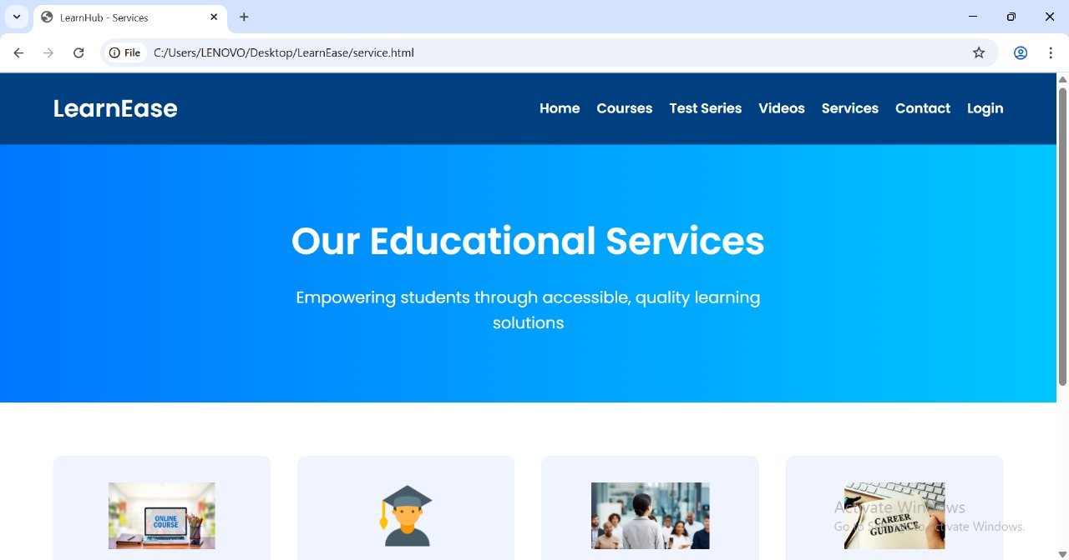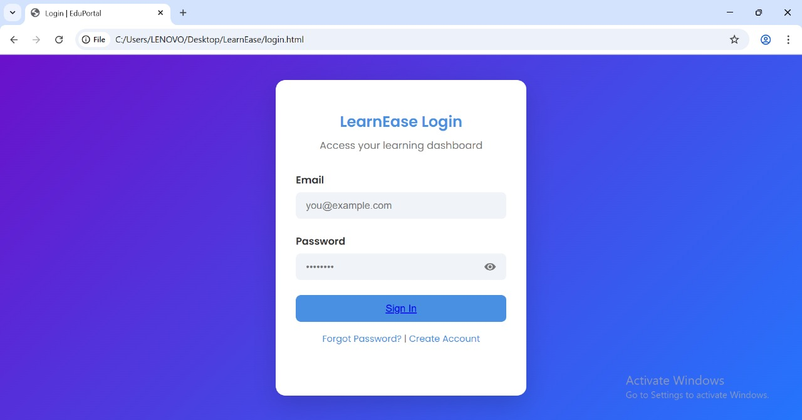

**Chapter 5: Conclusions and Recommendation**

**5.1 Summary of the result :**

Education platforms provide digital learning experiences through various formats, including video lectures, interactive courses, and virtual classrooms. They enable students to access educational content remotely, offering flexibility in learning schedules and accessibility from anywhere with an internet connection. These platforms often include features like assessments, discussion forums, and personalized learning paths to enhance engagement and effectiveness

**5.2 Advantages of Your Work :**

Here are some significant advantages of the education platform based on the work done so far:

**1. Accessibility & Flexibility** – Learners can study from anywhere, at any time, making education more inclusive for people with different schedules and locations.

**2. Cost-Effective** – Digital courses often reduce expenses related to travel, accommodation, and printed materials.

**3. Personalized Learning** – AI-driven features allow tailored content recommendations and adaptive learning paths.

**4 .Scalability** – Institutions and educators can reach a global audience without physical constraints.

**5. Interactive & Engaging Content** – Multimedia formats like videos, quizzes, and gamified experiences enhance learner engagement.

**6. Skill-Based Learning** – Many platforms focus on practical skills, helping learners improve their employability.

**5.3 Scope of Future Work:**

**Future Scope of the education platform**

The future scope of education platforms is promising, with continuous advancements in technology shaping new possibilities. Here are some key areas of development:

1. **AI-Driven Personalization** – Enhanced adaptive learning systems that tailor content based on individual progress and preferences.
2. **Immersive Learning** – Integration of Virtual Reality (VR) and Augmented Reality (AR) for interactive and experiential education.
3. **Blockchain for Credentialing** – Secure digital certification and verification of educational achievements.
4. **Gamification & Engagement** – Improved gamification elements to make learning more engaging and effective.
5. **Collaborative & Social Learning** – Strengthening peer-to-peer interactions and live mentoring through AI-driven communities.
6. **Accessibility & Inclusion** – Further development of platforms to support learners with disabilities and diverse language needs.

**5.4 Unique Features of Our Project**

* AI-Powered Adaptive Learning – The platform customizes learning paths based on individual progress, ensuring a personalized experience.
* Gamification Elements – Features like badges, points, and interactive challenges make learning engaging and rewarding.
* Live & Asynchronous Learning – Students can attend real-time sessions or study at their own pace through recorded lectures.
* Immersive Technologies – VR and AR enhance understanding with interactive, hands-on experiences.

**References :**

* 1. Websites and Online Tutorials:

W3Schools. "Online Web Tutorials."Available at: <https://www.w3schools.com/>

* 1. Frameworks and Libraries:

Bootstrap. "Bootstrap · The world’s most popular framework for building responsive, mobile first sites." Available at: <https://getbootstrap.com/>

* 1. Youtube video
  2. With the help of A.I:

Chat GPT, GEMINI, BLACKBOX A.I.

**Software and Tools**:

Visual Studio Code. "Visual Studio Code - Code Editing. Redefined." Available at: <https://code.visualstudio.com/>

Freepik. "Freepik: Graphic resources for everyone. " Available at: https://www.freepik.com/

"Figma: The collaborative interface design tool." Available at: https://figma.com/

"Pexels: Free stock photos and videos."

Available at: <https://pexels.com/>

"Storyset: Free customizable illustrations for your next project." Available at: <https://storyset.com/>

ChatGPT by OpenAI. "ChatGPT: Language model for generating human-like text."

Available at: <https://openai.com/chatgpt>

XAMPP. "XAMPP: Apache + MariaDB + PHP + Perl." Available at: <https://apachefriends.org/>

**APPENDIX:**

A copy of perodic progress report submitted by team members with guide comment and signature on it