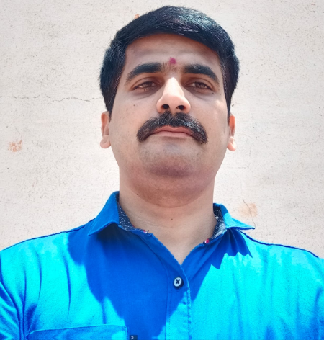

**Summary:**

BA (Bachelor of Arts) by education with over 12 years of Sales and Marketing experience on multiple domains such as sales of **Farming Equipments, Medical Products, Automobile products, Corporate gifts, School uniform & accessories, Digital products/software products**.

**Currently working as Zonal Manager in Bangalore** since last about 3 years handling team of 5 sales personnel and responsible for sales on South Karnataka zone.

Well versed with strategizing on sales to reach-out to large areas or to access bigger market reach in quick times.

Worked with target driven environment and with higher management reporting on the plan and outcome on regular basis

Worked with CRM (Customer Relationship Management) and ERP applications for sales update and reporting

Have huge contacts in the areas I worked ie. Medical, Industrial, Schools, Travel/Tourism and farming sectors. Have very good relationship with clients by reaching them regularly and keep up the rapport.

Well versed with different standards and methods such as ASME, DIN, ISO; also with norms and CDQs.

Has experience of international travel to Malaysia on business visit and working with international customers.

Basically from Honnavar Taluk; Uttara Kannada district; marries with 2 kids; have good communication and presentation skills; more than anything trustworthy person with result oriented workmanship and developing great relation with customers.

**I am well versed with following domain areas.**

* **Domain Areas:**
  + Medical: Worked in collecting data on doctors, hospitals, clinics, diagnostic centers, and labs; Collection of ads for the magazine
  + Farming: Selling of farm equipments especially on irrigation and fencing areas.
  + Education: Selling of School uniform and accessories to Bangalore and Karnataka South region
  + Travel/Tourism: Worked for getting the travel bookings for international travels
  + Industrial: Selling of Prototype development for R and D related companies
  + Automotive: Selling of products such as Car vacuum cleaners, batteries to car show rooms
  + Corporate Gifts: Getting the booking from the corporates for mass selling of products
  + Digital/software: Selling of ERP solutions to industries; understanding the requirement and customized solutioning
* **Sales Management**
  + Managing the sales team with the target driven environment and driving the sales strategy
  + Managing the marketing events such as advertising in news papers, TV, organizing events, setting up stalls at exhibitions, etc.
  + Has experience over handling multiple level of stake holders at customer side and internal management side
  + Experience over training the team members in new technologies, reviewing the performance, doing annual appraisals, etc.
  + Vast working experience in multiple domain areas in sales and reaching out different sectors and sales regions
* **Functional Areas:**
  + Have good connect with the dealer network with respect to farming sectors
  + Have 700+ schools connect with higher management
  + Have great connect with medical area with several hospitals, diagnostic centers, doctors, labs, etc.
  + Good connect with industries in Bangalore and outside Bangalore with respect to the IT requirements
  + Worked with internal management in effectively convincing of sales requirement and negotiating on the deals ensuring the company min profit margin is taken care

**Current Role: Zonal Manager (Since September 2017)**

Responsibilities: Overall sales and marketing responsible for Karnataka South zone; with achievement of targets, handing sales team members, guiding and training.

* + Detailed Responsibilities:
  + Strategizing the sales of school uniforms to big schools or institutions
  + Convert the large volume business
  + Train the sales team for effective sales and customer reach-out
  + Verify daily and monthly sales
  + Timely guidance and motivation to the team members
  + Direct visit to big institutions and canvasing our products
  + Define targets to the team and constantly monitor to achieve
  + Support and guide team members to achieve the targets
  + Coordination with management and provide sales updates on regular basis
  + Collection of payments and keep track of the payments
  + Supervision of the products supply to customers in time.

Highlights:

* + Achieved more than target in the peak demand and cracked sales of large institutions.
  + Promoted as Zonal sales manager from Sales senior leader within an year timeframe
  + Maintained great customer satisfaction and achieved return business

**Details of Prev. Experience:**

1. **Sales Manager for selling automotive and farming products:Adyadashu group.**

* Worked as Sales Manager for Adyadashu Engineering Solutions (AES) from 2014 to 2017September
* Responsibility was to sell car vacuum cleaners, farming equipments, Customized ERP software
* Reaching out industries and advertising Web ERP and other customized solutions.

1. **Relationship Manager for an International travel company:Chariot world tours Ltd.**

* Worked as Relationship Manager developing the business by connecting corporate offices 2011 to 2013December
* Responsibility was to book the travels for groups of travelers to one location and supervising the travel

1. **Marketing Manager for an Industrial catalogue company:Business X.**

* Worked as Sales lead in the area of bringing advertisements to an Industrial catalogue company from 2008 to 2011October.
* Responsibility was to reach-out different industries for advertising their products and services in our magazine
* Worked with Govt officials in setting up the magazine and release.
* Established good connect with Govt officials and sectors for smooth running of our catalogue.

1. **Sales Representative for a Medical data collection company:Pro-solutions.**

* Worked as Sales representative for Pro-Solutions from 2004to 2008March
* Responsibility was to reach out Hospitals, clinics, labs and diagnostic centers to get data with respect to their facility available and specialization.

**Summary of Experience in Brief:**

* Handling team of 12-15 telesales &sales persons
* Responsible for achieving sales target
* Defining the exact marketing processes and responsible for executing the same.
* Developing relevant business proposals
* Monitor market Intelligence within the industry in terms of market development,
* new projects, competitive activity, new customers etc.
* Handling meeting with key clients
* Provide necessary training to sales team as and when needed
* Monitoring & evaluating the performance of sales team – by guiding them to move
* in proper direction

## PERSONAL Details:

**EDUCATIONAL QUALIFICATION:**

Bachelor of Arts (BA) with first class completed on year 2002

Father’s Name : Ganesh Hegde

Date of Birth : 22 March 1981

Nationality : Indian

Marital status : Married

Contact No : **7892661229/9739414509**

Email :