TEAM NUMBER 22 , E-VOTING USING BLOCKCHAIN

1. Voting system to handle the problem regarding the online elections that are to be held in the college.

PROBLEM STATEMENT

Amidst this pandemic situation the heat of electronics,polling around the world was done in different ways.Some resorted to postal ballots while some ensured that COVID safeguards are heightened at ballot houses .

But a question arises: With everything going online why not the elections? And ,major concern is security!

But all elections are not so upscale . Disha Mimani , Vice President , College COuncil wants to conduct the college council elections online and wants a secure platform

She has E-mail IDs of all student for any sort of communication.Solve her issue

P.S : Ensure anonymity of the voter to admin

SOLUTION

Implementing blockchain so as to keep the polling free from being tampered and to hold the election properly.

DETAILED EXPLANATION

E-voting system using blockchain ensures that there would be no tampering done to the result and the user can verify it at every step.

Users will cast their votes and can see the updates in real time but they cant change the vote once voted and any third party interaction wont be possible.

The blockchain will be a decentralized ledger that has peer to peer transaction ledger.Every vote will be counted as one transaction.At the end the results will be announced.

AUTHENTICATION PROCESS :- The user will have to log in using the valid credentials and the system will check for its authenticity.

VOTE CASTING :- The user will cast vote for the candidate via user interface.

ENCRYPTING VOTES :- After the casting of vote the system will check for the unique number and hash of the block and previous block.

ADDING BLOCK :- After voting the required data wil be stored and the block will be linked to the previous block in the blockchain.

DISPLAYING RESULT :- After the election ends the result will be made public.

ARCHITECTURE DIAGRAM

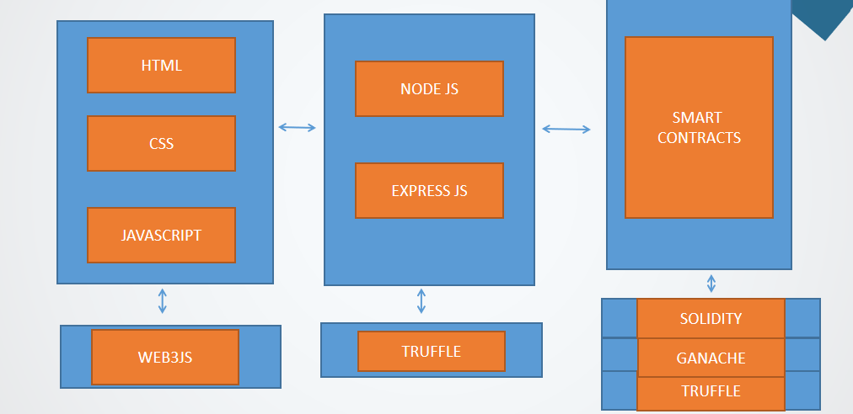

SCREEN SHOTS

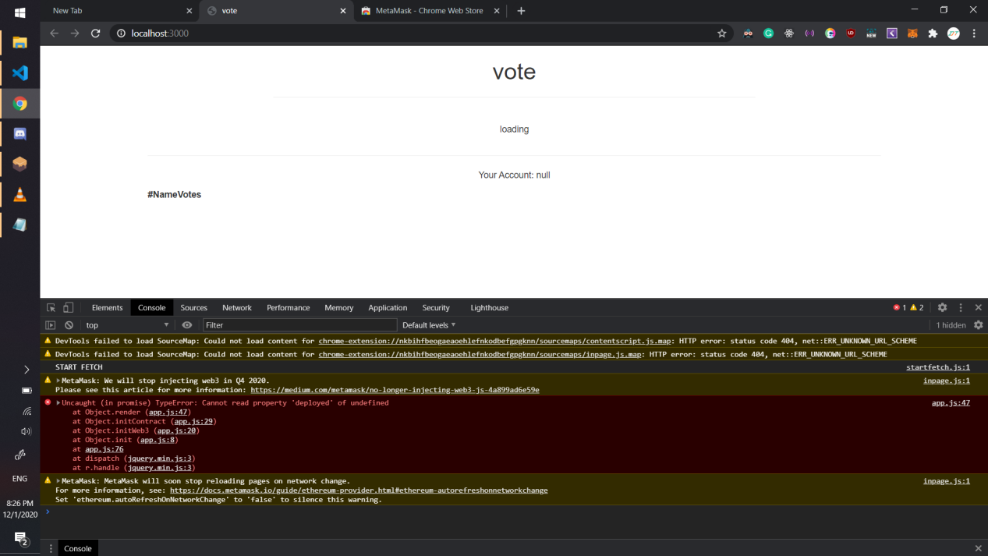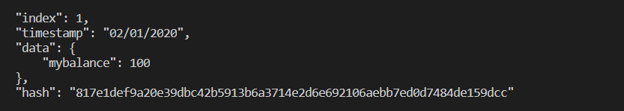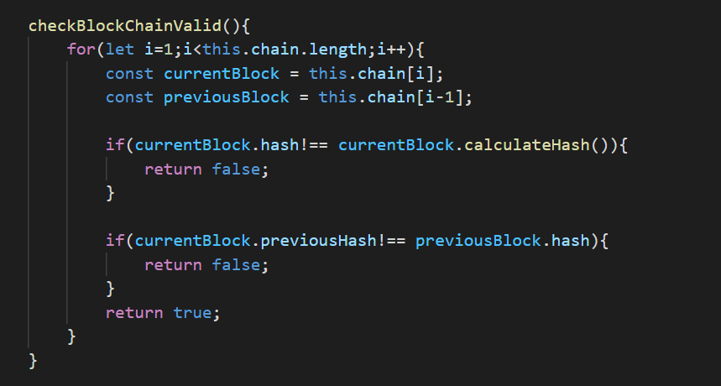

### **Team Members**

| **Member Name** | **Email** |
| --- | --- |
| Bhaskar Gupta | Bhaskargupta1997@gmail.com |
| Member 2 | [mem2@example.com](mailto:mem2@example.com) |
| SANDEEP SUBHANKAR SAHOO | sandeepsahoo542@gmail.com |