Berlin CO2 Leistungsbild

Bhaskar Kamble

15 August 2019

Table of Contents

# Teil 1.

General Notes:

Have all co2 emissions for the Bezirke ready, then add then up to find the co2 for berlin

You can compare the sum of all bezirke with the total for Berlin also

Use this:

<file:///D:/GITHUB_REPOS/co2emissions/Berlin/BezirkAnalysis/01_charlottenburg_wilmersdorf/ExtractData2.R>

Important variables:

* berlin_co2_all: kilo tons of co2 emitted by each bezirk in each year. (all = mfh+sfh)
* bezirk_areas_all: areas of each bezirk in each year.
* bezirk_spez_co2: per unit area co2 emitted by each bezirk in each year.
* bezirke_spez_co2_linea: linear trend of bezirke_spez_co2
* spez_co2_emission: berlin all buildings, specific co2 emissions for each year
* bezirk_population: population of each bezirk in each year for mfh+sfh.

source("D:/GITHUB_REPOS/co2emissions/Berlin/BezirkAnalysis/getAllBezirkeTotalCO2_v2.R")  
alle_bezirke_co2 <- getAllBezirkeTotalCO2()

i_section <- 1

# 1. Alle Stadtbezirke, CO2-Emission aus Beheizung, alle Wohngebäude

i_subsection <- 1

## 1.1 Absolute Zahlen

i_subsubsection <- 1

### 1.1.1 Berlin, MFH + 1-2 FH, CO2-Emission aus der Beheizung von Wohnraum 2002-2018 in 1.000 t

* Berlin, summed over all Bezirke and all Energieträger.
* Berlin, summed over all Bezirke, split by Energieträger.

#alle_bezirke_co2$all - datatframe of year, and co2 emissions of each bezirk , summed over ET.  
berlin_co2_all <- getRowSums(alle_bezirke_co2$all , dropCols = "abrechnungsjahr")  
#berlin_co2_all

#plot(berlin_co2_all$abrechnungsjahr , berlin_co2_all$total)  
require(ggplot2)  
#look at line 187 of BerlinPresentationCO2BalanceUnified_v6.Rmd  
points_line_lm <- function(input_data,  
 xVar,  
 yVar,  
 ymin,  
 ymax,  
 x_eq=2008,  
 y_eq=2500,  
 size_eq=6,  
 plot_title,  
 xlab,  
 ylab,  
 slope_round_to = 2,  
 intercept_round_to = 0) {  
 linmod <- lm(data=input_data , formula = get(yVar)~get(xVar))  
 coeff_a <- as.numeric(coefficients(linmod)[1])  
 coeff_b <- as.numeric(coefficients(linmod)[2])  
 if (coeff_a<0) {  
 sign_coeff_a <- " "  
 } else {sign_coeff_a <- "+"}  
   
   
 b_round <- as.character(round(coeff_b,slope_round_to))  
 a_round <- as.character(round(coeff_a,intercept_round_to))  
 lm_equation <- paste0( b_round , "x" , sign_coeff_a , a_round)  
   
 g <- ggplot() + geom_line(data=input_data , aes(x=get(xVar) , y=get(yVar)) , color="blue"  
 )+geom_point(data=input_data , aes(x=get(xVar) , y=get(yVar)) , color="blue"  
 )+geom_smooth(method="lm" , data=input_data , aes(x=get(xVar) , y=get(yVar)) , se=FALSE  
 )+annotate(geom="text" , label=lm_equation , x = x_eq , y = y_eq , size=size_eq  
 )+ylim(ymin,ymax)+scale_x_continuous(breaks=seq(2002,2018,2)  
 )+theme_bw()+labs(x=xlab,  
 y=ylab,title=plot_title)+theme(  
 plot.title=element_text(size=10),   
 axis.title.x=element_text(size=15, face="bold"),   
 axis.title.y = element_text(size=15, face="bold"),   
 axis.text.x=element_text(size=10,face="bold"),   
 axis.text.y=element_text(size=10,face="bold")  
 )  
 return(g)  
}  
points_line_lm(input_data = berlin_co2_all,  
 xVar = "abrechnungsjahr",  
 yVar = "total",  
 ymin = 0,  
 ymax = max(berlin_co2_all$total),  
 x_eq = 2010,  
 y_eq = 3600,  
 size_eq = 4,  
 plot_title = "CO2 Emissionen in Berlin, alle Wohngebäude",  
 xlab = "Jahr",  
 ylab = "kilo t.")

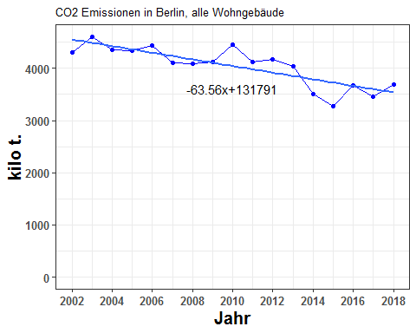

berlin_co2_all[, c("abrechnungsjahr","total")]

## abrechnungsjahr total  
## 1 2002 4300.367  
## 2 2003 4604.759  
## 3 2004 4360.758  
## 4 2005 4333.933  
## 5 2006 4439.307  
## 6 2007 4104.045  
## 7 2008 4082.187  
## 8 2009 4125.395  
## 9 2010 4450.679  
## 10 2011 4116.304  
## 11 2012 4171.740  
## 12 2013 4046.696  
## 13 2014 3509.463  
## 14 2015 3280.266  
## 15 2016 3676.228  
## 16 2017 3465.873  
## 17 2018 3692.675

* Now you should write a new function which gives the CO2 emission of Berlin, MFH+SFH, summed over all Bezirke, and split by ET.

source("D:/GITHUB_REPOS/co2emissions/Berlin/BezirkAnalysis/getAllBezirkeByETCO2_v2.R")  
co2_allebezirke_byET <- getAllBezirkeByETCO2()  
co2_all_allebezirke_byET <- co2_allebezirke_byET$all  
#co2_all_allebezirke_byET

require(ggplot2)  
col_list <- c("royalblue4","orangered1","gray59","orange","blue","olivedrab4")  
cols <- c(  
 "erdgas" = "royalblue4",  
 "waerme" = "orangered1",  
 "fluessiggas" = "gray59",  
 "heizoel" = "orange",  
 "holzpellets" = "blue",  
 "strom" = "olivedrab4"  
 )  
plot_title <- NULL  
order_legend <- rev(c("erdgas","waerme","fluessiggas","heizoel","holzpellets","strom"))  
order_labels <- rev(c("Erdgas","Wärme (N+F)","Flüssiggas","Heizöl","Holzpellets","Strom (D+WP)"))  
et_list <- c("erdgas","waerme","fluessiggas","heizoel","holzpellets","strom")  
plot_byET <- function(obj,xlabel,ylabel,plottitle) {  
 ggplot()+geom_line(data=obj,aes(x=abrechnungsjahr,y=get(et_list[1]),color=et_list[1]),size=5  
 )+geom_line(data=obj,aes(x=abrechnungsjahr,y=get(et_list[2]),color=et_list[2])  
 )+geom_line(data=obj,aes(x=abrechnungsjahr,y=get(et_list[3]),color=et_list[3])  
 )+geom_line(data=obj,aes(x=abrechnungsjahr,y=get(et_list[4]),color=et_list[4])  
 )+geom_line(data=obj,aes(x=abrechnungsjahr,y=get(et_list[5]),color=et_list[5])  
 )+geom_line(data=obj,aes(x=abrechnungsjahr,y=get(et_list[6]),color=et_list[6])  
 )+scale_color_manual(labels=order_labels,name=" ",values=cols,breaks=order_legend  
 )+geom_ribbon(data=obj,aes(x=abrechnungsjahr,ymin=0,ymax=get(et_list[6])),fill=col_list[6]  
 )+geom_ribbon(data=obj,aes(x=abrechnungsjahr,ymin=0,ymax=get(et_list[5])),fill=col_list[5]  
 )+geom_ribbon(data=obj,aes(x=abrechnungsjahr,ymin=0,ymax=get(et_list[4])),fill=col_list[4]  
 )+geom_ribbon(data=obj,aes(x=abrechnungsjahr,ymin=0,ymax=get(et_list[3])),fill=col_list[3]  
 )+geom_ribbon(data=obj,aes(x=abrechnungsjahr,ymin=0,ymax=get(et_list[2])),fill=col_list[2]  
 )+geom_ribbon(data=obj,aes(x=abrechnungsjahr,ymin=0,ymax=get(et_list[1])),fill=col_list[1])+theme_bw()+ labs(x=xlabel,y=ylabel,title=plottitle) + theme(  
 plot.title=element_text(size=10),   
 axis.title.x=element_text(size=15, face="bold"),   
 axis.title.y = element_text(size=15, face="bold"),   
 legend.text = element_text(size=12),   
 axis.text.x=element_text(size=10,face="bold"),   
 axis.text.y=element_text(size=10,face="bold"),   
 legend.key.size=unit(2, "lines")  
 )+scale_x_continuous(breaks=seq(2002,2018,2))  
}

source("D:/GITHUB_REPOS/co2emissions/Berlin/BezirkAnalysis/getCumSums.R")  
co2_all_allebezirke_byET_cumsums <- getCumSums(obj=co2_all_allebezirke_byET , dropCols=c("abrechnungsjahr","total"))  
#co2_all_allebezirke_byET_cumsums  
plot_byET(co2_all_allebezirke_byET_cumsums ,   
 xlabel = "Jahr" ,   
 ylabel = "kilo t." ,   
 plottitle = "CO2 Emissionen in Berlin, alle Wohngebäude, nach Energieträgern")

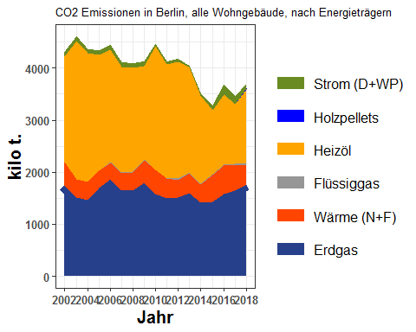

co2_all_allebezirke_byET

## abrechnungsjahr erdgas waerme fluessiggas heizoel holzpellets  
## 1 2002 1746.306 440.6780 0.000000 2034.860 0.00000000  
## 2 2003 1507.779 356.8875 0.000000 2661.570 0.00000000  
## 3 2004 1463.165 349.5755 1.927683 2467.567 0.00000000  
## 4 2005 1696.369 331.3529 7.738564 2219.900 0.04967672  
## 5 2006 1859.785 324.0964 8.583952 2168.262 0.05636583  
## 6 2007 1653.945 329.6998 3.774203 2038.044 0.05977333  
## 7 2008 1647.829 346.3019 23.237083 1986.111 0.18485772  
## 8 2009 1794.166 433.4917 19.659725 1799.082 0.47207509  
## 9 2010 1580.796 458.9509 10.065080 2377.492 0.74027282  
## 10 2011 1503.528 369.4881 13.736308 2190.026 1.54561390  
## 11 2012 1518.224 319.8752 33.103532 2246.576 1.86321340  
## 12 2013 1604.555 377.2518 19.693120 2015.530 2.05043255  
## 13 2014 1416.577 346.0610 10.428462 1694.626 0.32888674  
## 14 2015 1433.409 516.9907 9.235242 1235.567 1.17639896  
## 15 2016 1587.513 548.1129 12.772169 1336.274 2.66348293  
## 16 2017 1643.734 486.4845 24.140778 1146.234 3.81484010  
## 17 2018 1768.508 380.7035 14.267661 1427.271 11.23196682  
## strom total  
## 1 78.52314 4300.367  
## 2 78.52314 4604.759  
## 3 78.52314 4360.758  
## 4 78.52314 4333.933  
## 5 78.52314 4439.307  
## 6 78.52314 4104.045  
## 7 78.52314 4082.187  
## 8 78.52314 4125.395  
## 9 22.63532 4450.679  
## 10 37.97940 4116.304  
## 11 52.09856 4171.740  
## 12 27.61575 4046.696  
## 13 41.44172 3509.463  
## 14 83.88785 3280.266  
## 15 188.89217 3676.228  
## 16 161.46481 3465.873  
## 17 90.69271 3692.675

i_subsubsection <- i_subsubsection + 1

### 1.1.2 Stadtbezirke, MFH + 1-2 FH, CO2-Emission aus der Beheizung von Wohnraum 2002-2018 summiert in 1.000 t

* Here split by the Bezirke

#berlin_co2_all

bezirk_list <- names(berlin_co2_all)[!(names(berlin_co2_all)%in% c("abrechnungsjahr","total"))]  
#bezirk_list  
get_BezirkNames <- function(obj) {  
 obj[obj=="charlottenburg_wilmersdorf"] <- "Charlottenburg-Wilmersdorf"  
 obj[obj=="friedrichshain_kreuzberg"] <- "Friedrichshain-Kreuzberg"  
 obj[obj=="lichtenberg"] <- "Lichtenberg"  
 obj[obj=="marzahn_hellersdorf"] <- "Marzahn-Hellersdorf"  
 obj[obj=="mitte"] <- "Mitte"  
 obj[obj=="neukoelln"] <- "Neukölln"  
 obj[obj=="pankow"] <- "Pankow"  
 obj[obj=="reinickendorf"] <- "Reinickendorf"  
 obj[obj=="spandau"] <- "Spandau"  
 obj[obj=="steglitz_zehlendorf"] <- "Steglitz-Zehlendorf"  
 obj[obj=="tempelhof_schoeneberg"] <- "Tempelhof-Schöneberg"  
 obj[obj=="treptow_koepenick"] <- "Treptow-Köpenick"  
 return(obj)  
}  
#data.frame(blist = bezirk_list , bname = get_BezirkNames(bezirk_list))  
bezirk_name <- get_BezirkNames(bezirk_list)

berlin_co2_all_cumsums <- getCumSums(obj=berlin_co2_all , dropCols=c("abrechnungsjahr","total"))

gg_color_hue <- function(n) {  
 hues = seq(15, 375, length = n + 1)  
 hcl(h = hues, l = 65, c = 100)[1:n]  
}  
cols_bezirk <- gg_color_hue(12)  
names(cols_bezirk) <- bezirk_name  
order_legend_bez <- bezirk_name  
order_labels_bez <- bezirk_name

Put it all together into a function:

plot_byBezirke <- function(obj,xlabel,ylabel,plottitle) {  
 names(obj) <- get_BezirkNames(names(obj))  
 ggplot()+geom_line(data=obj,aes(x=abrechnungsjahr,y=get(bezirk_name[1]),color=bezirk_name[1]),size=5  
 )+geom_line(data=obj,aes(x=abrechnungsjahr,y=get(bezirk_name[2]),color=bezirk_name[2])  
 )+geom_line(data=obj,aes(x=abrechnungsjahr,y=get(bezirk_name[3]),color=bezirk_name[3])  
 )+geom_line(data=obj,aes(x=abrechnungsjahr,y=get(bezirk_name[4]),color=bezirk_name[4])  
 )+geom_line(data=obj,aes(x=abrechnungsjahr,y=get(bezirk_name[5]),color=bezirk_name[5])  
 )+geom_line(data=obj,aes(x=abrechnungsjahr,y=get(bezirk_name[6]),color=bezirk_name[6])  
 )+geom_line(data=obj,aes(x=abrechnungsjahr,y=get(bezirk_name[7]),color=bezirk_name[7])  
 )+geom_line(data=obj,aes(x=abrechnungsjahr,y=get(bezirk_name[8]),color=bezirk_name[8])  
 )+geom_line(data=obj,aes(x=abrechnungsjahr,y=get(bezirk_name[9]),color=bezirk_name[9])  
 )+geom_line(data=obj,aes(x=abrechnungsjahr,y=get(bezirk_name[10]),color=bezirk_name[10])  
 )+geom_line(data=obj,aes(x=abrechnungsjahr,y=get(bezirk_name[11]),color=bezirk_name[11])  
 )+geom_line(data=obj,aes(x=abrechnungsjahr,y=get(bezirk_name[12]),color=bezirk_name[12])  
 )+scale_color_manual(labels=order_labels_bez,name=" ",values=cols_bezirk,breaks=order_legend_bez  
 )+geom_ribbon(data=obj,aes(x=abrechnungsjahr,ymin=0,ymax=get(bezirk_name[12])),fill=cols_bezirk[12]  
 )+geom_ribbon(data=obj,aes(x=abrechnungsjahr,ymin=0,ymax=get(bezirk_name[11])),fill=cols_bezirk[11]  
 )+geom_ribbon(data=obj,aes(x=abrechnungsjahr,ymin=0,ymax=get(bezirk_name[10])),fill=cols_bezirk[10]  
 )+geom_ribbon(data=obj,aes(x=abrechnungsjahr,ymin=0,ymax=get(bezirk_name[9])),fill=cols_bezirk[9]  
 )+geom_ribbon(data=obj,aes(x=abrechnungsjahr,ymin=0,ymax=get(bezirk_name[8])),fill=cols_bezirk[8]  
 )+geom_ribbon(data=obj,aes(x=abrechnungsjahr,ymin=0,ymax=get(bezirk_name[7])),fill=cols_bezirk[7]  
 )+geom_ribbon(data=obj,aes(x=abrechnungsjahr,ymin=0,ymax=get(bezirk_name[6])),fill=cols_bezirk[6]  
 )+geom_ribbon(data=obj,aes(x=abrechnungsjahr,ymin=0,ymax=get(bezirk_name[5])),fill=cols_bezirk[5]  
 )+geom_ribbon(data=obj,aes(x=abrechnungsjahr,ymin=0,ymax=get(bezirk_name[4])),fill=cols_bezirk[4]  
 )+geom_ribbon(data=obj,aes(x=abrechnungsjahr,ymin=0,ymax=get(bezirk_name[3])),fill=cols_bezirk[3]  
 )+geom_ribbon(data=obj,aes(x=abrechnungsjahr,ymin=0,ymax=get(bezirk_name[2])),fill=cols_bezirk[2]  
 )+geom_ribbon(data=obj,aes(x=abrechnungsjahr,ymin=0,ymax=get(bezirk_name[1])),fill=cols_bezirk[1]  
 )+theme_bw()+ labs(x=xlabel,y=ylabel,title=plottitle) + theme(plot.title=element_text(size=10), axis.title.x=element_text(size=10, face="bold"), axis.title.y=element_text(size=10, face="bold"), legend.text = element_text(size=8), axis.text.x=element_text(size=15,face="bold"), axis.text.y=element_text(size=12,face="bold"), legend.key.size=unit(2, "lines"),legend.position = "bottom"  
 )+scale_x_continuous(breaks=seq(2002,2018,2))  
}

plot_byBezirke(berlin_co2_all_cumsums , xlabel = "Jahr" , ylabel = "kilo t." , plottitle="CO2 Emissionen in Berlin, alle Wohngebäude, nach Bezirk")

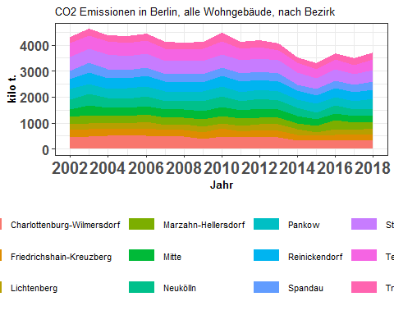

berlin_co2_all

## abrechnungsjahr charlottenburg_wilmersdorf friedrichshain_kreuzberg  
## 1 2002 437.5293 297.2324  
## 2 2003 466.5623 288.0173  
## 3 2004 523.9296 267.8083  
## 4 2005 499.0712 269.5375  
## 5 2006 506.4530 287.4582  
## 6 2007 467.4310 260.4179  
## 7 2008 471.6374 257.8947  
## 8 2009 397.8959 252.1482  
## 9 2010 497.1840 300.9858  
## 10 2011 439.2849 238.1180  
## 11 2012 463.8478 260.7414  
## 12 2013 460.5407 236.0173  
## 13 2014 338.4202 191.1728  
## 14 2015 314.9513 190.9628  
## 15 2016 348.3044 210.2256  
## 16 2017 318.8350 212.4325  
## 17 2018 329.1718 252.2647  
## lichtenberg marzahn_hellersdorf mitte neukoelln pankow  
## 1 216.6343 275.2513 303.6602 386.9229 388.7110  
## 2 238.3496 313.2014 367.6347 434.6238 404.7990  
## 3 226.4307 266.9005 306.9894 361.8178 366.1182  
## 4 233.5679 282.3000 317.1532 346.5096 381.9396  
## 5 240.4608 289.4489 336.6562 352.5077 404.0113  
## 6 211.0525 281.6287 296.0844 335.1829 358.1850  
## 7 211.7719 271.9283 301.2731 343.1990 343.8619  
## 8 216.2582 272.4331 329.3362 371.2087 372.7440  
## 9 199.0213 268.4016 349.9835 418.6494 381.8390  
## 10 210.1798 279.1120 336.5241 338.8299 351.1555  
## 11 233.6965 246.1024 342.7206 379.0212 355.0812  
## 12 261.3005 237.7976 331.0666 345.8917 348.4189  
## 13 225.7927 238.5314 281.0405 314.7469 315.8817  
## 14 131.4076 268.7053 232.6526 271.3746 320.3199  
## 15 196.6574 356.8285 265.7401 297.6735 330.3642  
## 16 204.8809 289.4252 241.6136 243.6720 327.4611  
## 17 217.9276 260.0886 218.6250 260.2750 388.1170  
## reinickendorf spandau steglitz_zehlendorf tempelhof_schoeneberg  
## 1 392.7612 315.9709 535.8396 515.1772  
## 2 417.0745 389.6866 555.1910 492.2442  
## 3 412.3152 346.3917 552.0756 500.0783  
## 4 406.9920 310.4068 530.5820 506.1757  
## 5 404.3762 317.5846 530.4499 503.6604  
## 6 377.9894 297.4208 495.0667 471.0199  
## 7 372.0310 296.8566 501.0394 459.7635  
## 8 365.0171 289.5115 508.4172 482.2675  
## 9 394.3945 323.8770 507.7911 495.7093  
## 10 393.8126 339.7322 482.6590 451.6065  
## 11 384.5755 310.7582 495.2810 435.5185  
## 12 372.4470 311.8237 498.2495 407.9688  
## 13 344.9816 227.1596 464.8513 378.6392  
## 14 330.9450 237.0958 432.2612 333.2663  
## 15 329.4780 280.6585 463.3482 364.9747  
## 16 351.5174 270.5330 429.6898 353.5214  
## 17 368.5619 312.0977 442.2216 393.2160  
## treptow_koepenick total  
## 1 234.6767 4300.367  
## 2 237.3749 4604.759  
## 3 229.9027 4360.758  
## 4 249.6980 4333.933  
## 5 266.2393 4439.307  
## 6 252.5663 4104.045  
## 7 250.9305 4082.187  
## 8 268.1575 4125.395  
## 9 312.8423 4450.679  
## 10 255.2892 4116.304  
## 11 264.3958 4171.740  
## 12 235.1742 4046.696  
## 13 188.2448 3509.463  
## 14 216.3241 3280.266  
## 15 231.9750 3676.228  
## 16 222.2915 3465.873  
## 17 250.1079 3692.675

i_subsubsection <- i_subsubsection + 1

### 1.1.3 Stadtbezirke, MFH + 1-2 FH, CO2-Emission aus der Beheizung von Wohnraum 2002-2018 in Prozent

* Here the percent of the co2 emission broken up by percentage - by ET first, and then by bezirk.
* The function find_proportions is to be used for this purpose.

#find_proportions

#co2_all_allebezirke_byET

co2_all_allebezirke_byET_prop <- find_proportions(co2_all_allebezirke_byET , drop_cols = c("abrechnungsjahr","total"))  
#co2_all_allebezirke_byET_prop

co2_all_allebezirke_byET_prop_cumsums <- getCumSums(obj=co2_all_allebezirke_byET_prop , dropCols = "abrechnungsjahr")  
#co2_all_allebezirke_byET_prop_cumsums

plot_byET(co2_all_allebezirke_byET_prop_cumsums,xlabel = "Jahr" , ylabel = "Anteile in %" , plottitle = "CO2 Emissionen in Berlin, alle Wohngebäude, \nAnteile nach Energieträgern")

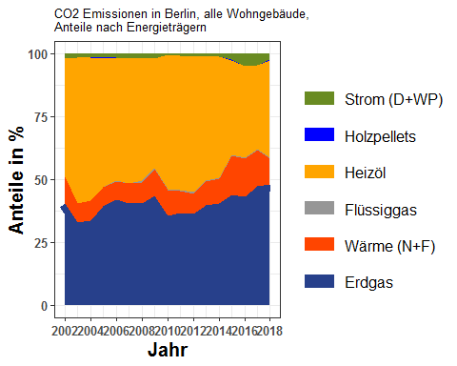

co2_all_allebezirke_byET_prop

## erdgas waerme fluessiggas heizoel holzpellets strom  
## 1 40.60830 10.247450 0.00000000 47.31829 0.000000000 1.8259637  
## 2 32.74392 7.750406 0.00000000 57.80041 0.000000000 1.7052606  
## 3 33.55300 8.016393 0.04420523 56.58573 0.000000000 1.8006765  
## 4 39.14156 7.645548 0.17855753 51.22137 0.001146227 1.8118217  
## 5 41.89359 7.300609 0.19336246 48.84235 0.001269699 1.7688156  
## 6 40.30036 8.033531 0.09196299 49.65938 0.001456449 1.9133108  
## 7 40.36632 8.483244 0.56923121 48.65312 0.004528399 1.9235557  
## 8 43.49077 10.507883 0.47655375 43.60994 0.011443148 1.9034090  
## 9 35.51808 10.311930 0.22614706 53.41863 0.016632807 0.5085814  
## 10 36.52616 8.976212 0.33370492 53.20371 0.037548588 0.9226579  
## 11 36.39305 7.667669 0.79351856 53.85225 0.044662740 1.2488449  
## 12 39.65099 9.322463 0.48664683 49.80681 0.050669294 0.6824271  
## 13 40.36449 9.860797 0.29715268 48.28734 0.009371427 1.1808565  
## 14 43.69795 15.760633 0.28153940 37.66667 0.035862909 2.5573486  
## 15 43.18321 14.909654 0.34742590 36.34905 0.072451514 5.1382059  
## 16 47.42626 14.036419 0.69652796 33.07202 0.110068650 4.6587047  
## 17 47.89232 10.309696 0.38637740 38.65142 0.304168859 2.4560168  
## abrechnungsjahr  
## 1 2002  
## 2 2003  
## 3 2004  
## 4 2005  
## 5 2006  
## 6 2007  
## 7 2008  
## 8 2009  
## 9 2010  
## 10 2011  
## 11 2012  
## 12 2013  
## 13 2014  
## 14 2015  
## 15 2016  
## 16 2017  
## 17 2018

#berlin_co2_all

berlin_co2_all_prop <- find_proportions(berlin_co2_all,drop_cols=c("abrechnungsjahr","total"))  
berlin_co2_all_prop_cumsums <- getCumSums(berlin_co2_all_prop,dropCols="abrechnungsjahr")  
plot_byBezirke(berlin_co2_all_prop_cumsums,xlabel = "Jahr" , ylabel = "Anteile in %" , plottitle = "CO2 Emissionen in Berlin, alle Wohngebäude, Anteile nach Bezirk")

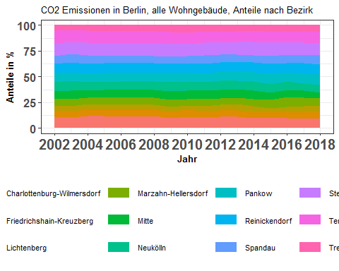

berlin_co2_all_prop

## charlottenburg_wilmersdorf friedrichshain_kreuzberg lichtenberg  
## 1 10.174232 6.911790 5.037577  
## 2 10.132176 6.254775 5.176157  
## 3 12.014645 6.141325 5.192462  
## 4 11.515433 6.219234 5.389282  
## 5 11.408382 6.475294 5.416630  
## 6 11.389518 6.345396 5.142549  
## 7 11.553547 6.317562 5.187706  
## 8 9.645037 6.112097 5.242121  
## 9 11.170970 6.762695 4.471706  
## 10 10.671830 5.784752 5.106033  
## 11 11.118808 6.250182 5.601896  
## 12 11.380659 5.832346 6.457131  
## 13 9.643077 5.447354 6.433824  
## 14 9.601392 5.821565 4.006003  
## 15 9.474504 5.718513 5.349434  
## 16 9.199270 6.129263 5.911380  
## 17 8.914185 6.831491 5.901619  
## marzahn_hellersdorf mitte neukoelln pankow reinickendorf spandau  
## 1 6.400647 7.061263 8.997439 9.039020 9.133203 7.347533  
## 2 6.801690 7.983798 9.438578 8.790883 9.057465 8.462693  
## 3 6.120506 7.039818 8.297131 8.395746 9.455127 7.943383  
## 4 6.513713 7.317907 7.995268 8.812770 9.390822 7.162242  
## 5 6.520138 7.583530 7.940603 9.100776 9.108995 7.153923  
## 6 6.862222 7.214452 8.167134 8.727607 9.210166 7.247015  
## 7 6.661338 7.380187 8.407234 8.423471 9.113523 7.271999  
## 8 6.603805 7.983144 8.998138 9.035353 8.848053 7.017788  
## 9 6.030576 7.863597 9.406417 8.579344 8.861446 7.277025  
## 10 6.780645 8.175397 8.231412 8.530845 9.567141 8.253331  
## 11 5.899275 8.215291 9.085446 8.511586 9.218587 7.449127  
## 12 5.876339 8.181156 8.547508 8.609959 9.203728 7.705636  
## 13 6.796806 8.008078 8.968520 9.000858 9.830041 6.472774  
## 14 8.191569 7.092491 8.272945 9.765056 10.088967 7.227944  
## 15 9.706376 7.228607 8.097253 8.986499 8.962392 7.634415  
## 16 8.350716 6.971219 7.030607 9.448154 10.142247 7.805622  
## 17 7.043367 5.920504 7.048414 10.510456 9.980891 8.451805  
## steglitz_zehlendorf tempelhof_schoeneberg treptow_koepenick  
## 1 12.46032 11.979843 5.457132  
## 2 12.05689 10.689901 5.154990  
## 3 12.66008 11.467692 5.272082  
## 4 12.24250 11.679361 5.761464  
## 5 11.94894 11.345474 5.997318  
## 6 12.06289 11.476966 6.154081  
## 7 12.27380 11.262675 6.146961  
## 8 12.32409 11.690213 6.500166  
## 9 11.40930 11.137836 7.029093  
## 10 11.72555 10.971165 6.201903  
## 11 11.87229 10.439733 6.337783  
## 12 12.31250 10.081528 5.811511  
## 13 13.24565 10.789092 5.363921  
## 14 13.17762 10.159731 6.594712  
## 15 12.60390 9.927965 6.310137  
## 16 12.39773 10.200065 6.413723  
## 17 11.97564 10.648542 6.773083  
## abrechnungsjahr  
## 1 2002  
## 2 2003  
## 3 2004  
## 4 2005  
## 5 2006  
## 6 2007  
## 7 2008  
## 8 2009  
## 9 2010  
## 10 2011  
## 11 2012  
## 12 2013  
## 13 2014  
## 14 2015  
## 15 2016  
## 16 2017  
## 17 2018

i_subsubsection <- i_subsubsection + 1

### 1.1.4 Stadtbezirke, MFH + 1-2 FH, CO2-Emission aus der Beheizung von Wohnraum 2002-2018 in 1.000 t

plot_reqdColumns <- function(input_data, # data frame  
 xVar, # column name of "input_data" to be plotted on the x-axis  
 cols_to_plot, #column names of "input_data" to be plotted on the y-axis  
 yColsName, # for eg. if cols_to_plot = c("Bonn","Berlin"), then this can be City  
 yVar, # for eg. "population" if the columns for "Berlin" etc. show population  
 plot_title = NULL,  
 xlabel = NULL,  
 ylabel = NULL  
) {  
   
 input_data <- input_data[ , c(xVar , cols_to_plot)]  
 names(input_data) <- get_BezirkNames(names(input_data))  
   
 #convert data to long format  
 require(reshape2)  
 input_data <- melt(input_data , id.vars = xVar )  
 names(input_data) <- c(xVar , yColsName , yVar)  
   
 require(ggplot2)  
 return_object <-   
 ggplot(input_data  
 )+geom_point(aes(x=get(xVar),y=get(yVar),col=get(yColsName))  
 ) + geom_smooth(method="lm",aes(x=get(xVar),y=get(yVar),col=get(yColsName)),se=FALSE  
 )+scale_color_discrete(name = yColsName  
 )+labs(x=xlabel,y=ylabel,title=plot_title)+ylim(0,max(input_data[[yVar]]))  
   
 detach("package:reshape2")  
 #detach("package:ggplot2")  
   
 return(return_object)   
}

(Eine Grafik: co2 Emissionen je Bezirk und Jahr) Co2 emissions of all city districts by year in a single graph. (year on x-axis and co2 emission on y-axis). One Graph: Co2 emissions of all city districts by year

plot_reqdColumns(berlin_co2_all,  
 xVar = "abrechnungsjahr",  
 cols_to_plot = names(berlin_co2_all)[!(names(berlin_co2_all) %in% c("abrechnungsjahr","total"))],  
 yColsName = "Bezirk",  
 yVar = "kilo t.",  
 plot_title = "CO2 Emissionen von Stadtbezirken, alle Wohngebäude")

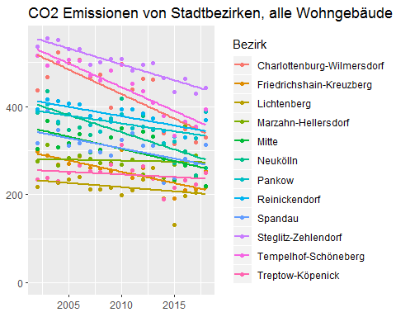

max_co2_value <- max(berlin_co2_all[ , names(berlin_co2_all)[!(names(berlin_co2_all) %in% c("abrechnungsjahr","total"))]])  
require(ggplot2)  
g_co2_bezirk <- list()  
for (ii in 1:12) {  
 g_co2_bezirk[[ii]] <- points_line_lm(input_data = berlin_co2_all,  
 xVar = "abrechnungsjahr",  
 yVar = bezirk_list[ii],  
 ymin=0,  
 ymax=max_co2_value,  
 x_eq = 2010,  
 y_eq = 0.5*max_co2_value,  
 size_eq = 4,  
 plot_title = bezirk_name[ii],  
 xlab = "Jahr",  
 ylab = "kilo t.")  
}  
require(grid)  
require(gridExtra)  
grid.arrange(g_co2_bezirk[[1]],g_co2_bezirk[[2]],g_co2_bezirk[[3]],g_co2_bezirk[[4]],  
 g_co2_bezirk[[5]],g_co2_bezirk[[6]],g_co2_bezirk[[7]],g_co2_bezirk[[8]],  
 g_co2_bezirk[[9]],g_co2_bezirk[[10]],g_co2_bezirk[[11]],g_co2_bezirk[[12]],ncol=3)

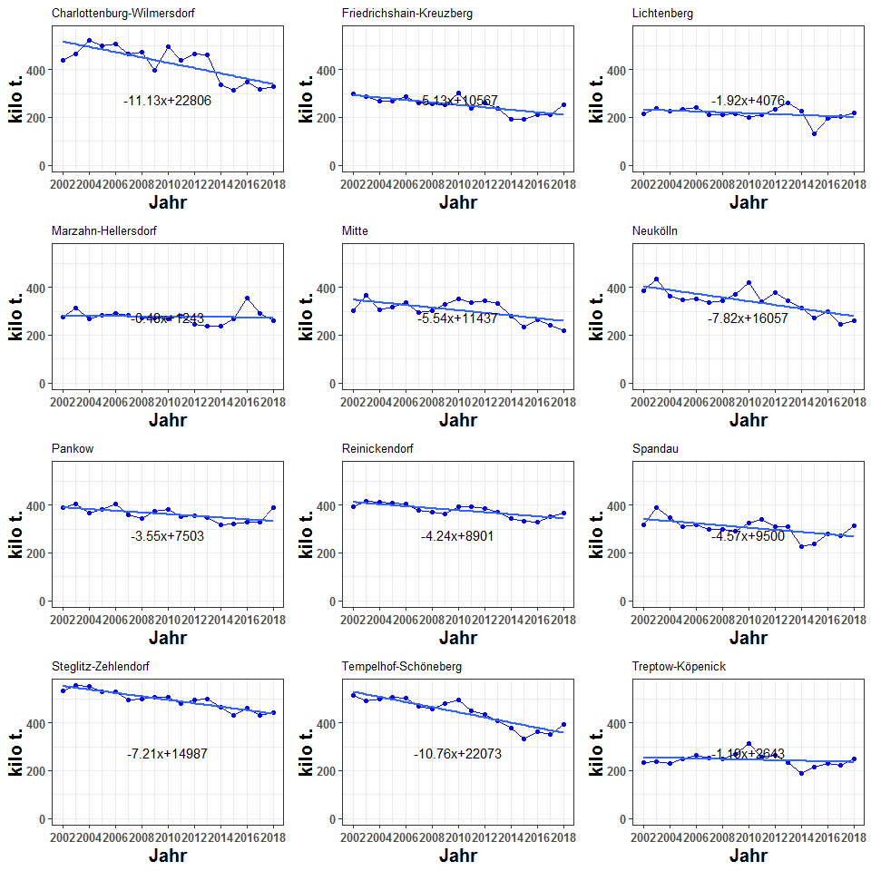

berlin_co2_all

## abrechnungsjahr charlottenburg_wilmersdorf friedrichshain_kreuzberg  
## 1 2002 437.5293 297.2324  
## 2 2003 466.5623 288.0173  
## 3 2004 523.9296 267.8083  
## 4 2005 499.0712 269.5375  
## 5 2006 506.4530 287.4582  
## 6 2007 467.4310 260.4179  
## 7 2008 471.6374 257.8947  
## 8 2009 397.8959 252.1482  
## 9 2010 497.1840 300.9858  
## 10 2011 439.2849 238.1180  
## 11 2012 463.8478 260.7414  
## 12 2013 460.5407 236.0173  
## 13 2014 338.4202 191.1728  
## 14 2015 314.9513 190.9628  
## 15 2016 348.3044 210.2256  
## 16 2017 318.8350 212.4325  
## 17 2018 329.1718 252.2647  
## lichtenberg marzahn_hellersdorf mitte neukoelln pankow  
## 1 216.6343 275.2513 303.6602 386.9229 388.7110  
## 2 238.3496 313.2014 367.6347 434.6238 404.7990  
## 3 226.4307 266.9005 306.9894 361.8178 366.1182  
## 4 233.5679 282.3000 317.1532 346.5096 381.9396  
## 5 240.4608 289.4489 336.6562 352.5077 404.0113  
## 6 211.0525 281.6287 296.0844 335.1829 358.1850  
## 7 211.7719 271.9283 301.2731 343.1990 343.8619  
## 8 216.2582 272.4331 329.3362 371.2087 372.7440  
## 9 199.0213 268.4016 349.9835 418.6494 381.8390  
## 10 210.1798 279.1120 336.5241 338.8299 351.1555  
## 11 233.6965 246.1024 342.7206 379.0212 355.0812  
## 12 261.3005 237.7976 331.0666 345.8917 348.4189  
## 13 225.7927 238.5314 281.0405 314.7469 315.8817  
## 14 131.4076 268.7053 232.6526 271.3746 320.3199  
## 15 196.6574 356.8285 265.7401 297.6735 330.3642  
## 16 204.8809 289.4252 241.6136 243.6720 327.4611  
## 17 217.9276 260.0886 218.6250 260.2750 388.1170  
## reinickendorf spandau steglitz_zehlendorf tempelhof_schoeneberg  
## 1 392.7612 315.9709 535.8396 515.1772  
## 2 417.0745 389.6866 555.1910 492.2442  
## 3 412.3152 346.3917 552.0756 500.0783  
## 4 406.9920 310.4068 530.5820 506.1757  
## 5 404.3762 317.5846 530.4499 503.6604  
## 6 377.9894 297.4208 495.0667 471.0199  
## 7 372.0310 296.8566 501.0394 459.7635  
## 8 365.0171 289.5115 508.4172 482.2675  
## 9 394.3945 323.8770 507.7911 495.7093  
## 10 393.8126 339.7322 482.6590 451.6065  
## 11 384.5755 310.7582 495.2810 435.5185  
## 12 372.4470 311.8237 498.2495 407.9688  
## 13 344.9816 227.1596 464.8513 378.6392  
## 14 330.9450 237.0958 432.2612 333.2663  
## 15 329.4780 280.6585 463.3482 364.9747  
## 16 351.5174 270.5330 429.6898 353.5214  
## 17 368.5619 312.0977 442.2216 393.2160  
## treptow_koepenick total  
## 1 234.6767 4300.367  
## 2 237.3749 4604.759  
## 3 229.9027 4360.758  
## 4 249.6980 4333.933  
## 5 266.2393 4439.307  
## 6 252.5663 4104.045  
## 7 250.9305 4082.187  
## 8 268.1575 4125.395  
## 9 312.8423 4450.679  
## 10 255.2892 4116.304  
## 11 264.3958 4171.740  
## 12 235.1742 4046.696  
## 13 188.2448 3509.463  
## 14 216.3241 3280.266  
## 15 231.9750 3676.228  
## 16 222.2915 3465.873  
## 17 250.1079 3692.675

i_subsubsection <- i_subsubsection + 1

### 1.1.5 Stadtbezirke, MFH + 1-2 FH, CO2-Emission aus der Beheizung von Wohnraum 2002-2018, Veränderung in Prozent

* Finds the mean co2 emitted by each bezirk in each year (for eg for year Y, total co2 by all bezirks in Y divided by number of bezirks).
* For bezirk X, it finds the difference of co2 emitted by X in year Y and the mean co2 in year Y, divides by the diffference by the mean co2 in year Y, and multiplies by 100

getDeviationsFromMean <- function(input_data,xVar,colsToAvgOver) {  
 input_data <- input_data[ , c(xVar , colsToAvgOver)]  
 input_data$meanVal <- rowMeans(input_data[ , colsToAvgOver])  
 for (colName in colsToAvgOver) {  
 input_data[[colName]] <- 100.0*(input_data[[colName]] - input_data[["meanVal"]])/input_data[["meanVal"]]  
 }  
 return(input_data)  
}

berlin_co2_all_devFromMean <- getDeviationsFromMean(berlin_co2_all,  
 xVar = "abrechnungsjahr",  
 colsToAvgOver = names(berlin_co2_all)[  
 !(names(berlin_co2_all  
 ) %in% c("abrechnungsjahr","total"))]  
)

#berlin_co2_all_devFromMean

plotDevFromMean <- function(input_data,xVar,yVar,ymin,ymax,ylabel,plot_title) {  
 input_data <- input_data[, c(xVar,yVar)]  
 input_data$p_or_m <- as.integer(input_data[[yVar]] > 0)  
 input_data$p_or_m[input_data$p_or_m == 0] <- "g_reen"  
 input_data$p_or_m[input_data$p_or_m == 1] <- "r_ed"  
 return(  
 ggplot(data=input_data,aes(x=get(xVar),y=get(yVar),fill=p_or_m))+geom_bar(stat="identity")+scale_fill_manual(values=c("g_reen" = "green", "r_ed" = "red") )+ylim(ymin,ymax)+theme(legend.position="none")+labs(title=plot_title,x="Jahr",y=ylabel)  
 )  
 #  
}

ymin <- min(berlin_co2_all_devFromMean[ ,   
 names(berlin_co2_all_devFromMean)[  
 !(names(berlin_co2_all_devFromMean) %in% c("abrechnungsjahr",  
 "meanVal"))  
 ]])  
ymax <- max(berlin_co2_all_devFromMean[ ,   
 names(berlin_co2_all_devFromMean)[  
 !(names(berlin_co2_all_devFromMean) %in% c("abrechnungsjahr",  
 "meanVal"))  
 ]])  
#plotDevFromMean(berlin_co2_all_devFromMean,"abrechnungsjahr","mitte",yMin=yMin,yMax=yMax)  
g_co2dev_bezirk <- list()  
for (ii in 1:12) {  
 g_co2dev_bezirk[[ii]] <- plotDevFromMean(input_data = berlin_co2_all_devFromMean,  
 xVar = "abrechnungsjahr",  
 yVar = bezirk_list[ii],  
 ymin=ymin,  
 ymax=ymax,  
 ylabel="% deviation from mean",  
 plot_title = bezirk_name[ii])  
}

require(grid)  
require(gridExtra)  
grid.arrange(g_co2dev_bezirk[[1]],g_co2dev_bezirk[[2]],g_co2dev_bezirk[[3]],g_co2dev_bezirk[[4]],  
 g_co2dev_bezirk[[5]],g_co2dev_bezirk[[6]],g_co2dev_bezirk[[7]],g_co2dev_bezirk[[8]],  
 g_co2dev_bezirk[[9]],g_co2dev_bezirk[[10]],g_co2dev_bezirk[[11]],g_co2dev_bezirk[[12]],ncol=3)

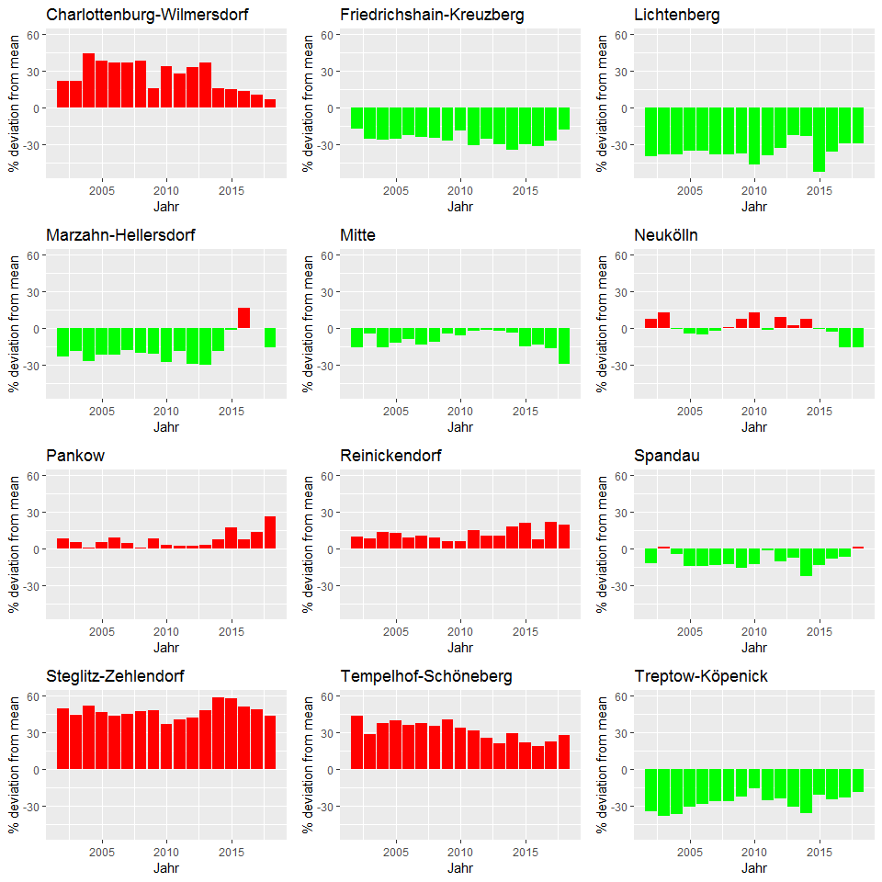

berlin_co2_all_devFromMean

## abrechnungsjahr charlottenburg_wilmersdorf friedrichshain_kreuzberg  
## 1 2002 22.090781 -17.05852  
## 2 2003 21.586108 -24.94270  
## 3 2004 44.175734 -26.30410  
## 4 2005 38.185196 -25.36919  
## 5 2006 36.900579 -22.29647  
## 6 2007 36.674214 -23.85525  
## 7 2008 38.642560 -24.18926  
## 8 2009 15.740443 -26.65483  
## 9 2010 34.051645 -18.84766  
## 10 2011 28.061958 -30.58297  
## 11 2012 33.425691 -24.99781  
## 12 2013 36.567904 -30.01185  
## 13 2014 15.716927 -34.63175  
## 14 2015 15.216708 -30.14122  
## 15 2016 13.694048 -31.37784  
## 16 2017 10.391237 -26.44885  
## 17 2018 6.970215 -18.02211  
## lichtenberg marzahn_hellersdorf mitte neukoelln pankow  
## 1 -39.54908 -23.1922320 -15.264843 7.9692644 8.4682370  
## 2 -37.88611 -18.3797259 -4.194423 13.2629367 5.4905934  
## 3 -37.69046 -26.5539298 -15.522185 -0.4344250 0.7489483  
## 4 -35.32862 -21.8354434 -12.185116 -4.0567792 5.7532418  
## 5 -35.00044 -21.7583420 -8.997635 -4.7127637 9.2093110  
## 6 -38.28942 -17.6533366 -13.426574 -1.9943968 4.7312869  
## 7 -37.74753 -20.0639471 -11.437753 0.8868088 1.0816561  
## 8 -37.09454 -20.7543406 -4.202271 7.9776552 8.4242335  
## 9 -46.33953 -27.6330836 -5.636831 12.8769981 2.9521237  
## 10 -38.72760 -18.6322542 -1.895240 -1.2230549 2.3701400  
## 11 -32.77725 -29.2086995 -1.416511 9.0253468 2.1390318  
## 12 -22.51442 -29.4839287 -1.826124 2.5700944 3.3195026  
## 13 -22.79411 -18.4383287 -3.903066 7.6222445 8.0102901  
## 14 -51.92796 -1.7011769 -14.890112 -0.7246658 17.1806759  
## 15 -35.80680 16.4765174 -13.256721 -2.8329618 7.8379937  
## 16 -29.06344 0.2085929 -16.345375 -15.6327102 13.3778485  
## 17 -29.18057 -15.4795952 -28.953951 -15.4190350 26.1254765  
## reinickendorf spandau steglitz_zehlendorf tempelhof_schoeneberg  
## 1 9.598430 -11.8295997 49.52386 43.75812  
## 2 8.689582 1.5523144 44.68274 28.27881  
## 3 13.461528 -4.6793994 51.92100 37.61230  
## 4 12.689869 -14.0530957 46.91004 40.15233  
## 5 9.307937 -14.1529245 43.38724 36.14569  
## 6 10.521988 -13.0358172 44.75474 37.72359  
## 7 9.362271 -12.7360094 47.28557 35.15210  
## 8 6.176635 -15.7865451 47.88902 40.28255  
## 9 6.337348 -12.6756969 36.91155 33.65403  
## 10 14.805689 -0.9600255 40.70654 31.65398  
## 11 10.623040 -10.6104809 42.46745 25.27680  
## 12 10.444741 -7.5323733 47.74999 20.97833  
## 13 17.960489 -22.3267117 58.94785 29.46911  
## 14 21.067599 -13.2646679 58.13150 21.91677  
## 15 7.548710 -8.3870145 51.24683 19.13558  
## 16 21.706962 -6.3325370 48.77281 22.40078  
## 17 19.770694 1.4216555 43.70772 27.78251  
## treptow_koepenick meanVal  
## 1 -34.51442 358.3639  
## 2 -38.14012 383.7299  
## 3 -36.73502 363.3965  
## 4 -30.86243 361.1611  
## 5 -28.03218 369.9422  
## 6 -26.15102 342.0038  
## 7 -26.23647 340.1823  
## 8 -21.99801 343.7829  
## 9 -15.65089 370.8899  
## 10 -25.57717 343.0253  
## 11 -23.94660 347.6450  
## 12 -30.26186 337.2247  
## 13 -35.63295 292.4552  
## 14 -20.86345 273.3555  
## 15 -24.27835 306.3523  
## 16 -23.03532 288.8228  
## 17 -18.72300 307.7229

i_subsubsection <- i_subsubsection + 1

### 1.1.6 Stadtbezirke, MFH + 1-2 FH, CO2-Emission aus der Beheizung von Wohnraum 2002-2018, in Prozent

* Pending

i_subsection <- i_subsection + 1

## 1.2 Flächenbezug

i_subsubsection <- 1

### 1.2.1 Berlin, MFH + 1-2 FH, flächenbezogene co2 Emission aus der Beheizung von Wohnraum 2002-2018 in kg/m2 [AN]

Here you have to get the areas of SFH and MFH buildings…

* Short method: Do as in BerlinPresentationCO2BalanceUnified_v7.Rmd. I.e. read directly from the file for total Berlin areas.

totalArea <- read.table("D:/GITHUB_REPOS/co2emissions/Berlin/berlin_wohnflaeche.txt",header=TRUE)  
totalArea <- totalArea*1000000  
totalArea$totArea <- rowSums(totalArea)  
totalArea$abrechnungsjahr <- 2002:2018  
#totalArea <- totalArea[ , c("abrechnungsjahr","totArea")]  
#totalArea

* Long method: find for each bezirk separately, and add them. The units of Bezirk areas are 100 m-squared in the original file. So multiply with 100 to get the areas in m^2.

bezirk_areas_sfh <- 100*getRowSums(obj=alle_bezirke_co2$areas_sfh , dropCols = "abrechnungsjahr")  
bezirk_areas_mfh <- 100*getRowSums(obj=alle_bezirke_co2$areas_mfh , dropCols = "abrechnungsjahr")  
bezirk_areas_all <- bezirk_areas_mfh + bezirk_areas_sfh  
bezirk_areas_all$abrechnungsjahr <- 2002:2018  
#bezirk_areas_all

*WHY DO I GET A FACTOR OF 1.4 OFF IN THE TWO METHODS ????*

Use the long method.

#spz_co2 <- 1e6*berlin_co2_all$total/totalArea$totArea  
spz_co2 <- 1e6*berlin_co2_all$total/bezirk_areas_all$total  
spez_co2_emission <- data.frame(abrechnungsjahr=2002:2018 , spez_co2 = spz_co2 )

#spez_co2_emission

points_line_lm(input_data = spez_co2_emission,  
 xVar = "abrechnungsjahr",  
 yVar = "spez_co2",  
 ymin=0,  
 ymax=max(spez_co2_emission$spez_co2),  
 x_eq = 2010,  
 y_eq = 20,  
 size_eq = 4,  
 plot_title = "Spezifische CO2 Emissionen in Berlin, alle Wohngebäude",  
 xlab = "Jahr",  
 ylab = "kg/qm")

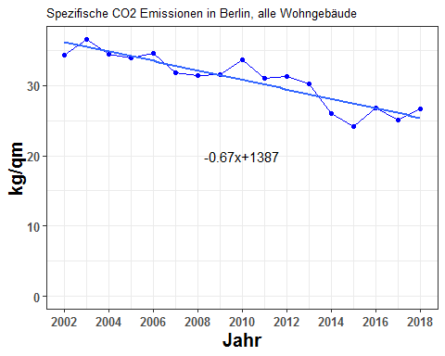

spez_co2_emission

## abrechnungsjahr spez_co2  
## 1 2002 34.37184  
## 2 2003 36.56125  
## 3 2004 34.39632  
## 4 2005 33.96149  
## 5 2006 34.56152  
## 6 2007 31.74543  
## 7 2008 31.37412  
## 8 2009 31.50442  
## 9 2010 33.66437  
## 10 2011 31.02535  
## 11 2012 31.30158  
## 12 2013 30.21521  
## 13 2014 26.03424  
## 14 2015 24.15518  
## 15 2016 26.85315  
## 16 2017 25.11814  
## 17 2018 26.67217

i_subsubsection <- i_subsubsection + 1

### 1.2.2 Stadtbezirke, MFH + 1-2 FH, flächenbezogene co2 Emission aus der Beheizung von Wohnraum 2002-2018 in kg/m2 [AN]

*Is this not similar to 7.2.1?*

*Or am I supposed to show the pictures of all the bezirke simultaneously?*

#berlin_co2_all

#bezirk_areas_all

bezirke_spez_co2 <- 1e6*berlin_co2_all/bezirk_areas_all  
bezirke_spez_co2$abrechnungsjahr <- 2002:2018

#bezirke_spez_co2

plot_reqdColumns(bezirke_spez_co2,  
 xVar = "abrechnungsjahr",  
 cols_to_plot = names(bezirke_spez_co2)[!(names(bezirke_spez_co2) %in% c("abrechnungsjahr","total"))],  
 yColsName = "Bezirk",  
 yVar = "kg/qm",  
 plot_title = "Spezifische CO2 Emissionen von Stadtbezirken, alle Wohngebäude")

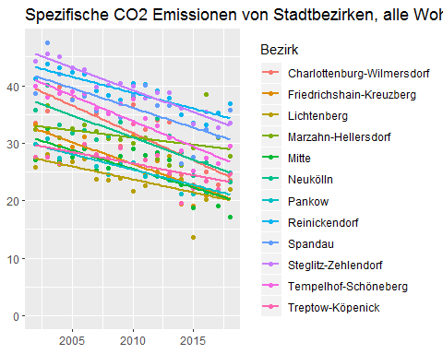

reqdCols <- names(bezirke_spez_co2)[!(names(bezirke_spez_co2) %in% c("abrechnungsjahr" , "total"))]  
ymax <- max(bezirke_spez_co2 [ , reqdCols])  
g_co2spez_bezirk <- list()  
for (ii in 1:12) {  
 g_co2spez_bezirk[[ii]] <- points_line_lm(input_data = bezirke_spez_co2,  
 xVar = "abrechnungsjahr",  
 yVar = bezirk_list[ii],  
 ymin=0,  
 ymax=ymax,  
 x_eq = 2010,  
 y_eq = 0.5*ymax,  
 size_eq = 4,  
 plot_title = bezirk_name[ii],#Here put bezirk_name[ii]  
 xlab = "Jahr",  
 ylab = "kg/qm")  
}  
require(grid)  
require(gridExtra)  
grid.arrange(g_co2spez_bezirk[[1]],g_co2spez_bezirk[[2]],g_co2spez_bezirk[[3]],g_co2spez_bezirk[[4]],  
 g_co2spez_bezirk[[5]],g_co2spez_bezirk[[6]],g_co2spez_bezirk[[7]],g_co2spez_bezirk[[8]],  
 g_co2spez_bezirk[[9]],g_co2spez_bezirk[[10]],g_co2spez_bezirk[[11]],g_co2spez_bezirk[[12]],ncol=3)

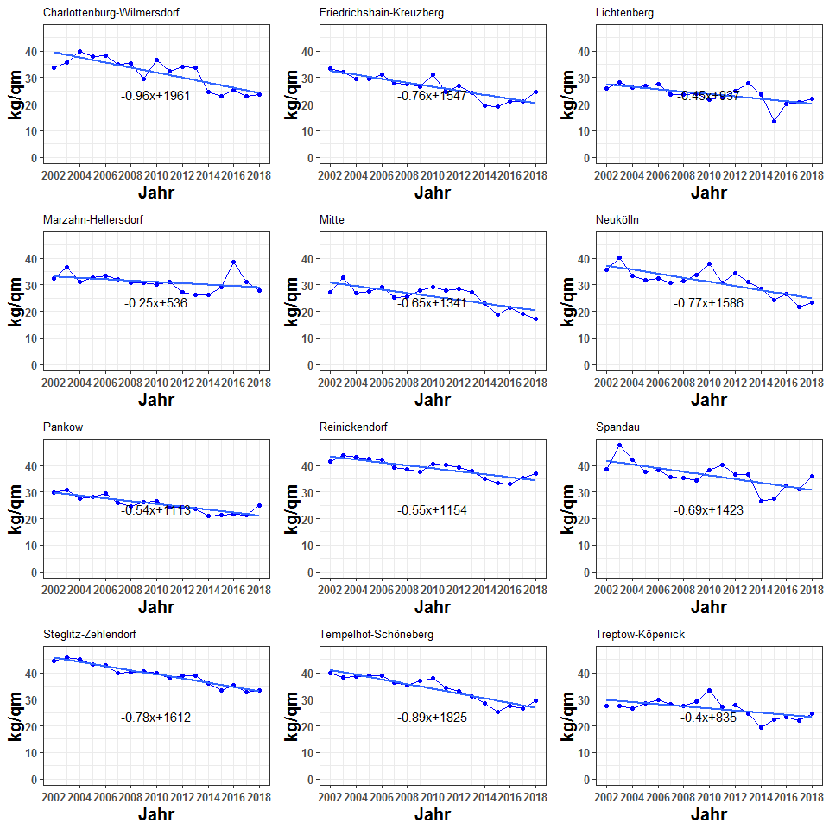

bezirke_spez_co2

## abrechnungsjahr charlottenburg_wilmersdorf friedrichshain_kreuzberg  
## 1 2002 33.57633 33.25013  
## 2 2003 35.63707 31.93619  
## 3 2004 39.83281 29.43672  
## 4 2005 37.76728 29.37096  
## 5 2006 38.14932 31.05559  
## 6 2007 35.04844 27.89548  
## 7 2008 35.20240 27.39269  
## 8 2009 29.56346 26.55878  
## 9 2010 36.70257 31.22130  
## 10 2011 32.32556 24.62033  
## 11 2012 34.03863 26.89136  
## 12 2013 33.67363 24.21386  
## 13 2014 24.59735 19.44988  
## 14 2015 22.80240 19.13302  
## 15 2016 25.07753 20.90341  
## 16 2017 22.81435 20.86292  
## 17 2018 23.49628 24.71456  
## lichtenberg marzahn_hellersdorf mitte neukoelln pankow  
## 1 25.74273 32.40022 27.12654 35.71894 29.86472  
## 2 28.00612 36.62810 32.56488 40.03452 30.71854  
## 3 26.31113 31.01205 26.96583 33.25525 27.44592  
## 4 26.84331 32.59122 27.62785 31.77875 28.28854  
## 5 27.33620 33.20381 29.08586 32.25844 29.56863  
## 6 23.73593 32.10236 25.37217 30.60638 25.90763  
## 7 23.56435 30.80177 25.60813 31.27041 24.58367  
## 8 23.81115 30.66618 27.76906 33.74933 26.34354  
## 9 21.58769 29.95253 29.09232 37.92080 26.62142  
## 10 22.63747 31.02244 27.91180 30.66556 24.27504  
## 11 24.98306 27.19995 28.33783 34.25654 24.27026  
## 12 27.70244 26.17245 27.14706 31.21682 23.59698  
## 13 23.74291 26.09067 22.82952 28.33082 21.14774  
## 14 13.63899 29.17570 18.76579 24.38073 21.17523  
## 15 20.14313 38.49158 21.20255 26.66823 21.57819  
## 16 20.71723 30.94067 19.04854 21.73256 21.20024  
## 17 21.92513 27.71826 17.19342 23.21158 24.86834  
## reinickendorf spandau steglitz_zehlendorf tempelhof_schoeneberg  
## 1 41.30073 38.67256 44.27202 39.93988  
## 2 43.71861 47.49698 45.61158 38.07935  
## 3 43.08342 42.04557 45.10071 38.60183  
## 4 42.39347 37.52266 43.10256 38.98829  
## 5 41.98898 38.23303 42.85232 38.71110  
## 6 39.12643 35.65947 39.77283 36.12468  
## 7 38.38972 35.44719 40.03139 35.18586  
## 8 37.54900 34.43020 40.39878 36.82923  
## 9 40.40720 38.33908 39.99206 37.74676  
## 10 40.25520 40.11100 37.92700 34.33043  
## 11 39.20239 36.50610 38.78625 33.04590  
## 12 37.86954 36.48810 38.82655 30.93720  
## 13 34.97558 26.48813 36.04141 28.62623  
## 14 33.44838 27.52639 33.31339 25.12903  
## 15 33.15902 32.45470 35.37360 27.44831  
## 16 35.24691 31.16201 32.65343 26.52969  
## 17 36.88289 35.81176 33.49101 29.46204  
## treptow_koepenick total  
## 1 27.58477 34.37184  
## 2 27.57664 36.56125  
## 3 26.40079 34.39632  
## 4 28.34730 33.96149  
## 5 29.88472 34.56152  
## 6 28.03417 31.74543  
## 7 27.54577 31.37412  
## 8 29.11613 31.50442  
## 9 33.31974 33.66437  
## 10 27.07834 31.02535  
## 11 27.85871 31.30158  
## 12 24.63718 30.21521  
## 13 19.52544 26.03424  
## 14 22.16163 24.15518  
## 15 23.34528 26.85315  
## 16 22.00863 25.11814  
## 17 24.73110 26.67217

i_subsubsection <- i_subsubsection + 1

### 1.2.3 Stadtbezirke, MFH + 1-2 FH, flächenbezogene co2 Emission aus der Beheizung von Wohnraum im Jahr 2018 in kg/m2 [AN]

Extract the 2018 values from the above…

bezirke_spez_co2_2018 <- bezirke_spez_co2[bezirke_spez_co2$abrechnungsjahr==2018 , ]  
#bezirke_spez_co2_2018

bezirke_spezco2_2018 <- as.data.frame(t(bezirke_spez_co2_2018))  
bezirke_spezco2_2018$bezirk <- row.names(bezirke_spezco2_2018)  
names(bezirke_spezco2_2018) <- c("wert","bezirk")  
bezirke_spezco2_2018 <- bezirke_spezco2_2018[bezirke_spezco2_2018$bezirk!="abrechnungsjahr" , ]  
#bezirke_spezco2_2018

Here it makes more sense to put in the values of the linear trend…

linearizer <- function(obj,dropCols,xVar) {  
 obj_new <- obj[ , !(names(obj) %in% dropCols)]  
 feature_list <- names(obj_new)[ !(names(obj_new) %in% c(dropCols,xVar)) ]  
 storage <- list()  
 for (feature in feature_list) {  
 storage[[feature]] <- lm(get(feature) ~ get(xVar) , data = obj)  
 obj_new[[feature]] <- as.numeric(predict(storage[[feature]] , newdata = obj))  
 }  
 return(obj_new)  
}

bezirke_spez_co2_linear <- linearizer(bezirke_spez_co2 , dropCols = NULL , xVar = "abrechnungsjahr")

bezirke_spez_co2_linear_2018 <- bezirke_spez_co2_linear[bezirke_spez_co2_linear$abrechnungsjahr==2018 , ]  
bezirke_spezco2_linear_2018 <- as.data.frame(t(bezirke_spez_co2_linear_2018))  
bezirke_spezco2_linear_2018$bezirk <- row.names(bezirke_spezco2_linear_2018)  
names(bezirke_spezco2_linear_2018) <- c("wert","bezirk")  
bezirke_spezco2_linear_2018 <- bezirke_spezco2_linear_2018[!(bezirke_spezco2_linear_2018$bezirk%in%c("abrechnungsjahr","total")) , ]  
#bezirke_spezco2_linear_2018

Now make a bar plot of these.

bezirke_spezco2_linear_2018$bezirk <- factor(  
 bezirke_spezco2_linear_2018$bezirk ,   
 levels = bezirke_spezco2_linear_2018$bezirk[order(bezirke_spezco2_linear_2018$wert)])  
#barplot(bezirke_spezco2_linear_2018$wert)  
ggplot(data=bezirke_spezco2_linear_2018,aes(x=bezirk,y=wert,fill=wert))+geom_bar(stat="identity")+scale_fill_gradient(  
 low="green",high="red"  
)+theme(legend.position="none",axis.text.x=element_text(angle=45,hjust=1))+labs(x=" ",y="kg/qm",title="Spezifische CO2 Emissionen 2018, alle Wohngebäude")#+coord_flip()

plot_spezCO2_2018 <- function(obj,plot_title) {  
 obj$bezirk <- get_BezirkNames(obj$bezirk)  
 obj$bezirk <- factor(obj$bezirk ,   
 levels = obj$bezirk[order(obj$wert)])  
 return(  
 ggplot(data=obj,aes(x=bezirk,y=wert,fill=wert))+geom_bar(stat="identity")+scale_fill_gradient(  
 low="green",high="red"  
 )+theme(legend.position="none",axis.text.x=element_text(angle=45,hjust=1))+labs(x=" ",y="kg/qm",title=plot_title)#+coord_flip()  
 )  
}

plot_spezCO2_2018(obj = bezirke_spezco2_linear_2018 ,   
 plot_title = "Spezifische CO2 Emissionen 2018, alle Wohngebäude")

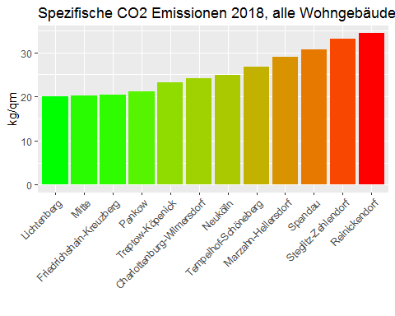

bezirke_spezco2_linear_2018

## wert bezirk  
## charlottenburg_wilmersdorf 24.10319 charlottenburg_wilmersdorf  
## friedrichshain_kreuzberg 20.35541 friedrichshain_kreuzberg  
## lichtenberg 20.03695 lichtenberg  
## marzahn_hellersdorf 28.94024 marzahn_hellersdorf  
## mitte 20.27215 mitte  
## neukoelln 24.81356 neukoelln  
## pankow 21.05257 pankow  
## reinickendorf 34.32516 reinickendorf  
## spandau 30.62220 spandau  
## steglitz_zehlendorf 33.00652 steglitz_zehlendorf  
## tempelhof_schoeneberg 26.73684 tempelhof_schoeneberg  
## treptow_koepenick 23.20318 treptow_koepenick

i_subsubsection <- i_subsubsection + 1

### 1.2.4 Berlin, flächenbezogene co2 Emission aus Beheizung von Wohnraum nach Stadtbezirken, 2002-2008, 2002=100

The per unit area co2 emission when the 2002 value is 100.

spez_co2_emission contains the berlin values of the specific co2 emission.

#spez_co2_emission

get2002as100 <- function(obj,dropCols) {  
 isNotDropCol <- !(names(obj) %in% dropCols)  
 for (xvar in names(obj)[isNotDropCol]) {  
 obj[[xvar]] <- 100*obj[[xvar]]/obj[[xvar]][1]  
 }  
 return(obj)  
}

get2002as100(spez_co2_emission , "abrechnungsjahr")

## abrechnungsjahr spez_co2  
## 1 2002 100.00000  
## 2 2003 106.36977  
## 3 2004 100.07121  
## 4 2005 98.80616  
## 5 2006 100.55185  
## 6 2007 92.35885  
## 7 2008 91.27855  
## 8 2009 91.65764  
## 9 2010 97.94172  
## 10 2011 90.26386  
## 11 2012 91.06752  
## 12 2013 87.90689  
## 13 2014 75.74294  
## 14 2015 70.27608  
## 15 2016 78.12543  
## 16 2017 73.07767  
## 17 2018 77.59889

points_line_lm(input_data = get2002as100(spez_co2_emission , "abrechnungsjahr"),  
 xVar = "abrechnungsjahr",  
 yVar = "spez_co2",  
 ymin=0,  
 ymax=110,  
 x_eq = 2010,  
 y_eq = 60,  
 size_eq = 4,  
 plot_title = "Spezifische CO2 Emissionen in Berlin, 2002 Wert = 100",  
 xlab = "Jahr",  
 ylab = " ")

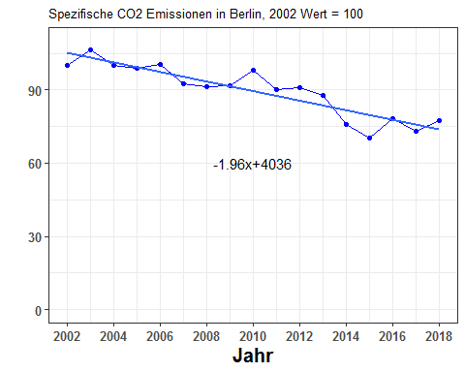

get2002as100(spez_co2_emission , "abrechnungsjahr")

## abrechnungsjahr spez_co2  
## 1 2002 100.00000  
## 2 2003 106.36977  
## 3 2004 100.07121  
## 4 2005 98.80616  
## 5 2006 100.55185  
## 6 2007 92.35885  
## 7 2008 91.27855  
## 8 2009 91.65764  
## 9 2010 97.94172  
## 10 2011 90.26386  
## 11 2012 91.06752  
## 12 2013 87.90689  
## 13 2014 75.74294  
## 14 2015 70.27608  
## 15 2016 78.12543  
## 16 2017 73.07767  
## 17 2018 77.59889

i_subsubsection <- i_subsubsection + 1

### 1.2.5 Alle Stadtbezirke, alle Wohngebäude, flächenbezogene co2 Emission aus der Beheizung von Wohnraum, Entwicklung 2002-2018 und Niveau 2018 (Rang-folge)

***(Berlin specific CO2 emission for 2018) - (Bezirk specific CO2 emission for 2018)***

Make a linear trend of spez_co2_emission. This is the value for Berlin total. The 2018 value is the baseline. bezirke_spezco2_linear_2018 gives the 2018 values of the linear trend for the bezirke.

First find the linear trend:

spez_co2_emission_linear <- linearizer(spez_co2_emission,dropCols=NULL,xVar="abrechnungsjahr")  
spez_co2_emission_linear_2018 <- spez_co2_emission_linear$spez_co2[spez_co2_emission_linear$abrechnungsjahr==2018]  
#spez_co2_emission_linear_2018

#bezirke_spezco2_linear_2018

bezirke_spezco2_linear_2018$dev_from_berlin <- bezirke_spezco2_linear_2018$wert - spez_co2_emission_linear_2018

#bezirke_spezco2_linear_2018

bezirke_spezco2_linear_2018$bezirk <- factor(  
 bezirke_spezco2_linear_2018$bezirk ,   
 levels = bezirke_spezco2_linear_2018$bezirk[order(bezirke_spezco2_linear_2018$dev_from_berlin)])  
  
ggplot(data=bezirke_spezco2_linear_2018,aes(x=bezirk,y=dev_from_berlin,fill=dev_from_berlin))+geom_bar(stat="identity")+scale_fill_gradient(  
 low="green",high="red"  
)+theme(legend.position="none",axis.text.x=element_text(angle=45,hjust=1))+labs(x=" ")#+coord_flip()

plot_devFromBerlin2018 <- function(obj,  
 plot_title=NULL,  
 ylabel = NULL) {  
 obj$bezirk <- get_BezirkNames(obj$bezirk)  
 obj$bezirk <- factor(obj$bezirk , levels = obj$bezirk[order(obj$dev_from_berlin)])  
 return(  
 ggplot(data=obj,aes(x=bezirk,y=dev_from_berlin,fill=dev_from_berlin))+geom_bar(stat="identity")+scale_fill_gradient(  
 low="green",high="red"  
)+theme(legend.position="none",axis.text.x=element_text(angle=45,hjust=1))+labs(x=" ",y=ylabel,title=plot_title)#+coord_flip()  
 )  
}  
  
plot_devFromBerlin2018(bezirke_spezco2_linear_2018,  
 "2018 deviation from Berlin",  
 "some y-label")

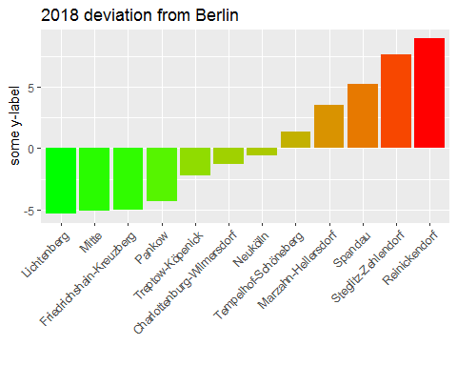

bezirke_spezco2_linear_2018

## wert bezirk  
## charlottenburg_wilmersdorf 24.10319 charlottenburg_wilmersdorf  
## friedrichshain_kreuzberg 20.35541 friedrichshain_kreuzberg  
## lichtenberg 20.03695 lichtenberg  
## marzahn_hellersdorf 28.94024 marzahn_hellersdorf  
## mitte 20.27215 mitte  
## neukoelln 24.81356 neukoelln  
## pankow 21.05257 pankow  
## reinickendorf 34.32516 reinickendorf  
## spandau 30.62220 spandau  
## steglitz_zehlendorf 33.00652 steglitz_zehlendorf  
## tempelhof_schoeneberg 26.73684 tempelhof_schoeneberg  
## treptow_koepenick 23.20318 treptow_koepenick  
## dev_from_berlin  
## charlottenburg_wilmersdorf -1.2935464  
## friedrichshain_kreuzberg -5.0413333  
## lichtenberg -5.3597898  
## marzahn_hellersdorf 3.5434984  
## mitte -5.1245909  
## neukoelln -0.5831814  
## pankow -4.3441681  
## reinickendorf 8.9284220  
## spandau 5.2254568  
## steglitz_zehlendorf 7.6097822  
## tempelhof_schoeneberg 1.3401033  
## treptow_koepenick -2.1935588

i_subsubsection <- i_subsubsection + 1

### 1.2.6 Berlin, alle Wohngebäude, durchschnittliche Emissionsminderung je qm Nutzfläche im Zeitraum 2002-2018

Take the 2012 value of specific co2 emission as the base line. Plot the changes of each year with respect to this value.

spez_co2_emission contains the berlin specific co2 emissions.

changeFrom2012 <- function(obj) {  
 wert2012 <- obj$spez_co2[obj$abrechnungsjahr==2012]  
 obj$delta2012 <- obj$spez_co2 - wert2012  
 return(obj)  
}  
barPlot_delta2012 <- function(obj,ylabel=NULL,plot_title=NULL) {  
 obj$abrechnungsjahr <- as.character(obj$abrechnungsjahr)  
 require(ggplot2)  
 return(  
 ggplot(data=obj,aes(x=abrechnungsjahr,y=delta2012,fill=delta2012))+geom_bar(stat="identity")+scale_fill_gradient(  
 low="green",high="red"  
 )+theme(legend.position="none",axis.text.x=element_text(angle=45,hjust=1))+labs(x=" ",y=ylabel,title=plot_title)  
 )  
}

#changeFrom2012(spez_co2_emission)

barPlot_delta2012(changeFrom2012(spez_co2_emission),"some y-label")

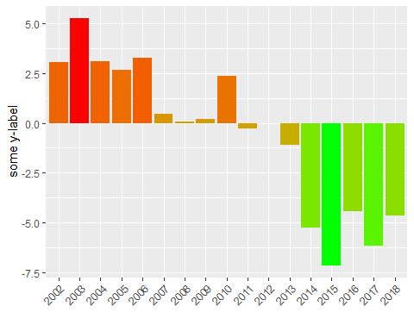

changeFrom2012(spez_co2_emission)

## abrechnungsjahr spez_co2 delta2012  
## 1 2002 34.37184 3.07025788  
## 2 2003 36.56125 5.25966585  
## 3 2004 34.39632 3.09473469  
## 4 2005 33.96149 2.65991335  
## 5 2006 34.56152 3.25993870  
## 6 2007 31.74543 0.44385411  
## 7 2008 31.37412 0.07253498  
## 8 2009 31.50442 0.20283479  
## 9 2010 33.66437 2.36278999  
## 10 2011 31.02535 -0.27623206  
## 11 2012 31.30158 0.00000000  
## 12 2013 30.21521 -1.08636598  
## 13 2014 26.03424 -5.26733936  
## 14 2015 24.15518 -7.14639860  
## 15 2016 26.85315 -4.44843309  
## 16 2017 25.11814 -6.18344319  
## 17 2018 26.67217 -4.62941443

i_subsection <- i_subsection + 1

## 1.3 Emission pro Einwohner

i_subsubsection <- 1

### 1.3.1 Stadtbezirke, alle Wohngebäude, co2-Emission aus der Beheizung von Wohnraum pro Einwohner

bezirk_population <- read.csv2("D:/GITHUB_REPOS/co2emissions/Berlin/BezirkAnalysis/PopulationBezirke/BerlinBezirkPopulation.csv",stringsAsFactors = FALSE)  
names(bezirk_population) <- c("bezirk",2002:2018)  
#converting data from wide to long: http://www.cookbook-r.com/Manipulating_data/Converting_data_between_wide_and_long_format/  
# look at the reshape2 option. id.vars has to be bezirk  
require(reshape2)  
bezirk_population <- melt(bezirk_population,id.vars = "bezirk")  
#convert $variable and $value to numeric  
bezirk_population$variable <- as.character(bezirk_population$variable)  
bezirk_population$variable <- as.numeric(bezirk_population$variable)  
bezirk_population$value <- gsub("\\.","",bezirk_population$value)  
bezirk_population$value <- as.numeric(bezirk_population$value)  
names(bezirk_population) <- c("bezirk","abrechnungsjahr","population")  
  
bezirk_population$bezirk[ bezirk_population$bezirk=="Berlin-Mitte"] <- "mitte"  
bezirk_population$bezirk[ bezirk_population$bezirk=="Charlottenburg Wilmersdorf"] <- "charlottenburg_wilmersdorf"  
bezirk_population$bezirk[ bezirk_population$bezirk=="Friedrichshain - Kreuzberg"] <- "friedrichshain_kreuzberg"  
bezirk_population$bezirk[ bezirk_population$bezirk=="Lichtenberg"] <- "lichtenberg"  
bezirk_population$bezirk[ bezirk_population$bezirk=="Marzahn-Hellersdorf"] <- "marzahn_hellersdorf"  
bezirk_population$bezirk[ bezirk_population$bezirk=="Neukölln"] <- "neukoelln"  
bezirk_population$bezirk[ bezirk_population$bezirk=="Pankow"] <- "pankow"  
bezirk_population$bezirk[ bezirk_population$bezirk=="Reinickendorf"] <- "reinickendorf"  
bezirk_population$bezirk[ bezirk_population$bezirk=="Spandau"] <- "spandau"  
bezirk_population$bezirk[ bezirk_population$bezirk=="Steglitz Zehlendorf"] <- "steglitz_zehlendorf"  
bezirk_population$bezirk[ bezirk_population$bezirk=="Tempelhof-Schöneberg"] <- "tempelhof_schoeneberg"  
bezirk_population$bezirk[ bezirk_population$bezirk=="Treptow-Köpenick"] <- "treptow_koepenick"  
bezirk_population  
dcast(bezirk_population , abrechnungsjahr~bezirk,value.var = "population")

from: Johannes Hengstenberg [johanneshengstenberg@gmail.com](mailto:johanneshengstenberg@gmail.com) to: Bhaskar Kamble [kbhaskar.iitk@gmail.com](mailto:kbhaskar.iitk@gmail.com) date: Jun 17, 2019, 7:46 PM subject: Population Data for the Bezirke

from: Johannes Hengstenberg [johanneshengstenberg@gmail.com](mailto:johanneshengstenberg@gmail.com) to: Bhaskar Kamble [kbhaskar.iitk@gmail.com](mailto:kbhaskar.iitk@gmail.com) date: Jun 16, 2019, 3:09 PM subject: Population of Berlin

Now you know the population, so can find per capita co2 emissions.

source("D:/GITHUB_REPOS/co2emissions/Berlin/BezirkAnalysis/getBerlinBezirkPopulation.R")  
bezirk_population <- getBerlinBezirkPopulation()  
#bezirk_population

bezirk_population <- getRowSums(bezirk_population , dropCols = "abrechnungsjahr")  
#bezirk_population

berlin_co2_percapita <- 1e6*berlin_co2_all$total / bezirk_population$total  
#bezirk_co2_percapita$abrechnungsjahr <- 2002:2018  
berlin_co2_percapita <- data.frame( abrechnungsjahr = 2002:2018 , co2_percapita = berlin_co2_percapita)  
#berlin_co2_percapita

points_line_lm(input_data = berlin_co2_percapita,  
 xVar = "abrechnungsjahr",  
 yVar = "co2_percapita",  
 ymin=0,  
 ymax=max(berlin_co2_percapita$co2_percapita),  
 x_eq = 2010,  
 y_eq = 500,  
 size_eq = 4,  
 plot_title = "Pro Kopf CO2 Emissionen in Berlin, alle Wohngebäude",  
 xlab = "Jahr",  
 ylab = "kg")

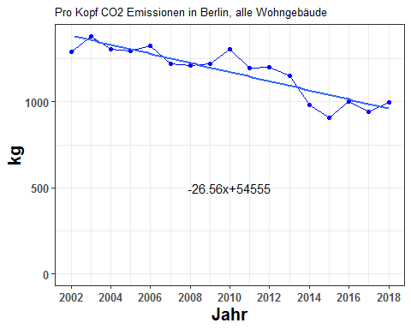

berlin_co2_percapita

## abrechnungsjahr co2_percapita  
## 1 2002 1290.1621  
## 2 2003 1380.8363  
## 3 2004 1306.5680  
## 4 2005 1297.1615  
## 5 2006 1326.1114  
## 6 2007 1223.2912  
## 7 2008 1213.2947  
## 8 2009 1220.4553  
## 9 2010 1307.7297  
## 10 2011 1198.5932  
## 11 2012 1201.2689  
## 12 2013 1150.5135  
## 13 2014 984.1460  
## 14 2015 907.5403  
## 15 2016 1004.2682  
## 16 2017 940.4804  
## 17 2018 995.2671

i_subsubsection <- i_subsubsection + 1

### 1.3.2. Stadtbezirke, alle Wohngebäude, CO2-Emission aus der Beheizung von Wohnraum pro Einwohner

*One Graph: CO2 Emissions in kg/head. All 12 lines in a single plot.*

#berlin_co2_all

#bezirk_population

berlin_bezirke_all_co2perhead <- 1e6*berlin_co2_all/bezirk_population  
berlin_bezirke_all_co2perhead$abrechnungsjahr <- 2002:2018  
#berlin_bezirke_all_co2perhead

plot_reqdColumns(berlin_bezirke_all_co2perhead,  
 xVar = "abrechnungsjahr",  
 cols_to_plot = names(berlin_bezirke_all_co2perhead)[!(names(berlin_bezirke_all_co2perhead) %in% c("abrechnungsjahr","total"))],  
 yColsName = "Bezirk",  
 yVar = "co2 kg/head",  
 plot_title = "Pro Kopf CO2 Emissionen von Stadtbezirken, alle Wohngebäude",  
 xlabel = "Jahr",  
 ylabel = "kg/Kopf")

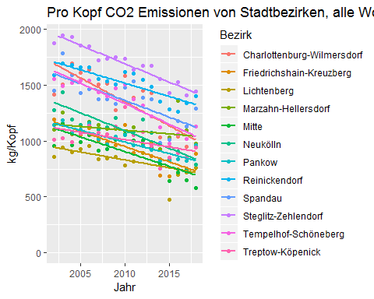

max_co2perhead_value <- max(berlin_bezirke_all_co2perhead[ , names(berlin_bezirke_all_co2perhead)[!(names(berlin_bezirke_all_co2perhead) %in% c("abrechnungsjahr","total"))]])  
require(ggplot2)  
g_co2perhead_bezirk <- list()  
for (ii in 1:12) {  
 g_co2perhead_bezirk[[ii]] <- points_line_lm(input_data = berlin_bezirke_all_co2perhead,  
 xVar = "abrechnungsjahr",  
 yVar = bezirk_list[ii],  
 ymin=0,  
 ymax=max_co2perhead_value,  
 x_eq = 2010,  
 y_eq = 0.5*max_co2perhead_value,  
 size_eq = 4,  
 plot_title = bezirk_name[ii],  
 xlab = "Jahr",  
 ylab = "kg/Kopf")  
}  
require(grid)  
require(gridExtra)  
grid.arrange(g_co2perhead_bezirk[[1]],g_co2perhead_bezirk[[2]],g_co2perhead_bezirk[[3]],g_co2perhead_bezirk[[4]],  
 g_co2perhead_bezirk[[5]],g_co2perhead_bezirk[[6]],g_co2perhead_bezirk[[7]],g_co2perhead_bezirk[[8]],  
 g_co2perhead_bezirk[[9]],g_co2perhead_bezirk[[10]],g_co2perhead_bezirk[[11]],g_co2perhead_bezirk[[12]],ncol=3)

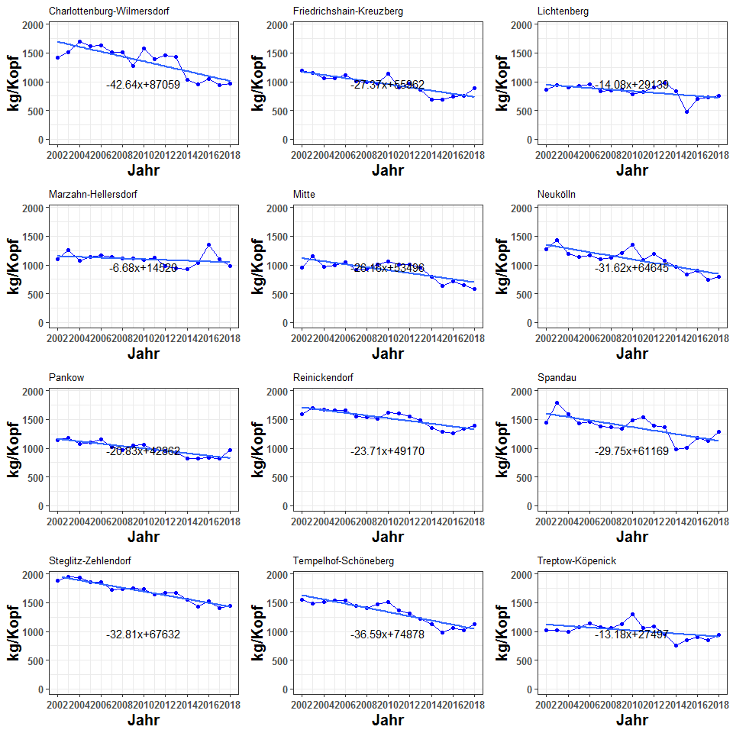

berlin_bezirke_all_co2perhead

## abrechnungsjahr charlottenburg_wilmersdorf friedrichshain_kreuzberg  
## 1 2002 1416.1312 1190.7632  
## 2 2003 1510.1742 1147.4519  
## 3 2004 1695.3400 1060.1274  
## 4 2005 1614.2970 1056.1606  
## 5 2006 1636.1579 1115.0346  
## 6 2007 1506.4764 1003.9977  
## 7 2008 1516.6701 989.7595  
## 8 2009 1275.0335 963.0555  
## 9 2010 1583.8325 1141.7066  
## 10 2011 1388.6788 895.5810  
## 11 2012 1453.3711 969.2051  
## 12 2013 1426.8033 866.1600  
## 13 2014 1034.7786 693.4618  
## 14 2015 951.6466 685.4866  
## 15 2016 1040.8144 746.2747  
## 16 2017 946.8876 750.1068  
## 17 2018 971.5759 885.7424  
## lichtenberg marzahn_hellersdorf mitte neukoelln pankow  
## 1 858.2703 1099.4837 958.5295 1276.5477 1143.3384  
## 2 944.3103 1254.5470 1159.1165 1435.0745 1185.4495  
## 3 897.3487 1071.2526 964.8658 1195.5663 1066.8120  
## 4 927.7955 1139.1056 994.1016 1145.8424 1101.9353  
## 5 956.0952 1172.7173 1050.2028 1163.8950 1154.0774  
## 6 838.8816 1145.1161 917.3232 1102.7022 1016.2948  
## 7 840.9820 1106.8843 928.5797 1125.3165 967.9297  
## 8 855.9157 1107.0464 1008.2483 1208.0354 1040.4636  
## 9 781.6956 1085.6440 1060.4531 1348.7677 1056.1928  
## 10 816.6700 1120.2792 1004.5737 1080.0324 960.3753  
## 11 896.3197 978.3556 1005.4083 1194.3882 955.6112  
## 12 985.8536 935.5591 950.8107 1075.8484 922.8002  
## 13 834.9764 929.1028 789.7835 970.3568 822.5144  
## 14 476.8643 1034.6996 640.1350 830.9896 820.6722  
## 15 700.6138 1358.8447 717.2200 906.7257 833.8004  
## 16 722.0448 1095.4654 645.9981 740.7816 820.3384  
## 17 760.3363 978.4647 578.9703 790.5519 964.8771  
## reinickendorf spandau steglitz_zehlendorf tempelhof_schoeneberg  
## 1 1592.557 1448.5905 1878.860 1558.7483  
## 2 1693.717 1787.8978 1946.051 1492.4541  
## 3 1678.446 1590.7553 1934.420 1518.9514  
## 4 1663.059 1428.5699 1856.642 1543.0964  
## 5 1659.347 1464.5019 1852.220 1538.8481  
## 6 1557.839 1374.7778 1723.596 1439.9698  
## 7 1537.134 1371.3649 1736.988 1404.2867  
## 8 1506.350 1332.8644 1752.994 1470.7581  
## 9 1619.909 1481.0208 1740.304 1509.4680  
## 10 1604.484 1538.1475 1642.753 1371.0347  
## 11 1550.676 1388.1438 1674.825 1316.0642  
## 12 1484.379 1372.6265 1675.723 1223.9995  
## 13 1356.326 983.2343 1552.542 1124.7031  
## 14 1285.263 1009.7778 1432.852 978.1264  
## 15 1266.288 1179.0245 1525.908 1058.9995  
## 16 1343.002 1127.4603 1409.970 1019.2077  
## 17 1398.998 1291.1430 1443.221 1127.4721  
## treptow_koepenick total  
## 1 1013.5296 1290.1621  
## 2 1023.4676 1380.8363  
## 3 989.2204 1306.5680  
## 4 1070.3010 1297.1615  
## 5 1136.7499 1326.1114  
## 6 1073.6354 1223.2912  
## 7 1061.0167 1213.2947  
## 8 1127.0201 1220.4553  
## 9 1305.0976 1307.7297  
## 10 1056.3019 1198.5932  
## 11 1083.5051 1201.2689  
## 12 952.8515 1150.5135  
## 13 751.7223 984.1460  
## 14 849.4993 907.5403  
## 15 894.2271 1004.2682  
## 16 848.7390 940.4804  
## 17 944.6376 995.2671

i_subsubsection <- i_subsubsection + 1

### 1.3.3 Stadtbezirke, alle Wohngebäude, co2-Emission pro Einwohner aus der Beheizung von Wohnraum, 2002-2018, 2002=100

berlin_co2_percapita_2002as100 <- get2002as100(berlin_co2_percapita , "abrechnungsjahr")

points_line_lm(input_data = berlin_co2_percapita_2002as100,  
 xVar = "abrechnungsjahr",  
 yVar = "co2_percapita",  
 ymin=0,  
 ymax=max(berlin_co2_percapita_2002as100$co2_percapita),  
 x_eq = 2010,  
 y_eq = 70,  
 size_eq = 4,  
 plot_title = "Pro Kopf CO2 Emissionen in Berlin, alle Wohngebäude,2002 Wert = 100",  
 xlab = "Jahr",  
 ylab = "CO2 Pro Kopf")

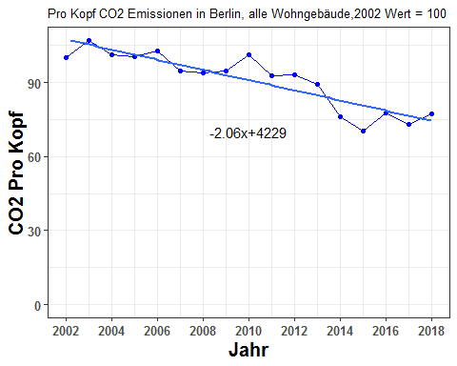

berlin_co2_percapita_2002as100

## abrechnungsjahr co2_percapita  
## 1 2002 100.00000  
## 2 2003 107.02813  
## 3 2004 101.27161  
## 4 2005 100.54252  
## 5 2006 102.78642  
## 6 2007 94.81686  
## 7 2008 94.04203  
## 8 2009 94.59705  
## 9 2010 101.36166  
## 10 2011 92.90253  
## 11 2012 93.10991  
## 12 2013 89.17588  
## 13 2014 76.28080  
## 14 2015 70.34312  
## 15 2016 77.84046  
## 16 2017 72.89630  
## 17 2018 77.14279

i_subsubsection <- i_subsubsection + 1

### 1.3.4. Stadtbezirke, alle Wohngebäude, CO2-Emission pro Einwohner aus der Beheizung von Wohnraum, 2002 - 2018, 2002 = 100

*One Graph: CO2 Emissions with 2002 value = 100 for each Bezirk. All 12 lines on the same plot.*

The following object, modify it

#berlin_bezirke_all_co2perhead

get_bezirk_prohead_2002As100 <- function(obj) {  
 for (var in names(obj)) {  
 wert2002 <- obj[[var]][obj$abrechnungsjahr == 2002]  
 obj[[var]] <- obj[[var]]/wert2002  
 obj$abrechnungsjahr <- 2002:2018  
 }  
 obj <- 100*obj  
 obj$abrechnungsjahr <- 2002:2018  
 return(obj)  
}  
bezirk_prohead_2002As100_all <- get_bezirk_prohead_2002As100(berlin_bezirke_all_co2perhead)

plot_reqdColumns(bezirk_prohead_2002As100_all,  
 xVar = "abrechnungsjahr",  
 cols_to_plot = names(bezirk_prohead_2002As100_all)[!(names(bezirk_prohead_2002As100_all) %in% c("abrechnungsjahr","total"))],  
 yColsName = "Bezirk",  
 yVar = "co2 pro head, 2002=100",  
 xlabel="Jahr",  
 ylabel = NULL,  
 plot_title = "Pro Kopf CO2 Emissionen in Stadtbezirken, alle Wohngebäude, 2002 Wert = 100")

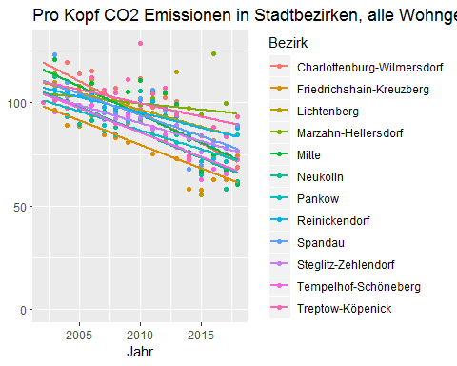

plot_bezirkeGridPlot <- function(obj,ylabel) {  
 max_y_val <- max(obj[ , names(obj)[!(names(obj) %in% c("abrechnungsjahr","total"))]])  
 g_return <- list()  
 require(ggplot2)  
 for (ii in 1:12) {  
 g_return[[ii]] <- points_line_lm(input_data = obj,  
 xVar = "abrechnungsjahr",  
 yVar = bezirk_list[ii],  
 ymin=0,  
 ymax=max_y_val,  
 x_eq = 2010,  
 y_eq = 0.5*max_y_val,  
 size_eq = 4,  
 plot_title = bezirk_name[ii],  
 xlab = "Jahr",  
 ylab = ylabel)  
 }  
 return(g_return)  
}

gg_co2perhead_2002As100 <- plot_bezirkeGridPlot(bezirk_prohead_2002As100_all,ylabel="")

#gg_co2perhead_2002As100[[1]]  
require(grid)  
require(gridExtra)  
grid.arrange(gg_co2perhead_2002As100[[1]],gg_co2perhead_2002As100[[2]],gg_co2perhead_2002As100[[3]],gg_co2perhead_2002As100[[4]],  
 gg_co2perhead_2002As100[[5]],gg_co2perhead_2002As100[[6]],gg_co2perhead_2002As100[[7]],gg_co2perhead_2002As100[[8]],  
 gg_co2perhead_2002As100[[9]],gg_co2perhead_2002As100[[10]],gg_co2perhead_2002As100[[11]],gg_co2perhead_2002As100[[12]],ncol=3)

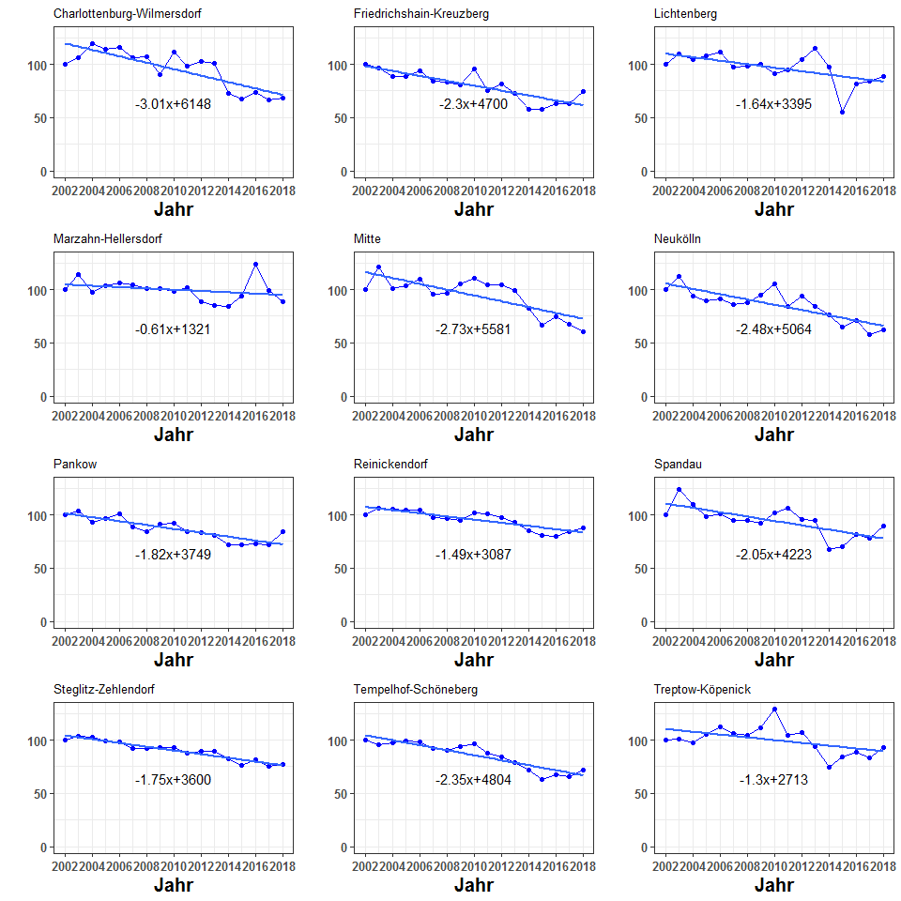

bezirk_prohead_2002As100_all

## abrechnungsjahr charlottenburg_wilmersdorf friedrichshain_kreuzberg  
## 1 2002 100.00000 100.00000  
## 2 2003 106.64084 96.36273  
## 3 2004 119.71631 89.02924  
## 4 2005 113.99346 88.69611  
## 5 2006 115.53716 93.64034  
## 6 2007 106.37972 84.31548  
## 7 2008 107.09955 83.11976  
## 8 2009 90.03640 80.87717  
## 9 2010 111.84221 95.88024  
## 10 2011 98.06145 75.21067  
## 11 2012 102.62969 81.39360  
## 12 2013 100.75361 72.73990  
## 13 2014 73.07081 58.23675  
## 14 2015 67.20045 57.56699  
## 15 2016 73.49703 62.67197  
## 16 2017 66.86440 62.99378  
## 17 2018 68.60776 74.38443  
## lichtenberg marzahn_hellersdorf mitte neukoelln pankow  
## 1 100.00000 100.00000 100.00000 100.00000 100.00000  
## 2 110.02481 114.10329 120.92653 112.41840 103.68317  
## 3 104.55316 97.43234 100.66104 93.65622 93.30677  
## 4 108.10062 103.60369 103.71111 89.76103 96.37876  
## 5 111.39791 106.66073 109.56395 91.17520 100.93927  
## 6 97.74095 104.15035 95.70109 86.38159 88.88837  
## 7 97.98567 100.67310 96.87544 88.15311 84.65820  
## 8 99.72565 100.68785 105.18698 94.63300 91.00225  
## 9 91.07802 98.74126 110.63333 105.65744 92.37797  
## 10 95.15301 101.89139 104.80362 84.60572 83.99747  
## 11 104.43326 88.98319 104.89070 93.56393 83.58079  
## 12 114.86517 85.09077 99.19472 84.27796 80.71103  
## 13 97.28595 84.50356 82.39532 76.01414 71.93972  
## 14 55.56108 94.10777 66.78303 65.09664 71.77860  
## 15 81.63090 123.58935 74.82503 71.02951 72.92683  
## 16 84.12791 99.63453 67.39470 58.03007 71.74940  
## 17 88.58938 88.99311 60.40192 61.92890 84.39121  
## reinickendorf spandau steglitz_zehlendorf tempelhof_schoeneberg  
## 1 100.00000 100.00000 100.00000 100.00000  
## 2 106.35204 123.42327 103.57619 95.74696  
## 3 105.39312 109.81401 102.95709 97.44687  
## 4 104.42692 98.61792 98.81749 98.99587  
## 5 104.19386 101.09841 98.58213 98.72332  
## 6 97.81997 94.90451 91.73626 92.37988  
## 7 96.51987 94.66891 92.44904 90.09066  
## 8 94.58685 92.01112 93.30092 94.35507  
## 9 101.71750 102.23875 92.62553 96.83847  
## 10 100.74890 106.18235 87.43352 87.95741  
## 11 97.37021 95.82720 89.14050 84.43083  
## 12 93.20725 94.75601 89.18830 78.52451  
## 13 85.16657 67.87524 82.63213 72.15424  
## 14 80.70436 69.70761 76.26175 62.75076  
## 15 79.51287 81.39115 81.21459 67.93910  
## 16 84.32993 77.83154 75.04391 65.38629  
## 17 87.84602 89.13098 76.81364 72.33189  
## treptow_koepenick total  
## 1 100.00000 100.00000  
## 2 100.98053 107.02813  
## 3 97.60153 101.27161  
## 4 105.60136 100.54252  
## 5 112.15754 102.78642  
## 6 105.93035 94.81686  
## 7 104.68532 94.04203  
## 8 111.19756 94.59705  
## 9 128.76759 101.36166  
## 10 104.22013 92.90253  
## 11 106.90414 93.10991  
## 12 94.01319 89.17588  
## 13 74.16876 76.28080  
## 14 83.81593 70.34312  
## 15 88.22901 77.84046  
## 16 83.74092 72.89630  
## 17 93.20277 77.14279

i_subsubsection <- i_subsubsection + 1

### 1.3.5 Stadtbezirke, alle Wohngebäude, co2-Emission aus der Beheizung von Wohnraum pro Einwohner, Niveau im Jahr 2018 in t/Einwohner

* Looks like a bar plot is needed here

bezirk_co2_percapita <- 1e6*berlin_co2_all/bezirk_population  
bezirk_co2_percapita$abrechnungsjahr <- 2002:2018  
#bezirk_co2_percapita

bezirk_co2_percapita_linear <- linearizer(bezirk_co2_percapita,dropCols = NULL , xVar = "abrechnungsjahr")  
#bezirk_co2_percapita_linear

bezirk_co2_percapita_linear_2018 <- bezirk_co2_percapita_linear[bezirk_co2_percapita_linear$abrechnungsjahr==2018 , ]  
bezirk_co2_percapita_linear_2018 <- as.data.frame(t(bezirk_co2_percapita_linear_2018))  
bezirk_co2_percapita_linear_2018$bezirk <- row.names(bezirk_co2_percapita_linear_2018)  
names(bezirk_co2_percapita_linear_2018) <- c("wert","bezirk")  
bezirk_co2_percapita_linear_2018 <- bezirk_co2_percapita_linear_2018[bezirk_co2_percapita_linear_2018$bezirk!="abrechnungsjahr" , ]  
bezirk_co2_percapita_linear_2018 <- bezirk_co2_percapita_linear_2018[bezirk_co2_percapita_linear_2018$bezirk!="total" , ]  
#bezirk_co2_percapita_linear_2018

bezirk_co2_percapita_linear_2018$bezirk <- factor(  
 bezirk_co2_percapita_linear_2018$bezirk ,   
 levels = bezirk_co2_percapita_linear_2018$bezirk[order(bezirk_co2_percapita_linear_2018$wert)])  
ggplot(data=bezirk_co2_percapita_linear_2018,aes(x=bezirk,y=wert))+geom_bar(stat="identity")+coord_flip()

plot_co2perhead_2018 <- function(obj,  
 ylabel = NULL,  
 plot_title = NULL) {  
 obj$bezirk <- get_BezirkNames(obj$bezirk)  
 obj$bezirk <- factor(obj$bezirk , levels = obj$bezirk[order(obj$wert)])  
 return(  
 ggplot(data=obj,aes(x=bezirk,y=wert))+geom_bar(stat="identity")+labs(x="",y=ylabel,title=plot_title)+coord_flip()  
 )  
}  
plot_co2perhead_2018(bezirk_co2_percapita_linear_2018,  
 ylabel = "kg / Einwohner",  
 plot_title = "CO2 Emissionen pro Einwohner in Stadtbezirken,\nalle Wohngebäude")

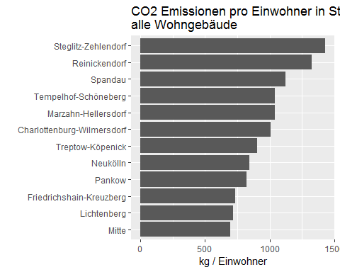

bezirk_co2_percapita_linear_2018

## wert bezirk  
## charlottenburg_wilmersdorf 1009.9738 charlottenburg_wilmersdorf  
## friedrichshain_kreuzberg 731.6425 friedrichshain_kreuzberg  
## lichtenberg 716.4392 lichtenberg  
## marzahn_hellersdorf 1041.4226 marzahn_hellersdorf  
## mitte 695.0533 mitte  
## neukoelln 840.6739 neukoelln  
## pankow 823.5517 pankow  
## reinickendorf 1327.8565 reinickendorf  
## spandau 1124.9026 spandau  
## steglitz_zehlendorf 1430.4903 steglitz_zehlendorf  
## tempelhof_schoeneberg 1042.3609 tempelhof_schoeneberg  
## treptow_koepenick 905.2580 treptow_koepenick

i_subsubsection <- i_subsubsection + 1

### 1.3.6 Stadtbezirke, alle Wohngebäude, co2-Emission aus der Beheizung von Wohnraum pro Einwohner, Veränderung 2002/2018 in Prozent

*(Zwei Grafiken: absolute values and percentage values of change compared to 2002 and 2018 values as grouped bar charts.) Group barchart of only 2002 and 2018 values for each city district - either absolute values and percentage.*

Use bezirk_co2_percapita_linear. This is the linear version of bezirk_co2_percapita, which is the same as berlin_bezirke_all_co2perhead.

#bezirk_co2_percapita_linear

is_2002_or_2018 <- bezirk_co2_percapita_linear$abrechnungsjahr==2002 |  
 bezirk_co2_percapita_linear$abrechnungsjahr==2018  
  
bezirk_co2_percapita_linear_20022018 <- bezirk_co2_percapita_linear[ is_2002_or_2018 , ]  
#bezirk_co2_percapita_linear_20022018

require(reshape2)  
data_long <- melt(bezirk_co2_percapita_linear_20022018,id.vars="abrechnungsjahr")  
names(data_long) <- c("abrechnungsjahr","bezirk","wert")  
data_long <- data_long[ data_long$bezirk!="total" , ]

plot_groupBar <- function(obj,yVar,ylabel) {  
 obj$bezirk <- get_BezirkNames(as.character(obj$bezirk))  
 obj$abrechnungsjahr <- as.factor(as.character(obj$abrechnungsjahr))   
 return(  
 ggplot(obj , aes(x=bezirk,y=get(yVar),fill=abrechnungsjahr))+geom_bar(stat="identity", position=position_dodge()  
)+ scale_fill_discrete(name="Jahr") +theme(axis.text.x=element_text(angle=45,hjust=1))+labs(x=" ",y=ylabel)  
 )  
}  
plot_groupBar(data_long,"wert","kg/head")

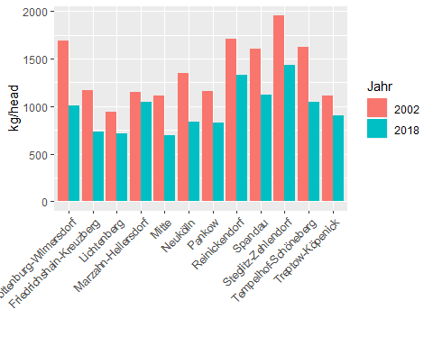

plot_groupBarPercent <- function(obj) {  
 values2002 <- obj$wert[obj$abrechnungsjahr == 2002]  
 obj$percentchange <- rep(values2002, each = 2)  
 obj$percentchange <- 100*obj$wert/obj$percentchange  
 g_return <- plot_groupBar(obj,"percentchange","per capita percent change, 2002=100")  
 return(g_return)  
}

plot_groupBarPercent(data_long)

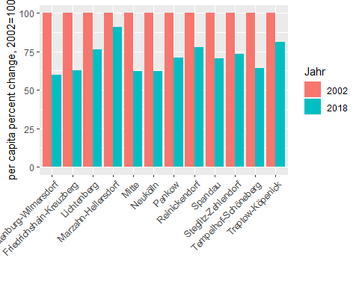

data_long

## abrechnungsjahr bezirk wert  
## 1 2002 charlottenburg_wilmersdorf 1692.2226  
## 2 2018 charlottenburg_wilmersdorf 1009.9738  
## 3 2002 friedrichshain_kreuzberg 1169.5428  
## 4 2018 friedrichshain_kreuzberg 731.6425  
## 5 2002 lichtenberg 941.7931  
## 6 2018 lichtenberg 716.4392  
## 7 2002 marzahn_hellersdorf 1148.2913  
## 8 2018 marzahn_hellersdorf 1041.4226  
## 9 2002 mitte 1113.6903  
## 10 2018 mitte 695.0533  
## 11 2002 neukoelln 1346.5523  
## 12 2018 neukoelln 840.6739  
## 13 2002 pankow 1156.8581  
## 14 2018 pankow 823.5517  
## 15 2002 reinickendorf 1707.1759  
## 16 2018 reinickendorf 1327.8565  
## 17 2002 spandau 1600.9681  
## 18 2018 spandau 1124.9026  
## 19 2002 steglitz_zehlendorf 1955.3767  
## 20 2018 steglitz_zehlendorf 1430.4903  
## 21 2002 tempelhof_schoeneberg 1627.7788  
## 22 2018 tempelhof_schoeneberg 1042.3609  
## 23 2002 treptow_koepenick 1116.0975  
## 24 2018 treptow_koepenick 905.2580

i_subsection <- i_subsection + 1

## 1.4 Prognose

* Do the x + I(x^2) analysis.

i_subsubsection <- 1

### 1.4.1 Berlin, alle Wohngebäude, Prognose der co2-Emission aus Beheizung 2019-2030 in Mio. t (Trend Polynom 2. Grades)

#berlin_co2_all  
quadmodel <- lm(total~abrechnungsjahr+I(abrechnungsjahr^2),data=berlin_co2_all)  
from2002_till_2030 <- data.frame(abrechnungsjahr=2002:2030)  
prognose <- data.frame(abrechnungsjahr = 2002:2030 , pred = as.numeric(predict(quadmodel,newdata=from2002_till_2030)))  
ggplot(prognose , aes(x=abrechnungsjahr , y = pred))+geom_point()

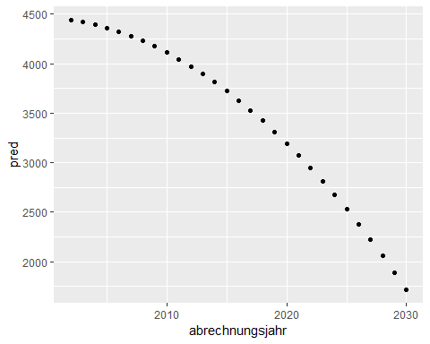

prognose

## abrechnungsjahr pred  
## 1 2002 4440.911  
## 2 2003 4419.460  
## 3 2004 4392.395  
## 4 2005 4359.716  
## 5 2006 4321.424  
## 6 2007 4277.517  
## 7 2008 4227.996  
## 8 2009 4172.862  
## 9 2010 4112.113  
## 10 2011 4045.751  
## 11 2012 3973.774  
## 12 2013 3896.184  
## 13 2014 3812.979  
## 14 2015 3724.161  
## 15 2016 3629.729  
## 16 2017 3529.683  
## 17 2018 3424.022  
## 18 2019 3312.748  
## 19 2020 3195.860  
## 20 2021 3073.358  
## 21 2022 2945.242  
## 22 2023 2811.512  
## 23 2024 2672.168  
## 24 2025 2527.211  
## 25 2026 2376.639  
## 26 2027 2220.453  
## 27 2028 2058.654  
## 28 2029 1891.240  
## 29 2030 1718.212

i_subsection <- i_subsection + 1

## 1.5 Diskussion

i_section <- i_section+1  
i_subsection <- 1  
i_subsubsection <- 1

# 2. Alle Stadtbezirke, co2-emission aus Beheizung, 1-2 Familiengebäude

## 2.1 Absolute Zahlen

### 2.1.1 Berlin, 1-2 Familiengebäude, co2-Emission aus der Beheizung von Wohnraum 2002-2018 in 1.000 t

#alle_bezirke_co2$sfh

berlin_co2_sfh <- getRowSums(alle_bezirke_co2$sfh , dropCols = "abrechnungsjahr")  
#berlin_co2_sfh

points_line_lm(input_data = berlin_co2_sfh,  
 xVar = "abrechnungsjahr",  
 yVar = "total",  
 ymin = 0,  
 ymax = max(berlin_co2_sfh$total),  
 x_eq = 2010,  
 y_eq = 700,  
 size_eq = 4,  
 plot_title = "CO2 Emissionen in Berlin, 1-2 Familiengebäude",  
 xlab = "Jahr",  
 ylab = "kilo t.")

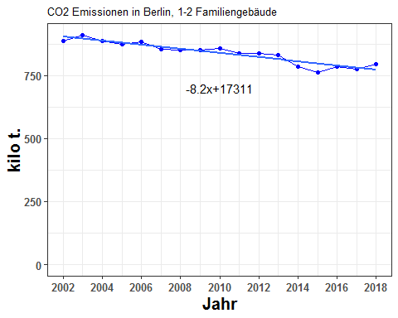

berlin_co2_sfh[ , c("abrechnungsjahr" , "total")]

## abrechnungsjahr total  
## 1 2002 886.2040  
## 2 2003 909.7584  
## 3 2004 886.4692  
## 4 2005 872.3823  
## 5 2006 883.4464  
## 6 2007 854.8635  
## 7 2008 849.5944  
## 8 2009 850.2879  
## 9 2010 856.1211  
## 10 2011 836.8370  
## 11 2012 837.0138  
## 12 2013 831.1885  
## 13 2014 784.9885  
## 14 2015 762.0550  
## 15 2016 786.1857  
## 16 2017 774.2198  
## 17 2018 793.9504

* Now split by ET

co2_sfh_allebezirke_byET <- co2_allebezirke_byET$sfh  
#co2_sfh_allebezirke_byET

co2_sfh_allebezirke_byET_cumsums <- getCumSums(obj=co2_sfh_allebezirke_byET , dropCols=c("abrechnungsjahr","total"))  
#co2_all_allebezirke_byET_cumsums  
plot_byET(co2_sfh_allebezirke_byET_cumsums , xlabel = "Jahr" , ylabel = "kilo t." , plottitle = "CO2 Emissionen in Berlin, 1-2 Familiengebäude, nach Energiträger")

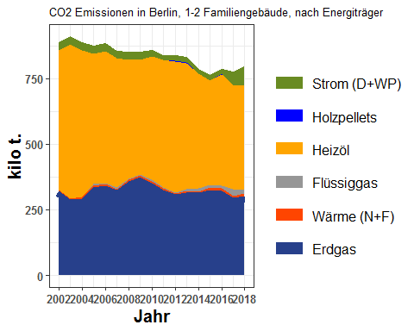

co2_sfh_allebezirke_byET

## abrechnungsjahr erdgas waerme fluessiggas heizoel holzpellets  
## 1 2002 320.9928 3.542946 0.000000 533.4710 0.00000000  
## 2 2003 288.7111 5.133224 0.000000 587.7168 0.00000000  
## 3 2004 293.6147 5.557091 1.294382 557.8058 0.00000000  
## 4 2005 336.6383 6.331517 4.772830 496.4423 0.00000000  
## 5 2006 341.9268 4.810459 5.423371 503.0885 0.00000000  
## 6 2007 325.0396 5.030013 3.481267 493.1154 0.00000000  
## 7 2008 358.6379 4.556824 5.637400 452.4517 0.11328082  
## 8 2009 375.8390 5.708403 4.265570 435.8945 0.38321201  
## 9 2010 352.8829 5.229627 5.043785 471.1952 0.28678993  
## 10 2011 326.2533 6.160202 2.308130 484.7856 0.08716954  
## 11 2012 307.3344 4.142617 3.783370 500.4167 0.62720918  
## 12 2013 316.6940 6.655070 3.911524 482.0715 0.54576652  
## 13 2014 316.1633 3.764043 10.428462 438.7797 0.32888674  
## 14 2015 326.3678 7.899303 9.235242 397.7130 1.17639896  
## 15 2016 322.7153 7.825622 12.772169 422.2456 1.44910686  
## 16 2017 295.5077 7.796519 24.140778 397.5856 1.07763261  
## 17 2018 303.1870 9.379784 14.267661 395.8030 0.76041751  
## strom total  
## 1 28.19724 886.2040  
## 2 28.19724 909.7584  
## 3 28.19724 886.4692  
## 4 28.19724 872.3823  
## 5 28.19724 883.4464  
## 6 28.19724 854.8635  
## 7 28.19724 849.5944  
## 8 28.19724 850.2879  
## 9 21.48274 856.1211  
## 10 17.24262 836.8370  
## 11 20.70961 837.0138  
## 12 21.31071 831.1885  
## 13 15.52417 784.9885  
## 14 19.66328 762.0550  
## 15 19.17783 786.1857  
## 16 48.11157 774.2198  
## 17 70.55260 793.9504

i_subsubsection <- i_subsubsection+1

### 2.1.2 Stadtbezirke, 1-2 Familiengebäude, co2-emissionen aus der Beheizung von Wohnraum 2002-2018 summiert in 1.000 t

* Here co2 emissions split by the bezirke

berlin_co2_sfh_cumsums <- getCumSums(obj=berlin_co2_sfh , dropCols=c("abrechnungsjahr","total"))  
plot_byBezirke(berlin_co2_sfh_cumsums , xlabel = "Jahr" , ylabel = "kilo t." , plottitle="CO2 Emissionen in Berlin, 1-2 Familiengebäude, nach Bezirk")

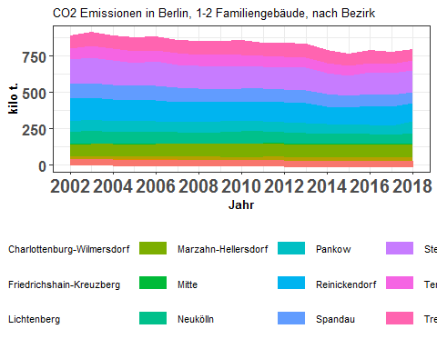

berlin_co2_sfh

## abrechnungsjahr charlottenburg_wilmersdorf friedrichshain_kreuzberg  
## 1 2002 38.09742 2.6420502  
## 2 2003 37.80490 2.7574057  
## 3 2004 36.55557 2.3157077  
## 4 2005 34.80975 2.1676129  
## 5 2006 35.52038 2.2005804  
## 6 2007 34.61589 1.8013261  
## 7 2008 33.81660 1.7387840  
## 8 2009 30.81899 1.5790129  
## 9 2010 30.76203 1.3024370  
## 10 2011 33.24231 1.8863541  
## 11 2012 30.61746 1.3811595  
## 12 2013 27.84803 1.5588895  
## 13 2014 26.35995 0.8894664  
## 14 2015 26.40115 1.0898912  
## 15 2016 28.38397 1.2836638  
## 16 2017 27.63538 1.2231399  
## 17 2018 29.68616 1.6292390  
## lichtenberg marzahn_hellersdorf mitte neukoelln pankow  
## 1 18.80552 80.29233 3.836556 81.14603 74.17578  
## 2 19.42690 84.46877 4.181974 86.99925 78.64285  
## 3 20.40776 82.75563 3.869602 81.03644 74.09706  
## 4 20.93251 83.02717 3.888013 80.69251 73.81314  
## 5 21.41632 83.67787 3.832410 81.31154 75.59073  
## 6 23.53900 84.22570 3.055829 78.38818 68.76782  
## 7 23.22817 83.67059 3.696686 75.90290 72.00213  
## 8 22.81696 87.06740 3.991344 77.35572 75.55150  
## 9 22.27817 89.12768 3.480997 83.21631 71.20420  
## 10 23.90214 86.27044 3.268652 81.69211 70.36263  
## 11 24.81632 90.44962 3.177118 77.75053 68.67108  
## 12 23.71329 87.64955 3.398270 75.06751 70.25719  
## 13 26.93261 88.17813 3.382550 66.00111 68.17455  
## 14 26.07808 86.56237 2.785607 67.69596 64.07787  
## 15 24.14080 85.85100 2.847629 69.64469 65.76191  
## 16 25.91904 85.78029 2.681060 66.79758 62.71243  
## 17 22.28390 90.09915 3.598195 70.68510 82.90741  
## reinickendorf spandau steglitz_zehlendorf tempelhof_schoeneberg  
## 1 155.1445 101.20824 169.3693 76.75137  
## 2 150.5977 100.71995 173.8795 80.01171  
## 3 148.6573 100.88057 169.2140 78.90565  
## 4 144.2388 97.68165 162.0571 78.51654  
## 5 143.4262 97.30835 165.5459 78.80365  
## 6 140.6145 96.40701 158.9971 76.37955  
## 7 135.6047 95.39718 159.3082 73.19770  
## 8 133.3465 89.78284 154.5792 76.52411  
## 9 136.9576 87.43720 155.0516 75.95741  
## 10 134.3306 89.50052 151.5932 72.35013  
## 11 133.8169 87.06058 153.4708 72.65895  
## 12 133.5823 91.68378 155.4803 70.33320  
## 13 123.6634 82.36480 145.6058 70.16355  
## 14 119.8576 78.59102 139.6859 69.36799  
## 15 128.5625 81.42450 147.5800 65.82777  
## 16 131.0118 80.72755 145.1726 67.40713  
## 17 125.1291 77.52542 145.1965 70.78976  
## treptow_koepenick total  
## 1 84.73493 886.2040  
## 2 90.26747 909.7584  
## 3 87.77392 886.4692  
## 4 90.55750 872.3823  
## 5 94.81250 883.4464  
## 6 88.07161 854.8635  
## 7 92.03076 849.5944  
## 8 96.87429 850.2879  
## 9 99.34538 856.1211  
## 10 88.43798 836.8370  
## 11 93.14328 837.0138  
## 12 90.61622 831.1885  
## 13 83.27256 784.9885  
## 14 79.86163 762.0550  
## 15 84.87713 786.1857  
## 16 77.15177 774.2198  
## 17 74.42051 793.9504

i_subsubsection <- i_subsubsection+1

### 2.1.3 Stadtbezirke, 1-2 Familiengebäude, co2-emissionen aus der Beheizung von Wohnraum 2002-2018 in Prozent

co2_sfh_allebezirke_byET_prop <- find_proportions(co2_sfh_allebezirke_byET , drop_cols = c("abrechnungsjahr","total"))  
co2_sfh_allebezirke_byET_prop_cumsums <- getCumSums(obj=co2_sfh_allebezirke_byET_prop , dropCols = "abrechnungsjahr")  
plot_byET(co2_sfh_allebezirke_byET_prop_cumsums,xlabel = "Jahr" , ylabel = "Anteile in %" , plottitle = "CO2 Emissionen in Berlin, 1-2 Familiengebäude, \nAnteile nach Energieträgern")

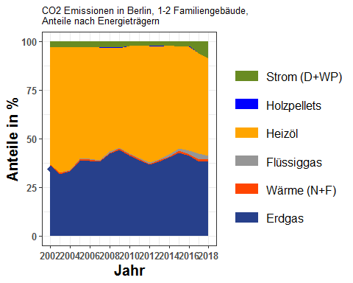

co2_sfh_allebezirke_byET_prop

## erdgas waerme fluessiggas heizoel holzpellets strom  
## 1 36.22110 0.3997890 0.0000000 60.19731 0.00000000 3.181800  
## 2 31.73492 0.5642404 0.0000000 64.60141 0.00000000 3.099420  
## 3 33.12181 0.6268792 0.1460155 62.92445 0.00000000 3.180848  
## 4 38.58840 0.7257733 0.5471031 56.90652 0.00000000 3.232211  
## 5 38.70374 0.5445105 0.6138879 56.94613 0.00000000 3.191731  
## 6 38.02240 0.5883995 0.4072308 57.68353 0.00000000 3.298449  
## 7 42.21284 0.5363529 0.6635401 53.25503 0.01333352 3.318906  
## 8 44.20138 0.6713494 0.5016619 51.26434 0.04506850 3.316199  
## 9 41.21881 0.6108514 0.5891439 55.03839 0.03349876 2.509311  
## 10 38.98648 0.7361292 0.2758159 57.93070 0.01041655 2.060451  
## 11 36.71796 0.4949282 0.4520081 59.78595 0.07493415 2.474225  
## 12 38.10134 0.8006692 0.4705941 57.99785 0.06566098 2.563884  
## 13 40.27616 0.4795029 1.3284860 55.89632 0.04189701 1.977630  
## 14 42.82733 1.0365791 1.2118866 52.18953 0.15437192 2.580297  
## 15 41.04823 0.9953911 1.6245741 53.70813 0.18432120 2.439351  
## 16 38.16845 1.0070162 3.1180781 51.35307 0.13918950 6.214200  
## 17 38.18714 1.1814067 1.7970469 49.85236 0.09577645 8.886272  
## abrechnungsjahr  
## 1 2002  
## 2 2003  
## 3 2004  
## 4 2005  
## 5 2006  
## 6 2007  
## 7 2008  
## 8 2009  
## 9 2010  
## 10 2011  
## 11 2012  
## 12 2013  
## 13 2014  
## 14 2015  
## 15 2016  
## 16 2017  
## 17 2018

berlin_co2_sfh_prop <- find_proportions(berlin_co2_sfh,drop_cols=c("abrechnungsjahr","total"))  
berlin_co2_sfh_prop_cumsums <- getCumSums(berlin_co2_sfh_prop,dropCols="abrechnungsjahr")  
plot_byBezirke(berlin_co2_sfh_prop_cumsums,xlabel = "Jahr" , ylabel = "Anteile in %" , plottitle = "CO2 Emissionen in Berlin, 1-2 Familiengebäude, Anteile nach Bezirk")

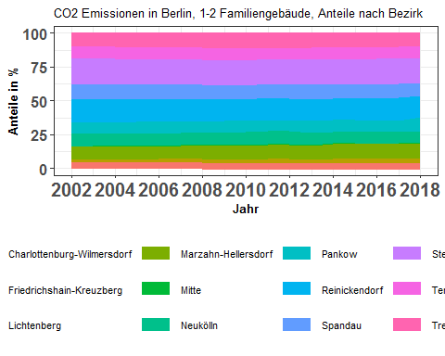

berlin_co2_sfh_prop

## charlottenburg_wilmersdorf friedrichshain_kreuzberg lichtenberg  
## 1 4.298945 0.2981312 2.122030  
## 2 4.155488 0.3030921 2.135391  
## 3 4.123728 0.2612282 2.302140  
## 4 3.990194 0.2484705 2.399466  
## 5 4.020660 0.2490904 2.424178  
## 6 4.049288 0.2107151 2.753539  
## 7 3.980323 0.2046605 2.734031  
## 8 3.624536 0.1857033 2.683439  
## 9 3.593187 0.1521323 2.602222  
## 10 3.972375 0.2254148 2.856248  
## 11 3.657939 0.1650104 2.964864  
## 12 3.350387 0.1875494 2.852938  
## 13 3.358004 0.1133095 3.430956  
## 14 3.464467 0.1430200 3.422073  
## 15 3.610339 0.1632774 3.070623  
## 16 3.569449 0.1579836 3.347763  
## 17 3.739045 0.2052066 2.806712  
## marzahn_hellersdorf mitte neukoelln pankow reinickendorf  
## 1 9.060254 0.4329202 9.156587 8.370058 17.50663  
## 2 9.284748 0.4596797 9.562896 8.644367 16.55359  
## 3 9.335421 0.4365185 9.141484 8.358673 16.76959  
## 4 9.517292 0.4456777 9.249674 8.461101 16.53390  
## 5 9.471754 0.4338022 9.203902 8.556345 16.23485  
## 6 9.852533 0.3574640 9.169673 8.044304 16.44877  
## 7 9.848299 0.4351119 8.934016 8.474884 15.96111  
## 8 10.239755 0.4694108 9.097591 8.885402 15.68251  
## 9 10.410640 0.4066010 9.720156 8.317071 15.99746  
## 10 10.309108 0.3905960 9.762010 8.408164 16.05218  
## 11 10.806228 0.3795777 9.289038 8.204294 15.98742  
## 12 10.545087 0.4088447 9.031346 8.452618 16.07124  
## 13 11.233048 0.4309045 8.407908 8.684784 15.75354  
## 14 11.359070 0.3655388 8.883343 8.408562 15.72820  
## 15 10.919940 0.3622082 8.858555 8.364680 16.35270  
## 16 11.079579 0.3462919 8.627728 8.100081 16.92179  
## 17 11.348209 0.4532014 8.902961 10.442391 15.76032  
## spandau steglitz_zehlendorf tempelhof_schoeneberg treptow_koepenick  
## 1 11.420422 19.11177 8.660689 9.561560  
## 2 11.071066 19.11272 8.794831 9.922136  
## 3 11.380043 19.08854 8.901116 9.901519  
## 4 11.197116 18.57638 9.000245 10.380484  
## 5 11.014629 18.73864 8.920026 10.732117  
## 6 11.277474 18.59912 8.934707 10.302418  
## 7 11.228555 18.75109 8.615605 10.832318  
## 8 10.559111 18.17964 8.999789 11.393116  
## 9 10.213182 18.11095 8.872274 11.604128  
## 10 10.695096 18.11502 8.645666 10.568125  
## 11 10.401331 18.33551 8.680734 11.128046  
## 12 11.030443 18.70578 8.461763 10.902005  
## 13 10.492485 18.54878 8.938163 10.608124  
## 14 10.313037 18.33016 9.102754 10.479772  
## 15 10.356905 18.77165 8.373057 10.796067  
## 16 10.426955 18.75082 8.706459 9.965100  
## 17 9.764516 18.28785 8.916144 9.373446  
## abrechnungsjahr  
## 1 2002  
## 2 2003  
## 3 2004  
## 4 2005  
## 5 2006  
## 6 2007  
## 7 2008  
## 8 2009  
## 9 2010  
## 10 2011  
## 11 2012  
## 12 2013  
## 13 2014  
## 14 2015  
## 15 2016  
## 16 2017  
## 17 2018

i_subsubsection <- i_subsubsection+1

### 2.1.4 Stadtbezirke, 1-2 Familiengebäude, co2-emissionen aus der Beheizung von Wohnraum 2002-2018 in 1.000 t

**BOOKMARK**

plot_reqdColumns(berlin_co2_sfh,  
 xVar = "abrechnungsjahr",  
 cols_to_plot = names(berlin_co2_sfh)[!(names(berlin_co2_sfh) %in% c("abrechnungsjahr","total"))],  
 yColsName = "Bezirk",  
 yVar = "CO2 Emissions",  
 plot_title = "CO2 Emissionen von Stadtbezirken, 1-2 Familiengebäude",  
 xlabel = "Jahr",  
 ylabel = "kilo t.")

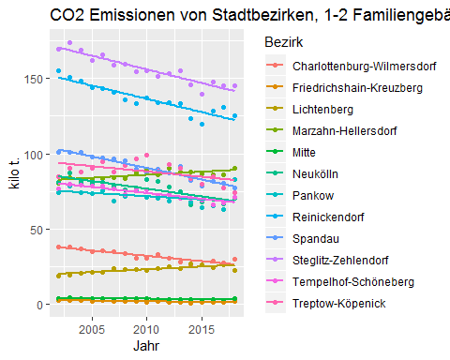

gg_co2_sfh <- plot_bezirkeGridPlot(berlin_co2_sfh,ylabel="kilo t.")  
require(grid)  
require(gridExtra)  
grid.arrange(gg_co2_sfh[[1]],gg_co2_sfh[[2]],gg_co2_sfh[[3]],gg_co2_sfh[[4]],  
 gg_co2_sfh[[5]],gg_co2_sfh[[6]],gg_co2_sfh[[7]],gg_co2_sfh[[8]],  
 gg_co2_sfh[[9]],gg_co2_sfh[[10]],gg_co2_sfh[[11]],gg_co2_sfh[[12]],ncol=3)

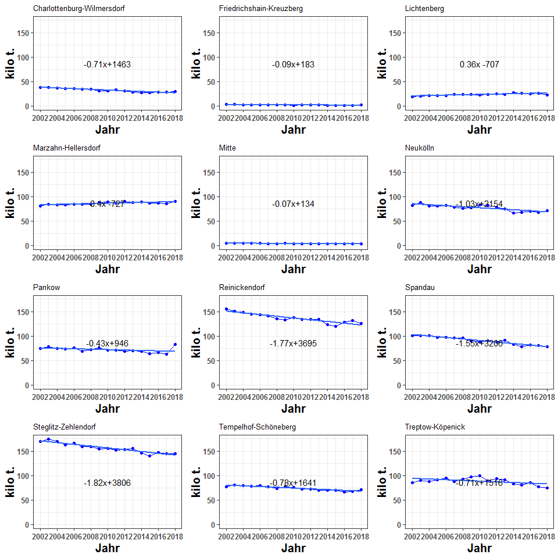

berlin_co2_sfh

## abrechnungsjahr charlottenburg_wilmersdorf friedrichshain_kreuzberg  
## 1 2002 38.09742 2.6420502  
## 2 2003 37.80490 2.7574057  
## 3 2004 36.55557 2.3157077  
## 4 2005 34.80975 2.1676129  
## 5 2006 35.52038 2.2005804  
## 6 2007 34.61589 1.8013261  
## 7 2008 33.81660 1.7387840  
## 8 2009 30.81899 1.5790129  
## 9 2010 30.76203 1.3024370  
## 10 2011 33.24231 1.8863541  
## 11 2012 30.61746 1.3811595  
## 12 2013 27.84803 1.5588895  
## 13 2014 26.35995 0.8894664  
## 14 2015 26.40115 1.0898912  
## 15 2016 28.38397 1.2836638  
## 16 2017 27.63538 1.2231399  
## 17 2018 29.68616 1.6292390  
## lichtenberg marzahn_hellersdorf mitte neukoelln pankow  
## 1 18.80552 80.29233 3.836556 81.14603 74.17578  
## 2 19.42690 84.46877 4.181974 86.99925 78.64285  
## 3 20.40776 82.75563 3.869602 81.03644 74.09706  
## 4 20.93251 83.02717 3.888013 80.69251 73.81314  
## 5 21.41632 83.67787 3.832410 81.31154 75.59073  
## 6 23.53900 84.22570 3.055829 78.38818 68.76782  
## 7 23.22817 83.67059 3.696686 75.90290 72.00213  
## 8 22.81696 87.06740 3.991344 77.35572 75.55150  
## 9 22.27817 89.12768 3.480997 83.21631 71.20420  
## 10 23.90214 86.27044 3.268652 81.69211 70.36263  
## 11 24.81632 90.44962 3.177118 77.75053 68.67108  
## 12 23.71329 87.64955 3.398270 75.06751 70.25719  
## 13 26.93261 88.17813 3.382550 66.00111 68.17455  
## 14 26.07808 86.56237 2.785607 67.69596 64.07787  
## 15 24.14080 85.85100 2.847629 69.64469 65.76191  
## 16 25.91904 85.78029 2.681060 66.79758 62.71243  
## 17 22.28390 90.09915 3.598195 70.68510 82.90741  
## reinickendorf spandau steglitz_zehlendorf tempelhof_schoeneberg  
## 1 155.1445 101.20824 169.3693 76.75137  
## 2 150.5977 100.71995 173.8795 80.01171  
## 3 148.6573 100.88057 169.2140 78.90565  
## 4 144.2388 97.68165 162.0571 78.51654  
## 5 143.4262 97.30835 165.5459 78.80365  
## 6 140.6145 96.40701 158.9971 76.37955  
## 7 135.6047 95.39718 159.3082 73.19770  
## 8 133.3465 89.78284 154.5792 76.52411  
## 9 136.9576 87.43720 155.0516 75.95741  
## 10 134.3306 89.50052 151.5932 72.35013  
## 11 133.8169 87.06058 153.4708 72.65895  
## 12 133.5823 91.68378 155.4803 70.33320  
## 13 123.6634 82.36480 145.6058 70.16355  
## 14 119.8576 78.59102 139.6859 69.36799  
## 15 128.5625 81.42450 147.5800 65.82777  
## 16 131.0118 80.72755 145.1726 67.40713  
## 17 125.1291 77.52542 145.1965 70.78976  
## treptow_koepenick total  
## 1 84.73493 886.2040  
## 2 90.26747 909.7584  
## 3 87.77392 886.4692  
## 4 90.55750 872.3823  
## 5 94.81250 883.4464  
## 6 88.07161 854.8635  
## 7 92.03076 849.5944  
## 8 96.87429 850.2879  
## 9 99.34538 856.1211  
## 10 88.43798 836.8370  
## 11 93.14328 837.0138  
## 12 90.61622 831.1885  
## 13 83.27256 784.9885  
## 14 79.86163 762.0550  
## 15 84.87713 786.1857  
## 16 77.15177 774.2198  
## 17 74.42051 793.9504

i_subsubsection <- i_subsubsection+1

### 2.1.5 Stadtbezirke, 1-2 Familiengebäude, co2-emissionen aus der Beheizung von Wohnraum 2002-2018, Veränderung in Prozent

berlin_co2_sfh_devFromMean <- getDeviationsFromMean(berlin_co2_sfh,  
 xVar = "abrechnungsjahr",  
 colsToAvgOver = names(berlin_co2_sfh)[  
 !(names(berlin_co2_sfh  
 ) %in% c("abrechnungsjahr","total"))]  
)

ymin <- min(berlin_co2_sfh_devFromMean[ ,   
 names(berlin_co2_sfh_devFromMean)[  
 !(names(berlin_co2_sfh_devFromMean) %in% c("abrechnungsjahr",  
 "meanVal"))  
 ]])  
ymax <- max(berlin_co2_sfh_devFromMean[ ,   
 names(berlin_co2_sfh_devFromMean)[  
 !(names(berlin_co2_sfh_devFromMean) %in% c("abrechnungsjahr",  
 "meanVal"))  
 ]])  
#plotDevFromMean(berlin_co2_all_devFromMean,"abrechnungsjahr","mitte",yMin=yMin,yMax=yMax)  
g_co2dev_bezirk <- list()  
for (ii in 1:12) {  
 g_co2dev_bezirk[[ii]] <- plotDevFromMean(input_data = berlin_co2_sfh_devFromMean,  
 xVar = "abrechnungsjahr",  
 yVar = bezirk_list[ii],  
 ymin=ymin,  
 ymax=ymax,  
 ylabel="% deviation from mean",  
 plot_title = bezirk_name[ii])  
}

require(grid)  
require(gridExtra)  
grid.arrange(g_co2dev_bezirk[[1]],g_co2dev_bezirk[[2]],g_co2dev_bezirk[[3]],g_co2dev_bezirk[[4]],  
 g_co2dev_bezirk[[5]],g_co2dev_bezirk[[6]],g_co2dev_bezirk[[7]],g_co2dev_bezirk[[8]],  
 g_co2dev_bezirk[[9]],g_co2dev_bezirk[[10]],g_co2dev_bezirk[[11]],g_co2dev_bezirk[[12]],ncol=3)

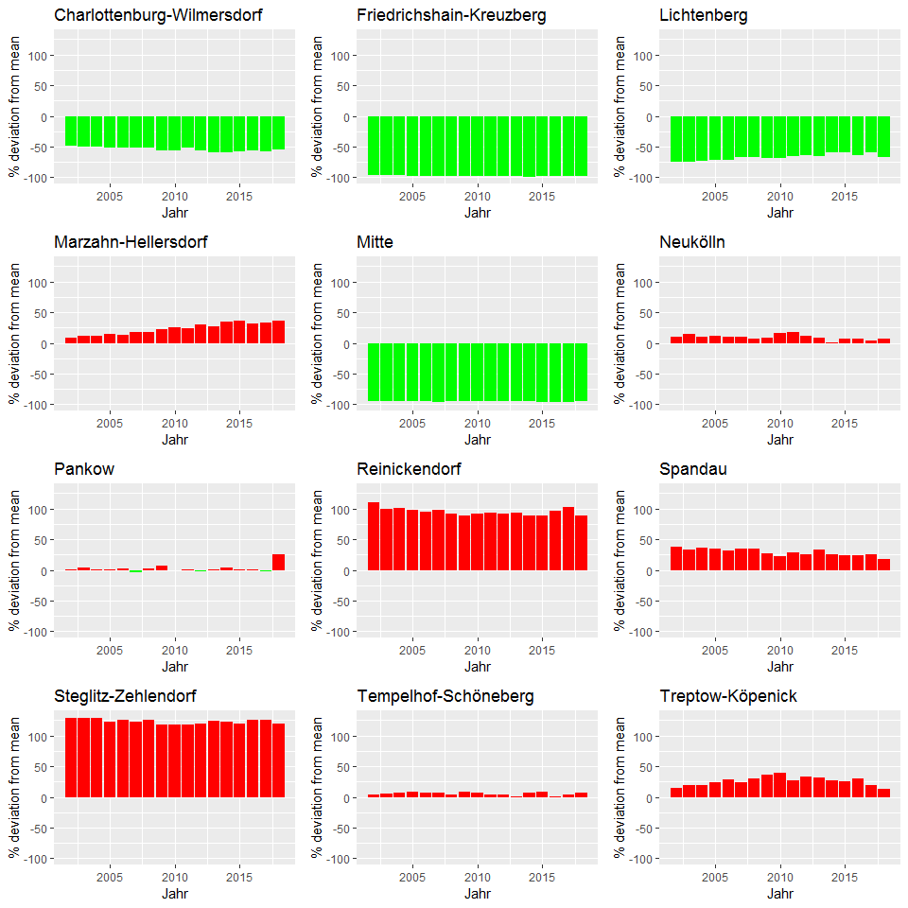

berlin_co2_sfh_devFromMean

## abrechnungsjahr charlottenburg_wilmersdorf friedrichshain_kreuzberg  
## 1 2002 -48.41266 -96.42243  
## 2 2003 -50.13414 -96.36289  
## 3 2004 -50.51527 -96.86526  
## 4 2005 -52.11767 -97.01835  
## 5 2006 -51.75208 -97.01091  
## 6 2007 -51.40854 -97.47142  
## 7 2008 -52.23612 -97.54407  
## 8 2009 -56.50556 -97.77156  
## 9 2010 -56.88175 -98.17441  
## 10 2011 -52.33149 -97.29502  
## 11 2012 -56.10473 -98.01988  
## 12 2013 -59.79536 -97.74941  
## 13 2014 -59.70395 -98.64029  
## 14 2015 -58.42639 -98.28376  
## 15 2016 -56.67593 -98.04067  
## 16 2017 -57.16661 -98.10420  
## 17 2018 -55.13147 -97.53752  
## lichtenberg marzahn_hellersdorf mitte neukoelln pankow  
## 1 -74.53563 8.723054 -94.80496 9.8790390 0.4406925  
## 2 -74.37530 11.416976 -94.48384 14.7547515 3.7324051  
## 3 -72.37432 12.025052 -94.76178 9.6978066 0.3040742  
## 4 -71.20641 14.207502 -94.65187 10.9960842 1.5332061  
## 5 -70.90986 13.661045 -94.79437 10.4468248 2.6761438  
## 6 -66.95753 18.230391 -95.71043 10.0360741 -3.4683495  
## 7 -67.19163 18.179587 -94.77866 7.2081892 1.6986028  
## 8 -67.79873 22.877059 -94.36707 9.1710961 6.6248202  
## 9 -68.77333 24.927680 -95.12079 16.6418775 -0.1951471  
## 10 -65.72502 23.709301 -95.31285 17.1441176 0.8979629  
## 11 -64.42164 29.674731 -95.44507 11.4684519 -1.5484683  
## 12 -65.76475 26.541039 -95.09386 8.3761547 1.4314120  
## 13 -58.82853 34.796572 -94.82915 0.8948958 4.2174056  
## 14 -58.93512 36.308842 -95.61353 6.6001115 0.9027453  
## 15 -63.15253 31.039285 -95.65350 6.3026573 0.3761552  
## 16 -59.82685 32.954943 -95.84450 3.5327346 -2.7990327  
## 17 -66.31946 36.178512 -94.56158 6.8355349 25.3086944  
## reinickendorf spandau steglitz_zehlendorf tempelhof_schoeneberg  
## 1 110.07957 37.04507 129.3413 3.9282654  
## 2 98.64307 32.85279 129.3526 5.5379706  
## 3 101.23509 36.56051 129.0625 6.8133940  
## 4 98.40678 34.36539 122.9166 8.0029415  
## 5 94.81821 32.17555 124.8637 7.0403147  
## 6 97.38520 35.32969 123.1894 7.2164862  
## 7 91.53328 34.74266 125.0131 3.3872658  
## 8 88.19014 26.70933 118.1556 7.9974635  
## 9 91.96952 22.55818 117.3313 6.4672904  
## 10 92.62615 28.34115 117.3802 3.7479878  
## 11 91.84908 24.81597 120.0262 4.1688121  
## 12 92.85488 32.36531 124.4694 1.5411517  
## 13 89.04243 25.90982 122.5853 7.2579595  
## 14 88.73844 23.75644 119.9619 9.2330421  
## 15 96.23234 24.28286 125.2598 0.4766782  
## 16 103.06147 25.12346 125.0099 4.4775089  
## 17 89.12383 17.17419 119.4542 6.9937258  
## treptow_koepenick meanVal  
## 1 14.73873 73.85033  
## 2 19.06563 75.81320  
## 3 18.81823 73.87243  
## 4 24.56581 72.69852  
## 5 28.78540 73.62054  
## 6 23.62902 71.23862  
## 7 29.98781 70.79953  
## 8 36.71739 70.85733  
## 9 39.24954 71.34342  
## 10 26.81750 69.73642  
## 11 33.53655 69.75115  
## 12 30.82406 69.26571  
## 13 27.29749 65.41571  
## 14 25.75727 63.50459  
## 15 29.55281 65.51547  
## 16 19.58120 64.51832  
## 17 12.48135 66.16253

i_subsubsection <- i_subsubsection+1

### 2.1.6 Stadtbezirke, 1-2 Familiengebäude, Veränderung der co2-emissionen aus der Beheizung von Wohnraum 2002-2018 in Prozent

*Skip this

i_subsubsection <- 1  
i_subsection <- i_subsection+1

## 2.2. Flächenbezug

### 2.2.1 Berlin, 1-2 Familiengebäude, flächenbezogene CO2-Emission aus der Beheizung von Wohnraum 2002 - 2018 in kg/m2[AN]

bezirk_areas_sfh$abrechnungsjahr <- 2002:2018  
#bezirk_areas_sfh

spz_co2_sfh <- 1e6*berlin_co2_sfh$total/bezirk_areas_sfh$total  
spez_co2_sfh <- data.frame(abrechnungsjahr=2002:2018 , spez_co2 = spz_co2_sfh )  
  
points_line_lm(input_data = spez_co2_sfh,  
 xVar = "abrechnungsjahr",  
 yVar = "spez_co2",  
 ymin=0,  
 ymax=max(spez_co2_sfh$spez_co2),  
 x_eq = 2010,  
 y_eq = 35,  
 size_eq = 4,  
 plot_title = "Spezifische CO2 Emissionen in Berlin, 1-2 Familiengebäude",  
 xlab = "Jahr",  
 ylab = "kg/qm")

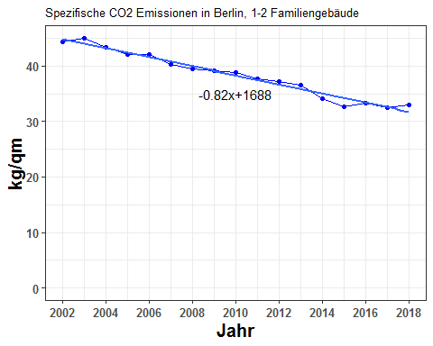

spez_co2_sfh

## abrechnungsjahr spez_co2  
## 1 2002 44.39996  
## 2 2003 45.00062  
## 3 2004 43.29820  
## 4 2005 42.08188  
## 5 2006 42.09374  
## 6 2007 40.23909  
## 7 2008 39.51306  
## 8 2009 39.07821  
## 9 2010 38.84485  
## 10 2011 37.61944  
## 11 2012 37.16411  
## 12 2013 36.49149  
## 13 2014 34.04896  
## 14 2015 32.69275  
## 15 2016 33.34064  
## 16 2017 32.54050  
## 17 2018 32.98276

i_subsubsection <- i_subsubsection+1

### 2.2.2. Stadtbezirke, 1-2 Familiengebäude, flächenbezogene CO2-Emission aus Beheizung von Wohnraum 2002 - 2008 in kg/m2[AN]

bezirke_spez_co2_sfh <- 1e6*berlin_co2_sfh/bezirk_areas_sfh  
bezirke_spez_co2_sfh$abrechnungsjahr <- 2002:2018

plot_reqdColumns(bezirke_spez_co2_sfh,  
 xVar = "abrechnungsjahr",  
 cols_to_plot = names(bezirke_spez_co2_sfh)[!(names(bezirke_spez_co2_sfh) %in% c("abrechnungsjahr","total"))],  
 yColsName = "Bezirk",  
 yVar = "CO2 Emissions in kg/m2",  
 xlabel = "Jahr",  
 ylabel = "kg / qm",  
 plot_title = "Spezifische CO2 Emissionen von Stadtbezirken,\n1-2 Familiengebäude")

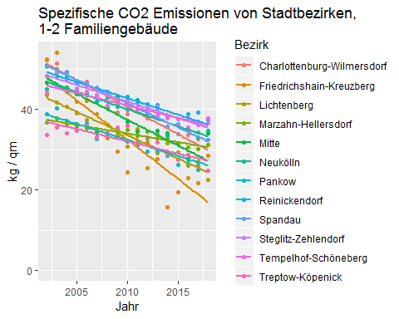

reqdCols <- names(bezirke_spez_co2_sfh)[!(names(bezirke_spez_co2_sfh) %in% c("abrechnungsjahr" , "total"))]  
ymax <- max(bezirke_spez_co2_sfh [ , reqdCols])  
g_co2spez_bezirk <- list()  
for (ii in 1:12) {  
 g_co2spez_bezirk[[ii]] <- points_line_lm(input_data = bezirke_spez_co2_sfh,  
 xVar = "abrechnungsjahr",  
 yVar = bezirk_list[ii],  
 ymin=0,  
 ymax=ymax,  
 x_eq = 2010,  
 y_eq = 0.5*ymax,  
 size_eq = 4,  
 plot_title = bezirk_name[ii],  
 xlab = "Jahr",  
 ylab = "kg/qm")  
}  
require(grid)  
require(gridExtra)  
grid.arrange(g_co2spez_bezirk[[1]],g_co2spez_bezirk[[2]],g_co2spez_bezirk[[3]],g_co2spez_bezirk[[4]],  
 g_co2spez_bezirk[[5]],g_co2spez_bezirk[[6]],g_co2spez_bezirk[[7]],g_co2spez_bezirk[[8]],  
 g_co2spez_bezirk[[9]],g_co2spez_bezirk[[10]],g_co2spez_bezirk[[11]],g_co2spez_bezirk[[12]],ncol=3)

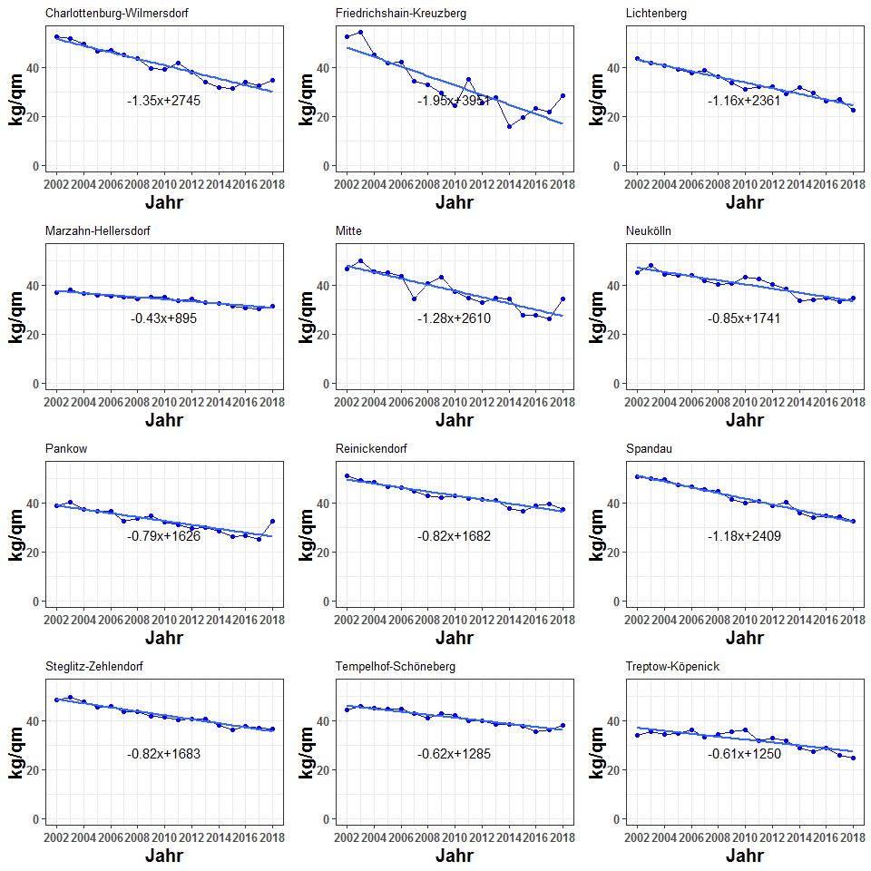

bezirke_spez_co2_sfh

## abrechnungsjahr charlottenburg_wilmersdorf friedrichshain_kreuzberg  
## 1 2002 52.58175 52.27839  
## 2 2003 51.57206 54.11984  
## 3 2004 49.29530 45.08609  
## 4 2005 46.40828 41.86698  
## 5 2006 46.82426 42.16825  
## 6 2007 45.12551 34.24729  
## 7 2008 43.59970 32.80135  
## 8 2009 39.30350 29.55767  
## 9 2010 38.95901 24.34462  
## 10 2011 41.52693 35.06234  
## 11 2012 37.91166 25.48265  
## 12 2013 33.94032 27.78769  
## 13 2014 31.61044 15.68724  
## 14 2015 31.47490 19.49716  
## 15 2016 33.74224 23.00473  
## 16 2017 32.61197 21.76406  
## 17 2018 34.48886 28.51881  
## lichtenberg marzahn_hellersdorf mitte neukoelln pankow  
## 1 43.68744 36.74286 46.65114 45.12915 38.83670  
## 2 41.71773 37.88984 49.97878 47.98966 40.32812  
## 3 40.74268 36.40170 45.46551 44.33877 37.23078  
## 4 39.04496 35.82656 44.92402 43.79617 36.35499  
## 5 37.48488 35.43345 43.55896 43.78070 36.50882  
## 6 38.80793 35.01198 34.17470 41.87320 32.58192  
## 7 36.19391 34.15545 40.68840 40.22779 33.47772  
## 8 33.70358 34.91389 43.24818 40.67890 34.48451  
## 9 30.86047 34.97947 37.07132 43.29222 32.03356  
## 10 32.20011 33.40449 34.47945 42.32533 31.03914  
## 11 31.91810 34.45700 32.82147 40.04044 29.61492  
## 12 29.11393 32.96087 34.67623 38.38789 29.82180  
## 13 31.54810 32.60905 34.20172 33.38785 28.44755  
## 14 29.39038 31.40300 27.47147 33.98733 26.28728  
## 15 26.07561 30.55957 27.62007 34.70608 26.59518  
## 16 26.97652 30.07513 26.00446 33.05992 25.07795  
## 17 22.41930 31.17132 34.19989 34.73926 32.48605  
## reinickendorf spandau steglitz_zehlendorf tempelhof_schoeneberg  
## 1 51.01622 50.72967 48.43132 44.18474  
## 2 49.21090 49.86568 49.31249 45.84476  
## 3 48.27445 49.34000 47.59824 44.99910  
## 4 46.54985 47.20345 45.21656 44.56829  
## 5 46.00301 46.46675 45.81960 44.52355  
## 6 44.82557 45.49807 43.65694 42.95447  
## 7 42.96596 44.50118 43.39714 40.97566  
## 8 41.99540 41.40368 41.77918 42.64158  
## 9 42.87563 39.91655 41.50759 42.09099  
## 10 41.81497 40.51264 40.37209 39.98791  
## 11 41.39735 38.81088 40.61363 39.89619  
## 12 41.04668 40.28285 40.76034 38.52185  
## 13 37.80254 35.81234 37.83147 38.24878  
## 14 36.43087 33.80986 36.07777 37.65702  
## 15 38.85826 34.78193 37.73171 35.50006  
## 16 39.35826 34.27339 36.97063 36.22286  
## 17 37.37668 32.41774 36.65962 37.88465  
## treptow_koepenick total  
## 1 33.78271 44.39996  
## 2 35.54502 45.00062  
## 3 34.14243 43.29820  
## 4 34.80159 42.08188  
## 5 36.00384 42.09374  
## 6 33.05133 40.23909  
## 7 34.13625 39.51306  
## 8 35.52054 39.07821  
## 9 35.95953 38.84485  
## 10 31.72208 37.61944  
## 11 32.97458 37.16411  
## 12 31.82643 36.49149  
## 13 28.91709 34.04896  
## 14 27.42595 32.69275  
## 15 28.76508 33.34064  
## 16 25.89073 32.54050  
## 17 24.73346 32.98276

i_subsubsection <- i_subsubsection+1

### 2.2.3. Stadtbezirke, 1-2 Familiengebäude, flächenbezogene CO2-Emission aus der Beheizung von Wohnraum im Jahr 2018 in kg/m2[AN]

bezirke_spez_co2_sfh_linear <- linearizer(bezirke_spez_co2_sfh , dropCols = NULL , xVar = "abrechnungsjahr")

#bezirke_spez_co2_sfh_linear

bezirke_spez_co2_sfh_linear_2018 <- bezirke_spez_co2_sfh_linear[bezirke_spez_co2_sfh_linear$abrechnungsjahr==2018 , ]  
bezirke_spezco2_sfh_linear_2018 <- as.data.frame(t(bezirke_spez_co2_sfh_linear_2018))  
bezirke_spezco2_sfh_linear_2018$bezirk <- row.names(bezirke_spezco2_sfh_linear_2018)  
names(bezirke_spezco2_sfh_linear_2018) <- c("wert","bezirk")  
bezirke_spezco2_sfh_linear_2018 <- bezirke_spezco2_sfh_linear_2018[bezirke_spezco2_sfh_linear_2018$bezirk!="abrechnungsjahr" , ]  
bezirke_spezco2_sfh_linear_2018 <- bezirke_spezco2_sfh_linear_2018[bezirke_spezco2_sfh_linear_2018$bezirk!="total" , ]  
#bezirke_spezco2_sfh_linear_2018

plot_spezCO2_2018(obj = bezirke_spezco2_sfh_linear_2018 ,   
 plot_title = "Spezifische CO2 Emissionen 2018, 1-2 Familiengebäude")

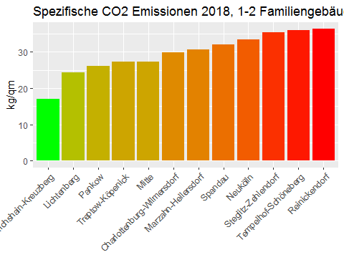

bezirke_spezco2_sfh_linear_2018

## wert bezirk  
## charlottenburg_wilmersdorf 29.88073 charlottenburg_wilmersdorf  
## friedrichshain_kreuzberg 16.95070 friedrichshain_kreuzberg  
## lichtenberg 24.37576 lichtenberg  
## marzahn_hellersdorf 30.57223 marzahn_hellersdorf  
## mitte 27.24539 mitte  
## neukoelln 33.33331 neukoelln  
## pankow 26.08267 pankow  
## reinickendorf 36.28970 reinickendorf  
## spandau 32.08602 spandau  
## steglitz_zehlendorf 35.45359 steglitz_zehlendorf  
## tempelhof_schoeneberg 36.03124 tempelhof_schoeneberg  
## treptow_koepenick 27.22228 treptow_koepenick

i_subsubsection <- i_subsubsection+1

### 2.2.4. Berlin, 1-2 Familiengebäude, flächenbezogene CO2-Emission aus Beheizung von Wohnraum nach Stadtbezirken, 2002 - 2008, 2002 = 100

#get2002as100(spez_co2_sfh , "abrechnungsjahr")

points_line_lm(input_data = get2002as100(spez_co2_sfh , "abrechnungsjahr"),  
 xVar = "abrechnungsjahr",  
 yVar = "spez_co2",  
 ymin=0,  
 ymax=110,  
 x_eq = 2010,  
 y_eq = 60,  
 size_eq = 4,  
 plot_title = "Spezifische CO2 Emissionen in Berlin, 1-2 Familiengebäude, 2002 Wert = 100",  
 xlab = "Jahr",  
 ylab = " ")

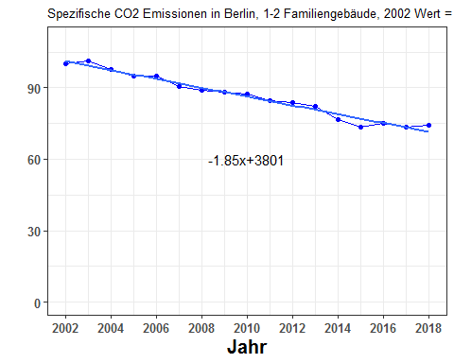

get2002as100(spez_co2_sfh , "abrechnungsjahr")

## abrechnungsjahr spez_co2  
## 1 2002 100.00000  
## 2 2003 101.35284  
## 3 2004 97.51855  
## 4 2005 94.77911  
## 5 2006 94.80581  
## 6 2007 90.62866  
## 7 2008 88.99346  
## 8 2009 88.01408  
## 9 2010 87.48848  
## 10 2011 84.72856  
## 11 2012 83.70303  
## 12 2013 82.18812  
## 13 2014 76.68691  
## 14 2015 73.63240  
## 15 2016 75.09161  
## 16 2017 73.28948  
## 17 2018 74.28556

i_subsubsection <- i_subsubsection+1

### 2.2.5. Alle Stadtbezirke, 1-2 Familiengebäude, flächenbezogene CO2-Emission aus der Beheizung von Wohnraum, Entwicklung 2002 - 2018 und Niveau 2018 (Rang¬folge)

**Take the Berlin specific CO2 emission for 2018 as the baseline, Subtract from this the 2018 value of specific co2 emission of Stadtbezirk X. Do for all the bezirks and make a barplot.**

spez_co2_sfh_linear <- linearizer(spez_co2_sfh,dropCols=NULL,xVar="abrechnungsjahr")  
spez_co2_sfh_linear_2018 <- spez_co2_sfh_linear$spez_co2[spez_co2_sfh_linear$abrechnungsjahr==2018]  
#spez_co2_sfh_linear_2018

#bezirke_spezco2_sfh_linear_2018

bezirke_spezco2_sfh_linear_2018$dev_from_berlin <- bezirke_spezco2_sfh_linear_2018$wert - spez_co2_sfh_linear_2018

#bezirke_spezco2_sfh_linear_2018

plot_devFromBerlin2018(bezirke_spezco2_sfh_linear_2018,  
 "2018 deviation from Berlin, 1-2 Familiengebäude",  
 "some y-label")

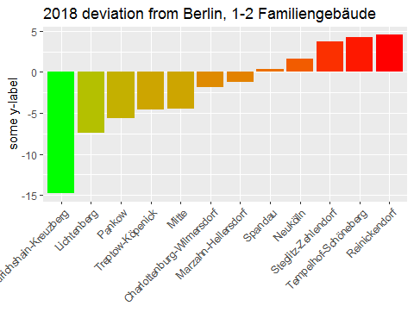

bezirke_spezco2_sfh_linear_2018

## wert bezirk  
## charlottenburg_wilmersdorf 29.88073 charlottenburg_wilmersdorf  
## friedrichshain_kreuzberg 16.95070 friedrichshain_kreuzberg  
## lichtenberg 24.37576 lichtenberg  
## marzahn_hellersdorf 30.57223 marzahn_hellersdorf  
## mitte 27.24539 mitte  
## neukoelln 33.33331 neukoelln  
## pankow 26.08267 pankow  
## reinickendorf 36.28970 reinickendorf  
## spandau 32.08602 spandau  
## steglitz_zehlendorf 35.45359 steglitz_zehlendorf  
## tempelhof_schoeneberg 36.03124 tempelhof_schoeneberg  
## treptow_koepenick 27.22228 treptow_koepenick  
## dev_from_berlin  
## charlottenburg_wilmersdorf -1.8734372  
## friedrichshain_kreuzberg -14.8034755  
## lichtenberg -7.3784140  
## marzahn_hellersdorf -1.1819394  
## mitte -4.5087848  
## neukoelln 1.5791386  
## pankow -5.6715040  
## reinickendorf 4.5355294  
## spandau 0.3318537  
## steglitz_zehlendorf 3.6994142  
## tempelhof_schoeneberg 4.2770692  
## treptow_koepenick -4.5318942

i_subsubsection <- i_subsubsection+1

### 2.2.6. Berlin, 1-2 Familiengebäude, durchschnittliche Emissionsminderung je qm Nutzfläche im Zeitraum 2012 - 2018

barPlot_delta2012(changeFrom2012(spez_co2_sfh) , "some-y-label" , "some title")

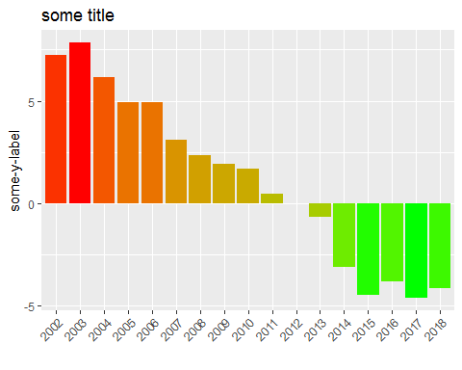

changeFrom2012(spez_co2_sfh)

## abrechnungsjahr spez_co2 delta2012  
## 1 2002 44.39996 7.2358466  
## 2 2003 45.00062 7.8365076  
## 3 2004 43.29820 6.1340857  
## 4 2005 42.08188 4.9177732  
## 5 2006 42.09374 4.9296294  
## 6 2007 40.23909 3.0749768  
## 7 2008 39.51306 2.3489466  
## 8 2009 39.07821 1.9141024  
## 9 2010 38.84485 1.6807392  
## 10 2011 37.61944 0.4553335  
## 11 2012 37.16411 0.0000000  
## 12 2013 36.49149 -0.6726222  
## 13 2014 34.04896 -3.1151534  
## 14 2015 32.69275 -4.4713565  
## 15 2016 33.34064 -3.8234699  
## 16 2017 32.54050 -4.6236134  
## 17 2018 32.98276 -4.1813556

i_subsection <- i_subsection + 1

## 2.3. Emission pro Einwohner

i_subsubsection <- 1

### 2.3.1. Stadtbezirke, 1-2 Familiengebäude, CO2-Emission aus der Beheizung von Wohnraum pro Einwohner

**I need the data for the population in SFH and MFH buildings**

i_subsubsection <- i_subsubsection+1

### 2.3.2. Stadtbezirke, 1-2 Familiengebäude, CO2-Emission pro Einwohner aus der Beheizung von Wohnraum, 2002 - 2008, 2002 = 100

**I need the data for the population in SFH and MFH buildings**

i_subsubsection <- i_subsubsection+1

### 2.3.3. Stadtbezirke, 1-2 Familiengebäude, CO2-Emissionen aus der Beheizung von Wohnraum pro Einwohner, Niveau im Jahr 2018 in t/Einwohner

**I need the data for the population in SFH and MFH buildings**

i_subsubsection <- i_subsubsection+1

### 2.3.4. Stadtbezirke, 1-2 Familiengebäude, CO2-Emissionen aus der Beheizung von Wohnraum pro Einwohner, Veränderung 2002 / 2018 in Prozent

**I need the data for the population in SFH and MFH buildings**

i_subsection <- i_subsection+1

## 2.4. Prognose

i_subsubsection <- 1

### 2.4.1 Berlin, 1-2 Familiengebäude, Prognose der CO2-Emission aus der Beheizung 2019-2030 in Mio. t (Trend Polynom 2. Grades)

quadmodel_sfh <- lm(total~abrechnungsjahr+I(abrechnungsjahr^2),data=berlin_co2_sfh)  
from2002_till_2030 <- data.frame(abrechnungsjahr=2002:2030)  
prognose_sfh <- data.frame(abrechnungsjahr = 2002:2030 , pred = as.numeric(predict(quadmodel_sfh,newdata=from2002_till_2030)))  
ggplot(prognose_sfh , aes(x=abrechnungsjahr , y = pred))+geom_point()

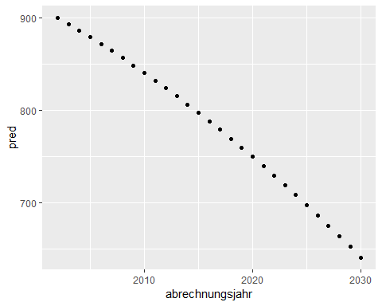

prognose_sfh

## abrechnungsjahr pred  
## 1 2002 900.4637  
## 2 2003 893.6411  
## 3 2004 886.6354  
## 4 2005 879.4467  
## 5 2006 872.0751  
## 6 2007 864.5205  
## 7 2008 856.7828  
## 8 2009 848.8622  
## 9 2010 840.7586  
## 10 2011 832.4720  
## 11 2012 824.0024  
## 12 2013 815.3498  
## 13 2014 806.5142  
## 14 2015 797.4957  
## 15 2016 788.2941  
## 16 2017 778.9095  
## 17 2018 769.3420  
## 18 2019 759.5914  
## 19 2020 749.6579  
## 20 2021 739.5414  
## 21 2022 729.2418  
## 22 2023 718.7593  
## 23 2024 708.0938  
## 24 2025 697.2453  
## 25 2026 686.2138  
## 26 2027 674.9993  
## 27 2028 663.6019  
## 28 2029 652.0214  
## 29 2030 640.2579

i_subsection <- i_subsection + 1

## 2.5. Diskussion

i_section <- i_section + 1

# 3. Alle Stadtbezirke, CO2-Emission aus Beheizung, Mehrfamiliengebäude

i_subsection <- 1

## 3.1. Absolute Zahlen

i_subsubsection <- 1

### 3.1.1. Berlin, Mehrfamiliengebäude, CO2-Emission aus der Beheizung von Wohnraum 2002 - 2018 in 1.000 t

berlin_co2_mfh <- getRowSums(alle_bezirke_co2$mfh , dropCols = "abrechnungsjahr")  
#berlin_co2_mfh

points_line_lm(input_data = berlin_co2_mfh,  
 xVar = "abrechnungsjahr",  
 yVar = "total",  
 ymin = 0,  
 ymax = max(berlin_co2_mfh$total),  
 x_eq = 2010,  
 y_eq = 2000,  
 size_eq = 4,  
 plot_title = "CO2 Emissionen in Berlin, Mehrfamiliengebäude",  
 xlab = "Jahr",  
 ylab = "kilo t.")

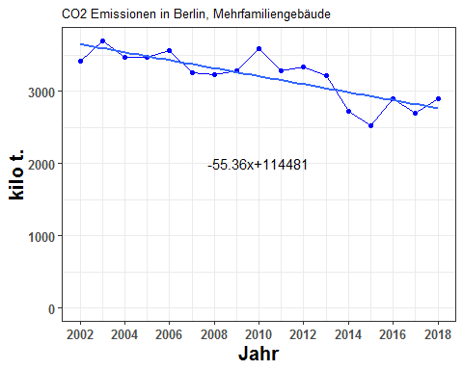

berlin_co2_mfh

## abrechnungsjahr charlottenburg_wilmersdorf friedrichshain_kreuzberg  
## 1 2002 399.4319 294.5903  
## 2 2003 428.7574 285.2599  
## 3 2004 487.3740 265.4926  
## 4 2005 464.2615 267.3698  
## 5 2006 470.9326 285.2576  
## 6 2007 432.8151 258.6166  
## 7 2008 437.8208 256.1559  
## 8 2009 367.0769 250.5691  
## 9 2010 466.4220 299.6834  
## 10 2011 406.0426 236.2316  
## 11 2012 433.2303 259.3602  
## 12 2013 432.6927 234.4584  
## 13 2014 312.0602 190.2834  
## 14 2015 288.5501 189.8730  
## 15 2016 319.9204 208.9419  
## 16 2017 291.1997 211.2094  
## 17 2018 299.4857 250.6355  
## lichtenberg marzahn_hellersdorf mitte neukoelln pankow  
## 1 197.8288 194.9590 299.8237 305.7769 314.5353  
## 2 218.9227 228.7326 363.4527 347.6245 326.1561  
## 3 206.0229 184.1448 303.1198 280.7814 292.0211  
## 4 212.6354 199.2728 313.2652 265.8171 308.1265  
## 5 219.0445 205.7710 332.8238 271.1962 328.4206  
## 6 187.5135 197.4030 293.0286 256.7947 289.4172  
## 7 188.5437 188.2577 297.5764 267.2961 271.8597  
## 8 193.4413 185.3657 325.3449 293.8530 297.1925  
## 9 176.7431 179.2739 346.5025 335.4331 310.6348  
## 10 186.2777 192.8415 333.2555 257.1378 280.7929  
## 11 208.8802 155.6528 339.5435 301.2706 286.4102  
## 12 237.5872 150.1481 327.6683 270.8242 278.1617  
## 13 198.8600 150.3532 277.6579 248.7458 247.7072  
## 14 105.3295 182.1429 229.8670 203.6787 256.2420  
## 15 172.5166 270.9775 262.8924 228.0288 264.6023  
## 16 178.9619 203.6450 238.9326 176.8744 264.7486  
## 17 195.6437 169.9895 215.0268 189.5899 305.2096  
## reinickendorf spandau steglitz_zehlendorf tempelhof_schoeneberg  
## 1 237.6168 214.7627 366.4703 438.4259  
## 2 266.4768 288.9667 381.3114 412.2325  
## 3 263.6580 245.5112 382.8616 421.1726  
## 4 262.7532 212.7252 368.5249 427.6592  
## 5 260.9500 220.2762 364.9041 424.8567  
## 6 237.3749 201.0138 336.0696 394.6403  
## 7 236.4264 201.4594 341.7312 386.5658  
## 8 231.6706 199.7286 353.8380 405.7434  
## 9 257.4369 236.4398 352.7395 419.7519  
## 10 259.4820 250.2316 331.0659 379.2563  
## 11 250.7585 223.6976 341.8102 362.8596  
## 12 238.8646 220.1399 342.7692 337.6356  
## 13 221.3182 144.7948 319.2455 308.4756  
## 14 211.0874 158.5048 292.5753 263.8983  
## 15 200.9154 199.2340 315.7682 299.1469  
## 16 220.5056 189.8054 284.5172 286.1142  
## 17 243.4327 234.5722 297.0251 322.4263  
## treptow_koepenick total  
## 1 149.9418 3414.163  
## 2 147.1074 3695.001  
## 3 142.1288 3474.289  
## 4 159.1405 3461.551  
## 5 171.4268 3555.860  
## 6 164.4947 3249.182  
## 7 158.8997 3232.593  
## 8 171.2832 3275.107  
## 9 213.4970 3594.558  
## 10 166.8512 3279.467  
## 11 171.2525 3334.726  
## 12 144.5580 3215.508  
## 13 104.9723 2724.474  
## 14 136.4625 2518.211  
## 15 147.0979 2890.042  
## 16 145.1398 2691.654  
## 17 175.6874 2898.724

* Now split by ET

co2_mfh_allebezirke_byET <- co2_allebezirke_byET$mfh  
#co2_mfh_allebezirke_byET

co2_mfh_allebezirke_byET_cumsums <- getCumSums(obj=co2_mfh_allebezirke_byET , dropCols=c("abrechnungsjahr","total"))  
#co2_mfh_allebezirke_byET_cumsums

plot_byET(co2_mfh_allebezirke_byET_cumsums , xlabel = "Jahr" , ylabel = "kilo t." , plottitle = "CO2 Emissionen in Berlin, Mehrfamiliengebäude, nach Energieträgern")

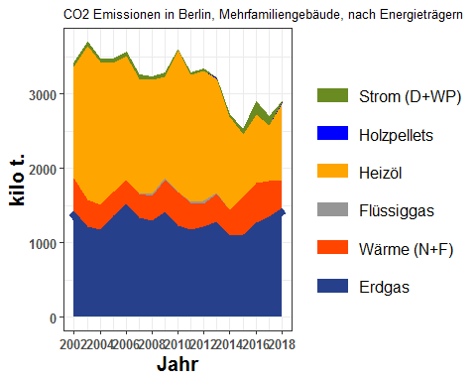

co2_mfh_allebezirke_byET

## abrechnungsjahr erdgas waerme fluessiggas heizoel holzpellets  
## 1 2002 1425.313 437.1350 0.0000000 1501.3892 0.00000000  
## 2 2003 1219.068 351.7543 0.0000000 2073.8530 0.00000000  
## 3 2004 1169.550 344.0184 0.6333009 1909.7609 0.00000000  
## 4 2005 1359.731 325.0214 2.9657339 1723.4576 0.04967672  
## 5 2006 1517.858 319.2860 3.1605813 1665.1732 0.05636583  
## 6 2007 1328.905 324.6698 0.2929358 1544.9283 0.05977333  
## 7 2008 1289.191 341.7451 17.5996834 1533.6597 0.07157690  
## 8 2009 1418.327 427.7833 15.3941549 1363.1877 0.08886308  
## 9 2010 1227.913 453.7213 5.0212943 1906.2964 0.45348290  
## 10 2011 1177.274 363.3279 11.4281780 1705.2408 1.45844436  
## 11 2012 1210.889 315.7326 29.3201612 1746.1593 1.23600422  
## 12 2013 1287.861 370.5967 15.7815962 1533.4588 1.50466603  
## 13 2014 1100.413 342.2969 0.0000000 1255.8463 0.00000000  
## 14 2015 1107.041 509.0914 0.0000000 837.8540 0.00000000  
## 15 2016 1264.798 540.2873 0.0000000 914.0285 1.21437607  
## 16 2017 1348.226 478.6880 0.0000000 748.6488 2.73720749  
## 17 2018 1465.321 371.3238 0.0000000 1031.4683 10.47154931  
## strom total  
## 1 50.325909 3414.163  
## 2 50.325909 3695.001  
## 3 50.325909 3474.289  
## 4 50.325909 3461.551  
## 5 50.325909 3555.860  
## 6 50.325909 3249.182  
## 7 50.325909 3232.593  
## 8 50.325909 3275.107  
## 9 1.152581 3594.558  
## 10 20.736782 3279.467  
## 11 31.388955 3334.726  
## 12 6.305046 3215.508  
## 13 25.917551 2724.474  
## 14 64.224565 2518.211  
## 15 169.714340 2890.042  
## 16 113.353242 2691.654  
## 17 20.140117 2898.724

i_subsubsection <- i_subsubsection + 1

### 3.1.2. Stadtbezirke, Mehrfamiliengebäude, CO2-Emissionen aus der Beheizung von Wohnraum 2002 - 2018 summiert in 1.000 t

* Here CO2 emissions split by the bezirke

berlin_co2_mfh_cumsums <- getCumSums(obj=berlin_co2_mfh , dropCols=c("abrechnungsjahr","total"))  
plot_byBezirke(berlin_co2_mfh_cumsums , xlabel = "Jahr" , ylabel = "kilo t." , plottitle="CO2 Emissionen in Berlin, Mehrfamiliengebäude, nach Bezirk")

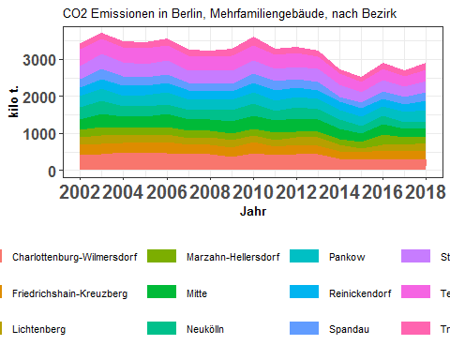

berlin_co2_mfh

## abrechnungsjahr charlottenburg_wilmersdorf friedrichshain_kreuzberg  
## 1 2002 399.4319 294.5903  
## 2 2003 428.7574 285.2599  
## 3 2004 487.3740 265.4926  
## 4 2005 464.2615 267.3698  
## 5 2006 470.9326 285.2576  
## 6 2007 432.8151 258.6166  
## 7 2008 437.8208 256.1559  
## 8 2009 367.0769 250.5691  
## 9 2010 466.4220 299.6834  
## 10 2011 406.0426 236.2316  
## 11 2012 433.2303 259.3602  
## 12 2013 432.6927 234.4584  
## 13 2014 312.0602 190.2834  
## 14 2015 288.5501 189.8730  
## 15 2016 319.9204 208.9419  
## 16 2017 291.1997 211.2094  
## 17 2018 299.4857 250.6355  
## lichtenberg marzahn_hellersdorf mitte neukoelln pankow  
## 1 197.8288 194.9590 299.8237 305.7769 314.5353  
## 2 218.9227 228.7326 363.4527 347.6245 326.1561  
## 3 206.0229 184.1448 303.1198 280.7814 292.0211  
## 4 212.6354 199.2728 313.2652 265.8171 308.1265  
## 5 219.0445 205.7710 332.8238 271.1962 328.4206  
## 6 187.5135 197.4030 293.0286 256.7947 289.4172  
## 7 188.5437 188.2577 297.5764 267.2961 271.8597  
## 8 193.4413 185.3657 325.3449 293.8530 297.1925  
## 9 176.7431 179.2739 346.5025 335.4331 310.6348  
## 10 186.2777 192.8415 333.2555 257.1378 280.7929  
## 11 208.8802 155.6528 339.5435 301.2706 286.4102  
## 12 237.5872 150.1481 327.6683 270.8242 278.1617  
## 13 198.8600 150.3532 277.6579 248.7458 247.7072  
## 14 105.3295 182.1429 229.8670 203.6787 256.2420  
## 15 172.5166 270.9775 262.8924 228.0288 264.6023  
## 16 178.9619 203.6450 238.9326 176.8744 264.7486  
## 17 195.6437 169.9895 215.0268 189.5899 305.2096  
## reinickendorf spandau steglitz_zehlendorf tempelhof_schoeneberg  
## 1 237.6168 214.7627 366.4703 438.4259  
## 2 266.4768 288.9667 381.3114 412.2325  
## 3 263.6580 245.5112 382.8616 421.1726  
## 4 262.7532 212.7252 368.5249 427.6592  
## 5 260.9500 220.2762 364.9041 424.8567  
## 6 237.3749 201.0138 336.0696 394.6403  
## 7 236.4264 201.4594 341.7312 386.5658  
## 8 231.6706 199.7286 353.8380 405.7434  
## 9 257.4369 236.4398 352.7395 419.7519  
## 10 259.4820 250.2316 331.0659 379.2563  
## 11 250.7585 223.6976 341.8102 362.8596  
## 12 238.8646 220.1399 342.7692 337.6356  
## 13 221.3182 144.7948 319.2455 308.4756  
## 14 211.0874 158.5048 292.5753 263.8983  
## 15 200.9154 199.2340 315.7682 299.1469  
## 16 220.5056 189.8054 284.5172 286.1142  
## 17 243.4327 234.5722 297.0251 322.4263  
## treptow_koepenick total  
## 1 149.9418 3414.163  
## 2 147.1074 3695.001  
## 3 142.1288 3474.289  
## 4 159.1405 3461.551  
## 5 171.4268 3555.860  
## 6 164.4947 3249.182  
## 7 158.8997 3232.593  
## 8 171.2832 3275.107  
## 9 213.4970 3594.558  
## 10 166.8512 3279.467  
## 11 171.2525 3334.726  
## 12 144.5580 3215.508  
## 13 104.9723 2724.474  
## 14 136.4625 2518.211  
## 15 147.0979 2890.042  
## 16 145.1398 2691.654  
## 17 175.6874 2898.724

i_subsubsection <- i_subsubsection + 1

### 3.1.3. Stadtbezirke, Mehrfamiliengebäude, CO2-Emissionen aus der Beheizung von Wohnraum 2002 - 2018 in Prozent

co2_mfh_allebezirke_byET_prop <- find_proportions(co2_mfh_allebezirke_byET , drop_cols = c("abrechnungsjahr","total"))  
co2_mfh_allebezirke_byET_prop_cumsums <- getCumSums(obj=co2_mfh_allebezirke_byET_prop , dropCols = "abrechnungsjahr")  
plot_byET(co2_mfh_allebezirke_byET_prop_cumsums,xlabel = "Jahr" , ylabel = "Anteile in %" , plottitle = "CO2 Emissionen in Berlin, Mehrfamiliengebäude, \nAnteile nach Energieträgern")

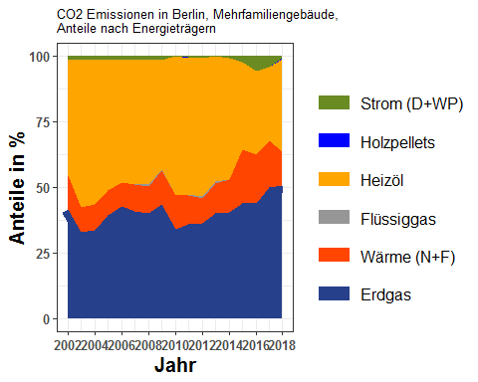

co2_mfh_allebezirke_byET_prop

## erdgas waerme fluessiggas heizoel holzpellets strom  
## 1 41.74707 12.803578 0.000000000 43.97532 0.000000000 1.47403350  
## 2 32.99235 9.519735 0.000000000 56.12592 0.000000000 1.36199994  
## 3 33.66302 9.901836 0.018228216 54.96840 0.000000000 1.44852401  
## 4 39.28097 9.389473 0.085676441 49.78859 0.001435100 1.45385424  
## 5 42.68610 8.979148 0.088883736 46.82899 0.001585153 1.41529495  
## 6 40.89969 9.992353 0.009015679 47.54822 0.001839642 1.54887934  
## 7 39.88102 10.571856 0.544444810 47.44364 0.002214226 1.55682800  
## 8 43.30629 13.061658 0.470035137 41.62269 0.002713288 1.53661865  
## 9 34.16033 12.622451 0.139691571 53.03285 0.012615819 0.03206462  
## 10 35.89835 11.078873 0.348476731 51.99751 0.044471999 0.63232178  
## 11 36.31150 9.468022 0.879237430 52.36290 0.037064638 0.94127531  
## 12 40.05156 11.525293 0.490796366 47.68947 0.046794038 0.19608244  
## 13 40.38994 12.563780 0.000000000 46.09500 0.000000000 0.95128640  
## 14 43.96142 20.216390 0.000000000 33.27179 0.000000000 2.55040400  
## 15 43.76399 18.694786 0.000000000 31.62682 0.042019316 5.87238225  
## 16 50.08915 17.784160 0.000000000 27.81371 0.101692411 4.21128632  
## 17 50.55054 12.809902 0.000000000 35.58352 0.361246806 0.69479241  
## abrechnungsjahr  
## 1 2002  
## 2 2003  
## 3 2004  
## 4 2005  
## 5 2006  
## 6 2007  
## 7 2008  
## 8 2009  
## 9 2010  
## 10 2011  
## 11 2012  
## 12 2013  
## 13 2014  
## 14 2015  
## 15 2016  
## 16 2017  
## 17 2018

berlin_co2_mfh_prop <- find_proportions(berlin_co2_mfh,drop_cols=c("abrechnungsjahr","total"))  
berlin_co2_mfh_prop_cumsums <- getCumSums(berlin_co2_mfh_prop,dropCols="abrechnungsjahr")  
plot_byBezirke(berlin_co2_mfh_prop_cumsums,xlabel = "Jahr" , ylabel = "Anteile in %" , plottitle = "CO2 Emissionen in Berlin, Mehrfamiliengebäude, Anteile nach Bezirk")

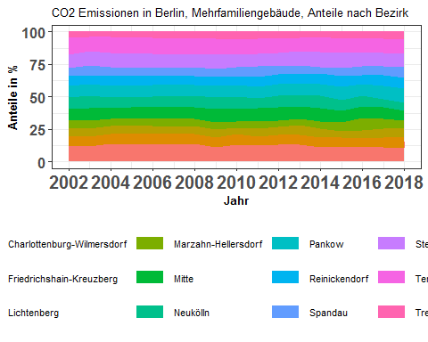

berlin_co2_mfh_prop

## charlottenburg_wilmersdorf friedrichshain_kreuzberg lichtenberg  
## 1 11.69926 8.628478 5.794356  
## 2 11.60372 7.720158 5.924834  
## 3 14.02802 7.641639 5.929931  
## 4 13.41195 7.723989 6.142777  
## 5 13.24385 8.022182 6.160099  
## 6 13.32074 7.959437 5.771100  
## 7 13.54395 7.924163 5.832584  
## 8 11.20809 7.650716 5.906410  
## 9 12.97578 8.337142 4.916963  
## 10 12.38136 7.203355 5.680122  
## 11 12.99148 7.777556 6.263789  
## 12 13.45643 7.291490 7.388793  
## 13 11.45396 6.984224 7.299025  
## 14 11.45853 7.539993 4.182711  
## 15 11.06975 7.229718 5.969344  
## 16 10.81862 7.846825 6.648772  
## 17 10.33164 8.646407 6.749303  
## marzahn_hellersdorf mitte neukoelln pankow reinickendorf  
## 1 5.710301 8.781762 8.956129 9.212660 6.959737  
## 2 6.190327 9.836336 9.407969 8.826957 7.211820  
## 3 5.300216 8.724658 8.081694 8.405205 7.588833  
## 4 5.756749 9.049850 7.679132 8.901398 7.590620  
## 5 5.786815 9.359866 7.626739 9.236039 7.338590  
## 6 6.075468 9.018533 7.903364 8.907385 7.305682  
## 7 5.823736 9.205501 8.268785 8.409959 7.313831  
## 8 5.659835 9.933870 8.972318 9.074283 7.073681  
## 9 4.987370 9.639641 9.331693 8.641809 7.161851  
## 10 5.880271 10.161881 7.840842 8.562150 7.912323  
## 11 4.667634 10.182049 9.034344 8.588716 7.519614  
## 12 4.669498 10.190250 8.422439 8.650630 7.428520  
## 13 5.518615 10.191249 9.130047 9.091926 8.123335  
## 14 7.233027 9.128185 8.088227 10.175555 8.382434  
## 15 9.376248 9.096491 7.890154 9.155655 6.951989  
## 16 7.565794 8.876794 6.571216 9.835910 8.192198  
## 17 5.864286 7.417979 6.540460 10.529099 8.397926  
## spandau steglitz_zehlendorf tempelhof_schoeneberg treptow_koepenick  
## 1 6.290346 10.733825 12.84139 4.391757  
## 2 7.820477 10.319658 11.15649 3.981255  
## 3 7.066515 11.019855 12.12256 4.090875  
## 4 6.145371 10.646235 12.35455 4.597375  
## 5 6.194738 10.262048 11.94807 4.820966  
## 6 6.186597 10.343207 12.14584 5.062649  
## 7 6.232132 10.571427 11.95838 4.915549  
## 8 6.098385 10.803859 12.38870 5.229852  
## 9 6.577717 9.813154 11.67743 5.939450  
## 10 7.630254 10.095113 11.56457 5.087753  
## 11 6.708126 10.250022 10.88124 5.135430  
## 12 6.846194 10.659877 10.50023 4.495651  
## 13 5.314596 11.717693 11.32239 3.852936  
## 14 6.294341 11.618378 10.47959 5.419025  
## 15 6.893810 10.926074 10.35095 5.089818  
## 16 7.051629 10.570349 10.62968 5.392215  
## 17 8.092258 10.246753 11.12304 6.060853  
## abrechnungsjahr  
## 1 2002  
## 2 2003  
## 3 2004  
## 4 2005  
## 5 2006  
## 6 2007  
## 7 2008  
## 8 2009  
## 9 2010  
## 10 2011  
## 11 2012  
## 12 2013  
## 13 2014  
## 14 2015  
## 15 2016  
## 16 2017  
## 17 2018

i_subsubsection <- i_subsubsection + 1

### 3.1.4. Stadtbezirke, Mehrfamiliengebäude, CO2-Emissionen aus der Beheizung von Wohnraum 2002 - 2018 in 1.000 t

(Eine Grafik: co2 Emissionen je Bezirk und Jahr) Co2 emissions of all city districts by year in a single graph. (year on x-axis and co2 emission on y-axis). One Graph: Co2 emissions of all city districts by year

plot_reqdColumns(berlin_co2_mfh,  
 xVar = "abrechnungsjahr",  
 cols_to_plot = names(berlin_co2_mfh)[!(names(berlin_co2_mfh) %in% c("abrechnungsjahr","total"))],  
 yColsName = "Bezirk",  
 yVar = "CO2 Emissions",  
 xlabel = "Jahr",  
 ylabel = "kilo t.",  
 plot_title = "CO2 Emissionen von Stadtbezirken, Mehrfamiliengebäude")

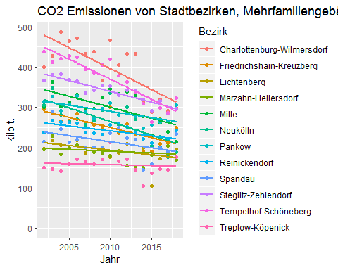

gg_co2_mfh <- plot_bezirkeGridPlot(berlin_co2_mfh,ylabel="kilo t.")  
require(grid)  
require(gridExtra)  
grid.arrange(gg_co2_mfh[[1]],gg_co2_mfh[[2]],gg_co2_mfh[[3]],gg_co2_mfh[[4]],  
 gg_co2_mfh[[5]],gg_co2_mfh[[6]],gg_co2_mfh[[7]],gg_co2_mfh[[8]],  
 gg_co2_mfh[[9]],gg_co2_mfh[[10]],gg_co2_mfh[[11]],gg_co2_mfh[[12]],ncol=3)

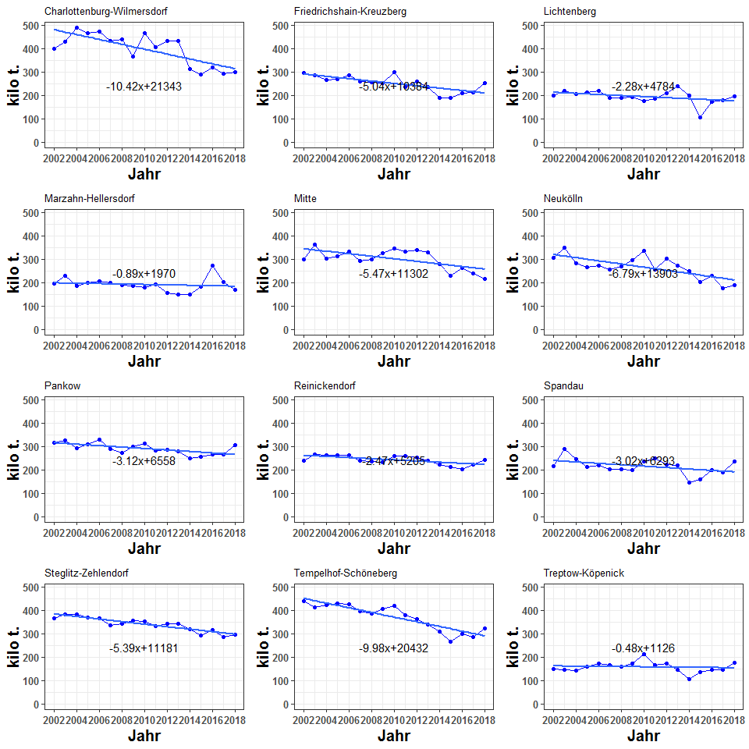

berlin_co2_mfh

## abrechnungsjahr charlottenburg_wilmersdorf friedrichshain_kreuzberg  
## 1 2002 399.4319 294.5903  
## 2 2003 428.7574 285.2599  
## 3 2004 487.3740 265.4926  
## 4 2005 464.2615 267.3698  
## 5 2006 470.9326 285.2576  
## 6 2007 432.8151 258.6166  
## 7 2008 437.8208 256.1559  
## 8 2009 367.0769 250.5691  
## 9 2010 466.4220 299.6834  
## 10 2011 406.0426 236.2316  
## 11 2012 433.2303 259.3602  
## 12 2013 432.6927 234.4584  
## 13 2014 312.0602 190.2834  
## 14 2015 288.5501 189.8730  
## 15 2016 319.9204 208.9419  
## 16 2017 291.1997 211.2094  
## 17 2018 299.4857 250.6355  
## lichtenberg marzahn_hellersdorf mitte neukoelln pankow  
## 1 197.8288 194.9590 299.8237 305.7769 314.5353  
## 2 218.9227 228.7326 363.4527 347.6245 326.1561  
## 3 206.0229 184.1448 303.1198 280.7814 292.0211  
## 4 212.6354 199.2728 313.2652 265.8171 308.1265  
## 5 219.0445 205.7710 332.8238 271.1962 328.4206  
## 6 187.5135 197.4030 293.0286 256.7947 289.4172  
## 7 188.5437 188.2577 297.5764 267.2961 271.8597  
## 8 193.4413 185.3657 325.3449 293.8530 297.1925  
## 9 176.7431 179.2739 346.5025 335.4331 310.6348  
## 10 186.2777 192.8415 333.2555 257.1378 280.7929  
## 11 208.8802 155.6528 339.5435 301.2706 286.4102  
## 12 237.5872 150.1481 327.6683 270.8242 278.1617  
## 13 198.8600 150.3532 277.6579 248.7458 247.7072  
## 14 105.3295 182.1429 229.8670 203.6787 256.2420  
## 15 172.5166 270.9775 262.8924 228.0288 264.6023  
## 16 178.9619 203.6450 238.9326 176.8744 264.7486  
## 17 195.6437 169.9895 215.0268 189.5899 305.2096  
## reinickendorf spandau steglitz_zehlendorf tempelhof_schoeneberg  
## 1 237.6168 214.7627 366.4703 438.4259  
## 2 266.4768 288.9667 381.3114 412.2325  
## 3 263.6580 245.5112 382.8616 421.1726  
## 4 262.7532 212.7252 368.5249 427.6592  
## 5 260.9500 220.2762 364.9041 424.8567  
## 6 237.3749 201.0138 336.0696 394.6403  
## 7 236.4264 201.4594 341.7312 386.5658  
## 8 231.6706 199.7286 353.8380 405.7434  
## 9 257.4369 236.4398 352.7395 419.7519  
## 10 259.4820 250.2316 331.0659 379.2563  
## 11 250.7585 223.6976 341.8102 362.8596  
## 12 238.8646 220.1399 342.7692 337.6356  
## 13 221.3182 144.7948 319.2455 308.4756  
## 14 211.0874 158.5048 292.5753 263.8983  
## 15 200.9154 199.2340 315.7682 299.1469  
## 16 220.5056 189.8054 284.5172 286.1142  
## 17 243.4327 234.5722 297.0251 322.4263  
## treptow_koepenick total  
## 1 149.9418 3414.163  
## 2 147.1074 3695.001  
## 3 142.1288 3474.289  
## 4 159.1405 3461.551  
## 5 171.4268 3555.860  
## 6 164.4947 3249.182  
## 7 158.8997 3232.593  
## 8 171.2832 3275.107  
## 9 213.4970 3594.558  
## 10 166.8512 3279.467  
## 11 171.2525 3334.726  
## 12 144.5580 3215.508  
## 13 104.9723 2724.474  
## 14 136.4625 2518.211  
## 15 147.0979 2890.042  
## 16 145.1398 2691.654  
## 17 175.6874 2898.724

i_subsubsection <- i_subsubsection + 1

### 3.1.5. Stadtbezirke, Mehrfamiliengebäude, CO2-Emissionen aus der Beheizung von Wohnraum 2002 - 2018, Veränderung in Prozent

berlin_co2_mfh_devFromMean <- getDeviationsFromMean(berlin_co2_mfh,  
 xVar = "abrechnungsjahr",  
 colsToAvgOver = names(berlin_co2_mfh)[  
 !(names(berlin_co2_mfh  
 ) %in% c("abrechnungsjahr","total"))]  
)  
ymin <- min(berlin_co2_mfh_devFromMean[ ,   
 names(berlin_co2_mfh_devFromMean)[  
 !(names(berlin_co2_mfh_devFromMean) %in% c("abrechnungsjahr",  
 "meanVal"))  
 ]])  
ymax <- max(berlin_co2_mfh_devFromMean[ ,   
 names(berlin_co2_mfh_devFromMean)[  
 !(names(berlin_co2_mfh_devFromMean) %in% c("abrechnungsjahr",  
 "meanVal"))  
 ]])  
#plotDevFromMean(berlin_co2_all_devFromMean,"abrechnungsjahr","mitte",yMin=yMin,yMax=yMax)  
g_co2dev_bezirk <- list()  
for (ii in 1:12) {  
 g_co2dev_bezirk[[ii]] <- plotDevFromMean(input_data = berlin_co2_mfh_devFromMean,  
 xVar = "abrechnungsjahr",  
 yVar = bezirk_list[ii],  
 ymin=ymin,  
 ymax=ymax,  
 ylabel="% deviation from mean",  
 plot_title = bezirk_name[ii])  
}  
require(grid)  
require(gridExtra)  
grid.arrange(g_co2dev_bezirk[[1]],g_co2dev_bezirk[[2]],g_co2dev_bezirk[[3]],g_co2dev_bezirk[[4]],  
 g_co2dev_bezirk[[5]],g_co2dev_bezirk[[6]],g_co2dev_bezirk[[7]],g_co2dev_bezirk[[8]],  
 g_co2dev_bezirk[[9]],g_co2dev_bezirk[[10]],g_co2dev_bezirk[[11]],g_co2dev_bezirk[[12]],ncol=3)

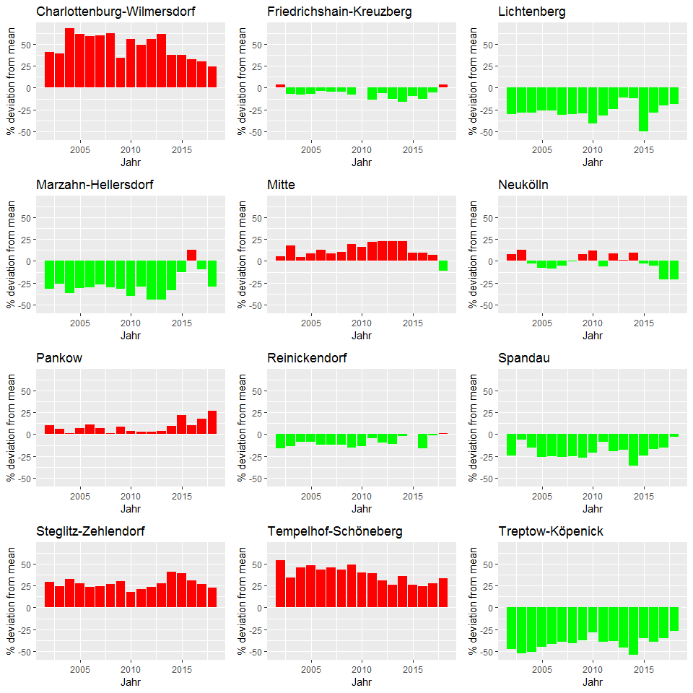

berlin_co2_mfh_devFromMean

## abrechnungsjahr charlottenburg_wilmersdorf friedrichshain_kreuzberg  
## 1 2002 40.39114 3.54173106  
## 2 2003 39.24459 -7.35810113  
## 3 2004 68.33626 -8.30032971  
## 4 2005 60.94338 -7.31212669  
## 5 2006 58.92616 -3.73381227  
## 6 2007 59.84889 -4.48675528  
## 7 2008 62.52742 -4.91004678  
## 8 2009 34.49705 -8.19141145  
## 9 2010 55.70939 0.04570303  
## 10 2011 48.57634 -13.55974325  
## 11 2012 55.89776 -6.66932684  
## 12 2013 61.47720 -12.50212035  
## 13 2014 37.44755 -16.18930925  
## 14 2015 37.50240 -9.52008839  
## 15 2016 32.83697 -13.24337877  
## 16 2017 29.82339 -5.83810031  
## 17 2018 23.97965 3.75688158  
## lichtenberg marzahn_hellersdorf mitte neukoelln pankow  
## 1 -30.46772 -31.476386 5.381143 7.4735500 10.5519223  
## 2 -28.90199 -25.716071 18.036035 12.8956320 5.9234828  
## 3 -28.84083 -36.397405 4.695897 -3.0196767 0.8624585  
## 4 -26.28668 -30.919009 8.598205 -7.8504111 6.8167778  
## 5 -26.07881 -30.558219 12.318395 -8.4791336 10.8324635  
## 6 -30.74680 -27.094386 8.222402 -5.1596273 6.8886205  
## 7 -30.00899 -30.115164 10.466016 -0.7745849 0.9195093  
## 8 -29.12308 -32.081985 19.206440 7.6678124 8.8913997  
## 9 -40.99644 -40.151557 15.675694 11.9803113 3.7017138  
## 10 -31.83854 -29.436749 21.942573 -5.9098933 2.7458023  
## 11 -24.83453 -43.988397 22.184587 8.4121292 3.0645916  
## 12 -11.33449 -43.966030 22.282998 1.0692644 3.8075621  
## 13 -12.41170 -33.776623 22.294991 9.5605604 9.1031141  
## 14 -49.80747 -13.203677 9.538215 -2.9412721 22.1066637  
## 15 -28.36787 12.514971 9.157887 -5.3181477 9.8678568  
## 16 -20.21474 -9.210476 6.521532 -21.1454056 18.0309218  
## 17 -19.00836 -29.628569 -10.984251 -21.5144833 26.3491903  
## reinickendorf spandau steglitz_zehlendorf tempelhof_schoeneberg  
## 1 -16.4831535 -24.515849 28.80590 54.09663  
## 2 -13.4581628 -6.154279 23.83589 33.87791  
## 3 -8.9340083 -15.201814 32.23826 45.47068  
## 4 -8.9125608 -26.255551 27.75483 48.25464  
## 5 -11.9369209 -25.663144 23.14457 43.37686  
## 6 -12.3318203 -25.760837 24.11849 45.75004  
## 7 -12.2340243 -25.214418 26.85712 43.50057  
## 8 -15.1158260 -26.819383 29.64631 48.66445  
## 9 -14.0577917 -21.067402 17.75785 40.12913  
## 10 -5.0521258 -8.436946 21.14136 38.77489  
## 11 -9.7646375 -19.502494 23.00026 30.57489  
## 12 -10.8577605 -17.845674 27.91852 26.00272  
## 13 -2.5199797 -36.224853 40.61232 35.86869  
## 14 0.5892119 -24.467906 39.42053 25.75509  
## 15 -16.5761266 -17.274284 31.11289 24.21141  
## 16 -1.6936215 -15.380453 26.84419 27.55619  
## 17 0.7751135 -2.892909 22.96103 33.47648  
## treptow_koepenick meanVal  
## 1 -47.29891 284.5136  
## 2 -52.22494 307.9167  
## 3 -50.90950 289.5241  
## 4 -44.83150 288.4626  
## 5 -42.14840 296.3217  
## 6 -39.24821 270.7652  
## 7 -41.01341 269.3827  
## 8 -37.24178 272.9256  
## 9 -28.72660 299.5465  
## 10 -38.94696 273.2889  
## 11 -38.37483 277.8939  
## 12 -46.05219 267.9590  
## 13 -53.76476 227.0395  
## 14 -34.97170 209.8510  
## 15 -38.92218 240.8369  
## 16 -35.29342 224.3045  
## 17 -27.26977 241.5604

i_subsubsection <- i_subsubsection + 1

### 3.1.6. Stadtbezirke, Mehrfamiliengebäude, Veränderung der CO2-Emission aus der Beheizung von Wohnraum 2002 - 2018 in Prozent

Skip this

i_subsection <- i_subsection + 1  
i_subsubsection <- 1

## 3.2. Flächenbezug

### 3.2.1. Berlin, Mehrfamiliengebäude, flächenbezogene CO2-Emission aus der Beheizung von Wohnraum 2002 - 2018 in kg/m2[AN]

bezirk_areas_mfh$abrechnungsjahr <- 2002:2018  
#bezirk_areas_mfh

spz_co2_mfh <- 1e6*berlin_co2_mfh$total/bezirk_areas_mfh$total  
spez_co2_mfh <- data.frame(abrechnungsjahr=2002:2018 , spez_co2 = spz_co2_mfh )  
  
points_line_lm(input_data = spez_co2_mfh,  
 xVar = "abrechnungsjahr",  
 yVar = "spez_co2",  
 ymin=0,  
 ymax=max(spez_co2_mfh$spez_co2),  
 x_eq = 2010,  
 y_eq = 25,  
 size_eq = 4,  
 plot_title = "Spezifische CO2 Emissionen in Berlin, Mehrfamiliengebäude",  
 xlab = "Jahr",  
 ylab = "kg/qm")

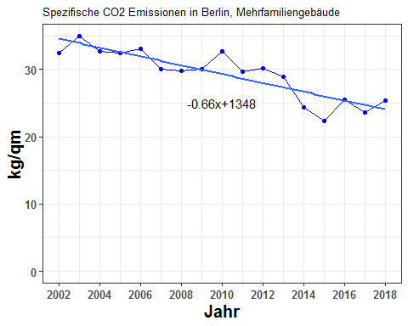

spez_co2_mfh

## abrechnungsjahr spez_co2  
## 1 2002 32.46837  
## 2 2003 34.94756  
## 3 2004 32.68190  
## 4 2005 32.38649  
## 5 2006 33.09042  
## 6 2007 30.07520  
## 7 2008 29.76287  
## 8 2009 29.99513  
## 9 2010 32.62800  
## 10 2011 29.69706  
## 11 2012 30.10942  
## 12 2013 28.92906  
## 13 2014 24.38071  
## 14 2015 22.38607  
## 15 2016 25.50319  
## 16 2017 23.57163  
## 17 2018 25.34402

i_subsubsection <- i_subsubsection + 1

### 3.2.2. Stadtbezirke, Mehrfamiliengebäude, flächenbezogene CO2-Emission aus Beheizung von Wohnraum 2002 - 2008 in kg/m2[AN]

BOOKMARK - Section 3.2.2.

bezirke_spez_co2_mfh <- 1e6*berlin_co2_mfh/bezirk_areas_mfh  
bezirke_spez_co2_mfh$abrechnungsjahr <- 2002:2018

plot_reqdColumns(bezirke_spez_co2_mfh,  
 xVar = "abrechnungsjahr",  
 cols_to_plot = names(bezirke_spez_co2_mfh)[!(names(bezirke_spez_co2_mfh) %in% c("abrechnungsjahr","total"))],  
 yColsName = "Bezirk",  
 yVar = "CO2 Emissions in kg/m2",  
 xlabel = "Jahr",  
 ylabel = "kg / qm",  
 plot_title = "Spezifische CO2 Emissionen von Stadtbezirken,\nMehrfamiliengebäude")

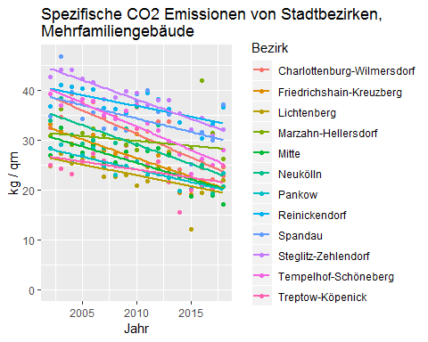

reqdCols <- names(bezirke_spez_co2_mfh)[!(names(bezirke_spez_co2_mfh) %in% c("abrechnungsjahr" , "total"))]  
ymax <- max(bezirke_spez_co2_mfh [ , reqdCols])  
g_co2spez_bezirk <- list()  
for (ii in 1:12) {  
 g_co2spez_bezirk[[ii]] <- points_line_lm(input_data = bezirke_spez_co2_mfh,  
 xVar = "abrechnungsjahr",  
 yVar = bezirk_list[ii],  
 ymin=0,  
 ymax=ymax,  
 x_eq = 2010,  
 y_eq = 0.5*ymax,  
 size_eq = 4,  
 plot_title = bezirk_name[ii],  
 xlab = "Jahr",  
 ylab = "kg/qm")  
}  
require(grid)  
require(gridExtra)  
grid.arrange(g_co2spez_bezirk[[1]],g_co2spez_bezirk[[2]],g_co2spez_bezirk[[3]],g_co2spez_bezirk[[4]],  
 g_co2spez_bezirk[[5]],g_co2spez_bezirk[[6]],g_co2spez_bezirk[[7]],g_co2spez_bezirk[[8]],  
 g_co2spez_bezirk[[9]],g_co2spez_bezirk[[10]],g_co2spez_bezirk[[11]],g_co2spez_bezirk[[12]],ncol=3)

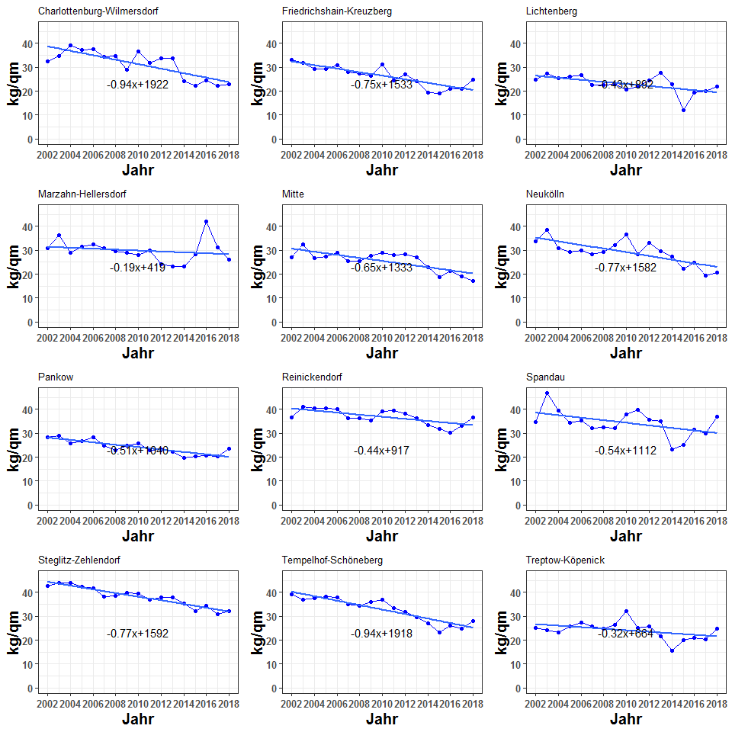

bezirke_spez_co2_mfh

## abrechnungsjahr charlottenburg_wilmersdorf friedrichshain_kreuzberg  
## 1 2002 32.45739 33.14194  
## 2 2003 34.69192 31.81015  
## 3 2004 39.26746 29.34786  
## 4 2005 37.24728 29.30006  
## 5 2006 37.62357 30.99258  
## 6 2007 34.43346 27.85949  
## 7 2008 34.68640 27.36206  
## 8 2009 28.96090 26.54181  
## 9 2010 36.56290 31.25968  
## 10 2011 31.74961 24.56192  
## 11 2012 33.79463 26.89928  
## 12 2013 33.65661 24.19317  
## 13 2014 24.14486 19.47171  
## 14 2015 22.24167 19.13097  
## 15 2016 24.51892 20.89169  
## 16 2017 22.18191 20.85792  
## 17 2018 22.77668 24.69314  
## lichtenberg marzahn_hellersdorf mitte neukoelln pankow  
## 1 24.77535 30.89632 26.98204 33.84605 28.32174  
## 2 27.21243 36.18314 32.43484 38.43980 29.04950  
## 3 25.41925 29.07727 26.82648 31.01750 25.73006  
## 4 26.04215 31.40941 27.49646 29.33523 26.86082  
## 5 26.63125 32.37537 28.97500 29.89915 28.32913  
## 6 22.63251 31.00306 25.30420 28.28332 24.70516  
## 7 22.59310 29.51380 25.49077 29.41078 22.96761  
## 8 23.01438 29.00847 27.64766 32.30085 24.85205  
## 9 20.79991 27.95520 29.02955 36.78841 25.62888  
## 10 21.80650 30.06338 27.85975 28.19772 23.01807  
## 11 24.35438 24.23404 28.30166 33.02537 23.26363  
## 12 27.56904 23.36353 27.08607 29.68001 22.41522  
## 13 22.97313 23.35294 22.73741 27.23623 19.75273  
## 14 12.04123 28.22433 18.69400 22.28700 20.19323  
## 15 19.52163 41.94049 21.14932 24.90648 20.61183  
## 16 20.04367 31.32036 18.99154 19.24263 20.45117  
## 17 21.87023 26.18104 17.05153 20.65605 23.37915  
## reinickendorf spandau steglitz_zehlendorf tempelhof_schoeneberg  
## 1 36.73327 34.77732 42.58190 39.27927  
## 2 41.12471 46.72340 44.10226 36.86729  
## 3 40.62062 39.63768 44.07849 37.60038  
## 4 40.41264 34.29313 42.23425 38.11222  
## 5 40.06740 35.45751 41.62927 37.79590  
## 6 36.38603 32.30872 38.16634 35.04619  
## 7 36.17954 32.33223 38.63454 34.26898  
## 8 35.39212 32.00690 39.82395 35.90616  
## 9 39.20637 37.78684 39.36034 37.05470  
## 10 39.49257 39.96928 36.90360 33.42820  
## 11 38.12368 35.68144 38.01819 31.94749  
## 12 36.29831 35.11059 38.00860 29.71831  
## 13 33.57273 23.07119 35.28004 27.07684  
## 14 31.96260 25.20390 32.13771 23.10823  
## 15 30.31405 31.59085 34.36970 26.14349  
## 16 33.18718 30.00355 30.81725 24.95632  
## 17 36.63411 37.09532 32.13333 28.09088  
## treptow_koepenick total  
## 1 24.99346 32.46837  
## 2 24.24195 34.94756  
## 3 23.15798 32.68190  
## 4 25.64128 32.38649  
## 5 27.31693 33.09042  
## 6 25.92698 30.07520  
## 7 24.77544 29.76287  
## 8 26.42177 29.99513  
## 9 32.21915 32.62800  
## 10 25.12857 29.69706  
## 11 25.69084 30.10942  
## 12 21.58130 28.92906  
## 13 15.52545 24.38071  
## 14 19.92357 22.38607  
## 15 21.05610 25.50319  
## 16 20.38394 23.57163  
## 17 24.73010 25.34402

i_subsubsection <- i_subsubsection + 1

### 3.2.3. Stadtbezirke, Mehrfamiliengebäude, flächenbezogene CO2-Emission aus der Beheizung von Wohnraum im Jahr 2018 in kg/m2[AN]

bezirke_spez_co2_mfh_linear <- linearizer(bezirke_spez_co2_mfh , dropCols = NULL , xVar = "abrechnungsjahr")

#bezirke_spez_co2_mfh_linear

bezirke_spez_co2_mfh_linear_2018 <- bezirke_spez_co2_mfh_linear[bezirke_spez_co2_mfh_linear$abrechnungsjahr==2018 , ]  
bezirke_spezco2_mfh_linear_2018 <- as.data.frame(t(bezirke_spez_co2_mfh_linear_2018))  
bezirke_spezco2_mfh_linear_2018$bezirk <- row.names(bezirke_spezco2_mfh_linear_2018)  
names(bezirke_spezco2_mfh_linear_2018) <- c("wert","bezirk")  
bezirke_spezco2_mfh_linear_2018 <- bezirke_spezco2_mfh_linear_2018[bezirke_spezco2_mfh_linear_2018$bezirk!="abrechnungsjahr" , ]  
bezirke_spezco2_mfh_linear_2018 <- bezirke_spezco2_mfh_linear_2018[bezirke_spezco2_mfh_linear_2018$bezirk!="total" , ]  
#bezirke_spezco2_mfh_linear_2018

plot_spezCO2_2018(obj = bezirke_spezco2_mfh_linear_2018 ,   
 plot_title = "Spezifische CO2 Emissionen 2018, Mehrfamiliengebäude")

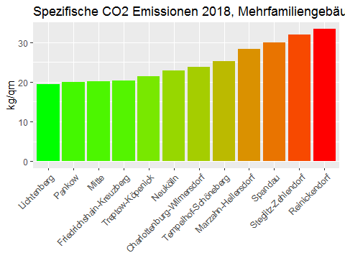

bezirke_spezco2_mfh_linear_2018

## wert bezirk  
## charlottenburg_wilmersdorf 23.71006 charlottenburg_wilmersdorf  
## friedrichshain_kreuzberg 20.37490 friedrichshain_kreuzberg  
## lichtenberg 19.44274 lichtenberg  
## marzahn_hellersdorf 28.22129 marzahn_hellersdorf  
## mitte 20.21140 mitte  
## neukoelln 22.91205 neukoelln  
## pankow 20.04699 pankow  
## reinickendorf 33.30245 reinickendorf  
## spandau 30.00880 spandau  
## steglitz_zehlendorf 31.95092 steglitz_zehlendorf  
## tempelhof_schoeneberg 25.22699 tempelhof_schoeneberg  
## treptow_koepenick 21.49346 treptow_koepenick

i_subsubsection <- i_subsubsection + 1

### 3.2.4. Berlin, Mehrfamiliengebäude, flächenbezogene CO2-Emission aus Beheizung von Wohnraum nach Stadtbezirken, 2002 - 2008, 2002 = 100

#get2002as100(spez_co2_mfh , "abrechnungsjahr")

points_line_lm(input_data = get2002as100(spez_co2_mfh , "abrechnungsjahr"),  
 xVar = "abrechnungsjahr",  
 yVar = "spez_co2",  
 ymin=0,  
 ymax=110,  
 x_eq = 2010,  
 y_eq = 60,  
 size_eq = 4,  
 plot_title = "Spezifische CO2 Emissionen in Berlin, Mehrfamiliengebäude, 2002 Wert = 100",  
 xlab = "Jahr",  
 ylab = " ")

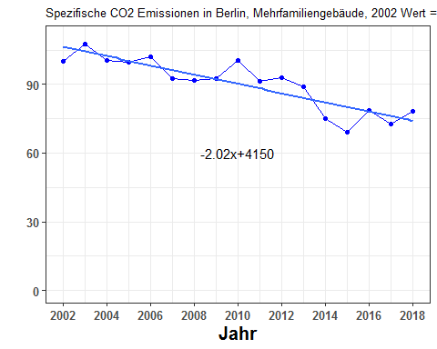

get2002as100(spez_co2_mfh , "abrechnungsjahr")

## abrechnungsjahr spez_co2  
## 1 2002 100.00000  
## 2 2003 107.63571  
## 3 2004 100.65766  
## 4 2005 99.74783  
## 5 2006 101.91587  
## 6 2007 92.62924  
## 7 2008 91.66728  
## 8 2009 92.38264  
## 9 2010 100.49165  
## 10 2011 91.46458  
## 11 2012 92.73462  
## 12 2013 89.09921  
## 13 2014 75.09067  
## 14 2015 68.94733  
## 15 2016 78.54783  
## 16 2017 72.59875  
## 17 2018 78.05759

i_subsubsection <- i_subsubsection + 1

### 3.2.5. Alle Stadtbezirke, Mehrfamiliengebäude, flächenbezogene CO2-Emission aus der Beheizung von Wohnraum, Entwicklung 2002 - 2018 und Niveau 2018 (Rang¬folge)

Take the Berlin specific CO2 emission for 2018 as the baseline, Subtract from this the 2018 value of specific co2 emission of Stadtbezirk X. Do for all the bezirks and make a barplot.

spez_co2_mfh_linear <- linearizer(spez_co2_mfh,dropCols=NULL,xVar="abrechnungsjahr")  
spez_co2_mfh_linear_2018 <- spez_co2_mfh_linear$spez_co2[spez_co2_mfh_linear$abrechnungsjahr==2018]  
#spez_co2_mfh_linear_2018

#bezirke_spezco2_mfh_linear_2018

bezirke_spezco2_mfh_linear_2018$dev_from_berlin <- bezirke_spezco2_mfh_linear_2018$wert - spez_co2_mfh_linear_2018

plot_devFromBerlin2018(bezirke_spezco2_mfh_linear_2018,  
 "2018 deviation from Berlin, Mehrfamiliengebäude",  
 "some y-label")

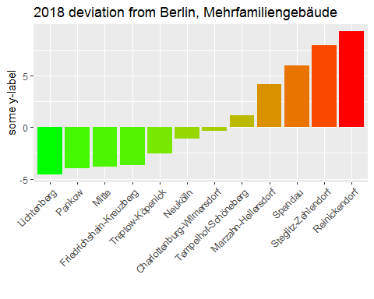

bezirke_spezco2_mfh_linear_2018

## wert bezirk  
## charlottenburg_wilmersdorf 23.71006 charlottenburg_wilmersdorf  
## friedrichshain_kreuzberg 20.37490 friedrichshain_kreuzberg  
## lichtenberg 19.44274 lichtenberg  
## marzahn_hellersdorf 28.22129 marzahn_hellersdorf  
## mitte 20.21140 mitte  
## neukoelln 22.91205 neukoelln  
## pankow 20.04699 pankow  
## reinickendorf 33.30245 reinickendorf  
## spandau 30.00880 spandau  
## steglitz_zehlendorf 31.95092 steglitz_zehlendorf  
## tempelhof_schoeneberg 25.22699 tempelhof_schoeneberg  
## treptow_koepenick 21.49346 treptow_koepenick  
## dev_from_berlin  
## charlottenburg_wilmersdorf -0.3348077  
## friedrichshain_kreuzberg -3.6699727  
## lichtenberg -4.6021340  
## marzahn_hellersdorf 4.1764167  
## mitte -3.8334709  
## neukoelln -1.1328187  
## pankow -3.9978869  
## reinickendorf 9.2575814  
## spandau 5.9639235  
## steglitz_zehlendorf 7.9060493  
## tempelhof_schoeneberg 1.1821175  
## treptow_koepenick -2.5514156

i_subsubsection <- i_subsubsection + 1

### 3.2.6. Berlin, Mehrfamiliengebäude, durchschnittliche Emissionsminderung je qm Nutzfläche im Zeitraum 2012 - 2018

barPlot_delta2012(changeFrom2012(spez_co2_mfh),"some-y-label" , "some title")

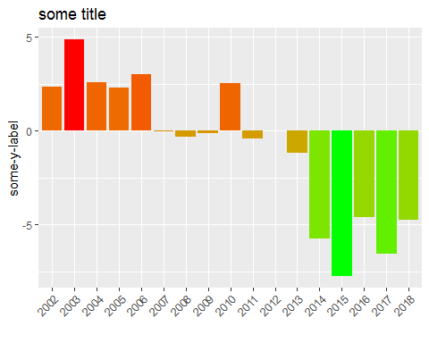

changeFrom2012(spez_co2_mfh)

## abrechnungsjahr spez_co2 delta2012  
## 1 2002 32.46837 2.35894905  
## 2 2003 34.94756 4.83814062  
## 3 2004 32.68190 2.57248013  
## 4 2005 32.38649 2.27707370  
## 5 2006 33.09042 2.98099928  
## 6 2007 30.07520 -0.03421669  
## 7 2008 29.76287 -0.34654984  
## 8 2009 29.99513 -0.11428249  
## 9 2010 32.62800 2.51858007  
## 10 2011 29.69706 -0.41236087  
## 11 2012 30.10942 0.00000000  
## 12 2013 28.92906 -1.18036026  
## 13 2014 24.38071 -5.72870229  
## 14 2015 22.38607 -7.72334458  
## 15 2016 25.50319 -4.60622119  
## 16 2017 23.57163 -6.53778802  
## 17 2018 25.34402 -4.76539347

i_subsection <- i_subsection + 1  
i_subsubsection <- 1

## 3.3. Emission pro Einwohner

### 3.3.1. Stadtbezirke, Mehrfamiliengebäude, CO2-Emission aus der Beheizung von Wohnraum pro Einwohner

i_subsubsection <- i_subsubsection + 1

### 3.3.2. Stadtbezirke, Mehrfamiliengebäude, CO2-Emission pro Einwohner aus der Beheizung von Wohnraum, 2002 - 2008, 2002 = 100

i_subsubsection <- i_subsubsection + 1

### 3.3.3. Stadtbezirke, Mehrfamiliengebäude, CO2-Emissionen aus der Beheizung von Wohnraum pro Einwohner, Niveau im Jahr 2018 in t/Einwohner

i_subsubsection <- i_subsubsection + 1

### 3.3.4. Stadtbezirke, Mehrfamiliengebäude, CO2-Emissionen aus der Beheizung von Wohnraum pro Einwohner, Veränderung 2002 / 2018 in Prozent

i_subsection <- i_subsection + 1  
i_subsubsection <- 1

## 3.4. Prognose

### 3.4.1. Berlin, Mehrfamiliengebäude, Prognose der CO2-Emission aus Behei¬zung 2019 - 2030 in Mio. t (Trend Polynom 2. Grades)

quadmodel_mfh <- lm(total~abrechnungsjahr+I(abrechnungsjahr^2),data=berlin_co2_mfh)  
from2002_till_2030 <- data.frame(abrechnungsjahr=2002:2030)  
prognose_mfh <- data.frame(abrechnungsjahr = 2002:2030 , pred = as.numeric(predict(quadmodel_mfh,newdata=from2002_till_2030)))  
ggplot(prognose_mfh , aes(x=abrechnungsjahr , y = pred))+geom_point()

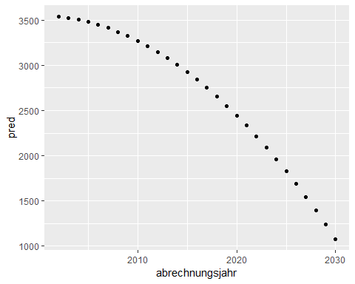

prognose_mfh

## abrechnungsjahr pred  
## 1 2002 3540.447  
## 2 2003 3525.819  
## 3 2004 3505.760  
## 4 2005 3480.270  
## 5 2006 3449.349  
## 6 2007 3412.996  
## 7 2008 3371.213  
## 8 2009 3323.999  
## 9 2010 3271.354  
## 10 2011 3213.279  
## 11 2012 3149.772  
## 12 2013 3080.834  
## 13 2014 3006.465  
## 14 2015 2926.665  
## 15 2016 2841.435  
## 16 2017 2750.773  
## 17 2018 2654.680  
## 18 2019 2553.157  
## 19 2020 2446.202  
## 20 2021 2333.817  
## 21 2022 2216.000  
## 22 2023 2092.753  
## 23 2024 1964.075  
## 24 2025 1829.965  
## 25 2026 1690.425  
## 26 2027 1545.454  
## 27 2028 1395.052  
## 28 2029 1239.219  
## 29 2030 1077.955

Johannes used to use the index of the years, with 0 for 2002, 1 for 2003, and so on. I should do the same:

berlin_co2_mfh_temp <- berlin_co2_mfh  
berlin_co2_mfh_temp$jahrIndex <- berlin_co2_mfh_temp$abrechnungsjahr - 2002  
quadmodel2_mfh <- lm(total~jahrIndex+I(jahrIndex^2),data=berlin_co2_mfh_temp)  
from2002_till_2030_index <- data.frame(jahrIndex=(2002:2030) - 2002)  
prognose2_mfh <- data.frame(jahrIndex = (2002:2030)-2002 , pred = as.numeric(predict(quadmodel2_mfh,newdata=from2002_till_2030_index)))  
ggplot(prognose2_mfh , aes(x=jahrIndex , y = pred))+geom_point()

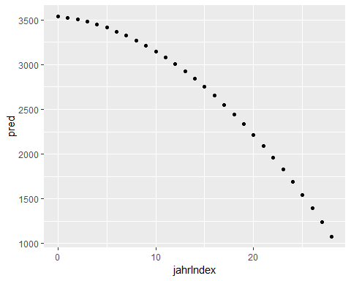

Apparently makes no difference…

i_subsection <- i_subsection + 1

## 3.5. Diskussion

i_section <- i_section + 1  
i_subsection <- 1

# 4. Heizenergieverbrauch nach Stadtbezirken 2002 - 2018, alle Wohngebäude

## 4.1. Stadtbezirke, alle Wohngebäude, Heizenergieverbrauch 2002 - 2018

* getAllBezirkeTotalCO2.R and getAllBezirkeByETCO2.R both invoke mainScriptCO2Emissions_v2.R.
* mainScriptCO2Emissions_v2.R creates the attribute energy_shares_absolute. This is the energy produced by the respective ETs.
* So modify the returned object in getAllBezirkeTotalCO2.R and getAllBezirkeByETCO2.R so that it includes the energy_shares_absolute as well.
* Total energy split by ET:

by_ten_9 <- 1e-9  
aes_by_ET_TWh <- by_ten_9 * co2_allebezirke_byET$aes_all  
aes_by_ET_TWh$abrechnungsjahr <- 2002:2018  
aes_by_ET_TWh_cumsums <- getCumSums(obj=aes_by_ET_TWh , dropCols = c("abrechnungsjahr","total"))

points_line_lm(input_data = aes_by_ET_TWh,  
 xVar = "abrechnungsjahr",  
 yVar = "total",  
 ymin = 0,  
 ymax = max(aes_by_ET_TWh$total),  
 x_eq = 2010,  
 y_eq = 0.1,  
 size_eq = 4,  
 plot_title = "Energieverbrauch in Berlin, alle Wohnungen",  
 xlab = "Jahr",  
 ylab = "TWh",  
 slope_round_to = 4)

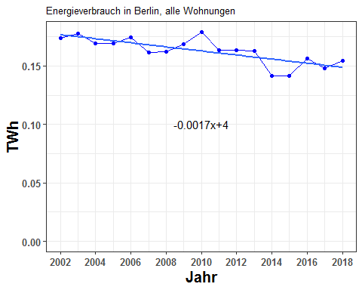

aes_by_ET_TWh[ , c("abrechnungsjahr" , "total")]

## abrechnungsjahr total  
## 1 2002 0.1738874  
## 2 2003 0.1776849  
## 3 2004 0.1690847  
## 4 2005 0.1696637  
## 5 2006 0.1742836  
## 6 2007 0.1617350  
## 7 2008 0.1619519  
## 8 2009 0.1686783  
## 9 2010 0.1790742  
## 10 2011 0.1635207  
## 11 2012 0.1632793  
## 12 2013 0.1628974  
## 13 2014 0.1417215  
## 14 2015 0.1417530  
## 15 2016 0.1562276  
## 16 2017 0.1479574  
## 17 2018 0.1542095

plot_byET(aes_by_ET_TWh_cumsums , xlabel = "Jahr" , ylabel = "TWh" , plottitle = "Energieverbrauch in Berlin, alle Wohngebäude, nach Energieträgern")

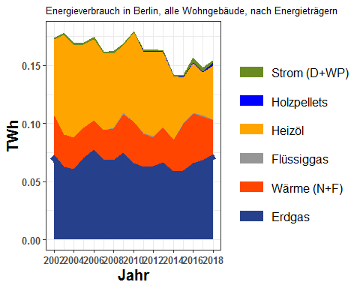

aes_by_ET_TWh

## erdgas waerme fluessiggas heizoel holzpellets strom  
## 1 0.07276275 0.03408182 0.000000e+00 0.06564065 0.000000e+00 0.0014021990  
## 2 0.06282411 0.02760151 0.000000e+00 0.08585709 0.000000e+00 0.0014021990  
## 3 0.06096521 0.02703600 8.237962e-05 0.07959893 0.000000e+00 0.0014021990  
## 4 0.07068205 0.02562668 3.307079e-04 0.07160968 1.241918e-05 0.0014021990  
## 5 0.07749104 0.02506546 3.668356e-04 0.06994393 1.409146e-05 0.0014021990  
## 6 0.06891437 0.02549882 1.612907e-04 0.06574334 1.494333e-05 0.0014021990  
## 7 0.06865953 0.02678282 9.930377e-04 0.06406811 4.621443e-05 0.0014021990  
## 8 0.07475693 0.03352604 8.401592e-04 0.05803491 1.180188e-04 0.0014021990  
## 9 0.06586649 0.03549504 4.301316e-04 0.07669328 1.850682e-04 0.0004042022  
## 10 0.06264699 0.02857603 5.870217e-04 0.07064601 3.864035e-04 0.0006782036  
## 11 0.06325932 0.02473900 1.414681e-03 0.07247019 4.658033e-04 0.0009303315  
## 12 0.06685646 0.02917647 8.415863e-04 0.06501710 5.126081e-04 0.0004931385  
## 13 0.05902402 0.02676419 4.456608e-04 0.05466535 8.222168e-05 0.0007400307  
## 14 0.05972538 0.03998382 3.946685e-04 0.03985700 2.940997e-04 0.0014979973  
## 15 0.06614639 0.04239079 5.458192e-04 0.04310562 6.658707e-04 0.0033730745  
## 16 0.06848892 0.03762448 1.031657e-03 0.03697530 9.537100e-04 0.0028833002  
## 17 0.07368782 0.02944343 6.097291e-04 0.04604101 2.807992e-03 0.0016195127  
## abrechnungsjahr total  
## 1 2002 0.1738874  
## 2 2003 0.1776849  
## 3 2004 0.1690847  
## 4 2005 0.1696637  
## 5 2006 0.1742836  
## 6 2007 0.1617350  
## 7 2008 0.1619519  
## 8 2009 0.1686783  
## 9 2010 0.1790742  
## 10 2011 0.1635207  
## 11 2012 0.1632793  
## 12 2013 0.1628974  
## 13 2014 0.1417215  
## 14 2015 0.1417530  
## 15 2016 0.1562276  
## 16 2017 0.1479574  
## 17 2018 0.1542095

* Total energy split by bezirk:

by_ten_9 <- 1e-9  
aes_by_bezirk_TWh <- by_ten_9 * alle_bezirke_co2$aes_all  
aes_by_bezirk_TWh$abrechnungsjahr <- 2002:2018  
aes_by_bezirk_TWh_cumsums <- getCumSums(obj=aes_by_bezirk_TWh , dropCols = "abrechnungsjahr")

plot_byBezirke(aes_by_bezirk_TWh_cumsums , xlabel = "Jahr" , ylabel = "TWh" , plottitle="Energieverbrauch in Berlin, alle Wohngebäude, nach Bezirk")

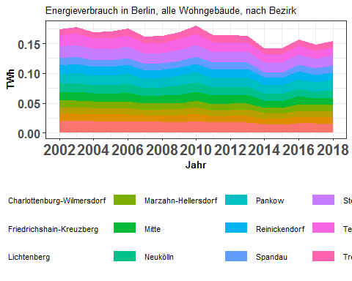

aes_by_bezirk_TWh

## abrechnungsjahr charlottenburg_wilmersdorf friedrichshain_kreuzberg  
## 1 2002 0.02056930 0.012601162  
## 2 2003 0.01947896 0.012308522  
## 3 2004 0.01971218 0.011515207  
## 4 2005 0.01905369 0.011522096  
## 5 2006 0.01967211 0.011646211  
## 6 2007 0.01866483 0.010842707  
## 7 2008 0.01837063 0.010414274  
## 8 2009 0.01797911 0.011206353  
## 9 2010 0.01997899 0.012606370  
## 10 2011 0.01717365 0.010571487  
## 11 2012 0.01760947 0.010801474  
## 12 2013 0.01772155 0.010639259  
## 13 2014 0.01448168 0.009124327  
## 14 2015 0.01427768 0.009615560  
## 15 2016 0.01641859 0.010787497  
## 16 2017 0.01590434 0.010643913  
## 17 2018 0.01559906 0.011531901  
## lichtenberg marzahn_hellersdorf mitte neukoelln pankow  
## 1 0.010346350 0.011602053 0.01253993 0.01458647 0.01666747  
## 2 0.010645083 0.011927357 0.01420296 0.01483361 0.01726239  
## 3 0.010636608 0.011176681 0.01307703 0.01414639 0.01602723  
## 4 0.010107949 0.011184999 0.01356770 0.01437222 0.01639901  
## 5 0.011097848 0.011186048 0.01439023 0.01499376 0.01668113  
## 6 0.009273411 0.011086949 0.01242849 0.01346809 0.01544396  
## 7 0.010479395 0.010566376 0.01345748 0.01374220 0.01545381  
## 8 0.010160321 0.010664800 0.01467927 0.01487231 0.01678418  
## 9 0.010348584 0.011354233 0.01454819 0.01568388 0.01749993  
## 10 0.009825253 0.011218439 0.01396212 0.01337870 0.01597693  
## 11 0.010104309 0.010820548 0.01369059 0.01376584 0.01607921  
## 12 0.011270087 0.010290538 0.01413710 0.01400898 0.01603305  
## 13 0.009354912 0.008725347 0.01272870 0.01235206 0.01476532  
## 14 0.008327827 0.009680190 0.01181564 0.01185425 0.01496278  
## 15 0.010367155 0.010895177 0.01274030 0.01284021 0.01598270  
## 16 0.009276495 0.011079803 0.01092230 0.01174522 0.01519813  
## 17 0.009104472 0.011784907 0.01150169 0.01225512 0.01649426  
## reinickendorf spandau steglitz_zehlendorf tempelhof_schoeneberg  
## 1 0.01471641 0.011955543 0.01956343 0.01852145  
## 2 0.01483627 0.013103266 0.01955477 0.01880860  
## 3 0.01431104 0.011625180 0.01878948 0.01787866  
## 4 0.01411371 0.011516848 0.01875426 0.01816902  
## 5 0.01436174 0.011827938 0.01896182 0.01830079  
## 6 0.01356175 0.010679781 0.01783761 0.01736587  
## 7 0.01355615 0.010597612 0.01781614 0.01696434  
## 8 0.01359500 0.010672167 0.01845044 0.01789139  
## 9 0.01423557 0.011740696 0.01907780 0.01867142  
## 10 0.01359310 0.012041021 0.01753816 0.01673671  
## 11 0.01348887 0.011228263 0.01766789 0.01657435  
## 12 0.01350431 0.010876574 0.01775745 0.01600310  
## 13 0.01198205 0.008100502 0.01655819 0.01439913  
## 14 0.01203914 0.008787955 0.01640753 0.01426870  
## 15 0.01320579 0.010953503 0.01730656 0.01457668  
## 16 0.01281333 0.010362612 0.01667775 0.01361002  
## 17 0.01313580 0.011352507 0.01722785 0.01395958  
## treptow_koepenick  
## 1 0.010217841  
## 2 0.010723111  
## 3 0.010189023  
## 4 0.010902223  
## 5 0.011163920  
## 6 0.011081515  
## 7 0.010533507  
## 8 0.011722918  
## 9 0.013328544  
## 10 0.011505102  
## 11 0.011448497  
## 12 0.010655384  
## 13 0.009149261  
## 14 0.009715705  
## 15 0.010153393  
## 16 0.009723461  
## 17 0.010262348

i_subsection <- i_subsection+1

## 4.2. Stadtbezirke, alle Wohngebäude, Heizenergieverbrauch 2002 - 2018

Eine Grafik: Heizenergieverbrauch aller 12 Bezirke in einer Grafik) One Graph: All 12 lines in a single graph.

#aes_by_bezirk_kWh <- 1e9 * aes_by_bezirk_TWh  
#aes_by_bezirk_kWh$abrechnungsjahr <- 2002:2018  
#aes_by_bezirk_TWh

plot_reqdColumns(aes_by_bezirk_TWh,  
 xVar = "abrechnungsjahr",  
 cols_to_plot = names(aes_by_bezirk_TWh)[!(names(aes_by_bezirk_TWh) %in% c("abrechnungsjahr"))],  
 yColsName = "Bezirk",  
 yVar = "Energy in TWh",  
 xlab = "Jahr",  
 ylab = "TWh",  
 plot_title = "Energieverbrauch in Stadtbezirken, alle Wohngebäude")

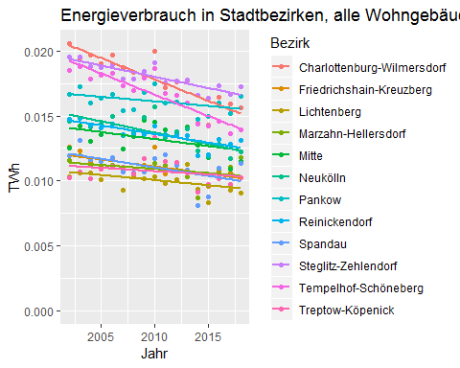

max_aes_value <- max(aes_by_bezirk_TWh[ , names(aes_by_bezirk_TWh)[!(names(aes_by_bezirk_TWh) %in% c("abrechnungsjahr","total"))]])  
require(ggplot2)  
g_aes_bezirk <- list()  
for (ii in 1:12) {  
 g_aes_bezirk[[ii]] <- points_line_lm(input_data = aes_by_bezirk_TWh,  
 xVar = "abrechnungsjahr",  
 yVar = bezirk_list[ii],  
 ymin=0,  
 ymax=max_aes_value,  
 x_eq = 2010,  
 y_eq = 0.5*max_aes_value,  
 size_eq = 4,  
 plot_title = bezirk_name[ii],  
 xlab = "Jahr",  
 ylab = "TWh",  
 slope_round_to = 4,  
 intercept_round_to = 2)  
}  
require(grid)  
require(gridExtra)  
grid.arrange(g_aes_bezirk[[1]],g_aes_bezirk[[2]],g_aes_bezirk[[3]],g_aes_bezirk[[4]],  
 g_aes_bezirk[[5]],g_aes_bezirk[[6]],g_aes_bezirk[[7]],g_aes_bezirk[[8]],  
 g_aes_bezirk[[9]],g_aes_bezirk[[10]],g_aes_bezirk[[11]],g_aes_bezirk[[12]],ncol=3)

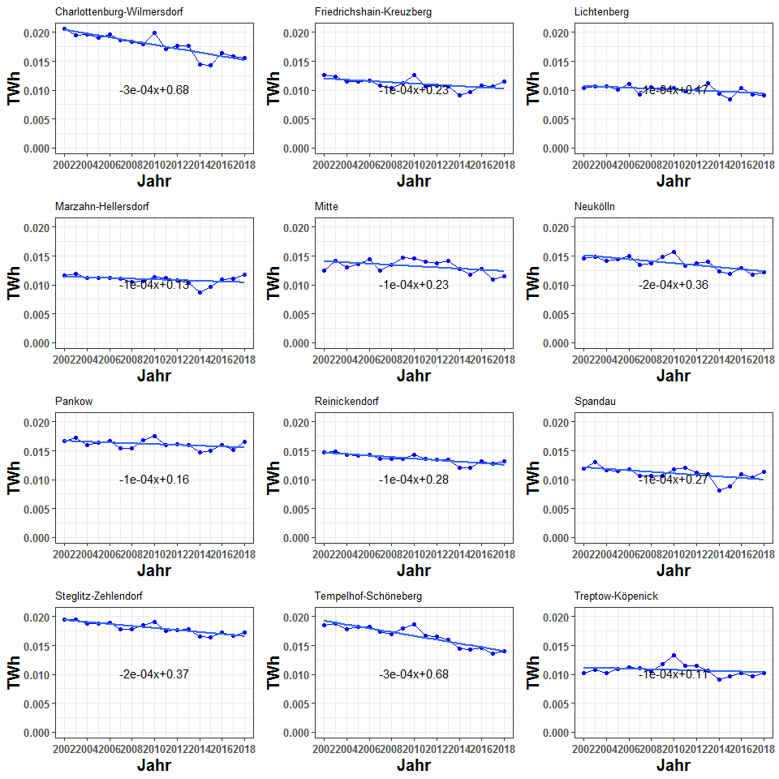

aes_by_bezirk_TWh

## abrechnungsjahr charlottenburg_wilmersdorf friedrichshain_kreuzberg  
## 1 2002 0.02056930 0.012601162  
## 2 2003 0.01947896 0.012308522  
## 3 2004 0.01971218 0.011515207  
## 4 2005 0.01905369 0.011522096  
## 5 2006 0.01967211 0.011646211  
## 6 2007 0.01866483 0.010842707  
## 7 2008 0.01837063 0.010414274  
## 8 2009 0.01797911 0.011206353  
## 9 2010 0.01997899 0.012606370  
## 10 2011 0.01717365 0.010571487  
## 11 2012 0.01760947 0.010801474  
## 12 2013 0.01772155 0.010639259  
## 13 2014 0.01448168 0.009124327  
## 14 2015 0.01427768 0.009615560  
## 15 2016 0.01641859 0.010787497  
## 16 2017 0.01590434 0.010643913  
## 17 2018 0.01559906 0.011531901  
## lichtenberg marzahn_hellersdorf mitte neukoelln pankow  
## 1 0.010346350 0.011602053 0.01253993 0.01458647 0.01666747  
## 2 0.010645083 0.011927357 0.01420296 0.01483361 0.01726239  
## 3 0.010636608 0.011176681 0.01307703 0.01414639 0.01602723  
## 4 0.010107949 0.011184999 0.01356770 0.01437222 0.01639901  
## 5 0.011097848 0.011186048 0.01439023 0.01499376 0.01668113  
## 6 0.009273411 0.011086949 0.01242849 0.01346809 0.01544396  
## 7 0.010479395 0.010566376 0.01345748 0.01374220 0.01545381  
## 8 0.010160321 0.010664800 0.01467927 0.01487231 0.01678418  
## 9 0.010348584 0.011354233 0.01454819 0.01568388 0.01749993  
## 10 0.009825253 0.011218439 0.01396212 0.01337870 0.01597693  
## 11 0.010104309 0.010820548 0.01369059 0.01376584 0.01607921  
## 12 0.011270087 0.010290538 0.01413710 0.01400898 0.01603305  
## 13 0.009354912 0.008725347 0.01272870 0.01235206 0.01476532  
## 14 0.008327827 0.009680190 0.01181564 0.01185425 0.01496278  
## 15 0.010367155 0.010895177 0.01274030 0.01284021 0.01598270  
## 16 0.009276495 0.011079803 0.01092230 0.01174522 0.01519813  
## 17 0.009104472 0.011784907 0.01150169 0.01225512 0.01649426  
## reinickendorf spandau steglitz_zehlendorf tempelhof_schoeneberg  
## 1 0.01471641 0.011955543 0.01956343 0.01852145  
## 2 0.01483627 0.013103266 0.01955477 0.01880860  
## 3 0.01431104 0.011625180 0.01878948 0.01787866  
## 4 0.01411371 0.011516848 0.01875426 0.01816902  
## 5 0.01436174 0.011827938 0.01896182 0.01830079  
## 6 0.01356175 0.010679781 0.01783761 0.01736587  
## 7 0.01355615 0.010597612 0.01781614 0.01696434  
## 8 0.01359500 0.010672167 0.01845044 0.01789139  
## 9 0.01423557 0.011740696 0.01907780 0.01867142  
## 10 0.01359310 0.012041021 0.01753816 0.01673671  
## 11 0.01348887 0.011228263 0.01766789 0.01657435  
## 12 0.01350431 0.010876574 0.01775745 0.01600310  
## 13 0.01198205 0.008100502 0.01655819 0.01439913  
## 14 0.01203914 0.008787955 0.01640753 0.01426870  
## 15 0.01320579 0.010953503 0.01730656 0.01457668  
## 16 0.01281333 0.010362612 0.01667775 0.01361002  
## 17 0.01313580 0.011352507 0.01722785 0.01395958  
## treptow_koepenick  
## 1 0.010217841  
## 2 0.010723111  
## 3 0.010189023  
## 4 0.010902223  
## 5 0.011163920  
## 6 0.011081515  
## 7 0.010533507  
## 8 0.011722918  
## 9 0.013328544  
## 10 0.011505102  
## 11 0.011448497  
## 12 0.010655384  
## 13 0.009149261  
## 14 0.009715705  
## 15 0.010153393  
## 16 0.009723461  
## 17 0.010262348

i_subsection <- i_subsection+1

## 4.3. Stadtbezirke, alle Wohngebäude, flächenbezogener Heizenergieverbrauch 2002 - 2018 in kWh/(m2[AN]*a)

* bezirk_areas_all$total gives the total areas of berlin (MFH+SFH).
* aes_by_ET_TWh$total gives the total TWh consumption.
* So the quotient will give the per unit area consumption.

spz_verbrauch_all <- data.frame(abrechnungsjahr=2002:2018,  
 kWh_per_m2 = 1e9 * aes_by_ET_TWh$total/bezirk_areas_all$total)  
points_line_lm(input_data = spz_verbrauch_all,  
 xVar = "abrechnungsjahr",  
 yVar = "kWh_per_m2",  
 ymin = 0,  
 ymax = max(spz_verbrauch_all$kWh_per_m2),  
 x_eq = 2010,  
 y_eq = 0.8,  
 size_eq = 4,  
 plot_title = "Spezifischer Energieverbrauch in Berlin, alle Wohngebäude",  
 xlab = "Jahr",  
 ylab = "kWh/m^2")

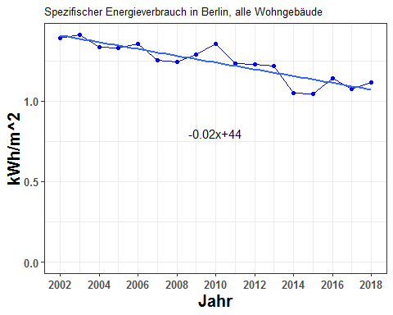

spz_verbrauch_all

## abrechnungsjahr kWh_per_m2  
## 1 2002 1.389842  
## 2 2003 1.410797  
## 3 2004 1.333688  
## 4 2005 1.329516  
## 5 2006 1.356857  
## 6 2007 1.251045  
## 7 2008 1.244700  
## 8 2009 1.288146  
## 9 2010 1.354495  
## 10 2011 1.232486  
## 11 2012 1.225124  
## 12 2013 1.216296  
## 13 2014 1.051332  
## 14 2015 1.043839  
## 15 2016 1.141170  
## 16 2017 1.072288  
## 17 2018 1.113854

i_subsection <- i_subsection+1

## 4.4. Stadtbezirke, alle Wohngebäude, flächenbezogener Heizenergieverbrauch und beheizte Wohnfläche 2002 - 2018

Plot of the total area (to be combined with the specific energy consumption into one picture):

###########################################################################################  
#plot(2002:2018 , bezirk_areas_all$total,ylim=c(0,max(bezirk_areas_all$total)),col="blue")  
#par(new=TRUE)  
#plot(2002:2018, spz_verbrauch_all$kWh_per_m2,xlab="", ylab="", #ylim=c(0,max(spz_verbrauch_all$kWh_per_m2)), axes = FALSE)  
###########################################################################################  
  
#spz_verbrauch_all$kWh_per_m2  
#make a function to plot two quantities, a dual plot, one on the left axis and the other on the right axis. Plot the linearized versions of these  
  
plot_dualPlot <- function(y1 , y2 , x , xlab, ylab1 , ylab2, ylegend1, ylegend2) {  
 dframe <- data.frame(x=x , y1=y1 , y2=y2)  
 lm1 <- lm(y1~x , data = dframe)  
 lm2 <- lm(y2~x , data = dframe)  
 #replace with linear predictions  
 y1 <- as.numeric(lm1$fitted.values)  
 y2 <- as.numeric(lm2$fitted.values)  
   
 par(mar=c(5, 4, 4, 6) + 0.1)  
 plot(x,y1,ylim=c(0,max(y1)),col="black",xlab=xlab,ylab=ylab1,pch=16)  
   
 par(new=TRUE)  
   
 plot(x,y2,xlab="", ylab="", ylim=c(0,max(y2)), axes = FALSE , col = "red",pch=15)  
 mtext(ylab2, side = 4, line = 4,col="red")  
 axis(4, ylim=c(0,max(y2)), col="red",col.axis="red",las=1)  
  
 legend("bottomleft", c(ylegend1, ylegend2),  
 col = c("black", "red"), pch = c(16, 15))  
   
}

plot_dualPlot(bezirk_areas_all$total,  
 spz_verbrauch_all$kWh_per_m2,  
 2002:2018,  
 "Jahr",  
 "Area MFH + 1-2 FH Buildings (m2)",  
 "TWh/m2",  
 "Area",  
 "Energy consumption per m2")

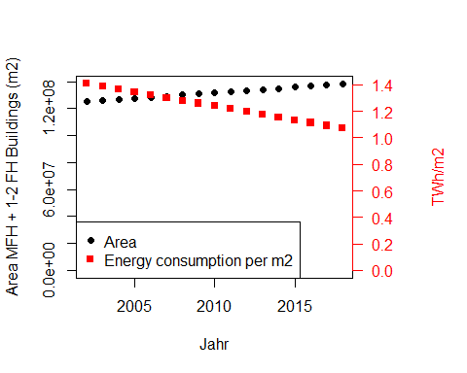

data.frame(Jahr=2002:2018 , area=bezirk_areas_all$total,  
 spez_verbrauch = spz_verbrauch_all$kWh_per_m2)

## Jahr area spez_verbrauch  
## 1 2002 125113096 1.389842  
## 2 2003 125946450 1.410797  
## 3 2004 126779804 1.333688  
## 4 2005 127613157 1.329516  
## 5 2006 128446511 1.356857  
## 6 2007 129279864 1.251045  
## 7 2008 130113218 1.244700  
## 8 2009 130946571 1.288146  
## 9 2010 132207400 1.354495  
## 10 2011 132675500 1.232486  
## 11 2012 133275700 1.225124  
## 12 2013 133929100 1.216296  
## 13 2014 134801800 1.051332  
## 14 2015 135799700 1.043839  
## 15 2016 136901200 1.141170  
## 16 2017 137982900 1.072288  
## 17 2018 138446754 1.113854

i_section <- i_section + 1  
i_subsection <- 1

# 5. Heizenergieverbrauch nach Stadtbezirken 2002 - 2018, 1-2 Familiengebäude

## 5.1. Stadtbezirke, 1-2 Familiengebäude, Heizenergieverbrauch 2002 - 2018 summiert

* Total energy split by ET:

by_ten_9 <- 1e-9  
aes_by_ET_TWh_sfh <- by_ten_9 * co2_allebezirke_byET$aes_sfh  
aes_by_ET_TWh_sfh$abrechnungsjahr <- 2002:2018  
aes_by_ET_TWh_sfh_cumsums <- getCumSums(obj=aes_by_ET_TWh_sfh , dropCols = c("abrechnungsjahr","total"))

points_line_lm(input_data = aes_by_ET_TWh_sfh,  
 xVar = "abrechnungsjahr",  
 yVar = "total",  
 ymin = 0,  
 ymax = max(aes_by_ET_TWh_sfh$total),  
 x_eq = 2010,  
 y_eq = 0.025,  
 size_eq = 4,  
 plot_title = "Energieverbrauch in Berlin, 1-2 Familiengebäude",  
 xlab = "Jahr",  
 ylab = "TWh",  
 slope_round_to = 4)

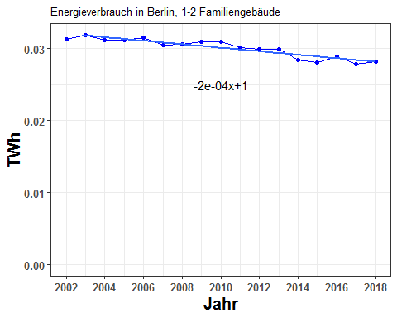

aes_by_ET_TWh_sfh[, c("abrechnungsjahr","total")]

## abrechnungsjahr total  
## 1 2002 0.03136097  
## 2 2003 0.03188876  
## 3 2004 0.03121630  
## 4 2005 0.03123803  
## 5 2006 0.03158294  
## 6 2007 0.03049158  
## 7 2008 0.03066364  
## 8 2009 0.03094417  
## 9 2010 0.03097862  
## 10 2011 0.03013689  
## 11 2012 0.02995676  
## 12 2013 0.02994512  
## 13 2014 0.02842386  
## 14 2015 0.02807894  
## 15 2016 0.02892308  
## 16 2017 0.02790134  
## 17 2018 0.02818576

plot_byET(aes_by_ET_TWh_sfh_cumsums , xlabel = "Jahr" , ylabel = "TWh" , plottitle = "Energieverbrauch in Berlin, 1-2 Familiengebäude, nach Energieträgern")

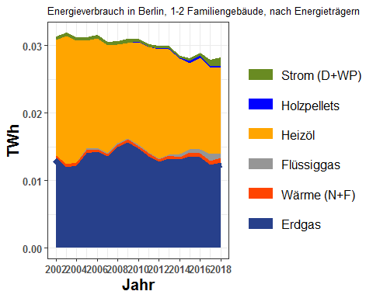

aes_by_ET_TWh_sfh

## erdgas waerme fluessiggas heizoel holzpellets  
## 1 0.01337470 0.0002740097 0.000000e+00 0.01720874 0.000000e+00  
## 2 0.01202963 0.0003970011 0.000000e+00 0.01895861 0.000000e+00  
## 3 0.01223394 0.0004297827 5.531548e-05 0.01799374 0.000000e+00  
## 4 0.01402660 0.0004896765 2.039671e-04 0.01601427 0.000000e+00  
## 5 0.01424695 0.0003720386 2.317680e-04 0.01622866 0.000000e+00  
## 6 0.01354332 0.0003890188 1.487721e-04 0.01590695 0.000000e+00  
## 7 0.01494325 0.0003524226 2.409145e-04 0.01459522 2.832020e-05  
## 8 0.01565996 0.0004414851 1.822893e-04 0.01406111 9.580300e-05  
## 9 0.01470345 0.0004044569 2.155464e-04 0.01519985 7.169748e-05  
## 10 0.01359389 0.0004764271 9.863801e-05 0.01563824 2.179239e-05  
## 11 0.01280560 0.0003203880 1.616825e-04 0.01614247 1.568023e-04  
## 12 0.01319558 0.0005146999 1.671592e-04 0.01555069 1.364416e-04  
## 13 0.01317347 0.0002911093 4.456608e-04 0.01415418 8.222168e-05  
## 14 0.01359866 0.0006109283 3.946685e-04 0.01282945 2.940997e-04  
## 15 0.01344647 0.0006052299 5.458192e-04 0.01362083 3.622767e-04  
## 16 0.01231282 0.0006029790 1.031657e-03 0.01282534 2.694082e-04  
## 17 0.01263279 0.0007254280 6.097291e-04 0.01276784 1.901044e-04  
## strom abrechnungsjahr total  
## 1 0.0005035221 2002 0.03136097  
## 2 0.0005035221 2003 0.03188876  
## 3 0.0005035221 2004 0.03121630  
## 4 0.0005035221 2005 0.03123803  
## 5 0.0005035221 2006 0.03158294  
## 6 0.0005035221 2007 0.03049158  
## 7 0.0005035221 2008 0.03066364  
## 8 0.0005035221 2009 0.03094417  
## 9 0.0003836204 2010 0.03097862  
## 10 0.0003079039 2011 0.03013689  
## 11 0.0003698144 2012 0.02995676  
## 12 0.0003805484 2013 0.02994512  
## 13 0.0002772173 2014 0.02842386  
## 14 0.0003511301 2015 0.02807894  
## 15 0.0003424613 2016 0.02892308  
## 16 0.0008591351 2017 0.02790134  
## 17 0.0012598678 2018 0.02818576

* Total energy split by bezirk:

by_ten_9 <- 1e-9  
aes_by_bezirk_TWh_sfh <- by_ten_9 * alle_bezirke_co2$aes_sfh  
aes_by_bezirk_TWh_sfh$abrechnungsjahr <- 2002:2018  
aes_by_bezirk_TWh_sfh_cumsums <- getCumSums(obj=aes_by_bezirk_TWh_sfh , dropCols = "abrechnungsjahr")

plot_byBezirke(aes_by_bezirk_TWh_sfh_cumsums , xlabel = "Jahr" , ylabel = "TWh" , plottitle="Energieverbrauch in Berlin, 1-2 Familiengebäude, nach Bezirk")

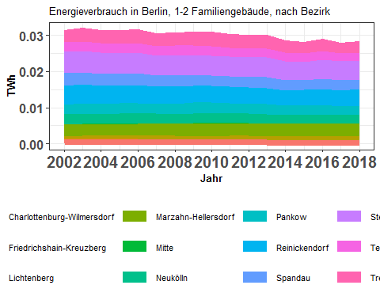

aes_by_bezirk_TWh_sfh

## abrechnungsjahr charlottenburg_wilmersdorf friedrichshain_kreuzberg  
## 1 2002 0.0012340179 8.593297e-05  
## 2 2003 0.0013152991 9.000103e-05  
## 3 2004 0.0012276634 7.668603e-05  
## 4 2005 0.0012239500 7.456248e-05  
## 5 2006 0.0012051856 7.172745e-05  
## 6 2007 0.0011812972 6.287678e-05  
## 7 2008 0.0011515396 6.086307e-05  
## 8 2009 0.0011246333 6.243335e-05  
## 9 2010 0.0011230201 5.633951e-05  
## 10 2011 0.0012279860 5.921415e-05  
## 11 2012 0.0011266930 5.356043e-05  
## 12 2013 0.0010640499 5.253745e-05  
## 13 2014 0.0009522346 4.501432e-05  
## 14 2015 0.0009879918 4.704828e-05  
## 15 2016 0.0010256174 5.330179e-05  
## 16 2017 0.0009875743 5.065690e-05  
## 17 2018 0.0010189984 5.977010e-05  
## lichtenberg marzahn_hellersdorf mitte neukoelln pankow  
## 1 0.0007664723 0.003147315 1.285797e-04 0.002723939 0.002747108  
## 2 0.0007612600 0.003163056 1.406819e-04 0.002887632 0.002926626  
## 3 0.0008335342 0.003179845 1.301728e-04 0.002695950 0.002759434  
## 4 0.0008573903 0.003253749 1.341047e-04 0.002745132 0.002813765  
## 5 0.0008549122 0.003281472 1.415149e-04 0.002777042 0.002887519  
## 6 0.0009514727 0.003299470 1.167428e-04 0.002645982 0.002629560  
## 7 0.0009431355 0.003300728 1.310679e-04 0.002613658 0.002756625  
## 8 0.0009251783 0.003427196 1.468744e-04 0.002713572 0.002917131  
## 9 0.0009247984 0.003473960 1.291553e-04 0.002829420 0.002782929  
## 10 0.0009364622 0.003315694 1.177669e-04 0.002756292 0.002717309  
## 11 0.0009567771 0.003377290 1.213891e-04 0.002656068 0.002723239  
## 12 0.0009453442 0.003364607 1.318077e-04 0.002566571 0.002799062  
## 13 0.0010690769 0.003416242 1.296241e-04 0.002269308 0.002686279  
## 14 0.0010879983 0.003429039 1.128732e-04 0.002330918 0.002574712  
## 15 0.0009898398 0.003380480 1.143926e-04 0.002490295 0.002675535  
## 16 0.0010665303 0.003363379 9.050839e-05 0.002363793 0.002436683  
## 17 0.0010043909 0.003393415 9.698399e-05 0.002489975 0.002590577  
## reinickendorf spandau steglitz_zehlendorf tempelhof_schoeneberg  
## 1 0.005244864 0.003372879 0.005872336 0.002723201  
## 2 0.005124802 0.003357908 0.005843043 0.002737822  
## 3 0.005058003 0.003379058 0.005798507 0.002670435  
## 4 0.004949233 0.003269893 0.005661884 0.002693149  
## 5 0.004938889 0.003279111 0.005736362 0.002686476  
## 6 0.004825256 0.003224362 0.005488866 0.002617405  
## 7 0.004750353 0.003244425 0.005561029 0.002600787  
## 8 0.004658836 0.003036979 0.005414303 0.002677769  
## 9 0.004733305 0.002910417 0.005425589 0.002629258  
## 10 0.004558506 0.003030731 0.005347192 0.002503142  
## 11 0.004547378 0.002961282 0.005326869 0.002503277  
## 12 0.004532588 0.002979653 0.005438398 0.002471186  
## 13 0.004244504 0.002781217 0.005104194 0.002440971  
## 14 0.004261594 0.002726458 0.004982838 0.002403030  
## 15 0.004460972 0.002846115 0.005295549 0.002367590  
## 16 0.004445704 0.002789726 0.005147163 0.002293427  
## 17 0.004461914 0.002690942 0.005123832 0.002312920  
## treptow_koepenick  
## 1 0.003314329  
## 2 0.003540628  
## 3 0.003407012  
## 4 0.003561221  
## 5 0.003722732  
## 6 0.003448286  
## 7 0.003549431  
## 8 0.003839264  
## 9 0.003960428  
## 10 0.003566599  
## 11 0.003602937  
## 12 0.003599321  
## 13 0.003285197  
## 14 0.003134436  
## 15 0.003223397  
## 16 0.002866196  
## 17 0.002942039

i_subsection <- i_subsection+1

## 5.2. Stadtbezirke, 1-2 Familiengebäude, Heizenergieverbrauch 2002 - 2018

(Eine Grafik: Heizenergieverbrauch aller 12 Bezirke in einer Grafik) One Graph: All 12 lines in a single graph.

plot_reqdColumns(aes_by_bezirk_TWh_sfh,  
 xVar = "abrechnungsjahr",  
 cols_to_plot = names(aes_by_bezirk_TWh_sfh)[!(names(aes_by_bezirk_TWh_sfh) %in% c("abrechnungsjahr"))],  
 yColsName = "Bezirk",  
 yVar = "Energy in TWh",  
 xlab = "Jahr",  
 ylab = "TWh",  
 plot_title = "Energieverbrauch in Stadtbezirken,\n1-2 Familiengebäude")

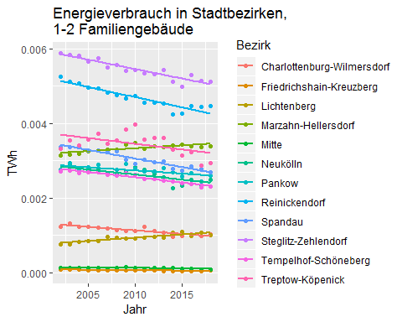

max_aes_value <- max(aes_by_bezirk_TWh_sfh[ , names(aes_by_bezirk_TWh_sfh)[!(names(aes_by_bezirk_TWh_sfh) %in% c("abrechnungsjahr","total"))]])  
require(ggplot2)  
g_aes_bezirk <- list()  
for (ii in 1:12) {  
 g_aes_bezirk[[ii]] <- points_line_lm(input_data = aes_by_bezirk_TWh_sfh,  
 xVar = "abrechnungsjahr",  
 yVar = bezirk_list[ii],  
 ymin=0,  
 ymax=max_aes_value,  
 x_eq = 2010,  
 y_eq = 0.5*max_aes_value,  
 size_eq = 4,  
 plot_title = bezirk_name[ii],  
 xlab = "Jahr",  
 ylab = "TWh",  
 slope_round_to = 4,  
 intercept_round_to = 2)  
}  
require(grid)  
require(gridExtra)  
grid.arrange(g_aes_bezirk[[1]],g_aes_bezirk[[2]],g_aes_bezirk[[3]],g_aes_bezirk[[4]],  
 g_aes_bezirk[[5]],g_aes_bezirk[[6]],g_aes_bezirk[[7]],g_aes_bezirk[[8]],  
 g_aes_bezirk[[9]],g_aes_bezirk[[10]],g_aes_bezirk[[11]],g_aes_bezirk[[12]],ncol=3)

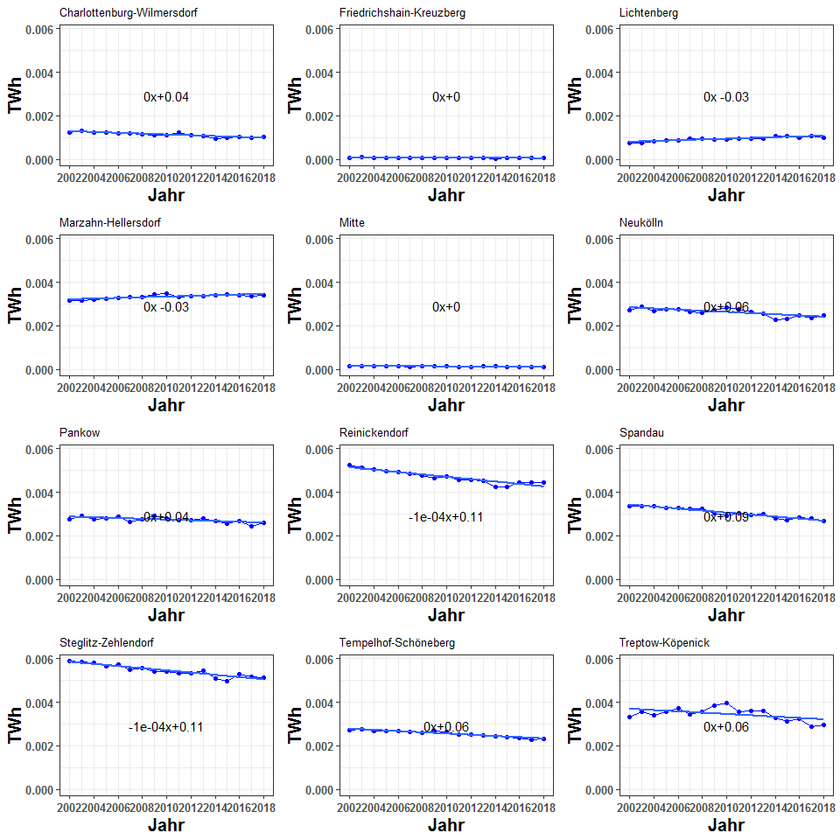

aes_by_bezirk_TWh_sfh

## abrechnungsjahr charlottenburg_wilmersdorf friedrichshain_kreuzberg  
## 1 2002 0.0012340179 8.593297e-05  
## 2 2003 0.0013152991 9.000103e-05  
## 3 2004 0.0012276634 7.668603e-05  
## 4 2005 0.0012239500 7.456248e-05  
## 5 2006 0.0012051856 7.172745e-05  
## 6 2007 0.0011812972 6.287678e-05  
## 7 2008 0.0011515396 6.086307e-05  
## 8 2009 0.0011246333 6.243335e-05  
## 9 2010 0.0011230201 5.633951e-05  
## 10 2011 0.0012279860 5.921415e-05  
## 11 2012 0.0011266930 5.356043e-05  
## 12 2013 0.0010640499 5.253745e-05  
## 13 2014 0.0009522346 4.501432e-05  
## 14 2015 0.0009879918 4.704828e-05  
## 15 2016 0.0010256174 5.330179e-05  
## 16 2017 0.0009875743 5.065690e-05  
## 17 2018 0.0010189984 5.977010e-05  
## lichtenberg marzahn_hellersdorf mitte neukoelln pankow  
## 1 0.0007664723 0.003147315 1.285797e-04 0.002723939 0.002747108  
## 2 0.0007612600 0.003163056 1.406819e-04 0.002887632 0.002926626  
## 3 0.0008335342 0.003179845 1.301728e-04 0.002695950 0.002759434  
## 4 0.0008573903 0.003253749 1.341047e-04 0.002745132 0.002813765  
## 5 0.0008549122 0.003281472 1.415149e-04 0.002777042 0.002887519  
## 6 0.0009514727 0.003299470 1.167428e-04 0.002645982 0.002629560  
## 7 0.0009431355 0.003300728 1.310679e-04 0.002613658 0.002756625  
## 8 0.0009251783 0.003427196 1.468744e-04 0.002713572 0.002917131  
## 9 0.0009247984 0.003473960 1.291553e-04 0.002829420 0.002782929  
## 10 0.0009364622 0.003315694 1.177669e-04 0.002756292 0.002717309  
## 11 0.0009567771 0.003377290 1.213891e-04 0.002656068 0.002723239  
## 12 0.0009453442 0.003364607 1.318077e-04 0.002566571 0.002799062  
## 13 0.0010690769 0.003416242 1.296241e-04 0.002269308 0.002686279  
## 14 0.0010879983 0.003429039 1.128732e-04 0.002330918 0.002574712  
## 15 0.0009898398 0.003380480 1.143926e-04 0.002490295 0.002675535  
## 16 0.0010665303 0.003363379 9.050839e-05 0.002363793 0.002436683  
## 17 0.0010043909 0.003393415 9.698399e-05 0.002489975 0.002590577  
## reinickendorf spandau steglitz_zehlendorf tempelhof_schoeneberg  
## 1 0.005244864 0.003372879 0.005872336 0.002723201  
## 2 0.005124802 0.003357908 0.005843043 0.002737822  
## 3 0.005058003 0.003379058 0.005798507 0.002670435  
## 4 0.004949233 0.003269893 0.005661884 0.002693149  
## 5 0.004938889 0.003279111 0.005736362 0.002686476  
## 6 0.004825256 0.003224362 0.005488866 0.002617405  
## 7 0.004750353 0.003244425 0.005561029 0.002600787  
## 8 0.004658836 0.003036979 0.005414303 0.002677769  
## 9 0.004733305 0.002910417 0.005425589 0.002629258  
## 10 0.004558506 0.003030731 0.005347192 0.002503142  
## 11 0.004547378 0.002961282 0.005326869 0.002503277  
## 12 0.004532588 0.002979653 0.005438398 0.002471186  
## 13 0.004244504 0.002781217 0.005104194 0.002440971  
## 14 0.004261594 0.002726458 0.004982838 0.002403030  
## 15 0.004460972 0.002846115 0.005295549 0.002367590  
## 16 0.004445704 0.002789726 0.005147163 0.002293427  
## 17 0.004461914 0.002690942 0.005123832 0.002312920  
## treptow_koepenick  
## 1 0.003314329  
## 2 0.003540628  
## 3 0.003407012  
## 4 0.003561221  
## 5 0.003722732  
## 6 0.003448286  
## 7 0.003549431  
## 8 0.003839264  
## 9 0.003960428  
## 10 0.003566599  
## 11 0.003602937  
## 12 0.003599321  
## 13 0.003285197  
## 14 0.003134436  
## 15 0.003223397  
## 16 0.002866196  
## 17 0.002942039

i_subsection <- i_subsection+1

## 5.3. Stadtbezirke, 1-2 Familiengebäude, flächenbezogener Heizenergieverbrauch 2002 - 2018 in kWh/(m2[AN]*a)

spz_verbrauch_sfh <- data.frame(abrechnungsjahr=2002:2018,  
 kWh_per_m2 = 1e9 * aes_by_ET_TWh_sfh$total/bezirk_areas_sfh$total)  
points_line_lm(input_data = spz_verbrauch_sfh,  
 xVar = "abrechnungsjahr",  
 yVar = "kWh_per_m2",  
 ymin = 0,  
 ymax = max(spz_verbrauch_sfh$kWh_per_m2),  
 x_eq = 2010,  
 y_eq = 1.25,  
 size_eq = 4,  
 plot_title = "Spezifischer Energieverbrauch in Berlin, 1-2 Familiengebäude",  
 xlab = "Jahr",  
 ylab = "kWh/m^2")

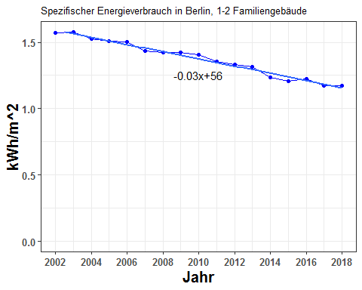

spz_verbrauch_sfh

## abrechnungsjahr kWh_per_m2  
## 1 2002 1.571225  
## 2 2003 1.577357  
## 3 2004 1.524711  
## 4 2005 1.506857  
## 5 2006 1.504838  
## 6 2007 1.435262  
## 7 2008 1.426109  
## 8 2009 1.422157  
## 9 2010 1.405595  
## 10 2011 1.354784  
## 11 2012 1.330105  
## 12 2013 1.314674  
## 13 2014 1.232888  
## 14 2015 1.204608  
## 15 2016 1.226573  
## 16 2017 1.172695  
## 17 2018 1.170909

i_subsection <- i_subsection+1

## 5.4. Stadtbezirke, 1-2 Familiengebäude, flächenbezogener Heizenergieverbrauch und beheizte Wohnfläche 2002 - 2018

Plot of the 1-2 FH area (to be combined with the specific energy consumption into one picture):

plot_dualPlot(bezirk_areas_sfh$total,  
 spz_verbrauch_sfh$kWh_per_m2,  
 2002:2018,  
 "Jahr",  
 "Area 1-2 FH Buildings (m2)",  
 "TWh/m2",  
 "Area",  
 "Energy consumption per m2")

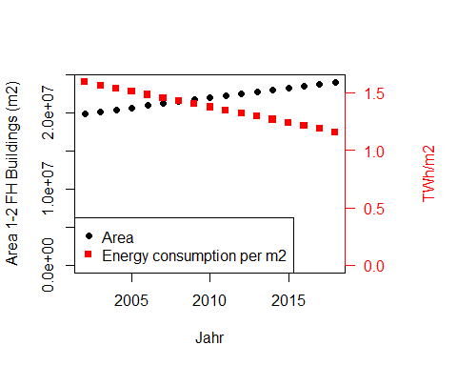

data.frame(Jahr=2002:2018,  
area= bezirk_areas_sfh$total,  
 spez_verbrauch = spz_verbrauch_sfh$kWh_per_m2)

## Jahr area spez_verbrauch  
## 1 2002 19959568 1.571225  
## 2 2003 20216575 1.577357  
## 3 2004 20473582 1.524711  
## 4 2005 20730589 1.506857  
## 5 2006 20987596 1.504838  
## 6 2007 21244604 1.435262  
## 7 2008 21501611 1.426109  
## 8 2009 21758618 1.422157  
## 9 2010 22039500 1.405595  
## 10 2011 22244800 1.354784  
## 11 2012 22522100 1.330105  
## 12 2013 22777600 1.314674  
## 13 2014 23054700 1.232888  
## 14 2015 23309600 1.204608  
## 15 2016 23580400 1.226573  
## 16 2017 23792500 1.172695  
## 17 2018 24071682 1.170909

i_section <- i_section + 1  
i_subsection <- 1

# 6. Heizenergieverbrauch nach Stadtbezirken 2002 - 2018, Mehrfamiliengebäude

## 6.1. Stadtbezirke, Mehrfamiliengebäude, Heizenergieverbrauch 2002 - 2018 summiert

* Total energy split by ET:

by_ten_9 <- 1e-9  
aes_by_ET_TWh_mfh <- by_ten_9 * co2_allebezirke_byET$aes_mfh  
aes_by_ET_TWh_mfh$abrechnungsjahr <- 2002:2018  
aes_by_ET_TWh_mfh_cumsums <- getCumSums(obj=aes_by_ET_TWh_mfh , dropCols = c("abrechnungsjahr","total"))

points_line_lm(input_data = aes_by_ET_TWh_mfh,  
 xVar = "abrechnungsjahr",  
 yVar = "total",  
 ymin = 0,  
 ymax = max(aes_by_ET_TWh_mfh$total),  
 x_eq = 2010,  
 y_eq = 0.025,  
 size_eq = 4,  
 plot_title = "Energieverbrauch in Berlin, Mehrfamiliengebäude",  
 xlab = "Jahr",  
 ylab = "TWh",  
 slope_round_to = 4)

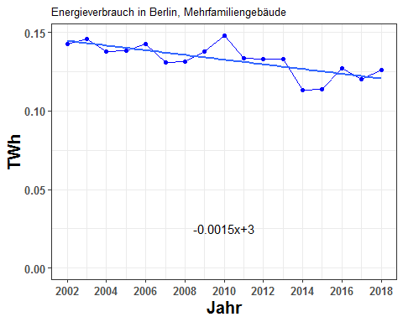

aes_by_ET_TWh_mfh[ , c("abrechnungsjahr","total")]

## abrechnungsjahr total  
## 1 2002 0.1425264  
## 2 2003 0.1457962  
## 3 2004 0.1378684  
## 4 2005 0.1384257  
## 5 2006 0.1427006  
## 6 2007 0.1312434  
## 7 2008 0.1312883  
## 8 2009 0.1377341  
## 9 2010 0.1480956  
## 10 2011 0.1333838  
## 11 2012 0.1333226  
## 12 2013 0.1329522  
## 13 2014 0.1132976  
## 14 2015 0.1136740  
## 15 2016 0.1273045  
## 16 2017 0.1200560  
## 17 2018 0.1260237

plot_byET(aes_by_ET_TWh_mfh_cumsums , xlabel = "Jahr" , ylabel = "TWh" , plottitle = "Energieverbrauch in Berlin, Mehrfamiliengebäude, nach Energieträgern")

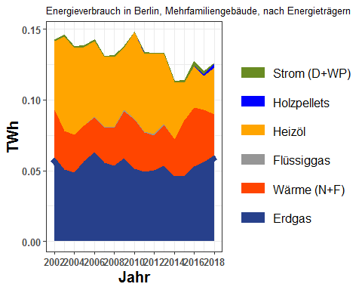

aes_by_ET_TWh_mfh

## erdgas waerme fluessiggas heizoel holzpellets strom  
## 1 0.05938804 0.03380781 0.000000e+00 0.04843191 0.000000e+00 8.986769e-04  
## 2 0.05079448 0.02720451 0.000000e+00 0.06689849 0.000000e+00 8.986769e-04  
## 3 0.04873127 0.02660622 2.706414e-05 0.06160519 0.000000e+00 8.986769e-04  
## 4 0.05665545 0.02513700 1.267408e-04 0.05559541 1.241918e-05 8.986769e-04  
## 5 0.06324409 0.02469342 1.350676e-04 0.05371527 1.409146e-05 8.986769e-04  
## 6 0.05537106 0.02510980 1.251862e-05 0.04983640 1.494333e-05 8.986769e-04  
## 7 0.05371629 0.02643040 7.521232e-04 0.04947289 1.789422e-05 8.986769e-04  
## 8 0.05909697 0.03308455 6.578699e-04 0.04397380 2.221577e-05 8.986769e-04  
## 9 0.05116303 0.03509059 2.145852e-04 0.06149343 1.133707e-04 2.058181e-05  
## 10 0.04905310 0.02809961 4.883837e-04 0.05500777 3.646111e-04 3.702997e-04  
## 11 0.05045372 0.02441861 1.252998e-03 0.05632772 3.090011e-04 5.605170e-04  
## 12 0.05366088 0.02866177 6.744272e-04 0.04946641 3.761665e-04 1.125901e-04  
## 13 0.04585056 0.02647308 0.000000e+00 0.04051117 0.000000e+00 4.628134e-04  
## 14 0.04612673 0.03937289 0.000000e+00 0.02702755 0.000000e+00 1.146867e-03  
## 15 0.05269992 0.04178556 0.000000e+00 0.02948479 3.035940e-04 3.030613e-03  
## 16 0.05617610 0.03702150 0.000000e+00 0.02414996 6.843019e-04 2.024165e-03  
## 17 0.06105503 0.02871800 0.000000e+00 0.03327317 2.617887e-03 3.596449e-04  
## abrechnungsjahr total  
## 1 2002 0.1425264  
## 2 2003 0.1457962  
## 3 2004 0.1378684  
## 4 2005 0.1384257  
## 5 2006 0.1427006  
## 6 2007 0.1312434  
## 7 2008 0.1312883  
## 8 2009 0.1377341  
## 9 2010 0.1480956  
## 10 2011 0.1333838  
## 11 2012 0.1333226  
## 12 2013 0.1329522  
## 13 2014 0.1132976  
## 14 2015 0.1136740  
## 15 2016 0.1273045  
## 16 2017 0.1200560  
## 17 2018 0.1260237

* Total energy split by bezirk:

by_ten_9 <- 1e-9  
aes_by_bezirk_TWh_mfh <- by_ten_9 * alle_bezirke_co2$aes_mfh  
aes_by_bezirk_TWh_mfh$abrechnungsjahr <- 2002:2018  
aes_by_bezirk_TWh_mfh_cumsums <- getCumSums(obj=aes_by_bezirk_TWh_mfh , dropCols = "abrechnungsjahr")

plot_byBezirke(aes_by_bezirk_TWh_mfh_cumsums , xlabel = "Jahr" , ylabel = "TWh" , plottitle="Energieverbrauch in Berlin, Mehrfamiliengebäude, nach Bezirk")

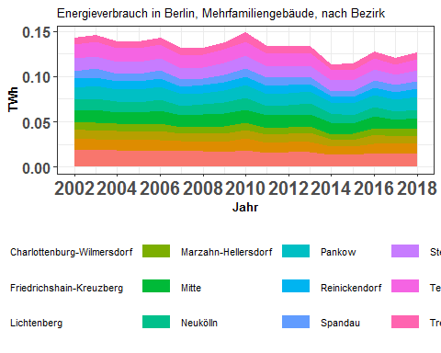

aes_by_bezirk_TWh_mfh

## abrechnungsjahr charlottenburg_wilmersdorf friedrichshain_kreuzberg  
## 1 2002 0.01933529 0.012515229  
## 2 2003 0.01816366 0.012218521  
## 3 2004 0.01848452 0.011438521  
## 4 2005 0.01782974 0.011447534  
## 5 2006 0.01846693 0.011574484  
## 6 2007 0.01748354 0.010779830  
## 7 2008 0.01721909 0.010353411  
## 8 2009 0.01685448 0.011143920  
## 9 2010 0.01885597 0.012550030  
## 10 2011 0.01594566 0.010512272  
## 11 2012 0.01648278 0.010747914  
## 12 2013 0.01665750 0.010586722  
## 13 2014 0.01352945 0.009079312  
## 14 2015 0.01328969 0.009568512  
## 15 2016 0.01539297 0.010734195  
## 16 2017 0.01491677 0.010593256  
## 17 2018 0.01458006 0.011472131  
## lichtenberg marzahn_hellersdorf mitte neukoelln pankow  
## 1 0.009579878 0.008454737 0.01241135 0.011862530 0.01392036  
## 2 0.009883823 0.008764301 0.01406228 0.011945977 0.01433577  
## 3 0.009803074 0.007996837 0.01294686 0.011450441 0.01326779  
## 4 0.009250559 0.007931250 0.01343359 0.011627088 0.01358525  
## 5 0.010242935 0.007904576 0.01424872 0.012216720 0.01379361  
## 6 0.008321938 0.007787479 0.01231174 0.010822110 0.01281440  
## 7 0.009536259 0.007265648 0.01332642 0.011128543 0.01269718  
## 8 0.009235142 0.007237604 0.01453240 0.012158735 0.01386704  
## 9 0.009423786 0.007880272 0.01441904 0.012854458 0.01471700  
## 10 0.008888790 0.007902745 0.01384435 0.010622408 0.01325962  
## 11 0.009147532 0.007443258 0.01356920 0.011109775 0.01335597  
## 12 0.010324743 0.006925931 0.01400529 0.011442409 0.01323399  
## 13 0.008285835 0.005309105 0.01259907 0.010082754 0.01207904  
## 14 0.007239829 0.006251151 0.01170277 0.009523335 0.01238807  
## 15 0.009377315 0.007514697 0.01262591 0.010349919 0.01330716  
## 16 0.008209965 0.007716424 0.01083179 0.009381425 0.01276145  
## 17 0.008100082 0.008391492 0.01140470 0.009765141 0.01390368  
## reinickendorf spandau steglitz_zehlendorf tempelhof_schoeneberg  
## 1 0.009471549 0.008582664 0.01369110 0.01579825  
## 2 0.009711464 0.009745358 0.01371173 0.01607078  
## 3 0.009253040 0.008246122 0.01299097 0.01520823  
## 4 0.009164476 0.008246956 0.01309237 0.01547587  
## 5 0.009422856 0.008548826 0.01322546 0.01561431  
## 6 0.008736496 0.007455420 0.01234875 0.01474846  
## 7 0.008805797 0.007353187 0.01225511 0.01436355  
## 8 0.008936164 0.007635188 0.01303614 0.01521362  
## 9 0.009502264 0.008830279 0.01365221 0.01604216  
## 10 0.009034590 0.009010290 0.01219097 0.01423357  
## 11 0.008941495 0.008266981 0.01234102 0.01407107  
## 12 0.008971719 0.007896921 0.01231905 0.01353191  
## 13 0.007737545 0.005319286 0.01145399 0.01195816  
## 14 0.007777542 0.006061498 0.01142470 0.01186568  
## 15 0.008744813 0.008107388 0.01201101 0.01220909  
## 16 0.008367622 0.007572886 0.01153059 0.01131659  
## 17 0.008673890 0.008661564 0.01210402 0.01164666  
## treptow_koepenick  
## 1 0.006903512  
## 2 0.007182483  
## 3 0.006782011  
## 4 0.007341003  
## 5 0.007441189  
## 6 0.007633229  
## 7 0.006984076  
## 8 0.007883653  
## 9 0.009368116  
## 10 0.007938503  
## 11 0.007845561  
## 12 0.007056063  
## 13 0.005864064  
## 14 0.006581269  
## 15 0.006929996  
## 16 0.006857265  
## 17 0.007320309

i_subsection <- i_subsection+1

## 6.2. Stadtbezirke, Mehrfamiliengebäude Wohngebäude, Heizenergieverbrauch 2002 - 2018

(Eine Grafik: Heizenergieverbrauch aller 12 Bezirke in einer Grafik) One Graph: All 12 lines in a single graph.

plot_reqdColumns(aes_by_bezirk_TWh_mfh,  
 xVar = "abrechnungsjahr",  
 cols_to_plot = names(aes_by_bezirk_TWh_mfh)[!(names(aes_by_bezirk_TWh_mfh) %in% c("abrechnungsjahr"))],  
 yColsName = "Bezirk",  
 yVar = "Energy in TWh",  
 xlab = "Jahr",  
 ylab = "TWh",  
 plot_title = "Energieverbrauch in Stadtbezirken, Mehrfamiliengebäude")

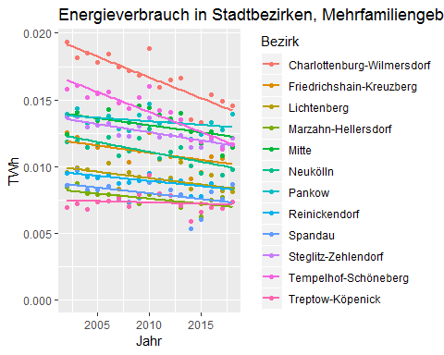

max_aes_value <- max(aes_by_bezirk_TWh_mfh[ , names(aes_by_bezirk_TWh_mfh)[!(names(aes_by_bezirk_TWh_mfh) %in% c("abrechnungsjahr","total"))]])  
require(ggplot2)  
g_aes_bezirk <- list()  
for (ii in 1:12) {  
 g_aes_bezirk[[ii]] <- points_line_lm(input_data = aes_by_bezirk_TWh_mfh,  
 xVar = "abrechnungsjahr",  
 yVar = bezirk_list[ii],  
 ymin=0,  
 ymax=max_aes_value,  
 x_eq = 2010,  
 y_eq = 0.5*max_aes_value,  
 size_eq = 4,  
 plot_title = bezirk_name[ii],  
 xlab = "Jahr",  
 ylab = "TWh",  
 slope_round_to = 4,  
 intercept_round_to = 2)  
}  
require(grid)  
require(gridExtra)  
grid.arrange(g_aes_bezirk[[1]],g_aes_bezirk[[2]],g_aes_bezirk[[3]],g_aes_bezirk[[4]],  
 g_aes_bezirk[[5]],g_aes_bezirk[[6]],g_aes_bezirk[[7]],g_aes_bezirk[[8]],  
 g_aes_bezirk[[9]],g_aes_bezirk[[10]],g_aes_bezirk[[11]],g_aes_bezirk[[12]],ncol=3)

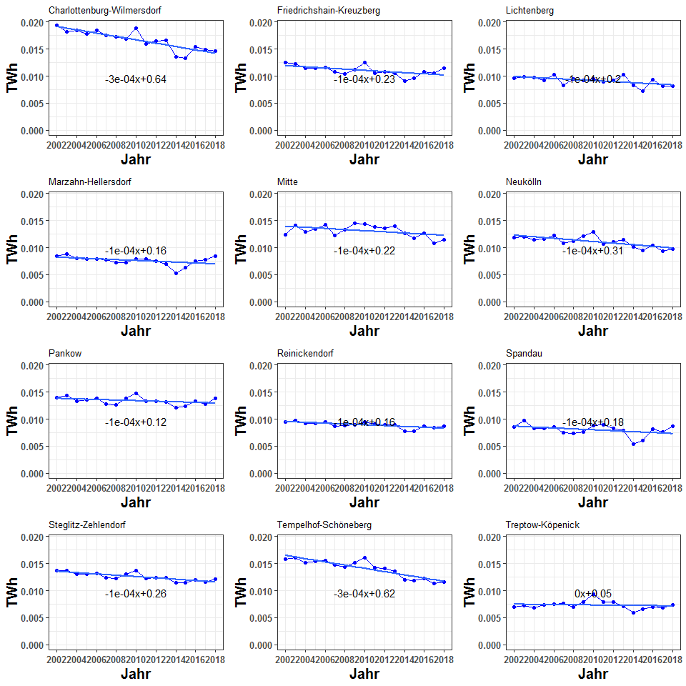

aes_by_bezirk_TWh_mfh

## abrechnungsjahr charlottenburg_wilmersdorf friedrichshain_kreuzberg  
## 1 2002 0.01933529 0.012515229  
## 2 2003 0.01816366 0.012218521  
## 3 2004 0.01848452 0.011438521  
## 4 2005 0.01782974 0.011447534  
## 5 2006 0.01846693 0.011574484  
## 6 2007 0.01748354 0.010779830  
## 7 2008 0.01721909 0.010353411  
## 8 2009 0.01685448 0.011143920  
## 9 2010 0.01885597 0.012550030  
## 10 2011 0.01594566 0.010512272  
## 11 2012 0.01648278 0.010747914  
## 12 2013 0.01665750 0.010586722  
## 13 2014 0.01352945 0.009079312  
## 14 2015 0.01328969 0.009568512  
## 15 2016 0.01539297 0.010734195  
## 16 2017 0.01491677 0.010593256  
## 17 2018 0.01458006 0.011472131  
## lichtenberg marzahn_hellersdorf mitte neukoelln pankow  
## 1 0.009579878 0.008454737 0.01241135 0.011862530 0.01392036  
## 2 0.009883823 0.008764301 0.01406228 0.011945977 0.01433577  
## 3 0.009803074 0.007996837 0.01294686 0.011450441 0.01326779  
## 4 0.009250559 0.007931250 0.01343359 0.011627088 0.01358525  
## 5 0.010242935 0.007904576 0.01424872 0.012216720 0.01379361  
## 6 0.008321938 0.007787479 0.01231174 0.010822110 0.01281440  
## 7 0.009536259 0.007265648 0.01332642 0.011128543 0.01269718  
## 8 0.009235142 0.007237604 0.01453240 0.012158735 0.01386704  
## 9 0.009423786 0.007880272 0.01441904 0.012854458 0.01471700  
## 10 0.008888790 0.007902745 0.01384435 0.010622408 0.01325962  
## 11 0.009147532 0.007443258 0.01356920 0.011109775 0.01335597  
## 12 0.010324743 0.006925931 0.01400529 0.011442409 0.01323399  
## 13 0.008285835 0.005309105 0.01259907 0.010082754 0.01207904  
## 14 0.007239829 0.006251151 0.01170277 0.009523335 0.01238807  
## 15 0.009377315 0.007514697 0.01262591 0.010349919 0.01330716  
## 16 0.008209965 0.007716424 0.01083179 0.009381425 0.01276145  
## 17 0.008100082 0.008391492 0.01140470 0.009765141 0.01390368  
## reinickendorf spandau steglitz_zehlendorf tempelhof_schoeneberg  
## 1 0.009471549 0.008582664 0.01369110 0.01579825  
## 2 0.009711464 0.009745358 0.01371173 0.01607078  
## 3 0.009253040 0.008246122 0.01299097 0.01520823  
## 4 0.009164476 0.008246956 0.01309237 0.01547587  
## 5 0.009422856 0.008548826 0.01322546 0.01561431  
## 6 0.008736496 0.007455420 0.01234875 0.01474846  
## 7 0.008805797 0.007353187 0.01225511 0.01436355  
## 8 0.008936164 0.007635188 0.01303614 0.01521362  
## 9 0.009502264 0.008830279 0.01365221 0.01604216  
## 10 0.009034590 0.009010290 0.01219097 0.01423357  
## 11 0.008941495 0.008266981 0.01234102 0.01407107  
## 12 0.008971719 0.007896921 0.01231905 0.01353191  
## 13 0.007737545 0.005319286 0.01145399 0.01195816  
## 14 0.007777542 0.006061498 0.01142470 0.01186568  
## 15 0.008744813 0.008107388 0.01201101 0.01220909  
## 16 0.008367622 0.007572886 0.01153059 0.01131659  
## 17 0.008673890 0.008661564 0.01210402 0.01164666  
## treptow_koepenick  
## 1 0.006903512  
## 2 0.007182483  
## 3 0.006782011  
## 4 0.007341003  
## 5 0.007441189  
## 6 0.007633229  
## 7 0.006984076  
## 8 0.007883653  
## 9 0.009368116  
## 10 0.007938503  
## 11 0.007845561  
## 12 0.007056063  
## 13 0.005864064  
## 14 0.006581269  
## 15 0.006929996  
## 16 0.006857265  
## 17 0.007320309

i_subsection <- i_subsection+1

## 6.3. Stadtbezirke, Mehrfamiliengebäude, flächenbezogener Heizenergieverbrauch 2002 - 2018 in kWh/(m2[AN]*a)

spz_verbrauch_mfh <- data.frame(abrechnungsjahr=2002:2018,  
 kWh_per_m2 = 1e9 * aes_by_ET_TWh_mfh$total/bezirk_areas_mfh$total)  
points_line_lm(input_data = spz_verbrauch_mfh,  
 xVar = "abrechnungsjahr",  
 yVar = "kWh_per_m2",  
 ymin = 0,  
 ymax = max(spz_verbrauch_mfh$kWh_per_m2),  
 x_eq = 2010,  
 y_eq = 1.1,  
 size_eq = 4,  
 plot_title = "Spezifischer Energieverbrauch in Berlin, Mehrfamiliengebäude",  
 xlab = "Jahr",  
 ylab = "kWh/m^2")

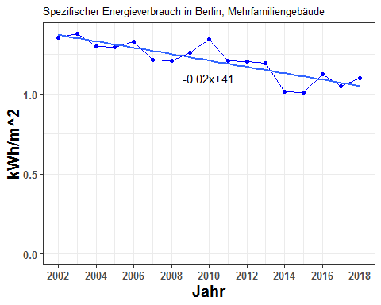

spz_verbrauch_mfh

## abrechnungsjahr kWh_per_m2  
## 1 2002 1.355413  
## 2 2003 1.378949  
## 3 2004 1.296899  
## 4 2005 1.295119  
## 5 2006 1.327955  
## 6 2007 1.214820  
## 7 2008 1.208787  
## 8 2009 1.261440  
## 9 2010 1.344272  
## 10 2011 1.207850  
## 11 2012 1.203776  
## 12 2013 1.196135  
## 13 2014 1.013875  
## 14 2015 1.010525  
## 15 2016 1.123399  
## 16 2017 1.051367  
## 17 2018 1.101846

i_subsection <- i_subsection+1

## 6.4. Stadtbezirke, Mehrfamiliengebäude, flächenbezogener Heizenergieverbrauch und beheizte Wohnfläche 2002 - 2018

Plot of the MFH area (to be combined with the specific energy consumption into one picture):

plot_dualPlot(bezirk_areas_mfh$total,  
 spz_verbrauch_mfh$kWh_per_m2,  
 2002:2018,  
 "Jahr",  
 "Area MFH Buildings (m2)",  
 "TWh/m2",  
 "Area",  
 "Energy consumption per m2")

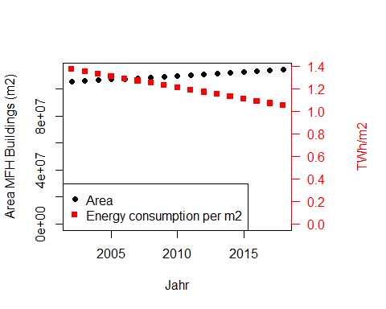

data.frame(Jahr=2002:2018,  
area= bezirk_areas_mfh$total,  
 spez_verbrauch = spz_verbrauch_mfh$kWh_per_m2)

## Jahr area spez_verbrauch  
## 1 2002 105153529 1.355413  
## 2 2003 105729875 1.378949  
## 3 2004 106306221 1.296899  
## 4 2005 106882568 1.295119  
## 5 2006 107458914 1.327955  
## 6 2007 108035261 1.214820  
## 7 2008 108611607 1.208787  
## 8 2009 109187954 1.261440  
## 9 2010 110167900 1.344272  
## 10 2011 110430700 1.207850  
## 11 2012 110753600 1.203776  
## 12 2013 111151500 1.196135  
## 13 2014 111747100 1.013875  
## 14 2015 112490100 1.010525  
## 15 2016 113320800 1.123399  
## 16 2017 114190400 1.051367  
## 17 2018 114375071 1.101846

# Points to do

* Write a description of what each point does. What the graph shows.
* Improve the title, xlabel etc.
* Make a table of the sample size
* Change font style to calibri or verdana or ariel
* The graphs in svg OR in jpeg or png with a resolution of 300 - 600 DPI. # Inferences
* Section 5.2, 1-2 FH energy consumption is increasing for Lichtenberg and Marzahn-Hellersdorf.
* Treptow-Kopenick. Energy consumption for MFH is stagnant. Also Marzahn-Hellersdorf (almost stagnant) and Pankow.