**User Engagement by Traffic Source**

**How many unique users (based on user_pseudo_id) visited the website on January 23, 2024?**

unique_users_count = 638

**What is the count of active users (is_active_user) for the given data/given date ?**

active_users_count = 948

**What are the different traffic sources (traffic_source_name) that led users to the website?**

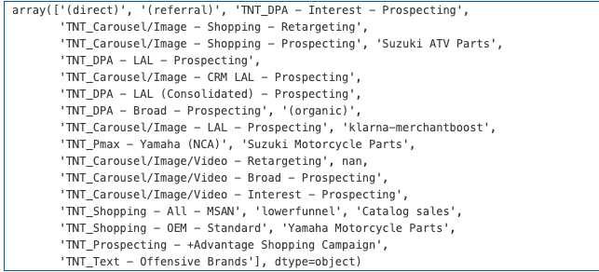

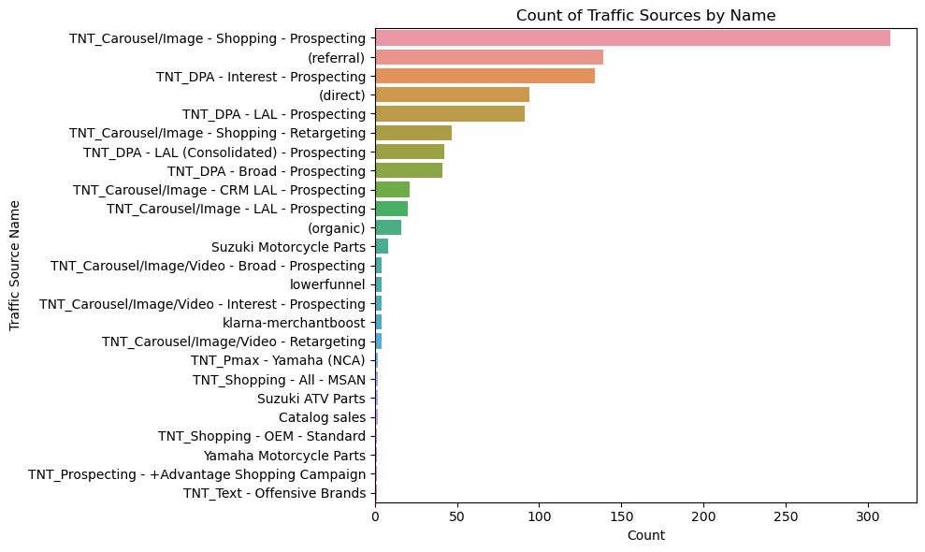

* The most significant traffic source is categorized under "TNT_Carousel/Image - Shopping - Prospecting (referral)", suggesting that referral traffic aimed at shopping and prospecting is the highest driver of users to the website.
* The next prominent categories are "TNT_DPA - Interest - Prospecting" and "TNT_DPA - LAL - Prospecting (direct)", indicating dynamic product ads and lookalike audience strategies are also major contributors, both from direct and referral channels.
* The chart shows that retargeting strategies like "TNT_Carousel/Image - Shopping - Retargeting" and "TNT_Carousel/Image/Video - Retargeting" have a significant count, meaning users who previously visited the site are being successfully brought back through these methods.

**Traffic Source Effectiveness**

**Which traffic source medium (traffic_source_medium) is the most common among the users?**

most_common_medium, most_common_medium_count

('cpc', 742)

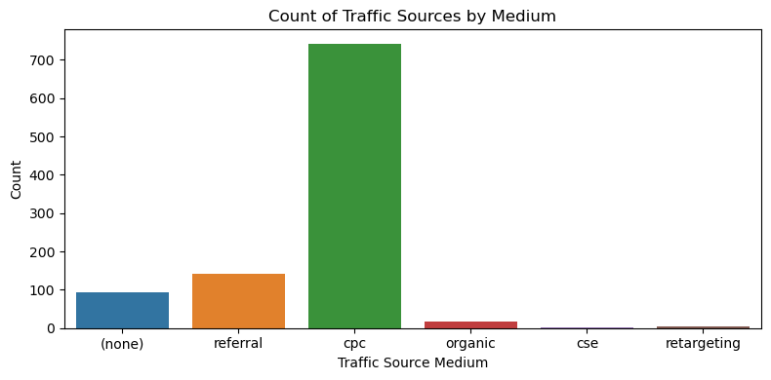

the most common traffic source medium among the users is "cpc" (cost per click), which indicates that a significant number of users are coming to the website through paid advertisement clicks.

**What is the role of advertising campaigns (identified by traffic_source_name starting with "TNT_") in driving traffic to the site, and how do they compare in effectiveness?**

campaign_traffic_count, total_traffic_count, campaign_traffic_proportion

(729, 1000, 0.729)

**How effective are referral links from Facebook in bringing traffic to the website compared to other visits?**

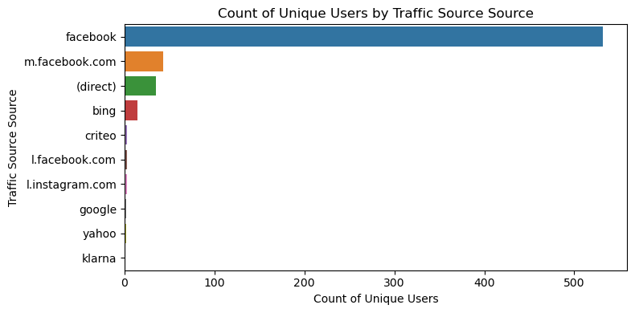

The chart shows that Facebook referrals are quite effective, with the number of visits from Facebook being notably higher than those from other sources.

**Content Popularity**

**Which page title (page_title) had the highest number of visits?**

most_visited_page_title, most_visited_page_visits

('P: OEM Motorcycle Parts, ATV Parts, Marine Parts', 63)

1. The most visited page title is "**P: OEM Motorcycle Parts, ATV Parts, Marine Parts**," which indicates a strong interest in original equipment manufacturer parts across various types of vehicles. This suggests that users are likely looking for authentic, brand-specific parts for motorcycles, ATVs, and marine vehicles.

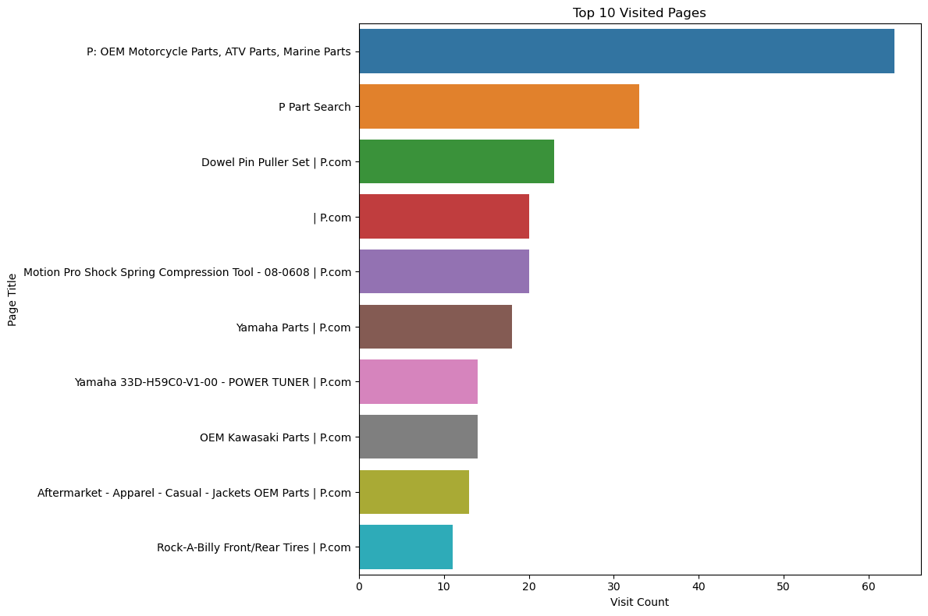

1. The second most visited page is titled "**P Part Search**," suggesting that users are actively utilizing search features on the website to find specific parts, indicating a user-friendly search utility could be vital for the website's engagement.
2. The page titled "**Dowel Pin Puller Set | P.com**" is the third most visited, highlighting interest in specialized tools, which could suggest a customer base that is engaged in detailed mechanical work or repairs.

**Can we identify any trends in the type of content (e.g., OEM parts, specific brands like Polaris or Honda) that attracts more users?**

{'Parts': 338,

'Honda': 278,

'OEM': 267,

'Motorcycle': 140,

'ATV': 131,

'Polaris': 81,

'Marine': 72,

'Suzuki': 65}

**What types of content (e.g., OEM parts, specific brands) attract the most users?**

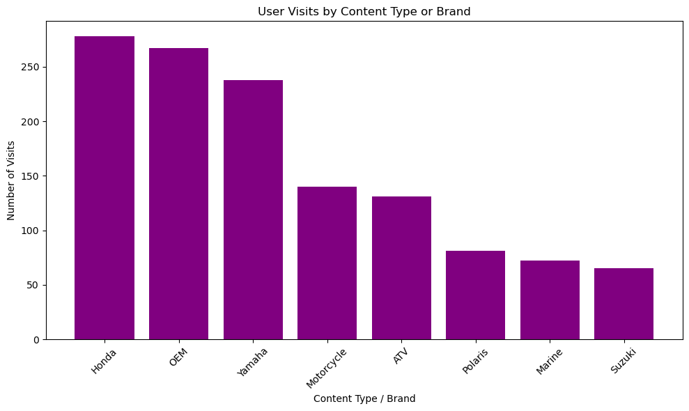

1. **Honda** still leads with the highest number of user visits, highlighting its strong market presence or the content's appeal associated with this brand on the website.
2. **OEM Parts Interest**: The content type 'OEM' has the second-highest number of visits, indicating a significant interest in Original Equipment Manufacturer parts. This suggests that users are keen on finding parts that are made by the original manufacturer of their vehicles or equipment.
3. **Yamaha's Strong Following**: Yamaha is the third most popular content type or brand. This points to a robust interest in Yamaha products, which could be motorcycles, ATVs, marine products, or power equipment.

**Geographical Insights**

**From which city did the website receive the most traffic?**

most_traffic_city, most_traffic_city_visits

('Dallas', 35)

1. **Dallas stands** out with the highest number of visits, which suggests it is a major hub for the website's audience

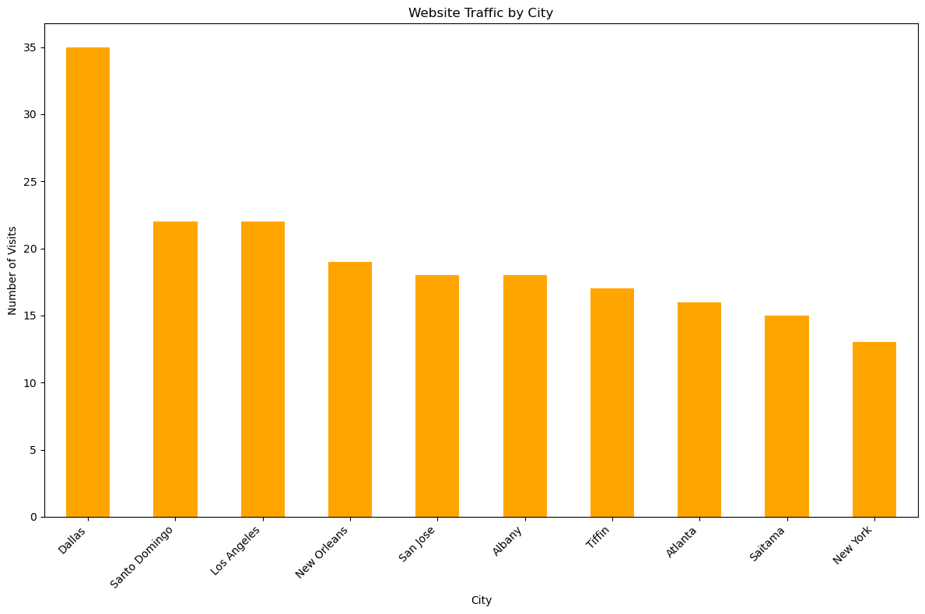

1. **Consistent Interest Across Other Cities**: There is a relatively consistent level of interest across the next several cities - San Diego, Los Angeles, New York, San Jose, Seattle, and Tampa

**Are there any insights into user preferences or behaviour based on the geographical data (e.g., certain products being more popular in specific cities)?**

1. **Dallas**: The top visited page in Dallas is related to "2016 Polaris OEM Side by Side Parts", which suggests a preference or a higher ownership rate for Polaris vehicles, specifically side by sides, in this area.
2. **Los Angeles**: Users from Los Angeles are visiting a page for a "Yamaha 1HP-F512A-00-00 - WHEEL CAP", indicating an interest in specific Yamaha parts, possibly for motorcycles or ATVs.
3. **Santo Domingo**: The page with "Yamaha ATV 2024 OEM Parts Diagram for Graphics..." is popular, suggesting that there's a market for Yamaha ATV parts and perhaps a community interested in graphics or customization.

