import os  
import sys  
from tempfile import NamedTemporaryFile  
from urllib.request import urlopen  
from urllib.parse import unquote, urlparse  
from urllib.error import HTTPError  
from zipfile import ZipFile  
import tarfile  
import shutil  
  
CHUNK_SIZE = 40960  
DATA_SOURCE_MAPPING = 'nslkdd:https%3A%2F%2Fstorage.googleapis.com%2Fkaggle-data-sets%2F174616%2F394223%2Fbundle%2Farchive.zip%3FX-Goog-Algorithm%3DGOOG4-RSA-SHA256%26X-Goog-Credential%3Dgcp-kaggle-com%2540kaggle-161607.iam.gserviceaccount.com%252F20240413%252Fauto%252Fstorage%252Fgoog4_request%26X-Goog-Date%3D20240413T085322Z%26X-Goog-Expires%3D259200%26X-Goog-SignedHeaders%3Dhost%26X-Goog-Signature%'  
  
KAGGLE_INPUT_PATH='/kaggle/input'  
KAGGLE_WORKING_PATH='/kaggle/working'  
KAGGLE_SYMLINK='kaggle'  
  
!umount /kaggle/input/ 2> /dev/null  
shutil.rmtree('/kaggle/input', ignore_errors=True)  
os.makedirs(KAGGLE_INPUT_PATH, 0o777, exist_ok=True)  
os.makedirs(KAGGLE_WORKING_PATH, 0o777, exist_ok=True)  
  
try:  
 os.symlink(KAGGLE_INPUT_PATH, os.path.join("..", 'input'), target_is_directory=True)  
except FileExistsError:  
 pass  
try:  
 os.symlink(KAGGLE_WORKING_PATH, os.path.join("..", 'working'), target_is_directory=True)  
except FileExistsError:  
 pass  
  
for data_source_mapping in DATA_SOURCE_MAPPING.split(','):  
 directory, download_url_encoded = data_source_mapping.split(':')  
 download_url = unquote(download_url_encoded)  
 filename = urlparse(download_url).path  
 destination_path = os.path.join(KAGGLE_INPUT_PATH, directory)  
 try:  
 with urlopen(download_url) as fileres, NamedTemporaryFile() as tfile:  
 total_length = fileres.headers['content-length']  
 print(f'Downloading {directory}, {total_length} bytes compressed')  
 dl = 0  
 data = fileres.read(CHUNK_SIZE)  
 while len(data) > 0:  
 dl += len(data)  
 tfile.write(data)  
 done = int(50 * dl / int(total_length))  
 sys.stdout.write(f"\r[{'=' * done}{' ' * (50-done)}] {dl} bytes downloaded")  
 sys.stdout.flush()  
 data = fileres.read(CHUNK_SIZE)  
 if filename.endswith('.zip'):  
 with ZipFile(tfile) as zfile:  
 zfile.extractall(destination_path)  
 else:  
 with tarfile.open(tfile.name) as tarfile:  
 tarfile.extractall(destination_path)  
 print(f'\nDownloaded and uncompressed: {directory}')  
 except HTTPError as e:  
 print(f'Failed to load (likely expired) {download_url} to path {destination_path}')  
 continue  
 except OSError as e:  
 print(f'Failed to load {download_url} to path {destination_path}')  
 continue  
  
print('Data source import complete.')

Downloading nslkdd, 14529600 bytes compressed  
[==================================================] 14529600 bytes downloaded  
Downloaded and uncompressed: nslkdd  
Data source import complete.

# Loading

#loading and importing data  
import numpy as np  
import pandas as pd  
import matplotlib.pyplot as plt  
import seaborn as sns  
from sklearn.model_selection import train_test_split,StratifiedKFold,GridSearchCV  
from sklearn.linear_model import LogisticRegression  
from sklearn.ensemble import RandomForestClassifier,VotingClassifier  
from sklearn.neighbors import KNeighborsClassifier  
from sklearn.tree import DecisionTreeClassifier  
from sklearn.metrics import accuracy_score  
from sklearn.metrics import confusion_matrix  
from sklearn.model_selection import GridSearchCV,RandomizedSearchCV  
from sklearn.svm import SVC  
from sklearn import metrics  
from sklearn.naive_bayes import GaussianNB  
from sklearn.metrics import make_scorer, roc_auc_score  
import scipy  
from scipy import stats  
import warnings  
warnings.filterwarnings("ignore")  
from sklearn.preprocessing import StandardScaler  
  
  
# add the column labels  
columns = (['duration'  
,'protocol_type'  
,'service'  
,'flag'  
,'src_bytes'  
,'dst_bytes'  
,'land'  
,'wrong_fragment'  
,'urgent'  
,'hot'  
,'num_failed_logins'  
,'logged_in'  
,'num_compromised'  
,'root_shell'  
,'su_attempted'  
,'num_root'  
,'num_file_creations'  
,'num_shells'  
,'num_access_files'  
,'num_outbound_cmds'  
,'is_host_login'  
,'is_guest_login'  
,'count'  
,'srv_count'  
,'serror_rate'  
,'srv_serror_rate'  
,'rerror_rate'  
,'srv_rerror_rate'  
,'same_srv_rate'  
,'diff_srv_rate'  
,'srv_diff_host_rate'  
,'dst_host_count'  
,'dst_host_srv_count'  
,'dst_host_same_srv_rate'  
,'dst_host_diff_srv_rate'  
,'dst_host_same_src_port_rate'  
,'dst_host_srv_diff_host_rate'  
,'dst_host_serror_rate'  
,'dst_host_srv_serror_rate'  
,'dst_host_rerror_rate'  
,'dst_host_srv_rerror_rate'  
,'attack'  
,'level'])  
  
  
df_train=pd.read_csv('../input/nslkdd/KDDTrain+.txt',header=None,names=columns)  
df_test=pd.read_csv('../input/nslkdd/KDDTest+.txt',header=None,names=columns)

df_train

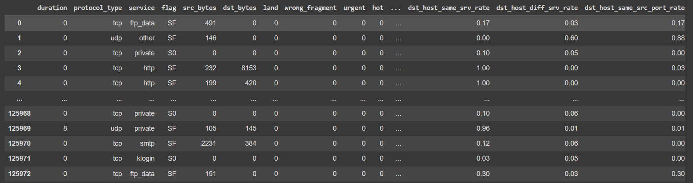# information of our data  
df_train.info()

<class 'pandas.core.frame.DataFrame'>  
RangeIndex: 125973 entries, 0 to 125972  
Data columns (total 43 columns):

# Column Non-Null Count Dtype   
--- ------ -------------- -----   
 0 duration 125973 non-null int64   
 1 protocol_type 125973 non-null object   
 2 service 125973 non-null object   
 3 flag 125973 non-null object   
 4 src_bytes 125973 non-null int64   
 5 dst_bytes 125973 non-null int64   
 6 land 125973 non-null int64   
 7 wrong_fragment 125973 non-null int64   
 8 urgent 125973 non-null int64   
 9 hot 125973 non-null int64   
 10 num_failed_logins 125973 non-null int64   
 11 logged_in 125973 non-null int64   
 12 num_compromised 125973 non-null int64   
 13 root_shell 125973 non-null int64   
 14 su_attempted 125973 non-null int64   
 15 num_root 125973 non-null int64   
 16 num_file_creations 125973 non-null int64   
 17 num_shells 125973 non-null int64   
 18 num_access_files 125973 non-null int64   
 19 num_outbound_cmds 125973 non-null int64   
 20 is_host_login 125973 non-null int64   
 21 is_guest_login 125973 non-null int64   
 22 count 125973 non-null int64   
 23 srv_count 125973 non-null int64   
 24 serror_rate 125973 non-null float64  
 25 srv_serror_rate 125973 non-null float64  
 26 rerror_rate 125973 non-null float64  
 27 srv_rerror_rate 125973 non-null float64  
 28 same_srv_rate 125973 non-null float64  
 29 diff_srv_rate 125973 non-null float64  
 30 srv_diff_host_rate 125973 non-null float64  
 31 dst_host_count 125973 non-null int64   
 32 dst_host_srv_count 125973 non-null int64   
 33 dst_host_same_srv_rate 125973 non-null float64  
 34 dst_host_diff_srv_rate 125973 non-null float64  
 35 dst_host_same_src_port_rate 125973 non-null float64  
 36 dst_host_srv_diff_host_rate 125973 non-null float64  
 37 dst_host_serror_rate 125973 non-null float64  
 38 dst_host_srv_serror_rate 125973 non-null float64  
 39 dst_host_rerror_rate 125973 non-null float64  
 40 dst_host_srv_rerror_rate 125973 non-null float64  
 41 attack 125973 non-null object   
 42 level 125973 non-null int64

dtypes: float64(15), int64(24), object(4)  
memory usage: 41.3+ MB

# Check for duplicates

print(df_train.duplicated().sum())  
print(df_test.duplicated().sum())

0  
0

df_train.isnull().sum()

duration 0  
protocol_type 0  
service 0  
flag 0  
src_bytes 0  
dst_bytes 0  
land 0  
wrong_fragment 0  
urgent 0  
hot 0  
num_failed_logins 0  
logged_in 0  
num_compromised 0  
root_shell 0  
su_attempted 0  
num_root 0  
num_file_creations 0  
num_shells 0  
num_access_files 0  
num_outbound_cmds 0  
is_host_login 0  
is_guest_login 0  
count 0  
srv_count 0  
serror_rate 0  
srv_serror_rate 0  
rerror_rate 0  
srv_rerror_rate 0  
same_srv_rate 0  
diff_srv_rate 0  
srv_diff_host_rate 0  
dst_host_count 0  
dst_host_srv_count 0  
dst_host_same_srv_rate 0  
dst_host_diff_srv_rate 0  
dst_host_same_src_port_rate 0  
dst_host_srv_diff_host_rate 0  
dst_host_serror_rate 0  
dst_host_srv_serror_rate 0  
dst_host_rerror_rate 0  
dst_host_srv_rerror_rate 0  
attack 0  
level 0  
dtype: int64

# checking for outliers

#Boxplot of all columns to see outliers  
df_train.plot(kind='box',subplots=True,layout=(15,3),figsize=(20,40))  
plt.show()

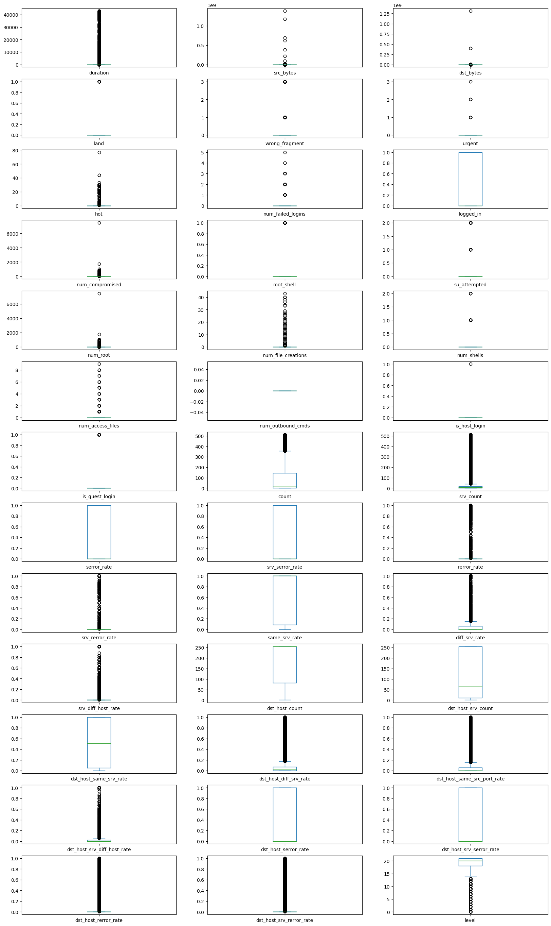

df_train['attack'].value_counts()

attack  
normal 67343  
neptune 41214  
satan 3633  
ipsweep 3599  
portsweep 2931  
smurf 2646  
nmap 1493  
back 956  
teardrop 892  
warezclient 890  
pod 201  
guess_passwd 53  
buffer_overflow 30  
warezmaster 20  
land 18  
imap 11  
rootkit 10  
loadmodule 9  
ftp_write 8  
multihop 7  
phf 4  
perl 3  
spy 2  
Name: count, dtype: int64

# I will convert other abnormal classes to one class  
  
df_train["binary_attack"]=df_train.attack.map(lambda a: "normal" if a == 'normal' else "abnormal")  
df_train.drop('attack',axis=1,inplace=True)  
  
df_test["binary_attack"]=df_test.attack.map(lambda a: "normal" if a == 'normal' else "abnormal")  
df_test.drop('attack',axis=1,inplace=True)

df_train.select_dtypes(['object']).columns

Index(['protocol_type', 'service', 'flag', 'binary_attack'], dtype='object')

# Encoding

# Label Encoder  
from sklearn import preprocessing  
le=preprocessing.LabelEncoder()  
clm=['protocol_type', 'service', 'flag', 'binary_attack']  
for x in clm:  
 df_train[x]=le.fit_transform(df_train[x])  
 df_test[x]=le.fit_transform(df_test[x])

# Spliting

#Spliting the data  
  
x_train=df_train.drop('binary_attack',axis=1)  
y_train=df_train["binary_attack"]  
  
x_test=df_test.drop('binary_attack',axis=1)  
y_test=df_test["binary_attack"]

# Feature Engineering

from sklearn.feature_selection import mutual_info_classif  
mutual_info = mutual_info_classif(x_train, y_train)  
mutual_info = pd.Series(mutual_info)  
mutual_info.index = x_train.columns  
mutual_info.sort_values(ascending=False)

src_bytes 0.566350  
service 0.468260  
dst_bytes 0.439951  
flag 0.369316  
same_srv_rate 0.367211  
diff_srv_rate 0.360573  
dst_host_srv_count 0.336736  
dst_host_same_srv_rate 0.310676  
logged_in 0.291961  
dst_host_serror_rate 0.288241  
dst_host_diff_srv_rate 0.285672  
dst_host_srv_serror_rate 0.282648  
serror_rate 0.277372  
srv_serror_rate 0.267642  
count 0.263547  
dst_host_srv_diff_host_rate 0.185727  
level 0.152463  
dst_host_count 0.143691  
dst_host_same_src_port_rate 0.131663  
srv_diff_host_rate 0.098324  
srv_count 0.063181  
dst_host_srv_rerror_rate 0.062184  
protocol_type 0.055352  
rerror_rate 0.041890  
dst_host_rerror_rate 0.036344  
srv_rerror_rate 0.035635  
duration 0.024879  
wrong_fragment 0.007604  
hot 0.007384  
num_compromised 0.005702  
num_access_files 0.004444  
is_guest_login 0.003038  
num_file_creations 0.001993  
num_shells 0.001881  
num_root 0.001138  
num_failed_logins 0.000907  
urgent 0.000590  
num_outbound_cmds 0.000403  
land 0.000247  
is_host_login 0.000000  
su_attempted 0.000000  
root_shell 0.000000  
dtype: float64

mutual_info.sort_values(ascending=False).plot.bar(figsize=(20, 8));

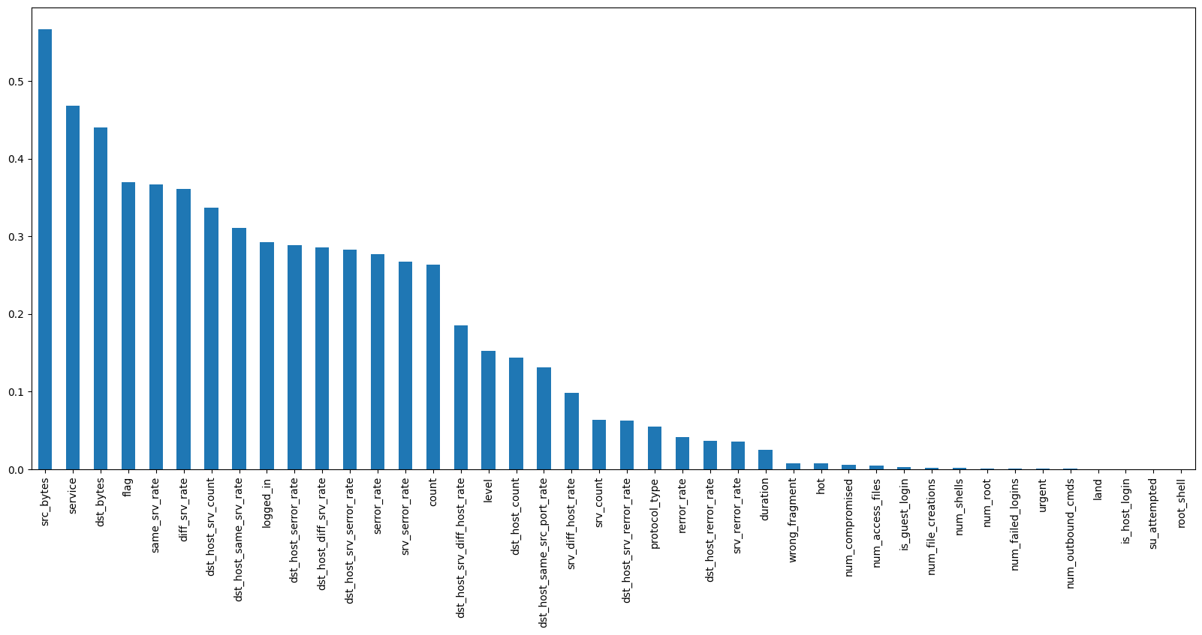

# I will choose 20 features to select  
from sklearn.feature_selection import SelectKBest  
sel_five_cols = SelectKBest(mutual_info_classif, k=20)  
sel_five_cols.fit(x_train, y_train)  
x_train.columns[sel_five_cols.get_support()]

Index(['service', 'flag', 'src_bytes', 'dst_bytes', 'logged_in', 'count',  
 'serror_rate', 'srv_serror_rate', 'same_srv_rate', 'diff_srv_rate',  
 'srv_diff_host_rate', 'dst_host_count', 'dst_host_srv_count',  
 'dst_host_same_srv_rate', 'dst_host_diff_srv_rate',  
 'dst_host_same_src_port_rate', 'dst_host_srv_diff_host_rate',  
 'dst_host_serror_rate', 'dst_host_srv_serror_rate', 'level'],  
 dtype='object')

col=['service', 'flag', 'src_bytes', 'dst_bytes', 'logged_in',  
 'same_srv_rate', 'diff_srv_rate', 'dst_host_srv_count',  
 'dst_host_same_srv_rate', 'dst_host_diff_srv_rate']  
x_train=x_train[col]  
x_test=x_test[col]

plt.figure(figsize=(12,10))  
p=sns.heatmap(x_train.corr(), annot=True,cmap ='RdYlGn')

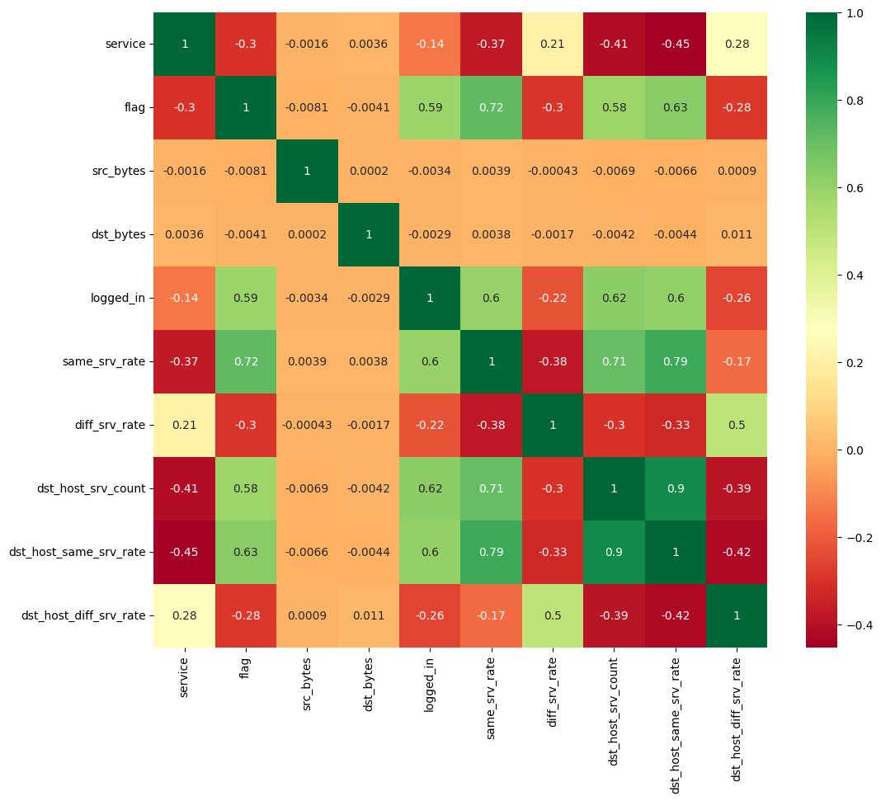

# Scaling

from sklearn.preprocessing import MinMaxScaler  
scaler = MinMaxScaler()  
x_train= scaler.fit_transform(x_train)  
x_test= scaler.fit_transform(x_test)

# Binary classification models

# we'll initialize each model and store it by name in a dictionary  
models = {}  
  
# Logistic Regression  
from sklearn.linear_model import LogisticRegression  
models['Logistic Regression'] = LogisticRegression()  
  
# Support Vector Machines  
from sklearn.svm import LinearSVC  
models['Support Vector Machines linear'] = LinearSVC()  
models['Support Vector Machines plonomial'] = SVC(kernel='poly')  
models['Support Vector Machines RBf'] = SVC(C=100.0)  
  
# Decision Trees  
from sklearn.tree import DecisionTreeClassifier  
models['Decision Trees'] = DecisionTreeClassifier(max_depth=3)  
  
# Random Forest  
from sklearn.ensemble import RandomForestClassifier  
models['Random Forest'] = RandomForestClassifier()  
  
# K-Nearest Neighbors  
from sklearn.neighbors import KNeighborsClassifier  
models['K-Nearest Neighbor'] = KNeighborsClassifier(n_neighbors=20)

# we'll loop over each one, train it by calling .fit(), make predictions, calculate metrics, and store each result in a dictionary.  
  
from sklearn.metrics import accuracy_score, precision_score, recall_score  
  
accuracy, precision, recall = {}, {}, {}  
  
for key in models.keys():  
  
 # Fit the classifier  
 models[key].fit(x_train, y_train)  
  
 # Make predictions  
 predictions = models[key].predict(x_test)  
  
 # Calculate metrics  
 accuracy[key] = accuracy_score(predictions, y_test)  
 precision[key] = precision_score(predictions, y_test)  
 recall[key] = recall_score(predictions, y_test)

df_model = pd.DataFrame(index=models.keys(), columns=['Accuracy', 'Precision', 'Recall'])  
df_model['Accuracy'] = accuracy.values()  
df_model['Precision'] = precision.values()  
df_model['Recall'] = recall.values()  
  
df_model

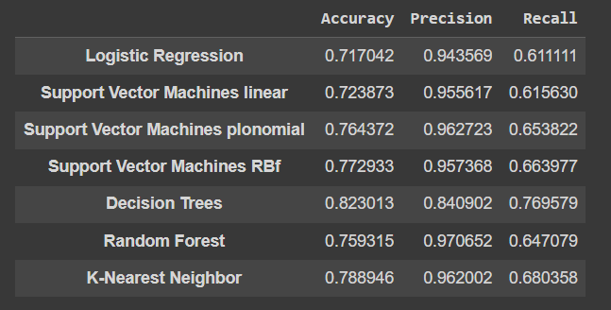

ax = df_model.plot.barh()  
ax.legend(  
 ncol=len(models.keys()),  
 bbox_to_anchor=(0, 1),  
 loc='lower left',  
 prop={'size': 14}  
)  
plt.tight_layout()

[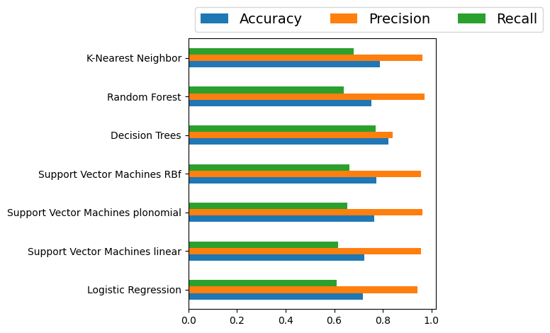](https://www.kaggleusercontent.com/kf/105881659/eyJhbGciOiJkaXIiLCJlbmMiOiJBMTI4Q0JDLUhTMjU2In0..JcEgiIXSkPIHERgsJfQ_ig.Ticmp8kpJklg2OsVm7RpHx9cryeebqi79MoP1RZvctqu0wejS81UK8S7RFjXu8tPqRmB_8zoErMMgCLm3KF42V1eMCCeDKnMIDRlRvqyb_LeEHJ83NgejAXVkdaomYbVDm1tPkkJ9b9y1qLh1jPaXLpWUt5Z9WLX30Cig1ZV3k25iM47N40IPuGp1_ow7zJ2sSXanqBSM1WZK4FS8FlesuWlzWO-zF9weyGpxXVexy0XZqRzfDaDW3TByHnL_hY7OlWwqLfAmDj95cUJFHRqp0Vs_-5haqoYoYWdGmT5Z2tSPdToEn3tVjpjyDs7qVRm1Mo1uCOKcY6NjeSfV4cV20hH3zr-73YZrNC5aZKYb5y_-53zzSGdXzeCoBsERjM_tOYIhAYYxKUAt4Dm5Oiicwfe8IUAeoAOKpQbYmIOucvuSjBoCKWGaDkeyFDNdT8pxNtMYxVUofMy5wa6fL0H0W7IUPq0P6JwmJcEzMYjsu054azxLHMkBGBNPQHSAlLPNuGAwnTl-v2PDKR3vYvDFNNv4Y2tnUU9JTuM1mVWkJWWglLNbNha2HTSTOTIsYzozg3G7SiRO-doVzpvQIj5h46nqT-_CnMBYDhVjDZak0g8ykxG63mHl81O9FUV_uJvowj-U5ZgWT3-zuUxICRl2o8an8tOziTPKRmhqNOFgBjrNHYcB97-I__UNZyFocZI.tKvX0tRdHhCCg5_eFT55UQ/__results___files/__results___32_0.png)

from sklearn.metrics import plot_roc_curve

for key in models.keys():

plot_roc_curve( models[key], x_test, y_test)

