**Change default kernel (boot with Old kernel)--CentOS 7**

This is the process how to modify the GRUB2 default entry to boot a different kernel version.

1. Check the current kernel Version:

# uname -a



2. Generating grub configuration file

# grub2-mkconfig -o /boot/grub2/grub.cfg

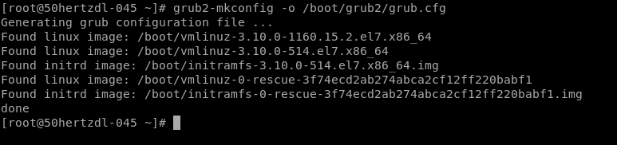

3. To list all the menu entries that will be displayed at system boot, issue the following commands

# awk -F\' '$1=="menuentry " {print i++ " : " $2}' /etc/grub2.cfg

or

# grep "^menuentry" /boot/grub2/grub.cfg | cut -d "'" -f2

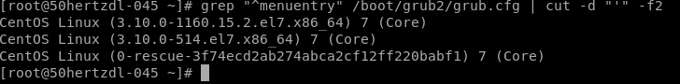

4.The default entry is defined by the GRUB_DEFAULT line in the /etc/default/grub file. However, if the GRUB_DEFAULT line is set as saved, the parameter is stored in the /boot/grub2/grubenv file. It may be viewed by:

# grub2-editenv list



5. The /boot/grub2/grubenv file cannot be manually edited. Use the following command instead:

# grub2-set-default 1

# grub2-editenv list



6. Changes to /etc/default/grub require rebuilding the grub.cfg file as follows:

# grub2-mkconfig -o /boot/grub2/grub.cfg

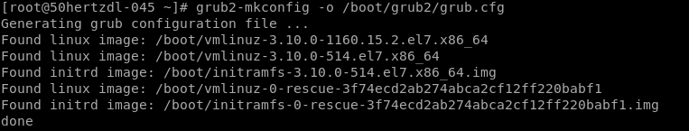

7. Reboot the Server and it will boot with Kernel Version

# shutdown -r now