**Working with FTP :**

There are two process getting the data into our FTP server.

**1.** **PULL:** In this process we are pulling the data from client machine using FTP and Java programming.

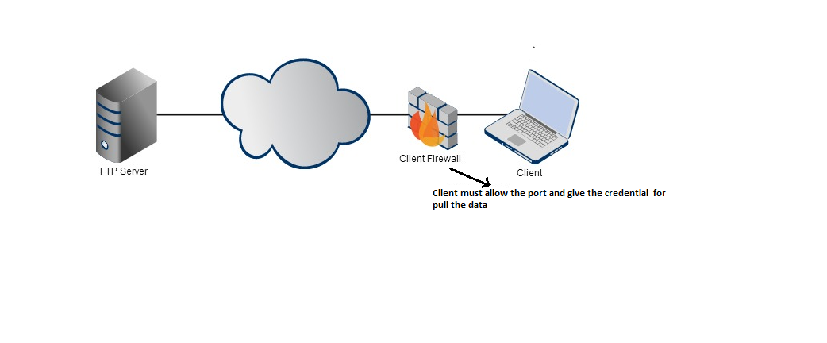

**2. PUSH:** In this process client push data into our FTP Server.

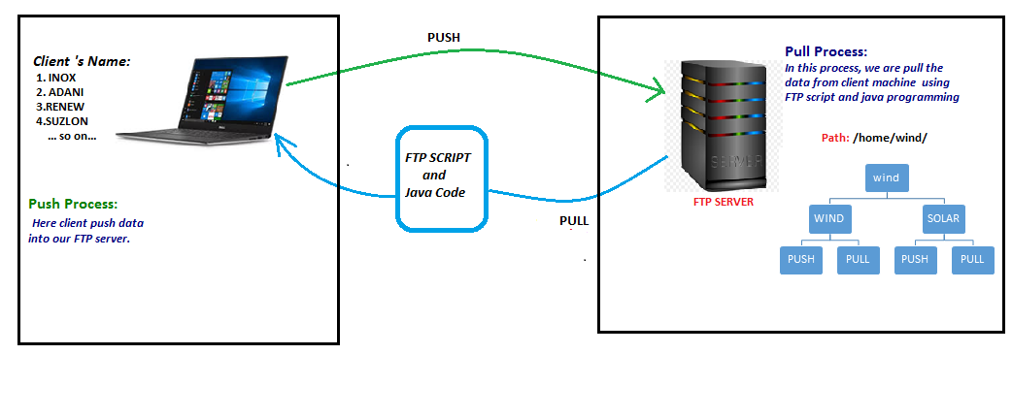

**Backup Process of FTP Data:**

There are below points we are following the backup process.

1. Currently we are getting the data into our wind3 server by the process of pull/ push and it will store on respective folders i.e. **WIND** and **SOLAR**.

2. Here we are created **arch** folder on wind3 server, for storing the WIND and SOLAR data internally.

3. We have one **Local Backup server** in which we are taken backup of **WIND** and **SOLAR** data.

4. From **Local Backup Server** ,we created tar file and storing into S3 bucket and Amresh Sir’s sytem.

Ths above 4 point is describing our backup process of wind3 ftp server.

5. In this point, we are sync the data from wind3 to aws ftp server as this is new ftp server on aws.

6. Some of clients, are start pushing the data into our new FTP Server.

7. Here also we are taken backup of **WIND** and **SOLAR** in arch folder internally.

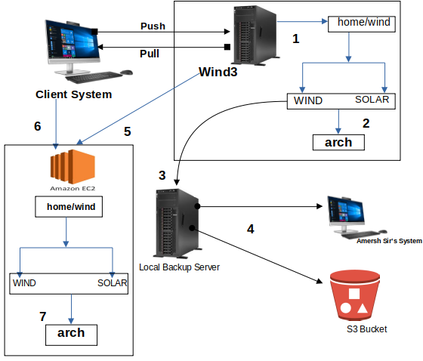

**Backup Process of EPM FTP data:**

There are below process we are following the EPM ftp data.

1. By the process of pull and push we are collecting the ftp data into our ftp folder on aws ec2 instance.

Here the below folder name is as below:

*/home/ftp-data/*

*/home/www_epm/prod/files/weather/*

*Note:- On weather ftp data we are storing it for 7 days.*

2. For backup process, we have **Local Backup Server** in which we are taken backup of EMP data.

3. From **Local Backup Server** ,we created tar file and storing into S3 bucket and Amresh Sir’s sytem.

**Removing Process:**

1. Every 7 days data is removing from aws ec2 instance(*/home/www_epm/prod/files/weather/*)’ s data.

2. we are removeing data every 6 month from Amersh sir’s system as well as Local server.

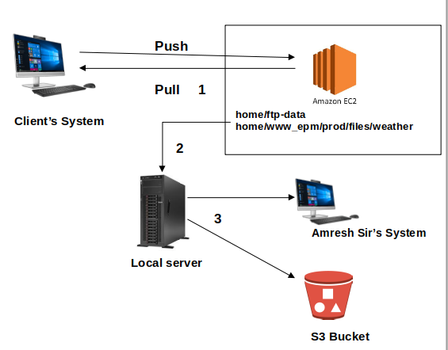

**How to make Backup From Server:**

