**FTP Configuration and FTP Monitoring**

Introduction:

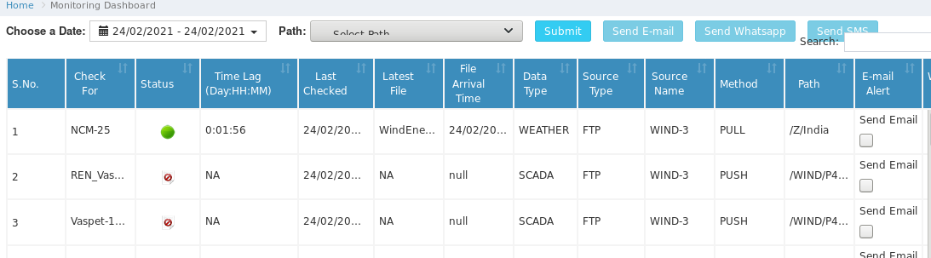In this document explains FTP Monitoring and vsftp configuration.

**Some Points to Understanding while monitoring the FTP:**

* **NCM-25:** National Center for Media Feed Weather Feed and forecasting.
* **SCADA**- Getting data interval 10 or 15 min, this is depending on SCADA program
* **Meter:** Real time power generator data.

– Energy meter install, it measure actual power of generator in real time.

**Source Name:**

* PULL: In this process we are pulling the data from client machine using ftp and java programming.

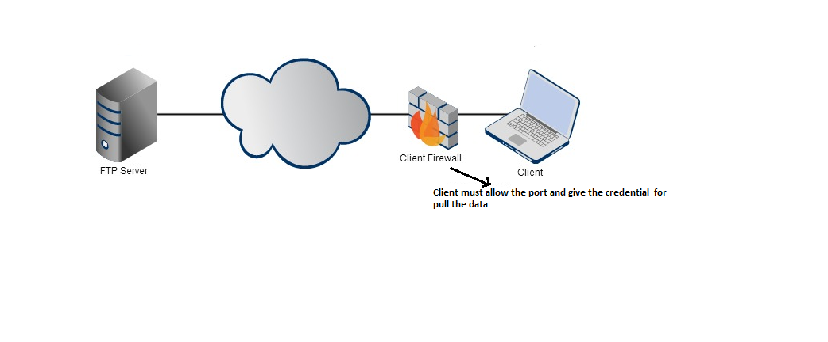

* PUSH: Here client push the data into our ftp server.

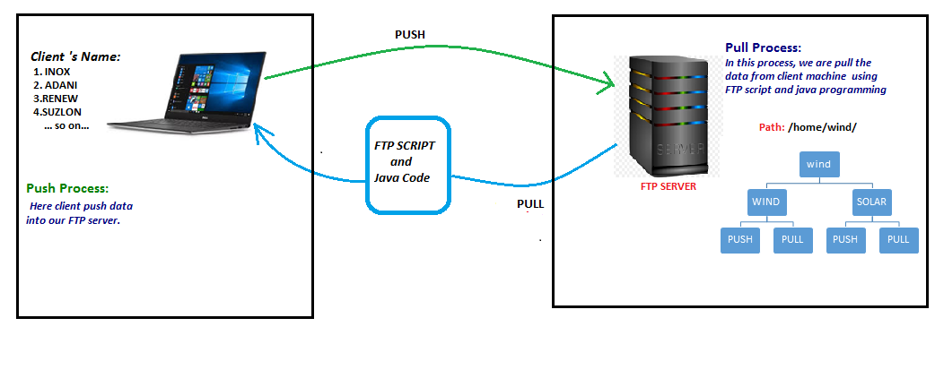

**Installation FTP server in Centos7:**

FTP: FTP (File Transfer Protocol) is a traditional and widely used standard tool for transferring files between a server and clients over a network, especially where no authentication is necessary(permits anonymous users to connect to a server).

In this guide, we will install and configure and a secure a FTP server (VSFTPD stands for very Secure FTP Daemon).

Note: All install process will be run as root.

**Installing VSFTPD Server:**

1. Installing vsftpd server is straight forward, just run the following command in the terminal

#yum install vsftpd -y

1. After the installation completes, the service will be disabled at first, we need to start it manually for the time being and enable it to start automatically from the next system boot as well:

# systemctl start vsftpd

# systemctl enable vsftpd

**Configuring FTP Server:**

1. Now we will move over to perform a few configurations to setup and secure our FTP server, let us start by taking a backup of the original config file /*etc/vsftpd/vsftpd.conf /etc/vsftpd/vsftpd.conf.default*

*# cp /etc/vsftpd/vsftpd.conf /etc/vsftpd/vsftpd.conf.default*

1. Next open the config file and set the following options with corresponding values:

#selected configuration for vsftpd

anonymous_enable=NO

local_enable=YES

write_enable=YES

local_umask=022

dirmessage_enable=YES

xferlog_enable=YES

connect_from_port_20=YES

xferlog_std_format=YES

dual_log_enable=YES

log_ftp_protocol=YES

xferlog_file=/var/log/xferlog

idle_session_timeout=1800

data_connection_timeout=1800

chroot_local_user=YES

listen=YES

pam_service_name=vsftpd

userlist_enable=YES

tcp_wrappers=YES

pasv_enable=YES

use_localtime=YES

local_root=/home/wind

max_per_ip=90

max_clients=100

log_ftp_protocol=YES

pasv_promiscuous=YES

1. After all changes done, we need to restart the server for effect the changes.

# service vsftpd restart

**Creating User:**

1. Now we will creating FTP user for nologin shell

# useradd -s /sbin/nologin/ exam1

#useradd -s /sbin/nologin/ exam2

1. Give the password to these user

e.g. #passwd exam1

1. check the user is availability

[root@files bhasker]# cat /etc/passwd |grep exam

Output as like below:

exam2:x:1005:1005::/home/exam2:/sbin/nologin

exam1:x:1006:1006::/home/exam1:/sbin/nologin/

exam3:x:1007:1007::/home/exam3:/sbin/nologin/

**Creating Directory for user and their permissions:**

* Create the directory under home which will access by FTP user

[root@files home]# mkdir -p wind/WIND

[root@files home]# mkdir -p wind/SOLAR

1. Give read and execute permission to user : Using setfacl giving read and execute permission to wind directory

[root@files home]# setfacl -m u:exam1:rx wind

[root@files home]# setfacl -m u:exam3:rx wind

1. Give read, write, execute permission to WIND –for exam1 and SOLAR –exam3

Here is given example for the same:

[root@files wind]# setfacl -m u:exam1:rwx WIND

[root@files wind]# setfacl -m u:exam3:rwx SOLAR

Check the permission for given changes:

[root@files wind]# ll

total 8

drwxrwx---+ 2 root root 4096 Jan 28 17:05 SOLAR

drwxrwx---+ 2 root root 4096 Jan 28 17:05 WIND

1. 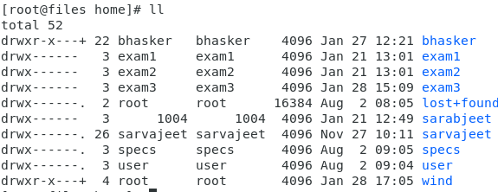File permission of /wind directory should be like below i.e. chmod 700 wind

1. If file permission of wind directory was not like above, then change it by using chmod command.

# chmod 700 wind

1. Suppose you wrongly change the user mode, then use given command.

Here the given example of wrongly mention user exam1 as exam2

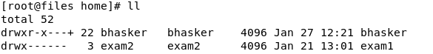For change it, use the below command:

[root@files home]# chown -R exam1:exam1 exam1

[root@files home]# chown -R exam2:exam2 exam2

1. Suppose we want to check what permission is given to wind, we can use given command as below.

e.g. # getfacl wind

output:

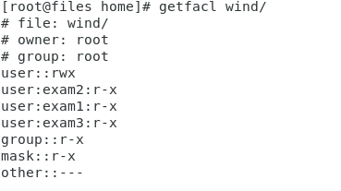

1. By default sub-directory has all permission, but we want 770 permission to the sub directory, so change it as below screen shot commands.

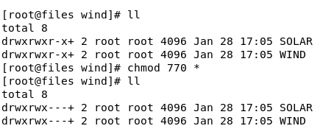

* The above process is for installation of VSFTPD, User creation and directory creation which will access from ftp user.
* Next step, we will install Filezila and access it by creating user for this.