## NGINX:

NGINX is open source software for web serving, reverse proxying, caching, load balancing, media streaming, and more. It started out as a web server designed for maximum performance and stability. In addition to its HTTP server capabilities, NGINX can also function as a proxy server for email (IMAP, POP3, and SMTP) and a reverse proxy and load balancer for HTTP, TCP, and UDP servers.

## Step One—Add Nginx Repository

To add the CentOS 7 EPEL repository, open terminal and use the following command:

# sudo yum install epel-release

## Step Two—Install Nginx

Now that the Nginx repository is installed on your server, install Nginx using the following yum command:

#sudo yum install nginx

## Step Three—Start Nginx

Nginx does not start on its own. To get Nginx running, type:

#sudo systemctl start nginx

Note: Some times its through the error as like below,

Job for nginx.service failed because the control process exited with error code. See "systemctl status nginx.service" and "journalctl -xe" for details.



Try to run the following two commands: Resolve the issue.

sudo fuser -k 80/tcp

sudo fuser -k 443/tcp

* Now we can start the nginx.

# sudo service nginx restart

* Check the status of nginx

# sudo service nginx status

Note:-Before continuing, you will probably want to enable Nginx to start when your system boots. To do so, enter the following command:

#sudo systemctl enable nginx

Refer link for installation nginx:

https://www.digitalocean.com/community/tutorials/how-to-install-nginx-on-centos-7

**NGINX Configuration for Tomcat server Access On CentOS7:**

Edit configuration file: vim /etc/nginx/nginx.conf

Add the tomcat URL on it.

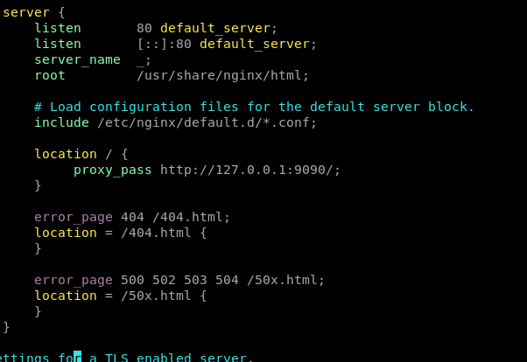

After made changes on configuration file, restart the nginx .

#sudo service nginx restart

Now, we can access the tomcat url from nginx

- - > http: <server_ip> or localhost

We can see the tomcat page on this browser:

