**Observium:**

* Observium is a PHP/MySQL driven Network observation and Monitoring application, that supports a wide range of operating systems/hardware platforms including, Linux and Windows.
* It seeks to present a robust and simple web interface to monitor health and performance of our work.
* SNMP based auto discover network monitoring tool

**We are use for Observium:**

* We are using the Observium for CPU, memory and for storage statistics.
* Also we monitoring the processes, load average and uptime statistics.

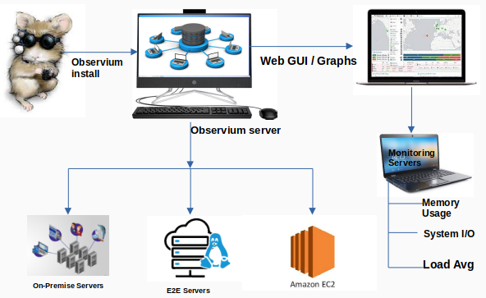 **Architecture for Observium**