SKILL – 1
GIT VERSION CONTROL

Introduction :
Git Version Control is used to manage and track changes in project files. It helps developers work together by saving different versions of code safely. Using Git, we can create branches, make updates, and merge changes without losing data. This skill helps us understand how real software teams collaborate and manage their projects efficiently

TASKS :

STEP 1️⃣ : Create a new project folder, initialize Git using git init, and configure Git with your username and email.
1. Open Git Bash or Terminal
- Create a new folder
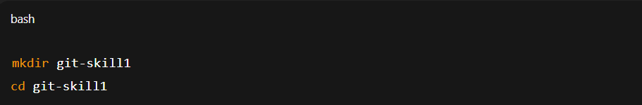
- Initialize Git
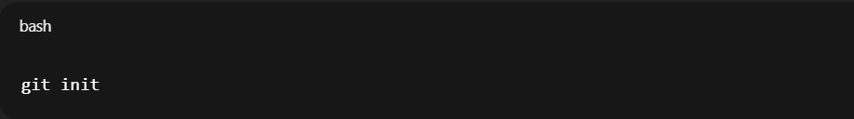

- Configure username and email
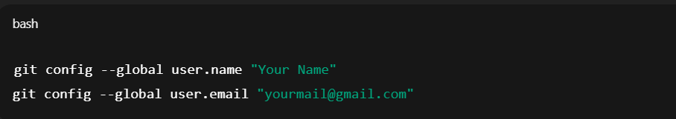

- Verify configuration
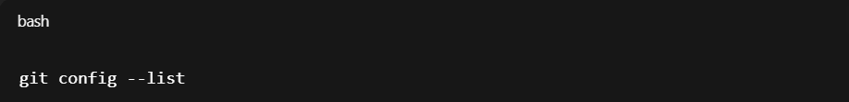

STEP 2️⃣: Create two files (example: main.java, notes.txt) with sample content, check the repository status, and add them to staging.

- Create two files
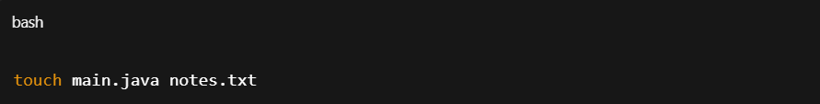

- Add sample content
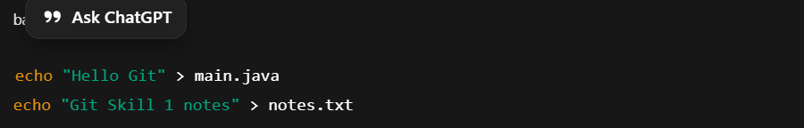

- Check repository status
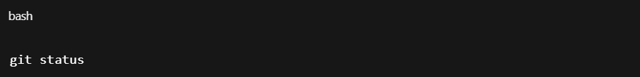

✔️ Files will appear in red (untracked).

- Add files to staging
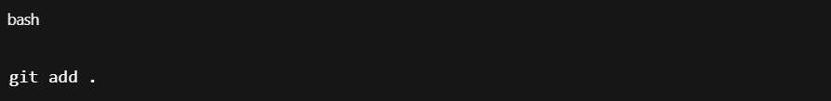

- Check status again
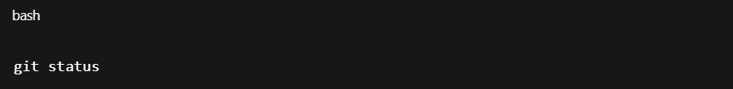✔️ Files will appear in green (staged).

STEP 3️⃣: Commit the staged files with a meaningful commit message
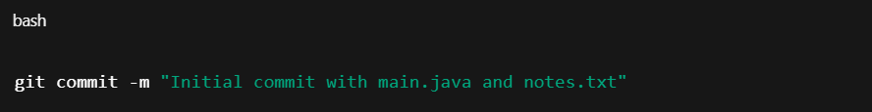
✔️ Files are now saved in Git history.

STEP 4️⃣: Create a new repository on GitHub, connect your local repo using the remote URL and push the committed changes.

1. Go to GitHub → New Repository
- Repository name: git-skill1
- Keep it Public
- ❌ Do NOT add README
2. Copy repository URL
3. Connect local repo to GitHub
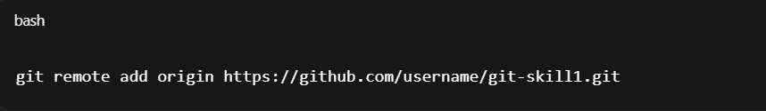
4. Push code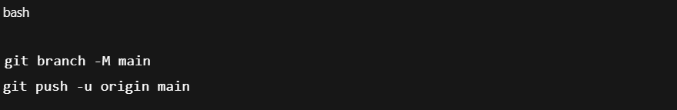✔️ Code is now visible on GitHub.

STEP 5️⃣: Create the first branch (example: feature-update), make modifications, and add + commit the changes.
- Create and switch branch
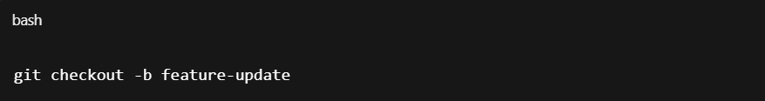
- Modify file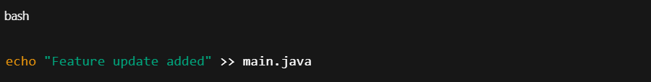

- Add and commit

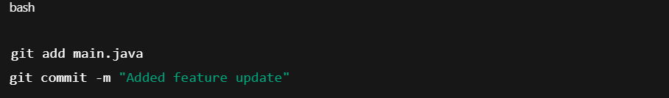
STEP 6️⃣: Create a second branch (example: bug-fix), apply changes, and add + commit them.
- Switch to main
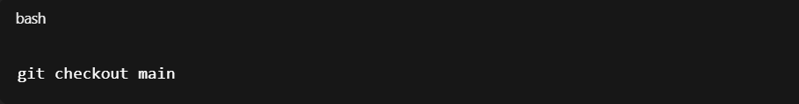

- Create new branch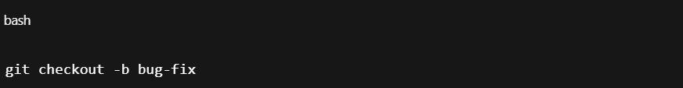

- Modify file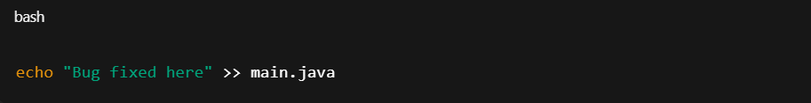

- Add and commit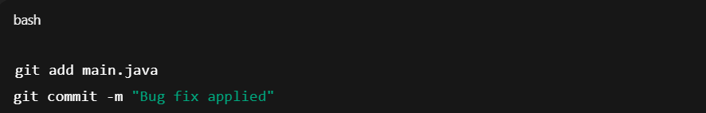

STEP 7️⃣: Switch back to the main branch and merge both branches one after the other
- Switch to main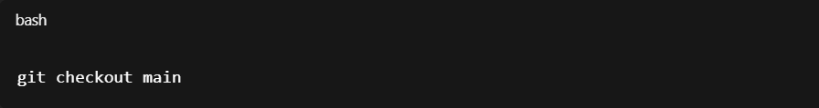
- Merge feature branch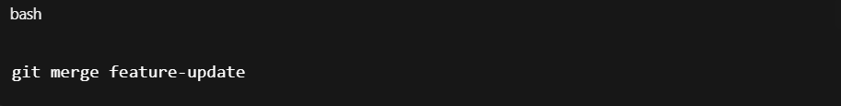
- Merge bug-fix branch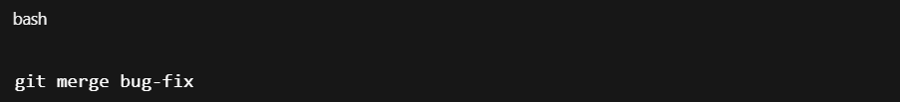

✔️ If no conflict → merge completes.

STEP 8️⃣: If any merge conflict occurs, resolve it manually, commit the fix, and complete the merge
- Open conflicted file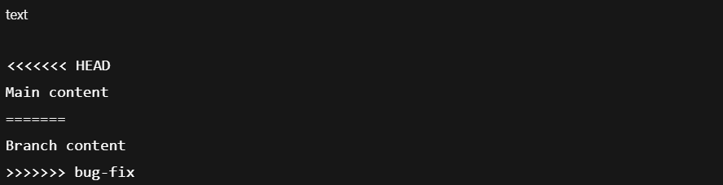

- Edit manually and keep correct code ( (Delete conflict symbols)

- Add resolved file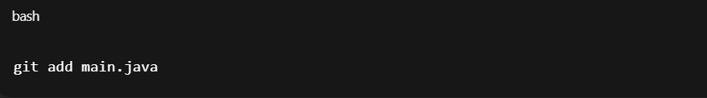

- Commit resolution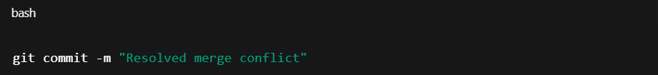

✅ FINAL CHECK
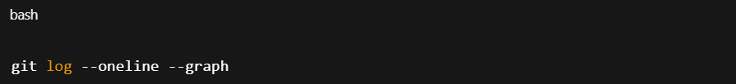

✔️ Shows all commits and merges.

