SKILL – 4: Spring Dependency Injection – Constructor & Setter Injection
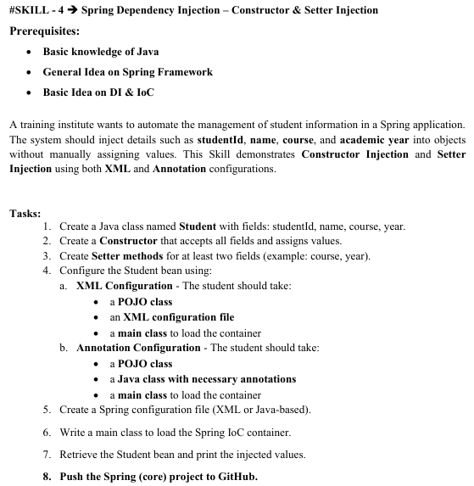
You can use both:
- applicationContext.xml (XML autowiring)
- Annotations (@Autowired, @Component, etc.)
Spring supports mixed configuration.
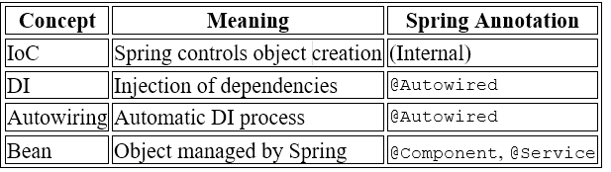
Create Project In Eclipse / STS
File → New → Maven Project
✔ Create a simple project
Group Id : com.klu
Artifact Id : springcore-student
Packaging : com.klu
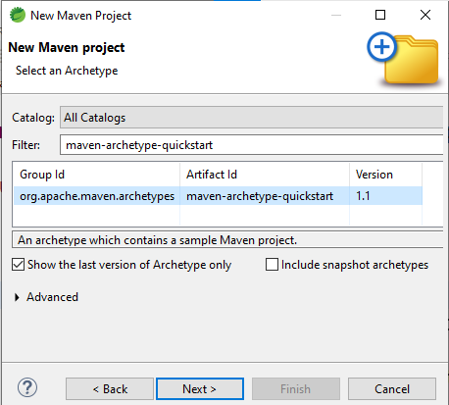
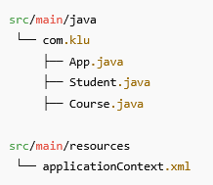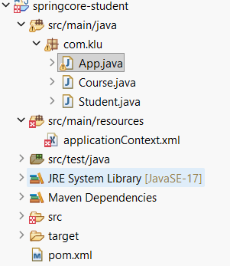
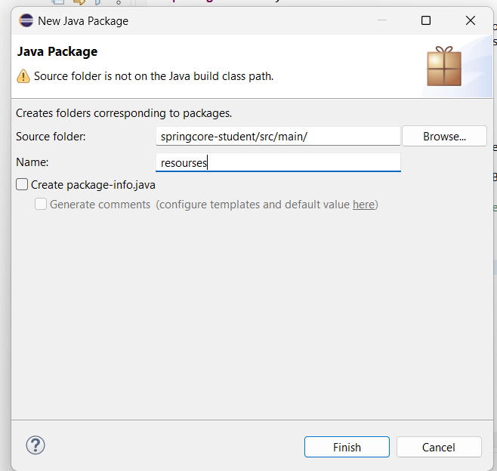
Add Spring Dependency (pom.xml):
-----------------------------------------------------------------------------------------------------
<dependency>
<groupId>org.springframework</groupId>
<artifactId>spring-context</artifactId>
<version>5.3.30</version>
</dependency>

Course.java :
package com.klu;
public class Course {
private String courseName;
private int duration; // duration in months
// Constructor Injection
public Course(String courseName, int duration) {
this.courseName = courseName;
this.duration = duration;
}
// Getters (optional but good practice)
public String getCourseName() {
return courseName;
}
public int getDuration() {
return duration;
}
@Override
public String toString() {
return courseName + " (" + duration + " months)";
}
}
Student.java:
package com.klu;
public class Student {
private int studentId;
private String name;
private int year;
private Course course;
private String email;
private String phoneNumber;
// Constructor Injection
public Student(int studentId, String name, int year) {
this.studentId = studentId;
this.name = name;
this.year = year;
}
// Setter Injection
public void setCourse(Course course) {
this.course = course;
}
public void setEmail(String email) {
this.email = email;
}
public void setPhoneNumber(String phoneNumber) {
this.phoneNumber = phoneNumber;
}
// Display method (each detail in a separate line)
public void display() {
System.out.println("Student ID : " + studentId);
System.out.println("Student Name : " + name);
System.out.println("Academic Year : " + year);
System.out.println("Email : " + email);
System.out.println("Phone Number : " + phoneNumber);
System.out.println("Course : " + course);
}
}
applicationContext.xml:
📁 src/main/resources/applicationContext.xml
-----------------------------------------------------------------------------------------------------
<?xml version="1.0" encoding="UTF-8"?>
<beans xmlns="http://www.springframework.org/schema/beans"
xmlns:xsi="http://www.w3.org/2001/XMLSchema-instance"
xsi:schemaLocation="
http://www.springframework.org/schema/beans
https://www.springframework.org/schema/beans/spring-beans.xsd">

<!-- Course Bean -->
<bean id="course" class="com.klu.Course">
<constructor-arg value="Spring Framework"/>
<constructor-arg value="6"/>
</bean>

<!-- Student Bean -->
<bean id="student" class="com.klu.Student">

<!-- Constructor Injection -->
<constructor-arg value="101"/>
<constructor-arg value="ram"/>
<constructor-arg value="2026"/>
<!-- Setter Injection -->
<property name="course" ref="course"/>
<property name="email" value="ram@klu.edu"/>
<property name="phoneNumber" value="9876543210"/>
</bean>
</beans>

App.java:
package com.klu;
import org.springframework.context.ApplicationContext;
import org.springframework.context.support.ClassPathXmlApplicationContext;
public class App {
public static void main(String[] args) {
ApplicationContext context =
new ClassPathXmlApplicationContext("applicationContext.xml");
Student student = (Student) context.getBean("student");
student.display();
}
}
=====================================================================Run the Application:
- Right-click App.java
- Run As → Java Application
OUTPUT on the console:

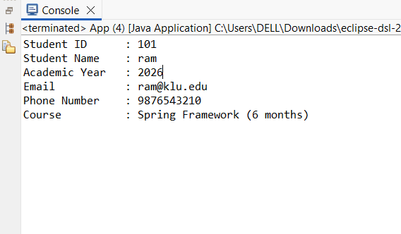
Now Add the Springcore-students into the Github:
There are 2 ways to push into the Github
1.Through the eclipse
2.Through the files to direct Github.
*The easiest method is do it from the files
Now go the file and type springcore-students as shown below
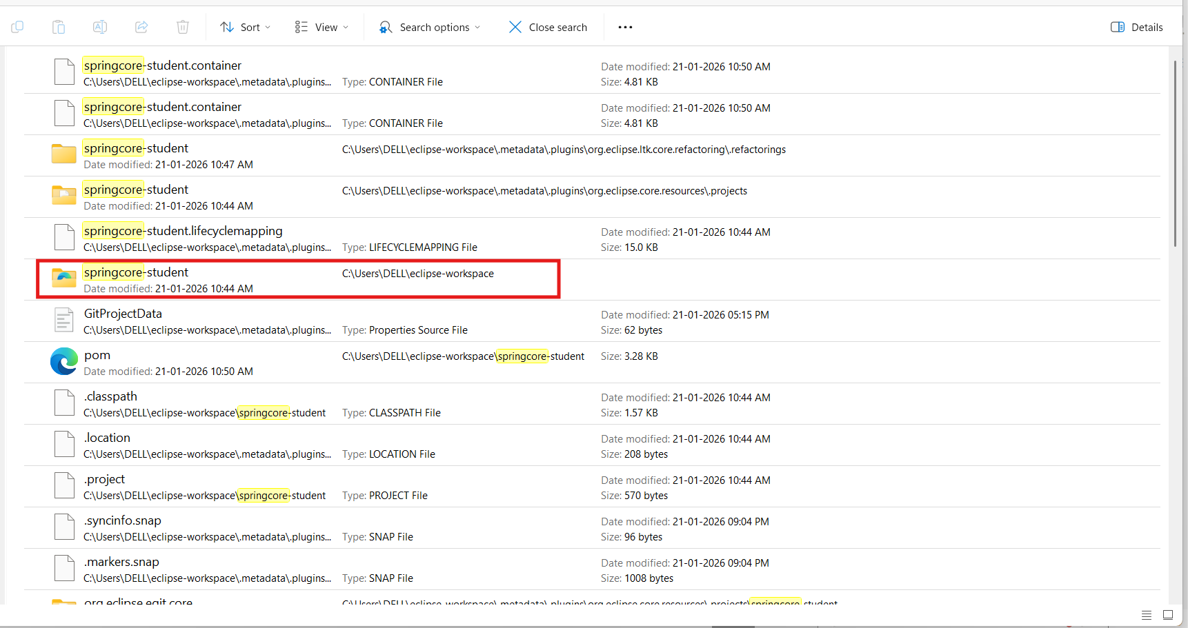
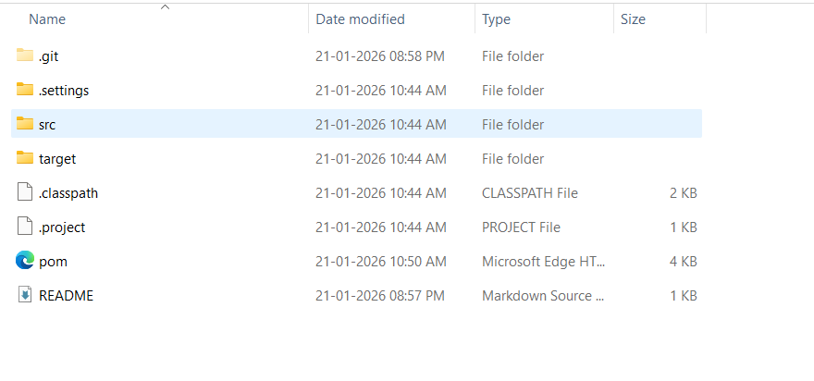
- Keep it aside and Now goto the Github and create a new repository and name it spring-core-ioc .
- After create go the files and type cmd in the search bar
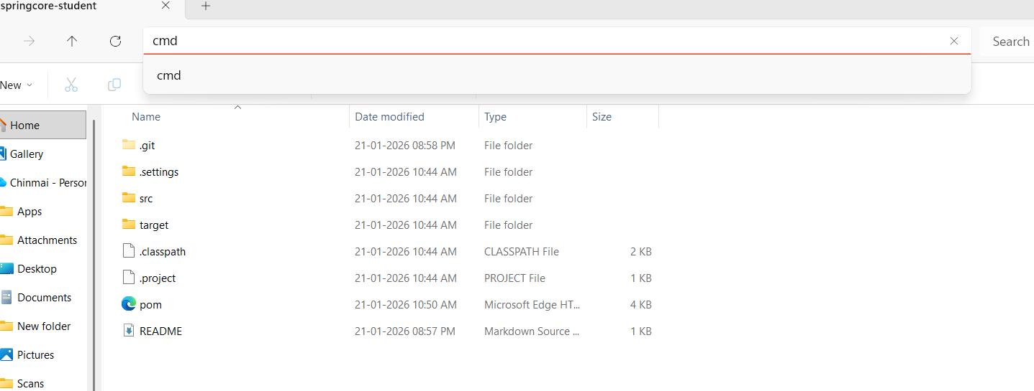
- Now use the command given the in Github ,so that your files can be uploaded into the Github as shown below or you can upload directly from the Github if cmd didn’t work.
