✦ DEVOPS STUDY NOTES • MOTION DIAGRAM EDITION ✦
Ansible Automation & Ad-Hoc Guide
Step-by-Step Hands-on Lab on Amazon Linux 2023 with Animated Motion Diagrams & Cluster Targeting
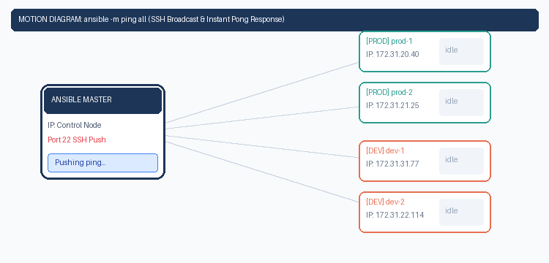
▶ Animated Motion Diagram: Live Looping Flow: Master pushes SSH ping -> All 4 Nodes return instant PONG
PLATFORM SPECS  • Amazon Linux 2023 (AL2023)  • AWS EC2 t3.micro Instances  • Python 3 + Pip installed  • Native SSH Port 22 | 5-NODE TOPOLOGY  • 1 Ansible Master (Control)  • 2 PROD Nodes (prod-1, prod-2)  • 2 DEV Nodes (dev-1, dev-2)  • 100% Agentless Architecture | STUDY GOALS  • Localhost Ad-Hoc Validation  • SSH Keyless Authentication  • Group Inventory ([prod], [dev])  • Filtered Multi-Node Runs

⚡ INTERACTIVE MOTION SIMULATOR INCLUDED
In addition to this Word document, open 'ansible_motion_diagram.html' in your browser to interactively switch between Ping, Dev targeting, Prod targeting, and SSH handshake animations with live terminal outputs!

Chapter 1: Ansible Core Concepts & Architecture
What is Ansible? Ansible is an IT automation and configuration management tool. It lets you configure systems, deploy software, and orchestrate advanced workflows across hundreds of servers simultaneously from a single master machine.
The 3 Pillars You Must Remember
1. Agentless: You do NOT install any client agent on worker nodes. It uses standard OpenSSH.
2. Push Model: The master initiates and pushes tasks immediately when you want them.
3. Idempotent: Running a command 10 times produces the same result as running it once, without breaking anything.
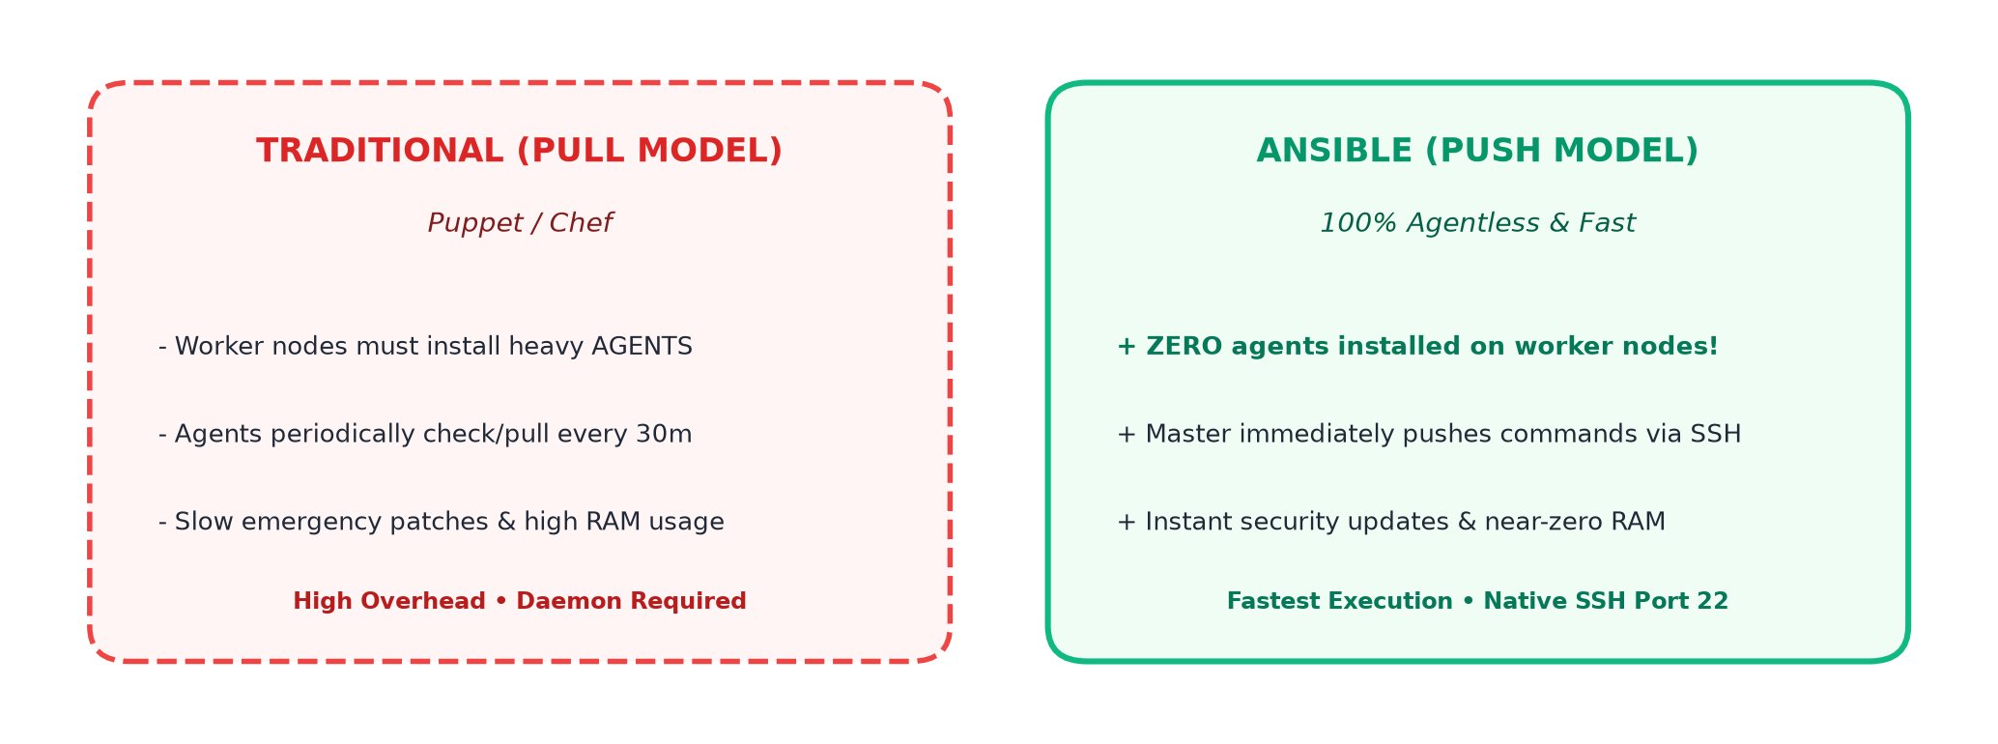
✎ Visual Schematic: Traditional Pull vs. Ansible Agentless Push Model
Quick Comparison Matrix
Metric | Ansible | Chef / Puppet | Why Ansible Wins
Agent Required? | NO (100% Agentless) | YES (Heavy agent daemon) | Zero agent maintenance & zero RAM overhead
Protocol | Standard SSH (Port 22) | Custom TCP ports / SSL | Works through existing company firewalls
Speed | Instant Push | Slow Pull (Waits 30 mins) | Critical for instant zero-day security patching
Configuration | YAML (Plain English) | Ruby DSL / Puppet code | Anyone can learn in 1 afternoon

Chapter 2: Installation & First Ad-Hoc Commands
Step 1: Installation: Launch 1 Amazon Linux 2023 EC2 instance (t3.micro). Run these 3 simple commands to install Ansible:
sudo dnf install python3 python3-pip -y # 1. Install Python prerequisites
sudo dnf install ansible -y # 2. Install Ansible
ansible --version # 3. Verify installation

What are Ad-Hoc Commands?
Definition: Ad-hoc commands are quick, single Linux commands executed across machines for one-off or daily repetitive tasks without writing a playbook file.
🔑 THE TWO KEY FLAGS
• -m = MODULE: Tells Ansible what tool to run (default is 'command', or 'ping', 'yum', 'service').
• -a = ARGUMENTS: The actual command or parameters you want to execute.

Hands-On Practice on Localhost
Category | Ad-Hoc Command to Run | What It Does
Ping Test | ansible localhost -m ping | Checks if Ansible & Python can run locally.
Install Git | ansible localhost -a "yum install git -y" | Installs Git version control.
Check Git | ansible localhost -a "git --version" | Confirms Git is installed.
Install Maven | ansible localhost -a "yum install maven -y" | Installs Maven build tool.
Check Maven | ansible localhost -a "mvn --version" | Confirms Maven version.
Create File | ansible localhost -a "touch file1" | Creates a test file named file1.
List Files | ansible localhost -a "ls -la" | Lists directory contents.
Install Apache | ansible localhost -a "yum install httpd -y" | Installs Apache Web Server.
Check Service | ansible localhost -a "systemctl status httpd" | Checks if httpd is running.
Start Service | ansible localhost -a "systemctl start httpd" | Starts Apache web server.
Add User | ansible localhost -a "useradd bhaskar" | Creates user account 'bhaskar'.
Audit User | ansible localhost -a "cat /etc/passwd" | Checks /etc/passwd for bhaskar.
Clean Up | ansible localhost -a "yum remove git* maven* httpd* -y" | Removes all installed test packages.
Understanding Ping Output
localhost | SUCCESS => {
"changed": false, <-- Notice 'false'! Ping does not alter the system.
"ping": "pong" <-- Successful connection response!
}

Chapter 3: Building the 5-Server Enterprise AWS Lab
Lab Goal: Launch 5 Amazon Linux 2023 EC2 instances in the same AWS VPC: 1 Ansible Master, 2 PROD, and 2 DEV nodes.
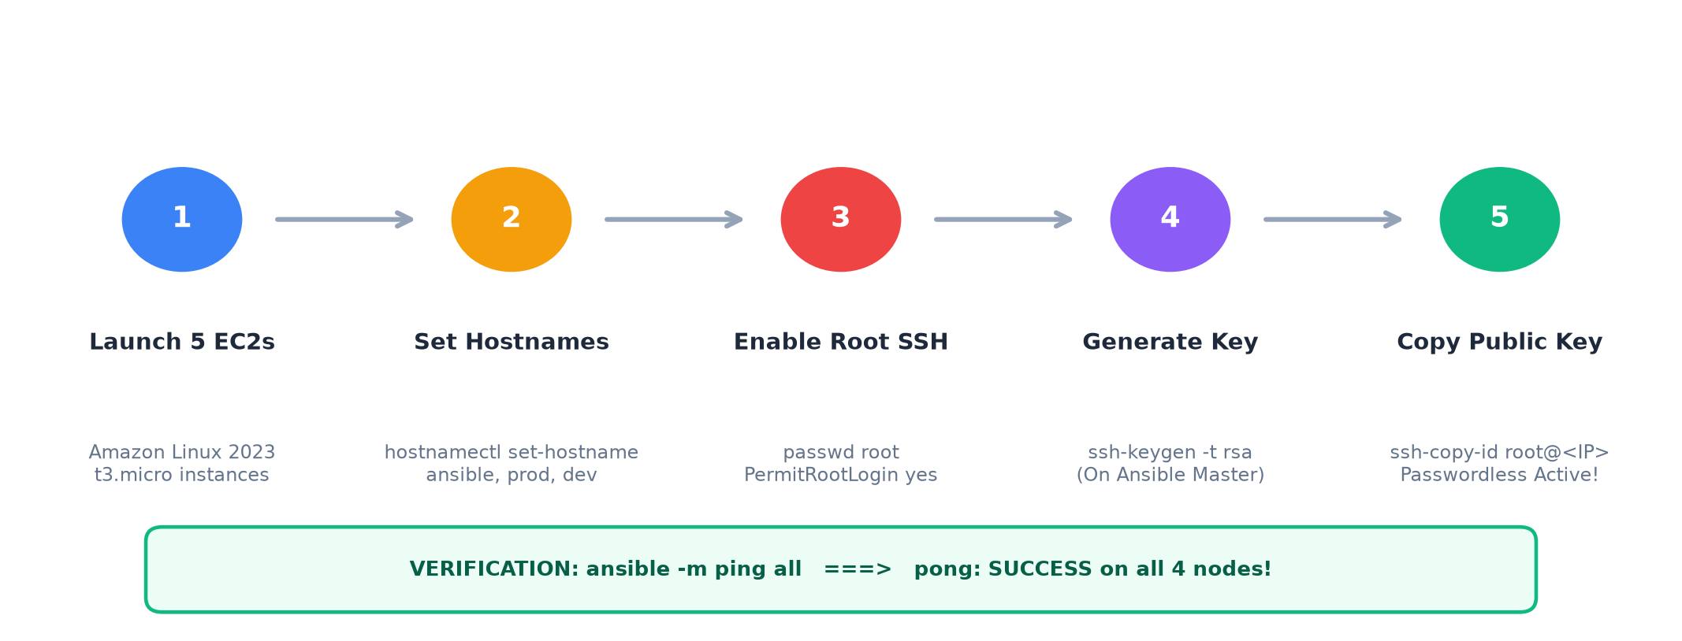
✎ Visual Schematic: 5 Simple Steps to Connect Master and Worker Nodes
Step 1: Set Hostnames (On all 5 instances)
# On Master: hostnamectl set-hostname ansiblemaster
# On Prod 1: hostnamectl set-hostname prod-1
# On Prod 2: hostnamectl set-hostname prod-2
# On Dev 1: hostnamectl set-hostname dev-1
# On Dev 2: hostnamectl set-hostname dev-2
sudo -i # Run sudo -i to refresh your terminal prompt

Step 2: Enable Root SSH (On all 4 worker nodes)
sudo -i
passwd root # 1. Set a password for root
vi /etc/ssh/sshd_config # 2. Uncomment/enable these 2 lines:
# PermitRootLogin yes (line 40)
# PasswordAuthentication yes (line 65)
systemctl restart sshd # 3. Restart SSH daemon
hostname -i # 4. Note down the private IP

Step 3: Generate & Copy SSH Keys (On Ansible Master)
ssh-keygen # Press Enter for all prompts (accept defaults)
ssh-copy-id root@<prod-1-private-ip> # Type 'yes', enter root password
ssh-copy-id root@<prod-2-private-ip>
ssh-copy-id root@<dev-1-private-ip>
ssh-copy-id root@<dev-2-private-ip>
ssh <prod-1-private-ip> # Test login: logs in without asking password!

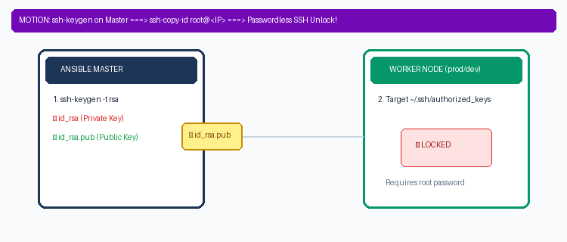
▶ Animated Motion Diagram: Live Looping Flow: Key generation on Master -> ssh-copy-id -> Passwordless Unlock

Chapter 4: Inventory File Mastery (/etc/ansible/hosts)
What is the Inventory? The inventory file tells Ansible WHICH servers exist and HOW to group them. By default, it lives at /etc/ansible/hosts.
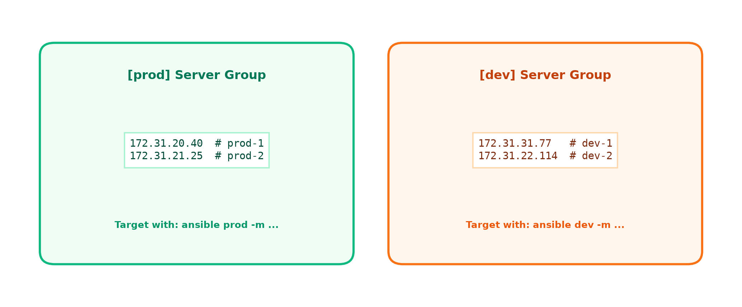
✎ Visual Schematic: Grouping Servers in /etc/ansible/hosts
Configuring Groups in /etc/ansible/hosts
vi /etc/ansible/hosts
[prod] # Production server group
172.31.20.40
172.31.21.25
[dev] # Development server group
172.31.31.77
172.31.22.114

Alternative Enterprise Authentication Method: [all:vars]
Production Standard: In real company production environments, we never enable root passwords. Instead, we use the AWS .pem key pair:
# Append to /etc/ansible/hosts:
[all:vars]
ansible_user=ec2-user
ansible_ssh_private_key_file=/home/ec2-user/MyKey.pem
ansible_become=true # Runs commands with sudo privileges

Verify Your Inventory & Ping All Nodes
ansible-inventory --list # View inventory in JSON format
ansible-inventory --graph # View visual hierarchy tree
ansible -m ping all # Pings ALL 4 servers at the same time!

Chapter 5: Multi-Node Execution & Group Filtering
Execution Power: Now you can run commands across all 4 servers simultaneously or target specific groups (dev or prod).
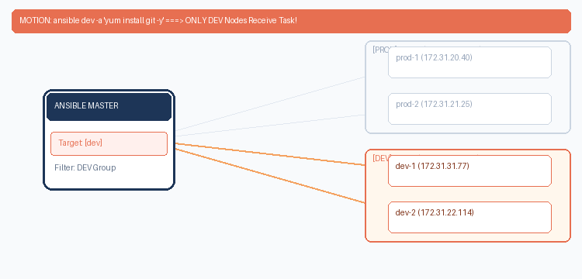
▶ Animated Motion Diagram: Live Looping Flow: Targeting 'dev' fires only to DEV nodes; Targeting 'prod' fires only to PROD nodes
1. Commands Targeting ALL Nodes ('all')
Command (Targets: all) | What Happens on All 4 Servers
ansible all -a "yum update -y" | Updates operating system packages across all nodes.
ansible all -a "yum install git -y" | Installs Git version control on all 4 servers concurrently.
ansible all -a "git --version" | Checks Git version across all nodes in parallel.
ansible all -a "yum install maven -y" | Installs Maven on all nodes.
ansible all -a "touch file1" | Creates file1 on all 4 servers at once.
ansible all -a "touch reyaz.txt" | Creates reyaz.txt on all servers.
ansible all -a "ls -l" | Lists files on all servers.
ansible all -a "yum install httpd -y" | Installs Apache HTTP Web Server.
ansible all -a "systemctl start httpd" | Starts Apache web service on all 4 servers.
ansible all -a "useradd reyaz" | Creates user 'reyaz' across all nodes.
ansible all -a "yum remove git* maven* httpd* -y" | Cleans up / uninstalls packages cluster-wide.
2. Laser-Focused Targeting: 'dev' vs 'prod'
# Install Git ONLY on DEV servers (prod servers remain untouched):
ansible dev -a "yum install git -y"
# Verify: Dev nodes have git, Prod nodes DO NOT:
ansible dev -a "git --version" # Returns git version
ansible prod -a "git --version" # Returns 'git: command not found'
# Restart web service ONLY on PROD servers:
ansible prod -a "systemctl restart httpd"

Chapter 6: Revision Cheat Sheet & Interview Q&A
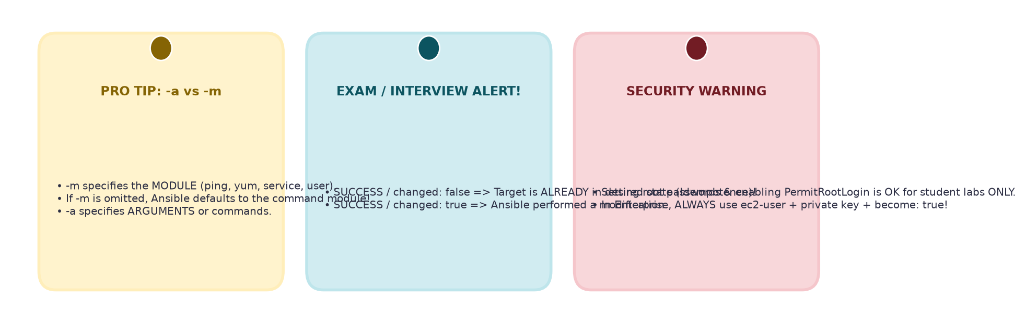
✎ Visual Schematic: Essential Sticky Notes: Idempotency, Flags, and Security
Essential CLI Flags Quick Matrix
Flag | Full Name | When to Use
-m | --module-name | Specifies module: ping, yum, service, shell, user (default is 'command')
-a | --args | The arguments or Linux command string to run
-i | --inventory | Custom inventory file path (overrides /etc/ansible/hosts)
-b | --become | Run task with sudo / root permissions (privilege escalation)
-u | --user | Remote SSH username (e.g. -u ec2-user)
-v / -vvv | --verbose | Debugging output (shows exact SSH connection logs)
Common Troubleshooting Gotchas
• Gotcha 1: Pipe '|' and Redirect '>' Fail in -a: The default 'command' module does not use a shell. To use pipes, use the shell module: ansible all -m shell -a 'cat /etc/passwd | grep reyaz'.
• Gotcha 2: 'Permission denied (publickey)': SSH key permissions are wrong or ssh-copy-id was missed. Run chmod 400 MyKey.pem and re-run ssh-copy-id.
• Gotcha 3: Why does second run show 'changed: false'?: This is IDEMPOTENCY! Ansible verified the software is already installed, so it safely took no action.
Top 3 Interview Questions & Answers
Q1: Why is Ansible agentless and what is the benefit?
Answer: Ansible uses standard OpenSSH and Python. There is no daemon to maintain, update, or consume RAM on worker nodes.
Q2: What is the difference between -a and -m?
Answer: -m specifies the Ansible module (e.g. yum, ping). -a specifies the arguments or Linux command passed to that module.
Q3: How do you authenticate in AWS production securely?
Answer: Set [all:vars] in the inventory with ansible_user=ec2-user, ansible_ssh_private_key_file=key.pem, and ansible_become=true.

