BUILDER CLUB TECH SHOWCASE

NeuralBox
Private AI in the Browser
No server. No account. WebGPU-powered local chat with RAG, voice, vision, and trust metadata.
Core idea  Run useful AI locally, inside a browser tab. | Builder energy  A serious app with hackable surfaces everywhere.
Technical angle  WebGPU, WebLLM, IndexedDB, RAG, Whisper, Playwright. | Honest status  Much stronger now, still with real engineering frontiers.

1. The 10-second pitch
NeuralBox is a local-first AI workbench that runs models directly in the browser using WebGPU. It keeps chats and documents local, adds optional web lookup only when requested, and explains why each answer happened through trust metadata.
- Private by design: conversations and RAG documents stay in browser storage.
- No backend app server: Vite serves a single-page app; inference happens client-side.
- Expandable interface: text, local docs, optional web search, voice, and image input.
- Builder-friendly: plain JavaScript, modular helpers, smoke tests, and clear docs.
2. Architecture: tiny app shell, surprisingly big runtime
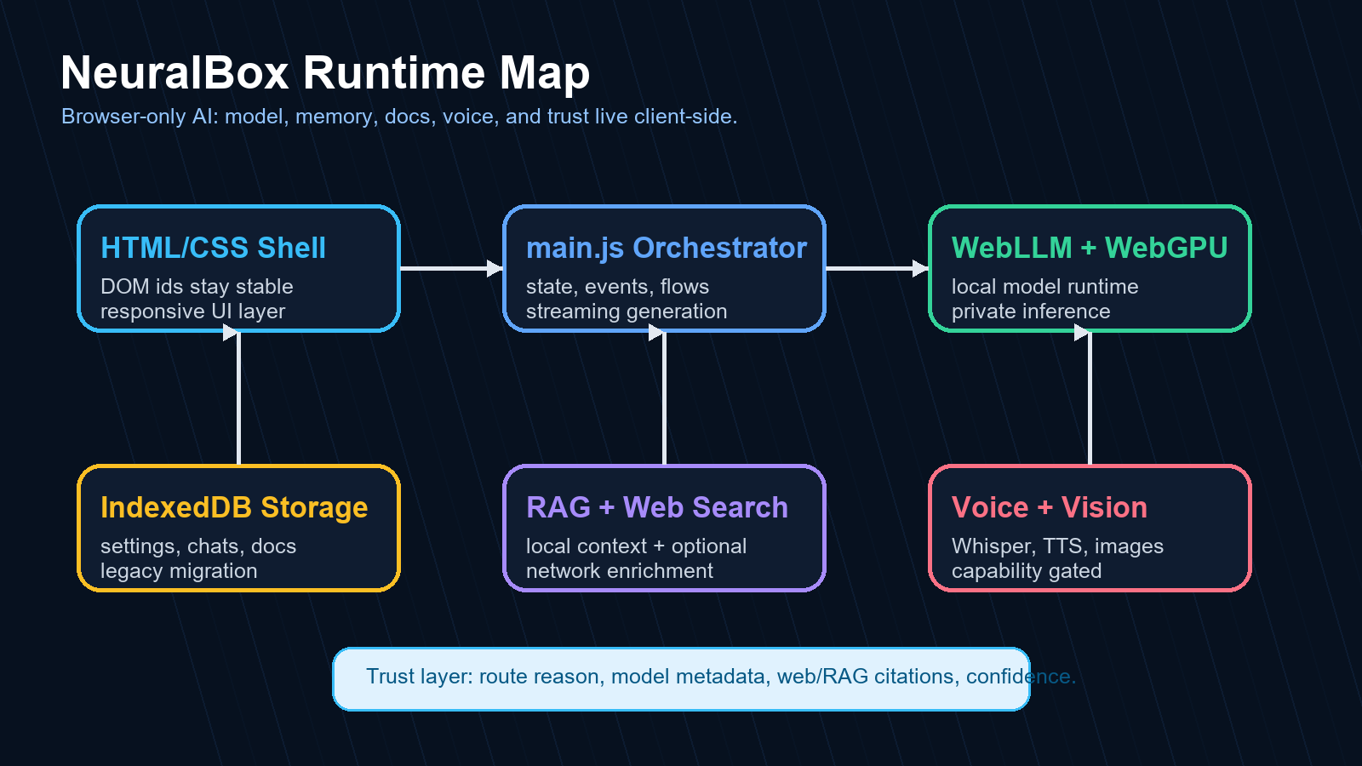
The big technical trick is not just local inference. It is coordinating model lifecycle, GPU fit, local persistence, optional retrieval, dynamic UI state, and diagnostics in one browser app.
3. Feature tour: what builders can poke at
Local chat  Streaming responses from WebLLM through WebGPU. | Auto routing  Task heuristics can hot-swap to a better model.
Local RAG  Docs are chunked, scored, cited, and kept local. | RAG profiles  Precise, Balanced, and Broad retrieval modes.
Web recovery  Search failures classify and degrade gracefully. | Voice  Whisper transcription plus browser speech synthesis.
Vision  Image input for supported models with compatibility handling. | Trust layer  Model, route, sources, profile, and confidence metadata.

4. What changed in the improvement sweep
Area | Upgrade
Security | Audit cleaned to 0 vulnerabilities; Vite lockfile moved to safe resolved version.
Accessibility | Dialogs, live regions, labels, aria state, keyboard activation, and focus styling.
Web search | Failure classification, recovery notices, and workbench/runtime telemetry.
RAG | Configurable retrieval profiles plus trust/export metadata.
Architecture | Model catalog extracted into `src/lib/models.js` with integrity test.
Documentation | Codebase scan, improvement report, test report, roadmap/task sync.

5. Testing: the validation wall
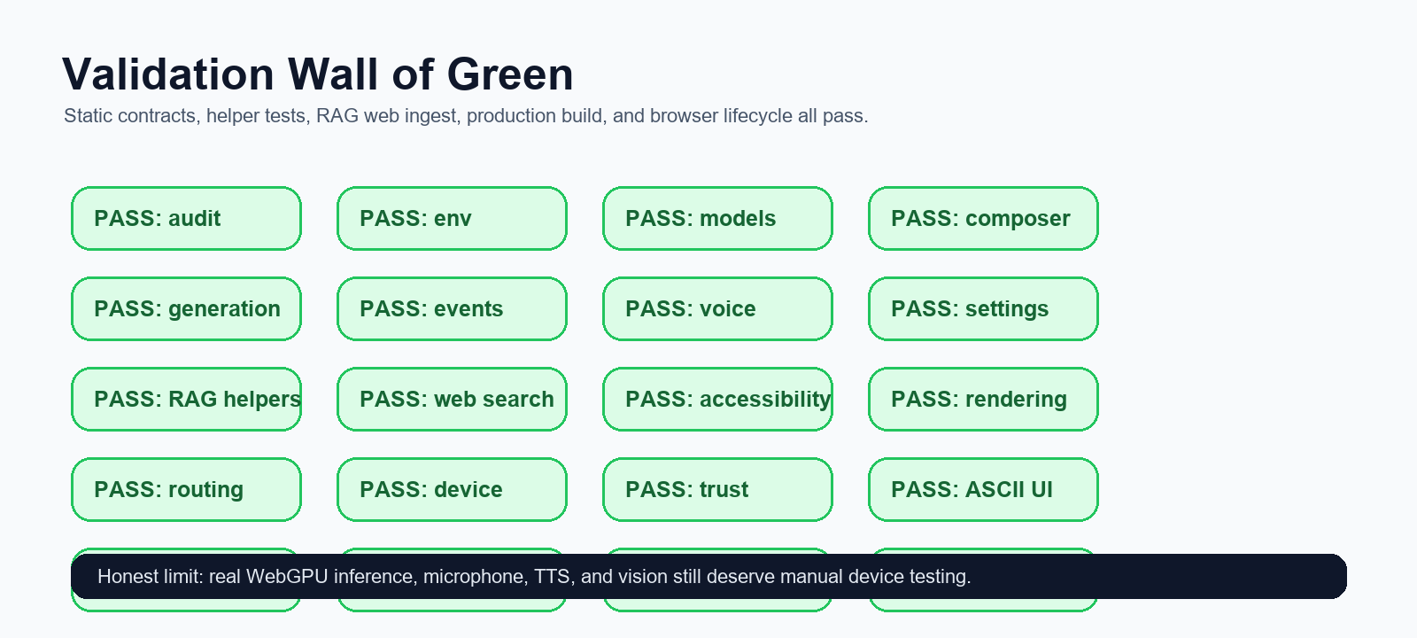
Automated tests validate helper logic, static UI contracts, source safety, RAG ingestion, production build, and a Playwright browser lifecycle. The suite is not a replacement for real GPU demo testing, but it is a strong regression net.
6. Builder club demo script
- Open NeuralBox and explain: this is not a hosted chatbot; it is browser-local inference.
- Show model selector: tiny models for low memory, stronger models for better GPUs, Auto mode for routing.
- Ask a normal chat question and point out streaming plus local storage.
- Attach RAG docs and switch between Precise, Balanced, and Broad retrieval.
- Open trust metadata under an answer: model, route, RAG docs, confidence, web mode.
- Toggle web search and intentionally discuss graceful failure if the endpoint is unavailable.
- Show voice input or voice overlay if microphone permissions cooperate.
- Close with the builder challenge: what would you extract, improve, or ship next?
7. The honest engineering story
The codebase is now stronger, but the most interesting part is that the hard problems are visible instead of hidden.
Still hard  Real WebGPU behavior depends on device, browser, VRAM, and upstream WebLLM. | Still big  `src/main.js` remains the central orchestrator and should be split further.
Still lexical  RAG uses token scoring, not semantic embeddings yet. | Still fun  Every remaining gap is a great builder-club challenge.

8. Next builder challenges
- Extract feature controllers: settings, conversations, web search runtime, RAG UI, voice chat.
- Add embedding-based local retrieval and compare it against lexical RAG profiles.
- Create a GPU benchmark screen that recommends models from measured tokens/sec.
- Add a first-run demo dataset and guided onboarding tour.
- Build a local plugin system for tools that still preserve privacy boundaries.
Appendix: repo guide for technical readers
Important files to inspect:
- Runtime orchestrator: `src/main.js`
- Model catalog: `src/lib/models.js`
- RAG helpers/profiles: `src/lib/rag.js`
- Web recovery helpers: `src/lib/web-search.js`
- Persistence: `src/db/database.js`
- Validation report: `doc/TEST_REPORT_2026-05-04.md`
- Improvement report: `doc/IMPROVEMENT_REPORT_2026-05-04.md`
Suggested closing line: NeuralBox is not just a chatbot demo. It is a browser-native AI systems lab wearing a friendly chat UI.

