OpenOpportunity
Job Portal — Technical Architecture
Web · Mobile · Multi-Country · Multi-Language · High-Performance, Zero-Downtime Platform
Cloud: Google Cloud Platform (GCP) · Frontend: React SPA only (no SSR / no SEO scope)
Prepared for Bhaskar
July 2026 — Revision 4

Table of Contents

1. Executive Summary
OpenOpportunity is a two-sided job marketplace connecting candidates and employers, with an internal admin/moderation layer. The provided UI covers three surfaces: a public candidate-facing experience (landing, job search, job detail, partnerships, community), an authenticated application layer (candidate and company dashboards, applications, job posting, candidate search, seminar scheduler, mock interview), and an admin console (job/company approvals, user management, reporting).
This revision moves the target cloud from AWS to Google Cloud Platform (GCP). The rest of the architecture — a single React SPA (no SSR, no SEO scope), Spring Boot microservices, Kafka-based eventing, PostgreSQL, and a governed analytics pipeline — is unchanged in shape; every managed service has simply been swapped for its GCP equivalent. Where GCP has no exact 1:1 counterpart, that trade-off is called out explicitly rather than glossed over.

Key Architectural Decisions
- Unified frontend: one React 18 + Vite SPA covers every page in the product (public and authenticated); no Next.js, no SSR/ISR, no server rendering tier.
- Static hosting: the SPA build is deployed to Cloud Storage and served globally through Cloud Load Balancing + Cloud CDN — no application servers to run for the frontend, and deployments are an atomic asset swap with effectively zero downtime.
- Shared codebase for mobile: the React Native app shares business logic, the API client, and design tokens with the web app via a monorepo — not a rebuild.
- Backend: Java 21 + Spring Boot 3 microservices, event-driven via Kafka, deployed on Google Kubernetes Engine (GKE).
- Data: AlloyDB for PostgreSQL for transactional data with a database-per-service pattern, Elastic Cloud on GCP for multilingual job/candidate search, Memorystore for Redis for caching and sessions, Cloud Storage for documents/media.
- Global reach: multi-region GCP footprint, locale-based routing inside the SPA, per-market data residency, and a translation pipeline for content in multiple languages.
- Analytics: a single Kafka-fed pipeline covering product/behavioral analytics (RudderStack), a governed data lake and warehouse (Cloud Storage, BigLake, dbt, BigQuery), BI dashboards for admins (Looker), and self-serve product analytics/experimentation (PostHog) — see Section 8.
- Zero downtime: GitOps (Argo CD) + progressive delivery (Argo Rollouts canary/blue-green) for the backend on Kubernetes; an independent hashed-asset Cloud Storage/Cloud CDN deploy path for the frontend; backward-compatible database migrations; automated rollback on SLO breach.
Note on future SEO: because the frontend talks to the backend purely through a versioned REST API, an SSR layer (e.g., Next.js) could be introduced later for specific public routes without changing the backend at all, if search-engine visibility becomes a requirement. It is out of scope for this build.
Note on the AWS → GCP move: the one place GCP does not have a like-for-like counterpart is Aurora's sub-second, multi-region synchronous read replication. AlloyDB for PostgreSQL (the recommended replacement) offers strong single-region performance and cross-region read pools with typically low-single-digit-second replication lag, which is more than adequate for this platform's read patterns. If a future requirement demands synchronous, strongly-consistent multi-region writes, Cloud Spanner (which now offers a PostgreSQL-compatible interface) is the natural upgrade path — see Section 7.1.

2. Product Scope — Page Inventory from the Provided UI
The uploaded design bundle was reviewed to map every screen to a backend service owner. All pages below are delivered by the same React SPA described in Section 4; the split is by access level (public vs. authenticated), not by rendering strategy.

2.1 Public Pages (no login required)
- Landing / Home page
- Job Search (listing, filters, facets)
- Job Detail (individual job posting)
- Company / Partnership Landing pages
- Community page
- Registration and Login (Candidate + Company)

2.2 Authenticated Application Pages (behind login)
- Candidate Dashboard, Candidate Profile, Add Missing Details
- Company Dashboard, Post a Job, Search Candidates
- Applications (candidate application tracker)
- Seminar Scheduler, Mock Interview
- Admin Dashboard, Admin Jobs, Job Approvals, Company Approvals, Admin Users, Admin Reports

2.3 Shared UI
- Header, Footer, and a shared Style Guide — the basis for the cross-platform design system described in Section 4.3.

3. High-Level System Architecture
The diagram below shows the full request path: clients (web + mobile), a single Cloud Load Balancing entry point (one global anycast IP) that fronts both the static SPA (served from Cloud Storage) and the API (served from GKE), the Spring Boot microservices, the async event backbone, and the data/cache tier.
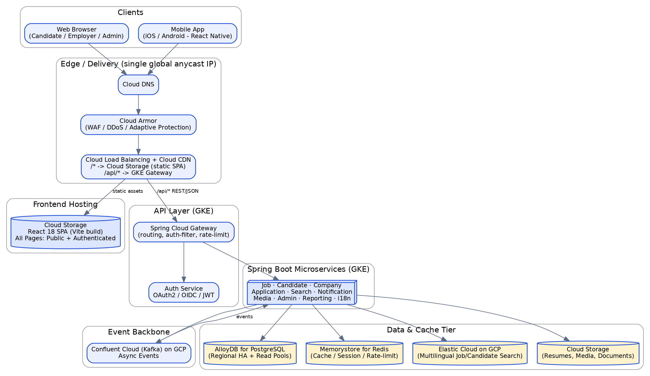
Figure 1 — High-level system architecture

4. Frontend Architecture
The frontend is a single monorepo (Nx or Turborepo) producing two deployables — a React web SPA and a React Native app — that share a design system, API client, and TypeScript types. There is no separate rendering tier for public pages; every route in Section 2 is part of the same client-rendered application, code-split by route so the initial bundle stays small.
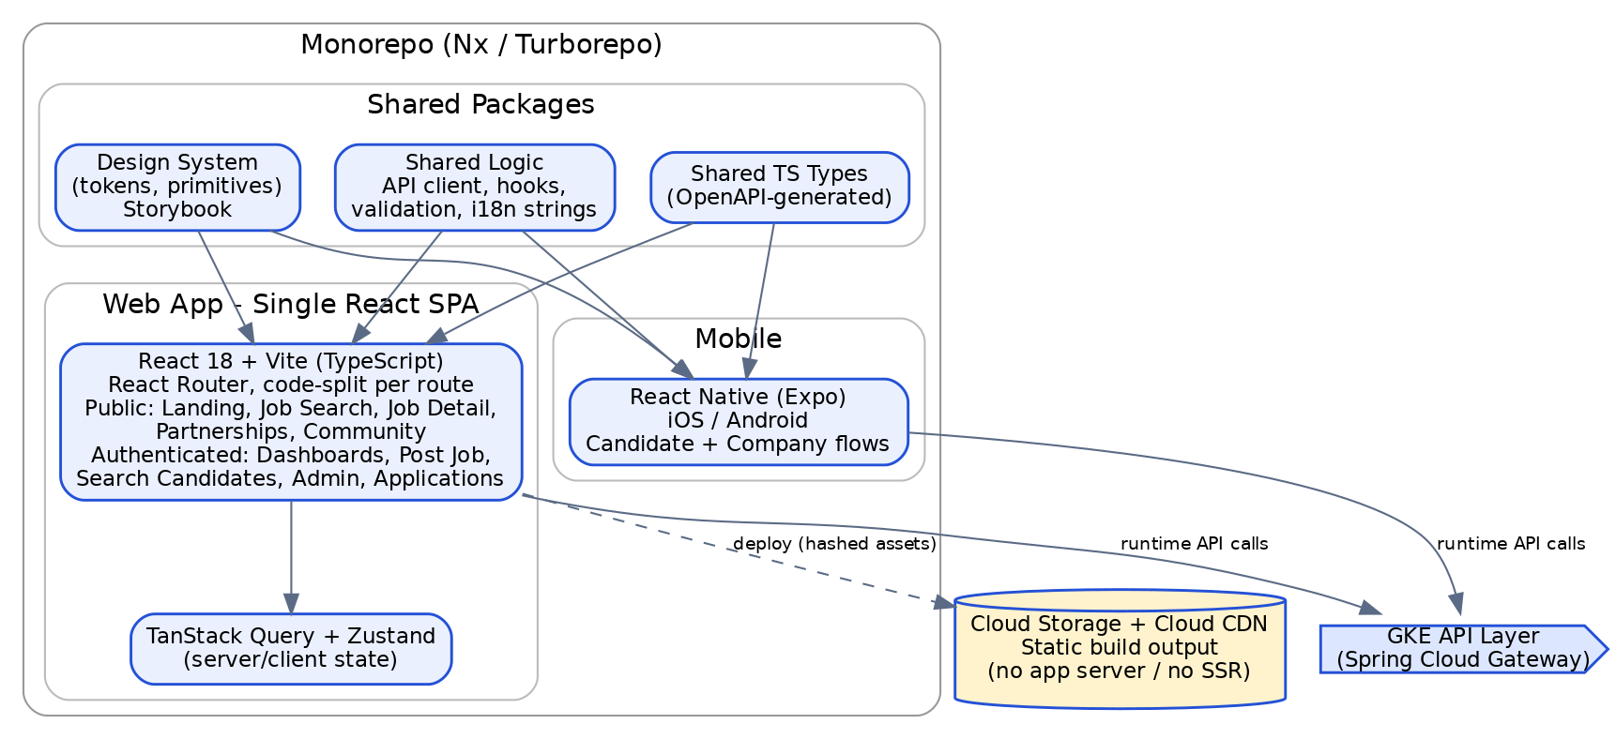
Figure 2 — Frontend monorepo and deployment

4.1 Web App — Single React SPA
React 18 + Vite (TypeScript) builds one application covering both the public pages (landing, job search, job detail, partnerships, community, registration/login) and the authenticated pages (dashboards, post a job, candidate search, applications, seminar scheduler, mock interview, admin console).
- Routing: React Router, code-split per route/module (public routes and authenticated modules are separate lazy-loaded chunks so an anonymous visitor never downloads the admin console bundle).
- State: TanStack Query for server-state/caching, Zustand for local UI state, React Hook Form + Zod for form validation.
- Auth: OIDC/OAuth2 PKCE flow against the Auth service, tokens held in memory + httpOnly refresh cookie (not localStorage, to reduce XSS token theft risk); public routes render without requiring a token, authenticated routes redirect to login if none is present.
- Data fetching: the SPA calls the backend exclusively through the versioned REST API served from GKE — job listings, search results, and job detail content are all fetched client-side after the initial HTML/JS shell loads.

4.2 Mobile App — React Native
The mobile app is React Native (Expo, bare workflow for native modules like push notifications and biometric auth) sharing the same API client, TypeScript types, validation schemas, and as much business logic as possible with the web SPA. Only the presentation layer (screens/navigation) is mobile-specific; the design system exposes primitives themed consistently with the responsive web UI.
- Navigation: React Navigation (stack + tab).
- Offline support: cached job listings and draft applications via TanStack Query persistence + SQLite (WatermelonDB or Expo SQLite) for offline-first candidate flows.
- Push notifications: Firebase Cloud Messaging (Android) / APNs (iOS) via the Notification microservice — Firebase Cloud Messaging is already a Google product, so this is a natural fit on GCP.
- Deep linking: universal links / app links so shared job URLs open directly in-app when installed.

4.3 Shared Design System
A single component/token package (colors, spacing, typography extracted from the provided Style Guide screen) is published inside the monorepo and consumed by both the web SPA and React Native (via a React Native-compatible primitives layer, e.g., Tamagui or NativeWind, mapped to the same design tokens). Storybook documents components; visual regression tests (Chromatic) catch UI drift across both targets.

4.4 Hosting & Delivery
Because there is no server rendering, the web app's build output (index.html, hashed JS/CSS bundles, images) is deployed as static files to a Cloud Storage bucket and served globally through Cloud Load Balancing + Cloud CDN. This removes an entire compute tier from the architecture compared to an SSR approach — no servers to provision, scale, or patch for the frontend. A single global external Application Load Balancer routes /* to the Cloud Storage bucket and /api/* to the GKE-hosted API layer on the same domain, avoiding CORS friction and giving the browser one origin to talk to; because the load balancer is anycast, this is also the mechanism that gets users to their nearest healthy region automatically (see Section 9.2). See Section 10.2 for deployment mechanics.

5. Internationalization & Multi-Country Support
Multi-country support touches routing, content, data storage, search, compliance, and currency/date formatting — handled consistently across web, mobile, and backend, entirely client-side since there is no server rendering step.

5.1 Routing & Content
- Locale-in-path routing: /{country}/{lang}/... (e.g., /us/en/, /in/hi/, /fr/fr/), resolved client-side by React Router with a browser Accept-Language / persisted user-preference fallback.
- First-visit locale detection at the edge: a Cloud Load Balancing Service Extension (a lightweight WASM plugin that runs as part of the load balancing request path) inspects the client's geo signal and issues a redirect to the right locale-prefixed route before the SPA shell even loads — this gets "smart" locale defaulting without needing a full SSR tier. If the team prefers not to take on Service Extensions, the simpler fallback is a small Cloud Run endpoint the SPA calls once on first load.
- Translation management: react-i18next with ICU message format; translation keys extracted in CI and synced with a TMS (Lokalise or Phrase) so translators work outside the codebase; PR-based review before merge.
- RTL languages (Arabic, Hebrew): CSS logical properties throughout the design system, dir="rtl" toggle, mirrored iconography — planned into the design system from day one rather than retrofitted.
- Employer-authored job content is captured per locale; an auto-translate fallback (Google Cloud Translation API) fills in missing locales with a "machine translated" badge until human-reviewed.

5.2 Data & Compliance
- Locale/country is a first-class field on Job, Candidate, and Company entities; content tables carry a locale key with a fallback chain (requested locale → country default → English).
- Data residency: EU candidate PII is partitioned to europe-west3 (Frankfurt, GDPR); other regions follow local requirements (e.g., PDPA for Singapore/India, served from asia-south1) — enforced at the infrastructure level in Section 9.
- Locale-aware formatting: Intl API + date-fns/dayjs locale packs for dates, currency, and numbers; salary fields store an ISO currency code and are rendered per user locale.
- Country-specific compliance fields (e.g., EEO reporting in the US, right-to-work declarations) are modeled as configurable, country-scoped form schemas rather than hardcoded fields.

5.3 Multilingual Search
Elastic Cloud on GCP indexes use language-specific analyzers per locale (ICU tokenizer plus Kuromoji for Japanese, SmartCN for Chinese, Snowball/standard stemmers for Latin-script languages), with synonym and stop-word lists maintained per language. Query-time language detection routes a search to the right analyzer chain, with a cross-language fallback so a query in one language can still surface relevant results tagged in another when the corpus is thin for that locale.

6. Backend Architecture — Java Spring Boot Microservices
The backend is a set of domain-oriented Spring Boot 3 (Java 21) microservices behind a shared API layer, communicating synchronously via REST/OpenAPI for request/response flows and asynchronously via Kafka for cross-service events. Each service owns its own database schema (database-per-service) to keep services independently deployable. This layer is unaffected by either the SSR-vs-SPA decision or the choice of cloud — it serves the same versioned REST API to the SPA, the mobile app, and (if added later) an SSR tier, on any Kubernetes-conformant cluster.
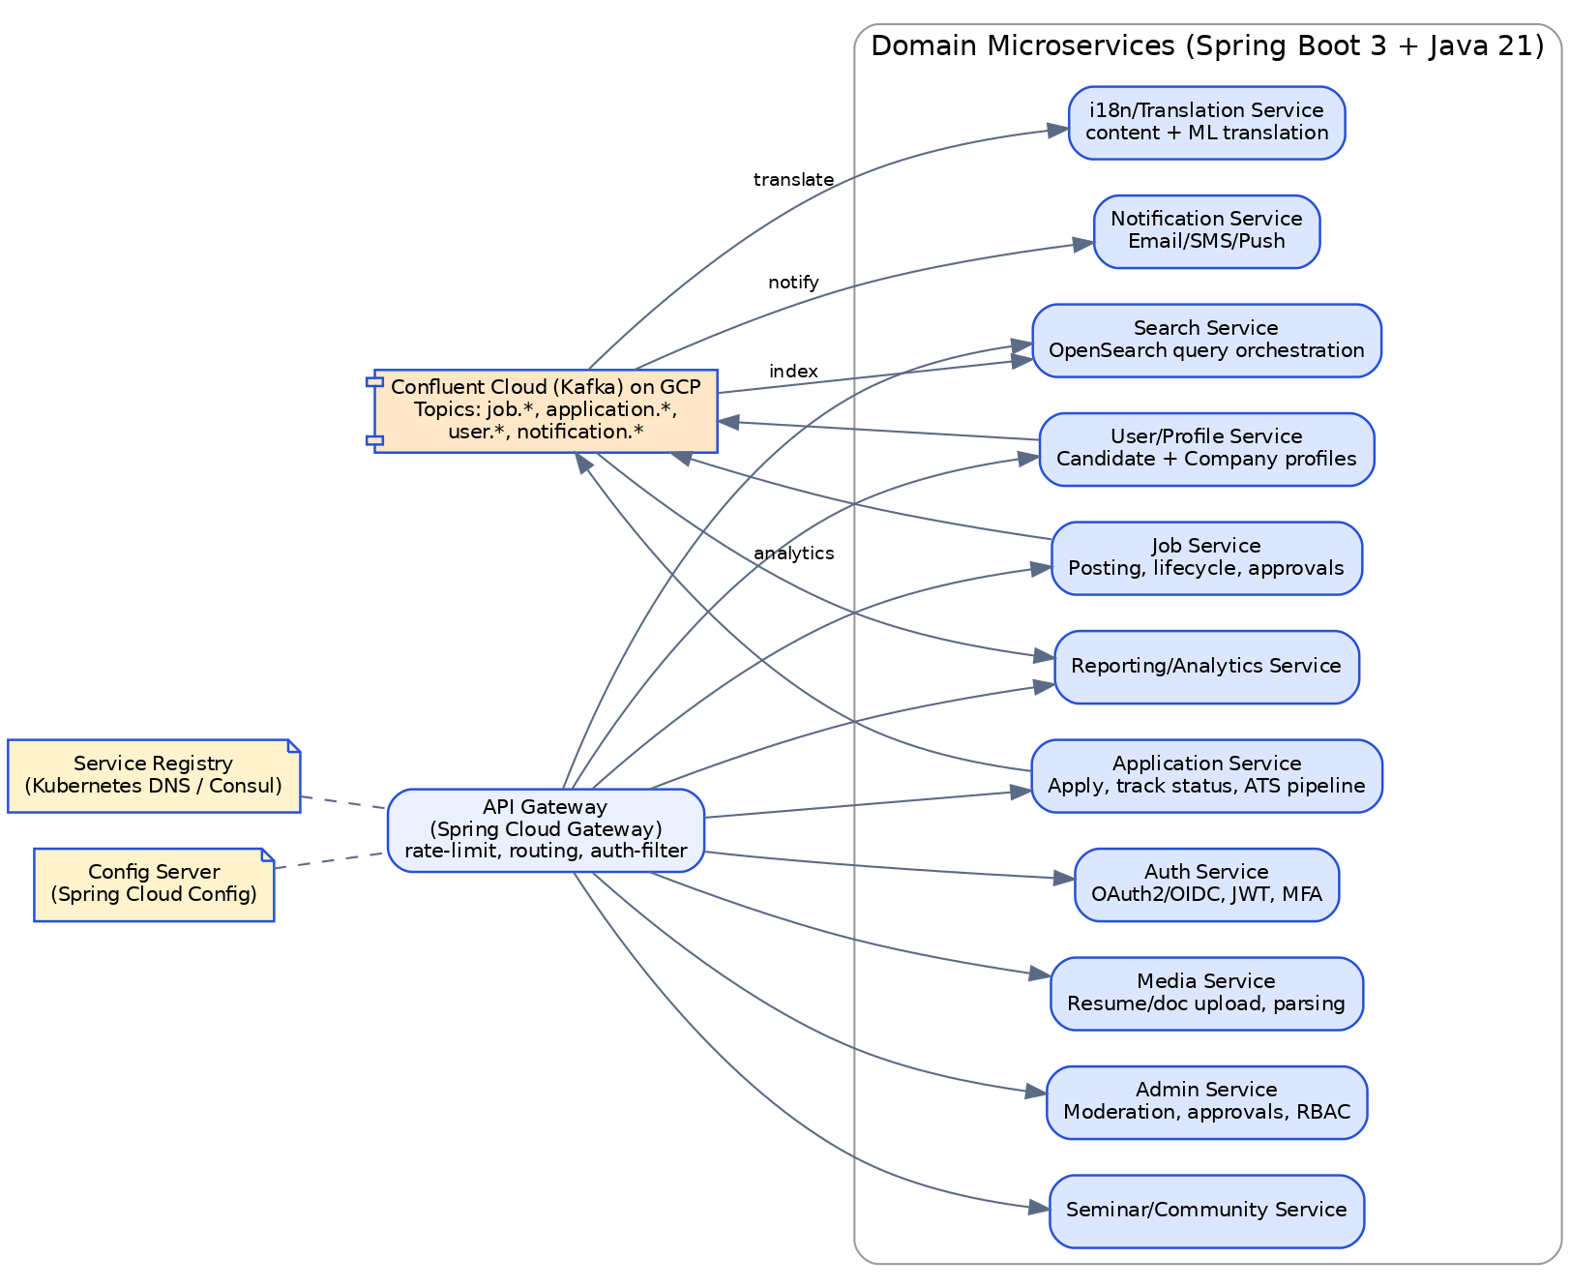
Figure 3 — Backend microservices architecture

6.1 Service Breakdown
Service | Responsibility | Primary Store
API Layer | Routing, auth filter, rate limiting, request aggregation (Spring Cloud Gateway) | —
Auth Service | OAuth2/OIDC, JWT issuance, MFA, social login | auth_db (PostgreSQL)
User/Profile Service | Candidate & company profiles, resumes metadata | user_db (PostgreSQL)
Job Service | Job posting lifecycle, drafts, expiry, approvals workflow | job_db (PostgreSQL)
Application Service | Apply flow, status tracking, ATS-style pipeline | application_db (PostgreSQL)
Search Service | Query orchestration, ranking, facets | Elastic Cloud (read)
Notification Service | Email/SMS/push templating & delivery | notification_db + queue
Media Service | Resume/document upload, parsing, virus scan | Cloud Storage + media_db
Admin Service | Moderation, approvals, RBAC, audit trail | admin_db (PostgreSQL)
Reporting Service | Serves real-time dashboard widgets from the analytics pipeline (Section 8) | Memorystore read model
i18n/Translation Service | Locale content, machine-translation fallback | i18n_db (PostgreSQL)
Seminar/Community Service | Events, scheduling, mock interview bookings | events_db (PostgreSQL)

6.2 Cross-Cutting Patterns
- API layer: Spring Cloud Gateway terminates auth, applies per-client rate limits, and routes to services registered via Kubernetes-native service discovery; sits behind GKE's Gateway API resource, which the external Cloud Load Balancer targets directly (Section 9.2).
- Resilience: Resilience4j circuit breakers, retries with backoff, and bulkheads on all inter-service calls; graceful degradation (e.g., search falls back to cached popular listings if Elastic Cloud is degraded).
- Contracts: OpenAPI-first design; Springdoc generates specs consumed to auto-generate the shared TypeScript client used by both the web SPA and React Native.
- Async events: Confluent Cloud (Kafka) on GCP, with a schema registry (Avro/Protobuf) for events like job.published, application.submitted, user.registered — consumed by Search (indexing), Notification, Reporting, and i18n services without tight coupling. Confluent Cloud was chosen over Google Cloud's own Managed Service for Apache Kafka for its more mature Kafka Connect connector catalog and Cluster Linking for cross-region replication, both of which the analytics pipeline in Section 8 relies on; Google's native managed Kafka remains a valid, slightly leaner alternative if minimizing third-party billing relationships matters more than ecosystem maturity.
- Idempotency & transactions: Outbox pattern for reliable event publication from each service's own database transaction, avoiding dual-write inconsistency between PostgreSQL and Kafka.

7. Data, Caching & Search Architecture
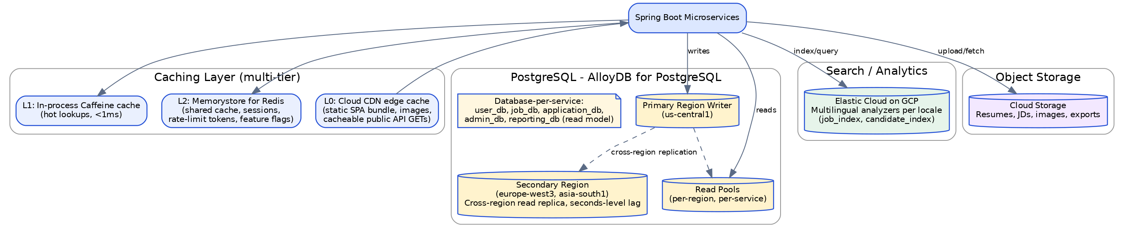
Figure 4 — Data, caching, and search topology

7.1 PostgreSQL (AlloyDB for PostgreSQL)
- AlloyDB for PostgreSQL as the primary transactional store: wire-compatible with vanilla PostgreSQL, so Flyway migrations, JPA/Hibernate, and standard pg tooling all work unchanged. A single primary region handles writes, with regional read pools scaling read traffic and cross-region read replicas serving other regions.
- Database-per-service ownership (user_db, job_db, application_db, admin_db, etc.) — no service reaches into another service's tables directly; cross-service reads go through APIs or the Kafka-fed read models.
- Trade-off vs. the previous AWS design: Aurora's Global Database offered synchronous-feeling, sub-second cross-region read replication. AlloyDB's cross-region read pools are asynchronous with typically low-single-digit-second lag — acceptable for read-your-own-writes-tolerant flows like job search and browsing, but worth knowing about for anything that assumes near-instant global consistency. If that becomes a hard requirement, Cloud Spanner (PostgreSQL interface) offers true synchronous multi-region writes at the cost of some PostgreSQL extension/tooling compatibility.
- Flyway-managed, backward-compatible migrations (expand/contract pattern) to support zero-downtime deploys — see Section 10.
- Connection pooling via AlloyDB's built-in connection pooling (or a PgBouncer sidecar) to protect the database from connection storms during autoscaling events.
- Large, high-growth tables (applications, audit logs, notifications) are time-partitioned to keep query performance predictable as data grows.

7.2 Caching (Multi-Tier)
- L0 — Cloud CDN edge cache for the static SPA bundle/images and for cacheable public GET API responses (e.g., popular search facets), keyed by locale/country.
- L1 — In-process Caffeine cache inside each Spring Boot pod for extremely hot, small lookups (e.g., feature flags, reference data) — sub-millisecond, no network hop.
- L2 — Memorystore for Redis (Standard/HA tier) shared across pods for session data, rate-limit counters, search-result caching, and computed aggregates (e.g., job counts per filter).
- Cache invalidation follows a write-through/event-driven pattern: writes publish a Kafka event that both indexes into Elastic Cloud and busts the relevant Memorystore keys, avoiding manual TTL guesswork for frequently changing data.

7.3 Search (Elastic Cloud on GCP)
- Separate job_index and candidate_index, each with per-locale analyzer chains (Section 5.3).
- Indexing is asynchronous via Kafka consumers off the Job/User services — the transactional PostgreSQL write never blocks on search indexing.
- Multi-zone Elastic Cloud deployment with dedicated master nodes for enterprise-scale query volume; cross-cluster replication to the secondary region for read locality and DR. Elastic Cloud was chosen over standing up self-managed OpenSearch/Elasticsearch on GKE because GCP has no native managed Elasticsearch-family service — running it self-managed would add meaningful operational burden for the same underlying engine and plugin ecosystem (Kuromoji, SmartCN, ICU) the search design already depends on.

7.4 Object Storage
- Cloud Storage for resumes, job description attachments, and generated exports, fronted by Cloud CDN; server-side encryption (Cloud KMS) and malware scanning on upload.
- A dual-region or multi-region Cloud Storage bucket class is used for the documents bucket, which gives built-in geo-redundancy without hand-rolled cross-region replication rules — one of the more convenient differences versus configuring S3 Cross-Region Replication. This is a separate bucket from the one hosting the SPA build in Section 4.4, and its region placement follows the data-residency rules in Section 5.2.

8. Analytics & Reporting Architecture
This is deliberately a separate concern from Section 11's observability stack: Cloud Monitoring/Logging/Trace answer "is the system healthy?"; this pipeline answers business questions — funnels, conversion, job performance, and the data behind the Admin Reports page. Both draw on the same Kafka backbone (Section 6.2) but serve different audiences.
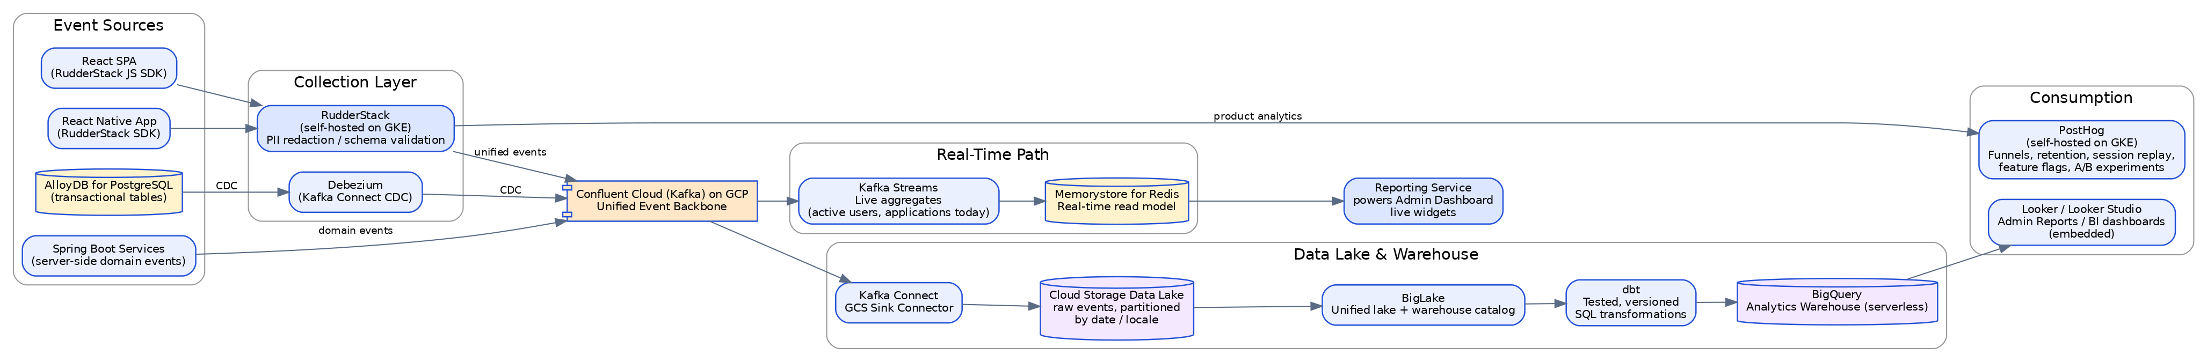
Figure 7 — Analytics and reporting architecture

8.1 Recommended Stack & Rationale
- Event collection — RudderStack (self-hosted on GKE): a Segment-API-compatible SDK ships in the web SPA and React Native app to capture behavioral events (job_viewed, search_performed, application_started/submitted, filter_used). Self-hosting on the existing GKE cluster avoids Segment-style per-event-unit SaaS billing at enterprise volume, keeps PII redaction and consent enforcement inside our own network, and pins data to a chosen region for residency — all while giving a single source that fans out to multiple destinations (the warehouse and the product-analytics tool below) without re-instrumenting the app for each one.
- Unified backbone — Confluent Cloud (Kafka) on GCP: RudderStack publishes into the same Kafka cluster already used for domain events (Section 6.2), so there is no second messaging system to operate. Backend services also publish server-side events directly (e.g., application.status_changed) for anything that shouldn't rely on the client.
- Change data capture — Debezium on Kafka Connect: streams row-level changes from AlloyDB for PostgreSQL into Kafka in near real time (Debezium talks standard PostgreSQL logical replication, so it works against AlloyDB without modification), so warehouse tables for jobs/applications/users stay current without nightly batch jobs or dual-write risk.
- Data lake — Cloud Storage via Kafka Connect GCS Sink: every event lands as an immutable, date/locale-partitioned raw record — the source of truth for reprocessing if a downstream model needs to be rebuilt.
- Warehouse — BigQuery: chosen as the natural GCP-native replacement for the previous Redshift Serverless design — BigQuery is serverless by default, scales queries automatically, and BigLake lets it query the Cloud Storage raw zone directly as external/managed tables without a separate Glue-style catalog and ETL tool to operate.
- Transformation — dbt: raw landed events and CDC tables are modeled into tested, version-controlled marts (job_funnel, application_funnel, employer_engagement, search_quality) directly in BigQuery, queried by both Looker and analysts.
- BI / Admin Reports — Looker (or Looker Studio for lighter needs): powers the existing Admin Reports page via embedded dashboards (Looker's embedded analytics SDK) and, being a Google product, integrates natively with BigQuery and the same GCP IAM used everywhere else. Looker Studio is a reasonable lower-cost starting point if full Looker's semantic-modeling layer (LookML) isn't needed yet.
- Product analytics & experimentation — PostHog (self-hosted): consolidates funnels, retention, session replay, and A/B testing in one tool for the product team, and its feature-flag capability overlaps usefully with the Unleash/LaunchDarkly flagging already planned in Section 10.3. Self-hosting (also on GKE) keeps candidate behavioral data out of a third-party SaaS, which matters given the GDPR/data-residency commitments in Section 5.2.
- Real-time operational widgets — Kafka Streams + Memorystore: a lightweight Java-native stream processor (no separate Dataflow/Flink job needed at this scale) maintains live counters — active postings, applications today, moderation queue depth — in a Memorystore read model that the Reporting Service exposes to the Admin Dashboard. If streaming needs grow materially more complex, Dataflow (Apache Beam, GCP's fully managed stream/batch processor) is the natural component to swap in.

8.2 What Gets Measured
- Candidate funnel: visit → search → job view → apply started → apply submitted, broken down by country/locale and traffic source.
- Employer funnel: register → verify → post job → review candidates → hire, with time-to-fill and cost/time-per-hire.
- Job performance: views and applications per posting, feeding back into Search Service ranking tuning (Section 7.3).
- Search quality: top queries, zero-result-rate, filter usage — a direct input to Elastic Cloud analyzer and synonym tuning.
- Retention/cohorts: candidate return rate, repeat employer usage, seminar/mock-interview engagement.
- Experimentation: onboarding flow variants, job card layout, employer pricing/plan pages, measured through PostHog experiments gated by the same flagging mechanism used for progressive delivery.

8.3 Governance & Privacy
- PII minimization at collection: RudderStack transformations strip or hash direct identifiers (name, email, resume text) before events reach PostHog or the general-access warehouse marts; the raw zone in Cloud Storage retains full fidelity but is locked down to a small data-engineering IAM group.
- Consent management: a CMP banner in the SPA (e.g., OneTrust or Osano) gates non-essential tracking per applicable regional law (GDPR/ePrivacy, CCPA, India DPDP), with RudderStack consent-aware destinations honoring the user's choice per category (analytics vs. essential).
- Retention: raw events retained on a rolling window (e.g., 13 months) in Cloud Storage with lifecycle rules to Archive storage class then deletion; aggregated/anonymized dbt marts may be retained longer for trend analysis since they no longer carry direct identifiers.
- Access control: BigQuery IAM and column/row-level security policies, so a regional admin can be scoped to only their country's data where required.
- Right-to-erasure requests handled in the User/Profile service (Section 12) also propagate a deletion event through Kafka so downstream warehouse and product-analytics copies of that user's data are purged, not just the system of record.

9. GCP Infrastructure & Server Architecture
Given the enterprise-scale, multi-country requirement, the platform runs on a multi-region GCP footprint: a primary region for global writes and a secondary region for read locality, EU data residency, and disaster recovery. Everything is provisioned via Terraform (IaC, using the Google provider). Note that compute (GKE) is only needed for the backend — the frontend has no compute footprint at all, just Cloud Storage + Cloud CDN.
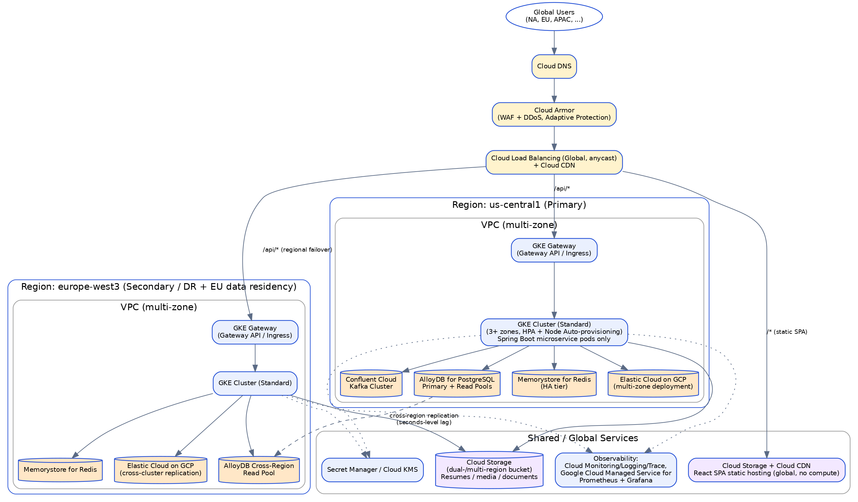
Figure 5 — Multi-region GCP infrastructure

9.1 Compute
- GKE Standard, regional clusters spanning 3+ zones per region, running only the Spring Boot microservices — there is no frontend rendering workload to host.
- Autoscaling: Horizontal Pod Autoscaler on CPU/memory + custom request-rate metrics; GKE Node Auto-provisioning + Cluster Autoscaler for node-level scaling (the GCP equivalent of Karpenter-style automatic node pool management). GKE Autopilot is a viable lower-ops alternative if the team is willing to trade some node-level control for fully managed infrastructure.
- Optional service mesh — Cloud Service Mesh (Google's managed Istio) — for mTLS between services, fine-grained traffic shaping (used by canary rollouts), and consistent L7 observability at enterprise scale.

9.2 Networking & Edge
- Cloud DNS resolves the domain to a single global anycast IP; Google's global external Application Load Balancer natively routes each user to their nearest healthy region and fails over automatically — this replaces the Route 53 latency-based DNS routing used in the AWS design with something simpler: one IP, one load balancer resource, no separate DNS failover configuration to maintain.
- That same load balancer serves both the static SPA (default behavior, origin: Cloud Storage) and the API (path pattern /api/*, origin: GKE Gateway) — one domain for the browser, no CORS configuration needed.
- Cloud Armor (WAF + Adaptive Protection) for DDoS/bot protection in front of every public endpoint.
- Private VPCs per region (Shared VPC if multiple projects are used) with only the load balancer's managed proxy subnet exposed; all compute and data tiers in private subnets, reached via Cloud NAT for egress.

9.3 Data Tier per Region
- AlloyDB for PostgreSQL (single primary write region, regional read pools plus cross-region read replicas), Memorystore for Redis per region, Elastic Cloud deployment per region with cross-cluster replication, Confluent Cloud Kafka cluster in the primary region (with Cluster Linking to a secondary region if a secondary active event backbone is required).

9.4 Secrets & Identity
- Secret Manager + Cloud KMS for credentials and encryption keys; Workload Identity binds Kubernetes service accounts to Google service accounts so pods assume least-privilege GCP permissions without static credentials (the GCP equivalent of AWS IRSA).

10. CI/CD & Zero-Downtime Deployment
Deployment is GitOps-driven for the backend and a simple atomic asset swap for the frontend — the two halves of the platform have very different deployment mechanics, and both are zero-downtime by construction. Both mechanisms are Kubernetes/GitOps-native and carried over unchanged from the AWS design; only the underlying storage and registry services changed.
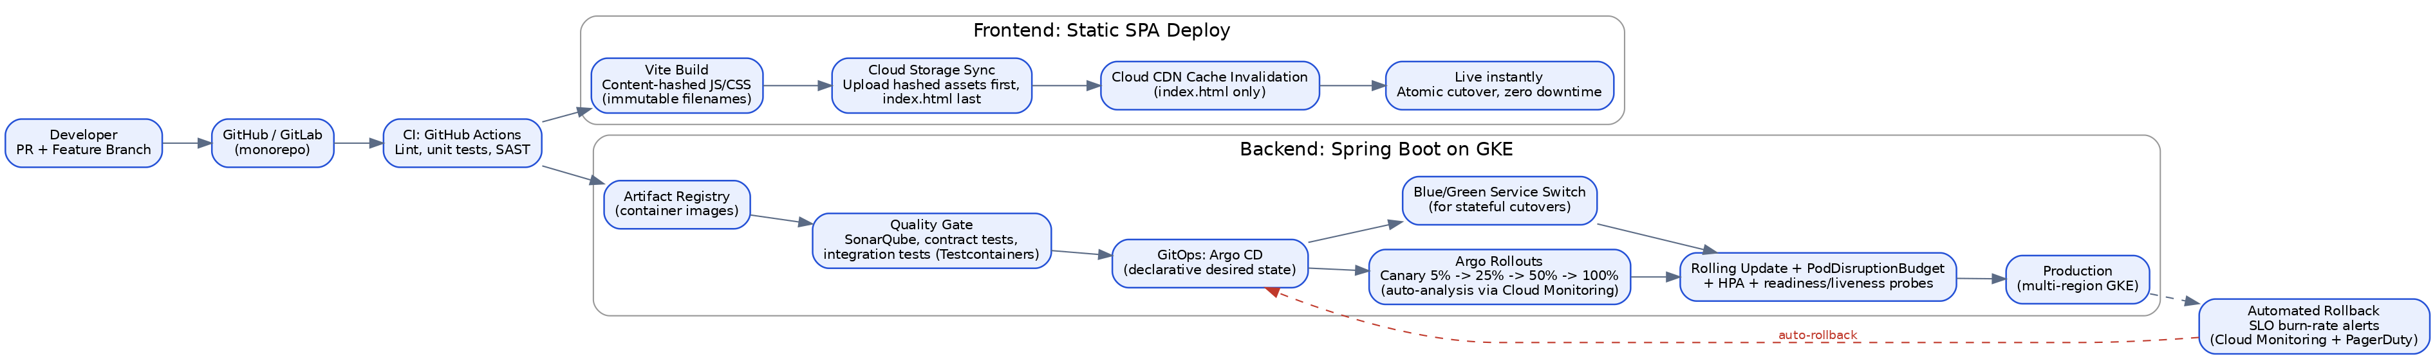
Figure 6 — CI/CD pipeline and zero-downtime rollout strategy

10.1 Frontend Deployment (Static SPA)
Because the frontend is a static build with no server, "zero downtime" is simpler here than for the backend — there is no rolling restart to coordinate.
- Content-hashed assets: Vite outputs JS/CSS files with a content hash in the filename (e.g., main.a1b2c3.js); these are uploaded to Cloud Storage with a long, immutable Cache-Control header. Old and new versions of hashed files can coexist in the bucket indefinitely without collision.
- index.html last, short cache: index.html (which references the current hashed asset filenames) is uploaded last, with no-cache headers, and only its Cloud CDN cache entry is invalidated. The cutover from old to new version is a single atomic write — any user loading the app gets either fully the old version or fully the new version, never a mix.
- Instant rollback: rolling back is re-invalidating index.html to point at the previous build's asset hashes — no redeploy, no waiting for pods to cycle.

10.2 Backend Deployment (Spring Boot on GKE)
Stage | Tooling
Source & PR checks | GitHub (monorepo), branch protection, required reviews
CI | GitHub Actions — lint, unit tests, SAST, build, SBOM generation, container image scan (Trivy)
Quality gate | SonarQube, contract tests, integration tests via Testcontainers
Registry | Artifact Registry
GitOps | Argo CD — syncs desired state from Git to the GKE clusters
Progressive delivery | Argo Rollouts — canary (5% → 25% → 50% → 100%) or blue/green, with automated analysis
Rollback trigger | Cloud Monitoring SLO burn-rate alerts feed Argo Rollouts' automated analysis for auto-rollback

10.3 Zero-Downtime Mechanics (Backend)
- Rolling updates with health gates: readiness/liveness probes and PodDisruptionBudgets ensure a minimum number of healthy pods stay in service throughout every rollout; preStop hooks and connection draining prevent in-flight requests from being dropped on pod termination.
- Stateless services: sessions live in Memorystore, not in-process, so any pod can serve any request — required for rolling deploys and horizontal scaling to work safely together.
- Canary analysis: Argo Rollouts shifts a small percentage of production traffic to the new version and automatically evaluates latency/error-rate metrics from Cloud Monitoring before continuing or auto-rolling-back.
- Blue/green for high-risk releases: used for changes that touch shared infrastructure or require an instant full cutover/rollback (e.g., gateway or auth changes).
- Database migrations: Flyway-managed, expand/contract pattern — additive, backward-compatible schema changes ship ahead of the code that needs them, and destructive changes (drops/renames) only happen once no running version depends on the old shape.
- Feature flags: LaunchDarkly or self-hosted Unleash decouple "deploy" from "release," so risky features can be dark-launched and enabled gradually independent of the deployment pipeline.
- Multi-region failover: handled by the anycast global load balancer described in Section 9.2 — health checks against each region's GKE Gateway automatically remove an unhealthy region from rotation, complementing in-region zero-downtime deploys.

11. Observability & Monitoring
Concern | Tooling
Metrics | Google Cloud Managed Service for Prometheus + Grafana dashboards per service/SLO
Distributed tracing | OpenTelemetry SDKs exporting to Cloud Trace
Logs | Cloud Logging (native GKE integration); optionally forwarded to Elastic Cloud for unified search alongside job/candidate search infrastructure
Frontend error tracking | Sentry (web SPA and React Native)
Alerting/on-call | PagerDuty or Opsgenie, wired to Cloud Monitoring SLO burn-rate alerts
Synthetic monitoring | Scheduled checks against critical flows (search, apply, login) per region/locale

12. Security & Compliance
- Cloud Armor and Security Command Center in front of and around the public surface for DDoS/bot protection and continuous posture monitoring (the GCP equivalent of AWS WAF/Shield/GuardDuty/Security Hub).
- OAuth2/OIDC via a managed identity provider (Google Cloud Identity Platform or self-hosted Keycloak on GKE), short-lived JWTs, refresh-token rotation, and mandatory MFA for admin and employer accounts.
- Encryption in transit (TLS everywhere, mTLS between services if Cloud Service Mesh is adopted) and at rest (Cloud KMS-backed encryption for AlloyDB, Cloud Storage, and Elastic Cloud).
- SAST/DAST in CI (Snyk/Sonar, OWASP ZAP) and a recurring third-party penetration test cadence for an enterprise-scale, PII-handling platform.
- GDPR (EU), CCPA (California), and locally applicable data-protection regimes: data residency per Section 5.2, right-to-erasure workflows in the User/Profile service, and a documented data retention policy for resumes and application data.
- Resume/document uploads are virus-scanned before being made available for download — an Eventarc trigger fires a Cloud Run job running ClamAV whenever a new object lands in the uploads bucket, the GCP-native pattern equivalent to a GuardDuty Malware Protection or ClamAV-on-Lambda setup.
- Since the SPA holds no server-side secrets, its attack surface is limited to standard browser-side concerns (XSS, dependency vulnerabilities); a strict Content-Security-Policy header is set on index.html via the load balancer's response headers policy.

13. Performance & Scalability Targets
Metric | Target
API latency (p95 / p99) | < 200ms / < 500ms
SPA initial load (cold, edge-cached) | TTFB < 100ms, Time to Interactive < 3s on 4G
Core Web Vitals | LCP < 2.5s, CLS < 0.1, INP < 200ms ("Good" threshold on all locales)
Availability (single region) | 99.95%
Availability (multi-region active/DR) | 99.99%
Search query latency (p95) | < 150ms
Deployment frequency | Multiple times/day, zero perceived downtime (both frontend and backend)
Recovery Time Objective (RTO) | < 15 minutes (regional failover)
Recovery Point Objective (RPO) | < 1 minute for application data (AlloyDB cross-region replication lag is typically low seconds; treat sub-minute as the practical RPO target rather than sub-second)

14. Technology Stack Summary
Layer | Technology
Web Frontend | React 18 + Vite (TypeScript), React Router, TanStack Query, Zustand, React Hook Form + Zod, react-i18next
Frontend Hosting | Cloud Storage (static build) + Cloud Load Balancing / Cloud CDN — no application server
Mobile App | React Native (Expo), React Navigation, shared API client & design tokens
Design System | Storybook, shared component package, Chromatic visual regression
Backend Services | Java 21, Spring Boot 3, Spring Cloud Gateway, Spring Security, Spring Data JPA
Resilience | Resilience4j (circuit breaker, retry, bulkhead)
Async/Eventing | Confluent Cloud (Kafka) on GCP + schema registry (Avro/Protobuf); Google Cloud Managed Service for Apache Kafka as a GCP-native alternative
Auth/Identity | OAuth2/OIDC via Google Cloud Identity Platform or Keycloak, JWT
Relational Database | AlloyDB for PostgreSQL, cross-region read pools, Flyway migrations
Cache | Memorystore for Redis (HA tier), Caffeine (in-process)
Search | Elastic Cloud on GCP (multilingual analyzers)
Object Storage | Cloud Storage (dual-/multi-region buckets; separate bucket from SPA hosting)
Container Platform | Google Kubernetes Engine — GKE Standard (backend only), Helm, Node Auto-provisioning
IaC | Terraform (Google provider)
CI | GitHub Actions, SonarQube, Trivy
CD — Backend | Argo CD, Argo Rollouts (canary/blue-green) on GKE
CD — Frontend | Cloud Storage sync + Cloud CDN invalidation (hashed assets, atomic index.html swap)
Container Registry | Artifact Registry
Observability | Google Cloud Managed Service for Prometheus, Grafana, OpenTelemetry, Cloud Trace, Cloud Logging, Sentry
Edge/CDN/Security | Cloud Load Balancing (global anycast), Cloud CDN, Cloud DNS, Cloud Armor
Translation | Google Cloud Translation API (machine fallback) + Lokalise/Phrase (human translation workflow)
Event Collection | RudderStack (self-hosted on GKE), Segment-compatible SDKs (web + mobile)
CDC | Debezium on Kafka Connect (AlloyDB for PostgreSQL → Kafka)
Data Lake | Cloud Storage (raw, partitioned), Kafka Connect GCS Sink, BigLake catalog
Data Warehouse | BigQuery (serverless), dbt (transformation/modeling)
BI / Admin Reporting | Looker or Looker Studio (embedded dashboards)
Product Analytics & Experimentation | PostHog (self-hosted on GKE) — funnels, retention, session replay, A/B tests
Real-Time Analytics | Kafka Streams + Memorystore read model (live Admin Dashboard widgets)
Consent Management | OneTrust or Osano (CMP for GDPR/CCPA/DPDP tracking consent)

15. Implementation Roadmap

Phase 0 — Foundation (4–6 weeks)
- Monorepo setup; design system extracted from the provided UI/Style Guide.
- Auth service, base PostgreSQL schemas on AlloyDB, Terraform for a single-region GCP footprint (GKE for backend, Cloud Storage + Cloud CDN for the SPA), CI/CD skeleton for both deploy paths.

Phase 1 — MVP (8–10 weeks)
- Candidate/company registration & login, job posting & search (single language), applications flow, admin approvals.
- Single React SPA covering all public and authenticated pages, deployed to Cloud Storage/Cloud CDN.

Phase 2 — Scale & Internationalization (8–10 weeks)
- 3–5 additional locales/countries, Elastic Cloud multilingual search, translation pipeline, Memorystore caching layer, observability stack, React Native mobile app MVP.

Phase 3 — Enterprise Hardening (6–8 weeks)
- Multi-region deployment (us-central1 + europe-west3), canary/blue-green pipelines for the backend, Cloud Armor/pen-test hardening, DR failover drills, seminar/community/mock-interview services, performance tuning to the targets in Section 13.
- Analytics foundation: RudderStack + Kafka + Cloud Storage data lake + Debezium CDC live, first dbt models and Looker dashboards for Admin Reports (Section 8).

Phase 4 — Continuous
- Self-serve product analytics and experimentation on PostHog (funnels, retention, A/B tests), ML-based job-matching and recommendations built on the BigQuery marts (a natural fit with Vertex AI if the team wants managed ML), expanded BI dashboards; revisit SSR/SEO as a discrete, additive workstream if it becomes a business priority.

