**Project Charter Document**



**Project Name:** Predicting the performance of an employees working from remote locations

**Department:** HR

**Focus Area:** Employee performance Analysis Working from remote locations.

**Product/Process:** Data Extraction, Analysis, Data Pre-Processing, Model Building.



**Prepared By**

|  |  |
| --- | --- |
| **Document Owner(s)** | **Project/Organization Role** |
| Bhaskar Chakali | INNODATATICS |
|  |  |
|  |  |
|  |  |
|  |  |
|  |  |

**TABLE OF CONTENTS**

**1** **PROJECT CHARTER PURPOSE 3**

**2** **PROJECT EXECUTIVE SUMMARY 3**

**3** **PROJECT OVERVIEW 3**

**4** **PROJECT SCOPE 4**

4.1 Goals and Objectives 4

4.2 Project Deliverables 4

4.3 Deliverables Out of Scope 4

4.4 Project Duration 4

**5** **PROJECT CONDITIONS 5**

5.1 Project Assumptions 5

5.2 Project Issues 5

5.3 Project Risks 5

5.4 Project Constraints 5

**6** **Project Structure Approach 6**

**7** **Project Team Organization Plans 6**

**8** **PROJECT REFERENCES 6**

**9** **APPROVALS 6**

**10** **APPENDICES 8**

10.1 Document Guidelines 8

10.2 Project Charter Document Sections Omitted 8

# PROJECT CHARTER PURPOSE

The project charter defines the scope, objectives, and overall approach for the work to be completed. It is a critical element for initiating, planning, executing, controlling, and assessing the project. It should be the single point of reference on the project for project goals and objectives, scope, organization, estimates, work plan, and budget. In addition, it serves as a contract between the Project Team and the Project Sponsors, stating what will be delivered according to the budget, time constraints, risks, resources, and standards agreed upon for the project.



# PROJECT EXECUTIVE SUMMARY

* **Project goals**: To Calculate the Performance of an Employee in Remote Location.
* **Objectives**:

Maximize: Increase Employee Productivity and improve their skill set towards the organization goals.

* **Scope**: The scope of this Project is to motivate and enhance the employee's Skillset so that they can improve their productivity and perform efficiently towards organization goals.



# PROJECT OVERVIEW

* By evaluating employee performance, we can suggest that they take appropriate action and make changes in their strategies So that they can help the individual growth of employees.



# PROJECT SCOPE

## Goals and Objectives

|  |  |
| --- | --- |
| **Goals** | **Objectives** |
| To Calculate the Performance of an Employee in Remote Location. | * Maximize: Increase Employee Productivity and improve their skillset towards the organization goals. |

## Project Deliverables

|  |  |
| --- | --- |
| **Milestone** | **Deliverable** |
| * Identifying Constraints and design the project architecture, explore various public forums to collect relevant data, Data Preparation. | * Deliverable 1.1—Identifying Constraints and design the project architecture. * Deliverable 1.2—Explore various public forums to collect relevant data. * Deliverable 1.3— Data Preparation |
| * EDA and Descriptive Analytics, Model Building for Association (Fuzzy Algorithm) and Recommendation | * Deliverable 2.1— EDA and Descriptive Analytics * Deliverable 2.2— Model Building for Association (Fuzzy Algorithm) and Recommendation |
| * Model Evaluation, tuning and insights, Deployment | * Deliverable 3.1— Model Evaluation, tuning and insights. * Deliverable 3. 2— Deployment |
| * Show case and review, Final Presentation and documentation, Handover and KT. | * Deliverable4.1 – show case and review * Deliverable4.2 – Final Presentation and documentation * Deliverable4.3 – Handover and KT |

## Deliverables Out of Scope

* designs
* mobile app

## Project Duration (start date: 15/09/2021 End date: 15/10/2021)

|  |  |  |
| --- | --- | --- |
| **Project Milestone** | **Deliverable(s) Included** | **Confidence Level** |
| * Identifying Constraints and design the project architecture, explore various public forums to collect relevant data, Data Preparation. | * Deliverable 1.1—Identifying Constraints and design the project architecture. * Deliverable 1.2—Explore various public forums to collect relevant data. * Deliverable 1.3— Data Preparation | [High] |
| * EDA and Descriptive Analytics, Model Building for Association (Fuzzy Algorithm) and Recommendation | * Deliverable 2.1— EDA and Descriptive Analytics * Deliverable 2.2— Model Building for Association (Fuzzy Algorithm) and Recommendation | [High] |
| * Model Evaluation, tuning and insights, Deployment | * Deliverable 3.1— Model Evaluation, tuning and insights. * Deliverable 3. 2— Deployment | [High] |
| * Show case and review, Final Presentation and documentation, Handover and KT. | * Deliverable4.1 – show case and review * Deliverable 4.2 – Final Presentation and documentation * Deliverable 4.3 – Handover and KT | [Medium] |



# PROJECT CONDITIONS

## Project Assumptions

* Work on data which is extracted from public sources.
* Employees are Working from home.
* **Robust Tested:** Theapplication should be tested for noise data also.

## Project Issues

**Priority Criteria**

1 − High-priority/critical-path issue; requires immediate follow-up and resolution.

2 − Medium-priority issue; requires follow-up before completion of next project milestone.

3 − Low-priority issue; to be resolved prior to project completion.

4 − Closed issue.

|  |  |  |  |  |  |
| --- | --- | --- | --- | --- | --- |
| **#** | **Date** | **Priority** | **Owner** | **Description** | **Status & Resolution** |
| 1 | Downtime of Streamlight | High | Vendor |  |  |
|  |  |  |  |  |  |

## Project Risks

|  |  |  |  |  |
| --- | --- | --- | --- | --- |
| **#** | **Risk Area** | **Likelihood** | **Risk Owner** | **Project Impact-Mitigation Plan** |
| 1 | Downtime of Streamlit | [High/Medium/Low] | Vendor | Model down |
|  |  |  |  |  |

## Project Constraints

* Monitor and Tracking activities of employees when they are working from home is difficult.
* It is not feasible to use similar parameters for evaluating employees performance working from home and office.
* 

# Project Structure Approach

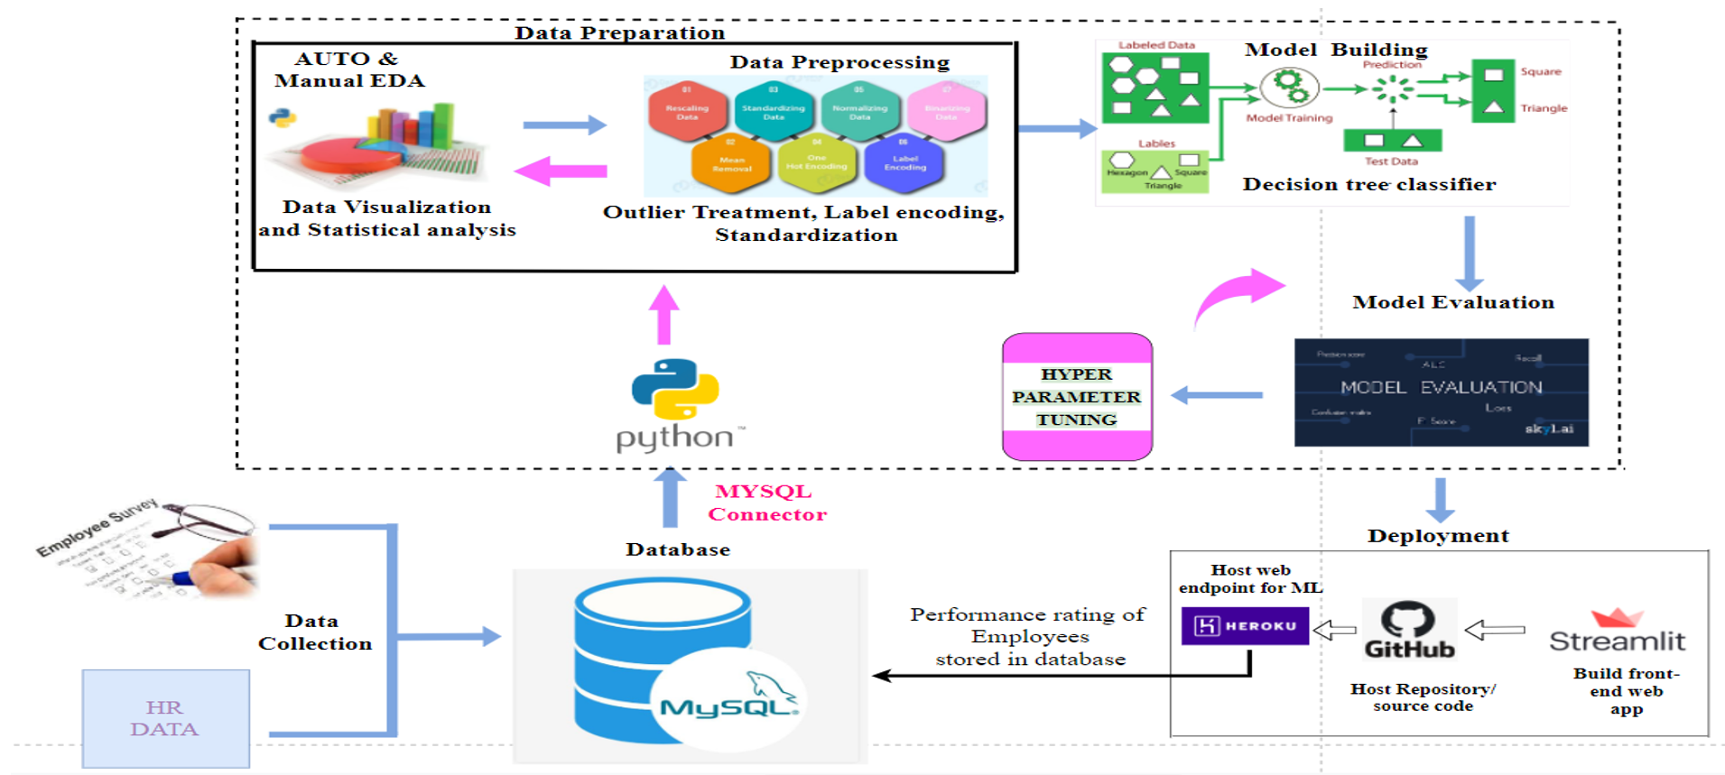



# Project Team Organization Plans

|  |
| --- |
| * Deliverable 1.1— Data Collection * Deliverable 1.2— EDA and Auto EDA Part * Deliverable 1.3— Data Pre-Processing |
| * Deliverable 2.1— Model Building * Deliverable 2.2— Model Evaluation |
| * Deliverable 3.1— Model Tuning * Deliverable 3. 2— Model Deployment |
| * Deliverable 4.1 – Showcase Review and Final Resolution * Deliverable 4.2 – Final Documentation and PPT * Deliverable4.3 – Handover |



# PROJECT REFERENCES

|  |  |
| --- | --- |
| **Milestone** | **Deliverable** |
| [ Data Collection, EDA and Auto EDA Part | Collected the data from different Public Sources,Performed EDA and Auto EDA part. |
| Data Pre-Processing & Model Building | Python Libraries, Codes and Supervised Machine Learning Algorithms. |
| Model Deployment | Streamlit library and Heroku Cloud Platform. |

# APPROVALS

**Prepared by** Bhaskar Chakali

**Approved by** Sharat Chandra M____________________

Project Sponsor

__________________________________

Executive Sponsor

__________________________________

Client Sponsor



# APPENDICES

## Document Guidelines

## Project Charter Document Sections Omitted

