1.RUNNING A ALPINE CONTAINER

First in our local system we don’t have alpine image. So we pull alpine image from Docker registry with the help of “*docker pull alpine*” command.

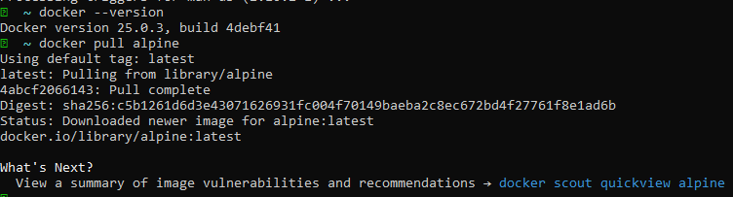$ *docker pull alpine*

Once pull the image from docker registry. you can check on your system with the help “*docker images*” command.

*$ docker images*

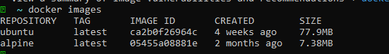

**DOCKER RUN:**

We will run a container based on alpine image. So we use “*docker run*” command. We use “ls -l” include that command

Automatically it will give list of files inside the running container.

$ *docker run alpine ls -l*

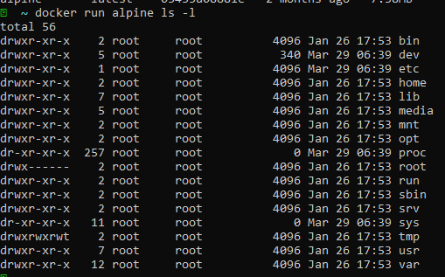

We use one more command is “*echo*”. Basically “*echo*” is a linux command. The purpose (or) function of “*echo*” is to print

the program. We use below command the “*echo*” will print the program inside the container.

$ docker run alpine echo “hello from alpine”



**2. So we will use some other commands in Docker:**

$ *docker run alpine /bin/sh*

We use the above command to run a container. In container scripted commands run and automatically it will go to exited

Mode.



When we want to see running container use below command.

$ *docker ps*

The above command gives us the list of running containers only.

However we want see all containers in our machine use below command.

$ *docker ps -a*

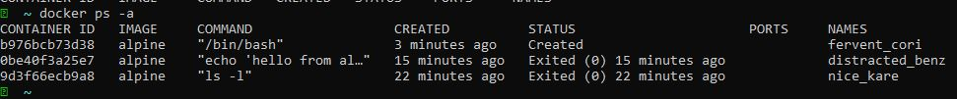

In the above image all containers are in Exited mode. Exited mode it means the containers are not running state. When the

Containers are exited mode we can not go inside the container.

When we go inside the container we will use interactive terminal. We use below command ,we will interact inside container

Files. Once we enter inside the container do some more operations.

$ *docker run -it alpine /bin/sh*

