Tasks
Learners have to develop a dashboard to support the answers to the following questions.

Objective Questions:

- What is the total no. of tables present in the data?
The complete data is present in one single table.
- What is the total no. of attributes present in the data?
The total number of attributes present in the table is 35 i.e. A to AI
- The data consists of some inconsistent and missing values so ensure that the data used for further analysis is cleaned.
Data Cleaning has been performed on the dataset by using the REMOVE DUPLICATES function of google sheets.
Dropped Unusable Columns: timeDuration and __v (version key) were dropped.
Unified Columns: user and uid were confirmed to be redundant; user was dropped. guru and gid were also redundant; guru was dropped.
Handled Missing Data:
- chatStatus and callStatus nulls were filled with 'unknown'.
- guruName nulls were filled with 'unknown'.
- Financial columns (amount, astrologersEarnings, netAmount) and duration columns (chatSeconds, astrologerOnCallDuration, userOnCallDuration) were filled with 0.
Converted Data Types:
- createdAT, chatStartTime, and chatEndTime were converted to datetime objects.
- All financial, duration, and rating columns were converted to numeric types.
Feature Engineering:
- A unified session_status column was created from chatStatus and callStatus.
- A unified session_duration_sec column was created.
  - For Calls, it uses the astrologerOnCallDuration.
  - For Chats, it calculates the duration using (chatEndTime - chatStartTime).
- The createdAT timestamp was used to extract date, month_name, and year for filtering.
- What is the change in daily call volume day by day and also find the average daily call volume.
Pivot table functionality was used to analyse the sum of all the calls per day with date into rows and CallVolume in values field as count and filtering records with Consultation_Type = "Call".
The call volume varied daily, with a peak of 430 calls on 10/12/2023 and a low of 107 calls on 03/01/2024.
It was observed that the daily number of calls varies significantly and this was calculated by subtracting the total number of calls on one day from the previous day's total.
The average daily call volume is approximately 250 calls per day (rounded off).
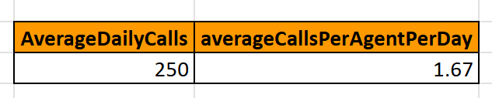
Average was calculated by using =AVERAGE (RANGE OF DAILY CALLS) formula and used MAX and MIN function to find highest and lowest calls.
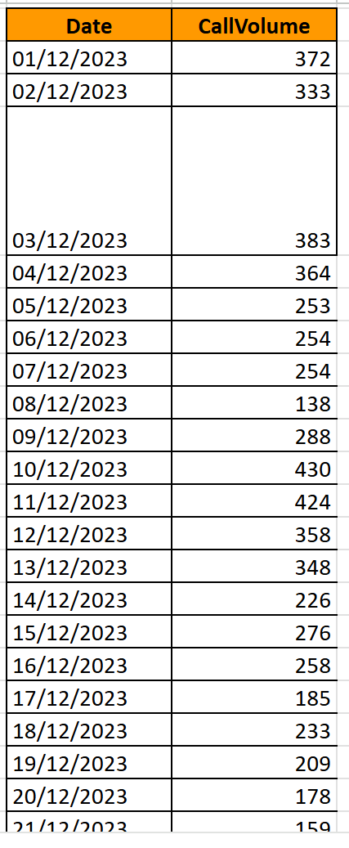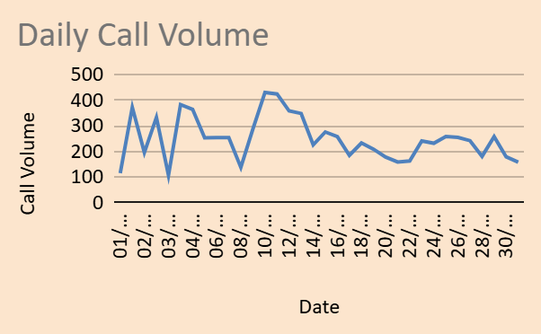
- Which months experienced the highest and lowest call volumes?
Conditional formula was used to find the total volumes during each month using a bar chart to analyse them.
=COUNTIFS(data!T:T,N2,data!H:H,"Call")
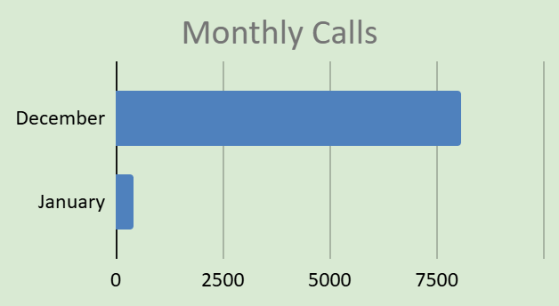
It was noticed that Highest calls volumes were in December
Whereas the Lowest volume was observed in January.
- What is the total operational cost for that month?
Conditional formula was again used to find the cost for each month using a bar chart to analyse then.
=sumif(data!T:T,N2,data!AD:AD)
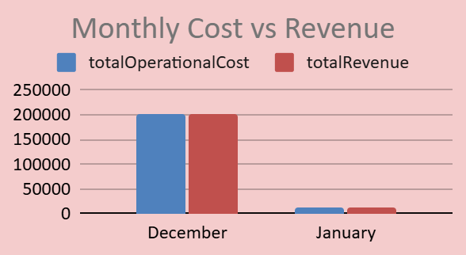
December: 202239.2087
January: 11826.69
- What is the average number of calls handled per agent per day?
Conditional Average function was used to get the result as 1.67
=round((K12/COUNTA(A2:A151)),2)
- How many repeat callers are there, and what percentage of total calls do they represent?
Pivot table was created by grouping by UID to count Calls per user.
Counted the users after filtering users with only 1 or 0 calls to identify repeat callers which comes out to be 1277.
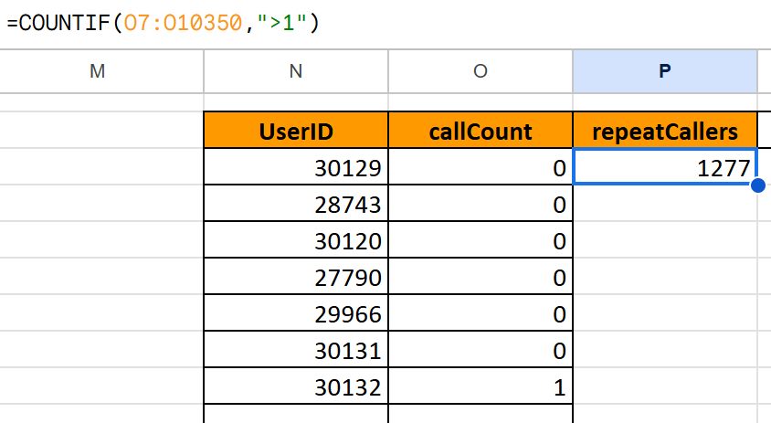
Total calls for these users were calculated and then total counts of users were subtracted from it resulting in a count of 4881 repeated calls. (=V3633-count(U2:U3628))
Further, a division by total calls was done to conclude the total repeat calls percentage to be as 56.97% (=round((V3634/D154)*100,2))
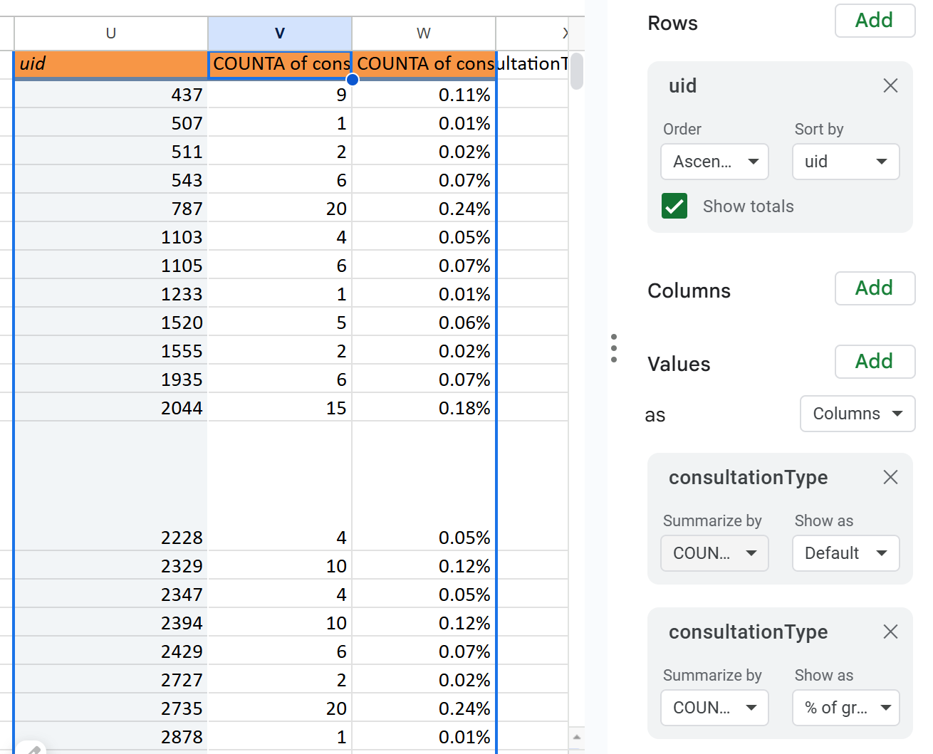
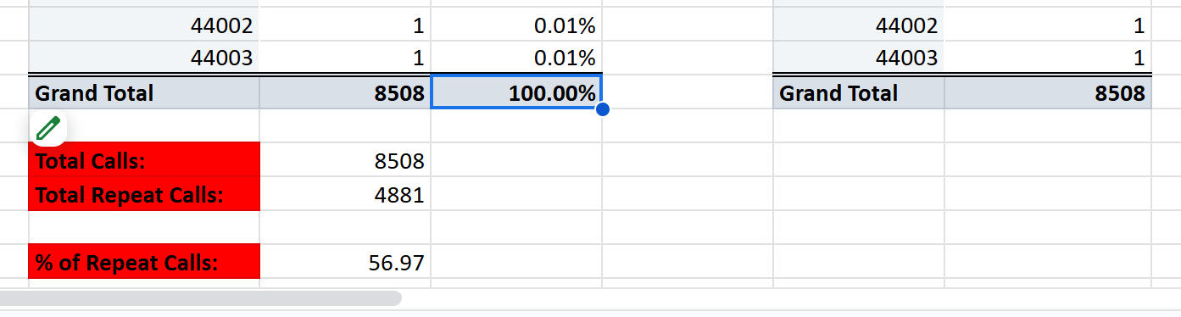

- What are the total sales generated by the call centre for each product category?
Sum of total revenue was derived by using the SUMIF function and then fillhandle was used to fill the results for other categories
=round((sumifs(data!AH:AH,data!I:I,K2)),2)
Gurucool: 88719.93
App: 125267.38
Dashboard: 0
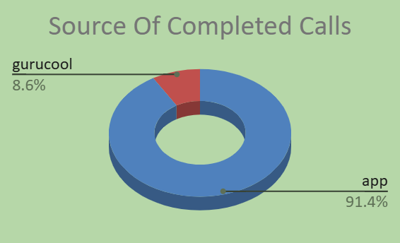
- How many calls were made for each user ID and guru ID?
Two different pivot tables were created to show the total calls by each user id as well as each guru id having total counts as 8508.
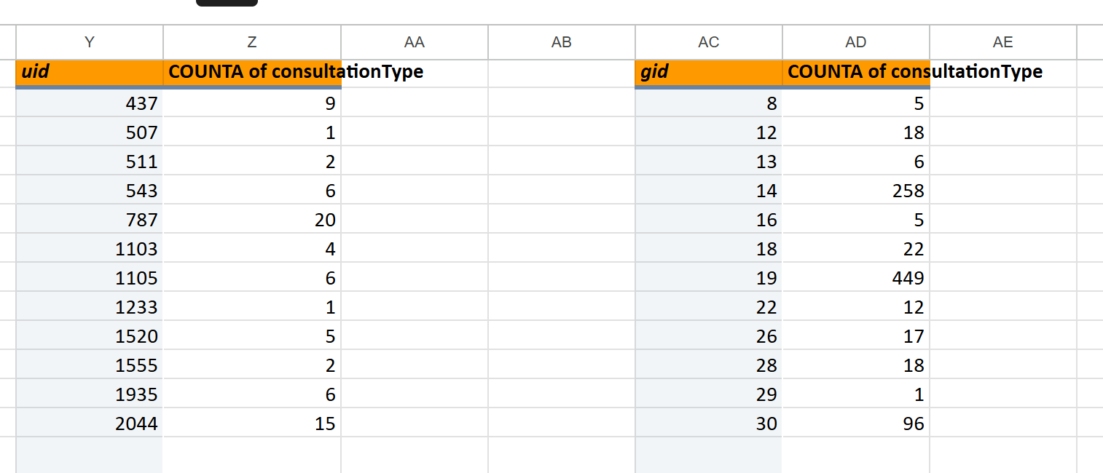
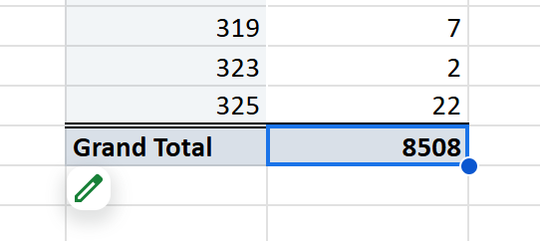
- What is the correlation between call duration and customer satisfaction?
Correlation function was used to derive the result.
=CORREL(data!Y:Y,data!AL:AL)
0.4805358755
- Which guru has the highest and lowest customer satisfaction scores?
Aggregate functions were used to find the highest and the lowest ratings for agents.
=max(B2:B151) || =MIN(B2:B151)
Highest: Astro Pujaa Rai with average rating of 7.5
Lowest: Tarot Rittika with average rating of 0
- What is the average customer satisfaction score by month?
Conditional Functions were used to find the same.
=round(AVERAGEIF(data!T:T,N2,data!AL2:AL28028),2)
2.95 for December
2.68 for January
- How many categorical columns are there in the data? [Search about categorical and continuous data, and try to answer this question]
Categorical: 10
Continuous:9

Subjective Question:

- Should the investment be used to hire more agents, improve training programs, or upgrade call center technology?
Hiring:
Upon analysing the below pie chart, the investment should aim to improve the call center technology mainly as only 40% of the calls and 28% of chats being initiated are getting completed. Almost 60% of calls and 72% chats are getting not completed which would be a serious concern and a huge potential miss.
Additionally, a significant percentage of calls and chats are getting missed as well which should push for a thought on hiring as well.
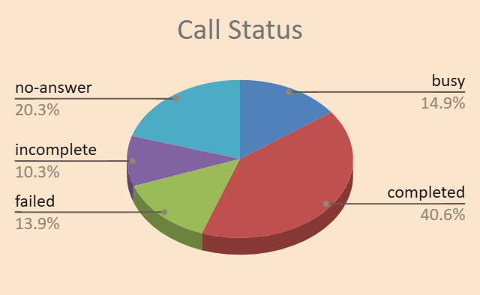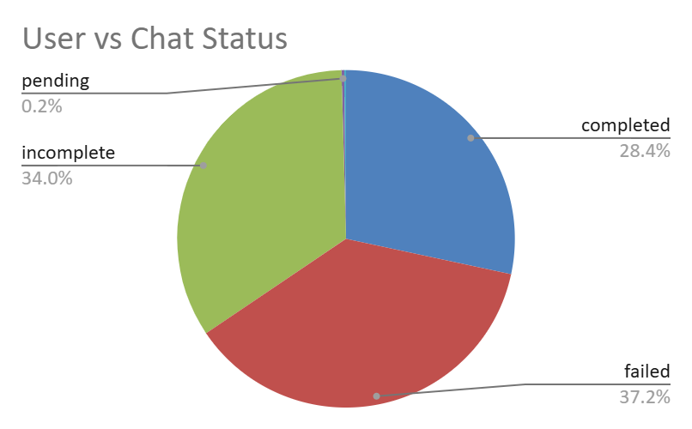
The call center receives approximately 250 calls per day, but only 40% of calls are completed. To manage the workload, investment is needed in hiring agents.
Training:
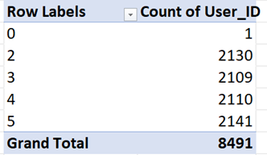
Only 25.21% of users are satisfied with the service.
Total users = 20694
Satisfied user (Rating-5,6,7,8) = 37.13 %
(formula- =(SUM(satisfied users)*100/total users))
Unsatisfied user (Rating-1,2,3,4) = 74.79 %
Since the maximum average rating of agents does not even cross 8 hence and there are very limited agents who even have a rating of 5 or above hence training would be a pivotal step in improvement as well.
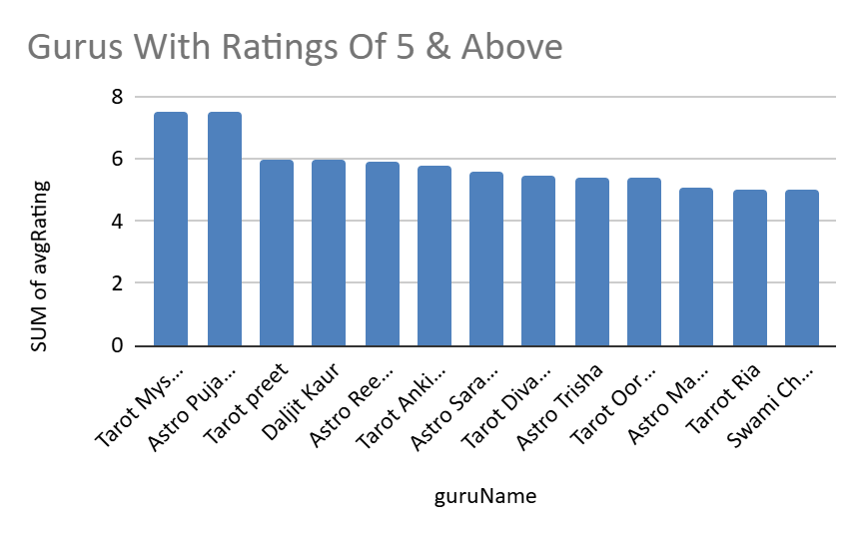
Upgrade call center technology:
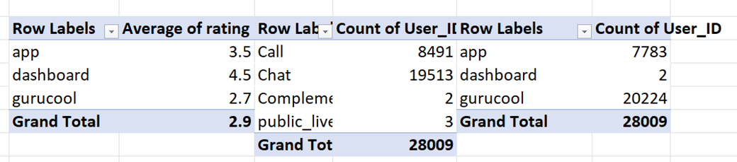
69.8% of users use the chat service, primarily through the Gurucool platform, which has an average rating of just 2.72, indicating significant user dissatisfaction. This highlights a clear need for technology upgrades to improve service quality, user experience, and retention. Investing in tech will enhance system performance and satisfaction, though potential risks like implementation delays and training requirements should be planned for and mitigated.

- What are the potential risks of each investment option (hiring, training, technology upgrades), and how can they be mitigated?
Name the chart/spreadsheet function you will use for solving the problem.
Potential risks would include some missed calls/incomplete chats initially and a lower customer satisfaction level as the new hires would be untrained initially but in the longer run should result in fruitful results.
Additionally, individual pointers would be as below:
1) HIRING
Possible Problems (Risks):
- High hiring cost – The company has to spend money on hiring, like paying agencies or job platforms.
- Training cost wasted – If the new employee doesn’t perform well, the time and money spent on training them goes to waste.
- Leaves quickly – If the person doesn’t stay long, it wastes company time and effort.
- Wrong skills – If the person hired doesn’t have the right skills, it may lead to poor work or delays.
- Bad behavior – If the new hire behaves badly or unprofessionally, it can affect the company’s image.
Mitigating These Problems (Solutions):
- Take more interview rounds to better check their skills and behavior.
- Clearly explain the job role and expectations before hiring.
- Check if they match the company culture to make sure they’ll stay longer.

2) TRAINING
Only 37.13% of users are satisfied with the service.
Total users = 20694
Satisfied user (Rating-5,6,7,8) = 37.13 %
(formula- =(SUM(satisfied users)*100/total users))
Unsatisfied user (Rating-1,2,3,4) = 62.87 %
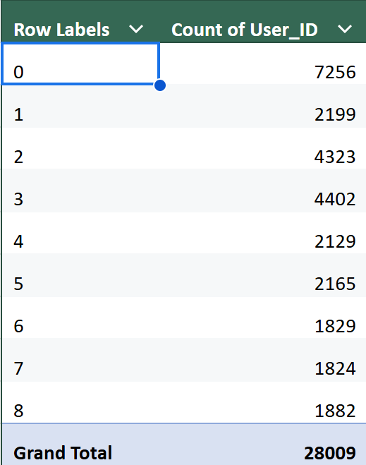
Possible Problems (Risks):
- High cost – Hiring outside trainers or giving paid certifications can be expensive.
- Employees may leave – After learning new skills, some employees may switch jobs for better offers.
- Training may not help – If the training is not related to the actual work, it won’t improve performance.
Mitigating These Problems (Solutions):
- Use in-house training where possible, and check if the cost is worth the results.
- Build a positive work environment and give chances to grow within the company.
- Use contracts or agreements so employees stay for some time after training.

3) TECHNOLOGY UPGRADES:
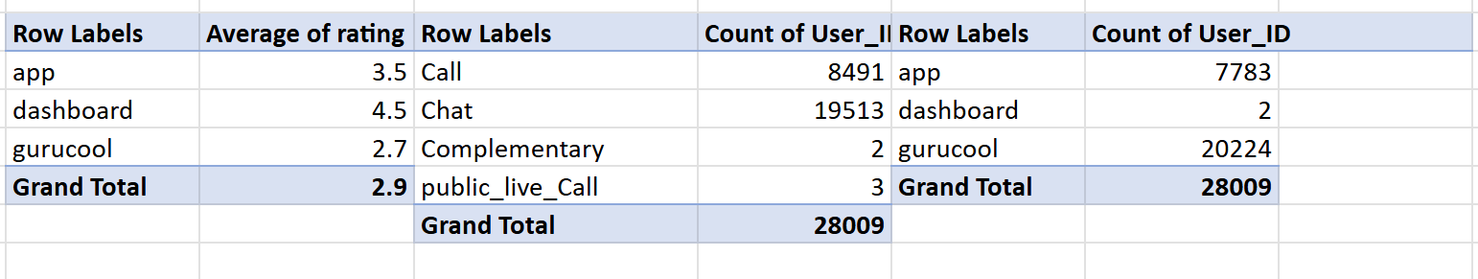
69.7% of users use the chat service, primarily through the Gurucool platform, which has an average rating of just 2.72, indicating significant user dissatisfaction. This highlights a clear need for technology upgrades to improve service quality, user experience, and retention. Investing in tech will enhance system performance and satisfaction, though potential risks like implementation delays and training requirements should be planned for and mitigated.
Possible Problems (Risks):
- High cost – Upgrading systems can be expensive. It includes buying software, licenses, hardware, and training.
- Need for training – Employees may need help learning how to use the new systems.
- May not work as expected – The new tools might not perform well or might need more resources (like faster internet or better devices).
- Risk of losing data – Data might get lost or corrupted during the upgrade.
How to Reduce These Problems (Solutions):
- Make a clear budget plan before starting the upgrade to avoid overspending.
- Train employees properly so they can use the new tools with confidence.
- Back up all important data before making any changes, so nothing is lost.
- How does AstroSage's call center performance compare to AstroGuru's average call volume, customer satisfaction, and agent performance?
Will you use any aggregation function or a visualization here to solve the problem?
Insights extracted via visualization tools in the dashboard indicate that majorly the calls handled by agents vary between 0-250 calls during the data reporting period, however, some agents have handled above the average range as well. Additionally, the average rating of agents seem to vary between 3 and 4 which looks like moderate satisfactory levels by customers.
The call center receives around 250 calls per day, and there are 148 gurus available to handle them.
However, out of 8,491 total calls, only 3,450 were completed, which is just 40.63%.
This means 59.36% of users didn’t get their call session, even after booking it.
This low completion rate is one of the main reasons why the average rating for the call service is only 3.5.

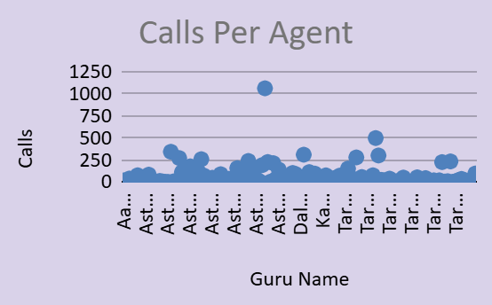


If astrologers’ ratings improve, the overall company rating will also improve.
Since 78.71% of the company's net income and 78.46% of astrologers’ earnings come from the Call service, it's clearly the key revenue source.
So, investing in training programs to improve astrologer performance would be a smart and strategic move to maintain and grow this success.
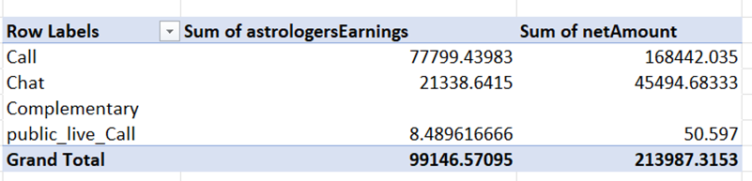
Percent of call income = (Call income * 100)/Total income
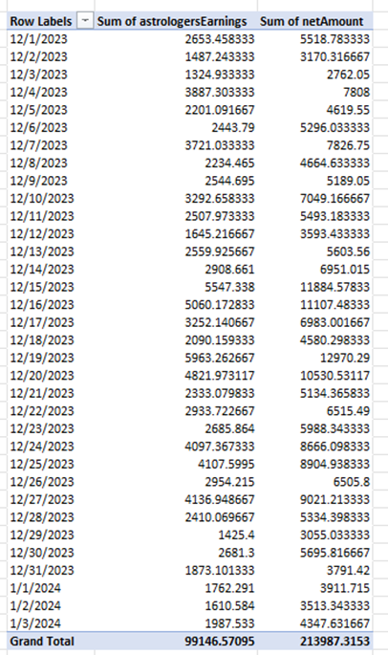
The performance of agents (astrologers) is crucial to the company’s success because their earnings are strongly linked to the company’s income.
Using the formula “=CORREL()”, the correlation between astrologers’ earnings and the company’s net income is 0.9969, which shows a very strong positive relationship.
This means:
When agent earnings increase, the company’s net income also increases-almost every time and in a predictable way.
A correlation of 0.99 indicates that both are highly interconnected, and improving agent performance can directly boost company profitability.
- How can the call center improve its handling of peak call periods to ensure high customer satisfaction? Mention the functionality you will use for giving the suggestions, will it be any aggregated function or a visualization?
 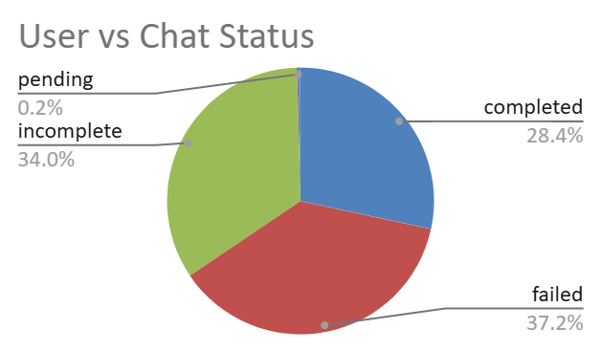
Post studying the above chart, it can be suggested that automated IVRs/Chatbots can be added and hardware has to be improved to better tackle the missed calls and reduce idle time for chats.
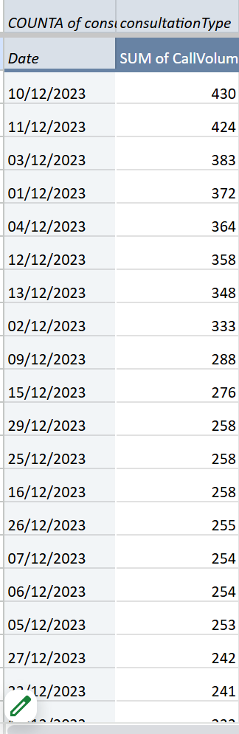
On December 10 and 11, 2023, the call center received the highest number of calls.
However, only 34.82% of users were successfully served, while the remaining 65.18% received messages such as "astrologer busy" or had their calls cancelled due to the unavailability of astrologers.
Additionally, as mentioned in above questions, if training is implemented for staff, then it would tend to show faster resolution times which would allow agents to increase their productivity as well as for them to be able to handle an increased number of calls.
Analysis of peak hours:
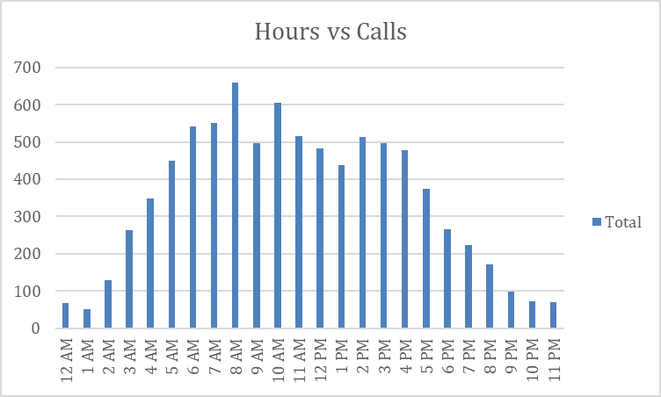
Here we can see the hourly distribution of calls. First, we have to take out hours from creation time with the help of = HOUR FUNCTION, later by taking hours in a row, the count of calls in values, and consultation type in filters, and set that filter as call. This is how we can form the pivot table, and later with the help of the pivot table, we can visualize it with a chart.
•Peak Call Volume: The busiest hours are between 10:00 to 18:00, peaking around 15:00, indicating when customer demand is at its highest.

•Off-Peak Hours: Call volume remains low between 00:00 to 06:00, suggesting minimal customer interaction during these early morning hours.
●Introduce Live Streaming:
The company can offer live sessions where astrologers interact with multiple users at once. This will reduce waiting time, keep users engaged, and also help generate more revenue.
●Optimize Agent Shifts:
Schedule more agents during peak hours (like evenings or weekends) to handle higher call volumes efficiently.
●Hire Part-time or Freelance Agents:
Keep a few on-call or freelance astrologers who can step in during busy times.
This helps manage the load without adding permanent staffing costs.

- Based on historical data, what strategic initiatives should be prioritized to improve efficiency and customer satisfaction?
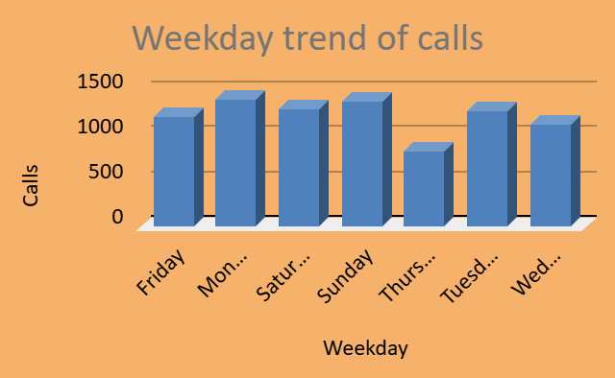
Post analysing the calls per weekday, it was noticed that Thursdays had a significantly lower call volumes amongst the other days, so planned training sessions can be organised for agents to increase efficiency.
New hires can be made familiar with the procedures during the same.
Also chats can be the first medium with which the new hires can be made familiar with as that medium would not need elocuted responses as compared to calls and it would also allow them to get familiar with the system and overall workflow.

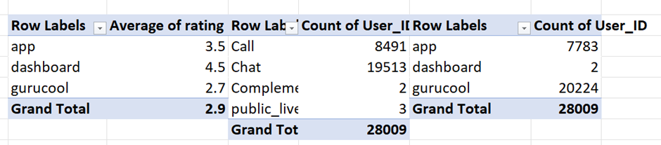
● With 69.62% of users using the chat service and an average rating of only 2.72 (for Gurucool), there is a clear need to enhance the chat platform for a smoother user experience.
Key Factor:
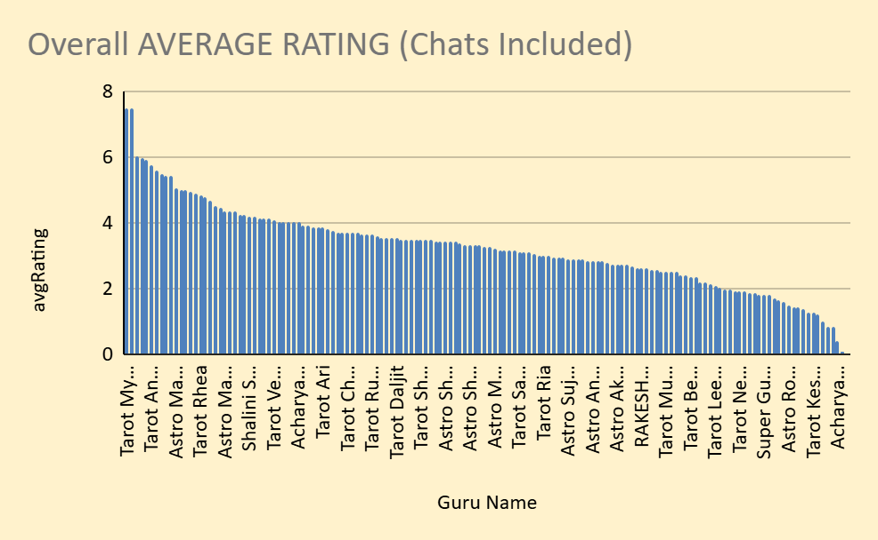 
The Guru. The wide range of average scores (2.0 to 8.0) proves that individual performance dictates the rating.
Leverage Strategy: Using AVERAGEIFS to identify the top 10% of gurus.
Create training materials and shadow programs based on the successful techniques of these high-satisfaction agents.
Guru Excellence Program: Implement performance-based bonuses and mandatory retraining for low-rated agents. (Addresses the high variance in satisfaction.)
CRM & Loyalty: Implement a system to recognize and reward the repeat customer base. (Capitalizes on the most valuable customer segment.)
● On peak days like 2023-12-10 & 2023-12-11, only 34.82% of users got service.
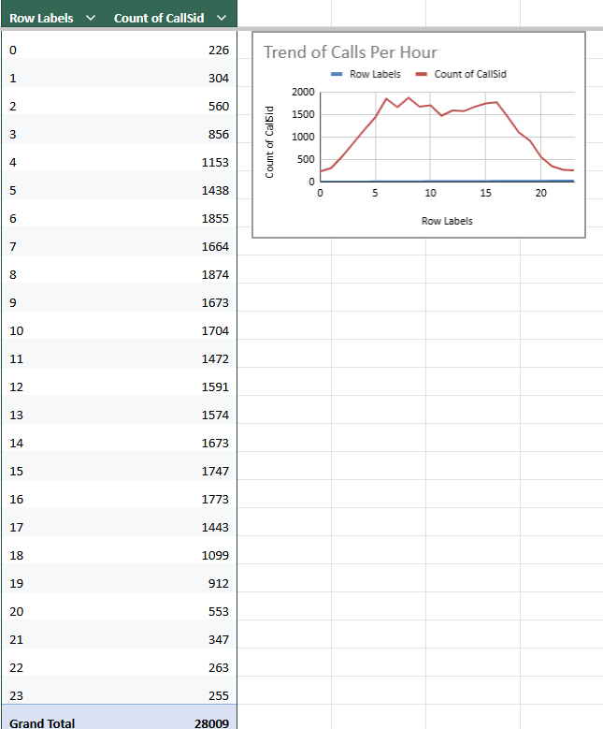
● Use shift planning, part-time astrologers, or live sessions to better handle high traffic.
This move can make the company stand separate among the rivals. And bring customers and revenue to the company.

- What can be the key factors contributing to high customer satisfaction scores, and how can these be leveraged to improve overall performance?
What is the basis for the suggestions? And mention how you decide if the satisfaction score affects the ratings.

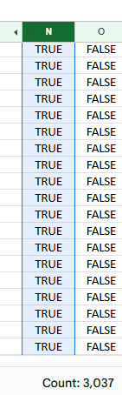
Post analysing the data with correct filters, it was noticed that the majority of the calls were FREE CALLS.
More such offers can be used to attract customers. Additionally, the free call duration can be increased which can be used to attract new customers and increase repeated callers which in turn gives a chance to improve satisfaction level.
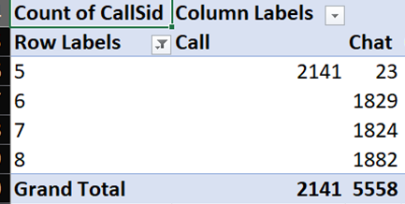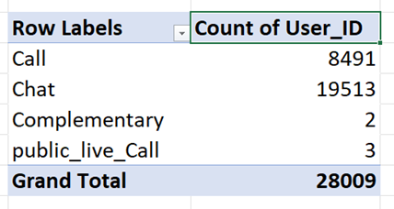
69.80% of total users use the chat service.
% of user using chat = (Chat user*100)/ Total user
Rating of 6,7,8 is considered as the high satisfaction range.
Only chat service receives the rating of 6,7,8.
As 69.80% of total users use the chat service and 100% of high satisfaction scores are given by chat users only, then the Chat service can be considered as the key factor contributing to high satisfaction score.
Improvements:
To further enhance user experience, the company can:
●Introduce AI chatbots to handle basic queries and reduce wait times.
●Train employees to adopt new tools, technologies, and workflows that support better service delivery.
These steps will help the company boost overall performance and user satisfaction.

- How should the call center balance the workload among agents to ensure optimal performance and avoid burnout?
Mention your approach and spreadsheet function for the answer.
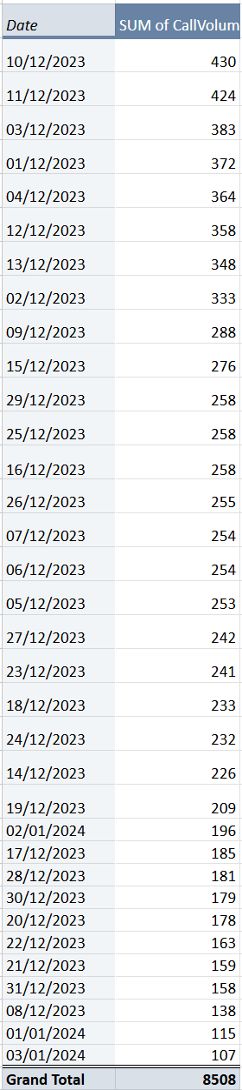 
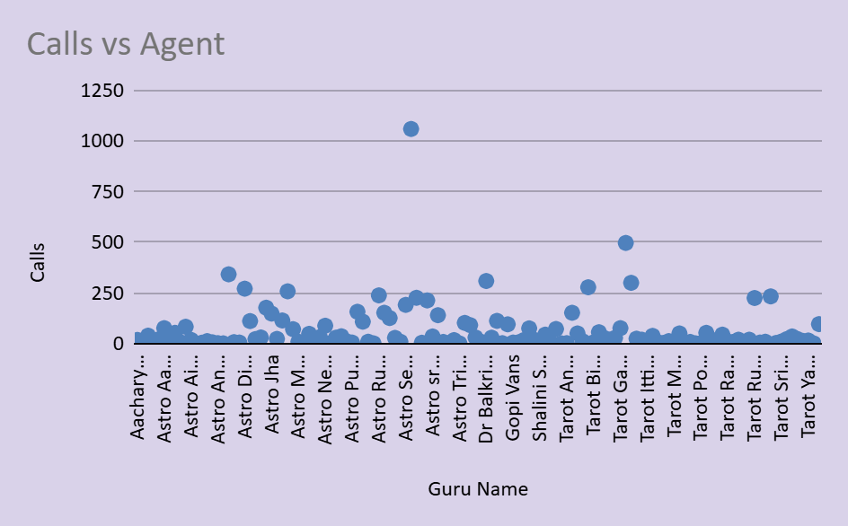
It has been noticed that many agents have handled more than 250 calls as well which is significantly higher in number compared to the average range of 0 to 250 calls bracket. Also, many agents have a lower average call duration as well which means a lower workload for them. Efficient call routing mechanisms need to be implemented which would allow to maintain a balance between agents in terms of workload. Additionally, a limited staffing policy can be implemented for Thursdays to provide rest for some agents who have handled a set limit of completed calls.
Approach: Stop manual routing where users can only choose favorites, which overloads top gurus. Implement a dynamic Load-Balanced Router.
Spreadsheet Function: The system should route to the next available agent whose current day's load is the lowest.
This is monitored using:
=COUNTIFS(Date_Column, TODAY(), GID_Column, [Specific_Guru_ID])
New calls are assigned to the guru with the lowest count from this formula.
Suggestions-
1) To balance the workload, the company can analyze the historical data. The hourly distribution of calls can help the company to balance workload accordingly among agents.
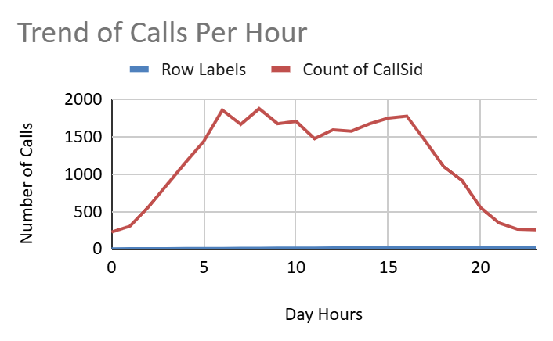
2) Introduce live streaming to handle multiple users at once and increase engagement.
3) Optimize agent shifts by scheduling more agents during peak hours.
4) Use part-time or freelance astrologers to manage high workloads cost-effectively.
5) Implement AI chatbots to handle basic queries and reduce agent load.
6) Analyze hourly call trends to distribute workload more evenly among agents.

- What new technologies or tools could be implemented to enhance call center operations and customer service?
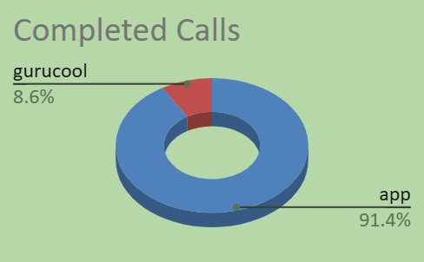
Considering that the app constitutes for more than 90% of the completed calls, a new consultation type of Video Call can be introduced to lure new customers.
Also, since the amount of calls received via the website guruCool and Dashboard is comparatively less, promotional offers can be made for customers to direct them to the website and target new customers.
Additionally, below are some suggestions that can be implemented to better achieve this:
●AI Chatbots
Handle basic user queries 24/7, reduce agent workload, and improve response speed.
●Live Streaming Sessions
Allow astrologers to interact with multiple users at once, especially during peak times.
●Call Routing Systems
Automatically direct users to the best available astrologer, reducing wait and call drop rates.
●Real-time Dashboards & Alerts
Monitor agent performance, call traffic, and satisfaction in real time for quick decision-making.
●Automated Feedback Collection Tools
Collect post-session ratings and suggestions without manual effort.

- What metrics should be included in the final dashboard to comprehensively view call center performance and guide investment decisions?
Calls per agent, Calls per day, Amount generated by each agent, Average rating for each call and Average rating for each agent and Average repeated clients can be some of the parameters which can be utilized to better guide investment decisions.
To effectively monitor call center performance and support strategic investment decisions, a mix of operational, financial, and quality-focused metrics have been added.
Key metrics to include:
- Total Calls & Chats Handled – Tracks overall workload and service type preference.
- Total users – Helps assess efficiency and workload per consultation.
- Customer Satisfaction Score (Average Rating) – Measures quality of service and user feedback.
- Total Guru – For getting a view on the available work force.
- Revenue by Consultation Type (Call vs. Chat) – Guides which service drives profitability.
- Agent-wise Performance – Includes total calls handled, average rating, and workload balance.
- Peak Hour/Day Trends – Identifies when to allocate more resources.
- Daily Call Volume – for getting daily performance and workload management.
- Revenue by consultation type – for identifying which service is generating what percentage of total revenue.
- Monthly average rating – for tracking customer satisfaction for quick actions
- Call status – for identifying call status
- Consultation type – for identifying which products are mostly used by the users for better customer satisfaction and service
- Top 10 guru – for identifying which agents are mostly liked by the users so we can analyse their common practice and can provide the same training to other agents for better customer satisfaction and this data can help us to recognise those agents who are successfully satisfying customers.
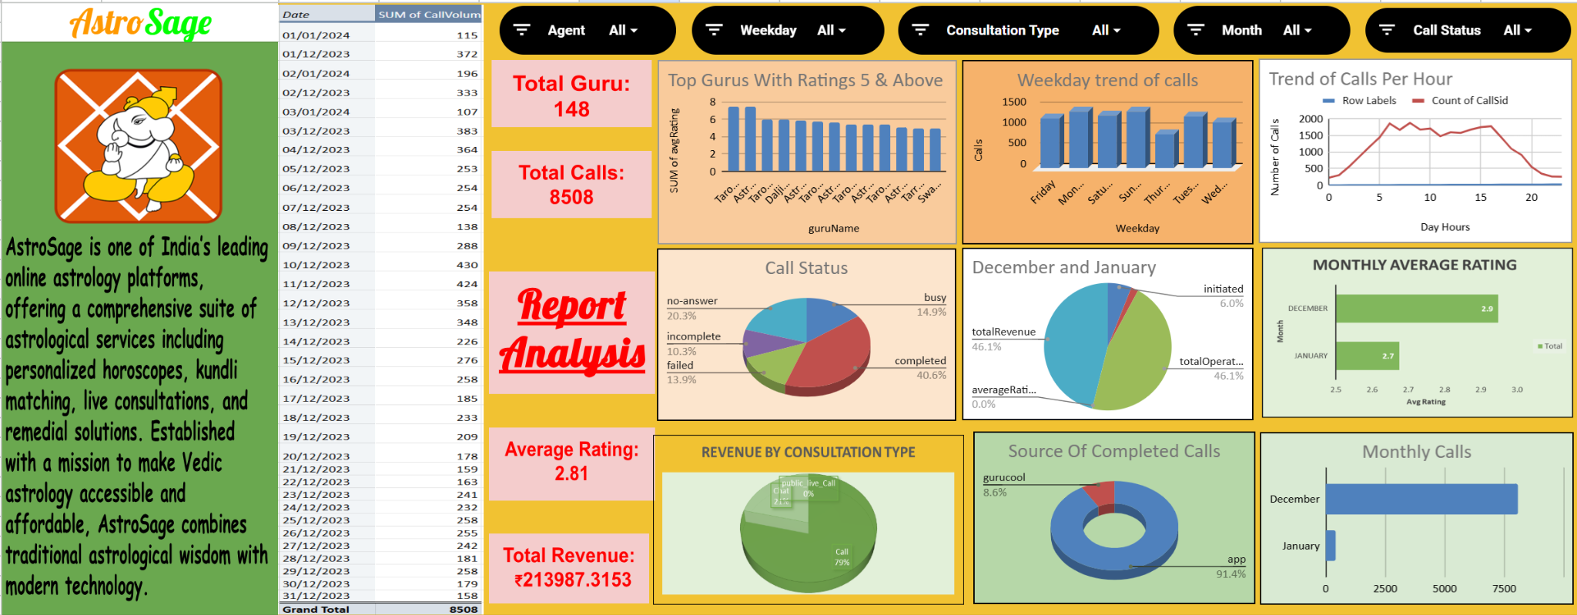
- How would you allocate a 1 crore rupee investment to optimize operational efficiency, enhance customer satisfaction, and boost profitability, and what analysis-based recommendations would you offer to support this?
[you have to give bullet pointers to answer this question]
1. Technology Upgrade – ₹40 lakhs (40%)
●69.62% of users use chat services, mainly on Gurucool, which has a low average rating of 2.72.
●Recommendation:
Upgrade the chat platform (UI/UX).
Introduce AI chatbots for instant query resolution.
Improve backend performance to reduce lag or crashes.
●Expected Outcome: Improved chat satisfaction, better retention, and reduced operational delays.
2. Agent Training Program – ₹25 lakhs (25%)
●Only 40.77% of booked calls are completed. Calls are the main revenue driver, contributing 78.69% of the company’s income.
●Recommendation:
○Conduct monthly training on soft skills, upselling, and technical handling.
○Use analytics to identify underperforming agents and offer targeted coaching.
●Expected Outcome: Increase in successful calls, better customer experience, and improved satisfaction.
3. Support Infrastructure, Data Security & Customer Care Tools – ₹35 Lakhs (35%)
●Hire freelance/part-time agents to manage peak hours and reduce customer wait time.
●Invest in infrastructure and data protection (cloud backups, system stability).
●Set up automated feedback tools (post-call surveys, follow-ups) to improve customer support and satisfaction

Conclusion:
This project offered a valuable opportunity to apply data analytics to solve real business challenges faced by AstroSage’s call center operations. Through detailed data cleaning, exploratory analysis, metric building, and dashboard planning, I was able to uncover meaningful patterns and provide actionable recommendations focused on operational efficiency, customer satisfaction, and strategic investment planning.
The insights and suggestions presented in this report are based entirely on thorough analysis of the dataset provided. I have ensured that each recommendation is data-driven, practical, and aligned with industry best practices. I believe that with the implementation of these insights, AstroSage can strengthen its service delivery, retain more customers, and scale its operations efficiently.
Thank you for reviewing my work.
– Bhaskar Jha
Certified Data Analyst
(Excel | SQL | Power BI | Python)

