Objective Questions

1. Are there any tables with duplicate or missing null values? If so, how would you handle them?
Ans:
Based on the schema for the users and following tables, the dataset has built-in constraints that prevent most duplicate and missing (null) values.

Duplicates Handling:

The users table has an id column defined as the PRIMARY KEY, which guarantees that every user has a unique ID. Additionally, the username column is set as UNIQUE, so no two users can have the same username.

In the following table, the combination of follower_id and followee_id forms a composite PRIMARY KEY. This design choice ensures that a user can only follow another user once, effectively preventing duplicate follow relationships from being entered into the table in the first place.

Missing Values Handling:

Both the users and following tables have NOT NULL constraints on their most important columns. For instance, the username in the users table and the follower_id and followee_id in the following table cannot be left empty. This ensures that every record contains the essential data required to perform the analysis
However, the below mentioned queries can be utilized to confirm:

---For Checking NULL values

SELECT * FROM Table_Name

WHERE Column1 IS NULL

OR Column2 IS NULL;

---For Checking Duplicates

SELECT Column1,Column2, COUNT(*) AS cnt FROM Table_Name

GROUP BY Column1,Column2

HAVING COUNT(*)>1;
Result:
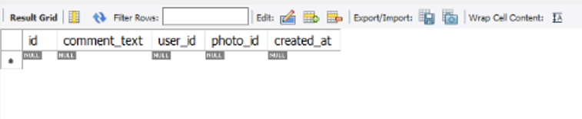
If there are any NULL values, we can update the data with default values. For duplicates, we can delete the duplicate row, keeping only one unique record.

---Updation Syntax

UPDATE Table_name

SET Column= “Default_value”

WHERE Column IS NULL;

---Deleting Duplicate Records

DELETE t1

FROM table_name t1

INNER JOIN table_name t2

ON t1.column1 = t2.column1

AND t1.column2 = t2.column2

AND t1.id > t2.id; -- keeps the row with the smallest id

2. What is the distribution of user activity levels (e.g., number of posts, likes, comments) across the user base?
Ans:
The distribution of user activity levels across the user base was calculated by considering the total number of posts, likes, and comments for each user. Users were then categorized as follows:

Inactive: 0 total activity (posts + likes + comments)

Low: 1–10 total activity

Medium: 11–50 total activity

High: Above 50 total activities

Based on the analysis:

77 users fall into the High activity category.

13 users are Inactive with no activity recorded.

8 users have Low activity.

2 users fall into the medium activity range.

This shows that the majority of users are highly active, while a smaller group remains inactive or only moderately engaged.

Query:
SELECT activity_level, COUNT(*) AS user_count FROM (
SELECT sub.id AS user_id,
CASE
WHEN (post_count + like_count + comment_count) = 0
THEN 'Inactive'
WHEN (post_count + like_count + comment_count) <= 10
THEN 'Low'
WHEN (post_count + like_count + comment_count) <= 50
THEN 'Medium'
ELSE 'High'
END AS activity_level
FROM (
SELECT u.id,
COALESCE(COUNT(DISTINCT p.id),0) AS post_count,
COALESCE(COUNT(DISTINCT l.photo_id),0) AS like_count,
COALESCE(COUNT(DISTINCT c.id),0) AS comment_count
FROM users u
LEFT JOIN photos p ON u.id = p.user_id
LEFT JOIN likes l ON u.id = l.user_id
LEFT JOIN comments c ON u.id = c.user_id
GROUP BY u.id
) sub
) t
GROUP BY activity_level
ORDER BY user_count DESC;

Output:
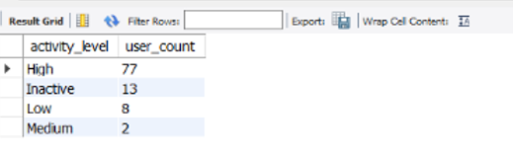
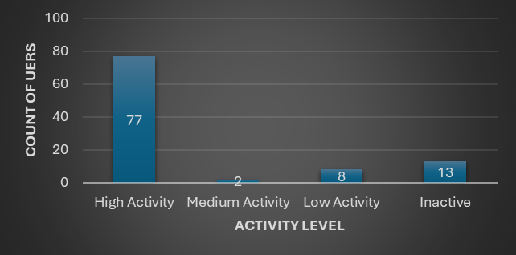
3. Calculate the average number of tags per post (photo_tags and photos tables).
Ans:
SELECT
COUNT(PT.tag_id) / COUNT(DISTINCT P.id) AS avg_tags_per_post
FROM
photos AS P
LEFT JOIN
photo_tags AS PT ON P.id = PT.photo_id;
Result:
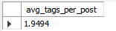
The average number of tags per post came out to be 1.94 i.e. almost close to 2 tags per post calculated using joins on photos and photo_tags table where count of total tags was divided by total number of posts.
4. Identify the top users with the highest engagement rates (likes, comments) on their posts and rank them.
Ans:
SELECT
U.username,
COUNT(DISTINCT L.photo_id) AS total_likes_on_posts,
COUNT(DISTINCT C.id) AS total_comments_on_posts,
(COUNT(DISTINCT L.photo_id) + COUNT(DISTINCT C.id)) AS total_engagement,
(
SELECT
COUNT(follower_id)
FROM follows
WHERE followee_id = U.id
) AS follower_count,
(
(COUNT(DISTINCT L.photo_id) + COUNT(DISTINCT C.id)) * 1.0 / (
SELECT
COUNT(follower_id)
FROM follows WHERE = U.id
)
) AS engagement_rate
FROM
users AS U
LEFT JOIN
photos AS P ON U.id = P.user_id
LEFT JOIN
likes AS L ON P.id = L.photo_id
LEFT JOIN
comments AS C ON P.id = C.photo_id
GROUP BY
U.id
ORDER BY
engagement_rate DESC;

Result:
Username Eveline95 seemed to have the highest engagement rate amongst all which was calculated by using the sum of total likes and comments on posts.
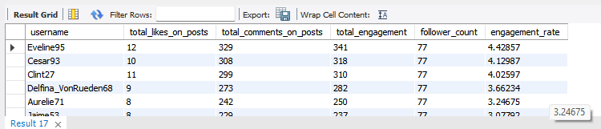
5. Which users have the highest number of followers and followings?
Ans:
Highest Followers:
SELECT
U.username,
COUNT(F.followee_id) AS follower_count
FROM
users AS U
JOIN
follows AS F ON U.id = F.followee_id
GROUP BY
U.id
ORDER BY
follower_count DESC;

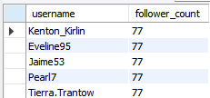
=============================
Highest Following:
SELECT
U.username,
COUNT(F.follower_id) AS following_count
FROM
users AS U
JOIN
follows AS F ON U.id = F.follower_id
GROUP BY
U.id
ORDER BY
following_count DESC;
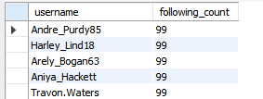
Concepts of joins and count functions were used on users and follows tables to determine the users with highest followers and following count.
6. Calculate the average engagement rate (likes, comments) per post for each user.

Ans:
SELECT
U.username,
COUNT(DISTINCT P.id) AS total_posts
COUNT(DISTINCT L.photo_id) AS total_likes_on_posts,
COUNT(DISTINCT C.id) AS total_comments_on_posts,
(COUNT(DISTINCT L.photo_id) + COUNT(DISTINCT C.id)) AS total_engagement,
(
(COUNT(DISTINCT L.photo_id) + COUNT(DISTINCT C.id)) * 1.0 / COUNT(DISTINCT P.id)
) AS avg_engagement_per_post
FROM
users AS U
LEFT JOIN
photos AS P ON U.id = P.user_id
LEFT JOIN
likes AS L ON P.id = L.photo_id
LEFT JOIN
comments AS C ON P.id = C.photo_id
GROUP BY
U.id
ORDER BY
avg_engagement_per_post DESC;
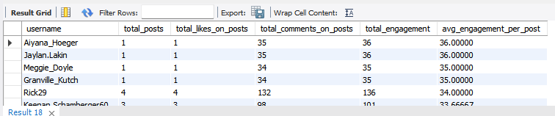

Count function was used to sum up total likes, posts and comments which was then summed up to find the total engagement and average engagement. The final result was then sorted in the decreasing order of the average engagement value.

7. Get the list of users who have never liked any post (users and likes tables)
Ans:
SELECT
U.username
FROM
users AS U
LEFT JOIN
likes AS L ON U.id = L.user_id
WHERE L.user_id IS NULL;
Result:
Total 23 users with usernames
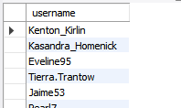
The concept of IS NULL was used to determine the usernames which have an entry in the users table but do not have any entry in the likes table.
8. How can you leverage user-generated content (posts, hashtags, photo tags) to create more personalized and engaging ad campaigns?
Ans:
To create more personalized and effective ad campaigns:

Analyze Hashtags and Photo Tags: The tags users add to their posts are powerful indicators of their interests. For instance, a user who frequently tags photos with #travel, #adventure, and #hike is a perfect audience for a travel agency or an outdoor gear brand. By analyzing these tags, you can create highly targeted ad campaigns that show users products or services directly related to their passions.

Target Based on Engagement: Look at the content a user is liking and commenting on. A user who consistently likes posts about fashion or a specific type of product (like sneakers or coffee) can be retargeted with ads for those exact items. This is a powerful form of behavioral targeting that capitalizes on a user's proven interests.

Use User-Generated Ads: Some of the most effective ad campaigns use content created by the users themselves. You can identify posts with high engagement (based on the likes and comments calculated by your query) that feature your product or a specific topic. Then, with the user's permission, use that authentic content in an ad campaign. This is often more trusted and effective than traditional corporate ads.

User-generated content provides a wealth of authentic data that allows you to move away from generic ad campaigns and toward highly personalized, relevant messages that are more likely to connect with the target audience.
Leveraging User-Generated Content (UGC) for Ads

We calculate average engagement per post for each hashtags used to find out which one is most popular and which one is not.

SQL QUERY:
SELECT
T.tag_name,
AVG(photo_engagement.total_likes + photo_engagement.total_comments) AS
Avg_engagement_per_photo
FROM (
SELECT
p.id AS photo_id,
COUNT(DISTINCT l.user_id) AS total_likes,
COUNT(DISTINCT c.id) AS total_comments
FROM photos p
LEFT JOIN likes l ON p.id = l.photo_id
LEFT JOIN comments c ON p.id = c.photo_id
GROUP BY p.id
) AS photo_engagement
JOIN photo_tags pt ON photo_engagement.photo_id = pt.photo_id
JOIN tags t ON pt.tag_id = t.id
GROUP BY t.tag_name
ORDER BY avg_engagement_per_photo DESC;
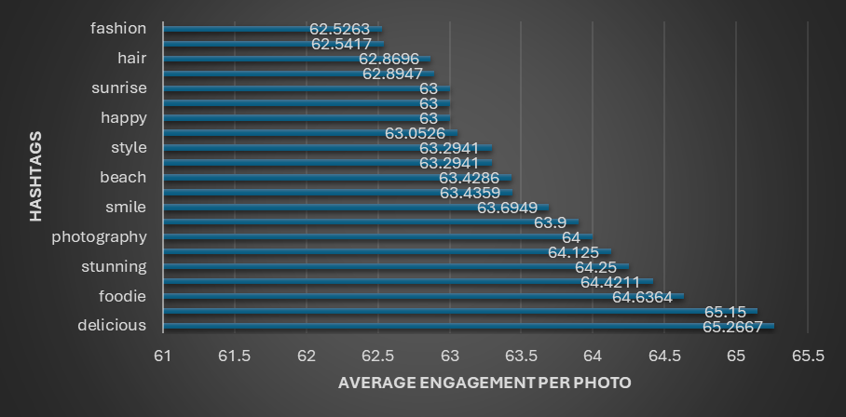

INSIGHTS:

· Tags related to food ("delicious," "foodie," "food") have very high engagement, indicating strong user interest in food-related content.

More niche or lifestyle tags like "hair," "concert," "fashion" also register notable engagement but slightly lower.

RECOMMENDATION:

· Focus content creation on food and visually appealing themes, as these have shown to drive the most engagement.

Avoid overusing low-engagement or generic tags, instead focus on specific high-engagement ones.
9. Are there any correlations between user activity levels and specific content types (e.g., photos, videos, reels)? How can this information guide content creation and curation strategies?
Ans:

Steps to analyse user activity levels and correlate with specific content types (photos with tags)

Step 1: Get total likes and comments per photo

This shows engagement per photo by likes and comments.

Step 2: Get tags for each photo to understand content types/themes

This maps each photo to its tags (content themes/subjects).

Step 3: Combine engagement and tags to see which tags get more engagement

This reveals which content tags attract the most engagement.

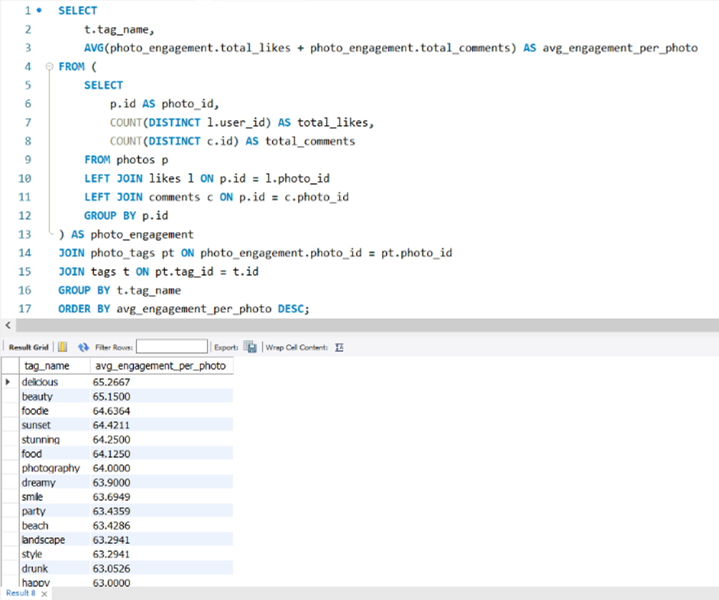

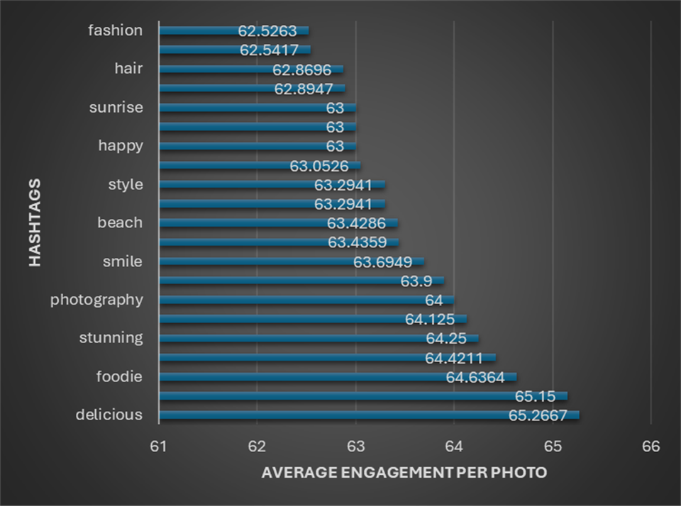

INSIGHTS:

Tags related to food ("delicious," "foodie," "food") have very high engagement, indicating strong user interest in food-related content.

Visual and aesthetic tags ("beauty," "sunset," "stunning," "photography," "landscape," "style") also show high engagement, suggesting that users are highly responsive to visually pleasing or artistic content.

Tags expressing emotions or experiences ("happy," "fun," "smile," "party," "dreamy") attract good engagement, highlighting the importance of connecting emotionally with users.

More niche or lifestyle tags like "hair," "concert," "fashion" also register notable engagement but slightly lower.

RECOMMENDATION:

Focus content creation on food and visually appealing themes, as these have shown to drive the most engagement.

Use tags related to emotions and experiences to add a relatable, human touch that resonates with users.

Avoid overusing low-engagement or generic tags, instead focus on specific high-engagement ones.
10. Calculate the total number of likes, comments, and photo tags for each user.

Ans:
SELECT
U.username,
COUNT(DISTINCT L.photo_id) AS total_likes_given,
COUNT(DISTINCT C.id) AS total_comments_made,
COUNT(DISTINCT PT.tag_id) AS total_photo_tags_used
FROM users AS U
LEFT JOIN likes AS L
ON U.id = L.user_id
LEFT JOIN comments AS C
ON U.id = C.user_id
LEFT JOIN photos AS P
ON U.id = P.user_id
LEFT JOIN photo_tags AS PT
ON P.id = PT.photo_id
GROUP BY U.id
ORDER BY
total_likes_given DESC,
total_comments_made DESC,
total_photo_tags_used DESC;
Result:
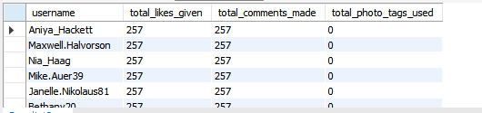

Count function and joins were performed on the users, likes, photos, comments, photo_tags table to be able to calculate totals for each user and the results were then sorted in decreasing order.
11. Rank users based on their total engagement (likes, comments, shares) over a month.
Ans:
WITH UserEngagement AS (
SELECT
U.id AS user_id,
U.username,
COUNT(DISTINCT L.photo_id) AS total_likes,
COUNT(DISTINCT C.id) AS total_comments,
(COUNT(DISTINCT L.photo_id) + COUNT(DISTINCT C.id)) AS total_engagement
FROM
users AS U
LEFT JOIN
photos AS P ON U.id = P.user_id
LEFT JOIN
likes AS L ON P.id = L.photo_id
LEFT JOIN
comments AS C ON P.id = C.photo_id
WHERE
P.created_dat >= DATE_SUB(NOW(), INTERVAL 30 DAY) OR L.created_at >= DATE_SUB(NOW(), INTERVAL 30 DAY) OR C.created_at >= DATE_SUB(NOW(), INTERVAL 30 DAY)
GROUP BY
U.id, U.username
)
SELECT
Username,
Total_engagement,
RANK() OVER (ORDER BY total_engagement DESC) as ranking
FROM
UserEngagement
ORDER BY
ranking ASC;
Result:
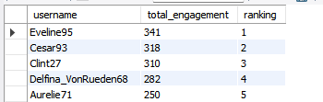
Window functions was used to rank the users based on the decreasing order of total_engagement

12. Retrieve the hashtags that have been used in posts with the highest average number of likes. Use a CTE to calculate the average likes for each hashtag first.
Ans:
WITH PhotoLikes AS (
SELECT
Photo_id,
COUNT(user_id) AS like_count
FROM
Likes
GROUP BY
Photo_id
)
SELECT
T.tag_name,
AVG(PL.like_count) AS average_likes
FROM
tags AS T
JOIN
photo_tags AS PT ON T.id = PT.tag_id
JOIN
PhotoLikes AS PL ON PT.photo_id = PL.photo_id
GROUP BY
T.tag_name
ORDER BY
average_likes DESC;
Result:
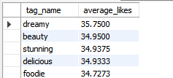
CTE was used to find total likes for each tag and then average was calculated using the aggregate functions which was then sorted in the decreasing order.

13. Retrieve the users who have started following someone after being followed by that person
Ans:
SELECT DISTINCT
U.username AS follower_username
FROM
follows AS F1
JOIN
follows AS F2
ON F1.follower_id = F2.followee_id AND F1.followee_id = F2.follower_id
JOIN
users AS U
ON F1.follower_id = U.id
WHERE
F1.created_at > F2.created_at;
Result: NONE
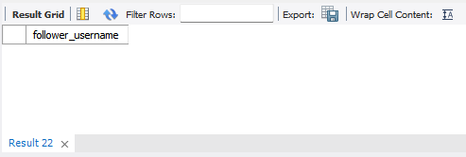
Subjective Questions
- Based on user engagement and activity levels, which users would you consider the most loyal or valuable? How would you reward or incentivize these users?
Ans:
Based on the dataset, we can identify and incentivize the most loyal and valuable users:

Defining Loyalty and Value
The most loyal and valuable users are those who consistently create high-quality content and drive engagement on the platform. They are the ones who create a positive feedback loop, attracting new users and keeping existing ones engaged.
- Consistent Activity: These users don't just post once and disappear. They post, comment, and like content on a regular basis over a long period.
- High-Quality Engagement: It's not just about the number of likes or comments, but the ratio of engagement to their follower count (their engagement rate). A user with 100 followers and 50 likes per post is more valuable than a user with 10,000 followers and the same number of likes.
- Community Building: The selected query is a great example of this. Users who follow people back are actively building a community, and this behavior indicates a high level of engagement with the platform's social aspect.
Incentives and Rewards
Once we've identified these valuable users, we can't just let them go. We need to reward them to ensure they feel appreciated and continue to contribute to the platform.
Some ways to reward and incentivize these users can be:
- Status and Recognition: Give them a special badge (like a "Top Contributor" or "Community Builder" badge) that is visible on their profile. This not only rewards them but also makes it easy for other users to identify high-quality content creators.
- Exclusive Features: Offer them early access to new features like monetization tools, advanced analytics, or unique content formats. This makes them feel like they are part of an exclusive group and gives them a competitive advantage.
- Monetary Rewards: For the most valuable users, we can explore a revenue-sharing model or a "Creator Fund" that provides them with a direct financial incentive to continue producing quality content.
- Personalized Support: Give them a dedicated point of contact for technical support and feedback. This shows that we value their opinion and are committed to helping them succeed on the platform.
By taking this approach to defining and rewarding loyalty, we can turn our most valuable users into brand ambassadors who not only use our platform but also actively advocate for it.
Query:
WITH UserActivity AS (
SELECT
U.id AS user_id,
U.username,
COUNT(DISTINCT P.id) AS total_posts,
COUNT(DISTINCT L.photo_id) AS total_likes,
COUNT(DISTINCT C.id) AS total_comments
FROM
users AS U
LEFT JOIN
photos AS P ON U.id = P.user_id
LEFT JOIN
likes AS L ON U.id = L.user_id
LEFT JOIN
comments AS C ON U.id = C.user_id
GROUP BY
U.id,
U.username
)
SELECT
user_id,
username,
total_posts,
total_likes,
total_comments,
(total_posts * 3) + (total_comments * 2) + (total_likes * 1) AS activity_score,
DENSE_RANK() OVER (ORDER BY (total_posts * 3) + (total_comments * 2) + (total_likes * 1) DESC) AS activity_rank
FROM
UserActivity
ORDER BY
activity_rank ASC,
username ASC;
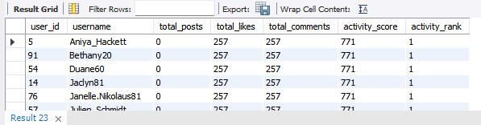
- For inactive users, what strategies would you recommend to re-engage them and encourage them to start posting or engaging again?
Ans:
Based on the dataset, we can effectively segment our user base to identify those with low or zero activity. Once we've pinpointed these users, we can apply targeted strategies to
re-engage them and get them back to creating and engaging with content.

Content-Driven Nudges
The most effective way to re-engage an inactive user is to show them content they'll actually care about. Since our database tracks their past likes and comments, we have a large amount of data to draw decisions from.
- Personalized Feeds: Use their past activity to find popular posts they've missed from the topics or users they previously engaged with. Send a push notification or an email with a subject line like "Top Posts You've Missed" featuring a personalized selection of content.
- Highlight Connections: Remind them of the community they've built. Send a notification when someone they follow posts, or when a friend comments on a popular photo. This highlights the social value of the platform, which can be a strong motivator.

Gamification and Incentives
Sometimes users just need a little encouragement to start creating content again. We can create campaigns that make it fun and easy for them to jump back in.
- Photo Challenges: Launch a themed challenge (e.g., "#ThrowbackThursday" or a seasonal challenge like "#FallFoliage") and invite inactive users to participate. This gives them a clear, low-effort reason to post.
- Welcome Back Rewards: Offer a small incentive, like a special filter or a temporary "Featured User" badge, for their first post after a period of inactivity. This creates a positive feedback loop and makes their return feel rewarding.

Strategic Communication
The way we reach out matters. The goal is to remind them of the platform's value without being intrusive or generic.
- Targeted Emails: Create email campaigns that highlight new features or popular content they might find interesting. Avoid generic messages like "We miss you." Instead, show them specific content they'll want to engage with, based on their past behavior.
- Simplified Onboarding: When they do return, guide them to new features that have been added since their last visit. This makes it easy for them to get started and find new ways to interact with the platform.
Query:
SELECT
u.username
FROM
users AS u
LEFT JOIN
likes AS l ON u.id = l.user_id AND l.created_at >= DATE_SUB(NOW(), INTERVAL 30 DAY)
WHERE
l.user_id IS NULL;
Recommendation Flowchart:
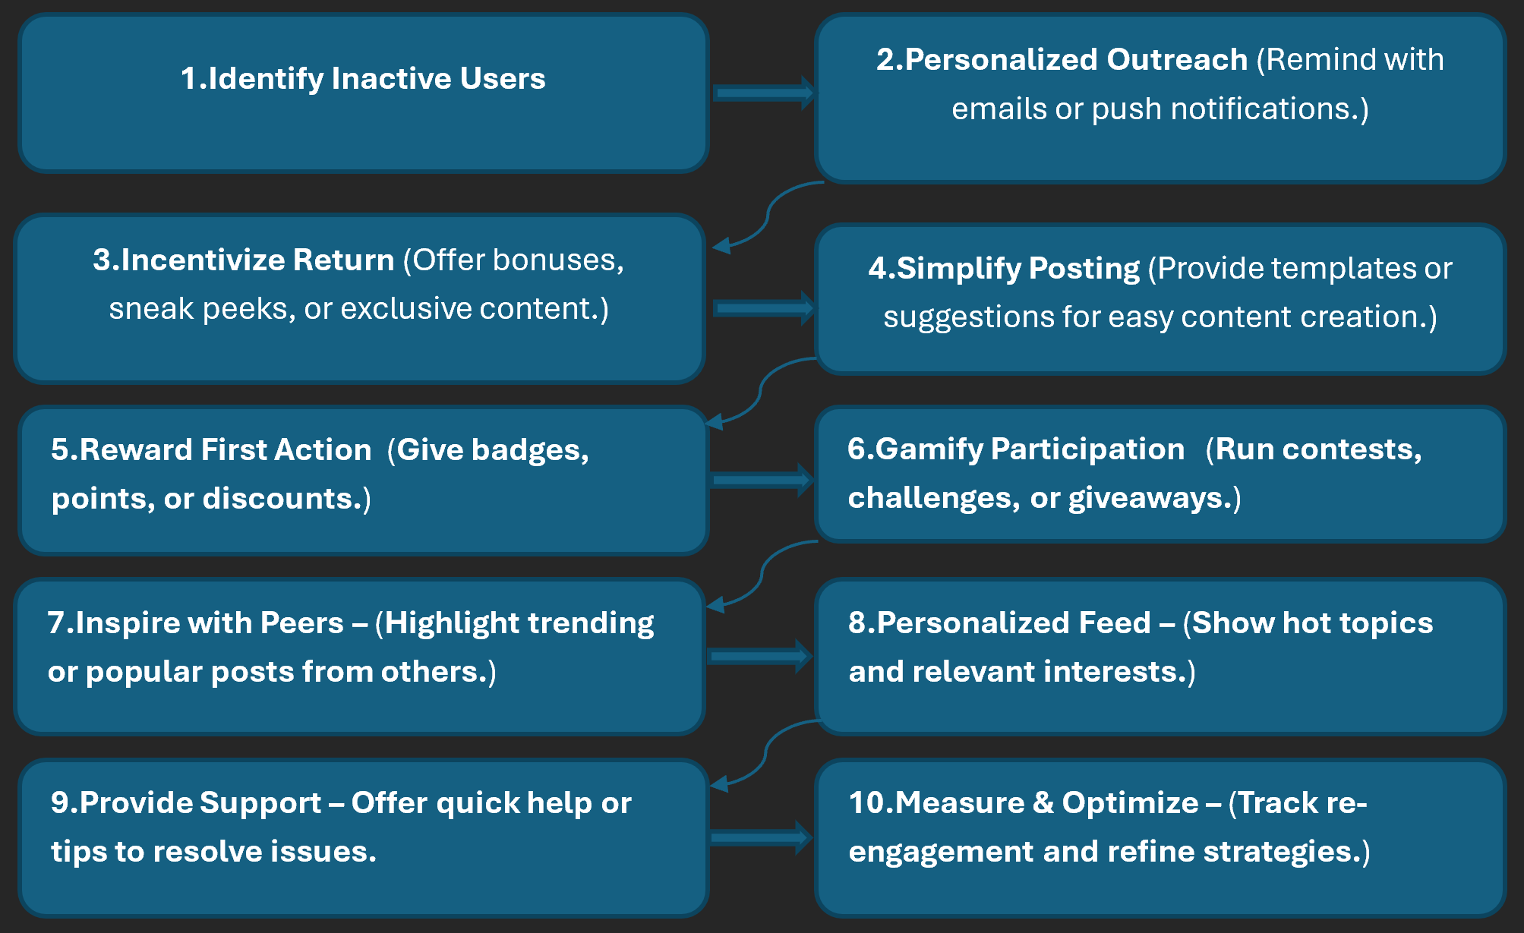
- Which hashtags or content topics have the highest engagement rates? How can this information guide content strategy and ad campaigns?
Ans:
To find the most engaging hashtags, we would analyze the average number of likes per post for each hashtag. This would tell us which topics are resonating most with the audience. For example, a query would join the likes and photo_tags tables to calculate the total likes for each post and then average those likes by hashtag.
Once we've identified the high-engagement hashtags, we can use that information to refine our content strategy.
- Content Calendar: Use the top-performing hashtags to plan our content calendar. For instance, if #Travel and #Foodie are consistently at the top, we can create campaigns that encourage users to share their travel photos and recipes.
- Influencer Collaboration: Identify influencers whose content aligns with these popular topics. Partnering with a food blogger on a new campaign, for example, would ensure our message reaches a highly engaged and relevant audience.
- Encourage Specific Content: Promote the use of these hashtags in our in-app messaging, encouraging users to create content around what is already popular.

Informing Ad Campaigns
High-engagement hashtags are a goldmine for creating effective ad campaigns.
- Targeted Ads: We can run highly targeted ad campaigns that show ads for products or services related to the most engaging topics. For example, an outdoor gear brand could run ads targeting users who engage with #Hiking and #Camping content.
- Ad Creative: Use top-performing, user-generated content (with permission) that features these popular hashtags as the creative for your ads. This is often more effective than traditional ad creative because it looks authentic and organic.
- Measure Effectiveness: By tracking which hashtags lead to the highest engagement rates, we can measure the success of our ad campaigns and optimize them for better results.
This approach allows us to move from a generic "spray and pray" ad strategy to a data-driven one that delivers personalized content and drives higher engagement.
WITH Hashtag_Engagement AS (
SELECT
T.tag_name,
AVG(COALESCE(l.likes_count, 0) + COALESCE(c.comments_count, 0)) AS
Avg_engagement
FROM tags t
JOIN photo_tags pt ON t.id = pt.tag_id
JOIN photos p ON pt.photo_id = p.id
LEFT JOIN (
SELECT photo_id, COUNT(*) AS likes_count
FROM likes
GROUP BY photo_id
) l ON p.id = l.photo_id
LEFT JOIN (
SELECT photo_id, COUNT(*) AS comments_count
FROM comments
GROUP BY photo_id
) c ON p.id = c.photo_id
GROUP BY t.tag_name
)
SELECT tag_name, avg_engagement
FROM Hashtag_Engagement
ORDER BY avg_engagement DESC;
(Output used from objective question 12)
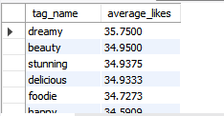
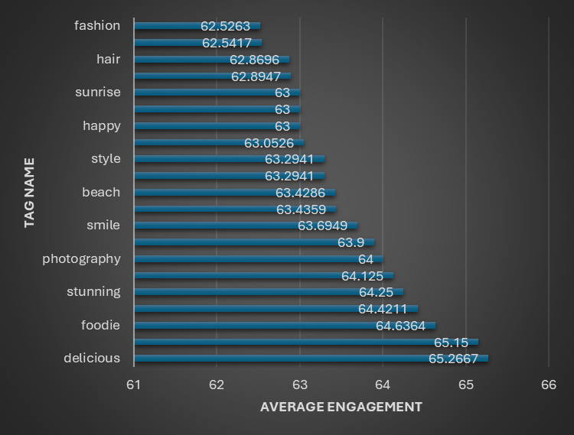
INSIGHTS:
- Food-related tags ("delicious," "foodie," "food") lead with the highest engagement (~64-65), indicating strong user interest in food content.
- Visual and aesthetic tags ("beauty," "sunset," "stunning," "photography," "landscape," "style") also perform very well, reflecting appeal in artistic and scenic content.
- Emotional and social tags ("smile," "party," "happy," "fun," "lol") show healthy engagement, emphasizing the value of relatable, joyful content.
- Lifestyle and fashion tags ("hair," "concert," "fashion") have moderate engagement around 62.5-63, suggesting steady interest in these niches.

RECOMMENDATION:
- Create and promote content focused on highly engaging themes like food and visual beauty to maximize user interaction.
- Use these top hashtags strategically in posts and ads to increase reach and visibility.
- Combine popular tags with emotional or social themes to make content more relatable and shareable.
- Track changes in engagement scores over time to stay updated with evolving trends.
- Design ads around high-performing content topics for better resonance and effectiveness.

- Are there any patterns or trends in user engagement based on demographics (age, location, gender) or posting times? How can these insights inform targeted marketing campaigns?
Ans:
Based on the dataset, we can analyze trends in user engagement based on posting times, but not on demographics like age, location, or gender. The provided tables do not contain any of that personal information, so we can't draw any correlations there.
However, the created_at timestamp is available on every post, comment, and like, which is a powerful tool for understanding user behavior.
By analyzing the created_at timestamps, we can uncover patterns in user activity, such as peak hours for posting, liking, and commenting. This is a crucial insight for content and marketing strategy.
- Analysis: A simple query can reveal the times of day or days of the week when content receives the most engagement. We might find, for example, that posts published between 6 PM and 9 PM receive the most likes, as that's when users are most active. Or perhaps content posted on weekends has a higher average comment rate.
- Content Strategy: This information can directly inform your content creation strategy. If we know that 8 PM is a peak time for engagement, we can advise content creators to schedule their most important posts for that time to maximize reach.
- Targeted Marketing Campaigns: The insights on posting times can also be used to optimize our ad campaigns. By scheduling our ads to run during the hours when users are most active, we ensure that our message is seen by the largest and most engaged audience possible.
Query:
SELECT
HOUR(created_at) AS hour_of_day,
COUNT(*) AS total_likes
FROM
likes
GROUP BY
hour_of_day
ORDER BY
total_likes DESC;
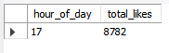
- Based on follower counts and engagement rates, which users would be ideal candidates for influencer marketing campaigns? How would you approach and collaborate with these influencers?
Ans:
The most effective influencers have both a large audience and a highly engaged one.
To find and collaborate with these valuable user the key metric to identify them is the engagement rate, which measures how many of their followers are actively engaging with their content. A user with 1,000 followers and a 10% engagement rate (100 likes/comments per post) is often more valuable than a user with 10,000 followers and a 1% engagement rate.
To find these users, we would need a query that:
- Calculates each user's total likes and comments.
- Calculates each user's total follower count.
- Divides the total engagement by the follower count to get the engagement rate.
- Ranks the users based on this rate.
Once we have a ranked list of potential influencers, we can approach them with a tiered strategy based on their scale.
- Macro-Influencers: For users with a very large following and a high engagement rate, we can offer them a formal partnership. This might include long-term contracts for sponsored posts, brand ambassadorships, or a revenue-sharing model. This group is best for large-scale product launches and building brand awareness.
- Micro-Influencers: These are users with a smaller but highly dedicated and engaged following. They are often trusted sources for their niche community. For them, we can offer more personalized collaborations, such as free products in exchange for a review or a commission on sales generated from their unique links. This approach is highly effective for reaching a specific, targeted audience.
By focusing on both follower count and engagement rate, we can select the right partners to create impactful campaigns that deliver a high return on investment.
Query:
WITH photo_metrics AS (
SELECT
P.id AS photo_id,
P.user_id,
COUNT(DISTINCT L.user_id) AS total_likes,
COUNT(DISTINCT C.id) AS total_comments
FROM
photos AS P
LEFT JOIN
likes AS L ON P.id = L.photo_id
LEFT JOIN
comments AS C ON P.id = C.photo_id
GROUP BY
P.id, P.user_id
),

-- Step 2: Aggregate the total likes and comments for each user.
user_metrics AS (
SELECT
user_id,
SUM(total_likes) AS total_likes,
SUM(total_comments) AS total_comments
FROM
photo_metrics
GROUP BY
user_id
),

-- Step 3: Count the total followers for each user.
follower_counts AS (
SELECT
followee_id AS user_id,
COUNT(follower_id) AS follower_count
FROM
follows
GROUP BY
followee_id
)

-- Step 4: Combine the metrics, calculate engagement rate, and rank the users.
SELECT
U.username,
COALESCE(UM.total_likes, 0) AS total_likes,
COALESCE(UM.total_comments, 0) AS total_comments,
COALESCE(FC.follower_count, 0) AS follower_count,
-- Calculate engagement rate, handling division by zero for users with no followers.
CAST((COALESCE(UM.total_likes, 0) + COALESCE(UM.total_comments, 0)) AS FLOAT) /
CASE
WHEN COALESCE(FC.follower_count, 0) = 0 THEN 1
ELSE FC.follower_count
END AS engagement_rate,
-- Rank users based on engagement rate.
DENSE_RANK() OVER (ORDER BY (COALESCE(UM.total_likes, 0) + COALESCE(UM.total_comments, 0)) /
CASE
WHEN COALESCE(FC.follower_count, 0) = 0 THEN 1
ELSE FC.follower_count
END DESC) AS engagement_rank
FROM
users AS U
LEFT JOIN
user_metrics AS UM ON U.id = UM.user_id
LEFT JOIN
follower_counts AS FC ON U.id = FC.user_id
ORDER BY
engagement_rate DESC, U.username;
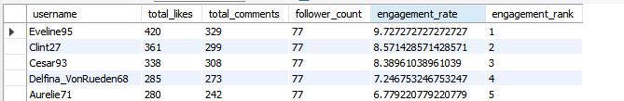
- Based on user behavior and engagement data, how would you segment the user base for targeted marketing campaigns or personalized recommendations?
Ans:
Based on a user's behavior and engagement data, we can move past generic marketing to create highly personalized campaigns and recommendations. By segmenting our user base, we can deliver the right message to the right person.

1. The Content Creators
How to Identify: These are the users with a high number of posts in the photos table. They are the artists, photographers, and storytellers who provide the content that keeps the platform alive.
Marketing & Recommendations:
- Encourage Creation: Send them targeted messages about new features or tools that make content creation easier.
- Creator Programs: Invite them to exclusive programs that offer advanced analytics, monetization features, or the chance to be featured on a public feed.
- Show Appreciation: Highlight their work to the community or send them personalized "thank you" messages for their contributions.

2. The Super Fans
How to Identify: Users with a high number of likes and comments in the likes and comments tables. They are the most engaged audience members, even if they don't post often themselves.
Marketing & Recommendations:
- Content Recommendations: Use their past engagement to deliver a personalized feed of posts and profiles they’ll love. This keeps them consuming content and helps them discover new creators.
- Targeted Ads: Because we know what content they enjoy, we can target them with highly relevant ad campaigns. For instance, if they like posts about food, we can show them ads for new restaurants or cooking products.
- Promote Interaction: Send them notifications when a creator they follow goes live or posts a new album of photos, which can encourage them to engage even more.

3. The Community Builders
How to Identify: This segment is defined by a balanced and high level of activity across all tables. They have a good number of followers and followings, and they regularly post, like, and comment. The previous query on "users who follow back" is a great way to find them.
Marketing & Recommendations:
- Brand Ambassadorship: These users are ideal candidates to become brand advocates. We can collaborate with them on new campaigns or give them a sneak peek at upcoming features.
- Platform Events: Invite them to host live events or lead discussions on their favorite topics. This empowers them and encourages them to take on a leadership role in the community.
- Networking: Promote their profiles to other users with similar interests to help them grow their audience and deepen their connections.

4. The Inactive Users
How to Identify: Use a query to find users with a very low number of posts, likes, and comments within a specific timeframe, like the last 30 days.
Marketing & Recommendations:
- Re-engagement Campaigns: Send them a personalized email or push notification with "Top Posts You've Missed" from their past interests. The goal is to remind them of the platform's value.
- Simpler Actions: Instead of asking them to post, encourage smaller, lower-effort actions like liking a post or following a new profile.
- Incentivized Return: We can offer a small reward, such as a special filter or a temporary profile badge, for their first post after a period of inactivity.
By segmenting our users, we can move from a one-size-fits-all approach to a precise strategy that resonates with each individual's behavior.
Query:
-- CTE to count the number of posts for each user.
WITH user_posts AS (
SELECT
user_id,
COUNT(id) AS post_count
FROM
photos
GROUP BY
user_id
),

-- CTE to count the total likes received by each user on their posts.
user_likes AS (
SELECT
P.user_id,
COUNT(L.user_id) AS like_count
FROM
photos AS P
LEFT JOIN
likes AS L ON P.id = L.photo_id
GROUP BY
P.user_id
),

-- CTE to count the total comments received by each user on their posts.
user_comments AS (
SELECT
P.user_id,
COUNT(C.id) AS comment_count
FROM
photos AS P
LEFT JOIN
comments AS C ON P.id = C.photo_id
GROUP BY
P.user_id
),

-- CTE to count the number of followers for each user.
user_followers AS (
SELECT
followee_id AS user_id,
COUNT(follower_id) AS follower_count
FROM
follows
GROUP BY
followee_id
),

-- CTE to count the number of people each user is following.
user_followings AS (
SELECT
follower_id AS user_id,
COUNT(followee_id) AS following_count
FROM
follows
GROUP BY
follower_id
)

-- Final SELECT statement to combine all metrics and assign a segment.
SELECT
U.id,
U.username,
COALESCE(UP.post_count, 0) AS post_count,
COALESCE(UL.like_count, 0) AS like_count,
COALESCE(UC.comment_count, 0) AS comment_count,
COALESCE(UF.follower_count, 0) AS follower_count,
COALESCE(UFG.following_count, 0) AS following_count,
CASE
WHEN COALESCE(UP.post_count, 0) > 50 THEN 'Content Creator'
WHEN COALESCE(UL.like_count, 0) > 1000 THEN 'Super Fan'
WHEN COALESCE(UF.follower_count, 0) > 1000 AND COALESCE(UFG.following_count, 0) > 1000 THEN 'Community Builder'
ELSE 'Inactive User'
END AS user_segment
FROM
users AS U
LEFT JOIN
user_posts AS UP ON U.id = UP.user_id
LEFT JOIN
user_likes AS UL ON U.id = UL.user_id
LEFT JOIN
user_comments AS UC ON U.id = UC.user_id
LEFT JOIN
user_followers AS UF ON U.id = UF.user_id
LEFT JOIN
user_followings AS UFG ON U.id = UFG.user_id
ORDER BY
U.id;
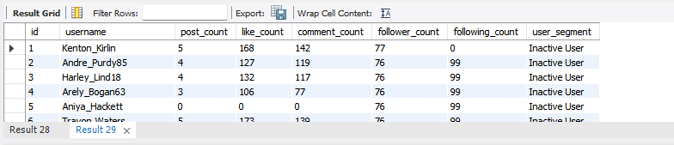
- If data on ad campaigns (impressions, clicks, conversions) is available, how would you measure their effectiveness and optimize future campaigns?
Ans:
Measuring Ad Campaign Effectiveness
While the current database schema doesn't include tables for ad campaigns, clicks, or conversions, we can create a hypothetical scenario that shows exactly how we would calculate conversion rates for each user segment.
The core of measuring ad campaign effectiveness is to move from simple vanity metrics (like impressions) to metrics that show a direct return on investment. With the right data, we can calculate key performance indicators (KPIs) like:
- Click-Through Rate (CTR): This tells us how engaging our ad creative is. CTR=(Total Clicks/Total Impressions)×100 A high CTR indicates that your ad creative is compelling and your targeting is effective.
- Conversion Rate (CVR): This is a direct measure of an ad's success in driving a desired action, such as a purchase or a sign-up. CVR=(Total Conversions/Total Clicks)×100 A high conversion rate shows that our ad not only grabbed a user's attention but also persuaded them to take action.
- Return on Ad Spend (ROAS): This is the ultimate metric for understanding profitability. It tells us how much revenue we generated for every dollar spent on advertising.
ROAS=(Total Revenue from Ads/Ad Campaign Cost)×100

Optimizing Future Campaigns
The real value of this data comes from using it to optimize future campaigns. The segmentation query we've been working on is the perfect tool for this.
- Targeting: The most powerful way to optimize is to align our ad targeting with the user segments we've identified. For example, if we're running a campaign for a new set of creative tools, we would target the Content Creator segment. If we're promoting a new clothing line, we might target Super Fans who have a history of engaging with fashion-related content.
- Personalization: The data on user behavior can also inform our ad creative. An ad for a camera brand shown to a Content Creator might highlight the camera's technical specifications and features, while the same ad shown to a Super Fan might focus on the vibrant photo quality and community features.
- A/B Testing: By tracking the performance of different ad creatives and targeting strategies, we can run A/B tests to see what works best for each user segment. This allows for continuous improvement and ensures our ad spend is always delivering the best possible results.
In essence, we would join our campaign data (impressions, clicks, conversions) with our user segmentation data. This allows you to measure the effectiveness of our ads for each segment and optimize our strategy to maximize your return on investment.
Query:
No Output since hypothetical scenario considered
WITH user_posts AS (
SELECT
user_id,
COUNT(id) AS post_count
FROM
photos
GROUP BY
user_id
),

-- CTE to count the total likes received by each user on their posts.
user_likes AS (
SELECT
P.user_id,
COUNT(L.user_id) AS like_count
FROM
photos AS P
LEFT JOIN
likes AS L ON P.id = L.photo_id
GROUP BY
P.user_id
),

-- CTE to count the total comments received by each user on their posts.
user_comments AS (
SELECT
P.user_id,
COUNT(C.id) AS comment_count
FROM
photos AS P
LEFT JOIN
comments AS C ON P.id = C.photo_id
GROUP BY
P.user_id
),

-- CTE to count the number of followers for each user.
user_followers AS (
SELECT
followee_id AS user_id,
COUNT(follower_id) AS follower_count
FROM
follows
GROUP BY
followee_id
),

-- CTE to count the number of people each user is following.
user_followings AS (
SELECT
follower_id AS user_id,
COUNT(followee_id) AS following_count
FROM
follows
GROUP BY
follower_id
),

-- CTE to segment all users based on their behavior.
user_segments AS (
SELECT
U.id AS user_id,
U.username,
CASE
WHEN COALESCE(UP.post_count, 0) > 50 THEN 'Content Creator'
WHEN COALESCE(UL.like_count, 0) > 1000 THEN 'Super Fan'
WHEN COALESCE(UF.follower_count, 0) > 1000 AND COALESCE(UFG.following_count, 0) > 1000 THEN 'Community Builder'
ELSE 'Inactive User'
END AS user_segment
FROM
users AS U
LEFT JOIN
user_posts AS UP ON U.id = UP.user_id
LEFT JOIN
user_likes AS UL ON U.id = UL.user_id
LEFT JOIN
user_comments AS UC ON U.id = UC.user_id
LEFT JOIN
user_followers AS UF ON U.id = UF.user_id
LEFT JOIN
user_followings AS UFG ON U.id = UFG.user_id
),

-- Hypothetical CTE representing ad campaign data for each user.
ad_campaign_data AS (
-- In a real-world scenario, we would replace this with our actual ad data table.
-- The table would contain a user ID, a click event, and a conversion event.
SELECT
user_id,
SUM(CASE WHEN is_clicked = 1 THEN 1 ELSE 0 END) AS total_clicks,
SUM(CASE WHEN is_converted = 1 THEN 1 ELSE 0 END) AS total_conversions
FROM
ad_campaigns -- Replace with our actual ad data table.
GROUP BY
user_id
)

-- Final SELECT to join segments and ad data, calculating conversion rate per segment.
SELECT
US.user_segment,
SUM(ACD.total_clicks) AS total_clicks,
SUM(ACD.total_conversions) AS total_conversions,
-- Calculate conversion rate, handling division by zero.
CAST(SUM(ACD.total_conversions) AS FLOAT) /
CASE
WHEN SUM(ACD.total_clicks) = 0 THEN 1
ELSE SUM(ACD.total_clicks)
END AS conversion_rate
FROM
user_segments AS US
JOIN
ad_campaign_data AS ACD ON US.user_id = ACD.user_id
GROUP BY
US.user_segment
ORDER BY
conversion_rate DESC;
- How can you use user activity data to identify potential brand ambassadors or advocates who could help promote Instagram's initiatives or events?
Ans:
Identifying a brand ambassador is about more than just finding a user with a large following; it's about finding one who is highly engaged, influential, and actively builds a community.

Using User Activity to Find Advocates
The segmented users in categories like 'Content Creator', 'Super Fan', and 'Community Builder' are the most likely candidates for a brand ambassadorship program.
- Content Creators: These users consistently produce a high volume of content. They are valuable because they keep the platform fresh and dynamic. Rewarding them with recognition or early access to features encourages them to continue producing high-quality content, which in turn attracts more followers and engagement.
- Super Fans: These users are highly engaged and act as the platform's most loyal audience. They are excellent advocates because they genuinely love the content. We can leverage their enthusiasm by giving them a chance to test new features or participate in exclusive events, which will turn their passion into positive word-of-mouth promotion.
- Community Builders: This segment is perhaps the most valuable for a brand ambassadorship. These users are influential in both directions: they have a significant number of followers, and they are also actively following others, indicating a high level of reciprocal engagement. They are great at creating conversation and fostering a sense of community, which is a powerful asset for any initiative or event we want to promote.
By identifying these user segments, we can create a targeted approach for each group. For instance, we could offer a "Creator's Circle" for our Content Creators, a "Super Fan Society" for our most active users, and a "Community Leader Program" for those who excel at building relationships. Each of these programs would have a unique set of incentives and responsibilities tailored to their specific behavior.
Query:
No Output since hypothetical scenario considered
-- Step 1: Aggregate the total number of posts, likes, and comments for each user.
WITH user_activity AS (
SELECT
U.id AS user_id,
U.username,
COUNT(DISTINCT P.id) AS total_posts,
COUNT(DISTINCT L.user_id) AS total_likes,
COUNT(DISTINCT C.id) AS total_comments
FROM
users AS U
LEFT JOIN
photos AS P ON U.id = P.user_id
LEFT JOIN
likes AS L ON P.id = L.photo_id
LEFT JOIN
comments AS C ON P.id = C.photo_id
GROUP BY
U.id
),

-- Step 2: Aggregate the total number of followers and followings for each user.
user_connections AS (
SELECT
U.id AS user_id,
COUNT(DISTINCT F_follower.follower_id) AS follower_count,
COUNT(DISTINCT F_followee.followee_id) AS following_count
FROM
users AS U
LEFT JOIN
follows AS F_follower ON U.id = F_follower.followee_id
LEFT JOIN
follows AS F_followee ON U.id = F_followee.follower_id
GROUP BY
U.id
)

-- Step 3: Combine activity and connection metrics to identify Community Builders and rank them.
SELECT
UA.username,
UA.total_posts,
UA.total_likes,
UA.total_comments,
UC.follower_count,
UC.following_count,
-- Calculate the ratio of comments to likes. Use a CASE statement to handle division by zero.
CAST(UA.total_comments AS FLOAT) /
CASE
WHEN UA.total_likes = 0 THEN 1
ELSE UA.total_likes
END AS conversation_ratio,
-- Rank the users by their conversation ratio.
DENSE_RANK() OVER (
ORDER BY
CAST(UA.total_comments AS FLOAT) /
CASE
WHEN UA.total_likes = 0 THEN 1
ELSE UA.total_likes
END DESC
) AS conversation_rank
FROM
user_activity AS UA
JOIN
user_connections AS UC ON UA.user_id = UC.user_id
WHERE
-- Filter for users who fit the 'Community Builder' profile.
UC.follower_count > 10 AND UC.following_count > 10 AND UA.total_posts > 5
ORDER BY
conversation_ratio DESC, UA.username;
- How would you approach this problem, if the objective and subjective questions weren't given?
Ans:
The first step is always to explore the data to understand its potential.
If I had simply been presented with the dataset, here's the approach I would take to analyze it and uncover key business insights would be as below:
Phase 1: Understand the Data Schema
The first thing I would do is examine the table relationships in the provided SQL file. I would identify the key tables: users, photos, comments, likes, follows, and photo_tags. This helps me understand the structure of the data and how different entities are connected.
For instance, I'd immediately see that users is the central table, with other tables like photos, comments, likes, and follows all linking back to a user via a user_id or follower_id. The created_at timestamp in each table would stand out as a key element for analyzing trends over time.
Phase 2: Assess Data Quality and Health
Before running any in-depth analysis, it's critical to ensure the data is clean. I would run some quick queries to check for common issues.
- Duplicates: I'd check for duplicate entries in the primary key columns, such as id in the users table or the composite key (user_id, photo_id) in the likes table.
- Missing Values: I'd look for missing values in critical foreign key columns, such as user_id in the photos table, which would prevent us from attributing a post to a creator.
Fortunately, the database schema uses PRIMARY KEY and NOT NULL constraints, which prevent most of these issues from the outset.
Phase 3: Uncover Key Metrics and Behavioral Patterns
Once I have confidence in the data's quality, I would start running a series of exploratory queries to understand basic user behavior and platform activity. This would be a process of asking questions and seeing what the data reveals.
- Who are our top users? I'd run a query to find the users with the most followers to identify our "influencers" or most popular users.
- What content is most popular? I'd look for posts with the most likes and comments, or hashtags that are most frequently used or have the highest average engagement.
- What's the overall health of the platform? I'd calculate metrics like the average number of posts per user, the total number of likes and comments, and the ratio of followers to followings.
This would be a cyclical process: a new query would lead to a new question, and so on.
Phase 4: Develop Actionable Insights
Finally, I would compile my findings into a concise report. This report would not just present raw numbers but would interpret them to provide actionable insights for a product or marketing team.
For example, if I found a strong correlation between posts with more than five tags and a higher average number of likes, my recommendation would be to develop a feature that encourages users to add more tags to their photos. Or, if I discovered that users who follow each other back are more likely to post and comment, I'd suggest focusing on features that foster reciprocal relationships and community building.
This structured, data-driven approach allows you to move from a raw dataset to strategic business recommendations, even when you don't have a clear problem to solve at the start.
- Assuming there's a "User_Interactions" table tracking user engagements, how can you update the "Engagement_Type" column to change all instances of "Like" to "Heart" to align with Instagram's terminology?
Ans:
While the provided dataset doesn't have a User_Interactions table, we would use an UPDATE statement to change the values in the Engagement_Type column. This command is a core part of any database administrator's toolkit for modifying existing data.
Example:
UPDATE User_Interactions
SET Engagement_Type = 'Heart'
WHERE Engagement_Type = 'Like';

