**EXPERIMENT – Smartphone Controlled System to Control LED**

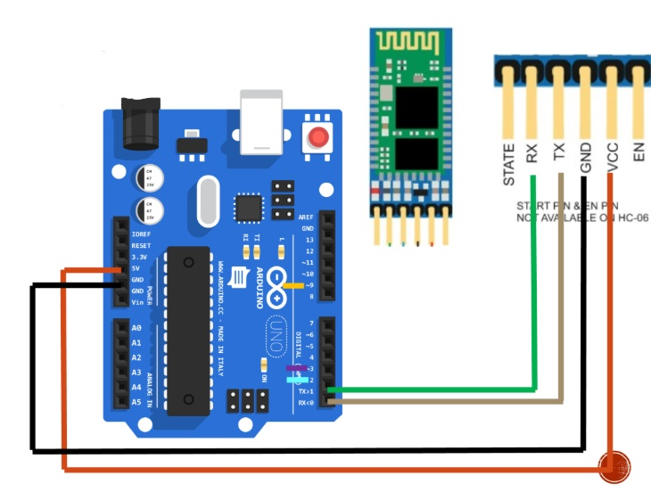

**THEORY -**

**Concept Used:**

In this experiment we have done coding using HC-05 bluetooth connector in

arduino to on and off led light which is connected in breadboard, using bluetooth.

learning outcomes:

The coding is done on computer

from which the instructions are given to the Arduino Uno board. Coding done on Arduino software is C++.

Arduino is a singleboard microcontroller meant to make the application more

accessible which are interactive objects and its surroundings.

This micro controller gives the valid instruction to the elements

fitted on the breadboard according to coding done on software.

also a hc-05 bluetooth connector is connected in arduino and the required connections are done. Now using

led mobile application we flash the led light on the board. The whole process is done using bluetooth.

**Precautions:**

1. The coding done on the software should be correct in every

manner. All the errors should be avoided i.e. syntax,logical

errors etc..

1. All the wires and elements should be connected tightly and

according to the coding done on the system.

1. Postive and Negative terminals should be put in correct

order.

**Problems and Trouble shooting:**

1. The incorrect coding might cause problems in the working of

hardware. This can be corrected by learning C++ and practicing

it on the software.

**2.** Hardware should be correctly fitted on the Breadboard or

they might get fuse or get permanently damaged .

**3.** Arduino wire must be checked if they are loose or not. And

the ports should be properly cleaned before using ,they might

cause problem in future.

**Learning Outcome:**

**1.** From this experiment we have learn how to code in the

software .

**2.** This project was the pillar for the upcoming project

we are going to do in upcoming semester.

**3.** Here we have also learnt how to flash a led using bluethooth service.