**Launch Mongo Server**

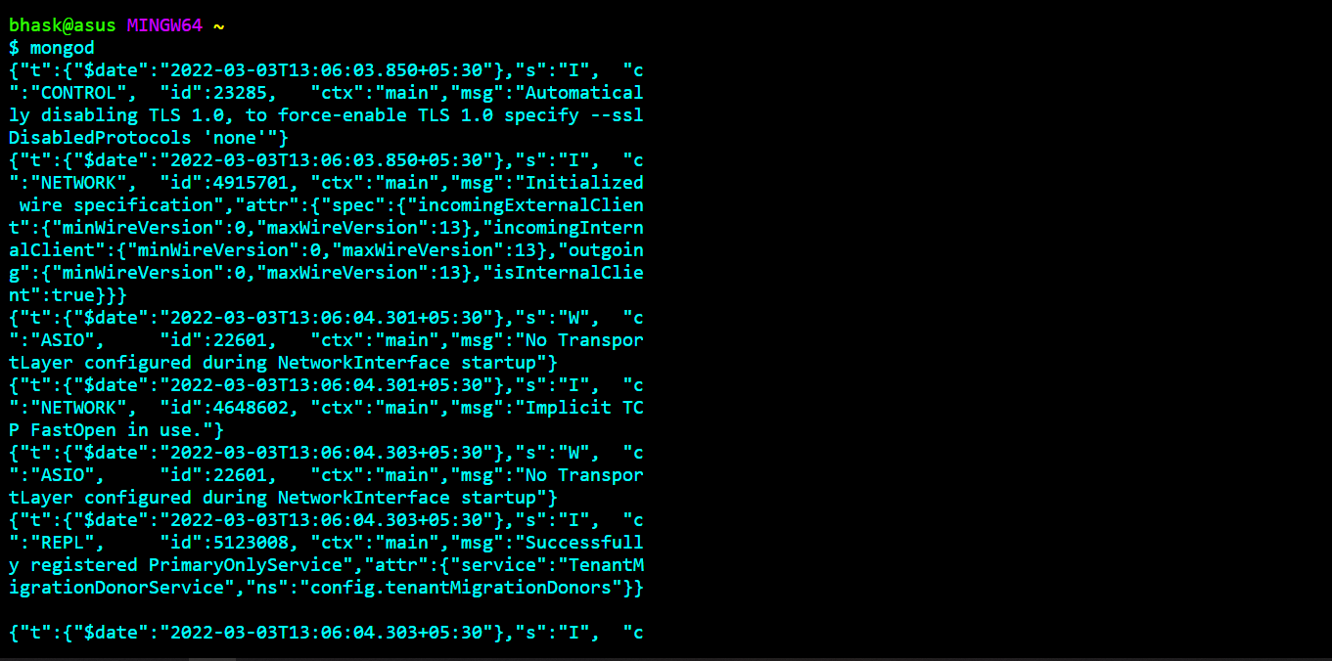

**Then to use mongo**

Type *mongo* in new console

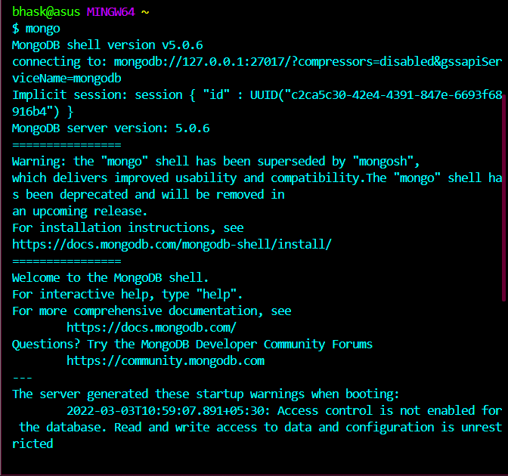

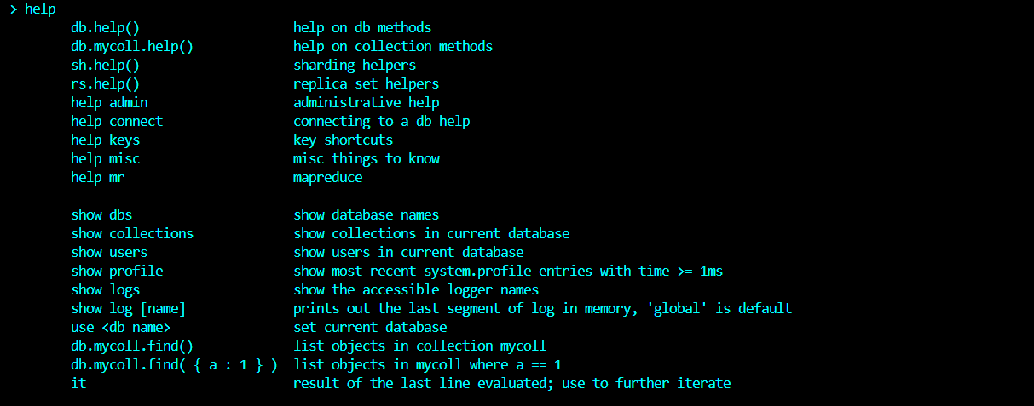

**For creating new Database**

Type *use <dbname>*

Then to add data type

Here products is the collection name

Insertone or insertMany keyword

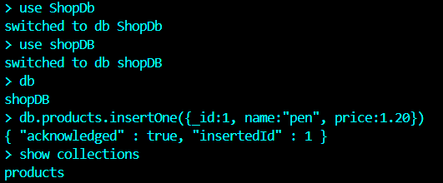

**Reading Operations**



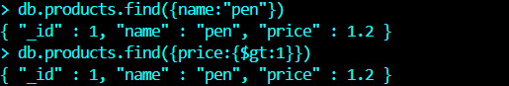

**Update and Delete Operations:**

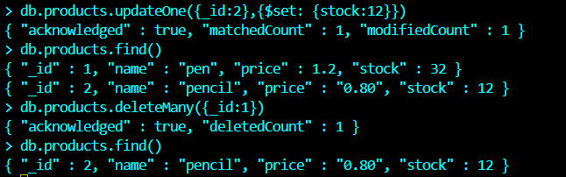

Example in One GO

