Hands-On Lecture Guide
Sessions 1 and 2: Header / Top Navigation Bar

What are we building?
NETRA is a browser-based control room for the six rovers that move around the KL campus. At end of all sessions one page will show a live fleet table, battery and status cards, a telemetry chart, campus zones, system alerts, and a pop-up form to dispatch a mission. Everything runs in the browser, with no server and no paid software.

The three layers of every web page
Layer | Language | Its job | NETRA file | Human body analogy
Structure | HTML | Decides what is on the page: headings, links, buttons | index.html | Skeleton
Style | CSS | Decides how it looks: colours, spacing, layout | style.css | Skin and clothes
Behaviour | JavaScript | Decides what it does: clock, clicks, data | script.js | Muscles and brain

What happens when you open a web page
- The browser reads index.html from top to bottom.
- It meets <link rel="stylesheet" href="style.css"> and loads the CSS file.
- It builds the visible page from the HTML tags and applies the CSS rules.
- It meets <script src="script.js"></script> at the end and runs the JavaScript.

Project Set-up and Header Structure (HTML)
- Install VS Code and the Live Server extension, and open a project folder.

Create the project folder and three files
- In File Explorer, create a folder named netra-project in an easy place such as the Desktop or D:\. Use lowercase letters and no spaces.
- In VS Code choose File, then Open Folder, select netra-project, and click Trust the authors if asked.
- In the Explorer panel, hover over the folder name and click the New File icon. Type index.html and press Enter.
- Repeat to create style.css and script.js.
The Explorer should now look like this:
Project structure
netra-project/
|-- index.html (page structure)
|-- style.css (all styling)
|-- script.js (all behaviour)
The page skeleton
index.html (skeleton)
<!DOCTYPE html>
<html lang="en">
<head>
<!-- information for the browser goes here -->
</head>
<body>
<!-- everything visible goes here -->
</body>
</html>

The head section
index.html (head)
<!DOCTYPE html>
<html lang="en">
<head>
<!-- Defines character encoding and mobile responsiveness -->
<meta charset="UTF-8">
<meta name="viewport" content="width=device-width, initial-scale=1.0">

<!-- Browser tab title -->
<title>NETRA Robot Monitoring System</title>

<!-- Connects the external CSS file -->
<link rel="stylesheet" href="style.css">
</head>

Build the header in four pieces

index.html (body, start)
<body>
<!-- ================= HEADER SECTION ================= -->
<!-- Contains project logo, navigation, system status and mission button -->
<header class="topbar">

</header>
</body>

- the brand
index.html (inside header)
<!-- Project branding -->
<div class="brand">
<div class="brand-logo">N</div>
<div>
<h1>NETRA</h1>
<p>ROBOT MISSION CONTROL</p>
</div>
</div>

- the navigation
index.html (inside header, after brand)
<!-- Navigation links to different dashboard sections -->
<nav>
<a href="#dashboard">Dashboard</a>
<a href="#fleet">Fleet</a>
<a href="#telemetry">Telemetry</a>
<a href="#alerts">Alerts</a>
</nav>

- the status area
index.html (inside header, after nav)
<!-- Displays system status and live clock -->
<div class="header-right">
<span class="online-dot"></span>
<span>SYSTEM ONLINE</span>
<strong id="clock">--:--:--</strong>
</div>

- the Dispatch button.
index.html (inside header, after header-right)
<!-- Opens the mission dispatch popup -->
<button id="dispatch-open" type="button">+ Dispatch Mission</button>

Connect the script and preview
index.html (end of body)
</header>

<!-- Connects the external JavaScript file (kept at the end of the body) -->
<script src="script.js"></script>
</body>
</html>

Right-click index.html and choose Open with Live Server. The result is shown below.
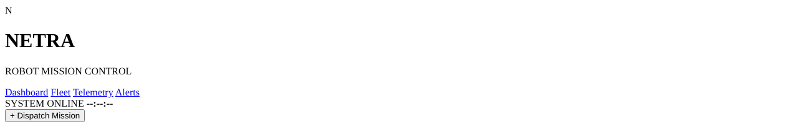

Header Styling (CSS) and Live Clock (JavaScript)
Global reset and page theme
style.css
/* ================= GLOBAL RESET ================= */
/* Removes default browser spacing and uses border-box sizing */

* {
box-sizing: border-box;
margin: 0;
padding: 0;
}

/* Enables smooth scrolling when navigation links are clicked */
html {
scroll-behavior: smooth;
}

/* Main page styling */
body {
background: #08111f;
color: #edf4ff;
font-family: Arial, sans-serif;
min-height: 100vh;
}

/* Applies the same font to form controls */
button, input, select {
font-family: inherit;
}
Result:
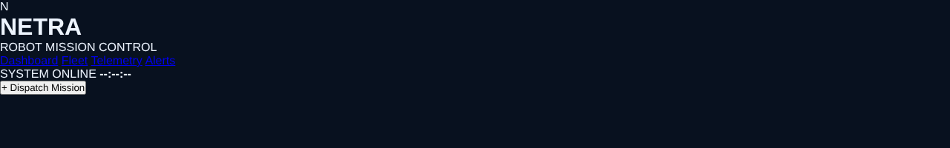

Style all buttons
style.css (add below Step 1)
/* ================= BUTTON STYLING ================= */
button {
background: #287ee8;
border: 0;
color: white;
padding: 12px 20px;
border-radius: 8px;
cursor: pointer;
font-weight: bold;
}

/* Changes button colour when the mouse moves over it */
button:hover {
background: #1765c3;
}

Style the top bar and brand
style.css (add below Step 2)
/* ================= HEADER SECTION ================= */
/* Creates the top navigation bar */
.topbar {
min-height: 82px;
display: flex;
align-items: center;
justify-content: space-between;
gap: 20px;
padding: 15px 4%;
background: #111f34;
border-bottom: 1px solid #2a3d59;
}

/* Arranges the logo and project name horizontally */
.brand {
display: flex;
align-items: center;
gap: 12px;
}

/* NETRA logo styling */
.brand-logo {
background: #287ee8;
border-radius: 10px;
padding: 12px 16px;
font-size: 23px;
font-weight: bold;
}

/* Project title and subtitle */
.brand h1 {
color: #54a5ff;
letter-spacing: 3px;
}

.brand p {
font-size: 9px;
color: #91a8c5;
}

Style the navigation and status area
style.css (add below Step 3)
/* Navigation menu layout */
nav {
display: flex;
gap: 20px;
}

/* Navigation link styling */
nav a {
color: #aebed3;
text-decoration: none;
font-size: 13px;
}

/* Navigation hover effect */
nav a:hover {
color: #54a5ff;
}

/* System status and clock layout */
.header-right {
display: flex;
align-items: center;
gap: 8px;
color: #39d6a0;
font-size: 11px;
}

/* Green circle indicating online status */
.online-dot {
width: 9px;
height: 9px;
background: #39d6a0;
border-radius: 50%;
}

/* Digital clock styling */
#clock {
color: white;
margin-left: 10px;
font-family: monospace;
}

Make the clock work
script.js
// ================= DIGITAL CLOCK =================
// Updates the dashboard clock with the current system time.
function updateClock() {

// Finds the clock element in the HTML.
const clock = document.getElementById("clock");

// Displays the current time.
if (clock) clock.textContent = new Date().toLocaleTimeString();
}

// Calls the clock function immediately.
updateClock();

// Repeats the clock update every one second (1000 milliseconds).
setInterval(updateClock, 1000);

