Pytest log for output on screen of Task1:s

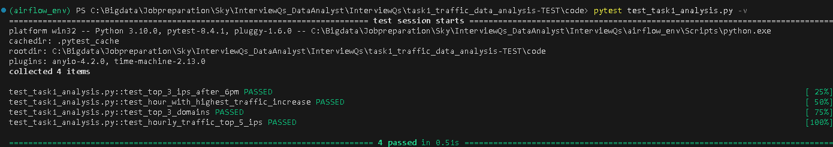
Pytest log for CSV output of Task1:
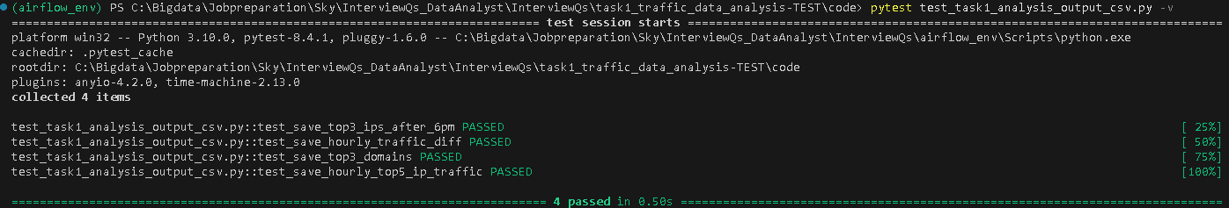
Airflow Dag test screen shot for Task2:
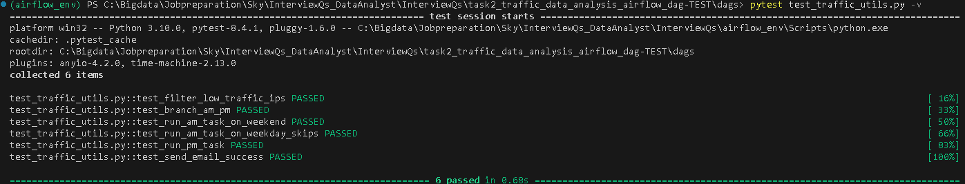
Airflow Dag screen shot local:
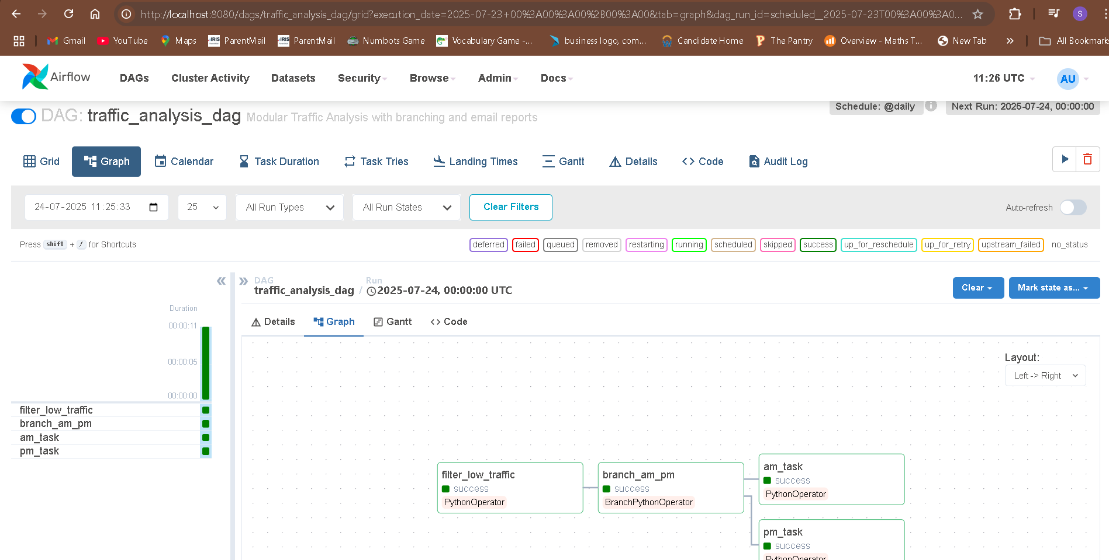

Sample email:
