**Attaching WS2812B RGB LED strip to Flight Controller**

Flight Controller (FC): Omnibus F4 Pro V3

Firmware: ArduCopter 4.0.2, 4.0.3

List of changes in the firmware before compilation:

**For Bhaskar**

Attach PWM pin 5/6 of FC to Data In pin of LED strip. It is recommended to Use a separate 5V DC power supply to power LED strips depending upon # LEDs in the strip. Each LED consumes 60 mA (Peak).

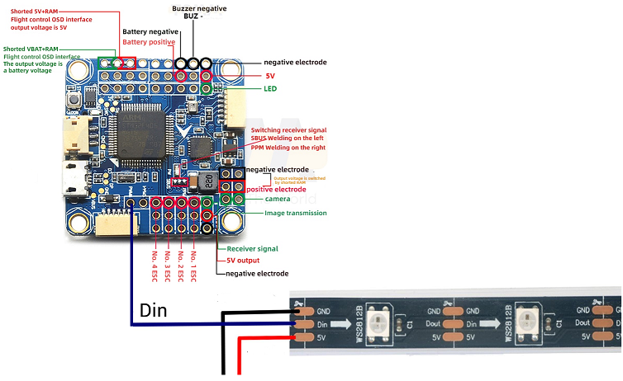

Check list of parameters:

|  |  |  |
| --- | --- | --- |
| Parameter | Value | Remarks |
| NTF_LED_OVERRIDE | 1 | To control LED via mavlink command |
| NTF_LED_TYPES |  | Make sure NeoPixel is checked |
| SERVO_FUNCTIONX | 120 | To enable led driver on specific channel no.X |
|  |  |  |
|  |  |  |

Mavlink command to control LED

**Samarth**

**LED_CONTROL (**[**#186**](https://mavlink.io/en/messages/ardupilotmega.html#LED_CONTROL)**)**

[[Message]](https://mavlink.io/en/messages/ardupilotmega.html#messages)Control vehicle LEDs.

|  |  |  |
| --- | --- | --- |
| **Field Name** | **Type** | **Description** |
| target_system | uint8_t | System ID. |
| target_component | uint8_t | Component ID. |
| instance | uint8_t | Instance (LED instance to control or 255 for all LEDs). |
| pattern | uint8_t | Pattern (see LED_PATTERN_ENUM). |
| custom_len | uint8_t | Custom Byte Length. |
| custom_bytes | uint8_t[24] | Custom Bytes. |

Short note on Led control function usage