**Think and Answer**

**eYRC#1456**

|  |  |
| --- | --- |
| **Team leader name** | Bhaskar Dutt |
| **College** | ADGITM |
| **Email** | bhaskar.dragonballz@gmail.com |
| **Date** | 25-11-2019 |

Please answer all the questions given below. You are allowed to use figures or diagrams to support your answer. Since these questions test your understanding of the whole subject, please refrain from directly asking for answers on Piazza.

**Section 1 - Simple Pendulum**

Q1) Find the eigenvalues of Simple Pendulum at equilibrium point (0,0). Is the system stable or unstable at this point? (2)

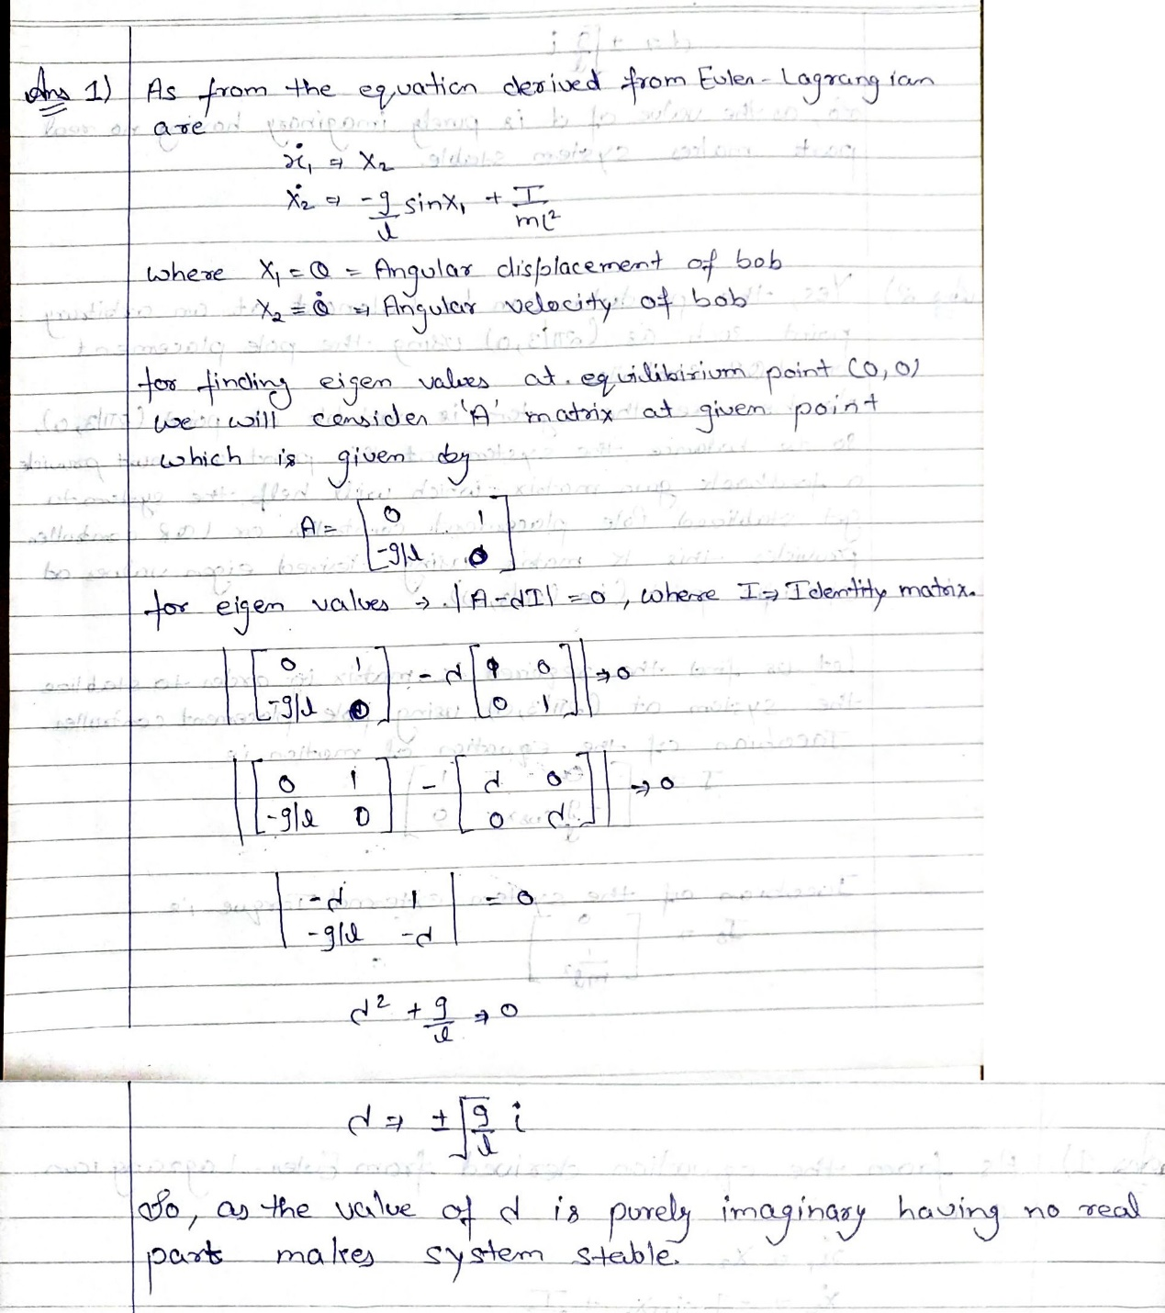

Q2) Can the Pendulum be balanced at an arbitrary point such as (2π/3,0) using the Pole Placement or LQR controller? Why? Why Not? Justify your answer. (3)

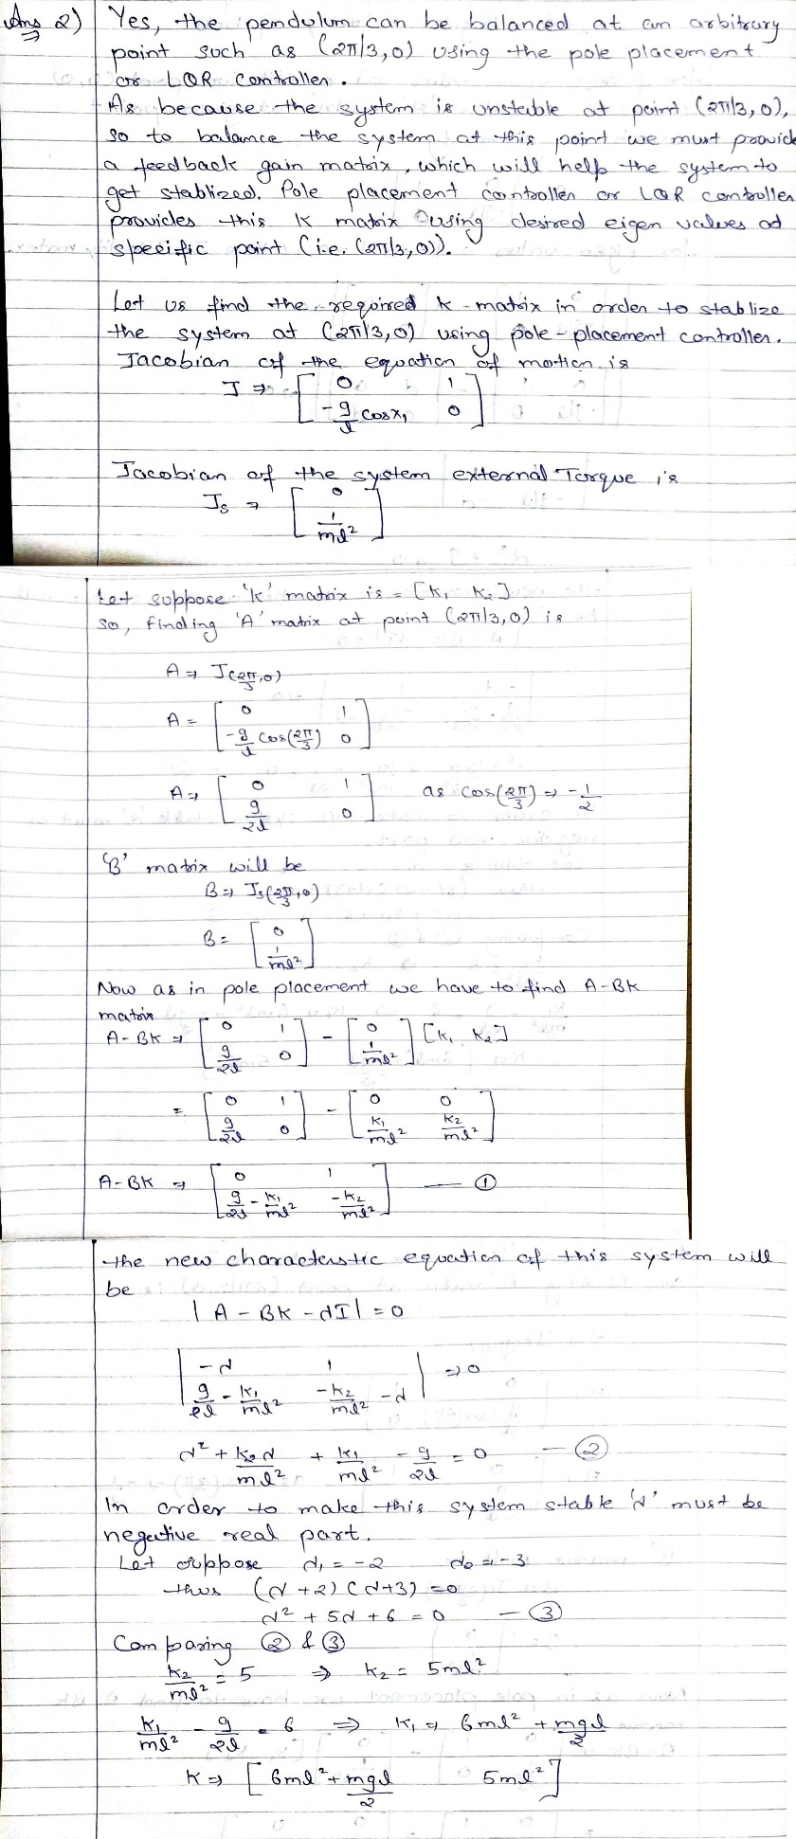

**Section 2 - Mass Spring System**

Q3) Derive the equations of Mass Spring system. (3)

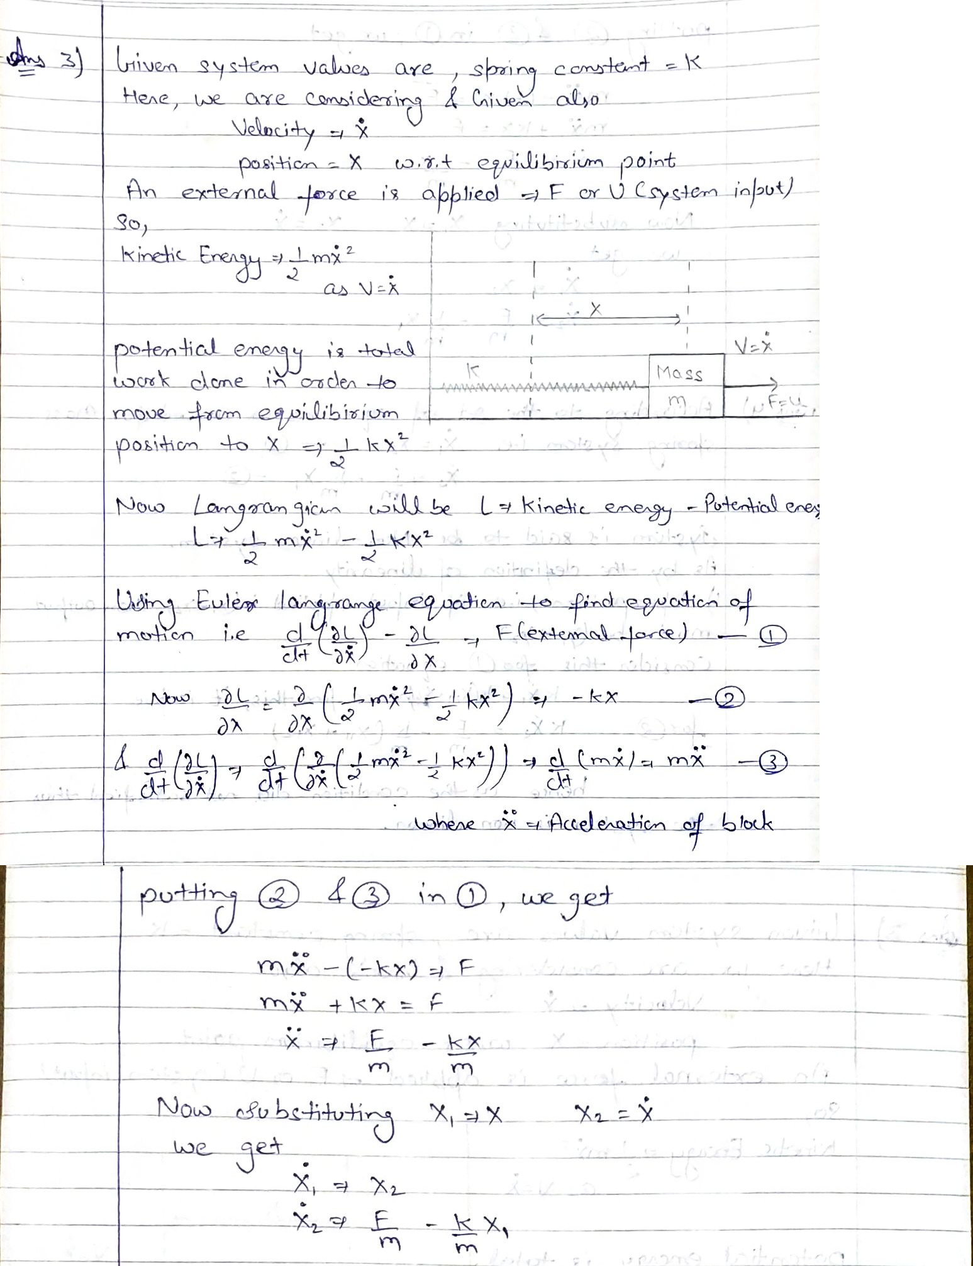

Q4) Is the mass spring system a linear system or non-linear? Justify your answer. (1)

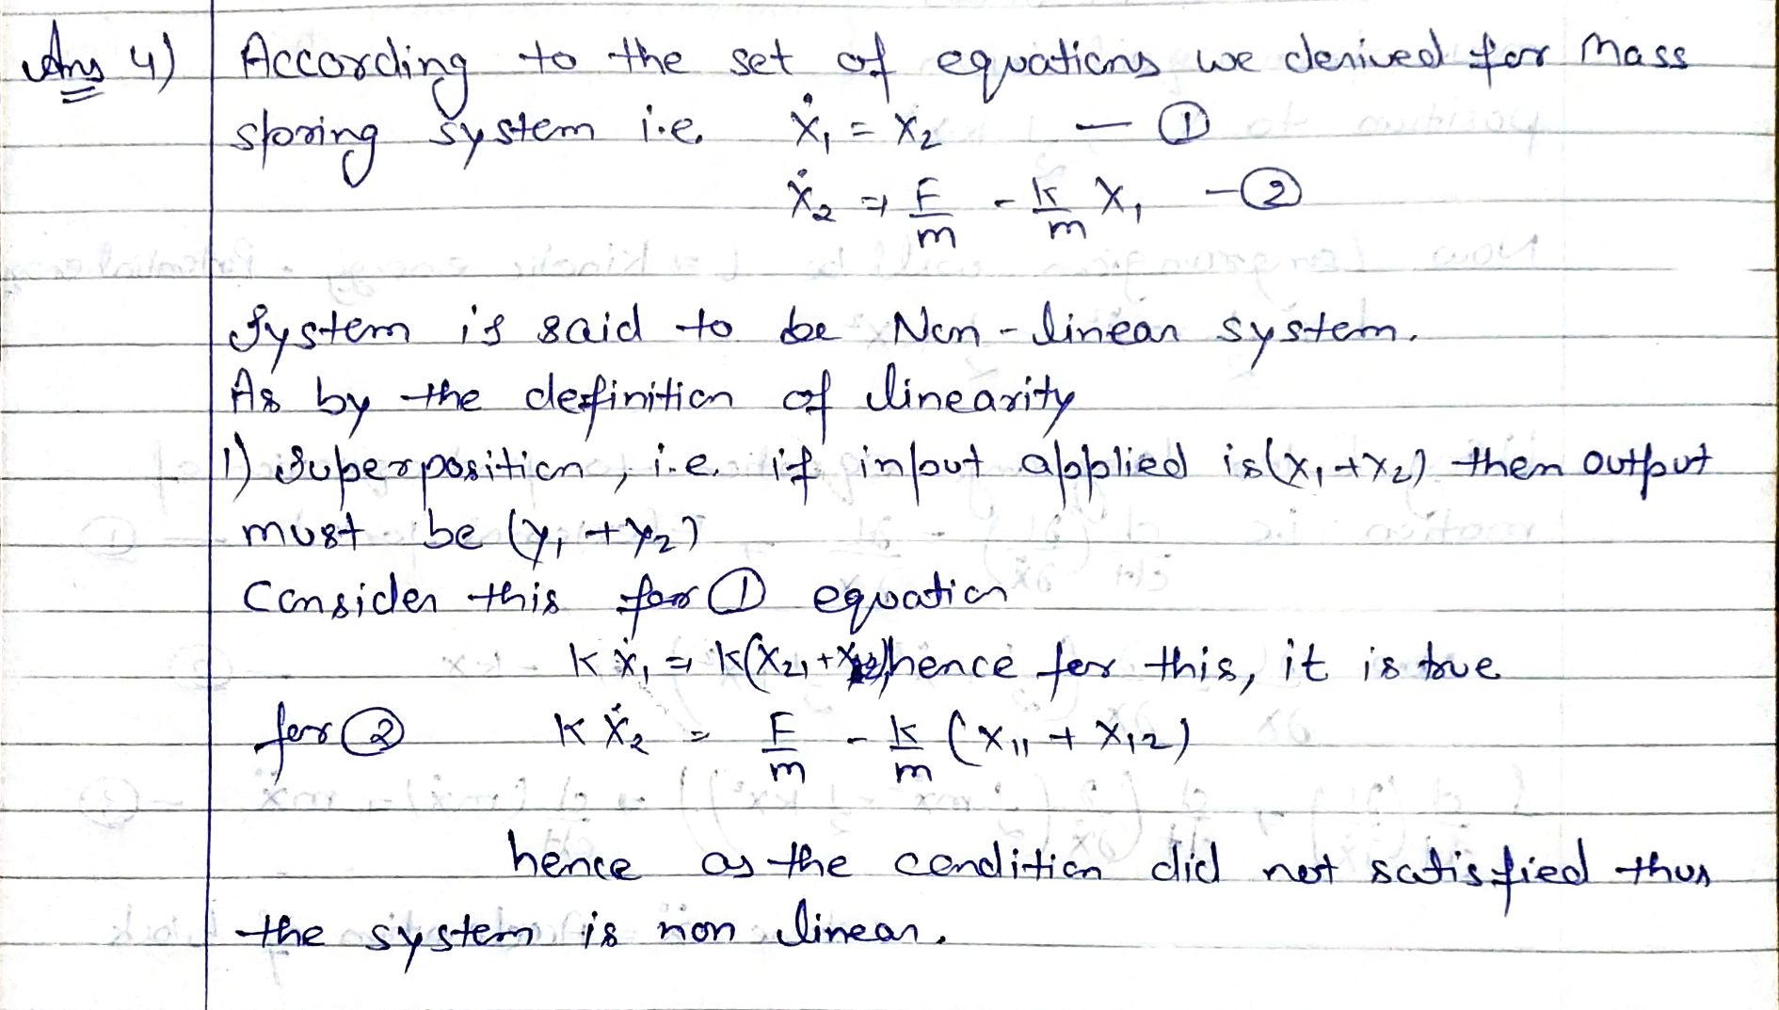

Q5) Can the mass spring system be driven to arbitrary state (0.8, 0) using pole placement controller? (Assuming 0.8 is the position and 0 is the velocity). (1)

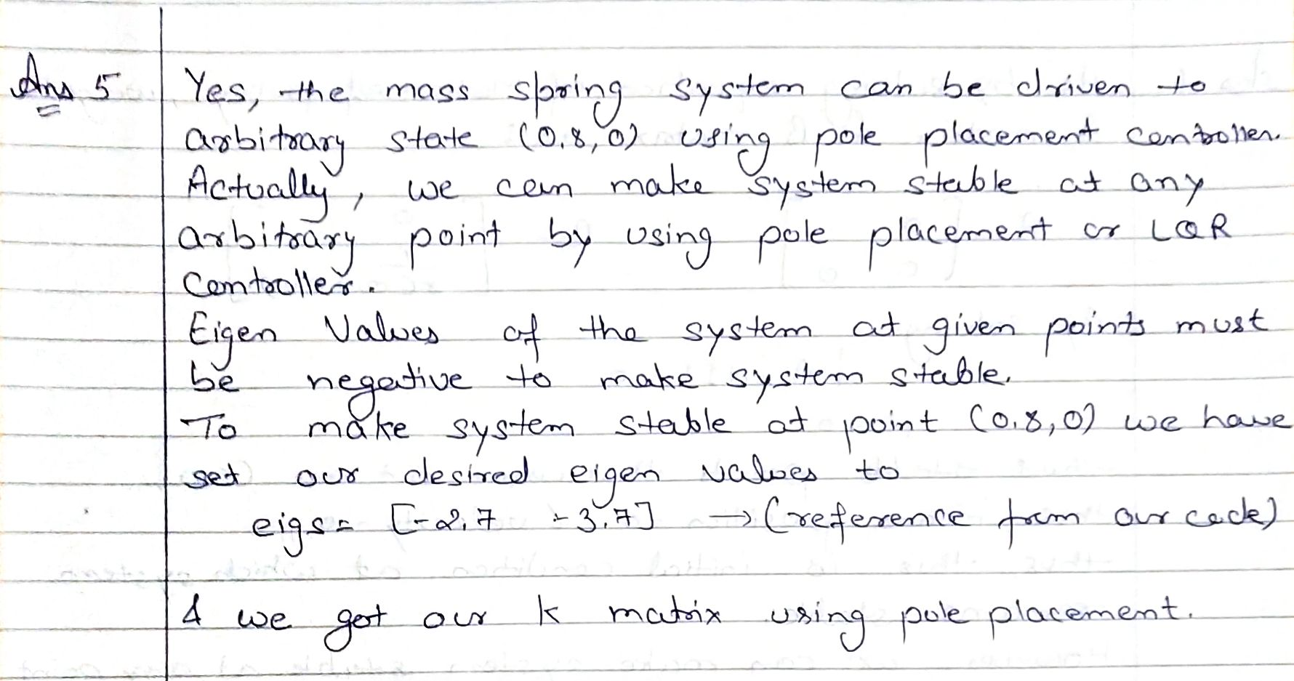

**Section 3 - Simple Pulley**

Q6) Under what conditions, will the system remain perfectly at rest? Justify your answer. (1)

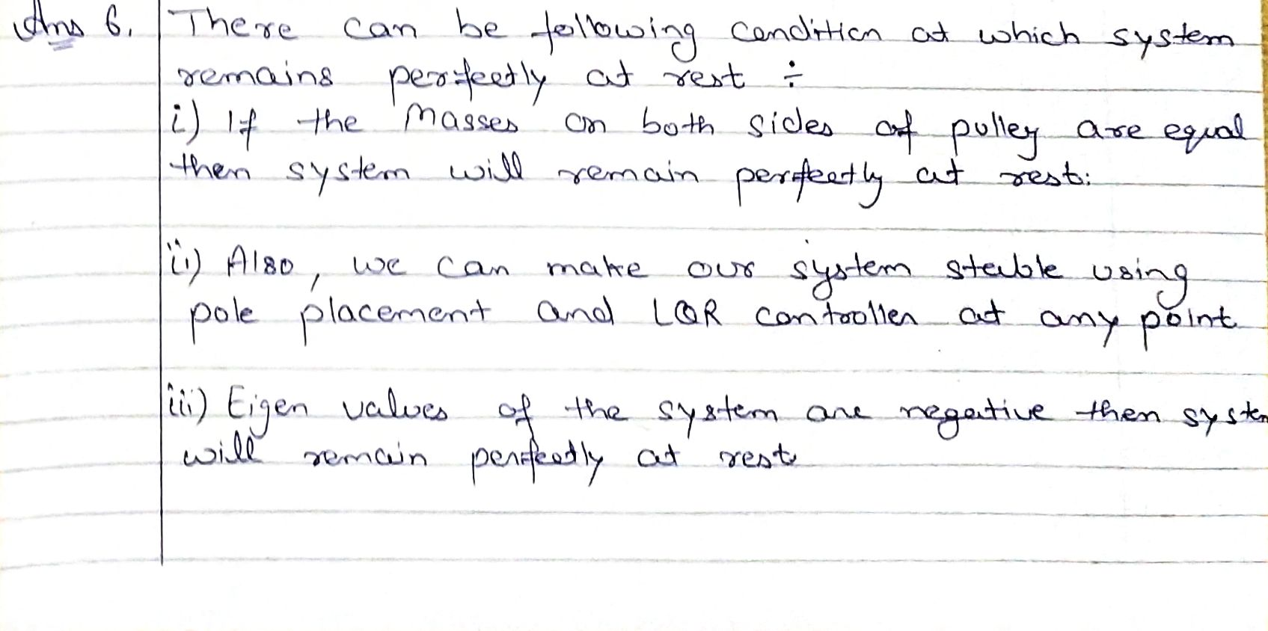

Q7) How many equilibrium points does the system have? Are they stable or unstable? Justify your answer. (2)

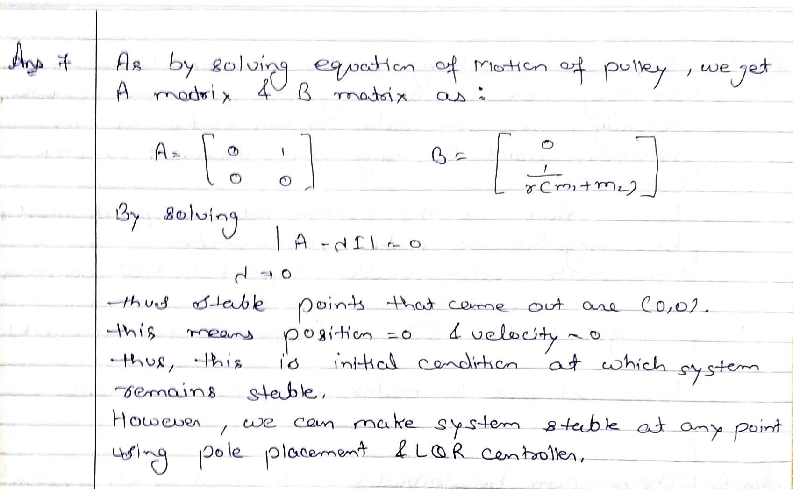

**Section 4 - Complex Pulley**

Q8) Derive the equations of motion for the complex pulley system. (5)

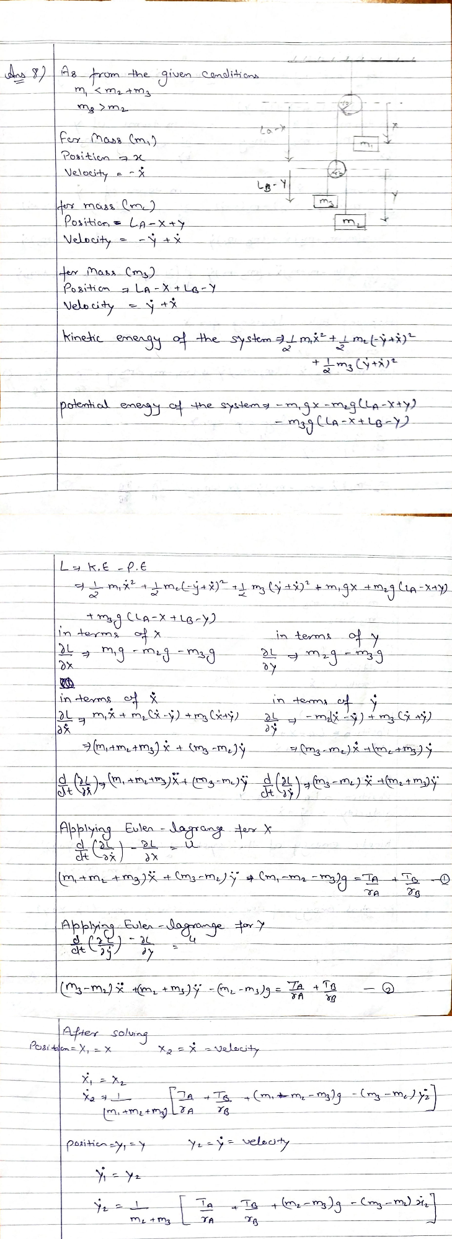

Q9) Derive the A and B matrices for the complex pulley system. Is the system linear or non linear? (4)

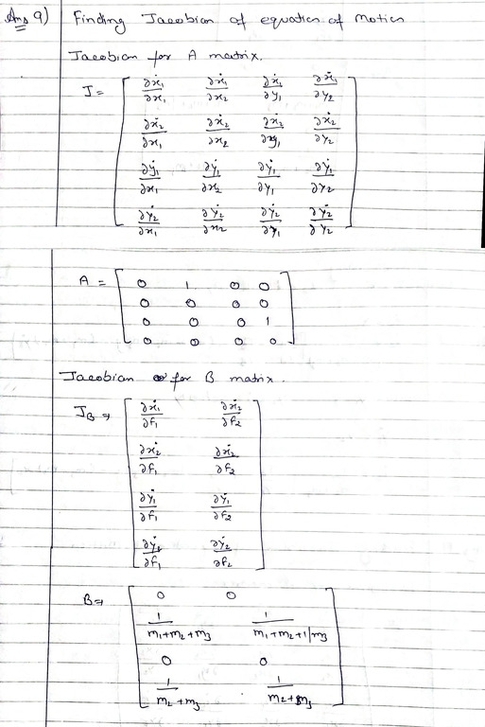

Q10) Under what conditions, will the system remain perfectly at rest? Justify your answer. (3)

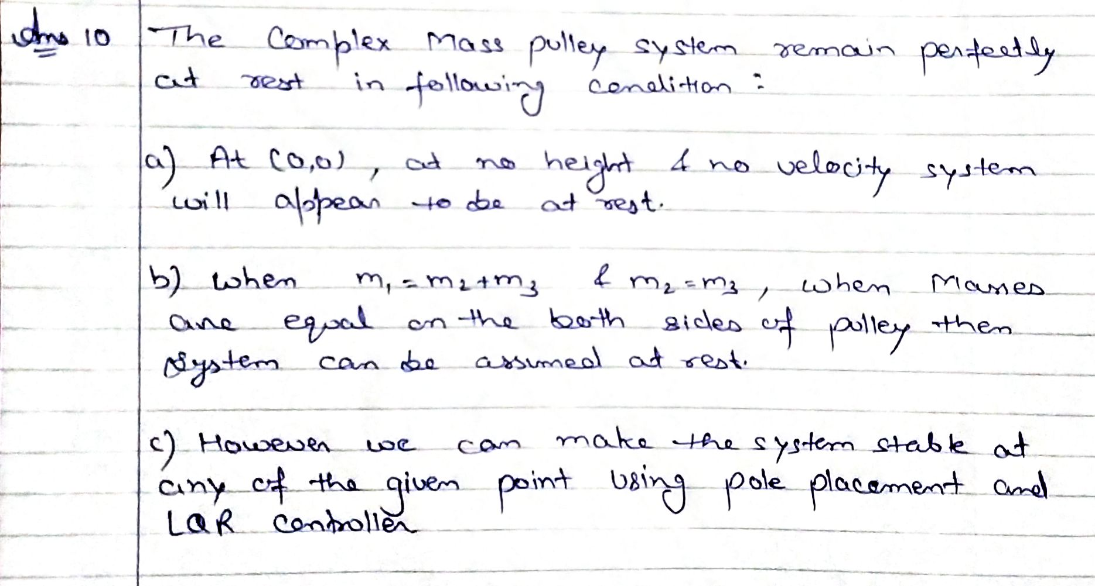

**Section 5 - Inverted Cart Pendulum**

Q11) Derive the equations of motion for the inverted cart pendulum system. Is this system linear or non-linear? Why? (7)

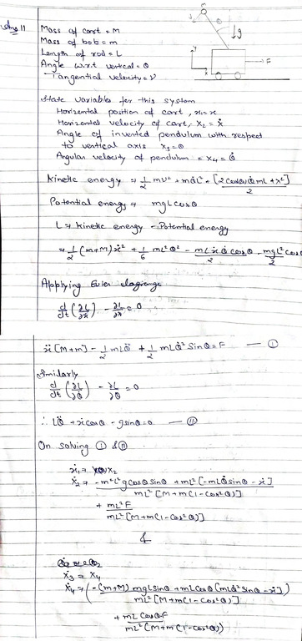

Q12) How many equilibrium points does the inverted cart pendulum system have? Categorize them as stable or unstable? (3)

