**Grafana report Generator**

This is a python based Grafana dashboard reporting tool and it helps to create

1. docx report on linux
2. docx and pdf on window

here using **grafana render image plugin** to convert the dashboard graph to image

**prerequisites :**

* python 3.6 and above
* Grafana instance should have render image plugin installed [Grafana image render](https://grafana.com/grafana/plugins/grafana-image-renderer)

**how to run**

*Download the application extract and cd to the application*  
directory run :-

*  pip install -r requirement.txt
*  check the config
*  python [webconsole.py](http://webconsole.py)

*On grafana dash board create the link* [reference to create link](https://grafana.com/docs/grafana/latest/linking/dashboard-links/#add-a-url-link-to-a-dashboard)  
syntax:- http:/**/ip:port**/?dashbordname=<**your dashboard name**>

* ip- the system IP where the you deploy this utility port - listening
* port on with the reporting utility running
* once above steps are completed in the grafana dashbord you should see the link which you have created

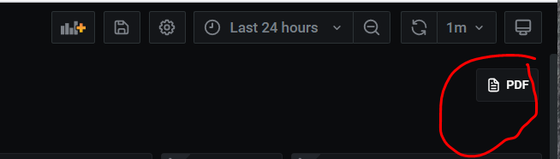

* select the time range and other required details in the Grafana and click on the link created
* on the next page fill the details like report name and test details

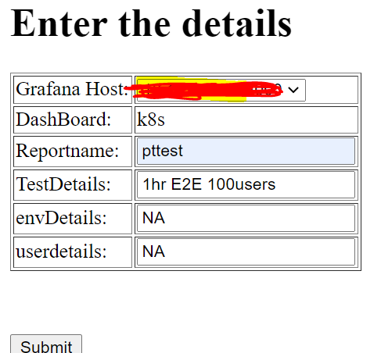

* and wait for few min(it depends on how many panels in the dashboard
* once report generation completes you will see the dashboard link to download the reports

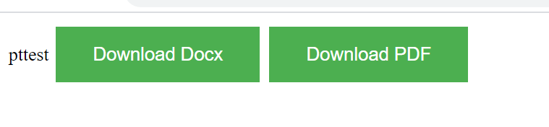

Credits:-

<https://github.com/AlJohri/docx2pdf>  
<https://github.com/IzakMarais/reporter>